Inspiration and Research
- ROUNDS (Landfall) – The game has a mechanic where players can pick a power up from a selection of “cards”. The power-up picking mechanic is similar to the ones seen in rogue-lite. Games like Hades and Dead Cells are great for a singleplayer setting, however these games are expected to be part of a long tun, so by design, the power ups essentially drip-feed the player with buffs. ROUNDS is a multiplayer game designed to be played in quick bursts, making players have less power-ups overall. ROUNDS combats this by making the power-ups “mechanic changing”. Essentially one power-up can completely change the way you play your game. For example, there is a power-up that transforms their base pistol into a shotgun like weapon. This changes the play style from being able to shoot at any distance to needing to have to be in close quarters but having the advantage of extremely high damage. This shows how the design philosophy between a singleplayer and a multiplayer game differs greatly even when you compare similar mechanics. Games like Call of Duty rewards players for performing well with game changing abilities via the ScoreStreak/ Killstreaks system. I have, however, found that players tend to gain a sense of frustration when the opposing team is dominating, and then they gain access to helicopters, essentially rendering them unstoppable/ ROUNDS’s power up mechanic acts more like a catchup mechanic. Players who are winning are not only challenged by the enemies getting harder as they win, it also gives losers a sense of “correction” when being able to gain a power-up to counter-act the winning players strength. One shortcoming of this game however is that there are moments where players can enter a slate-mate.
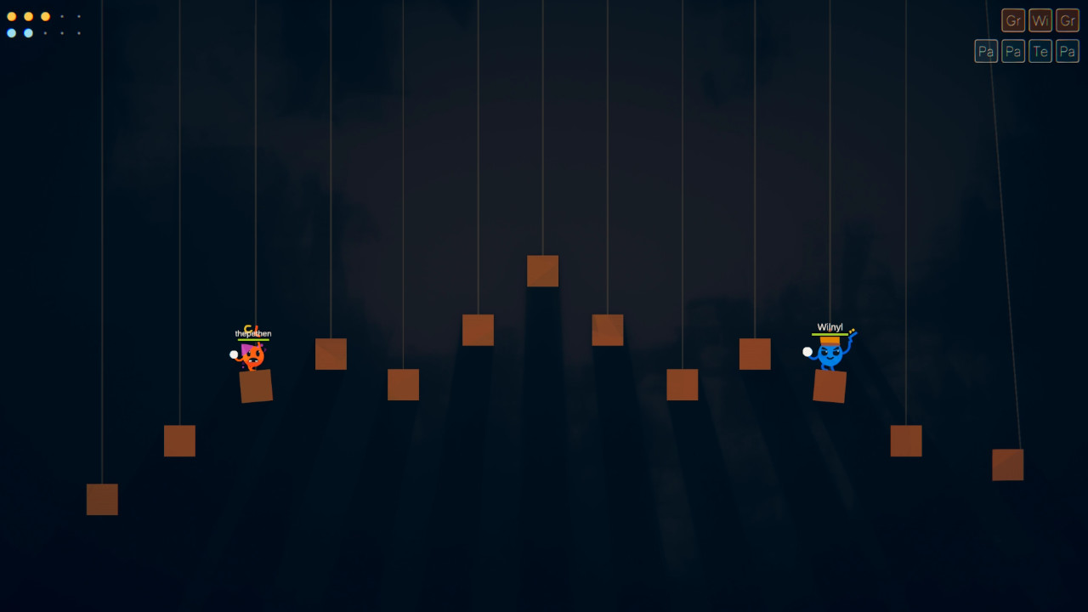This image shows the 2 players on equal footing. The game has no means of forcing an end (e.g. no timer, no hazards etc etc). This could cause camping, which slows down the pacing of a round, ruining the flow of the fast-paced game. This is definitely an area where they can improve. (Landfall, 2021)
- Fortnite (Epic Games) - Fortnite Battle Royale (will be called Fortnite for short) is a PvP battle royale game. It is heavily reliant on players fighting other players for the gameplay loop (however has been limited time events with interactable NPCs in a match). Fortnite boasts a large playable area. If we look at Call of Duty Black Ops Cold War, there is a game mode within the game called Outbreak. It, too, boasts a large map, however it is purely a PvE experience that can be taken on by yourself or with friends. These 2 games show how a singleplayer game and multiplayer games have significant differences in how these large-scale maps work. In outbreak, the developers are able to create a sense of constant action. As players, traverse the map to explore points of interest, the game can throw hordes of zombies, mini – bosses, and large-scale events to keep the player on their toes. Fortnite is heavily reliant on player interactions. This means that the developers can’t throw hordes of enemies to keep a player engaged throughout the match but rather design their game in a manner where the players are forced to interact with each other. The primary way Fortnite achieves this is by use of its “Storm”. This essentially pushes players inwards, making the playable space smaller. This is essential for keeping the player engaged with constant combat scenarios, since the a match relies on perma-death, so the total amount of players in a match constantly reduces, hence needing to push players towards a central location. (Epic Games, 2017)
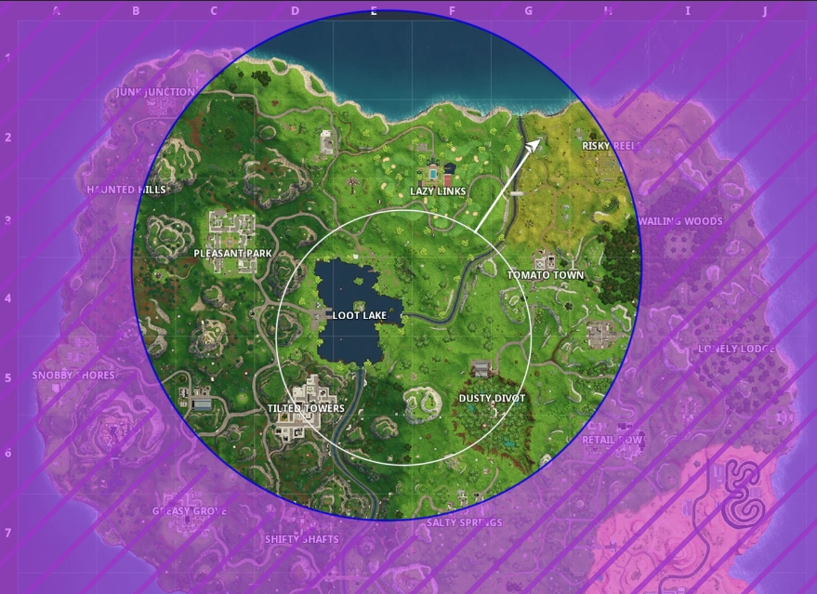
- Among Us (Innersloth LLC) – Among Us has a mechanic to keep players engaged to the game whilst they are dead. Dead players become ghosts and can still interact with the game to help their team (e.g. sabotage or complete tasks). A lot of games have a spectate feature by simply seeing the game through a specified players camera. Among Us’ ghost spectator mode grants the player full movement freedom. (Innersloth, 2018)
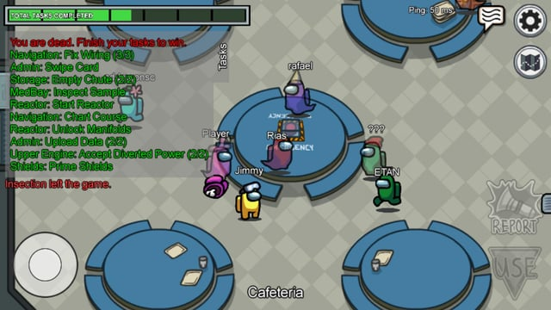

Multiplicative Mechanic Design
When designing the game, the core systems were made in such a way to make single mechanics that serve multiple purposes. This prevents the gameplay loop becoming one-dimensional. It increases the skill ceiling without bloating the control scheme.
- Blocking as Offensive Crowd Control: A block mechanic is simple defensive tool to mitigate incoming damage, rendering it purely as a defensive tool. The game has a Parry Power-Up. This allows players who time their blocks to release a shockwave that applies severe knockback to nearby enemies, transforming a defensive reflex into an offensive attack.
- Projectile Clashing as Active Defence: Projectiles are inherently offensive. If 2 bullets collide, a check occurs in NetworkProjectile to see the difference in size. If they are both the same size, the bullets both cancel each other out. However if a player acquires the Bullet Size or Giant power-ups, their larger projectiles will destroy the incoming enemy projectiles impact and carry on. This means a player can tactically fire their weapon defensively to “eat” enemy bullets, shifting the projectile mechanic from simple DPS to active shielding.
- Melee and Environmental Lethality: The melee deals damage to the player. Its multiplicative value lies in its physics knockback. Because the arena dynamically shrinks and is surrounded by an instant-kill boundary, the win condition is not solely in reducing an opponent's HP to zero. Melee becomes a vital positional tool, allowing players to utilise the player environment for instant eliminations by pushing enemies off the map.
- Poison Clouds as Area Denial: The poison cloud power up leaves a lingering damage-over-time volume upon projectile collision. It can force players to use the mechanic as area denial mechanic. On a shrinking map, intentionally miss direct hits to place poison clouds at strategic chokepoints, effectively herding the opponent into lava hazards or restricting their movement options.

System Interaction and Code Structure
Since implementing netcode into a game can get complicated, keeping scalability and modularity for the sake of long-term maintenance must be at the forefront. Making quick code will make prototyping initially easy, but following a modular design pattern ensures that the code base has minimal friction when trying to work with as the project scales, allowing a faster route to shippable code.

Observer Pattern
Having an event-driven architecture allows the utilisation of the Observer pattern. This architecture essentially allows systems in the project to communicate via event subscriptions. Having objects constantly pol one another in an Update() loop causes significant performance bottlenecks. (Nystrom, 2011)

Implementation Details
- ScriptableObject (SO) Channels: These channels acts as a form of medium between broadcasters and listeners. Broadcasters and listeners will know about the ScriptableObject, but not about each other, making it completely decoupled. For example, when a player spawns/ dies, they register/ deregister with the PlayerCameraChannelSO. This allows the MultiplayerCameraManager to simply listen to this channel, without ever needing direct references to the player prefabs, and updates its cinemachine target group accordingly.
- Local C# Actions & Network Variables: Component-level communication is handled by Action delegates and the NetworkVariable callbacks. The NetworkHealth component broadcasts OnHealthChanged and OnDeath events. PlayerHUDController has these events subscribed so that the UI reacts instantly to damage without any tightly coupled logic.
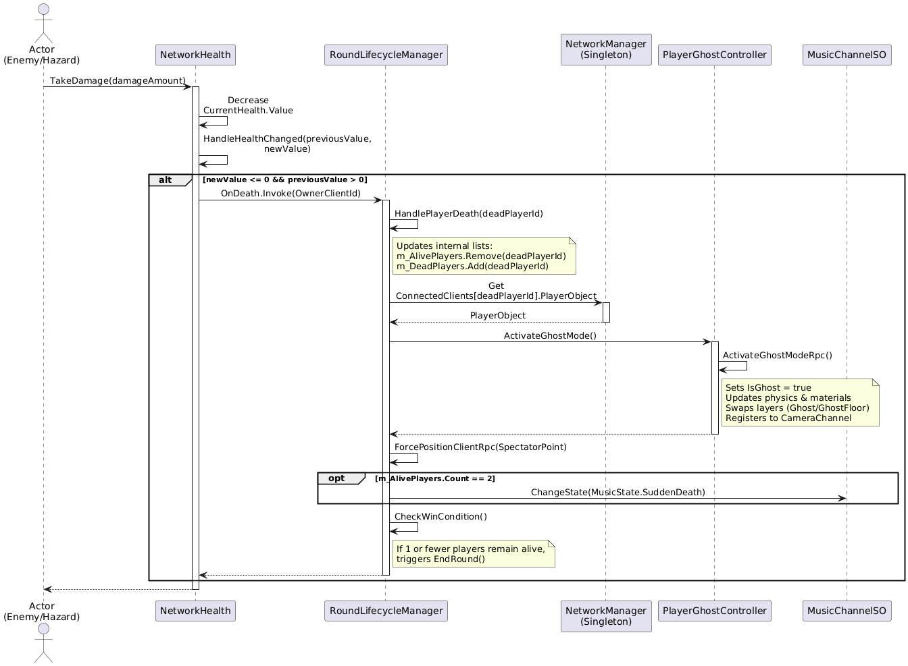
PlantURL link

Strategy Pattern
Strategy pattern is utilised to make a dynamic and easily expandable power-ups system. A block of conditional statemants/ inheritance tree for every single player buff will make the codebase rigid. Behaviours are instead encapsulated into interchangeable strategy classes. (Gamma, et al., 1994)

Implementation Details
- Power-Up Abstraction: The PlayerPowerUpCOntroller maintains a list of active power-ups without needing to know what they do. The PowerUpEffect abstract class defines the contract (OnEquip and OnUnequip). The logic of the mechanic are in the individual script.
- Data-Driven Strategy Configuration: PowerUpDefinition ScriptableObjects acts as data containers. The carriable values can be edited in the editor. When a power-up is granted, the ScriptableObject simply passes its customised data into the strategy class and equips it to the player. This completely separates the design balancing data from the runtime execution logic. (Unity, 2017)
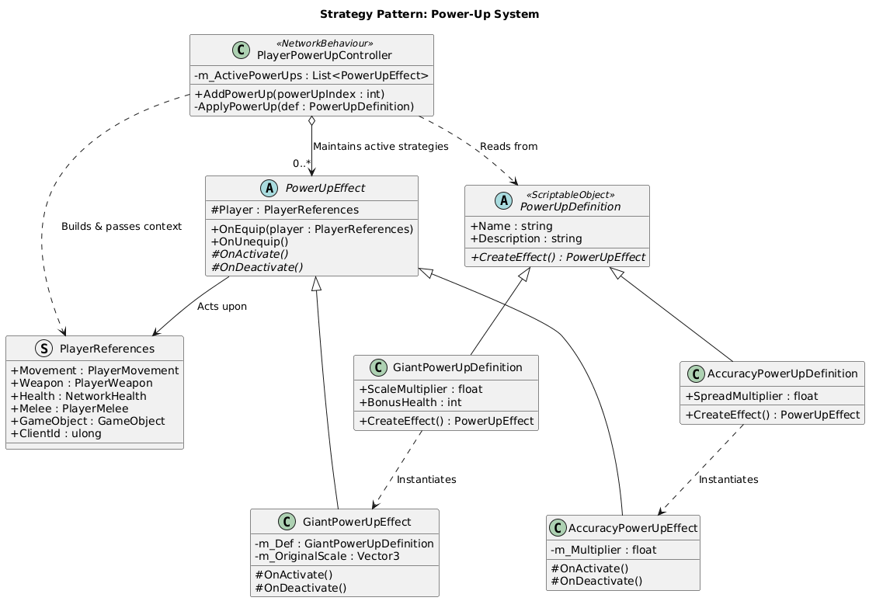
PlantURL link

Network Architecture
Unity Netcode for GameObjects (NGO) with a strict Server-Authorative model is fair and prevents client-side cheats.

Implementation Details
- State Management: The game is handled by RoundLifecycleManager, which acrs as a centralised state machine. It seamlessly transitions the server state from active gameplay to Sudden Death, and finally to the Power-Up selection screen.
- RPCs and Authority: ServerRpc handles gameplay actions, like dealing damage and validating blocks. Visual and auditory feedback are then broadcast back to clients using ClientRpc and Network Variable state changes, ensuring minimal network overhead while maintaining a responsive player experience
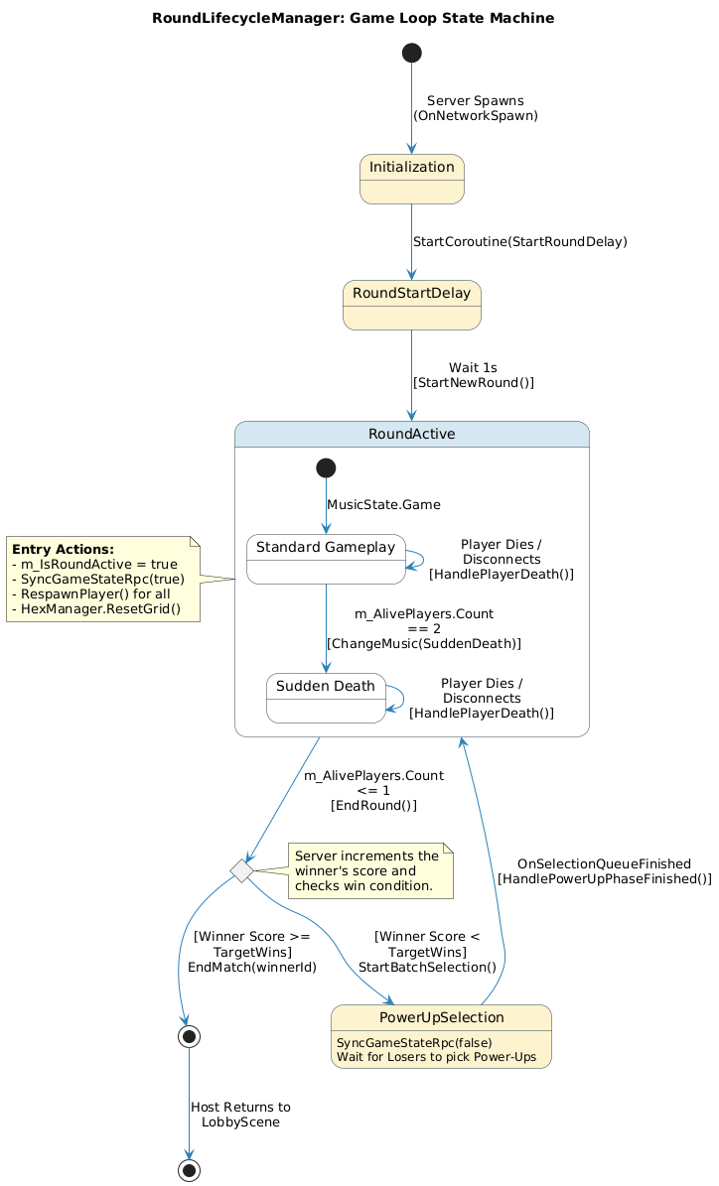
PlantUML link

Documentation
The title for the game is KnockOut. It is a fast paced, top-down arena brawler. The aesthetics of the game goes for a fun vibrancy, by meshing Kenney’s platformer 3d assets with a toon shader from unity’s asset store. Players face off in a physics-based environment where the arena itself is a hazard. As the match progresses, the floor tiles on the edges systematically fall away. This forces players into intense close-quarters combat. The power-ups acts as a form of balancing, giving players a ”catch-up” mechanic, maintaining a dynamic flow. These power-ups are game-changing, to alter their playstyle and level the playing field for the next round and level the playing field for the next round.

Controls
The game has native support for both keyboard and mouse, though the game was designed with controllers in mind.
Controls | Keyboard | Gamepad
Move | WASD | Left Stick
Aim | Mouse | Right Stick
Attack | Left Mouse Button | Button West/ Right Trigger
Block | Right Mouse Button | Button North/ Left Shoulder
Melee | C | Button East/ Right Shoulder
Jump | Space | Button South

Game Rules
- The Arena: Players spawn on a hexagonal grid. Over time, outer tiles break and fall away. Falling off the grid into the lava or losing all health to projectiles/ poison results to death.
- Sudden Death: When only two players remain alive, the game enters a “Sudden Death” phase, accompanies by a dynamic music shift to heighten tension.
- Round Loss & Power-Ups: The last player standing wins the round. Defeated players are immediately entered into the Power-Up Phase, where they can choose one of 5 randomly drawn cards to permanently buff their character for the remainder of the match.
- Match Win Condition: The first player to reach the Target Scorer (default is 3 wins, adjustable in the lobby) is dedicated the overall winner.
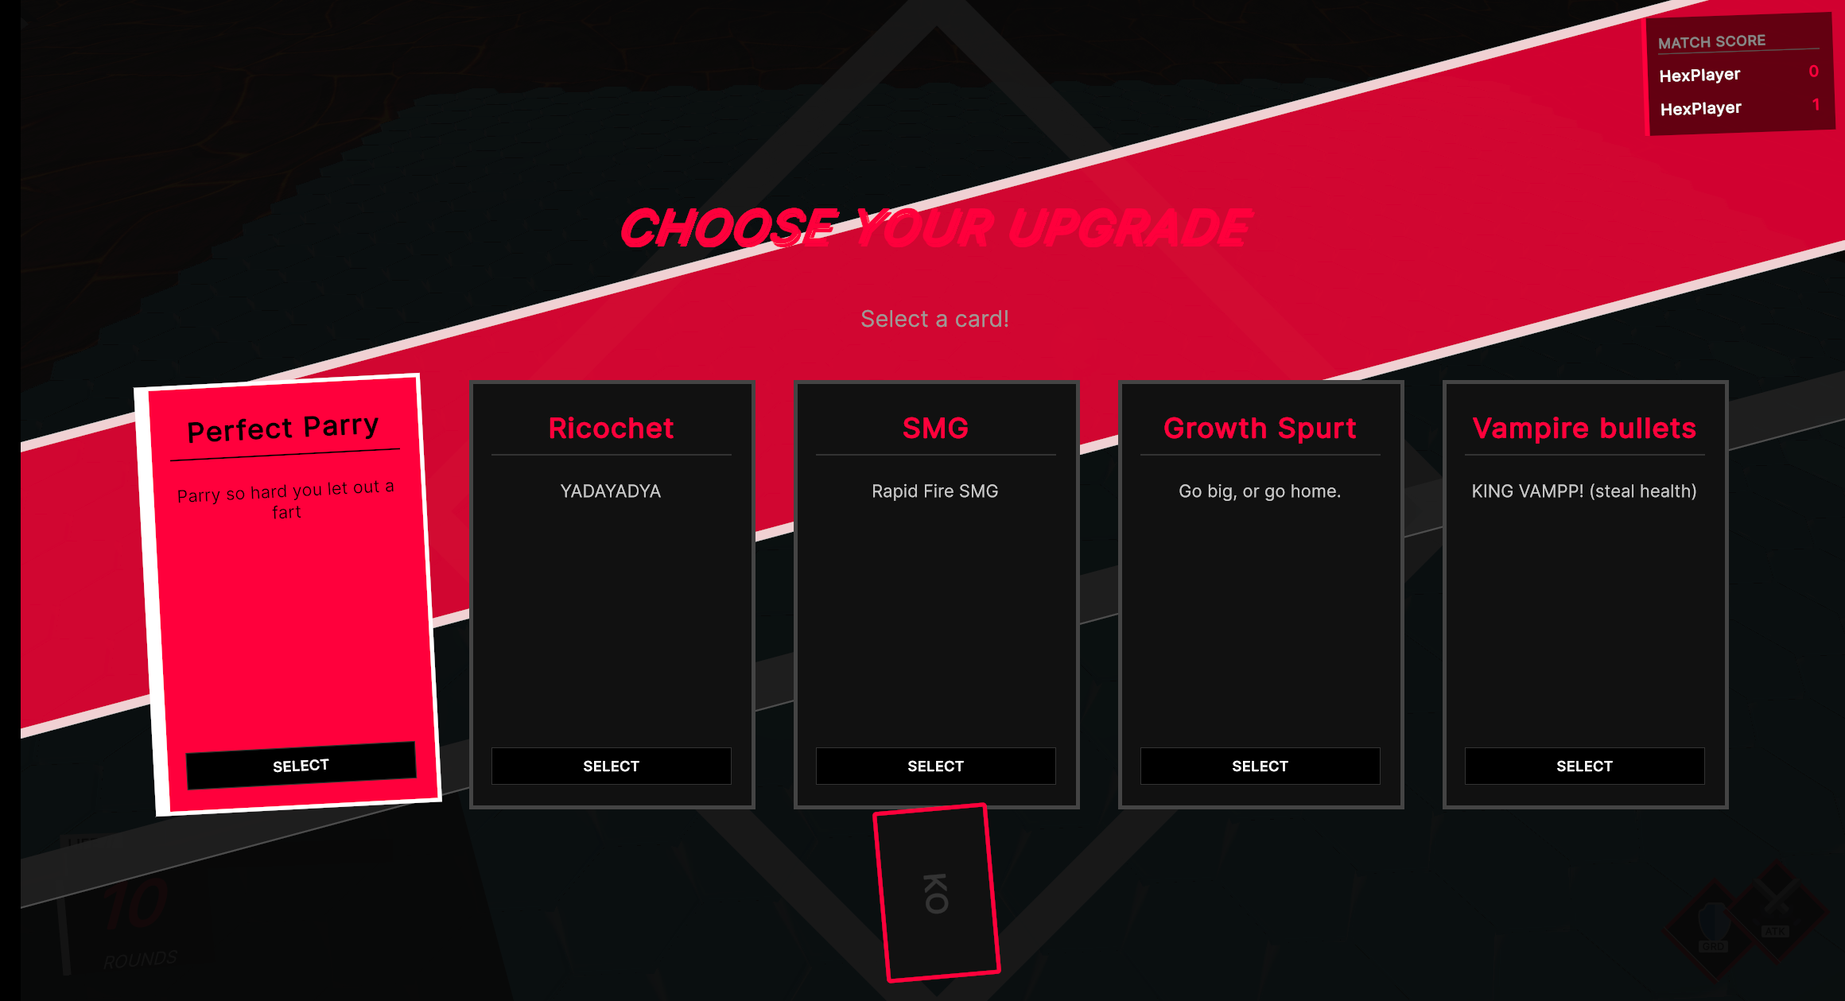

Designer Instructions on expanding the game
The data-driven Strategy pattern gives designers the opportunity to easily create, tweak, and implement new power-ups without rouching the core runtime code.

Creating a new Power-Up
- Create the Data Container: In the Unity Editor’s project window, right-click and navigate to Create > PowerUps > [Select Desired Type] (e.g. Giant Transformation) 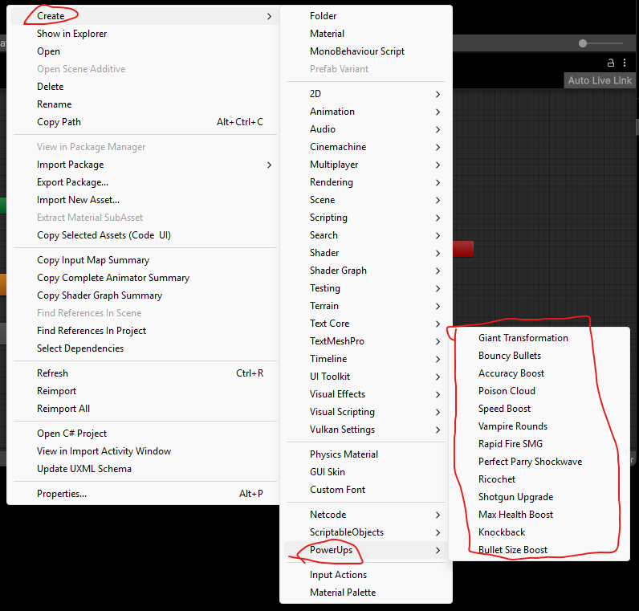
- Tweak the Values: Select the newly created ScriptableObject. In the inspector, you can now balance the power-up by adjusting exposed variables. For example, for the Giant power-up, you can increase the Scale Multiplier or Bonus Health, while reducing the Speed Multiplier to balance it (Nystrom, 2011)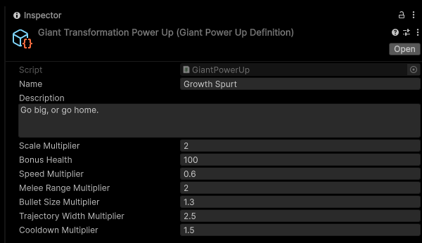
- Add to the Deck: Locate the GameManager object in the GameScene. Within the PowerUpSelectionManager component, you will see All Power Ups as an option with an arrow on the left.
Clicking it will expand the list. Pressing the plus icon will duplicate the last power up in the list, allowing you to override it with the power up. You can do this by clicking on the circle button on the right of the element you want to replace
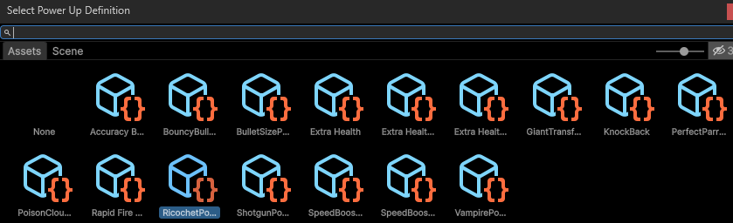
The game will ignore elements that are unassigned.

Bibliography
Epic Games, 2017. Fortnite Battle Royale [Video game]. s.l.:Epic Games.
Gamma, E., Helm, R., Johnson, R. & Vlissides, J., 1994. Behavioral Patterns: Strategy. In: Design Patterns: Elements of Reusable Object-Oriented Software. s.l.:Addison-Wesley Professional, p. 317.
Innersloth, 2018. Among Us [Video game]. s.l.:Innersloth.
Landfall, 2021. ROUNDS [Video game]. s.l.:Landfall.
Nystrom, B., 2011. Game Programming Patterns. [Online]
Available at: https://gameprogrammingpatterns.com/observer.html#achievement-unlocked
Unity, 2017. Unite Austin 2017 - Game Architecture with Scriptable Objects, s.l.: s.n.

