

FINAL YEAR PROJECT

COMP60011

Real-Time IoT Plant Health Monitoring and Alert System

Eleanor Weaver

23022284

Supervisor: Dr Pantaleon Lutta Odongo

May 2026

A project report submitted in partial fulfilment of the requirements of university of Staffordshire for the Bachelor of Science in Computer Science

ACKNOWLEDGEMENTS
I would like to express my gratitude to my supervisor, Dr. Pantaleon Lutta, for overseeing this project from start to finish. The patience and dedication in helping me navigate this project was essential in keeping this project on track.
I would also like to thank my brother Sam for providing initial help in developing the concept for this project, as it would not have taken form without that input early on. I am extremely grateful to my father for his support on this journey as well.

ABSTRACT
The goal of this project was to develop a real-time IOT-based plant monitoring system that functioned as an improvement to traditional schedule-based indoor plant care. This goal was determined based on the overreliance on fixed watering schedules in domestic households. These schedules fail to account for environmental variables such as temperature, humidity and light changes. This often leads to plant health degrading due to overwatering or neglect.
To solve this, a prototype for a plant monitoring system was developed using an ESP32 microcontroller connected to environmental sensors. These sensors include a capacitive soil moisture sensor to monitor soil hydration, a BME280 to monitor temperature and humidity, and a TCS34725 for light intensity monitoring and light colour analysis. Unlike other light sensors, the light colour analysis allows for the system to distinguish between red and blue light, allowing for the system to provide more in-depth insights about light quality, root development, and plant growth.
The system allows for the user to monitor plant health from any location by transmitting the real-time data to an Adafruit IO cloud dashboard. Furthermore, the system utilises Adafruit IO to send automated email alerts when environmental conditions become unhealthy for plant development and health. Through testing it was determined that the system could successfully identify and send alerts in response to conditions that a fixed schedule would not have accounted for. Overall, this project demonstrates that IoT technology can be used to improve the sustainability of domestic indoor gardening.

TABLE OF CONTENTS
ACKNOWLEDGEMENTS i
ABSTRACT ii
LIST OF FIGURES v
LIST OF TABLES vi
ABBREVIATIONS vii
1. INTRODUCTION 1
1.1. Research Background 1
1.2. Research Motivation 1
1.3. Hypothesis 2
1.4. Aim 2
1.5. Objectives 2
1.6. Deliverables 2
1.7. Academic Challenge 3
1.8. Project Plan 3
1.9. Structure of Report 3
2. LITERATURE REVIEW 5
2.1. Preamble 5
2.2. Internet of Things (IoT): Concepts and Applications 5
2.3. Internet of Things (IoT): Architecture Models 5
2.4. Circuit Components and Design 7
2.4.1. Environmental Sensing in IoT Systems 7
2.4.2. Microcontrollers and Communication 8
2.5. UX Design in IoT systems 9
2.6. Related Work 9
2.7. Research Gap 9
2.8. Conclusion 10
3. RESEARCH METHODS 11
3.1. Preamble 11
3.2. Research Methodology 11
3.2.1. Research Philosophy 11
3.2.2. Research Approach 12
3.2.3. Research Strategy 12
3.2.4. Time Horizon 12
3.3. Project Management Methodology 12
3.4. Data Collection and Evaluation 13
4. DESIGN AND IMPLEMENTATION OF ARTEFACT 14
4.1. System Overview 14
4.2. Hardware Design 14
4.2.1. Microcontroller Selection 14
4.2.2. Sensor Selection and Integration 15
4.2.3. LCD Screen 16
4.3. Circuit Design 16
4.4. Software Implementation 19
4.4.1. Acquisition of Sensor Data 19
4.4.2. Data Processing 21
4.4.3. Communication Layer 22
4.4.4. UI 23
4.5. Design Decisions 30
5. TESTING AND VALIDATION OF ARTEFACT 31
5.1. Test Results 31
5.1.1. Test Case T1: System Stability 32
5.1.2. Test Case T2: Soil Moisture Accuracy 33
5.1.3. Test Case T3: Light Colour Accuracy 34
5.1.4. Test Case T4: Event Alert Latency 34
5.1.5. Test Case T5: Environmental Reactiveness 35
5.2. Validation and Evaluation 35
6. CONCLUSIONS AND FUTURE WORK 36
6.1. Evaluation of Project Aims, Objectives and Hypothesis 36
6.2. Critical Evaluation and Lessons Learned 36
6.3. Future Work and Improvements 36
6.4. Summary 37
REFERENCE LIST 38

LIST OF FIGURES
Figure 1: Three-Layer Approach 6
Figure 2: Saunders' Research Onion Framework 11
Figure 3: Agile Methodology 13
Figure 4: System Block Diagram 14
Figure 5: Prototype Circuit 17
Figure 6: Case model in Fusion 360 18
Figure 7: Complete Physical Artefact 18
Figure 8: Code Libraries 19
Figure 9: Soil and LED Pin References 19
Figure 10: TCS34725 LED Control 19
Figure 11: Hardware Configuration and Pin Assignment 20
Figure 12: BME280 and TCS34725 initialisation and error validation 20
Figure 13: Data Acquisition Loop 20
Figure 14: Threshold Limits 21
Figure 15: Status Messages Logic 21
Figure 16: Light Analysis Logic 22
Figure 17: WiFi Connection 23
Figure 18: Serial Monitor Output 23
Figure 19: LCD UI 24
Figure 20: LCD Display Rotation Logic 25
Figure 21: Adafruit IO Connection Logic 26
Figure 22: Feed Transmission to Cloud 27
Figure 23: Reconnection Logic 28
Figure 24: Adafruit IO Dashboard 28
Figure 25: Automated Email Alert Logic 29
Figure 26: Example Email Alert 30
Figure 27: Dashboard displaying error 32
Figure 28: 24 hours of Light feedback 33

LIST OF TABLES
Table 1: Three-Layer Implementation 6
Table 2: Microcontroller Comparison 8
Table 3: Soil Moisture Readings 15
Table 4: Pin Assignment Table 16
Table 5: Test Cases 31
Table 6: Soil Moisture Accuracy Testing 33
Table 7: Light Colour Testing 34
Table 8: Event Alert Testing 34
Table 9: Soil Moisture Sensor Testing 35

ABBREVIATIONS
ADC --- Analogue-To-Digital
AI --- Artificial Intelligence
ARPANET --- Advanced Research Projects Agency Network
BLE --- Bluetooth Low Energy
CPU --- Central Processing Unit
GPIO --- General Purpose Input/Output
HTTP --- HyperText Transfer Protocol
IO --- Input/Output
IoT --- Internet of Things
I2C --- Inter-Integrated Circuit
LCD --- Liquid Crystal Display
LoRa --- Long Range
LoRaWAN --- Long Range Wide Area Network
MQTT --- Message Queuing Telemetry Transport
PCB --- Printed Circuit Board
UX --- User Experience

INTRODUCTION

Research Background
House plant care is a common activity in domestic households; however, many people find it difficult to keep their indoor plants healthy because they rely on fixed watering schedules that do not reflect the actual environment their plants are in. This often leads to overwatering or underwatering, which can cause root rot and other plant issues. A growing number of cases show that inconsistent watering and unsuitable indoor conditions are the leading causes of houseplants failing to thrive.
In recent years, there has been an increased interest in using smart environmental monitoring to support sustainable living and automation in homes, especially following the COVID-19 pandemic (Umair et al., 2021). Systems like these allow users to track real-time data and adjust their behaviour accordingly, as is shown in devices such as smart meters, which enable users to track their energy use, allowing them to reduce energy costs in their home (Tahir et al., 2022). As such, as technology becomes increasingly involved in everyday life, there is an increasing interest in systems that can help improve home-life in a simple but meaningful way. House plant care is an example of something that can make use of simple systems to easily make home environments more sustainable. Collecting house plants is often seen as a relaxing break from the stressors of life and work, yet it can also cause frustration when plants fail for reasons that could have been prevented.
Prototype systems using Arduino and common sensors have already demonstrated that multiple environmental factors can be monitored and linked to cloud services for automatic alerts (Bakar et al., 2022). A key factor that is considered in my approach is designing for modularity, ensuring each component, both hardware and software wise, can be easily replaced or upgraded without changing the whole system, to increase the durability of the system. This project built on these ideas by focusing on improving accuracy, reliability and user experience.

Research Motivation
The motivation for this project came from the fact that most plant-care apps tend to give users fixed, rigid, watering schedules rather than live data from the user’s environment (Owino et al., 2022). Although data trends are often reliable and can be used to generalise many experiences, environmental conditions influence a plants health and how much water they may require greatly. This project measured factors such as soil moisture, humidity and temperature in order to make plant care more reliable and efficient. Using real environmental data has already been shown to reduce water use while maintaining healthy plants (Jędrzejuk et al., 2022). Additionally, smart irrigation systems have been shown to optimise watering cycles by using real-time information from sensors (Obaideen et al., 2022), and these same principles can be adapted for small-scale or domestic environments, even when users do not have as much access to industry-level materials or technology. The research investigated existing smart gardening tools and compared how they approach these problems, identifying ways that a user-focused design can improve accessibility and accuracy. Another way to improve accuracy is to ensure regular calibration of sensors, which is important to maintain accuracy over time (Lynda et al., 2023).
This project involved designing and developing a smart monitoring system for indoor plants using a microcontroller and a set of environmental sensors. The design and implementation of the system, which is documented in this report, measures factors such as soil moisture, humidity, temperature, and light quality, and then sends the data wirelessly to a virtual dashboard that provides real-time alerts and watering suggestions. Combining simple sensors with a small amount of programming within this project also shows how Internet-of-Things (IoT) technologies can be applied to everyday life. By using wireless data transfer for the connection between the physical system and the dashboard, users can access live updates without manually checking their plants, improving long-term care of plants. The end application and physical set-up is relatively simple, making it a practical example of how low-cost technology can support sustainability in smaller, more domestic environments (Menon, 2025).
While there are already apps and smart devices for plant care, such as Planta, the vast majority focus purely on delivering schedules based on data that is not influenced by the user’s specific environment. When users follow the exact schedule or advice provided by the app, it does not go well due to the limited accuracy (Clarin et al., 2024). This project addresses those limitations by creating a system that informs the user based on real measurements rather than fixed rules.

Hypothesis
A system that provides real-time alerts based on environmental sensor data will result in more efficient indoor plant care compared to methods based on a fixed schedule.

Aim
To design and develop a working prototype that can demonstrate real-time indoor plant data monitoring that is accurate and delivers notifications to users.

Objectives
The objectives of this project are as follows:
- Review existing IoT-based plant monitoring systems to identify common design practices, strengths, and limitations that will inform the proposed solution.
- Design an integrated IoT plant monitoring system that outlines the overall architecture, hardware components, communication methods, and data flow required for effective real-time indoor plant monitoring.
- Develop, implement, and test a functional prototype, integrating sensors, a microcontroller, and appropriate communication methods to accurately collect, transmit, and store environmental data for continuous monitoring and user notifications.
- Evaluate the overall system’s performance and effectiveness through testing against predefined success criteria.

Deliverables
This deliverables of this project are as follows:
- A literature review of existing research, technologies and existing solutions that investigate real-time IoT based plant monitoring and environmental sensors.
- A working prototype circuit comprised of a microcontroller and environmental sensors, capable of accurately measuring factors such as soil moisture, temperature and humidity, as well as being able to collect and transmit real-time plant data.
- Design documentation, including diagrams that explore the structure and operation of the circuit and system.
- A fully completed document that explores the research, design, implementation, testing, evaluation and conclusions of the project.

Academic Challenge
The academic challenge of this project comes in the form of designing a system that is both reliable and useful. This project utilised several skills: programming a microcontroller to collect and process sensor data, managing IoT communication to transmit that data, and designing a readable user interface for real-time feedback. These combine several elements from computer science which make it academically challenging. Additionally, similar IoT architectures are widely used in smart agriculture and precision environmental monitoring, making this a small-scale demonstration of computing principles utilised in real life industries (Morchid et al., 2024).
The hardware system successfully integrates sensors, ensuring accurate and stable readings over time. This means that sensor calibration and environmental variables are taken into account. On the software side, the system is capable of handling data transmissions between the circuit and the dashboard. Translating the sensor data to understandable feedback for users presented a challenge.

Project Plan
This project is structured into different phases of development which carry the project through from the research stage to the implementation and evaluation.
The initial phase of the project focused on the literature review and background research. During this phase, a study was conducted on existing academic literature and solutions related to plant monitoring. This research served as a foundation which informed the design and development done in later phases.
After this is the design phase, where the system and circuit were planned. It is during this phase that different hardware components were considered and selected.
The implementation phase follows this, using the designs constructed in the previous phase. This is where the physical prototype was constructed and connected to the virtual dashboard.
The next phase is the testing phase which walks through the evaluation of the prototype created to ensure it met specific success criteria. This phase ensured that the system was durable, stable, reliable, usable and has good response time.
The final phase involved the refinement and validation of the project. This addressed any flaws discovered during the testing phase. Final checks were completed to ensure the project had achieved all success criteria.

Structure of Report
This report is structured as six chapters, showing the progression of the project from the research stage through to the evaluation.
Chapter 1: Introduction explores the background of this project, including the reasoning behind this project choice, the objectives the project aims to address, and the deliverables this project aims to produce.
Chapter 2: Literature Review outlines the existing research on IoT plant monitoring systems, environmental sensing, microcontrollers, communication technologies, and user experience. This chapter establishes the foundation that the project will be built on, as well as identifying gaps in the research that the system proposed in this project aims to address.
Chapter 3: Research Methodology goes through the strategies and approaches used to research, design, implement and evaluate the project.
Chapter 4: Design and Implementation describes how the system was designed and developed. This focuses on how the hardware is configured as well as how the software was designed and written.
Chapter 5: Testing and Validation investigates the evaluation of the system, conducting tests and comparing the results against how the system is expected to perform, assessing the overall success of the project.
Chapter 6: Conclusion summarises the outcome of the project, how well the objectives and deliverables were completed, and investigates areas for future improvements or flaws in the system that can be expanded upon.

LITERATURE REVIEW

Preamble
This literature review functions to investigate and justify the design and development of the system by evaluating and exploring current IoT technology, specifically through analysing previously conducted research, commonly used technologies, existing applications and scientific studies that investigate IoT and environmental monitoring.
This chapter will begin with an overview of the core concepts, models and applications of IoT. It will then go through the environmental sensing in IoT systems, investigating how to utilise sensors and the role of sensors in plant health and care. This is followed by a review of the common microcontrollers and communication methods used in IoT applications, showing how these sensors connect and transport data. It will then investigate UX design in IoT systems, and how this can impact the use of plant monitoring systems. The review will be closed off by identifying gaps and limitations in existing plant care applications and plant monitoring research.

Internet of Things (IoT): Concepts and Applications
IoT is a broad concept that has evolved swiftly over time, and there is no single universally accepted definition, which can lead to some ambiguity around the topic (Sorri, Mustafee and Seppänen, 2022). However, on a general basis, IoT is described as a network of physical objects (Patel et al., 2016), where every device can collect, exchange and act upon data that they receive over the internet, allowing for the creation of more efficient systems that can operate with minimal or no direct human intervention (Balaji, Nathani and Santhakumar, 2019). At its core, IoT relies heavily on embedded systems, as these devices are more readily able to function within interconnected networks.
As well as in the commercial environment, IoT use surged in domestic environments, as modern homes have seen an increase in smart devices. These devices allow for users to automate common tasks in their home and have more energy-aware smart homes, increasing energy efficiency in a way that’s convenient for users (Risteska Stojkoska and Trivodaliev, 2017).
Alongside domestic and commercial uses, IoT has additionally been applied in environmental monitoring and agriculture. IoT-based sensing systems and AI have been integrated into the agricultural sector, utilising their ability to monitor soil conditions, climate variables, and crop health to increase crop production and minimise inefficiencies in resource usage (Alahmad et al., 2023). These applications demonstrate how IoT can bridge the gap between digital systems and physical environments, making it relevant for plant monitoring and care.

Internet of Things (IoT): Architecture Models
Modern IoT systems must meet requirements such as real-time processing, autonomous operation, data analysis, and scalability, all of which are more achievable when system components are clearly separated, when using an approach that utilises modularity (Alabadi, Habbal and Wei, 2022). A typical IoT data flow follows a path from sensors to a microcontroller, where the information is then transported across the network to a server or database, which can then be displayed on a user interface. One potential model for IoT is shown in the figure below.
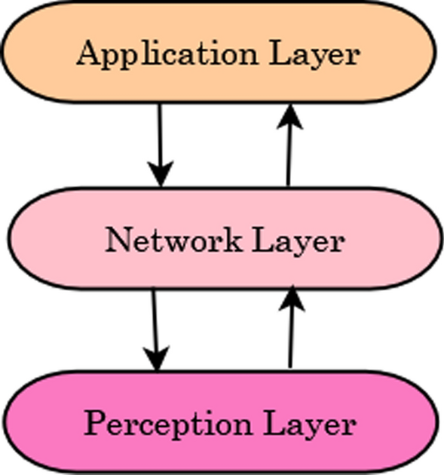
Figure 1: Three-Layer Approach (Choudhary, 2024)
IoT systems are structured using layered architecture models, which help to organise complex systems down into more manageable components. Usually, a three-layer approach is used, shown in the figure above, being commonly utilised due to its clarity and simplicity. However, four-layer and five-layer approaches may also be used. The three-layer approach divides an IoT system into the perception layer, network layer, and application layer, shown in the table below.
Table 1: Three-Layer Implementation
Layer | Potential Technologies | Role in System
Perception | Environmental Sensors | Environment Sensing
Network | MQTT / HTTP | Data Transportation
Application | Dashboards and UI | User Interaction

As shown in the table above, the perception layer is responsible for object recognition, data sensing, and acquisition. It consists of physical objects such as sensors and embedded devices that interact directly with the environment (Nasiri et al., 2021). When used for plant monitoring, this layer includes objects such as soil moisture sensors, temperature sensors, humidity sensors, and light sensors that capture the environmental conditions that may affect the health of the plant.
The network layer facilitates communication between the devices and backend systems. This layer transmits sensor data to cloud services, servers, etc. Devices may connect directly to the cloud or communicate via gateway devices, depending on the system design and constraints (Ali et al., 2022). This layer allows flexibility in how data is transmitted and processed by incorporating various communication and protocol technologies, such as Wi-Fi, MQTT, or HTTP.
The application layer is the top layer of the three-layer model and is the point at which users interact with the system. It provides software services and interfaces designed for specific use cases, such as mobile applications or web dashboards (Sha et al., 2018). For example, in a smart home, a user may interact with an interface to switch on a coffee machine (Vijay et al., 2024). Within a plant monitoring system, this layer would be responsible for allowing a user to view sensor readings or receive recommendations, such as when watering is required.
When used in plant monitoring systems, this model is useful as it allows for hardware components to be modified and upgraded independently of the software interfaces. Dhaka et al. (2023) found that IoT architecture models are key in agriculture, as they solve common challenges in smart farming such as the early classification, detection and visualisation of diseases effecting plants.

Circuit Components and Design

Environmental Sensing in IoT Systems
Environmental sensing enables devices to monitor and respond to physical conditions around them in real-time. In the context of IoT for plant monitoring, environmental sensing refers to the use of sensors to collect data about the surrounding conditions such as temperature, humidity, soil moisture and light. Environmental sensing takes place during the perception layer of the three-layer model which is discussed in Section 2.3.
Particularly relevant to the topic of plant care, soil moisture sensors allow for precise measurements of water content in soil to be taken. By providing accurate real-time readings, these sensors support optimised irrigation strategies based on the actual conditions around plants and help prevent over-irrigation and under-watering (Loconsole et al., 2025).
The importance of environmental sensing is found in its ability to conduct real-time monitoring and early detection of issues, this allows systems to identify changes in environmental conditions as they occur, rather than relying on manual observation. For example, a sudden drop in soil moisture can trigger alerts before visible signs of damage to the plant can be seen, allowing for interventions to be made quickly. This is important both in agriculture and in domestic plant care.
However, sensor accuracy and reliability can face challenges in environmental sensing. Sensors often require calibration to ensure accurate measurements, as they may experience sensor drift, in which readings gradually become less accurate over time. The sensors can also be impacted by the environment around them. For example, Qi et al. (2024) found that environmental factors such as high salinity in soil can significantly impact sensor accuracy, with some soil moisture sensors overestimating water content when under high salinity conditions. Additional challenges include noisy data, interoperability issues, and adoption barriers, where there may be factors slowing down the integration of sensor-based technologies in some fields of work and smart home systems (Aarif K. O., Alam and Hotak, 2025).
Environmental sensing can additionally play a role in addressing global challenges such as climate change, land degradation, and limited natural resources. IoT based systems can improve productivity and resource efficiency to improve the ability of agriculture to meet global food demands (Dhal et al., 2024). Moreover, IoT based environmental sensing can offer a cost-effective way of collecting real-time soil and crop data to help improve productive and support more informed agriculture practices in smaller scaled farms which may face challenges such as limited resources and a lack of real-time reliable data (Bayih et al., 2022).
While larger scale agriculture systems focus on optimisation of yield and resource management, home plant monitoring systems prioritise the affordability and usability of the system. This difference shows the importance of adapting environmental sensing to the specific context in which they are used.

Microcontrollers and Communication
Microcontrollers act as the core processing unit that collect data from sensors, process data and manage communication between hardware components and network services in IoT systems.
Two of the most used microcontrollers in IoT applications are the Raspberry Pi and Arduino. The Raspberry Pi is a single-board computer that has high processing power and flexible connection options. Arduinos are microcontroller-based boards designed for simpler systems where ease of use is a priority, and they often have lower power consumption. A study by Wan et al. (2022) had success using the Raspberry Pi to create an aquaponics monitoring system. This shows that the Raspberry Pi can be used to monitor plants. They additionally used the ESP8266 module in the network layer, explained in Section 2.3. for Wi-Fi wireless connection. There has also been success with aquaponics monitoring using an Arduino. The system created using an Arduino used sensors to gather the pH content, temperature and oxygen saturation of the water (Mandap et al., 2018).
While Arduino systems are a standard for IoT systems due to their energy efficiency, low cost, and simple programming, the ESP32 is also useful for IoT systems. The differences between an Arduino system, specifically the Arduino Uno, and the ESP32 are shown in Table 2 below.
Table 2: Microcontroller Comparison
Feature | Arduino Uno | ESP32
Connectivity | Requires additional hardware | Built-in Wi-Fi
Memory | 32 KB | 520 KB
Voltage | 5V | 3.3V

As shown in the table above, the ESP32 has built-in Wi-Fi, which is useful for IoT based systems as it allows for a reduction in bulk and cost that would come with requiring an additional piece of hardware if you were working with an Arduino Uno.
Wireless communication methods are also a key factor to consider in IoT systems. Common communication methods include Wi-Fi, BLE, and LoRa. Wi-Fi has fast data speeds but consumes a high amount of power. BLE consumes a low amount of power but can only be used for short distances. Simo et al. (2023) conducted a study on IoT-driven greenhouse monitoring systems. They used LoraWAN because it has long-range, low-power communication.
Current research in Smart Agriculture and IoT has a focus on integrating networks of wireless sensors to optimise plant growth and improve resource management. According to a paper by Coelho et al., (2020), the most cost-effective soil moisture monitors and atmospheric sensors include the DHT11 and FC-28. Research additionally suggests that capacitive sensors can be better for long term monitoring than resistive models due to them being less prone to oxidation.

UX Design in IoT systems
UX technologies are the primary interface between complex technical processes and end users in IoT systems. IoT applications must present real-time data from physical environments in a way that is understandable, actionable and reliable. Poor UX design can reduce users adopting a system, even when the technology functions correctly (Romero-Riaño et al., 2022).
IoT systems introduce unique challenges for UX. One issue is the large amount of environmental data that sensors generate. Without considering the design carefully, users may struggle to interpret large amounts of data. Using existing IoT platforms such as Adafruit IO are a valuable alternative to creating an interface from scratch and serve as an efficient way for users to view data.

Related Work
Previous research into IoT-based plant monitoring has established a standard framework for data collection and observation. Studies consistently highlight a three-layer architectural mode, consisting of the perception, network, and application layers (Xu, Gu and Tian, 2022). Within this framework, studies focus mainly on the practicality of using lower cost microcontrollers, such as Arduinos, to connect to atmospheric sensors such as the DHT11, used for measuring temperature and humidity, and soil moisture sensors (Narayana et al., 2024)
The methods for communicating data to the user has also been explored extensively. Previous work has demonstrated the success of integrating systems utilising ESP8266 as the microcontroller, with cloud platforms such as Blynk to provide mobile notifications (Ayeni and Adesoba, 2025). Studies such as these have found that providing users with real-time alerts regarding soil moisture levels can lead to improvements in resource management and water conservation in domestic settings (Et-taibi et al., 2024).

Research Gap
One gap in existing literature is a lack of translating quantitative data into qualitative insights that are understandable by the user. While current research provides many methods of data collection, many systems rely heavily on raw numerical data which can be difficult for regular users to interpret. Therefore, this project will aim to implement logic in the software that allows for more user-friendly feedback of the sensor data.
Additionally, much of the current literature focuses on industrial or larger scale agricultural environments, so the research into domestic environments is lacking. This is particularly noticeable when it comes to power optimisation for smaller scale systems that must operate for long periods of time without using too much power. This project will explore methods to balance the power costs of real-time sensor data with lower power consumption strategies to ensure for a more practical system for a domestic home.
Furthermore, most current studies utilise and investigate mainly lux values when it comes to light measurements. Agricultural research suggests that different colour light factors into different types of growth in a plant. Blue light helps in root growth while red light aids in leaf growth and flowering. It is therefore important that users do not only understand the clear light quality but are also kept informed of the specific colour values.

Conclusion
In summary, this literature review shows that IoT technology is reliable and effective when utilised in both industrial and domestic plant care. By using a three-layer architecture, research has allowed for microcontrollers to be successfully integrated alongside sensors to monitor environmental conditions in real-time. However, while hardware such as Arduino and ESP allow for cost-effective data collection, a lot of the existing work and research is heavily focused on larger scale industrial agriculture which uses raw data, as opposed to systems designed for a domestic environment.

RESEARCH METHODS

Preamble
This section serves to outline the research and development strategies that are used for this project and explores the purpose and reasoning behind the selected methodologies and frameworks. The aim of this section is to demonstrate how practical techniques were used to research, design, implement and evaluate the proposed, using structured approaches to do so.

Research Methodology
Saunders’ Research Onion Framework, shown in the figure below, was used as a model to guide the structure of the research design. It shows all the significant issues that need to be taken into consideration during any research project. This framework describes research across several layers, including the researcher’s philosophical position, the approach, strategies, choices, and method of data collection (Alturki, 2021).
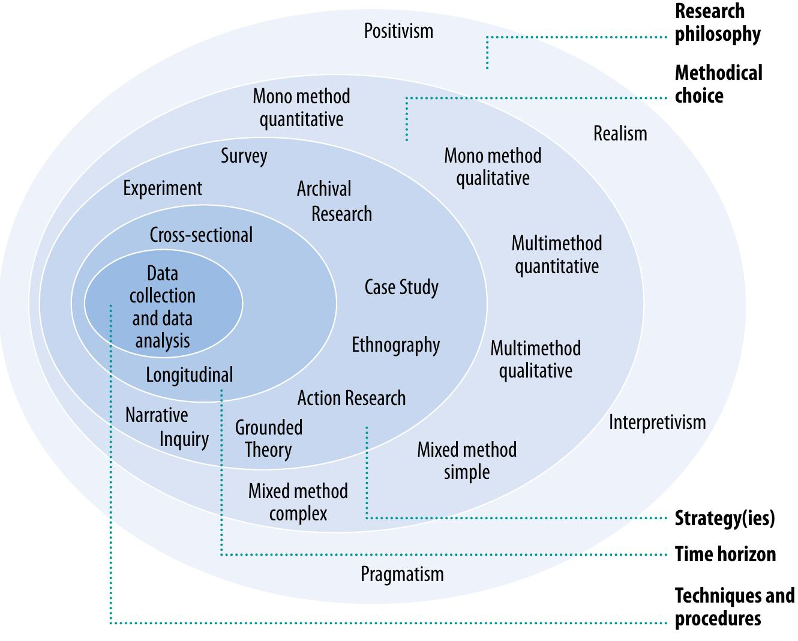
Figure 2: Saunders' Research Onion Framework (Saunders, 2012)
As shown in the figure above, some parts of the research onion include the research philosophy, approach, strategy, and time horizon. These will be investigated in the next sections.

Research Philosophy
Research philosophy is a term that describes the system of beliefs and assumptions that a researcher holds that will guide the development of knowledge in a research context (Saunders, M. N. K., Lewis, P., Thornhill, 2023). The research philosophy shows how the researcher views the topic and contains the assumptions that will be used to progress their work (Alturki, 2021).
This projects system relies on environmental sensor data, which can be objectively recorded and analysed. The effectiveness of the system is evaluated using quantitative measurements such as accuracy, response time, and reliability. Therefore, this project utilises a positivist approach, which states that valid knowledge is found only through objective observation, measurement, and scientific methods (Park, Konge and Artino, 2020).

Research Approach
A deductive approach has been used for this project, as it builds upon existing literature on the topic of IoT systems, environmental sensing, microcontrollers and plant monitoring technologies. Established theories and principles are used to inform the design of the system, which is then implemented and tested to evaluate whether it meets set objectives and success criteria.

Research Strategy
The research strategy used is design science research combined with experimental evaluation. The project involves designing and constructing an artefact and evaluating its performance under controlled conditions. This strategy works well for computing projects where the primary goal is a developed system rather than theoretical knowledge.

Time Horizon
The research follows a cross-sectional time horizon, as the system is developed and evaluated within the fixed timeframe of the academic year rather than observed over multiple years.

Project Management Methodology
Agile principles were used to develop the project, allowing for an iterative and incremental approach to development. The agile methodology, shown in the figure below, was selected as within the development of this system, the selection of hardware, software development, system testing etc often inform and rely on one another, and revisiting a previous stage of development may be required for the health of the project.
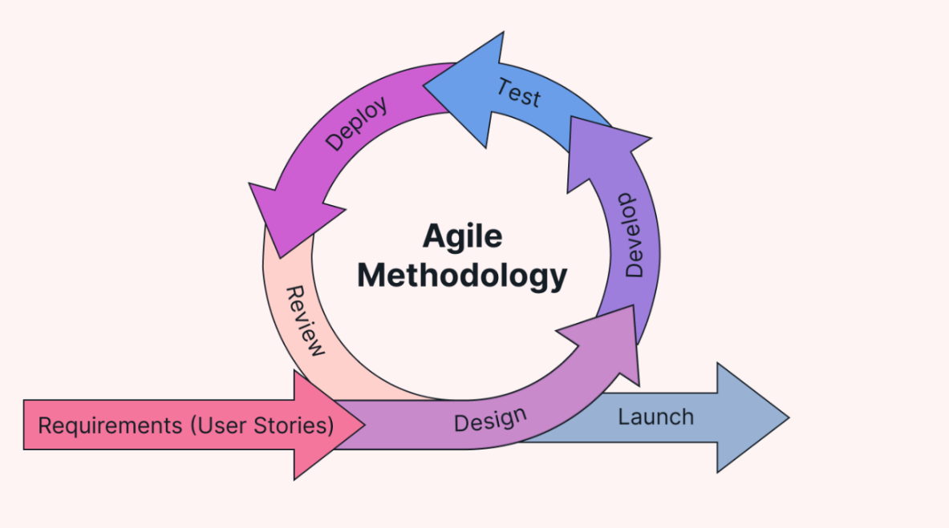
Figure 3: Agile Methodology (Chukwuebuka, 2024)
The agile methodology shown in the figure above allows for continuous testing and refinement throughout the project’s lifespan, as well as allowing for easier adaptation to resource constraints or challenges that may come up unexpectantly. This approach is particularly suitable for IoT systems, as it allows for the hardware and software components to be adjusted iteratively and separately.

Data Collection and Evaluation
This project primarily utilised quantitative data collection methods, as the system performance is evaluated using environmental readings and metrics that yield very limited qualitative data. Additionally, as this project utilised a prototype which cannot presently be mass produced, generating qualitative results from feedback from users is made difficult.

DESIGN AND IMPLEMENTATION OF ARTEFACT

System Overview
The proposed system is an IoT based plant monitoring prototype that has an architecture which senses, processes and then outputs. This allows for the system to track soil moisture, temperature, humidity and light intensity in real time.
The figure below shows a block diagram of the data flow of the proposed system. It illustrates the input layer, processing layer and output layer, where data is gathered by the sensors, transmitted into the microcontroller for processing, and then output to the UI.
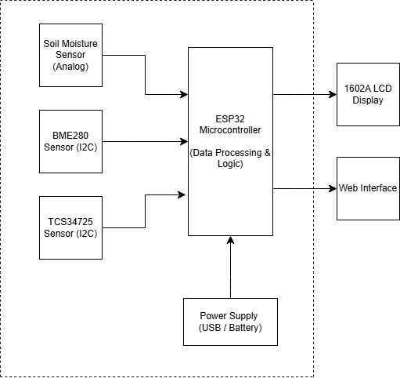
Figure 4: System Block Diagram
The figure above shows how raw data is collected by sensors and then evaluated and utilised by the microcontroller to deliver meaningful feedback through UI for users. This diagram aids in demonstrating how the hardware and software is structured. The reasonings behind the hardware selection and layout will be discussed in the next section.

Hardware Design

Microcontroller Selection
The microcontroller serves as the CPU of the plant monitoring system, responsible for collecting data, processing the readings and transmitting it. When designing the circuit, several microcontrollers were considered, including the Arduino Uno R4 WiFi, the Arduino Mega 2560 and the ESP32 development board.
The ESP32 has many ADC pins, which allow the microcontroller to read analogue sensor data such as the soil moisture levels. Additionally, the board is designed with low power consumption in mind, which is important for IoT devices such as the plant monitoring system, as they need to be efficient and able to run for extended periods of time. As well as this, the ESP32 has built-in WiFi and Bluetooth, which increases its suitability for IoT systems. It is for these reasons that the ESP32 was determined to be the most suitable board to use to implement the proposed system.

Sensor Selection and Integration

Soil Moisture Sensor
To understand the sensor sensitivity and ensure we are using the correct data within the coding; tests were conducted using this sensor to determine what the base readings are. This allowed for the conditions which the system should report that the plant is overwatered or underwatered to be determined. The table below shows the readings from the sensor when tested in different environments.
Table 3: Soil Moisture Readings
Condition | Sensor Reading
Air | 3317
Fresh soil | 3088
Dry soil | 3137
Freshly watered | 2465
Overly Wet soil | 1163
Water | 1213

The raw data in the table above aids in determining the thresholds to be used later in the software components. As the system utilises a capacitive moisture sensor, this raw data is the measurement of the changes in dielectric permittivity of the soil around the sensor (Baghdadi et al., 2025). This means that as the water content in the soil is increased, the electrical signal of the sensor changed. This was then converted into an analog voltage and read by the ESP32. From these readings, we can determine that the soil should be registered as dry when at a value at 3000 or higher, and as too wet when registered at a value of 2000 or lower.

Temperature and Humidity Sensor
The BME280 temperature and humidity sensor was selected as it is a cost-effective multi-purpose sensor that fulfils all the needs of this project. This sensor utilises the I2C communication protocol, which allows for simplified connection with the ESP32.
The thresholds for these variables were based upon pre-existing botanical research for common house plants including but not limited to: Spathiphyllum, Monstera deliciosa, Epipremnum aureum and a variety of orchids. For this project it was determined that to be in a healthy range, temperature must be between 15 and 30 degrees Celsius while humidity must be between 35% and 60%.

RGB Colour Sensor
The TCS24725 was integrated into the circuit to monitor the ambient light conditions and colour temperature of the environment. The TCS24725 contains a 3 x 4 photodiode array categorised into four channels: Red, Green, Blue, and Clear. The clear values are used to create a measurement of the light, measured in lux, around the plant. This sensor was selected for its ability to detect Red and Blue light, as these are important for determining whether the plant is receiving the optimum colour of light. The threshold for low light was determined to be under 500 lux based upon the light requirements of a spathiphyllum.

LCD Screen
A 16-pin 1602A Parallel LCD was implemented into the system to allow for the option to read data as part of the circuit itself rather than having the only access be online. This allows for the system to still be utilised even when WiFi is not available. The choice of screen was made based on the parts available at the time, and a 10k 0hm potentiometer was integrated into the circuit to allow for manual contrast adjustment, ensuring the interface is legible.

Circuit Design
The circuit was designed utilising breadboards as a system for prototyping, allowing for easy changes to be made. After multiple iterations, the final pin assignments were decided, as shown in the table below.
Table 4: Pin Assignment Table
Component | Device Pin | ESP32 Pin | Function
Soil Sensor | Signal (AOUT) | D34 | Analog Input
BME280 | SDA | D21 | Data
BME280 | SCL | D22 | Clock
TCS34725 | SDA | D21 | Data
TCS34725 | SCL | D22 | Clock
TCS34725 | LED | D4 | Light Control
1602A LCD | 4 (RS) | D13 | Register Select
1602A LCD | 6 (E) | D12 | Enables Signal
1602A LCD | 11 (D4) | D14 | Data
1602A LCD | 12 (D5) | D27 | Data
1602A LCD | 13 (D6) | D26 | Data
1602A LCD | 14 (D7) | D25 | Data
1602A LCD | 3 (V0) | Pot. Centre | Contrast Control
Potentiometer | Outer Pins | VIN / GND | Power Supply
Power (5V) | VCC / VIN | VIN (5V) | Power for Screen
Power (3V3) | VCC / 3V3 | 3V3 | Power for Sensors
Ground Rail | GND | GND | Common Ground (All Components)

As shown in the table above, the BME280 and TCS34725 sensors share the GPIO 21 and 22 pins to minimise the wiring complexity. The soil moisture sensor uses the ADC on GPIO 34 for accurate moisture readings.
The figure below shows how the circuit was physically connected based upon the pin assignment table.
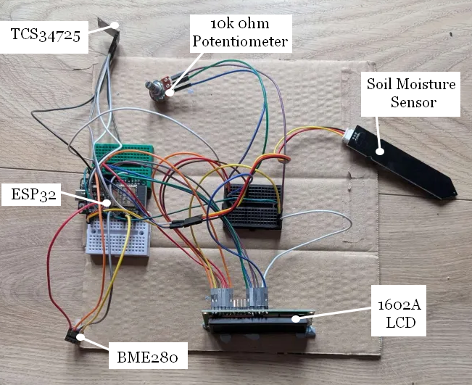
Figure 5: Prototype Circuit
The figure above uses breadboards to quickly and easily connect the wiring of the sensors. This prototype was utilised to lay out all hardware in an easy to modify way so that software implementation could begin.
As shown in Figure 6 below, a simple shell container was modelled in fusion 360 to contain the circuit. This change was made for the purpose of easier transport, protection of the circuit, and more efficient testing.
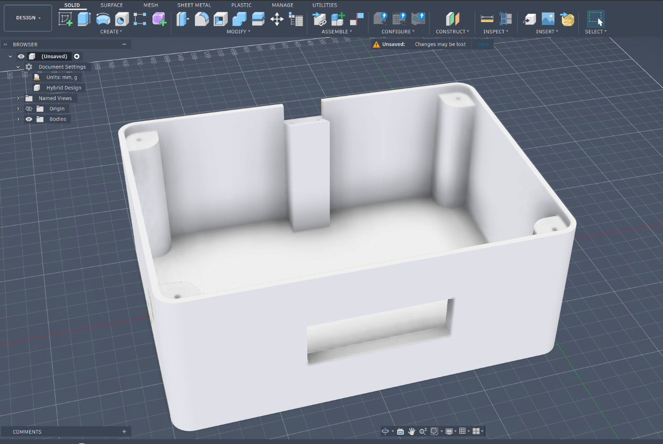
Figure 6: Case model in Fusion 360
As shown in the figure above, the case was modelled with considerations made to the circuit’s components. The LCD screen was measured, and the measurements were utilised to create a gap in the shell where the readings can be read from. Additionally, a platform was added for the TCS24725 top ensure light could reach it, and a small hole was created in the side for the BME280 to be exposed to the air to accurately read temperature and humidity.
This model was then printed on the Anycubic Kobra 3 with holes included to appropriately attach the circuit components with screws to the container. The completed printed model with the circuit attached within is shown below in Figure 7.
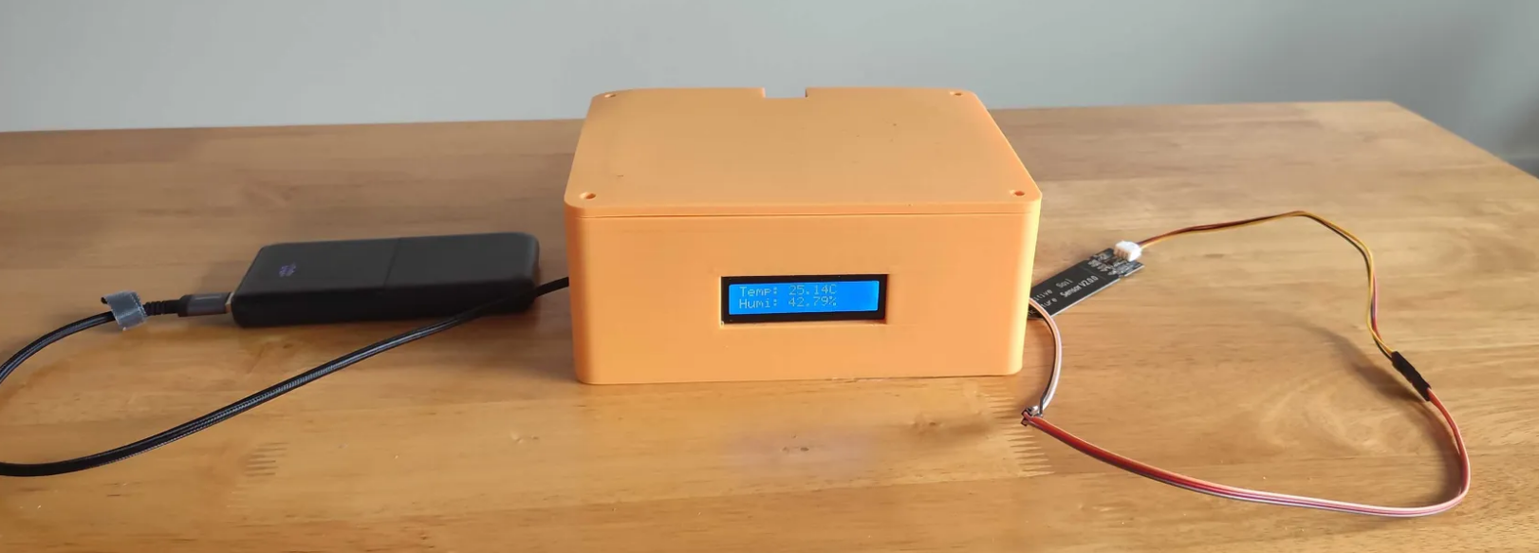
Figure 7: Complete Physical Artefact
As shown in the figure above, a power bank was attached to the circuit using a USB-A cable. The circuit additionally has the capabilities to be connected to a permanent power source, however, the choice was made to utilise a power bank due to the portability and convenience that it brought to testing.

Software Implementation

Acquisition of Sensor Data
The software for this system was developed using the Arduino IDE version 2.3.7. Several libraries were utilised to ensure full functionality with the previously specified sensors and other hardware. These libraries can be seen in Figure 8 below.
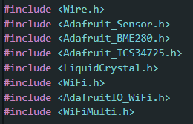
Figure 8: Code Libraries
As shown in the figure above, there were multiple open-source libraries available for the specific sensors used for this project. For example, the Adafruit_TCS34725 allowed for easier integration of the sensor, as it allowed for the raw data from the TCS34725 sensor to be translated into usable RGB values.
The capacitive soil sensor, as well as the LED for the TCS34725, required the pin of which they were connected to on the ESP32 to be stated in the software. This is shown in the figure below.
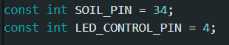
Figure 9: Soil and LED Pin References
The constants created in the figure above are utilised throughout the code, such as in Figure 10 below where the software was altered to include logic to turn off the LED on the sensor, due to an issue found in initial implementation where the LED present on the TCS34725 sensor interfered with light readings. This lead to inaccurate readings of environmental light until it was fixed.
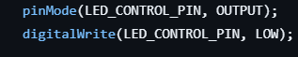
Figure 10: TCS34725 LED Control
In Figure 10 above, the system is told to send a low signal to the pin which the LED is connected to. In this case, the LED control pin was designated as GPIO 4.
To ensure the ESP32 can receive data from and transmit data to the hardware, all of the sensors and the LCD must be defined at the top of the code before anything else is run. Figure 11 below shows the pin assignment block and the configuration for the main components, configured before the setup or loop so that they can be used globally.
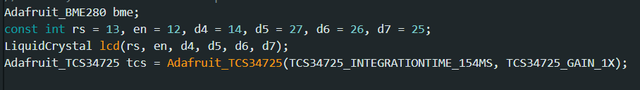
Figure 11: Hardware Configuration and Pin Assignment
As shown in the figure above, the configuration creates an instance of the BME280 sensor called bme, which is then utilised later in the code. Additionally, a row of constant integers are used to instruct the software on which pins are connected to the LCD screen. These pins are passed into the LiquidCrystal function which serves to initialise the physical LCD display. Furthermore, the TCS34725 colour sensor is initialised as tcs using the Adafruit_TCS34725 library in order to set specific hardware parameters including setting a 1x gain to ensure the readings do not overload the sensor.
Within the setup of the software, the system needs to ensure that the sensors are functioning properly. The figure below shows the initialisation and error checking for the humidity and temperature sensor as well as the light sensor.
Figure 12: BME280 and TCS34725 initialisation and error validation
Shown in Figure 12 above, the code uses if statements to first check if the hardware is connected and online. The first line checks the most common addresses the BME280 connection can be found at, and outputs an error if it cannot locate the sensor at either address. The second line checks if it can find the TCS34725 and outputs an error message to the serial monitor if it cannot be found. This logic is included within the prototype to ensure that troubleshooting goes seamlessly.
Figure 13 below is within the void loop of the software, this is the part of the code that retrieves the data from the sensors in real-time.
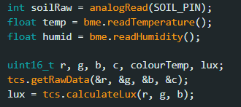
Figure 13: Data Acquisition Loop
In the figure above, the raw soil moisture data is read and saved temporarily as an integer. The humidity and temperature from the BME280 are read and saved as floats due to decimals holding value in these measurements. In the fifth line, variables are created to hold the values required for processing the data from the TCS34725. In the next line, the raw values of the red, green, blue and clear light gathered from the TCS34725 sensor are saved into some of these variables. The final line utilises the calculateLux function to transform the raw sensor numbers into a singular Lux value, which is more readily usable as a measurement for light in plant health systems. These values are defined every loop and can then be used for data processing, which is discussed in the next section.

Data Processing
To transform the raw sensor data into usable information for the user, a processing layer was implemented. Shown in the figure below, thresholds were established in the software to categorise different states. For example, the raw ADC values of the soil moisture sensor were converted using a threshold of values higher than 3000 being classified as ‘too dry’ while values lower than 2000 were classified as ‘too wet’.
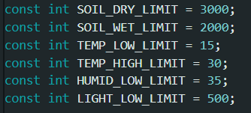
Figure 14: Threshold Limits
Shown in Figure 14 above, the threshold constants allowed for decision making logic to be implemented more easily throughout the system. By defining these at the beginning of the code, it allows for easy alteration if later testing determines that the thresholds were miscalculated.
The figure below shows the logic for determining the messages provided for different values received for soil moisture, temperature, and humidity.
Figure 15: Status Messages Logic
In Figure 15 above, the software utilises the thresholds previously discussed from Figure 14 to translate the raw data into usable feedback. The code checks the current readings against the thresholds and saves the current state as a string of text such as “too dry” or “too wet” for the soil moisture sensor.
Figure 16 below shows the logic for analysing the colour quality of light read by the TCS34725 and determining the appropriate messages based upon this analysis to be later utilised as feedback.
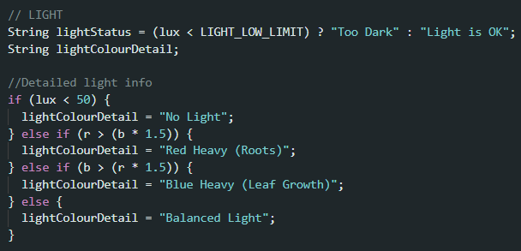
Figure 16: Light Analysis Logic
As shown in the figure above, the software first does a general check on whether the lux value surpasses the threshold for what is considered good light in this system. It then works through the logic of comparing the ratio of red to blue light. The system checks whether either red or blue light is 1.5 times stronger than the other, to identify whether there is red heavy light, blue heavy light, or balanced light. This is important in a plant health system as depending on the quality of the light, different areas of the plant are developed. Knowing which colour is more prominent around the plant can aid users in determining whether they may need to move to an alternative light source depending on what type of growth they are looking for.

Communication Layer
The communication layer within the program was designed to transport the acquired and processed data to the cloud. To ensure the system had as many ways to connect as possible, the WiFiMulti library was utilised, as shown in Figure 17 below. This allowed for the ESP32 to store multiple WiFi credentials and routes in order to automatically connect to the strongest available network.
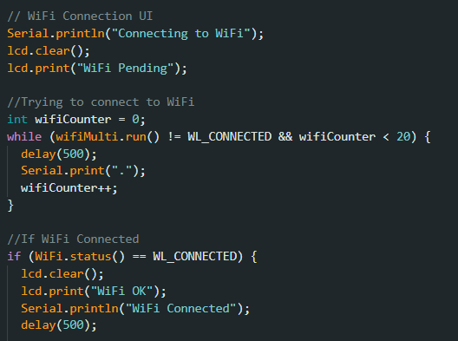
Figure 17: WiFi Connection
As shown in Figure 17 above, the ESP32 would attempt to establish a connection for 10 seconds, before moving on. This ensures that the program does not get stuck attempting to connect to WiFi and the LCD display remains functional even when no internet is accessible. Once the connection to the network was established and provably functional, the system was then programmed to connect to Adafruit IO using the AdafruitIO_WiFi library.

UI
The UI was split into three components: Serial monitor output in the Arduino IDE, local feedback on an LCD screen, and remote notifications on Adafruit IO.
The serial monitor was set to output raw data for testing and comparison purposes, allowing for checks to be done to ensure no data was lost or changed during transmission. The figure below shows how the data is output to the serial monitor.
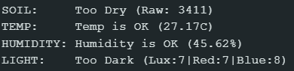
Figure 18: Serial Monitor Output
Figure 18 above is useful as it allows for all data, both the actionable feedback as well as the raw data, to be seen. The serial monitor is only viewable when the system is connected to a system running the Arduino IDE, so it exists purely for debugging, testing, and prototyping purposes.

For local display, the system used a 16x2 LCD, where the screen cleared and updated every five seconds to rotate through data including soil moisture, temperature, humidity and light. This is shown in Figure 19 below.
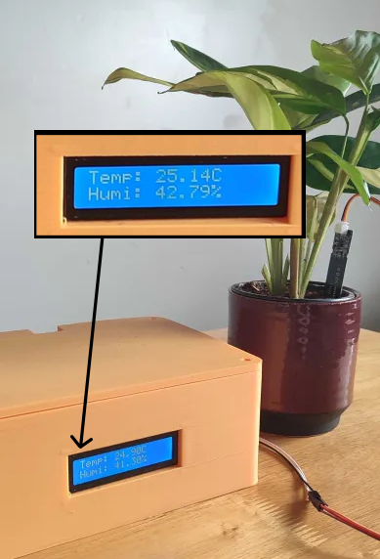
Figure 19: LCD UI
Figure 19 above shows the completed system monitoring the environmental variables of a plant. Because of the small screen size, this UI has less actionable feedback than the cloud. However, it is still usable as a method of viewing the data quickly if you need to check your plant.
The LCD screen switches between a screen showing the temperature and humidity to a screen showing the soil moisture and light intensity. The software required to perform this is shown in the figure below.
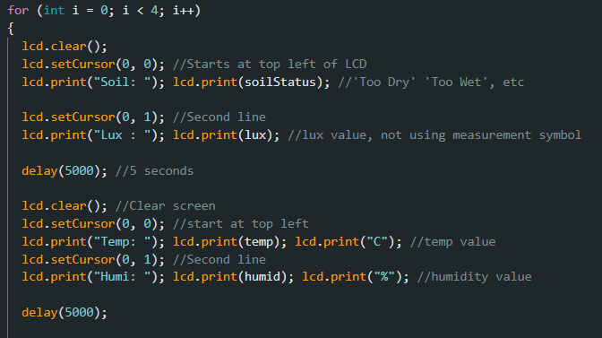
Figure 20: LCD Display Rotation Logic
As shown in Figure 20 above, the for loop is set to run four times. Each rotation of the system takes 10 seconds, which ensures that 40 seconds pass before the code attempts to move on to a new loop of the system. This is important as the system was designed using the Adafruit IO Free Tier which prevents users from sending data too frequently or else limits are put on the users’ account. By implementing a looping system on the LCD screen, it allows users to continue to view data on the physical device with no stalling even if the data is only transmitted online every 40 seconds. Further details on Adafruit IO are discussed in the next section.

Adafruit IO
The remote UI was managed through the Adafruit IO Dashboard, whereby data was transferred from the ESP32 directly to the platform, allowing for data feeds to be viewed from other devices no matter where you were.
To connect the hardware to the Adafruit Dashboard online, the system must authenticate with the Adafruit servers during the setup phase of the software. The code shown in Figure 21 below initialises the connection between the ESP32 and the cloud.
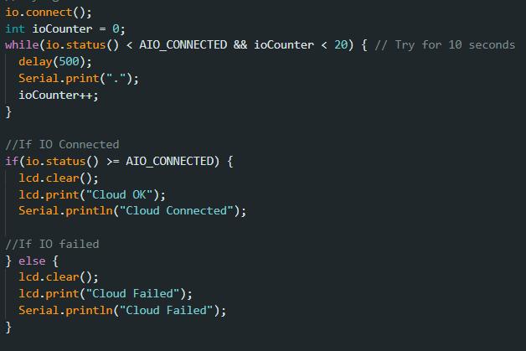
Figure 21: Adafruit IO Connection Logic
In the figure above, a while loop is used to attempt connection to the Adafruit servers for a maximum of 10 seconds. This limit prevents the system from getting stuck if an error occurs that prevents connection. Additionally, the code above serves to give immediate feedback to the user on the status of the system, returning a message of “Cloud OK” or “Cloud Failed” to the LCD, allowing for easier troubleshooting.
Once the connection is active, the system then has to transport the raw data to the cloud correctly. The figure below shows how the software prepares the data for transmission and transfers the feeds to the Adafruit Dashboard.
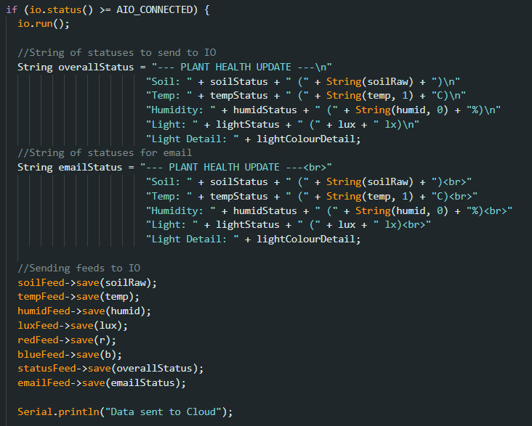
Figure 22: Feed Transmission to Cloud
In Figure 22 above, the data is sent over several feeds to Adafruit IO. Two separate status updates are created, one of which is formatted for use in the Adafruit Dashboard while the other is formatted to be used for email alerts.
Since internet connections can be unreliable and can temporarily drop, the system required a way to reconnect and fix itself if it lost connection to WiFi or the cloud. The figure below shows the logic used to attempt reconnection.
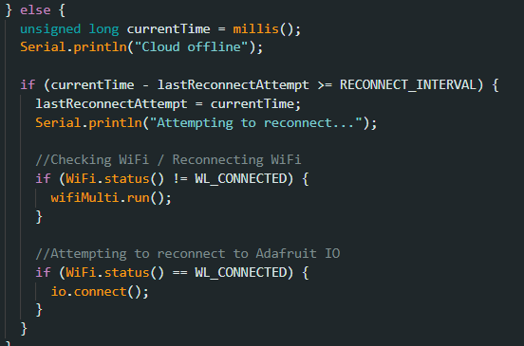
Figure 23: Reconnection Logic
In the figure above, the code utilises the millis() function to check the time since the last connection attempt. This ensures that the system does not get stuck attempting to reconnect and is still able to continue displaying feedback through the serial monitor and LCD even if the cloud is struggling to reconnect.
Figure 24 below shows the final layout of the Adafruit IO Dashboard created to act as a visual interface for the data to be displayed on and read from.
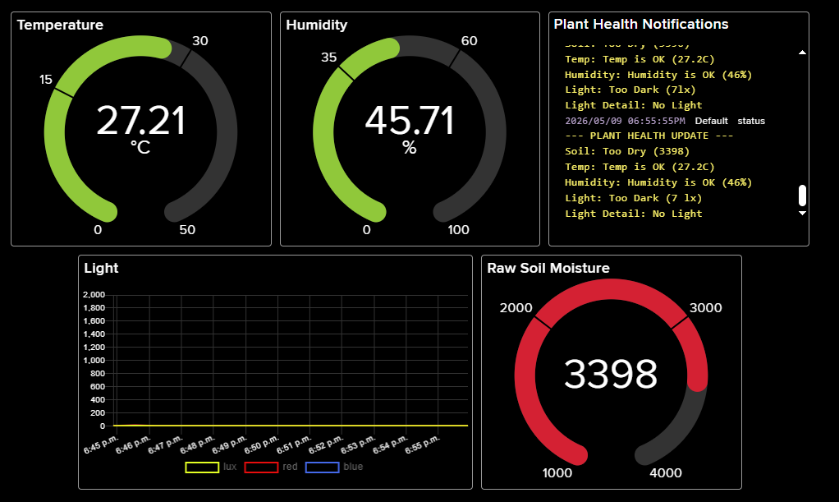
Figure 24: Adafruit IO Dashboard
The dashboard shown in the figure above functions as a quick overview of a plant’s health. It uses gauges for environmental factors that need immediate attention, such as temperature and soil moisture, and a line chart to track how the light levels change throughout the day. The “Plant Health Notifications” block shows the most recent summary of all sensor data, including the worded feedback not just the raw data.
The data feeds were additionally linked to a system that allowed for automated email notifications to be sent out whenever a threshold was passed. For example, when the soil moisture lowered past its threshold, a “soil too dry” message would be sent. The figure below shows the backend logic of how this action is created in Adafruit.
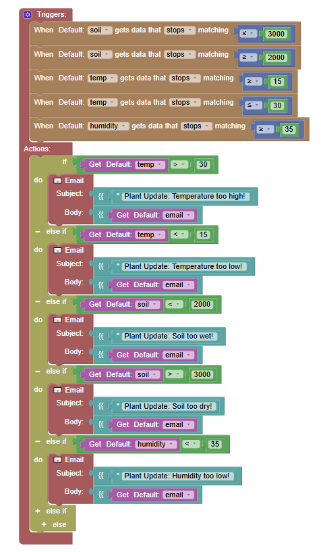
Figure 25: Automated Email Alert Logic
As shown in Figure 25 above, the logic is set to only react and send out an email when data stops matching a specific value. Using this setting instead of simply sending an email every time the value equals anything past a threshold helps to avoid email spam. The system will send one email when the soil gets too wet but will not send another until an unrelated issue occurs or the problem has been fixed only to occur again. This helps to avoid users developing alert fatigue.
An example of the email sent out when the plant requires attention is shown in Figure 26 below.
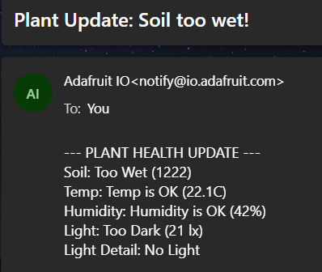
Figure 26: Example Email Alert
The figure above shows how the HTML formatted code input shown previously in Figure 22 translates into a real email. The subject email serves as the main alert while the main text gives the full plant health update. This gives the user all of the context to solve the issue.

Design Decisions
Throughout the design and development of the prototype, many decisions were made to ensure that the project was both possible to complete with the time and resources available, as well as reliable and functional.
To begin with, the microcontroller selection involved the choice between the ESP32 and Arduino Uno. The ESP32 was chosen over the Arduino UNO due to its built-in Wi-Fi capabilities and higher clock speed which fit the project goals of creating a real-time system capable of processing sensor data quickly and transporting it to the cloud with as little bulk as possible.
When investigating sensor choices, a capacitive soil moisture sensor was selected over a resistive sensor due to capacitive soil moisture sensors being less prone to corrosion than their resistive counterparts. This meant the soil moisture sensor was more reliable and ensured more accurate readings.
The choice of using Adafruit IO rather than designing and developing a UI was made based on the considerations of the project’s timeframe. It was unlikely that a usable UI would have been able to be developed without it taking away a significant amount of the focus from the hardware. The choice was therefore made to focus on the hardware logic and data processing and utilise a premade microcontroller dashboard for the prototype.

TESTING AND VALIDATION OF ARTEFACT
To assess the effectiveness of the prototype and ensure that it is functioning as intended in real world conditions, a testing phase was required.
The table below shows a summary of the test cases conducted during the testing period.
Table 5: Test Cases
Test ID | Objective | Steps | Expected Result | Actual Result | Status
T1 | System Stability | Run system for 72 consecutive hours | Consistent uptime with no software crashes | Initially crashed at 6 hours  72 hours reached after code fixes | Pass
T2 | Soil Moisture Accuracy | Gradually add 10ml water to dry soil | Raw soil moisture readings decrease with added moisture and system does not display “Too Wet” | System initially displayed “Too Wet”  After altering thresholds, readings decreased with added moisture and returned “Soil OK” successfully | Pass
T3 | Light Colour Accuracy | Compare light quality of phone flashlight, window, and grow light | System identifies differences in blue, red, and balanced light | System identified differences in blue, red, and balanced light across different light sources. | Pass
T4 | Alert Latency | Time email arrive after moisture sensor submerged in water | Email received within 120 seconds | Average response time of 58 seconds | Pass
T5 | Environmental Reactiveness | Measure soil moisture of three containers in different environments | Higher heat and sun levels leads to accelerated moisture loss | Warm and sunny environments resulted in higher moisture difference | Pass

As shown in Table 5 above, the system successfully passed all tests. While some issues occurred in testing, these issues were resolved and allowed for improvements to be made to the software.
The individual tests discussed in Table 5 are investigated further in Section 5.1 below.

Test Results
This section will investigate the tests shown in Table 5. They will go through how they were conducted, the results of the tests, and how improvements and observations were made based on the results.

Test Case T1: System Stability
The purpose of this test is to validate the reliability of the hardware and network connection when the system is up for an extended period of time.
In initial testing, the system was powered with a portable charger and left to transmit data to the cloud at an interval of 45 seconds per transmission. The system was set up at approximately 10:30pm, and experienced failure at 6:34am as shown in the figure below.
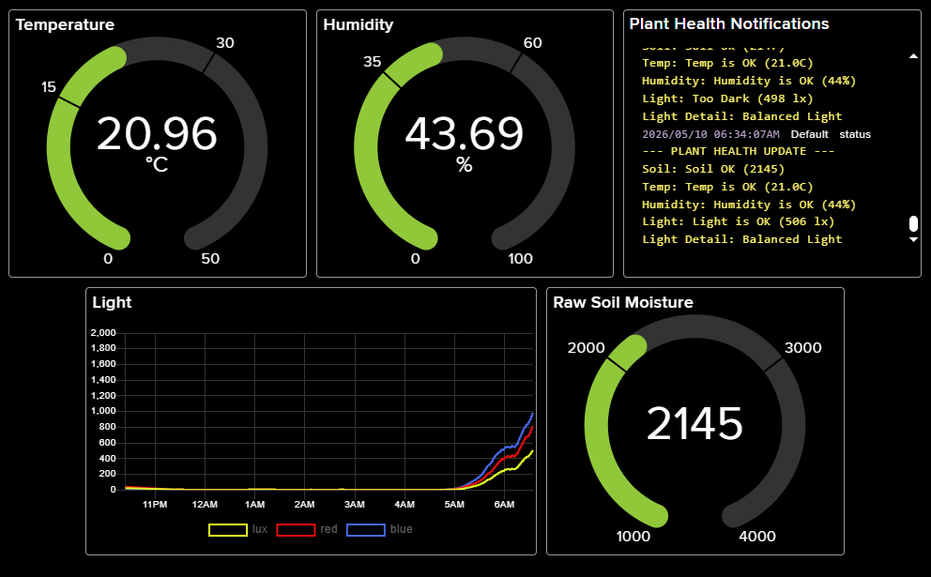
Figure 27: Dashboard displaying error
In addition to the lack of data transmission displayed above in Figure 27, the physical system had encountered an error and could no longer update, displaying only the temperature and humidity screen with the same values no matter how much time elapsed.
After the first test iteration, the code was altered to reduce the number of for and while loops, instead switching to a system of utilising the millis function to appropriately time cloud synchronisation and LCD screen switches. Additionally, the reconnection logic was moved within the main Adafruit IO connection logic. The improved code was uploaded to the physical system and then placed on a windowsill at 11:00am plugged into a wall socket for more reliable power. The system was then left to run for over 72 hours, with the results of the light values from the first day of running shown in the figure below.
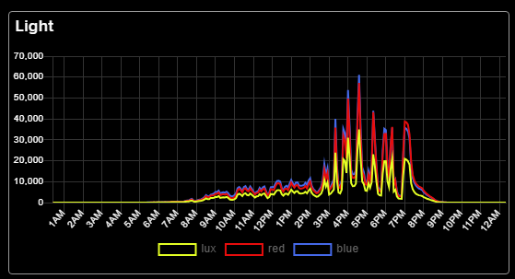
Figure 28: 24 hours of Light feedback
As shown in the figure above, after the changes made to the system, a full 24 hours of data was able to be captured without the system encountering an error.

Test Case T2: Soil Moisture Accuracy
In order to verify that the capacitive soil moisture sensor provides reliable soil readings and that the thresholds are accurate, a test was conducted whereby a 400ml pot of fresh potting soil was measured for moisture. Water was then added beneath the pot in a catch tray in 50ml increments. The soil moisture was measured 10 minutes after the new water increment was added to ensure the soil was saturated. Bottom watering was chosen as a method of watering in this test case as the soil will only absorb enough water to saturate itself fully and no further, therefore no reading from this test should result in a “Too Wet” reading.
The results of this test are shown in the table below.
Table 6: Soil Moisture Accuracy Testing
Water Added (ml) | Raw Moisture Reading | Soil Moisture Output
0 | 2615 | Soil OK
50 | 1594 | Too Wet
100 | 1517 | Too Wet

As shown in Table 6, the original thresholds established in Section 4 were found to be inaccurate. The testing showed that the system triggers a “Too Wet” alert when the soil is at a moisture level that is acceptable. Because of this, the threshold for too high of moisture has been altered to 1400 instead of the previous 2000. The threshold for the soil being dry has not been altered, as the fresh soil used in the testing came out of the package moist and does not serve as an accurate baseline for dry soil.
After altering the soil moisture thresholds, the test was conducted for a second time, and resulted in the system displaying “Soil OK” for every level of saturation successfully.

Test Case T3: Light Colour Accuracy
The purpose of this test is to verify that the TCS34725 can distinguish between different light sources and recognise different colours of light. Within this test, the system was exposed to different light sources to confirm that the software can correctly calculate the red to blue ratio of light. The results of these tests are shown in Table 7 below.
Table 7: Light Colour Testing
Light Source | Red Value (R) | Blue Value (B) | R:B Ratio | System Output
Natural Window Light  (11am) | 2,744 | 4,375 | 1:1.6 | Blue Heavy (Leaf Growth)
Natural Window Light  (7pm) | 37,866 | 14,933 | 2.5:1 | Red Heavy (Roots)
Phone Flashlight | 2651 | 2886 | 1:1.1 | Balanced Light
Regular Bulb | 415 | 158 | 2.6:1 | No Light
LED Grow Light | 8,318 | 7,312 | 1.1:1 | Balanced Light

As shown in the table above, the sensor successfully was able to detect changes in the spectrum of light throughout the day. The change in natural light from blue heavy to red heavy showcases how the sensor can detect the light changes at sunset, as the device was placed in a west facing window. The regular bulb showed no light as an output due to the low light detection when placed within a room. Overall, these results show that the prototype can accurately detect different light qualities.

Test Case T4: Event Alert Latency
The purpose of this test is to measure the delay between a plant health concern and the user receiving an email notification. For this test, a timer was used to track how long it took for an email warning the user of the soil moisture readings being “too wet” to arrive to the inbox after the sensor was removed from a stable environment and placed in a glass of water. The table below shows the results of this test when run three times.
Table 8: Event Alert Testing
Attempt(s) | Latency (in seconds)
Run 1 | 57.66
Run 2 | 61.20
Run 3 | 55.40
Average | 58.09~

In Table 8 above, the average latency of alert notifications is around 58 seconds. While this may not look good at first glance, became changes in plant health occur over hours, a one-minute notification time is acceptable. This time is mainly caused by the Adafruit IO only pulling in data every 40 seconds alongside the standard email transmission delays.

Test Case T5: Environmental Reactiveness
This test serves to validate the usefulness of real-time environmental sensing. This test was conducted by filling three 100ml containers with general-use potting mix and adding 50ml of tap water to fully saturate the soil. The raw soil moisture data was then gathered before each container was placed in a different location. These containers were then left to sit for 5 hours before the soil moisture readings were gathered again, the results of which are shown in the table below.
Table 9: Soil Moisture Sensor Testing
Location | First Reading | Second Reading | Difference
Sunny Windowsill | 1520 | 2365 | 845
Shelf in Partial Shade | 1461 | 1590 | 129
Fully Shaded Radiator | 1418 | 2209 | 791

As shown in Table 9 above, the soil in warmer locations lost moisture much faster than soil in partial shade. Indoor environments vary drastically depending on a user’s ownership of heaters, air conditioning, and windows. When this is combined with broader environmental variables such as location and heatwaves, plants can be exposed to many different conditions. A fixed schedule would have ignored any potential differences in heating and would recommend the same watering schedule for all plants. These results prove that a reactive sensor system is necessary for accurate plant care.

Validation and Evaluation
This section will investigate the tests shown in Table 5. They will go through how they were conducted, the results of the tests, and how improvements and observations were made based on the results.
Conducting tests allowed for the prototype to be verifiably resilient and functional. Test T1 was especially significant as it exposed a flaw in the software which lead to the change from delay() logic to millis() logic which reduced errors. This allowed for the device to have a reliable amount of up-time. Additionally, T4 showed that the email notification has an acceptable response time of 58 seconds. The recalibration of the soil sensor in T2 and the light data gathered in T3 allowed for the system to be further improved and become more usable in real-world contexts and environments. The level of light quality analysis shown in test T3 allows for a more detailed and nuanced understanding of plant health than other plant systems.
Overall, these tests serve to validate the hypothesis of this project. In T5, the rate of moisture loss in different environments varied drastically, which is something that a schedule-based watering routine would ignore. This evaluation shows that a system that uses real-time environmental sensor data provides more efficient indoor plant care than the alternatives.

CONCLUSIONS AND FUTURE WORK

Evaluation of Project Aims, Objectives and Hypothesis
The main goal of this project was to design, develop and implement a working prototype for an indoor plant monitor that is accurate and able to deliver notifications to the users. Based on the successful implementation and deployment discussed in Section 4, as well as the data collected and validified in Section 5, this aim and all objectives have been fully met. The prototype can capture and measure environmental variables, specifically soil moisture, humidity, temperature and light.
Through the testing of the prototype, the hypothesis was proven. Fixed-schedule plant care does not account for variables such as differing evaporation rates and changing humidity. During testing, case T5 proved that identical potting soil can vary in moisture loss by over 500% if placed in different environments, which proves that fixed schedules are inadequate. By providing alerts only when the plant needs additional care, the system ensures that resources are used efficiently and that the plant does not suffer from root rot or dehydration.

Critical Evaluation and Lessons Learned
The development of this project required a significant learning curve, as prior to this study I had very little experience with electronic circuits and microcontrollers. One of the most important lessons learned was how complex hardware integration can be, I had to learn how to create and utilise pin diagrams as well as understand the requirements of different sensors.
Furthermore, there were some stalls in development as I had to overcome the hurdle that writing software for a device that must stay on 24/7 is very different from writing standard computer software. The initial coding for this device discussed in Section 4 was coded with long delays which paused the entire device for simple systems such as the LCD screen changing. In Section 5 during Test T1 it was discovered that this would lead to the system eventually breaking down and crashing. This was solved by transitioning to code that used timing instead of loops.

Future Work and Improvements
While the current prototype fulfils the main requirements for this system, it only serves as a proof of concept, and several areas of improvement can be identified. If development were continued the focus would be on transitioning the device from a prototype designed with testing in mind, to a more reliable device made with considerations made to daily use.
The most important step in moving away from the design simply being a prototype would be to integrate the components onto a PCB. This would remove the risk of wires becoming loose and overall increase the systems reliability, improving reliability in humid environments. Additionally, this would allow for the size of the circuit to be reduced, leading to the potential of a system that can fit neatly into a plant pot.
From a UI perspective, if the project was continued, a mobile application would be developed to replace the Adafruit IO interface. This would allow for the implementation of more specific thresholds tailored for different plant types and soil substrates. For example, a user could select their plant type from a database, and the system would automatically adjust its alert thresholds. Additionally, as some plants such as aroids require mixes that include additions such as leca, orchid bark and perlite, this can affect the readings of the capacitive soil moisture sensor to result in a ‘too dry’ alert because the sensor is calibrated for a standard potting soil.
Finally, the durability of the soil moisture sensor would need improvement. Currently, there is no protection for the sensor from damage. If development were to be continued, exploration of protective measures such as the use of heat-shrink tubing around the wiring, would be conducted to ensure no errors occur in the system due to sensor damage.

Summary
In summary, this project achieved its goal of introducing sensor-based plant care into a domestic setting. This research has shown that a data driven approach that utilises real-time environmental data is superior and more resource efficient than schedule-based plant care.
While the process of developing the system had some challenges and constraints, the end system is a reliable and scalable proof of concept that demonstrates how plant care can be made more effective while staying simple. In the end, this work proves that even small-scale embedded systems can significantly aid in domestic gardening and efficient resource management.

REFERENCE LIST
Aarif K. O., M., Alam, A. and Hotak, Y. (2025) ‘Smart Sensor Technologies Shaping the Future of Precision Agriculture: Recent Advances and Future Outlooks’, Journal of Sensors. John Wiley & Sons, Ltd, 2025(1), p. 2460098. doi: 10.1155/JS/2460098.
Alabadi, M., Habbal, A. and Wei, X. (2022) ‘Industrial Internet of Things: Requirements, Architecture, Challenges, and Future Research Directions’, IEEE Access. Institute of Electrical and Electronics Engineers Inc., 10, pp. 66374–66400. doi: 10.1109/ACCESS.2022.3185049.
Alahmad, T., Neményi, M., Nyéki, A., Alahmad, T., Neményi, M. and Nyéki, A. (2023) ‘Applying IoT Sensors and Big Data to Improve Precision Crop Production: A Review’, Agronomy 2023, Vol. 13,. Multidisciplinary Digital Publishing Institute, 13(10). doi: 10.3390/AGRONOMY13102603.
Ali, O. et al. (2022) ‘A Comprehensive Review of Internet of Things: Technology Stack, Middlewares, and Fog/Edge Computing Interface’, Sensors 2022, Vol. 22,. Multidisciplinary Digital Publishing Institute, 22(3). doi: 10.3390/S22030995.
Alturki, R. (2021) ‘Research Onion for Smart IoT-Enabled Mobile Applications’, Scientific Programming. John Wiley & Sons, Ltd, 2021(1), p. 4270998. doi: 10.1155/2021/4270998.
Ayeni, P. O. and Adesoba, O. C. (2025) ‘IoT-based home control system using NodeMCU and Firebase’, Journal of Edge Computing. Academy of Cognitive and Natural Sciences, 4(1), pp. 17–34. doi: 10.55056/JEC.814.
Baghdadi, N., Chakraborty, S., Akif Gümüser, M., Pichlhöfer, A. and Korjenic, A. (2025) ‘A Comparison of Capacitive Soil Moisture Sensors in Different Substrates for Use in Irrigation Systems’, Sensors 2025, Vol. 25, Page 1461. Multidisciplinary Digital Publishing Institute, 25(5), p. 1461. doi: 10.3390/S25051461.
Bakar, Z. A., Nor, M. Z. M., Kadiran, K. A., Misnan, M. F. and Noorezam, M. (2022) ‘Smart Plant Monitoring System Using Aquaponics Production Technological with Arduino Development Environment (IDE) and SMS Alert: A Prototype’, International Journal of Interactive Mobile Technologies (iJIM). International Association of Online Engineering, 16(22), pp. 32–47. doi: 10.3991/IJIM.V16I22.34581.
Balaji, S., Nathani, K. and Santhakumar, R. (2019) ‘IoT technology, applications and challenges: a contemporary survey’, Springer. Springer New York LLC, 108(1), pp. 363–388. doi: 10.1007/S11277-019-06407-W.
Bayih, A. Z., Morales, J., Assabie, Y., By, R. A. de, Bayih, A. Z., Morales, J., Assabie, Y. and By, R. A. de (2022) ‘Utilization of Internet of Things and Wireless Sensor Networks for Sustainable Smallholder Agriculture’, Sensors 2022, Vol. 22,. Multidisciplinary Digital Publishing Institute, 22(9). doi: 10.3390/S22093273.
Choudhary, A. (2024) ‘Internet of Things: a comprehensive overview, architectures, applications, simulation tools, challenges and future directions’, Discover Internet of Things 2024 4:1. Springer, 4(1), pp. 31-. doi: 10.1007/S43926-024-00084-3.
Chukwuebuka, E. (2024) Agile Methodologies: Navigating Change in Software Development. Available at: https://www.linkedin.com/pulse/agile-methodologies-navigating-change-software-development-ejie-eukdf (Accessed: 17 February 2026).
Clarin, L., Osman, B., Yusof, Y. and Rahmat, A. R. (2024) ‘INTEGRATING IOT AND MOBILE APPLICATIONS FOR EFFICIENT PLANT WATERING: THE IOT SMART WATERING SYSTEM (SWS)’, Journal of Digital System Development. UUM Press, Universiti Utara Malaysia, pp. 124–139. doi: 10.32890/JDSD2024.2.1.8.
Coelho, A. D., Dias, B. G., De Oliveira Assis, W., De Almeida Martins, F. and Pires, R. C. (2020) ‘Monitoring of soil moisture and atmospheric sensors with internet of things (IoT) applied in precision agriculture’, Proceedings - 2020 14th Technologies Applied to Electronics Teaching Conference, TAEE 2020. Institute of Electrical and Electronics Engineers Inc. doi: 10.1109/TAEE46915.2020.9163766.
Dhaka, V. S. et al. (2023) ‘Role of Internet of Things and Deep Learning Techniques in Plant Disease Detection and Classification: A Focused Review’, Sensors 2023, Vol. 23,. Multidisciplinary Digital Publishing Institute, 23(18). doi: 10.3390/S23187877.
Dhal, S., Wyatt, B. M., Mahanta, S., Bhattarai, N., Sharma, S., Rout, T., Saud, P. and Acharya, B. S. (2024) ‘Internet of Things (IoT) in digital agriculture: An overview’, Agronomy Journal. John Wiley and Sons Inc, 116(3), pp. 1144–1163. doi: 10.1002/AGJ2.21385;REQUESTEDJOURNAL:JOURNAL:14350645;WEBSITE:WEBSITE:ACSESS.ONLINELIBRARY.WILEY.COM;WGROUP:STRING:PUBLICATION.
Et-taibi, B., Abid, M. R., Boufounas, E. M., Morchid, A., Bourhnane, S., Abu Hamed, T. and Benhaddou, D. (2024) ‘Enhancing water management in smart agriculture: A cloud and IoT-Based smart irrigation system’, Results in Engineering. Elsevier, 22, p. 102283. doi: 10.1016/J.RINENG.2024.102283.
Jędrzejuk, A. et al. (2022) ‘Development of an Algorithm to Indicate the Right Moment of Plant Watering Using the Analysis of Plant Biomasses Based on Dahlia × hybrida’, Sustainability 2022, Vol. 14,. Multidisciplinary Digital Publishing Institute, 14(9). doi: 10.3390/SU14095165.
Loconsole, D., Elia, M., Conversa, G., De Lucia, B., Cristiano, G. and Elia, A. (2025) ‘Soil Moisture Sensing Technologies: Principles, Applications, and Challenges in Agriculture’, Agronomy. Multidisciplinary Digital Publishing Institute (MDPI), 15(12). doi: 10.3390/AGRONOMY15122788/S1.
Lynda, D., Brahim, F., Hamid, S. and Hamadoun, C. (2023) ‘Towards a semantic structure for classifying IoT agriculture sensor datasets : An approach based on machine learning and web semantic technologies’, Journal of King Saud University - Computer and Information Sciences. Elsevier, 35(8), p. 101700. doi: 10.1016/J.JKSUCI.2023.101700.
Mandap, J. P., Sze, D., Reyes, G. N., Matthew Dumlao, S., Reyes, R. and Danny Chung, W. Y. (2018) ‘Aquaponics pH Level, Temperature, and Dissolved Oxygen Monitoring and Control System Using Raspberry Pi as Network Backbone’, IEEE Region 10 Annual International Conference, Proceedings/TENCON. Institute of Electrical and Electronics Engineers Inc., 2018-Octob, pp. 1381–1386. doi: 10.1109/TENCON.2018.8650469.
Menon, Anasuya. (2025) ‘IoT in Everyday Life Anasuya Menon’. Educohack Press.
Morchid, A., Jebabra, R., Khalid, H. M., El Alami, R., Qjidaa, H. and Ouazzani Jamil, M. (2024) ‘IoT-based smart irrigation management system to enhance agricultural water security using embedded systems, telemetry data, and cloud computing’, Results in Engineering. Elsevier, 23, p. 102829. doi: 10.1016/J.RINENG.2024.102829.
Narayana, T. L., Venkatesh, C., Kiran, A., J, C. B., Kumar, A., Khan, S. B., Almusharraf, A. and Quasim, M. T. (2024) ‘Advances in real time smart monitoring of environmental parameters using IoT and sensors’, Heliyon. Elsevier, 10(7), p. e28195. doi: 10.1016/J.HELIYON.2024.E28195.
Nasiri, S., Sadoughi, F., Dehnad, A., Tadayon, M. H. and Ahmadi, H. (2021) ‘Layered Architecture for Internet of Things-based Healthcare System: A Systematic Literature Review’, Informatica (Slovenia). Slovene Society Informatika, 45(4), p. 543. doi: 10.31449/inf.v45i4.3601.
Obaideen, K., Yousef, B. A. A., AlMallahi, M. N., Tan, Y. C., Mahmoud, M., Jaber, H. and Ramadan, M. (2022) ‘An overview of smart irrigation systems using IoT’, Energy Nexus. Elsevier, 7, p. 100124. doi: 10.1016/J.NEXUS.2022.100124.
Owino, L., Söffker, D., Nicholas Koumboulis, F. and Kouvakas, N. (2022) ‘How much is enough in watering plants? State-of-the-art in irrigation control: Advances, challenges, and opportunities with respect to precision irrigation’, Frontiers in Control Engineering. Frontiers, 3, p. 982463. doi: 10.3389/FCTEG.2022.982463.
Park, Y. S., Konge, L. and Artino, A. R. (2020) ‘The Positivism Paradigm of Research’, Academic Medicine. Wolters Kluwer Health, 95(5), pp. 690–694. doi: 10.1097/ACM.0000000000003093.
Patel, K., Patel, S., Of, P. S.-I. journal and 2016, U. (2016) ‘Internet of things-IOT: definition, characteristics, architecture, enabling technologies, application & future challenges’, researchgate.net. Available at: https://www.researchgate.net/profile/Carlos-Salazar-51/publication/330425585_Internet_of_Things-IOT_Definition_Characteristics_Architecture_Enabling_Technologies_Application_Future_Challenges/links/5c3f8a24299bf12be3ccc584/Internet-of-Things-IOT-Definitio (Accessed: 5 January 2026).
Qi, Q. et al. (2024) ‘Performance of Soil Moisture Sensors at Different Salinity Levels: Comparative Analysis and Calibration’, Sensors 2024, Vol. 24,. Multidisciplinary Digital Publishing Institute, 24(19). doi: 10.3390/S24196323.
Risteska Stojkoska, B. L. and Trivodaliev, K. V. (2017) ‘A review of Internet of Things for smart home: Challenges and solutions’, Journal of Cleaner Production. Elsevier, 140, pp. 1454–1464. doi: 10.1016/J.JCLEPRO.2016.10.006.
Romero-Riaño, E., Galeano-Barrera, C., Guerrero, C. D., Martinez-Toro, M. and Rico-Bautista, D. (2022) ‘IoT aplicado a sistemas de riego en agricultura: Un análisis de usabilidad’, Revista Colombiana de Computación. Universidad Autonoma de Bucaramanga, 23(1), pp. 44–52. doi: 10.29375/25392115.4483.
Saunders, M. N. K. and https://birmingham.academia.edu/MarkSaunders (2012) ‘The Layers of Research Design’, Rapport. Available at: https://www.academia.edu/4107831/The_Layers_of_Research_Design (Accessed: 17 February 2026).
Saunders, M. N. K., Lewis, P., Thornhill, A. (2023) ‘Research methods for business students (9th ed.)’, Pearson., p. 860.
Sha, K., Wei, W., Andrew Yang, T., Wang, Z. and Shi, W. (2018) ‘On security challenges and open issues in Internet of Things’, Future Generation Computer Systems. North-Holland, 83, pp. 326–337. doi: 10.1016/J.FUTURE.2018.01.059.
Simo, A, Dzitac, S, Duţu, A, Pandelica, I, Simo, Attila, Dzitac, Simona, Duţu, Amalia and Pandelica, Ionuţ (2023) ‘Smart Agriculture in the Digital Age: A Comprehensive IoT-Driven Greenhouse Monitoring System’, INTERNATIONAL JOURNAL OF COMPUTERS COMMUNICATIONS & CONTROL. Agora University, 18(6), p. 6147. doi: 10.15837/IJCCC.2023.6.6147.
Sorri, K., Mustafee, N. and Seppänen, M. (2022) ‘Revisiting IoT definitions: A framework towards comprehensive use’, Technological Forecasting and Social Change. North-Holland, 179, p. 121623. doi: 10.1016/J.TECHFORE.2022.121623.
Tahir, M., Ismat, N., Rizvi, H. H., Zaffar, A., Nabeel Mustafa, S. M. and Khan, A. A. (2022) ‘Implementation of a smart energy meter using blockchain and Internet of Things: A step toward energy conservation’, Frontiers in Energy Research. Frontiers Media S.A., 10, p. 1029113. doi: 10.3389/FENRG.2022.1029113/BIBTEX.
Umair, M., Aamir Cheema, M., Cheema, O., Li, H., Lu, H., Watters, P., Ceesay, E., Qi, M. and Islam, M. S. (2021) ‘Impact of COVID-19 on IoT Adoption in Healthcare, Smart Homes, Smart Buildings, Smart Cities, Transportation and Industrial IoT’, Sensors 2021, Vol. 21, Page 3838. Multidisciplinary Digital Publishing Institute, 21(11), p. 3838. doi: 10.3390/S21113838.
Vijay, A., Kasiselvanathan, M., Sridhar, P., Sharan, R., Surya, G. and Vishva Surjith, M. (2024) ‘Recent Developments in Designing Internet of Things Architectures’, Proceedings of the 3rd International Conference on Applied Artificial Intelligence and Computing, ICAAIC 2024. Institute of Electrical and Electronics Engineers Inc., pp. 1575–1580. doi: 10.1109/ICAAIC60222.2024.10574910.
Wan, S. et al. (2022) ‘A Modularized IoT Monitoring System with Edge-Computing for Aquaponics’, Sensors 2022, Vol. 22,. Multidisciplinary Digital Publishing Institute, 22(23). doi: 10.3390/S22239260.
Xu, J., Gu, B. and Tian, G. (2022) ‘Review of agricultural IoT technology’, Artificial Intelligence in Agriculture. Elsevier, 6, pp. 10–22. doi: 10.1016/J.AIIA.2022.01.001.

