Synth Wall

Controls

Playing
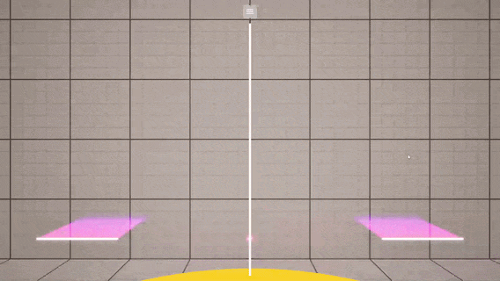
To play the synth, press, hold, and release the mouse’s left-click button anywhere on the screen.

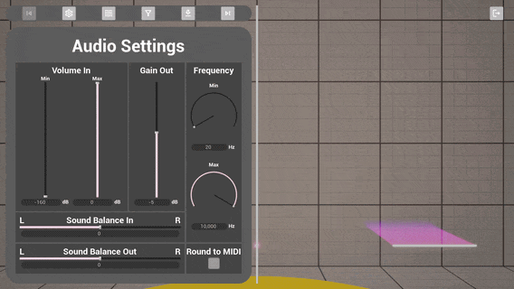
While holding, move the mouse around to change the pitch and volume of your synth.
The range of these changes will be according to your Settings, which you can find by right-clicking anywhere on the screen or by pressing the menu at the top.
You can close the settings by right-clicking on the background. They can also be moved left and right by pressing either of the left and right-most buttons of the navigation bar.

Waves and Envelopes
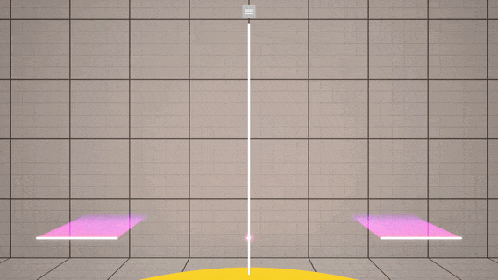
You can add, reorder, and remove waves from your synth’s base sounds.
Add waves up to 8 total by pressing the Plus button on the wave list’s right.
Reorder waves by dragging them to different positions. Remove them by dragging them out of the wave list.

Wave & Envelope Settings
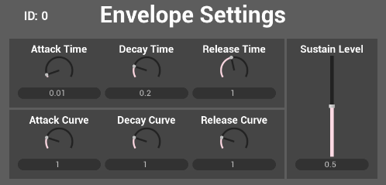
Attack, Decay, and Release are for: getting up to 1 when clicked, getting down to Sustain Level after reaching 1, and getting down to 0 when released. Time controls how long each transition takes, and Curve controls how logarithmic, linear, or exponential each transition is.

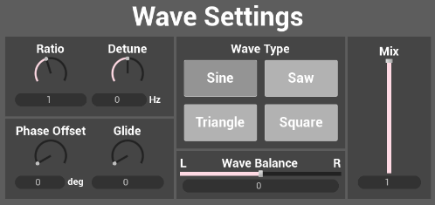
Ratio and Detune will control the relative pitch of the wave, of which Glide controls the rate of change. Mix controls its relative volume, which then is processed through left and right Balance. Phase Offset allows waves to go out of sync, and different Wave Types have different sound profiles due to their shapes (test them out!).

Filters
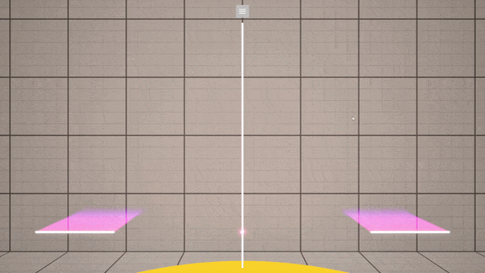
Filters can be added, reordered, and removed just like Waves, the only difference being the synth allows for 0 filters to be applied at once.
Each filter has its list of inputs, with the most being Chorus’ 5 controls. It is recommended to play around with them, but here is a list of all the filters so you can know where to start:
- Biquad: filters frequencies before and/or after a cutoff with a set strength.
- Waveshaper: shapes the input’s “height” values through the function defined in Type.
- Soft Clipping: caps input values without forming a harsh edge.
- Clipping: caps input values. Forms a harsh edge.
- Bitcrusher: reduces the audio quality of the input. Powers of 2 recommended for Bit Depth.
- Chorus: adds harmonic complexity to the input by adding voices with oscillating pitches around it. Output often has a lower volume.
- Reverb: uses a series of small feedbacking delays on the input to recreate reverb as heard in real life.
- Echo: Repeats the input after a set Delay. Input can be muted so only the repeats come through. Warning: the right wave with the right Delay may cancel itself out, leading to immediate silence on the second repeat.

Presets
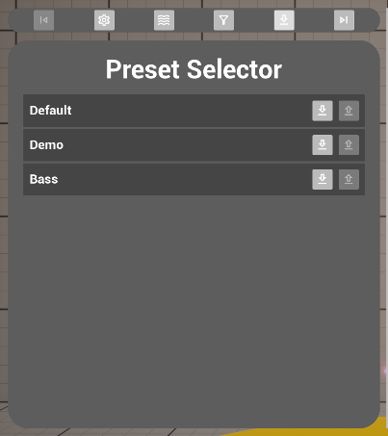
Quickly bring up pre-set configurations with the Preset Selector. This can help quickly reset your changes or give you a starting point in your exploration of the synth. Exporting and/or sharing a preset was not implemented before submission, but it is a planned feature for the future of this project. Three presets were created for this demonstration:
Default is a sandbox preset, starting with no filters and just one sine wave at max range.
Demo is a filtered preset with the default sine wave, the filters being those used throughout this project’s development until the implementation of presets.
Bass attempts to replicate the sound of plucking a Bass guitar. It does a good job at it, but there appears to be something off; just barely missing the mark.

End of Tutorial
After experimenting, if you want an initial task:
- Import and test the Bass preset.
- Remove the preset’s Bitcrusher filter.
- Listen to the difference in the sound’s profile.
Whenever you want to leave, the Settings screen has an Exit button on the top corner of the panel’s opposite side. Pressing it will close the application.
Note: synth settings do not save between playthroughs.
Enjoy!

Behind the Scenes

MetaSounds

Q: Why are wave, envelope, and filter inputs float arrays?
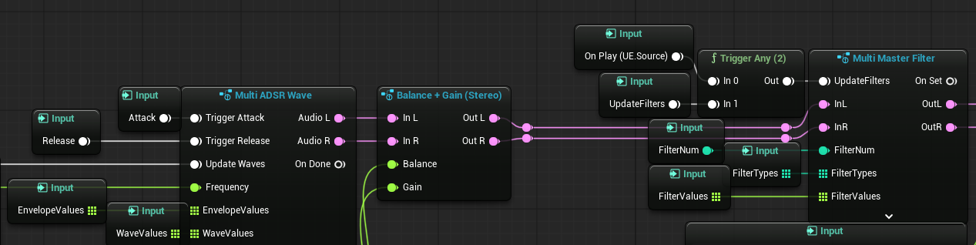
A: as of writing, MetaSounds does not support custom structs as inputs. In addition, having too many inputs in one Source file will introduce heavy latency to the editor.
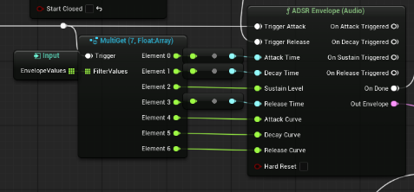
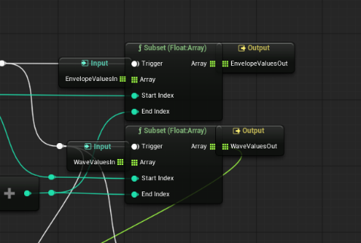
Therefore, I took advantage of how all waves and envelopes are the same size and only split the arrays into their individual values later down the execution line. On the main source alone, this saved 14 inputs per wave from 8 waves total (112 inputs) compared to inputting “wave 0 value 4”, “wave 0 value 5”, and so on (or 2 inputs per wave if using one array for each wave & envelope instead).
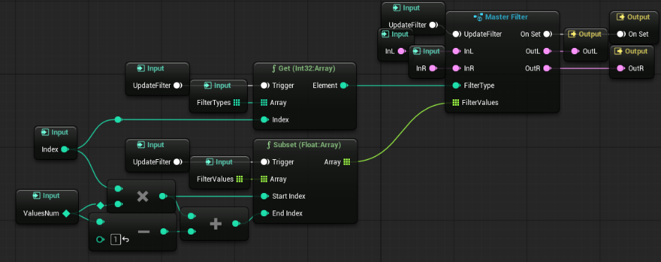
Similarly, I designed all filters to be roughly equal in size to warrant the same approach. This also saved inputs on every patch managing the filters, which added up and resulted in an editor running very smoothly and a code that, comparatively, became easy to maintain.

Multi Get Nodes
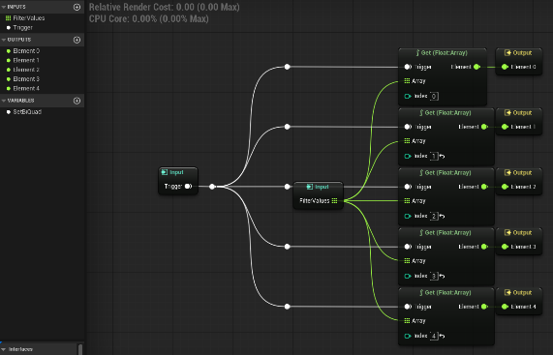
I wanted to reserve some space in this document for this MetaSound Patch category. They were very useful for readability as MetaSound Patches using arrays got larger, and I am glad to have had the idea to make a folder full of them. I will say, however, that others out there may have come up with the same solution and possibly created their own Quality-of-Life plugins with this change.

Trigger Route Stereo
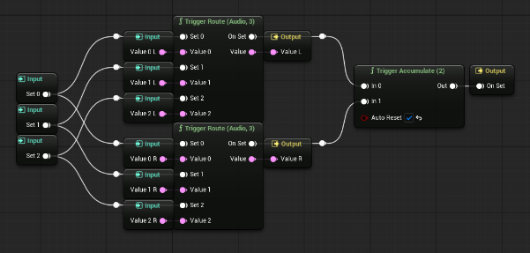
Same thing goes for this similar addition. I only needed the 2 to 4 -sized trigger routes, so this didn’t even take much time and saved so much screen space to be able to take in the flow of signal on other code sections.
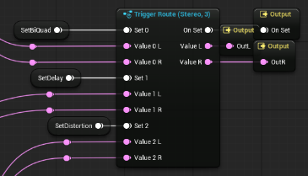
I’ve attached the patch’s code and how it looks when in-use for comparison’s sake, and it does not do justice to the number of audio signal lines that would cross over each other before I added this. I’ll be proud of this change for a long time.

Blueprints

Control Widget
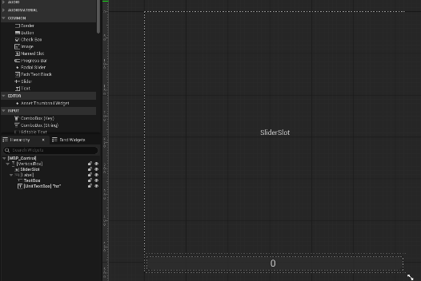
Considering how long I was spending creating slider and radial controls with similar functionality, a widget parent class was very helpful to create.
Every radial, horizontal, or vertical slider in this game’s UI relies on this parent class to function as expected. It only has one event dispatcher: “On Value Changed”, which is used everywhere to set different variables and change most values in the synth that can be changed. Genuinely the backbone of a lot of this synth’s functionality, ensuring text can be input into controls and, when it does so, to update values and the slider to match the text (and remaining within the limits and caps of the control).

Drag and Drop
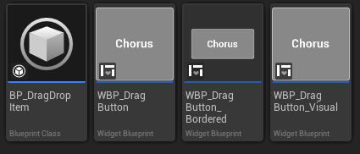
One of the last features to have been added, the previous design relied on a series of buttons to move and remove filters and waves. Dragging them and dropping them either in a new location or outside the list has removed a large inconvenience from the user experience, as well as giving users a faster workflow and giving additional space in the Filters UI for more and larger dials.
To separate dragging and dropping, the button detects the start of the drag, and the border detects when dragging over a new position in the list or when the button is released. This also solved another issue where the button’s visual was spawning too far left due to its border not being stretched by the button list’s horizontal box anymore: by separating out the bordered version, the visual spawns on the drag button’s centre and now has matching dimensions.

Filter UI
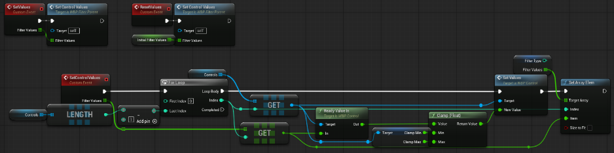
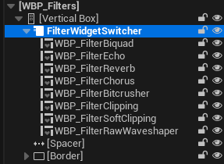
Since each filter type has a different interface but all filters can only be from the same list of filter types, I just load the values of the desired filter into the desired type’s UI. I then present it to the user with a Widget Switcher.
Each child of “Filter Parent” populates the “Controls” array and the parent class can hold the logic for loading the values in.

