Game Design Document

Controller Clash

Liam Burns

Initial Information

Game Name: Controller Clash

Genre:
Asymmetrical Platform Fighter

Game Elements:
This game is a platform fighter meaning the players will pick unique characters and attack each other to rack up damage on the opponents which will increase distance launched by attacks. Once knocked out of the bounds of the screen, the player knocked out will lose a stock. After losing all stocks, you are out of the game and once only one player is left, victory is declared.

Players:
2 minimum, 2 maximum.

Technical Specs

Technical Form:
2D

View:
Fixed camera, Side view

Platform:
PC

Engine:
Unity

Language:
C#

Device:
PC

Gameplay

The players will each pick a stage to play on and then decide which characters they want to play as. The character selection is based on what controller they want to use with the options being: Wii controller and Nunchuck, GameCube Controller, Donkey Kong Bongo Controller and the N64 Controller (using the directional pad and the joystick). Even when using the more unorthodox controllers, all characters will be of similar power level.
Once the stage loads the fighters, there is a three second count down for players to prepare before the game begins. When the game begins, characters can use their move sets to attack to deal damage to the other players and prevent attacks hitting themselves with blocking. Higher damage equates to further knockback scaling from hit attacks and players can be sent off the stage which they may be able to jump back onto. If a player hits the blast-zone (any part of the screen border) they are considered dead and lose a stock (lives).
When a player dies, their damage taken resets back to zero and they are put on a recovery platform until they act again which will make the platform disappear. Once off the recovery platform and a couple seconds after, the recently downed player has invincibility frames.
When all but one player has no stocks left, the remaining player will win and the other players will get second, third and fourth depending on who survived the longest. After the game is over, it will loop back to stage selection.

Design Pillars

Controls
The controls are central to the game’s design. The different controllers will vastly change the gameplay styles.

Controller types
Each controller will be tied to different characters which will have move sets tied to the controller that is using them. E.g. controllers with accelerometers will have motion controls as separate inputs. This will encourage the players to try every style of gameplay to see what the game has to offer. Each controller will have a character as a different archetype associated with them.

Combos
Players should be able to use combinations of moves in succession to create satisfying combos which look flashy as well as dealing massive damage. Combos should be discoverable and not be completely obvious to the players such as pressing one button repeatedly and getting results out of it. Combos should demonstrate skill expression.

Natural Mapping
Controllers should have intuitive button layouts so that even new players won’t need a tutorial to be able to play the game. They should be able to easily figure out which buttons do what because of previous games they have played. E.g. ‘A’ button is to jump, and the left stick is to move.

Character Similarities
Each selectable character should all be tied to a base character that they derive the original move set from. Controls and button layouts will be mapped to different things on each controller. The unique controller types will build on these base move sets in unique ways. This will create a sense of familiarity even when switching between different controllers.

MoSCoW
Must Have
2 Controller types with unique characters
Characters must have fully completed visuals, move sets and be tested and balanced.
1 Stage to play on
The stage must have a fitting aesthetic alongside functional death zones.
Core gameplay loop
The game must bring the player into a stage and reset when the game ends.
UI
During the gameplay, there should be character portraits at the bottom of the screen which tracks how much damage has been taken and how many stocks are left.

Should Have
4 Controller types with unique characters
4 characters with fully completed visuals, move sets that are tested and balanced should be implemented.
3 stages to choose from
3 unique stages from each other with fitting aesthetic alongside functional death zones should be implemented.
Updated Gameplay Loop with UI Selection screens
The game should let the players choose which stage to play, then which characters and then should start the game and go back to the stage select after the game ends.
Music and Sound effects
The game should have functional menu music, gameplay music and sound effects for everything suitable.
VFX and Juice
The game should have suitable visual effects to emphasize hits and other impactful parts of the game such as losing a stock.

Could Have
6 Controller types and unique players
6 characters with fully completed visuals, move sets that are tested and balanced could be implemented.
5 Stages to choose from
5 unique stages from each other with fitting aesthetic alongside functional death zones could be implemented.
Combos
This game could have a diverse combo system where each character has unique, hard to pull off combos as well as potential for other combos to be discovered with testing and practice.
High-level executable techniques
This game should have tech such as advanced movement mechanics and optimised ways to play the game with an emphasis on skill ceilings
Training Mode
This game could have a single player training mode where a single player can practice on a stationary character with no end to it unless manually quit
Alternative costumes/ colourations for characters
This game could have multiple visual options for each character to further the player’s attachment to the character they are playing as.

Won’t Have
AI Controlled Players
This game won’t have characters controlled by AI which means at least two players are required to play.
Online Multiplayer
This game won’t have online multiplayer support which means all games need to be ran locally.
Meta Progression
This game won’t have a way to unlock characters or customisations as all will be unlocked from the start.

Core Game Loop

Main Menu
Players Play Match
Stage Selection
Character Selection
Play Again?
No
Yes
Main Menu

Characters and Controllers

General
Every character will have the same 5 controls
- Movement left and right
- 3 Jumps
- Basic attack
- Shield/ Block
- Grab
Characters will be able to attack while inputting left, right and in midair but can only shield and grab while grounded. When attempting to shield while moving or midair, the character will execute a dodge which grants them temporary invincibility but they will be unable to act while in it.
Shield
While holding the shield button, the character will be invulnerable to every attack aside from being grabbed. The shields will lose health by being damaged as well as while the shield is up, it will slowly deplete further. When a shield is down, the health will slowly replenish. If a shield breaks, the character who was shielding will be stunned for an extended period allowing for another character to capitalise off it.
Grab
When a character lands a grab, they will be able to repeatedly press the attack input to deal small chip damage to the opponent and if a direction is inputted, a throw will be done in that direction. When grabbed however, an internal timer will play for how long the grab can last. This can be shortened by the person who was grabbed repeatedly pressing buttons.

Wii Remote and Nunchuck
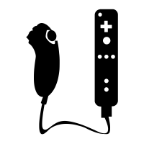
The Wii remote and Nunchuck controller character will serve as the ‘rush down’ archetype meaning they will have quick movements and attacks with the gameplan of getting up close and overwhelming the opponents with continuous fast attacks.
B - Attack
A - Jump
C - Grab
Z - Shield
Stick - Move
Shake Controller – Power Dash
The Wii Remote’s special ability involves the motion controls as it is the only controller with an accelarometer. It will give the character a combo finisher tool to clean up kills but it will also function as a burst movement option to surprise opponents.

N64 Controller
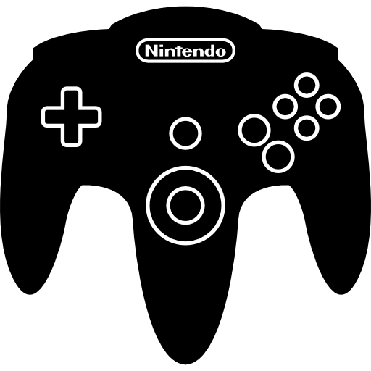
The N64 controller character will serve as the ‘zoner’ archetype meaning they have multiple projectiles to keep the opponent at a distance and try to keep the distance while wearing them down. The player will be holding the N64 controller in the least common way with the left hand on the left part of the controller (using the directional pad) and the right hand on the middle part of the controller (using the joystick).
Jump
Stick (Down) - Shield
D-pad - Move
L - Grab
Z - Attack
Stick - Projectiles
The N64 controller’s special ability involves the joystick as it is the only controller with a joystick rather than face buttons but also to the N64 controller’s detriment, it only has 2 accessible buttons when held like this so there cannot be a button bound to all three of grab, attack and shield. Shield has been set to down on the joystick. As for the other directions on the joystick, up will be a stronger projectile which flies in an arc which can pick up kills if caught by it. Left and right on the joystick would flip depending on which direction the character is facing. Forward would be a straight projectile which has average speed and damage. Back would be a boomerang projectile which travels backward before changing directions and passing through the user until it gets to the end of the screen.

GameCube Controller
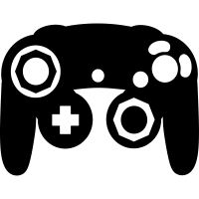
The GameCube Controller character will serve as the ‘balance’ archetype meaning they have a balanced kit with a mix of every archetype trait to try and beat the opponent with fundamental abilities. They will have the strongest ’Neutral’ meaning that when both characters are at even parts of the map, this character will have moves which win the neutral by out positioning and gaining advantage against the opponent. This doesn't mean that they will be able to capitalise on the neutral the best though. This will be the lowest skill floor character to play as.
X or Y - Jump
A - Attack
Left Stick - Move
L or R - Shield
Z - Grab
This character has no special abilities.

Donkey Kong Bongo Controller
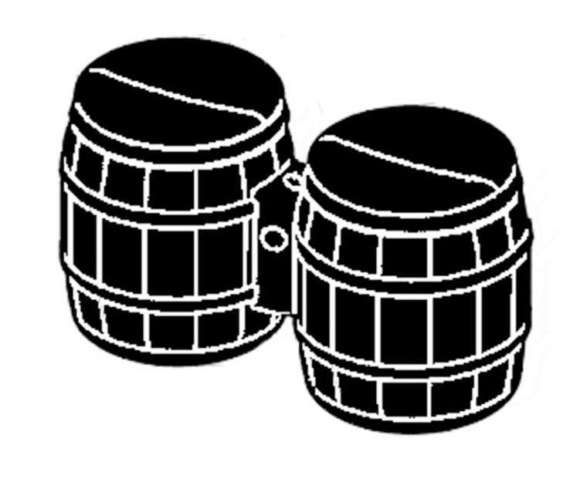
The Donkey Kong Bongo controller character will serve as the ‘grappler’ archetype meaning they have less mobility than other character types which means they need to rely on predictions to land grabs. The bongo’s are especially tricky to use as there are 5 inputs including the movement inputs. Another problem with this input method is all of the inputs are impulse inputs meaning you cannot hold down buttons which is important for shielding and moving continuously.
Top Left Hit – Move Left
Top Right Hit – Move Right
Bottom Left Hit – Attack
Bottom Right Hit – Shield
Both Top Hit – Jump
Microphone ‘Clap’ Input - Grab

The bongo controller must have a couple changes to it to make it fundamentally work as a platform fighter character. First, moving left and right will provide the character with burst movements rather than continuous input as the buttons cannot be held down. Second, macro inputs have been created by combining inputs like both top inputs will make the character jump, and both left or both right buttons will make the character dash and attack in that direction for easier attacks to implement. Third, the shield has been replaced by a parry/ counter throw as the bongo character cannot hold down the shield button, so you must time a shield for it to work. Because the shield is harder to execute, the bongo character will automatically try to counterattack if a parry is successfully landed. The special ability of the bongo character is the ability to rack up big damage after landing a grab. This can be done by pummelling the opponent using fast inputs from any or multiple of the bongo’s buttons. The bongo character can finish the grab with a throw by using the microphone input.

Stages
Stages will be what the matches take place on; there will be one main platform which all fighters spawn on. The camera will not move and if anyone leaves the bounds of the screen, they will lose a stock.

Solid Platform
Stage Bounds
Key

Character Move Sets
The attack button can do multiple types of inputs depending on the controller type, a different attack will be played depending on if the player is on the ground or in the air, as well as what direction they are holding.
Tilts – Using the attack button while holding a direction on the ground.
Aerials – Using the attack button while in the air.
Grab - A small hitbox in front of the user and will make the other character actionless until the grabber has thrown the opponent.
Throws – Inputting a direction after grabbed.

Wii mote
The Wii mote character needs to be able to combo into itself with its moves to keep up pressure so that it can rack up damage before killing with the special motion dash attack. The Wii mote and Nunchuck controller compliments itself to this style as fast paced gameplay is adrenaline inducing and this will make the motion input feel most exiting. This character will also have a lightweight stat making them a glass cannon.
Jab will be a short-range poke attack to get some distance from the opponent.
Forward tilt will be a medium hit across the floor to send characters in a horizontal arc.
Up air will be a quick arc above the head to send characters upwards but doesn't combo.
Down tilt will be a low hit across the floor to send characters upwards to start combos.
Neutral air will make a hit which is short range and weak but covers a lot of angles around the user.
Forward air will be a quick hit that deals good damage and knockback.
Up air will be a single hit which hits upwards to juggle characters.
Down air will be a diagonal dash downwards which is initially a hitbox which sends down but after it has been casted, the hitbox changes to an upwards hit.
Forward throw will be a mid-powered throw which is a horizontal arc of launch.
Down throw will be a low powered throw which starts combos at mid percents by sending them upwards and slightly forward.
Up throw will be a mid-powered throw which sends them upwards and can be used to start combos at low percents.
Motion input attack is a burst movement dash forwards with good killing power but bad ending lag.

GameCube
The GameCube character needs to be able to thrive in the neutral interactions – where both characters have an even chance of landing hits and neither character is in an advantageous position. This will be with safe and disjointed moves rather than being able to string together combos so this character's hitboxes will look like they wield a sword. The GameCube controller compliments this playstyle well because it is the most standard controller out of the four so players can feel more comfortable and be more precise with inputs.
Jab is a downwards slash which sends opponents diagonally away from them.
Forward tilt is an upwards slash that sends opponents a bit lower than jab away but with more knockback
Down tilt is a low stab which sends the opponent mainly horizontally.
Up tilt is a long slice above the head which sends opponents diagonally and mainly upwards
Neutral air is a “sex kick” which is an attack where the extended foot and arm hitboxes linger for longer than most attacks after using it.
Forward air is a long reaching overhead slash which sends opponents away.
Down air is a semi-circle down slash which sends opponents down.
Up air is an upwards slash with lots of end lag.
Forward Throw is a basic throw forwards and slightly upwards with not much knockback
Down Throw is a basic throw upwards and slightly forwards with not much knockback
Up throw is a basic throw upwards with not much knockback.

N64
The N64 character needs a collection of ‘get off me’ tools to push close range characters back so that they can use their projectiles to control the distance and pacing of the fight. The character should have some moves with longer ending lag to give them a vulnerability to close quarters combat but to get in, the opponent must take risks which can be punished. The N64 controller compliments this playstyle as using the “Claw grip” (left and middle) gives the player multiple projectile options based on how close the enemy is while having attack and shield on the back buttons to represent how they won't be used as often if the person playing is successfully keeping space.
Jab is a medium speed chop downwards to anti air people trying to dive you.
Forward tilt is a poke forward with low knockback scaling but high base knockback to send opponents away.
Down tilt is a faster but lower knockback poke to be more of an urgent get off me tool than forward tilt.
Neutral air is a poke attack which hits forwards before hitting backwards.
Forward air is a rising arcing attack to hit both forwards and upwards that sends the opponent forwards.
Down air is a slow but large hitbox spike attack which sends opponents directly downwards.
Forward Throw is a medium power regular knockback throw that sends mainly forwards.
Down Throw is a low power diagonally upwards knockback throw.
The N64 character has three kinds of projectiles: one where the player flicks the right stick in the direction they are looking; another where the player flicks the control stick in the opposite direction to where they are looking; and one when the player flicks the control stick upwards.
Forward projectile is an average projectile which disappears after flying a bit.
Back projectile a boomerang projectile with low damage and knockback which flies for a bit before changing direction and going until it flies offscreen.
Up projectile strong, killing projectile which flies in an arc trajectory.

Bongo
The Bongo character needs a powerful grab which has a good reward for landing and some heavy hitting basic attacks to make the opponent want to use shield so that it can be punished with grab. This character also needs a bad disadvantage state as they already hit hard, have a good grab and a high weight stat. The bongo controller compliments this as after landing a grab, the bongo can pummel (attack the opponent in the grabbed state before throwing) by hitting the bongo controller really fast to rack up damage which simulates real bongos. The bongo controller also doesn’t have up and down attacks due to the button limitations which will automatically make the character bad in advantage and disadvantage states as they cannot challenge attacks above or below them very easily.
Jab is a large forward attack which comes out at medium speed.
Forward tilt is a bigger forward attack which comes out at a slow speed but has high launch power.
Neutral air is a short-range attack which covers all angles around it for medium knockback.
Forward air is a large, slow arcing hit forwards with a lot of knockback.
Grab, unlike the other characters will be detected in a circle around the player to combat the bongo’s lack of verticality.
Pummel once grabbed, the player needs to hit the bongos as fast as possible to deal a lot of damage before launching the player when they get freed.

User Interface

Character name

Percent

Stocks

Systems Design Document
Game Manager
The game manager is responsible for handling the current state that the game is in and switching it between states. It will set the controllers to the corresponding scripts at the start of the game and will track when all characters have been selected so that the game can start. It will also hold data between scene loading if needed.

UI Manager
The UI Manager will take data from the game manager and use that to display the relevant UI components on the screen.

Playable Character
The playable character script is given to the player prefab to indicate that it is a character that can be assigned a controller. It will change to match the assigned controller and will also handle some general functions like taking damage or losing lives and will communicate that to the UI Manager. It will also take inputs from the controls as it is a child of monobehaviour unlike the controller scripts.

Base Character
The base character script is the parent that all the controller type scripts will share and will hold certain relevant variables which don’t need to be passed into playable character.

Device Manager
When the game is first run, the device manager will take in every device that the computer can read inputs from and isolates the inputs for each controller. Then, the input handler creates an input map for each device that can only be read from that device. It can also add a listener which takes inputs from every map at the same time. This is used in the join event which will link the input maps to different character types.

Character Controller
The character controller keeps track of different controllers and their types. It has enumerator for the controller types and holds the index of its corresponding input device.
Damage System
Attack Hits
Is Shield Up
Attack hit in parry window
Yes
No
No
Shield takes damage
Yes
Attack parried (no shield damage)
Is Launch power above threshold
Yes
Player enters launch state
Player takes damage
Player receives knockback
No

