2/17/2026
Cole Martin
Modernizing 2D Turn-Based Combat
GDEV60001
GAMES DEVELOPMENT PROJECT

Supervisor: Catherine Flick
Second Supervisor: David White

Word Count: 12,271

Contents
Abstract 4
Introduction 4
Aims and Objectives 5
Literature Review 6
Introduction 6
Historical Context: Evolution of Turn-Based Combat 7
Tabletop Origins 7
Early CRPGs and 2D Implementations 7
The JRPG Influence 8
Transition to 3D and Real-Time Hybrid Combat 8
Modern 3D and Hybrid Systems 8
Active Time Systems 8
Real-Time with Pause 9
Timed Inputs in Modern Turn-Based Design 10
Visual Enhancements in Modern Turn-Based Design 11
Design Challenges 12
The Philosophy of Player Engagement 12
Flow Theory 13
Self-Determination Theory 13
Secondary Player Engagement Frameworks 14
Engagement Challenges Specific to Turn-Based Combat 15
Implications for Turn-Based Combat Design 16
Modern 2D Game Design Trends 16
Retro Aesthetic and Nostalgia 16
Accessibility and UI Simplicity 17
Gaps in Research 17
Literature Review Conclusion 18
Research Methodologies 19
Research Paradigm and Approach 19
Research Design Overview 19
Tools and Engine Choice 20
Artefact Design 20
Shared Systems 20
Traditional Baseline Demo 20
Engagement-Enhanced Demo 21
Participants and Sampling Strategy 21
Testing Procedure 21
Data Collection Methods 22
Quantitative Data 22
Qualitative Data 22
Ethical Considerations 22
Limitations 22
Results and Findings 23
Overview of Findings 23
Quantitative Findings 23
Completion Time 23
Player Input Frequency 23
Encounter Completion 24
Interaction Density per Encounter 24
Overall Enjoyment and Engagement 25
Combat Pacing Perception 25
Downtime Preferences 25
Bug and Glitch Reporting 26
Qualitative Findings 26
Perceived Engagement and Interactivity 26
Strategic Depth and Difficulty 26
Feedback on Mechanics 27
Visual and Presentation Feedback 27
Observational Findings 27
Summary of Findings 28
Discussion and Analysis 28
Overview of Key Findings 28
Engagement vs Interaction: Quantity does not mean Quality 29
Strategic Depth and the Cost of Forgiving Mechanics 29
Presentation as an Engagement Tool 30
Regarding Accessibility and Exploitation 30
Reflection and limitations 31
Summary 31
Conclusion 31
Recommendations 33
Bibliography 35
Appendices 40
Appendix A 40
Appendix B 47
Appendix C 52

Abstract
Turn-based combat systems have long been valued for their emphasis on strategy, planning and player agency. However, traditional 2D turn-based combat games often struggle to engage the broader modern audience, which is accustomed to the immediate and responsive feedback of real-time and hybrid combat systems. In response to this, contemporary 3D turn-based games have integrated timing-based inputs through reactive mechanics and improved cinematic feedback to enhance moment-to-moment engagement. However, there has been limited research exploring whether similar engagement-enhancing mechanics can be effectively adapted into 2D frameworks without undermining their strategic identity.
This dissertation investigates whether engagement-focused mechanics can meaningfully enhance the player experience within 2D turn-based combat. A design science research approach was employed in the development of an artefact, comprising two playable 2D combat prototypes, a traditional baseline, and an engagement-enhanced hybrid system. A mixed-methods evaluation was done with eleven participants, combining in-game telemetry data with post-play questionnaires, qualitative feedback, and observational notes.
Quantitative results highlighted that the engagement-enhanced prototype significantly increased player input frequency whilst reducing overall demo completion time, indicating reduced passive downtime during combat encounters. However, questionnaire responses revealed that overall enjoyment and engagement ratings were identical across both demos. Qualitative findings further revealed that while players perceived the hybrid demo as more interactive and visually engaging, it was significantly less challenging due to the forgiving nature of the implemented engagement mechanics, which diminished strategic depth and encounter tension.
The findings suggest that increased interaction alone does not guarantee improved engagement. Instead, effective modernisation of 2D turn-based combat requires holistic system redesign with a focus on balance to ensure that engagement-enhancing mechanics introduce meaningful risk, consequence and challenge. This research provides practical design insights for developers targeting a modern audience with their 2D turn-based combat while preserving strategic foundations.

Introduction
Turn-based combat systems have played a foundational role in the history and evolution of video games, originating from tabletop role-playing games such as Dungeons & Dragons to later becoming a defining genre of early digital role-playing games. These systems emphasise strategic planning, deliberate pacing and player agency, distinguishing them from the reflex-driven mechanics found in real-time combat systems. As digital technology advanced, turn-based combat adapted across a range of formats, from text-based computer role-playing games (CRPGs) to visually expressive and distinct Japanese role-playing games (JRPGs), and eventually into hybrid systems where turn-based systems are blended with real-time mechanics and responsiveness.
Despite periodic resurgences in popularity, particularly within indie and nostalgic titles, traditional 2D turn-based combat systems often struggle to achieve the same level of mainstream appeal within contemporary audiences. Modern players are increasingly accustomed to fast-paced feedback, constant mechanical interaction, and high levels of audiovisual presentation present in real-time, action-oriented 3D games. As a result, passive menu-driven turn-based systems can feel slow, static, or disconnected, even when strategically deep. This presents the design challenge of how 2D turn-based combat can retain its strategic strengths while meeting modern expectations for feedback and engagement.
Recent 3D games with turn-based and hybrid combat systems offer potential solutions to this problem. Titles such as Persona 5, Baldur’s Gate 3, and Clair Obscur: Expedition 33 demonstrate how timed inputs during attack and defence phases, dynamic camera movement and expressive feedback can reduce player perceived downtime and increase engagement, without abandoning turn-based structure. However, all these titles use 3D presentation, raising the question of whether increased engagement is primarily driven by mechanical innovations or by the immersion afforded form 3D environments.
Academic research addressing this question is limited by existing combat design literature focusing on real-time and hybrid systems. This leaves a gap in understanding, regarding how engagement-enhancing mechanics transfer to a 2D-turn based framework, and what impact, if any, this has on player experience. This gap is relevant as 2D turn-based games remain popular among indie developers due to lower production costs and stylistic capabilities yet face challenges with attracting wider audiences in most circumstances.
This dissertation seeks to address this gap by investigating whether engagement-focused mechanics inspired by modern 3D and hybrid turn-based combat can be successfully implemented into a 2D turn-based framework. Through the design and evaluation of two 2D combat demos, one traditional baseline system and one engagement-enhanced hybrid built on top of this baseline. The study will then test and examine how these mechanics influence player interaction, engagement, perceived challenge and overall enjoyment along with other metrics which will be gathered through in game telemetry, a post play-test questionnaire and observational notes. The findings aim to provide insight and guidance for designers seeking to modernise 2D turn-based combat without sacrificing its strategic identity.

Aims and Objectives
This dissertation aims to is to identify the key mechanical and design differences between traditional 2D turn-based combat systems and their modern 3D counterparts, examining how these differences impact player engagement and experience.
As the mainstream video game industry audience increasingly shifts its preferences towards real-time and hybrid combat mechanics, traditional 2D turn-based systems have struggled to maintain player attention due to their slower pacing and limited moment-to-moment interactivity. This research aims to address these challenges by investigating how engagement focused design principles can be adapted for use within a 2D framework.
By analysing these distinctions, this research will identify the mechanics that provide more engaging player experiences. These identified mechanics will then be integrated into a 2D prototype built upon a baseline traditional system, which will serve as a point of comparison for measuring player engagement and overall experience. This comparison and evaluation will help determine whether increased engagement arises from the mechanics themselves, rather than from three-dimensional presentation alone.
This aim will be achieved through the following objectives:
- Conduct a comprehensive literature review to establish an up-to-date understanding of turn-based combat systems, their evolution and methods of sustaining player engagement.
- Identify and compare the mechanical and design differences between 2D and 3D turn-based systems, with attention to pacing, feedback and player perception, with acknowledgement of real-time combat systems design.
- Design and develop a game artefact consisting of two 2D turn-based demos: one a traditional baseline system, and the other incorporating engagement-enhancing mechanics built upon this baseline.
- Evaluate each demo through player feedback, in game telemetry data, questionnaires and observations to determine whether these mechanics improve engagement and enhance the overall player experience.

Literature Review

Introduction
Turn-based combat systems have played a defining role in video games since the medium’s emergence. Originating from pen and paper tabletop role-playing systems to evolving into digital CRPGs (Computer Role-Playing Games), JRPGs (Japanese Role-Playing Games) and eventually modern hybrid combat systems. While contemporary video game design discourse often focuses on real-time, reactive and animation-rich combat experiences (Raph, 2005); (Consalvo, 2012); (Rogers, 2014), turn-based combat remains a core mechanic within many role-playing and strategy titles due to its emphasis on tactical planning, player agency, and strategical challenge (Bycer, 2023).
Turn-based combat has experienced a resurgence in the mainstream market recently. For example, the Persona 5 series has sold over 13 million units worldwide as of October 2025 (Sega), reinforcing the potential mainstream audience interest in the genre. Similarly, 2D turn-based games have also experienced a resurgence, driven by nostalgia and reduced production cost relative to 3D pipelines. However, their commercial successes remain limited in comparison, with the Octopath Traveller series selling over 4 million units as of June 2023 (Square Enix, 2024), highlighting the disparity in mainstream appeal.
One reason for this disparity is the lack of real-time micro engagement loops within traditional 2D turn-based games, which modern players associate with “responsive” game feel (Swink, 2009). In contrast, contemporary 3D turn-based combat systems, such as Clair Obscure: Expedition 33 or Baldur’s Gate 3, have implemented hybrid mechanics including timed inputs, reactive systems and dynamic camera movements (Abd El-Ghany, 2025). Comparatively little research explores how similar systems might be effectively adapted in 2D turn-based spaces to create larger mainstream appeal, without hindering the strategic pacing valued by the current player base demographic.
This literature review examines the evolution of turn-based combat from its tabletop foundations to contemporary iterations of modern hybrid combat systems. It explores psychological theories of player engagement, analyses design trends in contemporary 3D turn-based games and identifies a research gap concerning engagement-focused enhancements for 2D turn-based combat design. This gap directly informs the design and creation of an artefact, consisting of two 2D combat demos, one traditional and one including engagement enhancing mechanics. The comparison and evaluation of these demos will determine if 2D turn based combat can be more appealing, through these additions.

Historical Context: Evolution of Turn-Based Combat

Tabletop Origins
Turn-based combat originated from pen-and-paper TTRPGs (Tabletop Role Playing Games), where groups of players would engage in imagined battles orchestrated by a Game Master using NPCs (Non-player Characters) and enemies, with the most notable being Dungeons & Dragons (1974). Gygax and Arneson designed a combat system that introduced key mechanics such as initiative order, which determined the sequence in which participants took their turns. This system also established mechanics like the action economy-where players could attack, move, cast or interact with the environment during their turn. This design focused on strategic pauses, planning and player agency grounded in meaningful decision-making (Gygax & Arneson, 1974).
This format intentionally separated thinking time from execution time, allowing anticipation, strategic planning and narrative imagination from both players and Game Master. The delay between intention and outcome distinguished tabletop gameplay from later action-driven digital experiences, cementing strategy over reflex (Loponen & Särkijärvi, 2010). Early digital adaptations retained this turn-based structure out of both necessity and tradition. Limited computational power in the 1970s and early 1980s made real-time simulation impractical, making turn-based systems well-suited to the technological constraints of early hardware. These systems replicated dice logic, randomness and sequential turns through simulation-driven design.

Early CRPGs and 2D Implementations
Early CRPGs such as pedit5 (1975), also known as Dungeon and Wizardry (1981) translated tabletop combat to computer screens, using menus and text-based visual representations (Barton & Stacks, 2019). As technology advanced, graphical presentation of combat began to appear through methods like ASCII art and simple sprite-based visuals, though the underlying systems remained fundamentally sequential. Limited memory and CPU capacity at the time encouraged the use of step-based movement, grid-based encounters and static or minimally animated battle scenes (CRPG Addict, 2021).
These design conventions influenced the development of roguelikes such as Rogue (1980) and NetHack (1987), where turn-based combat was combined with procedural generation to create more replayable experiences. These developments aligned with broader attempts to define and categorise role-playing games as a genre, distinguishing CRPGs, roguelikes, and tabletop RPGs through their mechanics, not just their aesthetic differences (Zagal & Deterding, 2018).

The JRPG Influence
The emergence of Japanese role-playing games reframed turn-based combat for a broader audience. Titles such as Dragon Quest (1986) and Final Fantasy (1987) introduced streamlined command menus, stronger visual feedback through sprite attack animations and a greater focus on narrative and character identity (Pelletier-Gagnon, 2016). These systems prioritised player engagement through emotional investment from narrative alongside strategical depth, contrasting with the simulation-heavy design of many Western CRPGs. JRPGs further expanded their appeal through anime-inspired aesthetics and narrative, tapping into other demographics to increase appeal (Consalvo, 2016).

Transition to 3D and Real-Time Hybrid Combat
As hardware advanced throughout the 1990s, game developers were able to deliver richer animation, more cinematic presentation and continuous simulation, leading to experimentation beyond the rigid structures which had previously defined turn-based combat. This period marked the start of a transitional phase, in which traditional turn-based systems began to merge with real-time elements to increase moment-to-moment engagement.
One of the most influential developments in hybrid turn-based design was the introduction of the Active Time Battle (ATB) system in Final Fantasy IV (1991), which later titles like Chrono Trigger (1995) built upon. Rather than alternating turns, characters could only act after their individual time gauges filled, meanwhile combat continued to progress in the background. In addition, abilities were conditional to enemy and player character positioning. This design combined time pressure and spatial awareness, making encounters feel more dynamic and continuous without leaving the turn-based structure and strategy (Earl, 2012).
Final Fantasy Tactics (1997) further expanded the upon spatial considerations through its grid-based battlefield that added varying elevation and positioning to its core strategic gameplay loop. These mechanical additions increase the cognitive load on the player, demonstrating how added complexity could increase engagement without relying on increased inputs from players.
Western RPGs explored other hybrid system designs, such as real-time-with-pause combat systems. Baldur’s Gate (1998) simulated continuous combat in real-time while allowing players to pause, issue commands and resume. Grounded in the Dungeons and Dragons ruleset, turn-based logic was the foundation to continuous simulation presented by constant animation and movement (Noorudin et al., 2021). By providing players with constant visual activity, even during decision-making phases, players perception of downtime was reduced.
As 3D presentation became more advanced, factors such as time pressure, animation clarity and player feedback became increasingly important when refining combat feel (Bycer, 2023). The focus on hybrid systems paved the way for modern mechanics seen in contemporary strategy and JRPG titles such as Persona 5 and XCOM 2(Amereh, 2024); (Zagal & Deterding, 2024).

Modern 3D and Hybrid Systems

Active Time Systems
The evolution of modern 3D hybrid turn based combat systems can be traced to the experimental design iterations of pacing and how players perceive turns. The Active Time Battle (ATB) system introduced in Final Fantasy IV (1991) transformed combat from a static queue of turns into a time-sensitive continuous flow governed by character speed and charging gauges (Morton, 2021).
Unlike previous traditional turn-based systems where all combatants act in a fixed sequential order, the ATB system assigns a time gauge to each character based on speed attributes, which fill continuously. Once their gauge is full, the character may act, while time continues to progress for all other combatants. This creates asynchronous combat, introducing tension and urgency even during decision-making phases and menu navigation. By allowing time to progress while players navigate menus, the ATB system adds real-time pressure to the turn-based structure, reducing perceived downtime (Price, 2023).
Later Final Fantasy titles further iterated upon the ATB system with Final Fantasy X (2001), adding visualised turn queues to enhance clarity and strategy through planning and turn manipulation (Conley, 2020). Similarly, Grandia (1997) expanded on this by adding interrupt mechanics allowing players to cancel enemy attack as they wind up through planning. Ubisoft’s Child of Light (2014) presented a visible “initiative timeline” where manipulating speed and delay became the core strategic hook (Boyd, 2014). Each iteration dramatically altered the traditional combat rhythm into a less rigid sequential system without completely abandoning the turn-based identity.
These games collectively reveal an ongoing design pursuit of balancing strategic depth and planning with moment-to-moment engagement. Time-based mechanics introduce a sense of momentum to combat without reflex-based mechanics but through prediction, timing and pacing. Research into player experience supports this design direction, for example extended downtime longer than four seconds, between actions in active time battle combat systems have been shown to reduce engagement (Anditya & Sihabuddin, 2016).
The ATB system represents one of the earliest successful attempts to create tension and responsiveness into what had traditionally been a static model of combat. This inclusion of real time mechanics provided engagement expected from a contemporary audience shaped by real-time genres such as action and shooter games.

Real-Time with Pause
While the Active Time Battle systems blurred the lines between turns and time, Western RPGs explored a different hybrid approach through the combination of real time simulation with strategic pausing. Titles like Baldur’s Gate (1998) and Dragon Age: Origins (2009) popularised this real-time-with-pause combat model, where combat played out continuously, but players are given the ability to pause the simulation and issue commands (Lilura1, n.d.). This approach enabled tactical decision-making within real time combat simulation by providing continuity through from constant animations.
The critical and commercial success of Baldur’s Gate 3 (2023), with over 15 million units sold (Mulligan, 2024), demonstrates how this design philosophy can be refined for contemporary audiences. The developer Larian Studios adapted the Dungeons & Dragons 5th Edition rules into a turn-based 3D system that feels visually continuous, despite its turn-based methodical pace. Notably, this system allowed for party members in combat to adhere to turn-based sequences and rules, while additional members outside of combat or in stealth state can perform actions unrestricted by turn order and duration, creating more dynamic combat scenarios. Through its versatile combat system, environmental interactivity, animation and camera direction, a real-time sensation is achieved within a system governed by discrete turns (Dabirian, 2023).
Baulder’s Gate 3 showcases that turn-based combat does not need to be restrictive, slower, less engaging or less immersive than its real-time counterparts. Instead, player engagement can emerge from reactivity and feedback. When combat systems acknowledge player input through animation, physics responses and environmental reactions, player agency is strengthened. This aligns with user experience (UX) research that states perceived agency increases when systems provide immediate, meaningful and expected feedback (Nacke et al., 2010), encouraging players to explore and manipulate interconnected mechanics or systems.

Timed Inputs in Modern Turn-Based Design
In recent years, a design approach has emerged in which traditional, menu-structured turn systems are blended with timing-based inputs, inspired from real-time systems. The goal of these hybrid systems is not to abandon strategic pacing, but to reduce the amount of passive downtime associated with traditional turn-based combat and align it modern expectations for responsiveness. This design places turn-based combat closer to real-time action games and allows player skill expression to be mechanical, not just strategic.
Modern hybrid turn-based games such as Sea of Stars (Sabotage Studio, 2023) employ timed inputs to enhance both offensive and defensive actions. Players are rewarded for pressing inputs at precise moments by amplifying damage or mitigating incoming attacks. This rewards rhythm, focus and anticipation but importantly, failure to execute these inputs does not cancel actions or invalidate strategic decisions (Boulanger, 2022). While preserving accessibility and adding the potential for mechanical skill expression combined with the traditional planning.
A similar implementation can be seen in Clair Obscur: Expedition 33 (Sandfall Interactive, 2025), a French-developed RPG that combines 3D turn based combat with real-time parrying, dodging and aim-based inputs. While the overall combat system remains turn-based in structure, defensive phases require active player participation alongside attacking phases. This transforms passive downtime into moments of tension and engagement, aligning with research suggesting frequent player input is essential for sustaining engagement and enjoyment (Anditya & Sihabuddin, 2016). Industry commentary surrounding the title highlights these mechanics were introduced to appeal to players accustomed with action-oriented combat design (Bailes, 2024). The game’s commercial performance further supports this design rationale, achieving over one million in sales within the first three days of release and maintaining strong player reception (Statista, 2025).
Timing-based inputs are not exclusive to contemporary turn-based titles. Paper Mario introduced quick-time events (QTEs) to player action commands, to ensure players remained engaged during both attack and defence phases (O’Leary McCann, 2018). Similarly, Yakuza: Like a Dragon (Ryu, Ga Gotoku Studio, 2020) uses QTEs to modify damage and positioning, further reinforcing the idea that real-time interaction can coexist with turn-based structure to boost engagement (Kelly, 2020). These examples demonstrate an overall design intention to transform passive execution into active participation.
The effectiveness of timing-based defensive mechanics boosting player engagement can be further contextualised through analysis and comparison of real-time action titles such as Sekiro: Shadows Die Twice (FromSoftware, 2019). Sekiro’s deflection system requires precise, rhythmic input timing in response to enemy attacks, transforming defence from a passive guarding, prevalent in previous games like Dark Souls 3 (FromSoftware, 2016), into an active skill-based interaction. Successful deflections deliver immediate audiovisual feedback, reinforcing player competence and requiring heightened attention throughout encounters from players to succeed. Industry analysis frequently identifies this deflection mechanic as central to Sekiro’s engagement and mastery-driven appeal, as it rewards pattern recognition, timing precision, and sustained focus rather than raw reaction speed alone (Mozel, 2019).
While Sekiro’s combat sits entirely within real-time action, the engagement principles underpinning its deflection system, such as continuous player involvement via input, are potential reasons for modern turn-based gams adopting similar mechanics.

Visual Enhancements in Modern Turn-Based Design
Modern 3D turn-based titles also frequently enhance engagement through presentation; this can be alongside or as a substitute to mechanical alteration. Contemporary titles demonstrate presentation itself can act as a form of engagement by reinforcing player actions with immediate, expressive or even humorous feedback. Achieved through animation, camera movement, sound design and user interface responsiveness, these systems reduce perceived downtime or make downtime engaging for players.
Persona 5 (Altus, 2016) exemplifies this idea of engagement from presentation through its cinematic framing, dynamic camera movements and stylised animations. Minor player interactions such as menu navigation trigger animations, sound cures and camera movements to transform the often-tedious routine of menu navigation into a visual spectacle for player to enjoy. By reducing menu fatigue through its reactive user interface, Persona 5 ensures engagement remans high during downtime, influencing many games since with its user interface design philosophy (Abd El-Ghany, 2025).
Similarly, Divinity: Original Sin 2 (Larian Studios, 2017) uses cinematic camerawork and environmental interactivity to reward strategy with visual spectacle and feedback. Various elemental surfaces, physics-driven explosions and dynamic reactions provide clear feedback to player actions and system interactions. These features contribute to the player’s mental model of combat space and game systems, reinforcing how decisions influence outcomes. This further demonstrates that engagement can be generated not only through mechanical design, but also through visual presentation, with responsive aesthetics helping static systems feel more dynamic and alive.
Presentation-driven engagement is also evident in Yakuza: Like a Dragon (Ryu Ga Gotoku Studio, 202), which uses exaggerated animations and cinematic cut-ins to ensure turn-based actions remain entertaining to observe. This reduces the monotony associated with waiting during attack animations by providing an entertaining emotional investment during both player and enemy turns (Kelly, 2020).
Recent titles such as Clair Obscur: Expedition 33 also highlight the importance of presentation. Developer insight highlights a deliberate focus on animation, camera movement and visual effects to ensure continuous on-screen activity, even during menu navigation. Sandfall Interactive described treating abilities as cinematic sequences, consisting of dynamic camera shots and visual spectacle (Unreal Engine, 2025). This suggests an emerging industry standard where turn-based ‘turns’ are treated as micro-cinematic moments, bridging the perceptual gap between turn-based and real-time combat experiences.
Collectively, these examples suggest both player engagement and the perceptual boundary between turn-based and real-time combat can be reduced through presentation. Contemporary turn-based design is therefore shaped not only by mechanical structure, but also by the quality of audiovisual feedback provided to players. Consequently, while presentation alone cannot replace meaningful challenge or strategic depth, it plays a significant role in shaping perceived engagement and responsiveness within modern turn-based systems.

Design Challenges
Despite their potential engagement benefits, hybrid turn-based systems introduce several design challenges. The introduction of timing-based interactions can risk cognitive overload as players must balance strategic planning along with reactive input. If implemented poorly, such mechanics may prioritise reflex-based play over deliberative strategy, undermining one of the genre’s core appeals, thoughtful decision-making (NIKI, 2024).
Increased visual effects and spectacle introduce the risk of visual clarity. Excessive visual effects, camera movements and exaggerated animation may hinder readability and obscure vital gameplay information, which can further strain cognitive load. Turn-based games rely heavily on clear presentation of player and enemy state information such as health, turn order or character weaknesses and therefore spectacle must not compromise visibility.
Accessibility is another potential concern. Reflex-based mechanics can disadvantage players with slower reaction times or motor impairments, potentially excluding audiences who traditionally favour turn-based systems for their lower physical demands. Inclusive designs such as adjustable timing windows, auto-parry features, or input assists pose as potential solutions, allowing the addition of these engagement mechanics to remain accessible.
Player reception to reflex mechanics is also currently mixed. Community discourse suggests that while some players welcome increased interactivity and responsiveness, others prefer the slower, more contemplative pacing of traditional turn-based systems (ResetEra, 2025). This reinforces the importance of optional or scalable engagement mechanics rather than implementing mandatory reflex systems.
The success of Clair Obscur: Expedition 33 and Sea of Stars lies in their careful balance between visual noise, additional engagement mechanics and strategy. These games demonstrate modern turn-based combat does not need to abandon its deliberate pacing to increase engagement. Instead, they provide meaningful interaction during each phase of combat, rather than simply selecting actions and waiting on outcomes.

The Philosophy of Player Engagement
Player engagement refers to the degree of cognitive and emotional involvement a player experiences during gameplay. Engagement typically manifests and can be measured through; sustained attention, repeated play, emotional investment and an ongoing desire to progress. (Nacke et al., 2010). Engagement is driven by compelling gameplay, clear objectives, meaningful progression, a sense of accomplishment and emotional experiences such as enjoyment and satisfaction (Rigby & Ryan, 2011). Effective game design creates a cycle of engagement by making the experience enjoyable, rewarding and immersive. (Heyland, 2025). Turn-based combat systems, which rely on decision-making and anticipation, hold a unique position within engagement literature because they balance strategic planning with pacing constraints. As a result, engagement within turn-based combat is about proving enough depth and challenge to balance out the pacing and intermittent passive participation phases. This section outlines core theoretical frameworks relevant to turn-based combat design and analyses how traditional and hybrid systems support or hinder player engagement.

Flow Theory
Csikszentmihalyi’s Flow Theory (1990) proposes optimal engagement is achieved when the challenge of a task closely matches the player’s skill. When the challenge exceeds their ability, players will feel anxious, if ability exceeds challenge, then they feel boredom but in between lies the flow channel (Mulder, 2024). When in the flow channel players experience intense concentration, time distortion and a sense of agency. Three core elements to facilitate flow are clear goals, unambiguous feedback and continuous meaningful action.
Traditional turn-based combat systems support these conditions for flow through its structed decision phases, predictable pacing and vast opportunity for mastery. Without real-time pressure, players can take time to plan, evaluate and refine strategies supporting a strong challenge-skill dynamic. However, long periods of downtime from watching attacks animations, navigating repetitive menus or waiting for turns cycles to complete, can interrupt flow by significantly reducing the number of decisions per minute. Research by (Anditya & Sihabuddin, 2016) suggests delays of more than a few seconds between player actions, significantly reduces engagement highlighting pacing as a crucial aspect to maintain flow.
Hybridised systems attempt to mitigate these interruptions to flow through mechanics such as timed inputs, reactive defence mechanics and interrupt abilities which add micro engagement challenges throughout turns. These reduce passive waiting and increase player inputs per minute, providing more consistent interaction, allowing hybrid systems to keep players in the flow channel for longer periods and therefore engaged.

Self-Determination Theory
Self-Determination Theory (SDT) (Ryan & Deci, 1985) identifies three core psychological needs that underpin intrinsic motivation:
- Competence – feeling effective and capable
- Autonomy – feeling in control of actions and outcomes
- Relatedness – feeling connected to characters, narrative or systems
Traditional turn-based combat systems strongly support competence, as their structured format rewards mastery of rules, prediction and system optimisation. CRPGs and JRPGs rely heavily on competence-driven motivation, with players often learning ability synergies, damage type strengths and weaknesses, or enemy patterns through repeated encounters.
Hybrid combat mechanics expand this sense of competence through mechanical skill expression in addition to strategic. Timed attacks and parries as seen in Sea of Stars and Clair Obscur: Expedition 33 allow players to improve performance through practicing timing. These mechanics also enhance autonomy by allowing a plethora of playstyles along a mechanical spectrum, from purely strategic, purely reflexive, or a combination of both depending on each players preference.
While the relatedness component SDT is traditionally associated with narrative and character connection, modern turn-based systems also leverage audiovisual design to create emotional resonance within combat itself. Persona 5 exemplifies this by embedding personality and character identity into combat animations, UI transitions and victory poses, reinforcing a sense of identity and connection between players and their characters (Ryan et al., 2006).

Secondary Player Engagement Frameworks
While core theories such as Flow Theory and SDT provide a foundational understanding of player engagement, a range of secondary engagement frameworks offer further insight into why players are drawn to turn-based combat systems. These frameworks highlight how motivation, personality and emotion contribute to engagement beyond strategic decision-making.

Bartle’s Player Types
Bartle’s Player Types proposes that different player personalities results in different goals for motivation and preferred gameplay experience. The model categories players into four archetypes: the Achiever, the Explorer, the Socialiser and the Killer (Bartle, 1996).
Achievers who seek mastery, progress and optimisation are directly supported by turn-based systems which provide strategic depth and reward mechanical and resource optimisation. Players can analyse outcomes, refine strategies across encounters and observe improvements in performance, which reinforces a sense of accomplishment.
Explorers are motivated by discovery and system understanding which turn-based systems satisfy with their transparent underlying mechanics. Elements such as damage calculations, status effects and turn order are all provided to the player, allowing them to experiment with different mechanics and character builds to uncover optimal strategies (Kumar et al., 2025).
However, players motivated by immediacy or competition may find traditional turn-based pacing less satisfying, potentially alluding to why hybrid systems introduce real-time elements to broaden appeal beyond these dominant archetypes.

Lazzaro’s Four Keys to Fun
Lazzaro’s Four Keys to Fun emphasises emotional triggers as the key to player enjoyment and identifies four main keys or types of fun: People Fun (Social Interaction), Easy Fun (Novelty and Exploration), Hard Fun (Challenge and Mastery) and Serious Fun (Meaning and Purpose) (Lazzaro, 2004). Turn-based combat systems align most strongly with Hard Fun and Serious Fun.
Hard Fun is derived from overcoming difficult challenges and mastering mechanics. Turn-based combat provides these challenges through complex systems, requiring mastery and understanding to succeed. The traditional turn-based structure allows players to engage with this strategic depth without time pressure enabling systemic mastery whereas, hybrid systems can offer mechanical mastery through reflex-dependant systems.
Serious Fun relates to meaning, setting long-term goals and having purpose. Turn-based systems provide this through game wide progression systems, character development and strategic investment over time through the introduction of additional mechanics. Players are often encouraged to think beyond one single encounter, considering long-term consequences and narrative stakes. Lazzaro’s later work emphasises that games engage players by allowing them to meaningfully influence outcomes rather than functioning as a simple task checklist (Lazzaro, 2008). Turn-based systems provide this through meaningful player choices that influence combat outcomes and outside of combat through character developments.

Yee’s Gamer Motivation Model
Yee’s Gamer Motivation Model identifies three high level motivation clusters: Action-Social, Mastery-Achievement and Immersion-Creativity, with turn-based combat landing strongly in the Mastery-Achievement Cluster (Yee, 2015).
Players in this cluster value long-term progression, system optimisation and cumulative mechanics, engaging deeply with challenges demanding careful decision-making, strategic planning and skill refinement. These players enjoy analysing options, balancing resources and devising optimal long-term strategies, making turn-based titles such as XCOM 2 and Fire Emblem particularly appealing (Bycer, 2019).
Although turn-based systems primarily engage the Mastery–Achievement cluster, they also appeal to Immersion–Creativity. Immersion consists of rich narratives, aesthetic worlds, or character-driven combat, as seen in JRPGs where fantasy, story and visual identity are core. This overlap of audience profiles demonstrates how turn-based combat systems satisfy several demographics, with potential to expand into other action profiles through hybrid systems.

Norman’s Emotional Design
Norman’s Emotional Design highlights how aesthetics and feedback influence emotional engagement across three levels: visceral, behavioural and reflective (Norman, 2004). Traditional turn-based combat excels at the reflective level, engaging players reasoning and planning but hybridised systems and modern JRPGs increasingly target the visceral level through dynamic animations, hit effects and stylised UI boosting moment-to-moment emotional impact.
Taken together, these frameworks demonstrate engagement in turn-based combat arises from a combination of strategic depth, appealing aesthetics and emotional resonance. They reinforce the idea that players are drawn not only to the cognitive demands of turn-based systems but also to feedback, audio and visual presentation, and personal motivational profiles. However, hybrid turn-based systems present an opportunity to broaden the genre’s potential appeal by integrating elements that appeal to additional motivational clusters such as real-time responsiveness, increased feedback and greater immediacy, thereby accommodating players who may find traditional turn-based pacing too passive or emotionally distant.

Engagement Challenges Specific to Turn-Based Combat
Despite their strategic strengths, traditional 2D turn-based systems face several engagement challenges. Repetitive menu navigation can lead to menu fatigue and several periods of passive during enemy attack animations or long turn cycles can interrupt player focus. Additionally, limited feedback reduces perceived impact of actions and slower pacing reduces the sense of immediacy (Steckecilo, 2008).
Hybrid systems directly address these engagement shortcomings by inserting active micro-engagement loops between decisions. Timed inputs keep players mentally invested whilst waiting for their turn, increasing the frequency of meaningful interactions. However, these enhancements also introduce risks. Increased cognitive load can overwhelm players who prefer slow contemplative pacing and reflex-dependent mechanics may reduce accessibility for players with motor or coordination impairments.

Implications for Turn-Based Combat Design
Engagement theory suggests effective turn-based combat should:
- Maintain flow by minimising passive downtime and sustaining challenge–skill balance.
- Support competence and autonomy through clear feedback, meaningful decisions and reflex-based mechanics.
- Reinforce player actions with strong audiovisual feedback.
- Avoid excessive visual noise and reflex demands to preserve accessibility.
These principles directly inform the artefact developed in this study. By comparing a traditional 2D turn-based prototype with a hybrid version incorporating timed interactions and enhanced user experience and visual feedback, the project evaluates whether engagement-informed design choices measurably increase player enjoyment, responsiveness and perceived agency within 2D turn-based combat.

Modern 2D Game Design Trends

Retro Aesthetic and Nostalgia
Modern 2D games often draw on retro aesthetics due to their strong cultural and emotional resonance. Pixel art remains a dominant stylistic choice, providing a distinct visual charm while evoking nostalgia among players who grew up with earlier console generations. This nostalgic attachment continues to shape market expectations, particularly within genres rooted in classic aesthetics, as seen by the increasing number of 2D-HD remakes and retro-inspired titles released in recent years.
Long-term genre studies indicate that while existing fans of turn-based role-playing games often remain loyal to established conventions, the genre struggles to attract large numbers of new players due to slower pacing and lack of feedback (Mäkelä & Schmidt, 2020). As a response to this, modern 2D games attempt to mitigate this by blending familiar retro aesthetics with updated visuals and additional mechanical innovations.
Indie developers also favour 2D formats due to reduced production costs and simpler development pipelines, allowing small teams to deliver polished and cohesive experiences without the technical overhead of full 3D development (Eden, 2010). Beyond production costs, 2D visuals also support visual clarity due to simplified geometry and fewer overlapping layers, allowing players to quickly understand combat information and track game state changes without getting overwhelmed.
These visual and mechanical conventions are further reinforced through intercontextuality, which is the repetition of familiar tropes, structures and visual signifiers across games and media. As players already understand these conventions, modern 2D turn-based systems can build on pre-existing player knowledge, making them easier to learn and immediately more engaging.
Contemporary titles such as Octopath Traveler 2 exemplify these trends by combining pixel-art nostalgia with modern rendering techniques (Gravelle, 2023). Using dynamic lighting, depth-of-field effects and layered backgrounds, the game creates a 2.5D visual identity that appeals simultaneously to retro-focused audiences and players seeking modern production values.

Accessibility and UI Simplicity
Modern game design places significant emphasis on accessibility. By operating within a two-dimensional plane, designers inherently reduce visual noise and limit the number of on-screen variables competing for player attention. This supports clearer information presentation and helps maintain a readable game space.
UI in 2D titles is often minimalistic, prioritising clarity and reducing cognitive load. These characteristics make turn-based and strategy systems more approachable for inexperienced or casual players, who may otherwise be overwhelmed by the complex interfaces. The simplicity of 2D interaction from less movement axes, buttons and fewer dimensions to navigate naturally contributes to ease of play and quicker onboarding (treeform, 2016).
Importantly, these inherent accessibility benefits position 2D turn-based systems as well-suited for experimentation with engagement-enhancing mechanics. Clear visuals and readable interfaces provide a solid foundation for additional feedback, timing-based inputs, or reactive systems to be layered onto without overwhelming the player.

Gaps in Research
Despite a growing body of literature revolving around player engagement, significant gaps remain in the study of engagement mechanics, particularly within turn-based combat systems. Currently, studies tend to prioritize real-time combat, action games or hybrid-action games, leaving 2D turn-based combat underexamined.
Firstly, there is limited research investigating how engagement-focused mechanics, such as timed inputs and animation-based feedback, affect the player experience in traditional 2D turn-based combat. Instead turn-based design literature often discusses balance, strategy and pacing (Björk & Holopainen, 2005). As a result, the moment-to-moment impact of increased interactivity within turn-based systems remains unexplored.
Secondly, most academic work assessing engagement and flow focuses on real-time systems where responsiveness and instant feedback are core to enjoyment (Perttula et al., 2017). This leaves a theoretical gap on whether engagement-enhancing mechanics commonly found in modern action or hybrid RPGs translate effectively to fully turn-based 2D systems.
A further complication arises from many modern engagement-enhanced RPGs such as Yakuza: Like a Dragon, Clair Obcure: Expedition 33 and Persona 5, being 3D games. This raises the research question:
Do players find hybrid turn-based games engaging because of the mechanics themselves, or because they are accompanied by 3D presentation?
However, there are no current peer-reviewed works exploring this.
One relevant industry insight from analysis of the Paper Mario RPG series, where timed inputs are used for offensive and defensive play to increase player involvement (O’Leary McCann, 2018). Industry writers argue the inclusion of these inputs increases engagement by turning passive turns into active phases (Critical Inputs, 2023). However, these discussions lack empirical studies validating claims.
Overall, there remains a clear lack of peer-reviewed and academic research examining how engagement mechanics influence player experience and agency within 2D turn-based contexts. This gap justifies an investigation into modern combat systems and how they can be applied to 2D counterparts.

Literature Review Conclusion
The literature highlights turn-based combat has undergone significant evolution, from its tabletop origins rooted in strategy to modern hybrid approaches that blend planning with real-time responsiveness. While traditional systems emphasise strategic challenge, visual clarity and player agency, contemporary 3D titles increasingly incorporate timed interaction and cinematic presentation to address modern expectations for immediacy and engagement. Across historical, mechanical and psychological perspectives, a consistent pattern emerges that player engagement in turn-based systems is strongly shaped by pacing, responsiveness, challenge and the frequency of meaningful actions.
Engagement theories indicate turn-based combat can successfully fulfil player needs for competence, autonomy, challenge and emotional resonance but these needs are undermined when pacing becomes too passive or challenge too unfair. Hybrid mechanics such as timed inputs and reactive defence have been shown in 3D turn-based games to reduce downtime and enhance feedback loops, helping players remain within the engagement “flow channel.” However, literature also highlights design risks including cognitive overload, accessibility concerns and the possibility that engagement mechanics may undermine the strategic identity of the genre if not implemented carefully.
A significant research gap persists, particularly around how these engagement-enhancing mechanics function within 2D turn-based spaces. Existing work focuses on 3D or real-time titles, leaving unanswered whether the mainstream appeal of ‘modernised’ turn-based combat stems from the mechanics themselves or from the 3D nature of these games. Similarly, while industry commentary suggests timed actions increase involvement in series such as Paper Mario, there is little empirical study validating these claims, especially within strictly 2D contexts. This gap is particularly relevant as 2D turn-based games remain popular within indie development yet often struggle to attract wider audiences.
Overall, the literature indicates modern engagement techniques hold potential value for revitalising 2D turn-based combat, but empirical evidence is lacking. Therefore, understanding whether hybridised mechanics genuinely enhance player enjoyment and engagement, without compromising accessibility or strategic depth, remains an open question. Addressing this gap is the aim of this study.
The following methodology therefore outlines how this artefact will investigate these issues through the empirical comparison of two playable 2D demos: one designed using traditional turn-based conventions and one incorporating modern engagement mechanics such as timed inputs and enhanced visual feedback combined with traditional conventions. By examining player responses and behaviour across both prototypes, the study seeks to clarify whether these systems improve engagement, from which practical design guidelines for future 2D turn-based hybrid systems can be produced.

Research Methodologies

Research Paradigm and Approach
This research is grounded in Design Science Research (DSR) as its primary methodological framework. DSR is an established research paradigm that focuses on the design, development and evaluation of artefacts intended to address identified real-world problems, while simultaneously contributing to academic knowledge (Brocke et al., 2020). This approach is particularly well suited to game design research, where knowledge is gained through the creation of systems that can be tested and observed.
The identified problem of this study is the lack of moment-to-moment engagement in traditional 2D turn-based combat systems when compared to contemporary 3D and hybrid combat designs. Following DSR principles, this problem is addressed through the creation of a game artefact consisting of multiple playable 2D turn-based combat demos. These demos are designed to explore whether engagement-enhancing mechanics, such as timed inputs and reactive feedback, can be successfully adapted to a 2D turn-based context without undermining strategic depth or accessibility.
To evaluate the effectiveness of the artefact, the study employs a practice-based mixed-methods data approach. Mixed methods research uses quantitative and qualitative data within a single study to provide a more comprehensive understanding of the research topic (McLeod, 2024). In this research, quantitative data is gathered using in-game telemetry to measure behavioural indicators of engagement, including interaction frequency, play time and encounters. Qualitative methods, including player questionnaires and post-play interviews, are used to capture subjective thoughts on enjoyment, responsiveness, and overall player experience (McLeod, 2025) .
The use of these various methods strengthens the results through cross referencing, allowing data to be interpreted alongside player-reported experience. Through this DSR-driven, mixed-methods approach, the research aims to generate insights for 2D turn-based combat systems and the effectiveness of engagement mechanics within them.

Research Design Overview
This research study consists of four core phases:
- Design and development of combat prototypes
- Participant playtesting sessions
- Quantitative and qualitative data collection
- Comparative analysis and evaluation
Two distinct 2D turn-based combat demos were developed to allow direct comparison. The first prototype functions as a traditional baseline, consisting of established turn-based conventions such as menu-driven actions, fixed turn order and passive enemy phases. The second prototype incorporates engagement-enhancing mechanics inspired by modern 3D and hybrid turn-based systems, including timed attack and defence inputs and reactive camera feedback. This will enable easy comparison of engagement mechanics effects for testing by controlling other elements such as art, system depth, interface complexity.

Tools and Engine Choice
The Unity game engine was selected to develop the artefact for this research. Unity offers strong 2D development support, enabling rapid development, alongside its robust suite of tools suitable for solo development. It’s also highly flexible, allowing efficient and frequent mechanical adjustments throughout the creation process (Tereshchuk, 2024).
Unity was also chosen due to experience with the engine, reducing technical limitations and therefore allowing greater focus on the design of combat, player experience and data collection systems. Using a familiar engine aligns with best practice in practice-based research, which states that methodology benefits from minimising technical constraints.
Both demos were developed within a single project to ensure consistency and ease of use for play testers. Shared systems between the demos included combat systems, character statistics, enemy AI, user interface layout, assets and audio feedback. This ensured any differences in player experience could be attributed to the engagement mechanics under investigation rather than inconsistencies in presentation or system complexity.

Artefact Design
The complete design documentation for the project, including breakdowns of project hierarchy, combat systems, balancing and the lock-and-key mechanic, is provided in Appendix B. The following section outlines the core design structure of the artefact to provide context for the comparison in a later chapter.

Shared Systems
To ensure a controlled and fair comparison between the two combat systems, the traditional demo was developed first as a complete and mechanically sound baseline. The engagement-enhanced demo was then built directly on top of this foundation, with additional mechanics enabled or disabled depending on the selected demo in the main menu.
This meant both demos used identical character statistics, sounds and visuals, interface design, difficulty curve and the central ‘Lock Stun System’ inspired by Sea of Stars were present. The overworld level participants had to progress through to complete each demo included the same combat encounters and recruitable party member NPCs.
In-game telemetry systems were also implemented to automatically record player inputs, demo durations and encounters completed. This data helped form the basis of the quantitative analysis.

Traditional Baseline Demo
This demo follows standard turn-based systems. There is turn order determined by character agility stats, when it is a player characters turn, they can select an action such as attack or use item, and once the action has been selected, they watch animations play out. To provide strategic depth, characters have multiple attacks each with an action cost and damage type, with action points only regenerating from items or ending turn. There are three potential damage types which form the basis for the Sea of Stars inspired Lock-and-Key Stun system, which forces players to exploit enemy weaknesses and manage resources effectively if they want to optimise efficiency.
This prototype was intentionally designed to be mechanically sound and strategically deep to avoid biasing the comparison in favour of the modernised prototype. Without a meaningful strategy, any engagement improvements in the second prototype could be attributed to novelty rather than design quality and therefore add bias to results.

Engagement-Enhanced Demo
The engagement-enhanced prototype builds directly upon the traditional framework but introduces several additional mechanics designed to increase player interactions. These include timed inputs during attacks and defences, reactive camera movement, increased enemy damage to add importance to this reactive defence and increased damage to reward successful timing-based attack actions.
The additions of these mechanics were designed to add additional engagement loops within the turn structure and reduce passive downtime by increasing player input. Importantly, timing windows for these reflex-based mechanics were intentionally forgiving to maintain accessibility. This accessibility priority was due to the limited length of demos, during which participants could not be expected to fully master tight timing windows.

Participants and Sampling Strategy
Participants were recruited using a purposive sampling strategy, with all participants selected manually. The sample consisted of individuals aged 18 and above with some familiarity with video games. These criteria ensured participants were able to understand turn-based mechanics without requiring extensive onboarding of general mechanics like movement.
A minimum sample size of ten participants was selected, to provide enough data to form trends for analysis as smaller sample sizes limits statistical generalisation. Participants were recruited from university students and local contacts, for convenience which is commonly done in small-scale practice-based research.

Testing Procedure
Consent forms, participant information sheets and the full set of questions provided to participants are provided in Appendix A.
Each playtesting session followed a consistent structure:
- Participants were provided a consent form to sign followed by an information sheet outlining the study’s purpose, procedures and ethical considerations.
- Future instructions for downloading and loading the project for online testing were also provided.
- Participants played both through both demos in sequence, with tutorials built within the project to teach game mechanics where appropriate.
- Whilst playing, background stat systems automatically recorded relevant player data.
- Once both demos were completed, participants completed a questionnaire consisting of rating-based and open-ended questions.
- Participants were encouraged to think aloud during play when done in person, allowing observational insights into decision-making and emotional responses to be noted down.

Data Collection Methods

Quantitative Data
Quantitative data was provided by numerical rating questions within the questionnaire and collected automatically by the prototypes, and included:
- Total Input Actions for each Demo (Inputs include menu actions, attack confirmations, defensive parry actions and quick-time event (QTE) interactions.
- Total Encounters for each Demo.
- Total Time taken for each demo.
These metrics were selected as proxies for engagement as increased input frequency and reduced passive time are commonly associated with higher perceived engagement in interactive systems.

Qualitative Data
Qualitative data was gathered through post-test questionnaires and observational notes. The qualitative data comes from open-ended questions where participants can praise, critique and offer any further insight or information about their experience without limit or required metrics. This data offers deeper insight into participants’ thoughts and emotions, which cannot be quantified using rating questions alone, and in combination with other data collected, will form more concrete conclusions.

Ethical Considerations
Ethical considerations are essential in research to protect participants’ rights, wellbeing and privacy it also ensures that data collected is used responsibly. Ethical approval was obtained prior to data collection. All participants signed consent forms and were informed of their right to withdraw at any time without consequence. Data was anonymised using participant IDs and stored securely in encrypted digital storage. No personal information was collected beyond age confirmation. The study posed minimal risk, involving only short gameplay sessions and voluntary feedback.

Limitations
This study has several limitations. The small sample size limits the generalisation of findings and the short duration of playtesting may not reflect long-term engagement. Additionally, the researcher’s dual role as designer and evaluator leads to unconscious bias. Although this was mitigated through quantitative and qualitative data collection to provide cross references to any claims made. Despite these limitations, the research can still provide meaningful insight into engagement-focused turn-based combat design.

Results and Findings

Overview of Findings
This section presents the quantitative and qualitative data gathered from playtesting the two 2D turn-based combat demos created alongside this dissertation. Demo 1, the traditional baseline system and Demo 2 with added engagement mechanics. The results are reported objectively, without interpretation and are based on in-game telemetry data, post-play questionnaires and observational notes collected during testing. Complete datasets and questionnaire responses are provided in Appendix C.
A total of 11 participants played both demos and filled out the questionnaire. All participants successfully completed both demos in full, indicating that neither system was too difficult or inaccessible. Participants varied in prior turn-based experience, with self-assessed familiarity scores between 1 and 10 providing a mixed-experience sample.

Quantitative Findings

Completion Time
Across all participants, Demo 2 was consistently completed faster than Demo 1. This trend was consistent across all users, regardless of experience level.
Table 1: Example completion times for both prototypes (minutes: seconds).
Participant | Demo 1 Time | Demo 2 Time
User 1 | 30:48 | 20:12
User 2 | 21:58 | 10:06
User 3 | 12:31 | 08:12
User 6 | 23:38 | 08:31
User 7 | 12:25 | 11:42

Overall, participants completed Demo 2 between approximately 20% and 65% faster than Demo 1. This indicates the engagement-enhanced mechanics reduced downtime during encounters and accelerated overall progression through the various combat encounters.

Player Input Frequency
In-game telemetric data revealed a substantial increase in player input frequency in Demo 2. This increase was consistent across all participants and represented the most significant quantitative differences between the two prototypes. Inputs recorded included menu actions, attack confirmations, defensive parry actions, and quick-time event (QTE) interactions.

Table 2: Total player input actions recorded across both prototypes.
Participant | Demo 1 Inputs | Demo 2 Inputs
User 1 | 227 | 1214
User 2 | 221 | 150
User 3 | 136 | 383
User 4 | 130 | 160
User 5 | 139 | 580
User 6 | 223 | 625
User 7 | 144 | 170

For most participants, Demo 2 produced a 2 to 6 times increase in input actions compared to Demo 1. These additional inputs were primarily attributed to QTE attack confirmations and parry actions, which required additional player interaction during both player and enemy phases. One Participant (User 2) recorded fewer inputs in Demo 2, however the overall trend displays a substantial increase in player interaction for the engagement-enhanced prototype.

Encounter Completion
Most participants completed the mandatory 7 encounters required to finish each demo. Some participants completed additional encounters in either demo, but no clear trend can be mapped to this.

Interaction Density per Encounter
To control for differences in encounter count, average player inputs per encounter were calculated. This metric represents interaction density per combat encounters.
Table 3: Average player inputs per encounter for both prototypes.
Participant | Demo 1 Inputs | Demo 1 Encounters | Demo 1 Inputs per Encounter | Demo 2 Inputs | Demo 2 Encounters | Demo 2 Inputs per Encounter
User 1 | 227 | 7 | 32.4 | 1214 | 12 | 101.2
User 2 | 221 | 7 | 31.6 | 150 | 7 | 21.4
User 3 | 136 | 7 | 19.4 | 383 | 7 | 54.7
User 4 | 130 | 9 | 14.4 | 160 | 7 | 22.9
User 5 | 139 | 7 | 19.9 | 580 | 7 | 82.9
User 6 | 223 | 7 | 31.9 | 625 | 7 | 89.3
User 7 | 144 | 7 | 20.6 | 170 | 7 | 24.3
Across all participants, Demo 2 consistently produced higher interaction density per encounter compared to Demo 1. When averaged, the data continues to demonstrate a two to five times increase in inputs per encounter between Demo 1 and Demo 2. User 2 remains an anomaly after averaging with Demo 2 inputs being 30% lower than Demo 1.

Overall Enjoyment and Engagement
Participants completed post-play questionnaires rating enjoyment, difficulty, pacing and engagement on a 1–10 scale. Table 4 presents the average scores across all 11 participants.
Table 4: Average player ratings for fun, engagement, difficulty and pacing.
Metric | Demo 1 | Demo 2
Average Fun | 7.36 | 7.36
Average Engagement | 6.44 | 6.44
Average Difficulty | 6.18 | 4.45
Average Pacing | 6.00 | 6.45

Both demos achieved identical average scores for fun and engagement. Demo 2 was rated as significantly easier, with an average difficulty score approximately 28% lower than Demo 1. Demo 2 also received a slightly higher combat pacing score.

Combat Pacing Perception
Participants were asked whether combat pacing felt too fast, too slow, or “just right” and whether they desired more downtime between encounters.
For Demo 1, while most participants reported combat speed felt appropriate, some desired faster combat:
- 64% reported combat pacing felt “just right”.
- 9% stated a preference for slower combat pacing.
- 27% indicated a preference for faster combat pacing.
For Demo 2, most participants reported combat speed felt appropriate:
- 73% reported combat pacing felt “just right”.
- 27% stated a preference for slower combat pacing.
- 0% indicated a preference for faster combat pacing.
Several participants who requested slower combat pacing later emphasised in the additional feedback section that reduced speed could increase tension and improve the effectiveness of defensive timing mechanics.

Downtime Preferences
Participants were asked whether they would prefer additional downtime between combat encounters.
Demo 1
- 91% reported that they did not want additional downtime.
- 9% indicated that they would prefer more downtime between encounters.
Demo 2
- 82% reported that they did not want additional downtime.
- 18% indicated that they would prefer more downtime between encounters.
Participants who requested more downtime primarily cited encounter frequency rather than encounter length, noting that consecutive battles occurred with minimal exploration or recovery time.

Bug and Glitch Reporting
Participants were asked whether they encountered bugs or glitches during gameplay.
For Demo 2:
- 45% (5 of 11 participants) explicitly reported encountering bugs or glitches.
- 27% (3 of 11 participants) reported possible issues (“Maybe”).
- In total, 72% (8 of 11 participants) reported either confirmed or suspected technical issues.
Reported issues most frequently related to parry inputs spamming negating attacks without penalty, QTE audio feedback triggering multiple times and occasional camera jitter while navigating the overworld between encounters.

Qualitative Findings
Qualitative data was collected through questionnaires, open-ended responses and observational notes.

Perceived Engagement and Interactivity
Participants frequently described Demo 2 as more interactive and engaging due to timing-based mechanics and reactive feedback.
- “I liked that you can press space to enhance your attack and also shield an oncoming attack.”
- “The QTE was a nice change of pace from demo 1. Made the overall experience more engaging.”
- “The parries made it more engaging for sure.”
These comments indicate the addition of timed interactions were perceived as increasing moment-to-moment engagement during combat.

Strategic Depth and Difficulty
Several users said Demo 1 felt more strategically demanding, while Demo 2 felt easier due to forgiving timing windows:
- “I only used one health potion during Demo 2; encounters felt the same fight over and over.”
- “Parry was cool but made it too easy.”
- “Enemies have way too much health or player deals too little [in Demo 1].”
These responses indicate differing perceptions of challenge between the two systems, with Demo 1 perceived as more punishing and Demo 2 more forgiving.

Feedback on Mechanics
Lock-and-Key Weakness System
Participants consistently highlighted the lock system as a standout feature in Demo 1:
- “I liked how you had to figure out which fighting aspect was the weakness.”
- “The concept of different attack types being needed to stun enemies makes the combat more strategic.”
This mechanic was praised for increasing strategic planning and encounter variety.
Parry and Timed Input Mechanics
While praised, timed mechanics were also criticised for being exploitable/ too forgiving:
- “You can spam the parry and not get hit.”
- “QTE button can be spammed to create multiple input sounds.”
- “Currently you can spam spacebar to negate damage or increase damage so the QTEs feel cheeseable.”
Participants also reported parry timings lacked variation:
- “No [attack] wind-up difference between attacks made parry timings too similar.”

Visual and Presentation Feedback
Participants noted camera movement and feedback increased immersion and perceived pacing:
- “Camera movement made the fight feel more alive.”
- “It felt like it was in a 3D world but characters were 2D.”
- “I liked how it zoomed into the enemy when attacking.”
This suggests presentation changes influenced engagement, even within a 2D framework.

Observational Findings
During playtesting, several behavioural patterns were consistently observed. Participants frequently relied on parry mechanics in Demo 2, often spamming the mechanic during defensive phases without penalty, due to the forgiving input buffer. This behaviour reduced incoming damage to zero for some participants and limited the need for healing or resource management.
Enemies had limited attack animation variation and consequently limited variation in attack wind-up timing, resulting in similar parry window timings across encounters, which lowered the demo difficulty.
An audio glitch enabled the QTE success sound to play for every player input within the QTE timer window. This led to several cases where participants repeatedly triggered QTE inputs despite no additional mechanical benefit, engaging primarily with audiovisual feedback.
While the lock-and-key weakness system remained present in Demo 2, reduced overall difficulty appeared to limit player engagement with this mechanic. In certain cases, players ignored the system entirely, resulting in fewer strategic decisions were required to succeed in encounters.

Summary of Findings
The results demonstrate that:
- Demo 2 significantly increased player input frequency compared to Demo 1.
- Demo 2 reduced completion time and increased perceived combat pacing.
- Both demos were rated highly for fun and engagement, with Demo 1 slightly higher in perceived enjoyment.
- Demo 2 was perceived as substantially easier, with parry mechanics reducing the challenge.
- Timed mechanics and camera feedback were perceived as engaging and immersive.
- Strategic mechanics such as the lock-and-key weakness system were valued for encounter variety and challenge.
- Exploitable parry mechanics and limited animation telegraphing reduced skill expression.

Discussion and Analysis
This study set out to explore whether engagement-enhancing mechanics commonly found in modern 3D and hybrid turn-based combat systems could be successfully adapted to a 2D turn-based framework and if such additions would increase engagement and appeal. However, a question emerged from the literature as to whether players found hybrid turn-based titles more engaging because of the mechanical additions or because of the 3D presentation.

Overview of Key Findings
The aim of this research was to investigate whether engagement-focused mechanics from modern 3D and hybrid turn-based combat systems could be effectively adapted to a 2D turn-based context. Through the development and comparison of two playable demos, the findings revealed clear similarities and differences in player interaction and perception.
The quantitative data showed the engagement-enhanced demo (Demo 2) significantly increased player input frequency and interaction density, while also reducing overall demo completion time. This indicates the inclusion of timed, reactive inputs, accelerated combat encounters as anticipated, due to the damage buffs provided by successful QTEs. However, post-play test questionnaire responses revealed overall enjoyment and engagement scores remained similar across both demos, despite the increase in interaction and pacing. Demo 2 was consistently perceived as easier, with difficulty ratings notably lower than those of the traditional baseline prototype (Demo 1).
Qualitative feedback further highlighted this contrast in difficulty. Players frequently described Demo 2 as more interactive and visually engaging, but many also reported reduced tension and strategic depth due to overly forgiving defensive mechanics and timing windows. Collectively, these findings suggest that while hybrid mechanics increased moment-to-moment interaction, this interaction can only maintain enjoyment and engagement to a certain extent. To increase or boost engagement these mechanics must be supported with appropriate system redesign and balance.

Engagement vs Interaction: Quantity does not mean Quality
One unexpected finding from this study was the discrepancy between interaction frequency and perceived engagement ratings. Telemetry data demonstrated Demo 2 produced a 2 to 5 times increase in player inputs per encounter for most participants. Despite this, average enjoyment and engagement ratings did not surpass those of Demo 1 and in some cases, were marginally lower.
This outcome aligns with Flow Theory (Csikszentmihalyi, 1990), which emphasises the importance of balancing a task’s challenge with player skill. A deeper analysis of demo 2 feedback reveals the reduced difficulty was a consequence of the forgiving implementation of the parry mechanic. Players were able to repeatedly spam this defensive input without due to lenient input buffering and timing windows, effectively mitigating all incoming damage and removing any potential risk. As a result, the challenge-skill balance was disrupted, preventing players from remaining within the flow channel.
Observational data further indicated once enemies no longer posed a meaningful threat, the lock-and-key stun system was often ignored. When stunning enemies was no longer essential to success, players repeatedly spammed one ineffective attack per character, resulting in more ‘mindless’ inputs. Consequently, several participants reported that encounters felt repetitive once parry timing was learned, reducing emotional investment despite frequent interaction.
These findings are further supported by Self-Determination Theory (Ryan & Deci, 1985). When the success could be achieved without risk or mastery, the sense of achievement associated with overcoming encounters diminished. This showcases increased input frequency alone is insufficient to enhance engagement when those inputs are not meaningful or strategic.
Participants did note Demo 1 felt slower and expressed a desire to skip animations, but once the additional inputs from QTEs were added in Demo 2 this desire disappeared. This proves one area where the increase in inputs improves the player experience and engagement. However, a technical issue caused the QTE success audio to trigger multiple times within the timing window, leading some players to repeatedly press inputs purely for audio feedback rather than mechanical benefit.

Strategic Depth and the Cost of Forgiving Mechanics
Qualitative data indicated Demo 1 was perceived as more strategically demanding, while Demo 2 was much more forgiving. Participant feedback reinforces this with praise for the lock and key system encouraging strategic play along with the more demanding resource management present in Demo 1. In contrast, Demo 2’s parry mechanics frequently overshadowed these systems, allowing players to succeed without fully engaging with the strategic mechanics.
This finding supports Lazzaro’s concept of “Hard Fun,” where enjoyment arises from challenge, mastery and overcoming adversity (Lazzaro, 2008). When the challenge was indirectly reduced in Demo 2 because of the forgiving parry mechanics, players reported less tension and strategic decisions per encounter. This lack of punishment for spamming parry essentially removed the ability to fail and turned encounters from tense puzzles that demand smart decisions to succeed, into spamming inputs until completed. Consequently, several participants reported encounters felt repetitive once parry timing was learned, reducing emotional investment and satisfying strategy despite the systems being there.
From a design perspective, this suggests engagement-enhancing mechanics must be supported by corresponding adjustments to resource systems, stun or weakness systems and enemy behaviour. One suggested addition was varying parry timings, as current enemy attacks had similar parry timings because of similar animation lengths, with little to no variation. Without these changes, hybrid mechanics risk undermining the strategy of turn-based combat rather than enhancing it. Notably, several participants and observational notes indicated Demo 2 would likely outperform Demo 1 if its mechanics were properly balanced around increased difficulty and enemy variation.

Presentation as an Engagement Tool
A key question which emerged from this study was whether players find hybrid turn-based systems engaging due to the mechanics or because of the 3D presentation. This study’s findings suggest presentation plays a significant, though limited, role in enhancing player engagement that does not isolate them to only 3D titles.
Participants frequently commented that Demo 2 “felt more alive” or “felt like it was in a 3D world,” despite remaining 2D. Camera movement and feedback were consistently cited as positive elements that increased immersion and perception of pacing. This aligns with Norman’s Emotional Design framework, where adequate and reasonable visceral feedback can enhance emotional response even if underlying mechanics remain unchanged (Norman, 2004).
However, while presentation improvements enhanced the player experience, they did not completely compensate for the reduced challenge or systemic depth present. It must also be considered that engagement increases because of presentation might only be short term novelty rather than sustainable and therefore has the potential to diminish over longer play periods. This suggests while audiovisual feedback can elevate turn-based combat experiences, it cannot replace meaningful mechanical tension and consequence.

Regarding Accessibility and Exploitation
The forgiving nature of Demo 2’s timing-based mechanics contributed to its high accessibility and completion rate. Participants across varying experience levels were able to engage with parry and QTE systems quickly, reducing onboarding friction which was vital when considering the short demo length. This aligns with accessibility considerations stated in the literature review, where optional or lenient mechanics can broaden audience appeal.
However, this accessibility introduced exploitability. The frequent spamming of parry inputs without penalty resulted in minimal damage taken and a reduced reliance on healing or resource management. This highlights the potential design trade off, of how accessible combat systems should be before challenge and engagement are compromised. Potential solutions would highlight the importance of scalable engagement mechanics such as adjustable timing windows via difficulty tiers, though out of scope for this project.

Reflection and limitations
The comparative design of two prototypes built upon a shared framework made evaluation of the engagement mechanics simpler for participants. It also enabled efficient development of the artefact, which was critical when considering the four-week timeframe.
However, building Demo 2 directly on top of Demo 1 limited its ability to fully demonstrate the design intent of engagement mechanics, as the underlying balance was inherited rather than restructured. Additionally, technical issues such as parry exploits and QTE audio bugs influenced player behaviour and must be acknowledged as factors when analysing results. While the sample size was adequate for this design research, findings cannot be completely generalised without further testing across larger and more diverse groups, using a more stable build of the artefact.

Summary
Overall, the findings indicate hybrid engagement mechanics are highly likely to increase engagement in 2D turn-based combat systems. However, a concrete claim cannot be made as data only shows engagement and player experience to be similar across the demos, not improved. It can still be concluded that presentation does increase player experience and engagement, but with appropriate challenge, balance and systemic integration, the chosen engagement mechanics risk reducing strategic depth and long-term engagement.
The study raises further questions regarding the role of 3D presentation in perceived appeal and the extent to which accessibility should be prioritised in combat design. Participant feedback suggests a separately designed and fully balanced engagement-focused demo, as opposed to the layered demo used, would likely outperform the traditional system, but further research would be required for each of these questions.
The results support the position that players do not inherently prefer real-time or turn-based combat, but rather well-designed systems that maintain tension, agency, and meaningful decision-making. Hybrid mechanics therefore provide potential for revitalising 2D turn-based combat, but only when supported by holistic system design rather than layered atop traditional systems.

Conclusion
This dissertation set out to investigate whether engagement-focused mechanics commonly found in modern 3D hybrid turn-based combat systems could be effectively adapted to a 2D turn-based framework, without undermining the strategy associated with the genre. In response to a perceived decline in the mainstream appeal of 2D turn-based combat, the project aimed to bridge a design gap by analysing mechanical and visual differences between 2D and 3D systems. These differing mechanics were then implemented into an artefact and evaluated based on their effect to the player experience.
By conducting a literature review, this research showcased turn-based combat evolved significantly in response to changing player expectations, as real-time and action-oriented genres steadily dominate the contemporary games market. Modern 3D turn-based systems have increasingly started to incorporate timing-based inputs and cinematic presentation to reduce passive downtime and increase engagement. Existing literature largely focuses on these mechanics within 3D contexts, leaving a limited understanding of how successful these engagement-focused mechanics would be in a traditional 2D turn-based system.
To address this gap in understanding, a design science research approach was employed, resulting in the development of two playable 2D turn-based combat demos: a traditional baseline system and an engagement-enhanced hybrid system built upon the same mechanical foundation. A mixed-methods evaluation was then conducted by combining in-game telemetry, post-play questionnaires and observational notes with eleven participants.
The results of this testing highlight engagement-enhancing mechanics such as timed inputs and reactive camera feedback can be successfully implemented within a 2D turn-based combat framework, but the integration is not simple or seamless. Quantitative results showed the engagement-enhanced demo significantly increased player input frequency and interaction density, while also reducing overall completion time. These outcomes indicate such mechanics are effective at reducing passive downtime and increasing moment-to-moment action for players, even within a 2D environment.
This is further supported by qualitative feedback, with participants frequently describing the engagement-enhanced demo as more interactive, visually engaging and dynamic. Camera movement and timing-based interactions were repeatedly cited as elements that made combat feel more immediate and “alive,” despite the absence of a three-dimensional space. This directly challenges the assumption that engagement improvements in modern turn-based systems are inherently tied to 3D presentation, suggesting instead that the mechanics are the crucial component.
However, a central conclusion of this study is increased interaction does not inherently equate to increased engagement. Despite substantial increases in player input frequency, the post-play questionnaire data revealed overall enjoyment and engagement ratings remained similar between the two demos. In some cases, the engagement-enhanced demo was even perceived as less satisfying due to reduced challenge and diminished strategic depth.
This emphasises a critical distinction between interaction quantity and interaction quality. While the engagement-enhanced mechanics increased the number of player actions, those actions often lacked meaningful intent and consequence due to overly forgiving timing windows and exploitable defensive mechanics. Observations reinforced this as players frequently spammed parry inputs without penalty, effectively negating incoming damage and removing the need for careful planning, resource management, or use of the lock-and-key weakness system. As a result, encounters became repetitive and predictable once this exploit was discovered.
These findings do still align closely with established engagement theories discussed in the literature review. Flow Theory emphasises the importance of maintaining a balance between challenge and skill to sustain engagement. Consequently, in the engagement-enhanced demo, the collapse of difficulty disrupted this balance, preventing players from remaining within the flow channel. Similarly, Self-Determination Theory highlights competence as a core driver of intrinsic motivation. When success could be achieved without risk or mastery, the sense of achievement associated with overcoming encounters vanished, decreasing engagement.
While reactive camera movement and presentation improved player experience and engagement, the positive effects these brought were stunted by the lack of cohesive mechanics to go alongside them. From a design perspective, this leads to the conclusion that engagement-enhancing mechanics cannot be successfully layered onto traditional turn-based systems without holistic redesign and rebalance. When timing-based mechanics are introduced, enemy behaviour, damage values, resource systems and the underlying combat systems must be reworked to support them. In this study, building the engagement-enhanced demo directly on top of the traditional baseline limited its ability to fully engage players, as was its design intent, due to balance and systems in the traditional demo not working cohesively with the hybrid framework. As a result of this, the systems competed rather than reinforcing one another.
The design science research approach proved effective for exploring engagement through artefact creation and evaluation. Developing two closely related prototypes allowed for a controlled comparison and isolated the effects of engagement-focused mechanics. However, the layered design approach also created limitations, reinforcing the importance of designing hybrid systems as foundational rather than additive. Technical issues such as parry exploits and audio bugs further influenced player behaviour and must be acknowledged as confounding factors.
Overall, this study achieved its stated aims. It identified key mechanical and perceptual differences between traditional and modern turn-based combat systems, demonstrated that engagement-enhancing mechanics can function within a 2D framework, and evaluated their impact on player experience. More importantly, it established meaningful engagement emerges not from interaction frequency alone, but from the balance of responsiveness, challenge, consequence and strategic depth.
To conclude, this research provides insight into turn-based combat design by demonstrating hybrid engagement mechanics hold genuine potential for modernising 2D turn-based combat. However, the success depends on holistic system design rather than addition. Modernising 2D turn-based combat therefore requires not only the addition of engagement mechanics, but deliberate rebalance, enemy variation and sustained playtesting to preserve the strategic identity that defines the genre.

Recommendations
Based on the findings and limitations of this study, several recommendations are proposed for future research and design practice.
Firstly, future investigations should focus on the development of a single, fully realised hybrid prototype, rather than the parallel system used in this research. While the dual-demo approach was helpful for comparison, it constrained the engagement-enhanced demo by inheriting combat systems and balance from the traditional design. A single prototype designed from the ground up around hybrid mechanics would allow difficulty curves, enemy behaviour and resource systems to be tuned specifically to support timing-based interactions.
Secondly, enemy design should play a more prominent role in supporting engagement mechanics. Future iterations should incorporate a wider range of attack patterns, wind-up timings and deceptive animations to prevent easy mechanical exploitation and encourage skill expression. These changes would also restore tension and repair the relationship between player mastery and success lost in the 2nd demo used in this research.
Thirdly, defensive mechanics such as parries should have risks and limitations. Cooldowns or input buffers, stamina costs, or stricter timing windows could prevent spamming while preserving accessibility through difficulty options. This would allow players to engage with reflex-based mechanics without trivialising encounters and removing all encounter tension.
Fourthly, future designs should consider replacing or reworking traditional lock-and-key systems when combined with hybrid mechanics. A stagger or posture-based system, inspired by real-time designs, could be a more fitting system that integrates naturally with timing-based play, requiring the use of the improved defensive mechanics.
Finally, future research should target longer playtesting sessions and larger participant samples to capture long-term engagement patterns. Deeper insight could also be gained into whether hybrid mechanics sustain engagement beyond initial novelty and how players adapt over time.
By addressing these recommendations, future work can build upon the findings of this dissertation to create a more robust, engaging, and balanced 2D hybrid turn-based combat system.

Bibliography
Abd El-Ghany, M. (2025). Clair Obscur: Expedition 33 — The UX Alchemy of a Perfect RPG. [Online]. 31 August 2025. Medium. Available from: https://medium.com/design-bootcamp/clair-obscur-expedition-33-the-ux-alchemy-of-a-perfect-rpg-b247e284e85a. [Accessed: 19 November 2025].
Amereh, F. (2024). A Study and Implementation of Turn-Based Combat Systems in Role-Playing Games.
Anditya, A. & Sihabuddin, A. (2016). An Optimal Input for Role-Playing Game’s Combat Pace using an Active Time Battle System Algorithm. UGM : IEEE.
Bailes, J. (2024). ARTFUL Sandfall Interactive is relying on youth, surrealism and perfect timing to freshen up the turn-based RPG ARTFUL.
Bartle, R. (1996). Hearts, clubs, diamonds, spades: Players who suit MUDs.
Barton, M. & Stacks, S. (2019). Dungeons and Desktops: The History of Computer Role-Playing Games.
Björk, S. & Holopainen, J. (2005). Patterns in Game Design.
Boulanger, T. (2022). A closer look at the turn-based combat in Sea of Stars. [Online]. 22 July 2022. PlayStation.Blog. Available from: https://blog.playstation.com/2022/07/07/a-closer-look-at-the-turn-based-combat-in-sea-of-stars/. [Accessed: 15 February 2026].
Boyd, R. (2014). Lessons from 2014 JRPGs: Bravely Default, Child of Light, Persona Q. [Online]. 23 December 2014. Game Devloper. Available from: https://www.gamedeveloper.com/design/lessons-from-2014-jrpgs-bravely-default-child-of-light-persona-q. [Accessed: 19 November 2025].
Brocke, J. vom, Hevner, A. & Maedche, A. (2020). Introduction to Design Science Research. In: pp. 1–13.
Bycer, J. (2019). A Deep Dive Into XCOM and XCOM 2. [Online]. September 2019. Game Devloper. Available from: https://www.gamedeveloper.com/design/a-deep-dive-into-xcom-and-xcom-2. [Accessed: 15 February 2026].
Bycer, J. (2023). Game Design Deep Dive: Role Playing Games.
Conley, E. (2020). Comparing the Turn-Based Battle Systems of Final Fantasy VII, VIII, IX, and X. [Online]. 9 June 2020. Word Press. Available from: https://eliterev.wordpress.com/2020/06/09/comparing-the-turn-based-battle-systems-of-final-fantasy-vii-viii-ix-and-x/. [Accessed: 19 November 2025].
Consalvo, M. (2016). Atari to Zelda: Japan’s Videogames in Global Contexts.
Consalvo, M. (2012). The Future of Game Studies.
Critical Inputs (2023). Why Paper Mario Works? [Online]. 3 October 2023. Medium. Available from: https://medium.com/%40criticalinputs3/why-paper-mario-works-24ff9827e64d. [Accessed: 1 December 2025].
CRPG Addict (2021). BRIEF: Everything We Know About 1970s Mainframe RPGs We Can No Longer Play. [Online]. 30 June 2021. Available from: https://crpgaddict.blogspot.com/2021/06/brief-everything-we-know-about-1970s.html. [Accessed: 19 November 2025].
Csikszentmihalyi, M. (1990). Flow: The Psychology of Optimal Experience Flow-The Psychology of optimal experience. [Online]. Available from: https://www.researchgate.net/publication/224927532.
Dabirian, N. (2023). Baldur’s Gate 3 Review – Critical Success. [Online]. 14 August 2023. Game Luster. Available from: https://gameluster.com/baldurs-gate-3-review-critical-success/. [Accessed: 19 November 2025].
Earl, V. (2012). Chrono Trigger’s Design Secrets. [Online]. 26 June 2012. Game Devloper. Available from: https://www.gamedeveloper.com/design/-i-chrono-trigger-i-s-design-secrets. [Accessed: 19 November 2025].
Eden, M. (n.d.). Melior Games. [Online]. Melior Games. Available from: https://meliorgames.com/game-development/2d-vs-3d-games-differences-benefits-and-costs/. [Accessed: 1 December 2025].
Gravelle, C. (2023). Octopath Traveler 2 Interview: Making Good On Aesthetic & Expectation. [Online]. March 2023. ScreenRant. Available from: https://screenrant.com/octopath-traveler-2-interview-graphics-success/. [Accessed: 15 February 2026].
Gygax, G. & Arneson, D. (1974). dungeons & dragons Single Volume Edition.
Heyland, R. (2025). How Game Design Principles Drive Player Engagement. [Online]. 30 April 2025. cgspectrum. Available from: https://www.cgspectrum.com/blog/game-design-principles-player-engagement#:~:text=Video%20game%20design%20principles%20are,mechanics%20involve%20aiming%20and%20shooting. [Accessed: 19 November 2025].
Kelly, A. (2020). New hero, new turn-based combat, but Yakuza: Like a Dragon is still the game you know and love. [Online]. 12 October 2020. PC GAMER. Available from: https://www.pcgamer.com/new-hero-new-turn-based-combat-but-yakuza-like-a-dragon-is-still-the-game-you-know-and-love/. [Accessed: 22 January 2026].
Kumar, J.M., Herger, M. & Dam, R.F. (2025). Bartle’s Player Types for Gamification. 2025.
Lazzaro, N. (2008). The four fun keys. In: Game Usability: Advancing the Player Experience. pp. 317–343.
Lazzaro, N. (2004). Why we Play Games: Four Keys to More Emotion without Story. Game Dev Conf.
Lilura1 (n.d.). Baldur’s Gate’s Place in 1990s Computer Game History. [Online]. BlogSpot. Available from: https://lilura1.blogspot.com/2019/10/Baldurs-Gate-Retrospective-Review-Preamble.html. [Accessed: 19 November 2025].
Loponen, M. & Särkijärvi, J. (2010). Review: Playing at the World.
Mäkelä, V. & Schmidt, A. (2020). I Don’t Care as Long as It’s Good: Player Preferences for Real-Time and Turn-Based Combat Systems in Computer RPGs. In: CHI PLAY 2020 - Proceedings of the Annual Symposium on Computer-Human Interaction in Play. 2 November 2020, Association for Computing Machinery, Inc, pp. 231–240.
McLeod, S. (2024). Mixed Methods Research Guide With Examples.
McLeod, S. (2025). Qualitative vs Quantitative Research: What’s the Difference? [Online]. 16 May 2025. SimplyPsychology. Available from: https://www.simplypsychology.org/qualitative-quantitative.html. [Accessed: 15 February 2026].
Morton, L. (2021). Final Fantasy’s ATB battle system was originally inspired by race cars. [Online]. 19 June 2021. Rock Paper Shotgun. Available from: https://www.rockpapershotgun.com/final-fantasy-ivs-active-time-battle-system-was-inspired-by-race-cars. [Accessed: 19 November 2025].
Mozel, K. (2019). The Art & Science of Sekiro’s Combat. [Online]. 26 March 2019. Medium. Available from: https://medium.com/super-jump/the-art-science-of-sekiros-combat-d39baebc2d56. [Accessed: 22 January 2026].
Mulder, P. (2024). Flow Theory by Mihaly Csikszentmihalyi. [Online]. 5 March 2024. toolshero. Available from: https://www.toolshero.com/psychology/flow-theory/?utm_source.com. [Accessed: 19 November 2025].
Mulligan, J. (2024). Dublin firm behind Baldur’s Gate game posts €249m profit after runaway success. Irish Independent. [Online]. 22 November. Available from: https://www.independent.ie/business/irish/dublin-firm-behind-baldurs-gate-game-posts-249m-profit-after-runaway-success/a2033961431.html. [Accessed: 19 November 2025].
Nacke, L., Drachen, A. & Göbel, S. (2010). Methods for Evaluating Gameplay Experience in a Serious Gaming Context (Pre-print). Int. J. Comp. Sci. Sport. 9.
NIKI (2024). 5 Core Pillars That Make Turn-Based Combat Fun. [Online]. 6 June 2024. GAMEDEV’S JOURNEY. Available from: https://gamedevsjourney.substack.com/p/5-core-pillars-that-make-turn-based. [Accessed: 22 January 2026].
Noorudin, M.S., Jamil, S.N.K.M., Alkawaz, M.H. & Johar, M.G.M. (2021). The Role Playing Games from Classic to Modern: Future Perspective. In: 2021 IEEE Symposium on Industrial Electronics and Applications, ISIEA 2021. 2021, Institute of Electrical and Electronics Engineers Inc.
Norman, D. (2004). Emotional Design: Why We Love (or Hate) Everyday Things. In: The Journal of American Culture.
O’Leary McCann, P. (2018). Notes on Combat Systems in Paper Mario. [Online]. 15 January 2018. dampfkraft. Available from: https://www.dampfkraft.com/games/paper-mario-combat.html?.com. [Accessed: 1 December 2025].
Pelletier-Gagnon, J. (2016). ‘Very much like any other Japanese RPG you’ve ever played’: Text Analyzing 22 Years of JRPG Discourse. [Online]. Available from: http://mallet.cs.umass.edu.
Perttula, A., Kiili, K., Lindstedt, A. & Tuomi, P. (2017). Flow experience in game based learning – a systematic literature review. International Journal of Serious Games. 4.
Price, E. (2023). How FINAL FANTASY IV combined story and gameplay to make something wonderful. [Online]. 2 May 2023. Square Enix. Available from: https://www.square-enix-games.com/en_GB/news/final-fantasy-iv-pixel-remaster. [Accessed: 19 November 2025].
Raph, K. (2005). A Theory of Fun for game design.
ResetEra (2025). How do you feel about reflex-based elements in turn-based RPGs? [Online]. 21 May 2025. ResetEra. Available from: https://www.resetera.com/threads/how-do-you-feel-about-reflex-based-elements-in-turn-based-rpgs.1195794/. [Accessed: 22 January 2026].
Rigby, S. & Ryan, R.M. (2011). GLUED TO GAMES.
Rogers, S. (2014). Level Up! The Guide to Great Video Game Design. 2nd Ed. Wiley Publishing.
Ryan, R.M. & Deci, E.L. (1985). Self-Determination Theory and the Facilitation of Intrinsic Motivation, Social Development, and Well-Being Self-Determination Theory. Ryan.
Ryan, R.M., Rigby, C.S. & Przybylski, A. (2006). The motivational pull of video games: A self-determination theory approach. Motivation and Emotion. 30 (4). p.pp. 347–363.
Sega (2025). WELCOME TO THE NEXT LEVEL! SEGA SAMMY HOLDINGS INTEGRATED REPORT 2025. [Online]. Available from: https://www.segasammy.co.jp/en/ir/stock/regulation/.
Square Enix (2024). OCTOPATH SERIES NOW AVAILABLE ON ALL ​​​​​​​CONSOLE PLATFORMS AND XBOX GAME PASS. [Online]. June 2024. Square Enix. Available from: https://press.uk.square-enix.com/OCTOPATH-SERIES-NOW-AVAILABLE-ON-ALL-CONSOLE-PLATFORMS-AND-XBOX-GAME-P. [Accessed: 19 November 2025].
Statista (2025). Statista - Highest-rated video games of the year as of October 2025, based on Metascore. [Online]. October 2025. Statisa. Available from: https://www.statista.com/statistics/1545943/yearly-best-rated-video-games/. [Accessed: 20 January 2026].
Steckecilo, P. (2008). Why so much hate for Turn Based Games? [Online]. 2008. the Escapist. Available from: https://forums.escapistmagazine.com/threads/why-so-much-hate-for-turn-based-games.6163/. [Accessed: 26 November 2025].
Swink, S. (2009). GAME FEEL A GAME DESIGNER’S GUIDE TO VIRTUAL SENSATION. Elsevier/Morgan Kaufmann.
Tereshchuk, A. (2024). Benefits of Unity game engine: Why it’s still number one Unity. [Online]. 14 June 2024. N-ix Games. Available from: https://gamestudio.n-ix.com/benefits-of-unity-game-engine-why-its-still-number-one/#:~:text=Cost%2Defficiency,as%20UI%20or%20animation%20programmers. [Accessed: 15 February 2026].
treeform (2016). Strategy Game Battle UI. 15 October 2016. Medium.
Unreal Engine (2025). Inside the development journey of Clair Obscur: Expedition 33. [Online]. 27 March 2025. Unreal Engine. Available from: https://www.unrealengine.com/en-US/developer-interviews/inside-the-development-journey-of-clair-obscur-expedition-33. [Accessed: 20 January 2026].
Yee, N. (2015). Gamer Motivation Model.
Zagal, J.P. & Deterding, S. (2018). DEFINITIONS OF “ROLE-PLAYING GAMES”. In: Role-Playing Game Studies: Transmedia Foundations. Taylor and Francis, pp. 19–51.
Zagal, J.P. & Deterding, S. (2024). THE ROUTLEDGE HANDBOOK OF ROLE-PLAYING GAME STUDIES.

Appendices

Appendix A
The consent form and information sheet provided to every participant and the complete list of questions they were asked.
Consent Form
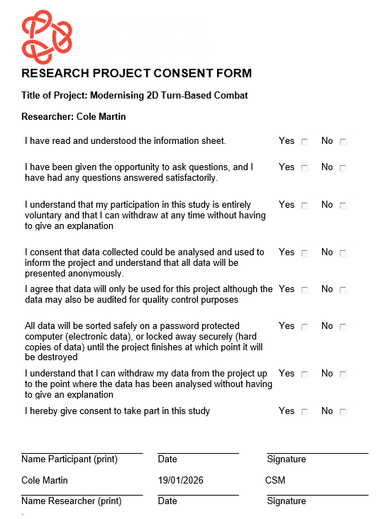
Information Sheet
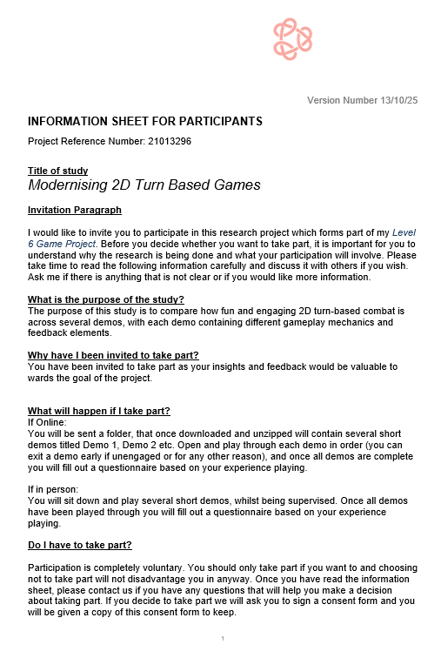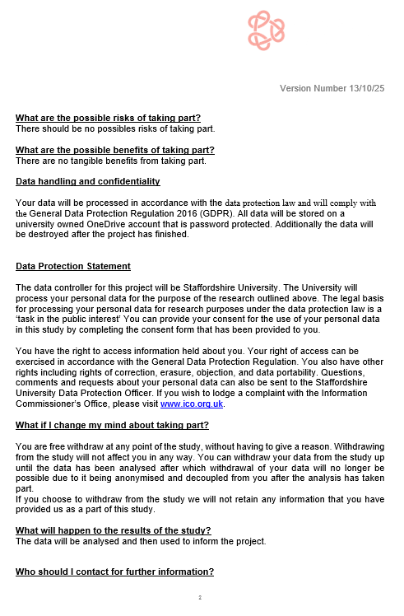
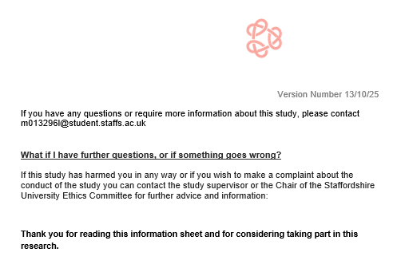

Questions – These were recreated in Microsoft Forms
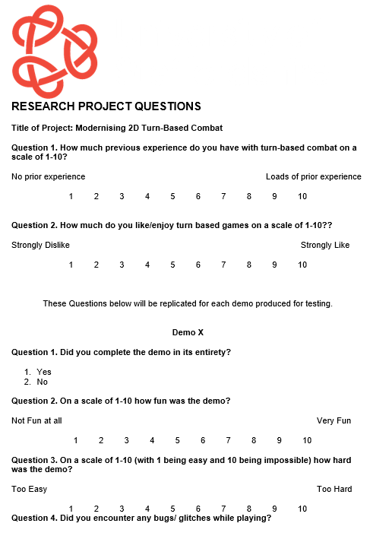
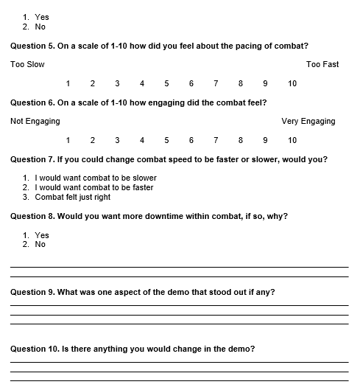

Appendix B
The Design Document created alongside the development of this artefact.
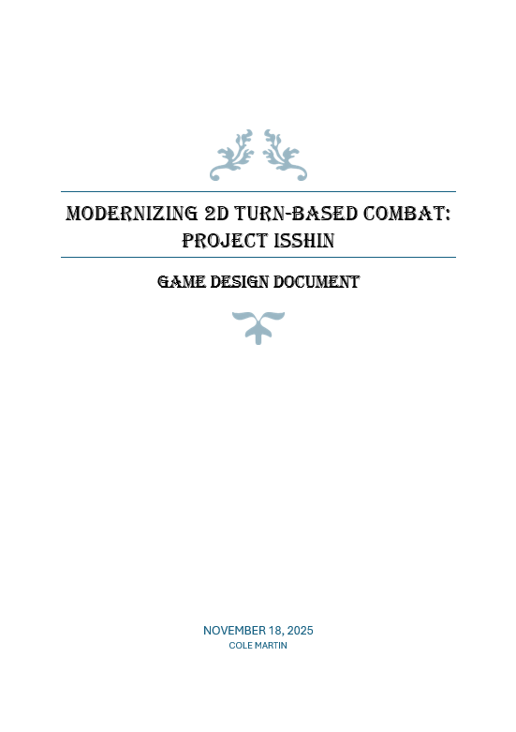
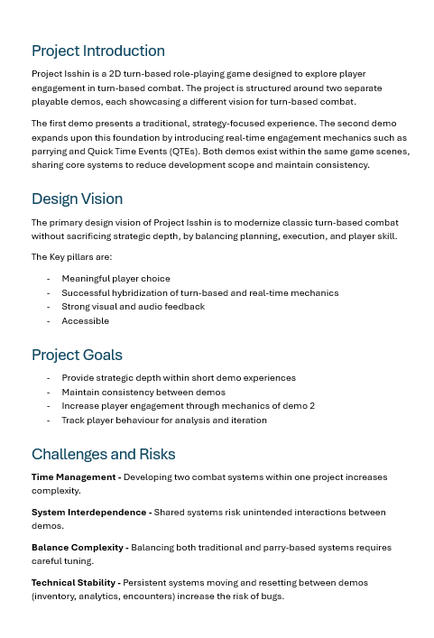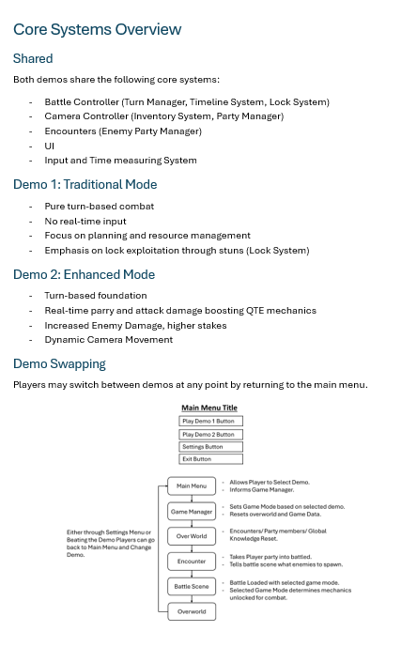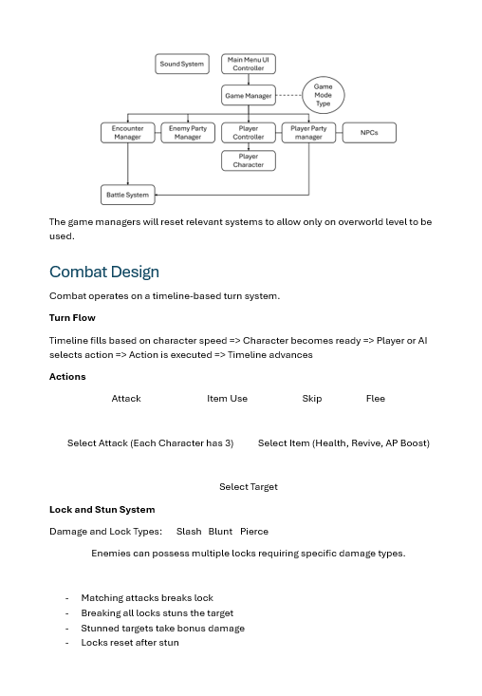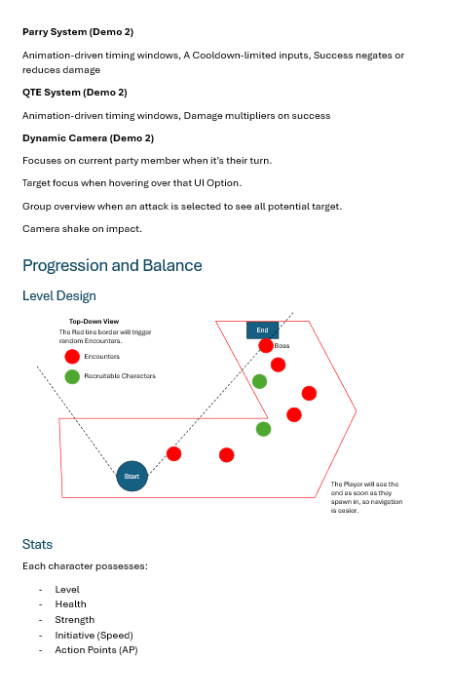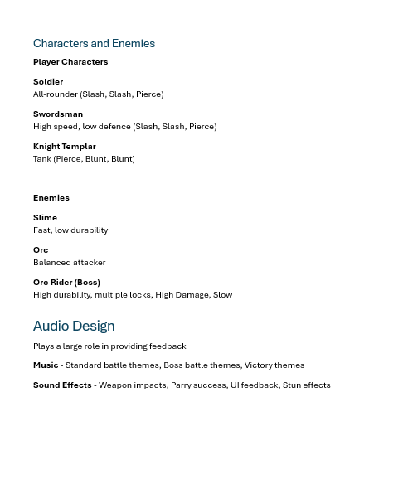

Appendix C
All the raw data collected during testing, including quantitative and qualitative.
Qualitative Data
Game Telemetry Data
Participant | Demo 1 Time Taken | Demo 1 Encounters | Demo 1 Inputs | Demo 2 Time Taken | Demo 2 Encounters | Demo 2 Inputs
User 1 | 30:48 | 7 | 227 | 20:12 | 12 | 1214
User 2 | 21:58 | 7 | 212 | 10:06 | 7 | 150
User 3 | 12:31 | 7 | 136 | 08:12 | 7 | 383
User 4 | 9:09 | 9 | 130 | 7:55 | 7 | 160
User 5 | 13:38 | 7 | 139 | 09:49 | 7 | 580
User 6 | 23:38 | 7 | 223 | 8:31 | 7 | 625
User 7 | 12:25 | 7 | 144 | 11:42 | 7 | 270

Questionnaire Raw Result
Background Questions | Responses (User 1 -11)
Turn-based experience (1-10) | 2 | 6 | 6 | 8 | 1 | 10 | 9 | 7 | 4 | 7 | 8
Enjoyment of turn based games (1-10) | 3 | 8 | 8 | 6 | 5 | 9 | 10 | 8 | 7 | 7 | 7

Demo 1 Questions | Responses (User 1 -11)
Completed Demo 1  (Yes/ No) | Y | Y | Y | Y | Y | Y | Y | Y | Y | Y | Y
Fun  (1-10) | 8 | 10 | 8 | 7 | 7 | 9 | 8 | 7 | 7 | 5 | 5
Difficulty  (1-10) | 8 | 6 | 3 | 8 | 8 | 3 | 6 | 10 | 9 | 4 | 3
Bugs Or Glitches  (Yes /No/ Maybe) | M | M | N | M | N | Y | N | Y | N | Y | N
Combat Pacing  (1-10) | 5 | 4 | 5 | 10 | 5 | 8 | 8 | 8 | 3 | 4 | 6
Combat Engagement  (1-10) | 9 | 8 | 6 | 7 | 8 | 7 | 8 | 6 | 6 | 4 | 4
Change Combat Speed (Faster /Slower/ Just Right) | JR | Slower | JR | JR | JR | Faster | JR | JR | Faster | Faster | JR
More Combat downtime  (Yes/ No) | N | N | N | Y | N | N | N | N | N | N | N

Demo 2 Questions | Responses (User 1 -11)
Completed Demo 1  (Yes/ No) | Y | Y | Y | Y | Y | Y | Y | Y | Y | Y | Y
Fun  (1-10) | 10 | 6 | 7 | 8 | 6 | 10 | 5 | 8 | 9 | 6 | 6
Difficulty  (1-10) | 6 | 2 | 3 | 9 | 3 | 1 | 3 | 10 | 3 | 6 | 3
Bugs Or Glitches  (Yes /No/ Maybe) | N | N | M | M | N | Y | Y | Y | Y | Y | M
Combat Pacing  (1-10) | 5 | 6 | 5 | 10 | 7 | 8 | 7 | 8 | 5 | 5 | 5
Combat Engagement  (1-10) | 10 | 4 | 8 | 8 | 8 | 7 | 5 | 6 | 8 | 5 | 4
Change Combat Speed (Faster /Slower/ Just Right) | JR | Slower | JR | JR | Slower | JR | JR | JR | JR | Slower | JR
More Combat downtime  (Yes/ No) | N | N | N | Y | N | N | N | N | N | Y | N

Qualitative Data
Demo 1
Standout Aspect
User 1 – “I liked how you had to figure out which fighting aspect was the weakness.”
User 2 – “I liked the management of the items, needing to use potions instead of constantly attacking made the combat more engaging in my opinion.”
User 3 – “the way it felt like it was in a 3d world and the characters was 2d.”
User 4 – “I liked the combat camera more, it felt less snappy and disorienting by staying static.”
User 5 – “I really liked the setting and the music it was a very nice vibe I thought. The characters were nicely designed also. I did think it was very engaging because demo 1 wasn't too easy or too hard, the last battle with he Orc Rider was challenging but in a fun way.”
User 6 – “”
User 7 – “The concept of different attack types being needed to stun enemies makes the combat more strategic.”
User 8 – “Enemies have way too much health or player deals too little, easy to get soft locked.”
User 9 – “Lock System was cool.”
User 10 – “Kind of just waiting for animations to play out.”
User 11 – “I enjoyed where you were able to move between battles even though the game seemed fairly 2D.”

Further Feedback
User 1 – “The game was very interactive and fun. The only suggestion would be potentially more loot drops once failing a level as it adds to the hardness.”
User 2 – “I would like the camera angles from the second demo in the first demo and maybe have the characters move to the enemy they are attacking instead of just moving forward to attack.
User 3 – “”
User 4 – “Currently you can spam spacebar to negate damage or increase damage so the QTE's feel quite cheeseable, no need to time correctly.”
User 5 – “I really liked the setting and the music it was a very nice vibe I thought. The characters were nicely designed also. I did think it was very engaging because demo 1 wasn't too easy or too hard, the last battle with the Orc Rider was challenging but in a fun way.”
User 6 – “”
User 7 – “less resources given, such as health and revive potions.”
User 8 – “Health was a bit low for my taste, enemies are hard, camera Jitters (physics problem with your rigidbody + translate), lock system only works if you have all the attack types aka all the companions?
User 9 – “Make Difficulty curve a bit more natural.”

User 10 – “A skip feature for the combat animations.”
User 11 – “I feel the enemies didn't level up at the same rate as the soldier therefore the game felt sort of easy towards the end, and perhaps while moving about allow the player to explore more maybe gaining more combat skills and potions.

Demo 2
Standout Aspect
User 1 – “I liked how it zoomed into the enemy that you were attacking when picking it in the menu.”
User 2 – “I liked the camera movement in the fights, I think it contributed to the fight and made the game more alive during combat.”
User 3 – “been able to parry”
User 4 – “The parries made it more engaging for sure”
User 5 – “Similar to what I said about demo 1 but it was interesting to see the difference in damage when using the QTE thing (space bar) and having to use that was definitely more engaging.”
User 6 – “QTE was a nice change of pace from demo 1. Made the overall experience more engaging.”
User 7 – “parry mechanic was cool if glitch is sorted out”
User 8 – “The encounter system seems to be broken.”
User 9 – “The Parry Was Cool, just made it a bit too easy”
User 10 – “I liked the lock system of stunning”
User 11 – “Not one massive thing, but I liked how when you hovered over the enemies name it would zoom in and show you who you are focusing on.”

Further Feedback
User 1 – “I liked that you can press space to enhance your attack and also to sheild an oncoming attack. Overall a very fun and interactive demo with character!”
User 2 – “I would maybe make it more clear to press space on the quick time events when more than one press is needed. On attacks like double slam I didn't realise that you needed to press more than once because the UI didn't change on the screen much, I think even making the green line around the "SPACE" that pops up might help with this. I think a lot of the game picks up in pace from the first demo, I found the parry mechanic really easy to pick up and I only got hit around 5 times during the demo. I think having the combat slow down leads to more tension in the parry and will make more players mess up. Because of this I only used 1 health potion during my run and the encounters became the same fight over and over, unlike with the first demo where each encounter felt unique based on what enemy I was fighting and if there was more than one, who would I eliminate first.”
User 3 – “probably add a delay into the parry as you can just spam space bar and not get hit”
User 4 – “probably add a delay into the parry as you can just spam space bar and not get hit.”
User 5 – “I think it was my fault because I was spamming the space bar but it was really easy because I wasn't taking any damage so the last battle with the Orc Rider wasn't as hard. Though, I think it is good how slow he took damage because it was harder in that aspect.”
User 6 – “The QTE button can be spammed to create multiple input sounds (damage multiplier does not appear to also stack).”
User 7 – “again less potions given”
User 8 – “You can spam the parry in attack and defense making you invincible, the encounters happen even if you dont move, its a bit rage inducing.”
User 9 – “Add different timings for attacks to make parry harder.”
User 10 – “Ap potions kind of feel pointless because it would be better to just heal and passively generate ap.”
User 11 – “Make it harder. I feel like the ability to parry made the game too easy.”

