

FINAL YEAR PROJECT

COMP60011

An Algorithm for Optimizing Grip Feedback within Robotics

Max McGill

23016770

Supervisor: Steve Cahill

06/05/26

Table Of Contents
Table Of Contents 2
List Of Figures 3
List Of Tables 3
1. Final Report 4
1.1. Abstract 4
1.2. Introduction 5
1.2.1. Research Background 5
1.2.2. Hypothesis 5
1.2.3. Aim 5
1.2.4. Objectives 6
1.2.5. Deliverables 6
1.2.6. Structure of Report 6
1.2.7. Research Methods 6
Research Methodologies 6
Introduction 6
Types of Project Methodologies 8
Chosen Methodology 10
Integration of Methodology with SDLC 10
Qualitative and Quantitive 10
Research Methods 11
1.3. Literature Review 13
Industrial/ Commerical Use 13
Manufacturers 13
Components 13
Materials 13
Software 14
Safety Precautions 15
1.4. Design And Implementation Of Artefact 16
Algorithm 16
Physical 21
1.5. Testing And Validation Of Artefact 22
Force Test 23
Object Pickup Test 24
Heavier Object Pickup Test 24
Potential future improvements identified from this test included: 24
Soft Object Test 25
Fragile Object Test 25
1.6. Conclusion 26
2. References 27
3. Appendices 29
Appendix A – Logbook of Meetings 29
Appendix B – Ethics Form 29
Appendix C – Risk Assessment 31
Appendix D – CodeBase 34

List Of Figures
Figure 1 The Software Development Lifecycle 7
Figure 2 Waterfall Methodology Diagram 8
Figure 3 Agile Methodology Diagram 8
Figure 4 Lean Methodology Diagram 9
Figure 5 DevOps Diagram 9
Figure 6 State Machine Diagram 16
Figure 7 Program Loop Button Code 17
Figure 8 MovingToTarget State 17
Figure 9 PWM Servo Write Code 18
Figure 10 Servo Motor Write Command 18
Figure 11 Calculation Functions 19
Figure 12 Check Force State 19
Figure 13 Force Calculation 19
Figure 14 Average Force Calculation 19
Figure 15 Force Threshold Definition for Measurement 20
Figure 16 If Resistance Detected 20
Figure 17 Retract the Fingers Slightly 20
Figure 18 Non Blocking Delay 20
Figure 19 Milestone Tests 23
Figure 20 Force Calculation again 23
Figure 21 Reverse State 25

List Of Tables

Final Report

Abstract
This project presents the design, implementation, and evaluation of a low-cost robotic force-feedback gripping system intended to prevent the crushing of delicate objects during automated handling. The system integrates a finite state machine (FSM) architecture, manually implemented Pulse Width Modulation (PWM) for servo control, and a software-based force estimation method derived from servo positional error. Developed using an ESP32-C3 microcontroller and Arduino-based C++ programming, the artefact operates as a closed-loop control system that continuously monitors servo behaviour and adapts grip strength in real time.
Experimental evaluation demonstrated successful force detection and adaptive grip control across a range of test scenarios, including rigid, soft, and fragile objects. However, limitations were identified in mechanical design tolerances, actuator strength, and the absence of dedicated force sensors, which constrained performance under higher load conditions.
Overall, the project demonstrates that effective force-feedback behaviour can be achieved using low-cost components and software-based sensing techniques, providing a scalable foundation for further development in adaptive robotic gripping systems.

Introduction

Research Background
In this project, an algorithm will be created that when implemented will allow for a robotic device to precisely apply of pressure to an object without crushing or dropping it. This idea stems from the inherent lack of advanced robotics with pressure systems like that and rely almost entirely on the user being careful. This idea is beneficial to all robotic arms like in car production for example. When a car is being manufactured different parts need to be painted, a robotic implement holds the part. This machine needs to ensure that it is not applying too much force which will cause damage and that is also not applying too little force as that will drop the part which will cause damage.
The researcher’s interest in robotics, specifically in the study of articulated prosthetics, led to the identification of this problem. Findings from this project will inform and support the researcher’s future studies and the creation of associated research artifacts.
The final artifact is made up of four components: the force sensor feedback circuit, the articulation of the arm, the algorithm that combines both of these components, and the shell that holds it all together.
There are five subtasks in this project: the Research, the Documentation, the Modelling, the Circuitry (Prototype), Algorithm, and the Artifact. The progress and timeline of each of these are managed in an excel spreadsheet and with the use of GitHub Projects, the individual tasks and goals of these can also tracked.
In terms of techniques to be used within this project, the main few are 3D Modelling, CAD Design, Circuit Design, and Programming. An algorithm will need to be made that handles the force sensor and potentiometer input and converts it into data usable by the motors in the arm.

Hypothesis
Hypothesis 1. There are mechanically and electrically simple mechanisms for force-feedback.
Hypothesis 2. These feedback systems could be easily implemented into a robotic system.
Hypothesis 3. Prosthetics are over-priced especially when it comes to having additional features like feedback, temperature sensing, and waterproofing.

Aim
There are two main goals for this project; the first of which is to have an algorithm that can take the force applied and user input and output the appropriate amount of rotation to a motor. The second is to have an artifact that can demonstrate this by picking up different kinds of objects that have varying texture and degrees of fragility.

Objectives
Objectives for this project are:
- Building a solution to the lack of force-feedback devices within robotic arms and prosthetics.

- Showcasing how affordable they could be when compared to the commercial products.

Deliverables
In this project, an artefact (including an algorithm for force feedback and a physical product being the robotic hand), a literature review, this report,

Structure of Report
This report is structured into several key sections that collectively document the research, development, and evaluation of the robotic force-feedback system. The report begins with an introduction outlining the project background, aims, objectives, and research methodology. This is followed by a literature review examining existing robotic grip systems, industrial applications, relevant components, materials, software, and safety considerations. The design and implementation section explains the development of the robotic artefact, including the finite state machine architecture, manual PWM servo control, and force-feedback algorithm. The testing and validation section evaluates the effectiveness and reliability of the system through practical experimentation. Finally, the report concludes by reflecting on the project outcomes, hypothesis validation, and future improvements, followed by references and appendices containing supporting documentation such as risk assessments and meeting logs.

Research Methods

Research Methodologies

Introduction
This project focuses on creating an algorithm that allows a robotic arm to automatically adjust the amount of pressure it applies when gripping different objects, preventing both crushing and accidental dropping. Modern robotic and prosthetic systems often lack this level of precision, relying heavily on careful manual control, so this project aims to provide a practical solution by combining user input with real-time force feedback. The final artifact will demonstrate this through a custom prototype arm built with a force sensor circuit, articulated joints, a housing structure, and the algorithm that links all components together. By developing this system, the project will contribute toward improving how robotic devices handle objects of varying fragility and will also inform future work in articulated prosthetics, which is the main area that inspired this research.
Project methodologies provide essential structure for managing tasks, ensuring that work is organized and progresses logically from start to finish. Choosing an appropriate methodology improves predictability, reduces risks, and helps break complex projects into manageable steps, making it easier to achieve key objectives. Different approaches, including Waterfall, Agile, Lean, and Design Thinking, offer a variety of strategies for planning, development, and review, each with its own benefits depending on the project’s needs.
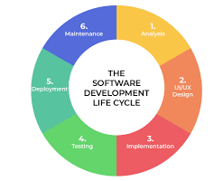
The Software Development Life Cycle (SDLC) offers a reliable framework for guiding software and artifact development through defined stages such as requirement gathering, design, implementation, testing, deployment, and maintenance. Pairing a well-suited methodology with the SDLC structure brings stability and flexibility to the development process, allowing consistent review and improvement as the project advances toward its goals. (GeeksforGeeks, 2024).
Figure 1 The Software Development Lifecycle
SDLC provides a structured framework for the development of software and digital artifacts, supporting consistency, quality control, and long-term sustainability. The process initiates with requirement gathering and analysis, which establishes technical objectives and project boundaries. System design translates these objectives into formal specifications, architectural schematics, and actionable development plans. Implementation follows, in which design artifacts are realized through the creation and integration of functional components.
Testing serves as a vital phase to confirm that the developed system aligns with documented requirements and performs reliably across intended scenarios. Deployment transitions the tested software into an operational environment with appropriate configuration and accessibility procedures. Subsequent maintenance activities address ongoing refinements, technical support, and adaptation to evolving contexts or needs. This phased approach under SDLC enables systematic development and continued viability for a wide range of software projects.

Types of Project Methodologies
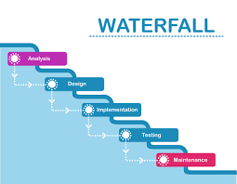
Waterfall methodology is a step by step approach where only one stage is worked on at a time and must be fully completed before moving on . Stages aren’t revisited after finishing which does make it easy to plan but doesn’t allow for changes to be made afterwards. This method works best when there is a solid understanding of what needs to be done before the project starts.(Atlassian, 2025).
Figure 2 Waterfall Methodology Diagram
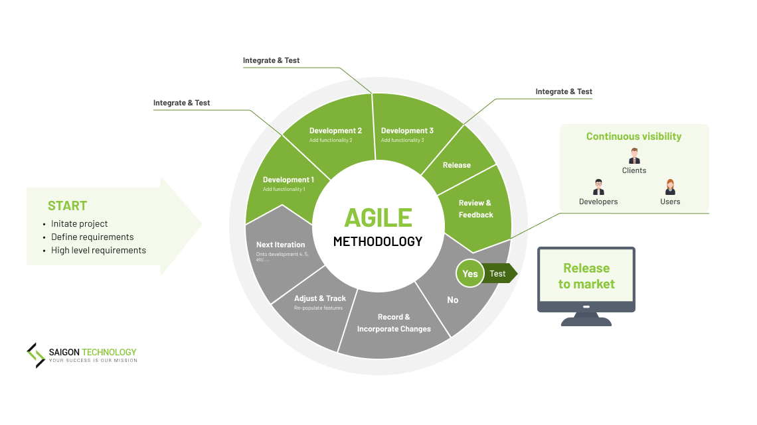
Agile is more flexible than waterfall as instead of doing everything in one continuous sequence, the project is broken up into smaller pieces which are iterated on and improved based on the review and feedback. Each iteration is called a sprint. These sprints are a series of tasks that must be completed before the review stage of the current iteration. Agile focuses on adapting to new information, testing things regularly, and responding to feedback throughout development. Agile also acts as an overarching philosphy for other methodologies like scrum to implement. (Pham, T.B; 2025, Coursera, 2023).
Figure 3 Agile Methodology Diagram

Scrum is a framework based on agile that is ‘designed to help teams develop, deliver, and sustain complex products through collaboration, transparency, and iterative progress.’ . An appointed Scrum Master is an individual who manages the scrum system within the team and helps things to run smoothly. This framework is useful for when the team needs a clear routine as well as flexibility.(Knowledge Train, 2025).
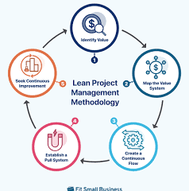
Lean is all about keeping things efficient and cutting out anything that doesn’t add value to the final result . This includes avoiding unnecessary steps, simplifying processes, and reducing delays wherever possible. It encourages constant improvement and making the most of limited time and resources. Lean is especially helpful when the project must stay focused and avoid wasting effort. (Asana, 2021).
Figure 4 Lean Methodology Diagram
Design Thinking focuses on understanding the user and the real problem before building anything. It involves steps like researching the user, defining the problem, brainstorming possible solutions, prototyping ideas, and testing them. It encourages creativity and makes sure the project solves the right issue. This approach is most useful for projects where usability and the overall user experience are important. (Interaction Design Foundation, 2016).
DevOps is ‘a software development methodology that breaks down traditional barriers between development (Dev) and IT operations (Ops) teams. It involves ideas like automation, regular testing, and continuous integration to speed up development and reduce errors. This approach is normally used for larger software systems that need constant updates or very high reliability. For smaller prototype projects, it can be more than what’s needed. (Microsoft, n.d.).
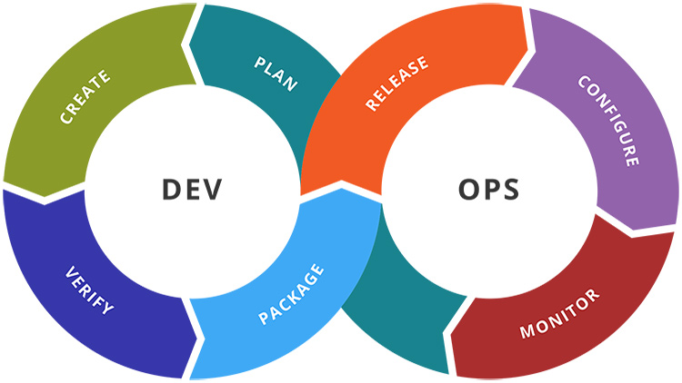
Figure 5 DevOps Diagram
Hybrid methodologies mix parts of different approaches to create something that fits the project better. For example, you might use Waterfall for the planning phase but switch to Agile when actually building and testing the system. Hybrid approaches are useful when the project doesn’t fully suit one single methodology and needs a balance between structure and flexibility. (Teamhood, 2021).
Each methodology approaches development differently. Waterfall is the most structured and easy to plan but doesn’t handle changes well. Agile and Scrum are far more flexible, breaking the work into smaller cycles that can be reviewed and improved as the project progresses. Lean focuses on efficiency and removing anything unnecessary, while Design Thinking is centred around understanding the user and solving the right problem. DevOps is suited to larger systems that need constant updates and automation. Hybrid approaches combine the strengths of different methods and are useful when a project needs both structure and flexibility.

Chosen Methodology
The most suitable methodology for this project would be a hybrid method between Design Thinking, Waterfall, and Agile. Overarching planning was based on the waterfall methodology, which made it easier to define important deliverables, schedules, and the initial organisation of resources. Design Thinking was adopted at the design and conceptual phaseto support the development of algorithmic logic and hardware configuration, prioritizing iterative ideation and responsiveness to end-user needs. Agile principles were incorporated into the implementation stage to guide development, enabling adaptability through iterative review cycles and continuous improvement based on emerging insights.
Alternative methodologies such as DevOps, Scrum, and Lean were considered but found to be less appropriate for the project context. DevOps and Scrum presuppose sustained team collaboration and specialized roles, conditions not present in a single-developer undertaking. Similarly, Lean methodology is generally orientated toward process optimization and incremental change within established organizational structures, which did not align with the project's exploratory and innovation-driven objectives. The combination of Waterfall, Design Thinking, and Agile was determined to provide the necessary structure and flexibility, ensuring efficient progression from concept to execution while meeting the demands of timeline, complexity, and diverse user requirements.

Integration of Methodology with SDLC
The selected hybrid methodology, which combines Waterfall, Design Thinking, and Agile principles, aligns closely with the structured phases of the SDLC. Foundational activities such as requirement analysis and system design reflect Waterfall principles, supporting thorough documentation and systematic planning. Design Thinking is particularly effective in the early stages, allowing iterative exploration and refinement of design objectives. Agile methods address the later phases, guiding development, testing, deployment, and ongoing maintenance, where incremental improvement and adaptability are required. This mapping ensures that each phase of the SDLC benefits from distinct methodological strengths, structured according to the needs of a single-developer project.
Integrating multiple methodologies within the SDLC framework provides both clarity and flexibility, supporting process management and continuous refinement. This hybrid approach streamlines decision-making and maintains a transparent workflow across each phase. The primary challenge lies in ensuring smooth transitions between different methodological frameworks and avoiding fragmentation in practice. With consistent oversight and disciplined project tracking, the combined approach supports efficient progress and effective delivery in a solo development context.

Qualitative and Quantitive
This project makes use of both qualitative and quantitative research methods to properly understand how the robotic grip system performs and how it can be improved. Using both types of data helps build a clearer picture of the system, since it allows you to look at real measurements as well as practical experiences during testing.
Qualitative research focuses on descriptive information rather than numbers. In this project, this includes observations made while testing the robotic arm, such as how smoothly it reacts, whether the grip adjustments feel natural, and any issues noticed during operation. It also includes user feedback on how easy the system is to control and whether the response of the arm seems reliable. This type of research helps identify problems that may not be obvious from numerical data alone. (University of Southern California, 2022a)
Quantitative research involves collecting measurable data that can be compared and analysed. For this project, this includes force readings from the sensor, the exact pressure applied to different objects, reaction times, and the number of successful vs. unsuccessful grips. These values help show whether the algorithm is accurate and consistent, and whether the system meets the technical requirements set out during planning.(University of Southern California, 2022b)
By combining both qualitative and quantitative methods, the project can evaluate the prototype more effectively. Quantitative data shows how well the system works in measurable terms, while qualitative data helps explain why certain behaviours happen and what could be improved. Together, they support a clearer understanding of the system’s reliability, usability, and overall performance.

Research Methods
As part of the research methods, a hardware experimentation phase was undertaken to determine the most suitable actuation and sensing components for implementing a functional force-feedback system. This stage was necessary due to the prototype nature of the artefact and the requirement to validate different electromechanical approaches before committing to a final design. The process followed an iterative experimental approach, where multiple actuator types and sensing methods were tested under identical control conditions to evaluate their suitability for real-time grip regulation.
Initially, DC motors were considered due to their simplicity, low cost, and ease of control using PWM speed modulation. Early experiments focused on using DC motors in combination with mechanical linkages to simulate finger motion. However, it quickly became apparent that DC motors lacked intrinsic positional control, meaning additional feedback mechanisms would be required to determine shaft position. Without encoder integration, the system could not reliably determine angular position, making DC motors unsuitable for a feedback-driven gripping system where positional accuracy is essential for force estimation. Even when PWM speed control was applied, the absence of positional awareness resulted in drift and inconsistent movement, which directly undermined the stability required for force-feedback logic.
Stepper motors were then evaluated as an alternative due to their inherent positional control characteristics. Stepper motors offer discrete angular movement in fixed steps, which theoretically makes them well suited for precise positioning tasks. In early testing, stepper motors demonstrated improved repeatability compared to DC motors, particularly in open-loop control scenarios. However, when integrated into the full system architecture, several limitations became apparent. Under load conditions, the stepper motors exhibited missed steps and torque loss, especially when resistance was applied to simulate object gripping. This introduced cumulative positional errors, which invalidated the assumption of accurate position tracking. Since the force estimation algorithm relied heavily on precise positional feedback, any loss of step integrity directly corrupted force calculations. Additionally, the increased power consumption and slower response times made stepper motors less suitable for dynamic grip adjustment.
Servo motors were ultimately selected as the primary actuation method due to their integrated feedback control system. Unlike DC and stepper motors, servos provide built-in positional control through internal potentiometers and control circuitry, allowing direct angle-based control via PWM signals. This made them significantly more suitable for real-time grip control and simplified the implementation of the finite state machine. Servo motors also provided sufficient torque for low-to-moderate load gripping tasks, making them appropriate for a prototype-scale robotic hand. Their compatibility with angle-based control logic aligned naturally with the force estimation approach used in the system, where positional deviation was interpreted as resistance force.
Alongside actuator testing, multiple types of potentiometers and analogue input devices were also evaluated to determine their suitability for positional feedback and control input. Different rotary potentiometers were tested to assess linearity, noise stability, and resolution. It was found that lower-quality potentiometers introduced signal noise and inconsistent analogue readings, which would have reduced the reliability of any direct force-sensing implementation. Higher-quality potentiometers provided more stable readings but were not ultimately required for the final system due to the adoption of servo-based internal feedback.
During the early design phase, force sensors such as force-sensitive resistors (FSRs) and load cells were intended to be incorporated into the fingertips to provide direct force measurement. However, these components were not available during the experimental phase due to being misplaced or unavailable in the development environment. As a result, they were excluded from initial testing. This constraint significantly influenced the direction of the project and reinforced the decision to adopt a software-based force estimation approach.
Instead of relying on dedicated force sensors, the system was adapted to infer force through indirect measurement using servo positional error. This decision was validated during experimentation with the alternative actuator and sensor combinations described above. The absence of force sensors shifted the research focus toward evaluating how effectively resistance could be estimated using motor behaviour alone. This was achieved by observing how each actuator type responded under load and determining whether positional deviation could reliably indicate external resistance.
This experimental phase provided critical insight into the trade-offs between different actuation and sensing technologies in robotic gripping systems. DC motors were rejected due to lack of positional control, stepper motors were limited by torque and step reliability under load, and potentiometer-based sensing introduced unacceptable noise for high-precision feedback. Servo motors were therefore selected as the most suitable compromise between control simplicity, positional accuracy, and integration with PWM-based control systems.
This iterative experimentation process directly informed the final system architecture and justified the use of a servo-based, software-estimated force-feedback model. It also demonstrated that effective grip regulation can be achieved without dedicated force sensors, provided that actuator feedback is sufficiently stable and accurately interpreted within a well-structured control system such as a finite state machine.

Literature Review

Industrial/ Commerical Use

Manufacturers
The global commercial and industrial robotic arm market is highly concentrated and dominated by a small number of multinational manufacturers sometimes known as “The Big Four”. The International Federation of Robotics identifies FANUC, ABB, Yaskawa Electric, and KUKA, as accounting for the majority of the global installed base, particularly within automotive, electronics, and metal industries. According to the World Robotics report 2023, cumulative global installations of industrial robots exceeded four million operational units by 2023, with annual installations continuing to grow despite regional variation. Regional deployment patterns further indicate that Asia accounts for the largest share of new industrial robot installations with an increase from 23,000 in 2011 to 276,000 in 2023, followed by Europe and the Americas, underscoring the global reach of these manufacturers and their reliance on export-oriented production networks. (International Federation of Robotics, 2023; International Federation of Robotics, 2024; Our World in Data, n.d.)

Components
Industrial robotic arms incorporate a set of common electronic and mechatronic components that enable precise motion control, sensing, and system integration. Central to these systems are electric actuators, most commonly servo motors, which provide controlled joint motion and are paired with motor driver electronics to regulate current, voltage, and torque output . Each joint is typically equipped with position and velocity sensors, such as optical encoders supplying real-time feedback necessary for closed-loop control and high positional accuracy. Motion planning and coordination are handled by a central control unit, often based on embedded processors or industrial controllers, which execute control algorithms and manage communication between sensors and actuators. Power management electronics distribute and condition electrical power to meet the requirements of motors, sensors, and control hardware, ensuring stable operation under varying loads. Many industrial robotic arms also integrate force-torque sensors, proximity sensors, and vision systems, enabling interaction with the environment, collision detection, and adaptive manipulation tasks. Together, these electronic subsystems form the technological foundation that supports the accuracy, repeatability, and reliability expected of modern industrial robotic arms. (Robotics Meta, 2023; A. Owen-Hill, 2022; Fiveable, 2025; Standard Bots, 2024; Ostbridge Tech, 2024)

Materials
Industrial robotic arms are fabricated from a combination of metals, polymers and advanced composites selected to optimise stiffness, strength, inertial properties and durability for specific tasks. Structural members and joints commonly employ steel and aluminium alloys to provide high load-bearing capacity and favourable strength-to-weight ratios, with steel favoured for high-payload and high-wear applications and aluminium used to reduce moving mass and improve dynamic response. To further reduce mass while retaining stiffness, manufacturers and researchers increasingly integrate carbon-fibre-reinforced polymers (CFRP) or hybrid CFRP-aluminium structures in lightweight, high-acceleration arms and end-effectors. Functional interfaces such as gears, bearings and bearing surfaces typically use hardened steels, bearing alloys and engineered polymers to minimise friction and extend service life under cyclic loading. Additive and robot-assisted manufacturing of large polymer and composite components is expanding design freedom for bespoke robotic structures and enabling novel material combinations that improve performance and reduce part count. Surface coatings, elastomers and cable-management polymers are also important for corrosion protection, electrical insulation and operator safety in diverse industrial environments. Collectively, these material choices determine the arm’s dynamic performance, energy consumption, durability and suitability for particular industrial applications. (Protolabs, 2023; Khan et al., 2024; Asahi Kasei, n.d.; Akbari et al., 2022)
The selection of these materials is governed by fundamental strength, stiffness and dynamic relationships. For a robotic arm link supporting a payload m, the static load is given by F = mg, which produces a bending moment at the joint of M = FL, where L is the link length. The resulting bending stress must remain below the allowable material stress and is expressed as σb = Mc/I, with c being the distance to the outer fibre and I the second moment of area. This relationship highlights the advantage of hollow aluminium or composite sections, which maximise I while minimising mass.
Axial tensile or compressive stresses are governed by σ = F/A, requiring that the working stress does not exceed the material’s yield or ultimate tensile strength divided by an appropriate safety factor. Stiffness and positional accuracy are constrained by elastic deflection, commonly approximated for a cantilevered arm as δ = FL³/(3EI), where E is Young’s modulus. This explains the continued use of high-modulus steels in high-payload robots and the need for careful fibre alignment in CFRP structures.
During high-speed operation, inertial forces F = ma and joint torques τ = Iα dominate, making low-density materials such as aluminium alloys and composites critical for reducing inertia, motor torque demand and energy consumption.
Finally, cyclic loading necessitates adequate fatigue strength, particularly in joints and bearings, justifying the use of hardened steels and engineered polymers in high-wear interfaces. Together, these governing equations demonstrate how material selection directly controls the structural integrity, dynamic performance and operational lifespan of industrial robotic arms.

Software
Industrial robotic arms produced by the dominant manufacturers FANUC, ABB, Yaskawa and KUKA rely on proprietary, tightly integrated software platforms that underpin motion control, programming, system integration and safety. Each manufacturer provides a dedicated robot controller and programming environment, including FANUC TP programming with ROBOGUIDE, ABB RAPID with RobotStudio, Yaskawa INFORM with MotoSim, and KUKA Robot Language (KRL) with KUKA.Sim, all designed to deliver deterministic real-time control and high positional accuracy. These software systems implement closed-loop motion control, trajectory planning and collision avoidance while enforcing joint, speed and payload constraints defined by the robot’s kinematic and dynamic models. Offline programming and digital simulation tools enable virtual commissioning and optimisation of robot programs prior to deployment, significantly reducing commissioning time and production risk. Standard industrial communication protocols are supported to allow integration with PLCs, vision systems and manufacturing execution systems, while certified safety software functions implement safe speed monitoring, safe stop modes and workspace limits in compliance with international robotic safety standards such as ISO 10218. (IFR, 2019; Owen-Hill, 2022; Craig, 2005; International Federation of Robotics, 2023; ISO, 2016; Pilz, 2025)
Industrial robotic arms from major manufacturers support multiple programming methods to accommodate different levels of user expertise and application complexity. Programming languages, such as RAPID, KRL, INFORM and FANUC TP, are widely used for precise control of motion, logic and process parameters in high-volume industrial applications. To improve accessibility and reduce programming time, manufacturers also provide block-based and graphical programming interfaces, allowing users to construct robot programs by assembling predefined motion and logic blocks, which is particularly effective for simple pick-and-place and collaborative applications. Sequence generators and teach-pendant programming further enable operators to create programs by manually guiding the robot through a series of positions and actions, which are then recorded and executed automatically. Offline programming and simulation tools complement these approaches by allowing programs to be developed, tested and optimised in a virtual environment before deployment, reducing downtime and programming errors while supporting rapid reconfiguration in flexible manufacturing systems (International Federation of Robotics, 2023; Craig, 2005; Owen-Hill, 2022; IFR, 2019).

Safety Precautions
Industrial robotic systems require layered safety measures that address hazards from high-speed motion, heavy payloads and non-routine operations such as programming and maintenance. A documented, task-specific risk assessment is the foundation of safe deployment and should consider guarding, emergency stop arrangements, isolation and the potential for human entry into the robot workspace. Engineering controls commonly include fixed or interlocked physical guards, light curtains and pressure sensitive mats, together with safety PLC functions such as Safe Torque Off (STO), speed monitoring and monitored stop states to prevent unintended motion. Regulatory and guidance frameworks emphasise that collaborative applications require additional measures, for example power-and-force limiting, speed-and-separation monitoring and validated hand-guiding modes, only after a specific collaborative risk assessment has demonstrated acceptably low residual risk. Organisational controls, operator training, isolation procedures, documented maintenance and inspection schedules, clear signage and incident reporting are essential to sustain technical safeguards and ensure compliance with national health-and-safety expectations. These technical and administrative layers create a defence-in-depth approach that reduces accident potential throughout the robot system lifecycle. (HSE, n.d.; ISO, 2011/2025; Pilz, n.d.; IFR, 2022; OSHA, n.d.)
The arm should operate at low speeds and have soft or padded end-effectors to minimise injury risk. A clear enclosure or guard can prevent accidental contact, and an easily accessible emergency stop should immediately cut power if needed. Software limits should restrict speed and range of motion, while supervision during operation ensures safe use.
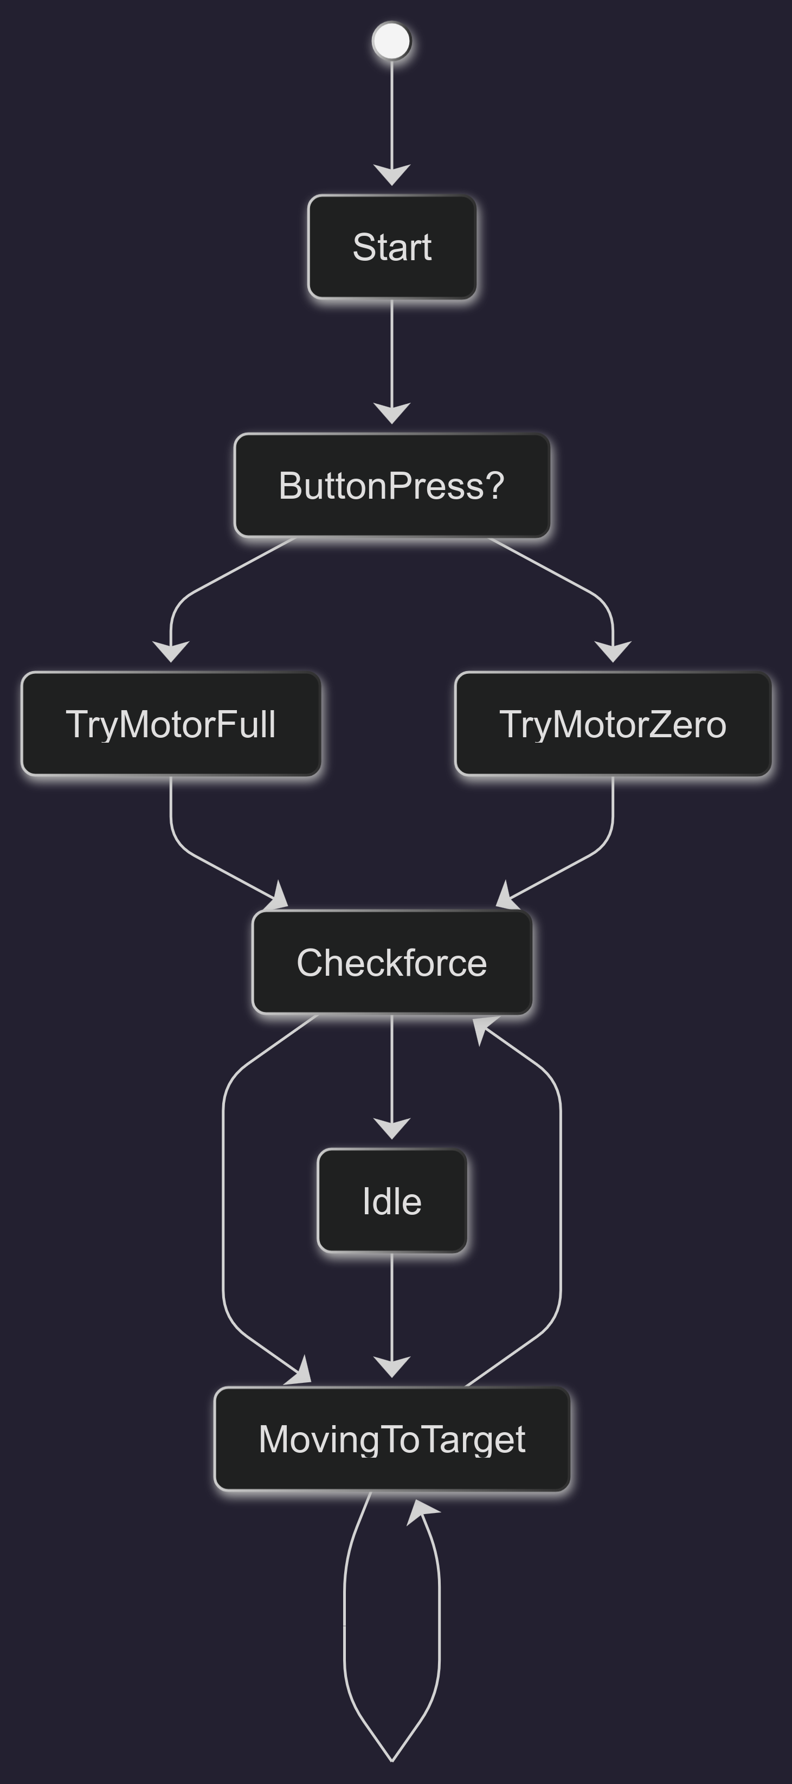
Figure 6 State Machine Diagram

Design And Implementation Of Artefact
The implementation of the robotic force-feedback artefact focused on creating a low-cost embedded control system capable of preventing excessive gripping pressure when interacting with objects of varying fragility. The final design combined software-based force estimation, manually generated Pulse Width Modulation (PWM) servo control, and a finite state machine (FSM) architecture to create an adaptive gripping mechanism. The system was developed using Arduino-based embedded programming in C++ and integrated both hardware and software components into a single closed-loop control system.

Algorithm
The overall design decision to use a finite state machine was made because FSMs provide a modular and highly structured method for controlling reactive systems. This approach was particularly suitable because the robotic gripper needed to continuously react to changing environmental conditions while transitioning predictably between operational behaviours. Additionally, the researcher had previous experience implementing state machines during the development of a second-year rollercoaster control system, making the architecture familiar, reusable, and easier to adapt for robotic force-feedback applications.
The system was designed around four primary states: IDLE, MOVING_TO_TARGET, CHECK_FORCE, and REVERSING. Each state was responsible for a specific behavioural task within the gripping process. Separating behaviours into independent states improved software readability, debugging, scalability, and maintainability.
The IDLE state acted as the resting state of the system. During this state, the controller continuously waited for user input through a button press connected to the Arduino input pin. This state ensured that unnecessary motor movement did not occur while the system was inactive. Once an input was detected, the system transitioned into the MOVING_TO_TARGET state.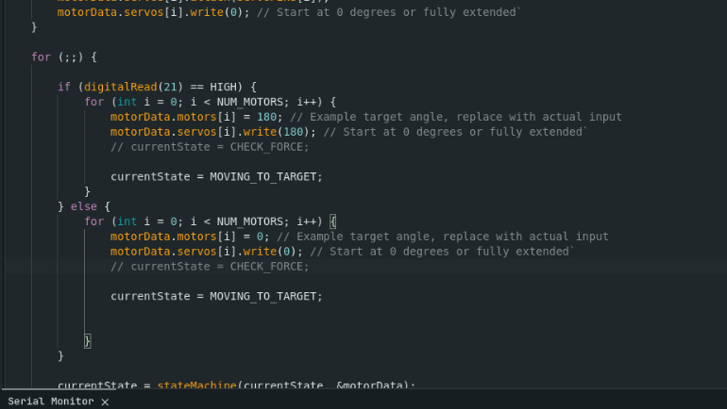
Figure 7 Program Loop Button Code

The MOVING_TO_TARGET state controlled the movement of the servo motors. The target angle for each motor was stored within the motorData->motors[i] array, and each servo was instructed to rotate toward its desired position. The implementation iterated through every motor individually:
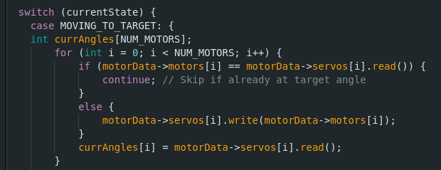
Figure 8 MovingToTarget State
Initially, the standard Arduino Servo library was intended to be used for controlling the servo motors. However, during implementation it became apparent that the library was incompatible with the ESP32-C3 microcontroller used within the system. The incompatibility caused compilation and runtime errors due to differences between the ESP32-C3 architecture and the timer implementations expected by the default Arduino Servo library.
Because the robotic gripping system depended entirely on stable and precise servo control, an alternative PWM solution had to be implemented manually. Servo motors operate using Pulse Width Modulation (PWM), where the duration of the HIGH pulse determines the angular position of the servo shaft. Rather than relying on the unsupported Servo library abstraction, the system generated PWM timing signals directly through software control.
Conceptually, the implementation operated as follows:
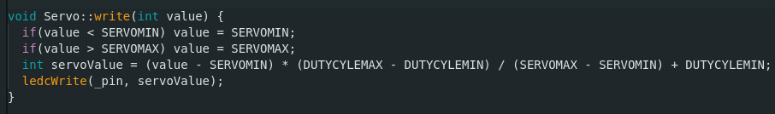
Figure 9 PWM Servo Write Code
This process manually generated the required PWM waveform by controlling the duty cyclem, ensuring it is within parameters. The pulse width was adjusted dynamically depending on the desired servo angle.
Implementing PWM manually provided complete control over signal timing and ensured compatibility with the ESP32-C3. This approach also integrated effectively with the finite state machine architecture and the force-feedback control loop.
Accurate PWM generation was particularly important because the force-feedback mechanism relied on comparing target servo positions with actual servo readings. Any instability or incorrect timing within the PWM signal would affect servo positioning accuracy and therefore reduce the reliability of the force estimation algorithm. By implementing PWM generation manually, the project ensured stable servo operation while maintaining compatibility with the ESP32-C3 microcontroller.
If the target had not yet been reached, the servo received a new movement command:
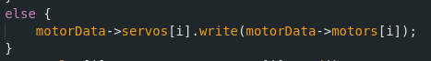
Figure 10 Servo Motor Write Command
This implementation ensured that only servos requiring movement would receive additional commands, reducing unnecessary processing and improving efficiency.
A key design decision within this project was the implementation of force feedback without dedicated force sensors. Instead of using expensive load cells or force-sensitive resistors, the system estimated force through positional error. This was achieved by comparing the commanded servo angle with the actual servo position reading. If the servo was unable to fully reach its intended position, this implied that an object was resisting the motion of the gripper.

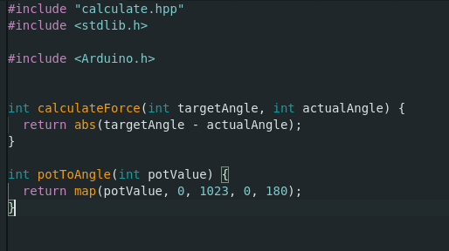
The actual force estimation was implemented within calculate.cpp:
This function calculated the absolute difference between the target angle and the measured angle. The larger the positional difference, the larger the inferred resistance force. This simplified method transformed servo positional deviation into a virtual force sensor, significantly reducing hardware complexity and project cost while still providing functional force feedback.
Figure 11 Calculation Functions

Once movement stabilised, the FSM transitioned into the CHECK_FORCE state. This state evaluated whether excessive gripping pressure was being applied. The implementation iterated through each servo and collected positional readings:
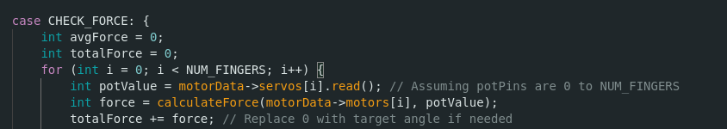
Figure 12 Check Force State
The force was then calculated using the positional error algorithm:
Figure 13 Force Calculation
The calculated force values for all fingers were accumulated and averaged:
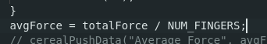
Figure 14 Average Force Calculation
Using an average force value rather than a single reading reduced sensitivity to noise and isolated positional inaccuracies, improving overall system stability.
The system then compared the calculated force against a predefined threshold:
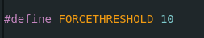
Figure 15 Force Threshold Definition for Measurement
This threshold acted as the maximum allowable gripping force before corrective action was required. Selecting an appropriate threshold was an important design decision because values set too low would cause unnecessary releases, while values set too high could still allow objects to be crushed.

When the average force exceeded the threshold, the FSM transitioned into the REVERSING state:
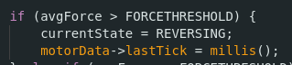
Figure 16 If Resistance Detected
The reversing state formed the core safety mechanism of the project. During this state, every servo was instructed to reverse slightly:
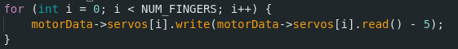
Figure 17 Retract the Fingers Slightly

This reduced the gripping pressure being applied to the object. The decision to reverse by only 5 degrees was made to ensure that objects would not be dropped while still sufficiently reducing compressive force. This small adjustment allowed the gripper to maintain contact with the object while preventing structural damage to fragile items.
The reversing action operated for a fixed duration controlled using Arduino timing functions:
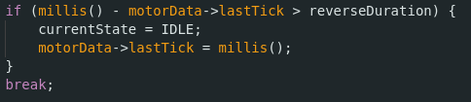
Figure 18 Non Blocking Delay
The use of millis() instead of blocking delay functions was another important implementation decision. Non-blocking timing allowed the FSM to continue updating and monitoring system behaviour while the reversing action occurred. This improved responsiveness and prevented the controller from becoming temporarily unresponsive.

Physical
During the physical implementation of the artefact, several hardware and manufacturing limitations affected the functionality of the final prototype. One of the most significant issues encountered involved the tolerances of the 3D printed components used to construct the robotic fingers and articulation system.
The robotic hand was designed with articulated fingers that included a degree of lateral movement, commonly referred to as finger splay. The intention behind this design was to improve adaptability when gripping irregularly shaped objects by allowing the fingers to spread naturally around the object surface. However, due to the limitations of consumer-grade 3D printing, the printed joints and moving sections did not achieve the required dimensional accuracy.
Small deviations in print tolerances accumulated across the articulated components, causing excessive friction and slight misalignment between the moving joints. Because the finger splay mechanism relied on smooth multi-axis articulation, these inaccuracies prevented the system from operating reliably. In several cases, joints became either too loose, causing instability, or too tight, restricting movement entirely. As a result, the finger splay system could not function consistently and was ultimately disabled within the final implementation.
This issue highlighted the importance of manufacturing tolerances within robotic systems, particularly where multiple moving mechanical assemblies interact simultaneously. Although the software and force-feedback algorithm operated correctly, the physical precision limitations of the printed components reduced the effectiveness of some intended mechanical behaviours. Future improvements would likely involve tighter manufacturing tolerances through resin printing, CNC machining, or redesigning the articulation system to better compensate for dimensional inaccuracies.
Another major limitation encountered during development involved component availability and incomplete hardware integration. The original design intended to incorporate dedicated force sensors within the fingertips to provide direct physical pressure measurements. These sensors would have enabled the system to measure real contact force rather than relying solely on positional error estimation.
However, due to missing components and delivery delays during the prototyping phase, the force sensors could not be integrated into the initial experimental implementation. Rather than halting development entirely, the decision was made to continue using software-based force estimation through servo positional feedback.
This decision ultimately influenced the direction of the project significantly. Instead of relying on dedicated hardware sensing, the system inferred force by measuring the difference between the target servo angle and the actual servo position. Although this method was initially intended as a temporary workaround, testing demonstrated that it provided surprisingly effective force-feedback behaviour for low-cost robotic gripping applications.
The absence of dedicated force sensors also introduced several engineering advantages. The simplified design reduced wiring complexity, lowered overall system cost, and decreased computational overhead associated with interpreting analogue sensor data. Additionally, fewer physical components reduced the number of potential hardware failure points within the prototype.
Despite these advantages, the lack of true force sensors also introduced limitations. Positional error can only estimate resistance indirectly and cannot provide precise measurements of applied force. External factors such as servo backlash, mechanical flex, tendon elasticity, and friction within the joints could all influence the positional readings and therefore affect force estimation accuracy.
As a result, the implemented feedback system functioned more as an inferred force approximation rather than a true force-sensing solution. While this proved sufficient for demonstrating adaptive grip control and crushing prevention, future iterations of the artefact would benefit from integrating dedicated force-sensitive resistors (FSRs), load cells, or torque sensors directly into the fingertips.
Additional issues were also encountered with the tendon-driven finger mechanism. The fingers were actuated using tensioned tendon cords connected to hobbyist-grade servo motors. While this approach simplified the mechanical design and reduced weight, it also introduced problems relating to durability and load handling. Under heavier loads, the tendon material stretched and occasionally slipped, reducing movement accuracy. During one of the heavier object tests, a tendon cord snapped completely due to excessive tension forces generated by the servomotor.
This failure demonstrated that although the control algorithm functioned correctly, the physical hardware was not yet capable of supporting high-load gripping applications. Stronger tendon materials, reinforced finger structures, and higher torque motors would be necessary for future versions intended to manipulate heavier objects reliably.
The development process therefore highlighted the interconnected relationship between software design and physical hardware constraints within robotics. Although the finite state machine and force-feedback algorithms successfully demonstrated adaptive gripping behaviour, the practical limitations of low-cost prototyping materials and consumer-grade hardware affected overall system performance. These limitations provided valuable insight into the challenges of translating theoretical robotic control systems into functional physical artefacts.

Testing And Validation Of Artefact
The robotic force-feedback artefact was tested through a series of practical milestone tests designed to evaluate the reliability, responsiveness, and effectiveness of the gripping system under different physical conditions. These tests were intended to validate both the software implementation and the physical behaviour of the robotic hand. The primary purpose of testing was to determine whether the finite state machine, force-feedback algorithm, and manual PWM servo control system could successfully prevent excessive gripping force while still maintaining sufficient grip strength to hold objects securely.
The tests focused on several key areas:
- Detecting resistance correctly
- Preventing excessive compressive force
- Maintaining stable object handling
- Evaluating motor limitations
- Assessing the effectiveness of the reversing safety mechanism
- Determining the practical limitations of the hardware
The following milestone tests were conducted throughout development
Test | Objective | Results | Notes
Force Test | Apply Resistance to Motor Unit | Passed | Resistance triggered feedback but had jitter.
Object Pickup | Grip Test | Passed | Successfully gripped and held standard objects
Heavier Object Pickup | Strength Test | Failed | Hobbyist servomotors could not support the load and a tendon cord snapped
Soft Object | Ability to Hold Compressible Objects | Passed | Grip adjusted without excessive deformation
Fragile Object | Ability to Hold Easily Crushable Objects | Passed | Force feedback prevented crushing behaviour
Figure 19 Milestone Tests
Figure 19 summarises the milestone tests used to evaluate the progression and functionality of the artefact throughout development.

Force Test
The force test was designed to validate the core functionality of the force-feedback algorithm. During this test, resistance was manually applied to the movement of the servo-driven fingers while the motors attempted to close toward their target position.
The objective of this test was to determine whether the system could correctly identify resistance through positional error. The software continuously compared the target servo angle with the actual servo reading:
Figure 20 Force Calculation again
If the motor encountered resistance and could not fully reach the commanded angle, the positional difference increased. This increase was interpreted as force by the system.
The test demonstrated that the finite state machine successfully transitioned into the REVERSING state whenever excessive force was detected. The servos then reduced grip pressure automatically. This validated the effectiveness of the positional-error-based force estimation method and confirmed that dedicated force sensors were not strictly necessary for basic grip feedback functionality.

Object Pickup Test
The object pickup test evaluated the ability of the robotic hand to grip and hold standard objects during normal operation. Various rigid objects with moderate weight were used to determine whether the system could maintain stable grip control while avoiding slippage.
The purpose of this test was to ensure that the force-feedback system did not overcorrect or release objects unnecessarily. While the reversing mechanism was designed to reduce excessive force, the system still needed to maintain sufficient gripping pressure to hold objects securely.
The test demonstrated that the finite state machine balanced grip strength and force limitation effectively. The motors successfully closed around objects, maintained stable contact, and did not prematurely reverse unless resistance exceeded the predefined threshold.
This validated that the system could function as both a gripping controller and a protective force-feedback mechanism simultaneously.

Heavier Object Pickup Test
The heavier object pickup test was designed to identify the physical limitations of the hardware implementation. Larger and heavier objects were introduced to determine whether the servomotors and tendon-driven mechanism could support increased mechanical loads.
This test ultimately failed due to hardware limitations rather than software issues. The hobbyist-grade servomotors used within the prototype did not provide sufficient torque to sustain the heavier loads. During testing, one of the tendon cords used to transfer force from the motor to the finger mechanism snapped under tension.
Although classified as a failed test, the outcome was still valuable because it identified practical engineering constraints within the design. The results demonstrated that the software architecture and force-feedback logic were functional, but the mechanical implementation required stronger materials and more powerful actuators for high-load applications.
The test highlighted the importance of considering both software and hardware constraints during robotic system design. It also demonstrated that the system’s limitations were mechanical rather than algorithmic.

Potential future improvements identified from this test included:
- Higher torque servomotors
- Reinforced tendon materials
- Improved load distribution
- Metal or composite finger structures

Soft Object Test
The soft object test evaluated the ability of the robotic hand to interact safely with deformable objects. Soft items such as foam, cloth, or compressible materials were gripped to determine whether the force-feedback system could reduce pressure before excessive deformation occurred.
The objective of this test was to replicate real-world situations where robotic systems must handle objects that deform under pressure, such as fruit, packaging materials, or medical equipment.
The force-feedback system successfully identified increased resistance as the object compressed. Once the calculated force exceeded the threshold value, the state machine transitioned into the reversing state and reduced pressure automatically.
This demonstrated that the system could dynamically adapt its grip strength based on environmental interaction rather than relying solely on predefined motor positions.
The successful completion of this test validated the responsiveness of the feedback loop and demonstrated that the artefact could safely interact with non-rigid objects.

Fragile Object Test
The fragile object test was the most significant validation test within the project because it directly assessed the primary project objective: preventing object crushing.
Easily deformable or crushable objects, including aluminium cans and similar lightweight items, were used during testing. The robotic hand was instructed to grip these objects while the force-feedback algorithm continuously monitored positional resistance.
Without force feedback, the servomotors would continue applying torque until the object became damaged. However, during testing, the system detected resistance before catastrophic deformation occurred and activated the reversing mechanism.

The servos then backed away slightly:
Figure 21 Reverse State
This reduced compressive force while still maintaining object contact.
The successful outcome of this test demonstrated that the artefact achieved its primary engineering goal. The robotic hand could grip delicate objects while autonomously limiting applied pressure.
This validated the effectiveness of the finite state machine architecture, positional-error-based force estimation, and manual PWM servo control working together as a closed-loop adaptive gripping system.

The testing process demonstrated that the artefact successfully implemented real-time force feedback capable of preventing excessive gripping force during object interaction. While the project revealed some hardware limitations relating to motor torque and structural durability, the software implementation and control architecture operated successfully across all major functional tests. The results confirmed that the proposed approach provided an effective low-cost solution for adaptive robotic gripping and crushing prevention.

Conclusion
This project set out to design and implement a low-cost robotic force-feedback gripping system capable of preventing damage to delicate objects during automated handling. By combining a finite state machine (FSM) control architecture, manually implemented PWM servo control, and a software-based force estimation method derived from servo positional error, the system successfully demonstrated adaptive grip behaviour without relying on dedicated force sensors. Implemented on an ESP32-C3 microcontroller using Arduino-based C++ programming, the artefact operated as a real-time closed-loop system that continuously adjusted grip strength in response to changing load conditions.
The test plan evaluated system performance across a structured range of scenarios involving rigid, compliant, and fragile objects. Results showed that the system could reliably detect changes in resistance and adapt its grip accordingly, particularly in low- to moderate-load conditions. This confirmed the viability of software-based force estimation as a cost-effective alternative to traditional force sensing hardware. However, testing also highlighted limitations in mechanical tolerance, actuator torque capacity, and estimation accuracy under higher load conditions, where physical constraints began to reduce reliability.
From an application perspective, the findings are particularly relevant to both prosthetics and industrial robotic arms. In prosthetic systems, the approach suggests a pathway toward more affordable, responsive grasp control that could improve user safety and object handling without significantly increasing system cost. In industrial robotics, the system demonstrates a scalable concept for lightweight, adaptive gripping in environments where cost constraints or distributed deployment make traditional force sensors impractical.
Overall, the project demonstrates that meaningful force-feedback behaviour can be achieved using accessible hardware and software-driven sensing techniques. While improvements in mechanical design and sensing accuracy are required for high-precision applications, the work provides a strong foundation for future development of affordable, adaptive gripping systems in both assistive and industrial robotics.

References
GeeksforGeeks. (2024). Real world applications of SDLC (Software Development Life Cycle). [online] GeeksforGeeks. Available at: https://www.geeksforgeeks.org/software-engineering/real-world-applications-of-sdlc-software-development-life-cycle/.
Atlassian. (2025). Waterfall Methodology for Project Management. [online] Atlassian. Available at: https://www.atlassian.com/agile/project-management/waterfall-methodology.
Pham, T.B. (2025). What is Agile Methodology? Agile in Project Management Explained. [online] Saigon Technology. Available at: https://saigontechnology.com/blog/agile-methodology/.
Coursera. (2023). Agile vs. Scrum: Which Should You Use, and Why? [online] Available at: https://www.coursera.org/gb/articles/agile-vs-scrum.
Knowledge Train. (2025). What is Scrum? Key Roles, Events & Artifacts in Agile. [online] Available at: https://www.knowledgetrain.co.uk/agile/scrum
Asana. (2021). What Is Lean Project Management? 5 Principles Explained • Asana. [online] Asana. Available at: https://asana.com/resources/lean-project-management.
Interaction Design Foundation. (2016). What is Design Thinking? [online] The Interaction Design Foundation. Available at: https://www.interaction-design.org/literature/topics/design-thinking.
Microsoft. (n.d.). What is DevOps? DevOps Explained | Microsoft Azure. [online] Available at: https://azure.microsoft.com/en-us/resources/cloud-computing-dictionary/what-is-devops.
Teamhood (2021). What is Hybrid Project Management ? [online] teamhood. Available at: https://teamhood.com/project-management-resources/hybrid-project-management/.
Akbari, S., Johansson, J., Johansson, E., Tönnäng, L. and Hosseini, S. (2022). Large-Scale Robot-Based Polymer and Composite Additive Manufacturing: Failure Modes and
‌‌Asahi Kasei Engineering Plastics (2022). Materials for robot parts | Asahi Kasei Engineering Plastics. Available at: https://www.asahi-kasei-plastics.com/en/trend/robot/.
Craig (1989). Introduction to robotics: mechanics and control. Reading (Mass.) Etc.: Addison-Wesley.
Fiveable (2025). Components of robotic systems. Fiveable. Available at: https://fiveable.me/robotics/unit-1/components-robotic-systems/study-guide/mDlWrNuJVr6FvOo5.
Health and Safety Executive (2024). Introduction to machinery safety - HSE. www.hse.gov.uk. Available at: https://www.hse.gov.uk/work-equipment-machinery/introduction.htm.
IF.R (2019). International Federation of Robotics. Ifr.org. Available at: https://ifr.org/industrial-robots.
International Federation of Robotics (2023) World Robotics 2023 Report. Available at: https://ifr.org/img/worldrobotics/2023_WR_extended_version.pdf.
International Federation of Robotics (2023). World Robotics 2023 Report: Asia ahead of Europe and the Americas. IFR International Federation of Robotics. Available at: https://ifr.org/ifr-press-releases/news/world-robotics-2023-report-asia-ahead-of-europe-and-the-americas.
International Federation of Robotics (2024). IFR World Robotics report says 4M robots are operating in factories globally - The Robot Report. The Robot Report. Available at: https://www.therobotreport.com/ifr-4-million-robots-operating-globally-world-robotics-report/.
ISO - International Organization for Standardization (2016). ISO 10218-1:2011. ISO. Available at: https://www.iso.org/standard/51330.html.
Khan, W.A., Anjum, M.U., Khan, H., Hamza, A., Jabbar, H., Zafar, T., Ansari, A.R. and Nawaz, R. (2024). Application of robotic manipulation for carbon fiber reinforced polymers manufacturing- A survey. Composites Part C Open Access, 15, pp.100503–100503. Available at https://eprints.staffs.ac.uk/8435/1/1-s2.0-S2666682024000720-main.pdf.
OSHA. (n.d.). Robotics - Overview | Occupational Safety and Health Administration. www.osha.gov. Available at: https://www.osha.gov/robotics.
OSHA. (n.d.). OSHA Technical Manual (OTM) - Section IV: Chapter 4 | Occupational Safety and Health Administration.Available at: https://www.osha.gov/otm/section-4-safety-hazards/chapter-4.
Ostbridge (2024). What Components do Industrial Robotic Arms Include? - OstBridge. Ostbridge-tech.com. Available at: https://www.ostbridge-tech.com/news/what-components-do-industrial-robotic-arms-include.html.
Our World in Data. (n.d.). Annual industrial robots installed. Available at: https://ourworldindata.org/grapher/annual-industrial-robots-installed.
Owen-Hill, A. (2022). The 5 Core Parts of a Robotic Arm in Industrial Robots. RoboDK blog. Available at: https://robodk.com/blog/5-core-parts-of-a-robotic-arm/.
Pilz GmbH. (2025). Cobots / Human-robot collaboration - Pilz GB. Pilz.com. Available at: https://www.pilz.com/en-GB/support/lexicon/articles/187781.
ProtoLabs. (n.d.). Protolabs Blog: Materials that command the Robotics Industry. Available at: https://www.protolabs.com/en-gb/resources/blog/materials-that-command-the-robotics-industry/.
Riva, P. (2025). LinkedIn. Available at: https://www.linkedin.com/pulse/big-four-robots-industry-peter-riva-dl4hc/.
Robotics Meta. (2023). Essential Components in Robotics. Robotics Meta. Available at: https://roboticsmeta.com/essential-components-in-robotics/.
‌Standardbots. (2024). What are the main components of a robot? A quick guide - Standard Bots. Available at: https://standardbots.com/blog/what-are-the-main-components-of-a-robot.
Thermal Simulation. Polymers, 14(9), p.1731. Available at https://pmc.ncbi.nlm.nih.gov/articles/PMC9105602/.
University of Southern California (2022a). Research Guides: Organizing Your Social Sciences Research Paper: Qualitative Methods. [online] Usc.edu. Available at: https://libguides.usc.edu/writingguide/qualitative.
University of Southern California (2022b). Research guides: Organizing your social sciences research paper: Quantitative methods. USC Libraries. Available at: https://libguides.usc.edu/writingguide/quantitative.

Appendices

Appendix A – Logbook of Meetings
Date | Topic
15/10/25 | Proposal
25/10/25 | Ethics Disclaimer
05/11/25 | Research Methodologies
12/11/25 | Qualitative and Quantitative Methods
03/12/25 | Lit Review
07/01/26 | Modelling Showcase
04/02/26 | Algorithm Design
11/03/26 | Report Meeting
06/05/26 | Report Meeting Again

Appendix B – Ethics Form
RESEARCH ETHICS
Disclaimer Form

The following declaration should be made in cases where the researcher and the supervisor (where applicable) conclude that it is not necessary to apply for ethical approval for a specific research project.
PART A: TO BE COMPLETED BY THE RESEARCHER
Name of Researcher: | Max McGill
School: | School of Computing and Digital Technologies

Student/Course Details (If Applicable)
Student ID Number: |  | 23016770
Name of Supervisor(s)/Module Tutor: |  | Stephen Cahill
PhD/MPhil project:
Taught Postgraduate ☐  Project/Assignment: | Award Title: | AI & Robotics
Undergraduate ☒  Project/Assignment | Module Title: | Final Year Project

Project Title: | An Algorithm for Optimizing Grip Feedback within Robotics
Project Outline: | The research and creation of an algorithm that allows robotic devices to carefully apply pressure to fragile objects without causing damage.
Give a brief description of research procedure (methods, tests etc.) | For the research, academic papers and documentation by robotic arm manufacturers and medical journals will be used as sources.  Algorithm will be tested by simulating a grip test to ensure no objects will get damaged.
Expected Start Date: | 07.11.2025 | Expected Date: | 08.05.2026

Declaration
I/We confirm that the University’s Ethical Review Policy has been consulted and that all ethical issues and implications in relation to the above project have been considered. I/We confirm that ethical approval need not be sought. I/We confirm that:
The research does not involve human or animal participants | ☒
The research does not present an indirect risk to non-participants (human or animal). | ☒
The research does not raise ethical issues due to the potential social or environmental implications of the study | ☒
The research does not re-use previously collected personal data which is sensitive in nature, or enables the identification of individuals. | ☒
Has a risk assessment been completed for this project? | ☒ Yes  ☐ N/A

Signature of Researcher: | Max McGill | Date: | 27.10.25
Signature(s) of Project Supervisor(s) (if student) OR  Signature of Head of Department/ Senior Researcher (if staff) | S.Cahill | Date: | 07/11/25

NB: If the research departs from the protocol which provides the basis for this disclaimer then ethical review may be required and the applicant and supervisor (where applicable) should consider whether or not the disclaimer declaration remains appropriate. If it is no longer appropriate an application for ethical review MUST be submitted.

Appendix C – Risk Assessment
  GENERAL RISK ASSESSMENT FORM |  |  | Severity multiplied by Likelihood equals Risk Rate.  NB: Calculated after taking in to account existing precautions
Department: Department for Digital Technologies and Arts |  | Severity | Insignificant (1) | Minor (2) | Moderate (3) | Serious (4) | Fatal / Critical (5)
Task/Activity/Area: Final Year Project |  | Almost Certain (5) | 5 | 10 | 15 | 20 | 25
 |  | Likely (4) | 4 | 8 | 12 | 16 | 20
Student ID: 23016770 | Signature: Max McGill | Possible (3) | 3 | 6 | 9 | 12 | 15
Student ID: 23016770 | Signature: Max McGill | Unlikely (2) | 2 | 4 | 6 | 8 | 10
Date of Assessment: 24.10.25 | Review Date: | Rare (1) | 1 | 2 | 3 | 4 | 5

ID | Activity/Process/Machines | Hazard | Persons in Danger | Severity  1-5 | Likelihood  1-5 | Risk Rate | Measures/Comments | Result
1 | Robotic Arm | Electronic Components may electrocute in a malfunction | Individuals handling the device | 5 | 1 | 5 | Inspect before operation | T
2 | Robotic Arm during Operation | Things may get caught in the joints of the arm | Nearby Individuals | 3 | 2 | 6 | Individuals should stand back from the device and keep hair tied back | A
3 | Computer Usage | Blue light affecting the users eyes | Researcher | 4 | 2 | 8 | Take regular breaks  (e.g every 45 mins)  Blue light glasses could counter this | A
4 | Sitting at desk | Bad Posture | Researcher | 1 | 5 | 5 | Better seating  Take regular breaks | T
5 | Computer Usage | Repetitive Strain Injury | Researcher | 4 | 3 | 12 | Take regular breaks | T
6 | Prototyping | Soldering Iron causing burns | Researcher | 5 | 2 | 10 | Ensure caution when soldering  Keep soldering iron out of the way and off when not in use | A
7 | Prototyping | Electric Shock | Researcher | 5 | 1 | 5 | Don’t touch the circuit whilst its powered on  Grounding bracelet to redirect any electric shocks | A
8 | 3D Printer | Burn from heating element/heated bed | Researcher | 5 | 2 | 10 | Keep hands away while in use  Allow printer to cool after use. | A
Key to result T = Trivial Risk A = Adequately Controlled N = Not Adequately Controlled U = Unable to decide (further information required).

