Aydan Kirk
Supervisor: Benjamin Williams
Code Block Based 2D Engine
GDEV60001 Games Development Project

Contents
Abstract 2
Introduction 2
Aims And Objectives 3
Literature Review 4
Introduction 4
Exploring Existing Engines 4
Alternate Applications 4
Games Engines: A Brief History 5
Scripting In Engines 5
A Look Into Low Knowledge Entry Engines 6
UI Design 8
Designing a User Interface 8
Visual Clues and Affordance 9
UI Design In Educational Tools 10
Teaching New Concepts 10
How is Information Learned 10
Different Learning Styles 11
Gamification: Teaching Through Games 11
Teaching Programming 12
Conclusion 13
Research Methodologies 14
Assessing Usability 14
Creation Of The Prototype 15
Object Orientation 15
SDL2: A Helpful Library 15
Application Of Research 16
Results And Findings 16
Discussion And Analysis 23
Succesful Features 23
Improvements 24
Reflection Of Results 25
Conclusion 25
RQ1: Features of The Game Engine 26
RQ2: Design of the GUI 26
RQ3: Quality of Learning 27
Success Evaluation 27
Recommendations 27
References 28
Appendices 31

Abstract
The entry barrier to games development is steep, mainly presenting difficult to newcomers due to the programming knowledge needed for the creation of a game. This paper aims to combat this steep entry requirement by looking into the way people learn, the way engines are created and the design philosophies that can be employed to assist in the reduction of this barrier. After acquiring this knowledge, a prototype game engine was developed making use of various aspects found in the researched literature. The Pixal Engine was then developed as a prototype, making use of drag and drop blocks that all have a unique function, these code blocks then click together to form a sequence of instructions, all without writing a single line of code.
Each code block can also take in some parameters in the form of smaller blocks where the user can type a value into. To simplify the vast number of different datatypes in conventional programming to a more manageable amount, there is only 3 different types present in the engine. These types include text (Used for outputting values on the screen, like scores), numbers (Used for setting positions or velocities of objects) and objects (The object in the scene the action will be applied to). Any of which can then be stored in a variable to later be used, without explicitly declaring what type of data is going to be stored within it beforehand.
Then allowing for an audience with a range of programming confidences to interact with the engine and share their findings, the effectiveness of the code block based engine can be assessed. Investigating whether the insights gained from research, applied into the engine have created an impact to better the users experience.

Introduction
Since their creation, video games have become a popular form of entertainment. Starting off as quite primitive, quickly evolved into something far more complex close to the visual spectacle that films provide (Berger, 2017). With games becoming increasingly more complex, the various skills needed to produce them has also increased.
With more and more needed to create a game, it’s only logical that a tool needed to be created to aid in this process. Developers realised that to cut down on unnecessary development time that they could reuse aspects of previous games. Reusing aspects such as rendering graphics and sound systems not only cut the development time but also free the developers from the tedious tasks to work on other aspects, further decreasing the development time (Freiknecht et al., 2016).
Even with the aid of a game engine, the development process of making a game is still quite daunting still involving computing and programming knowledge. This can put a high bar for entry for making a game leading to newcomers becoming overwhelmed and unable to translate their idea for a game into the real world.
This project aims to combat this steep entry to making a game by creating a game engine that is not too daunting to new users whilst being capable of creating some complex games. The game engine aims to reduce this high bar by making use of code blocks in order to script their games. Code blocks will make use of colours and shapes within their design to present programming in a more friendly way to newcomers and teach them the basics that could then assist in the creation of other games in more complex game engines.
The project will also explore the creation of a game engine. As pointed out by (Thorn, 2011) the creation of an engine is not a small task and presents many complex tasks. As such although there is a lot of literature available on it the sheer size of the project still leaves much to be documented.

Aims And Objectives
The goal of the project is to explore whether an engine can be created that provides a simple way to script whilst being capable enough of creating some more complex games. In order to do this the following question must be answered.
“Can an intuitive 2D games engine be created that is friendly to users with little or no programming experience?”
However, to answer this large question it must be first broken down into some smaller questions as undergoing this head on would be a difficult task.
- How should a game engine be created, what are some good features to have and what features may be too complicated to include for new users?

- In what way should the GUI of a game engine be created to be as intuitive as possible and easily navigable?

- What is the best way to approach teaching programming to newcomers and how should this be reflected in the creation of the code blocks?

By answering these smaller questions, the main goal of the project can be approached. Looking at many different fields of research such as psychology, design and computer science will allow different viewpoints to assess the project from and hopefully be able to answer the question at large.
As has been pointed out by (Cross, N., 2006) the process of designing is not just normal problem solving and involves the breakdown and structuring of the problem at large along with the inclusion of different viewpoints. This is exactly the approach that will be taken in this project, splitting focus to smaller issues and exploring them in depth.

Literature Review

Introduction
Before taking on the project of creating a block based engine, literature from its different relevant aspects must be surveyed. An in depth look into how game engines are created, their history and existing examples must be taken into account. Surveying this literature will inform the structure of the engine and how certain aspects have already been approached in the past.
With the structure of the engine being considered the design of its User Interface (UI) is just as important, allowing for users to interact with the project with ease. An investigation into what techniques are used to make a UI intuitive, and how similar educational tools interfaces function will be conducted. Investigating this aspect will inform the underlying design of graphical user interface that will be present in the engine.
The engine is aimed towards those with little programming experience and so holds a responsibility to be easy to understand and even teach programming concepts. With this in mind, a detailed look into how people learn, how coding is taught and how virtual and visual means can be used to do so. By looking into how learning is best conducted, the engine can be a much more enjoyable and engaging tool to use.

Exploring Existing Engines
In the majority of today’s games, a game engine is largely utilised in its development. A games engine is a collection of modules that simulate but do not directly specify a games behaviour or its environment. The engine includes modules for handling inputs and outputs such as rendering and sound. The modules may also include a generic physics and dynamics for the game. (Lewis and Jacobson, 2002)

Alternate Applications
Whilst games engines are primarily used by the games industry to make games, they can also be used for other industries. With the game engine being simply a tool for creation its applications span a wide range of categories. Game engines can be utilised to simulate an environment and as investigated by (Herwig and Paar, 2002) can be a perfect tool for visualising landscapes, allowing stakeholders to freely explore and experience their decisions with spatial context.
Games engines can also act as a tool in education such as the “STEAMiE” engine as explored by (Nykl et al., 2008). The “STEAMiE Educational Engine (SEE)” allows the creation of educational games, teaching topics such as geology, tides, space and momentum. It comes with many useful features such as a key-frame, joint-based animation system allowing realistic movement. It also includes a physics engine to simulate the interactions between rigid bodies as well as a force abstraction system to define complex forces such as buoyancy and gravity.
With all these features, middle-school students were motivated to build simple physics-based worlds in minutes. This ability to create something complex from something simple, makes this engine a good template for this project, allowing a knowledge barrier to be overcome to allow an avenue of creativity which may not have been available before.
With games engines being such powerful tools for 3D real-time visualisation they gain an edge over pre-rendered videos. This ability to simulate a 3D space in real-time has been adopted by urban planning, tourism, traffic management and even emergency response (Friese, Herrlich and Wolter, 2008). It is evident that games engines have become useful tools, not only in games but also in many other real world applications.

Games Engines: A Brief History
The creation of the games engine began with ID software realising that their 3D rendering code could be reutilised in other games. This then led to the creation of the “Keen engine” in 1991, one of the first reusable codebases for game development. Whilst the licensing attempt for the engine failed, the idea for an engine to be a modular, reusable core of a game lived on (Lowood, 2014).
ID releasing DOOM in 1993 redefined the separation between an engine and the assets. This also provided the opportunity for players to modify the content the content of the game without needing to alter its core software. This paved the way for a new way for the community to interact with the game, allowing the creation of mods (Custom software to add new behaviour to the game) and custom maps (A way to add new environments into the game). The openness of the PC platform and ID’s willingness to give some control to the player created a wave of player-creators.
With this new innovation, ID was pushed to becoming a more technology-driven studio, resulting in the creation of “Quake” in 1996. Quake’s engine and its architecture amplified player creativity even further, being a modular software allowing for more possibilities. Quake also boasted a unique processing capacity for rendering whole maps by purging certain areas from processing that the player can’t see. It also made use of a rendering technique called Z-buffering. Z-buffering is a way of determining which parts of the map are visible or obscured by another object, in which case don’t render those sections (Paul, Goon and Bhattacharya, 2012).
Following the success of Quake, “Unreal” and “Quake III Arena” were created with the main goal being code reusability and modding support. These games’ engines featured a scripting language such as “Quake C” allowing for easier customisation (Schreiner and von Mammen, 2021). This ability to script the behaviour from within the engine itself presented as a powerful tool and is an aspect that will be included in this project.

Scripting In Engines
One main feature of a games engine is the ability to script. This allows for a way for the developer to edit the behaviour of the game whilst not needing to touch the core code to execute their idea.
There are many examples of this in today’s engines, one of these is the Unity Engine. The Unity engine has been used to produce titles such as “Bad Piggies”, “Temple Run” and “HearthStone”. Unity has its own editor allowing for developers to define functionality via modular components that can be attached to a game object. These modular code components are known as “MonoBehaviours” typically wrote in C#.
This way of approaching scripting allows for rapid prototyping and makes the engine a bit more beginner friendly. In addition to this, Unity features a large community marketplace where developers can get scripts from to include in their own project, allowing for common functionality, such as character controllers or UI systems, to be simply dropped into the project rather than developing it from scratch (Andrade, 2015).
The CryEngine 3, released in 2009 also provided a way for scripting behaviours to its users. The CryEngine 3 featured a sandbox editor containing tools for level design, scripting, animation and object creation. Allowing the developer access to the full capability of the engine, such as advanced lighting, physics, vehicles, shaders, 3D audio, particle systems, Artificial Intelligence (AI) and real-time rendering features (Ahmad, 2013). With all this capability available to the developer avenues to endless capabilities opened up.
A very popular engine today, the Unreal Engine first launched in 1998 has since been used in the development of many big titles: “Fortnite”, “Borderlands 3”, “Street Fighter V” and “Ark: Survival Evolved”. Unreal boasts many features such as reusable libraries, object-oriented programming and advanced rendering technologies. Making use of physically based rendering, inspired by Disney’s model, the Unreal Engine is capable of outputting high-quality real-time graphics all whilst maintaining a performance above 30 Frames Per Second (FPS) (Vohera et al., 2021).
Although the engine is mainly known for its incredible graphical capability it also includes the ability to script in the form of Unreal Blueprints. These blueprints are a form of visual scripting comprised of nodes and connections intended to allow inexperienced programmers the ability to script many features within the engine such as mechanics, interfaces and interactions in the game (Sewell, 2015). This idea of visual scripting is something that this project aims to produce.

A Look Into Low Knowledge Entry Engines
Whilst many engines have already been produced that tailors towards those with less programming experience, they are quite often aimed at a younger demographic. In aiming at a younger audience, the engine tends to be stripped back of a lot of features, functionality this project still intends to keep whilst still retaining that low knowledge entry barrier. However, this does not mean that core concepts of these engines can’t still be used.

Kodu Game Engine
Kodu is a visual programming language aimed at young children as a tool for teaching programming through the creation of simplistic games. Whilst being aimed at young children, Kodu still offers the ability to create, program and learn within a 3D environment in real-time. The design principles of the engine were simple, create a user interface that makes programming intuitive and error-free. Kodu took inspiration from early 1980s home computer programming experiences, where after creating a game from a set of instructions teach children how the game works and provides a framework for them to modify and mould into their own game.
However, with games now being far more complex in nature to the 2D space shooters and side-scrollers of the 80s, Kodu had to highly abstract features present in a full 3D engine so children could focus on design rather than technical details. The visual scripting is comprised of a language built around concepts from robotics, sensors, filters, actuators and modifiers all that simplify to rules expressed like: When Condition, Do Action.
This interface had evolved through extensive testing, simplifying rules and adding default values removing any and all additional complexity. Variables were also deemed as a complexity and were abstracted into being a “world state”, effectively a global variable of every state within the environment being easily accessible rather than having many local copies within each object. Objects were also given colours to act as visible, intuitive state flags and scores serving as general purpose integers whilst still enabling complex behaviour if needs be (MacLaurin, 2011).

Scratch Game Engine
Another low entry engine is Scratch, designed for older children, features block based scripting instead of text based scripting allowing users the ability to program without needing to know specific syntax. Scratch was created with the ability to tinker in mind, its name coming from the technique how disc jockeys would tinker with the music by spinning vinyl records back and forth with their hands, mixing music together in creative ways.
Scratch also aimed to capture the enthusiasm of teaching all children how to code in the early 1980s, allowing an easy way to introduce children to coding so that they could go on to make their own games and projects. Scratch allowed the addition of custom images and audio into projects, presenting a high value of personalisation providing hours of fun and promoting learning. Scratch also featured a heavy focus on the social aspect of creating projects, allowing for users to post their creations online where people can play and comment on them. By having this online platform, the hope was to inspire other creators via exploring other projects there and looking at how they function.
Scratch was governed by 3 main design principles during its development: Make it more tinker-able, more meaningful, and more social than other programming environments. With these principles scratch allows for a diverse range of projects and allow users to express their ideas without the high programming entry barrier. It also allows a deepening of their understanding of core computational ideas that could then also assist with the switch to more commonly used text based languages (Resnick et al., 2009).

Unreal Engine Blueprints
Aimed towards adults, specifically those with a games design background, Unreal Engines blueprint system tries to make coding more accessible via visual scripting in place of line by line coding. Unreals blueprints function through node and edge-based visual scripting. Nodes are blocks of code that can run certain functions, they can be placed and connected via edges, connections to other nodes, with each node having its own set of inputs and outputs that can then also be connected to other nodes.
The blueprints allow for the creation of very advanced features such as animations, materials, AI logic, particle effects such as water and explosions, and UI widgets such as health bars and inventory systems all without writing a single line of code. Whilst a lot of these features are way out of scope for this project, it is useful to investigate how their complex behaviour has been presented in a more intuitive way.
Blueprints can come in five different forms: Level blueprints, Blueprint classes, Data-Only blueprints, Blueprint Interfaces and Blueprint Macro Libraries. Each blueprint defines how a different segment of the project should function.
- Level blueprints define the functionality of the game world logic at the scope of the entire level.
- Blueprint classes define gameplay functionality of a game object limited to the scope of that class.
- Data-Only blueprints allow the ability to tweak properties inherited from the parent class whilst not changing any functionality
- Blueprint interfaces allow for different classes and levels to share and send data between each other
- Blueprint Macro Libraries store self-contained graphs of nodes that can be added to other blueprints
By breaking down functionality to be handled by different types of blueprints Unreal is able to encompass a lot of advanced features to be developed in a simple way via nodes and connections (Eng and Hindle, 2025).

GameMaker Studio 2
Gamemaker is a 2D engine created by YoYo Games with the specific goal to streamline the game development process making use of drag and drop tools, first released in 1999 it aimed to be a novice friendly program for those who have not programmed before. Gamemaker Studio 2 features a visual scripting tool called drag and drop whilst also allowing work in code.
Gamemaker’s programming language is known as the “Game Maker Language” (GML), being easy to learn and program in but not quite as advanced as other more widely used languages. It also has inbuilt tools for the creation of tile-sets aimed specifically towards beginners in designing games.
YoYo Games also features its own website where plenty of tutorials and other resources are made available to new users. However, being aimed towards older users it does require some programming knowledge for more advanced projects but is not required to operate the engine (Pönni, 2021).
This idea of drag and drop functionality is definitely a feature that should be included in the project as an aid to ease new users into game development.

UI Design
Within the project, it is crucial that the UI it presents is intuitive to use and as pointed out by (Hamidli, 2023) must be structured, following a certain design process that meets the needs of the user. It is important that the UI within the engine is consistent. It must follow a structure as this will allow the user to more quickly know how it functions as they can intuit patterns from aspects they have already seen within the UI.

Designing a User Interface
To make a consistent interface is a difficult task to perform, however (Pitale and Bhumgara, 2019) suggest this process can be broken down into 3 different steps. The first of which is consistency, being the simplest of the 3 ensures that there is a structure to the way the interface is constructed. This could be as simple as keeping the font the same across the UI or using a set colour palette (a set of colours that work well together) for Graphical User Interface (GUI) components such as buttons and dropdown menus.
The second step is to ensure this consistency is good, using a good set of design principles e.g. more vibrant colours in the palette for more frequently used aspects of the GUI. The final step is to remove any unwanted consistencies within the UI, it is essential for the design to reflect the fact that it cannot be known exactly what the user will be doing within the program, but it is known the dialogue that will take place between the user and the system.
Whilst this consistency is an important aspect of the design, there are many more aspects to be considered. These include the users that will be interacting with the program, The most important activities in the program and iteration (Spolsky, 2008).
In considering the userbase of the program the UI can be specifically tailored to that demographic. If the userbase is very knowledgeable in the field of the program many options should be available to the user. The reverse is also true, if the userbase is expected to not be too knowledgeable then having too many options available at once will not be a good idea. With the project, the userbase is expected to be mainly the latter, users will not be well versed in games engines or making games and so the number of available options must be limited to the most useful.
The most common activities within the software must also be taken into account. Things like creating a GameObject or script in the project will be used much more than something like renaming an object or script. This should be reflected in the design having the more utilised function at the top of a dropdown menu or simply being a bigger button.
In order to assess the effectiveness of the UI, an iterative process must be taken. This process consisting of creating the interface and then letting the userbase utilise it giving their feedback. Then with the feedback, the UI can be modified to be more intuitive to the userbase and then tested again, each iteration presenting a better and better result. This is an approach that will be taken in the project, designing the engine GUI and then users filling in forms of their experiences and leaving suggestions on how they would like to see it improved.

Visual Clues and Affordance
In order to create an intuitive easily parsed interface a good technique to use is the inclusion of visual clues as to what an action will do. This is exactly what affordance is, first used to describe the possibilities of actions offered to an animal by its environment with reference to the animal’s capabilities, now also used to describe the understanding of mechanical actions and the knowledge of contextual relationships (Osiurak, Rossetti and Badets, 2017).
An example of visually indicating functionality to the user is in the Windows operating system, the mouse sprite (the image displayed as the mouse) will change depending on what it is above denoting what function will be carried out upon interaction e.g. sprite changing to a hand pointing when above a clickable aspect or stretching arrows when above a resizable aspect. It is therefore important to use icons and sprites that contain a lot of shared properties with each other, reducing the cost of recognition to the user (St. Amant, 1998).
The use of shapes, colours and textures are essential in presenting functionality. Different parts of the design can be distinguished from others by use of various shapes, colours and textures to visually distinguish one section from another, allowing users to quickly find information, enhancing the user s psychological satisfaction and emphasising the features of the program (Liu and Ma, 2010).
Another way to convey functionality via visual means is animation and movement as discussed by (Harrison et al., 2011). They suggest that instead of depicting function by the means of static imagery, it is far more effective depicted as an animated sequence. A few of these examples include loading bars, slowly changing their appearance over the time of an operation or a draw tool being represented by an animated pen drawing a line rather than a static sprite of a pen. This technique of adding animations to a graphical user interface is known as a kineticon.
Kineticons have been in use in GUIs for a while, one of the earliest and most successful being menu and window transitions, sliding or expanding out the menu or window rather than having it just appear. They can also be used to represent different states of an application, for example the bounce of an icon on the taskbar representing the state of the program, during its launch bouncing and then after its launch bouncing in a different way if it requires user attention.
These simple animations are a very effective way of communicating information to the user. The human brain is very good at visually processing motion in particular. It can view multiple movements and motions at the same time and in a very short amount of time. This can be utilized to catch the user’s attention more effectively than static means. It also assists users with impaired vision, as although vision is impaired, motion perception is not as seriously affected. Kineticons not only have the use of communicating function but also assist with accessibility making them a great inclusion into a user interface.

UI Design In Educational Tools
In designing an online learning platform for students, (Miya and Govender, 2022) shared their findings. It was found that when given a choice of 3 formats to answer questions in: (Multiple choice, Drag and drop, True or false) students would choose Drag and drop, given its ease of use and elimination of typing errors makes for a good choice. This is something that can be applied to the projects code block UI providing a panel of various code blocks ready to drag and drop into the script. Making the interface design as enticing as possible greatly improves the user experience and so will make the software much more fun to use, allowing users to enjoy creating games within it.
Some more features to be considered to assist the ease of learning the engine have been outlined by (Faghih, Azadehfar and Katebi, 2014). Their findings suggest that using a combination of visual and auditory elements can greatly improve the experience, by using a variety of colours and sounds within the engines interface a more effective experience can be accomplished. The different code blocks in the engine can be different colours appealing to the visual engagement, whilst sounds of blocks clicking together or being taken apart appeal for the auditory experience.
With the project having a range of users all with varying experience in games engines and coding it is important the engine is able to cater to each. In the creation of their educational tool “DEDOS” (Roldán-Álvarez et al., 2016) shared their findings. By creating 2 different sample groups, one of novices and one of experts, their tool was tested. The tool was designed with user diversity in mind, and so to cater for this range of ability the tools interface would hide away more advanced configuration settings. This would hide the full potential away from new users, whilst still allowing advanced users to access it. This practice can also be applied in the projects interface; this would allow for new users to be able to pick up the engine quicker whilst not taking more complex abilities away from the more experienced users.

Teaching New Concepts
In order to create an engine successful in teaching core programming knowledge, it is important to look at how the human brain actually functions to learn new information. By looking into the psychology decisions on the engine can be better informed and facilitate learning more effectively.

How is Information Learned
One way the brain learns effectively is highlighted by (Suarez, Martinez and Mendoza, 2019). They suggest that the most significant level of learning happens when learners are able to correlate new information more easily, affixing onto the learner’s pre-existing knowledge. This allows the establishment of new connections allowing their own personal concept of the subject. With this knowledge aspects of the engine could be built upon it, e.g. people already know how to fit blocks together and can build upon this knowledge slotting blocks together to form code that is able to perform certain functions.
Doing this as opposed to just writing in a text based language allows connections in the brain to be formed far easier, rather than starting from something the user has most likely never experienced.
Individuals effectively learn by arriving at the answer on their own, working down the path to the answer rather than being told the answer. By going through the process, they are much more likely to remember the solution than if outright told it, learning the subject at deeper level rather than just a surface understanding. It is also important that the individual is actively engaged with what they are learning, this promotes a deeper and more effective understanding of the topic (Cross, K. P., 2005).
These are principles the engine will address, as no outright solution will be told as users will create their own unique projects solving problems in vastly different ways. This ability for the creation of unique projects also allows for a heightened sense of engagement since the user is able to create something tailored to their own interests.

Different Learning Styles
The way people learn varies from person to person. (Gilakjani, 2012) categorises these different styles into 3 different varieties: Auditory learning, Visual learning and Kinaesthetic Learning. Individuals learn via all 3 styles however will have a large preference in how they learn best.
- Auditory learners process information best via listening, forming a more concrete understanding of reading information out loud rather than reading written information.
- Visual learners make use of imagery, writing descriptive notes on their understanding of the subject.
- Kinaesthetic learners favouring a more active and hands on approach, processing information best via interactions with the physical world.
With these vastly different styles it is important to have a catering for all three to be present in the project, the inclusion of visual, auditory and kinaesthetic aspects must be evident in its design.
The categorisation of learning styles however is a difficult task, (Manochehr, 2006) suggest 4 different categories of learning style: The Diverger, The Assimilator, The Converger and The Accommodator. Much like (Gilakjani, 2012) the different styles are categorised by the reception of an individual to their different senses.
- The Diverger learning best via feeling and watching. Preferring brainstorming and reading logs to gather information.
- The Assimilator learning best through thinking and watching. Preferring watching lectures and reading papers.
- The Converger learning best through thinking and doing. Preferring field work and making observations.
- The Accommodator learning best via feeling and doing. Preferring simulations and looking at case studies.
Whilst very different methods of classification both share the common ground of senses heavily impacting the effectiveness of learning. It is clear that the senses enact an important role in the education of an individual and so should not be overlooked when developing the project.

Gamification: Teaching Through Games
An emerging strategy in the incorporation of game elements into an interactive system, gamification has proved successful in many different use cases (Seaborn and Fels, 2015). Gamification aims to teach through the medium of games. It is not a new concept however, having roots in marketing strategies such as points cards, rewards memberships and in educational structures. It is most commonly used as an approach to encourage a change in behaviour as it involves a greater degree of participation in the task and so can lead to improved performance or better compliance. Whilst gamification is present in many fields such as online communities, health and wellness and crowdsourcing it is largely in use in the field of education.
Using gamification to aid in the learning of a subject can prove a very effective tool. Sharing their findings on the use of gamification in the learning process (Stott and Neustaedter, 2013), found that it encourages many positive benefits to learning. Gamification provides the freedom to fail, rapid feedback on the learners’ actions, progression and storytelling. Allowing this freedom of failure increased the student engagement, encouraging taking risks and experimentation taking the focus away from the final overall result and redirecting it to the process of learning instead.
Gamification at its core incorporating game design into learning, gives continual feedback to the learners via exercises that can be completed at an individual’s preferred pace. It also provides visual clues to arrive at a solution and the ability to add carefully placed comments by non-player characters that guide towards a solution. With these concepts already being present at the core of game design itself it easily helps with the reduction or outright elimination of learners not knowing where to start with tackling the problem.
An aspect present in most design of games is storytelling. By providing a unifying story throughout the teaching curriculum can put learned aspects into perspective. Providing a realistic context to practice tasks and actions in, furthering the engagement and motivation of the student.
The creation of a game-like environment to learn in creates a lot more freedom as is discussed by (Zeybek and Saygı, 2024). It allows for learners to make decisions about their learning and the ability to question the results of their decision. There is a lot more freedom to make mistakes as learners are able to start over again making mistakes along the way but provides the perception that mistakes can be corrected and are not something entirely negative.
Another finding highlights its effectiveness in teaching programming. Gamification was successful at conveying programming concepts to both young children and young adults, enhancing motivation for both. With difficult concepts and workloads causing a loss of motivation and a decrease in engagement levels in students, gamification provided a better way of presenting the same complex content. Its inclusion in the learning environment via gamifying the instructions given to students directly saw an increase in self-efficacy, motivation, engagement and learning.

Teaching Programming
Within the subject of programming there are many concepts that can be difficult for newcomers to grasp and so it is important to ensure these concepts are presented in an intuitive way. (Kaplancali and Demirkol, 2017) share their findings on teaching young children these key concepts. They suggest an approach of first teaching basic computing concepts, like algorithms and then teaching the structure of a program, loops and if conditionals, before then moving on to teaching solutions for efficient programming.
Younger, less experienced students responded better to being taught within a graphics-rich visual programming environments whilst the older more experienced students found conventional text-based environments more to their liking. With the project approaching the less experienced demographic, the visual way of programming is a much better fit than text-based alternatives.
Then with the basic concepts being conveyed, letting the student tinker within the visual environment allows them to drag in blocks into the coding area and begin snapping them together. Then a structure to the code emerging provides new ideas allowing for creativity and learning at the same time.
Another approach to teaching coding concepts is analysed by (Suh, Lee and Xia, 2020). This approach includes teaching concepts to students via comic strips. In learning programming students have to comprehend many abstract features that don’t really have a real life equivalent, e.g. how does a datatype, variable or memory address relate to a real world object.
This approach aims to explain visually using real world knowledge to assist with computational knowledge, for example the concept of a variable can be presented as a box that can have something put in it to later be looked at or changed. A datatype, what type of item can the box hold? Can it hold letters or numbers? A memory address, the location of the box, remembered for when it must be found again to check what is in it. When asked what students thought of this visual way of presenting key concepts, they found it fun and engaging as it was easier to understand with it relating to everyday life. However, a few students were uncertain, thinking it is more effective for those with a visual learning style.
Whilst this concern is valid, the comic strip approach of teaching also allowed for students to produce their own comic strips, addressing those with a different learning style as they must relate concepts in a way that can be presented in a comic. This approach to teaching proved successful and is something the project can incorporate aspects from, relating certain concepts to real world counterparts to better user understanding.

Conclusion
After surveying the literature available regarding the different aspects for consideration in the design of the engine, the design of the project is now well informed. With visual aspects presenting as a very effective aid in learning, it is crucial that they must be present in the engine. There must also be some auditory aspects present to appeal to those with a different learning style. This can be in the form of different colours of the code blocks and sound effects to signify blocks connecting.
In investigating user interface features, it is clear that dropdown menus will be an effective tool allowing multiple functions to be hidden away as to not complicate the user’s perception of the interface, instead having the most utilised features being the most easily accessed. GUI aspects could include animations to better convey information to the user; this however may be pushing out of scope and so won’t be a key inclusion.
Looking into similar engines, it is clear a drag and drop approach must be taken with the code blocks, this notion is also supported by the research conducted on learning approaches. It is also evident a visual scripting style of creating behaviour in the engine is the best approach for easing new users into coding games, with many existing game engines utilising this aspect and with this style of programming already seeing popularity with newcomers.
Customisability must also be a key component in the engine, with research showing the ability to do so creating a much more engaging experience. This can simply be in the form of the ability to add custom images and sounds into a folder to be used in the engine.

Research Methodologies

Assessing Usability
In order to assess the effectiveness of the engine, data will be gathered making use of an existing rating method, the System Usability Scale (SUS) developed by (Brooke, 1996) to score the effectiveness of user interaction with the engine. SUS features 10 different questions where the participant will rate how they found different aspects of the system by how much they agree or disagree with a given statement. Participants will rate experiences on a scale of 1 (Strongly Disagree) to 5 (Strongly Agree). The different aspects of the system they will be rating are as follows:
- The effectiveness of the system – can the user achieve their objectives?
- The efficiency of the system – how much effort and resources are expended in achieving those objectives?
- The satisfaction of the system – was what they experienced enjoyable?
After the correlation of the ratings from each individual question, an overall SUS score can be calculated to determine the overall usability of the product. The formula to achieve this is as follows:
$$SUS=2.5(20+ \sum{\left(SUS01,SUS03,SUS05,SUS07,SUS09\right)}- \sum{\left(SUS02,SUS04,SUS06,SUS08,SUS10\right)})$$
In the formula, the sum of the ratings of all even numbered questions are subtracted from the sum of the ratings of all the odd numbered questions. That value is then added to 20 and multiplied by 2.5 to give the final overall usability of the system. By making use of SUS the usability of the created engine can be compared to other such systems directly, since the value achieved will be a standardised output. The output is a number between 0 and 100 with 0 being unusable and 100 being absolute perfect usability.
Whilst the bulk of acquired data will be from the system usability scale, the participants will also be given the opportunity to comment upon what they found good about the experience and what they would like to see improved. This will further provide insight into exactly how experiences were positively and negatively shaped within the engine.
Upon calculating the SUS score, one such system the findings can be compared to is an e-learning system, similar in nature to the engine since both have primary focuses on education. The study conducted by (Harrati et al., 2016) focuses on the ease of usage for the e-learning platform “Moodle”. Lecturers were given tasks to complete on the platform, such as logging into the system and uploading teaching materials within an assigned course for their students. The lecturers were not given any direction other than their respective login information and the web address of the platform.
Upon reaching the conclusion of the evaluation sessions they would then fill in a questionnaire, utilising the SUS standardised questions within. The data was collected from the lecturers, and they were then split into 4 different age categories: (25 – 29), (30 – 39), (40 – 49) and (50 – 65).
The SUS scores were then averaged for each category, with the youngest age category achieving 74.67 then for (30 – 39) achieving 70.15, (40 – 49) achieving 59.75 and the oldest category achieving 69.57.
Whilst the participants in the Moodle study will be older than those that will test this game engine prototype, these are still some ballpark figures the engine’s own results can be directly compared with.

Creation Of The Prototype

Object Orientation
Before the usability of the system can be assessed the prototype for the block based games engine must be developed. The engine will be created using object oriented practices, this method of programming is perfect for the project since engines work directly with game objects to create functionality. Object Oriented Programming (OOP) is built upon classes. These classes are structures that hold their own functionality and stored data. Each instance of the same class can be different from each other, storing different values within themselves, however their functionality remains the same among all instances (Lieberherr, Holland and Riel, 1988).
The object oriented structure suits the needs of the engine perfectly, on the game side all objects on the screen can be classes of GameObject containing data for their own respective speeds, position and sprite image use. The GameObject class can also contain functionality to draw itself to the screen and update its own position each time step depending on its speed, this functionality will be the exact same for all instances. Another feature of OOP is that a class can inherit attributes from another class, its parent class. The parent class will give all its functionality and stored data to its child whilst allowing the child to build upon the data it has inherited adding its own new functionality on top (Snyder, 1986). The ability to inherit functionality is another reason OOP is the ideal candidate for the creation of a games engine.
On the engine side, a class for a Block can be created having the functionality of being dragged around and connected to other blocks. The Block class itself won’t be able to execute any code that will affect the game side, but will provide the blueprints for child classes that will. Block can have children CodeBlock and CodeBlockParameter each providing different functionality, the parameter class still being able to be dragged around but now able to hold a value that the CodeBlock can read if the parameter is inserted within it. The CodeBlock still having Block functionality will now also add the ability to run its own defined functionality taking in the parameters and directly affecting the game world.
This same structure can also be applied to the previously mentioned GameObject with the game object’s functionality just being an object within the game world where a TextObject could inherit that functionality. The TextObject can then add its own behaviour of displaying words and text instead of a sprite image, allowing the engine to display aspects such as score in the game world.
With this, a template has been laid out as to how both the engine side and the game side of the project are to be constructed.

SDL2: A Helpful Library
After surveying the literature surrounding the various fields of knowledge needed to create the engine, it is important to apply these findings to the prototype. The prototype will be coded in the C++ programming language and will make use of a library full of premade code that can be made use of, vastly simplify processes such as drawing an image to the screen or playing an audio file. The library that will fit this purpose is the “Simple DirectMedia Layer 2” (SDL2) library featuring many simplifications that will assist the creation of the engine.
The approach in this project is similar to that assessed by (Briggs, 2021), also making use of the C++ language and a different version of SDL2 dubbed “Simple Simple DirectMedia Layer” (SSDL) for students to code a game within, which proved to be successful. This SSDL version however, was handpicked for its simplicity and targeted towards beginner programmers. SDL2 will work fine for the purposes of building a prototype engine, allowing for more direct control over the library.
With this additional easily available functionality, a greater number of features identified by the research will be accessible to the project.

Application Of Research
The research that has been compiled makes evident that there must be many different features present to ensure that the engine’s usability is the best it can be. However, with only a limited amount of development time, the prototype project will not be able to make use of all of them. This means only features of the most importance can be focused on.
One such feature is sound, as discussed earlier it plays a crucial role in both the learning process and the satisfaction of use. Whilst it would be unfeasible to add sounds to every action within the engine, an effective feedback sound when picking up a block and putting it down again would be a very simple addition that would add quite a lot to the feel of the engine. These sounds will provide auditory feedback when interacting with the blocks, making them seem more familiar much like wooden building blocks in the real world.
Whilst including the aforementioned kineticons in the engine would be ideal, adding animation into the user interface would be time consuming. However, the visual appeal of the engine can still be catered to through the use of vibrant colours. Different colours also add to the enjoyability of use and learning, and as such can be used in the blocks, with different categories of blocks having different colours, whilst blocks similar in function retain the same colour as each other. Not only will this add to the visual appeal, but it also assists in the readability of the code that is built from the blocks, making the structure easier to understand for the user and others looking at their creation.
The kinetic nature of learning is also an important aspect to cater to. This will be the main focus of the construction of the engine; blocks must click together in a gratifying manner and be able to be moved around intuitively to construct the code. Navigating around the screen where the blocks are placed, must also feel smooth and instinctual, as this will further add to the satisfaction and enjoyment of users when creating their code within the engine.
To further the kinetic movement aspect of the engine, the blocks must all be able to be dragged and dropped from a menu visible on the screen. This is a crucial feature for ensuring ease of use and positively promoting the educational side of the engine. This connects back to the research which highlighted that drag and drop was the most popular form for students to create solutions to problems.

Results And Findings
With the prototype engine ready, it was now to be tested by a group of individuals with varying degrees of programming confidence. In order to assess the coding ability, each individual was asked to rate their confidence in programming on a scale of 1 (not at all confident) to 10 (Very confident) the results can be seen below in Figure 1.
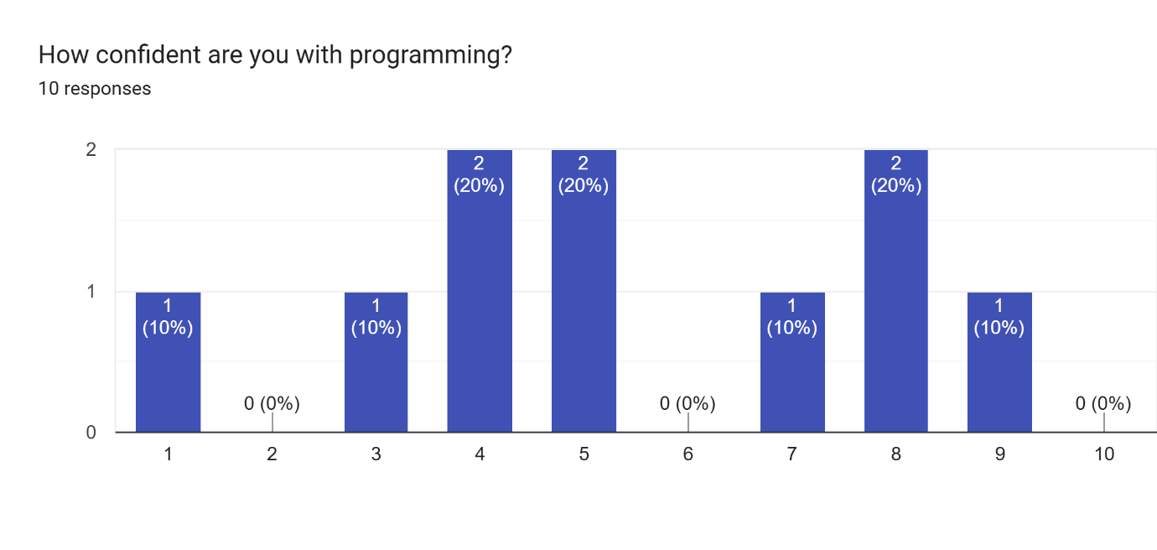
Figure 1
With a range of programming confidences, participant feedback can be acquired encompassing all the various levels of abilities to give their respective reflections on their experience.
The ages of each individual were also collected to determine the age range of the sample for comparison against other age ranges of conducted studies (Figure 2).
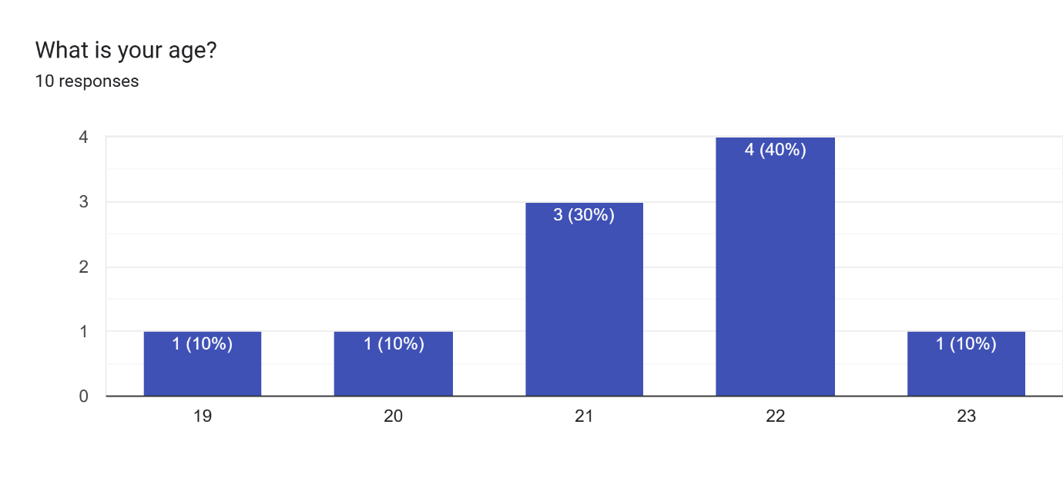
Figure 2
The age range of participants for this study can be concluded to be (19 – 23), whilst not a large spread this offers a higher focus on the diversity of programming experiences, rather than the diversity of ages.
The group was tasked with recreating the classic game Pong to the best of their ability (simply an arbitrary goal to ensure that sufficient interaction with the engine was achieved), the prototype was tested and data on its ease of use gathered. At the conclusion of the testing, the final usability score for the engine is calculated to be 67 (Figure 3).
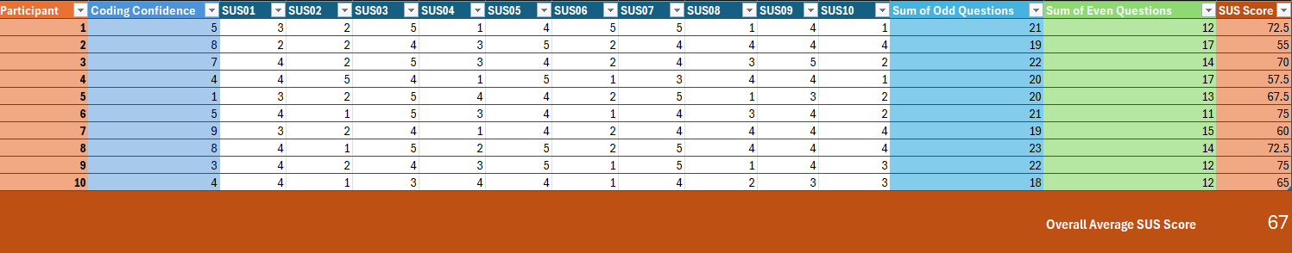
Figure 3
This SUS score of 67 places the engine as being of decent usability, with the system usability scale scoring being as follows: 0 being absolutely unusable to 100 being of perfect usability. A score of 67 ranks the current prototype as above 50 with scores below 50 being mostly regarded as poor.
Comparing this to the aforementioned scores achieved by (Harrati et al., 2016) when investigating the online learning platform Moodle, this value is similar to that of the older age ranges. The score for the (25 -29) age bracket was 74.67 which is comparable to the prototypes 67 for a similar tested age range (19 - 23), but this still shows there is room for improvement. This makes sense since the prototype did not include many of the researched features and, was missing some quality of life inclusions like copy and paste, to further improve the development experience. The sample size gathered was also fairly small, only consisting of 10 participants, however even with a small test group many useful insights have still been gathered.
Breaking down the achieved SUS score further, each area the participants were to provide input on can be looked at. Starting with the first question used in the system usability questions, how often the user would make use of the software (Figure 4).
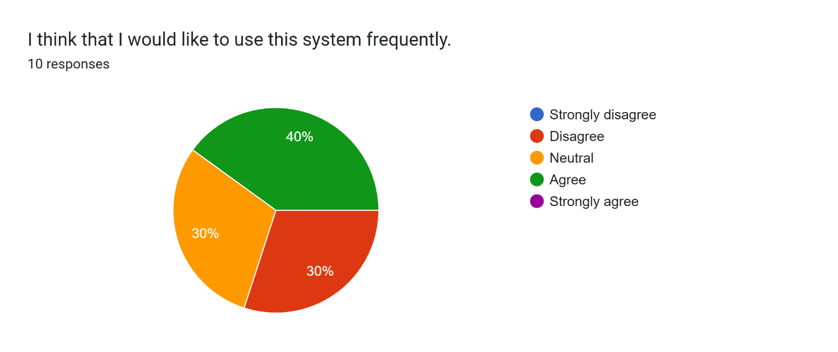
Figure 4
This question revealed a mix of responses, this is to be expected since the nature of game development itself has a mix of responses, some enjoying the process and others finding it is not really for them. The question has also outlined that there are no extreme opinions, no one person hating it, but no one person loving it. With no strong negative opinions, the engine has presented itself as fun and intuitive as it could, but with no strong positive opinions, outlines there are still some flaws with this prototype.
The next question was to assess the shortcomings of the engine, assessing if its use presented as overly complicated or convoluted to the user (Figure 5).
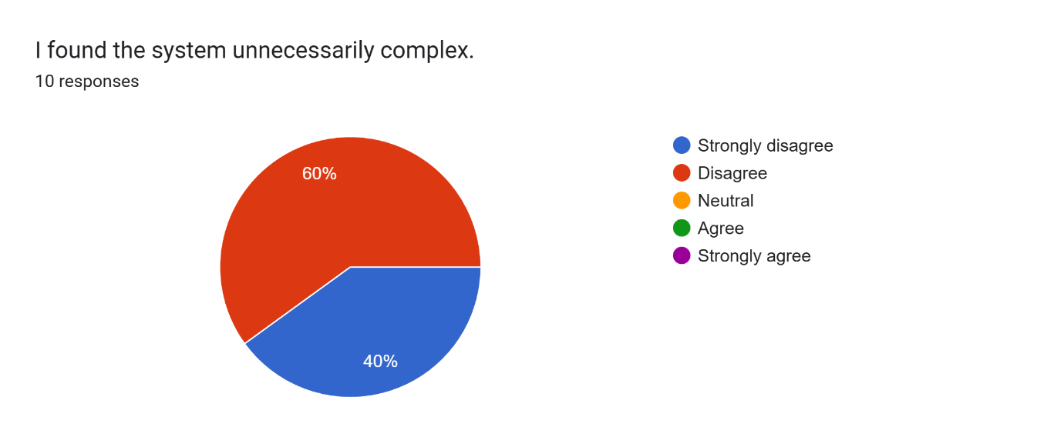
Figure 5
This is an aspect where the engine excelled, a unanimous agreement amongst participants that the prototype presented as straight forward and didn’t contain aspects that would hinder the users progress and experience during its use. This is further confirmed in the next question, asking users if they believed the engine was easy to use, presenting another unanimous agreement that it wasn’t too hard to operate (Figure 6).
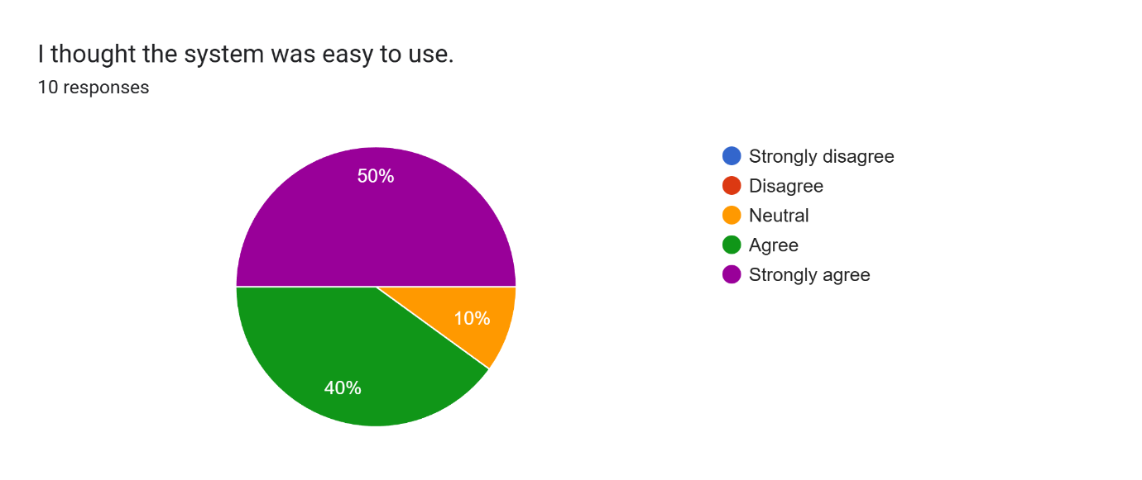
Figure 6
Here 50% of users felt strongly that during their use, the operation of the engine presented as simple and easy to intuit. The remaining 50% not having any negative feelings, also finding the prototype’s ease of use to be a positive aspect.
With a range of expertise in programming, it is to be expected that there will be a spread of different difficulties in creating their own code in the engine. In Figure 7, this is evident with a large spread of differing opinions.
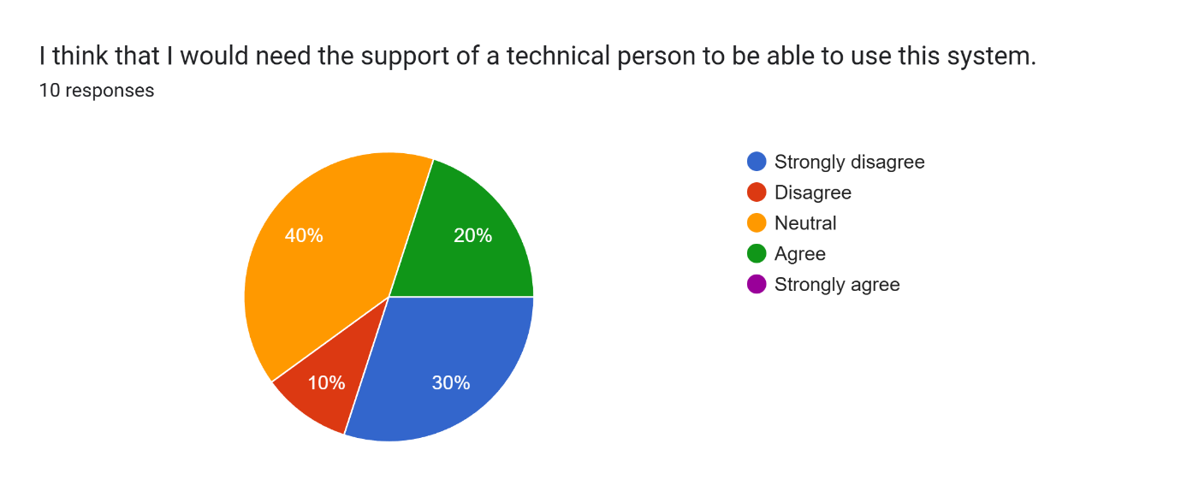
Figure 7
However, what is important to take away here, is that there are no responses pointing to an individual strongly needing the use of someone else’s expertise, in which case the engine would have failed its goal of making developing games accessible. Another positive takeaway is that 80% of users didn’t feel they would definitely need extra support, either being confident in programming already as to not need assistance or, feel enough confidence figuring out how to do something through experimentation and learning themselves.
Users were next asked to provide input on the function of the system (Figure 8).
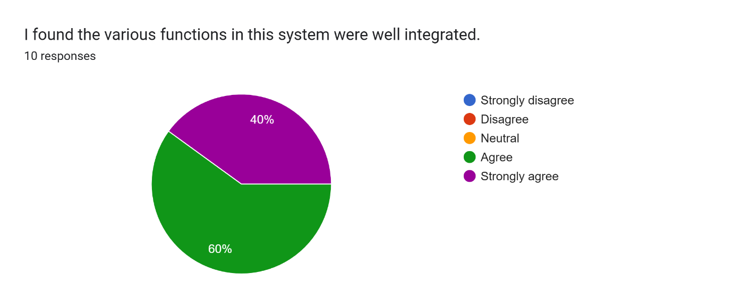
Figure 8
Here it is shown that 100% of users found the functions of the system to be good, no individual finding them just satisfactory or poorly integrated. This is excellent for the prototype, showing the core systems that have been implemented are already working well, even without other supporting systems and without a large degree of polish before being presented to users.
Users then went on to rate the consistency of the implemented systems, if the features work as they expected (Figure 9).
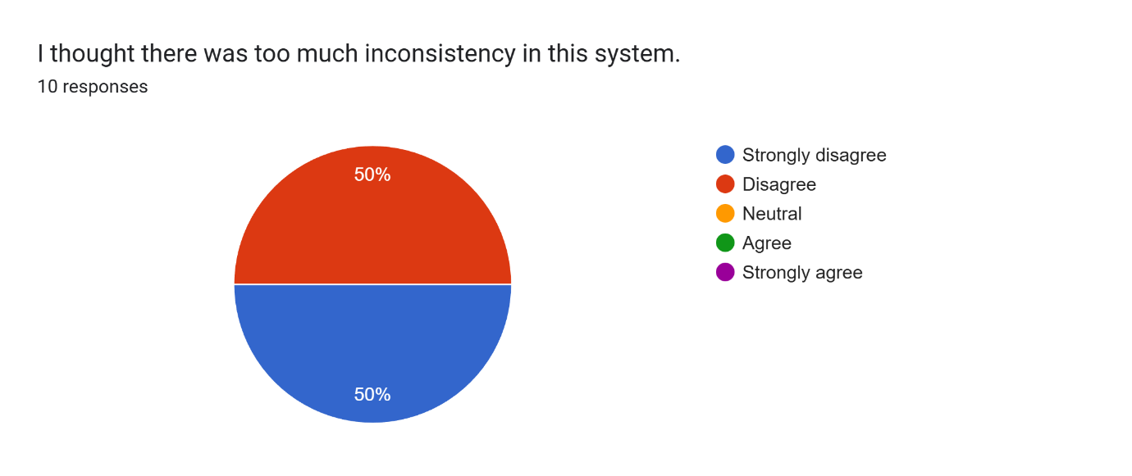
Figure 9
This is another aspect where the engine has excelled, a unanimous experience amongst users of consistency. The disagreement of there being inconsistencies in the design of the implemented features is welcome news, with 50% strongly disagreeing, suggesting the design of features currently present in the engine were well executed.
Next, participants were asked to assess whether they believed learning the operation of the system would be a quick undertaking (Figure 10).
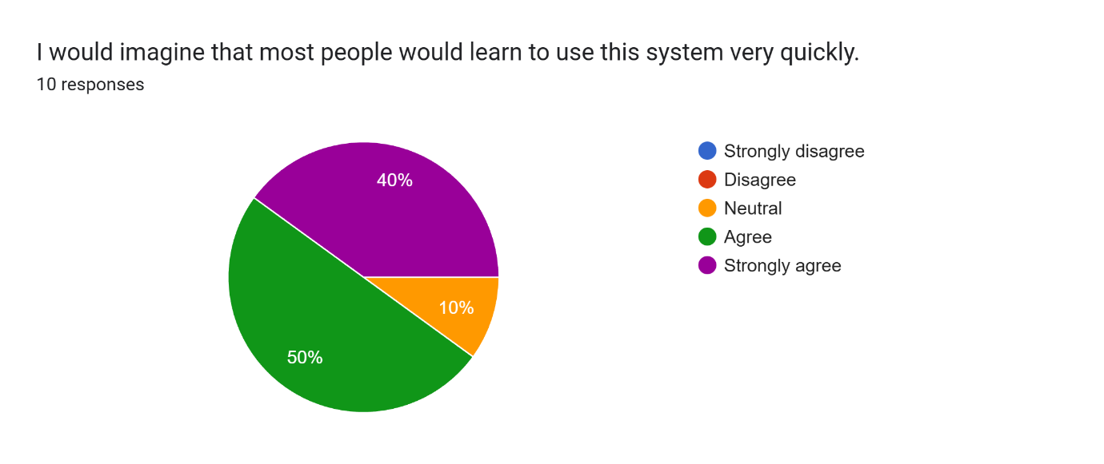
Figure 10
Here all participants were in agreement that learned operation of the engine would not be a difficult process, with 90% feeling it would be quick to pick up. This is positive news, with a lot of users thinking other users would be able to learn quickly, furthering the success of the engine’s overall objective of coding accessibility.
This next aspect of the engine is definitely something that presented as the most problematic, users were asked if they found the use of the system to be clunky and cumbersome to use (Figure 11).
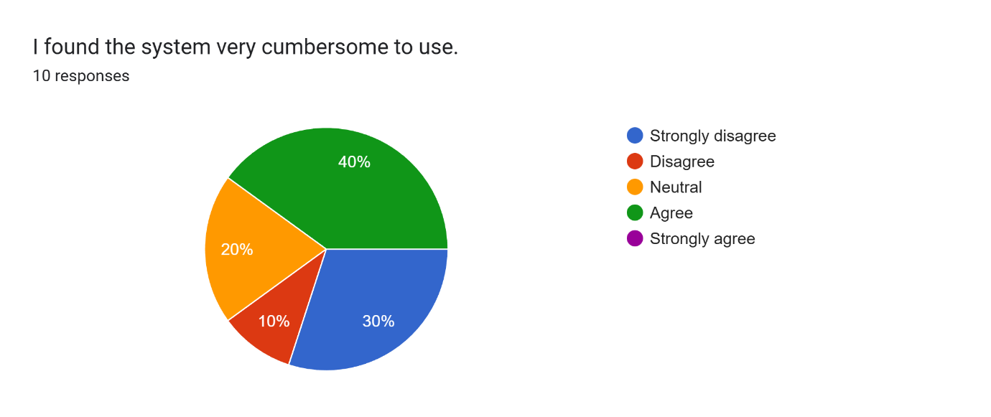
Figure 11
Here a range of positive and negative responses were given. With 40% finding it cumbersome and a further 20% not feeling it was smooth to use. 40% of users did find it smooth to use however, but the majority of participants were affected negatively by this aspect. It is important to remember the prototype presented to users was very bare bones, focusing more on important features whilst omitting smaller quality of life features. The majority of clunkiness of the system can be attributed to the deficit of assisting features present in the prototype, this meant that some simple actions the user had to perform manually, rather than being given the option to do it simpler and faster using a feature to assist them.
A successful goal of the engine has also been highlighted, as although the test group all had a range of confidences in programming, Figure 12 shows 100% of participants felt some degree of confidence after operating the system.
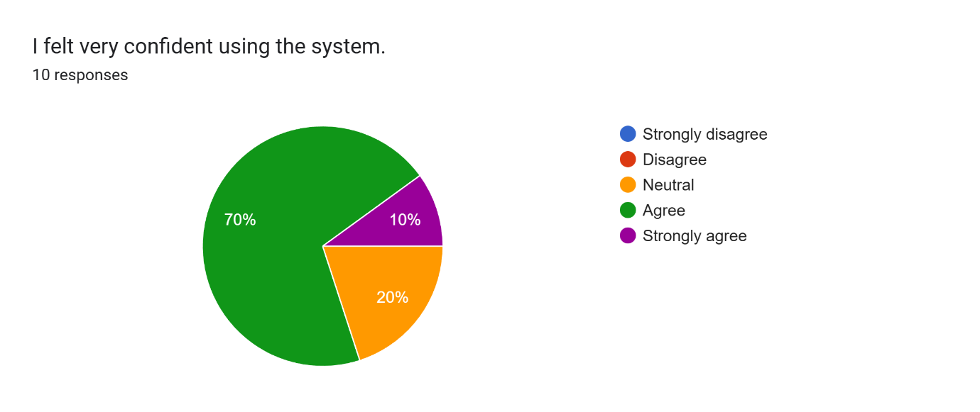
Figure 12
Participants didn’t feel overwhelmed or negatively impacted by use of the engine, with 80% stating a positive confidence level after use of the prototype. This is another large success the prototype has achieved.
The final question of the system usability section unveiled another split of greatly differing opinions, looking at the requirement of prior learning to use the program (Figure 13).
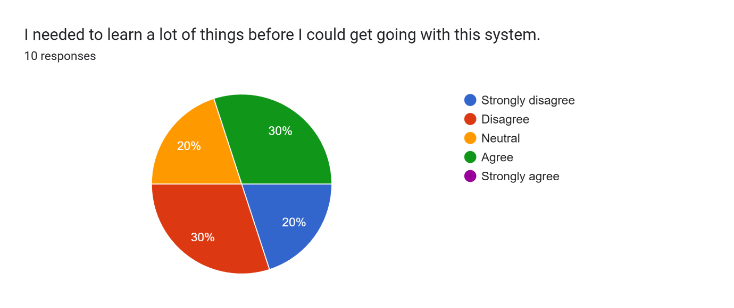
Figure 13
Here the split is evident once again due to the range of abilities of the participants, with 50% disagreeing that prior learning is required, as it is likely they had some degree of experience with programming and were able to start with little resistance. The remaining 50% felt a degree of knowledge still had to be gained before using the system. This is an aspect that could be improved, either by use of more visual aid to highlight what users must do to begin, or an inbuilt tutorial for beginners to highlight the basic features to get them going.
After looking through the data collected, it is clear that whilst the prototype has some drawbacks the results are mostly positive, with users finding the overall understandability of the engine to be positive. These results are all to be expected from a prototype, whilst small aspects of its execution could use improvement, the overall idea executed has been regarded as positive.

Discussion And Analysis
At the end of the questionnaire, participants could write what they found particularly good or what could be improved about their experience within the engine. These responses will be analysed to determine features that were perceived to be good or needing improvement.

Succesful Features
Looking at the positive feedback given from the user’s experience; it is clear the core features implemented were successful. For example, the inclusion of sound to aid in the learning and satisfaction within the engine were very well received, with comments “I like how the engine looks and sounds” and under the prompt of something that was done well, the response of “sound”.
The visual aspects of the engine were also very effective, colours aiding in the understanding and readability of the code, whilst also offering a more satisfactory visual appeal to the engine. Participants commented that “I really liked the use of categorised colours for different statements” and that “Ease of use, code readability” are positive inclusions to the prototype.
By far the most well received inclusion was kinetic nature of the engine. This is encouraging to hear as a lot of the prototype’s development time was focused into ensuring this kinetic aspect was well executed. The primary focus of movement in the project was to ensure that the process of making code was instantly familiar to the user, simply fitting things together and building rather than typing out specific syntax in a line by line format. The success of execution of aspects surrounding movement is evident with comments like “The dragging of the blocks was nice and nostalgic. I do like being able to see my code in a more tangible format” and that “the simple movement/zooming in allowed me to categorise each block of code to avoid confusion”.
The kinetic interactivity in the engine particularly seemed to resonate most with those with little programming confidence, “As someone who is not a programmer I found it had similarities to basic software I have used, i.e. scratch, both visually and in practice”. The use of blocks to construct code from also presented as a success, with those of little programming confidences and those with a lot, both being able to use the system, finding it “Easy to figure out, most blocks were well named and worked simply” and that “The blocks were intuitive and easy to connect”.
After analysing the responses, it is evident users overcame the tricky entry bar to programming with it being a lot less of an obstacle when developing projects inside the engine. It is clear that the inclusions of auditory, visual and kinaesthetic features into the core design of the engine have positively impacted both its enjoyability and ease of use, whilst also cultivating a positive learning experience.

Improvements
Whilst the core principles instilled into the prototype’s development proved successful, the project still had many drawbacks. With the limited development time, many qualities of life features were not able to make it into the prototype, such as copy paste or the saving of projects to files to later be loaded.
The most popular feature that did not quite make it, was the ability to delete the code blocks, with participants suggesting improvements like “let me delete the nodes” this view being shared by the majority of participants also suggesting, “quality of life features; deleting code, copy/paste”, “Unable to delete components”, “I would have liked the ability to delete code blocks, I made a few mistakes and that made the entire screen a little messy because there was no way to remove them”. Implementing this feature would be a simple way to vastly improve the user experience allowing for code to be more readable without there being stray unnecessary code blocks around that will annoy the user and negatively impacting their experience.
With development time mainly focused on the refining of the block building experience, aspects such as the graphics quality were poor, the text used on the code blocks was small and so when rendered was of poor quality, “Text is fuzzy and nearly unreadable without being zoomed in”. Another oversight was the jittering of large chains of code blocks when the camera was moved, “When moving the "canvas", all components jitter”. These graphical imperfections detract from the quality of the experience received. The jittering of long lines of connected blocks making the engine window hard to look at when the camera is panned, and the addition of blurry text not only subtract from the experience, but also the readability of created code. Resolving this issue would greatly boost not just the user experience, but also the ease of comprehension of produced code.
A participant also made evident another oversight, with little programming experience they were unsure about the parameter variables that click into the larger code blocks, specifically on what type the variable is representing, “the text (pink) would be more straight-forward labelled at "text" and not "hello"”. The pink text variable displaying what it actually is, rather than an example of its use in hindsight would have been far more effective, further decreasing the confusion to newcomers. The participant also highlighted another issue: “at first I was a little confused with where the variables were held, I think this would have been more effective at the start of the drawer”. The very last page in the drawer of blocks that the user can scroll through is where the variables are, increasing the time for newcomers to find them, especially since they are a well utilised feature of the engine. Editing the block drawer so that newcomers are instantly met with the parameters to put in the blocks rather than the blocks themselves would cut down on this unnecessary period of confusion.
The final features participants wanted to see was the inclusion of more blocks bringing even more functionality to the engine, “The system is not very expansible beyond simple game logic e.g. for loops, comparing objects not just numbers etc”. The current capability of the engine is extremely bare bones, mostly catered for simple games involving a ball and a paddle such as Pong and no way to make other types of games with objects that aren’t just a ball or a paddle. Adding a feature to import user created images into the engine, to set as the background of the game world or the sprite image used by a game object, would greatly improve the capabilities. This would also add customisability which will allow a much higher and more personal enjoyment of the engine. Participants also suggested that the engine “needs a random variable feature” and to add a “way to directly set a variable's value” simple features that if implemented would add much more capability.

Reflection Of Results
Linking the findings back to the literature that has been surveyed, it is clear that all the features implemented based using them have proven supportive to the overall goal of game creation accessibility. However, the sample size collected was small only consisting of 10 people and so some bias that would be evident in a larger sample size may not be evident in a sample size this small. The age range of the tested population was also fairly tight, not offering any insight from those older than 23, who may have found other aspects that may need improvement.
There is also no insight from those younger than 19, who would likely be the target demographic of the engine. By use of the engine for developing games at a younger age they can later in adulthood be able to move on to use industry standard engines such as Unreal Engine or the Unity Engine. This age group would also then not being too young where the majority of computational concepts are too hard to grasp, since the engine is aimed to offer a bit more control over itself than the previously researched Kodu environment or Scratch Jr, it requires a bit more of an advanced understanding.
There is also the aspect of the presented engine being but a prototype in its infancy. This will have skewed the results negatively to some degree, since features users have become expectant of other tools and programs are not available. This will likely cause some degree of annoyance when users have to do it themselves manually or just have to accept the feature doesn’t exist yet. Testing the engine again at a more well developed and polished state, may present as a fairer trial, likely raising the usability score in the process.

Conclusion
This project set out to answer the following Research Questions (RQs):
- RQ1: How should a game engine be created, what are some good features to have and what features may be too complicated to include for new users?

- RQ2: In what way should the GUI of a game engine be created to be as intuitive as possible and easily navigable?

- RQ3: What is the best way to approach teaching programming to newcomers and how should this be reflected in the creation of the code blocks?
After the investigation into existing literature, the creation of a working prototype and responses gathered from testing, the project is concluded and now the success of the engine in answering these three questions can be assessed.

RQ1: Features of The Game Engine
The game engine was created in such a way to omit complicated features users may find too daunting. One such feature was text based programming, the engine replacing it with the easier to intuit visual style of programming, taking inspiration from other low knowledge entry level engines like Scratch and Unreal Engine. This style of coding visually, making use of blocks and colours to create functionality proved successful in practise, allowing users of varying degrees of programming capabilities to develop some functionality to their projects. The functionality was created without having to write lines of code or having an advanced understanding of developing a game.
The overarching structure of the engine also proved successful because the visual scripts users created would work consistently and implemented features constructed in a similar way to other game engines. Aspects such as rendering an object each frame were abstracted away so that the user doesn’t need to create that functionality themselves, instead just add an object into the world and the engine handles the rest.
A very basic physics system was implemented, allowing the speed of an object to be set in the form of a velocity (splitting the speed into separate respective vertical and horizontal values that can be set). Instead of setting the position of the object to its own position plus an amount each time step to create movement, the engine will handle it instead, with only one block telling the object what its velocity is. This is another feature abstracted away since users can just set the velocity of an object to move it around the screen rather than creating their own system of setting positions over a span of time.
These are just some of the features common in other engines that have been utilised in the prototype, whilst not all functionality common in most other game engines is present, the majority are.

RQ2: Design of the GUI
The GUI of the prototype was also created to be as intuitive as possible, making use of findings in the literature of hiding some features away from the user, rather than showing them a lot of information that is likely going to cause them to get overwhelmed. This is evident in the prototype in the form of the block drawer, instead of displaying all available blocks at once to the user, the drawer is split into different pages that the user can scroll through, this allows for the discovery of functionality to happen at the users own preferred pace rather than all at once.
The user interface also heavily relies on the drag and drop ability, which was found in the literature to be the most popular way of creating answers to given problems. Users in the engine can simply see a block they think would fit their purpose in the block drawer and then drag it into the coding space to make use of. The feedback received appeared to support this claim, with multiple participants praising this feature, finding it intuitive and needing no direction in how to utilise it.
Shapes and colours also played a crucial role in the interface of the engine, being used to convey the functionality of the blocks, with similar functionality blocks being of similar colours. The shapes also help to denote how certain blocks need to be connected, e.g. the On Start block has a protrusion on the bottom but not the top, since it will only run code below it upon starting the game. Likewise, the If blocks feature a protrusion top and bottom, but also one nested inside to convey to the user they can put code inside that will only be run if the statement on the If block is true. If a block requires some parameter values to work, it features holes in the exact shape of the parameter variable blocks, giving additional visual clues as to what the user should do.
To further ensure the intuitiveness of the graphical interface, all its different components were stylised in a similar manner. Making use of a colour palette of grey and blue ensured consistency whilst also making the graphics more visually appealing to look at.

RQ3: Quality of Learning
The final point researched was the learning process involved with teaching programming to those with little experience. In order to appeal to a range of people, the design of the engine was to cater towards auditory, visual and kinaesthetic ways of learning all which it was successful in doing. The engine contained noises of picking up blocks and placing them down again, this also acts as an effective feedback device to let the user know they have just moved a block. This was well received by the participants, many commenting on the inclusion of this auditory feedback as being something they really enjoyed.
Catering towards those with a visual style of learning, the design in the engine for both the GUI and blocks included different vibrant colours, along with the previously mentioned visual clues in the blocks in the form of their protrusions and slots. This gave visual appeal to the engine whilst also successfully facilitating learning. With users able to intuit how to construct code at a glance, seeing instantly how the blocks should fit together. This was also successful with participants enjoying the use of colours and style of the engine.
The final offering the engine provided, is to those with a kinaesthetic style of learning. This was by far the biggest aspect of learning that was catered for by the prototype, with the whole process of creating code being very movement based in its nature. The process of learning in the engine is very stylised towards the kinaesthetic learner, since it is heavily encouraged to just make something and test it. The user will then learn from the test, then make some tweaks repeating the process until a project they are proud of has been produced.

Success Evaluation
Overall, the engine has been successful in answering the research questions and achieving its overall aim of making the development of games more accessible. It is not without its flaws; however, these flaws are mainly linked to the prototype being in its infancy. About the prototype not containing all the bells and whistles available in other programs and game engines, this does not however evidently hinder the overarching goal set for the project to achieve.

Recommendations
After the assessment of success of the project, it is clear that some aspects could have been executed differently. First of which would be to acquire a larger more diverse testing sample. This testing sample could either be of the same age range of the study conducted in this project but, hosting for far more participants to get a greater in depth look as to exactly how the larger population would find the use of the engine.
The alternative is to test at a different age range, perhaps to those younger, this could uncover more useful insights to help better the engine. The ideal age to test at would be those around their late teenage years, having a good enough grasp on crucial components of game development such as math and logic from high school education, whilst still being young enough to benefit from acquiring the knowledge of how to code. The engine could even be used as a stepping stone for those even younger than its intended demographic. With younger children perhaps starting out using Scratch Jr and or Kodu beforehand, then moving on to this engine which will build their skill further. Since this engine presents more advanced techniques than other such software, like the use of velocities and presenting code in a way structured more akin to that used in Unity and Unreal, it could benefit from users having experience in such programs as Scratch.
Although this project does not act as a better alternative to the low knowledge entry engines available, it could very well act to fill the big jump from using programs like Scratch to industry utilised software like Unreal Engine. This is also a very likely alternative use that could be investigated, whilst the project was aimed to act as a standalone introduction to programming, use in conjunction with other software could prove interesting.
Whereas the teachings of the majority of conveyed literature have been developed into features and tested upon by users, many features were omitted and so remain to be investigated. Features such as the use of the aforementioned kineticons remain unutilised. Adding animations and movements to convey the functions of features, Kineticons could prove a very useful inclusion in reducing any confusion when using the system. The addition of animation could be something of worth to investigate, getting another set of users to test the system usability, with use of kineticons and making a direct comparison to the usability of the system as it stands here.
Another aspect of investigation is to continue the development of the engine, iterating upon its design from previous feedback and then making refinements, then releasing yet another prototype for testing. This cycle could continue for 3 or 5 iterations and then the usability of the more polished system could be tested, the effectiveness of the final draft could then be compared to that of the system in its current state.
There are still many avenues of investigation that could be explored here, this prototype only scratching the surface of the possibilities that could be.

References
Ahmad, F.N. (2013) 'An Overview Study of Game Engines', Int.Journal of Engineering Research and Applications, 3(5), pp. 1673–1693.
Andrade, A. (2015) 'Game engines: A survey.', EAI Endorsed Trans.Serious Games, 2(6), pp. e8.
Berger, A.A. (2017) Video games: A popular culture phenomenon. Routledge.
Briggs, W. (2021) Using a Training-Wheels Games and Graphics Library from Day One with Beginning C. pp. 1263.
Brooke, J. (1996) 'SUS-A quick and dirty usability scale', Usability evaluation in industry, 189(194), pp. 4–7.
Cross, K.P. (2005) 'What do we know about students' learning and how do we know it?', .
Cross, N. (2006) Designerly ways of knowing. Springer.
Eng, K. and Hindle, A. (2025) Under the Blueprints: Parsing Unreal Engine’s Visual Scripting at Scale. IEEE, pp. 611.
Faghih, B., Azadehfar, D.M.R. and Katebi, P. (2014) 'User interface design for e-learning software', arXiv preprint arXiv:1401.6365, .
Freiknecht, J., Geiger, C., Drochtert, D., Effelsberg, W. and Dörner, R. (2016) 'Game Engines'Serious Games: Foundations, Concepts and Practice Springer, pp. 127–159.
Friese, K., Herrlich, M. and Wolter, F. (2008) Using game engines for visualization in scientific applications. Springer, pp. 11.
Gilakjani, A.P. (2012) 'Visual, auditory, kinaesthetic learning styles and their impacts on English language teaching', Journal of studies in education, 2(1), pp. 104–113.
Hamidli, N. (2023) 'Introduction to UI/UX design: key concepts and principles', Preuzeto, 28(3), pp. 2024.
Harrati, N., Bouchrika, I., Tari, A. and Ladjailia, A. (2016) 'Exploring user satisfaction for e-learning systems via usage-based metrics and system usability scale analysis', Computers in Human Behavior, 61, pp. 463–471.
Harrison, C., Hsieh, G., Willis, K.D., Forlizzi, J. and Hudson, S.E. (2011) Kineticons: using iconographic motion in graphical user interface design. pp. 1999.
Herwig, A. and Paar, P. (2002) 'Game engines: tools for landscape visualization and planning', Trends in GIS and virtualization in environmental planning and design, 161(10).
Kaplancali, U.T. and Demirkol, Z. (2017) 'Teaching coding to children: A methodology for kids 5', International Journal of Elementary Education, 6(4), pp. 32–37.
Lewis, M. and Jacobson, J. (2002) 'Game engines', Communications of the ACM, 45(1), pp. 27.
Lieberherr, K., Holland, I. and Riel, A. (1988) 'Object-oriented programming: An objective sense of style', ACM Sigplan Notices, 23(11), pp. 323–334.
Liu, H. and Ma, F. (2010) Research on visual elements of web UI design. IEEE, pp. 428.
Lowood, H. (2014) 'Game engines and game history', Kinephanos.Revue d'études des médias et de culture populaire, , pp. 179–198.
MacLaurin, M.B. (2011) The design of Kodu: A tiny visual programming language for children on the Xbox 360. pp. 241.
Manochehr, N. (2006) 'The influence of learning styles on learners in e-learning environments: An empirical study', Computers in Higher Education Economics Review, 18(1), pp. 10–14.
Miya, T.K. and Govender, I. (2022) 'UX/Ui design of online learning platforms and their impact on learning: a review.', International Journal of Research in Business & Social Science, 11.
Nykl, S., Mourning, C., Leitch, M., Chelberg, D., Franklin, T. and Liu, C. (2008) An overview of the STEAMiE educational game engine. IEEE, pp. F3B.
Osiurak, F., Rossetti, Y. and Badets, A. (2017) 'What is an affordance? 40 years later', Neuroscience & Biobehavioral Reviews, 77, pp. 403–417.
Paul, P.S., Goon, S. and Bhattacharya, A. (2012) 'History and comparative study of modern game engines', International Journal of Advanced Computed and Mathematical Sciences, 3(2), pp. 245–249.
Pitale, A. and Bhumgara, A. (2019) Human computer interaction strategies—designing the user interface. IEEE, pp. 752.
Pönni, O. (2021) 'Starting A Beginner Game Project With GameMaker Studio 2', .
Resnick, M., Maloney, J., Monroy-Hernández, A., Rusk, N., Eastmond, E., Brennan, K., Millner, A., Rosenbaum, E., Silver, J. and Silverman, B. (2009) 'Scratch: programming for all', Communications of the ACM, 52(11), pp. 60–67.
Roldán-Álvarez, D., Martín, E., García-Herranz, M. and Haya, P.A. (2016) 'Mind the gap: Impact on learnability of user interface design of authoring tools for teachers', International Journal of Human-Computer Studies, 94, pp. 18–34.
Schreiner, L. and von Mammen, S. (2021) Modding support of game engines. pp. 1.
Seaborn, K. and Fels, D.I. (2015) 'Gamification in theory and action: A survey', International Journal of human-computer studies, 74, pp. 14–31.
Sewell, B. (2015) Blueprints visual scripting for unreal engine. Packt Publishing Ltd.
Snyder, A. (1986) Encapsulation and inheritance in object-oriented programming languages. pp. 38.
Spolsky, A.J. (2008) User interface design for programmers. Apress.
St. Amant, R. (1998) Planning and user interface affordances. pp. 135.
Stott, A. and Neustaedter, C. (2013) 'Analysis of gamification in education', Surrey, BC, Canada, 8(1), pp. 36.
Suarez, A.M.S., Martinez, M.E.M. and Mendoza, L.R.M. (2019) 'Brain and learning', International Journal of Social Sciences and Humanities, 3(2), pp. 128–135.
Suh, S., Lee, M. and Xia, G. (2020) Coding strip: A pedagogical tool for teaching and learning programming concepts through comics. IEEE, pp. 1.
Thorn, A. (2011) Game engine design and implementation. Jones & Bartlett Publishers.
Vohera, C., Chheda, H., Chouhan, D., Desai, A. and Jain, V. (2021) Game engine architecture and comparative study of different game engines. IEEE, pp. 1.
Zeybek, N. and Saygı, E. (2024) 'Gamification in education: Why, where, when, and how?—A systematic review', Games and Culture, 19(2), pp. 237–264.

Appendices
Appendix 1 – Questionnaire Participant Information (age)


Appendix 2 – Questionnaire Participant Information (Programming Confidence)
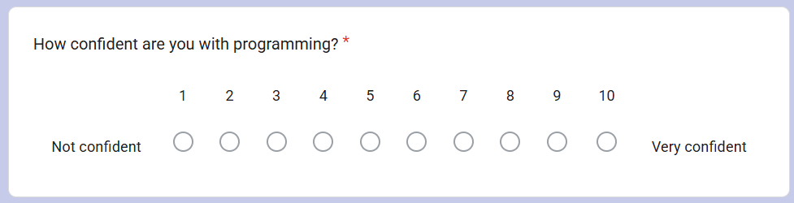

Appendix 3 – Questionnaire System Usability Question 1
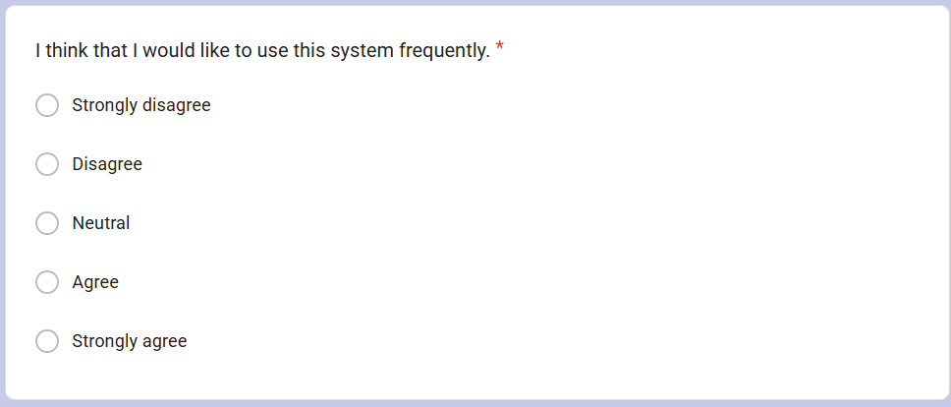

Appendix 4 – Questionnaire System Usability Question 2
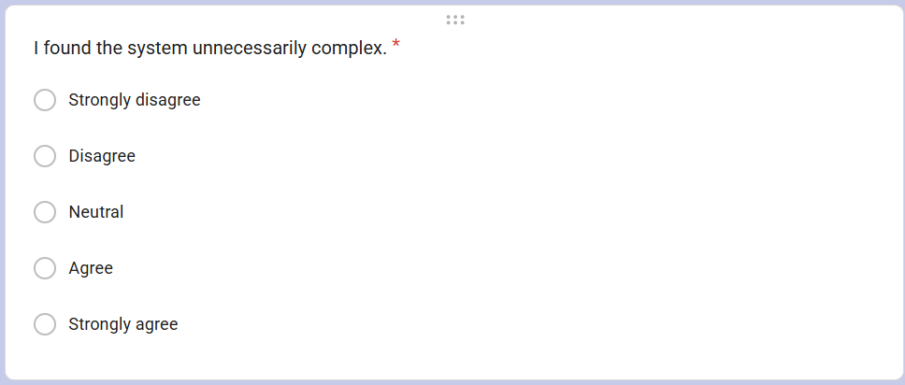

Appendix 5 – Questionnaire System Usability Question 3
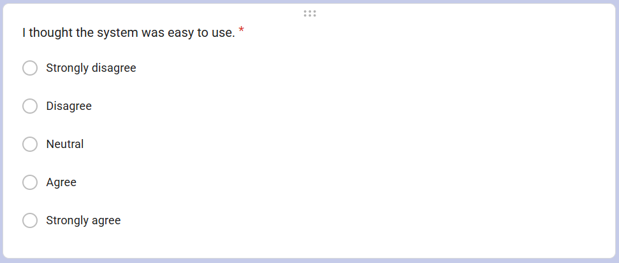

Appendix 6 – Questionnaire System Usability Question 4
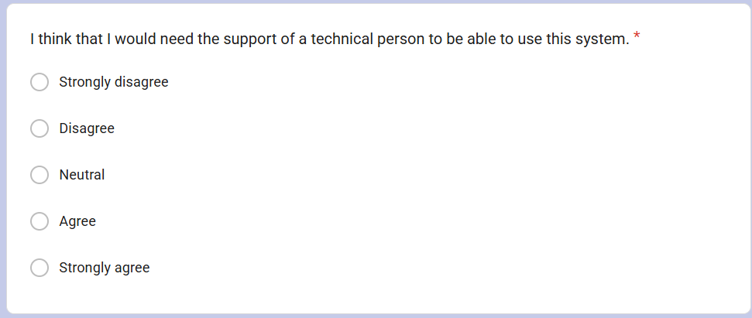

Appendix 7 – Questionnaire System Usability Question 5
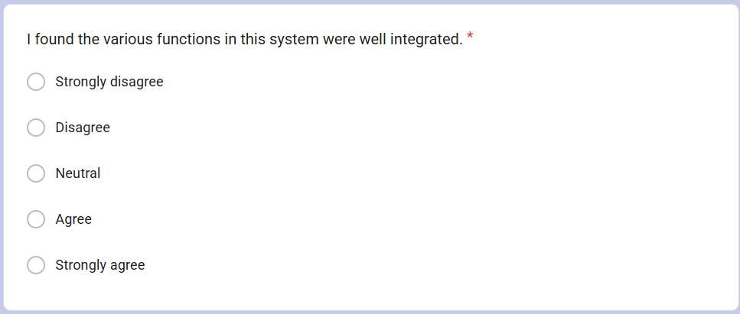

Appendix 8 – Questionnaire System Usability Question 6
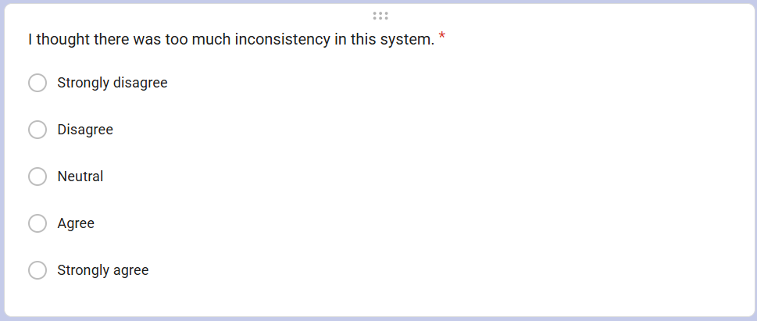

Appendix 9 – Questionnaire System Usability Question 7
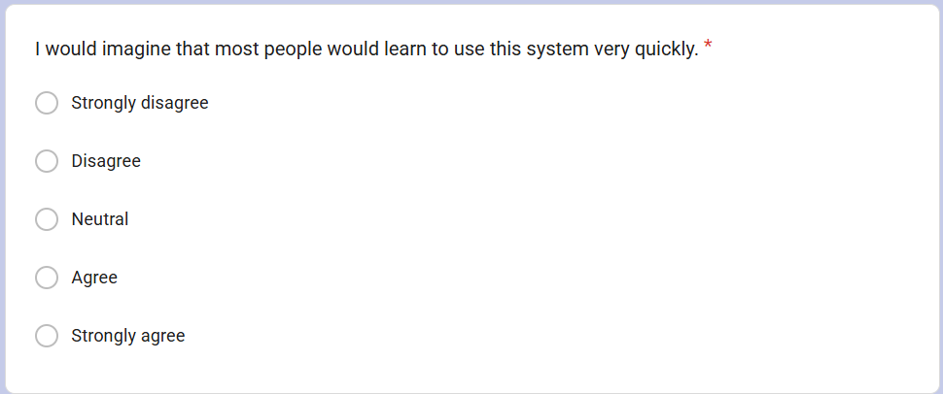

Appendix 10 – Questionnaire System Usability Question 8
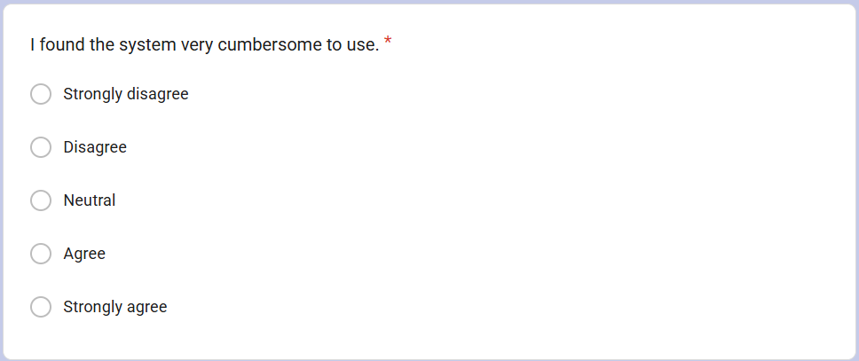

Appendix 11 – Questionnaire System Usability Question 9
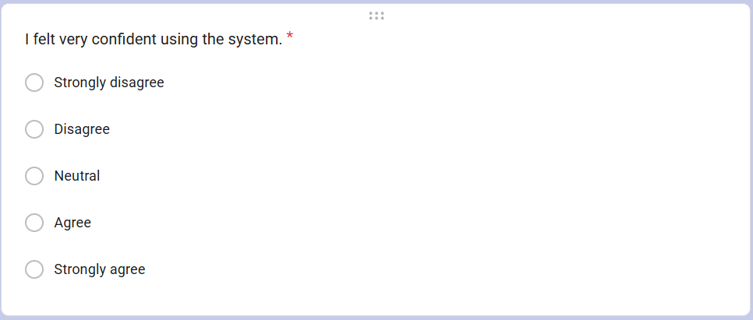

Appendix 12 – Questionnaire System Usability Question 10
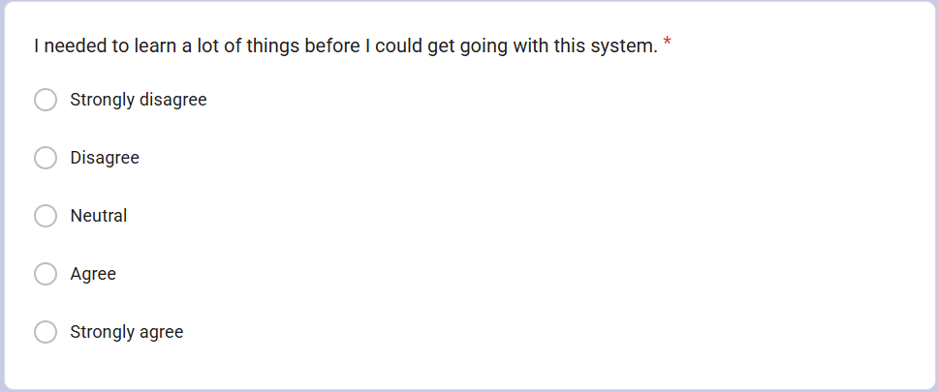

Appendix 13 – Questionnaire System Usability Feedback 1


Appendix 14 – Questionnaire System Usability Feedback 2
