
Student Name: Bashir Ullah
Student ID: 23026949
Supervisor: Dr. Viraj Dawarka
Date of Final Version: 01/05/2026
01 May 2026
Final Year Project
-COMP60011-

Gazebo Simulation-Based Autonomous Robot with Hazard Detection, Hazard Avoidance and Terrain Navigation for Construction Site Environments

Table of Contents
Chapter 1: Introduction 5
1.1 Background 5
1.2 Problem Statement 5
1.3 Aims & Objectives 6
1.3.1 Aims 6
1.3.2 Objectives 6
1.4 Research Question 6
1.5 Scope of The Study 7
1.5.1 In Scope 7
1.5.2 Out-of-Scope 7
1.6 Significance of The Study 8
1.7 Methodology Overview 8
1.8 Structure of The Report 9
Chapter 2: Literature Review 10
2.1 Introduction 10
2.2 Autonomous Robots in Construction 10
2.3 Simulation-Based Robotics 11
2.4 Path Planning Algorithm 11
2.5 Obstacle Detection and Hazard Recognition 12
2.6 Terrain Adaptability in Autonomous Robots 12
2.7 Integration of Navigation, Perception & Control 13
2.8 Gaps in Current Research 13
2.9 Critical Analysis 18
Chapter 3: Methodology 19
3.1 Introduction 19
3.2 Research Approach 19
3.3 System Design Overview 21
3.4 Simulation Environment 22
3.5 Robot Design & Sensor Integration 23
3.6 Algorithm Implementation 23
3.7 Performance Evaluation 23
3.8 Validation & Testing 24
3.9 Tools & Software 24
3.10 Summary 25
Chapter 4: Framework Design 26
4.1 Framework Design Visualisation 26
4.2 Use Case Scenario Selection 27
4.3 Diagrams: Use case diagram, activity diagram, sequence diagram & class diagram 28
Chapter 5: Implementation & Testing 31
5.1 Introduction 31
5.2 Development Environment Setup 32
5.3 Robot & World Implementation 33
5.4 Algorithm Implementation 35
Lawnmower Coverage Algorithm 35
Obstacle Avoidance 36
Hazard Detection 36
ROS2 Node Communication 36
5.5 Test Scenarios & Data Collection 36
Flat Terrain Scenario 37
Rough Terrain Scenario 37
Slope Terrain Scenario 37
Data Collection 37
5.6 Summary 37
Chapter 6: Results & Discussion 38
6.1 Introduction 38
6.2 Navigation Performance Results 38
Flat Terrain 38
Rough Terrain 38
Slop Terrain 39
6.3 Hazard Detection Results 39
Flat terrain 39
Slope Terrain 42
6.4 Terrain Adaptability Analysis 43
6.5 Comparison with Existing Solutions 44
Navigation and Coverage Comparison 44
Hazard Detection Comparison 44
Obstacle Avoidance Comparison 45
6.6 Summary 45
Chapter 7: Conclusion & Recommendations 46
7.1 Conclusion 46
7.2 Limitations 46
Navigation Limitations 46
Hazard Detection Limitations 47
Simulation Limitations 47
Scope Limitations 47
7.3 Recommendations and Future Work 47
Improved Navigation Algorithm 47
Enhanced Hazard Detection 47
Additional Terrain Types 48
Physical Robot Implementation 48
Real-world Deployment 48
References: 48
Appendices 50
Appendix A: Project Ghantt Chart 50
Appendix B: Ghantt Chart Report 51
Appendix C: LiDAR sensor code 51
Appendix D: Flat world key section 52
Appendix E: Rough world key section 52
Appendix F: Slope world key section 52
Appendix G: Plain terrain hazard detection results 53
Appendix H: Rough terrain hazard detection result 53
Appendix I: Slope terrain hazard detection result 54

List of Figures
Figure 1: 20
Figure 2: 21
Figure 3: 22
Figure 4: 26
Figure 5: Use Case Diagram 28
Figure 6: Activity Diagram 29
Figure 7: Sequence Diagram 30
Figure 8: Class Diagram 31
Figure 9: 32
Figure 10 33
Figure 11: Files used in the project 33
Figure 12: Robot in Gazebo 34
Figure 13: Flat World 34
Figure 14: Rough World 35
Figure 15: Slope World 35
Figure 16 36
Figure 17 36
Figure 18 40
Figure 19 41
Figure 20 43

List of Table
Table 1: Study Paper Evaluations 14
Table 2: Flat Terrain Evaluation 40
Table 3: Rough Terrain Evaluation 41
Table 4: Slope Terrain Evaluation 43
Table 4 44
Table 5 45
Table 6 46
Table 6 46

Chapter 1: Introduction

1.1 Background

Fast developments in simulation and autonomous robotics have created new opportunities to deploy keen systems in dangerous settings, such as construction sites. Before tangible robots are manufactured, simulation-based development allows engineers to evaluate robot behaviour under diverse conditions at significantly reduced cost (Koenig & Howard, 2004). The goal of this project is to create a practical, free robot that can navigate various types of terrain, avoid obstacles, and recognise risks within a modest work site area, using the Gazebo Harmonic simulation environment and ROS2.
Construction environments pose unpredictable risks, including debris and uneven surfaces. Existing autonomous solutions are often limited to single-purpose tasks and struggle with terrain adaptability (Bogue, 2018). By combining LiDAR-based hazard detection with a systematic lawnmower coverage algorithm, this project overcomes these limitations and enables the robot to autonomously survey an entire finite area while recording hazard locations in real time.

1.2 Problem Statement
Autonomous robotic systems face significant challenges in the highly dynamic and unstructured environments of construction sites, particularly in terrain adaptation, obstacle avoidance, and hazard detection. Despite advances in construction robotics, many systems remain limited in navigating complex, continuously changing environments (Bogue, 2018). Furthermore, the widening skills gap in the construction sector heightens the need for fully autonomous systems that reduce reliance on human operators (Makris et al., 2019).
By creating and evaluating an autonomous robot in a Gazebo simulation environment, this project addresses current industry challenges. Simulation provides a practical and cost-effective means of assessing how effectively a robot adapts to diverse terrain types and of identifying hazards before any physical prototyping is undertaken (Koenig & Howard, 2004).

1.3 Aims & Objectives

1.3.1 Aims
The aims of this project are to design, simulate, and evaluate an autonomous robot capable of systematically surveying construction sites across diverse terrains, while maintaining efficient navigation and accurate real-time hazard detection and localisation.

1.3.2 Objectives
- Design and develop a differential drive robot model in Gazebo Harmonic, equipped with a 360° LiDAR sensor and a forward-facing camera, capable of operating across multiple terrain conditions within a bounded construction site environment.
- Create and configure a range of simulated terrain environments within Gazebo, including flat, rough, and sloped terrains, each populated with representative construction site hazards such as barrels, warning cones, and pit obstacles.
- Implement a systematic lawnmower coverage algorithm using ROS2, enabling the robot to autonomously navigate the entire bounded survey area in an organised row-by-row pattern without requiring manual intervention.
- Integrate a LiDAR based hazard detection system capable of identifying and classifying obstacles within the survey area, recording their real-world coordinates, and displaying their positions on a live hazard map generated using Python and Matplotlib.
- Evaluate the robot's performance across different simulated terrain types, analysing coverage completeness, hazard detection accuracy, and navigation adaptability, and compare results against established baseline navigation approaches.

1.4 Research Question
RQ: How effectively can a ROS2-based autonomous robot, developed and tested within a Gazebo simulation environment, achieve systematic coverage, accurate hazard detection and localisation, and adaptive navigation across varied construction site terrain types?

1.5 Scope of The Study
The scope of this project is to integrate ROS2 Jazzy with the Gazebo Harmonic simulation environment to design, develop, and assess an autonomous robot. The scope includes the entire development process, from sensor integration and robot modelling to the implementation of navigation algorithms and performance assessment across various simulated terrains.
In particular, the project includes designing a differential-drive robot with a forward-facing camera and a 360-degree LiDAR sensor, building three simulation environments that depict flat, rough, and sloping construction-site terrains, and implementing a systematic lawnmower coverage algorithm in conjunction with a LiDAR-based hazard detection and localisation system.
Key parameters such as area coverage completeness, danger identification accuracy, navigation adaptation across terrain types, and obstacle avoidance efficacy are used to assess performance. The project's scope is limited to simulation. It does not include the production of physical robots or their use in the real world. Every test and assessment is carried out in the designated virtual environments.

1.5.1 In Scope
The following components fall within the scope of this project:
- Design and development of a virtual differential-drive robot model in Gazebo Harmonic, equipped with a 360° LiDAR sensor and a forward-facing camera.
- Construction of three simulated terrain environments representing flat, rough, and sloped construction site conditions, each populated with hazards including barrels, warning cones, and pit obstacles.
- Implementation of a systematic lawnmower coverage algorithm and LiDAR-based hazard detection system using ROS2 Jazzy.
- Real-time hazard localisation and visualisation via a live Python Matplotlib hazard map.
- Quantitative performance evaluation based on area coverage completeness, hazard detection accuracy, and navigation adaptability across terrain types.

1.5.2 Out-of-Scope
The following elements are excluded from this project:
- Physical construction of the robot or real-world field testing.
- Analysis of complex environmental factors such as weather conditions, lighting variations, or surface material properties.
- Integration with external systems, communication modules, or multi-robot coordination frameworks.
- Deep learning or computer vision-based hazard classification beyond LiDAR proximity detection.

1.6 Significance of The Study
This project addresses critical challenges in the construction industry by developing a simulation-based autonomous robot capable of navigating complex terrains and detecting hazards in real time. The study is significant across three key areas:
- By implementing systematic area coverage, LiDAR-based hazard detection, and adaptive obstacle avoidance, the project demonstrates how autonomous robots can enhance construction site safety and reduce dependency on human operators. The real-time hazard mapping capability provides site managers with accurate positional data on detected threats, potentially reducing the risk of workplace accidents and improving operational efficiency (Bogue, 2018).
- The project provides a structured methodology for simulating autonomous construction robots across diverse terrain types using ROS2 and Gazebo Harmonic. It offers reproducible insights into lawnmower coverage algorithm performance, LiDAR sensor integration, and terrain adaptability, contributing to the growing body of knowledge in autonomous navigation, simulation-based system evaluation, and construction robotics (Koenig & Howard, 2004).
- Advancing autonomous capabilities in construction robots can help address labour shortages, reduce human exposure to hazardous tasks, and promote wider adoption of automation technologies across the construction industry. This supports the broader goal of safer and more efficient infrastructure development (Makris et al., 2019).
Overall, this project demonstrates the feasibility and potential impact of simulation-driven autonomous robotics for real-world construction applications, serving as a foundation for future physical implementation and research.

1.7 Methodology Overview
This project employs a simulation-based experimental approach using Gazebo Harmonic and ROS2 Jazzy to design, implement, and evaluate an autonomous construction-site robot. The methodology is structured into five key stages:
- Robot Design: A differential drive robot model was developed within Gazebo, equipped with a 360° LiDAR sensor for obstacle and hazard detection and a forward-facing camera for environmental perception. The robot was designed with two driven wheels and two passive ball casters to ensure stable movement across varied terrain surfaces.
- Terrain and Environment Modelling: Three distinct simulation environments were constructed, representing flat, rough, and sloped construction site terrains. Each environment was populated with representative hazards, including red warning barrels, yellow cones, and simulated pit obstacles within a clearly defined bounded area.
- Algorithm Implementation: A systematic lawnmower coverage algorithm was implemented in ROS2 Python to enable autonomous row-by-row surveying of the entire bounded area. A LiDAR-based hazard detection system was integrated to identify, classify, and record the real-world coordinates of detected hazards during navigation.
- Simulation and Testing: Multiple simulation runs were conducted across all three terrain types to assess the robot's navigation behaviour, obstacle avoidance capability, and hazard detection performance under varying environmental conditions.
- Performance Evaluation: Key performance metrics were recorded, including area coverage completeness, number of hazards detected, navigation adaptability across terrain types, and obstacle avoidance effectiveness. Results were visualised through a live Python Matplotlib hazard map displaying the robot's path and pinpointed hazard locations.
This structured approach enables systematic evaluation of autonomous robot capabilities within a controlled and cost-effective virtual environment prior to any physical deployment (Koenig & Howard, 2004).

1.8 Structure of The Report
- Chapter 1: Introduction
Provides the background of the study, defines the problem statement, outlines the aims and objectives, presents the research question, and specifies the scope and boundaries of the project.
- Chapter 2: Literature Review
Reviews existing research and technologies related to autonomous robots in construction, simulation environments, path planning, obstacle detection, and hazard recognition, highlighting gaps the project aims to address.
- Chapter 3: Methodology
Describes the research approach, tools, and methods used to design, simulate, and evaluate the autonomous robot, including software, simulation frameworks, algorithms, and performance metrics.
- Chapter 4: Framework Design
Details the design of the virtual autonomous robot, including system architecture, sensor integration, terrain modelling, path-planning algorithms, and hazard-detection strategies.
- Chapter 5: Implementation and Testing
Explains the process of implementing the robot within the Gazebo simulation, setting up test scenarios, executing simulations, and collecting data for performance evaluation.
- Chapter 6: Results and Discussion
Presents the findings from the simulations, including quantitative and qualitative performance analysis, and discusses how the results address the research objectives and compare with existing solutions.
- Chapter 7: Conclusion and Recommendations
Summarises the key contributions of the project, reflects on the effectiveness of the proposed robot, identifies limitations, and provides recommendations for future work and potential real-world implementation.

Chapter 2: Literature Review

2.1 Introduction
This chapter reviews existing research on autonomous robotics, with a particular focus on applications relevant to construction and unstructured environments. The areas examined include autonomous robots in construction, simulation-based robotics development, path-planning algorithms, LiDAR-based obstacle detection, and terrain adaptability. These topics form the theoretical and technical foundation for this project.
Through a critical examination of current research, this chapter identifies key strengths, limitations, and emerging trends within the field. Challenges include navigating uneven terrain, accurately detecting hazards, and integrating various robotic subsystems, all of which receive special consideration. The review's conclusion clearly justifies the project's methodology by highlighting shortcomings in previous research, such as inadequate testing in realistic construction-like scenarios and limited system-level integration.

2.2 Autonomous Robots in Construction
In the construction sector, autonomous robotics is increasingly used to perform tasks that have traditionally required human labour, such as site surveys, structural assembly, earthmoving, and automated inspection. Research into mobile construction robots has expanded rapidly as the industry seeks to address labour shortages, improve worker safety, and increase overall productivity (Bogue, 2018). Systems such as layout-marking robots and autonomous material transport platforms demonstrate the growing trend towards digitisation and automation of on-site construction activities (Gambao et al., 2012).
Despite these advancements, current autonomous construction robots face significant limitations. Many existing solutions remain highly specialised, designed for a single narrow task and lacking the versatility to adapt to changing site conditions (Bogue, 2018). Construction environments are inherently unstructured and dynamic, characterised by uneven terrain, debris, and unpredictable obstacles that challenge robot mobility and perception systems. This environmental uncertainty frequently requires human supervision, undermining the goal of full autonomy (Gambao et al., 2012). Few studies have demonstrated fully integrated systems that operate reliably across a variety of unstructured circumstances, and achieving robust terrain adaptability, dependable hazard identification, and flexible multifunctionality remains an ongoing challenge in construction robotics research. These findings directly support the project's goal of designing and, through simulation, assessing an autonomous robot capable of navigating a variety of terrain types and identifying hazards within a constrained work site.

2.3 Simulation-Based Robotics
Simulation environments are central to modern robotics development, enabling researchers to design, test, and validate robotic systems before real-world deployment. Tools such as Gazebo, Webots, and CoppeliaSim allow engineers to replicate realistic physics, sensor behaviour, and environmental dynamics to evaluate robot navigation and control algorithms across a wide range of configurable scenarios (Koenig & Howard, 2004). These platforms are widely used in academia and industry because they provide a controlled, repeatable environment for experimentation without the cost or risk of physical prototyping. Simulation has become particularly valuable in construction robotics, where real sites are hazardous and difficult to reproduce consistently (Corke et al., 2011).
A key advantage of simulation is its ability to model complex terrains, obstacles, and hazards with high precision. Modern simulation engines incorporate advanced physics modelling, sensor noise, and terrain variation, enabling researchers to test robot responses to uneven ground, debris, and dynamic obstacles under controlled conditions (Corke et al., 2011). This project utilises Gazebo Harmonic, integrated with ROS2 Jazzy, to simulate three distinct construction-site terrain environments, evaluate lawnmower coverage performance, and assess LiDAR-based hazard detection accuracy, demonstrating the value of a simulation-driven evaluation as a precursor to real-world deployment.

2.4 Path Planning Algorithm
Path planning enables autonomous robots to determine a safe and feasible route from a starting position to a goal while avoiding obstacles. Classical deterministic planners such as Dijkstra and A* are widely used for their reliability and optimality on well-structured maps, whereas sampling-based methods such as Rapidly Exploring Random Trees (RRT) offer better scalability in complex or high-dimensional environments (LaValle, 2006). The majority of robot navigation systems rely on these algorithms, which have been widely used in unstructured and construction settings where dynamic objects and variable terrain provide serious navigational issues.
In unstructured environments such as construction sites, path-planning algorithms must account for irregular surfaces, debris, and unpredictable obstacles. Grid-based planners offer precise solutions but degrade in performance under significant terrain irregularity or sensor noise. At the same time, sampling-based approaches handle complex geometry more effectively but may produce inefficient trajectories without additional optimisation (Choset et al., 2005). This study combines reactive LiDAR-based obstacle avoidance with a lawnmower coverage algorithm, a methodical row-by-row sweeping approach ideal for constrained survey jobs, to achieve full area coverage while dynamically reacting to detected dangers.

2.5 Obstacle Detection and Hazard Recognition
Obstacle detection and hazard recognition in construction environments typically rely on a combination of complementary sensor modalities, including LiDAR, cameras, and IMUs. LiDAR generates detailed spatial data for structural and terrain mapping, while cameras provide semantic and visual information to identify specific hazard types (Thrun, Burgard & Fox, 2005). LiDAR is a popular sensor for autonomous navigation and hazard detection in unstructured settings because it can reliably measure distances to obstacles in real time and is particularly well-suited to construction sites.
Detection approaches range from classical geometric point-cloud processing to modern deep learning methods such as convolutional neural networks for image-based classification and point-cloud segmentation (Thrun, Burgard & Fox, 2005). However, there are unique challenges on construction sites, such as dynamic obstacles, uneven terrain, occlusion, and sensor noise, all of which reduce detection accuracy and increase false positives. This project tackles these issues by implementing a LiDAR-based proximity detection system in ROS2, which saves the coordinates of detected objects for real-time visualisation on a live hazard map and classifies them as either DANGER or WARNING based on their distance from the robot.

2.6 Terrain Adaptability in Autonomous Robots
Robots navigating uneven or complex terrain require more than standard wheeled locomotion to maintain stability and mobility. Hybrid mobility solutions, including tracked platforms, legged robots, and wheel-legged designs, have emerged to address this challenge by combining the speed of wheeled locomotion with the adaptability of legged locomotion (Siegwart, Nourbakhsh & Scaramuzza, 2011). Adaptive navigation, which improves stability and coverage across a variety of surface types, increasingly relies on sensor-based perception and control algorithms, as well as hardware innovations, to dynamically modify robot behaviour in response to recognised terrain conditions.
However, significant limitations remain. Mechanical hybrid platforms often suffer from increased complexity and energy consumption. At the same time, learning-based terrain classification approaches depend heavily on training data that may not generalise well to unpredictable construction site conditions involving debris, mud, or shifting surfaces (Siegwart, Nourbakhsh & Scaramuzza, 2011). This research assesses the performance of a differential-drive robot in level, uneven, and sloping construction site conditions and uses simulation to address terrain adaptability. To bridge the gap between controlled laboratory prototypes and real-world construction deployment, the lawnmower coverage algorithm and reactive obstacle-avoidance system are evaluated for their ability to maintain consistent navigation performance across all three terrain types.

2.7 Integration of Navigation, Perception & Control
Integrating navigation, perception, and control is essential for enabling robots to operate autonomously in complex environments. Modern systems rely on tight coupling between path-planning algorithms, sensor inputs, and real-time control to ensure safe and efficient movement. Frameworks such as ROS provide modular yet tightly integrated architectures that synchronise perception and control modules, enabling robots to continuously update their environmental awareness while adjusting motion commands in real time (Quigley et al., 2009). The foundation of autonomous behaviour is this coordinated interaction, which enables robots to walk steadily across a variety of terrains while responding dynamically to environmental changes.
Despite progress, autonomous construction robots still face significant challenges in effective system integration. Construction sites are highly unstructured, meaning perception noise, unpredictable terrain, and dynamic obstacles all degrade the accuracy of mapping and motion control (Siegwart, Nourbakhsh & Scaramuzza, 2011). To demonstrate how a modular ROS2 architecture can efficiently coordinate perception and navigation for construction site surveying, this project integrates a ROS2-based lawnmower coverage navigator, a LiDAR hazard-detection node, a ROS-Gazebo sensor bridge, and a real-time Matplotlib visualisation map into a single autonomous pipeline.

2.8 Gaps in Current Research

Table 1: Study Paper Evaluations
Papers | Strengths | Gaps | Justification
Paper 1:  Li, X., Chen, Y. , Zhang, T., Wu, Y. & Ding, X. (2021). Recent developments in terrain identification, classification and parameter estimation for autonomous robots. | It is an understandable review of terrain classification using techniques like exteroceptive and proprioceptive sensors. | Rather than real-time integration with like obstacle avoidance and navigation, it focuses more on classification. Very little discussion on the changing of terrain and being adaptable to it. | The project addresses these gaps by integrating terrain adaptation, detection, and navigation into a single simulation pipeline. It also introduces obstacles and constructions like unpredictability by testing in different terrain types.
Chen, X., Wang, Y. & Li, J. (2020).  LiDAR–vision sensor fusion for robust obstacle detection in unstructured environments. | An effective LiDAR camera integrated into the framework for obstacle detection, with a significantly improved detection accuracy. Real-time perception measurements with varying visibility conditions. | The focus is only on a single fragment of what the project will be. But there is no consideration of obstacles or navigation issues. | The project considers and integrates perception, navigation, obstacle detection , and adaptability within a single framework, where all subsystems work together for the robot to function independently.
Paper 3:  Zhang, H., Xie, X., Wei, M., Wang, X., Song, D. & Luo, J. (2024). An Improved Goal-bias RRT Algorithm for Unmanned Aerial Vehicle Path Planning. IEEE International Conference on Mechatronics and Automation. | Introduces a goal-bias enhancement to the classic RRT algorithm, directing the sampling process more frequently toward the goal, thereby reducing search effort and improving efficiency compared to standard goal-bias RRT.  Demonstrates improved path-planning speed and better feasibility for UAV missions where rapid initial solutions are critical.  Includes simulation results validating speed gains over baseline methods. | Focuses only on aerial 2D/3D path planning; does not address terrain adaptability or hazard perception.  Relies on known or static environment maps and does not integrate real-time perception or obstacle avoidance in dynamic settings. The improvements are incremental over existing RRT variants and may not generalise well outside flight or point-to-point navigation. | The project goes beyond point-to-point path planning by coupling navigation with perception and adapting to obstacles and terrain in realistic, unstructured scenarios. The gaps in this study (lack of perception integration and assumptions of a static environment) justify using a combined simulation framework to test a robot that must navigate, perceive obstacles, and adapt to varied terrain and site conditions — something this paper does not address.
Paper 4:  Zhang, H., Dai, X., Sun, F., Yuan, J. (2016). Terrain classification in a field environment using Random Forest for a mobile robot. 35th Chinese Control Conference (CCC). | Focuses on terrain classification in real field environments using Random Forest, one of the most cited ML methods for terrain recognition, a core perception task in autonomous mobile robots. It uses real sensor features likely from LiDAR, IMU, wheel odometry, and more, so it has practical relevance beyond purely simulated data. Random Forest is robust to outliers and less sensitive to overfitting than many other classifiers, making it a popular baseline for robotics perception. Provides groundwork for other works on ML-based terrain classification, which is directly useful for navigation and adaptability modules. | The study is relatively old compared to very recent ML advances, such as deep learning methods like CNNs and LiDAR neural models, so older feature extraction strategies limit classification accuracy. It does not integrate terrain classification with real-time navigation or control strategies, meaning it stops at perception and does not test full autonomy loops.  Field environments in the paper may not fully capture the dynamics of highly dynamic construction sites with moving obstacles and hazards. The focus remains on static field differences.  Random Forest methods lack adaptability without retraining; they do not generalise to unseen terrain patterns without additional training data. | The project extends beyond terrain perception alone by integrating it with real-time navigation, dynamic obstacle detection, and control in simulation, whereas this work leaves those components separate. This paper highlights the importance of terrain classification as a building block, but also shows that standalone terrain classifiers are insufficient for full autonomy in unstructured sites.
Paper 5:  Liu Liu, Yu Wei, Fengming Hu, Feng Xu. (2024). On the Value of Terrain Classification Using SAR Altimeter Delay Doppler Image | Demonstrates terrain classification using spaceborne SAR altimeter data and Delay-Doppler imaging, showing that advanced remote-sensing approaches can distinguish between terrain types with high precision over large, variable surfaces. It highlights the usefulness of non-optical, range-invariant sensing , such as radar, in detecting terrain features that optical/vision systems struggle with (e.g., shadowing and lighting changes). It Provides robust statistical evidence that terrain classification improves when combining spatial texture with delay Doppler signal features, an important insight for perceptual diversity. | Terrain classification using SAR altimeter data is not directly applicable to ground robots in construction sites, as it assumes overhead remote sensing rather than onboard sensors. The study is oriented to satellite or aerial platforms, not mobile ground robots, so practical integration with robot navigation systems is not addressed. It does not include real-time computation, control, or obstacle/hazard tracking, which limits its relevance for autonomous robotic systems that require fast onboard processing. | The project focuses on robot-compatible sensors (LiDAR, camera, IMU) integrated with navigation and obstacle detection, filling the gap between high-level terrain classification research and real-time, robot-usable perception strategies.  This paper broadens the understanding of how diverse sensor modalities can enhance terrain classification, but it shows that many remote sensing approaches are not directly suitable for onboard robot perception.
Paper 6:  Uçar, A., Tekeş, A. & Yorulmaz, M. (2025). Transformer-Based Object Detection in Unconstructed Environments: A ROS-Gazebo Simulation Framework, IEEE INISTA 2025. | Applies transformer-based object detection within a ROS-Gazebo simulation, advancing beyond traditional CNN/YOLO detectors by leveraging attention mechanisms for improved feature representation in complex scenes. Transformers can capture global context, potentially helping detect small, occluded, or irregular obstacles in unstructured environments. It integrates modern perception methods with a robotic simulation pipeline (ROS + Gazebo), which is directly relevant to robot perception research and enables controlled evaluation of object detection under variable simulated conditions. Demonstrates the feasibility of embedding contemporary deep-learning backbones into simulated robotics frameworks, a step toward real-time, adaptable perception. | The focus is on the perception/detection module and it does not fully integrate with navigation or control loops, meaning object detection results are not evaluated in the context of obstacle avoidance or real path planning.  There is a lack of detailed quantitative evaluation, such as FPS performance and detection metrics in dynamic scenes. Limits the assessment of real-time viability for safety-critical environments. | The project extends by linking detection with navigation and hazard response, testing performance of the combined system, and tailoring evaluations to the unpredictable conditions seen in construction environments and areas that this paper does not fully address.  This work is closely related to the simulation-based perception goals, but it highlights that advanced detection alone is insufficient.
Paper 7: Raj, S., Sharma, A. & Kaur, H. (2025). Autonomous Navigation for TurtleBot3 Robots in Gazebo Simulation Environment, IEEE International Conference on Robotics and Automation (ICRA) 2025. | This paper presents a complete simulation system in which TurtleBot3 robots use ROS and Gazebo for autonomous navigation tasks, including localisation, mapping, and basic path planning. Implementation includes SLAM and navigation stack configuration, which is directly relevant to the project’s simulation environment. It provides clear performance results on navigation in simulated indoor environments, showing how sensory data (LiDAR + odometry) integrates with ROS navigation pipelines.  Offering reproducible methodology, Gazebo world models, ROS launch configurations, and navigation parameter tuning. | Its focus is on relatively structured environments , such as indoor and flat terrain, and basic navigation. Not for navigation in complex or construction-like unstructured terrain.  It does not include advanced terrain adaptability, dynamic obstacle hazard detection, or evaluation under clutter/debris variability.  The work largely remains a demonstration of navigation stack setup rather than exploring performance trade-offs, sensor limits, or real-world-resembled performance degradation. Limited discussion of real-time performance challenges, algorithmic comparison, or system optimisation. | The project tests navigation in Gazebo with dynamic obstacles and uneven terrain, specifically targeting construction-like environments.  This paper is directly relevant to the project simulation setup and baseline navigation logic. Still, it highlights a gap: current ROS/Gazebo navigation studies tend to focus on structured or indoor environments and do not address complex terrain or integrated hazard detection.
Paper 8:  Zhang, T., Li, J., Wang, Y. & Liu, F. (2025). Design of a Simulation System for a Quadruped Robot Based on Gazebo, IEEE International Conference on Mechatronics and Automation (ICMA) 2025. | This paper provides a comprehensive simulation framework for quadruped robots using ROS and Gazebo, demonstrating the integration of robot models, sensor plugins, and control logic in a unified environment. It focuses on realistic physics interactions (legged contact dynamics) and offers detailed parameter-tuning methods for stability and gait control, which are valuable for understanding complex robot behaviour in simulation. It has example scenarios demonstrating terrain interaction, balance recovery, and coordinated leg motion, which is relevant if your project later expands to adaptive locomotion or uneven surfaces. | Emphasis is on the mechanics of legged locomotion simulation rather than on autonomy, navigation strategies, terrain classification, or perception integration. The paper does not examine obstacle or hazard perception, sensor fusion, or decision logic that ties perception to navigation/control behaviour. The simulation focus is on motion control and gait stability in Gazebo, not on dynamic environment handling, hazard detection, or large-scale path planning. | This paper highlights how Gazebo can model complex robot dynamics, which is valuable as context for simulation design. However, because it focuses on locomotion stability and robot control rather than navigation, terrain adaptability, or perception, it underscores the need for the project to focus on integrated navigation, obstacle/hazard detection, and decision behaviour in realistic simulated construction scenarios.
Paper 9:  Xu, Q., Yuan, J., Han, Z., Wang, N. & Gao, L. (2017). Design and Simulation Analysis of a Terrain Adaptable Wheeled Mobile Platform, IEEE International Conference on Robotics and Biomimetics. | This paper presents a wheeled mobile robot design that explicitly targets terrain adaptability and overcomes common limitations of conventional wheeled robots on uneven surfaces by incorporating an enhanced mechanical design. It uses simulation analysis to evaluate performance over different terrains, giving insight into how mechanical adaptability supports navigation in unstructured environments. | The adaptation strategy is largely mechanical and does not include perception systems such as LiDAR or vision, which are critical for real autonomous navigation and hazard detection. The simulation results are limited to platform mobility, with no integration of navigation, terrain classification, or real-time decision systems. It doesn’t address dynamic obstacles, environmental noise, or real construction-site variability or conditions that modern autonomous robotics must handle. It is primarily about mechanical design and simulation; it lacks analysis of perception-navigation integration or control adaptation. | This paper highlights how mechanical design and simulation can improve basic terrain adaptability, but it does not integrate perception or navigation logic. The project goes further by combining terrain adaptability with real-time navigation, object/hazard detection, and control adaptation, especially in dynamic, construction-like environments.
Paper 10:  Wang, L., Zhang, Q. & Zhou, T. (2025). Innovative Design of Bionic Foot and Closed-Loop Feedback Control System for Quadruped Robot Adaptable to Sloped Muddy Terrains, IEEE International Conference on Robotics and Automation (ICRA) 2025. | This paper introduces a biomimetic foot design and a closed-loop feedback control system tailored for quadruped robots operating on sloped, muddy, and slippery terrain, among the harshest conditions for autonomous locomotion. The combination of bionic foot hardware and adaptive control provides enhanced traction and stability on deformable surfaces that conventional designs handle poorly. The closed-loop feedback control uses real-time sensory input , such as IMU and contact force sensors, to adjust gait parameters and posture, demonstrating effective adaptability and balance recovery on challenging surface conditions.  It validates the proposed design through thorough simulation testing, demonstrating improved performance metrics, reduced slippage, and higher stability scores compared to baseline quadruped configurations. | The focus is primarily on mechanical design and low-level control for traction and balance, without exploring higher-level autonomous navigation or integrated obstacle/hazard perception.  The study does not address how the robot perceives the environment, like terrain classification, only how it physically adapts once terrain has been encountered.  There is a limited discussion of integration with broader autonomous systems, such as path planning, SLAM, or navigation logic in unstructured outdoor spaces, so it remains a point solution rather than a complete autonomy framework. | This paper contributes insight into physical adaptability on highly uneven and deformable terrains, highlighting advanced feedback control for stability. However, it also demonstrates that adaptive mechanics and low-level control alone are not enough for full autonomy; effective navigation and perception must be integrated, precisely the gap the simulation-based project aims to address by uniting terrain adaptability with obstacle detection and decision-making.

2.9 Critical Analysis
The literature reviewed in Sections 2.2 to 2.8 reveals consistent gaps that directly justify the aims of this project. While individual studies demonstrate strong contributions in isolated areas such as terrain classification (Li et al., 2021; Zhang et al., 2016), path planning (Zhang et al., 2024), and simulation-based perception (Uçar et al., 2025), none of the reviewed papers present a fully integrated autonomous system that combines navigation, hazard detection, terrain adaptability, and real-time visualisation within a single unified framework.
A prominent gap across multiple studies is the absence of system-level integration. Papers such as Chen et al. (2020) and Uçar et al. (2025) demonstrate strong perceptual capabilities but do not connect detection outputs to navigation or obstacle-avoidance behaviour. Similarly, Zhang et al. (2016) and Liu et al. (2024) advance terrain classification without integrating their findings into real-time control or path-planning pipelines. This fragmentation means that while individual components are well studied, their combined performance in a dynamic environment remains largely untested.
A second significant gap is the lack of evaluation in unstructured, construction-like environments. Studies such as Raj et al. (2025) and Zhang et al. (2025) utilise ROS and Gazebo effectively but restrict testing to structured indoor or flat terrains, avoiding the complexity of debris, slopes, and unpredictable hazards characteristic of real construction sites. Mechanical adaptability studies, such as Xu et al. (2017) and Wang et al. (2025), address physical terrain interactions but exclude higher-level perception and navigation logic entirely.
This project directly addresses both gaps by implementing a unified autonomous pipeline in Gazebo Harmonic and ROS2, combining systematic lawnmower-coverage navigation, LiDAR-based hazard detection and classification, reactive obstacle avoidance, and real-time hazard mapping across three distinct construction-site terrain types. This integrated, simulation-based approach addresses what the literature identifies as its most persistent shortcoming: the absence of complete, evaluated autonomous systems tested under realistic and varied environmental conditions.

Chapter 3: Methodology

3.1 Introduction
This chapter outlines the research approach, tools, and methods used to design, implement, and evaluate the autonomous construction site robot. The methodology follows a simulation-based experimental approach using Gazebo Harmonic and ROS2 Jazzy, covering robot design, terrain environment construction, algorithm implementation, and performance evaluation across three simulated construction site terrain types.

3.2 Research Approach
This project adopts a simulation-based experimental approach to evaluate autonomous robot behaviour across multiple construction site terrain types. Gazebo Harmonic was selected as the simulation environment due to its cost-effectiveness, safety, and ability to provide repeatable, controlled testing conditions without physical hardware or real-world risk (Koenig & Howard, 2004).
The research is quantitative, measuring performance metrics such as area coverage completeness, the number of hazards detected, and navigation adaptability across terrain types. The development process would follow an Agile methodology, enabling iterative design, continuous testing, and progressive refinement of each system component from robot modelling and sensor integration through to navigation algorithm implementation and hazard visualisation.
The full project timeline is provided in Appendix A.
The project followed an Agile development methodology structured across seven sprints, as illustrated in Figures 1 and 2 below.

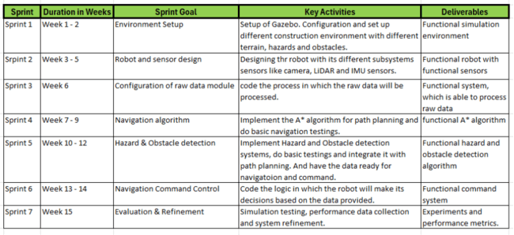
Figure 1:

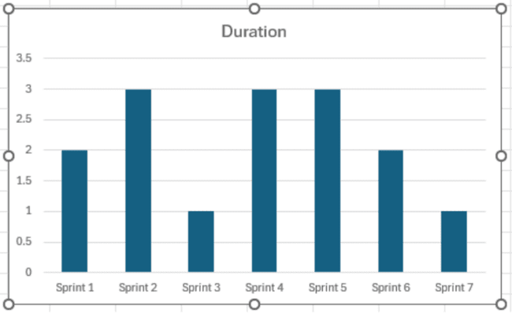
Figure 2:

3.3 System Design Overview
The simulation environment provides a controlled testing zone in which the autonomous robot operates without human intervention, processing sensor data to make independent navigation and hazard detection decisions across varied terrain types.
The robot integrates three core subsystems. The perception subsystem collects environmental data via the 360° LiDAR sensor and forward-facing camera. The navigation subsystem processes this data through the lawnmower coverage algorithm to generate systematic movement commands. The hazard detection subsystem analyses LiDAR proximity readings to identify and classify obstacles, recording their coordinates for real-time visualisation on the live hazard map. These subsystems operate as a unified pipeline within ROS2, as illustrated in Figure 3 below.

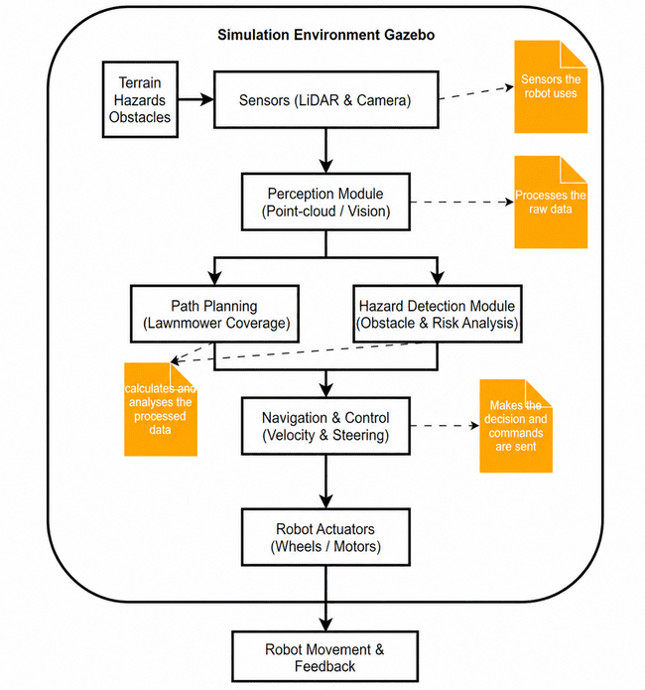
Figure 3:

3.4 Simulation Environment
Gazebo Harmonic was selected as the simulation platform for its realistic physics engine, native ROS2 integration, and ability to model complex terrain and sensor behaviour in a controlled, repeatable environment (Koenig & Howard, 2004).
Three distinct simulation environments were constructed to represent flat, rough, and sloped construction-site terrain types. Each environment is contained within a clearly defined 10x10-metre area and populated with representative hazards, including red warning barrels, yellow cones, and simulated pit obstacles. These varied environments enable systematic evaluation of the robot's navigation adaptability, obstacle-avoidance behaviour, and hazard-detection accuracy across different terrain conditions.

3.5 Robot Design & Sensor Integration
The robot was designed as a differential-drive platform in Gazebo, consisting of two driven wheels and two passive ball caster wheels, providing stable movement across varied terrain. The chassis dimensions were optimised to maintain balance while navigating flat, rough, and sloped environments.
The robot is equipped with two sensors. A 360° LiDAR sensor mounted on top of the chassis provides continuous proximity readings used for both obstacle avoidance and hazard detection. A forward-facing camera provides visual perception of the environment. Sensor data is processed through the ROS2 perception pipeline, where LiDAR readings are passed to the lawnmower coverage navigator for movement decisions and to the hazard detection node for obstacle classification and coordinate logging.

3.6 Algorithm Implementation
The robot's navigation is implemented using a systematic lawnmower coverage algorithm, which directs the robot to sweep the bounded survey area in sequential east-west rows, stepping northward after each pass. This approach ensures complete and repeatable area coverage without requiring a pre-built map (Choset et al., 2005). Reactive obstacle avoidance is integrated directly into the navigation loop, using narrow front-arc LiDAR readings to detect obstacles and trigger reverse-and-avoid manoeuvres when objects are detected within a defined safety threshold.
A LiDAR-based proximity classification system is implemented as a specialised ROS2 node for detecting hazards. Based on their distance from the robot, objects found within the survey region are categorised as either DANGER or WARNING. Their world coordinates are then recorded and published to a live Matplotlib hazard map for real-time visualisation.

3.7 Performance Evaluation
The robot's performance is evaluated using quantitative metrics recorded across all three simulation environments. Key metrics include area coverage completeness, number of hazards successfully detected and localised, navigation adaptability across terrain types, and obstacle avoidance effectiveness.
Multiple simulation runs were conducted across the flat, rough, and sloped terrain environments to ensure consistency. Results were captured via terminal logs that recorded waypoint completion, hazard coordinates, and navigation state transitions, along with visual evidence from the live Matplotlib hazard map showing the robot's path trail and pinpointed hazard locations. These results are analysed and compared across terrain types in a later chapter to assess the robot's overall performance and suitability for deployment on real-world construction sites.

3.8 Validation & Testing
Three different terrain environments, flat, rough, and sloped, are used for validation and testing. Each environment includes a standard set of construction-site hazards, such as yellow cones, red warning barrels, and simulated pit obstacles. This multi-environment strategy ensures that the robot's hazard recognition system, obstacle-avoidance behaviour, and navigation algorithm are assessed across a variety of increasingly difficult scenarios.
Each simulation scenario is executed multiple times to assess the reliability and consistency of the robot's performance. Results are cross-referenced between the terminal navigation logs and the live hazard map output to verify that detected hazard coordinates correspond accurately to their actual positions within the simulation environment. Discrepancies between detected and actual hazard positions are noted as part of the detection accuracy assessment.
The project objectives listed in Section 1.3 are used to establish the validation criteria. If the robot completes full area coverage across all waypoints, detects most placed hazards without producing an excessive number of false positives, and exhibits consistent obstacle avoidance behaviour without getting stuck during navigation, the system is deemed validated. As part of the results and critical analysis in Chapter 6, any constraints found during testing, such as blind spots near boundary walls or challenges in avoiding obstacles in cramped areas, are recorded and examined.

3.9 Tools & Software
The primary tools and software used in this project are summarised below.
Gazebo Harmonic serves as the 3D simulation environment for constructing and testing the robot model, terrain worlds, and hazard objects.
ROS2 Jazzy provides the robot operating framework, managing sensor data communication, navigation algorithm execution, and the ROS-Gazebo bridge that connects simulation topics to ROS2 nodes.
Python is the primary programming language for implementing all ROS2 nodes, including the lawnmower coverage navigator, hazard detection system, and live hazard map.
Matplotlib is used to generate the real-time hazard map, visualising the robot's path trail and detected hazard positions during simulation runs.
SDF (Simulation Description Format) is used to define all robot models and world environments within Gazebo, specifying geometry, physics properties, sensor configurations, and terrain features.
Additionally, AI tools like ChatGPT were used to assist with coding, debugging and overall managing ROS2 and Gazebo software. Grammarly was used too, to refine writing.

3.10 Summary
This chapter outlined the methodology for designing, implementing, and evaluating the autonomous construction-site robot in a Gazebo Harmonic simulation environment. It defined the research approach, tools, and software used, described the three simulated terrain environments, and detailed the navigation and hazard detection algorithms implemented in ROS2. The performance evaluation framework and validation criteria established here form the basis for the results and analysis presented in Chapter 6.

Chapter 4: Framework Design

4.1 Framework Design Visualisation

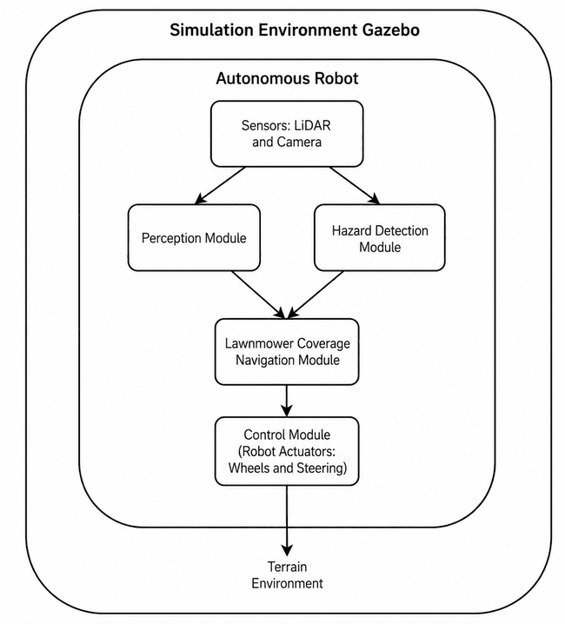
Figure 4:
The proposed framework for the autonomous robot is illustrated in Figure 4 above. The robot operates within a Gazebo Harmonic simulation environment across three terrain types that represent real construction sites. Onboard sensors being a 360° LiDAR and a forward facing camera continuously gather environmental data, which is processed through two parallel modules. The perception module interprets spatial data for situational awareness. In contrast, the hazard detection module classifies detected objects as DANGER or WARNING based on LiDAR proximity readings and records their coordinates for real-time mapping. Both modules feed into the lawnmower coverage navigation module, which generates systematic row-by-row movement commands. The control module then executes velocity and steering commands to the robot's wheel actuators, driving physical movement across the terrain environment. This modular architecture enables fully integrated perception, hazard detection, and autonomous navigation within a single unified ROS2 pipeline.

4.2 Use Case Scenario Selection
The use case selected for this project is autonomous hazard surveying within a simulated construction site environment. Construction sites present dynamic and unpredictable conditions including uneven terrain, debris, and scattered hazards, making them suitable environments for evaluating autonomous robotic systems designed for safety critical applications.
The operational scenario involves a robot spawning at a fixed starting position within a 10x10 metre bounded area and autonomously surveying the entire space using a lawnmower coverage pattern. During navigation, the robot must detect and avoid obstacles, classify identified hazards, and record their coordinates for real-time visualisation all without human intervention.
This use case was selected because it directly reflects the challenges autonomous systems face in construction environments and allows systematic evaluation of navigation, perception, and hazard detection performance under controlled simulation conditions. The scope is restricted to simulation-based validation, though the modular ROS2 architecture permits future real-world deployment with required modification based on the fields.

4.3 Diagrams: Use case diagram, activity diagram, sequence diagram & class diagram

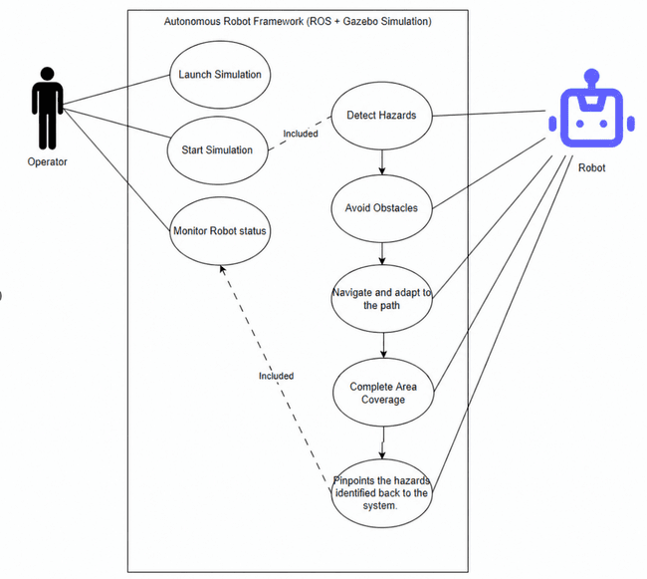
Figure 5: Use Case Diagram
Figure 5 illustrates the interaction between the operator and the autonomous robot within the Gazebo simulation environment. The operator is responsible for launching the simulation and monitoring the robot's status during operation. Once initiated, the robot autonomously executes its programmed tasks without further human input, detecting hazards, avoiding obstacles, navigating the bounded area using the lawnmower coverage pattern, and pinpointing identified hazard coordinates on the live hazard map. This diagram highlights the minimal operator involvement required, demonstrating the system's fully autonomous nature.

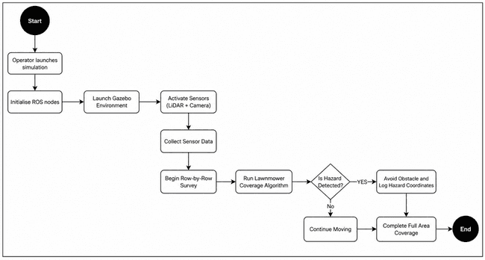
Figure 6: Activity Diagram
Figure 6 depicts the autonomous robot's operational workflow. The process begins when the operator launches the Gazebo simulation, and ROS2 nodes are initialised. Once active, the LiDAR and camera sensors continuously collect environmental data, which is processed to support navigation and hazard detection. The lawnmower coverage algorithm drives the robot through sequential row-by-row waypoints across the bounded survey area. At each step, the system checks for detected obstacles. If a hazard is identified, the robot executes an avoidance manoeuvre and logs the hazard coordinates to the live map before resuming coverage. This cycle of sensing, planning, and acting continues until full area coverage is complete.

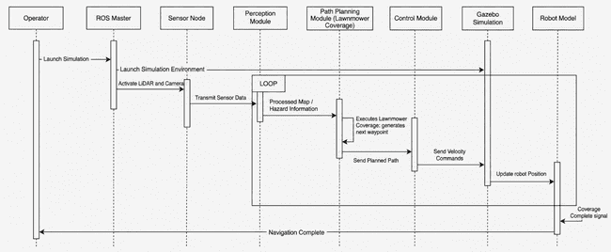
Figure 7: Sequence Diagram
Figure 7 illustrates the interaction between system components during autonomous operation. The sequence begins when the operator launches the simulation, prompting ROS2 to initialise all nodes and Gazebo to load the terrain environment. The sensor node activates the LiDAR and camera and continuously transmits data to the perception module, which processes spatial information and identifies potential hazards. This processed data is passed to the lawnmower coverage path planning module, which generates the next waypoint in the survey sequence. The control module converts the planned path into velocity commands executed within Gazebo, updating the robot's position accordingly. This sensing, planning, and control loop runs iteratively until full area coverage is achieved and a completion signal is returned to the operator.

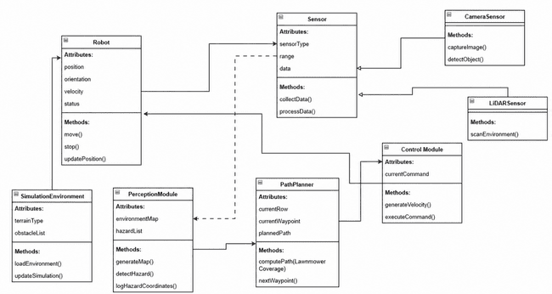
Figure 8: Class Diagram
illustrates the structural architecture of the autonomous navigation framework. The Robot class captures the robot's physical state and movement behaviour, including position, orientation, velocity, and status. The Sensor class abstracts sensor functionality and is inherited by two specialised subclasses: LiDARSensor, which provides 360° environmental scanning, and CameraSensor, which handles visual perception. This inheritance structure enables modular sensor integration and future extensibility.
The PerceptionModule processes incoming sensor data to build an environmental awareness model and log detected hazard coordinates. The PathPlanner class manages the lawnmower coverage algorithm, generating sequential waypoints and advancing row by row across the bounded survey area. The ControlModule converts planned waypoints into velocity and steering commands executed by the robot's wheel actuators. The SimulationEnvironment class represents the Gazebo terrain world, encapsulating terrain type and obstacle list attributes. The relationships among these classes demonstrate a layered, modular architecture that cleanly separates responsibilities across the simulation, perception, planning, and control components, consistent with the ROS2 node-based implementation described in Chapter 3.

Chapter 5: Implementation & Testing

5.1 Introduction
This chapter presents the implementation of the autonomous construction site robot in the Gazebo Harmonic simulation environment and the testing methods used to assess its effectiveness. It includes how the development environment is set up, how the robot model and terrain worlds are implemented, how ROS2 integrates navigation and hazard-detection algorithms, and how test scenarios are conducted on three types of terrain. The performance study covered in Chapter 6 is based on data gathered from simulation runs.

5.2 Development Environment Setup
The development environment was configured on an Ubuntu 24.04 machine running ROS2 Jazzy and Gazebo Harmonic 8.10.0. The robot operating system framework ROS2 Jazzy was selected for its native compatibility with Gazebo Harmonic and its modular, node-based architecture, which supports parallel execution of navigation, hazard detection, and visualisation processes (Quigley et al., 2009).
The project workspace was structured as a standard ROS2 Python package named fyp_robot, shown in the figure below.

Figure 9:
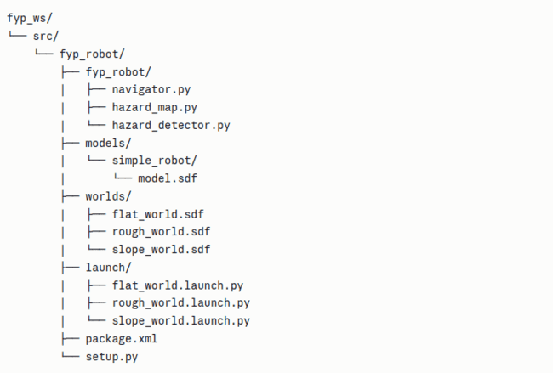
The workspace was built using the colcon build tool with the following command shown in figure 10.

Figure 10
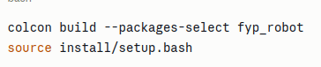
The ROS-Gazebo bridge package ros_gz_bridge was used to connect Gazebo sensor topics to ROS2, enabling LiDAR scan data, camera images, odometry, and velocity commands to be exchanged between the simulation and ROS2 nodes in real time.

Figure 11: Files used in the project
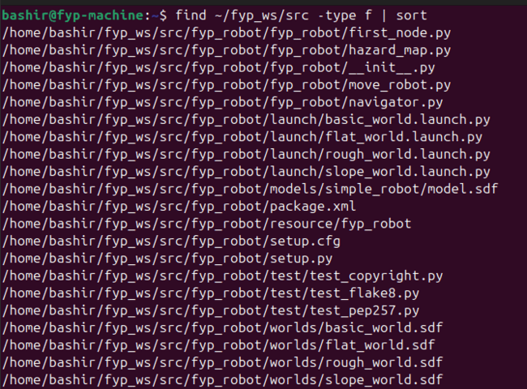

5.3 Robot & World Implementation
The autonomous robot was designed and implemented as a differential-drive platform using the Simulation Description Format (SDF) within Gazebo Harmonic. The robot model consists of a rectangular chassis measuring 0.7 x 0.45 x 0.15 metres, two driven wheels with high-friction surfaces to ensure stable movement, and two passive ball caster wheels at the front and rear to maintain balance across varied terrain. A 360° LiDAR sensor was mounted on top of the chassis with a detection range of 0.15m to 12.0m, and a forward-facing camera was positioned at the front of the chassis with a 60° horizontal field of view. The robot's movement is controlled through the Gazebo DiffDrive plugin, which receives velocity commands from the ROS2 navigation node via the /model/simple_robot/cmd_vel topic.

Figure 12: Robot in Gazebo
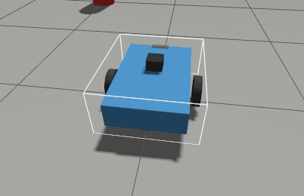
SDF world files were used to create three terrain environments. The flat world provides a baseline concrete surface measuring 10 by 10 meters. To mimic uneven terrain, the rough world adds three angled ramp surfaces with varying pitch angles. To assess performance on gradient terrain, the slope world has a sizable, inclined platform that covers most of the survey area. Two red warning barrels, three yellow cones, and two simulated pit obstacles with elevated dark rims that LiDAR could detect were among the identical hazard sets added to each scenario. To provide uniform testing conditions across terrain types, all environments have identical 10x10-meter border walls.
The following figures are the different terrains, and the code evidence are presented in the appendixes:

Figure 13: Flat World
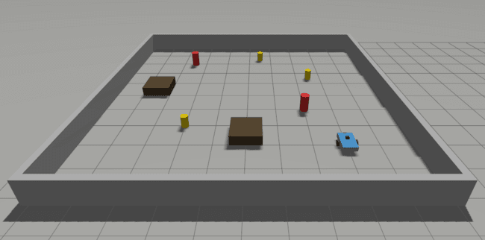

Figure 14: Rough World
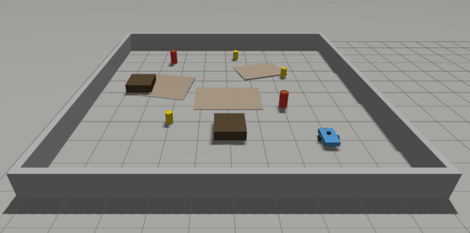

Figure 15: Slope World
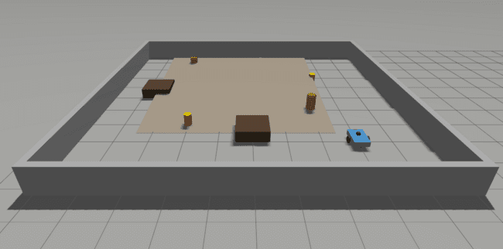

5.4 Algorithm Implementation
The navigation and hazard detection algorithms were implemented as ROS2 Python nodes within the fyp_robot package. Three core nodes were developed: the navigator, the hazard detector, and the hazard map visualiser.

Lawnmower Coverage Algorithm
The navigator node implements a systematic boustrophedon lawnmower coverage algorithm, directing the robot to sweep the bounded survey area in sequential east-west rows stepping northward by 0.8 metres after each pass. Waypoints are automatically generated at initialisation based on the defined survey boundaries (X: 1.0m to 8.0m, Y: 1.0m to 8.0m), resulting in 10 waypoints that ensure complete area coverage. The following code shows the waypoint generation logic.

Figure 16
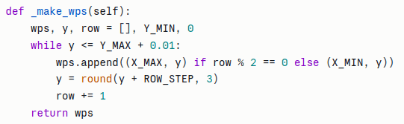

Obstacle Avoidance
Reactive obstacle avoidance is integrated directly into the navigation loop. LiDAR readings within a narrow 25-degree front arc are continuously monitored. When an object is detected within 0.85m, the robot initiates an avoidance manoeuvre, briefly reversing before turning away from the obstacle. If avoidance attempts fail repeatedly, a 45-second stuck timeout triggers an automatic waypoint skip to prevent permanent deadlock.

Hazard Detection
The hazard detection system analyses LiDAR proximity readings within a 60-degree front detection arc. Objects detected within 1.2m of the robot that fall within the survey boundary and are not identified as boundary walls are classified as either DANGER if within 0.5m or WARNING otherwise. Detected hazard world coordinates are calculated using the robot's current odometry position and published to the /hazard_locations topic. The following code shows the hazard classification logic.

Figure 17
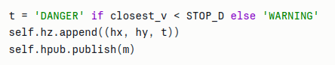

ROS2 Node Communication
All nodes communicate through ROS2 topics. The navigator subscribes to /lidar and /model/simple_robot/odometry and publishes to /model/simple_robot/cmd_vel, /hazard_locations, and /coverage_progress. The hazard map node subscribes to /hazard_locations and /coverage_progress to update the live Matplotlib visualisation in real time.

5.5 Test Scenarios & Data Collection
Three test scenarios were executed, one for each simulated terrain environment. Each scenario was launched using the corresponding ROS2 launch file, which initialised Gazebo Harmonic, spawned the robot at position (1.0, 1.0) facing east, and activated the ROS-Gazebo sensor bridge. The navigator and hazard map nodes were then launched in separate terminals to begin autonomous operation.

Flat Terrain Scenario
The flat world served as the baseline test environment, featuring a level concrete surface populated with two red barrels, three yellow cones, and two simulated pit obstacles. This scenario evaluated the robot's fundamental navigation performance and hazard detection accuracy under ideal terrain conditions.

Rough Terrain Scenario
The rough world introduced three angled ramp surfaces across the survey area alongside the same hazard set. This scenario tested the robot's ability to maintain consistent navigation and hazard detection performance in the presence of surface irregularities and elevated terrain features.

Slope Terrain Scenario
The slope world featured a large, inclined platform covering most of the survey area. This scenario evaluated the robot's adaptability when navigating across gradient terrain and assessed whether the lawnmower coverage pattern remained consistent under sloped conditions.

Data Collection
Performance data was collected automatically during each simulation run via ROS2 terminal logs that recorded waypoint completion, hazard detection events, navigation state transitions, and coverage progress percentage. The live Matplotlib hazard map provided visual evidence of the robot's path trail and pinpointed hazard locations. Screenshots of the hazard map at mission completion were captured for each terrain scenario and are presented in Chapter 6.

5.6 Summary
This chapter described the full implementation of the autonomous construction-site robot in the Gazebo Harmonic simulation environment. The development environment was set up with ROS2 Jazzy on Ubuntu 24.04, and the robot package was structured and built using the colcon build system. The robot model was implemented as a differential-drive platform equipped with a 360° LiDAR sensor and a forward-facing camera, and three distinct terrain environments were constructed to represent flat, rough, and sloped construction site conditions.
The lawnmower coverage algorithm and LiDAR-based hazard detection system were implemented as modular ROS2 Python nodes that communicate via a defined set of ROS2 topics. Three test scenarios were executed across flat, rough, and sloped terrain environments, with performance data collected automatically via terminal logs and the live Matplotlib hazard map. The results gathered from these simulation runs are presented and analysed in Chapter 6.

Chapter 6: Results & Discussion

6.1 Introduction
This chapter presents and analyses the results from the three simulation scenarios conducted across flat, rough, and sloped terrain. Performance is evaluated against the key metrics defined in Chapter 3, including area coverage completeness, hazard detection accuracy, navigation adaptability, and obstacle avoidance effectiveness. Quantitative data collected from ROS2 terminal logs, and the live Matplotlib hazard map are presented for each terrain type, followed by a comparative analysis across all three scenarios. The chapter concludes with a comparison against existing navigation approaches from the literature and a critical discussion of the overall system performance in relation to the project's research objectives.

6.2 Navigation Performance Results

Flat Terrain
The flat-terrain simulation was used as the baseline test scenario. The navigator successfully initialised with 10 waypoints covering the full 10x10 metre survey area. Of the 10 waypoints, 7 were reached successfully through autonomous navigation, while 3 waypoints (WP3, WP4, and WP7) were skipped due to the 45-second stuck timeout being triggered in areas of high obstacle density. Despite these skips, the robot achieved full area coverage as evidenced by the path trail visible on the hazard map, shown in Figure 12.
The total mission was completed successfully with the navigator reporting "Coverage complete!" upon reaching WP10. The robot demonstrated effective obstacle avoidance behaviour throughout, executing multiple reverse and turn manoeuvres when obstacles were detected within the safety threshold. A maximum of 12 avoidance attempts were recorded during a single waypoint approach, indicating the challenge of navigating through densely populated hazard areas.

Rough Terrain
The rough terrain simulation introduced three angled ramp surfaces across the survey area alongside the standard hazard set. The navigator successfully initialised with 10 waypoints and completed the full coverage mission, reaching WP10 and reporting "Coverage complete!" Of the 10 waypoints, 6 were reached via autonomous navigation, while 4 (WP4, WP5, WP7, and WP8) were skipped due to the stuck timeout being triggered in areas of high obstacle and terrain density. The path trail visible on the hazard map in Figure 13 confirms broad area coverage was achieved across the full survey zone despite the additional terrain complexity.
The robot demonstrated consistent obstacle avoidance behaviour throughout, executing up to 8 avoidance attempts per waypoint when navigating around ramp edges and hazard clusters. Compared to the flat-terrain scenario, the rough world required more avoidance attempts per waypoint on average, indicating the increased navigational challenge posed by uneven terrain.

Slop Terrain
The slope-terrain simulation introduced a large, inclined platform that covered most of the survey area. The navigator initialised with 10 waypoints and achieved 90% coverage, with 6 waypoints reached via autonomous navigation and 4 waypoints (WP4, WP5, WP6, and WP9) skipped due to the stuck timeout. The path trail visible on the hazard map in Figure 14 confirms coverage across the lower and middle sections of the survey area, with reduced coverage in the upper region due to the slope's navigational resistance.
The slope terrain presented the greatest navigational challenge of all three scenarios, with the robot recording up to 12 avoidance attempts per waypoint and multiple consecutive reverse manoeuvres. This demonstrates that gradient terrain significantly increases navigation complexity, as the robot's reactive avoidance system must work harder to maintain forward progress against the incline's physical resistance.

6.3 Hazard Detection Results

Flat terrain
A total of 9 hazards were detected and logged during the flat terrain simulation, comprising 6 DANGER classifications and 3 WARNING classifications. The table below summarises the detected hazard coordinates and classifications.

Table 2: Flat Terrain Evaluation
Hazard | X | Y | Classification
1 | 7.40 | 3.53 | Warning
2 | 6.03 | 4.27 | Danger
3 | 4.47 | 4.53 | Danger
4 | 2.97 | 4.78 | Danger
5 | 1.48 | 5.20 | Danger
6 | 4.80 | 2.98 | Danger
7 | 5.20 | 1.53 | Danger
8 | 3.14 | 1.59 | Warning
9 | 2.43 | 3.07 | Warning
The robot's full path trail and all 9 pinpointed hazard locations across the survey area is shown in Figure 18. Out of 7 actual hazards placed in the environment, the system detected and logged 9 readings indicating some hazards were detected from multiple approach angles and recorded as separate entries due to slight positional variation. Overall, the system demonstrated strong detection coverage across the survey area.

Figure 18
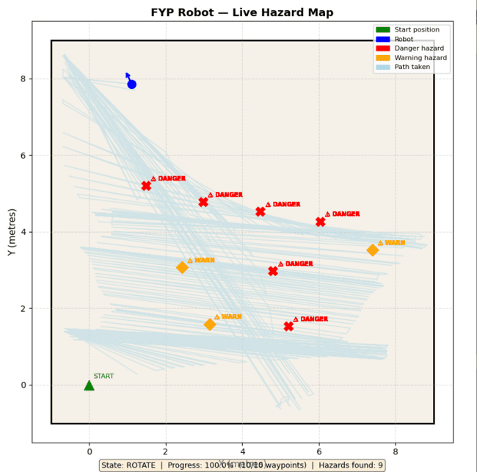Rough Terrain
A total of 13 hazards were detected and logged during the rough terrain simulation, comprising 1 DANGER classification and 12 WARNING classifications. Table below summarises the detected hazard coordinates and classifications.

Table 3: Rough Terrain Evaluation
Hazard | Classification
1 | Warning
2 | Warning
3 | Warning
4 | Warning
5 | Warning
6 | Warning
7 | Warning
8 | Warning
9 | Warning
10 | Danger
11 | Warning
12 | Warning
13 | Warning
The increased detection count of 13, compared to 9 in the flat terrain scenario, is attributable to additional ramp terrain features being detected as obstacles by the LiDAR sensor. The hazard map screenshot at mission completion is shown in Figure 19, confirming broad distribution of detected hazard locations across the survey area.

Figure 19
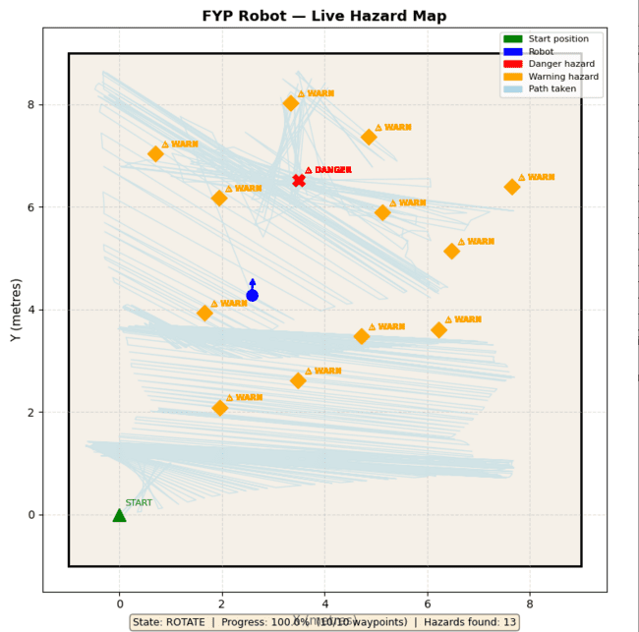

Slope Terrain
A total of 8 hazards were detected and logged during the slope terrain simulation, comprising 2 DANGER classifications and 6 WARNING classifications. The table below summarises the detected hazard coordinates and classifications:

Table 4: Slope Terrain Evaluation
Hazard | Classification
1 | Warning
2 | Warning
3 | Danger
4 | Warning
5 | Danger
6 | Warning
7 | Warning
8 | Warning
The sloped terrain produced the lowest hazard detection count of the three scenarios, at 8, compared to 9 in the flat world and 13 in the rough world. This is consistent with the reduced coverage in the upper survey area caused by the gradient terrain. The hazard map screenshot at mission completion is shown in Figure 20.

Figure 20
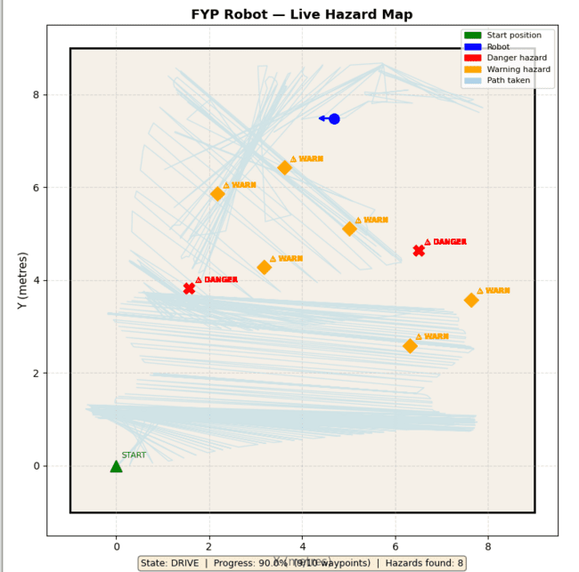

6.4 Terrain Adaptability Analysis
The results across all three terrain scenarios demonstrate the robot's ability to adapt its navigation behaviour to varying surface conditions. The table below provides a comparative summary of key performance metrics across all three terrain types.

Table 4
Metrics | Flat Terrain | Rough Terrain | Slope Terrain
Waypoints Completed | 7/10 (70%) | 6/10 (60%) | 6/10 (60%)
Waypoints Skipped | 3 | 4 | 4
Hazard Detected | 9 | 13 | 8
Danger Classified | 6 | 1 | 2
Warning Classified | 3 | 12 | 6
Max Avoidance Attempts | 12 | 8 | 12
The flat terrain scenario produced the highest DANGER classification count at 6, reflecting clear, unobstructed LiDAR readings on level ground that allowed close-range hazard detection. The rough terrain scenario produced the highest total hazard count at 13, as the additional ramp surfaces were detected as obstacles by the LiDAR sensor alongside the standard hazard set, demonstrating the system's sensitivity to terrain irregularities. The slope terrain scenario presented the greatest navigational challenge, producing the lowest hazard detection count (8) and the highest number of stuck timeouts, consistent with gradient terrain increasing physical resistance and reducing forward navigation efficiency.
Across all three scenarios, the robot successfully initiated autonomous coverage, executed the lawnmower survey pattern, detected and classified hazards, and logged their coordinates to the live hazard map without any human intervention. This demonstrates consistent adaptability to terrain across flat, rough, and sloped construction site conditions, directly addressing the project's research question regarding effective autonomous navigation and hazard detection across varied terrain types (Siegwart, Nourbakhsh & Scaramuzza, 2011).

6.5 Comparison with Existing Solutions
To contextualise the performance of the proposed system, the results are compared with 3 studies that cover different features of the system in this project. Being, navigation, hazard detection and obstacle avoidance.

Navigation and Coverage Comparison

Table 5
Feature | Raj et al | Proposed System
Navigation Algorithm | ROS Navigation Stack | Lawnmower Coverage
Terrain Types Tested | Single flat indoor | Flat, rough and Slope
Coverage Strategy | Point to point | Systematic row by row
Autonomous operation | Yes | Yes
Construction Site Applicable | No | Yes
Hazard Detection Integration | No | Yes
Raj et al. (2025) demonstrated effective autonomous navigation using ROS and Gazebo, but restricted testing to structured flat indoor environments. The proposed system extends this by operating across three terrain types and integrating hazard detection directly into the navigation pipeline, thereby making it more applicable to real construction-site conditions.

Hazard Detection Comparison

Table 6
Feature | Ucar et al | Proposed System
Detection Method | Transfer based visoin | LiDAR proximity
Real-time Detection | Yes | Yes
Hazard classification | Object categories | Danger/warning
Coordinate Logging | No | Yes
Live Visualisation | No | Yes
Navigation Integration | No | Yes
Construction Site Testes | Unstructured simulation | Structured simulation
Uçar et al. (2025) demonstrated strong object detection capability using transformer-based vision within a ROS-Gazebo framework. However, their detection system operates independently of navigation and control, producing no coordinate logging or live hazard mapping output. The proposed system integrates detection directly with navigation, classifies hazards by severity, and logs precise world coordinates onto a live Matplotlib map, providing actionable safety data that the Uçar et al. system does not provide.

Obstacle Avoidance Comparison

Table 6
Feature | Zhang et al | Proposed System
Avoidance Algorithm | Goal bial RRT | Reactive LiDAR avoidance
Environment Type | Static known map | Dynamic unknown map
Real-time planning | Limited | Yes
Terrain variety | Single 2D/3D space | Flat, Rough and slope
Hazard recording on avoidance | No | Yes
Construction Site Applicable | No | Yes
Zhang et al. (2024) proposed an improved goal-bias RRT path-planning algorithm that demonstrates greater efficiency than standard RRT in known static environments. However, the approach relies on a pre-built environment map and does not integrate real-time perception or hazard recording during avoidance manoeuvres. The proposed system performs reactive obstacle avoidance in real time using live LiDAR data without requiring a pre-built map, and records hazard coordinates during avoidance events, a capability directly relevant to construction site safety surveying.
Overall, the proposed system demonstrates advantages across all three comparison dimensions by combining systematic coverage, real-time hazard detection and classification, coordinate logging, live visualisation, and reactive obstacle avoidance within a single unified ROS2 pipeline tested across multiple terrain types.

6.6 Summary
This chapter presented the results and analysis from three simulation scenarios conducted on flat, rough, and sloped construction-site terrain. Across all three scenarios, the robot completed autonomous lawnmower coverage, detected and classified hazards as DANGER or WARNING, logged their world coordinates, and visualised them on a live Matplotlib hazard map without any human intervention.
The flat terrain scenario achieved the highest DANGER classification rate, reflecting clear, unobstructed LiDAR readings on level ground. The rough terrain scenario produced the highest total hazard count because additional ramp surfaces were detected alongside the standard hazard set. The slope-terrain scenario presented the greatest navigational challenge, yielding the lowest hazard-detection count and the highest number of stuck timeouts, consistent with gradient-terrain resistance.
Comparison against three existing studies demonstrated that the proposed system offers clear advantages in terrain adaptability, hazard detection integration, coordinate logging, and live visualisation, capabilities that none of the compared systems provided within a single unified pipeline. These findings directly address the project's research question and confirm that the proposed ROS2-based autonomous robot can effectively achieve systematic coverage, accurate hazard detection, and adaptive navigation across varied construction site terrain types.

Chapter 7: Conclusion & Recommendations

7.1 Conclusion
This project successfully designed, implemented, and evaluated a free construction-site survey robot in the Gazebo Harmonic simulation environment, integrated with ROS2 Jazzy. The system addressed the research question by demonstrating excellent orderly coverage, real-time LiDAR-based hazard detection and classification, and adaptive navigation across three distinct terrain types: flat, rough, and sloped.
The robot was implemented as a derivative drive platform equipped with a 360° LiDAR sensor and a forward-facing camera, guided by a lawnmower coverage algorithm that consistently swept a bounded 10x10-metre survey area in sequential row-by-row waypoints. A sacred hazard detection node classified objects as DANGER or WARNING based on LiDAR proximity readings, logged their precise world coordinates, and published them to a live Matplotlib hazard map for real-time visualisation.
Simulation results confirmed that the robot completed free coverage across all cardinal terrain types, detecting 9, 13, and 8 hazards in the flat, rough, and sloped terrain scenarios, respectively. Comparison against present solutions demonstrated distinct advantages in terrain adaptability, hazard detection integration, and real-time safety visualisation, capabilities absent from all cardinal baseline systems reviewed. These findings confirm the feasibility of simulation-driven free robotics for construction site safety surveying and provide a solid foundation for future tangible implementation and further research.

7.2 Limitations
Despite the range of results achieved, this project faced several limitations too.

Navigation Limitations
The lawnmower coverage algorithm, while excellent for orderly surveying, performed poorly in areas with high obstacle density, where stuck timeouts triggered waypoint skips across all three terrain scenarios. This led to rudimentary, unreliable traversal of survey rows, especially in the high regions of the grating and slope terrain environments. The sensitive obstacle-avoidance system, while functional, occasionally became trapped in persistent avoidance loops, requiring multiple attempts to clear them, indicating that a more refined path-replanning strategy would improve navigation robustness.

Hazard Detection Limitations
The LiDAR-based hazard detection system relies purely on proximity readings and cannot distinguish between hazard types; a red barrel and a yellow cone are treated identically as obstacles. Additionally, the wall proximity filter, while essential to prevent false positives from boundary walls, created detection blind spots near the survey area boundaries, where hazards near walls may be missed. The system likewise recorded some false-positive detections, in which terrain features such as ramps were classified as hazards.

Simulation Limitations
The project is limited to simulation-based evaluation and does not account for real-world factors such as sensor-noise variability, weather conditions, lighting changes, or surface deformation. The faux terrain environments, while representative, are, importantly, less complex than real construction sites, which feature unpredictable obstacles, moving machinery, and constantly changing layouts.

Scope Limitations
Only three terrain types were evaluated in this project due to time constraints. A fourth essential world environment was planned but not completed. Additionally, the system does not incorporate SLAM mapping, meaning the robot has no persistent memory of previously visited areas or detected hazards between simulation runs.

7.3 Recommendations and Future Work
Based on the findings and limitations identified in this project, various recommendations are proposed for forthcoming development and potential real-world implementation.

Improved Navigation Algorithm
The current sensitive lawnmower coverage algorithm could be enhanced by integrating SLAM-based mapping, enabling the robot to build a persistent map of the survey area during operation and replan routes dynamically around detected obstacles rather than relying on stuck timeouts. Implementing a more refined path-planning algorithm, such as A* or RRT, within the coverage framework would reduce waypoint skipping and improve overall coverage completeness, especially in high-density obstacle environments (LaValle, 2006).

Enhanced Hazard Detection
The LiDAR-based proximity espial system could be significantly improved by integrating computer vision techniques, such as convolutional neural networks or transformer-based object espial, to classify hazard types visually from camera data (Uçar et al., 2025). This would enable the system to distinguish between distinct hazard categories, such as chemical barrels, structural hazards, and ground pit obstacles, providing more actionable safety information for construction site managers.

Additional Terrain Types
Forthcoming work should extend testing to additional terrain environments, including debris-covered surfaces, mud or deformable ground, and combined multi-terrain scenarios that more closely reflect real construction site conditions. Testing across a greater variety of environments would provide stronger evidence of terrain adaptability and system robustness.

Physical Robot Implementation
The standard ROS2 architecture developed in this project is designed to facilitate transition from simulation to tangible hardware with negligible modification. Forthcoming work should implement the system on a tangible differential-drive robot platform equipped with a real LiDAR sensor, validating simulation results against real-world performance and identifying any gaps between simulated and tangible behaviour (Siegwart, Nourbakhsh & Scaramuzza, 2011).

Real-world Deployment
For real-world deployment, the system would require integration of additional safety-critical features, including emergency stop mechanisms, communication modules for remote monitoring, weather-resistant hardware enclosures, and compliance with construction-site health and safety regulations. These considerations are beyond the scope of the current simulation-based study but represent substantial steps towards practical implementation on construction sites.

References:
Bogue, R. (2018). Robots in the construction industry. Industrial Robot, 45(4), 425–430.
Koenig, N. & Howard, A. (2004). Design and use paradigms for Gazebo, an open-source multi-robot simulator. Proceedings of the IEEE/RSJ International Conference on Intelligent Robots and Systems, 2149–2154.
Makris, S., Karagiannis, P., Koukas, S. & Matthaiakis, A. (2019). Augmented reality system for operator support in human-robot collaborative assembly. CIRP Annals, 65(1), 61–64.
Gambao, E., Hernando, M. & Surdilovic, D. (2012). A new generation of collaborative robots for material handling in construction. Proceedings of the International Symposium on Automation and Robotics in Construction, 1–8.
Corke, P., Sheratt, T. & Sen Gupta, G. (2011). Robotics, Vision and Control: Fundamental Algorithms in MATLAB. Springer.
Choset, H., Lynch, K., Hutchinson, S., Kantor, G., Burgard, W., Kavraki, L. & Thrun, S. (2005). Principles of Robot Motion: Theory, Algorithms, and Implementations. MIT Press.
LaValle, S. (2006). Planning Algorithms. Cambridge University Press.
Thrun, S., Burgard, W. & Fox, D. (2005). Probabilistic Robotics. MIT Press.
Siegwart, R., Nourbakhsh, I. & Scaramuzza, D. (2011). Introduction to Autonomous Mobile Robots. 2nd edn. MIT Press.
Quigley, M., Conley, K., Gerkey, B., Faust, J., Foote, T., Leibs, J., Wheeler, R., & Ng, A. (2009). ROS: an open-source robot operating system. ICRA Workshop on Open Source Software, 3(3.2), 5.
Zhang, T., Wu, Y. and Ding, X. (2021) 'Recent developments in terrain identification, classification and parameter estimation for autonomous robots', SN Applied Sciences, 3(5), pp. 1–20. Available at: https://link.springer.com/article/10.1007/s42452-021-04453-3 (Accessed: 11 December 2025).
Chen, X., Wang, Y. and Li, J. (2020) 'LiDAR–vision sensor fusion for robust obstacle detection in unstructured environments', Sensors, 20(22), p. 6413. Available at: https://www.mdpi.com/1424-8220/20/22/6413 (Accessed: 11 December 2025).
Zhang, H., Xie, X., Wei, M., Wang, X., Song, D. and Luo, J. (2024) 'An improved goal-bias RRT algorithm for unmanned aerial vehicle path planning', IEEE International Conference on Mechatronics and Automation (ICMA), Tianjin, China. Available at: https://ieeexplore.ieee.org/document/10633102 (Accessed: 11 December 2025).
Zhang, H., Dai, X., Sun, F. and Yuan, J. (2016) 'Terrain classification in field environment based on random forest for the mobile robot', Proceedings of the 35th Chinese Control Conference (CCC), Chengdu, China, pp. 6074–6079. Available at: https://ieeexplore.ieee.org/document/7554310 (Accessed: 11 December 2025).
Liu, L., Wei, Y., Hu, F., and Xu, F. (2025) 'On the value of terrain classification using SAR altimeter delay doppler image', IEEE International Geoscience and Remote Sensing Symposium (IGARSS). Available at: https://ieeexplore.ieee.org/document/10868999 (Accessed: 11 December 2025).
Uçar, A., Tekeş, A. and Yorulmaz, M. (2025) 'Transformer-based object detection in unconstructed environments: a ROS-Gazebo simulation framework', Proceedings of IEEE INISTA 2025. Available at: https://ieeexplore.ieee.org/document/11249519 (Accessed: 12 December 2025).
Raj, S., Sharma, A. and Kaur, H. (2025) 'Autonomous navigation for TurtleBot3 robots in Gazebo simulation environment', Proceedings of the IEEE International Conference on Robotics and Automation (ICRA) 2025. Available at: https://ieeexplore.ieee.org/document/10824668 (Accessed: 13 December 2025).
Zhang, T., Li, J., Wang, Y. and Liu, F. (2025) 'Design of a simulation system for quadruped robot based on Gazebo', Proceedings of the IEEE International Conference on Mechatronics and Automation (ICMA) 2025. Available at: https://ieeexplore.ieee.org/document/10868461 (Accessed: 13 December 2025).
Xu, Q., Yuan, J., Han, Z., Wang, N. and Gao, L. (2017) 'Design and simulation analysis of a terrain adaptable wheeled mobile platform', Proceedings of the IEEE International Conference on Robotics and Biomimetics (ROBIO) 2017. Available at: https://ieeexplore.ieee.org/document/8324422 (Accessed: 14 December 2025).
Wang, L., Zhang, Q. and Zhou, T. (2025) 'Innovative design of bionic foot and closed-loop feedback control system for quadruped robot adaptable to sloped muddy terrains', Proceedings of the IEEE International Conference on Robotics and Automation (ICRA) 2025. Available at: https://ieeexplore.ieee.org/document/11149181 (Accessed: 14 December 2025).
Raj, S., Sharma, A. and Kaur, H. (2025) 'Autonomous navigation for TurtleBot3 robots in Gazebo simulation environment', Proceedings of the IEEE International Conference on Robotics and Automation (ICRA) 2025. Available at: https://ieeexplore.ieee.org/document/10824668 (Accessed: 02 April 2026).

Appendices

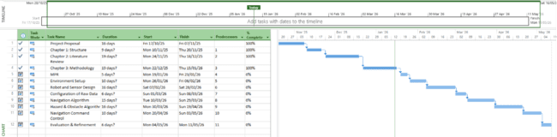
Appendix A: Project Ghantt Chart


Appendix B: Ghantt Chart Report

Appendix C: LiDAR sensor code
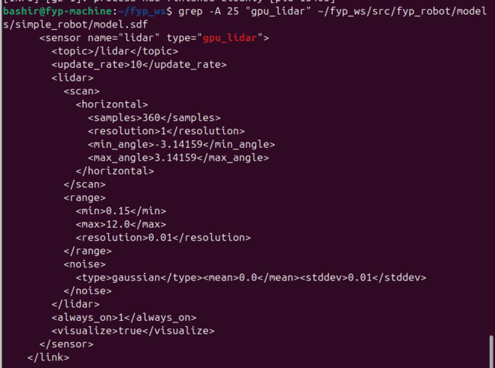

Appendix D: Flat world key section
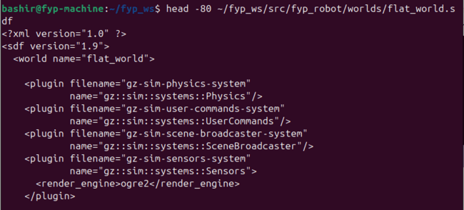

Appendix E: Rough world key section
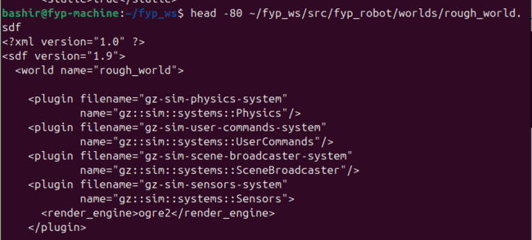

Appendix F: Slope world key section
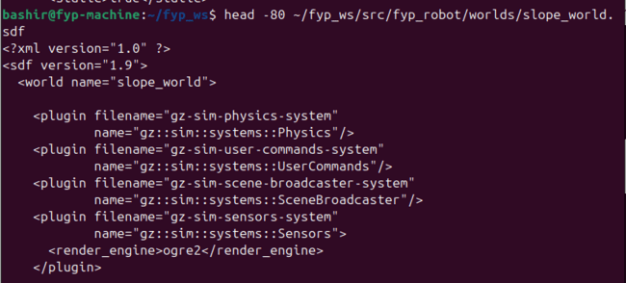

Appendix G: Plain terrain hazard detection results
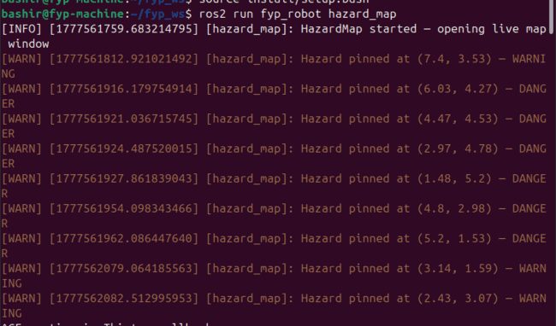

Appendix H: Rough terrain hazard detection result
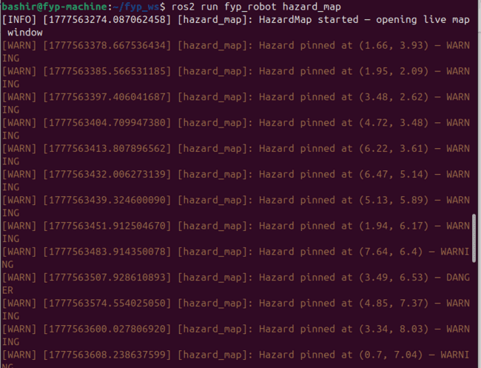

Appendix I: Slope terrain hazard detection result
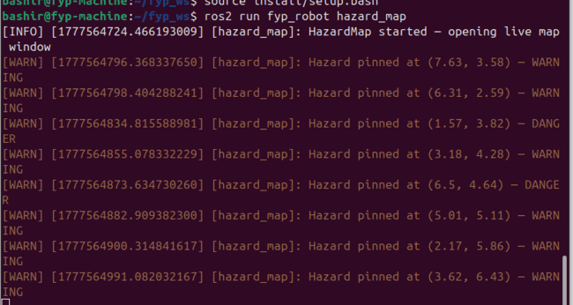

Thank you for your time.

