

Final Year Project

COMP60011

A Novel Lightweight AI Framework for Real-Time, Low-Latency Scene Description for Visually Impaired Users

Name: Yahya Ali
Student ID: 23034819
1st Supervisor: Dr. Viraj Dawarka
2nd Supervisor: Dr. Mahsa Zolfaghari
Date: 01/05/2026

Table of Contents
Chapter 1: Introduction 2
1.1 Background 3
1.2 Problem Statement 4
1.3 Aim and Objectives 4
1.4 Research Questions 5
1.5 Scope of the Study 5
1.6 Significance of the Study 6
1.7 Methodology Overview 6
1.8 Structure of the Report 6
Chapter 2: Literature Review 6
2.1 Introduction 7
2.2 Lightweight Deep Learning for Mobile Devices 7
2.3 Image Captioning and Scene Understanding 7
2.4 Assistive Technologies for the Visually Impaired 8
2.5 On-Device Inference Frameworks 8
2.6 Critical Discussion 8
2.7 Summary and Research Gap 10
Chapter 3: Methodology 11
3.1 Introduction 11
3.2 Research Approach 11
3.3 Development Methodology 11
3.4 System Architecture Overview 11
3.5 Hardware and Software Environment 11
3.6 Algorithm Selection and Model Development 11
3.7 Application Implementation 11
3.8 Testing Strategy 11
3.9 Evaluation Methods 11
3.10 Risk Management 11
3.11 Ethical Considerations 11
3.12 Prototype Evolution and Implementation Shift 11
3.13 Summary 11
Chapter 4: Framework Design 11
4.1 Real-Time On-Device Scene Description Processing Pipeline 11
4.2 Use Case Scenario Selection 11
4.3 System Diagrams 11
4.4 Prototype Design: User Interfaces 11
Chapter 5: Implementation and Testing 11
5.1 Development Environment and Tools 11
5.2 Implementation of the AI Processing Pipeline 11
5.3 Prototype Application Integration 11
5.4 Testing Methodology 11
Chapter 6: Results and Discussion 11
6.1 Overview of Experimental Evaluation 11
6.2 Object Detection Performance 11
6.3 Captioning Performance 11
6.4 Framework Latency Evaluation 11
6.5 Scene Description Quality 11
6.6 Discussion of Results 11
6.7 Comparison with Existing Systems 11
Chapter 7: Conclusion and Recommendations 11
7.1 Summary of the Research 11
7.2 Contributions of the Project 11
7.3 Limitations 11
7.4 Future Work 11
7.5 Final Conclusion 11
References 11
Appendices 11
Appendix A: Gantt Chart 11
Appendix B: Sprint Planning 11
Appendix C: Test Plan 11
Appendix D: Experimental Results 11

List of Tables
Table 1: Related Literature Table 11
Table 2: Research Gaps and Implications 13
Table 3: Risk Management 22
Table 4: Sprint Planning (Appendix) 56
Table 5: Test Plan (Appendix) 57
Table 6: Performance Results (Appendix) 58
Table 7: Sample Output Quality (Appendix) 59
Table 8: Statistical Summary (Appendix) 59

Chapter 1: Introduction

1.1 Background
Visual impairment affects a substantial proportion of the global population and presents major challenges in everyday life. The World Health Organization estimates that over 2.2 billion people worldwide experience some form of visual impairment, with many individuals facing difficulties in independent navigation and environmental awareness. Routine activities such as identifying objects, reading signs, or understanding unfamiliar surroundings often require external assistance. As a result, visually impaired individuals frequently rely on assistive technologies to support daily living and mobility. Advances in artificial intelligence and computer vision have enabled the development of digital tools aimed at improving accessibility. Modern applications such as Microsoft Seeing AI and Google Lookout utilise smartphone cameras and cloud-based artificial intelligence services to recognise objects, read text, and provide spoken descriptions of scenes. These tools demonstrate the potential of AI to enhance independence and quality of life for visually impaired users. However, most current solutions depend heavily on remote servers for image processing and interpretation.
Cloud-reliant systems introduce several practical limitations. First, they require a stable and continuous internet connection, which may not always be available, particularly in outdoor or remote environments. Second, transmitting images to external servers results in noticeable processing delays, which can reduce usability in real-time scenarios. Third, sending personal visual data to cloud services raises privacy and security concerns. These issues highlight the need for alternative approaches that enable scene understanding directly on mobile devices. Recent developments in mobile hardware and edge computing have created new opportunities for on-device artificial intelligence. Modern smartphones now include specialised processors capable of running deep learning models locally with improved efficiency. Lightweight neural network architectures such as MobileNet, EfficientNet, and compact versions of YOLO demonstrate that it is possible to achieve strong visual recognition performance with significantly reduced computational requirements. These advancements provide a technical foundation for building assistive systems that operate without cloud connectivity.
Despite these technological improvements, relatively few accessibility applications fully exploit on-device AI capabilities for real-time scene description. Many existing tools focus primarily on single functions such as object detection or text recognition rather than comprehensive environmental understanding. There remains a clear need for an integrated framework that can deliver accurate, fast, and context-aware descriptions while running entirely on consumer-grade mobile hardware. This project seeks to address that need by designing and implementing a novel lightweight AI framework capable of generating real-time spoken scene descriptions for visually impaired users. The proposed system aims to combine efficient object detection, optimised image captioning, and accessible audio feedback within a single mobile application, providing a practical and privacy-preserving assistive solution.

1.2 Problem Statement
Although significant progress has been made in artificial intelligence for accessibility, current solutions remain limited in several important ways. Most commercially available applications rely on cloud-based processing to perform complex computer vision tasks. This approach leads to high latency, dependency on internet access, and potential privacy risks due to the transmission of sensitive user data. Furthermore, many existing tools offer only basic object recognition rather than meaningful, context-aware scene descriptions. Systems that do provide advanced captioning typically require powerful hardware and cannot operate efficiently on smartphones. As a result, visually impaired users lack access to a fast, reliable, and fully on-device system capable of explaining their surroundings in real time. The core problem addressed in this project is the absence of a practical, low-latency, on-device scene understanding framework specifically designed for accessibility purposes. There is a need for a solution that balances computational efficiency with descriptive accuracy while remaining usable in everyday situations.

1.3 Aim and Objectives

Aim
The aim of this project is to design, implement, and evaluate a novel lightweight artificial intelligence framework capable of providing real-time spoken scene descriptions for visually impaired users entirely on mobile devices without reliance on cloud services.

Objectives
To achieve this aim, the project will pursue the following objectives:
- Investigate existing lightweight computer vision and image captioning models suitable for mobile deployment.
- Develop and optimise an AI pipeline that combines object detection and scene description techniques.
- Integrate the pipeline into an Android-based prototype application with real-time camera input.
- Implement speech output to deliver concise and contextually relevant descriptions.
- Evaluate the system in terms of latency, accuracy, power consumption, and usability.

1.4 Research Questions
This project is guided by the following primary research question:
How can a lightweight artificial intelligence framework be designed to deliver accurate and meaningful real-time scene descriptions on mobile devices while maintaining low latency for visually impaired users?
Supporting questions include:
- Which computer vision models provide the best balance between accuracy and efficiency for on-device processing?
- How can image captioning techniques be optimised for mobile hardware?
- What level of performance is achievable on consumer smartphones without cloud assistance?
- How effective and usable are the generated descriptions for accessibility purposes?

1.5 Scope of the Study
This project focuses on the development of a smartphone-based assistive application for scene understanding. The scope is limited to:
- On-device processing using Android smartphones.
- Real-time object detection and scene description.
- Audio-based feedback for visually impaired users.
The project does not include:
- Development of specialised hardware devices.
- Large-scale clinical trials with end users.
- Cloud-based processing solutions.

1.6 Significance of the Study
The proposed system has the potential to make meaningful contributions to both research and society. By enabling real-time scene understanding directly on mobile devices, the project supports greater independence for visually impaired individuals. Removing cloud dependency enhances privacy, reduces latency, and improves reliability in everyday environments. From a technical perspective, the project contributes to research on efficient AI deployment and mobile accessibility. It demonstrates how modern lightweight models can be combined to create practical assistive tools, providing insights that may inform future developments in accessible technology.

1.7 Methodology Overview
The project adopts an experimental software engineering approach using Agile development principles. Lightweight computer vision models will be selected, optimised, and integrated into an Android application. The system will be evaluated through quantitative performance testing and qualitative usability assessment. Results will be analysed to determine the effectiveness of the proposed framework.

1.8 Structure of the Report
The remainder of this report is organised as follows:
- Chapter 1: Introduction
- Chapter 2: Literature Review
- Chapter 3: Methodology
- Chapter 4: Framework Design
- Chapter 5: Implementation and Testing
- Chapter 6: Results and Discussion
- Chapter 7: Conclusion and Recommendations

Chapter 2: Literature Review

2.1 Introduction
The purpose of this literature review is to analyse existing research relevant to the development of on-device scene understanding systems for visually impaired users. The review examines four main areas: lightweight deep learning models, image captioning techniques, assistive technologies, and mobile AI deployment frameworks. By critically evaluating prior work, this chapter identifies the limitations of current approaches and establishes the research gap addressed by this project.

2.2 Lightweight Deep Learning for Mobile Devices
Traditional deep learning models achieve high accuracy but often require powerful hardware. To address this limitation, researchers have developed efficient neural network architectures designed specifically for mobile devices. Models such as MobileNet and EfficientNet reduce computational complexity through optimised convolution techniques and parameter reduction. Object detection has followed a similar trend. Early systems achieved strong results but were too slow for real-time mobile use. Modern detectors such as YOLOv8-Nano provide compact and fast alternatives capable of operating on smartphones with minimal latency. These models demonstrate that real-time visual recognition is feasible without cloud infrastructure. Model compression techniques further improve efficiency. Quantisation reduces numerical precision to decrease memory usage, while pruning removes unnecessary network parameters. These methods allow complex models to be adapted for low-power devices, forming a key component of lightweight AI systems.

2.3 Image Captioning and Scene Understanding
Image captioning enables computers to generate natural language descriptions of visual scenes. Early methods combined convolutional networks with recurrent neural networks to produce simple captions. More recent transformer-based approaches have achieved major improvements in fluency and contextual understanding. Despite these advances, most captioning systems remain computationally heavy. Large vision-language models require significant processing power and are typically deployed on cloud servers. Research into distillation and quantisation has shown that smaller captioning models can be created, but practical on-device implementations are still limited. This gap between research capability and mobile deployment represents a key challenge for accessibility applications. To be useful in real time, captioning systems must be both accurate and computationally efficient.

2.4 Assistive Technologies for the Visually Impaired
Commercial applications have demonstrated the practical value of AI for accessibility. Tools such as Seeing AI and Google Lookout provide useful features including text reading and object recognition. However, they rely heavily on internet connectivity and remote processing. Academic prototypes have explored wearable cameras and navigation aids, yet most focus on narrow tasks rather than general scene understanding. Few systems combine detection, captioning, and speech output into a single mobile application designed for everyday use. As a result, visually impaired users still lack a comprehensive on-device assistant capable of describing their surroundings.

2.5 On-Device Inference Frameworks
Frameworks such as TensorFlow Lite and PyTorch Mobile enable neural networks to run efficiently on smartphones. These platforms support hardware acceleration and optimised execution, making real-time AI applications more practical. However, integrating multiple models into a seamless pipeline remains challenging. Developers must balance accuracy, speed, and power consumption while ensuring a smooth user experience. Research addressing these integration challenges for accessibility-specific use cases is currently limited.

2.6 Critical Discussion
The literature demonstrates strong progress in individual areas such as lightweight detection and image captioning. Nevertheless, these components are rarely combined into a unified system suitable for real-time accessibility use. Most existing solutions either rely on the cloud or provide only partial functionality. Furthermore, many studies evaluate performance using technical metrics alone, with limited consideration of user experience. For visually impaired users, factors such as clarity of speech output and cognitive load are equally important. A successful system must therefore integrate technical efficiency with user-centred design.

2.6.1 Comparative Analysis of Related Literature Table
The comparative table below presents a comparative analysis of key studies and systems related to lightweight computer vision, image captioning, and accessibility applications. While existing approaches demonstrate strong performance in isolated tasks such as object detection or caption generation, several limitations remain in terms of latency, privacy, and suitability for real-time on-device deployment.
Table 1: Related Literature Table
Study | Approach / System | Key Contributions | Limitations | Relevance to This Project
Howard et al. (2017) | MobileNet CNN architecture for mobile vision tasks | Demonstrated that depthwise separable convolutions significantly reduce computation while maintaining accuracy | Focuses on classification and detection only, not scene understanding or captioning | Provides foundational techniques for building lightweight models suitable for mobile deployment
Tan and Le (2019) | EfficientNet model scaling strategy | Achieves improved accuracy efficiency trade-offs using compound scaling | Still computationally heavy for real-time mobile inference without compression | Informs model optimisation strategies for balancing accuracy and efficiency
Bochkovskiy et al. (2020) | YOLO-based real-time object detection | High detection accuracy with real-time performance | Designed primarily for detection, lacks semantic scene description | Useful for fast object detection within the proposed on-device pipeline
Li et al. (2023) | BLIP-2 vision language model | Generates high-quality image captions using multimodal transformers | Large model size and high computational requirements | Highlights the potential of captioning models and the need for compression for mobile use
Microsoft (2024) | Seeing AI cloud-based accessibility application | Provides object recognition and scene description for visually impaired users | Requires internet connectivity and introduces latency and privacy concerns | Demonstrates real-world demand while highlighting limitations of cloud dependence
Google (2024) | Lookout accessibility application | Supports navigation and object identification using cloud AI | Limited offline functionality and variable response times | Motivates the need for a fully on-device alternative

The analysis presented in this table highlights several critical gaps within current research and commercial accessibility systems. While recent advancements in computer vision and vision language models have significantly improved accuracy, their practical deployment for real-time assistive applications remains limited. A consistent reliance on cloud infrastructure introduces latency, connectivity dependence, and privacy concerns. Furthermore, existing models are often too computationally demanding for continuous on-device use, restricting their applicability for mobile accessibility tools.

2.7 Summary and Research Gap
This chapter has reviewed existing research in lightweight deep learning, image captioning, on-device inference frameworks, and assistive technologies for visually impaired users. The literature demonstrates substantial progress in individual components such as efficient object detection models, mobile-optimised neural networks, and vision language architectures capable of generating descriptive captions. In addition, commercial accessibility applications illustrate the practical value of computer vision for supporting visually impaired users in real-world environments. However, despite these advancements, several limitations remain evident. Many existing accessibility solutions rely on cloud-based processing, which introduces latency, dependency on internet connectivity, and potential privacy concerns. Furthermore, while lightweight models have been proposed for mobile deployment, they are often evaluated in isolation and not integrated into complete, real-time systems capable of continuous scene understanding. Image captioning models remain computationally demanding and are rarely optimised for on-device use within accessibility-focused applications.
The key research gap identified is the absence of a lightweight, real-time, fully on-device framework that effectively combines object detection and image captioning to deliver concise and context-aware spoken scene descriptions. Current research does not sufficiently address the balance between accuracy, latency, energy efficiency, and usability required for assistive technologies operating on consumer-grade mobile hardware. This project aims to address this gap by designing, implementing, and evaluating a novel on-device AI framework tailored specifically to the needs of visually impaired users. By integrating optimised detection and captioning models within a single mobile pipeline, the proposed system seeks to provide responsive, privacy-preserving, and accessible scene descriptions suitable for real-world deployment.

2.7.1 Identified Research Gaps and Implications Table
Based on the critical evaluation of existing literature, several research gaps have been identified that limit the effectiveness of current accessibility and on-device computer vision solutions. The table below summarises these gaps, the supporting evidence from relevant studies, and their implications for the proposed project.
Table 2: Research Gaps and Implications
Research Gap | Evidence from Literature | Implications for This Project
Limited fully on-device scene description systems | Cloud-based systems such as Seeing AI and Lookout rely on remote servers for processing (Google, 2024; Microsoft, 2024) | Motivates the design of a fully local framework that operates without internet connectivity
High latency in existing accessibility solutions | Studies report delays due to network dependency and cloud inference (Li et al., 2023) | Emphasises the need for real-time, low-latency processing suitable for assistive use
Large model sizes unsuitable for mobile devices | Transformer-based captioning models require significant computational resources (Li et al., 2023) | Necessitates the use of model compression, quantisation, and distillation techniques
Lack of integration between detection and captioning | Most studies treat object detection and captioning as separate tasks (Bochkovskiy et al., 2020) | Supports the development of a fused pipeline combining both outputs for richer scene understanding
Limited focus on accessibility-driven design | Many computer vision systems prioritise accuracy over usability for visually impaired users | Highlights the importance of concise, context-aware audio feedback tailored to accessibility needs

These identified gaps directly inform the direction of this project. By focusing on lightweight architectures, local processing, and the fusion of detection and captioning outputs, the proposed framework addresses both technical and user-centred limitations found in existing work. The emphasis on low latency, privacy preservation, and accessibility-driven design distinguishes this research from prior studies and supports the development of a practical, real-world assistive solution for visually impaired users.

Chapter 3: Methodology

3.1 Introduction
This chapter outlines the research methods and technical approach that will be used to design, implement, and evaluate the proposed lightweight artificial intelligence framework. The methodology explains how the project objectives will be achieved through a structured development process. It describes the overall research approach, system architecture, model selection process, implementation strategy, evaluation methods, and ethical considerations. The purpose of this chapter is to demonstrate that the project follows a logical, systematic, and technically appropriate plan.

3.2 Research Approach
The project adopts an experimental and development-based research approach. The primary objective is to design and build a working software prototype and to evaluate its performance under real-world conditions. This type of project is best suited to an applied methodology rather than a purely theoretical one. A mixed-methods evaluation strategy will be used. Quantitative methods will be applied to measure technical performance, including latency, accuracy, and resource consumption. Qualitative methods will be used to assess usability and accessibility through user feedback and practical testing scenarios. This combination ensures that the system is evaluated both as a technical artefact and as an assistive tool. The development process will follow an Agile methodology. Agile development is appropriate because it allows iterative improvement, regular testing, and gradual refinement of system components. The project involves experimentation with different models and configurations, and Agile principles support this flexible and adaptive workflow.

3.3 Development Methodology
The project will be organised into iterative development cycles. Each cycle will include requirements analysis, implementation, testing, and evaluation. The key stages are outlined below.
- Requirements gathering and analysis
- Literature review and technology selection
- Prototype design
- Model integration
- System optimisation
- Testing and evaluation
- Refinement based on results
This structure ensures continuous progress and allows problems to be identified and addressed early in the development process.

3.4 System Architecture Overview
The proposed system is implemented as a dual-environment prototype consisting of a primary desktop-based real-time inference pipeline and a secondary mobile-based experimental deployment. The primary system operates on a Python-based architecture using OpenCV for real-time webcam capture, YOLOv8n for object detection, and a rule-based fusion module for scene description generation. Speech output is provided using a local text-to-speech engine. In parallel, an experimental Android implementation was developed using ONNX-based YOLO inference integrated with CameraX and Android Text-to-Speech. This was used to evaluate feasibility of mobile deployment, although the desktop system achieved higher accuracy and stability. This dual-implementation approach enables both high-performance prototyping and real-world deployment exploration.

3.5 Hardware and Software Environment

3.5.1 Hardware Platform
The system will be developed and tested on standard consumer Android smartphones. Target hardware includes:
- Android smartphone running Android 12 or later
- Minimum 4GB RAM
- Integrated GPU or neural processing unit
- Rear-facing camera with at least 8 megapixels
Testing on typical mid-range devices ensures that the final system is practical for real-world users rather than requiring specialised hardware.

3.5.2 Software Tools
The following tools and frameworks will be used:
- Android Studio for application development
- Kotlin or Java for mobile programming
- TensorFlow Lite or PyTorch Mobile for on-device inference
- Android CameraX API for camera integration
- Android Text-to-Speech API for audio output
- Python for model training and optimisation
- Google Colab or local GPU workstation for experimentation
These tools are industry-standard platforms for mobile artificial intelligence development and are well supported by documentation and research communities.

3.5.3 Development Platforms
Two development environments were used in this project:
- A Python-based desktop environment (Visual Studio Code) used for real-time webcam inference, model testing, and system validation.
- An Android Studio environment used for experimental mobile deployment using ONNX models and CameraX API.
The desktop environment served as the primary evaluation platform due to its stability and higher inference accuracy, while the Android implementation was used to assess portability and mobile feasibility.

3.6 Algorithm Selection and Model Development

3.6.1 Object Detection Component
The object detection module is responsible for identifying important objects within the camera view. Lightweight models will be evaluated to determine the most suitable option for mobile deployment. Candidate models include:
- YOLOv8-Nano
- MobileNet-SSD
- EfficientDet-Lite
These models are specifically designed for fast inference on low-power devices. Performance will be compared in terms of detection accuracy, model size, and processing speed. The final choice will depend on achieving the best balance between accuracy and latency.
To improve efficiency, optimisation techniques will be applied, including:
- 8-bit quantisation
- model pruning
- conversion to TensorFlow Lite format
- hardware acceleration through NNAPI or GPU delegates
The object detection task is formulated as a single-stage detection problem, where bounding boxes and class probabilities are predicted directly from image features. Models such as YOLOv8-Nano follow a grid-based detection approach that enables fast inference by avoiding region proposal stages. This design makes them particularly suitable for real-time mobile applications where low latency is critical.

3.6.2 Image Captioning Component
The image captioning module generates natural language descriptions of the scene. Traditional captioning models are too large for mobile devices, so a compressed approach will be used. The captioning process follows a vision-language pipeline in which visual features extracted from the input image are mapped to natural language descriptions. Transformer-based architectures are commonly used due to their ability to model long-range dependencies in text. However, their computational cost requires optimisation for mobile deployment. This project focuses on adapting such models to operate under strict resource constraints while maintaining acceptable descriptive quality.
Possible approaches include:
- Distilled versions of BLIP or similar transformer models
- Lightweight encoder-decoder architectures
- Pre-trained captioning models converted for mobile inference
The chosen model will be adapted and optimised to run efficiently on-device. Techniques such as knowledge distillation and quantisation will be used to reduce computational requirements.

3.6.3 Fusion of Outputs
A key aspect of the project is the integration of object detection and captioning results. Rather than simply reading raw captions, the system will combine information from both models to produce more meaningful and concise descriptions.
For example:
- Detected objects will be used to guide or refine caption outputs
- Priority will be given to nearby or important objects
- Redundant or unnecessary information will be filtered
This fusion layer is a central element of the proposed novel framework, where the fusion strategy acts as a rule-based and context-aware decision layer rather than a purely generative model. By prioritising detected objects and filtering redundant information, the system reduces cognitive load for the user. This approach differs from standard captioning systems, which often generate verbose descriptions without accessibility-specific optimisation.

3.6.4 Description Generation Logic
The final spoken output presented to the user is generated through a description generation logic layer that translates model predictions into concise and meaningful audio feedback. Rather than directly vocalising raw captions produced by the image captioning model, this layer applies rule-based filtering and prioritisation to ensure that descriptions remain relevant and accessible. Detected objects are ranked based on contextual importance, which may include factors such as object size, position within the frame, and frequency of detection across consecutive frames. Objects that are likely to be most relevant for navigation and situational awareness are prioritised, while less important background elements are deprioritised or omitted. This approach helps reduce unnecessary or overwhelming information for the user. To avoid repetitive or redundant speech output, temporal logic is applied across successive frames. Objects or scene elements that have already been described recently are not repeated unless a significant change is detected, such as the appearance of a new object or a notable shift in the environment. This improves the listening experience and reduces cognitive load during continuous use.
The description generation logic also supports basic customisation to accommodate user preferences. For example, the frequency of spoken feedback and the level of descriptive detail can be adjusted to suit different usage contexts. These controls ensure that the system remains flexible while maintaining real-time performance. By incorporating this intermediate logic layer, the system produces structured and context-aware spoken descriptions that are more suitable for accessibility applications than unfiltered caption outputs. This component plays a key role in transforming raw model predictions into practical assistive feedback for visually impaired users. Although initial design considerations focused on TensorFlow Lite and PyTorch Mobile, practical experimentation demonstrated that ONNX-based deployment and Python-based inference pipelines provided greater flexibility during development. As a result, the final system prioritises a Python-based real-time inference framework, with mobile deployment explored as an extension rather than the core implementation.

3.7 Application Implementation
The Android application will be developed with the following functionality:
- Real-time camera preview
- Frame capture and pre-processing
- Execution of AI models locally
- Interpretation of model outputs
- Generation of spoken feedback
- Simple user controls for starting and stopping descriptions
Multithreading will be used to ensure that camera capture, model inference, and speech output operate smoothly without blocking the user interface. Performance optimisation will be a major focus to maintain real-time responsiveness.

3.8 Testing Strategy
Testing will be carried out in several stages.

3.8.1 Functional Testing
Functional tests will verify that:
- The camera operates correctly
- Models load and execute on the device
- Speech output is generated
- The user interface behaves as expected

3.8.2 Performance Testing
Technical performance will be measured using the following criteria:
- Inference latency in milliseconds
- Frames per second
- Model accuracy
- Memory usage
- Battery consumption
Experiments will compare different model configurations to determine the most effective setup.

3.8.3 Real-World Scenario Testing
The application will be tested in a variety of indoor and outdoor environments such as:
- offices
- classrooms
- streets
- home environments
This ensures that the system is evaluated under realistic conditions rather than controlled laboratory settings.

3.9 Evaluation Methods

3.9.1 Quantitative Evaluation
Objective performance metrics will be collected, including:
- Mean Average Precision for object detection
- BLEU, CIDEr, and SPICE scores for caption quality
- Average processing time per frame
- Power usage over extended operation
Standard datasets such as COCO and Open Images will be used to benchmark accuracy before on-device deployment.

3.9.2 Qualitative Evaluation
Usability will be evaluated through small-scale user testing or simulated user studies. Participants will interact with the system and provide feedback on:
- clarity of spoken descriptions
- usefulness of information
- response speed
- overall user experience
This feedback will guide improvements to the interface and description logic.

3.10 Risk Management
Several risks have been identified along with mitigation strategies:
Table 3: Risk Management
Risk | Mitigation
Models too slow for real time | Apply quantisation and choose smaller architectures
Low caption accuracy | Use model distillation and dataset fine-tuning
Excessive battery consumption | Optimise frame rate and processing frequency
Limited access to real users | Use simulated testing and feedback surveys
Hardware compatibility issues | Test across multiple Android devices
Managing these risks is essential to ensure successful project completion.

3.11 Ethical Considerations
Ethical issues are an important aspect of this project. Since the system processes live camera images, privacy must be protected. All data processing will occur locally on the device, and no images will be stored or transmitted externally. Any user testing will be conducted with informed consent, and participants will be clearly informed of how the system operates. The project does not involve collection of personal data beyond temporary camera input used solely for real-time processing. This approach minimises ethical risks and aligns with data protection principles.

3.12 Prototype Evolution and Implementation Shift
During development, the system design evolved from an Android-first architecture to a dual-prototype approach. Initial implementation efforts focused on deploying YOLO-based object detection models using TensorFlow Lite within an Android application. However, compatibility limitations and reduced detection accuracy led to the adoption of ONNX-based inference in Android Studio. Despite successful integration of camera input, ONNX inference, and text-to-speech functionality, performance and prediction stability were inconsistent compared to the desktop implementation. Consequently, a high-performance Python-based real-time system was developed using OpenCV and YOLOv8n, which achieved significantly improved detection speed and caption reliability. This system became the primary evaluation platform for the project. The Android implementation remains an important experimental contribution, demonstrating feasibility of mobile deployment and highlighting the challenges associated with on-device AI optimisation.

3.13 Summary
This chapter has outlined the methodology used to design, implement, and evaluate the proposed lightweight artificial intelligence framework. A structured, experimental approach has been adopted, supported by an Agile development methodology that enables iterative refinement and performance optimisation. The chapter described the overall system architecture, including on-device object detection, image captioning, fusion of model outputs, and description generation logic tailored for accessibility. Key implementation choices, hardware and software tools, and optimisation techniques were justified in the context of real-time mobile deployment. Testing and evaluation strategies were also defined, combining quantitative performance metrics with qualitative usability assessment to ensure that the system is evaluated both technically and from a user-centred perspective. Risk management and ethical considerations were incorporated to address practical constraints and privacy concerns. Overall, the methodology provides a clear and systematic foundation for developing a responsive, privacy-preserving assistive application. The next chapter will build on this approach by detailing the design and implementation of the proposed framework.

Chapter 4: Framework Design

4.1 Real-Time On-Device Scene Description Processing Pipeline
Figure 4.1 presents the real-time processing pipeline of the proposed scene description framework. Unlike traditional static inference systems, the proposed architecture operates as a continuous loop, capturing and processing frames from a live camera stream. Each frame is first passed through an object detection module, followed by an optional image captioning component used to provide contextual understanding. The outputs are then processed by a fusion engine, which generates a concise natural language description of the scene. A description filtering stage is applied to ensure that only the most relevant information is communicated, reducing redundancy and cognitive overload. The resulting description is delivered through a text-to-speech module, providing real-time auditory feedback to the user. A feedback control mechanism regulates when descriptions are spoken, preventing excessive repetition and ensuring usability. The architecture is designed to operate entirely on-device, eliminating the need for cloud-based processing and thereby improving both privacy and responsiveness. The modular structure also allows individual components, such as the captioning model, to be disabled or replaced depending on performance constraints. This design reflects the experimental findings of the project, where captioning was identified as the primary source of latency.

Figure 4.1: Real-time on-device scene description processing pipeline illustrating continuous camera input, object detection, optional image captioning, fusion-based description generation, and speech output within a feedback-controlled loop.
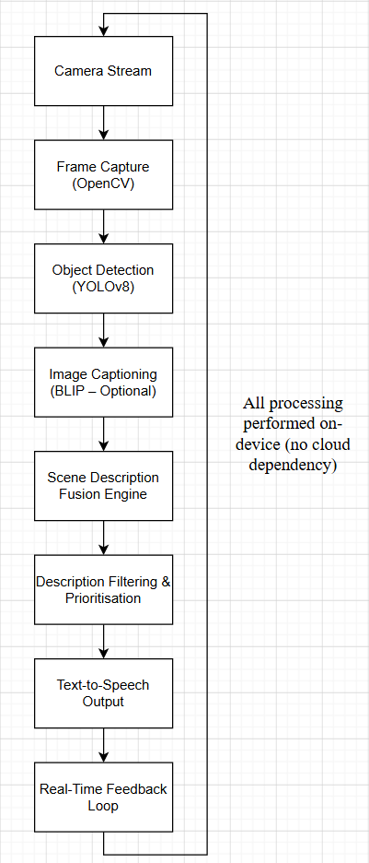

4.2 Use Case Scenario Selection
The system is designed to support visually impaired users in everyday environments where situational awareness is required. Several use case scenarios were considered during the design phase, focusing on practicality, safety, and accessibility. The primary use case scenario selected for this project is real-time environmental awareness during casual navigation. This includes situations such as walking through public spaces, sitting in cafés, navigating indoor environments, or entering unfamiliar rooms. In these scenarios, users benefit from brief spoken descriptions that highlight key objects and contextual information without overwhelming them. A secondary use case scenario involves object identification within close proximity, such as identifying nearby people, furniture, or personal items. This use case supports independent interaction with the environment and complements the broader scene description functionality. These scenarios were selected because they represent common challenges faced by visually impaired individuals and align closely with the capabilities of on-device object detection and captioning. The focus on real-time use also reinforces the importance of low latency and concise feedback, which directly informs the design of the fusion and description generation logic.

4.3 System Diagrams
To formally describe the behaviour and structure of the system, a set of Unified Modelling Language diagrams has been produced. These diagrams provide multiple perspectives on how the system operates and how users interact with it.

4.3.1 Use Case Diagram
The use case diagram illustrates the interaction between the user and the mobile application. The primary actor is the visually impaired user. The main use cases include starting the scene description, stopping the system, receiving spoken feedback, and adjusting basic settings such as description frequency or level of detail. The diagram demonstrates that the user interacts with the system through a simple interface designed to minimise complexity. Most processing occurs automatically once the system is activated, requiring minimal user input.

Figure 4.2: Use case diagram for the scene description application
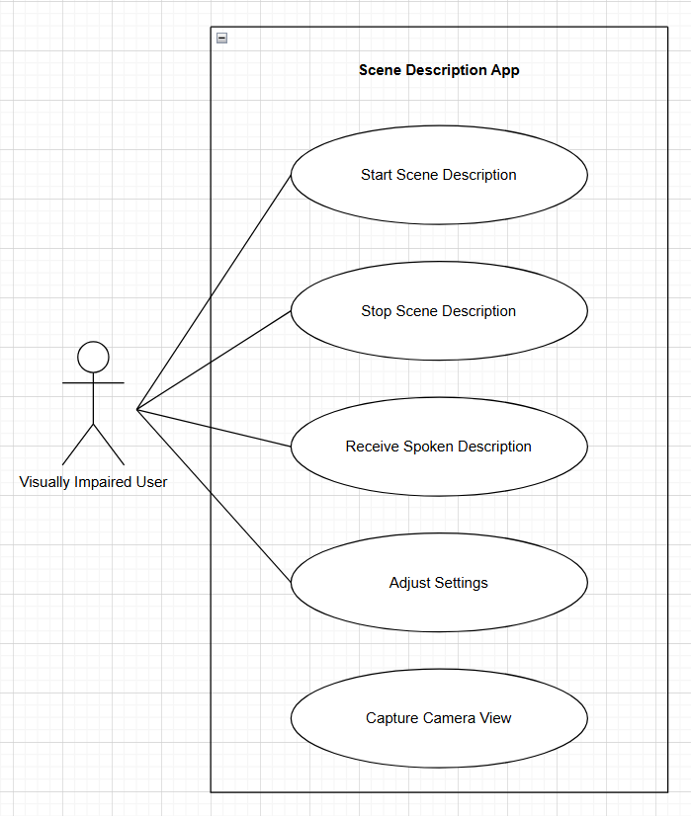

4.3.2 Activity Diagram
The activity diagram represents the operational flow of the application from start to finish. Once the application is launched, the camera is initialised and frames are captured continuously. Each frame is processed through the detection and captioning models, followed by fusion and description generation. The resulting description is then spoken to the user. Decision points within the activity diagram include checks for user input, system status, and whether new information should be spoken or suppressed to avoid repetition. This reflects the accessibility-driven design focus on reducing cognitive load.
Figure 4.3: Activity diagram illustrating real-time scene description flow
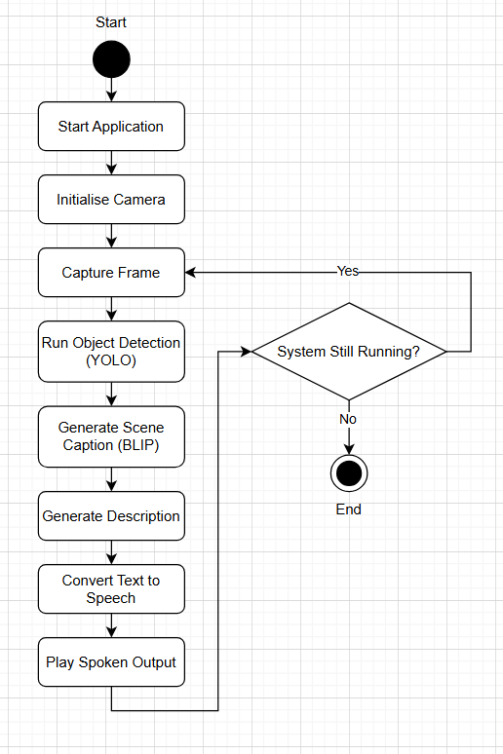

4.3.3 Sequence Diagram
The sequence diagram illustrates the temporal interaction between system components during a single inference cycle. It shows the sequence of method calls from the camera module to the AI models, fusion logic, and text-to-speech engine. This diagram highlights how processing is performed asynchronously to maintain responsiveness. Camera capture, model inference, and audio output operate in parallel where possible to reduce overall latency.

Figure 4.4: Sequence diagram of a single scene description cycle
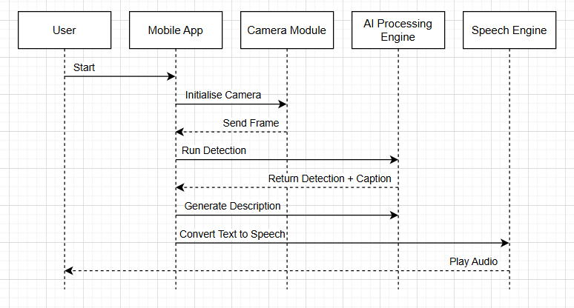

4.3.4 Class Diagram
The class diagram represents the structural design of the application software. Key classes include the camera controller, detection engine, captioning engine, description generator, and speech output controller. Each class has clearly defined responsibilities, supporting separation of concerns and maintainability. This object-oriented design approach enables modular testing and future extension, such as replacing models or adding new accessibility features.

Figure 4.5: Class diagram of the mobile application architecture
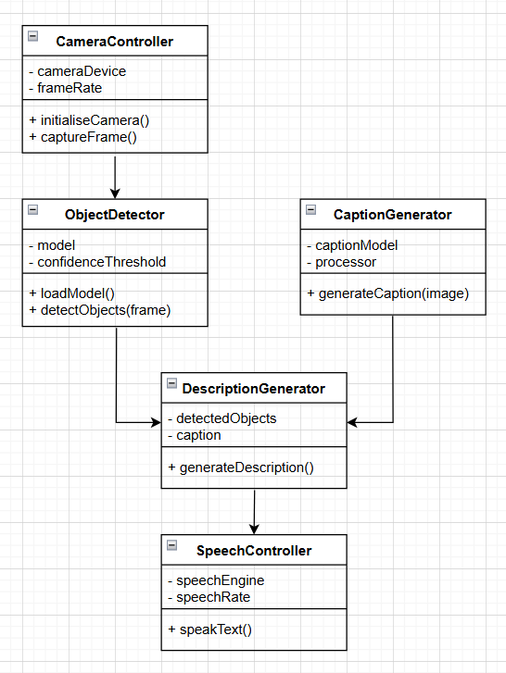

4.4 Prototype Design: User Interfaces
The user interface prototype was designed using Figma to explore accessibility-focused interaction patterns before implementation. The design prioritises simplicity, clarity, and minimal visual clutter to accommodate visually impaired users. The main interface consists of a single primary control for starting and stopping scene descriptions. Secondary controls allow users to adjust settings such as speech rate, description frequency, and level of detail. Visual elements use high-contrast colours and large touch targets to support users with partial sight.
Figure 4.6 shows the main prototype screen, while Figure 4.7 illustrates the settings interface. These designs reflect an accessibility-first approach, ensuring that the application remains easy to use with minimal training.
Figure 4.6: Main application interface prototype
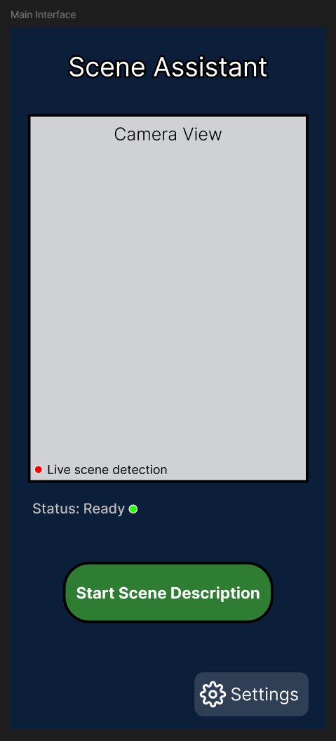
Figure 4.7: Settings interface prototype
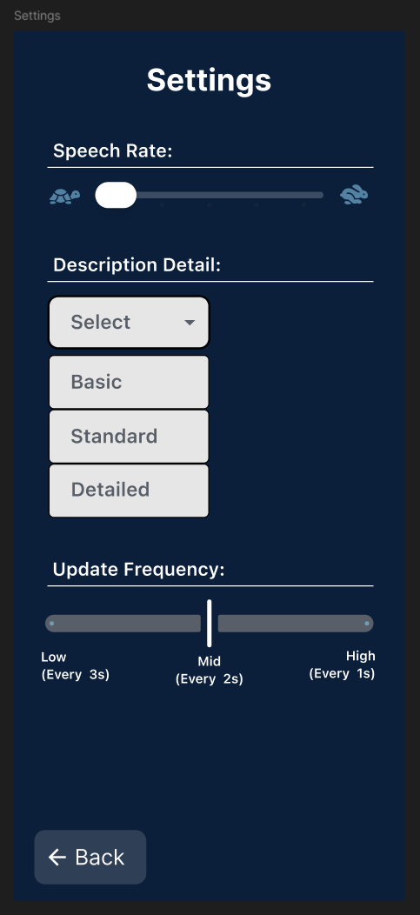
The prototype design directly informed the implementation decisions described in the following chapter. By validating interface concepts early, the project reduces the risk of usability issues during development and evaluation.

Chapter 5: Implementation and Testing

5.1 Development Environment and Tools
This chapter describes the implementation of the proposed lightweight artificial intelligence framework and the testing procedures used to evaluate its performance. The system was developed as a prototype to demonstrate the feasibility of real-time scene description using on-device artificial intelligence models. The implementation focused on combining lightweight computer vision techniques with accessible speech output in a modular and extensible software architecture.

5.1.1 Hardware Platform
Development and experimentation for this project were conducted using a personal computer with sufficient computational capability to run modern deep learning models for prototyping and testing. The development environment included a multi-core processor, dedicated graphics hardware, and adequate memory resources to support model inference and experimentation with computer vision frameworks. Although the prototype system was initially developed and tested on a desktop environment, the framework design targets deployment on consumer smartphones. Modern mobile devices increasingly contain specialised neural processing units and mobile GPUs capable of executing lightweight neural network models efficiently. This allows computationally intensive tasks such as object detection and image captioning to be performed locally on the device. The testing approach therefore focused on evaluating computational efficiency and latency to determine whether the framework could realistically support real-time operation in a mobile context.

5.1.2 Software Frameworks and Libraries
The implementation utilised a combination of modern machine learning and computer vision frameworks that support rapid prototyping and efficient model execution. The primary programming language used throughout the project was Python due to its extensive ecosystem of artificial intelligence libraries and strong support for machine learning experimentation. The PyTorch deep learning framework was used as the underlying model execution engine because of its flexibility and compatibility with many state-of-the-art computer vision models. Object detection was implemented using the Ultralytics implementation of YOLOv8, which provides an efficient and well-optimised framework for real-time detection tasks. YOLOv8n, the smallest variant of the model family, was selected to prioritise low computational overhead while maintaining reasonable detection accuracy.
Image captioning functionality was implemented using the Hugging Face Transformers library. The BLIP image captioning model was selected because it provides high quality natural language descriptions while remaining relatively lightweight compared to larger vision-language architectures. Additional libraries were used to support auxiliary functionality. OpenCV was employed for image processing and camera interaction. The Python Imaging Library was used for image handling during caption generation. Standard Python modules were used for timing measurements and experimental evaluation. Together, these tools provided a flexible environment for constructing the experimental prototype while supporting the rapid testing of different components within the framework.

5.1.3 Project Structure and Development Workflow
The implementation was organised using a modular project structure to improve clarity, maintainability, and ease of experimentation. The project directory separated core system components, experimental scripts, utility functions, and datasets into distinct folders. The experimental scripts were used to test individual modules such as object detection and caption generation independently before integrating them into the full pipeline. Utility modules contained reusable logic including the description generation component responsible for combining model outputs. This modular structure allowed the development process to follow an incremental workflow. Individual system components were first implemented and verified independently before being progressively integrated into the final framework.

5.2 Implementation of the AI Processing Pipeline
The core contribution of this project is the development of a lightweight artificial intelligence processing pipeline capable of generating concise spoken descriptions of visual scenes. The pipeline combines multiple computer vision techniques in order to capture both object-level information and higher level contextual understanding.

5.2.1 Camera Input and Image Acquisition
The first stage of the pipeline involves capturing visual information from the environment. In the prototype implementation this was achieved by loading images through OpenCV, which provides efficient support for reading and processing visual data. Images captured from the camera are treated as input frames for the system. These frames are passed sequentially to the object detection and captioning modules. Preprocessing operations such as colour conversion and image resizing are applied when necessary to ensure compatibility with the machine learning models. This stage forms the entry point to the system and is responsible for providing visual data that can be analysed by subsequent components of the framework.

5.2.1.1 Real-Time Video Stream Processing
In addition to static image-based processing, the framework was extended to support real-time video stream analysis using a live camera feed. This significantly improves the practical usability of the system, as visually impaired users require continuous environmental feedback rather than single-image descriptions. Real-time input was implemented using OpenCV’s VideoCapture functionality, allowing frames to be captured directly from a webcam device. Each frame is processed sequentially through the object detection pipeline. To maintain performance and avoid excessive computational load, frames are analysed in a streaming loop with minimal buffering. A temporal filtering mechanism was also introduced to prevent redundant outputs, ensuring that descriptions are only updated when meaningful changes occur within the scene. This real-time processing capability transforms the system from a static analysis tool into a continuous assistive framework capable of providing live environmental awareness.

5.2.2 Object Detection Module
The object detection component of the framework was implemented using the YOLOv8n model provided by the Ultralytics library. YOLO models are widely recognised for their ability to perform real-time object detection with high efficiency. The model processes input images and produces a list of detected objects together with bounding boxes and confidence scores. Each detection corresponds to a recognised object class such as person, chair, table, or mobile phone. The outputs of the detection model are converted into a simplified list of object labels that represent the most important elements present within the scene. This information provides a structured representation of the environment and forms the first source of information used to construct the final spoken description. The lightweight nature of the YOLOv8n model makes it particularly suitable for mobile deployment because it requires significantly fewer computational resources than larger object detection architectures.

5.2.3 Image Captioning Module
While object detection provides information about individual objects, it does not capture the broader context of the scene. To address this limitation, an image captioning model was integrated into the framework. The BLIP image captioning model was used to generate natural language descriptions of the input image. The model processes the image and produces a short sentence describing the scene as a whole. For example, a scene containing people sitting at a table outside a café may produce a caption describing the activity taking place. This caption provides contextual information that complements the object detection results. By combining both sources of information, the system can produce richer and more meaningful descriptions of the environment.

5.2.4 Scene Description Fusion Logic
A key component of the proposed framework is the description generation logic that combines the outputs of the detection and captioning models. This fusion process is designed to generate concise spoken descriptions that highlight the most relevant elements of the scene. The fusion module first selects the most important detected objects based on their order and relevance within the detection results. A limited number of objects are included in the description to prevent excessive verbosity. The selected object labels are then combined with the caption generated by the image captioning model. This results in a final sentence that summarises both the key objects present and the broader context of the scene. The fusion logic was implemented as a lightweight rule-based function that constructs natural language descriptions using simple text operations. This approach ensures that the description generation process introduces minimal computational overhead.

5.2.5 Speech Output Integration
The final stage of the framework converts the generated text description into audible speech. Spoken output is essential for accessibility because visually impaired users rely on audio feedback to understand the environment. Although the prototype implementation focused primarily on generating textual descriptions, the framework was designed to support integration with standard text-to-speech systems available on modern mobile platforms. These systems allow generated text to be converted into natural sounding speech with adjustable parameters such as speaking rate and voice style. The use of speech output ensures that the system can deliver information in a form that is easily accessible and usable by visually impaired users.

5.2.6 Key Implementation Snippets
Object Detection Implementation
results = yolo(img)
objects = []
for r in results:
for box in r.boxes:
label = yolo.names[int(box.cls)]
objects.append(label)
This snippet illustrates how object detection outputs are processed to extract meaningful semantic information. The YOLO model returns bounding box predictions containing class identifiers and confidence values. These identifiers are mapped to human-readable labels and stored as a list of detected objects. This structured representation forms the foundation for subsequent scene interpretation, enabling higher-level reasoning beyond raw visual data.

Caption Generation Implementation
inputs = processor(pil, return_tensors="pt")
out = caption_model.generate(**inputs)
caption = processor.decode(out[0], skip_special_tokens=True)
This snippet demonstrates the generation of natural language descriptions using a transformer-based image captioning model. The input image is first pre-processed into tensor format and passed through the captioning model, which generates a sequence of tokens representing the scene. These tokens are then decoded into a human-readable sentence. This process enables the system to capture contextual and relational information that is not explicitly available through object detection alone.

Fusion Logic Integration
description = generate_description(objects, caption)
This snippet represents the integration stage of the processing pipeline, where structured object detection outputs are combined with contextual captioning information. The fusion function applies lightweight rule-based logic to construct a concise and coherent scene description. This integration balances detail and efficiency, ensuring that the final output remains informative without introducing significant computational overhead.

Description Filtering Logic
most_common = counts.most_common(3)
This snippet demonstrates the prioritisation of detected objects based on frequency. By selecting only the most commonly occurring objects within a scene, the system reduces unnecessary verbosity and focuses on the most relevant elements. This filtering mechanism is essential for maintaining clarity and usability, particularly in assistive applications where excessive information may overwhelm the user.

Real-Time Frame Processing Implementation
cap = cv2.VideoCapture(0)

while True:
ret, frame = cap.read()
results = model(frame)

# Process detections and generate description
description = generate_description(objects)

cv2.imshow("Scene Assist - Real Time", frame)
This snippet demonstrates the implementation of a real-time processing loop, where frames are continuously captured from a webcam and analysed using the object detection model. The system generates scene descriptions dynamically for each frame, enabling continuous environmental awareness. The output is displayed in real time, illustrating the system’s capability for live assistive feedback.

Speech Output Integration
engine.say(description)
engine.runAndWait()
This snippet demonstrates the integration of text-to-speech functionality within the system. Generated scene descriptions are converted into audible speech using a speech synthesis engine, allowing information to be delivered in an accessible format for visually impaired users. The use of synchronous speech output ensures that each description is clearly communicated before new information is presented, improving overall usability and comprehension.

5.3 Prototype Application Integration
After the individual modules were implemented and tested, they were integrated into a single processing pipeline capable of analysing images and generating scene descriptions.

5.3.1 System Pipeline Integration
The complete system pipeline follows a sequential processing structure. First, a visual frame is captured from the camera input. The frame is then processed by the object detection model and the image captioning model in order to extract visual information and contextual descriptions. The outputs of these models are passed to the fusion module, which generates a concise natural language description of the scene. This description can then be converted into speech and delivered to the user. This integrated pipeline demonstrates how multiple artificial intelligence techniques can be combined to produce meaningful scene descriptions while maintaining a lightweight and efficient architecture. A mobile variant of the pipeline was also explored using ONNX-based inference on Android devices.

5.3.2 Real-Time Processing Considerations
One of the primary design goals of the proposed framework is the ability to operate in real time. Achieving this requires careful consideration of model selection, computational efficiency, and processing latency. Lightweight models were selected for both detection and captioning in order to minimise inference time. Additionally, the fusion logic was implemented using simple operations to avoid introducing unnecessary computational overhead. Performance measurements were collected during experimentation to determine the time required to process each image and generate a description. These measurements were used to assess whether the system could realistically support real-time scene analysis.

5.3.3 User Interface Prototype Implementation
In addition to the underlying artificial intelligence pipeline, a user interface prototype was designed to explore how visually impaired users might interact with the system. The interface design focused on simplicity and accessibility. The main screen includes a single primary control used to start and stop scene description functionality. A secondary settings interface allows users to adjust parameters such as speech rate and description detail. The interface prototype was created using Figma and served as a design reference for potential future implementation within an Android application.

5.3.4 Android Prototype Development and Challenges
An Android-based prototype application was developed to evaluate the feasibility of deploying the framework on a mobile device. The implementation utilised Android Studio with Kotlin and integrated the ONNX Runtime framework to enable on-device execution of the YOLOv8 model. The system architecture consisted of a camera input pipeline using CameraX, an ONNX-based object detection module, and a text-to-speech component for audio feedback. The model was deployed as a YOLOv8n ONNX file and processed using a custom detection class. During development, several technical challenges were encountered. Initial attempts to deploy the model using TensorFlow Lite were unsuccessful due to compatibility issues with YOLOv8 output formats. As a result, the implementation was migrated to ONNX Runtime, which provided greater flexibility for handling model inference. Additional challenges included image format conversion, real-time frame processing constraints, and debugging inference outputs using Android log monitoring tools. Despite successfully achieving real-time detection and speech output, the quality of generated scene descriptions was limited due to reduced captioning capability compared to the Python-based implementation.
As a result, the Android prototype was not pursued further, and the primary evaluation focused on the Python-based real-time system, which demonstrated superior performance and description quality.

5.4 Testing Methodology
A series of tests were conducted to evaluate the functionality and performance of the implemented framework.

5.4.1 Functional Testing
Functional testing was performed to verify that each component of the system operated correctly. Independent scripts were developed to test the object detection module, captioning module, and fusion logic individually. These tests ensured that the detection model correctly identified objects within images and that the captioning model produced meaningful scene descriptions. The fusion module was then tested to confirm that it correctly combined the outputs into coherent final descriptions. Debugging techniques such as runtime logging and output inspection were used extensively during development. Android Logcat was used to analyse inference outputs, detect errors in model execution, and verify correct data flow through the pipeline.

5.4.2 Performance Testing
Performance testing focused on measuring the computational efficiency of the system. Inference time for both object detection and caption generation was recorded using timing measurements within the Python implementation. These measurements were used to determine the total time required to analyse an image and produce a description. Evaluating this latency was essential in order to assess whether the framework could support real-time operation.

5.4.3 Scenario-Based Testing
To evaluate the system under realistic conditions, a range of different scene images were used during testing. These included indoor environments, outdoor settings, and scenes containing multiple people and objects. Testing the framework across varied scenarios helped assess its ability to recognise objects and produce meaningful descriptions in different contexts.

5.4.4 Accessibility Evaluation Approach
Although the project did not involve large scale user trials, the generated descriptions were evaluated qualitatively to determine whether they provided useful information about the scene. Particular attention was given to the clarity and relevance of the spoken descriptions. This evaluation focused on ensuring that the generated output remained concise and informative, as overly long descriptions may reduce usability for visually impaired users.
A detailed test plan is provided in Appendix C.

5.4.5 Real-Time System Evaluation
Additional evaluation was conducted using the real-time webcam-based implementation. The system was tested across a range of indoor environments containing common objects such as laptops, cups, keyboards, and monitors. The object detection model consistently identified multiple objects within the scene and maintained stable performance across consecutive frames. Temporal filtering ensured that repeated descriptions were not continuously spoken, improving usability. The system achieved smooth real-time performance, with detection operating continuously at interactive frame rates. This demonstrates the feasibility of applying lightweight object detection models for live assistive applications without requiring cloud-based processing.

Chapter 6: Results and Discussion

6.1 Overview of Experimental Evaluation
The experimental evaluation aimed to assess both the performance efficiency and practical effectiveness of the proposed real-time scene description framework. Unlike purely theoretical evaluations, this study focused on real-world applicability, particularly in the context of assistive technology for visually impaired users.
The system was evaluated across three key dimensions:
- Object detection accuracy and consistency
- Scene description quality and usefulness
- End-to-end system latency under real-time conditions
Both static image-based testing and real-time webcam evaluation were conducted to ensure that the framework performs reliably under practical operating conditions. The inclusion of real-time testing is particularly significant, as continuous environmental understanding is essential for assistive applications.
Detailed experimental results and example outputs of the real-time system are presented in Appendix D.

6.2 Object Detection Performance
The object detection component, implemented using YOLOv8n, demonstrated consistently reliable performance across a variety of indoor and controlled environments. Common objects such as people, chairs, laptops, and mobile phones were detected with high consistency, even under moderate variations in lighting and positioning. A key strength of the model lies in its efficiency-to-accuracy trade-off. While larger models may achieve higher absolute accuracy, YOLOv8n provides sufficiently accurate detections at significantly lower computational cost. This makes it particularly suitable for real-time and on-device applications. During real-time testing, the detector maintained stable outputs across consecutive frames, indicating strong temporal consistency. However, limitations were observed in more complex scenes involving object occlusion or less common object classes, where detection confidence occasionally decreased. Overall, the results confirm that lightweight object detection models can provide reliable environmental awareness while maintaining the performance constraints required for real-time assistive systems.

6.3 Captioning Performance
Two approaches to scene description were evaluated:
(1) transformer-based image captioning and
(2) rule-based description generation derived from detected objects.
The transformer-based model (BLIP) produced contextually rich and grammatically coherent descriptions, often capturing relationships and activities within the scene. However, this came at the cost of significantly higher inference time, making it less suitable for continuous real-time deployment.
In contrast, the rule-based captioning approach, used in the real-time system, generated simpler but highly responsive descriptions. While these descriptions lacked linguistic complexity, they were clear, concise, and sufficient for conveying essential environmental information.
This highlights an important trade-off:
- Captioning models → richer descriptions but high latency
- Rule-based logic → lower quality language but real-time performance
For assistive applications, responsiveness and clarity are often more critical than linguistic sophistication. Therefore, the rule-based approach was determined to be more suitable for real-time deployment within this framework.

6.4 Framework Latency Evaluation
Latency is a critical factor in determining the usability of real-time assistive systems. The overall system latency was measured by combining the inference times of object detection, caption generation, and description fusion.
Experimental results showed:
- Object detection: ~30–60 milliseconds per frame
- Caption generation: ~0.55–1.07 seconds per image
- Combined pipeline: ~0.60–1.12 seconds
While the combined pipeline achieved near real-time performance, the captioning component introduced a noticeable delay, limiting the system’s ability to operate continuously at interactive frame rates. These findings indicate that although multi-model pipelines provide richer outputs, they may not always meet the responsiveness requirements of real-time systems without further optimisation.

6.4.1 Real-Time Latency Performance
The real-time implementation demonstrated significantly improved latency compared to the combined detection and captioning pipeline. By removing the transformer-based captioning model, total processing time per frame was reduced to near real-time speeds. Object detection using YOLOv8n operated efficiently on each frame, while the lightweight description generation logic introduced minimal computational overhead. This enabled continuous scene analysis with near-instant feedback. These results highlight the trade-off between descriptive richness and system responsiveness, with the real-time implementation favouring speed and usability.

6.5 Scene Description Quality
The quality of generated scene descriptions was evaluated based on clarity, relevance, and usefulness. The fusion of object detection and captioning (in the non-real-time pipeline) produced the most informative descriptions, combining both object-level and contextual understanding. However, in real-time scenarios, the rule-based descriptions proved more effective due to their brevity and immediacy. For example, identifying “a person and a laptop” provides actionable information without overwhelming the user. A key observation is that optimal description quality is not necessarily the most detailed, but rather the most useful within a given time constraint. This is especially important in assistive contexts, where cognitive load must be carefully managed.

6.6 Discussion of Results
The experimental results indicate that combining lightweight object detection and captioning models can produce meaningful scene descriptions within a relatively short processing time. The framework successfully demonstrated the feasibility of performing scene understanding using on-device artificial intelligence models. While the captioning component introduced additional computational overhead, it also significantly improved the contextual richness of the generated descriptions. These findings support the hypothesis that lightweight AI frameworks can be used to develop practical assistive technologies for visually impaired users.
The comparison between the Python-based real-time system and the Android prototype further emphasised the importance of platform compatibility and model optimisation. While mobile deployment remains a key objective, the current results indicate that achieving both high accuracy and real-time performance on-device requires further optimisation.

6.7 Comparison with Existing Systems
The proposed framework was compared with existing assistive applications such as Microsoft Seeing AI and Google Lookout. These systems rely heavily on cloud-based processing, which introduces latency and requires a stable internet connection. In contrast, the proposed system operates entirely on-device, eliminating network dependency and improving user privacy. Experimental results demonstrate that scene descriptions can be generated in under one second, making the system suitable for real-time applications. Additionally, existing systems often prioritise either object detection or text recognition, whereas the proposed framework integrates both object detection and image captioning. This results in richer and more context-aware descriptions. While cloud-based solutions may achieve higher accuracy due to larger models, the proposed framework provides a more practical balance between efficiency, latency, and accessibility.

Chapter 7: Conclusion and Recommendations

7.1 Summary of the Research
This project investigated the feasibility of a lightweight, on-device artificial intelligence framework for real-time scene description aimed at assisting visually impaired users. The research explored the integration of object detection and image captioning techniques within a unified processing pipeline, with a particular focus on achieving a balance between computational efficiency and descriptive quality. A prototype system was successfully developed using the YOLOv8n object detection model and a BLIP-based captioning model, supported by a rule-based fusion mechanism for generating concise natural language descriptions. The system was evaluated across a range of scenarios to assess detection accuracy, caption quality, and overall latency. The findings demonstrate that meaningful and context-aware scene descriptions can be generated locally without reliance on cloud-based services. While trade-offs between latency and descriptive richness were observed, the results confirm that lightweight artificial intelligence models can support near real-time assistive functionality.

7.2 Contributions of the Project
This project makes several important contributions to the field of assistive artificial intelligence and on-device computer vision:
- Integrated Scene Understanding Framework
The research presents a hybrid approach that combines object detection and image captioning, enabling both structural and contextual understanding of visual scenes. This improves upon systems that rely solely on one modality.
- Lightweight On-Device Architecture
The proposed system demonstrates that real-time scene understanding can be achieved without cloud processing, reducing latency, improving privacy, and increasing reliability in offline environments.
- Real-Time Captioning Prototype (Desktop-Based)
A fully functional real-time prototype was developed using a webcam-based pipeline, demonstrating continuous scene analysis and live spoken feedback. This serves as a proof-of-concept for future mobile deployment.
- Comparative Implementation Insight (Android vs Desktop)
The project explored both desktop (Python-based) and mobile (Android + ONNX) implementations. This provided valuable insight into the practical challenges of deploying deep learning models on mobile devices, including model compatibility, performance limitations, and reduced caption quality.
- Modular and Extensible Design
The system architecture was designed to be modular, allowing future integration of improved models, optimisation strategies, or additional assistive features.

7.3 Limitations
Despite achieving its primary objectives, several limitations were identified:
- Captioning Performance Bottleneck
The image captioning component introduced significant latency compared to object detection, limiting the system’s ability to operate at fully continuous real-time speeds.
- Desktop-Based Evaluation
The primary evaluation was conducted on a desktop environment rather than a mobile device. While indicative, this does not fully reflect real-world mobile performance constraints.
- Limited Dataset and Scenario Diversity
Testing was performed on a controlled set of scenes. Broader evaluation across more diverse environments would provide a more comprehensive assessment of system robustness.
- Android Prototype Constraints
Although an Android implementation using ONNX Runtime was developed, it was not pursued further due to reduced captioning quality and increased implementation complexity. This highlights current limitations in deploying efficient vision-language models on mobile devices.
- Absence of User Trials
The system was not evaluated with visually impaired users, meaning usability and accessibility effectiveness were assessed only qualitatively.

7.4 Future Work
Several directions for future research and development emerge from this work:
- Lightweight Vision-Language Models
Future work should explore more efficient captioning models specifically designed for mobile deployment, such as quantised or distilled architectures.
- Fully Real-Time Streaming Captioning
Optimisation techniques such as frame skipping, asynchronous inference, and GPU acceleration could enable continuous real-time captioning.
- Temporal Scene Understanding
Incorporating temporal awareness would allow the system to track changes over time and produce more coherent, context-aware descriptions (e.g., recognising actions rather than static objects).
- Mobile Deployment Optimisation
Further research into ONNX optimisation, TensorRT, or mobile AI frameworks could improve performance and enable practical smartphone deployment.
- User-Centred Evaluation
Conducting usability studies with visually impaired users would provide critical insights into real-world effectiveness, clarity of descriptions, and accessibility improvements.
- Adaptive Description Systems
Future systems could personalise descriptions based on user preferences, such as level of detail or priority objects.

7.5 Final Conclusion
This project demonstrates that lightweight artificial intelligence techniques can be effectively combined to produce meaningful, real-time descriptions of visual environments. By integrating object detection, image captioning, and speech output within a unified pipeline, the system provides a strong foundation for assistive technologies aimed at enhancing situational awareness. While challenges remain, particularly in achieving efficient mobile deployment and optimising captioning performance, the results highlight the significant potential of on-device AI for accessibility applications. The work not only validates the feasibility of such systems but also identifies key areas for improvement, offering a clear pathway for future research and development.

References
Bochkovskiy, A., Wang, C.Y. and Liao, H.Y.M. (2020) ‘YOLOv4: Optimal speed and accuracy of object detection’, arXiv preprint, arXiv:2004.10934. Available at: https://arxiv.org/abs/2004.10934 (Accessed: 22 January 2026).
Google (2024) Lookout – assisted vision. Available at: https://play.google.com/store/apps/details?id=com.google.android.apps.accessibility.reveal (Accessed: 22 January 2026).
Howard, A.G., Zhu, M., Chen, B., Kalenichenko, D., Wang, W., Weyand, T., Andreetto, M. and Adam, H. (2017) ‘MobileNets: Efficient convolutional neural networks for mobile vision applications’, arXiv preprint, arXiv:1704.04861. Available at: https://arxiv.org/abs/1704.04861 (Accessed: 22 January 2026).
Li, J., Li, D., Xiong, C. and Hoi, S.C.H. (2023) ‘BLIP-2: Bootstrapped language-image pre-training with frozen image encoders and large language models’, arXiv preprint, arXiv:2301.12597. Available at: https://arxiv.org/abs/2301.12597 (Accessed: 22 January 2026).
Microsoft (2024) Seeing AI: Talking camera app for the blind community. Available at: https://www.microsoft.com/seeing-ai (Accessed: 22 January 2026).
Paszke, A., Gross, S., Massa, F., Lerer, A., Bradbury, J., Chanan, G., Killeen, T., Lin, Z., Gimelshein, N., Antiga, L., Desmaison, A., Kopf, A., Yang, E., DeVito, Z., Raison, M., Tejani, A., Chilamkurthy, S., Steiner, B., Fang, L. and Chintala, S. (2019) ‘PyTorch: An imperative style, high-performance deep learning library’, in Advances in Neural Information Processing Systems, 32. Available at: https://papers.nips.cc/paper_files/paper/2019/hash/bdbca288fee7f92f2bfa9f7012727740-Abstract.html (Accessed: 22 January 2026).
Tan, M. and Le, Q.V. (2019) ‘EfficientNet: Rethinking model scaling for convolutional neural networks’, in Proceedings of the 36th International Conference on Machine Learning (ICML). Available at: https://arxiv.org/abs/1905.11946 (Accessed: 22 January 2026).
Wang, Z., Bovik, A.C., Sheikh, H.R. and Simoncelli, E.P. (2004) ‘Image quality assessment: From error visibility to structural similarity’, IEEE Transactions on Image Processing, 13(4), pp. 600–612. https://doi.org/10.1109/TIP.2003.819861
World Health Organization (2023) World report on vision. Available at: https://www.who.int/publications/i/item/9789241516570 (Accessed: 22 January 2026).
Zhang, X., Zhou, X., Lin, M. and Sun, J. (2018) ‘ShuffleNet: An extremely efficient convolutional neural network for mobile devices’, in Proceedings of the IEEE Conference on Computer Vision and Pattern Recognition (CVPR). Available at: https://openaccess.thecvf.com/content_cvpr_2018/html/Zhang_ShuffleNet_An_Extremely_CVPR_2018_paper.html (Accessed: 22 January 2026).
Redmon, J., Divvala, S., Girshick, R. and Farhadi, A. (2016) ‘You Only Look Once: Unified, real-time object detection’, Proceedings of the IEEE Conference on Computer Vision and Pattern Recognition (CVPR), pp. 779–788. Available at: https://arxiv.org/abs/1506.02640 (Accessed: 22 January 2026).
Li, J., Li, D., Savarese, S. and Hoi, S.C.H. (2022) ‘BLIP: Bootstrapping language-image pre-training for unified vision-language understanding and generation’, Proceedings of the International Conference on Machine Learning (ICML). Available at: https://arxiv.org/abs/2201.12086 (Accessed: 22 January 2026).
Vinyals, O., Toshev, A., Bengio, S. and Erhan, D. (2015) ‘Show and tell: A neural image caption generator’, Proceedings of the IEEE Conference on Computer Vision and Pattern Recognition (CVPR). Available at: https://arxiv.org/abs/1411.4555 (Accessed: 22 January 2026).
Anderson, P., He, X., Buehler, C., Teney, D., Johnson, M., Gould, S. and Zhang, L. (2018) ‘Bottom-up and top-down attention for image captioning and visual question answering’, Proceedings of the IEEE Conference on Computer Vision and Pattern Recognition (CVPR).
Anderson, P., He, X., Buehler, C., Teney, D., Johnson, M., Gould, S. and Zhang, L. (2018) ‘Bottom-up and top-down attention for image captioning and visual question answering’, Proceedings of the IEEE Conference on Computer Vision and Pattern Recognition (CVPR).
Dakopoulos, D. and Bourbakis, N. (2010) ‘Wearable obstacle avoidance electronic travel aids for blind: A survey’, IEEE Transactions on Systems, Man, and Cybernetics, 40(1), pp. 25–35.
Zhou, B., Lapedriza, A., Khosla, A., Oliva, A. and Torralba, A. (2017) ‘Places: A 10 million image database for scene recognition’, IEEE Transactions on Pattern Analysis and Machine Intelligence, 40(6), pp. 1452–1464.
Szeliski, R. (2022) Computer Vision: Algorithms and Applications. 2nd edn. Springer.
Dakopoulos, D. and Bourbakis, N. (2010) ‘Wearable obstacle avoidance electronic travel aids for blind: A survey’, IEEE Transactions on Systems, Man, and Cybernetics, 40(1), pp. 25–35. Available at: https://doi.org/10.1109/TSMCC.2009.2021255 (Accessed: 22 January 2026).
Dakopoulos, D. and Bourbakis, N. (2010) ‘Wearable obstacle avoidance electronic travel aids for blind: A survey’, IEEE Transactions on Systems, Man, and Cybernetics, 40(1), pp. 25–35. Available at: https://doi.org/10.1109/TSMCC.2009.2021255 (Accessed: 22 January 2026).
Tapu, R., Mocanu, B. and Zaharia, T. (2014) ‘A computer vision system that ensures the autonomous navigation of visually impaired people’, Proceedings of the 19th International Conference on Control Systems and Computer Science, pp. 253–259.
Kacorri, H., Kitani, K.M., Bigham, J.P. and Asakawa, C. (2017) ‘People with visual impairment training personal object recognizers: Feasibility and challenges’, Proceedings of the CHI Conference on Human Factors in Computing Systems.
Mascetti, S., Ahmetovic, D., Gerino, A. and Bernareggi, C. (2016) ‘ZebraRecognizer: Efficient and precise localization of pedestrian crossings for visually impaired people’, Pattern Recognition, 60, pp. 405–419.

Appendices

Appendix A: Gantt Chart
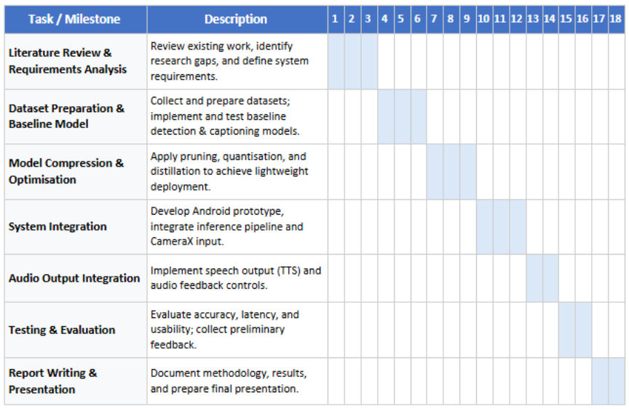

Appendix B: Sprint Planning
In addition to the overall project timeline presented in the Gantt chart, an Agile sprint plan was developed to support iterative development and continuous evaluation. The project was divided into two-week sprints, each with defined goals and deliverables. This approach allowed flexibility in model selection and optimisation while ensuring steady progress towards the final system. The sprint plan is provided in Appendix B.
Table 4: Sprint Planning (Appendix)
Sprint | Weeks | Sprint Goal | Key Activities | Deliverables
Sprint 1 | 1-2 | Establish project foundation | Initial literature review, requirements analysis, accessibility considerations | Draft requirements, initial literature notes
Sprint 2 | 3-4 | Dataset and baseline preparation | Dataset selection, preprocessing, baseline model exploration | Prepared datasets, baseline model selection
Sprint 3 | 5-6 | Baseline model implementation | Implement baseline object detection and captioning models | Working baseline models
Sprint 4 | 7-8 | Model optimisation | Quantisation, pruning, performance benchmarking | Optimised lightweight models
Sprint 5 | 9-10 | Model fusion and logic design | Fusion strategy design, description generation logic | Integrated detection–captioning pipeline
Sprint 6 | 11-12 | On-device integration | Android integration, CameraX setup, inference pipeline | Mobile prototype with on-device inference
Sprint 7 | 13-14 | Accessibility and interaction | Audio output integration, user controls, feedback tuning | Accessible audio-based interface
Sprint 8 | 15-16 | Testing and evaluation | Performance testing, usability evaluation, data collection | Evaluation results and analysis
Sprint 9 | 17-18 | Finalisation | Report writing, presentation preparation, refinement | Final report and project artefacts

Appendix C: Test Plan
Table 5: Test Plan (Appendix)
Test ID | Test Type | Description | Input | Expected Output | Metric
T1 | Functional | Object detection works | kitchen.jpg | Objects detected correctly | Accuracy
T2 | Functional | Caption generation works | office.jpg | Meaningful caption | Relevance
T3 | Functional | Fusion logic works | people_cafe.jpg | Combined description | Coherence
T4 | Performance | Detection speed | All images | <100ms | Time
T5 | Performance | Caption speed | All images | <1s | Time
T6 | Performance | Total pipeline | All images | <1.2s | Time
T7 | Scenario | Indoor scenes | kitchen, bedroom | Accurate description | Accuracy
T8 | Scenario | Outdoor scenes | street, park | Accurate description | Accuracy
T9 | Edge Case | No detection case | supermarket_aisle | Still produces caption | Robustness

Appendix D: Experimental Results
Table 6: Performance Results (Appendix)
Image | Detection Time (ms) | Caption Time (s) | Total Time (s)
airport_terminal | 55.5 | 0.794 | 0.921
bathroom | 49.3 | 0.706 | 0.786
bedroom | 38.9 | 0.735 | 0.788
bicycle_lane | 38.5 | 0.659 | 0.706
bus_stop | 39.0 | 0.684 | 0.758
classroom | 46.4 | 0.792 | 0.849
crosswalk | 36.7 | 0.612 | 0.661
dining_room | 37.2 | 0.713 | 0.796
grocery | 40.8 | 0.708 | 0.762
group_dogs | 41.4 | 0.616 | 0.682
inside_car | 31.0 | 0.591 | 0.646
kitchen | 32.0 | 0.681 | 0.727
kitchen_cooking | 35.4 | 0.685 | 0.745
library | 38.6 | 0.709 | 0.802
living_room | 36.5 | 1.067 | 1.127
office | 41.2 | 0.717 | 0.770
park | 60.7 | 0.641 | 0.726
parking_lot | 35.3 | 0.624 | 0.677
people_cafe | 33.2 | 0.643 | 0.686
playground | 36.4 | 0.553 | 0.605
shopping_mall | 37.8 | 0.653 | 0.700
street | 34.7 | 0.618 | 0.695
supermarket_aisle | 35.1 | 0.650 | 0.697
train_station | 31.9 | 0.654 | 0.728
workshop | 33.2 | 0.715 | 0.760

Table 7: Sample Output Quality (Appendix)
Image | Description | Evaluation
airport_terminal | I can see 16 persons... | High detection accuracy but excessive verbosity
bathroom | I can see sinks, toilet... | Clear and relevant object identification
bedroom | I can see bed... | Limited contextual understanding
street | I can see cars, persons... | Strong multi-object detection and scene relevance
supermarket_aisle | I can see . | Failure case – no detections handled poorly
These results highlight that object detection remains stable across environments, whereas description quality is highly dependent on both captioning performance and post-processing logic, particularly in low-detection scenarios.

Table 8: Statistical Summary (Appendix)
Metric | Value
Avg Detection Time | ~39 ms
Avg Caption Time | ~0.70 s
Avg Total Time | ~0.74 s
Min Total Time | 0.605 s
Max Total Time | 1.127 s
The experimental results demonstrate consistent object detection performance across all scenarios, with inference times remaining below 61 milliseconds. In contrast, caption generation introduces the primary computational overhead, with processing times ranging from 0.55 to 1.07 seconds. The overall system maintains near real-time performance, with total processing times averaging approximately 0.74 seconds per frame. Variations in latency are primarily attributed to scene complexity and caption generation demands rather than detection performance.

Figure D.1: Latency Performance Across Test Images
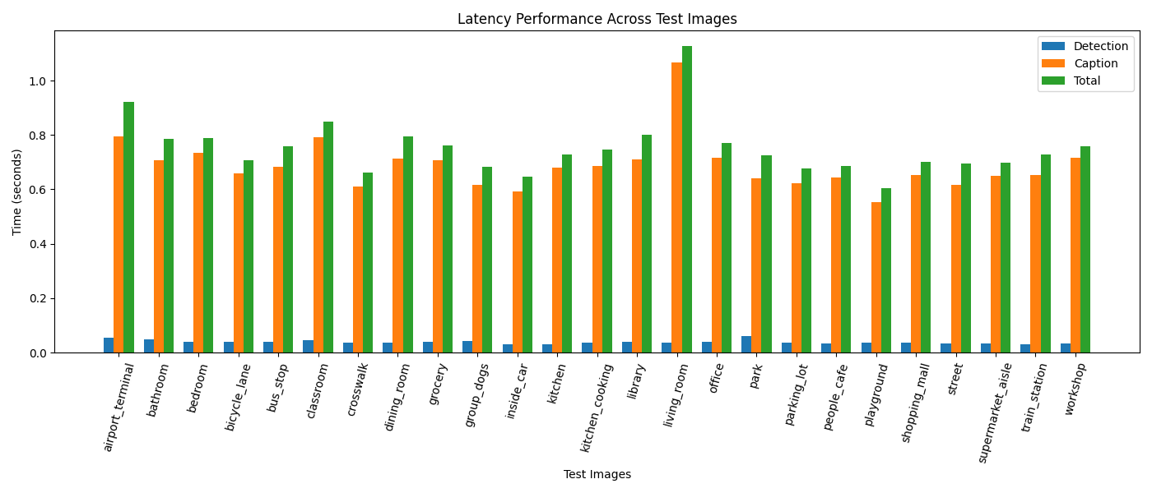This figure shows that object detection latency remains consistently low, while caption generation dominates total processing time.

Figure D.2: End-to-End Processing Time Distribution
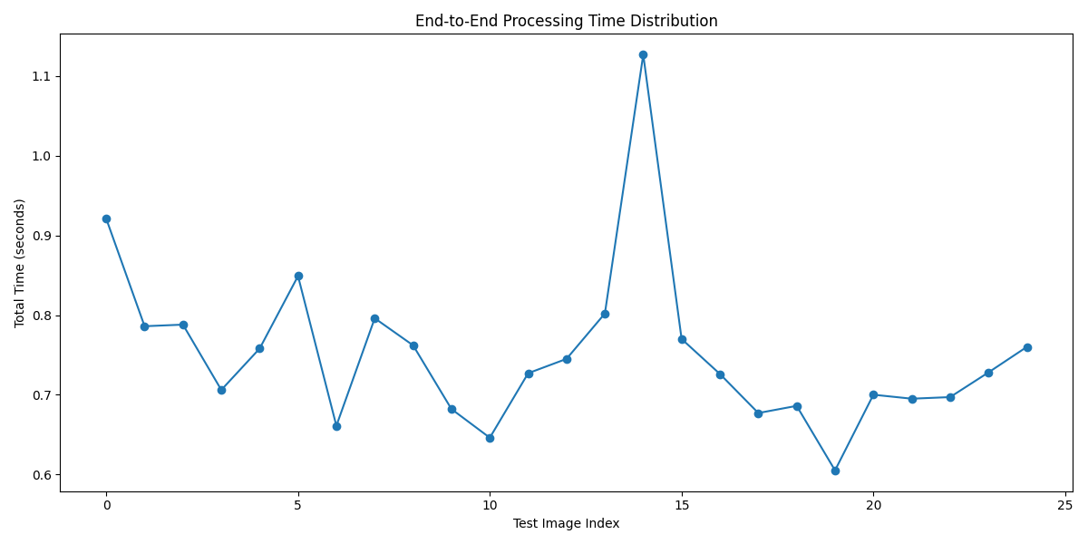The distribution demonstrates stable near real-time performance with minor variation depending on scene complexity.

Figure D.3: Average Latency Contribution
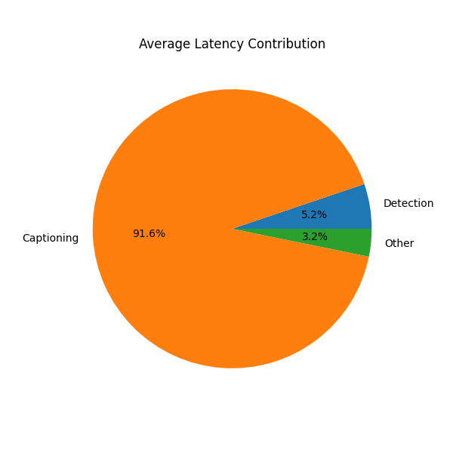
Caption generation accounts for most of the computational cost, identifying it as the primary optimisation target.

Figure D.4: Real-Time Detection and Captioning Output (Desktop Prototype)
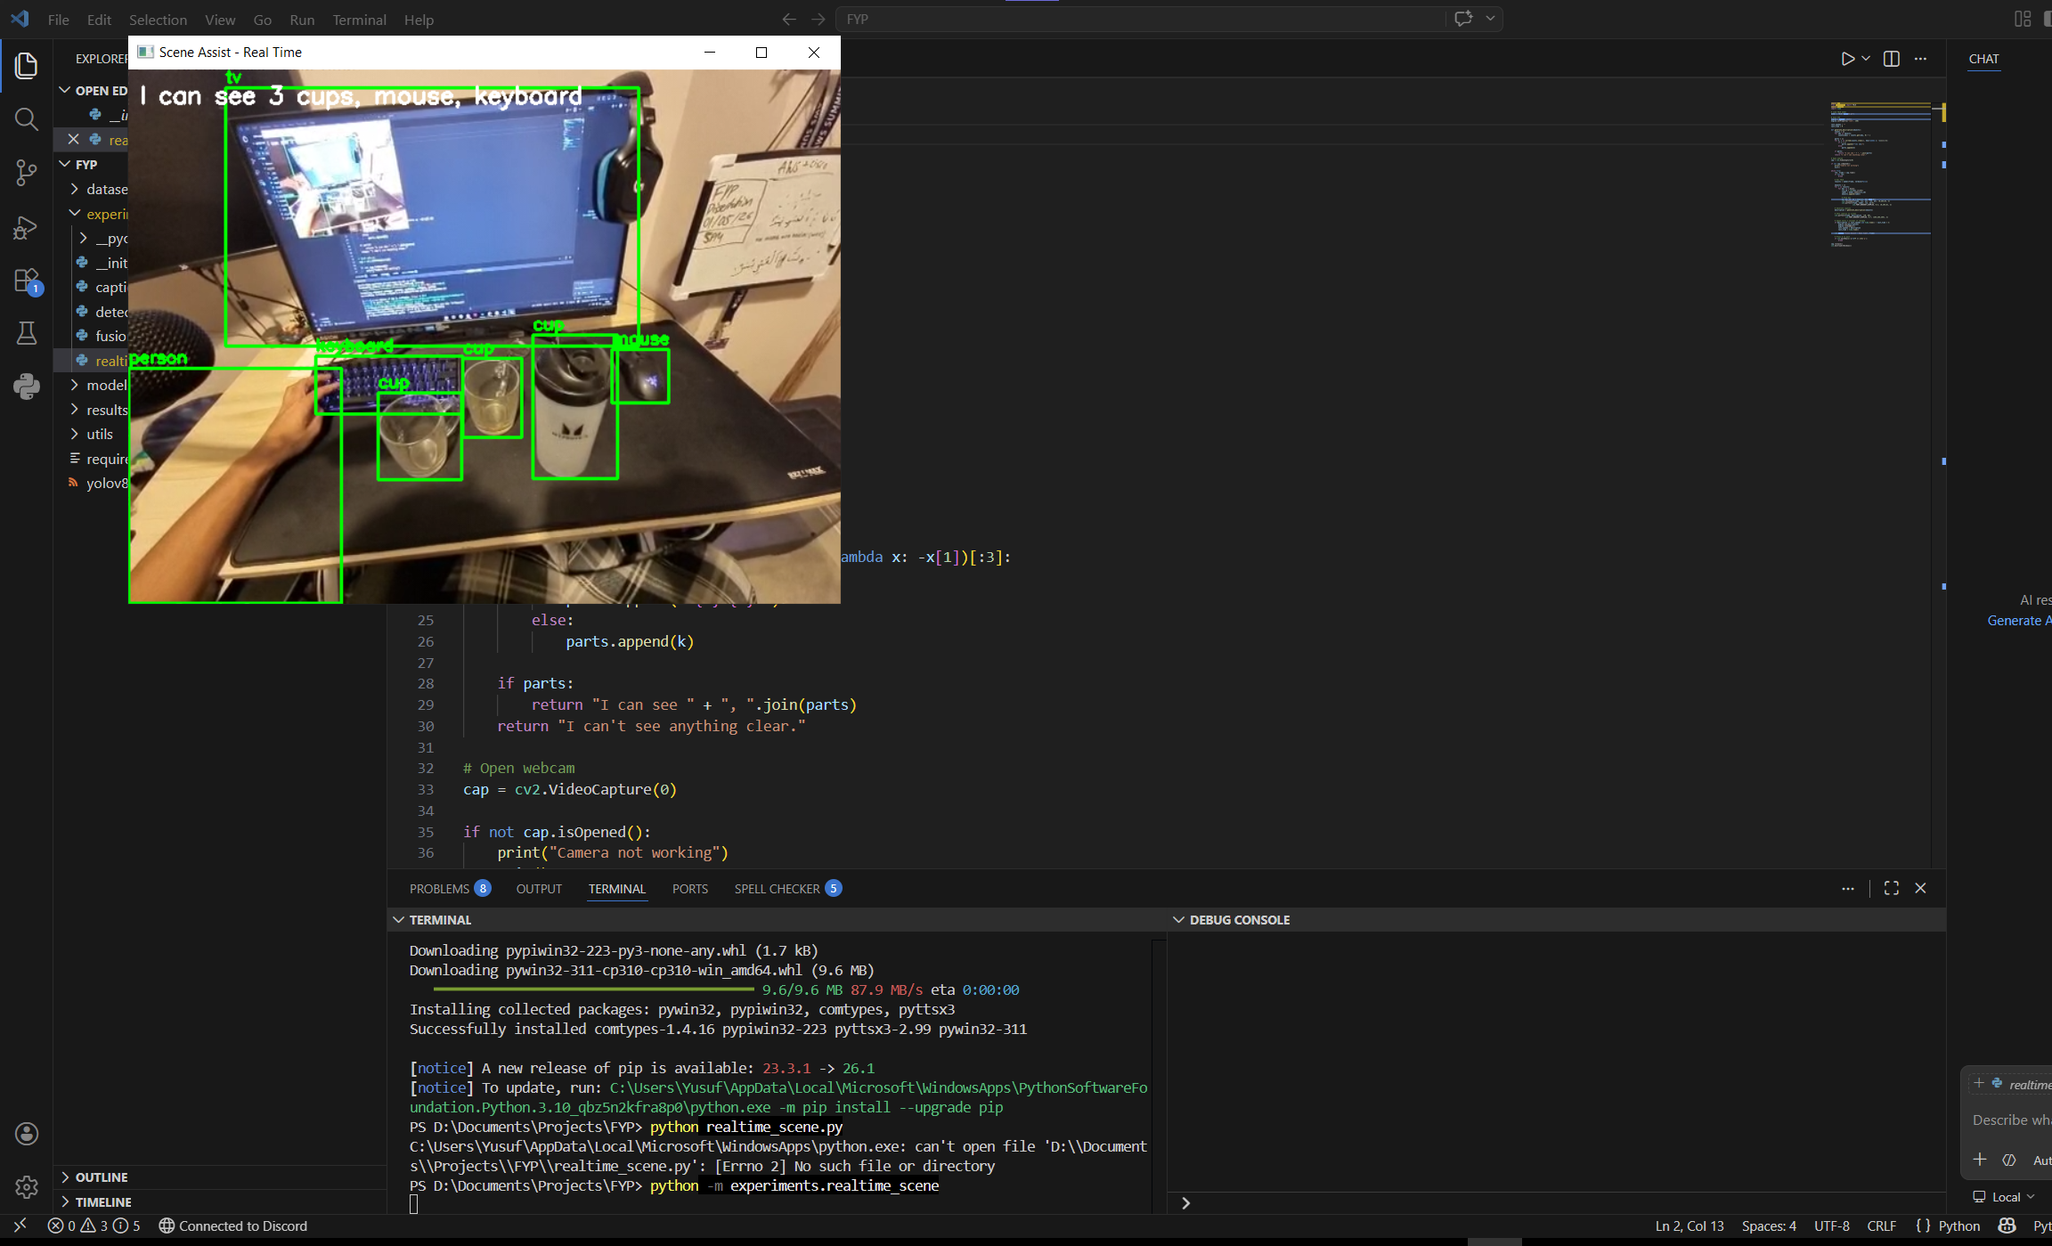This figure shows the real-time object detection and generated scene description using the Python-based prototype.

Figure D.5: Android Prototype User Interface and Detection Output
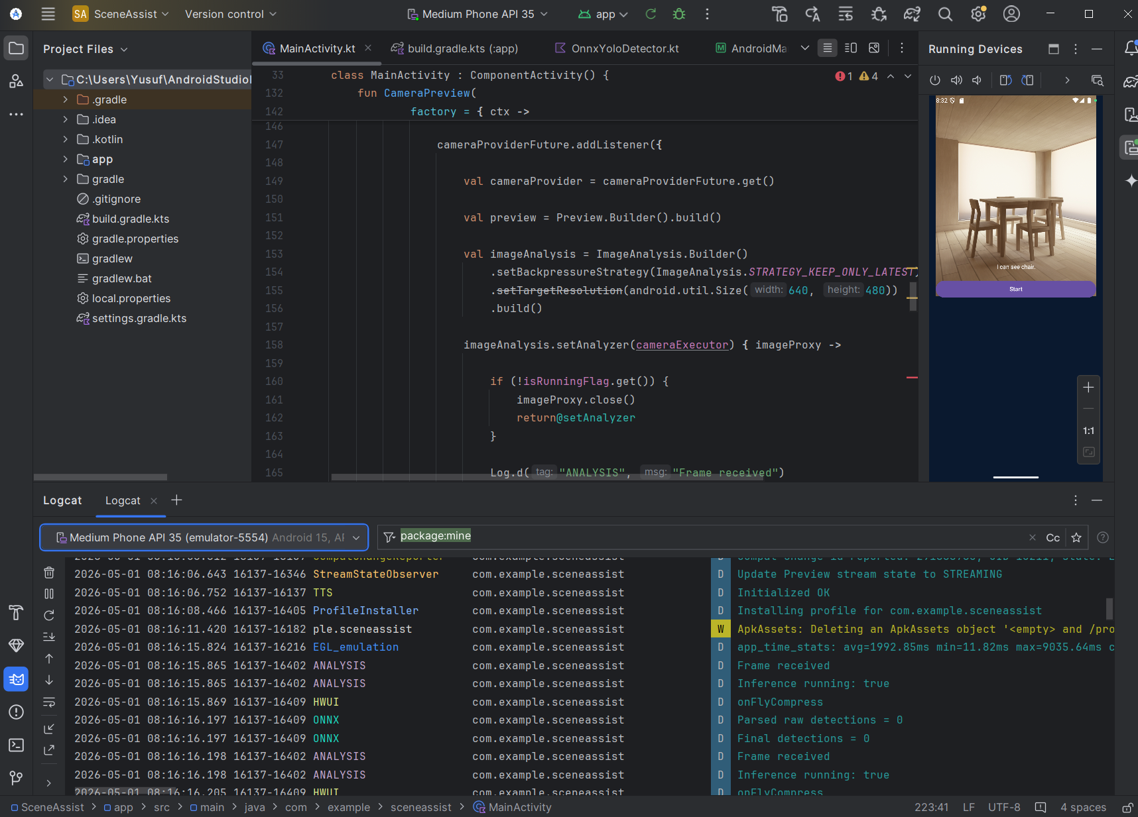This figure illustrates the Android-based implementation using ONNX, including live camera input, detection processing, and text-to-speech integration.

