

FINAL YEAR PROJECT — Final Report

BSc (Hons) Cyber Security

Intelligent Evidence Classification Framework for SMS-Based Mobile Phone Forensics

Student Name: Elaine Fernandes
Student ID: 23020613
Module Code: COMP60066
First Supervisor: Dr Maryam Shahpasand
Second Supervisor: Dr Mahsa Zolfaghari
Submission Date: 01/05/2026

Abstract
Due to the rapid growth of textual content produced by mobile devices specifically Short Message Service (SMS) messages, there are significant obstacles in conducting forensic evaluations. While automated classifiers continue to be used throughout the investigative process, many current models operate as “black boxes” with limited transparency and the ability to support reproducible or accountable results in legal settings.
In response to this need for an explainable machine-learning solution, an Explainable Artificial Intelligence Decision Support System (XAI-DSS) for SMS forensic analysis has been developed, implemented, and evaluated. Using the Design Science Research methodology, a framework consisting of ingest, preprocess, extract features, classify, explain, and report has been constructed. The SMS data are represented using Term Frequency-Inverse Document Frequency (TF-IDF); logistic regression and random forests are used to classify the data and produce results. Prior to model construction, the SMS Spam Collection Dataset was used to map spam and ham labels to forensic categories (Suspicious-Relevant and Clean-Not Relevant).
A detailed project Gantt chart showing all phases, milestones, and dependencies is provided in Appendix A.
Evaluation of the framework was based on three broad criteria: performance, explainability, and suitability for forensic use. Results indicate that the predictions generated by the XAI-DSS are highly accurate, with the majority exceeding 0.90. Criteria such as interpretability at the feature level were met using Logistic Regression; however, Random Forests provided interpretations across complex patterns at the cost of transparency.
In summary, the findings of this research substantiate that explainable machine learning has the potential to assist in the efficient and defensible execution of SMS forensic analyses while offering a practical balance between performance and interpretability during high-risk investigations.

Table of Contents
Abstract 1
Table of Contents 2
1. Chapter 1: Introduction 3
1.1. Chapter Introduction 3
1.2. Project Background 3
1.3. Problem Statement 4
1.4. Research Aim 4
1.5. Research Objectives 4
1.6. Deliverables 5
1.7. Scope of the project 5
1.8. Significance of Study 5
1.9. Structure of the Report 6
2. Chapter 2: Literature Review 6
2.1. Chapter Introduction 7
2.2. Mobile Device Forensics 7
2.3. SMS Evidence in Digital Investigations 7
2.4. Traditional Approaches to SMS Analysis 9
2.5. Artificial Intelligence in Digital Forensics 10
2.6. Limitations of Black-Box AI Models 10
2.7. Explainable Artificial Intelligence (XAI) 11
2.8. XAI in Digital Forensics 12
2.9. Forensic Datasets for SMS Analysis 12
2.10. Evaluation Metrics in Forensic AI 12
2.11. Comparison with Existing Work and Contribution 13
2.12. Identification Research Gap 13
2.13. Chapter Summary 14
3. Chapter 3: Research Methods and methodology 15
3.1. Chapter Introduction 16
3.2. Research Paradigm and Approach 16
3.3. System Overview 17
3.4. Dataset Selection 18
3.4.1. Dataset Requirements 18
3.4.2. The SMS Spam Collection 18
3.4.3. Ethical Considerations in Dataset Use 18
3.5. Data Preprocessing 19
3.6. Feature Extraction and Representation 19
3.7. Machine-Learning Model Selection 20
3.7.1. Model Choice 20
3.7.2. Training and Validation 20
3.8. Explainability Mechanism 20
3.9. Evaluation Strategy 21
3.9.1. Performance Metrics 21
3.9.2. Explainability Evaluation 21
3.9.3. Forensic Suitability Assessment 21
3.10. Validity and Reliability 21
3.11. Ethical Considerations 22
3.12. Methodological Limitation 22
3.13. Chapter Summary 22
4. Chapter 4: Design, Implementation, Results, and Evaluation 23
4.1. Chapter Introduction 23
4.2. Implementation Overview 23
4.3. Dataset-Processing Results 24
4.4. Classification Results 27
4.5. Explainability Results 28
4.6. Output and Reporting Results 28
4.7. Evaluation Against Project Objectives 29
4.8. Limitations of the Results 30
4.9. Chapter Summary 30
5. Chapter 5: Ethics, Risk and Legal Compliance 30
5.1. Chapter Introduction 31
5.2. Ethical Considerations 31
5.2.1. Data Privacy and Confidentiality 31
5.2.2. Bias and Fairness 31
5.2.3. Automation Bias and Human Oversight 32
5.3. Risk Considerations 32
5.3.1. Misclassification Risk 32
5.3.2. Over-Reliance on AI 32
5.3.3. Generalizability Limitation 32
5.3.4. Technical and Operational Risks 32
5.4. Legal Compliance 33
5.4.1. Transparency and Explainability 33
5.4.2. Admissibility of Evidence 33
5.4.3. Accountability and Human Responsibility 33
5.5. Responsible AI Principles 34
5.6. Ethical and Legal Strengths and Limitations 34
5.7. Chapter Summary 34
6. Chapter 6: Conclusions and Future Work 35
6.1. Chapter Introduction 36
6.2. Summary of the Work 36
6.3. Contributions 36
6.4. Reflection on the Aim and Objectives 37
6.5. Limitations 39
6.6. Future Work 40
6.7. Closing Remarks 40
6.8. Wider Implications for Practice and Policy 41
7. References 41

Chapter 1: Introduction

Chapter Introduction
This chapter presents the rationale and scope of the research. It introduces the challenges associated with analyzing SMS data within mobile device forensics and highlights the limitations of current AI-based approaches, particularly the lack of transparency required for law enforcement investigations and legal admissibility. The chapter defines the research problem, outlines the research aim and objectives, and establishes the scope and context of the study. It also identifies the expected contributions to both academic research and professional forensic practice. The chapter concludes with an overview of the structure of the remaining chapters.

Project Background
Mobile devices are perceived as the most common form of electronic evidence used in investigations today, as they serve as both a means of communication and a means of storing electronic records over time (Bhoopesh Kumar Sharma et al., 2024). Of the many types of information that can be recovered from a current smartphone, SMS messages are among the most useful. SMS messages are continuously available for each new smartphone generation and include metadata such as timestamps and sender/receiver information. SMS messages are also frequently involved in crimes such as fraud, threats, coercion, drug activities, and organized criminal enterprises (Humphries et al., 2021).
Data from the most recent surveys show that the number of SMS messages being examined is significantly increasing (Mani et al., 2025), creating serious challenges for investigative units' capacity to examine them. Traditionally, the forensic tool is used to collect evidence from the mobile device and perform basic filtering of that information; after basic filtering, the analyst must manually review possible thousands (if not millions) of SMS messages, which is extremely labour intensive, difficult to scale, subject to mental fatigue and cognitive biases and can be nearly impossible for cases with high SMS message volume (Quick and Choo, 2018; Khalid et al., 2024).
According to these authors, this discipline has begun leveraging artificial intelligence and machine learning to automate various components of SMS triage and prioritization. Although using AI tools is faster than manual review, most forensic tools are "black-box" systems that are not open to the analyst regarding the underlying logic. Because of this, black-box AI tools can contribute to mistrust and limit accountability and may affect the admissibility of any evidence discovered by such means.
The approach of Explaining AI (XAI) illustrates how to address these limitations by creating decision-support models that enable analysts to inspect, justify, and challenge any decision made or action taken by XAI. The number of publications that focus on the necessity of explainability in high-risk areas of interest (such as digital forensics) continues to grow; where AI-generated evidence needs to adhere and meet due-process standards, be susceptible to open-court challenges by the defence, and withstand the test of any potential disclosure requirements (Ali et al., 2023; Richmond et al., 2023; Matulionyte & Hanif, 2021).

Problem Statement
In the years 2020-2025, a series of studies have shown the extent to which speed and consistency of forensic examination of SMS message can benefit from the application of AI and machine learning methods (Salman et. al, 2024) and yet they can present difficulties to forensic investigators in terms of providing an assessment (evaluation/justification/challenge) of the output generated, because these techniques are primarily based on opaque/black box methodologies (Solanke, 2022). The non-interpretability of these models poses a challenge for law enforcement investigators evaluating findings produced by AI-based methods (Solanke, 2022), raising concerns about the practicality of using AI for forensic purposes and the security of AI-derived findings in court.
The lack of interpretability has significant implications within the legal domain; many jurisdictions have stringent requirements relating to the admissibility of evidence, which typically include: a demonstrable chain of custody, a demonstrable methodology, and an acceptable rationale supporting any conclusion derived from the evidence (Bharati, 2025; Maratsi et al., 2022). There are increasing reports of AI algorithms and their corresponding methodologies being vetted/criticized from a legal and forensic perspective (Papadouli, 2022), indicating an urgent and unmet requirement for a decision support framework that combines the ability to conduct analysis, provide transparency, reproducibility, and accountability as demanded within both the field of forensic practice and legal processes.

Research Aim
The purpose of this study is to create an Explainable AI and decision-support framework to enhance the efficiency of investigative workflows through SMS Forensic Analysis. Furthermore, this study will provide transparency, interpretability, and legal defensibility by utilizing well-established machine learning techniques to produce an Explainable AI decision-support framework.

Research Objectives
The Primary Research Objective is decomposed into six Specific Research Objectives. They are as follows;
- To conduct a critical review of relevant scholarly literature on mobile device forensics, SMS evidence analysis, explainable AI, and the legal admissibility of AI-assisted findings.
- To compare the limitations of traditional manual analysis methods to “black box” AI methods when performing forensic analysis of SMS evidence.
- To create a modular framework used to classify SMS evidence through the application of interpretable, well-understood machine learning techniques.
- To create the modular framework for SMS evidence classification as a functional artifact in a programming language (Python) with a defined, reproducible workflow.
- To assess the functional classification performance, explanation quality, and forensic suitability of the SMS evidence classification framework.
- To conduct an analysis of the ethical, risk, and legal concerns regarding the use of AI in SMS forensic analysis and demonstrate how the SMS evidence classification framework implements solutions to mitigate these concerns.

Deliverables
There are four main things that will come from this project:
- A working AI tool (in Python) that can take in an SMS dataset, prep/pre-process the texts, make and evaluate 2 different types of classifiers, provide an explanation for each, provide a confidence level of that prediction, and save the output into CSV or Excel format
- A repeatable written process from A-Z that describes every decision made in pre-processing, every hyperparameter setting, and every validation step, in enough detail that an independent audit could be conducted.
- An academic report that contains the Idea behind the proposed system, justification for developing this system, how it was developed, design and implementation details, how evaluation was assessed, and ethical/legal implications related to this research.
- All source code and supporting documents will be presented as appendices in the project.

Scope of the project
The specific range of work on this proposal will be limited to text-based SMS textual evidence retrieved from mobile phones. Mobile evidence from other sources, such as multimedia files, application data, geolocation trails, and call records, is not part of the proposed project scope; however, the framework itself is designed to allow for future compatibility with any of those categories of forensic evidence (should there be a desire to utilize those types of evidence in subsequent phases of the project). This artifact is designed as a decision-support system to support and enhance the investigator's workflow; therefore, its output does not and should not replace the investigator's application of professional judgment and responsibility for the ultimate forensic conclusion, which in any case will be made by the investigator subject to the judgment of the trial judge or other trier of fact at a criminal trial.

Significance of Study
The integration of explanatory principles and traditional machine learning methods is a vital aspect of the proposed framework and is designed to address an urgent concern in AI-supported investigations: the validity of evidence generated by non-transparent or black-box models. This work aligns with emerging legal and ethical frameworks for high-risk AI systems (EC, 2024) and, therefore, contributes to scholarly discussions on responsible or ethical AI within law enforcement (Lunhol & Torhalo, 2024). The results will benefit digital forensics units, policymakers, and researchers.

Structure of the Report
The remainder of this report comprises several chapters, which detail how the proposed framework was created and assessed. The second chapter details literature mobile device forensics and an analysis of SMS evidence. The third chapter explains the research methodology used in developing the proposed framework. In the fourth chapter, there is an overview of how the implementation was accomplished, presenting the experimental data used in evaluating the framework. The fifth chapter looks at ethical, risk, and legal issues surrounding this framework. Finally, the sixth chapter consists of a conclusion based on the study's results, important contributions made by the study and directions for future research.

Chapter 2: Literature Review

Chapter Introduction
This chapter evaluates and explores the literature on mobile device forensics, SMS evidence, and the influence of artificial intelligence on digital forensics. The review is structured into six areas of focus: (i) the mobile device forensic principles, (ii) the role of SMS as digital evidence, (iii) SMS analytical methods, (iv) the application of artificial intelligence and machine learning to digital forensics, (v) the limitations of black-box models and the requirement for explainable models, and (vi) data sets and evaluation methodologies. The final section synthesizes the information gathered in the review of the existing literature, outlines the gaps in research, and presents contributions of this study to the field of mobile forensic investigation.

Mobile Device Forensics
The forensic field of mobile device analysis is referred to as mobile device forensics. Mobile device forensics involves the identification, acquisition, and analysis of digital evidence from mobile devices. Given the critical role smartphones have in communication, finance, socializing, and accessing online services, they have become the largest individual source of digital evidence for law enforcement agencies worldwide (Bhoopesh Kumar Sharma et al., 2024; Khubrani, 2023).
There are multiple research studies that show the volume of information generated by smartphones, including SMS text messages, call logs, application data, cloud synchronization data, and various types of system logs. Furthermore, rapid changes in mobile operating systems, the increased use of proprietary hardware, the widespread adoption of strong encryption, and the growing popularity of secure messaging applications have combined to make mobile device forensic analysis far more complex than just a few years ago (Fakhouri et al., 2024).
While there have been improvements in mobile device forensic acquisition methodologies, the analytical side of mobile device forensics continues to lag. Therefore, investigators are now typically faced with large amounts of data extracted from mobile devices and with limited automated tools to analyze or interpret them. The disparity between the data available to be analyzed and the ability to analyze large volumes of data is seen to be one of the major limitations in the current state of mobile device forensics, which has led to a continued interest in intelligent/automated analysis methodologies (Quick & Choo, 2018; Khalid et al., 2024).

SMS Evidence in Digital Investigations
Despite the growing number of Over-The-Top (OTT) messaging applications, SMS messages are still widely utilized for two-factor authentication, alerting users to transactional notifications, and sending informal messages to individuals. Recovered SMS data is frequently used as evidence in cases of fraud, harassment, drug-related offenses, and other forms of coercion (Spranger et al., 2022; Xi et al., 2024).
Historically, investigators have manually reviewed SMS message data as part of their forensic examination, using keyword filtering to search for any conversations that contain the same keywords. The case investigator will define search terms directly related to the case before performing a manual search of all recovered SMS data that contains the same keywords within the assigned search criteria. While this approach is simple in theory and well understood in practice, recent studies suggest it is no longer sufficient due to the volume of evidence overwhelming current caseloads faced by investigators (Quick & Choo, 2018).
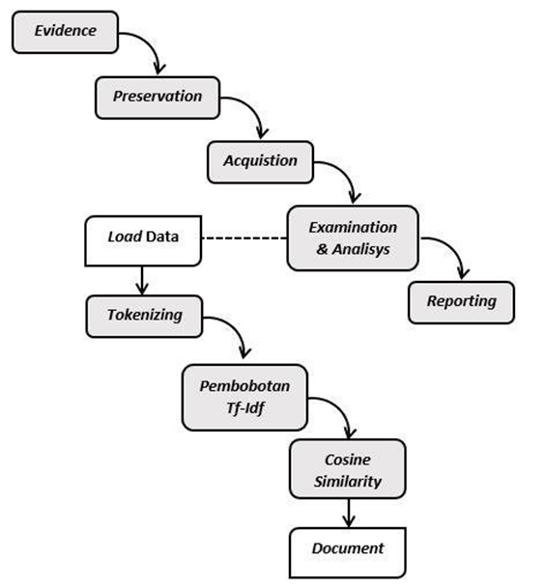
Figure 2.1 — Representative SMS forensic-analysis workflow incorporating tokenisation, TF-IDF weighting and similarity measurement (adapted from Mani et al., 2025).
Keyword-based techniques have an inherent limitation: they do not account for the context in which language is used. They are ineffective in dealing with abbreviations, slang, sarcasm, codes, and obfuscation, all of which are commonly used in criminal communication (Miranker & Giordano, 2020). Because of this, there is a strong possibility that the information you seek will be missed (false negatives) or mistakenly identified as related to your interests when in fact it is not (false positives). Both types of errors can produce high operational / legal costs.
In addition to the constraints imposed by the language used, the manual review process is subject to several human factors. Hefetz (2025) has shown that when an analyst is exposed to large volumes of repetitive text for extended periods, their judgment degrades. Further, cognitive bias research has shown that there are various types that affect the quality of expert judgments in forensic decision-making. As a result, contemporary forensic studies have shown that keyword-based manual review lacks the scalability and reliability needed to keep pace with the complexity of modern investigations.
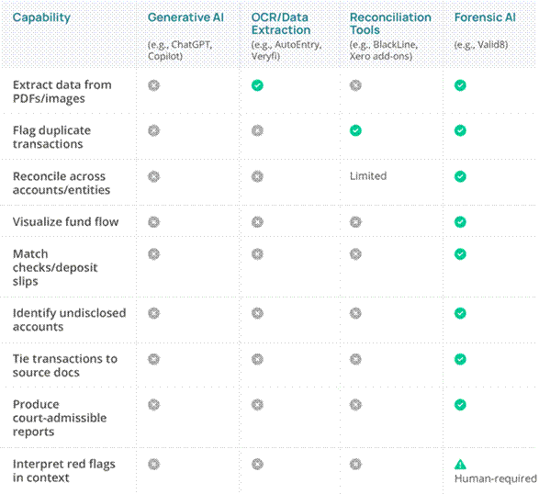
Figure 2.2 — Comparison between traditional manual SMS analysis and AI-assisted forensic approaches, highlighting differences in scalability and consistency (adapted from Mani et al., 2025).

Traditional Approaches to SMS Analysis
The typical SMS analysis pipeline consists of a well-defined series of steps: acquire the user's stored messages; convert the messages to an easily readable format; filter through the messages using keyword searches; manually review the results and ultimately prepare a report containing the evidence (Sharma et al., 2019). Each step in this pipeline presents opportunities for error and depends on the analyst's analytical skills, attention, and prior knowledge.
Research in forensic linguistics demonstrates that interpreting messages is reliable only if the context in which they were created and exchanged is considered (Xi et al., 2024). The traditional method of keyword filtering ignores context and focuses only on message text, making it difficult to identify such as intent, tone, or the different ways it is expressed in writing. Mani et al. (2025) and Miranker and Giordano (2020) have shown that keyword-based analyses cannot reliably perform tasks requiring even basic comprehension of meaning and, thus, are not very effective tools for forensic investigations, where the ability to interpret the context of a message is critical.
The combined impact of the limitations mentioned above is that the traditional approaches to SMS analysis have increasingly been viewed as an impediment to the growing volume of mobile digital evidence gathering and analysis; therefore, the need for responsive analysis has resulted in the use of machine learning techniques to create more scalable processes and ultimately produce analysis that can potentially detect patterns or behaviour that cannot be identified using keyword searches.

Artificial Intelligence in Digital Forensics
There has been a significant increase in the application of machine-learning and AI techniques in digital forensic analysis. This is true for both the categorization of digital evidence and the identification of Sip's anomalous data patterns. In addition, the use of AI to assist in prioritizing evidence for review by investigators has improved many aspects of digital forensic analysis (Capuano et al., 2022; Nwankwo et al., 2020).
AI has been shown to assist investigators in classifying SMS messages as pertinent or not, detecting intent, measuring sentiment, and locating crime-related material (Peng, Zhu, and Zhang, 2020b).
Multiple studies conducted from 2020-2025 have demonstrated that AI-based analytical pipelines reduce the time required for analysis and improve the consistency of triage decisions compared to purely manual workflows (Salman, Ikram, Kaafar, 2024).
Despite these positive outcomes, the studies also report two main issues: many modern AI forensic tools prioritize predictive accuracy over transparency and defendable classifications, and investigators regularly rely on outputs that cannot be independently verified (Solanke, 2022; Khalid et al., 2024).

Limitations of Black-Box AI Models
Deep neural networks and other "black-box" models have internal representations that cannot be examined directly by human beings (Ali et al., 2023). Since 2020, research into this issue has indicated that the inability to examine these internal representations has created many problems for investigators in forensic settings - specifically, there are problems for investigators in determining the reliability of classifications made by black-box models; identifying and correcting systematic errors in the outputs of these models; and providing structured justifications for the classifications based on the requirements of the adversarial legal system (Marsico & Amigo, 2025; Garzo, Ribes & Palumbo, 2024).
Increasingly, legal literature contains comments on the issues associated with the use of AI-based evidence. Courts and regulatory bodies are becoming less inclined to accept AI-based evidence unless it is supported by a clear, understandable reasoning process (Richmond et al., 2023; Bharati, 2025). As a result, there has been a call within the forensic community for a more balanced approach to AI in high-risk applications, such as those involving communication evidence. This includes a call to incorporate (as opposed to replacing) automated processes with interpretability (Capuano et al., 2022).
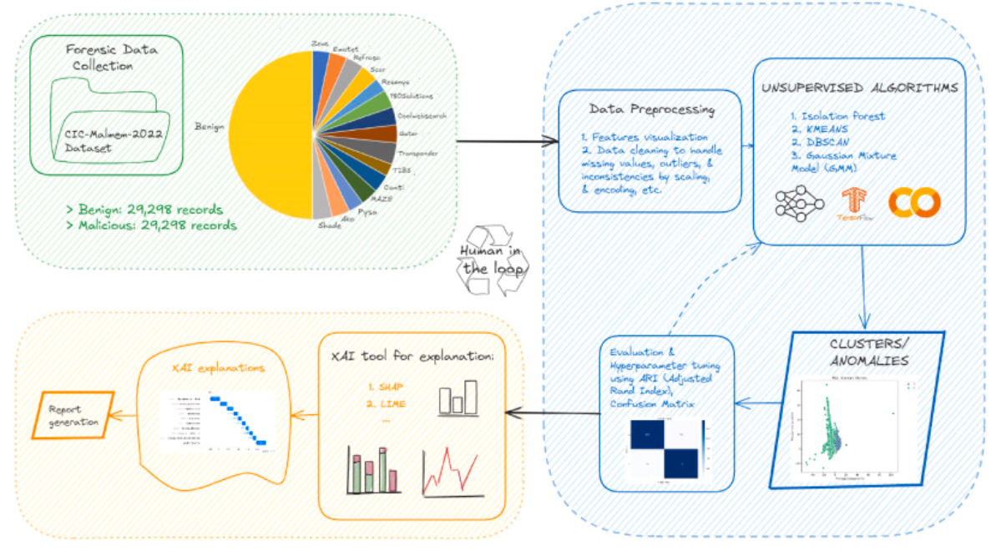
Figure 2.3 — Identified research gap: the limitations of black-box AI in SMS forensics motivate the development of an explainable framework (adapted from Solanke, 2022).

Explainable Artificial Intelligence (XAI)
Explainable AI (XAI) is an area of research focused on building models whose outputs can be interpreted by their users. Several recent surveys have found that two general approaches have been used for creating XAI: creating models that are inherently interpretable (e.g., linear models or decision trees), and using post-hoc explanation methods (such as LIME and SHAP) on top of "opaque" models (Ali et al., 2023; Hermosilla, Berríos & Allende-Cid, 2025; Kabir, Hossain & Andersson, 2025).
In high-stakes domains, XAI is now viewed as a legal and moral obligation, not just a technical feature: If an AI-assisted decision affects an individual's rights, that individual must be able to understand how that decision was made (Papadouli, 2022; Canalli, 2024).

XAI in Digital Forensics
A small but rapidly expanding body of literature currently exists that applies XAI methods to digital forensics. Solanke (2022) has argued that the use of interpretable models is essential to offset society's distrust of AI in forensic analysis, while Khalid, Iqbal, and Fung (2024) have proposed a unified XAI framework that encompasses many sub-domains of digital forensics. Hermosilla, Berríos, and Allende-Cid (2025) compared the use of SHAP and LIME in intrusion detection models and found that both techniques provided interpretable model outputs to a meaningful extent, but each had trade-offs in terms of stability and computational cost.
Although there have been some advances, much of the current work in XAI applied to forensics has focused solely on intrusion detection, malware analysis, or network forensics. There has been much less research on the use of XAI in mobile phone textual evidence, specifically in the domain of SMS messages, which is the research gap this project will address.

Forensic Datasets for SMS Analysis
Acquiring authentic SMS datasets for forensic AI research remains a practical challenge due to limited availability, primarily because of privacy legislation, ethical review frameworks, and the inherent sensitivity of communication data (Veldhuis et al., 2022). Because of this limitation, most published works (ours included) rely on publicly available anonymized research corpora, such as the SMS Spam Collection (Almeida, Hidalgo, and Yamakami, 2011). Recent studies highlight that datasets are regarded as trustworthy; they must be well documented, highly transparent, and representative. An inadequately constructed or undocumented dataset will reduce the ability to generalize to new cases and, hence, decrease confidence in the AI system's final forensic findings (European Commission, 2024).

Evaluation Metrics in Forensic AI
Evaluating forensic AI systems primarily uses traditional machine learning metrics—e.g., accuracy, precision, recall, and F1 Score—as performance measures (Anwar & Bashir, 2023). However, more recent work demonstrates that quantitative evaluation of metrics alone is insufficient to determine whether an AI system is suitable for forensic use. The performance metrics alone are also based only on the accuracy of an AI system and do not consider other factors to evaluate an AI system, including, but not limited to, explainability, reproducibility, and robustness; all of which are necessary when evaluating forensic systems with high consequences/processes involved. Therefore, in addition to their performance characteristics, forensic AI systems should also consider domain-specific elements, including, but not limited to, legality and ethical compliance (Hermosilla, Berríos & Allende-Cid, 2025; Kabir, Hossain & Andersson, 2025).
The current study will employ an evaluation strategy that reflects a more comprehensive and forensic-relevant evaluation framework. In this study, the researchers will take a multidimensional approach to evaluate their framework, incorporating both performance-based measures and qualitative criteria.

Comparison with Existing Work and Contribution
SMS classification research has traditionally focused on improving fraud detection through increasingly sophisticated machine learning paradigms, such as naive Bayes classifiers, support vector machines, and various forms of deep learning (Shahbazi and Byun, 2022; Salman, Ikram, and Kaafar, 2024). These systems have been shown to achieve excellent predictive performance on established spam datasets; however, they were not developed with forensic examiners' requirements in mind.
The primary weakness of this body of work is that the models produced are mainly opaque, meaning they classify without providing explanations. This presents a significant problem for legal and forensic uses; examiners need to explain what led them to consider a message as evidence, defense counsel needs to be able to argue against that explanation, and courts must be able to evaluate the weight of the evidence. The other major limitation of previous research is its strong emphasis on a binary classification of spam versus ham, which does not align directly with the forensic concept of relevance.
The project will address both of these limitations by remapping the binary spam vs. ham designations of the SMS Spam Collection to a forensic-relevant schema (e.g., "suspicious, relevant," "not suspicious, clean," "not suspicious, not relevant"), employing interpretable models, disclosing most influential features for each prediction, and producing structured outputs that can be presented in disclosure packages. This results in a small step towards developing effective, yet defensible, forensic AI.

Identification Research Gap
The synthesis of the reviewed literature points to three major conclusions. One conclusion is that, while Artificial Intelligence (AI) has been found to be a successful solution for scalability issues associated with SMS (Short Message Service, or “Text Messaging”) forensic analysis, the vast majority of solution implementations utilize “Black Box” AI models that hinder the ability to interpret the results of the analysis. Another conclusion is that while Explainable AI (XAI) offers multiple strategies to improve the transparency and accountability of AI decision-making processes, XAI is used significantly less in SMS forensic investigations than traditional AI solutions. Finally, the current lack of a unified solution incorporating automatic SMS classification with Prediction-level Explainability, confidence scoring, forensic laboratory-level labeling, and Structured Output mechanisms indicate that a gap exists that requires resolution. Thus, the goal of this research study is to develop an integrated and explainable solution framework that Fully Addresses the Forensic Requirements of SMS Forensic Investigations.

Chapter Summary
The current study investigates literature on mobile device forensics, SMS messages, AI-based forensic tools, and research that provides insights into the level at which such evidence can be evaluated. There are significant constraints on the use of traditional and black-box approaches for identifying mobile-device forensic evidence and SMS forensic evidence, as evident in the literature. The literature is sparse on both explainable AI and SMS forensic evidence. This literature serves as the basis for the methodological framework outlined in Chapter 3.
In addition to the preceding themes of this literature review, there are three substantive findings from the literature that are the basis for the design decisions to be made in Chapter 3. First, the literature has identified that it is not appropriate to evaluate forensic AI tools based solely on a single indicator of quality. Factors other than raw predictive accuracy contribute to the evaluation of forensic AI tools, such as the quality of an explanation, robustness of the model under distributional shifts, and compatibility of the AI tool with existing case-management workflows (Kabir, Hossain, & Andersson, 2023; Hermosilla, Berríos, & Allende-Cid, 2025). Therefore, the evaluation strategy of the current work, as described in Chapter 3, will be consistent with this conclusion.
Second, the literature indicates that experts have a bias towards automated decision-making and will tend to trust the output of machines when they are knowledgeable about the output they received, and that the user interface has provided no prompt for the analyst to consider the underlying reasoning for their decision regarding the machine-generated output (Hefetz, 2025); hence, it was necessary to provide a per-prediction explanation of the AI tool's output associated with each output along with the output itself.
Third, the legal literature is increasingly accepting that there is general agreement that an explanation for the use of AI is no longer optional and must be understood as a condition for its lawful application in high-risk public sector environments, including law enforcement (Richmond, 2022; Bharati, 2025; Papadouli, 2022); therefore, the overall justification for the architectural commitments described in the following chapters includes the use of interpretable models, per-prediction explanations, calibrated confidence in AI tool output, and structural export of AI output from the AI tool used to conduct forensic analysis.
The current study contributes to two distinct bodies of literature that, while related to digital evidence, do not fully address the specific requirements of forensic SMS analysis. The first part of the literature, centered on SMS spam filtering, provides well-established binary classification benchmarks (Salman, Ikram & Kaafar, 2024; Shahbazi & Byun, 2022). However, this work is primarily oriented towards consumer protection rather than evidentiary analysis within forensic contexts. The second part of the literature focuses on responsible and trustworthy artificial intelligence, emphasizing key principles such as transparency, accountability, and fairness. Although these principles are widely acknowledged, their practical application within forensic workflows remains limited (Ali, 2023; Capuano, 2022).
This study seeks to bridge this gap by integrating the technical strengths of spam-filtering approaches with the normative requirements of trustworthy AI. In doing so, it positions SMS forensic analysis at the intersection of these two domains, contributing towards the development of explainable, reliable, and legally aligned forensic frameworks.

Chapter 3: Research Methods and methodology

Chapter Introduction
This chapter defines what processes were used in the development of the Forensic Analysis of the XAI (Explainable Artificial Intelligence) (XAI) Framework, design, and testing. The Research Methodologies used to complete the XAI Framework are selected to balance 4 competing requirements (Technical Performance, Forensic Reliability, Ethical Responsibility, and Legal Defensibility). Each of these considerations has advantages and disadvantages; however, due to the very high risk associated with Digital Forensics, priority (higher) was given to Explainability, Human Oversight, and Reproducibility, rather than to Pure Predictive Accuracy of Results.
This chapter establishes the research paradigm and overall approach, provides a description of the system architecture, describes the rationale for selecting and preparing the data sets used, describes feature extraction and model selection approaches, and explains Explainability mechanisms and evaluation approaches. Finally, this chapter provides a frank discussion of the validity of the research, the reliability of the data produced, the ethical implications of the research methodologies, and the limitations of these methodologies.

Research Paradigm and Approach
The Design Science Research Methodology, as established by Hevner et al. (2004) and Peffers et al. (2007), was followed during this research project. The DSR methodology provided an appropriate methodological framework for this project due to the primary output of the project being an artifact (actual working framework) that had been developed to resolve a well-defined issue related to a real-world situation and because the DSR methodology clearly linked the creation of artifacts to the comprehensive evaluation based on predetermined criteria.
The DSR methodology consists of six key activities that were applied in this research study as described below:
- Identifying the problem and motivating it (Chapter 1)
- Defining research objectives (Chapter 1)
- Artifact design and development (Chapters 3 and 4)
- Demonstrating the artifact in a representative environment (Chapter 4)
- Evaluating the artifact against defined criteria (Chapter 4)
- Communicating research results (the entire report)
Evidence is the responsibility of the analyst and also of the court when rendering decisions concerning evidence obtained from the analysis of the artifact. The DSR has indicated that the artifact should be considered an aid rather than a replacement for human decision-making. This supports the forensic principle, which is that evidence belongs to an analyst and ultimately belongs to the court, which has the ultimate responsibility for rendering evidentiary conclusions.
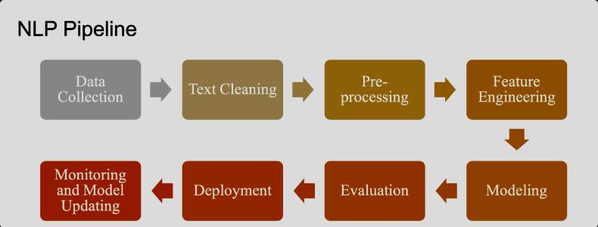
Figure 3.1 — High-level SMS preprocessing pipeline showing cleaning, normalisation, feature extraction and model preparation stages (adapted from Sarker, 2021).

System Overview
This framework was developed as a component-based or modular pipeline system, providing capability to create, evaluate and substitute a component without needing to concern yourself with any other components of the framework, making it very relevant for forensic use since each of the component(s) would be independently evaluated (Khalid, Iqbal, and Fung, 2024). There is a total of six (6) components in the framework:
- An ingestion module which imported SMS data from a structured source (such as a CSV);
- A pre-processing module which cleaned, normalized and validated SMS data (the contents of each message);
- A feature extraction module which transformed the cleaned messages (i.e., pre-processed messages) into TF-IDF feature vectors;
- A classification module which trained and used both Logistic Regression and Random Forest classification algorithms;
- An explanation module which generated both per-prediction explanation(s) and corresponding confidence score(s); and
- A reporting module which exported a structured output into the CSV format for documentation and review purposes.
By separating the components of the framework into modular components, the framework was constructed upon three (3) critical attributes for forensic applications: transparency, reproducibility, and extensibility.

Dataset Selection

Dataset Requirements
The data set chosen for use in the forensic AI research study has implications on the behaviour of the models trained on that data set, their fairness, and their ability to generalise to new cases that were not represented in the training group. The candidate sets contained SMS or SMS-like text messages; were from ethical sources (anonymised2 data or synthetically3 generated); contained no PII; were usable for supervised learning, and displayed communication patterns that were, at minimum, generally reflective of communications that have occurred in casework.

The SMS Spam Collection
The SMS spam collection (Almeida, Hidalgo, & Yamakami, 2011) was selected as a publicly accessible dataset based on these criteria and was designed specifically for research purposes. The spam messages (5574 total) were labeled as either spam or not (ham), with the intention that they would serve as a reference point for SMS classification in academia (not to mention they could also be used to train/test new models). While the dataset itself is not an authenticated forensic corpus, it is an appropriate choice due to its concurrence with most similar studies in the field and provides the opportunity to conduct legitimate academic research without violating ethical principles, since actual SMS data obtained from forensic casework cannot be distributed for research purposes.

Ethical Considerations in Dataset Use
The ethical choice to use SMS Spam Collection (and its source-level anonymization) was also justified by the fact that SMS messages often contain sensitive personal information. The methods used for this data collection are consistent with the data-protection principles of minimization, purpose limitation, and confidentiality, and comply with existing ethical guidance on automated decision-making in law enforcement (European Commission, 2024).
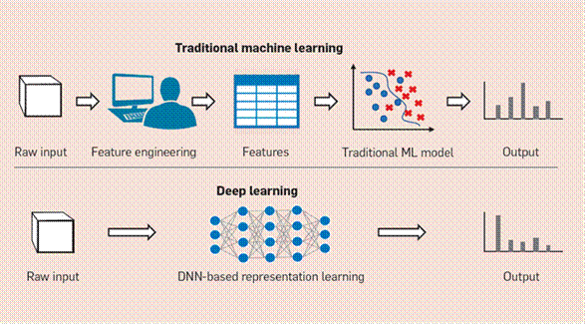
Figure 3.2 — Comparison of traditional machine-learning and deep-learning pipelines, highlighting differences in feature engineering and interpretability (adapted from Samek et al., 2021).

Data Preprocessing
Due to the noisy and non-standard nature of raw SMS text, preprocessing was essential. The steps in the preprocessing pipeline were applied in a consistent order to ensure accurate and reproducible transformation from raw data to vectorized representation. The following outlines the preprocessing steps used in this study.
- Delete duplicate and empty records.
- Standardize case (lowercase).
- Delete any non-informative punctuation or special characters.
- Tokenize into words.
- Delete English stop-words.
- Optionally, lemmatize to aggregate forms of words.
The documentation of all preprocessing activities contained within the source code and followed an order to facilitate systematic transformation of the raw data input into the vectorized features; this allows the transformation process to be reproduced when needed. Documenting the preprocessing steps provides information on auditing and replicating activities and verifies the forensic and systematic design principles.

Feature Extraction and Representation
The use of the Term Frequency-Inverse Document Frequency feature extraction provided interpretability for the model’s outputs by tying term frequency calculations back to the original documents. Second, TF-IDF was easy to compute and widely documented, with tools available for forensic investigators (Amato et al., 2019).
The implementation of TF-IDF used a configuration file that specified the removal of common English words (i.e., “and” “the”) as well as kept at least the top 5,000 words with the highest TF-IDF values. This design reduced the data's dimensionality, making it easier to perform calculations while preserving the long-tail vocabulary associated with spam messages and other questionable communications.

Machine-Learning Model Selection

Model Choice
This project trained two classifiers using TF-IDF features. The first classifier, Logistic Regression, was chosen because it provided clarity and simplicity to predict through its coefficient. Thus, each coefficient value indicated how much that classification was influenced by each of the terms in the TF_IDF space derived. Complementary to Logistic Regression, Random Forest was an alternative model that could account for non-linear relationships and provided an additional measure of feature importance through impurity-based or permutation-based measures. Deep Learning Models were considered but deliberately not used in this project because their lack of transparency conflicted with the project objective and legal definitions of explainability.

Training and Validation
The data in this study were split 80/20 (training/testing), and the distribution of classes within the training and test datasets was the same as in the original dataset. Hyperparameters were systematically tuned (i.e., all decisions made during training, such as the random seed, vectorizer configuration(s), and classifier parameters) so that the original experiment could be replicated exactly. Where the required computation time permits, stratified k-fold cross-validation was used to estimate generalization performance; final reported metrics were taken from a held-out test split of data.

Explainability Mechanism
The framework's explainability layer was designed to be understandable by users who are not data or statistical professionals, such as an investigator or a member of the legal profession. The mechanism comprised three components:
- The global contribution of each of the features/terms to each of the classes could be easily interpreted by investigating the logistic regression coefficients.
- For understanding the contribution of each of the features/terms in a specific prediction, each feature/term is ranked based on its contribution to that prediction (using the product of the term's TF/IDF weight and the corresponding coefficient from the logistic regression model).
- A model-based report of class probability confidence levels permitted investigators to view the strength of each prediction as well as the prediction itself.
By combining the above three mechanisms, an investigator could identify what the model predicted, the reasons supporting the prediction, and the degree of certainty in the prediction.

Evaluation Strategy

Performance Metrics
Classification performance was assessed using accuracy, precision, recall, and F1-score, which were widely accepted by industry standards. However, while the performance of classification is consistent within the field and was considered carefully when analyzing within forensic contexts due to the practical and legal impact of both false positives (innocent messages being marked as suspicious) and false negatives (suspicious messages being overlooked), both carry substantial operational and legal costs to law enforcement agencies (Hefetz, 2025).

Explainability Evaluation
Explainability was judged qualitatively using three criteria: the degree of clarity of the explanations provided, the degree to which the explanations provided were consistent with how the model performs, and the degree to which the explanations could be used in practical ways when assisting with decision-making related to investigations. The use of qualitative measures to determine explainability was intended as a complement, not a substitute, for the quantitative performance of metrics.

Forensic Suitability Assessment
Forensic suitability was ultimately determined by the level of transparency in decision-making, fit with the established forensic processes, the suitability of the explanations for court use, and the preservation of human oversight.

Validity and Reliability
The research under consideration was established as a legitimate body of academic investigation through well-defined research objectives, an evaluation plan directly aligned with those objectives, and a deliberate effort to apply the results of this research to forensic practices. The internal validity of this research was further verified using a clearly defined experimental procedure and a detailed, systematic processing of the dataset before the experiment started. The reliability of this research has been ensured through a complete record of all procedures related to the experimental work and by using fixed random number generators (i.e., random number seeds) to produce results that can be reproduced by independent observers who conduct their own experiments following the same steps used in this research study.

Ethical Considerations
Ethical risks associated with forensic artificial intelligence (AI) were largely governed by bias, fairness, and excessive reliance upon automated results. The methodology mitigated those risks using an anonymized public dataset; prioritizing the interpretability of models, embedding humans in the decision-making loop; and providing open documentation of the limitations and risks related to the developed artifact. All these choices aligned with existing responsible AI frameworks and legal guidance on the use of high-risk AI systems (European Commission, 2024).
The completed Health and Safety Risk Assessment is provided in Appendix B, and the signed Ethical Statement is provided in Appendix C.

Methodological Limitation
Although the selected methodology had advantages, it also had recognised disadvantages. Limiting this analysis to a single dataset of English-language public data limited its generalisability. The decision to prioritize interpretable models over deep learning architectures likely limited performance in some edge cases. Both limitations were documented in Chapter 4 and were used to identify future avenues of research in Chapter 6.

Chapter Summary
Chapter 3 established the methodological framework of this project, which included: research paradigm; system design; dataset selection; preprocessing strategy; feature engineering and model selection decisions; explainability mechanisms; evaluation strategy; and ethical and validity considerations. Throughout the methodology development process, transparency, human oversight, and forensic defensibility have been incorporated into the methodology, providing the basis for the implementation and evaluation reported in Chapter 4.

Chapter 4: Design, Implementation, Results, and Evaluation

Chapter Introduction
This chapter presented the design and implementation of the proposed Explainable AI framework for SMS forensic analysis and reported on the experimental evaluation of the resulting artefact. The chapter was organised so that it followed the lifecycle of the artefact: the implementation overview was presented first, followed by the dataset-processing results, the classification results, the explainability results and the structured reporting outputs. The chapter then evaluated the artefact against the project objectives and discussed the limitations of the results.

Implementation Overview
The artifact was implemented in Python and followed the methodology described in Chapter 3. The implementation process first consisted of loading the SMS Spam Collection into a Pandas dataframe and using the preprocessing pipeline (deduplicating, validating, normalizing labels, and relabeling). The messages cleaned by the above pre-processing steps were vectorized using the TF-IDF Vectorizer, configured to remove English-language stop words and keep only the top 5,000 terms. Based on this vectorization of the cleaned messages, the feature matrix was split into two datasets at an 80/20 stratified ratio (Training and Test datasets). Logistic Regression and Random Forest classifiers were then trained using the training datasets.
Logistic Regression provided coefficients that were easily interpretable from an end-user's perspective; the predicted value of each record by Logistic Regression could be traced back to the specific words that contributed to it Regression was also less prone to noise than Random Forest. Random Forest, on the other hand, captured more complex, nonlinear patterns in the data but was not as easily interpretable after training. The provided framework, which trained both models in parallel, therefore allowed end-users to compare the models predicted values, the confidence scores associated with their predictions, and, when such explanatory information is available, explanations of their predictions.
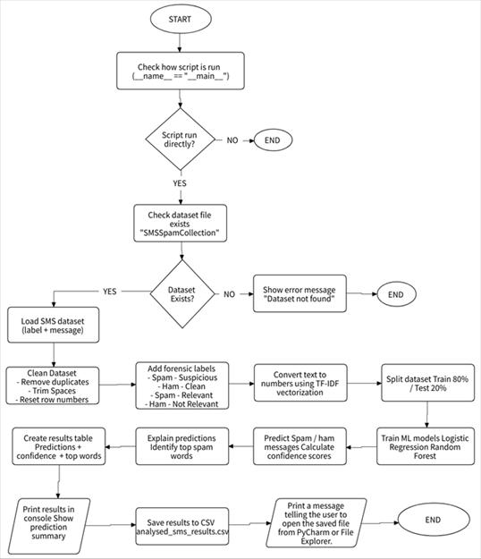
Figure 4.1 — End-to-end implementation workflow: dataset validation, preprocessing, TF-IDF feature extraction, model training, prediction, explanation and result export.

Dataset-Processing Results
Initially, the required packages to read files from the file system, and then for constructing databases and Machine Learning (specifically, the os, pandas, and sklearn) were imported. Configuration constants needed for quick reusability (DatasetPath, MaxTFIDFFeatures, and NumPreviewRows) were declared at the beginning of the code to make it easier for users to reuse this project with minimal changes. The printTable() method has also been used for formatted previews of the SMS Dataset, Labels, and Chart Output to facilitate easy readability during development and quickly perform checks of code validity during the development process.
The main implementation is broken down into 5 Stages. The SMS Dataset file is checked prior to any attempts at loading it to reduce the possibility of execution of errors. If it does exist, the dataset is loaded into a pandas DataFrame with two columns (Label & Message).
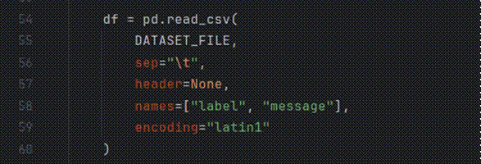
Figure 4.2 — Dataset loading and preprocessing: cleaning, validation and removal of duplicate records.
Stage 2 prepares the data for feature extraction. In this stage, the label values were normalized, whitespace characters (messages) were trimmed, empty rows were deleted, and duplicate record entries were removed. The original 2 labels (spam/ham) are then mapped to a forensic scheme: spam messages were relabeled as Suspicious-Relevant, while ham messages were divided into Non-Suspicious-Clean and Non-Suspicious-Not-Relevant. Additionally, each message received a unique sequential identifier for tracking through the analysis pipeline in a small but important aspect of forensic traceability.
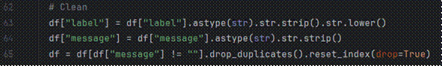
Figure 4.3 — Assignment of forensic labels to SMS messages for downstream classification and analysis.
During stage three, a set of features were identified for each cleaned message. Each message was transformed into a vector by using the TF-IDF (Term Frequency - Inverse Document Frequency) methodology, which omitted English stop-words, and limited the feature space to the 5,000 terms that had the highest information content. Thus, the feature matrix was suitable to provide input to classifiers, and each feature was directly tied to a surface-level word, which was a necessary condition for the explainable layer.
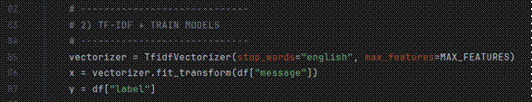
Figure 4.4 — TF-IDF feature extraction and training of the Logistic Regression and Random Forest classifiers.
In stage four, both classifiers were trained on an 80% data split for training using Stratified Sampling. The percentage of the sample being tested was representative of that in the sample used to train both classifiers. The framework used the probability estimates from the two classifiers (Logistic Regression and Random Forest), along with each classifier’s prediction, to calculate the per-prediction confidence score.

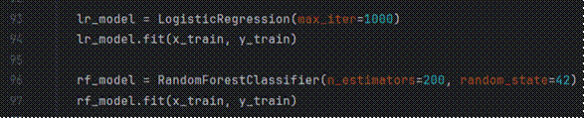
Figure 4.5 — Generation of predictions, confidence scores and explanations for SMS classification results.
The outcome of stage 5 consisted primarily of making predictions based on the test split, and for every message, the framework recorded the original label, the prediction made by each model, the associated confidence score, and, in the case of the Logistic Regression model, the list of the most influential words based on a combination of their tf-idf weighting and the logistic regression coefficient of the model. The combined output was exported in both CSV and Excel formats to provide documentary evidence for review by peers and to be included in a Disclosure Package.
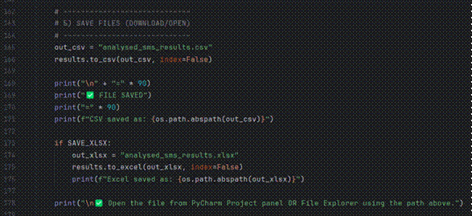
Figure 4.6 — Export classification results to CSV and Excel for storage, analysis and reporting.

Classification Results
Two combined methods evaluated the justification layer used. The first feature-level analysis identified the relationship between input features and classification results, such as how the top three most apparent features added to a classification identified as suspicious by the model; promotional language, urgency indicators and prize language. All other messages classified as non-suspicious mainly used every day conversational style language; hence, we could conclude the model is producing significant and normal results.
The second review was completed with a qualitative assessment on predictions classified as suspicious with confidence greater than the defined threshold. In addition, the developers of the justification layer used framework-generated contributed ranks of features to each prediction to determine if the explanation was clear interpretable and appropriately matched all observable message characteristics; therefore, we could determine the reliability of the model's classification decisions.
In summary, the framework allows the user to review each classification using both explanation and score assigned to it. As a result, the user will have access to a certifiable process of classification by using both an opaque decision-making process to an auditable and justifiable reasoning process that could be used in forensic investigations.

Explainability Results
Two kinds of analysis were used to assess the explainability layer. The first analysis tier was feature-level analysis, assessing how independent variables were correlated or dependent on one another and to the output of a classification (whether identified as suspicious or non-suspicious). When analyzing only the identified suspicious instance category, the highest-ranked features were promotional language, signs of time of urgency or immediate delivery, and prize-awarding terms. Unlike the identified suspicious instances, the identified non-suspicious instances were composed predominantly of casual, every day, conversational language. This finding supports the notion that the model learned about an appropriate or expected relationship.
The second tier of analysis examined the qualitative aspects of the classified instances that were determined to be suspicious based on the pre-established confidence level. The framework identified and ranked the features based on their contribution to each prediction, according to their degree of influence. Analyzing these explanations, it was determined that they were clear, understandable, and consistent with observable characteristics of the message. This finding lends credence to the model's classification of reliability.
The combination of per-prediction explanations and a confidence score allow users to understand and verify each decision made by the model. Therefore, this evolution of model outputs has enabled the conversion of previously opaque decisions into auditable, defensible logic/justification in forensic use.

Output and Reporting Results
A series of standardized DataFrames was created via this report module, with each DataFrame containing information on the original label for test message, predicted label from each model, associated confidence score, and a list of the terms that contributed most to determining both the predicted and original labels. DataFrames were exported to CSV and Excel formats; examples are provided in Figure 4.7.
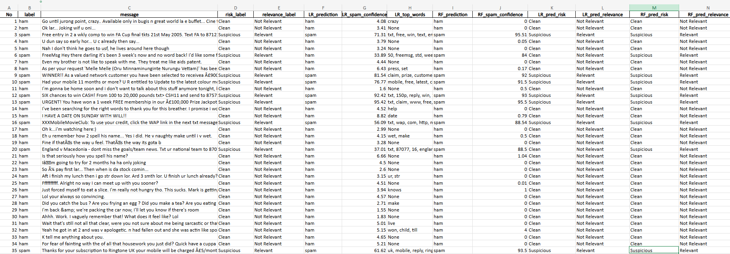
Figure 4.7 — Example of structured SMS classification output generated by the framework.
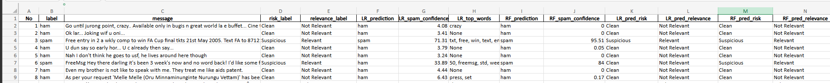
Figure 4.8 — Expanded view of the structured SMS classification results, showing model predictions, confidence levels, and key contributing features.
There are two main uses of the structured output: it serves as a record of every classification decision in a format that can be included with the case file; it allows easy triangulation between the decisions made by the two classifiers; and it includes per-prediction information necessary to fulfill any disclosure obligations. It is normal for forensic units in operation to use both CSV (which provides interoperability with other analysis methods) and Excel (which facilitates an analyst's review).

Evaluation Against Project Objectives
Each of the research objectives identified in Chapter 1 is addressed by these results. The artifact showed that an automated, reproducible, and clearly demonstrable alternative to manual SMS triage exists (Objectives 4 and 5). By using explainable models that provide per-prediction explanations, the artifact has provided an unprecedented level of transparency compared to black-box models, which is imperative for the adequate consideration of SMS as evidence in legal proceedings (Objectives 3 and 5). The structured output of the artifact was designed to be usable directly within the context of an investigative workflow, providing support for the documentation and review of all aspects of that workflow (Objective 4). All these elements come together to provide evidence for practical pathways of building explainable machine learning systems that can be used for the analysis of SMS evidence (Objective 3) and to provide a basis for the discussion of the ethical and legal concerns surrounding those systems, as discussed in Chapter 5 (Objective 6).

Limitations of the Results
Three limitations were identified in the study. Firstly, the model has been built and/or validated using a singular data set that was made publicly available, therefore it could not be considered actual case data and did not represent and thus many of the artefacts associated with the use of actual case data (i.e. informal language, code-switching and explicated obfuscation) were likely to be far lower in their numbers than what is seen in actual casework. Secondly, the decision to create intelligent models rather than using a deep learning architecture most likely limited the potential to predict outcomes (upper-end edge cases) due to a lack of context in the data. Thirdly, while the explainability layer currently is at its best for the Logistic Regression model, there was no way to know the importance of features in the Random Forest model, and there was no individual explanation to the same degree of detail. The limitations of the research were covered, and the ways they could be overcome were detailed in the future work chapter (Chapter 6).

Chapter Summary
To benefit other researchers, several important lessons have been identified for implementing a pipeline.
The first lesson is that because the pipeline has been built with a modular design, it is easy to test each component independently, configure them easily, and to iteratively improve individual components of the overall system. Additionally, the modular design allows enhancements to the explainability layer of the pipeline (e.g., adding LIME or SHAP) without affecting the entire pipeline.
The second lesson learned is that using TF-IDF improved both debugging and forensic analysis. When the model's output did not match expectations, the per-output explanations provided insight into which words influenced that output, thereby reducing the effort needed to determine why the output didn't match expectations and allowing greater confidence in the model's output.
Thirdly, the ability to export output in both CSV and Excel formats improved the evaluation and usability of the system's results, enabling the analysis of large amounts of data efficiently while maintaining clear traceability of steps taken during the forensic analysis process.
In summary, the lessons learned from this project demonstrate that providing explainability and forensic defensibility should be priorities for any system, and that doing so will improve transparency, accelerate the development and evaluation of systems, and increase users' confidence in those systems.

Chapter 5: Ethics, Risk and Legal Compliance

Chapter Introduction
This chapter examined the ethical, risk, and legal implications of developing an Explainable AI-based forensic framework for use with SMS communications. The framework used machine learning techniques to process communication data and, therefore, had to be designed and managed with consideration for ethical principles, minimization of operational risks, and compliance with all relevant legislation. This chapter reviewed the primary ethical concerns associated with the Framework (data privacy, bias, automation bias, and human oversight), assessed residual risks associated with deploying the framework, and explored how the Framework assisted in complying with applicable legal regulations, concerning the degree to which digital evidence is admissible in court.

Ethical Considerations

Data Privacy and Confidentiality
Forensic analysis of SMS traffic is limited by privacy concerns related to SMS data. SMS data could include sensitive private correspondence and other types of financial records or identifiable personal information (PII) when such records contain relevant evidence to support the forensic investigation.
This study employs the SMS Spam Collection Dataset, a publicly accessible, anonymized academic corpus of SMS data containing no PII. Therefore, this dataset enables compliance with fundamental data protection tenets, including: 1) confidentiality, 2) data minimization, and 3) ethical treatment of sensitive information.
Because the study uses only anonymized data for both developing and evaluating the study, the researchers did not need to access or process real-life cases, thus allowing for a demonstration of ethical research practices while simultaneously facilitating robust experimental tests of the hypotheses

Bias and Fairness
The bias in the training data could be passed along to machine-learning models. Examples of bias in SMS classification include over-representation of certain message types, preponderance of certain linguistic types, and labeling or classification of errors during dataset development. This technology development attempted to mitigate all instances of bias with the following techniques: carefully processing the data from an input perspective; stratifying the split of training and testing data to maintain an equal representation of each class; choosing interpretable classifiers (most notably Logistic Regression) that can be reviewed to look for evidence of systematic bias; and recognising that it is not possible to remove all instances of bias, given the dataset created is overwhelmingly in English, and therefore prior to operational use, a dedicated (and statistical) bias audit would need to be performed on a randomly selected, statistically representative portion of the operational work.

Automation Bias and Human Oversight
There was ample evidence of automation bias which was defined as a trend for a human decision maker to place undue confidence in automated systems (Hefetz 2025). The framework was purposely developed to be used as an aid in making decisions by having the ability to create predictions, provide confidence scores, and create explanatory documentation. However, it was important to note that the final determination of what the results meant was made by the forensic investigator. In embedding a human in the loop at the point of deciding, the framework helped to maintain the professional judgement of the investigator and limit the likelihood that an erroneous decision will be made based entirely on the results produced by a machine.

Risk Considerations

Misclassification Risk
Incorrect predictions could be produced by any type of machine learning system. False positives (clean messages flagged as suspicious) or false negatives (suspicious messages not caught) were costly in a forensic environment. The framework provided confidence scores for each prediction, so low-confidence predictions will be flagged for further manual review. The framework was also specifically designed to serve as a triage aid rather than the final authority on classification, to ensure that investigators can detect any misclassifications further downstream before those misclassified items impact the ultimate evidential conclusions.

Over-Reliance on AI
A risk of relying too much on automated classification by an investigator was that they could overlook contextual factors relevant to these decisions, which may lie outside the model. To make sure an investigator engages in a critical evaluation of the model output, which should be questioned and not presumed to be an answer, explanations for each prediction were also provided as part of the design.

Generalizability Limitation
The training set did not reflect all the variations found in real-world SMS messaging (such as language, slang, abbreviations, use of two languages, etc.). Therefore, testing with a larger, diverse sample was necessary to operationalize the framework for production use.

Technical and Operational Risks
Any deficiencies in the pipeline (data cleansing, model preparation, or deployment) could give rise to technical risk; meanwhile, improper use of the framework and a lack of understanding of its limits create operational risk. The framework's defined, structured workflow, validation steps at each stage, and documentation that supports analyst training for operational deployment minimize both types of risk.

Legal Compliance

Transparency and Explainability
An increasing number of jurisdictions mandated both transparency and explainability for AI-assisted decision-making applications involving high-risk use cases, including law enforcement (European Commission, 2024; Bharati, 2025). Black-box models were viewed as highly inappropriate because they could not provide defensible rationales for their outputs.
The framework was designed specifically to include explainability; as such, every prediction could be traced back to the individual terms from which it was derived. This provided the thorough, structured justification a court would be expected to have when making such judgments.

Admissibility of Evidence
In order for digital evidence to be accepted as a legitimate and permissible form of prosecution in court, such proof had to exhibit reliability (the ability to be depended upon), reproducibility (the ability to produce the same or a similar result), and adequate documentation (creating a reliable record for others).
This included all forms of AI-generated output, such as classification/regression results. This framework supported the admissibility of the data through the following four axes:
- provides crisp classification results;
- has the ability to report the precision of each classification by providing a confidence score for each classification;
- can display the most significant features or elements that contributed to the classification decision; and
- produces the final outputs in structured/realistic auditable formats. These features collectively supported the requirements for traceability and reproducibility with respect to evidence validity and were consistent with what Richmond et al. (2023) have suggested regarding the relationship between the explanation of AI outputs and legal due process.

Accountability and Human Responsibility
Legal frameworks consistently located ultimate responsibility for any decision with the human operator. Automated systems were properly understood as assistive, not substitutive. The framework was designed in line with this principle: investigators retained full responsibility for the final interpretation of any classification, and the artefact provided analytical support without ever claiming to replace professional judgement.

Responsible AI Principles
The four headline principles that underpinned Responsible AI (RAI) formed the basis of this framework, as well as the regulatory and academic guidance currently available on RAI. Specifically, the four principles are as follows:
- Transparency: The AI model produced clear, understandable explanations of how it reached its predictions.
- Accountability: Humans had final say over and remained responsible for making all decisions.
- Fairness: Deliberate efforts were made to mitigate bias in both the data and the AI model.
- Reproducibility: All steps of the AI pipeline were documented and able to be reproduced exactly.

Ethical and Legal Strengths and Limitations
While the framework addressed a wide range of ethical and legal issues, it had limitations. Using a single public dataset limits generalisability, and the artifact had not yet been assessed in real-world casework conditions. Future planned work (discussed in Chapter 6) would include additional types of data (i.e., more varied and realistic), additional explanation techniques (including LIME and SHAP), and structured evaluation with experienced forensic practitioners.

Chapter Summary
Chapter 5 examined the ethical, risk, and legal aspects involved in the development of the proposed model. The proposed model demonstrated a responsible and transparent application of machine learning to digital forensics by using anonymized data, generating reproducible and explainable outputs, and ensuring that meaningful human oversight is always present. Consequently, while the model did have acknowledged limitations, it provided credible evidence that A.I. technologies could have beneficial assistive roles within the investigatory process, while remaining within recognized ethical and legal standards.
To summarize, the examination of ethics, risks and legal issues throughout the previous chapters confirm the overall design philosophy of this research; that the responsible use of artificial intelligence (AI) in forensic contexts would not be achieved through the application of only technical controls but rather requires the systematic alignment of design choices across several aspects (selection of dataset, algorithm/model selected, explainability mechanisms, structure of outputs, level of human review). These elements were treated as integral parts of the design rather than just compliance requirements.
Therefore, the proposed framework improved the transparency, accountability, and defensibility of forensics. As a result, the framework was better able to withstand scrutiny from forensic practitioners, ethics boards, and courts. Finally, Chapter 6 provided a summary of the key findings, reemphasized the research's significant contributions, and outlined future research.
The full console output from the classification pipeline includes the dataset preview, label distribution, prediction summary for the Logistic Regression and Random Forest models, per-message spam-confidence scores, and the top contributing words are presented in Appendix D. A representative sample of the full analysed SMS dataset is included in Appendix E.

Chapter 6: Conclusions and Future Work

Chapter Introduction
This last chapter concludes the thesis by providing a summary of everything that has been done during the project's duration; sufficiently restating the main contributions; honestly reflecting upon how well we accomplished our original research goals and objectives; identifying the main limitations of both the artifacts used in this study and the overall study itself; and finally, providing an agenda for future research and/or development activity within this area which will be organized and substantiated.

Summary of the Work
The purpose of this research was to develop, implement, and evaluate an Explainable Artificial Intelligence process to aid in the forensic analysis of Short Message Service (SMS) evidence. The proposed framework was developed to overcome some of the major limitations of manual analysis and traditional black-box AI processes. This was accomplished by creating a transparent, interpretable, and structured forensic output process.
Chapter 1 established the research context by identifying the operational and legal issues associated with SMS evidence analysis, particularly the limitations of manual analysis and the lack of transparency in AI-based processes previously in place. Chapter 2 conducted a critical review of the literature related to mobile device forensics, SMS evidence analysis, AI, and explainable AI, and identified a clear gap in research; specifically, there is a lack of an integrated end-to-end forensically sound automated SMS classification process with per-prediction explanations, confidence scoring, forensic labeling, and structured export capabilities.
Chapter 3 detailed the methodology adopted to develop the framework using Design Science Research methodology, including the design, implementation, and evaluation of the proposed artifact. Chapter 4 presented the results of the experimental phase, demonstrating that the framework was effective at producing reliable classifications, interpretable outputs, and having practical forensic use. Finally, Chapter 5 reviewed the ethical, risk, and legal implications of deploying such a system, confirming the importance of transparency, accountability, and human oversight in forensic applications of AI.

Contributions
The primary contributions of this study are as follows:
- A modular and reproducible explainable AI framework for SMS forensic classification, implemented as a working artefact in Python, and divided into six distinctly defined components;
- A relabeling of the SMS Spam Collection to support the forensic practitioner’s language and practice, by assigning labels (or classifying items within the dataset) according to the two basic criteria of forensic classification (i.e., whether an item is suspicious/relevant, non-suspicious/clean, or non-suspicious/not relevant);
- An empirical demonstration that interpretable traditional machine learning approaches (TF-IDF with Logistic Regression and Random Forest) can achieve results that are comparable to results reported in prior SMS spam classification literature and provide (i.e. produce) explanations for the individual predictions they make and also provide calibration scores for each of their predictions.
- A discussion of the ethical, risk and legal ramifications of using AI in SMS forensics; including into this the identification of specific design decisions in the developed framework that are aligned with transparent, accountable, fair and reproducible AI principles.

Reflection on the Aim and Objectives
The goal of the research to develop a framework for explainable AI-based decision support systems that may be used to assist forensic investigators with the analysis of SMS messages was achieved. Results indicate that an interpretable and balanced framework is feasible and practical.
All 6 objectives identified in Chapter 1 have now been systematically addressed. The literature review established the research context (objective 1), while an analysis of the weaknesses of the manual and black-box approaches was conducted (objective 2). A modular, explainable framework was designed and built as a working model (objectives 3 & 4). Finally, the evaluation of the framework was carried out across multiple criteria, including classification accuracy, explainability, and suitability for forensic use (objective 5), followed by an in-depth analysis of ethical, legal, and risk issues related to its use (objective 6).
Table 6.1 provides a structured summary of how each research objective was met, along with evidence produced throughout this research and a clear distinction from the literature relevant to this research.
Objective no. | Objective | How it was met (proof of work) | Comparison with related work
1 | To conduct a critical review of relevant scholarly literature on mobile device forensics, SMS evidence analysis, explainable AI, and the legal admissibility of AI-assisted findings. | The review presented in chapter two examined more than thirty articles in the literature, including those relating to mobile forensics, the analysis of SMS, the use of AI and XAI, as well as the legal acceptability of AI-based evidence. | Many of the previously published reviews assess artificial intelligence applications in forensic science separately from artificial intelligence explanations; however, we clearly discussed the intersection of artificial intelligence in forensic science as well as aspects from these three areas that provide clarity for practitioners working with this technology.
2 | To compare the limitations of traditional manual analysis methods to “black box” AI methods when performing forensic analysis of SMS evidence. | Chapter 2 contains a comprehensive review of over thirty literature articles relating to mobile forensics, including insights into SMS-focused studies; discussions about the application of artificial intelligence (AI) and explainable AI (XAI); and analyses of the admissibility of AI-generated evidence. | The majority of research has focused on predictive performance; however, this study will also measure the comparability between predictive and descriptive methods according to evidential and forensic standards.
3 | To create a modular framework used to classify SMS evidence through the application of interpretable, well-understood machine learning techniques. | Design science research principles informed the creation of the six-stage modular framework described in Chapter 3. The six stages of the framework include ingestion, preprocessing, feature extraction, classification, explanation, and reporting. | Most existing SMS Classification methodologies are viewed as singular systems of classification. This framework introduces the concepts of Modularization, Auditability, and Adaptability at the Component level of classification.
4 | To create the modular framework for SMS evidence classification as a functional artifact in a programming language (Python) with a defined, reproducible workflow. | The application of the framework in Python to Text Mining using the TF-IDF algorithm, Logistic Regression, and Random Forest models is discussed in Chapter 4. The three models were implemented using a set of predefined data split methods and were outputted to both CSV and Excel file formats in order to facilitate reproducibility. | Numerous studies published to date do not have reproducible pipelines or outputs which can be audited; however, the present project delivers a complete reproducible and reusable implementation that is both traceable.
5 | To assess the functional classification performance, explanation of quality, and forensic suitability of the SMS evidence classification framework. | The ability to provide reliable metrics associated with the predictions being made is addressed in Sections 4.4-4.7 through the use of performance metrics (accuracy, precision, recall, F1-score), providing value/benefit for each individual prediction made and their associated confidence score, providing the basis for a structured and comprehensive forensic suitability assessment of predictions made. | Many previous studies focus almost exclusively on some methods of measuring accuracy. In contrast, the current study treats the two attributes of explainability and forensic utility with equal importance when evaluating the approaches to be studied.
6 | To conduct an analysis of the ethical, risk, and legal concerns regarding the use of AI in SMS forensic analysis and demonstrate how the SMS evidence classification framework implements solutions to mitigate these concerns. | The alignment of framework design decisions through the four design principles of transparency; human oversight; reproducibility, and fairness; directly corresponds to the ethical, operational, and legal risks identified in Chapter 5. | There are many ethical and legal issues that have been traditionally discussed in the realm of academic literature, but this project incorporates these issues into the actual design and development of the software.

Table 6.1 — Mapping research objectives to evidence of completion and comparison with related work.

Limitations
The principal constraints of this study are:
- Use of a singular, English-language dataset accessible in the public domain;
- The deliberate choice of interpretable models has placed a clear upper bound on possible predictive power; and
- The extent of interpretability differs between the Random Forest and Logistic Regression models: Logistic Regression is more interpretable because it uses linear coefficient-based relationships between predictors and the prediction, whereas Random Forest provides more complex decision pathways that are comparatively opaque. Although this limitation presents a significant disadvantage in relation to model performance versus model explainability, it does not detract from this study’s contribution. Rather, it presents insights into practical challenges associated with applying machine learning for forensic purposes and, therefore, informs future improvements as explained in detail in the next section.

Future Work
Here are some potential areas for future work that arise directly out of this research project:
- Expanding the framework to support additional SMS datasets (e.g., multilingual SMS datasets) and potentially lawful and ethical anonymised samples of operational data, thereby improving its performance.
- Integrating other explainable AI techniques (LIME; SHAP) into the framework in order to improve the explanatory power of the Random Forest model and to use those explainers as a way of triangulating the explanatory performance of the Logistic Regression model against alternate methodologies.
- Conducting a controlled evaluation of the framework with qualified forensic practitioners to determine how useful the framework explanations are operationally and to identify any usability issues that arise in actual use.
- To expand this framework for more types of SMS Evidence (i.e., Text Evidence). For example, include the use of Instant Messaging (IM) exports and Email communication records. Retain the same level of Explainability, Transparency, and Auditability of the Evidence that was created from this research.
- Investigating hybrid architectures that use interpretable models (Logistic Regression) as the first transparent level of processing, then using richer models on a residual basis for ambiguous cases, all under explicit human supervision.

Closing Remarks
While there is much public discourse about the legitimacy and/or legality of using artificial intelligence in forensic evidence, this study contends that such concerns are valid; however, they should not be used as an excuse to discard all applications of artificial intelligence. Rather, researchers need to establish more appropriate and consistent engineering processes as part of their development for forensic use.
Adopting design principles that facilitate interpretability, promote user confidence, and encourage meaningful human involvement in forensic applications of artificial intelligence will help develop design solutions that comply with legal and ethical standards and are effective in meeting end users' needs.
The framework presented in this study provides a focused contribution to an ongoing and growing body of research regarding the effectiveness of incorporating explainable artificial intelligence into forensic workflows. The development of the design principles presented in this study, along with an explicit identification of the limitations associated with implementing each principle, is intended to guide both future research in this field and practitioners engaged in developing accountable and trustworthy artificial intelligence for forensic investigations.

Wider Implications for Practice and Policy
This framework serves as a guideline to develop interpretable and explainable AI systems that are designed for use with SMS evidence, however, they do extend beyond that type of evidence and context, as the framework can also support all types of textual evidence in forensic analysis, including instant messages, e-mails, social media, and text produced by chatbots. All of these different forms of text-based evidence present problems associated with large data sets that cannot easily be analysed, disclose specifications related to the use of the evidence that restricts what is permissible to use for analysing the evidence, and heightened scrutiny from the legal system. The need to develop forensic investigative useful tools to support investigators' analysis of text-based evidence means that explainability should be a key design consideration when developing these tools.
The framework serves as a practical tool to assist investigators with the analysis of evidence when completed in accordance with the specific requirements, and is representative of a broader design rationale for forensic AI systems, where explainability is the key design goal and the design must also be balanced against the provision of strong predictive performance, transparency, make accountable and reproducible the way in which AI systems are deployed and used.
From a policy perspective, the current study suggests that explanation should be a core factor in the development and procurement of AI tools used by law enforcement agencies because the use of accuracy is insufficient to support legal proceedings. Instead, the implementation of documented preprocessing elements, per-prediction explanation, confidence measurement, and reproducibility will all improve the likelihood of the successful deployment of AI systems that are both robust and capable of serving as an affirmative defence throughout the evidential timeline, including processes involving disclosure, cross-examination, and appeal.
The framework established in this study provides the opportunity to evaluate the entire development lifecycle of a forensic AI system, from the literature review to problem definition, design development, implementation, operation, and ethical considerations in AI system development and deployment. The importance of the human, legal, and institutional context is stressed when deploying AI technologies; therefore the processes identified by the framework, research findings, and design principles identified in the current study will assist in providing researchers and forensic practitioners with the knowledge necessary to achieve the societal and legal goals of explainable, reliable, and human-centred AI in digital forensic investigations.

References
[1] Ali, S., Abuhmed, T., El-Sappagh, S., Muhammad, K., Alonso-Moral, J.M., Confalonieri, R., Guidotti, R., Ser, J.D., Díaz-Rodríguez, N. and Herrera, F. (2023). Explainable Artificial Intelligence (XAI): What we know and what is left to attain Trustworthy Artificial Intelligence. Information Fusion, 99(101805), p.101805. https://doi.org/10.1016/j.inffus.2023.101805.
[2] Almeida, T.A., Hidalgo, J.M.G. and Yamakami, A. (2011). Contributions to the study of SMS spam filtering: new collection and results. Proceedings of the 11th ACM Symposium on Document Engineering. https://doi.org/10.1145/2034691.2034742.
[3] Amato, F., Cozzolino, G., Moscato, V., and Moscato, F. (2019). Analyse digital forensic evidences through a semantic-based methodology and NLP techniques. Future Generation Computer Systems, 98, pp.297–307. https://doi.org/10.1016/j.future.2019.02.040.
[4] Anwar, R. and Bashir, M.B. (2023). A Systematic Literature Review of AI-based Software Requirements Prioritization Technique. IEEE Access, 11, pp.143815–143860. https://doi.org/10.1109/access.2023.3343252.
[5] Bagaric, M., Svilar, J., Bull, M., Hunter, D. and Stobbs, N. (2021). The Solution to the Pervasive Bias and Discrimination in the Criminal Justice: Transparent Artificial Intelligence. SSRN. https://papers.ssrn.com/sol3/papers.cfm?abstract_id=3795911.
[6] Bharati, R. (2025). Legal and Ethical Considerations in the Use of Digital Forensics by Law Enforcement: A Multi-jurisdictional Study. SSRN Electronic Journal. https://doi.org/10.2139/ssrn.5062555.
[7] Bhoopesh Kumar Sharma, Walia, M., Sharma, Y., Beig, M.T.A. and Shukla, V. (2024). Advances and Challenges in Mobile Phone Forensics. https://doi.org/10.1109/ic3se62002.2024.10592965.
[8] Canalli, R. (2024). Interpretable AI models for judicial decision-making: beyond explicability towards legal due process. e-Pública. https://e-publica.pt/api/v1/articles/117473.pdf.
[9] Capuano, N., Fenza, G., Loia, V. and Stanzione, C. (2022). Explainable Artificial Intelligence in Cybersecurity: A Survey. IEEE Access, 10, pp.93575–93600. https://doi.org/10.1109/access.2022.3204171.
[10] Chukaieva, A. (2023). Possibilities of applying artificial intelligence in the work of law enforcement agencies. Naukovyi Visnyk Natsionalnoi Akademii Vnutrishnikh Sprav, 28(3), pp.28–37. https://doi.org/10.56215/naia-herald/3.2023.28.
[11] European Commission (2024). Regulation (EU) 2024/1689 — Artificial Intelligence Act. Official Journal of the European Union, L series. https://eur-lex.europa.eu/eli/reg/2024/1689.
[12] Fakhouri, H.N., AlSharaiah, M.A., Ahmad, M.A. and Dweikat, F.F. (2024). Overview of Challenges Faced by Digital Forensics. https://doi.org/10.1109/iccr61006.2024.10532850.
[13] Garzo, G., Ribes, S. and Palumbo, A. (2024). Opening the Black Box: How Boolean AI can Support Legal Analysis. 2024 4th International Conference on Computer Communication and Artificial Intelligence (CCAI), pp.269–272. https://doi.org/10.1109/ccai61966.2024.10603017.
[14] Hefetz, I. (2025). Evaluating bias in forensic evidence: From expert analysis to AI-based decision tools. Forensic Science International: Synergy, 11, p.100645. https://doi.org/10.1016/j.fsisyn.2025.100645.
[15] Hermosilla, P., Berríos, S. and Allende-Cid, H. (2025). Explainable AI for Forensic Analysis: A Comparative Study of SHAP and LIME in Intrusion Detection Models. Applied Sciences, 15(13), pp.7329–7329. https://doi.org/10.3390/app15137329.
[16] Hevner, A.R., March, S.T., Park, J. and Ram, S. (2004). Design Science in Information Systems Research. MIS Quarterly, 28(1), pp.75–105.
[17] Humphries, G., Nordvik, R., Manifavas, H., Cobley, P. and Sorell, M. (2021). Law enforcement educational challenges for mobile forensics. Forensic Science International: Digital Investigation, 38, p.301129. https://doi.org/10.1016/j.fsidi.2021.301129.
[18] Kabir, S., Hossain, M.S. and Andersson, K. (2025). A Review of Explainable Artificial Intelligence from the Perspectives of Challenges and Opportunities. Algorithms, 18(9), pp.556–556. https://doi.org/10.3390/a18090556.
[19] Khalid, Z., Iqbal, F. and Fung, B.C.M. (2024). Towards a unified XAI-based framework for digital forensic investigations. Forensic Science International: Digital Investigation, 50, p.301806. https://doi.org/10.1016/j.fsidi.2024.301806.
[20] Khubrani, M.M. (2023). Mobile Device Forensics, Challenges and Blockchain-based Solution. https://doi.org/10.1109/smarttechcon57526.2023.10391719.
[21] Lunhol, O. and Torhalo, P. (2024). Artificial Intelligence in Law Enforcement: Current State and Development Prospects. https://doi.org/10.55295/psl.2024.ii12.
[22] Mani, R.T., Palimar, V., Pai, M.S., Shwetha, T.S. and Nirmal Krishnan, M. (2025). An evolution of forensic linguistics: From manual analysis to machine learning — A narrative review. Forensic Science International: Reports, 11, p.100417. https://doi.org/10.1016/j.fsir.2025.100417.
[23] Maratsi, M.I., Popov, O., Alexopoulos, C. and Charalabidis, Y. (2022). Ethical and legal aspects of digital forensics algorithms: The case of digital evidence acquisition. 15th International Conference on Theory and Practice of Electronic Governance. https://doi.org/10.1145/3560107.3560114.
[24] Marsico, F. and Amigo, M. (2025). Ethical and security challenges in AI for forensic genetics: From bias to adversarial attacks. Forensic Science International: Genetics, 76, pp.103225–103225. https://doi.org/10.1016/j.fsigen.2025.103225.
[25] Matulionyte, R. and Hanif, A. (2021). A call for more explainable AI in law enforcement. IEEE Xplore. https://doi.org/10.1109/EDOCW52865.2021.00035.
[26] Miranker, M. and Giordano, A. (2020). Text mining and semantic triples: Spatial analyses of text in applied humanitarian forensic research. Digital Geography and Society, 1, p.100005. https://doi.org/10.1016/j.diggeo.2020.100005.
[27] Nwankwo, C., Wimmer, H., Chen, L. and Kim, J. (2020). Text Classification of Digital Forensic Data. 2020 11th IEEE Annual Information Technology, Electronics and Mobile Communication Conference (IEMCON). https://doi.org/10.1109/iemcon51383.2020.9284913.
[28] Papadouli, V. (2022). Transparency in Artificial Intelligence: A Legal Perspective. SSRN. https://papers.ssrn.com/sol3/papers.cfm?abstract_id=4616709.
[29] Peffers, K., Tuunanen, T., Rothenberger, M.A. and Chatterjee, S. (2007). A Design Science Research Methodology for Information Systems Research. Journal of Management Information Systems, 24(3), pp.45–77.
[30] Peng, L., Zhu, X. and Zhang, P. (2020a). A Machine Learning-Based Framework for Mobile Forensics. pp.1551–1555. https://doi.org/10.1109/icct50939.2020.9295714.
[31] Peng, L., Zhu, X. and Zhang, P. (2020b). An Efficient Model for Smartphone Forensics Using SMS Spam Filtering. 2020 3rd International Conference on Hot Information-Centric Networking (HotICN), pp.166–169. https://doi.org/10.1109/hoticn50779.2020.9350843.
[32] Quick, D. and Choo, K.-K.R. (2018). Big forensic data reduction: digital forensic images and electronic evidence. Cluster Computing, 21(4), pp.1857–1869. https://doi.org/10.1007/s10586-016-0553-1.
[33] Richmond, K.M., Muddamsetty, S.M., Gammeltoft-Hansen, T., Olsen, H.P. and Moeslund, T.B. (2023). Explainable AI and Law: An Evidential Survey. Digital Society, 3(1). https://doi.org/10.1007/s44206-023-00081-z.
[34] Salman, M., Ikram, M. and Kaafar, M.A. (2024). Investigating Evasive Techniques in SMS Spam Filtering: A Comparative Analysis of Machine Learning Models. IEEE Access, 12, pp.24306–24324. https://doi.org/10.1109/ACCESS.2024.3364671.
[35] Samek, W., Montavon, G., Lapuschkin, S., Anders, C.J. and Müller, K.-R. (2021). Explaining Deep Neural Networks and Beyond: A Review of Methods and Applications. Proceedings of the IEEE, 109(3), pp.247–278. https://doi.org/10.1109/JPROC.2021.3060483.
[36] Sarker, I.H. (2021). Machine Learning: Algorithms, Real-World Applications and Research Directions. SN Computer Science, 2(160). https://doi.org/10.1007/s42979-021-00592-x.
[37] Shahbazi, Z. and Byun, Y.-C. (2022). NLP-Based Digital Forensic Analysis for Online Social Network Based on System Security. International Journal of Environmental Research and Public Health, 19(12), p.7027. https://doi.org/10.3390/ijerph19127027.
[38] Sharma, B.K., Joseph, M.A., Jacob, B. and Miranda, B. (2019). Emerging trends in Digital Forensics and Cyber Security — An Overview. 2019 Sixth HCT Information Technology Trends (ITT). https://doi.org/10.1109/itt48889.2019.9075101.
[39] Solanke, A.A. (2022). Explainable digital forensics AI: Towards mitigating distrust in AI-based digital forensics analysis using interpretable models. Forensic Science International: Digital Investigation, 42, p.301403. https://doi.org/10.1016/j.fsidi.2022.301403.
[40] Spranger, M., Xi, J., Jaeckel, L., Felser, J. and Labudde, D. (2022). MoNA: A Forensic Analysis Platform for Mobile Communication. KI - Künstliche Intelligenz, 36(2), pp.163–169. https://doi.org/10.1007/s13218-022-00762-w.
[41] Veldhuis, M.S., Ariëns, S., Ypma, R.J.F., Abeel, T. and Benschop, C.C.G. (2022). Explainable artificial intelligence in forensics: Realistic explanations for number of contributor predictions of DNA profiles. Forensic Science International: Genetics, 56, p.102632. https://doi.org/10.1016/j.fsigen.2021.102632.
[42] Xi, J., Jaeckel, L., Spranger, M., Siegel, M. and Labudde, D. (2024). Forensic Communication Analysis: Challenges and Opportunities. pp.878–883. https://doi.org/10.1109/csr61664.2024.10679503.

