
Exotic Bird Feather Analysis Investigations for Wildlife/Animal Crime
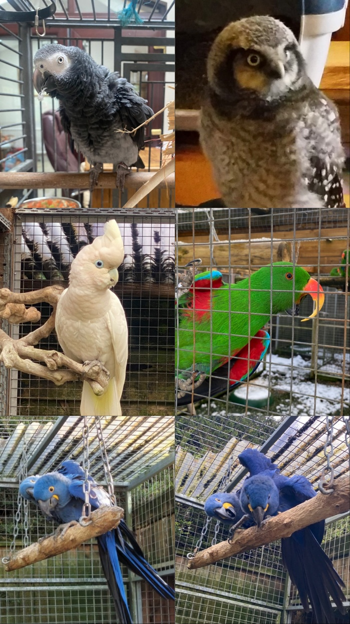
By Sophie Spilsbury
23014341
A dissertation submitted for the award of
BSc (Hons) Forensic Investigation
Under the supervision of Dr Claire Gwinnett
in the Department of Sport and Science
University of Staffordshire
April 2026
Word count = [17682]
Acknowledgements
I would like to thank my supervisor Claire, for always being by my side throughout my project. Through all my weird and wonderful questions and constant moaning. You are always there when I am struggling and for all your wise words throughout being my supervisor. You are always there to make me smile through your endless coffees and your caffeine highs.
To my parents, Liz, and Dan, and all my family who live with me thank you for putting up with all my emotions when I was writing this project. You have always been there with me through the highs and the lows. I know you are always there for me when I need you and I love you all, even the smallest achievement you have been my biggest supporters.
To my friends who supported me through university especially Paige and Ell. I do not know what I would have done without you. Both of you have been there throughout everything. I do not think we would have survived without our side quests throughout the journey of this project. Thank you both for everything you have done for me.
To my boyfriend, Josh, as much as I have stressed about university life thank you for always sticking by my side throughout all my assignments and projects. I may annoy you, but you have always been my biggest supporter providing me with food and drink through endless sleepless nights of me writing this. Thank you for everything.
To my Uncle Andy, you are my personal spell checker, and you have read every one of my assignments however long they may, but this was the longest and I am sorry for having to get you to check an 15000-word report. Thank you for always supporting me with everything I do.
To my sisters, Lydia, Katy and Natalie, thank you for being yourselves and making me happy and making sure my mind was not always on this project. You three have made me laugh and get me through this project the most, thank you all three of you never change.
Finally, thank you for everyone who has had to put up with me during this time as this has been one of the hardest and biggest achievements of my life.

Table of Contents
Table of Contents 3
List of Tables 5
List of Figures 5
List of Abbreviations 5
Abstract 5
1. Introduction 1839 5
1.1 Wildlife crime 5
1.1.1 Statistics of Wildlife Crime 5
1.1.2 Case Study 5
1.2 Bird Crime 6
1.2.1 Illegal Bird Trade 6
1.3 Feather Composition and Functions 6
1.3.1 Feather Types 7
1.3.2 Structure of a Feather 8
1.4. Evidential Value of Feathers 8
9
9
1.5 Analytical Methods of Analysing Feathers 9
2. Aims and Objectives 215 10
3. Method 2345 10
3.1 Sample Collection 10
3.2 Pilot Method 10
3.3 Main Experiment 11
3.3.1 Sample Preparation 11
3.3.2 Photographic Set Up 11
3.3.3 Macroscopic Observations Method 12
3.3.4 Scanning Electron Microscope (SEM) 13
3.5 SPSS 14
4. Results and discussion 15
4.1 Lengths 15
4.1.1 Lengths from tip to the start of the barbules 15
4.1.2 Length from widest part of the feather to the tip 18
4.2 Widths 21
4.2.1 Width from 1cm from the bottom 21
4.2.2 Width from 1cm from the top 24
4.2.3 Widest part of the feather 26
4.2.4 Left side of the vane at the widest part of the feather 29
4.2.5 Right side of the vane at the widest part of the feather 33
4.3 Weight 36
4.4 Coloration 39
4.5 Colour Distribution/Pattern 46
4.6 Scanning Electron Microscope (SEM) 48
5. Further work 54
6. Conclusions 55
Appendix 56
References 322

List of Tables
Table 1 Table of Measurements Taken on the Feathers Analysed 12
Table 2 SPSS Guide of Values to Bird Species 16
Table 3 Kruskal Wallis Results Table for Lengths from Tip to Start of Barbules 16
Table 4 Kruskall Wallis Results Tables on Length from Widest Point to the Tip 20
Table 5 SPSS Kruskral Wallis Test of the Width from 1cm from the Top of a Feather 26
Table 6 SPSS Kruskrall Wallis Results Table of the Width of a Feather at the Widest Point 29
Table 7 SPSS Kruskral Wallis Results Table of the Widest point of the Feather Left Side of the Vane 32
Table 8 SPSS Kruskrall Walis Results Table of the Widest Point of the Feather Right Side of the Vane 35
Table 9 Coloration Results Table of Eclectus Body Feathers Samples 40
Table 10 Percentage Range and Bandings For the Colour Distribution and Pattern 46
Table 11 Colour Distribution and Pattern Results Table for Northern Hawk Owl 48

List of Figures
Figure 1 feather types which can be seen on a bird species (Twootz, 2018) 12
Figure 2 composition of a feather diagram labelled (hollandwest, 2012). 13
Figure 3 SEM feather micromorphology characteristics (Griffith. 1970). 14
Figure 4 Feather Micromorphology Characteristics (Griffith, 1970). 15
Figure 5 Paper Fold for Feather Storage 18
Figure 6 storage of feather information sheet 18
Figure 7 Diagram of Measurements Taken on the Feathers Analysed 19
Figure 8 Box and Whisker Plot of Bird Species of the Length from the Tip of the Feather to the Start of the Barbules 22
Figure 9 Box and Whisker Plot of Bird Species Length of Feathers Tip to Starts of Barbules 22
Figure 10 Box and Whisker Plot of Bird Species of Lengths from the Widest Point to the Tip 27
Figure 11 Box and Whisker Plot of Bird Species of the Width from 1cm from the Bottom of a Feather 32
Figure 12 Box and Whisker Plot of Bird Species of the Width from 1cm from the Top of a Feather 36
Figure 13 Box and Whisker Plot of Bird Species of the Width of the Widest Point of a Feather 40
Figure 14 Box and Whisker Plot of Bird Species of the Width of the Widest Point of the Feather Left Side of the Vane 45
Figure 15 Box and Whisker Plot of the Bird Species of the Widest Point of the Feather Right Side of the Vane 49
Figure 16 Box and Whisker Plot of Bird Species of the Weight of the Feathers 54
Figure 17 RGB Values for Eclectus Female Feathers 57
Figure 18 RGB Values Chart of Eclectus Body Feathers 58
Figure 19 RGB Values Chart of Eclectus Male Fetahers 60
Figure 20 RGB Values Chart of Macaw Feathers 61
Figure 21 RGB Values Chart of African Grey Feathers 62
Figure 22 RGB Values Chart of Cockatoo Feathers 63
Figure 23 RGB Values Chart of Northern Hawk Owl Feathers 64
Figure 24 SEM Images of Eclectus Body Feathers 69
Figure 25 SEM Images of Eclectus Body Feathers 69
Figure 26 SEM Images of Eclectus Body Feathers 69
Figure 27 SEM Images of Eclectus Female Fetaher 70
Figure 28 SEM Images of Eclectus Female Feather 70
Figure 29 SEM Images of Eclectus Male Feather 71
Figure 30 SEM Images of Eclectus Male Feather 71
Figure 31 SEM Image of Cockatoo Feather 71
Figure 32 SEM Images of Cockatoo Feather 71
Figure 33 SEM Image of African Grey Feather 72
Figure 34 SEM Images of African Grey Feathers 72
Figure 35 SEM Image of African Grey Feather 72
Figure 36 SEM Image of Hyathcin Macaw Feather 73
Figure 37 SEM Image of Northern Hawk Owl Feather 73
Figure 38 SEM Images of Northern Hawk Owl Feather 73
Figure 39 SEM Image of Northern Hawk Owl Feather 74

List of Abbreviations
Hyacinth Macaw Anodorohynchus Hyacinthinus
Eclectus Eclectus Roratus
African Grey Psittacus Timneh
Ducorps’s Cockatoo Cacatua Ducorpsii
Northern Hawk Owl Surnia Ulula
SEM Scanning Electron Microscope
NWCU National Wildlife Crime Unit
SPSS Statistical Package for the Social Sciences

Abstract
Bird feathers are commonly encountered evidence type in wildlife crime investigations when bird crime is being investigated, they may provide species specific features to help identify a bird species. However, prior to this study there has been minimal research on the macroscopical characteristics of feathers which are species specific. To address these challenges the macroscopical features of feathers are being investigated and weather they offer any differences. This will be completed by observing length and width of various points of a feather, weight, coloration, colour distribution and pattern, and scanning electron microscopy. A total of 110 feathers were analysed over several different species including Hyacinth Macaw (Anodorohynchus Hyacinthinus), Eclectus (Eclectus Roratus) (female, male and body), African Grey (Psittacus Timneh), Ducorps’s Cockatoo (Cacatua Ducorpsii), and a Northern Hawk Owl (Surnia Ulula). The results of this researchfinds that hyacinth macaw feathers were found to be predominantly a medium blue, others suggest colbalt blue. Eclectus females found to be predominantly red coloration whereas cockatoo feathers were predominantly white. Eclectus body feathers had a statistical difference to all other bird species from the length from the tip to the start of the barbules. As well as Eclectus male compared to Eclectus body feathers were significantly different across most regions measured except for the right side of the vane at the widest point and 1cm width from the top. This is important to wildlife crime investigations when macroscopical characteristics need to be used to identify a bird species. It gives investigations a structured approach to identify and compare feathers as a form of evidence.

1. Introduction

1.1 Wildlife crime
Wildlife crime is a significant issue in the world which involves the illegal activities which include animal poaching, animal trafficking and hare coursing, which involves in the exploitation of natural resources. Wildlife crime can lead to the loss of habitats and causing animals to go extinct. (Narreddy and Shashidhar, 2023). The difference of hunting is that you are allowed to hunt and kill an animal, compared to poaching which is where there is a capturing wildlife which gives threats ecosystems and species in the wild (Lemieux and Andrew, 2014) (Anderson, 2010). Poaching can also be for monetary gain as wildlife trafficking has a high profit margin as there are usually low risk penalties involved with poaching (Pires and Moreto, 2011). Cultural reasons for poaching is in some traditions in different countries poaching is normal as in Africa Maasai warriors were linked to lion killing behaviour which is now linked with social cultural traditions which may influence poaching (Hazzah et,al. 2017). Issues with convicting poachers is that law agencies have not got the tools to identify certain species of animals for wildlife crime therefore few convictions occur. Animal hair and feather analysis is one of the most crucial parts of identifying an animal species (Gouda et.al, 2020).

1.1.1 Statistics of Wildlife Crime
During 2015 to 2021 there were 162 countries that where illegally trading over 4000 animal species and plants (UNODC, 2024). Around the globe there were $160 billion US dollars’ worth of animal’s illegaly imported in the early 1990s. Globally between 1996 and 2001 there were 7.5 million live caught reptiles and 6.2 million live caught birds rescued from being trafficked around the planet illegally (WWF, 2006). The parrot trade would usually include Cockatoos and Macaws as they dominate the bird trade markets, these birds are found across Australia, Africa, South Asia, and Latin America (UNODC, 2016). 25% of the global exotic pet trade is illegal with birds being one of the most traded groups worldwide (Ribeiro et.al, 2019). In Mexico, the parrot trade is driven by the demand for exotic birds in the US, there was an estimated around 4-14% of exotic birds around 9400 birds are smuggled each year (Birdlife International, 2021). 97% of the 41,737 African greys parrots traded to Singapore in 2005-2014 were from African countries (Birdlife International, 2021). Bird crime in Slovakia is a major problem with 92 cases reported in 2016-2022, at least 249 protected birds were founded in illegal activities, and the cost of the illegal activity was estimated at €696,250 (Veselovsky et.al, 2024)

1.1.2 Case Study
In November 2024, the largest seizure of bird’s eggs was found when the police raided homes in the UK, there were more found across the areas of Scotland, Essex, Wales, Gloucester and South Yorkshire. More than 50,000 eggs seized from a rural property in Longhope in Gloucestershire. The National Wildlife Crime Unit (NWCU) arrested sixteen people of the egg seizure as they have been investigating in Norway since 2023. The NWCU have said “that due to the number of birds declining the trading of wild bird eggs has an even greater impact now than it did years ago” (Lillywhite, 2025). In Australia there has been an estimated £250,000 worth of eggs seized in Australia. Illegal egg collecting has been illegal since 1954, but now the wildlife and countryside act 1981 protects all wild birds, nests, and eggs (Matthews, 2025).
1.2 Bird Crime
Bird crime results in the illegal activities that target wild bird or exotic bird species, it is a form of wildlife crime which creates major threats to wildlife creating more endangered animals which effects the environmental factors of bird crime (Natali et.al, 2025). Activities involved in bird crime are the capture of birds, the sale and exchange of birds which can either be wild or captive birds, reasons for bird crime are for pets, contests of animal parading, cultural practises, and breeding of birds (Ribeiro et.al, 2019). The impact of bird’s crime on wild birds increases the number of birds at risk of or going extinct also increases the risk of habitation loss. Examples of birds which are being targeted in bird crime across the world in Argentina golden-billed saltator and yellow cardinal are being targeted for high prices and a high demand on the markets for these common birds’ species (Lopez. et,al. 2025). In china common birds are songbirds are detected in the markets due to their small bodies make a preferable pet to families (Liang et.al, 2024)(Hu et.al, 2024).
1.2.1 Illegal Bird Trade
In Argentina, the illegal pet trade consisted of 72% birds, 2% reptiles and 26% mammals. This was through the trading of small birds as in society it is common to raise small birds, which is why it is important that people should be educated on the harm and changes to the environment that this could cause (Becerra, Marinero and Borghi, 2022). To try and tackle illegal bird trading involves the law enforcement and rules to be allowed. In Peru there were 80,000 to 90,000 wild caught parrots were sold annually these are as common as white winged parakeet and as endangered as a grey-cheeked parakeet. Daut et,al. (2015) stated that better training should commence as only 30% of the confiscated birds were identified. Macaws are one of the most affected parrots in the illegal bird trade which has threats to their population, this is being driven by their attractiveness of coloration and size which makes macaws high in value in legal and illegal markets increasing the rate of extinction of these species this includes places like Mexico, Peru, united states and Europe (Tella and Hiraldo, 2014). Cockatoos are also being traded as on Indonesia around 1600 cockatoos were exported illegally in Sumba in 1993 and in 1992 around 3200 cockatoos were illegally traded (Cahill, Walker and Marsden, 2006).

1.3 Feather Composition and Functions
A feather is a key feature to a bird’s appearance, this could be as small as a nanometre to a meter they serve as a vital protective barrier on a bird’s body, they also have essential functions which contain: (Hendrickx-Rodriguez and Lentink, 2025). Thermoregulation is through the bird feathers trapping in the warm heat created from the bird as they are endotherm animals, so they can regulate their own temperature (Birdfact, 2025). Coloration in a bird’s feather are spilt into three layers which are thin-layer interference, amorphous networks, and melanin granules. A bird’s body colour can also be dependent on a bird’s sex for example Eclectus females are red in colouration and males are green in colouration, age, seasons of the year and where the feathers lie on the bird. They also obtain pigments from dietary needs and structural colours in the feather (Yoshioka and Akiyama, 2021) (Alger, 2025). The thin-layer interference is the mechanism which lets the light reflect off multiple thin layers, it can also change the colour depending on the angle of the light (Shinya et.al, 2021). Amorphous network is the nanostructure organization in the barbs of the feather, they also contain keratin, the structure scatters light which results in the coloration of the feather (Prum et.el, 2009). Melanin granules is the microscopic granules inside the barbs of the feathers, the granules contain eumelanin and pheomelanin which help influence the colours observed by the eye (Galvan and Solano, 2016). Water repellence is where the oil from the uropygial gland this helps with letting the water run off the feather when water hits the feather at a particular angle but is also determined by the surface tension of the feather (35. Muzio and Rubega, 2024) (Deckel and Seewagen, 2025). Different species of birds which originate in high annual rainfall countries means that these birds have a higher adaptation to the moisture levels in the air (Klem, Bouwman and Rijke, 2018). Crypsis is where birds use their feathers to camouflage or background matching to hide from predators or to hide to hunt for prey, this could make a part of the bird unrecognisable (Breed and Moore, 2010). Silencing and sound protection are for hunting purposes, so they fly silently so their prey do not know they are there this is most known in owls due to them being a nocturnal animal (Chen et.al, 2012) (Lui and Clark, 2025). Directional fastening is what helps the overlapping feathers to not poke through to the bird’s main body by using a hook shaped structure which helps with wings to extend but leave no gaps in the wings (Matloff et.al, 2020) (Lopatka, 2020). It also helps with the flight control of a bird (Argonne, 2020).

1.3.1 Feather Types
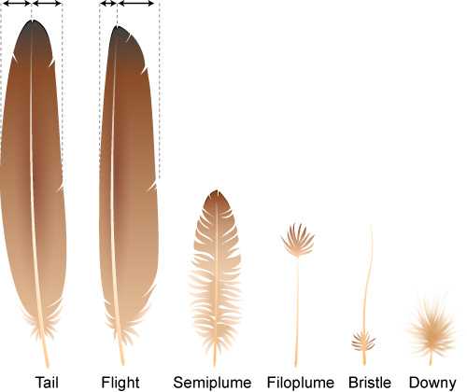
Birds have different feathers across the bird’s body see figure 1 to look at the feather types. Down feathers and Semiplumes these are used for thermoregulation. In adult birds the down feathers contain a medium number of long and soft barbs which are circular in the cross section and the larger feathers are on the wings and tail (Sun, Fand and Wu, 2022). Filoplumes help the bird with scene when flying as they can determine the location the bird and where the bird is going, it may also help with the speed that the bird is flying at (Rohwer, Rohwer and Kane, 2021). Powder downs are a part of the birds grooming adaptation as the barbs on this feather disintegrates and turns into a powder as the bird ages (Cavitt, 2004) (Kashib, 2021). Pennaceous feathers are a down feather which are flat and stiff, they have long barbules and very flexible barbs that help trap the air close to the bird’s body (Foth, Tischlinger and Rauhut, 2014). Bristles these are found on a head of a bird this type of feather has barely any barbs on the rachis, the bristle helps protect the bird’s eyes and face (Minias et.al, 2024). Contour feathers cover the bird’s body which are in an overlapping pattern these also have waterproof ends and fluffy barbs, these types of feathers on the wings are also called coverts (Thompson, 2014).
Figure 1 feather types which can be seen on a bird species (Twootz, 2018)
1.3.2 Structure of a Feather
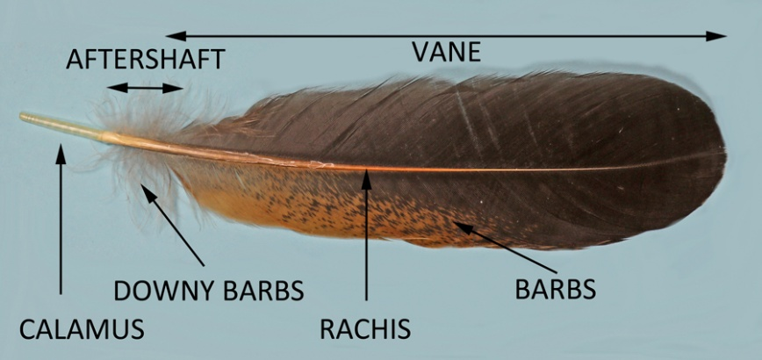
Barbs grows from the rachis; the angle and length of the barb determine the vanes which help with the aerodynamic performance of a bird (Feo, Field and Prum, 2015). Barbules branch from the rachilla off the barbs, the barbules are the smallest component of a bird’s feathers, this consist of a base and a pennulum (Dove and Koch, 2010). The base of the barbules attaches onto the central shaft which form an interlocking structure (Tarah et.al, 2017). The pennulum is the elongated structures at the endo of the barbules, they are velvet in texture, they help with reducing the noise as feathers rub against each other (Liu and Clark, 2025) Rachis is the part of the feather which holds the vanes, this is the main structure of a feather which helps holds the feathers shape (Pasayev et.el, 2017). Calamus is a hollow part of the shaft of the feather which attached to the bird’s skin, this part of the feather has no barbs on the calamus. This could also be known as the quill. Afterfeathers are the barbs which are used for warmth and not for flight (John, 2010). Vanes help the bird’s aerodynamic function of the wings they grow from the central shaft; they are used like a rudder when in flight and when landing, the vane is the whole of the feather where the barbs start and end (Kashib, 2021) (Deng et.al, 2023).
Figure 2 composition of a feather diagram labelled (hollandwest, 2012).

1.4. Evidential Value of Feathers
Feathers have a very significant value in wildlife crime when forensic wildlife is needed as they hold trace evidence and can create corroborative evidence for a wildlife crime case (Kashyap et.al, 2024). Feathers being durable in investigation means that they provide more intelligence on a case improving the arguments for the prosecution as they can also help build a genetic profile of the species of bird (Espinoza, 2024). As feathers have many ways to be analysed most being non-destructive suggests that there are more ways of analysing feathers creating more specific information on that feather (Coghlan, 2014). The strength of matching feather samples is dependent on the condition of the feather samples that have been taken, type of feather found and the methods of analysis. The morphological and microscope analysis can provide class and individual characteristics which help identify the species of bird (Kashyap et.el, 2024). The use of morphological and class characteristics can be used in collaboration with different elements of identification (Linacre and Tobe, 2013). The structure of a feather and different characteristics are a part of the main evidence but using DNA based techniques can potentially make a link to the specific bird (Linacre and Tobe, 2013). There are existing charts and online places where feathers can help be identified one is a website which is used where you are able to identify my feather which are compared to other feathers that are on the database this is through U.S. Fish and Wildlife Service Forensic Laboratory which can be accessed through https://www.fws.gov/lab/featheratlas/. (fws.gov, 2025). Griffith (1970) created a guide of scanning electron microscope and some characteristics which may occur in feathers which can be seen in figure 3&4 (Griffith, 1970).
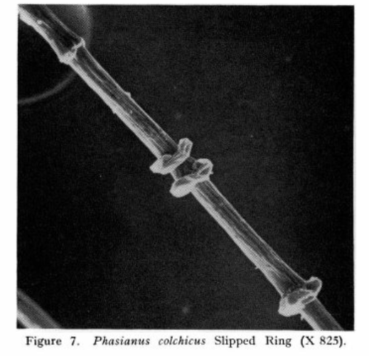
Figure 3 SEM feather micromorphology characteristics (Griffith. 1970).
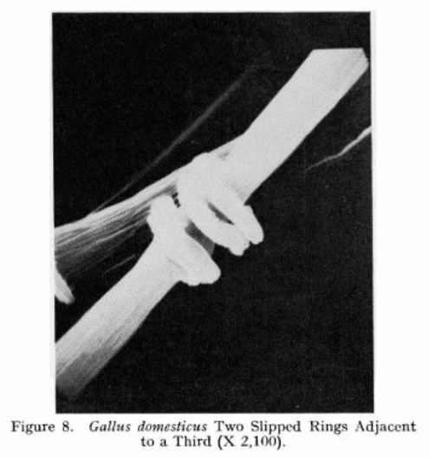
Figure 4 Feather Micromorphology Characteristics (Griffith, 1970).
1.5 Analytical Methods of Analysing Feathers
The collection of feathers can be done through using tweezers preferred plastic to not damage the hair, tape, vacuum devises which are sealed in a paper envelope stored in an evidence bag fully sealed and signed (Maje, 2019). The analysis of feathers can be used to identify a species of bird by examining class and individual characteristics of different feathers this can be done through the length of a feather and the diameter of the rachis which differ in different species of birds (Kashyap et.al, 2024). Feathers should be examined using a comparison light microscope and a light microscope with microslides which have the feather identified for example macaw. For general examination of the overall part of the feather at low power, then moved to high power to examine the pigmentation of the feathers and any other identifiable features (Dove and Koch, 2010). Using a scanning electron microscope (SEM) to analyse feathers is to analyse the microstructure of feathers at a high resolution, they also show a visualization of the components in the feathers (Deng et.al, 2023)(Robertson, Haekin and Govan, 1984) It also looks at the different microstructures in different species which help with the identification of the bird (Donghong et.al, 2025).

2. Aims and Objectives
The aim of this research project is to investigate the macroscopical characteristics of feathers from a range of exotic birds which include Eclectus, Macaw, African Grey, Cockatoo and Northern Hawk Owl. This is to gain more knowledge on the different variations of colour, lengths and width to see if there is a statistical difference in the distinctive characteristics found. The different macroscopical characteristics which were being assessed are length, width, weight, colouration, colour distribution, structural features, and scanning electron microscope characteristics looking at the pigment nodes found in different species feathers.
Objectives -
- Methodology on how to collect a feather from a bird enclosure and prepare the feather samples during the washing for analysis in a forensic manor.
- How to store feathers for transportation to the laboratory, and how to keep them when completing different analysis for different feathers in a forensic manor.
- Recording macroscopic observations of the feather which include different lengths and widths, weight, colour and distribution of the colour
- To identify any characteristics between different species based on macroscopical differences.
- Examining the results of the Scanning Electron Microscope (SEM) for an identification method of gaining more information on different species and their characteristics.
- To gain knowledge on any statistical differences between the bird types on any quantitative data.

3. Method

3.1 Sample Collection
African grey feathers that had been shed naturally were collected from the floor or in the cage and placed in a paper envelope to keep safe in storage. No feathers were plucked or brushed during collection. On the front of the envelope the species, age, and health were written.

3.2 Pilot Method
For the pilot, research was conducted behind the scenes which was not conducted in the laboratory. This consists of using research websites for example google scholar, research gate, and the Staffordshire university library website and many more. Boolean strings were conducted in the search bar for example ("wildlife crime" OR "wildlife trafficking") AND ("exotic birds" OR "bird species") AND ("feather analysis" OR "feather identification") AND ("investigation" OR "forensics") AND ("data analysis" OR "research skills") in research gate to gain research and background knowledge. To gain research on how to progress this project I used another Boolean string of ("feather analysis" OR "microscopic analysis") AND ("identifiable features" OR "characteristic features") AND "microscope" AND ("biological study" OR "ornithology") AND "data interpretation, to understand the best techniques in progressing the project before moving into the laboratory.

3.3 Main Experiment
The main experiment of this research project includes sample preparation, photographic set up, macroscopic and Scanning Electron Microscope observations methods.

3.3.1 Sample Preparation
Once the African grey or other specie feathers were collected, the feathers were cleaned using distilled water from a Savco squeeze bottle. Place a blue paper towel on the countertop to keep clean. The feathers were massaged gently the way the barbules went, going with the fan of the feather, to make sure the feather was clean with blue nitrate gloves on. As the feathers are wet the feathers were dried using blue paper towels. Once patted dry the feathers were left to the side to air dry before any results were made.
The feathers were stored using A4 pieces of paper, the sizes were different for different feathers a longer feather used a whole piece of A4 paper see figure 6. The paper was folded in half. On the front of the paper the species name, number, length, width top and bottom were written See figure 5. The feather was placed inside, and the edges were folded to keep the feather in place during the examination process. The feathers were stored neatly in a plastic container ready for further examination.
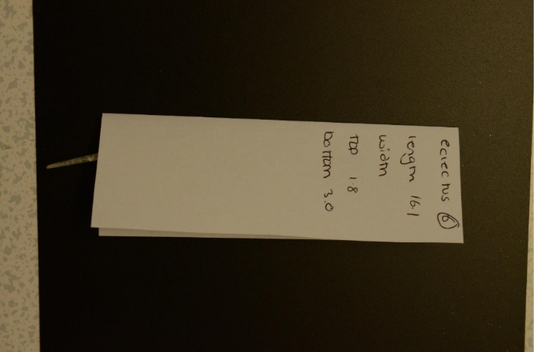
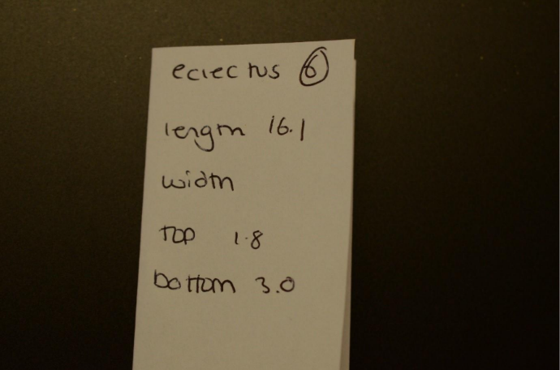

Figure 5 Paper Fold for Feather Storage
Figure 6 storage of feather information sheet

3.3.2 Photographic Set Up
The feathers were photographed using a Nikon digital camera. The feathers were placed on a A4 piece of paper either white or black depending on the colour of the feather to gain better contrast. The overview of the feathers which were taken the feathers were placed in the way of the feathers curved from biggest on the outside to smallest on the inside. For close up individual pictures a scale was placed around the feather, the camera was 90 degrees over the father and the ISO, shutter speed and aperture to gain the best image quality. Steps were used to gain a better height when needed.
3.3.3 Macroscopic Observations Method
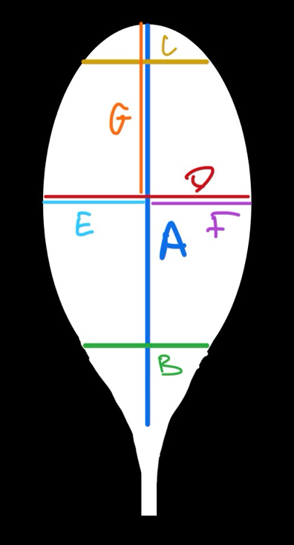
See table 1 and figure 7 to have a visual representation of where the feather has been analysed and below the methods which occurred.
Table 1 Table of Measurements Taken on the Feathers Analysed
Code on Diagram | Placement on Feather
A | Length from tip to the start of barbules
B | Width from 1cm from bottom
C | Width from 1cm from top
D | Width of the widest point
E | Width of the widest point Width of the left side of the vane at the widest point
F | Width of the right side of the vane at the widest point
G | Length from widest point to tip

Figure 7 Diagram of Measurements Taken on the Feathers Analysed

3.3.3.1 Length
The lengths of the bird species were measured using figure 7 and table 1 the placements of A and G were measured. Using a 30cm Banner Shatter Resistant ruler and a meter stick helix ruler for any larger feathers. The feathers were placed on the countertop spread out flat, using the ruler to take the measurements having the start of the barbules at 0. The results were measured in mm. The measurements were taken three times for each feather see in appendix x for examples. The table used the number on the paper fold was the identifying number in this research to identify the feather easy.
3.3.3.2 Width
The widths of the bird species were measured using figure 7 and table 1 the placements of B, C, D, E and F were measured. Using a 30cm Banner Shatter Resistant ruler. The feather was placed on the countertop and spread out flat making sure that the barbules laid the way they fall. The ruler was placed onto to the feather and measured the region stated above. The measurements were taken three different times and placed in a table see in appendix.

3.3.3.3 Weight
The weight of the bird species was taken using balance A&D Company Limited FX1200i Max 1200g d=0.0.1 and Sartonus Scale for the feathers which needed 0.0000g. The feathers were palaces on the scales one at a time and the weight was taken, tear was pressed before another feather was placed on the balance, each feather was repeated three times each. The weights were placed in a table using the number on the paper fold for that specific bird see appendix for examples. All the scales which were used in this experiment were pre-balanced before by laboratory technicians.

3.3.3.4 Pigmentation of Feathers
To determine the pigmentation of the bird species feathers a RGB colour scale from Rapid rTables was used a reference to different colour to match to the feather. The RGB values were placed on a screen with the brightness set to the maximum, this is to help with the consistency of the experiment. An individual feather was examined at one time the feather was being help on either and black or white piece of paper dependent on the colour. The feather was placed near the screen where the colours were seen visually and the RGB values were placed in a table of pigments see in results for an example.

3.3.3.5 Colour Distribution
The colour distribution of the bird species were analysed using a pigment and pattern table. The feathers were looked into the distinguished colour levels on a feather, how they sit on a feather and the proportion of each colour. The distribution types consist of; banded where there are clear bands vertically or horizontally, even where the feather is all one colour, uneven when the feather have unusual patterning which cannot be placed in a category, spotted the feather has dots over the feather. The number of patterning were analysed and stated, this is only through the main colours and not specific colours, this is counted on the amount bands or spots visible. The colour positioning was analysed through how each colour is presented on the fetter for example straight vertical or straight horizontal. The size of bandings was analysed which refers to how small, medium or large a band is, this is done through the eye, and an estimation of the bands were noted. The data collected was placed in a. Colour distribution and pattern table see results for examples.

3.3.4 Scanning Electron Microscope (SEM)
SEM was used to examine the surface morphology and pigment nodes of the feather samples on the various bird species. Samples were prepared following Staffordshire university guidelines on mounting the feather into a stub with a carbon sticky tab. The feather was not over hanging the sides of the stub. The SEM was used following the Staffordshire university guidelines and staff through the process. The feather images were obtained see in results for examples.

3.5 SPSS
Once all measurements and data were collected Statistical Testing occurred through IMB SPSS a statistical Package for the Social Sciences, this is to help with further expanding results and data on quantitative data (Rahman and Muktadir, 2021). The Shapiro Wilk test was conducted to see if the data was normally distributed and a Kruskal Wallis test occurred to see if the data had any statistical difference. Shapiro Wilks descriptive statistics test was completed using Laerd Statistics (2018) follow through appendix 1 for a step-by-step guide. Kruskal Wallis test was completed by following the guide of Marshall and Samules (2017) see appendix 2 to follow through the step-by-step guide.

4. Results and discussion

4.1 Lengths
This results section looks at the lengths of the feathers which were analysed including figures and tables to discuss the similarities and differences between species. The species analysed were Eclectus Female, Eclectus Body, Eclectus Male, Cockatoo, African Grey, Macaw and Northern Hawk Owl.

4.1.1 Lengths from tip to the start of the barbules
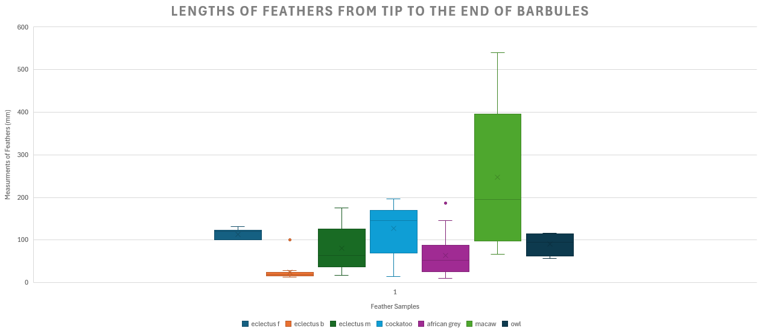
The box and whisker plot in figure 8 shows the distribution of feather lengths from the tip of the feather to where the barbules start. This includes the exotic birds of Eclectus Female, Male and Body feathers, Cockatoos, African Grey, Macaws and Northern Hawk Owl.
Figure 8 Box and Whisker Plot of Bird Species of the Length from the Tip of the Feather to the Start of the Barbules
Figure 9 Box and Whisker Plot of Bird Species Length of Feathers Tip to Starts of Barbules
Eclectus female feathers show that the median is 120mm and the mean is 113.8mm, this shows a clear difference suggesting that the data may be skewed. The median is on the same range as cockatoo being the third largest median. The interquartile range starts at 100mm and end at 122.75mm showing the range is small showing less variance in the data being the second smallest box with eclectus body feathers being first. The overall spread is not as large as other being the minimum measurements at 100mm and the maximum measurement being 131mm showing a range which is 31mm showing that the variance is not big and all the feathers are similar lengths at this region. Which suggest that theses feathers are similar in the way that they are structured. Female feathers are smaller than male feathers to help with nesting and survival in the nest which they need their feathers to be more practical (Jennings, 2018).
Eclectus Body Feathers have the lowest median at 18mm and mean at 19.4mm, this shows that the mean and median are close together showing normally distributed data. This shows that the body feathers on average are a smaller length than any other feathers which were analysed. The interquartile range starts at 16mm and ends at 23.5mm which shows a small variance showing that all the feathers in this area are similar and structured the same in length. The overall spread of this species is not wide with a range of 15mm suggesting a homogenous measurement. These feathers are small in length to help keep in heat which helps trap the air between these small feathers and the body to help with heat regulation (Muller, 2015).
Eclectus Male feathers have a lower median at 64mm and mean at 81.1mm, this shows that the data may be skewed, Eclectus males have a similar median to northern hawk owl. This suggests that on average the Eclectus male's feathers are small. The interquartile range starts at 37mm and ends at 126mm which suggest a large variance. This shows that there is a variety of different length within the feathers of an eclectus male. This could be up to the amount of different feather, if this were done again it would be useful to split the different types of feathers first and then look at the difference or similarities in the feathers. The overall spread is large with the minimum being 17mm and the largest being 176mm this shows a massive range due to the several types of feathers. This now shows that the data is not homogeneous and there is a large variety of feathers. Male feather in Eclectus is larger than females due to the visual aspect of attracting females (Foster, 2026).
Cockatoo feathers have a median at 145mm and a mean at 127.8mm, this data shows that the median and mean are different which may suggest that the data is skewed. This species is similar to Eclectus females. The interquartile range starts at 70mm and ends at 170mm which shows a larger range which means that there is more variance with a 100mm range. The overall spread shows that the minimum is 14mm and the maximum is 197mm which shows a large range of the feather measurements. This may be due to the different types of feathers which were in this data. Cockatoos have the second biggest range in all of the species with the largest being macaw feathers. This is because the feather lengths vary due to the different follicles' sizes and growth are different when it comes from different parts off the parrots body so the morphology of the parrot is one of the biggest influences (deeming, Durkin and Nudds, 2024).
Macaws have shown the most variety of values ranging much higher than other groups being at 540mm, they have the longest feathers out of all the feathers analysed due to flight efficiency, as macaws fly long distances which need balance and to keep stable in the air. These feathers are longer in length due to being more tail feathers help macaws to move for balance (Terrell and Shultz, 2022).
African grey feathers have a median of 53mm and a mean of 63.7mm, this show that the median and mean is different suggesting that the data is skewed. This mean and median is on the lower average of the lengths which a length may be found. The interquartile range shows that the range starts at 26mm and ends at 88.2mm. This shows a larger range compared to owl and eclectus body. Showing that there is some variance in the lengths of the feathers found on an African grey. The overall spread shows that the minimum measurements is 10mm and maximum measurement is 145mm. This shows a larger range at 135mm which may be due to the different types of feathers. His suggests that the feathers one in different lengths
Macaw feathers have the highest median at and mean at which suggests that on average macaw feathers are larger than other species which goes with the reason of why macaws are so big which helps with the robust structure of the bird itself (Jaclyn, 2021). The interquartile range is the largest ranges starting at 97mm and ending at 396mm, this shows that the variance in length of macaw feathers is large and the data is not homogeneous. The overall spread of this data is the largest out of all the species which were analysed. This starts at 66mm and the maximum measurements being 540mm which have the largest range. The long feathers help with balance when climbing also to keep their body stabilised when moving up and down trees (Jaclyn, 2021).
Northern Hawk Owl feathers have a median of 94.5mm and a mean of 90.3mm, this median and mean is closer suggesting that the data is normally distributed. This is similar to Eclectus male and African grey feathers as the average length of these feathers are medium range out of all of the feathers which were analysed. The interquartile range starts at 62mm and ends at 115mm which shows a large range showing that the data has variance within the feathers. The overall spread suggests that the owl feathers have a slight range with the third lowest overall spread. The minimum measurements are 57mm and the maximum measurement is 116mm. This may be due to the length of the feathers to help with silent noise reduction as the feathers are not too long (Bachmann et,al. 2007).
See table 2 to compare the bird species to one another for the statistical testing.
Table 2 SPSS Guide of Values to Bird Species
SPSS Value | Bird Species
1 | Eclectus Female
2 | Eclectus Body
3 | Eclectus Male
4 | Cockatoo
5 | African Grey
6 | Macaw
7 | Northern Hawk Owl

The Shapiro-wilks test was conducted on the lengths of feathers for each species of parrots analysed. All the data sets were normally distributed (p=>0.05) apart from Macaw (p=0.05). The krustal wallis test was conducted with Bonferroni post hoc test in table 3 which indicates the values of the krustal wallis test.
Table 3 Kruskal Wallis Results Table for Lengths from Tip to Start of Barbules
Pairwise Comparisons of group
Sample 1-Sample 2 | Test Statistic | Std. Error | Std. Test Statistic | Sig. | Adj. Sig.ª
Eclectus B – African G | -85.975 | 23.468 | -3.663 | <.001 | .005
Eclectus B – Eclectus M | -118.405 | 22.391 | -5.288 | <.001 | .000
Eclectus B - Owl | -137.161 | 33.897 | -4.046 | <.001 | .001
Eclectus B - Eclectus F | 170.286 | 37.319 | 4.563 | <.001 | .000
Eclectus B - Cockatoo | -189.873 | 23.345 | -8.133 | <.001 | .000
Eclectus B - Macaw | -231.333 | 25.034 | -9.241 | <.001 | .000
African Grey – Eclectus M | 32.430 | 14.714 | 2.204 | .028 | .578
African Grey - Owl | -51.186 | 29.396 | -1.741 | .082 | 1.000
African Grey -Eclectus F | 84.311 | 33.284 | 2.533 | .011 | .237
African Grey - Cockatoo | 103.898 | 16.128 | 6.442 | <.001 | .000
African Grey - Macaw | -145.358 | 18.489 | -7.862 | <.001 | .000
Eclectus M - Owl | -18.756 | 28.544 | -.657 | .511 | 1.000
Eclectus M – Eclectus F | 51.881 | 32.534 | 1.595 | .111 | 1.000
Eclectus M - Cockatoo | -71.468 | 14.516 | -4.923 | <.001 | .000
Eclectus M - Macaw | -112.929 | 17.102 | -6.603 | <.001 | .000
Owl -Eclectus F | 33.125 | 41.304 | .802 | .423 | 1.000
Owl – Cockatoo | 52.712 | 29.297 | 1.799 | .072 | 1.000
Owl -Macaw | 94.173 | 30.661 | 3.071 | .002 | .045
Eclectus F - Cockatoo | -19.587 | 33.197 | -.590 | .555 | 1.000
Eclectus F - Macaw | -61.048 | 34.406 | -1.774 | .076 | 1.000
Cockatoo - Macaw | -41.461 | 18.332 | -2.262 | .024 | .498

There was no significant difference between the following data sets 5-3 (p=0.578), 5-7 (p=1.000), 5-1 (p=0.578), 5-7 (p=1.000), 5-1 (p=0.237), 3-7 (p=1.000), 3-1 (p=1.000), 7-1 (p=1.000), 7-4 (p=1.000), 1-4 (p=1.000), 1-6 (p=1.000) and 4-6 (p=0.498).

4.1.2 Length from widest part of the feather to the tip
This box and whisker plot graph in figure10 show the length of the feather from the widest point to the tip of the feather to show the similarities and differences in Eclectus male, female and body feathers, Cockatoo, African Grey, Macaw and Northern Hawk Owl.
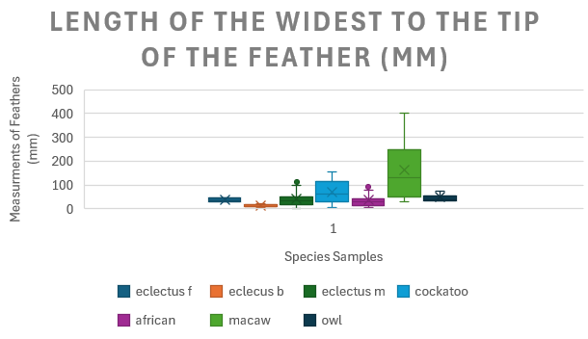
Figure 10 Box and Whisker Plot of Bird Species of Lengths from the Widest Point to the Tip
Eclectus females have a small length from the widest point to the tip of the feather compared to cockatoos and macaws. The median is 36mm and the mean is at 36.7mm this shows the mean and median close together suggesting normally distributed data. The interquartile range is short suggesting less variation of the measurements. The range of the data is 16mm with a minimum of 29mm and a maximum of 45mm. showing low variability on the lengths of this region of the feathers. This may be due to not many feathers being analysed. However out of the three feathers which were analysed it shows that the structural point of the feathers is similar in the measurements.
Eclectus body feathers have a small length from the widest point of the feather to the tip as this species have the smallest median and mean compared to all pf the other species. The median is 11mm and the mean is 12.8, there may be a slight skewness of the data as the mean and median are different. The interquartile range is the smallest box compared to all pf the other feathers showing less variation of the measurements showing the feathers are similar structured. The minimum measurement of the interquartile range was 9mm and the maximum was 18mm. there was no overall spread below 9mm but slightly above going up towards 20mm having a range of 11mm being the smallest range, this shows the homogeneous data of the length of this region of the feather is all similar.
Eclectus male feathers have a similar median at 34mm and mean at 40.5mm to eclectus females. This shows that the mean and median are different which may suggest that the data is not normally distributed. The interquartile range is a moderate size box which may suggest a slight variance in the measurements of this region. The minimum being 18.5mm and the maximum being 51.5mm showing the variance. The overall spread is the third largest out of the other species being below cockatoo and macaw. The minimum is 1mm and the maximum is 98mm showing the full range of the lengths from the widest point to the tip of the feather. This shows that the widest point of the feather is not the same for all feather in this species. There is an outlier, which was spotted at 112mm, this may be due to another feather being longer like a tail feather.
Cockatoo feathers have a mid to larger median at 61mm and a mean at 71.8mm showing a longer length on average in cockatoo feathers in this region. The mean and the median are slightly different which may mean that the data is a bit skewed. The interquartile range is the second largest with macaws being the largest. The minimum quartile range is 28.5mm and the maximum is 116.5mm, showing a larger range compared to other species meaning that there is variation within the lengths from the widest point to the tip. This suggests that the widest point on cockatoo feathers is different and are not similar in their positioning. The overall spread of the cockatoo feathers is different with the minimum measurement being 6mm and the maximum being 156mm showing a 150mm range which is the second largest range in all feathers analysed.
African grey feathers have a lower median at 28mm and mean at 36.5mm there is a slight differ in these values suggesting there may be a skew in the data. The average length of this region is a lower value being the second lowest median and mean. The interquartile range is a smaller sized box suggesting that the data has less variation suggesting the measurements are closer together with the minimum of the interquartile rage being 13mm and the maximum being 44mm. this interquartile range is similar sized to the eclectus males. The overall spread of this species is wider than other species being a medium spread the minimum measurement is 5mm and the maximum is 80mm, being a 75mm range, this suggest that the length of this region is differentiates between the feathers analysed. There were two outliers shown at 108mm and 92mm suggesting that there were a few feathers longer in this region than others or the widths were near the bottom of the feather and the length is longer than the rest of the measurements.
Macaw feathers have a biggest median at 113mm and mean at 162.9mm showing a larger difference meaning that the data may be skewed. This suggests that the length of this region in macaw feathers is longer this is due to macaw having long feather due to the size of them being much bigger than other birds which were analysed this is so xxx. The interquartile range is the largest range out of all the other species the minimum of the range being 50.75mm and the maximum being 249.25mm. this shows that there is a larger variance in this data set showing that the feathers which were analysed do not have a similar structure with where the widest point lies on the feathers. The overall spread is the largest as well with the minimum measurement being 30mm and the minimum being 401mm. the range is 371mm showing the largest range, this suggests that the widest point differs between different feathers as the different feather types have widths which are is different places, also dependent of the whole size of the feather which means that there is variety in the measurements.
Northern hawk owl feathers have a similar median at 40mm and mean at 48.5mm to eclectus females with the average being a lower value to other species which were analysed. The slight differentiation of the mean and median may suggest that the data is skewed. This interquartile range of the this species is a smaller box showing that there is less variation of the feathers which were analysed being the start of the box is 35mm and the end of the box is 55mm which shows that the range is not as big as other species which has been analysed suggesting that the structure of the feathers of where the widest point lies on the feather are similar in length. The overall spread of this data is 34mm and 74mm with a smaller range of 40mm which is still a smaller range compared to other bird species. This may suggest that the shape of the feathers are similar however this could be better done with a bigger sample size.
To improve this area the feather would be spilt into different types of feathers so tail feathers, wing feathers and other feathers available to see if there is any similarities or differences between the same feather types within the same bird species
The Shapiro-wilks test was conducted on the lengths of feathers for each species of parrots analysed. All the data sets were normally distributed (p=>0.05) apart from eclectus body (p=0.012), eclectus male (p=<0.001), cockatoo (p=<0.001), African grey (p=<0.001), macaw (p=<0.001) and owl (p=0.036). The krustal wallis test was conducted with Bonferroni post hoc test in table 4 which shows the values of the krustal wallis test.
Table 4 Kruskall Wallis Results Tables on Length from Widest Point to the Tip
Pairwise Comparisons of group
Sample 1-Sample 2 | Test Statistic | Std. Error | Std. Test Statistic | Sig. | Adj. Sig.ª
Eclectus B - African G | -81.907 | 23.466 | -3.490 | <.001 | .010
Eclectus B – Eclectus M | -99.657 | 22.390 | -4.451 | <.001 | .000
Eclectus B – Eclectus F | 110.897 | 37.316 | 2.972 | .003 | .062
Eclectus B - Owl | -147.869 | 33.894 | -4.363 | <.001 | .000
Eclectus B - Cockatoo | -153.764 | 23.343 | -6.587 | <.001 | .000
Eclectus B - Macaw | -213.440 | 25.032 | -8.527 | <.001 | .000
African G - Eclectus M | 17.750 | 14.713 | 1.206 | .228 | 1.000
African G - Eclectus F | 28.990 | 33.281 | .871 | .384 | 1.000
African G - Owl | -65.962 | 29.393 | -2.244 | .025 | .521
African G - Cockatoo | 71.857 | 16.126 | 4.456 | <.001 | .000
African G - Macaw | -131.534 | 18.488 | -7.115 | <.001 | .000
Eclectus M - Eclectus F | 11.240 | 32.531 | .346 | .730 | 1.000
Eclectus M - Owl | -48.212 | 28.541 | -1.689 | .091 | 1.000
Macaw - Cockatoo | -54.107 | 14.515 | -3.728 | <.001 | .004
Eclectus M - Macaw | -113.783 | 17.100 | -6.654 | <.001 | .000
Eclectus F - Owl | -36.972 | 41.301 | -.895 | .371 | 1.000
Eclectus F - Cockatoo | -42.867 | 33.195 | -1.291 | .197 | 1.000
Eclectus F - Macaw | -102.544 | 34.404 | -2.981 | .003 | .060
Owl - Cockatoo | 5.895 | 29.295 | .201 | .841 | 1.000
Owl - Macaw | 65.571 | 30.658 | 2.139 | .032 | .682
Cockatoo - Macaw | -59.677 | 18.331 | -3.256 | .001 | .024

There was no significant difference between the following data sets Eclectus B – Eclectus F (p=0.062), African G - Eclectus M (p=1.000), African G - Eclectus F (p=1.000), 5-7 (p=0.521), 3-1 (p=1.000), 3-7 (p=1.000), 1-7 (p=1.000), 1-4 (p=1.000), 1-6 (p=0.060), 7-4 (p=1.000), 7-6 (p=0.683).

4.2 Widths
This section looks at the widths of the different feathers at different points on each feather too look at the differences and similarities to see if there is a statistical difference between the different species between Eclectus male, female and body feathers, Macaw, Cockatoo, African Grey and Northern Hawk Owl.

4.2.1 Width from 1cm from the bottom
The box and whisker box plot in figure 11 show the different widths across 1cm from the bottom which show the differences or similarities in eclectus male, female and body feathers, cockatoo, African grey, macaw, northern hawk owl.

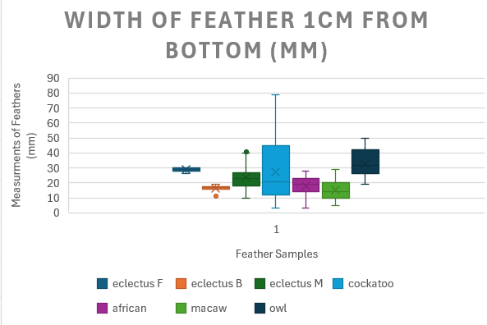
Figure 11 Box and Whisker Plot of Bird Species of the Width from 1cm from the Bottom of a Feather
Eclectus body feathers show that they have a minimal range however, the measurement being lower than females, but the feathers are all within the same measurement with an outlier which could be due to a variation in the barbules being more spread out compared to other feathers. The highest value being 30mm and the lowest being 26mm having a small range of 4mm. Having low heterogeneity.
Eclectus female interprets that the feathers are all similar value with minimal whiskers and the range is minimal showing the range of measurements are very similar between all the feathers which were analysed. With the highest value being 30mm and the lowest being 26mm showing a small range of 4mm. Having the mean and median being similar at 29mm and 28.9mm showing that this data set may be normally distributed as the mean and the median are similar.
Eclectus male the median off this feather sits like the cockatoo feathers at 23mm showing a mid-range median with the mean being at 23.2mm showing very similar measurements suggesting normal distributed data. The interquartile rage is a small box which suggests that the measurements which lie between these are closely clustered together meaning there is consistency within the feather. The variability of the feather is mid to high range with the lowest measurement being 10mm and the highest measurements being 40mm, having a lower variance compared to cockatoo feathers.
Cockatoo feathers show they have the widest range of measurements with the whiskers being extended further than any of the other species which were visible at 79mm being the highest point of the graph. Cockatoo also has one of the lowest whiskers at 3mm with African grey having the same lower whisker. As cockatoo has a high heterogeneity in the widths of a feather at 1cm from the bottom as the measurements are spread out. The median of this species being 21mm and the mean being 27mm having a slight variation which may suggest the data not being normal.
African grey the median being about the low to middle of the chart at 19mm which is close to the mean which is at 18.1mm showing a similar mean and median which suggest normal distributed data. The bottom whisker is at 3mm, and the bottom of the box is at 14 which shows minimal variance from the bottom half of the box and whisker plots. The highest value is at 28mm which shows that the range is in the middle compared to cockatoo and owl feathers.
Macaws have a lower average at 14mm which suggest that macaw feathers are on average have a thinner base compared to other feather species which were analysed like owls and cockatoos. The interquartile range is a median size box which is suggesting that the measurements in that area are tightly clustered. The highest value of macaw feather is 29mm and the lowest value being 5mm showing some variance in the measurements showing that there can be wide and small feathers, this could be due to the type of feathers which were being analysed.
Northern Hawk Owl have the highest median out of all the species analysed at 32mm suggesting that owls have a wider base of the feather 1cm from the bottom of the feathers. The interquartile range is moderate size which suggests that the feathers have some levels of consistency with less variance compared to cockatoos. The lowest value of the feathers analysed is at 19mm and the highest value is at 50mm which shows a moderate range. This couls be due to the feathers being wide to help with silent flying to reduce noise as a function of having a wide base of the feather.
The Shapiro-wilks test was conducted on the width from 1cm off bottom of feathers for each species of parrots analysed. All the data sets were normally distributed (p=>0.05) apart from eclectus body (p=<0.01). The krustal wallis test was conducted with Bonferroni post hoc test in table 5which indicates the values of the krustal wallis test.
Table 5 SPSS Kruskall Wallis Results Table for Width from 1cm from the Bottom of the Fetaher
Pairwise Comparisons of group
Sample 1-Sample 2 | Test Statistic | Std. Error | Std. Test Statistic | Sig. | Adj. Sig.ª
Macaw – Eclectus B | 2.024 | 25.018 | .081 | .936 | 1.000
Macaw – African Grey | 38.041 | 18.477 | 2.059 | .040 | .830
Macaw – Eclectus M | 87.324 | 17.091 | 5.109 | <.001 | .000
Macaw – Cockatoo | 88.180 | 18.320 | 4.813 | <.001 | .000
Macaw - Eclectus F | 157.960 | 34.384 | 4.594 | <.001 | .000
Macaw – Owl | -159.071 | 30.641 | -5.191 | <.001 | .000
Eclectus B - African G | -36.017 | 23.453 | -1.536 | .125 | 1.000
Eclectus B - Eclectus F | -85.300 | 22.377 | -3.812 | <.001 | .003
Eclectus B - Cockatoo | -86.156 | 23.330 | -3.693 | <.001 | .005
Eclectus B - Eclectus F | 155.937 | 37.295 | 4.181 | <.001 | .001
Eclectus B – Owl | -157.048 | 33.875 | -4.636 | <.001 | .000
African G - Eclectus M | 49.283 | 14.705 | 3.352 | <.001 | .017
African G - Cockatoo | 50.139 | 16.117 | 3.111 | .002 | .039
African G - Eclectus F | 119.919 | 33.263 | 3.605 | <.001 | .007
African G -Owl | -121.030 | 29.377 | -4.120 | <.001 | .001
Eclectus M - Cockatoo | -.856 | 14.507 | -.059 | .953 | 1.000
Eclectus M – Eclectus F | 70.637 | 32.513 | 2.173 | .030 | .626
Eclectus M - Owl | -71.748 | 28.525 | -2.515 | .012 | .250
Cockatoo - Eclectus F | 69.780 | 33.176 | 2.103 | .035 | .744
Cockatoo - Owl | -70.891 | 29.279 | -2.421 | .015 | .325
Eclectus F-Owl | -1.111 | 41.278 | -.027 | .979 | 1.000

There was no significant difference between the following data sets Macaw-Eclectus B (p=1.000), Macaw-African G (p=0.830), Macaw-African G (p=1.000), Eclectus M-Cockatoo (p=1.000), Eclectus M-Eclectus F (p=0.626), Eclectus M-Owl (p=0.250), Cockatoo-Eclectus F (p=0.744), Cockatoo-Owl (p=0.325) and Eclectus F-Owl (p=1.000).

4.2.2 Width from 1cm from the top
This box and whisker plot in figure 12 show the width of the feather one centimetre from the top of the feather to see the differences or similarities in eclectus body, male, female feathers, Cockatoo, African grey, macaw and Northan Hawk Owl.
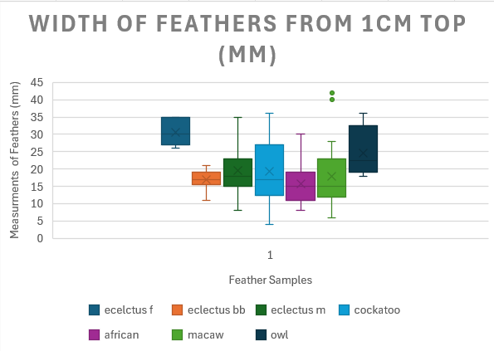
Figure 12 Box and Whisker Plot of Bird Species of the Width from 1cm from the Top of a Feather
Eclectus female these feathers have the highest mean at 30.5mm and median at 30mm which could suggest that the data is normally distributed as the mean and median are similar in measurements but have a small range which could now suggest that the eclectus females have a uniform structure of the widths 1cm from the top. This also suggests that the female feathers are consistently wide compared to other species.
Eclectus male has a moderate spread of widths with a median at 18mm and a mean at 19.5mm, showing the mean and median are similar suggesting the data is normally distributed. The eclectus males are considered in the range of median widths from 1cm from the top as these feathers are not as high as eclectus females but not a low as eclectus body feathers. The range is quite broad as the lowest measurement is 8mm and the highest measurement is at 35mm, suggesting that Eclectus male feathers can come at all different widths but highly common to fall between 15mm and 23mm.
Eclectus body shows a median at 17mm and a mean at 17mm which suggest the data could be normally distributed. With the interquartile range being very narrow this could be due to the widths of eclectus body feathers being relatively close together in measurements with little variance as the lowest measurement recorded was 11mm and the highest was 21mm showing a 10mm range showing these types of feathers are seen as consistent potentially suggest they are a uniform type of feather.
Cockatoo feathers show the most variance out of all the other feathers, with a median at 17mm and a mean at 19.4mm, being similar showing potentially normally distributed data. There is a wide spread of measurements in the interquartile range being the most spread and wide out of all the species being at 12.5mm to 27mm having a high level of variance. This suggest that this data of measurements means that the width from 1cm from the top can vary between different types of feathers within the cockatoo as the lowest measurement is 4mm and the highest is 36mm showing the widest range.
African grey had the lowest median at 15mm and mean at 15.7mm compared to all the species which were analysed. suggest the data could be normally distributed as the mean and median are similar in measurements, this also suggest that the typical measurement should be quite narrow on African greys compared to other species. The interquartile range has a moderate size box varying from 11mm to 19mm suggesting some variance in widths 1cm from the top however not too much. The whiskers have more variance above from the bottom with the highest value being 30mm and the lowest being 8mm this is a moderate range showing variance with a widespread showing the feathers may not be as consistent as others.
Macaw feathers have a lower median at 15mm and a higher mean at 17.5mm, which could potentially suggest normally distributed data. This indicated that the macaw feather tends to be more narrow than other species like owl or eclectus female. The interquartile range is a wider box suggesting there is some variance in the measurements which were recorded with the box being at 12mm and ending at 23mm. The whiskers do have a wider range suggesting they vary across types of feathers amongst the same species with the lowest measurement at 6mm and the highest at 28mm. There are two outliers sitting at 40mm and 42mm which could suggest that there is a different type of feather which was wider than the others.
Northern hawk owl shows the feather with the broader range of widths with a higher median than the rest of them at 24.8mm the width of this feather is consistent with owls needing larger feathers for the silent flying which occurs. This could be due to only analysing the same feathers which could have an impact on the results as analysing body feathers or other feather may have different outcomes.
The Shapiro-wilks test was conducted on the width 1cm from the top of the feathers for each species of parrots analysed. All the data sets were normally distributed (p=>0.05) apart from eclectus body (p=0.08). The krustal Walli’s test was conducted with Bonferroni post hoc test in table 6 which indicates the values of the krustal Walli’s test.
Table 6 SPSS Kruskral Wallis Test of the Width from 1cm from the Top of a Feather
Pairwise Comparisons of group
Sample 1-Sample 2 | Test Statistic | Std. Error | Std. Test Statistic | Sig. | Adj. Sig.ª
African G -Macaw | -2.429 | 18.468 | -.132 | .895 | 1.000
African G -Eclectus B | 22.988 | 23.441 | .981 | .327 | 1.000
African G -Cockatoo | 45.453 | 16.109 | 2.822 | .005 | .100
African G -Eclectus M | 54.136 | 14.697 | 3.683 | <.001 | .005
African G -Owl | -115.542 | 29.362 | -3.935 | <.001 | .002
African G -Eclectus F | 171.917 | 33.246 | 5.171 | <.001 | .000
Macaw-Eclectus B | 20.560 | 25.006 | .822 | .411 | 1.000
Macaw - Cockatoo | 43.024 | 18.311 | 2.350 | .019 | .395
Macaw -Eclectus M | 51.707 | 17.082 | 3.027 | .002 | .052
Macaw -Owl | -113.113 | 30.625 | -3.693 | <.001 | .005
Macaw – Eclectus F | 169.488 | 34.367 | 4.932 | <.001 | .000
Eclectus B- Cockatoo | -22.465 | 23.318 | -.963 | .335 | 1.000
Eclectus B – Eclectus M | -31.148 | 22.366 | -1.393 | .164 | 1.000
Eclectus B - Owl | -92.554 | 33.858 | -2.734 | .006 | .132
Eclectus B – Eclectus F | 148.929 | 37.276 | 3.995 | <.001 | .001
Cockatoo -Eclectus M | 8.683 | 14.500 | .599 | .549 | 1.000
Cockatoo -Owl | -70.089 | 29.264 | -2.395 | .017 | .349
Cockatoo -Eclectus F | 126.464 | 33.159 | 3.814 | <.001 | .003
Eclectus M - Owl | -61.406 | 28.511 | -2.154 | .031 | .656
Eclectus M - Eclectus F | 117.781 | 32.497 | 3.624 | <.001 | .006
Owl - Eclectus F | 56.375 | 41.257 | 1.366 | .172 | 1.000

There was no significant difference between the following data sets African G - Macaw (p=1.000), African G - Eclectus B (p=1.000), African G - Cockatoo (p=0.100), Macaw – Eclectus B (p=1.000), Macaw - Cockatoo (p=0.395), Macaw – Eclectus M (p=0.052), Eclectus B - Cockatoo (p=1.000), Eclectus B -Eclectus M (p=1.000), Eclectus B - Owl (p=0.132), Cockatoo – Eclectus M (p=1.000), Cockatoo - Owl (p=0.349), Eclectus M - Owl (p=0.656) and Owl -Eclectus F (p=1.000).

4.2.3 Widest part of the feather
This box and whisker plot in figure 13 show the width of the widest part of the feather to see the differences or similarities in eclectus body, male, female feathers, Cockatoo, African grey, macaw, and Northern Hawk Owl.
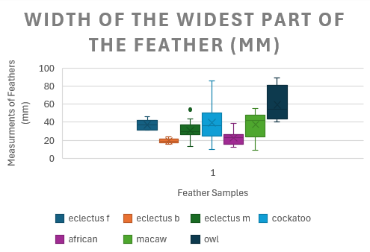
Figure 13 Box and Whisker Plot of Bird Species of the Width of the Widest Point of a Feather
Eclectus male had the median 30mm at and the mean at 30.8mm this may suggest that the data is normally distributed as the measurements are close together. Suggest a thinner to median feather compared to others for example owl. The interquartile range is minor compared to other species showing that tight clustering measurements suggest low variance in the measurements being at 26mm to 37mm showing a smaller range. The whiskers show that there is more variance through the whole data set being at 13mm to 44mm having a moderate range. There is a high heterogeneity to eclectus males showing a broad range overall.
Eclectus female has a median 37mm at and a mean at 37.2mm suggesting normally distributed data as the mean and the median is close together. This is one of the highest values on the chart suggesting a broad width of the widest part of the feather. The interquartile range has a small range from 31mm to 42mm this shows minimal variance in the measurements which have been recorded showing the feathers are tightly grouped together. This whisker only extends from the top showing the highest value at 46mm making the range 15mm being the second shortest range out of all the species. This suggest that the feathers are consistently wide and have a uniformed structure from the width.
Eclectus body has the lowest median and mean out of all the species which were analysed with a median is 19mm and the mean is 19.1mm having these measurements similar suggest normal distributed data. The interquartile range is small which suggest that there is little variance as the feathers which were analysed are constituently withe the size of the width of the widest part of the feather. The whiskers have little variance with the lowest measurement being 16mm and the lowest being 24mm, showing a small range of 8mm having a consistently small width. This is to help with thermoregulation within the bird which keeps the air trapped inside, the width is increases the surface providing more heat to be trapped (Crandell, Powers and Tobalske, 2025).
Cockatoo feathers have a median of 36mm and a mean of 39.4mm which suggest that the widest width of the widest part of the feather which shows mid-range compared to the other species. The median and mean being similar suggests normally distributed data and the data is not skewed. The interquartile range is the second largest out of all the species being between the measurements of 25.5mm and 50.5mm showing an extensive range suggesting that there is a lot of variances showing there is not much consistency between the measurements. The whiskers are the widest amongst all the other species starting at 10mm and finishing at 86mm. The cockatoo feathers have the second largest width from all the other feathers; this feather has the most variance and a wider feather compared to others.
African grey feathers have a median of 23mm and a range of 22.4mm, being similar show the data is not skewed and potentially normal. The median and mean are the second shortest width of the widest part showing that typically these feathers are shorter compared to other species. The interquartile range has a small box which suggest that the widest part of an African grey feather is tight together but do have some variance between 16mm and 24.4mm. The whiskers show that the overall spread of the feather measurements do not have much variance as the whiskers are not as large as other with the lowest measurement being 12mm and the highest being 39mm showing a medium range.
Macaw feathers have a median of 42mm and a range of 37.7mm, this is amongst the larger means of the species which were analysed, and the mean is different which could suggest that the data is skewed so may not be normally distributed. The interquartile range is a larger size box showing there is a noticeable variance in the macaw feathers at the widest part being from 24mm to 48mm, showing a large range. The overall spread show that it is one of the largest ranges out of all the species. The smallest measurements being 9mm and the lowest being 55mm, macaws have of the smallest measurements out of all the feathers. The spread is like eclectus males but are slights larger.
Northern Hawk Owl feathers have a median of 54.5mm and a mean of 59.5mm this data set has the largest median and mean showing they have the widest width of the widest part of the feather compared to all the other species which were analysed. The data may be slightly skewed with a difference in the mean and median. The interquartile range is the largest box compared to all the other species being from 35.5mm to 81.2mm showing a lot of variation on the data being the most compared to all the other species. The overall spread is not much different from the interquartile range being the lowest at 40mm and the highest at 89mm still showing the strongest of variance of the widest part of the feather. This is to help with aerodynamic of the owl to help the species fly as they fly like a hawk for diving on prey (Benson, 2025).
The Shapiro-wilks test was conducted on the lengths of feathers for each species of parrots analysed. All the data sets were normally distributed (p=>0.05) apart from owl (p=0.044). The krustal wallis test was conducted with Bonferroni post hoc test in table 7 which indicates the values of the krustal wallis test.
Table 7 SPSS Kruskrall Wallis Results Table of the Width of a Feather at the Widest Point
Pairwise Comparisons of group
Sample 1-Sample 2 | Test Statistic | Std. Error | Std. Test Statistic | Sig. | Adj. Sig.ª
Eclectus B - African G | -38.042 | 23.460 | -1.622 | .105 | 1.000
Eclectus B – Eclectus M | -108.900 | 22.384 | -4.865 | <.001 | .000
Eclectus B - Cockatoo | -145.110 | 23.337 | -6.218 | <.001 | .000
Eclectus B – Macaw | -146.464 | 25.026 | -5.852 | <.001 | .000
Eclectus B – Eclectus F | 163.651 | 37.307 | 4.387 | <.001 | .000
Eclectus B - Owl | -232.720 | 33.885 | -6.868 | <.001 | .000
African G – Eclectus M | 70.858 | 14.709 | 4.817 | <.001 | .000
African G - Cockatoo | 107.068 | 16.122 | 6.641 | <.001 | .000
African G – Macaw | -108.422 | 18.483 | -5.866 | <.001 | .000
African G – Eclectus F | 125.609 | 33.273 | 3.775 | <.001 | .003
African G - Owl | -194.678 | 29.386 | -6.625 | <.001 | .000
Eclectus M - Cockatoo | -36.210 | 14.511 | -2.495 | .013 | .264
Eclectus M – Macaw | -37.564 | 17.096 | -2.197 | .028 | .588
Eclectus M – Eclectus F | 54.751 | 32.523 | 1.683 | .092 | 1.000
Eclectus M – Owl | -123.820 | 28.534 | -4.339 | <.001 | .000
Cockatoo - Macaw | -1.355 | 18.326 | -.074 | .941 | 1.000
Cockatoo - Eclectus F | 18.541 | 33.186 | .559 | .576 | 1.000
Cockatoo- Owl | -87.611 | 29.288 | -2.991 | .003 | .058
Macaw - Eclectus F | 17.187 | 34.395 | .500 | .617 | 1.000
Macaw - Owl | -86.256 | 30.650 | -2.814 | .005 | .103
Eclectus F- Owl | -69.069 | 41.291 | -1.673 | .094 | 1.000

There was no significant difference between the following data sets Eclectus B-African G (p=1.000), Eclectus M-Cockatoo (p=0.264), Eclectus M-Macaw (p=0.588), Eclectus M-Eclectus F (p=1.000), Cockatoo-Macaw (p=1.000), Cockatoo-Eclectus F (p=1.000), Cockatoo-Owl (p=0.058), Cockatoo-Eclectus F (p=1.000), Macaw-Owl (p=0.103), Eclectus F-Owl (p=1.000).

4.2.4 Left side of the vane at the widest part of the feather
This box and whisker plot in figure 14 show the width of the feather the left side of the vane at the widest point of the feather to see the differences or similarities in eclectus body, male, female feathers, Cockatoo, African grey, macaw and Northern Hawk Owl.
.
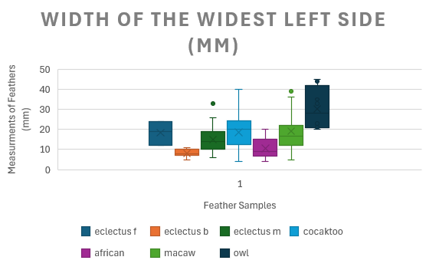
Figure 14 Box and Whisker Plot of Bird Species of the Width of the Widest Point of the Feather Left Side of the Vane
Eclectus body shows the smallest width of the left side of the feather compared to the rest of the feather. The median is 8mm and the mean is 8mm showing that the data could be suggested at being normally distributed. This is also the smallest mean and median. The interquartile range is the narrowest box out of all the other feathers showing less variance in the measurements which were collected and the feathers have levels of high consistency with the box starting at 7mm and finishing at 10mm. Teh overall spread of the feathers are short showing that even with the full range of measurements the measurements are still very consistent with lower values as the minimum measurement being 5mm and the maximum measurements being 11mm. This could be due to body feathers or contour feathers sitting so close to the body they are a shorter feather which helps keep in the warmth.
Eclectus female feathers have a median 19mm at and a range at 18.4mm which shows that the mean and median are close together suggesting that the data is normally distributed. The typical length is around 19mm for a feather at the widest point left side of the vane. The interquartile range had one of the larger boxes showing that there is a moderate range from the start of the box at 12mm and the end of the box at 24mm. There are no whiskers in eclectus female showing no other variation on these feathers.
Eclectus male feathers have a median 14mm of and a mean of 15mm which is a mid-range of widths compared to other feathers. This suggest that the data is normally distributed as the mean and median are close together. The interquartile range is a moderate length suggesting some variance with the measurements, this is not as big of a range of the owl group. The overall spread extends further from the interquartile range, this suggests that the range is even further, the minimum width from the widest part on the left side of the vane is 6mm and the maximum width is 26mm. There is an outlier which is 33mm this could be due to a longer feather, if more feathers were analysed then there could have been more feather that are in this range.
Cockatoo shows they have wide widths which is less than the owl but has more variability compared to the owl. Cockatoo has a high median but has the most variance in the widths. The median is 20mm and the mean is 18.5mm, this could suggest that there is normal distribution of data and the values are similar, however there could be a light skew of the data. The interquartile range is a moderate size being 12.5mm to 24.5mm showing some variance in the measurements. The overall spread is the largest compared to all the other species of birds but does not have the largest value. Cockatoo doses have the largest range at 36mm. The minimum value is 4mm and the largest value is 40mm showing that there is a great diversity. This could be due to
African Grey shows that they have more consistency with the variance of the widths of the left side of the feathers. The median is 9mm and mean is 10.5mm, this could suggest the data may be normally distributed. This mean and median is the second lowest out of all the species with Eclectus body being the lowest, suggesting that the left side of the widest point of a feather being smaller compared to other species. The interquartile range is a slightly compact box being the second smallest box at 6.75mm to 15mm showing that the measurements are closely grouped together with certain levels of consistency being close to the median and mean. The overall spread suggests further variation of the measurements of their width from the widest point left side of the vane the minimum being 4mm and the maximum being 20mm having a 16mm range which show as moderate spread of measurements but are on the shorter width side compared to other species.
Macaw feathers show that the median is 16.5mm and the range is 19.5mm, this is showing a medium range of the typical width of the widest part if the feather being like Eclectus female and male. The data may be slightly skewed up to a slight variation between the median and the mean. The interquartile range is a moderate size which is similar in Eclectus male starting at 12mm and ending at 22mm. This suggest that there is a slight variance in the measurements in which were collected this may be due to differences in types of feathers which were analysed. The overall spears are wide compared to others which were analysed showing a lot of variances from all the feathers measured. This has not got a consistent spread of measurements as the minimum is 5mm and the maximum is 36mm. There is an outlier which sits at 39mm this may just be a larger feather compared to others.
Northern Hawk Owl shows that this has the largest median at 28mm and mean at 30.35mm the mean and median are different which may mean that the data is slightly skewed and not normally distributed. This shows that the typical width of a northern hawk owl left side of the vane at the widest width is much higher than any other feather which was analysed. This could be because of. The interquartile range shows the largest box starting at 21mm and ending at 41.75mm showing a large variation between the measurements having a non-consistent width left side of the vane compared to other feathers. The overall spread is not much further away from the interquartile range the minimum being 20mm and the maximum being 45mm. Showing that the owl has the most interquartile range, but the smallest overall spread out of the feathers which were measured. This may differ if more feathers were analysed.
The Shapiro-wilks test was conducted on the lengths of feathers for each species of parrots analysed. All the data sets were normally distributed (p=>0.05) apart from Eclectus Male (p=<0.001), Cockatoo (p=0.019), African Grey (p=<0.001), macaw (p=0.003) and owl (p=0.013). The krustal wallis test was conducted with Bonferroni post hoc test in table 8 which indicates the values of the krustal wallis test.
Table 8 SPSS Kruskral Wallis Results Table of the Widest point of the Feather Left Side of the Vane
Pairwise Comparisons of group
Sample 1-Sample 2 | Test Statistic | Std. Error | Std. Test Statistic | Sig. | Adj. Sig.ª
Eclectus B- African G | -36.385 | 23.430 | -1.553 | .120 | 1.000
Eclectus B -Eclectus M | -94.576 | 22.355 | -4.231 | <.001 | .000
Eclectus B - Cockatoo | -130.092 | 23.307 | -5.582 | <.001 | .000
Eclectus B – Macaw | -130.964 | 24.994 | -5.240 | <.001 | .000
Eclectus B -Eclectus F | 144.198 | 37.259 | 3.870 | <.001 | .002
Eclectus B -Owl | -217.643 | 33.842 | -6.431 | <.001 | .000
African G- Eclectus | 58.191 | 14.690 | 3.961 | <.001 | .002
African G - Cockatoo | 93.707 | 16.102 | 5.820 | <.001 | .000
African G -Macaw | -94.579 | 18.459 | -5.124 | <.001 | .000
African G -Eclectus F | 107.813 | 33.231 | 3.244 | .001 | .025
African G -Owl | -181.258 | 29.349 | -6.176 | <.001 | .000
Eclectus M-Cockatoo | -35.516 | 14.493 | -2.451 | .014 | .300
Eclectus M - Macaw | -36.388 | 17.074 | -2.131 | .033 | .695
Eclectus M -Eclectus F | 49.622 | 32.482 | 1.528 | .127 | 1.000
Eclectus M -Owl | -123.067 | 28.498 | -4.318 | <.001 | .000
Cockatoo- Macaw | -.872 | 18.303 | -.048 | .962 | 1.000
Cockatoo- Eclectus F | 14.106 | 33.144 | .426 | .670 | 1.000
Cockatoo-Owl | -87.551 | 29.250 | -2.993 | .003 | .058
Macaw-Eclectus F | 13.234 | 34.351 | .385 | .700 | 1.000
Macaw-Owl | -86.679 | 30.611 | -2.832 | .005 | .097
Eclectus F-Owl | -73.444 | 41.238 | -1.781 | .075 | 1.000

There was no significant difference between the following data sets Eclectus B-African G (p=1.000), Eclectus M-Cockatoo (p=0.300), Eclectus M-Macaw (p=0.695), Eclectus M-Eclectus F (p=1.000), Cockatoo-Macaw (p=1.000), 4-1 (p=1.000), 4-7 (p=0.058), 6-1 (p=1.000), 6-7 (p=0.097) and 1-7 (p=1.000)

4.2.5 Right side of the vane at the widest part of the feather
This box and whisker plot in figure 15 shows the width of the right side of the vane at the widest point of the feather to see the differences or similarities in eclectus body, male, female feathers, Cockatoo, African grey, macaw, and Northern Hawk Owl.

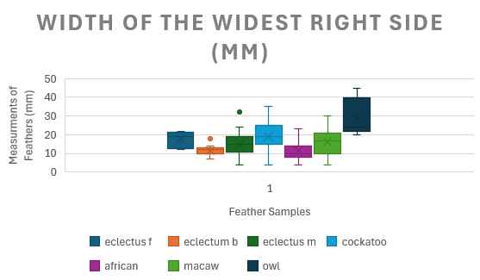
Figure 15 Box and Whisker Plot of the Bird Species of the Widest Point of the Feather Right Side of the Vane
Eclectus female feathers show the have a midrange medium and mean which is like eclectus males, cockatoo and macaws. The median at 19mm and the range at 17.5mm which suggests that the right side of the vane at the widest point of the feather is wider than eclectus body and African grey feathers. The data may be a little skewed due to a slight variation from the mean to the median. The interquartile range shows a moderate size of variation which means that the feathers are not consistently the same size the box starting at 12.5mm and ending at 21.5mm. The overall spread does not go too far away from the interquartile ranges the minimum measurements sit at 12mm, and the maximum is 22mm having the lowest whiskers but having a larger box.
Eclectus body feathers have the second lowest medium at 12mm, and the mean is the second lowest at 11.4mm with African grey being the lowest. This shows that the width of the right side of the vane at the widest point are lower and thinner compared to other species. The interquartile range is a compressed box being the smallest box out of any of any of the other species showing a consistency of the measurements with the box starting at 10mm and the largest is 13mm only having a 3mm range showing low variability. The overall spread of the feather does not spread further than the interquartile range as the minimum measurement is 7mm and the largest measurements being 14mm still showing the lowest variation out of all the species. There is an outlier which was measure at 18mm this may be due to a bird feather having the barbules slightly more spread or the way that it was measured.
Eclectus male feathers show a mid-range median which sits at 15mm and a median at 14.8m, this suggest that the widths of the right side of the feather at the widest point are in the middle compared to all the species. The data may be normally distributed as the mean and median are similar. The interquartile range is a moderate size box starting at 10.5mm and ending at 19mm having some variety on the measurements which were collected when the feather was analysed. This has a similar range to the eclectus females suggesting some similarities in the structure of the feathers as they are from the same species. The overall spread is larger than the eclectus female showing that there is more variation of the widths in the male's eclectus feathers. The overall spread is wide starting at 4mm and ending at 24mm having a 20mm range, this is one of the bigger ranges in the species showing low consistently in the widths of the feathers. There is an outlier at 32mm which could be a different feather type, or the barbules may have been spread out in a different way.
Cockatoo feathers have the second highest median at 19mm and mean at 19.1mm this shows that a typical width of the right side of the vane at the widest point is wider most species analysed. The data may be normally distributed as the mean and median are in similar positions. The interquartile range is a moderate size which shows moderate variation in the widths of a feather on the right side of the vane, this means that there is not much consistently as the interquartile range starts at 15mm and ends at 25mm. The overall spread is the largest variation out of all the species. This means that the overall range can vary from as little as 4mm and as large as 35mm having a range of 31mm. This could be due to the functions of the feathers for cockatoo compared to the owls.
African grey feathers have a narrow right width of a feather have a lower median at 10mm and a mean at 11.2mm. This is the lowest mean and median out of all the other bird species this shows a typical African grey width is a lower measurement. The data may be normally distributed as the mean and the median are similar. The interquartile range are the second narrowest quartile range which shows that the measurements are more concise compared to other parrots analysed. The start of the interquartile range is 8mm and the end is 14mm which shows the low variability in the width of the African grey feathers. The overall spread shows that there is variance is moderate with a 19mm range with the minimum of 4mm and a maximum width of 23mm, there is no tight clustering within the whole variance of the measurements.
Macaw feathers have a mid-range median at 16mm and a mean at 16.2mm which suggests that the typical value is like eclectus males and females. The data should be normally distributed due to the mean and the median being similar. The interquartile range is a moderate size which shows a high variability in the width this is not as extreme as other species. The range of the interquartile range starts at 10mm and ends at 21mm. The overall spread of the macaw feathers is moderately wide compared to other species, due to having a larger value at and lower values at this shows the wide variation but may vary towards higher measurements.
Northern Hawk Owl have the longest right side of the feather compared to the rest of the parrots which were analysed. With the longest side of the feather being 45mm, this is from the spread barbules of the being more separated and fanned out compared to other parrot feathers which were analysed. These have the highest mean and median compared to all the other parrots which then suggest that this feather is broader than the rest of them. The spread barbules help with the silent flying which suggest why these feathers are wider than the rest of the species analysed.
Widths of either side of the feather has not been research into in bird specific feathers, however tail feathers have an even split of barbules either side of the vane to help provide balance when when flying, also helps with courtship of fellow bird species (Sussex wildlife trust, 2022). In wing feathers one side is larger than the other to help with flight with trapping the air under the feather to reduce resistance when in the air (Hendrickx Rodriguez and Lentink, 2025).
The Shapiro-wilks test was conducted on the lengths of feathers for each species of parrots analysed. All the data sets were normally distributed (p=>0.05) apart from African Grey (p=<0.01), Macaw (p=0.007) and owl (p=0.008). The krustal wallis test was conducted with Bonferroni post hoc test in table 9 which indicates the values of the krustal wallis test.
Table 9 SPSS Kruskrall Walis Results Table of the Widest Point of the Feather Right Side of the Vane
Pairwise Comparisons of group
Sample 1-Sample 2 | Test Statistic | Std. Error | Std. Test Statistic | Sig. | Adj. Sig.ª
African G – Eclectus B | 4.117 | 23.439 | .176 | .861 | 1.000
African G – Eclectus M | 52.107 | 14.696 | 3.546 | <.001 | .008
African G - Macaw | -65.748 | 18.466 | -3.560 | <.001 | .008
African G – Eclectus F | 97.768 | 33.243 | 2.941 | .003 | .069
African G - Cockatoo | 103.256 | 16.108 | 6.410 | <.001 | .000
African G - Owl | -184.420 | 29.360 | -6.281 | <.001 | .000
Eclectus B – Eclectus M | -47.990 | 22.364 | -2.146 | .032 | .670
Eclectus B - Macaw | -61.631 | 25.004 | -2.465 | .014 | .288
Eclectus B – Eclectus F | 93.651 | 37.273 | 2.513 | .012 | .252
Eclectus B – Cockatoo | -99.139 | 23.316 | -4.252 | <.001 | .000
Eclectus B – Owl | -180.304 | 33.855 | -5.326 | <.001 | .000
Eclectus M - Macaw | -13.640 | 17.081 | -.799 | .425 | 1.000
Eclectus M – Eclectus F | 45.660 | 32.494 | 1.405 | .160 | 1.000
Eclectus M - Cockatoo | -51.148 | 14.498 | -3.528 | <.001 | .009
Eclectus M – Owl | -132.313 | 28.509 | -4.641 | <.001 | .000
Macaw - Eclectus F | 32.020 | 34.364 | .932 | .351 | 1.000
Macaw - Cockatoo | 37.508 | 18.310 | 2.049 | .041 | .851
Macaw - Owl | -118.673 | 30.623 | -3.875 | <.001 | .002
Eclectus F- Cockatoo | -5.488 | 33.157 | -.166 | .869 | 1.000
Eclectus F- Owl | -86.653 | 41.254 | -2.100 | .036 | .749
Cockatoo - Owl | -81.165 | 29.261 | -2.774 | .006 | .116

There was no significant difference between the following data sets African G-Eclectus M (p=1.000), African G-Eclectus F (p=0.069), Eclectus B-Eclectus M (p=0.670), Eclectus B-Macaw (p=0.288), Eclectus B-Eclectus F (p=0.252), Eclectus M-Macaw(p=1.000), Eclectus M-Eclectus F(p= 1.000), Macaw-Eclectus F (p=1.000), Macaw-Cockatoo (p=0.851), Eclectus F-Cockatoo (p=1.000), Eclectus F-Owl (p=0.749) and Cockatoo -Owl (p=0.116).
Comparing the widest left and right side of the feather shows a consistent pattern between all the bird which were sampled as the figures 14 and 15 show similar distribution trends which may suggest a symmetry in feather structures. In both datasets owls have the greatest widths with the highest median and range values in both datasets. This being across both datasets shows that the structure of the owl feathers is a broader structure compared to the other feathers analysed. Cockatoo feathers amongst both figures show that these feathers are relatively wide with high values with more variation. Eclectus male and macaw feather have very similar patterns between both figures showing that both have moderate widths with deviations in both figures which may be the reason for different bird feather types for example having more tail feathers then wing feathers. However, the similarity of the central tendency's is similar in both graphs which shows that the variations are not a measurement error. African grey and eclectus females in both figures show that both groups have a lower width on the left and right-side showing symmetry in both graphs and have less variation of measurements than other species which were analysed. Eclectus body feathers have the similar widths in both graphs, which is consistent which then shows that both sides of feathers are symmetrical with the median being the lowest than any other species.
Comparing the widest part of the feather to the tip of the feather to the widest part of the feather.

4.3 Weight
This section looks at the weight of the different feathers at different points on each feather too look at the differences and similarities to see if there is a statistical difference between the different species between Eclectus male, female and body feathers, Macaw, Cockatoo, African Grey and Northern Hawk Owl.
This box and whisker plot in figure 16 show the weight of the feather to see the differences or similarities in eclectus body, male, female feathers, Cockatoo, African grey, macaw, and northern Hawk Owl.

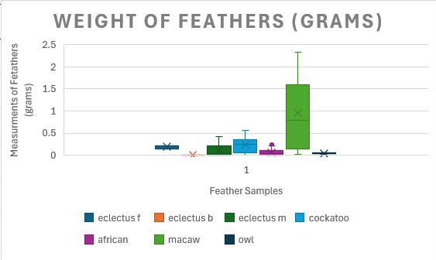
Figure 16 Box and Whisker Plot of Bird Species of the Weight of the Feathers
Eclectus female and male feathers as a collective are around the same weight. Eclectus body feathers are considerably lighter than the others with the heaviest feather weighing 0.0055grams and the lightest feather weighing 0.0003 grams. This may be due to body feathers being shorter than the average feather as the feather does not hold much heigh showing that the weight is in proportion to the weight. Eclectus females show a little range with the feathers which were analysed for the weight meaning that the feathers have similar weight, this may be due to the type of feathers being the same which were analysed, which then show consistency with the type of feather being similar weights. Eclectus male feathers are heavier than the females and body feathers and the male feathers have a bigger range of weight showing more variety of weights, this may be due to different feathers being analysed compared to the females as more feathers were able to be collected to the males.
Cockatoo feathers are like the eclectus males with a larger range of weights which were retrieved by the feathers. These feathers do have a slight heavier component which may be because of the length of the feather as the cockatoo is usually larger than an eclectus and African grey.
African grey feather is a lighter feather compared to eclectus and macaw feather, with most of the weight being between 0.003grams and 0.1grams with the heaviest feather being at 0.3grams. This may be due to having a loose arrangement of barbules making the weight of the feather decrease.
Macaw feathers have the biggest range but also the largest weight out of all the feathers analysed being 2.32grams, this is because of the length of the macaw feathers being longer compared to other feathers which were analysed. Macaw feathers are a dense feather with many barbules and a thick vane which may mean the reason of why these are a heavier feather. Macaw feathers have a larger weight due to the length of the feather so the weight will be heavier and also heavier feathers due to darker pigmented feather have more pigments causing the weight to be heavier (Galvan and Gomez-Vicioso, 2025).
Northern hawk owl feather are a lot lighter than other feathers this is due to the hawk owl having less barbules attached to the vane, which cause the weight to decrease, the range of the weights is minimal which shows that the feathers are consistent in their weights as the lightweight nature of these feathers help with the flight of the bird (Martinez, 2024), this could also be because of the types of feathers which were analysed as not many feathers were able to be collected from this species.
The Shapiro-wilks test was conducted on the lengths of feathers for each species of parrots analysed. All the data sets were normally distributed (p=>0.05) apart from Eclectus female (p=0.002), eclectus body (p=0.18), cockatoo (p=0.029), African grey (p=0.023) and macaw (p=0.011). The krustal wallis test was conducted with Bonferroni post hoc test in table 10 which indicates the values of the krustal wallis test.
Table 10 SPSS Kruskral Wallis Results Table for Weight of the Feathers
Pairwise Comparisons of group
Sample 1-Sample 2 | Test Statistic | Std. Error | Std. Test Statistic | Sig. | Adj. Sig.ª
Eclectus B- African G | -82.667 | 23.464 | -3.523 | <.001 | .009
Eclectus B -Owl | -105.250 | 33.891 | -3.106 | .002 | .040
Eclectus B - Eclectus M | -119.638 | 22.388 | -5.344 | <.001 | .000
Eclectus B - Eclectus F | 179.667 | 37.313 | 4.815 | <.001 | .000
Eclectus B -Cockatoo | -182.326 | 23.341 | -7.811 | <.001 | .000
Eclectus B -Macaw | -231.464 | 25.030 | -9.247 | <.001 | .000
African G -Owl | -22.583 | 29.391 | -.768 | .442 | 1.000
African G -Eclectus M | 36.971 | 14.712 | 2.513 | .012 | .251
African G -Eclectus F | 97.000 | 33.279 | 2.915 | .004 | .075
African G -Cockatoo | 99.659 | 16.125 | 6.180 | <.001 | .000
African G -Macaw | -148.798 | 18.486 | -8.049 | <.001 | .000
Owl- Eclectus M | 14.388 | 28.539 | .504 | .614 | 1.000
Owl- Eclectus F | 74.417 | 41.298 | 1.802 | .072 | 1.000
Owl-Cockatoo | 77.076 | 29.292 | 2.631 | .009 | .179
Owl-Macaw | 126.214 | 30.656 | 4.117 | <.001 | .001
Owl- Eclectus F | 60.029 | 32.528 | 1.845 | .065 | 1.000
Eclectus M -Cockatoo | -62.688 | 14.514 | -4.319 | <.001 | .000
Eclectus M-Macaw | -111.826 | 17.099 | -6.540 | <.001 | .000
Eclectus F-Cockatoo | -2.659 | 33.192 | -.080 | .936 | 1.000
Eclectus F-Macaw | -51.798 | 34.401 | -1.506 | .132 | 1.000
Cockatoo-Macaw | -49.138 | 18.329 | -2.681 | .007 | .154

There was no significant difference between the following data sets 5-Owl (p=1.000), African G- Eclectus M (p=0.251), African G - Eclectus F (p=0.075), Owl- Eclectus M (p=1.000), Owl- Eclectus F (p=1.00), Owl-Cockatoo (p=0.179), Eclectus M- Eclectus F (p=1.000), Eclectus F-Cockatoo (p=1.000) Eclectus M-Macaw (p=1.000) and Cockatoo-Macaw (p=0.154),

4.4 Coloration
This section looks at the coloration of the different feathers at different points on each feather too look at the differences and similarities to see if there is a statistical difference between the different species between Eclectus male, female and body feathers, Macaw, Cockatoo, African Grey and Northern Hawk Owl. The figure from 17 to 23 show the colouration and the RGB values of the species of feathers.
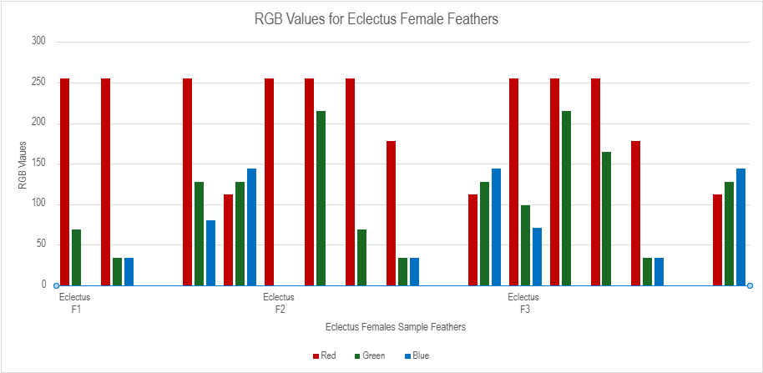
Figure 17 RGB Values for Eclectus Female Feathers

In the figure 18 above shows the red tones off the feather. This is due to the vibrant feathers on an eclectus female is for mating, also often the colouring used to show to their mate that they are willing to show off to their male partner. Compared to the male eclectus feathers in the figure 19 shows the green and blue tones, this is due to the males in eclectus parrots are to help with the camouflage in the trees when retrieving food for the females when they arrive back at the nest. Heinsohn (2008) also suggests it that males' feathers are ultraviolet, and he suggests that only eclectus parrots can see this feature. This could be researched further in other parrot species.

Eclectus body feathers in the figure 18 and table 9 above shows that this bird species have a variation in the colours which were analysed. The main colour is yellow, orange and red tones in these feathers, as shown of the figure above having a major variation of the red and green values in the different body feathers which were researched. In all feathers except eclectus B 6 have an orange, red or yellow but B6 shows the colours of light salmon which was seen in no other feathers. This can be seen in the table below which shows the variation of all the eclectus Body feathers. There were a few greys found in 4 of the 7 feathers mainly being slate grey however there is on dim grey which is visible. There is no research on body feathers alone however from the pigments which are found on female and male feathers come from the pigments of pisttacofulvins which bring out yellow, orange and red pigments which all these pigments are visible in the feathers (McGraw and Nogare, 2004). The role of the colouration of body feathers have not been researched into but from other research about male and female eclectus feathers, the red comes from the females as a signal to males of the ownership of the nests and the grey and green come from the males from the camouflage when foraging in the forests (Heinsohn, 2008).
Figure 18 RGB Values Chart of Eclectus Body Feathers

Table 11 Coloration Results Table of Eclectus Body Feathers Samples
Bird Species | Colour Name | Red | Green | Blue | Visual Colour
Eclectus B1 | Dark Red | 139 | 0 | 0
Eclectus B1 | Yellow | 255 | 255 | 0
Eclectus B1 | Slate Grey | 112 | 128 | 144
Eclectus B2 | Dark Red | 139 | 0 | 0
Eclectus B2 | Yellow | 255 | 255 | 0
Eclectus B2 | Slate Grey | 112 | 128 | 144
Eclectus B3 | Firebrick | 178 | 34 | 34
Eclectus B3 | Gold | 255 | 215 | 0
Eclectus B3 | Dim Grey | 105 | 105 | 105
Eclectus B4 | Red | 255 | 0 | 0
Eclectus B4 | Orange | 255 | 165 | 0
Eclectus B4 | Gold | 255 | 215 | 0
Eclectus B5 | Red | 255 | 0 | 0
Eclectus B5 | Orange | 255 | 165 | 0
Eclectus B5 | Gold | 255 | 215 | 0
Eclectus B6 | Maroon | 128 | 0 | 0
Eclectus B6 | Light salmon | 255 | 160 | 122
Eclectus B6 | Slate grey | 112 | 128 | 144
Eclectus B7 | Dark Sea Green | 143 | 188 | 143
Eclectus B7 | Olive Drab | 107 | 142 | 35
Eclectus B7 | Gold | 255 | 215 | 0
Eclectus B7 | Firebrick | 178 | 34 | 34

Eclectus male feathers in the figure 19 below shows that this bird species has a variety of colours, this has the most variety of colours compared to the rest of the feathers which were analysed are green and blue. The common green colour is lime this is due to the pigments which are in the food that they eat, and the nutrients are why the parrots are a vivid green. Also to help them camouflage when foraging when searching for foods and nesting (Heinsohn, 2008). The reason eclectus males are green through the presence of psittacofulvins pigments which helps with the responsible for the bright colours found in parrot feathers, this comes through the growth of feathers in the follicular tissue of a parrot (McGraw and Nogare, 2004).
Figure 19 RGB Values Chart of Eclectus Male Fetahers
Feather all has assorted colours for distinct species due to the environmental impact of the species, parrots which are native to warm or wetter countries usually have darker colours, blue or red tones to their feathers. This suggest why macaws are the dark blue due to the wet and humid conditions as they originate from south America which are consistent with the results which were found in figure 20. Midnight blue is one of the most common colours which have been in seven feathers, out of fourteen of all the feathers, which is half of the feathers having midnight blue, however most of the feathers have a shade of blue in them even if it is not the exact same shade of blue. The blue colour is not from pigments but from the arrangement of keretin and air which then the light reflects off the barbules creating a blue light which is visible to the naked eye (Stavenga et,al. 2011). The function of blue feathers is to help the communication or signals to other parrots (Arnould et.al, 2018)

Figure 20 RGB Values Chart of Macaw Feathers
African grey feathers are grey, which is shown in the figure 21 below, this is to help with the camouflage of the parrot when hiding in the shadows in the rainforest (Kingsgate, 2023). Two of the feathers which were analysed have that same colour which is brown. The red/brown colour in certain feathers also serve a purpose of communicating with males or warning signs to other species or animals. The most common colour is dim grey which was analysed in most of the feathers with fifteen out of twenty-two of the feathers having dim grey. But all the feathers which were analysed had a darker grey and lighter grey within the feathers which were analysed even if they are not all the same shade the main colour in this species is grey dark and light. African grey feathers are grey due to the high levels of melanin pigmentations which is responsible for the black and grey pigments found in a feather, this has not been studied as much the main function of the grey colour is for camouflage and signalling in sex of the African greys (Surmacki, Minias and Kudelska, 2021). The reasoning of red in an African grey feather is through psittacofulvins which handles the red, orange and yellow pigments in a feather which is considered the main reason for the red pigments, and it is not from their dietary needs (McGraw and Nogare, 2004). The red can be for male attraction if a bird has bright feathers, it could make male attraction easier for a bird, however this has not been researched.

Figure 21 RGB Values Chart of African Grey Feathers

Cockatoo feathers in figure 22 shows that cockatoos does not have much of a variation of colour, the colours which are visible are a variation of snow and white smoke. white smoke appears 8 times throughout the analysis of the cockatoo feathers and snow appears 13 times. Which in figure xx shows that it is consistently white throughout the RGB values in the graph. Suggesting that in all of the feathers there is an element of white coloration that appears on the feathers. Four of the feathers show that they have the colour yellow throughout the feather, which is visible in cockatoo 1, 2, 3 and 5. Cockatoo feathers are white due to the fact that cockatoos have less pigment of melanin's or carotenoids which help create the darker pigments in a bird feathers which shows that they have a lighter pigmentation (Eastburn, 1980). Cockatoos have yellow pigments in their feathers do to having pigments in the feathers called psittacofulvins which is a unique pigment which helps with the development of red, yellow and orange colours in feathers, cockatoos do not get there pigments from their food but they come from the pigments found inside the feather (McGraw and Nogare, 2005). This yellow colour in a feather includes ultraviolet range which has specific spectra peak only found in cockatoo feathers (Bonin and Homberger, 2012).

Figure 22 RGB Values Chart of Cockatoo Feathers
Northen hawk owls are brown and off-white coloured as seen in figure 23, this is suggested to be this colour to mimic a hawk's image to defer predators away (Animal Researcher, 2024). This is to help with camouflage to be with the brown tones to help blend in with the trees from prey and predators. The brown and off-white colours varied slightly but overall, all the same main colour. Looking at the figure 23, the variation of colorations is very similar between both colours which are present having owl 1 and owl 2 the same colour with RGB values, with the others having similar colours. There is minimal research into the reasons of the coloration of a northern hawk owl however, the reason may be inferred by trying to mimic a hawk, the dark colouration of the feathers could help with the camouflage of the owl.

Figure 23 RGB Values Chart of Northern Hawk Owl Feathers

4.5 Colour Distribution/Pattern
This section looks at the colour distribution/pattern of the different feathers at different points on each feather too look at the differences and similarities to see if there is a statistical difference between the different species between Eclectus male, female and body feathers, Macaw, Cockatoo, African Grey and Northern Hawk Owl. It looks at the
Table 12 Percentage Range and Bandings For the Colour Distribution and Pattern
Size of Bands | Percentage Range %
Small | 0-29
Medium | 30-54
Large | 55-100

These results show the pattern features on the different feathers from seven distinct species. Each species has shown a different array of colours across the whole feather including the pattern which the colour occurs in. Through the same species the colouration is similar however they may vary in pattern. This is why there is an estimation of the size of bands in percentages as saying small medium or large were not exact enough, this could be improved due to calculating the exact size of bandings by the length of the band compared to the length of the feather. The band are done with main colour for example red, green etc. And have not been completed with the exact colours. The colour distribution has been suggested by banded, striped, uneven, and even, this is to show the overall banding of a feather.
In eclectus females feathers the common banding is uneven which was seen through all the feathers. This could be due to the coloration of a female being for mating purposes, it could be for showing off the extravagant colours to attract a female; however, this has not been studied into. The number of bandings varies between 4-5, these bandings are usually in the main colours of orange, red, dark red and black with potentially a feather which was analysed had a grey band. The largest band in female feathers is the red band which varies between 45% and 65% which is common with female eclectus feathers due to their known colour difference between males and females. The other banding colours vary between different small sizes. In female feathers the shapes of the band varies a lot the most common shape is straight which is six out of thirteen shapes. This might differ with the type of feather which comes off a bird may vary in pattern, this could be improved by having more eclectus female feather to have a bigger understanding about the patterns across the whole bird.
In eclectus body feathers all have the same colour distribution with being banded, these feathers also have the same number of main colours in the feather being at three, most of these colures being red, yellow and grey with one feather having a variation of red, white and grey. The size of the bandings differs but the red band is the largest band varying between 85% and 50% of the feather being red. On most of the feathers the yellow and the grey band are similar sized however in some feathers the variation sometimes sees that the grey banding can be larger than the middle banding. All the other colours vary in the small banding areas. The most common shape of the bands is curved as 12 out of 18 shapes are curved this may be due to the shape of the feather however this has not been researched into further. There was a shape which was not in any other the other feathers which was the white colour was a circular pattern in the middle of the feather which could be seen in other feathers if more feathers were analysed.
In eclectus male feathers the distribution of colour varies from banded in 18 feathers, striped in 11 feathers and uneven distribution in 4 feathers. This suggests that the most common distribution is banded which shows that the feathers lay in a horizontal or vertical line on the feather. The amount of colour on a feather varies the most popular number of colours being three on nineteen feathers these colours vary between green, blue and brown. Three feathers have six colours distributed on the feather the most common colours for this are red, green, yellow, blue, brown, grey, or purple. The common shape of these colours is straight vertical or horizontal, however this species saw some unusual patterns on the feather like square, triangular and circular these shapes were not seen in other species which were analysed showing that the Eclectus male feathers have more colour to help them camouflage in trees when foraging (Martinez, Navarro and Paz, 2020). The proportion of the colours varied mainly being medium or small due to the number of colours which is visible on one feather creating the extravagant appearance using table 10 to see the categories for the percentages which were seen.
In Cockatoo feather the most common colour distribution is even, which is where the feather is all one colour, this was found to be the most common out of all the species which were analysed. The most common colour for the distribution was white with the majority, yellow were found in a few of the feather also with a bit of pink, this is because of the pigments of psittacofulvin which is responsible for red and orange hues, environmental factors ply with why cockatoos are their colour to reflect heat (Carballo, 2022). In every feather which was analysed white was the main colour found in the feathers. There were no dark colours found in cockatoo feathers, there were a few browns which may be due to dirt on the feather, or the feather was weathered from being outside. The most common shape of the distribution is straight vertical or horizontal, or no shape as the most common distribution was even which is all one colour. Or the feathers were banded either vertically or horizontally, a feather feathers have curved pigmentation. The size of banding’s varies from large to small, the substantial proportion of the feather is white which is correspondent with the percentages of the feather due to the pigments in the bird suggesting that this is the reason for why the large proportion is white (Price-Waldman and Stoddard, 2021). The small proportion of the sidings come from yellow, pink and brown pigments.
In African grey feathers the most common distribution is uneven which means that the colour of that segment is not in any shape. This was found in 14 out of the 22 feathers which were analysed. The second most common distribution pattern is banded which means that the colours which are analysed are in bands going across the width of the feather in near enough horizontal lines. The most common number of the number of bands is 2 which suggest that the band has 2 main colours, this may have variation of the same colour in the feather but two distinctive colours. There were 2 feathers which had 4 colours running through the feather. The most common main colours were grey and white being in nearly all of the feathers this is to help with camouflage being all different shades of grey. The white is usually situated at the bottom where the downy/fluffy feathers are situated, these are usually white because of different birds regulate pigments in different parts of the feather differently so it id sue to the genetics of the bird (Ng and Li, 2018). The shape of the colours varies between feather species and feathers colours. The main shape of the colours is straight which is 25 of the colours were situated straight horizontal, there is one staggard which is black in African grey 2 had a zig zag shape to the pattern. The distribution of the colour varies the most common percentage is large with 27 of the feathers having a large proportion in the feather, this varies from 55% to 100%, each colour has its own percentage. the most common percentages which were seen is 75%, 65% and 5%, which then means that the distribution in percentages are all different within the feathers showing no actual pattern with the percentage. There is a pattern with the colours and the number of colours which are situated in one of the feathers.
In Hyathcin macaws the most common distribution of colour is banded as it is the only type of distribution which was seen on a macaw feather. These bands were in a vertical positioning on the feather. The number of colours varied through the feathers analysed with the 14 feathers which were analysed 50% of the feathers only had two main colours in within the feather. Only four of the feathers had three colours distributed within the feather and the three of the feathers had four colours within the feather. The main colours which were situated in the feather is blue and black being every feather which was analysed had blue and black on the feather this is because of the way the feather is created the light enters the feather and scatters cause iridescence making the feather blue, this suggests that the blue colouration looks different tones under different light variations (Igic, D’Alba and Shawkey, 2016). The other colours which were visualised was dark blue being on four feathers, light blue being on one of the feathers and there were three feathers with the colour indigo. There is a slight variation of the type of blue however each feather the main colours were blue which is visual through all the feathers analysed. This colour was only seen in the Hyathcin macaws as this species has a distinctive colour palette. The proportion of the colour on the feather varied throughout with sixteen of the colours being medium, fourteen colours had the proportion of small, mostly this was the black as the black is only a small proportion of the feather being by the downy feathers. Eight of the colours on the feathers has the proportion of large which is blue as that is the main proportion of the feather.
Northern Hawk Owl feathers out of all the feather which has been analysed these owl feathers have shown the most consistent with the pattern of the colour and their distribution shown in table 13. All the feathers which have been analysed are banded and striped. These feathers have a pattern of alternating white and brown colours; all these feathers have had this pattern. The banding of colour varies between 14 to 26, which shows there is an even split between the white and the brown being that the size of the bands being small per band but overall, the brown and white pigments are an even 50% spilt. To note as well that northern hawk owls have two feathers attached to the same vane this is because of silent flying but also to help keep the owls warm in winter environments which is where they are based (Toutonghi, 2023). These do have the same pattern features on both feather, this was not seen in other feathers which were being analysed so an identifiable feature in just owl feathers that were analysed during this research. The percentage of banding of the owl is a 50 50 split with both colours which are present on this feather which helps with camouflage. The shape of the colour banding is all the same within the feathers which were analysed being irregular.
Table 13 Colour Distribution and Pattern Results Table for Northern Hawk Owl
Species | Colour Distribution | Number of Colour Bands | Shapes of Bands | Size of Bands
Owl 1 | Banded | 14 | White - Irregular | Large 50%
 |  |  | Brown - Irregular | Large 50%
Owl 2 | Banded | 24 | White - Irregular | Large 50%
 |  |  | Brown - Irregular | Large 50%
Owl 3 | Banded | 26 | White - Irregular | Large 50%
 |  |  | Brown - Irregular | Large 50%
Owl 4 | Banded | 20 | White - Irregular | Large 50%
 |  |  | Brown - Irregular | Large 50%

4.6 Scanning Electron Microscope (SEM)
This section looks at the scanning electron microscope of the different feathers at different points on each feather too look at the differences and similarities to see if there is a statistical difference between the different species between Eclectus male, female and body feathers, Macaw, Cockatoo, African Grey and Northern Hawk Owl.
4.7.1 Eclectus Body Feathers
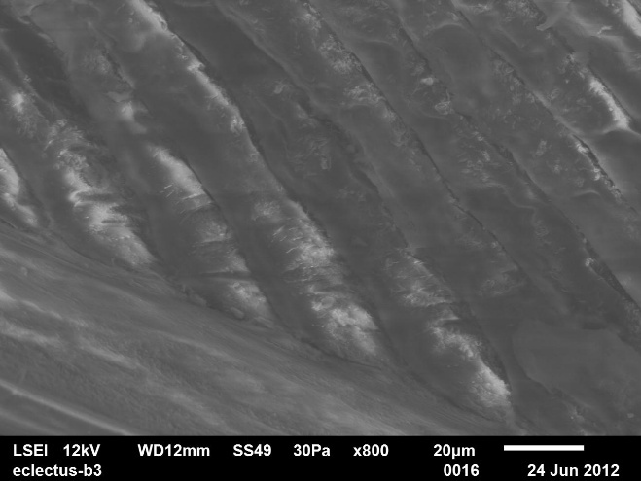
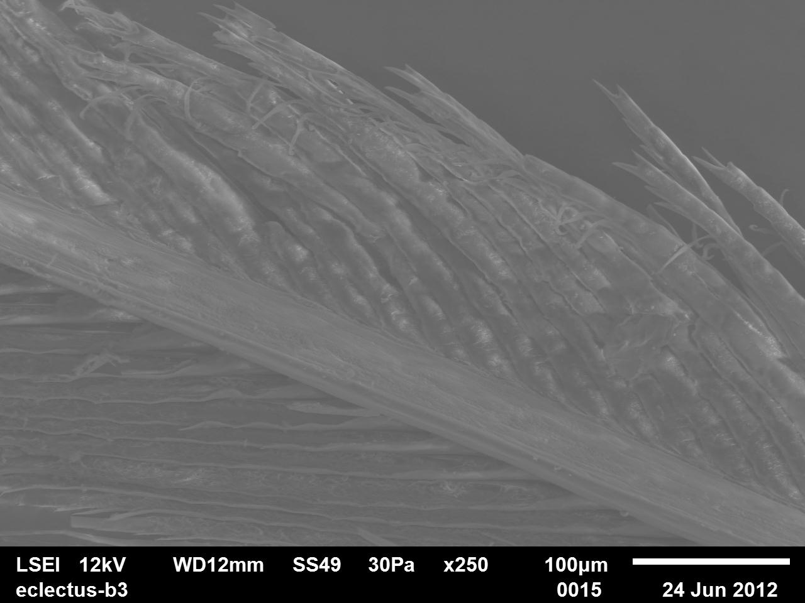
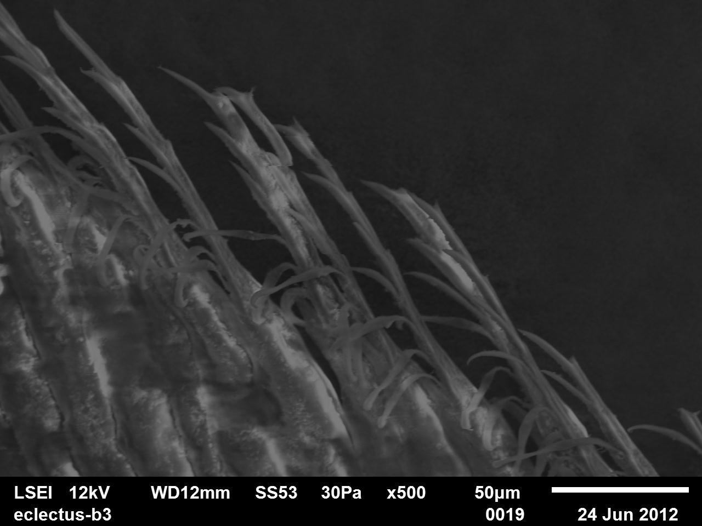
Figure 24 SEM Images of Eclectus Body Feathers
Figure 25 SEM Images of Eclectus Body Feathers
Figure 26 SEM Images of Eclectus Body Feathers

The SEM images in figures 26,25&24 illustrate the surface morphology of an Eclectus Body Feather. In figures 26 this shows a close-up view of the frongs which have not been researched into with eclectus bird feathers. These may be a different form of pennaceous barbs which helps give the feather its stiffness and strong structure to help with flying (Theagarten, 2017) (Theagarten and Murugan, 2013). In figure 25 shows an overview image of an eclectus body feather which shows the uneven thickness of a the rachilla, this also shows an uneven length of the rachilla. In figure 24 shows a close-up view of the base of the rachilla showing that it is thick in width but then the rachilla in another image shows the tips taper off and leave a spine shape that the very end.

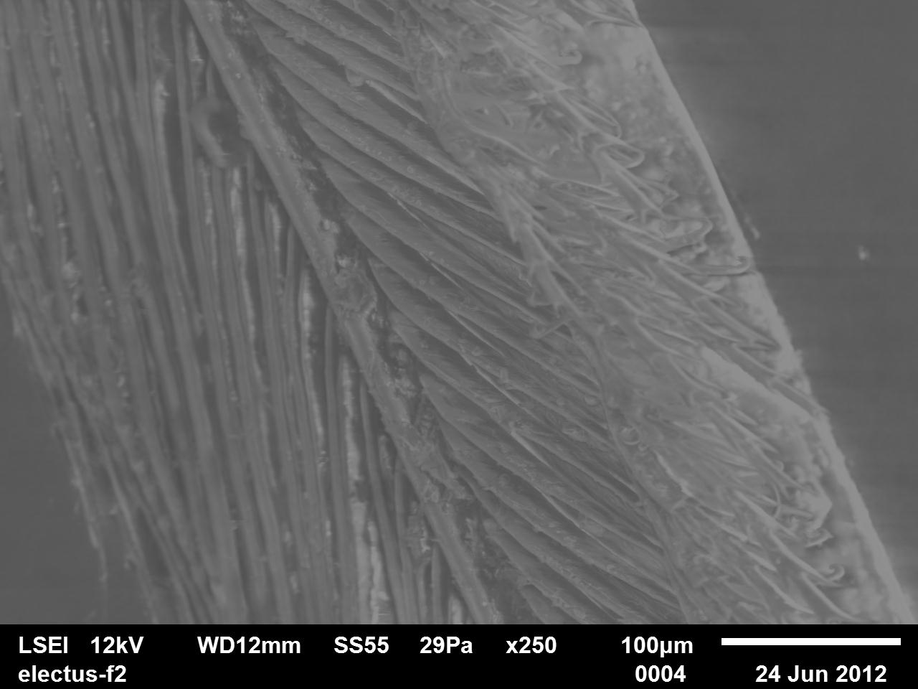
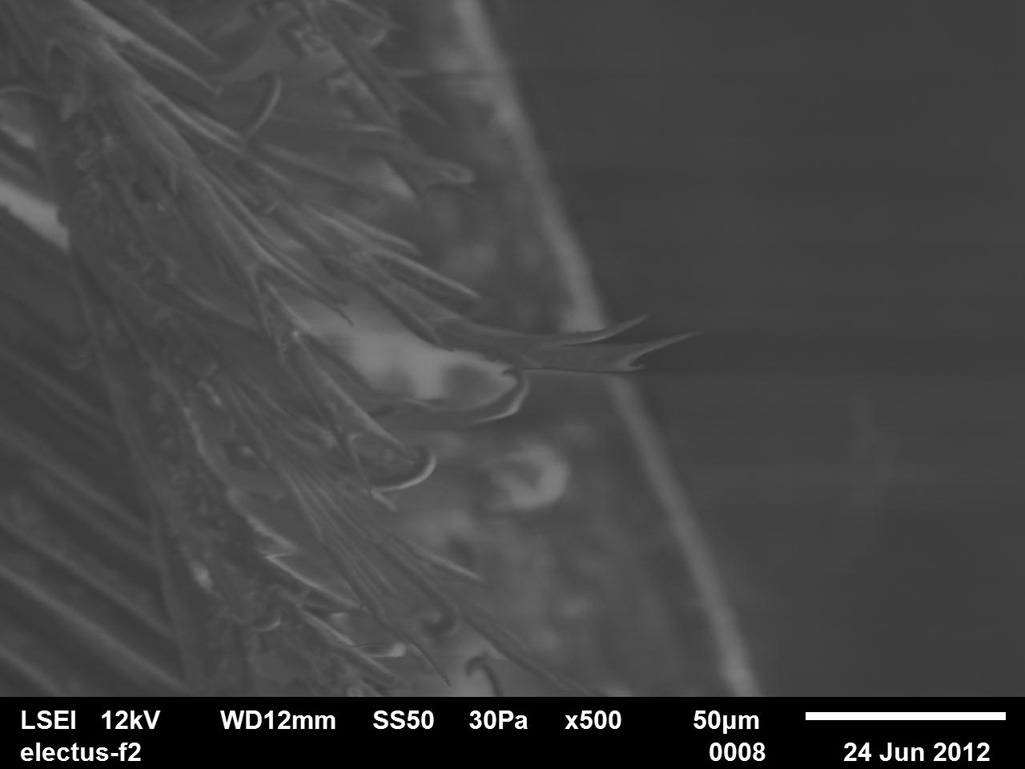
4.7.2 Eclectus Female Feathers
Figure 27 SEM Images of Eclectus Female Feather 1
Figure 27 SEM Images of Eclectus Female Fetaher
Figure 26 SEM Images of Eclectus Females Feather 1
Figure 28 SEM Images of Eclectus Female Feather
The SEM images in figures 27&28 illustrate the surface morphology of an Eclectus Female Feather. in figure 28 shows that in eclectus females, frongs were imaged at the end of the rachilla. This may be pennaceous barbs which is branches which are paired that come up from the rachis which helps with aerodynamic in feathers (Lingham-Soliar and Murugan, 2013). This is seen in all the eclectus males more prominent then in any of the species which were analysed. In figure 27 shows the rachilla in a tight structure, however these are thin in width compared to other species. On the right-hand side it can be seen as textured area, this may be damage to the barbule which came from or another identifying feature which has not been researched into.
4.7.3 Eclectus Male Feathers
The SEM images in figures 29&30 illustrate the surface morphology of a Eclectus Male. In figure 29 shows a different side of where the prongs are situated however, these are less prominent than image 30. these may be a different structural feature which has not been researched into in eclectus male feathers. In figure 30 shows a close of the end of the rachilla, which could be pennaceous barbs in a different shape, however this has not been researched into in eclectus males even though they could be different as the have a villis like structure shape. In all eclectus feathers which were analysed this structure was seen which may be another identifying feature in the feathers.
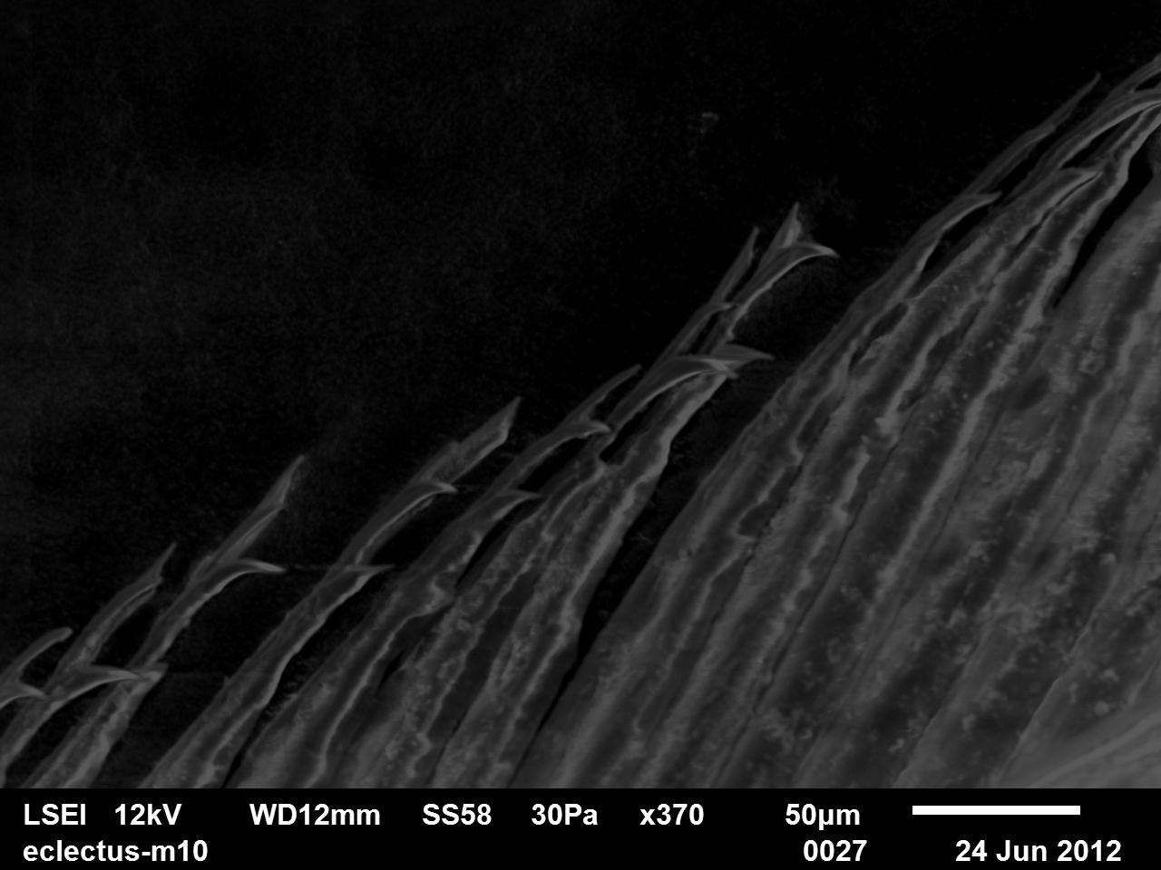
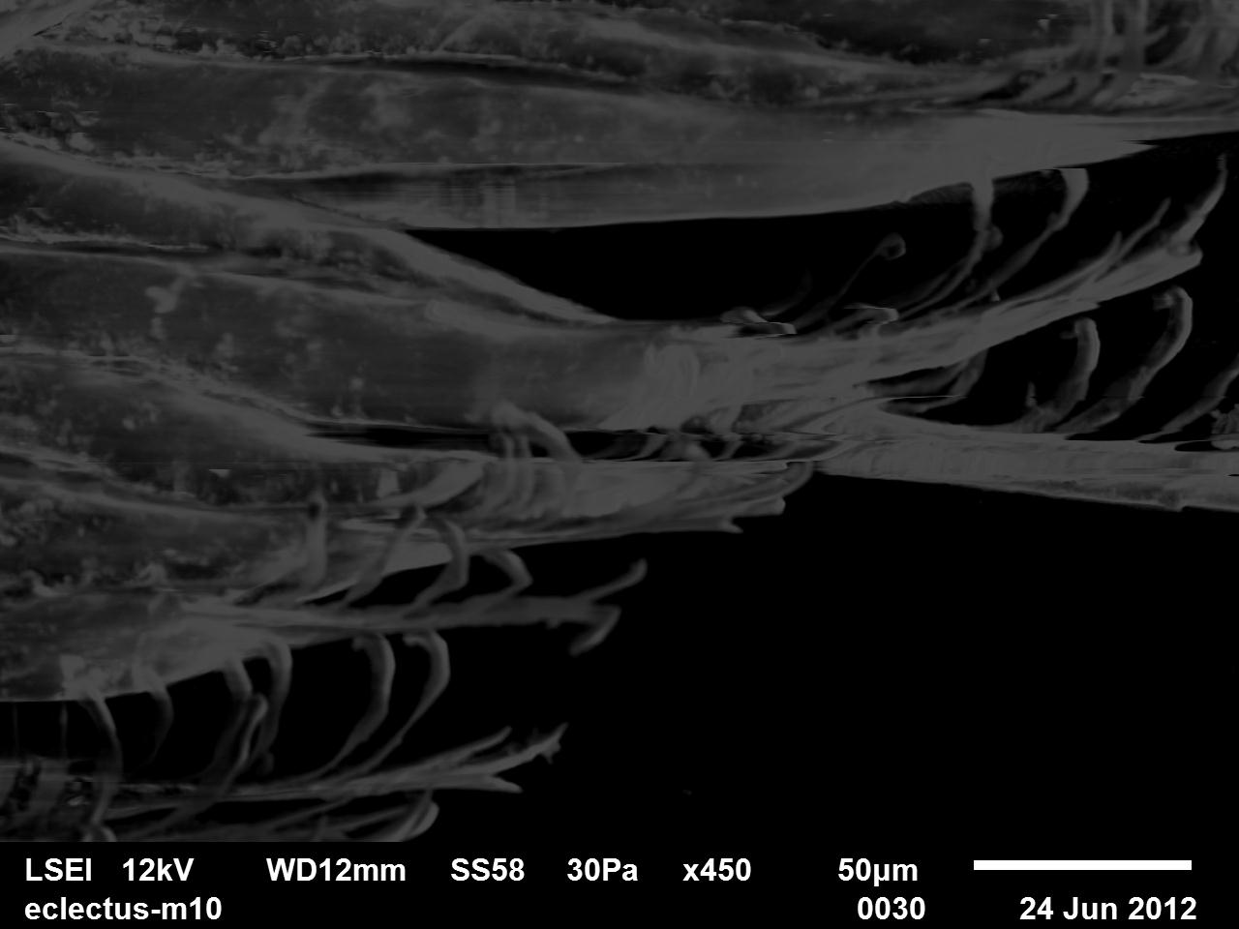
4.7.4 Cockatoo
Figure 28 SEM IMages of Eclectus Male Feather 1
Figure 29 SEM Images of Eclectus Male Feather
Figure 29 SEM Images of Eclectus Male Feather 1
Figure 30 SEM Images of Eclectus Male Feather
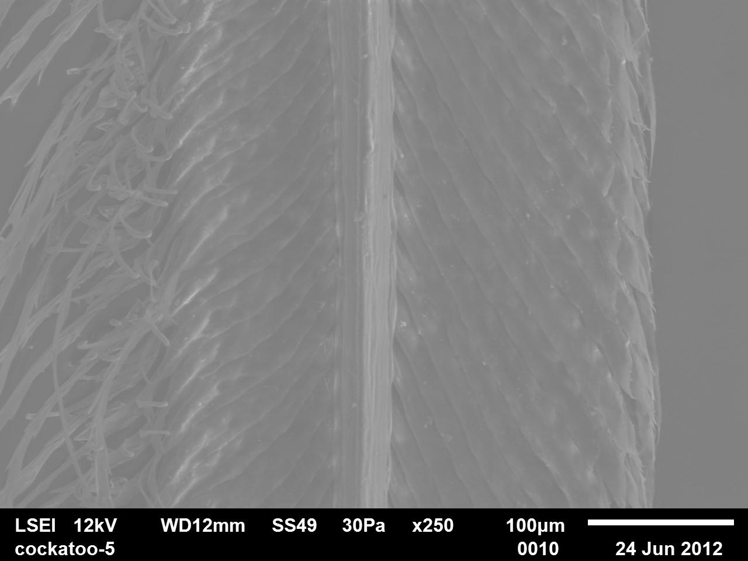
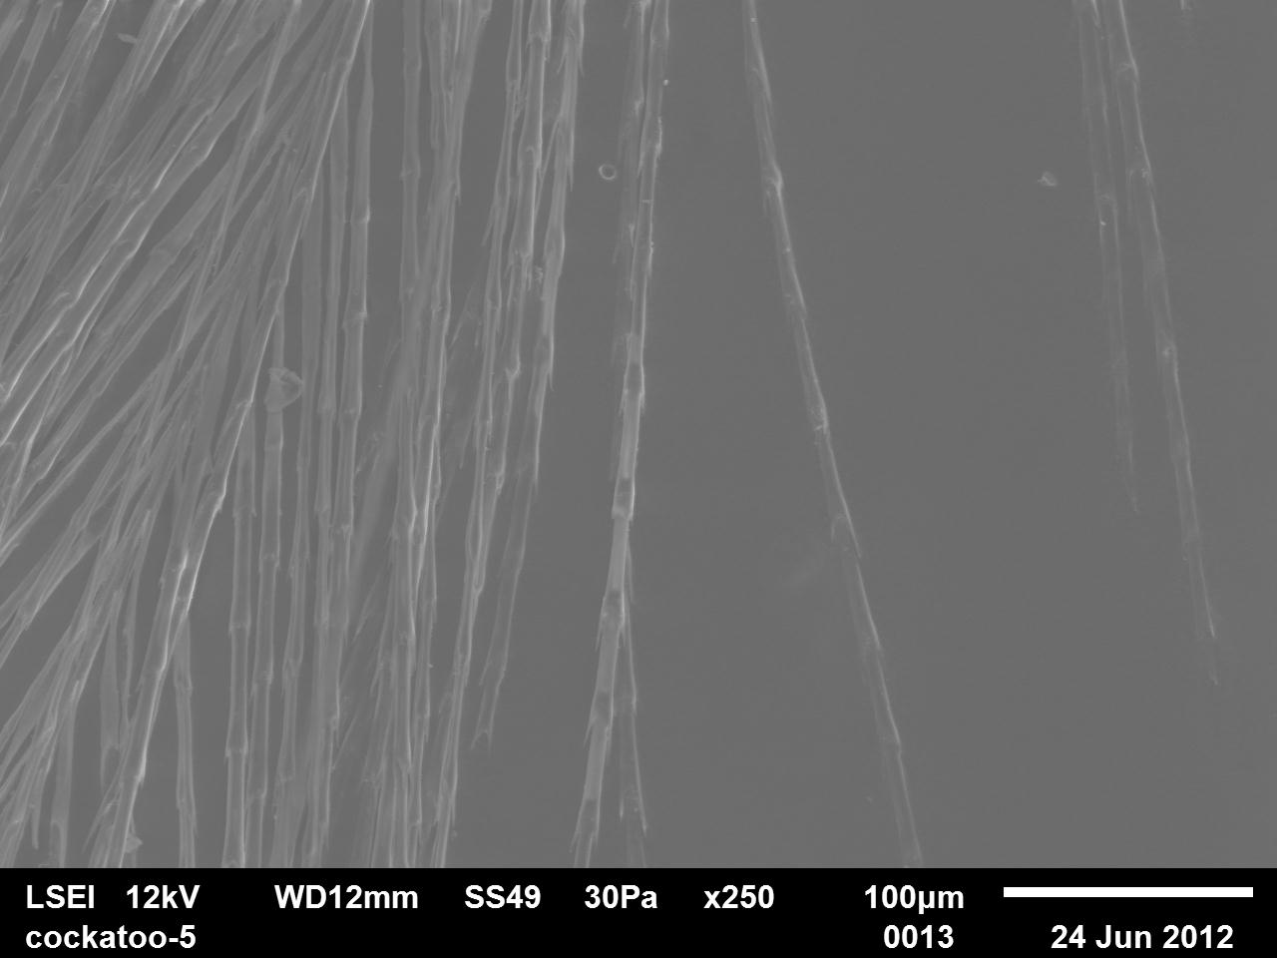
Figure 30 SEM Images of Cockatoo Feathers 1
Figure 31 SEM Images of Cockatoo Feathers 1
Figure 31 SEM Image of Cockatoo Feather
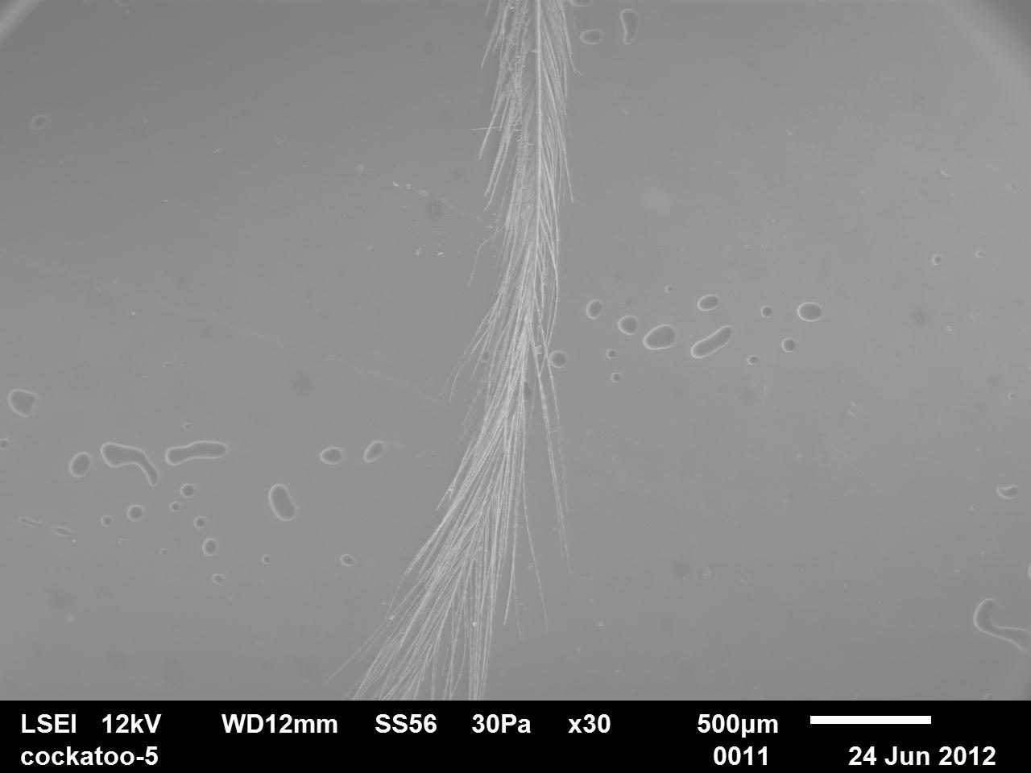
Figure 32 SEM Images of Cockatoo Feather
The SEM images in figures 30,31&32 illustrate the surface morphology of a Cockatoo. In figure 30 illustrates the barbule looks like a triangular shape with some texture visible but not much. The rachilla are thick in width and being tightly structured together showing a thickly structured barbule. There are also pennaceous barbs visible on the left-hand side this help with flight as the barbs which arise a thinner wall (Lingham-Soliar and Murugan, 2013). In figure 31 morphology nodes are visible which are spines, there are also pigment nodes visible their location in the rachilla is nodal which is situated in the in a circular shape inside of where the spine is. In figure 32 shows that at the end of a cockatoo feather being wispy in the shape the rachilla they are also overlapping and interlinking with other rachillas.

4.7.5 African Grey Feather
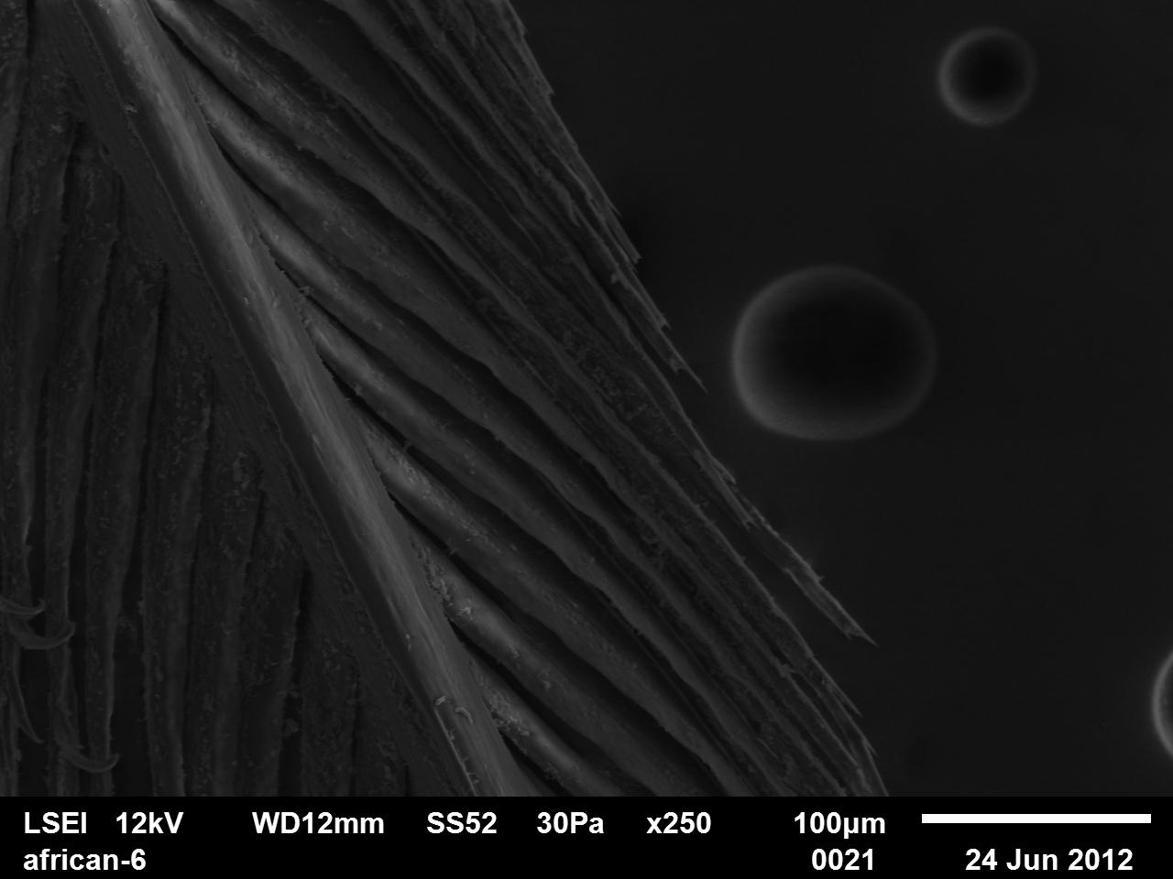
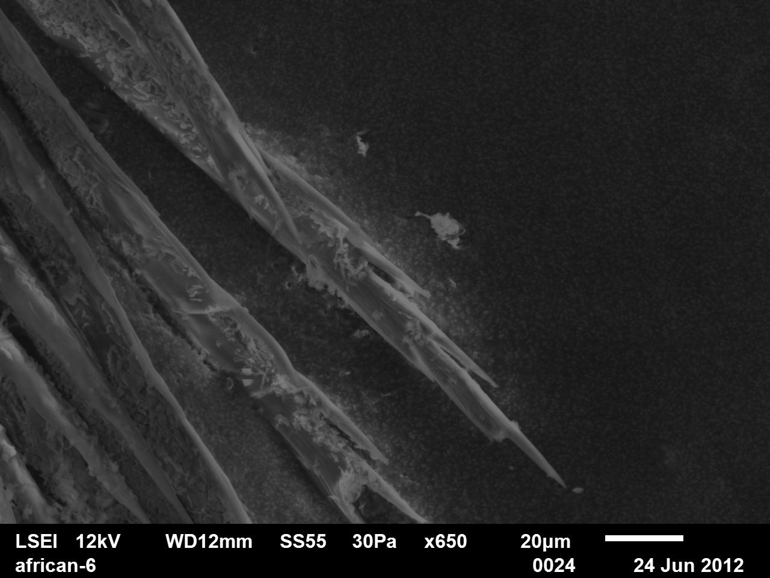
Figure 34 SEM Images of African Grey Feather 1
Figure 33 SEM Image of African Grey Feather
Figure 33 SEM Images of African Grey Feather 1
Figure 34 SEM Images of African Grey Feathers
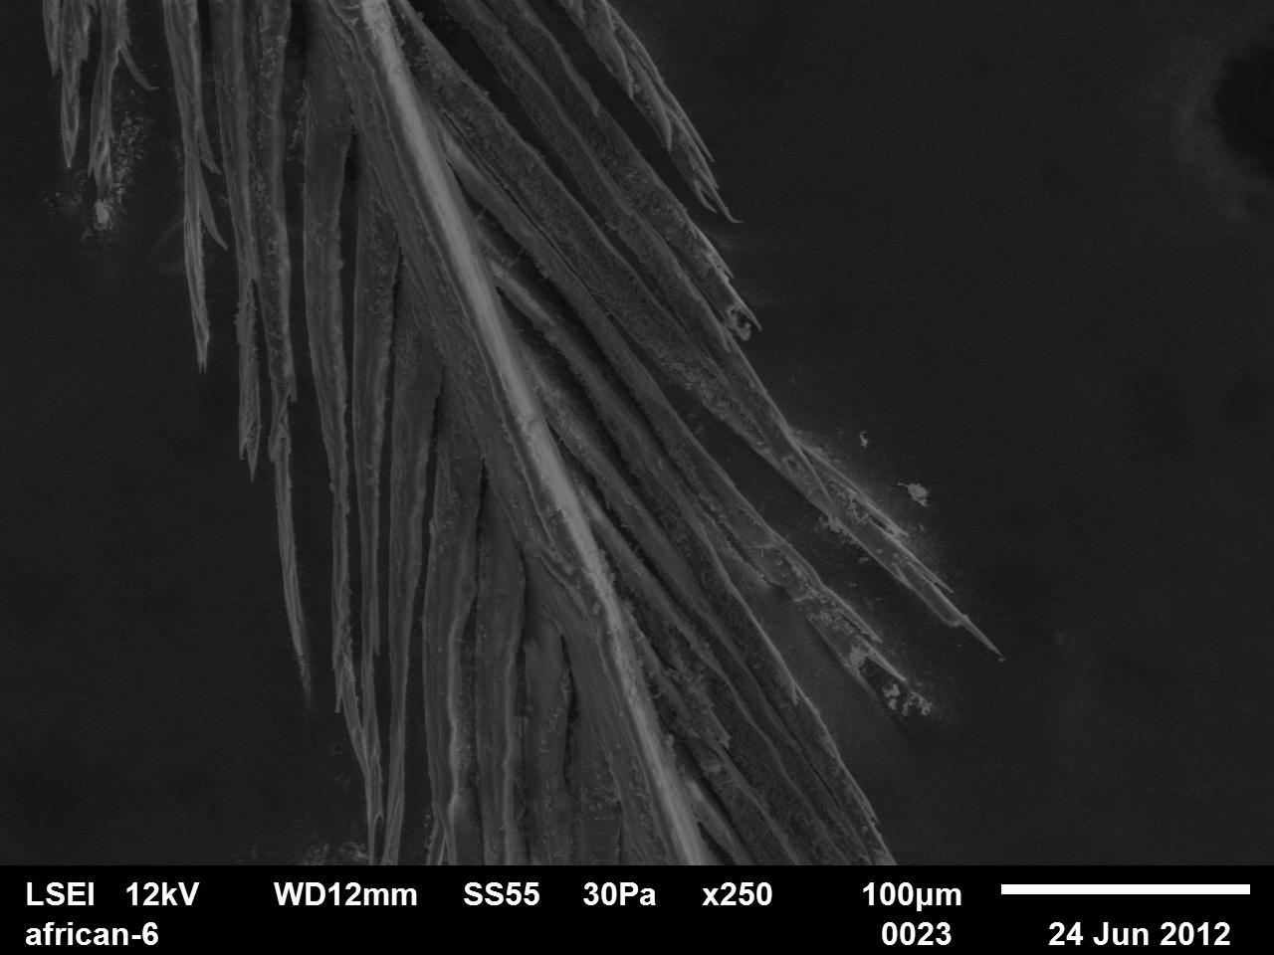
Figure 35 SEM Image of African Grey Feather
The SEM images in figures 33,34&35 illustrate the surface morphology of an African Grey. In figure 33 shows the end of a rachilla which shows spikey like structure which comes to a point which is a distal vanuale which extends from the central shaft, this helps the feathers to be more aerodynamic which is essential for a bird's flight function in feathers (Chen et,al. 2016)(Tang, Li and Fan, 2020). In figure 34 shows a thin barbules width with short rachilla in length, with the distal vanuale being shown on other rachilla. In figure 35 it shows a smooth rachilla which the function has not been researched into, the barbule shows that it is smooth texture as well with the distal vanule being shown.
4.7.6 Macaw Feathers
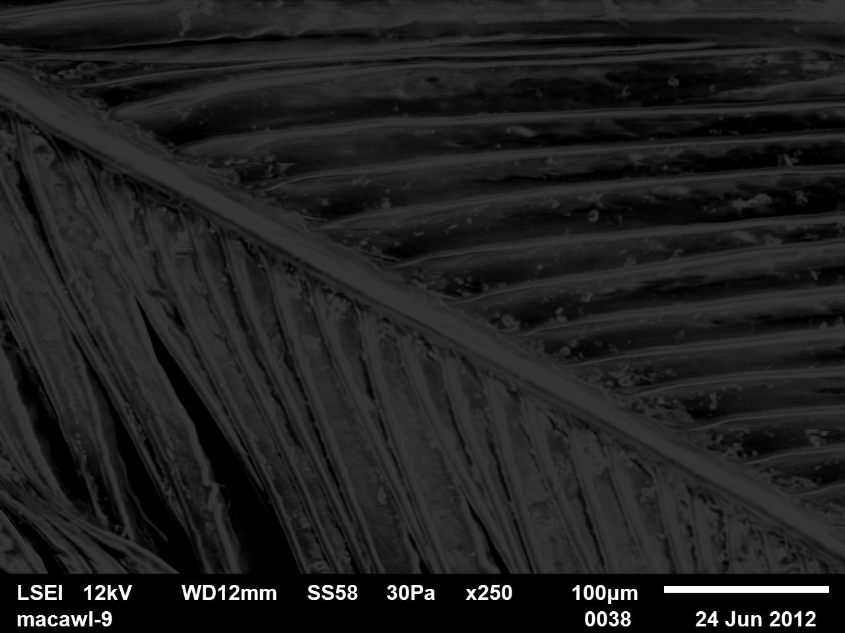
Figure 36 SEM Image of Hyathcin Macaw Feather
The SEM images in figure 36 illustrate the surface morphology of a Hyathcin macaw. This shows that tightly structured rachilla on the barbule with thin rachilla. The barbule is smooth and looks circular in shape. There are a few gaps on the rachilla bottom left corner this may be due to breakage in the barbule. These images were captured to gain more information forensically for other forensic practitioners.
4.7.7 Northern Hawk Owl Feathers
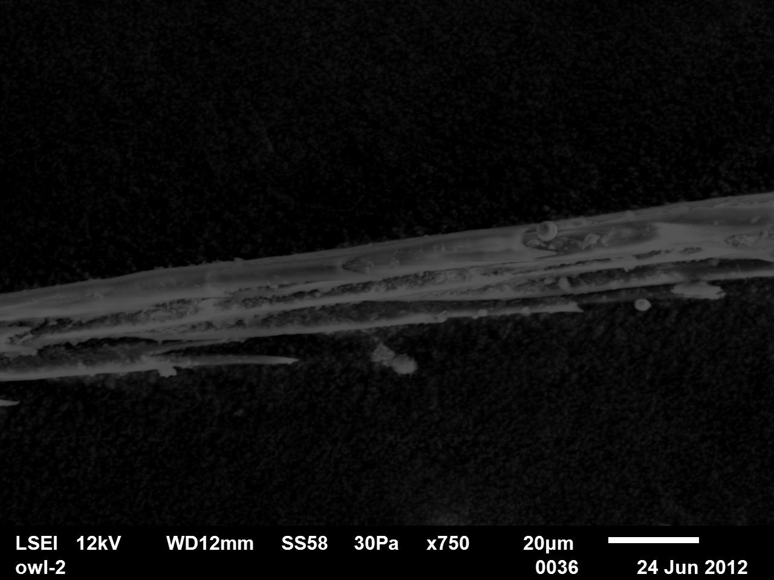
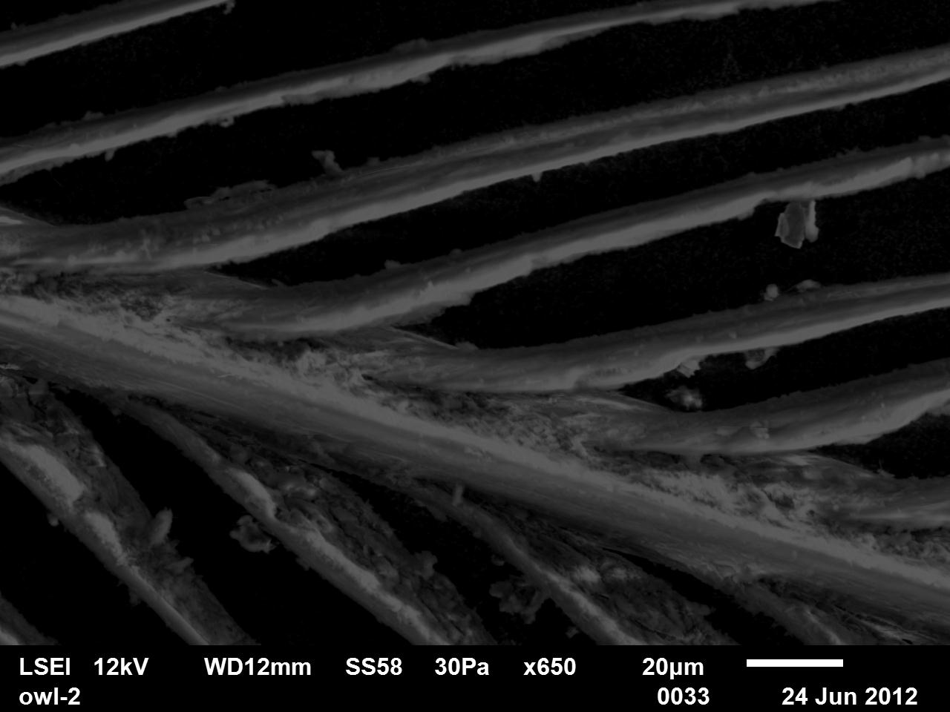
Figure 37 SEM Images of Northern Hawk Owl Feather 1
Figure 37 SEM Image of Northern Hawk Owl Feather
Figure 38 SEM Images of Northern Hawk Owl Feather 1
Figure 38 SEM Images of Northern Hawk Owl Feather
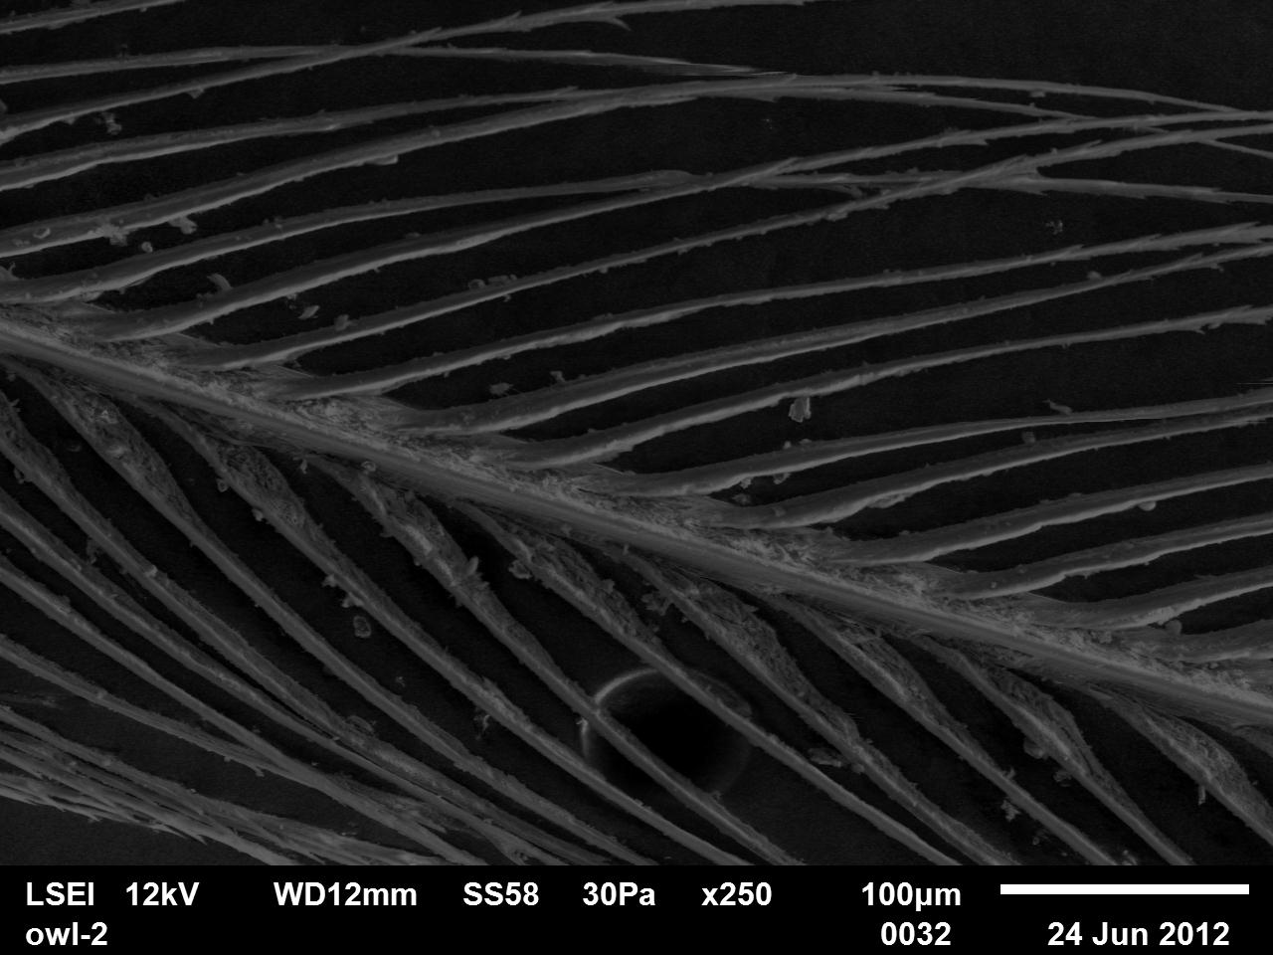
Figure 39 SEM Image of Northern Hawk Owl Feather
The SEM images in figures 37, 38 & 39 illustrate the surface morphology of a Northern Hawk Owl. In figure 37 it shows the end of the barbule which has been placed into the SEM which on this is present of pigment nodes and spines which are running through barbule. The node morphology is a spine which is a mushroom shape this helps with the aerodynamic function of feathers, of the spine nodes help with the feathers becoming less damaged when being used (Heck and Benavides-Piccione, 2016). In figure 38 the rachilla is being shown which shows a texture surface, this may be dirt form the feather not being cleaned as well or a morphological component which was only seen in northern hawk owl. In figure 39 this shows the barbule in view; this shows that the rachillas are spread out which may be a feature which is only in northern hawk owls.

5. Conclusions
This research sought to investigate the Feather analysis of exotic birds in wildlife crime investigations. On how different macroscopical analysis can assist wildlife crime investigators if a single feather or feathers are found at a scene of a crime. This study is to contribute to the wildlife forensic in the analysis of feathers to gain a type of identification of species. 110 feathers over Seven parrot species Hyacinth Macaw (Anodorohynchus Hyacinthinus), Eclectus (Eclectus Rotoras) female, male and body feathers, African Grey (Psittacus Timneh), Ducorps’s Cockatoo (Cacatua Ducorpsii), and a Northern Hawk Owl (Surnia Ulula) had macroscopical characteristics identified over the feathers. This entailed measurements from different region of the feather's length and widths, weight, coloration, colour distribution and pattern, and scanning electron microscopy.
Statistical differences were presented within this study which suggests that certain feather do have a difference in certain aspects. In the length from start of the barbules to the tip Eclectus body feathers were statistically different to any of the other species analysed. Eclectus body and northern hawk owl were statistically different expect from the width 1cm from the top of the feather. Eclectus body and Eclectus male's feathers are statistically different except for the widest point on the right side of the vane and 1cm from the top. Macaw feathers length was considerably longer than the other feather being over 500mm which was the largest feathers out of all of the species, macaw feather also weighed the most due to the large feathers. Eclectus body feathers were the smallest in length being xx the weight some of the smallest feathers. Northern hawk owl had one of the largest widths of the widest point due to the barbules being so spread and loose.
The results received from the coloration shown that the Hyathcin macaw each feather had a distinctive medium blue pigment which was the main colour found macaws and no other feathers. Cockatoo feathers majority where white some feathers had yellow and pink within the feather, African grey feathers were predominantly grey and black some feather had red within the feather. Eclectus females had red feathers as the main colour which helps with camouflage in the trees when nesting. Eclectus males were mainly green which helps with camouflage when foraging. the results which were received from the SEM showed that the Eclectus feather have an individual characteristic of frongs at the end of the feather which was seen in only Eclectus male, female and body feathers.
However, this study demonstrated some limitations of this research would be to use a coloration machine on a digital device, so it is not up to the investigators discretion as investigators may see colour in different way ending up with different colours for the same feather. If a picture was taken of a feather, then uploaded to a site where colour was given in certain places would be beneficial however, this may only be done if the camera and light settings were the same, so the brightness is the same throughout all of the feathers. The sample size for certain feather could have been bigger to gain a better aspect of different feathers, also splitting the feathers into their type of feather and then analysing the macroscopic differences and similarities. The importance of this research is to help forensic wildlife practitioners' information about if there is any difference between different exotic birds to gain an identification of a bird species. It gives more knowledge to other analysis’s to see different methodology on the identification of birds, also gains confidence in methods which are being researched into more often. Overall, this helps with the convictions of criminals which trafficked birds, illegal hunting and other wildlife crime as it may link suspects to a crime if a feather is found on an individual. Gain better knowledge of bird species which creates a larger span of research for other investigators to compare an evidential feather too.

6. Further work
Further research using mixed methods could enhance the understanding of the difference in species of macroscopical characteristics in study using further analysis of isotope analysis which could be valuable information (Zhao et.al, 2023). Also looking at the different isotopes in the different components of the feather, for example, the rachis compared to the vane (Bontempo et, al. 2014). This research opens several avenues for future research. It could be looking at the different variables and the distinctive characteristics between unusual types of feathers, for example tail and flight feathers to see if any characteristics overlap between each of the feathers of the same species. Another research avenue which could be investigated is microscopical analysis and the difference between the diverse species of birds to create more characteristics which can then be identified by other investigators (Li et.al, 2026) (Coddington, Dove and Luther, 2022). Another avenue of research could be looking into a larger variation of species of birds which are exotic and that are at risk of being trafficked and smuggled, for example Amazoa Auropalliata (yellow-naped amazon), Aratinga and Eupsittas and many others which are endangered and parrots which are illegally trafficked (WorlsAtlas, n.d). Another avenue for research is looking at the differences in feathers between the same species but different types of birds, for example macaws looking at the difference in hyathcin macaws, Scarlett macaws, great green macaws, blue and yellow macaws, military macaws, and green winged macaws. This could be looking at the coloration of the birds and how much they differ or if they have similar structural features in pigment nodes, proteins in the feather and any other techniques that look at structure (MONTERRUBIO-RICO, 2021). Also looking into if different birds' species have UV feathers or if it is just eclectus males to see if that could be an identifying feature in certain bird species. Looking into colouration tool which can give a better colour which is not up to the investigator and up to a machine which gives RGB values when placed on a feather so the subjectivity of colouration decreases. Further work which could be investigated could be how different feathers hold water and how different the water retention is in different species and in different types of that species. Future research which could be investigated could be a feather guide manual which could aid forensic investigators during the analysis of feathers process and the methods to successfully achieve the methods of different analysis, also through sequential sequencing off methods by using non-destructive methods then destructive methods (Fraigneau, 2021). Future investigations that could be the creation of a digital analysis of feathers through the coloration of different feathers and the distribution of the coloration to where feathers could be uploaded digitally or manually scanned into a system created where the system could be able to identify or narrow down the species from the feathers (Kale and Kumar, 2021).

Appendix
Appendix 1 step by step guide on how to do a Shapiro Wilks test
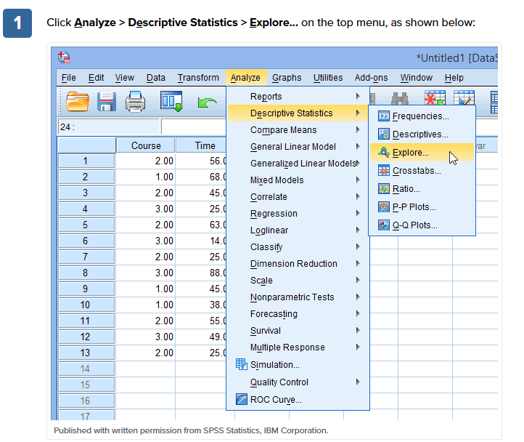
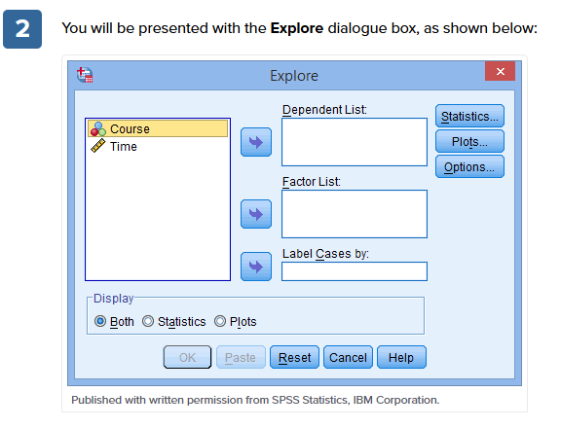

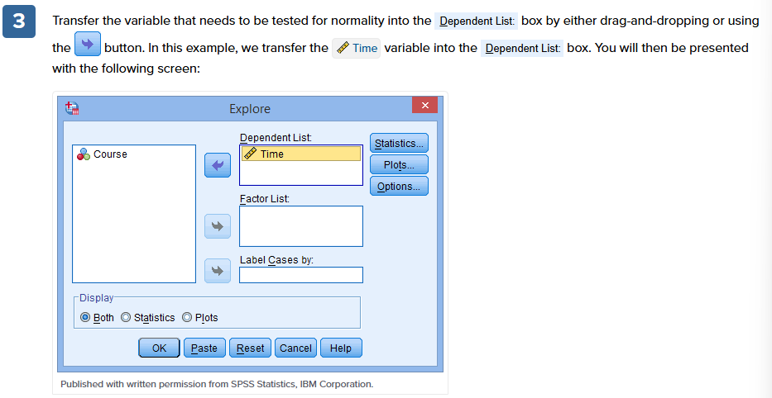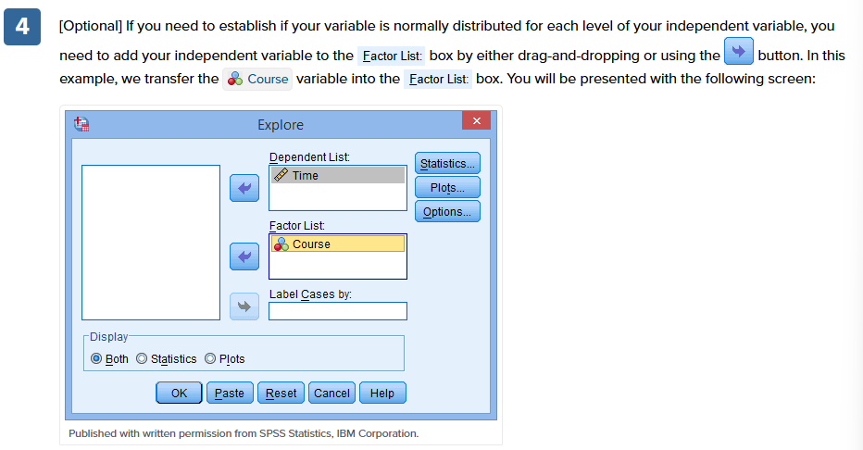

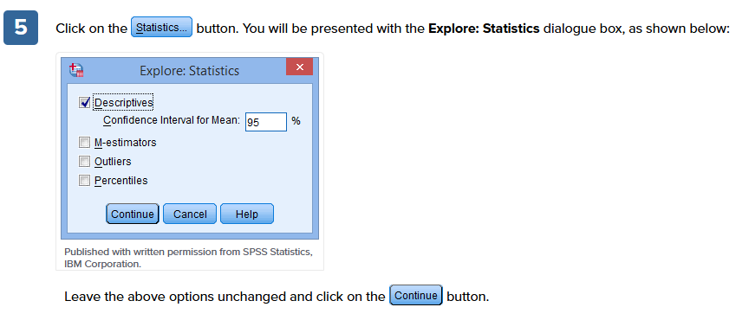

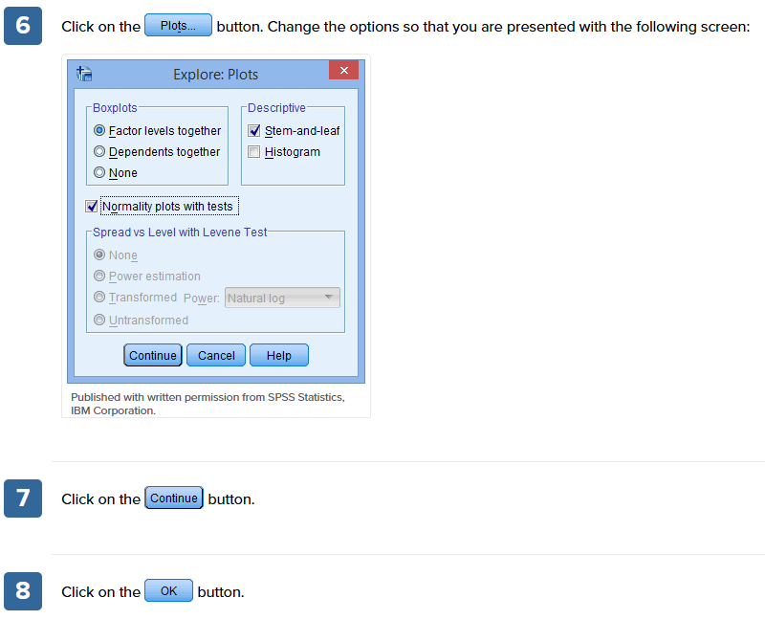

Appendix 2 step by step guide of how to do a Kruskal Wallis Test
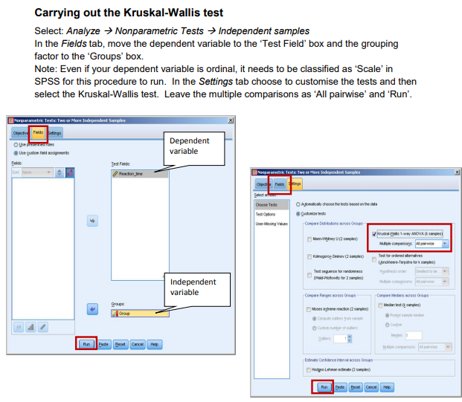
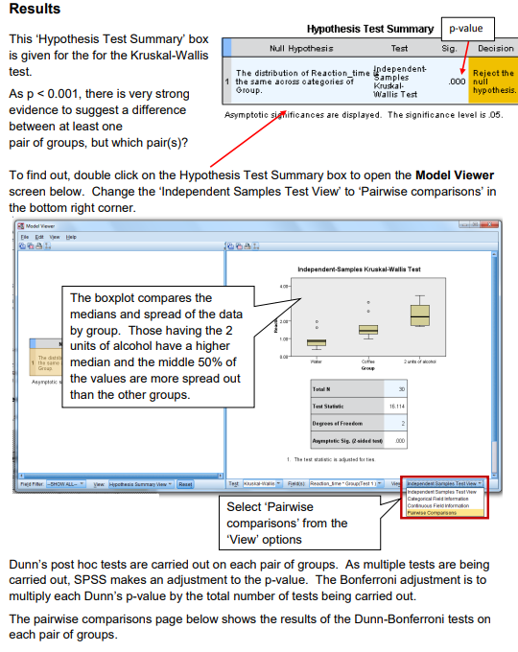

Appendix 3 table of raw data of lengths from tip to start of barbules
Bird Number | N-Value | Length of Feather (mm)
 |  | 1 | 2 | 3
Eclectus F1 | 3 | 100 | 100 | 101
Eclectus F2 | 3 | 121 | 121 | 120
Eclectus F3 | 3 | 125 | 131 | 124
Eclectus B1 | 3 | 16 | 17 | 15
Eclectus B2 | 3 | 23 | 24 | 24
Eclectus B3 | 3 | 14 | 13 | 14
Eclectus B4 | 3 | 17 | 16 | 18
Eclectus B5 | 3 | 17 | 16 | 18
Eclectus B6 | 3 | 22 | 22 | 22
Eclectus B7 | 3 | 28 | 26 | 27
Eclectus M1 | 3 | 153 | 154 | 153
Eclectus M2 | 3 | 67 | 67 | 67
Eclectus M3 | 3 | 126 | 127 | 126
Eclectus M4 | 3 | 161 | 160 | 161
Eclectus M5 | 3 | 176 | 176 | 176
Eclectus M6 | 3 | 136 | 135 | 136
Eclectus M7 | 3 | 89 | 89 | 88
Eclectus M8 | 3 | 134 | 135 | 134
Eclectus M9 | 3 | 123 | 122 | 122
Eclectus M10 | 3 | 118 | 119 | 120
Eclectus M11 | 3 | 53 | 54 | 53
Eclectus M12 | 3 | 42 | 43 | 42
Eclectus M13 | 3 | 75 | 74 | 74
Eclectus M14 | 3 | 51 | 52 | 51
Eclectus M15 | 3 | 82 | 81 | 82
Eclectus M16 | 3 | 44 | 43 | 43
Eclectus M17 | 3 | 51 | 51 | 51
Eclectus M18 | 3 | 63 | 63 | 64
Eclectus M19 | 3 | 63 | 64 | 63
Eclectus M20 | 3 | 18 | 17 | 18
Eclectus M21 | 3 | 28 | 29 | 28
Eclectus M22 | 3 | 34 | 34 | 35
Eclectus M23 | 3 | 34 | 34 | 33
Eclectus M24 | 3 | 36 | 35 | 36
Eclectus M25 | 3 | 44 | 43 | 43
Eclectus M26 | 3 | 35 | 34 | 35
Eclectus M27 | 3 | 39 | 39 | 40
Eclectus M28 | 3 | 165 | 166 | 165
Eclectus M29 | 3 | 110 | 109 | 110
Eclectus M30 | 3 | 137 | 134 | 136
Eclectus M31 | 3 | 126 | 125 | 125
Eclectus M32 | 3 | 136 | 137 | 135
Eclectus M33 | 3 | 33 | 34 | 33
Eclectus M34 | 3 | 37 | 36 | 37
Eclectus M35 | 3 | 21 | 20 | 19
Cockatoo 1 | 3 | 169 | 170 | 169
Cockatoo 2 | 3 | 162 | 158 | 156
Cockatoo 3 | 3 | 179 | 176 | 177
Cockatoo 4 | 3 | 115 | 115 | 115
Cockatoo 5 | 3 | 66 | 64 | 66
Cockatoo 6 | 3 | 70 | 71 | 70
Cockatoo 7 | 3 | 55 | 57 | 58
Cockatoo 8 | 3 | 40 | 37 | 38
Cockatoo 9 | 3 | 45 | 46 | 47
Cockatoo 10 | 3 | 145 | 144 | 145
Cockatoo 11 | 3 | 14 | 42 | 40
Cockatoo 12 | 3 | 142 | 141 | 142
Cockatoo 13 | 3 | 151 | 156 | 155
Cockatoo 14 | 3 | 141 | 145 | 142
Cockatoo 15 | 3 | 180 | 181 | 183
Cockatoo 16 | 3 | 173 | 17 | 175
Cockatoo 17 | 3 | 159 | 160 | 160
Cockatoo 18 | 3 | 140 | 140 | 139
Cockatoo 19 | 3 | 138 | 139 | 137
Cockatoo 20 | 3 | 150 | 151 | 151
Cockatoo 21 | 3 | 196 | 197 | 197
Cockatoo 22 | 3 | 170 | 172 | 171
Cockatoo 23 | 3 | 171 | 170 | 171
African G1 | 3 | 112 | 113 | 112
African G2 | 3 | 145 | 145 | 144
African G3 | 3 | 138 | 137 | 136
African G4 | 3 | 123 | 124 | 124
African G5 | 3 | 49 | 50 | 51
African G6 | 3 | 56 | 55 | 55
African G7 | 3 | 59 | 58 | 60
African G8 | 3 | 187 | 188 | 189
African G9 | 3 | 88 | 88 | 89
African G10 | 3 | 82 | 82 | 82
African G11 | 3 | 69 | 70 | 68
African G12 | 3 | 15 | 14 | 15
African G13 | 3 | 10 | 10 | 10
African G14 | 3 | 20 | 18 | 17
African G15 | 3 | 36 | 36 | 36
African G16 | 3 | 20 | 19 | 19
African G17 | 3 | 34 | 33 | 34
African G18 | 3 | 28 | 29 | 29
African G19 | 3 | 16 | 16 | 15
African G20 | 3 | 26 | 26 | 27
African G21 | 3 | 31 | 32 | 31
African G22 | 3 | 60 | 60 | 60
Macaw 1 | 3 | 67 | 66 | 66
Macaw 2 | 3 | 104 | 102 | 105
Macaw 3 | 3 | 75 | 78 | 77
Macaw 5 | 3 | 95 | 95 | 96
Macaw 6 | 3 | 98 | 97 | 97
Macaw 7 | 3 | 196 | 197 | 196
Macaw 8 | 3 | 187 | 188 | 189
Macaw 9 | 3 | 195 | 195 | 195
Macaw 11 | 3 | 455 | 455 | 455
Macaw 12 | 3 | 540 | 540 | 539
Macaw 13 | 3 | 345 | 347 | 345
Macaw 14 | 3 | 396 | 396 | 396
Macaw 15 | 3 | 451 | 449 | 448
Macaw 16 | 3 | 261 | 262 | 261
Owl 1 | 3 | 57 | 57 | 58
Owl 2 | 3 | 74 | 75 | 74
Owl 3 | 3 | 116 | 115 | 114
Owl 4 | 3 | 114 | 115 | 115

Appendix 4 SPSS length of feathers from tip to start of barbules
Explore
Notes
Output Created |  | 16-MAR-2026 12:59:52
Comments
Input | Active Dataset | DataSet0
Input | Filter | <none>
Input | Weight | <none>
Input | Split File | <none>
Input | N of Rows in Working Data File | 105
Missing Value Handling | Definition of Missing | User-defined missing values for dependent variables are treated as missing.
Missing Value Handling | Cases Used | Statistics are based on cases with no missing values for any dependent variable or factor used.
Syntax |  | EXAMINE VARIABLES=Ect_F Ect_B Ect_M coc af_G Mac Owl  /PLOT BOXPLOT HISTOGRAM NPPLOT  /COMPARE VARIABLES  /STATISTICS DESCRIPTIVES  /CINTERVAL 95  /MISSING LISTWISE  /NOTOTAL.
Resources | Processor Time | 00:00:02.64
Resources | Elapsed Time | 00:00:02.31

Case Processing Summary
 | Cases
 | Valid |  | Missing |  | Total
 | N | Percent | N | Percent | N | Percent
Ect_F | 9 | 8.6% | 96 | 91.4% | 105 | 100.0%
Ect_B | 9 | 8.6% | 96 | 91.4% | 105 | 100.0%
Ect_M | 9 | 8.6% | 96 | 91.4% | 105 | 100.0%
coc | 9 | 8.6% | 96 | 91.4% | 105 | 100.0%
af_G | 9 | 8.6% | 96 | 91.4% | 105 | 100.0%
Mac | 9 | 8.6% | 96 | 91.4% | 105 | 100.0%
Owl | 9 | 8.6% | 96 | 91.4% | 105 | 100.0%

Descriptives
 |  |  | Statistic | Std. Error
Ect_F | Mean |  | 116.00 | 4.052
Ect_F | 95% Confidence Interval for Mean | Lower Bound | 106.66
Ect_F | 95% Confidence Interval for Mean | Upper Bound | 125.34
Ect_F | 5% Trimmed Mean |  | 116.06
Ect_F | Median |  | 121.00
Ect_F | Variance |  | 147.750
Ect_F | Std. Deviation |  | 12.155
Ect_F | Minimum |  | 100
Ect_F | Maximum |  | 131
Ect_F | Range |  | 31
Ect_F | Interquartile Range |  | 24
Ect_F | Skewness |  | -.588 | .717
Ect_F | Kurtosis |  | -1.567 | 1.400
Ect_B | Mean |  | 19.78 | 1.544
Ect_B | 95% Confidence Interval for Mean | Lower Bound | 16.22
Ect_B | 95% Confidence Interval for Mean | Upper Bound | 23.34
Ect_B | 5% Trimmed Mean |  | 19.64
Ect_B | Median |  | 17.00
Ect_B | Variance |  | 21.444
Ect_B | Std. Deviation |  | 4.631
Ect_B | Minimum |  | 14
Ect_B | Maximum |  | 28
Ect_B | Range |  | 14
Ect_B | Interquartile Range |  | 7
Ect_B | Skewness |  | .590 | .717
Ect_B | Kurtosis |  | -.775 | 1.400
Ect_M | Mean |  | 129.44 | 11.408
Ect_M | 95% Confidence Interval for Mean | Lower Bound | 103.14
Ect_M | 95% Confidence Interval for Mean | Upper Bound | 155.75
Ect_M | 5% Trimmed Mean |  | 130.33
Ect_M | Median |  | 134.00
Ect_M | Variance |  | 1171.278
Ect_M | Std. Deviation |  | 34.224
Ect_M | Minimum |  | 67
Ect_M | Maximum |  | 176
Ect_M | Range |  | 109
Ect_M | Interquartile Range |  | 51
Ect_M | Skewness |  | -.658 | .717
Ect_M | Kurtosis |  | .091 | 1.400
coc | Mean |  | 100.11 | 18.921
coc | 95% Confidence Interval for Mean | Lower Bound | 56.48
coc | 95% Confidence Interval for Mean | Upper Bound | 143.74
coc | 5% Trimmed Mean |  | 99.07
coc | Median |  | 70.00
coc | Variance |  | 3222.111
coc | Std. Deviation |  | 56.764
coc | Minimum |  | 40
coc | Maximum |  | 179
coc | Range |  | 139
coc | Interquartile Range |  | 116
coc | Skewness |  | .452 | .717
coc | Kurtosis |  | -1.873 | 1.400
af_G | Mean |  | 106.33 | 15.684
af_G | 95% Confidence Interval for Mean | Lower Bound | 70.17
af_G | 95% Confidence Interval for Mean | Upper Bound | 142.50
af_G | 5% Trimmed Mean |  | 105.04
af_G | Median |  | 112.00
af_G | Variance |  | 2214.000
af_G | Std. Deviation |  | 47.053
af_G | Minimum |  | 49
af_G | Maximum |  | 187
af_G | Range |  | 138
af_G | Interquartile Range |  | 84
af_G | Skewness |  | .295 | .717
af_G | Kurtosis |  | -.855 | 1.400
Mac | Mean |  | 163.56 | 40.353
Mac | 95% Confidence Interval for Mean | Lower Bound | 70.50
Mac | 95% Confidence Interval for Mean | Upper Bound | 256.61
Mac | 5% Trimmed Mean |  | 152.73
Mac | Median |  | 104.00
Mac | Variance |  | 14655.028
Mac | Std. Deviation |  | 121.058
Mac | Minimum |  | 67
Mac | Maximum |  | 455
Mac | Range |  | 388
Mac | Interquartile Range |  | 111
Mac | Skewness |  | 2.031 | .717
Mac | Kurtosis |  | 4.681 | 1.400
Owl | Mean |  | 86.78 | 9.198
Owl | 95% Confidence Interval for Mean | Lower Bound | 65.57
Owl | 95% Confidence Interval for Mean | Upper Bound | 107.99
Owl | 5% Trimmed Mean |  | 86.81
Owl | Median |  | 75.00
Owl | Variance |  | 761.444
Owl | Std. Deviation |  | 27.594
Owl | Minimum |  | 57
Owl | Maximum |  | 116
Owl | Range |  | 59
Owl | Interquartile Range |  | 58
Owl | Skewness |  | .074 | .717
Owl | Kurtosis |  | -2.330 | 1.400

Tests of Normality
 | Kolmogorov-Smirnovª |  |  | Shapiro-Wilk
 | Statistic | df | Sig. | Statistic | df | Sig.
Ect_F | .326 | 9 | .006 | .808 | 9 | .026
Ect_B | .281 | 9 | .039 | .911 | 9 | .322
Ect_M | .203 | 9 | .200* | .951 | 9 | .703
coc | .258 | 9 | .087 | .849 | 9 | .072
af_G | .176 | 9 | .200* | .941 | 9 | .589
Mac | .283 | 9 | .036 | .747 | 9 | .005
Owl | .283 | 9 | .037 | .773 | 9 | .010
*. This is a lower bound of the true significance.
a. Lilliefors Significance Correction

Histograms

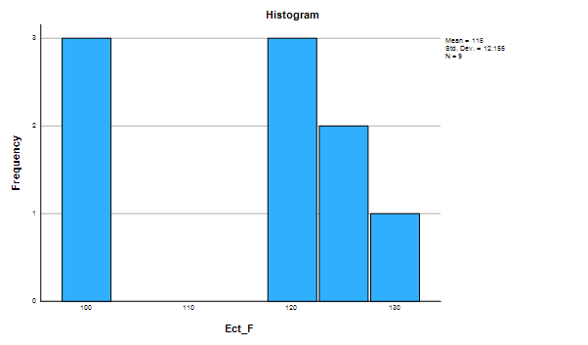

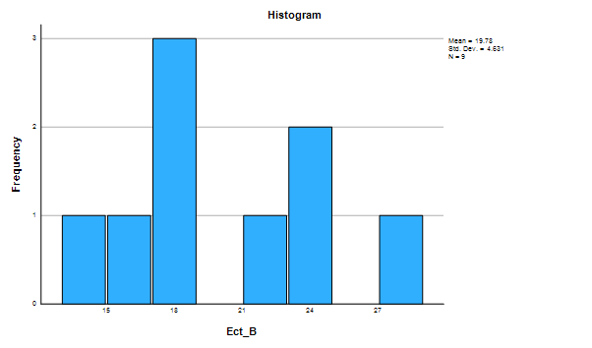

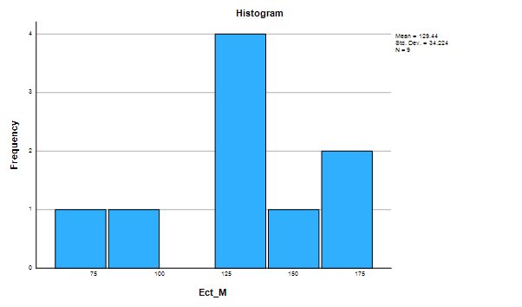

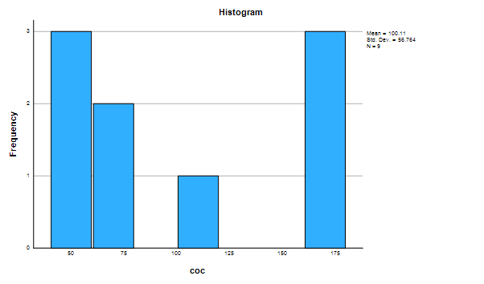

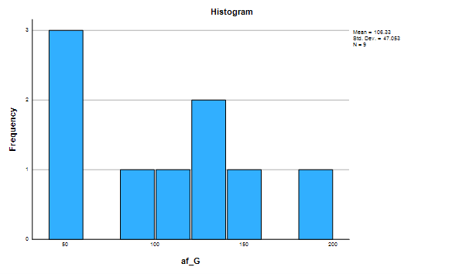

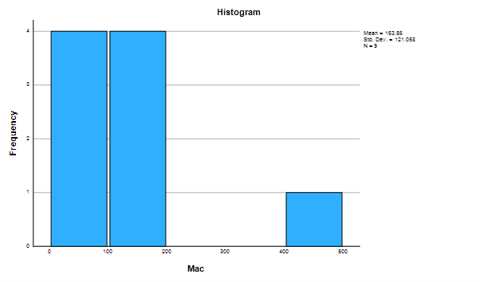

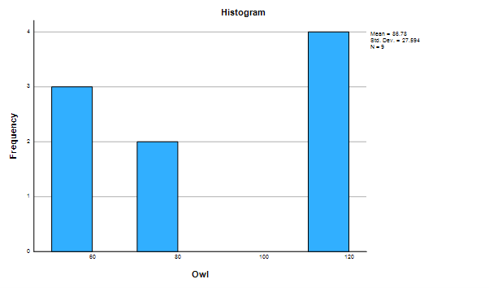

Normal Q-Q Plots

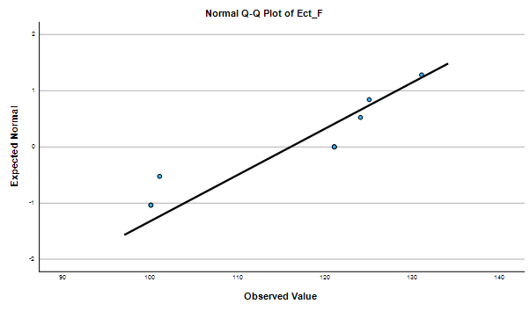

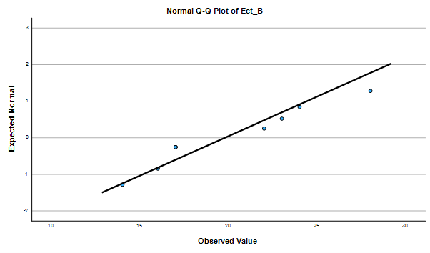

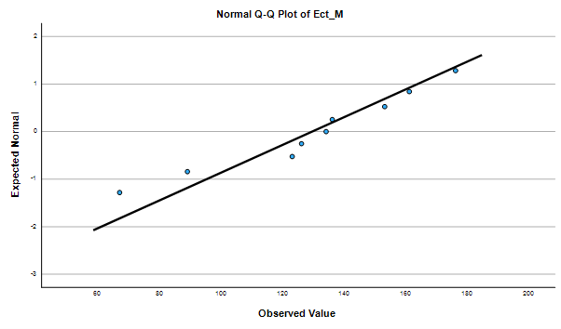

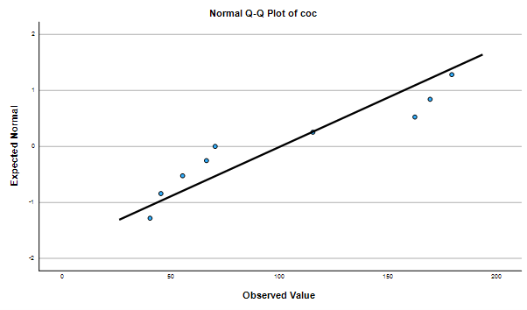

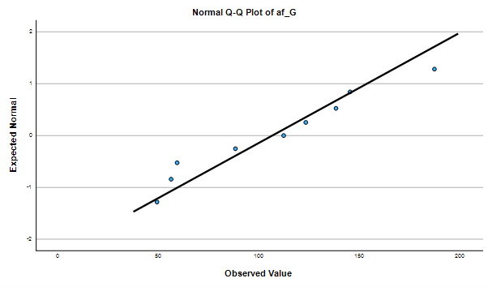

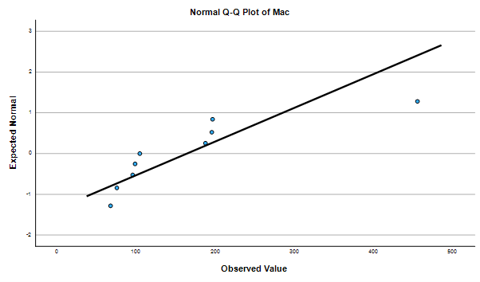

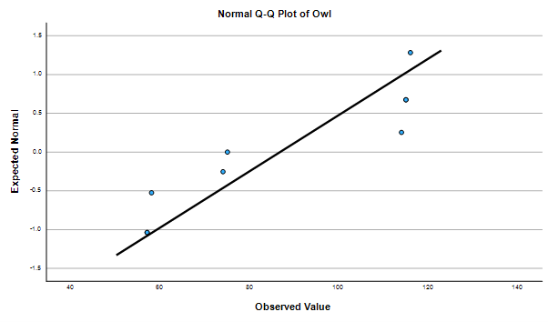

Detrended Normal Q-Q Plots

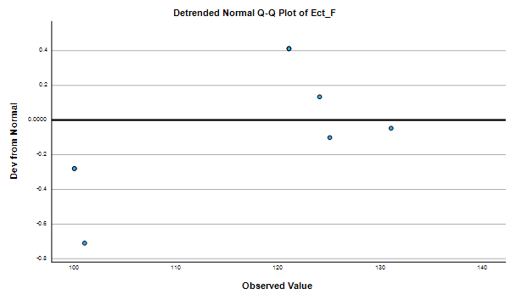

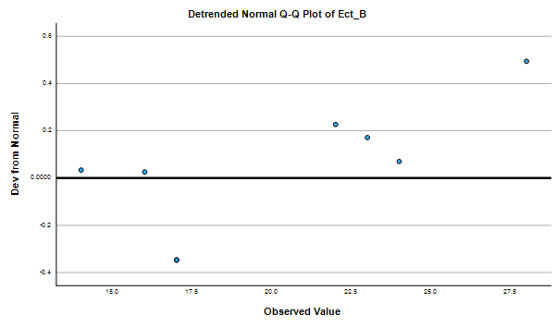

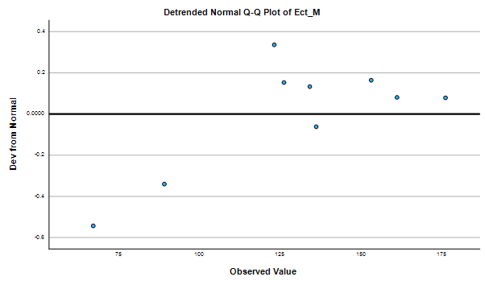

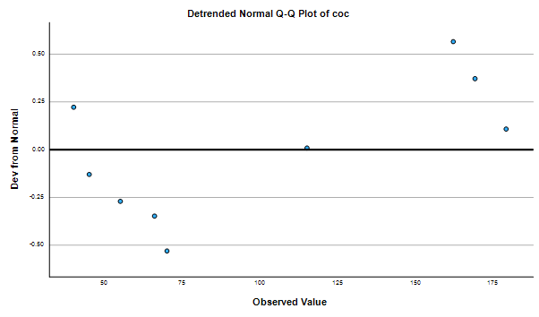

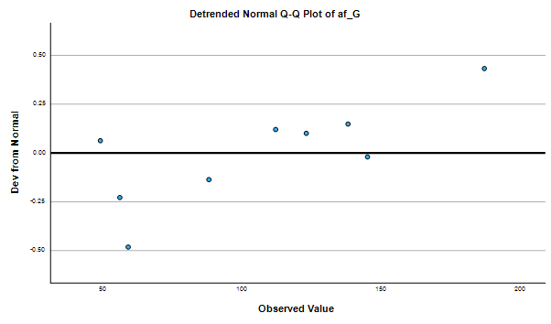

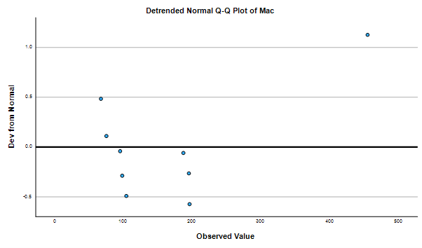

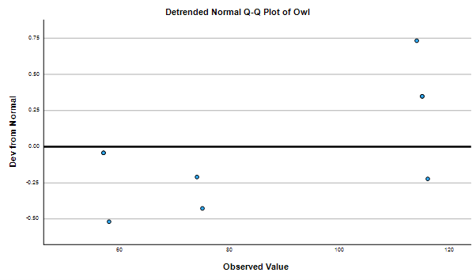

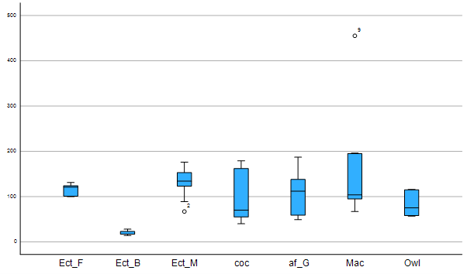

Appendix 5 Kruskal wails results of feathers from tip to start of barbules
Nonparametric Tests

Notes
Output Created |  | 17-MAR-2026 10:18:47
Comments
Input | Active Dataset | DataSet0
Input | Filter | <none>
Input | Weight | <none>
Input | Split File | <none>
Input | N of Rows in Working Data File | 324
Syntax |  | NPTESTS  /INDEPENDENT TEST (value) GROUP (group) KRUSKAL_WALLIS(COMPARE=PAIRWISE)  /MISSING SCOPE=ANALYSIS USERMISSING=EXCLUDE  /CRITERIA ALPHA=0.05 CILEVEL=95.
Resources | Processor Time | 00:00:01.24
Resources | Elapsed Time | 00:00:00.68

H ypothesis Test Summary
 | Null Hypothesis | Test | Sig.^{a,b}
1 | The distribution of value is the same across categories of group. | Independent-Samples Kruskal-Wallis Test | <.001

Hypothesis Test Summary
 | Decision
1 | Reject the null hypothesis.

a. The significance level is .050.
b. Asymptotic significance is displayed.

Independent-Samples Kruskal-Wallis Test

value across group

Independent-Samples Kruskal-Wallis Test Summary
Total N | 324
Test Statistic | 134.334ª
Degree Of Freedom | 6
Asymptotic Sig.(2-sided test) | <.001
a. The test statistic is adjusted for ties.

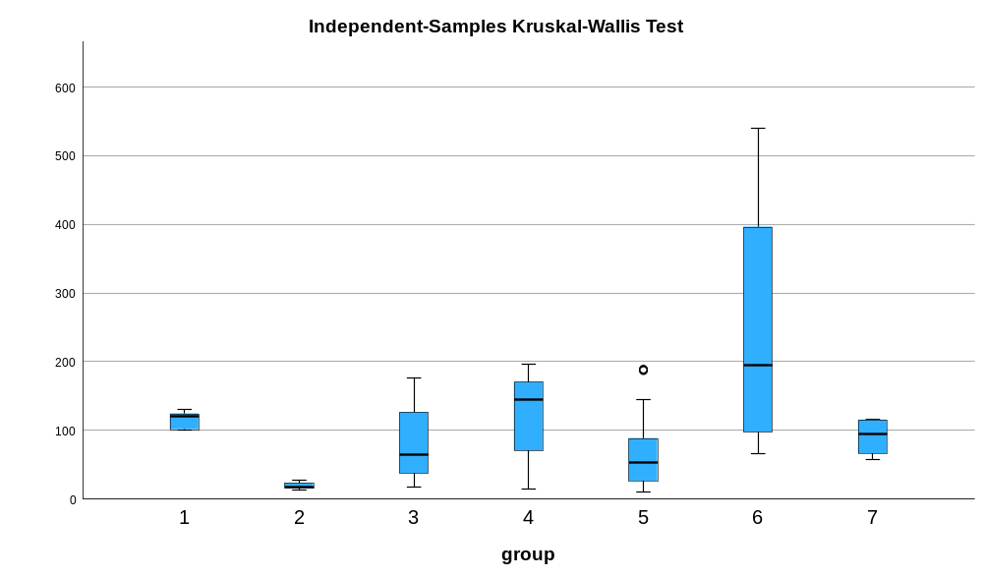

Pairwise Comparisons of group
Sample 1-Sample 2 | Test Statistic | Std. Error | Std. Test Statistic | Sig. | Adj. Sig.ª
2-5 | -85.975 | 23.468 | -3.663 | <.001 | .005
2-3 | -118.405 | 22.391 | -5.288 | <.001 | .000
2-7 | -137.161 | 33.897 | -4.046 | <.001 | .001
2-1 | 170.286 | 37.319 | 4.563 | <.001 | .000
2-4 | -189.873 | 23.345 | -8.133 | <.001 | .000
2-6 | -231.333 | 25.034 | -9.241 | <.001 | .000
5-3 | 32.430 | 14.714 | 2.204 | .028 | .578
5-7 | -51.186 | 29.396 | -1.741 | .082 | 1.000
5-1 | 84.311 | 33.284 | 2.533 | .011 | .237
5-4 | 103.898 | 16.128 | 6.442 | <.001 | .000
5-6 | -145.358 | 18.489 | -7.862 | <.001 | .000
3-7 | -18.756 | 28.544 | -.657 | .511 | 1.000
3-1 | 51.881 | 32.534 | 1.595 | .111 | 1.000
3-4 | -71.468 | 14.516 | -4.923 | <.001 | .000
3-6 | -112.929 | 17.102 | -6.603 | <.001 | .000
7-1 | 33.125 | 41.304 | .802 | .423 | 1.000
7-4 | 52.712 | 29.297 | 1.799 | .072 | 1.000
7-6 | 94.173 | 30.661 | 3.071 | .002 | .045
1-4 | -19.587 | 33.197 | -.590 | .555 | 1.000
1-6 | -61.048 | 34.406 | -1.774 | .076 | 1.000
4-6 | -41.461 | 18.332 | -2.262 | .024 | .498
Each row tests the null hypothesis that the Sample 1 and Sample 2 distributions are the same.
Asymptotic significances (2-sided tests) are displayed. The significance level is .050.
a. Significance values have been adjusted by the Bonferroni correction for multiple tests.

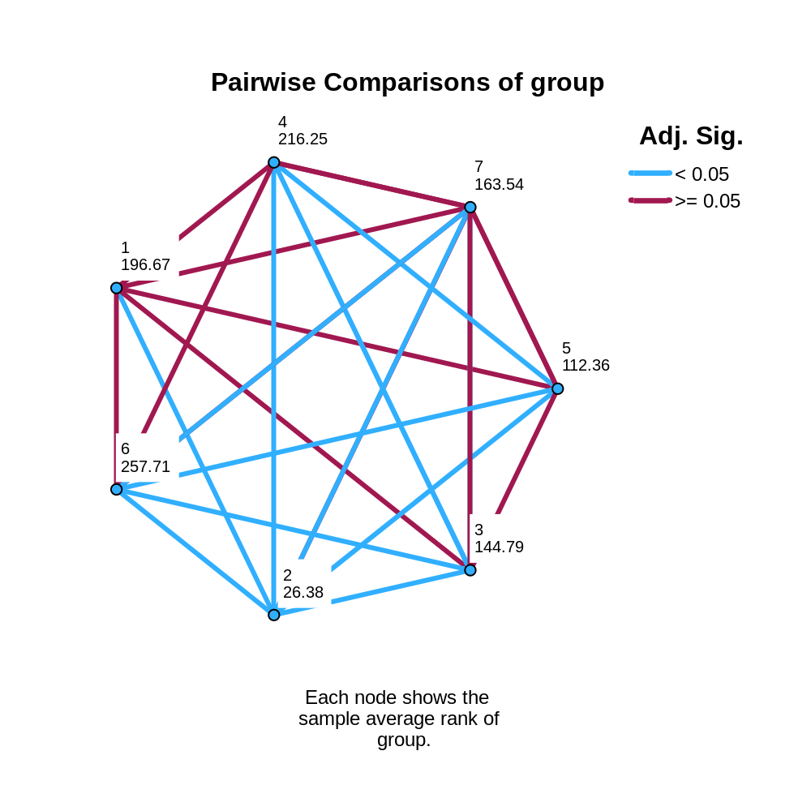

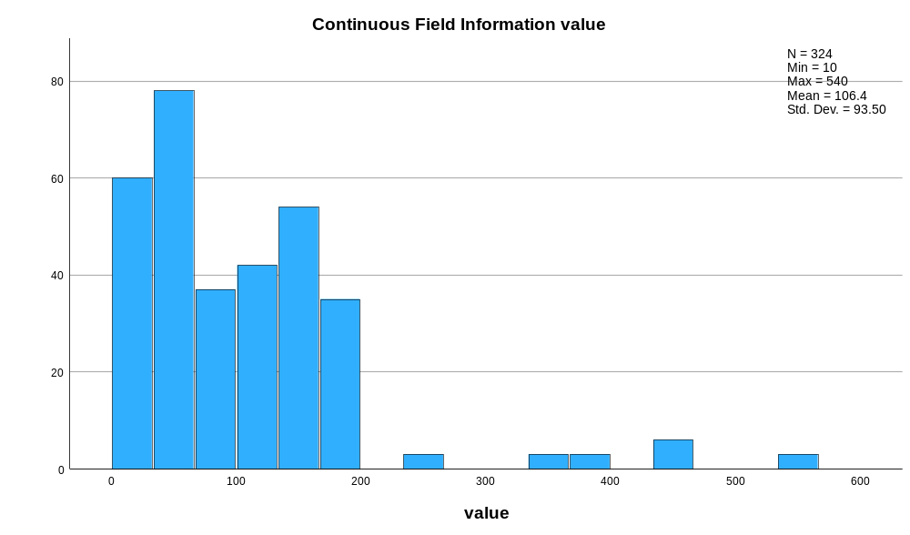

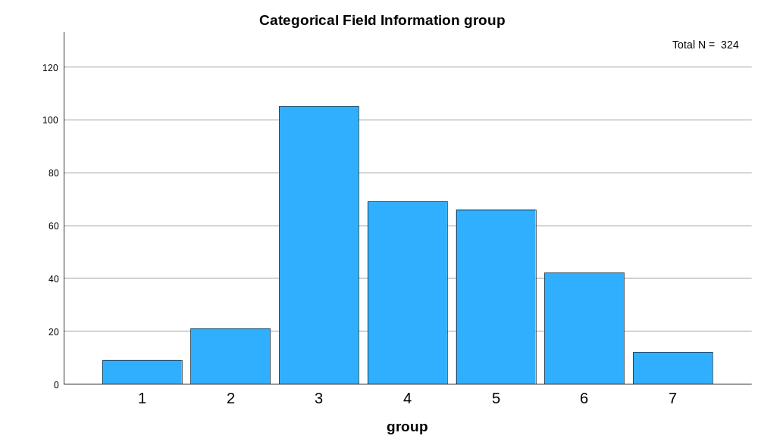

Appendix 6 table of raw data of length of feather from widest part of the feather to the tip
Bird Number | N-Value | Widest Part Feather to Tip (mm)
 |  | 1 | 2 | 3
Eclectus F1 | 3 | 29 | 29 | 29
Eclectus F2 | 3 | 44 | 46 | 46
Eclectus F3 | 3 | 35 | 36 | 37
Eclectus B1 | 3 | 11 | 12 | 10
Eclectus B2 | 3 | 7 | 8 | 8
Eclectus B3 | 3 | 17 | 15 | 14
Eclectus B4 | 3 | 10 | 10 | 9
Eclectus B5 | 3 | 10 | 9 | 9
Eclectus B6 | 3 | 18 | 18 | 18
Eclectus B7 | 3 | 19 | 20 | 18
Eclectus M1 | 3 | 87 | 88 | 87
Eclectus M2 | 3 | 51 | 51 | 50
Eclectus M3 | 3 | 36 | 36 | 34
Eclectus M4 | 3 | 63 | 64 | 64
Eclectus M5 | 3 | 93 | 94 | 93
Eclectus M6 | 3 | 51 | 50 | 51
Eclectus M7 | 3 | 78 | 79 | 80
Eclectus M8 | 3 | 67 | 68 | 66
Eclectus M9 | 3 | 49 | 48 | 49
Eclectus M10 | 3 | 18 | 18 | 17
Eclectus M11 | 3 | 29 | 28 | 28
Eclectus M12 | 3 | 20 | 21 | 20
Eclectus M13 | 3 | 46 | 47 | 46
Eclectus M14 | 3 | 36 | 37 | 36
Eclectus M15 | 3 | 41 | 42 | 41
Eclectus M16 | 3 | 21 | 20 | 20
Eclectus M17 | 3 | 18 | 19 | 18
Eclectus M18 | 3 | 34 | 33 | 34
Eclectus M19 | 3 | 22 | 21 | 22
Eclectus M20 | 3 | 1 | 2 | 2
Eclectus M21 | 3 | 21 | 20 | 19
Eclectus M22 | 3 | 14 | 15 | 14
Eclectus M23 | 3 | 23 | 24 | 24
Eclectus M24 | 3 | 20 | 21 | 20
Eclectus M25 | 3 | 13 | 14 | 13
Eclectus M26 | 3 | 14 | 13 | 13
Eclectus M27 | 3 | 9 | 9 | 10
Eclectus M28 | 3 | 112 | 112 | 113
Eclectus M29 | 3 | 45 | 46 | 46
Eclectus M30 | 3 | 90 | 89 | 80
Eclectus M31 | 3 | 96 | 98 | 96
Eclectus M32 | 3 | 52 | 51 | 53
Eclectus M33 | 3 | 23 | 24 | 24
Eclectus M34 | 3 | 13 | 15 | 13
Eclectus M35 | 3 | 11 | 12 | 11
Cockatoo 1 | 3 | 103 | 102 | 103
Cockatoo 2 | 3 | 90 | 90 | 90
Cockatoo 3 | 3 | 110 | 109 | 108
Cockatoo 4 | 3 | 50 | 49 | 49
Cockatoo 5 | 3 | 35 | 34 | 32
Cockatoo 6 | 3 | 28 | 27 | 29
Cockatoo 7 | 3 | 16 | 15 | 17
Cockatoo 8 | 3 | 20 | 18 | 19
Cockatoo 9 | 3 | 7 | 6 | 6
Cockatoo 10 | 3 | 14 | 13 | 15
Cockatoo 11 | 3 | 30 | 30 | 29
Cockatoo 12 | 3 | 120 | 120 | 119
Cockatoo 13 | 3 | 64 | 61 | 61
Cockatoo 14 | 3 | 32 | 31 | 31
Cockatoo 15 | 3 | 76 | 74 | 75
Cockatoo 16 | 3 | 149 | 148 | 148
Cockatoo 17 | 3 | 60 | 60 | 59
Cockatoo 18 | 3 | 120 | 115 | 118
Cockatoo 19 | 3 | 87 | 86 | 87
Cockatoo 20 | 3 | 122 | 122 | 121
Cockatoo 21 | 3 | 26 | 26 | 25
Cockatoo 22 | 3 | 152 | 155 | 156
Cockatoo 23 | 3 | 153 | 154 | 153
African G1 | 3 | 79 | 80 | 80
African G2 | 3 | 109 | 108 | 108
African G3 | 3 | 92 | 96 | 97
African G4 | 3 | 44 | 45 | 44
African G5 | 3 | 26 | 26 | 25
African G6 | 3
African G7 | 3 | 32 | 31 | 32
African G8 | 3 | 71 | 72 | 72
African G9 | 3 | 40 | 41 | 40
African G10 | 3 | 62 | 62 | 62
African G11 | 3 | 35 | 34 | 35
African G12 | 3 | 7 | 6 | 7
African G13 | 3 | 6 | 5 | 5
African G14 | 3 | 11 | 12 | 11
African G15 | 3 | 16 | 18 | 16
African G16 | 3 | 11 | 10 | 11
African G17 | 3 | 28 | 26 | 25
African G18 | 3 | 19 | 19 | 18
African G19 | 3 | 6 | 5 | 6
African G20 | 3 | 18 | 17 | 18
African G21 | 3 | 13 | 14 | 13
African G22 | 3 | 42 | 43 | 41
Macaw 1 | 3 | 40 | 40 | 40
Macaw 2 | 3 | 51 | 52 | 52
Macaw 3 | 3 | 30 | 31 | 30
Macaw 5 | 3 | 50 | 51 | 54
Macaw 6 | 3 | 46 | 46 | 46
Macaw 7 | 3 | 125 | 127 | 129
Macaw 8 | 3 | 71 | 72 | 72
Macaw 9 | 3 | 139 | 138 | 137
Macaw 11 | 3 | 339 | 338 | 338
Macaw 12 | 3 | 400 | 401 | 401
Macaw 13 | 3 | 250 | 249 | 248
Macaw 14 | 3 | 240 | 239 | 239
Macaw 15 | 3 | 345 | 346 | 346
Macaw 16 | 3 | 155 | 151 | 150
Owl 1 | 3 | 34 | 35 | 34
Owl 2 | 3 | 40 | 40 | 39
Owl 3 | 3 | 54 | 55 | 55
Owl 4 | 3 | 74 | 78 | 74

Appendix 7 descriptive statistics of length of feather from widest part of the feather to the tip
Explore
Notes
Output Created |  | 17-MAR-2026 11:10:24
Comments
Input | Active Dataset | DataSet0
Input | Filter | <none>
Input | Weight | <none>
Input | Split File | <none>
Input | N of Rows in Working Data File | 324
Missing Value Handling | Definition of Missing | User-defined missing values for dependent variables are treated as missing.
Missing Value Handling | Cases Used | Statistics are based on cases with no missing values for any dependent variable or factor used.
Syntax |  | EXAMINE VARIABLES=value BY group  /PLOT BOXPLOT HISTOGRAM NPPLOT  /COMPARE GROUPS  /STATISTICS DESCRIPTIVES  /CINTERVAL 95  /MISSING LISTWISE  /NOTOTAL.
Resources | Processor Time | 00:00:02.37
Resources | Elapsed Time | 00:00:02.23

group

Case Processing Summary
 | group | Cases
 | group | Valid |  | Missing |  | Total
 | group | N | Percent | N | Percent | N | Percent
value | 1 | 9 | 100.0% | 0 | 0.0% | 9 | 100.0%
value | 2 | 21 | 100.0% | 0 | 0.0% | 21 | 100.0%
value | 3 | 105 | 100.0% | 0 | 0.0% | 105 | 100.0%
value | 4 | 69 | 100.0% | 0 | 0.0% | 69 | 100.0%
value | 5 | 66 | 100.0% | 0 | 0.0% | 66 | 100.0%
value | 6 | 42 | 100.0% | 0 | 0.0% | 42 | 100.0%
value | 7 | 12 | 100.0% | 0 | 0.0% | 12 | 100.0%

Descriptives
 | group |  |  | Statistic | Std. Error
value | 1 | Mean |  | 36.78 | 2.379
value | 1 | 95% Confidence Interval for Mean | Lower Bound | 31.29
value | 1 | 95% Confidence Interval for Mean | Upper Bound | 42.26
value | 1 | 5% Trimmed Mean |  | 36.70
value | 1 | Median |  | 36.00
value | 1 | Variance |  | 50.944
value | 1 | Std. Deviation |  | 7.138
value | 1 | Minimum |  | 29
value | 1 | Maximum |  | 46
value | 1 | Range |  | 17
value | 1 | Interquartile Range |  | 16
value | 1 | Skewness |  | .233 | .717
value | 1 | Kurtosis |  | -1.663 | 1.400
value | 2 | Mean |  | 12.86 | .952
value | 2 | 95% Confidence Interval for Mean | Lower Bound | 10.87
value | 2 | 95% Confidence Interval for Mean | Upper Bound | 14.84
value | 2 | 5% Trimmed Mean |  | 12.79
value | 2 | Median |  | 11.00
value | 2 | Variance |  | 19.029
value | 2 | Std. Deviation |  | 4.362
value | 2 | Minimum |  | 7
value | 2 | Maximum |  | 20
value | 2 | Range |  | 13
value | 2 | Interquartile Range |  | 9
value | 2 | Skewness |  | .346 | .501
value | 2 | Kurtosis |  | -1.573 | .972
value | 3 | Mean |  | 40.50 | 2.805
value | 3 | 95% Confidence Interval for Mean | Lower Bound | 34.94
value | 3 | 95% Confidence Interval for Mean | Upper Bound | 46.07
value | 3 | 5% Trimmed Mean |  | 38.86
value | 3 | Median |  | 34.00
value | 3 | Variance |  | 826.272
value | 3 | Std. Deviation |  | 28.745
value | 3 | Minimum |  | 1
value | 3 | Maximum |  | 113
value | 3 | Range |  | 112
value | 3 | Interquartile Range |  | 33
value | 3 | Skewness |  | .896 | .236
value | 3 | Kurtosis |  | -.205 | .467
value | 4 | Mean |  | 71.87 | 5.783
value | 4 | 95% Confidence Interval for Mean | Lower Bound | 60.33
value | 4 | 95% Confidence Interval for Mean | Upper Bound | 83.41
value | 4 | 5% Trimmed Mean |  | 70.86
value | 4 | Median |  | 61.00
value | 4 | Variance |  | 2307.556
value | 4 | Std. Deviation |  | 48.037
value | 4 | Minimum |  | 6
value | 4 | Maximum |  | 156
value | 4 | Range |  | 150
value | 4 | Interquartile Range |  | 88
value | 4 | Skewness |  | .318 | .289
value | 4 | Kurtosis |  | -1.262 | .570
value | 5 | Mean |  | 36.36 | 3.590
value | 5 | 95% Confidence Interval for Mean | Lower Bound | 29.19
value | 5 | 95% Confidence Interval for Mean | Upper Bound | 43.53
value | 5 | 5% Trimmed Mean |  | 34.16
value | 5 | Median |  | 29.00
value | 5 | Variance |  | 850.758
value | 5 | Std. Deviation |  | 29.168
value | 5 | Minimum |  | 5
value | 5 | Maximum |  | 109
value | 5 | Range |  | 104
value | 5 | Interquartile Range |  | 31
value | 5 | Skewness |  | 1.085 | .295
value | 5 | Kurtosis |  | .239 | .582
value | 6 | Mean |  | 162.95 | 19.373
value | 6 | 95% Confidence Interval for Mean | Lower Bound | 123.83
value | 6 | 95% Confidence Interval for Mean | Upper Bound | 202.08
value | 6 | 5% Trimmed Mean |  | 157.11
value | 6 | Median |  | 133.00
value | 6 | Variance |  | 15762.632
value | 6 | Std. Deviation |  | 125.549
value | 6 | Minimum |  | 30
value | 6 | Maximum |  | 401
value | 6 | Range |  | 371
value | 6 | Interquartile Range |  | 199
value | 6 | Skewness |  | .646 | .365
value | 6 | Kurtosis |  | -1.035 | .717
value | 7 | Mean |  | 51.00 | 4.805
value | 7 | 95% Confidence Interval for Mean | Lower Bound | 40.42
value | 7 | 95% Confidence Interval for Mean | Upper Bound | 61.58
value | 7 | 5% Trimmed Mean |  | 50.44
value | 7 | Median |  | 47.00
value | 7 | Variance |  | 277.091
value | 7 | Std. Deviation |  | 16.646
value | 7 | Minimum |  | 34
value | 7 | Maximum |  | 78
value | 7 | Range |  | 44
value | 7 | Interquartile Range |  | 33
value | 7 | Skewness |  | .612 | .637
value | 7 | Kurtosis |  | -1.213 | 1.232

Tests of Normality
 | group | Kolmogorov-Smirnovª |  |  | Shapiro-Wilk
 | group | Statistic | df | Sig. | Statistic | df | Sig.
value | 1 | .195 | 9 | .200* | .856 | 9 | .088
value | 2 | .220 | 21 | .009 | .876 | 21 | .012
value | 3 | .174 | 105 | <.001 | .893 | 105 | <.001
value | 4 | .170 | 69 | <.001 | .912 | 69 | <.001
value | 5 | .156 | 66 | <.001 | .866 | 66 | <.001
value | 6 | .194 | 42 | <.001 | .854 | 42 | <.001
value | 7 | .246 | 12 | .044 | .850 | 12 | .036
*. This is a lower bound of the true significance.
a. Lilliefors Significance Correction

value

Histograms

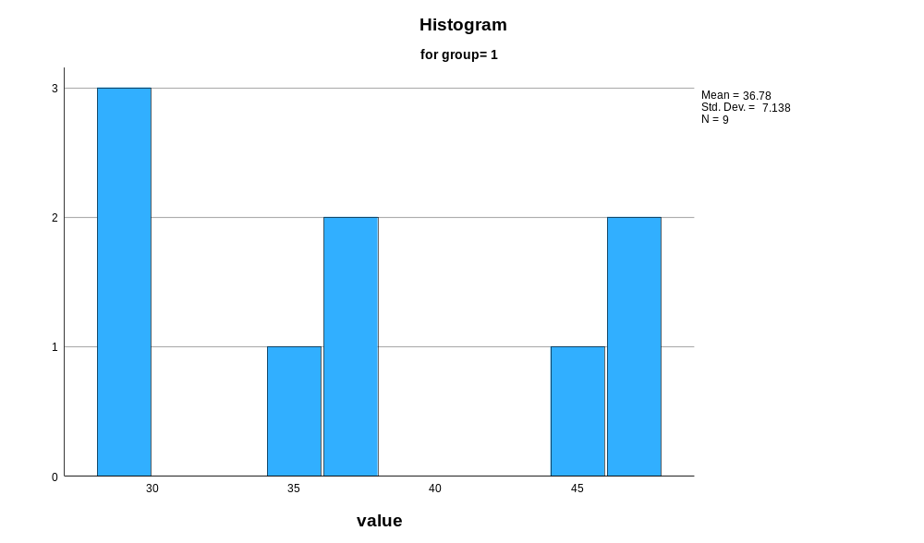

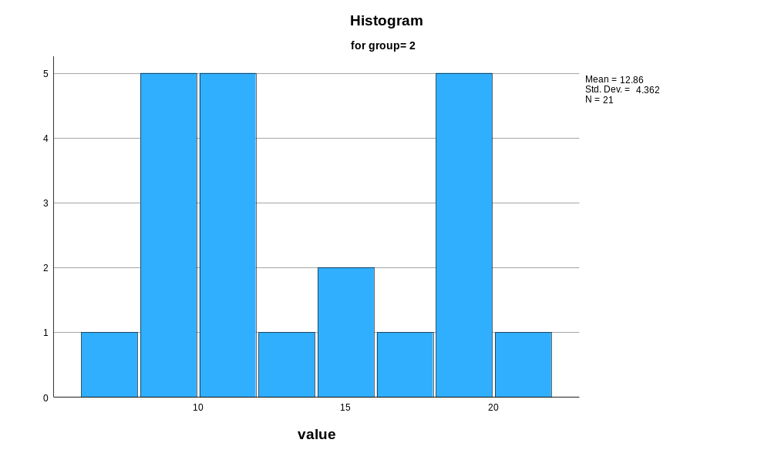

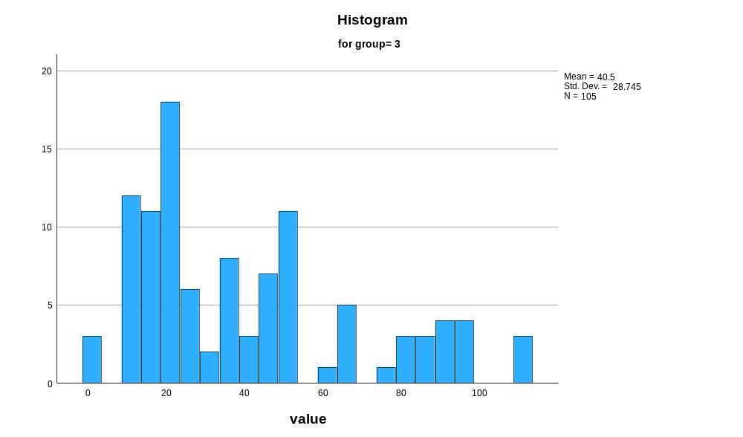

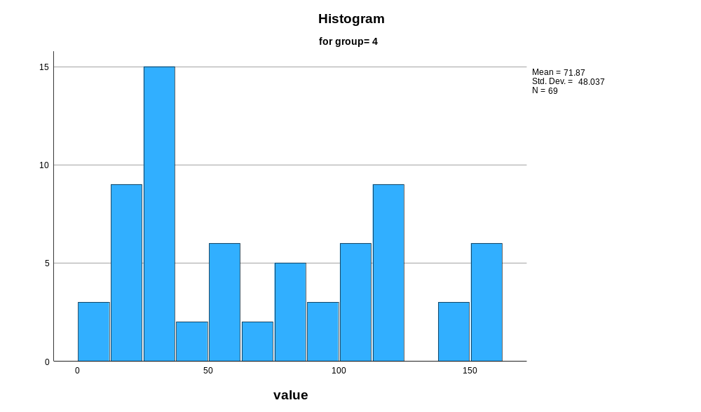

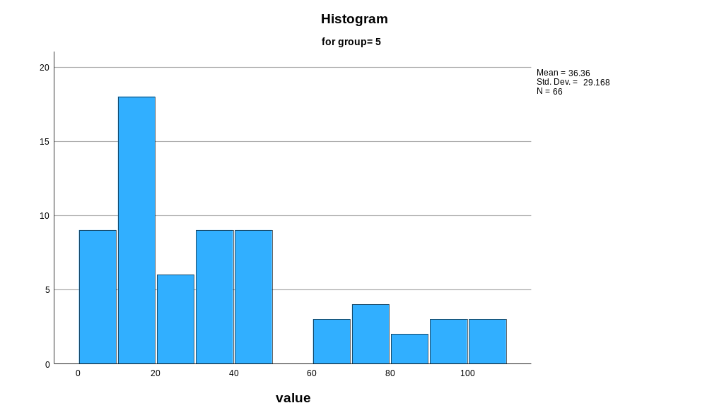

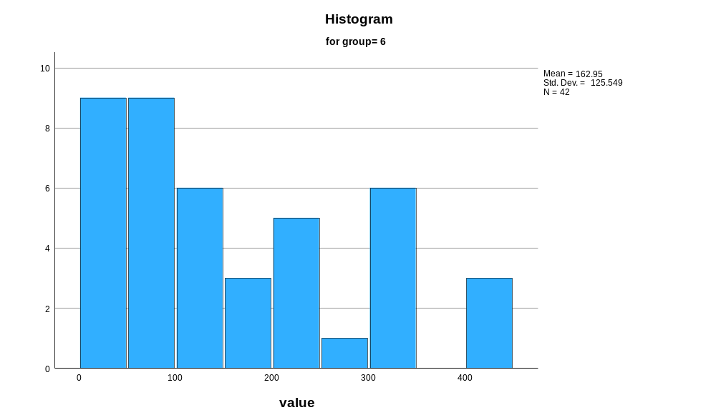

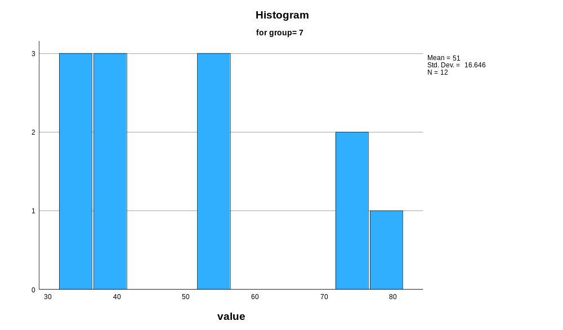

Normal Q-Q Plots

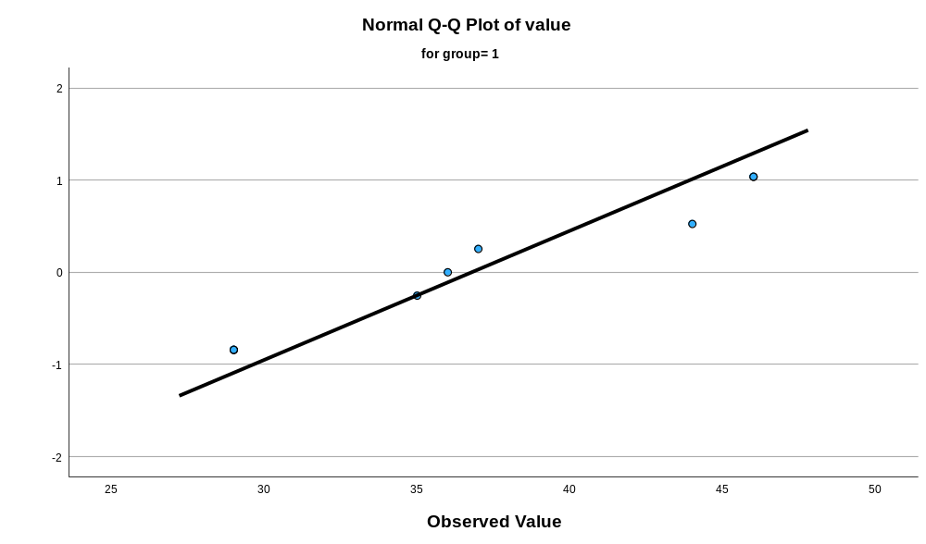

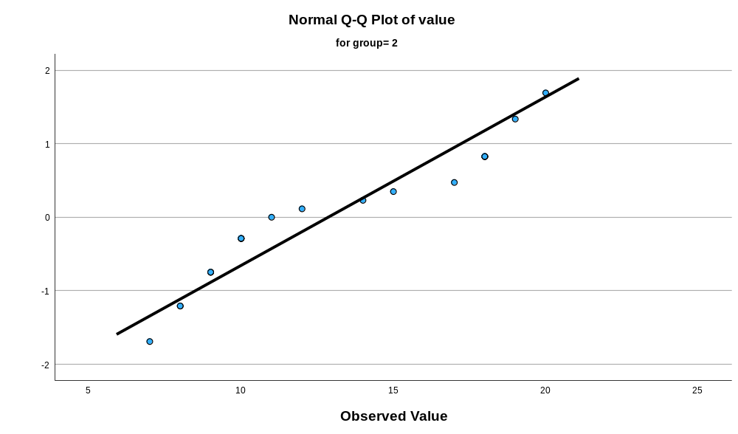

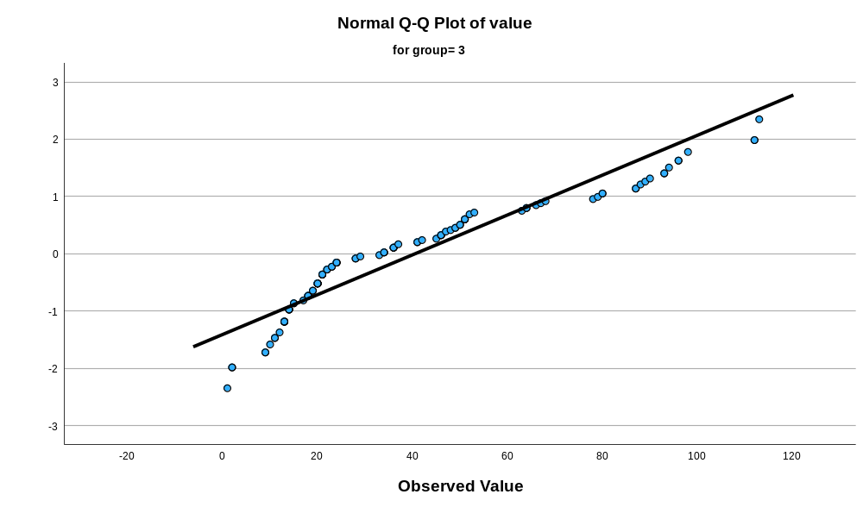

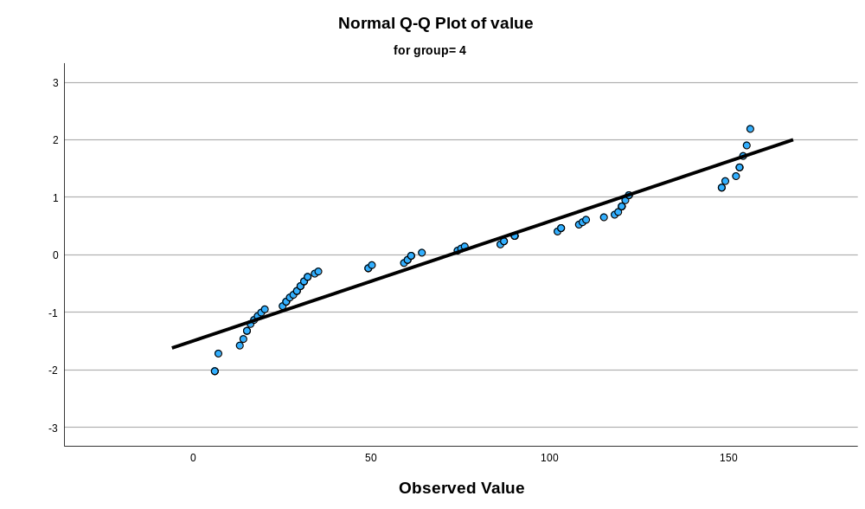

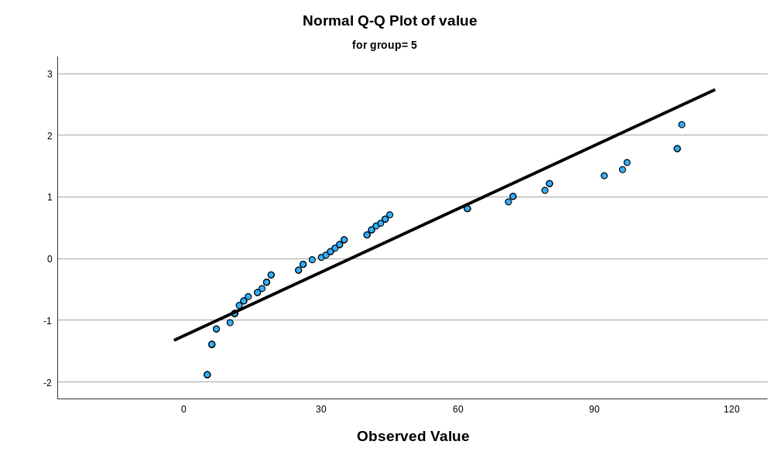

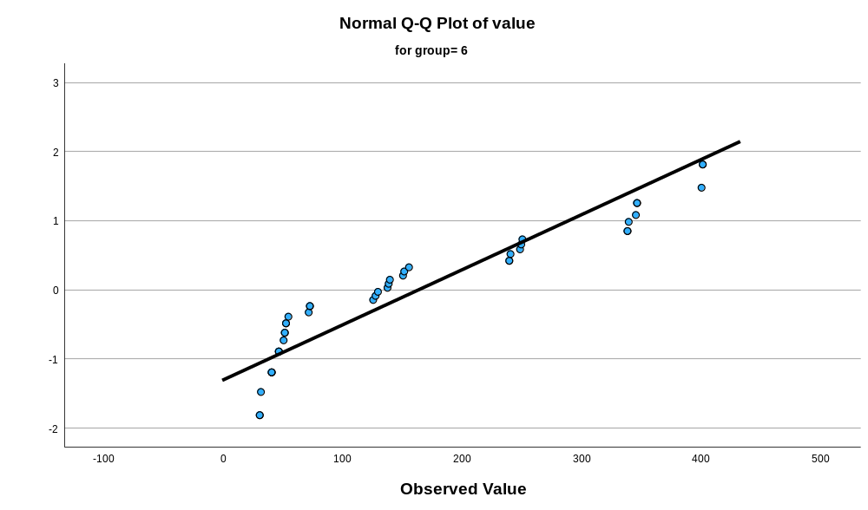

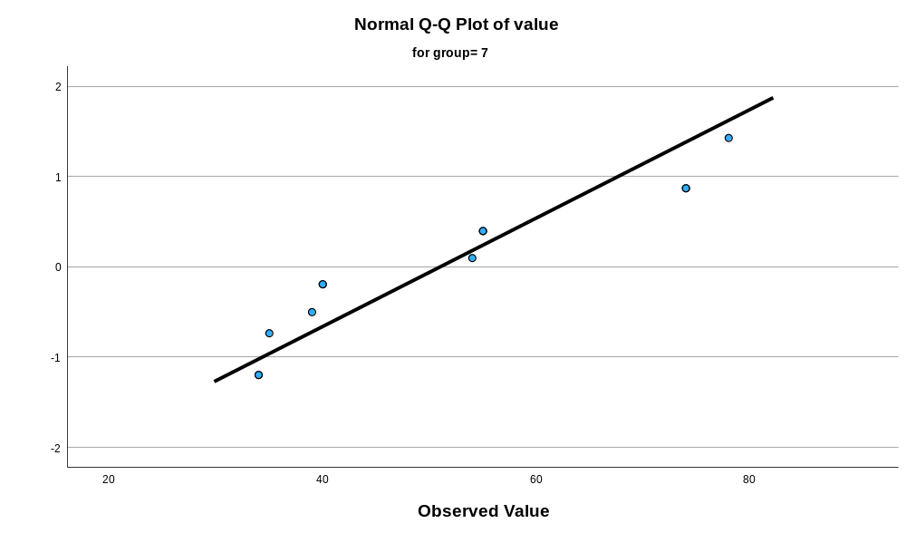

Detrended Normal Q-Q Plots

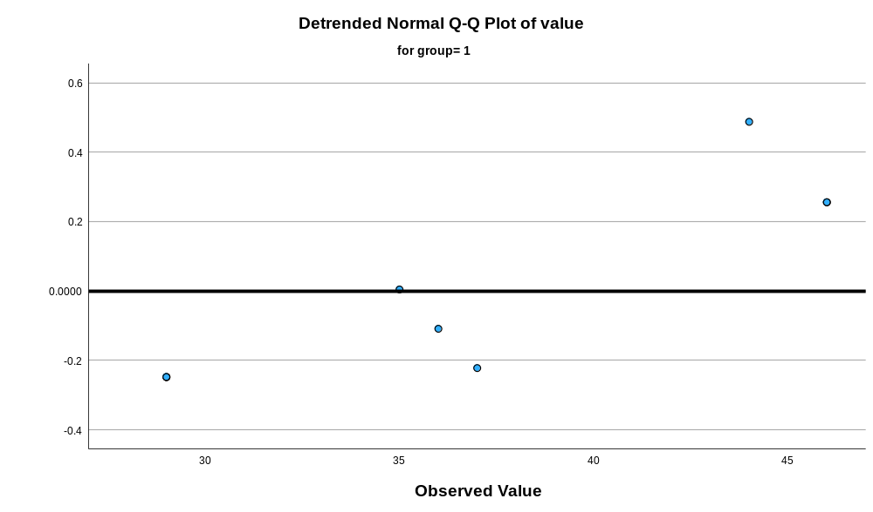

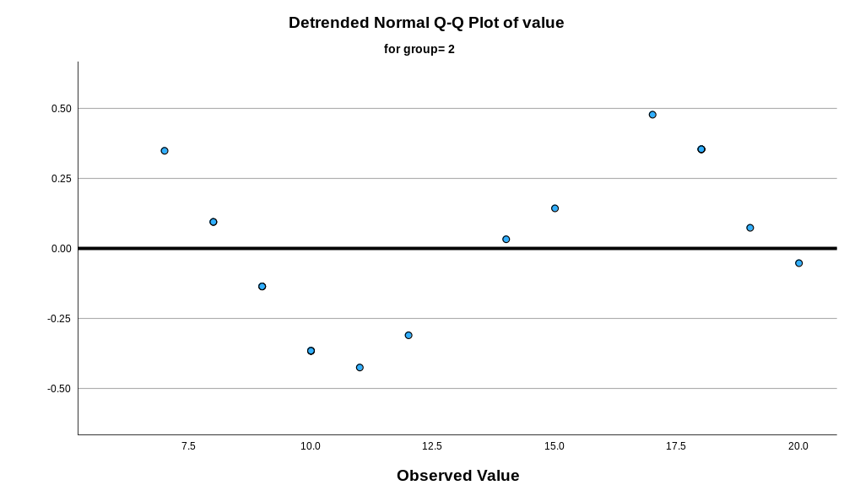

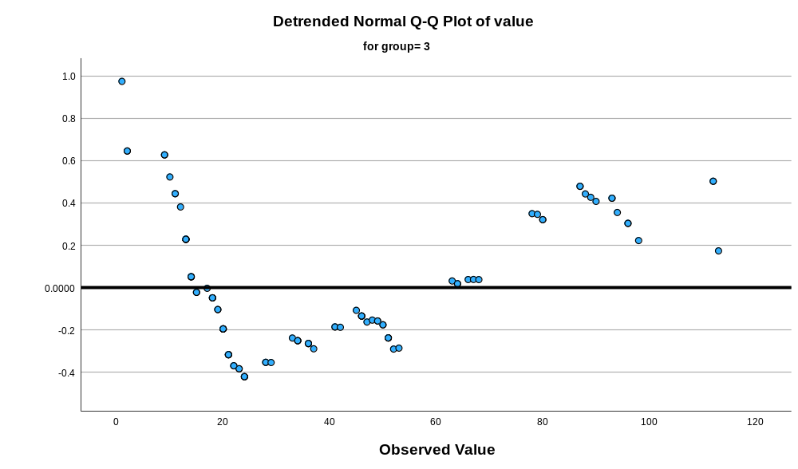

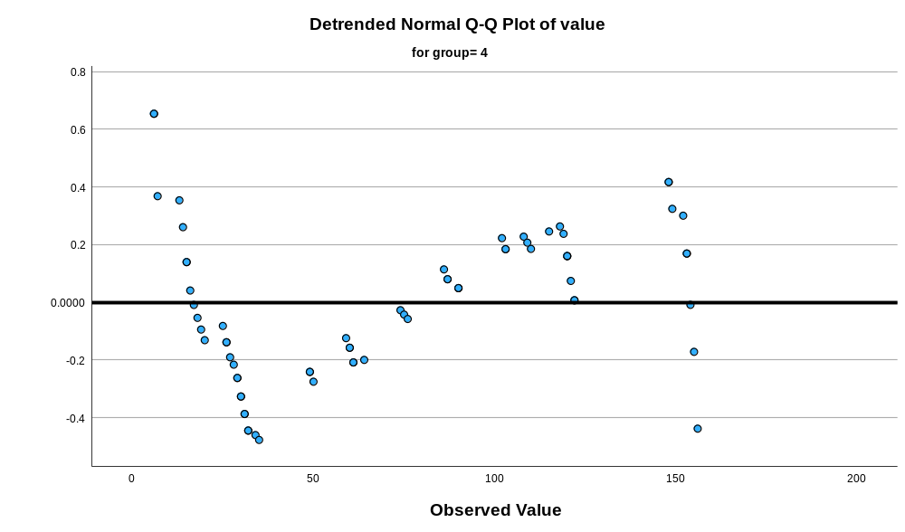

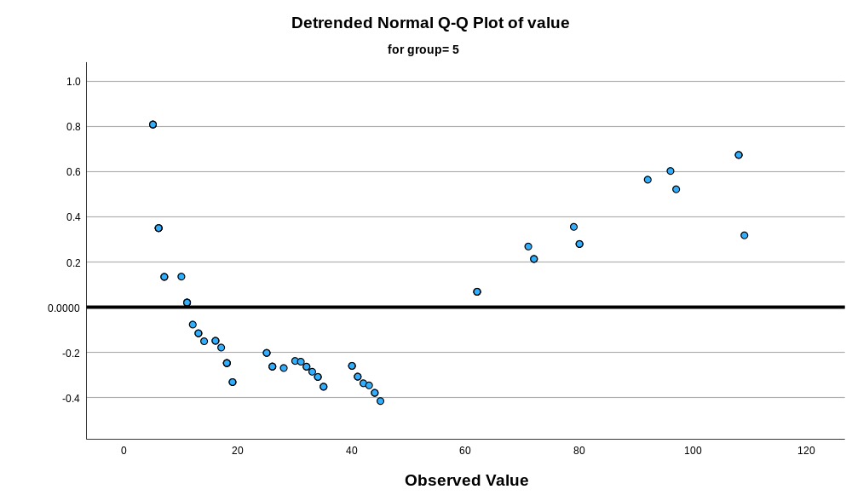

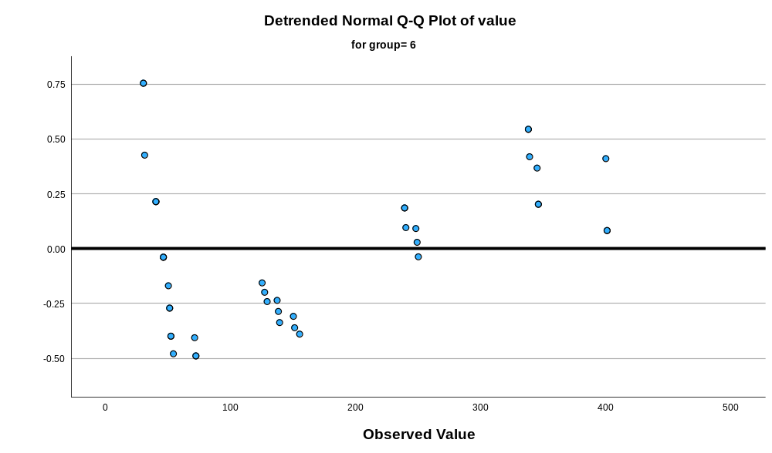

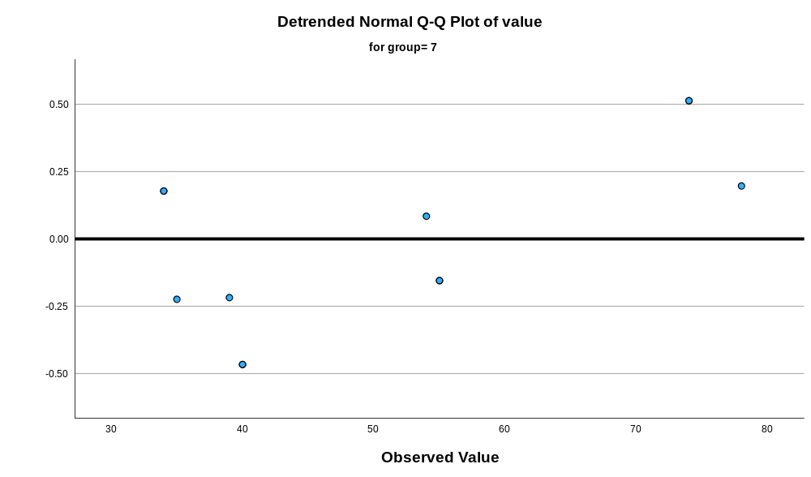

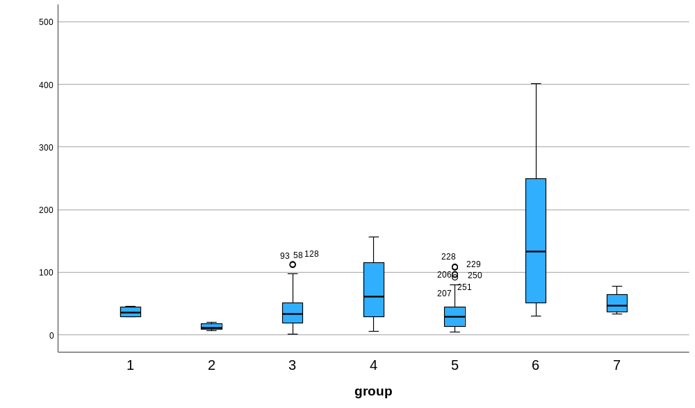

Appendix 8 Kruskal Walis test of feathers from widest part to the tip
Nonparametric Tests

Notes
Output Created |  | 17-MAR-2026 11:11:19
Comments
Input | Active Dataset | DataSet0
Input | Filter | <none>
Input | Weight | <none>
Input | Split File | <none>
Input | N of Rows in Working Data File | 324
Syntax |  | NPTESTS  /INDEPENDENT TEST (value) GROUP (group) KRUSKAL_WALLIS(COMPARE=PAIRWISE)  /MISSING SCOPE=ANALYSIS USERMISSING=EXCLUDE  /CRITERIA ALPHA=0.05 CILEVEL=95.
Resources | Processor Time | 00:00:00.53
Resources | Elapsed Time | 00:00:00.51

Hypothesis Test Summary
 | Null Hypothesis | Test | Sig.^{a,b}
1 | The distribution of value is the same across categories of group. | Independent-Samples Kruskal-Wallis Test | <.001

Hypothesis Test Summary
 | Decision
1 | Reject the null hypothesis.

a. The significance level is .050.
b. Asymptotic significance is displayed.

Independent-Samples Kruskal-Wallis Test

value across group

Independent-Samples Kruskal-Wallis Test Summary
Total N | 324
Test Statistic | 102.101ª
Degree Of Freedom | 6
Asymptotic Sig.(2-sided test) | <.001
a. The test statistic is adjusted for ties.

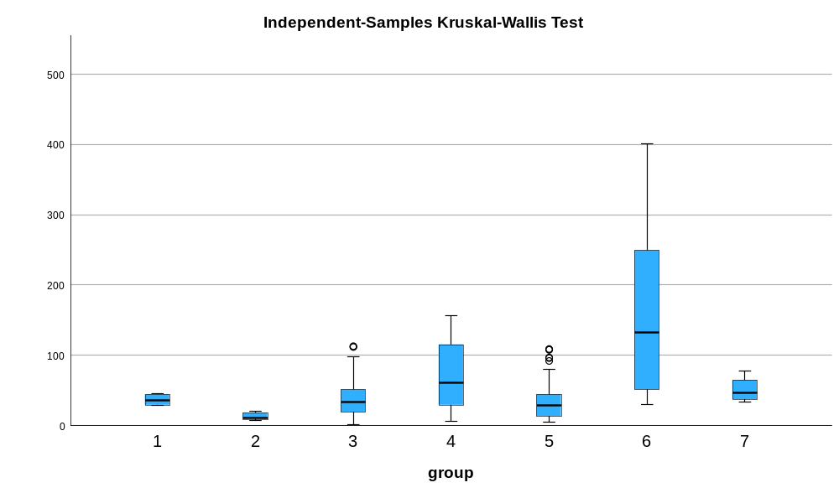

Pairwise Comparisons of group
Sample 1-Sample 2 | Test Statistic | Std. Error | Std. Test Statistic | Sig. | Adj. Sig.ª
2-5 | -81.907 | 23.466 | -3.490 | <.001 | .010
2-3 | -99.657 | 22.390 | -4.451 | <.001 | .000
2-1 | 110.897 | 37.316 | 2.972 | .003 | .062
2-7 | -147.869 | 33.894 | -4.363 | <.001 | .000
2-4 | -153.764 | 23.343 | -6.587 | <.001 | .000
2-6 | -213.440 | 25.032 | -8.527 | <.001 | .000
5-3 | 17.750 | 14.713 | 1.206 | .228 | 1.000
5-1 | 28.990 | 33.281 | .871 | .384 | 1.000
5-7 | -65.962 | 29.393 | -2.244 | .025 | .521
5-4 | 71.857 | 16.126 | 4.456 | <.001 | .000
5-6 | -131.534 | 18.488 | -7.115 | <.001 | .000
3-1 | 11.240 | 32.531 | .346 | .730 | 1.000
3-7 | -48.212 | 28.541 | -1.689 | .091 | 1.000
3-4 | -54.107 | 14.515 | -3.728 | <.001 | .004
3-6 | -113.783 | 17.100 | -6.654 | <.001 | .000
1-7 | -36.972 | 41.301 | -.895 | .371 | 1.000
1-4 | -42.867 | 33.195 | -1.291 | .197 | 1.000
1-6 | -102.544 | 34.404 | -2.981 | .003 | .060
7-4 | 5.895 | 29.295 | .201 | .841 | 1.000
7-6 | 65.571 | 30.658 | 2.139 | .032 | .682
4-6 | -59.677 | 18.331 | -3.256 | .001 | .024
Each row tests the null hypothesis that the Sample 1 and Sample 2 distributions are the same.
Asymptotic significances (2-sided tests) are displayed. The significance level is .050.
a. Significance values have been adjusted by the Bonferroni correction for multiple tests.

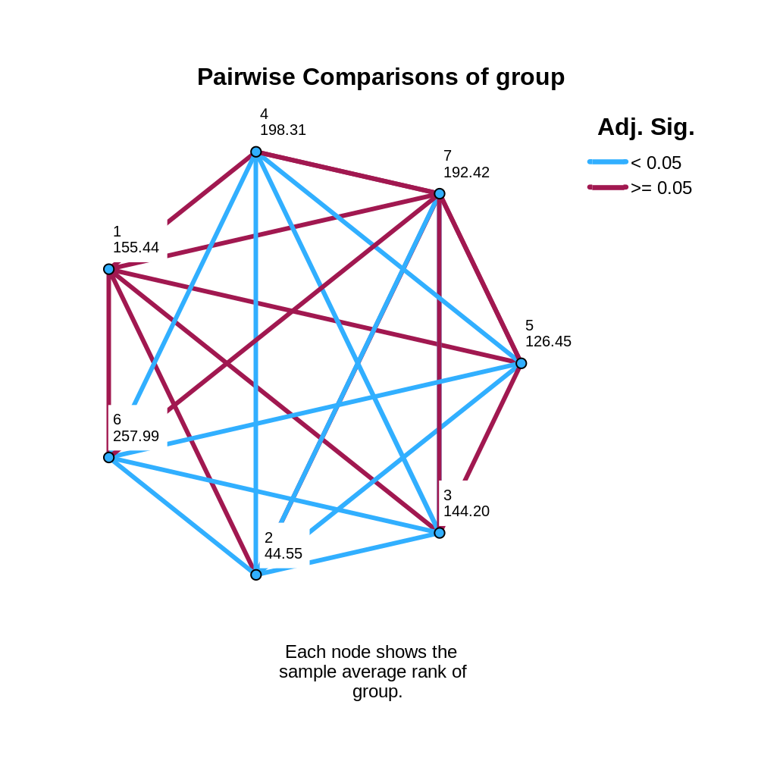

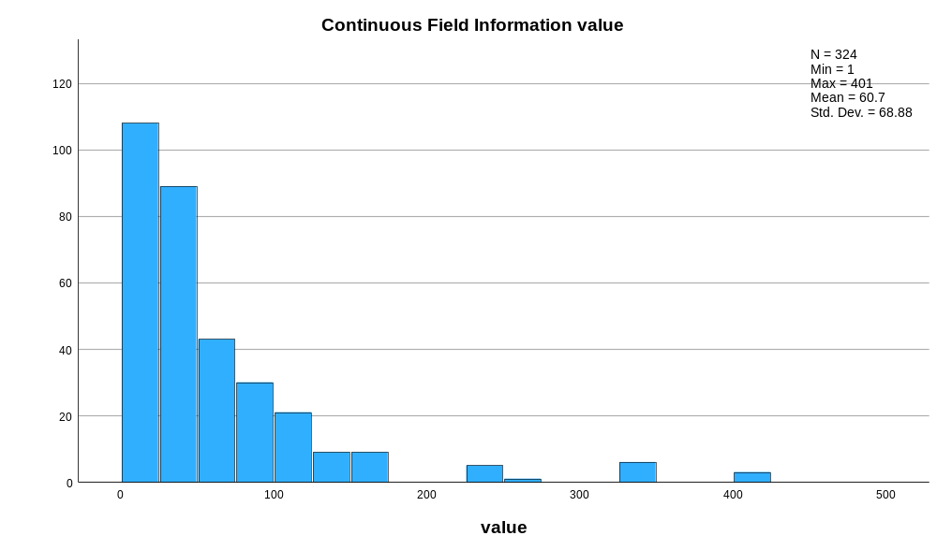

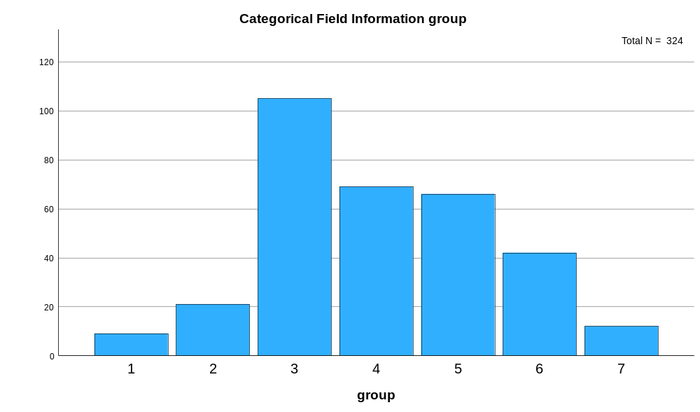

Appendix 9 raw data of widths 1cm from the bottom
Bird Number | N-Value | Width 1cm from Bottom (mm)
 |  | 1 | 2 | 3
Eclectus F1 | 3 | 26 | 28 | 30
Eclectus F2 | 3 | 30 | 30 | 29
Eclectus F3 | 3 | 30 | 29 | 28
Eclectus B1 | 3 | 17 | 16 | 17
Eclectus B2 | 3 | 18 | 17 | 18
Eclectus B3 | 3 | 17 | 18 | 19
Eclectus B4 | 3 | 16 | 16 | 16
Eclectus B5 | 3 | 11 | 12 | 13
Eclectus B6 | 3 | 17 | 17 | 17
Eclectus B7 | 3 | 18 | 16 | 17
Eclectus M1 | 3 | 22 | 21 | 22
Eclectus M2 | 3 | 41 | 40 | 41
Eclectus M3 | 3 | 31 | 30 | 31
Eclectus M4 | 3 | 10 | 11 | 12
Eclectus M5 | 3 | 13 | 14 | 14
Eclectus M6 | 3 | 19 | 19 | 20
Eclectus M7 | 3 | 36 | 35 | 36
Eclectus M8 | 3 | 18 | 17 | 16
Eclectus M9 | 3 | 15 | 14 | 15
Eclectus M10 | 3 | 26 | 26 | 25
Eclectus M11 | 3 | 26 | 25 | 26
Eclectus M12 | 3 | 33 | 34 | 34
Eclectus M13 | 3 | 21 | 22 | 21
Eclectus M14 | 3 | 30 | 29 | 29
Eclectus M15 | 3 | 34 | 30 | 32
Eclectus M16 | 3 | 19 | 20 | 22
Eclectus M17 | 3 | 27 | 28 | 27
Eclectus M18 | 3 | 22 | 23 | 23
Eclectus M19 | 3 | 14 | 15 | 14
Eclectus M20 | 3 | 18 | 17 | 18
Eclectus M21 | 3 | 11 | 10 | 11
Eclectus M22 | 3 | 25 | 24 | 25
Eclectus M23 | 3 | 25 | 26 | 25
Eclectus M24 | 3 | 20 | 20 | 19
Eclectus M25 | 3 | 15 | 16 | 15
Eclectus M26 | 3 | 24 | 24 | 26
Eclectus M27 | 3 | 21 | 22 | 23
Eclectus M28 | 3 | 25 | 24 | 24
Eclectus M29 | 3 | 27 | 27 | 28
Eclectus M30 | 3 | 15 | 17 | 16
Eclectus M31 | 3 | 28 | 27 | 29
Eclectus M32 | 3 | 36 | 35 | 35
Eclectus M33 | 3 | 21 | 22 | 22
Eclectus M34 | 3 | 26 | 27 | 26
Eclectus M35 | 3 | 18 | 20 | 19
Cockatoo 1 | 3 | 18 | 18 | 18
Cockatoo 2 | 3 | 12 | 10 | 10
Cockatoo 3 | 3 | 3 | 4 | 4
Cockatoo 4 | 3 | 9 | 9 | 8
Cockatoo 5 | 3 | 20 | 19 | 20
Cockatoo 6 | 3 | 7 | 5 | 6
Cockatoo 7 | 3 | 10 | 9 | 9
Cockatoo 8 | 3 | 15 | 18 | 17
Cockatoo 9 | 3 | 8 | 11 | 10
Cockatoo 10 | 3 | 9 | 7 | 8
Cockatoo 11 | 3 | 25 | 25 | 25
Cockatoo 12 | 3 | 34 | 33 | 33
Cockatoo 13 | 3 | 43 | 41 | 41
Cockatoo 14 | 3 | 34 | 30 | 32
Cockatoo 15 | 3 | 55 | 54 | 50
Cockatoo 16 | 3 | 75 | 76 | 79
Cockatoo 17 | 3 | 45 | 46 | 45
Cockatoo 18 | 3 | 45 | 43 | 47
Cockatoo 19 | 3 | 65 | 67 | 62
Cockatoo 20 | 3 | 45 | 46 | 45
Cockatoo 21 | 3 | 20 | 21 | 22
Cockatoo 22 | 3 | 52 | 49 | 48
Cockatoo 23 | 3 | 49 | 50 | 49
African G1 | 3 | 20 | 25 | 23
African G2 | 3 | 22 | 24 | 23
African G3 | 3 | 12 | 13 | 13
African G4 | 3 | 18 | 18 | 16
African G5 | 3 | 19 | 19 | 19
African G6 | 3 | 28 | 26 | 28
African G7 | 3 | 17 | 16 | 16
African G8 | 3 | 26 | 26 | 25
African G9 | 3 | 25 | 25 | 26
African G10 | 3 | 24 | 23 | 24
African G11 | 3 | 20 | 20 | 21
African G12 | 3 | 4 | 4 | 4
African G13 | 3 | 3 | 4 | 3
African G14 | 3 | 24 | 22 | 23
African G15 | 3 | 12 | 13 | 13
African G16 | 3 | 19 | 19 | 18
African G17 | 3 | 21 | 23 | 21
African G18 | 3 | 18 | 19 | 19
African G19 | 3 | 14 | 13 | 14
African G20 | 3 | 14 | 14 | 13
African G21 | 3 | 19 | 20 | 19
African G22 | 3 | 18 | 19 | 18
Macaw 1 | 3 | 15 | 15 | 16
Macaw 2 | 3 | 10 | 10 | 10
Macaw 3 | 3 | 5 | 5 | 5
Macaw 5 | 3 | 12 | 13 | 12
Macaw 6 | 3 | 18 | 18 | 19
Macaw 7 | 3 | 13 | 10 | 10
Macaw 8 | 3 | 15 | 14 | 18
Macaw 9 | 3 | 25 | 24 | 24
Macaw 11 | 3 | 13 | 14 | 13
Macaw 12 | 3 | 9 | 12 | 13
Macaw 13 | 3 | 29 | 28 | 29
Macaw 14 | 3 | 21 | 20 | 20
Macaw 15 | 3 | 10 | 10 | 10
Macaw 16 | 3 | 21 | 20 | 18
Owl 1 | 3 | 19 | 25 | 20
Owl 2 | 3 | 32 | 32 | 31
Owl 3 | 3 | 30 | 33 | 33
Owl 4 | 3 | 50 | 45 | 45

Appendix 10 descriptive test of feathers width 1cm from the bottom of the barbules
Explore

Notes
Output Created |  | 16-MAR-2026 13:09:56
Comments
Input | Active Dataset | DataSet0
Input | Filter | <none>
Input | Weight | <none>
Input | Split File | <none>
Input | N of Rows in Working Data File | 105
Missing Value Handling | Definition of Missing | User-defined missing values for dependent variables are treated as missing.
Missing Value Handling | Cases Used | Statistics are based on cases with no missing values for any dependent variable or factor used.
Syntax |  | EXAMINE VARIABLES=Ect_F Ect_B Ect_M coc af_G Mac Owl  /PLOT BOXPLOT HISTOGRAM NPPLOT  /COMPARE VARIABLES  /STATISTICS DESCRIPTIVES  /CINTERVAL 95  /MISSING LISTWISE  /NOTOTAL.
Resources | Processor Time | 00:00:02.55
Resources | Elapsed Time | 00:00:02.27

Case Processing Summary
 | Cases
 | Valid |  | Missing |  | Total
 | N | Percent | N | Percent | N | Percent
Ect_F | 9 | 8.6% | 96 | 91.4% | 105 | 100.0%
Ect_B | 9 | 8.6% | 96 | 91.4% | 105 | 100.0%
Ect_M | 9 | 8.6% | 96 | 91.4% | 105 | 100.0%
coc | 9 | 8.6% | 96 | 91.4% | 105 | 100.0%
af_G | 9 | 8.6% | 96 | 91.4% | 105 | 100.0%
Mac | 9 | 8.6% | 96 | 91.4% | 105 | 100.0%
Owl | 9 | 8.6% | 96 | 91.4% | 105 | 100.0%

Descriptives
 |  |  | Statistic | Std. Error
Ect_F | Mean |  | 28.89 | .455
Ect_F | 95% Confidence Interval for Mean | Lower Bound | 27.84
Ect_F | 95% Confidence Interval for Mean | Upper Bound | 29.94
Ect_F | 5% Trimmed Mean |  | 28.99
Ect_F | Median |  | 29.00
Ect_F | Variance |  | 1.861
Ect_F | Std. Deviation |  | 1.364
Ect_F | Minimum |  | 26
Ect_F | Maximum |  | 30
Ect_F | Range |  | 4
Ect_F | Interquartile Range |  | 2
Ect_F | Skewness |  | -1.268 | .717
Ect_F | Kurtosis |  | 1.383 | 1.400
Ect_B | Mean |  | 16.33 | .707
Ect_B | 95% Confidence Interval for Mean | Lower Bound | 14.70
Ect_B | 95% Confidence Interval for Mean | Upper Bound | 17.96
Ect_B | 5% Trimmed Mean |  | 16.54
Ect_B | Median |  | 17.00
Ect_B | Variance |  | 4.500
Ect_B | Std. Deviation |  | 2.121
Ect_B | Minimum |  | 11
Ect_B | Maximum |  | 18
Ect_B | Range |  | 7
Ect_B | Interquartile Range |  | 2
Ect_B | Skewness |  | -2.379 | .717
Ect_B | Kurtosis |  | 6.346 | 1.400
Ect_M | Mean |  | 22.78 | 3.597
Ect_M | 95% Confidence Interval for Mean | Lower Bound | 14.48
Ect_M | 95% Confidence Interval for Mean | Upper Bound | 31.07
Ect_M | 5% Trimmed Mean |  | 22.48
Ect_M | Median |  | 19.00
Ect_M | Variance |  | 116.444
Ect_M | Std. Deviation |  | 10.791
Ect_M | Minimum |  | 10
Ect_M | Maximum |  | 41
Ect_M | Range |  | 31
Ect_M | Interquartile Range |  | 20
Ect_M | Skewness |  | .673 | .717
Ect_M | Kurtosis |  | -.906 | 1.400
coc | Mean |  | 11.33 | 1.826
coc | 95% Confidence Interval for Mean | Lower Bound | 7.12
coc | 95% Confidence Interval for Mean | Upper Bound | 15.54
coc | 5% Trimmed Mean |  | 11.31
coc | Median |  | 10.00
coc | Variance |  | 30.000
coc | Std. Deviation |  | 5.477
coc | Minimum |  | 3
coc | Maximum |  | 20
coc | Range |  | 17
coc | Interquartile Range |  | 9
coc | Skewness |  | .278 | .717
coc | Kurtosis |  | -.664 | 1.400
af_G | Mean |  | 20.78 | 1.673
af_G | 95% Confidence Interval for Mean | Lower Bound | 16.92
af_G | 95% Confidence Interval for Mean | Upper Bound | 24.64
af_G | 5% Trimmed Mean |  | 20.86
af_G | Median |  | 20.00
af_G | Variance |  | 25.194
af_G | Std. Deviation |  | 5.019
af_G | Minimum |  | 12
af_G | Maximum |  | 28
af_G | Range |  | 16
af_G | Interquartile Range |  | 8
af_G | Skewness |  | -.205 | .717
af_G | Kurtosis |  | -.354 | 1.400
Mac | Mean |  | 14.00 | 1.833
Mac | 95% Confidence Interval for Mean | Lower Bound | 9.77
Mac | 95% Confidence Interval for Mean | Upper Bound | 18.23
Mac | 5% Trimmed Mean |  | 13.89
Mac | Median |  | 13.00
Mac | Variance |  | 30.250
Mac | Std. Deviation |  | 5.500
Mac | Minimum |  | 5
Mac | Maximum |  | 25
Mac | Range |  | 20
Mac | Interquartile Range |  | 6
Mac | Skewness |  | .574 | .717
Mac | Kurtosis |  | 1.791 | 1.400
Owl | Mean |  | 31.78 | 3.455
Owl | 95% Confidence Interval for Mean | Lower Bound | 23.81
Owl | 95% Confidence Interval for Mean | Upper Bound | 39.75
Owl | 5% Trimmed Mean |  | 31.48
Owl | Median |  | 32.00
Owl | Variance |  | 107.444
Owl | Std. Deviation |  | 10.366
Owl | Minimum |  | 19
Owl | Maximum |  | 50
Owl | Range |  | 31
Owl | Interquartile Range |  | 17
Owl | Skewness |  | .624 | .717
Owl | Kurtosis |  | -.190 | 1.400

Tests of Normality
 | Kolmogorov-Smirnovª |  |  | Shapiro-Wilk
 | Statistic | df | Sig. | Statistic | df | Sig.
Ect_F | .237 | 9 | .156 | .820 | 9 | .035
Ect_B | .326 | 9 | .006 | .685 | 9 | <.001
Ect_M | .195 | 9 | .200* | .919 | 9 | .383
coc | .152 | 9 | .200* | .969 | 9 | .883
af_G | .133 | 9 | .200* | .974 | 9 | .925
Mac | .206 | 9 | .200* | .949 | 9 | .676
Owl | .231 | 9 | .183 | .921 | 9 | .398
*. This is a lower bound of the true significance.
a. Lilliefors Significance Correction

Histograms

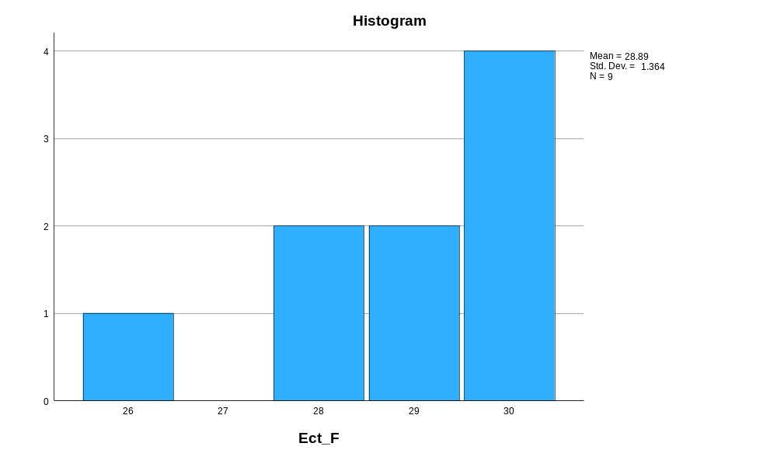

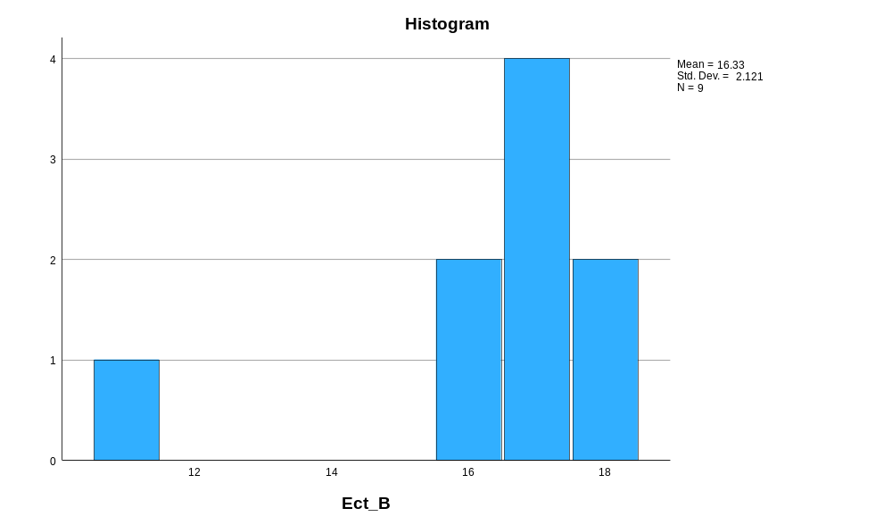

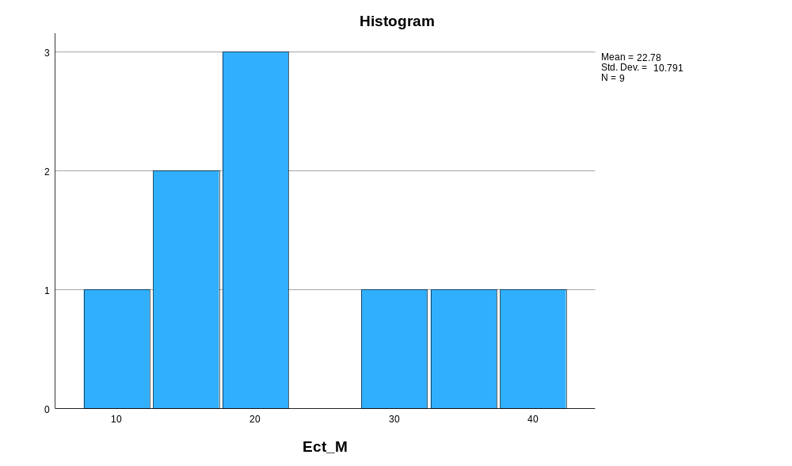

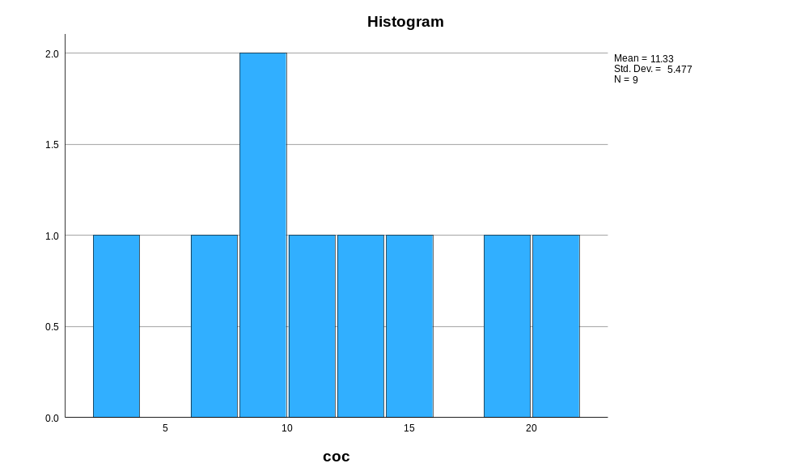

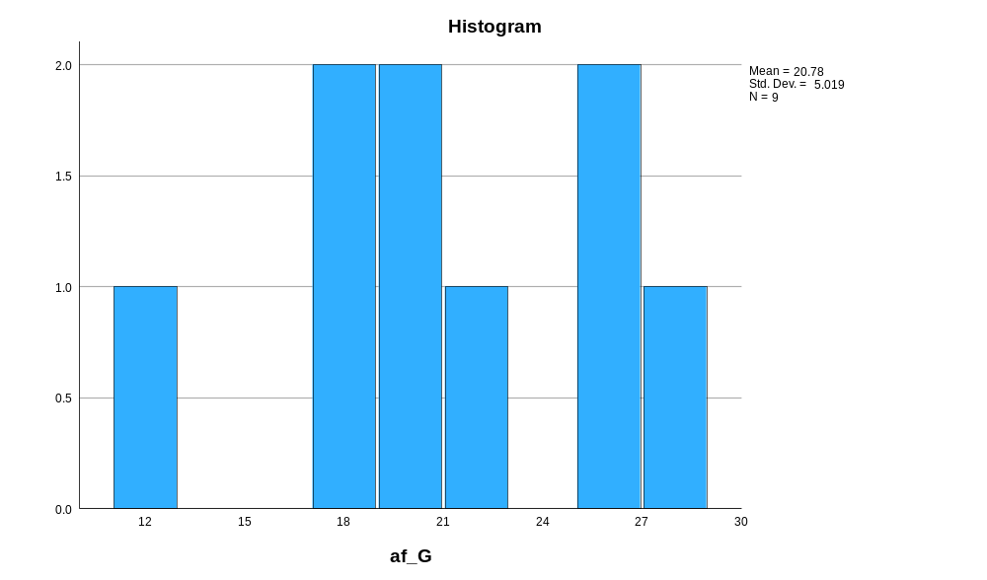

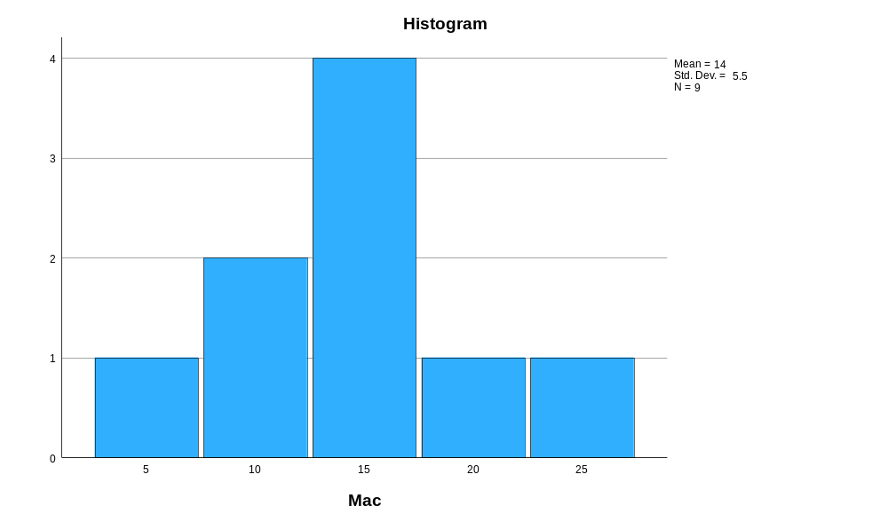

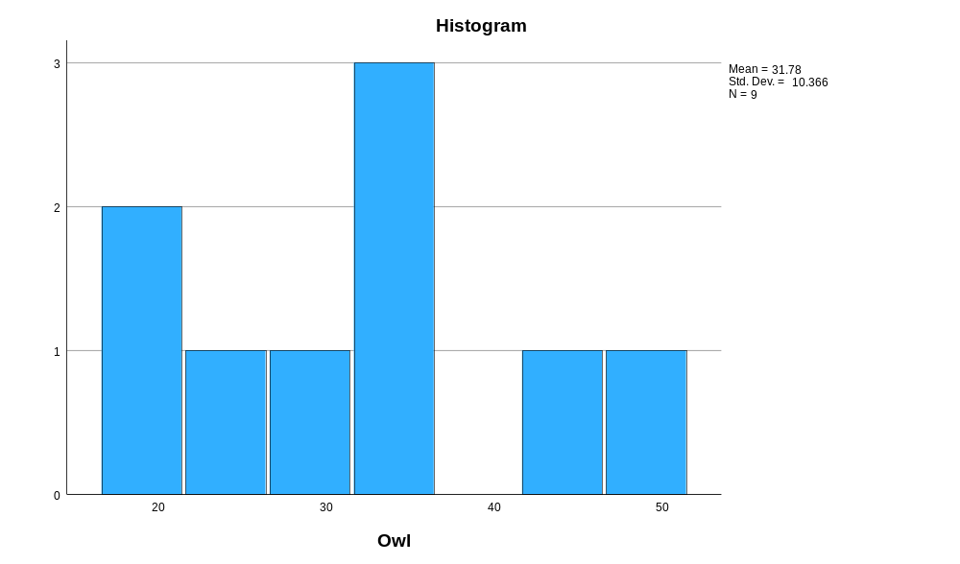

Normal Q-Q Plots

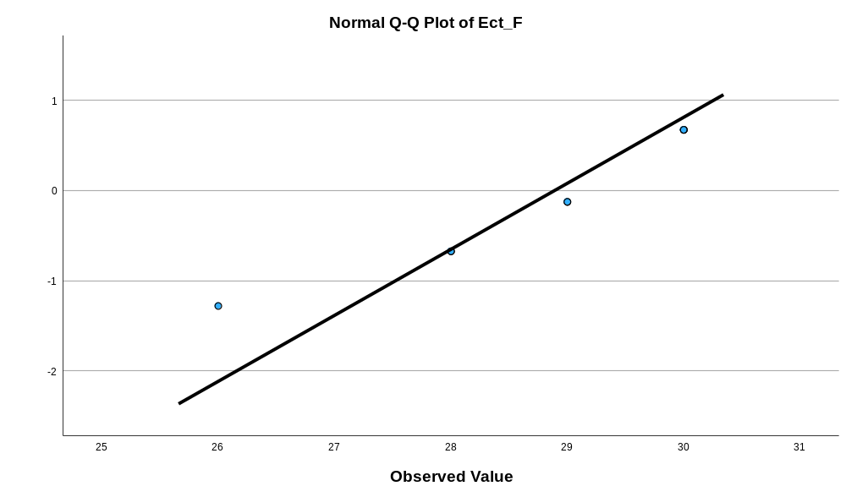

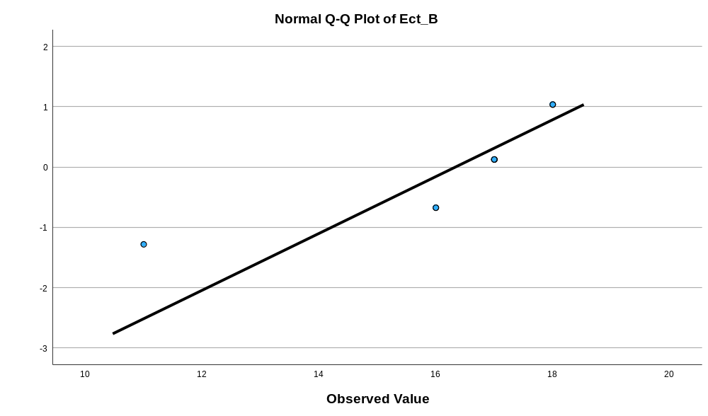

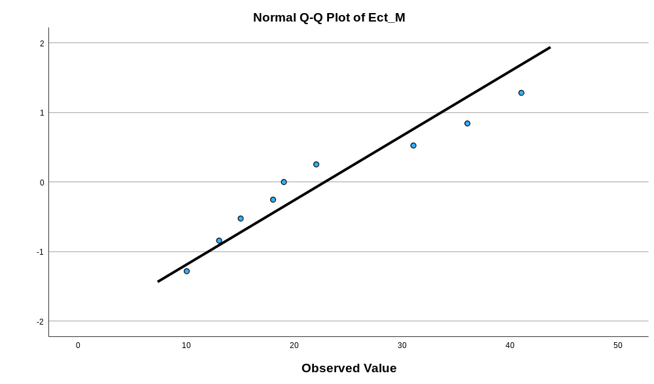

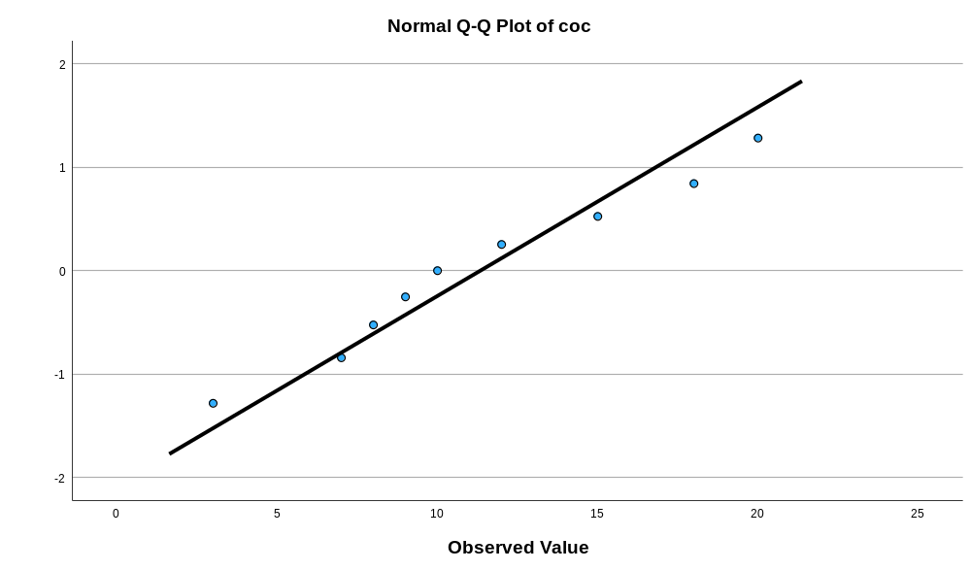

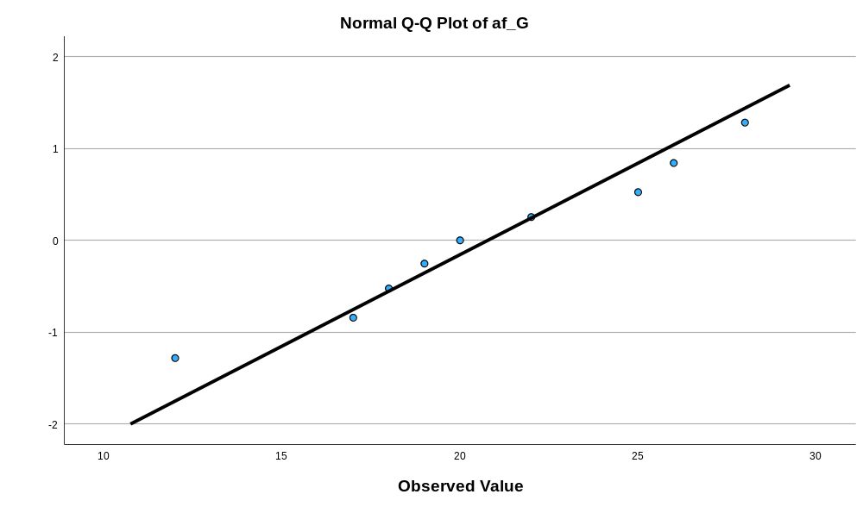

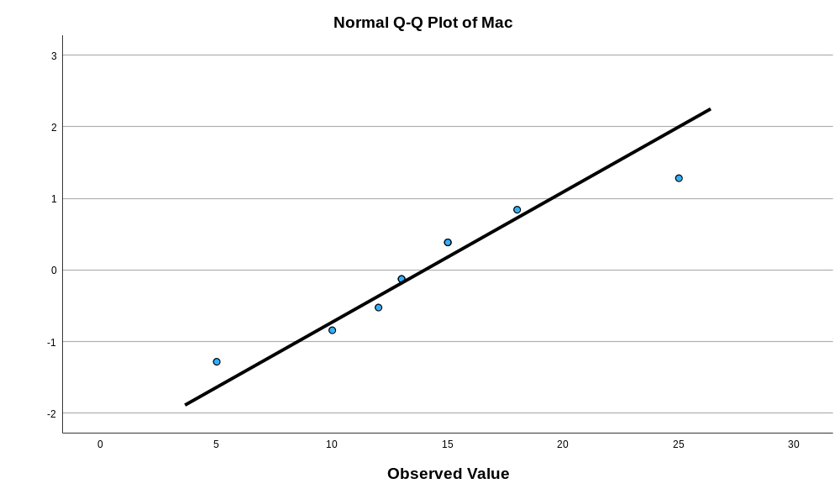

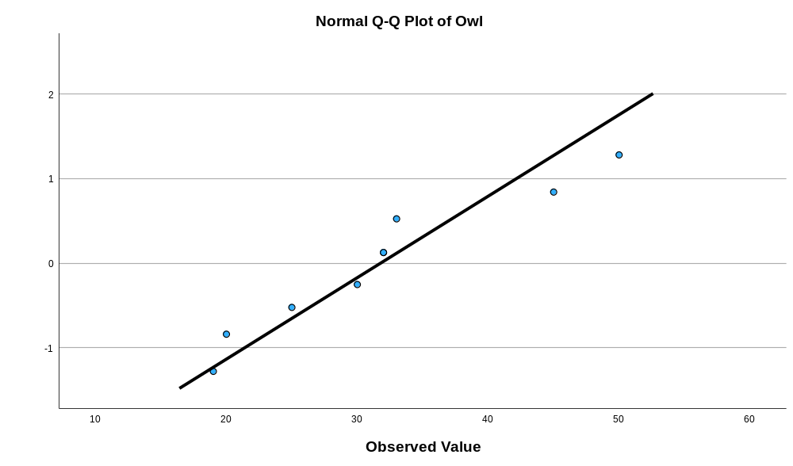

Detrended Normal Q-Q Plots

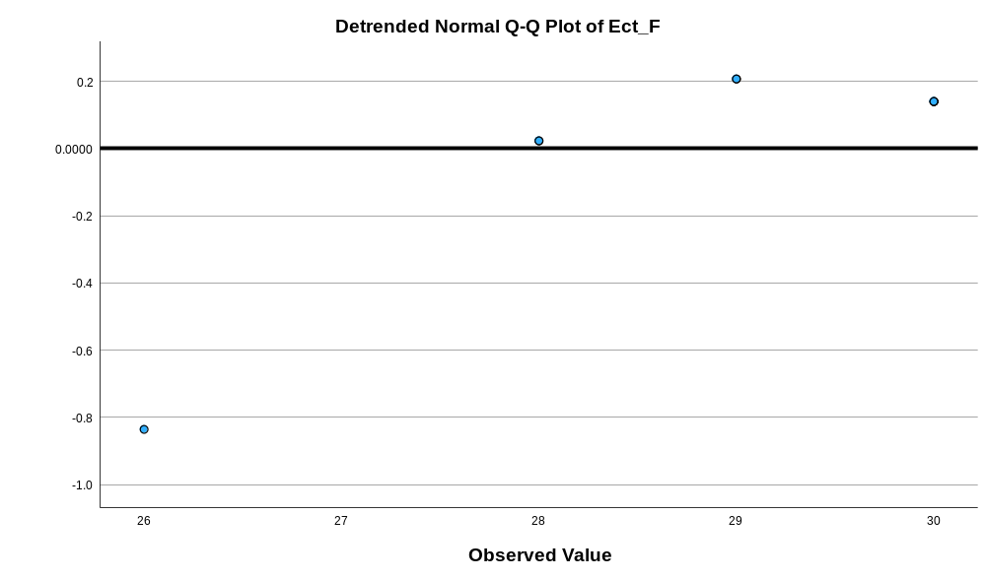

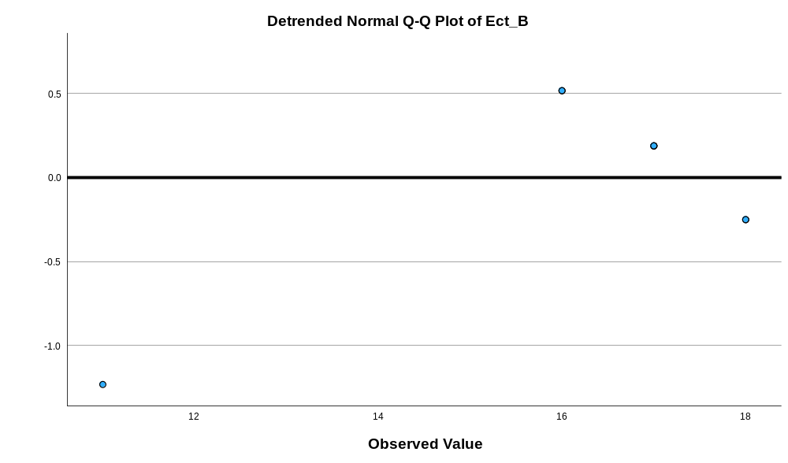

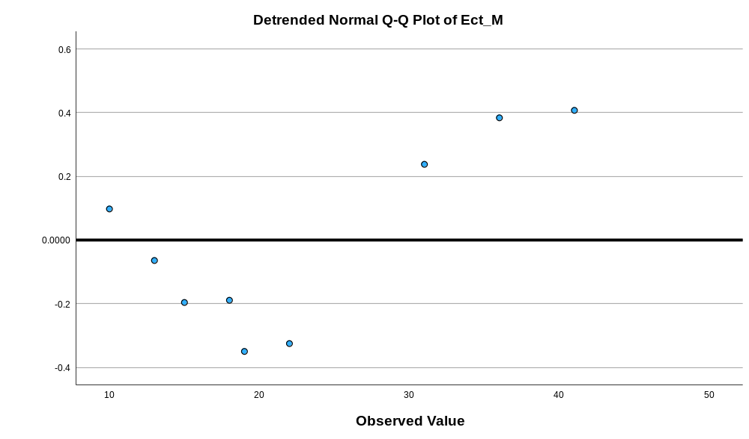

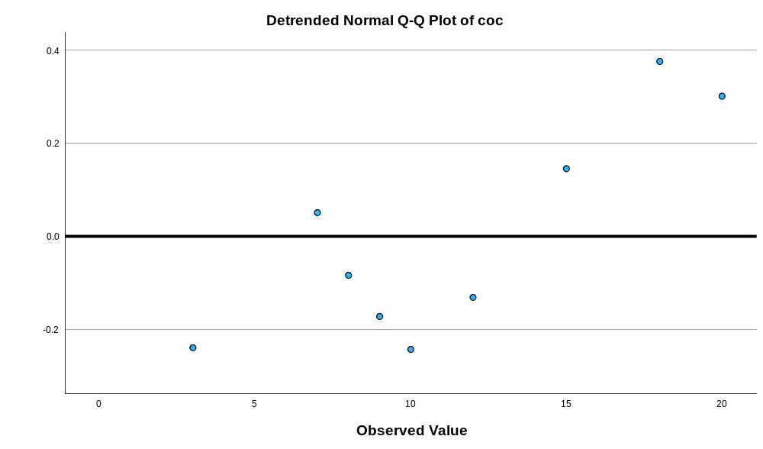

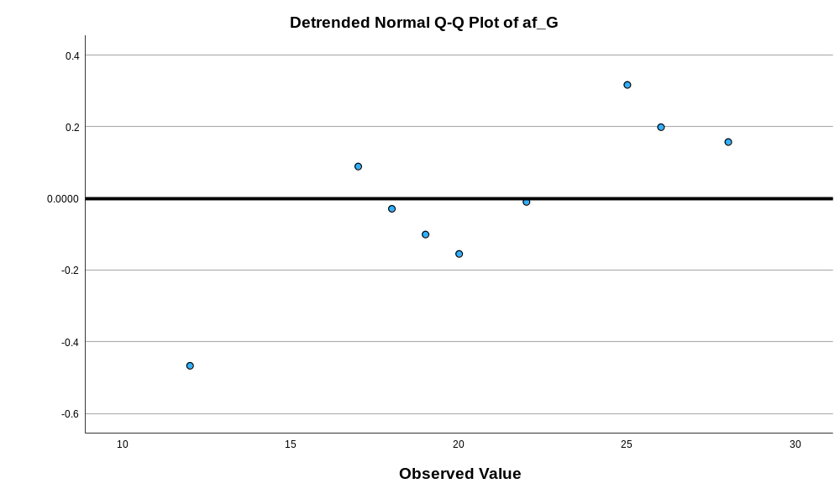

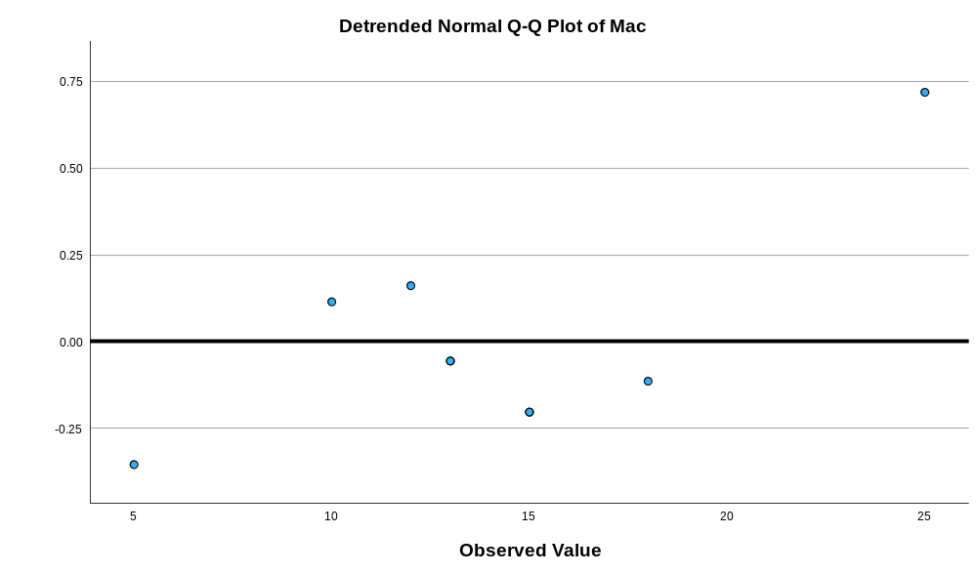

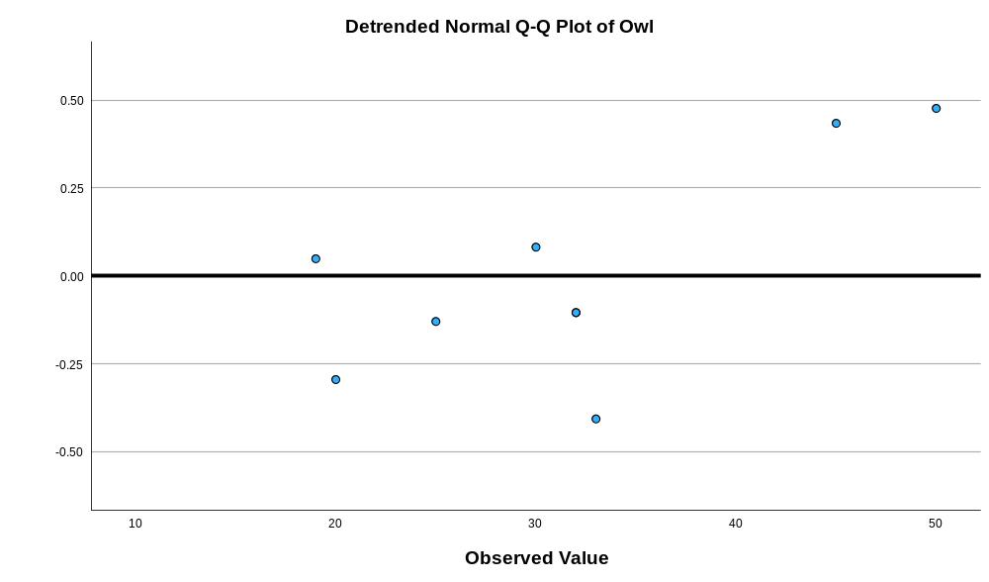

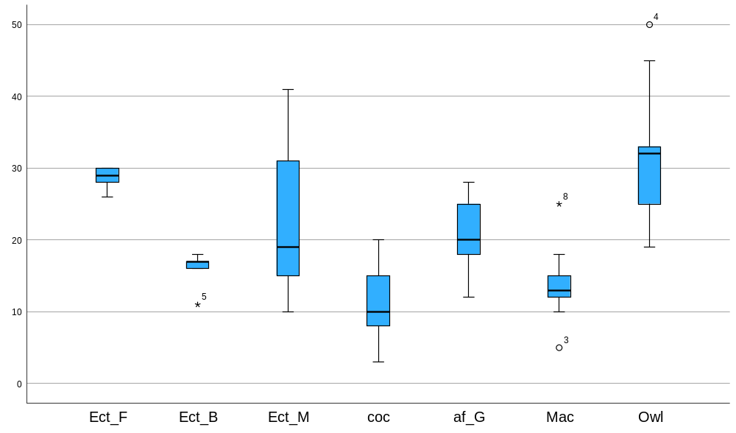

Appendix 11 Kruskal Walis test of feathers width 1cm from the bottom of the barbules
Nonparametric Tests

Notes
Output Created |  | 17-MAR-2026 10:26:45
Comments
Input | Active Dataset | DataSet0
Input | Filter | <none>
Input | Weight | <none>
Input | Split File | <none>
Input | N of Rows in Working Data File | 324
Syntax |  | NPTESTS  /INDEPENDENT TEST (value) GROUP (group) KRUSKAL_WALLIS(COMPARE=PAIRWISE)  /MISSING SCOPE=ANALYSIS USERMISSING=EXCLUDE  /CRITERIA ALPHA=0.05 CILEVEL=95.
Resources | Processor Time | 00:00:00.58
Resources | Elapsed Time | 00:00:00.54

Hypothesis Test Summary
 | Null Hypothesis | Test | Sig.^{a,b}
1 | The distribution of value is the same across categories of group. | Independent-Samples Kruskal-Wallis Test | <.001

Hypothesis Test Summary
 | Decision
1 | Reject the null hypothesis.

a. The significance level is .050.
b. Asymptotic significance is displayed.

Independent-Samples Kruskal-Wallis Test

value across group

Independent-Samples Kruskal-Wallis Test Summary
Total N | 324
Test Statistic | 66.423ª
Degree Of Freedom | 6
Asymptotic Sig.(2-sided test) | <.001
a. The test statistic is adjusted for ties.

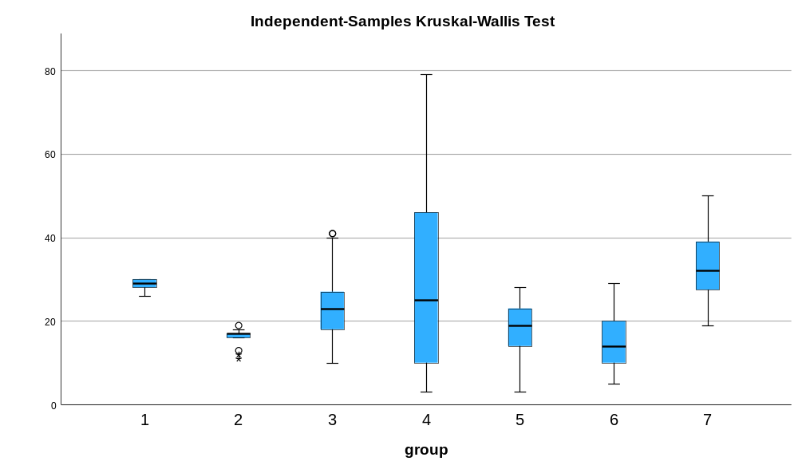

Pairwise Comparisons of group
Sample 1-Sample 2 | Test Statistic | Std. Error | Std. Test Statistic | Sig. | Adj. Sig.ª
6-2 | 2.024 | 25.018 | .081 | .936 | 1.000
6-5 | 38.041 | 18.477 | 2.059 | .040 | .830
6-3 | 87.324 | 17.091 | 5.109 | <.001 | .000
6-4 | 88.180 | 18.320 | 4.813 | <.001 | .000
6-1 | 157.960 | 34.384 | 4.594 | <.001 | .000
6-7 | -159.071 | 30.641 | -5.191 | <.001 | .000
2-5 | -36.017 | 23.453 | -1.536 | .125 | 1.000
2-3 | -85.300 | 22.377 | -3.812 | <.001 | .003
2-4 | -86.156 | 23.330 | -3.693 | <.001 | .005
2-1 | 155.937 | 37.295 | 4.181 | <.001 | .001
2-7 | -157.048 | 33.875 | -4.636 | <.001 | .000
5-3 | 49.283 | 14.705 | 3.352 | <.001 | .017
5-4 | 50.139 | 16.117 | 3.111 | .002 | .039
5-1 | 119.919 | 33.263 | 3.605 | <.001 | .007
5-7 | -121.030 | 29.377 | -4.120 | <.001 | .001
3-4 | -.856 | 14.507 | -.059 | .953 | 1.000
3-1 | 70.637 | 32.513 | 2.173 | .030 | .626
3-7 | -71.748 | 28.525 | -2.515 | .012 | .250
4-1 | 69.780 | 33.176 | 2.103 | .035 | .744
4-7 | -70.891 | 29.279 | -2.421 | .015 | .325
1-7 | -1.111 | 41.278 | -.027 | .979 | 1.000
Each row tests the null hypothesis that the Sample 1 and Sample 2 distributions are the same.
Asymptotic significances (2-sided tests) are displayed. The significance level is .050.
a. Significance values have been adjusted by the Bonferroni correction for multiple tests.

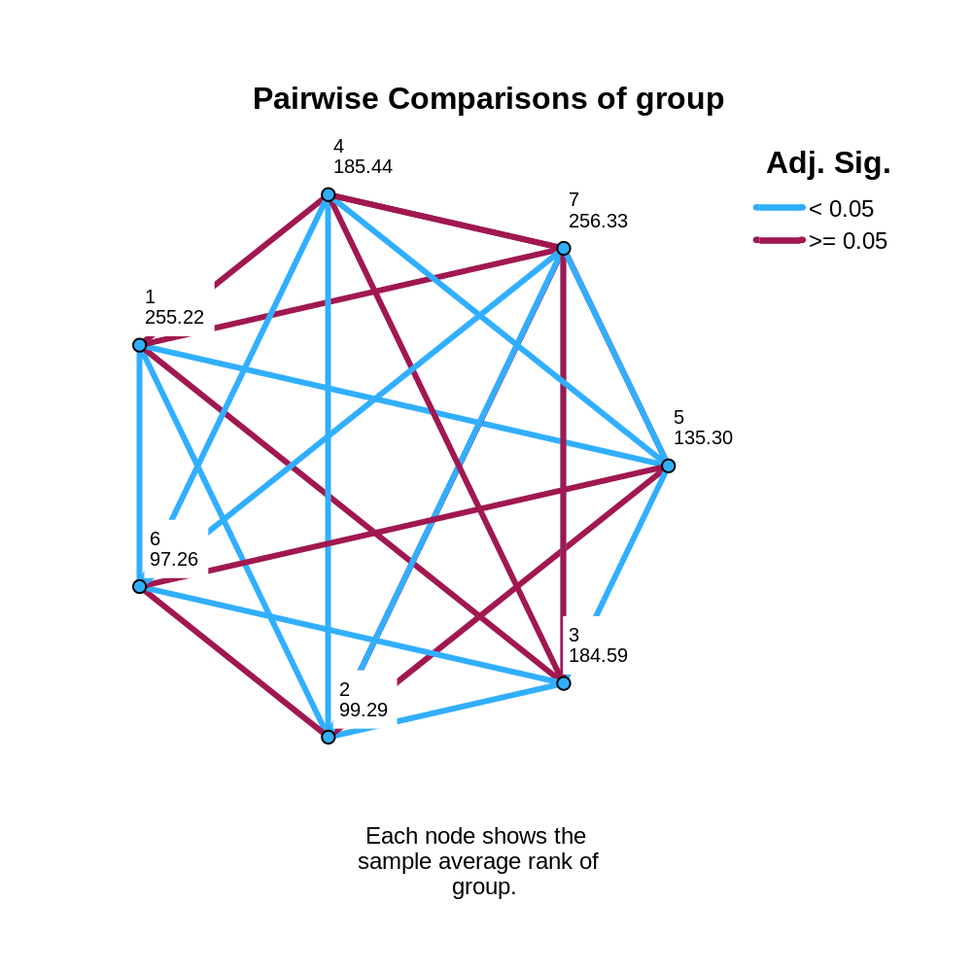

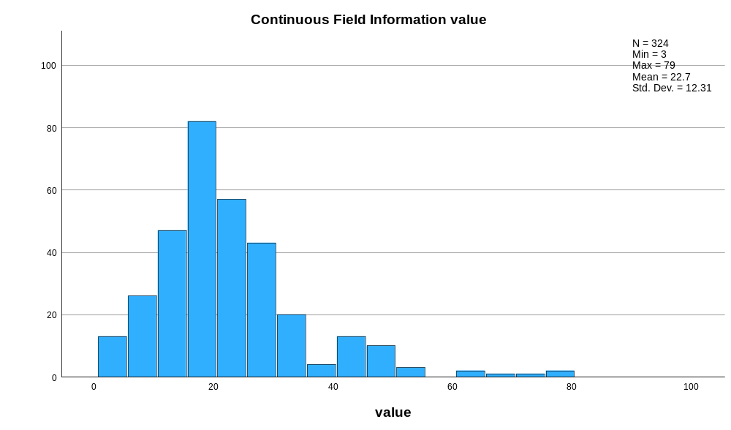

Appendix 12 raw data of widths 1cm from the top
Bird Number | N-Value | Width 1cm from Top (mm)
 |  | 1 | 2 | 3
Eclectus F1 | 3 | 27 | 27 | 30
Eclectus F2 | 3 | 35 | 35 | 29
Eclectus F3 | 3 | 30 | 30 | 28
Eclectus B1 | 3 | 11 | 13 | 17
Eclectus B2 | 3 | 18 | 18 | 18
Eclectus B3 | 3 | 19 | 20 | 19
Eclectus B4 | 3 | 18 | 17 | 16
Eclectus B5 | 3 | 11 | 13 | 13
Eclectus B6 | 3 | 17 | 17 | 17
Eclectus B7 | 3 | 18 | 20 | 17
Eclectus M1 | 3 | 15 | 16 | 22
Eclectus M2 | 3 | 25 | 26 | 41
Eclectus M3 | 3 | 33 | 30 | 31
Eclectus M4 | 3 | 14 | 15 | 12
Eclectus M5 | 3 | 8 | 9 | 14
Eclectus M6 | 3 | 27 | 28 | 20
Eclectus M7 | 3 | 18 | 18 | 36
Eclectus M8 | 3 | 35 | 34 | 16
Eclectus M9 | 3 | 19 | 18 | 15
Eclectus M10 | 3 | 30 | 32 | 25
Eclectus M11 | 3 | 15 | 16 | 26
Eclectus M12 | 3 | 29 | 30 | 34
Eclectus M13 | 3 | 20 | 21 | 21
Eclectus M14 | 3 | 18 | 19 | 29
Eclectus M15 | 3 | 14 | 14 | 32
Eclectus M16 | 3 | 23 | 24 | 22
Eclectus M17 | 3 | 22 | 23 | 27
Eclectus M18 | 3 | 12 | 12 | 23
Eclectus M19 | 3 | 16 | 15 | 14
Eclectus M20 | 3 | 17 | 16 | 18
Eclectus M21 | 3 | 11 | 12 | 11
Eclectus M22 | 3 | 19 | 20 | 25
Eclectus M23 | 3 | 11 | 10 | 25
Eclectus M24 | 3 | 20 | 20 | 19
Eclectus M25 | 3 | 15 | 16 | 15
Eclectus M26 | 3 | 22 | 23 | 26
Eclectus M27 | 3 | 16 | 17 | 23
Eclectus M28 | 3 | 11 | 10 | 24
Eclectus M29 | 3 | 24 | 25 | 28
Eclectus M30 | 3 | 18 | 18 | 16
Eclectus M31 | 3 | 21 | 22 | 29
Eclectus M32 | 3 | 26 | 26 | 35
Eclectus M33 | 3 | 18 | 17 | 22
Eclectus M34 | 3 | 21 | 20 | 26
Eclectus M35 | 3 | 17 | 18 | 19
Cockatoo 1 | 3 | 14 | 13 | 18
Cockatoo 2 | 3 | 10 | 10 | 10
Cockatoo 3 | 3 | 14 | 13 | 4
Cockatoo 4 | 3 | 22 | 25 | 8
Cockatoo 5 | 3 | 16 | 16 | 20
Cockatoo 6 | 3 | 8 | 7 | 6
Cockatoo 7 | 3 | 18 | 18 | 9
Cockatoo 8 | 3 | 29 | 31 | 17
Cockatoo 9 | 3 | 22 | 23 | 10
Cockatoo 10 | 3 | 6 | 7 | 8
Cockatoo 11 | 3 | 17 | 16 | 25
Cockatoo 12 | 3 | 16 | 15 | 33
Cockatoo 13 | 3 | 21 | 23 | 41
Cockatoo 14 | 3 | 36 | 32 | 32
Cockatoo 15 | 3 | 28 | 29 | 50
Cockatoo 16 | 3 | 29 | 28 | 79
Cockatoo 17 | 3 | 33 | 34 | 45
Cockatoo 18 | 3 | 26 | 26 | 47
Cockatoo 19 | 3 | 30 | 27 | 62
Cockatoo 20 | 3 | 16 | 17 | 45
Cockatoo 21 | 3 | 11 | 12 | 22
Cockatoo 22 | 3 | 10 | 9 | 48
Cockatoo 23 | 3 | 18 | 16 | 49
African G1 | 3 | 12 | 14 | 23
African G2 | 3 | 12 | 12 | 23
African G3 | 3 | 14 | 16 | 13
African G4 | 3 | 17 | 16 | 16
African G5 | 3 | 9 | 8 | 19
African G6 | 3 | 8 | 12 | 28
African G7 | 3 | 15 | 15 | 16
African G8 | 3 | 26 | 26 | 25
African G9 | 3 | 20 | 19 | 26
African G10 | 3 | 20 | 19 | 24
African G11 | 3 | 15 | 14 | 21
African G12 | 3 | 10 | 11 | 4
African G13 | 3 | 10 | 10 | 3
African G14 | 3 | 26 | 30 | 23
African G15 | 3 | 14 | 13 | 13
African G16 | 3 | 11 | 11 | 18
African G17 | 3 | 16 | 15 | 21
African G18 | 3 | 24 | 24 | 19
African G19 | 3 | 17 | 16 | 14
African G20 | 3 | 13 | 14 | 13
African G21 | 3 | 21 | 20 | 19
African G22 | 3 | 16 | 17 | 18
Macaw 1 | 3 | 9 | 9 | 16
Macaw 2 | 3 | 21 | 21 | 10
Macaw 3 | 3 | 7 | 7 | 5
Macaw 5 | 3 | 14 | 14 | 12
Macaw 6 | 3 | 6 | 7 | 19
Macaw 7 | 3 | 13 | 13 | 10
Macaw 8 | 3 | 26 | 26 | 18
Macaw 9 | 3 | 42 | 40 | 24
Macaw 11 | 3 | 18 | 19 | 13
Macaw 12 | 3 | 14 | 12 | 13
Macaw 13 | 3 | 22 | 23 | 29
Macaw 14 | 3 | 12 | 11 | 20
Macaw 15 | 3 | 15 | 15 | 10
Macaw 16 | 3 | 16 | 15 | 18
Owl 1 | 3 | 28 | 25 | 20
Owl 2 | 3 | 18 | 19 | 31
Owl 3 | 3 | 19 | 18 | 33
Owl 4 | 3 | 34 | 34 | 45

Appendix 13 descriptive test of feathers 1cm from top of the barbules
Explore

Notes
Output Created |  | 16-MAR-2026 13:16:56
Comments
Input | Active Dataset | DataSet0
Input | Filter | <none>
Input | Weight | <none>
Input | Split File | <none>
Input | N of Rows in Working Data File | 105
Missing Value Handling | Definition of Missing | User-defined missing values for dependent variables are treated as missing.
Missing Value Handling | Cases Used | Statistics are based on cases with no missing values for any dependent variable or factor used.
Syntax |  | EXAMINE VARIABLES=Ect_F Ect_B Ect_M coc af_G Mac Owl  /PLOT BOXPLOT HISTOGRAM NPPLOT  /COMPARE VARIABLES  /STATISTICS DESCRIPTIVES  /CINTERVAL 95  /MISSING LISTWISE  /NOTOTAL.
Resources | Processor Time | 00:00:02.37
Resources | Elapsed Time | 00:00:02.19

Case Processing Summary
 | Cases
 | Valid |  | Missing |  | Total
 | N | Percent | N | Percent | N | Percent
Ect_F | 9 | 8.6% | 96 | 91.4% | 105 | 100.0%
Ect_B | 9 | 8.6% | 96 | 91.4% | 105 | 100.0%
Ect_M | 9 | 8.6% | 96 | 91.4% | 105 | 100.0%
coc | 9 | 8.6% | 96 | 91.4% | 105 | 100.0%
af_G | 9 | 8.6% | 96 | 91.4% | 105 | 100.0%
Mac | 9 | 8.6% | 96 | 91.4% | 105 | 100.0%
Owl | 9 | 8.6% | 96 | 91.4% | 105 | 100.0%

Descriptives
 |  |  | Statistic | Std. Error
Ect_F | Mean |  | 30.67 | 1.167
Ect_F | 95% Confidence Interval for Mean | Lower Bound | 27.98
Ect_F | 95% Confidence Interval for Mean | Upper Bound | 33.36
Ect_F | 5% Trimmed Mean |  | 30.63
Ect_F | Median |  | 30.00
Ect_F | Variance |  | 12.250
Ect_F | Std. Deviation |  | 3.500
Ect_F | Minimum |  | 27
Ect_F | Maximum |  | 35
Ect_F | Range |  | 8
Ect_F | Interquartile Range |  | 8
Ect_F | Skewness |  | .357 | .717
Ect_F | Kurtosis |  | -1.714 | 1.400
Ect_B | Mean |  | 15.89 | 1.086
Ect_B | 95% Confidence Interval for Mean | Lower Bound | 13.38
Ect_B | 95% Confidence Interval for Mean | Upper Bound | 18.39
Ect_B | 5% Trimmed Mean |  | 15.99
Ect_B | Median |  | 18.00
Ect_B | Variance |  | 10.611
Ect_B | Std. Deviation |  | 3.257
Ect_B | Minimum |  | 11
Ect_B | Maximum |  | 19
Ect_B | Range |  | 8
Ect_B | Interquartile Range |  | 6
Ect_B | Skewness |  | -.877 | .717
Ect_B | Kurtosis |  | -1.272 | 1.400
Ect_M | Mean |  | 21.56 | 3.019
Ect_M | 95% Confidence Interval for Mean | Lower Bound | 14.59
Ect_M | 95% Confidence Interval for Mean | Upper Bound | 28.52
Ect_M | 5% Trimmed Mean |  | 21.56
Ect_M | Median |  | 19.00
Ect_M | Variance |  | 82.028
Ect_M | Std. Deviation |  | 9.057
Ect_M | Minimum |  | 8
Ect_M | Maximum |  | 35
Ect_M | Range |  | 27
Ect_M | Interquartile Range |  | 16
Ect_M | Skewness |  | .187 | .717
Ect_M | Kurtosis |  | -.992 | 1.400
coc | Mean |  | 17.00 | 2.186
coc | 95% Confidence Interval for Mean | Lower Bound | 11.96
coc | 95% Confidence Interval for Mean | Upper Bound | 22.04
coc | 5% Trimmed Mean |  | 16.83
coc | Median |  | 16.00
coc | Variance |  | 43.000
coc | Std. Deviation |  | 6.557
coc | Minimum |  | 8
coc | Maximum |  | 29
coc | Range |  | 21
coc | Interquartile Range |  | 10
coc | Skewness |  | .486 | .717
coc | Kurtosis |  | -.064 | 1.400
af_G | Mean |  | 14.78 | 1.877
af_G | 95% Confidence Interval for Mean | Lower Bound | 10.45
af_G | 95% Confidence Interval for Mean | Upper Bound | 19.11
af_G | 5% Trimmed Mean |  | 14.53
af_G | Median |  | 14.00
af_G | Variance |  | 31.694
af_G | Std. Deviation |  | 5.630
af_G | Minimum |  | 8
af_G | Maximum |  | 26
af_G | Range |  | 18
af_G | Interquartile Range |  | 8
af_G | Skewness |  | .918 | .717
af_G | Kurtosis |  | .754 | 1.400
Mac | Mean |  | 17.33 | 3.786
Mac | 95% Confidence Interval for Mean | Lower Bound | 8.60
Mac | 95% Confidence Interval for Mean | Upper Bound | 26.06
Mac | 5% Trimmed Mean |  | 16.59
Mac | Median |  | 14.00
Mac | Variance |  | 129.000
Mac | Std. Deviation |  | 11.358
Mac | Minimum |  | 6
Mac | Maximum |  | 42
Mac | Range |  | 36
Mac | Interquartile Range |  | 16
Mac | Skewness |  | 1.366 | .717
Mac | Kurtosis |  | 2.016 | 1.400
Owl | Mean |  | 24.44 | 2.167
Owl | 95% Confidence Interval for Mean | Lower Bound | 19.45
Owl | 95% Confidence Interval for Mean | Upper Bound | 29.44
Owl | 5% Trimmed Mean |  | 24.27
Owl | Median |  | 25.00
Owl | Variance |  | 42.278
Owl | Std. Deviation |  | 6.502
Owl | Minimum |  | 18
Owl | Maximum |  | 34
Owl | Range |  | 16
Owl | Interquartile Range |  | 13
Owl | Skewness |  | .545 | .717
Owl | Kurtosis |  | -1.268 | 1.400

Tests of Normality
 | Kolmogorov-Smirnovª |  |  | Shapiro-Wilk
 | Statistic | df | Sig. | Statistic | df | Sig.
Ect_F | .242 | 9 | .136 | .806 | 9 | .024
Ect_B | .300 | 9 | .019 | .766 | 9 | .008
Ect_M | .167 | 9 | .200* | .960 | 9 | .798
coc | .121 | 9 | .200* | .965 | 9 | .848
af_G | .151 | 9 | .200* | .940 | 9 | .583
Mac | .171 | 9 | .200* | .884 | 9 | .174
Owl | .243 | 9 | .133 | .851 | 9 | .076
*. This is a lower bound of the true significance.
a. Lilliefors Significance Correction

Histograms

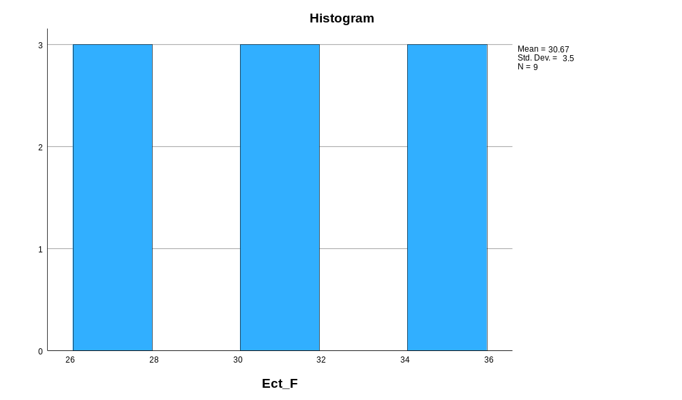

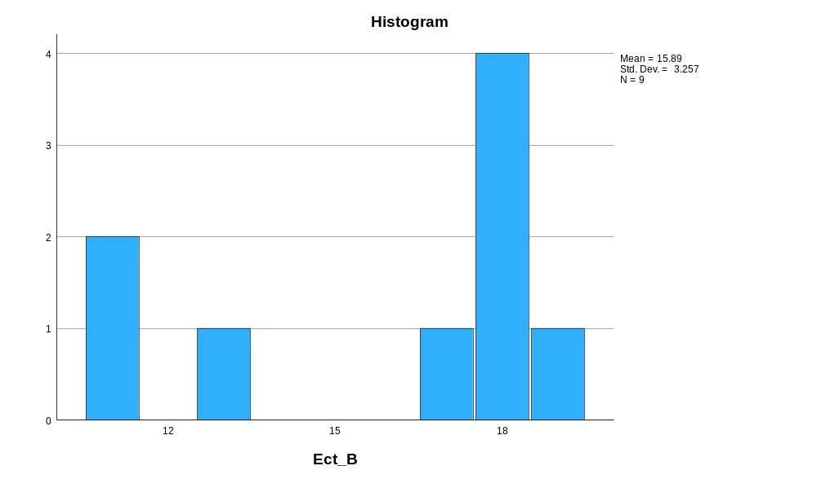

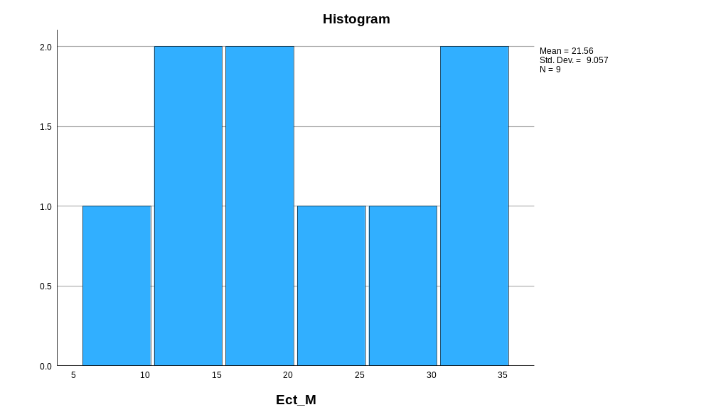

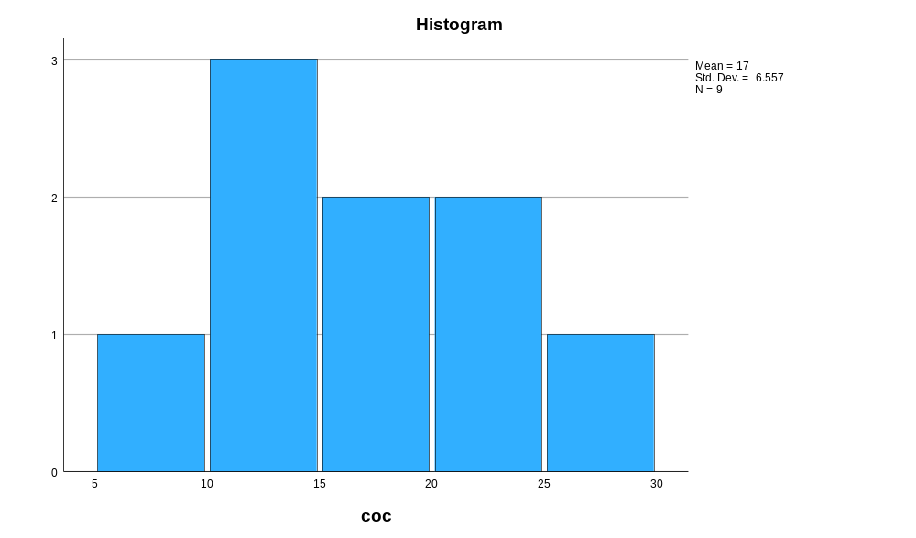

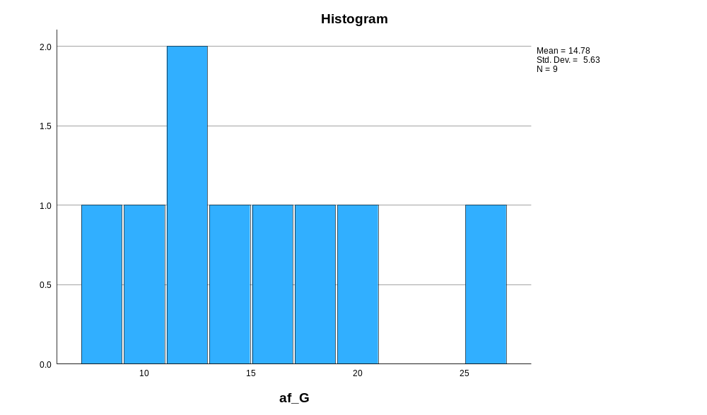

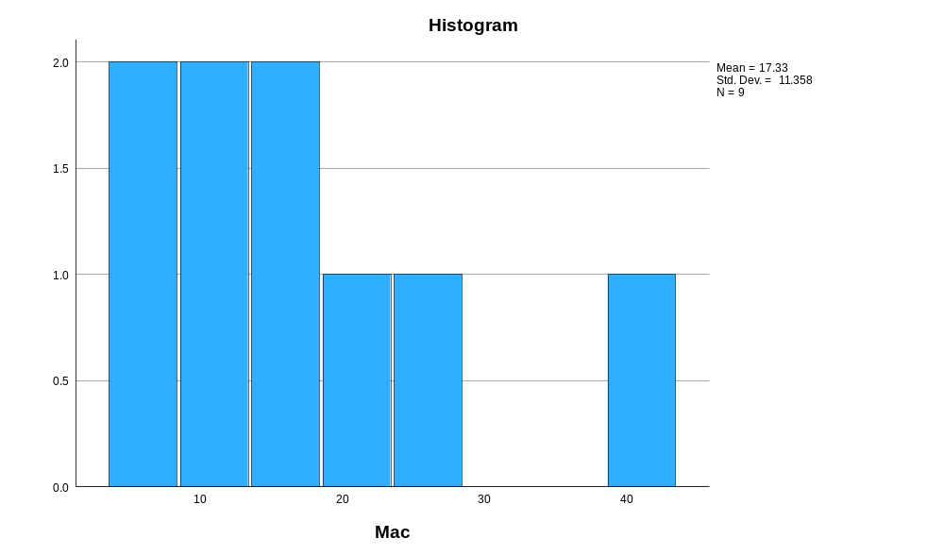

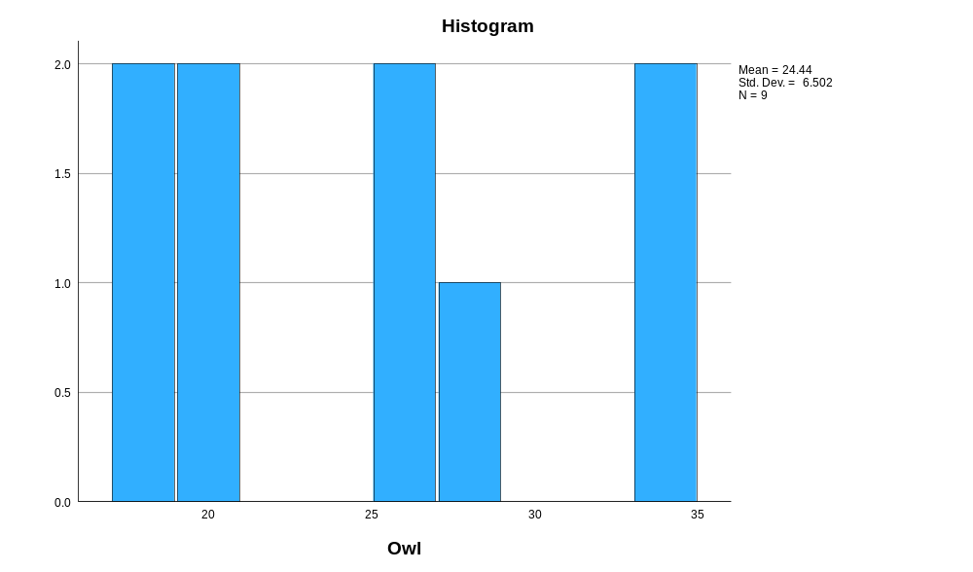

Normal Q-Q Plots

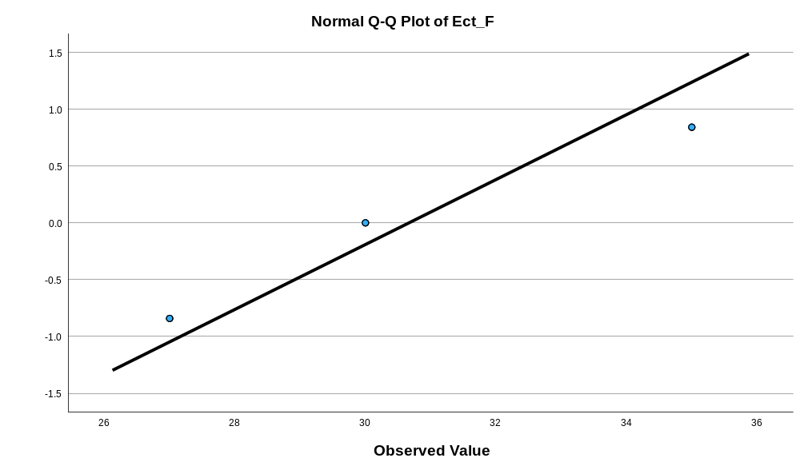

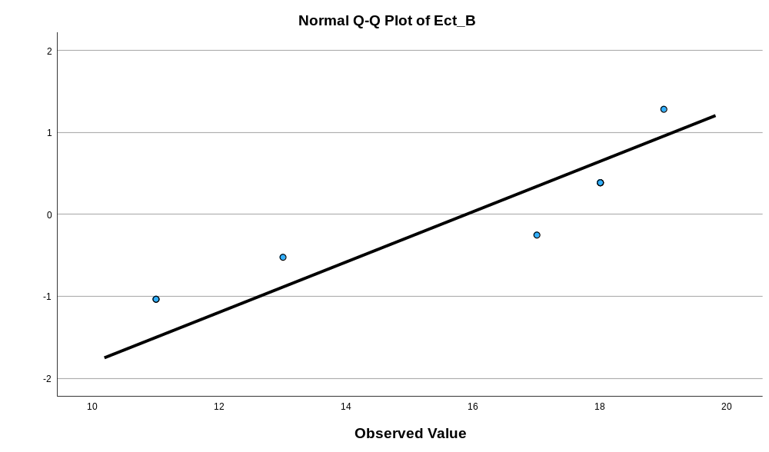

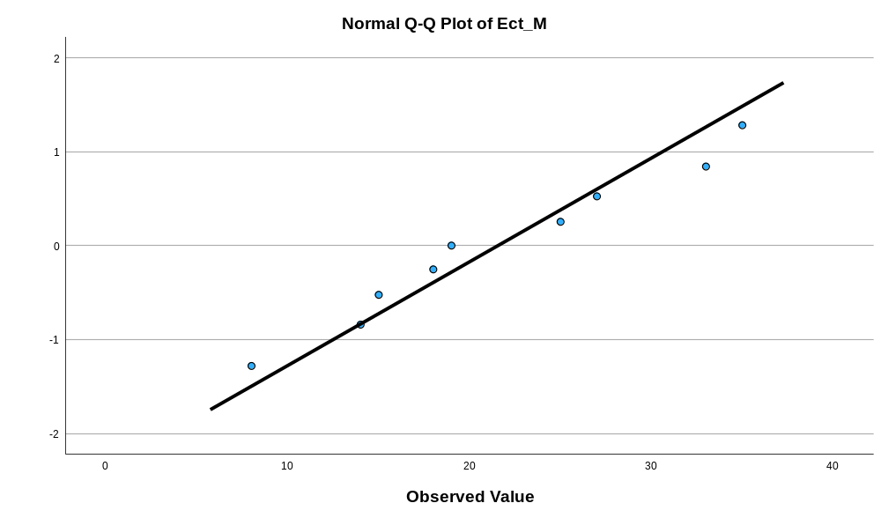

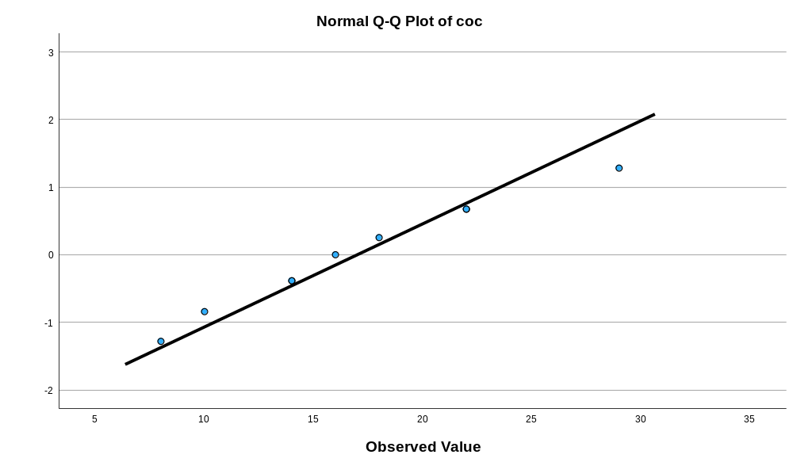

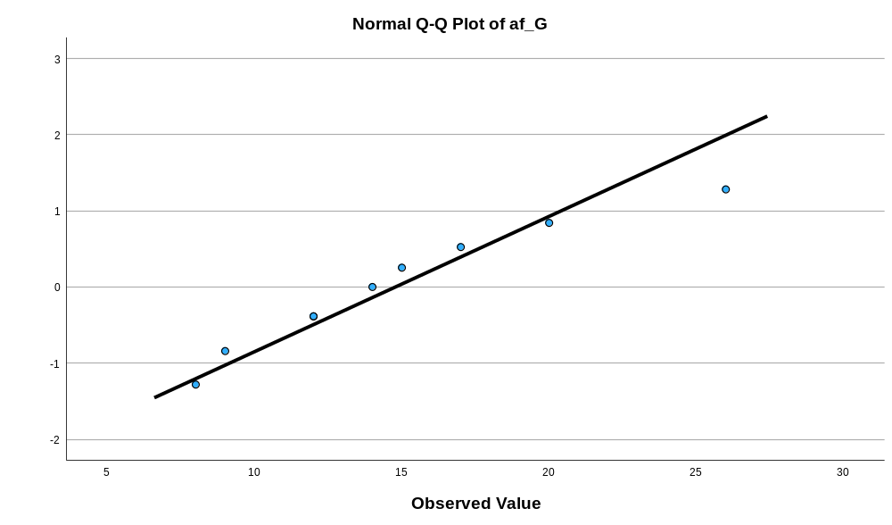

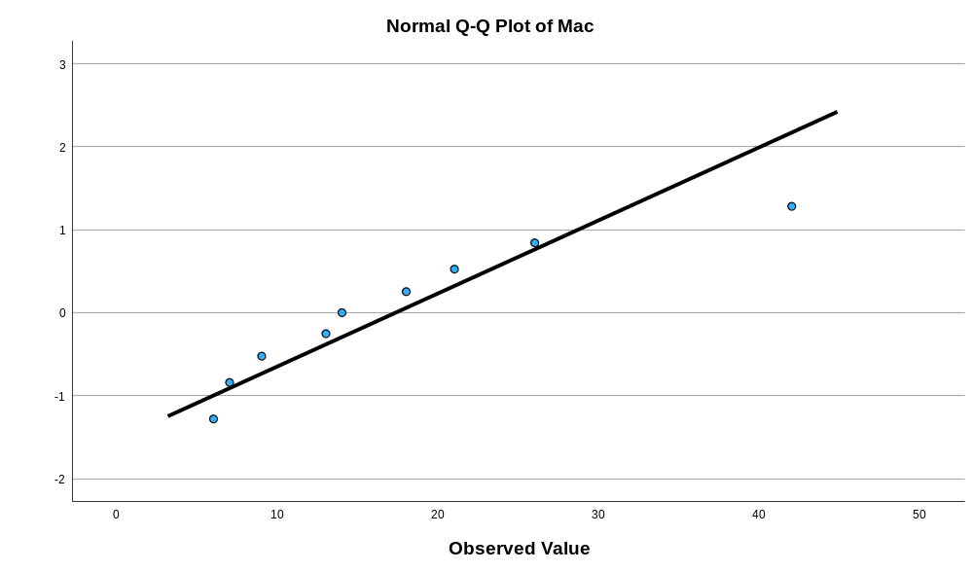

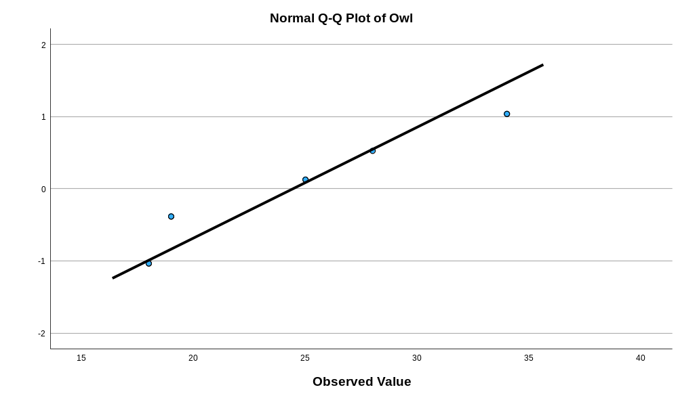

Detrended Normal Q-Q Plots

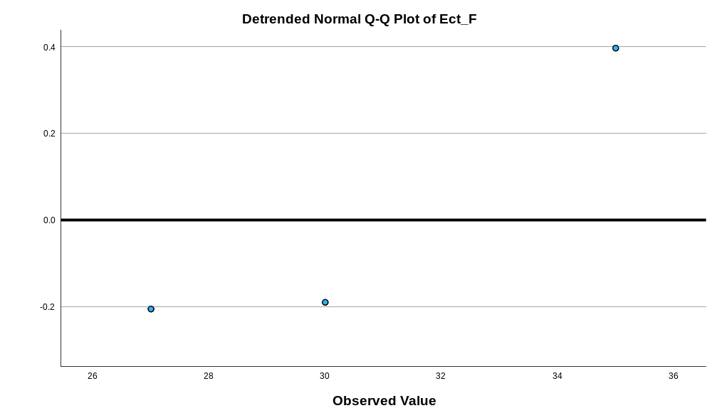

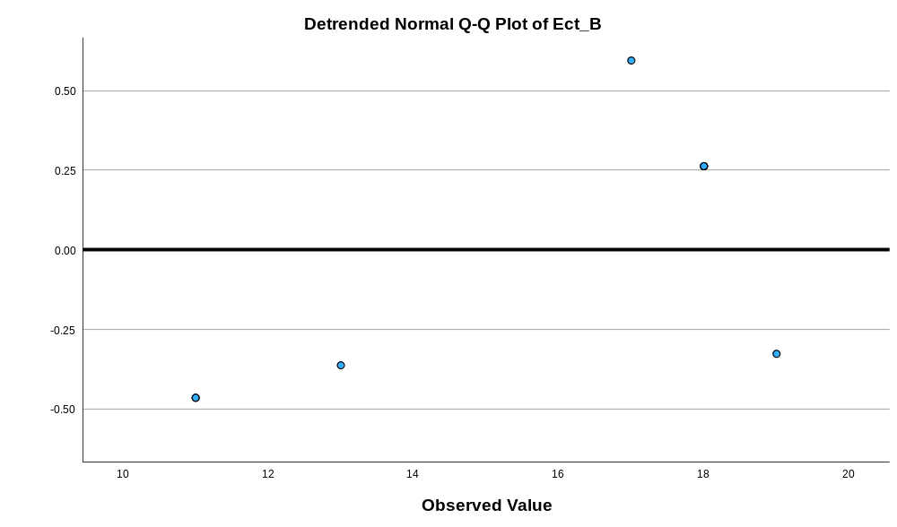

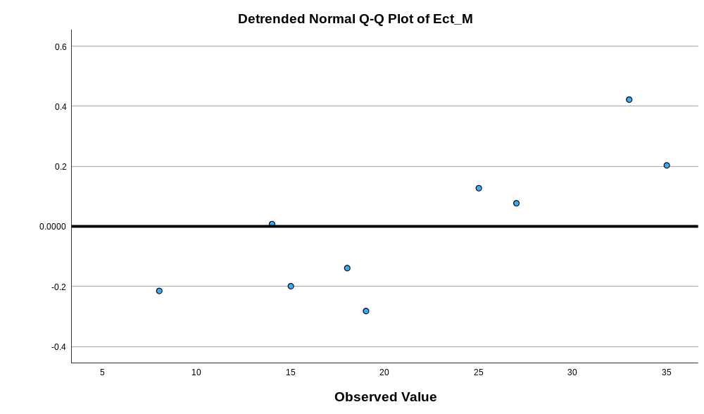

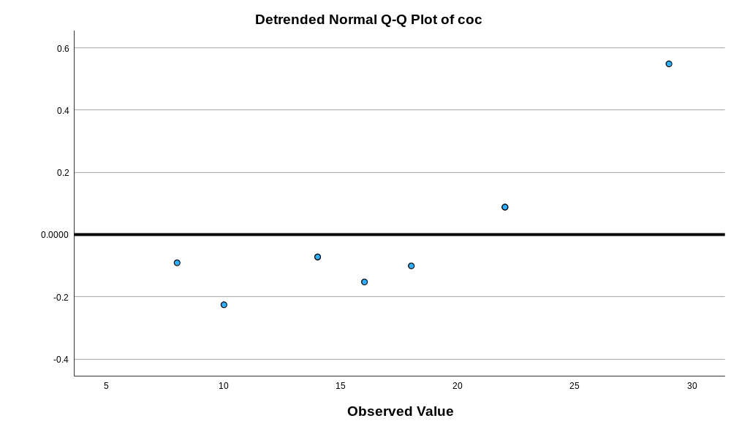

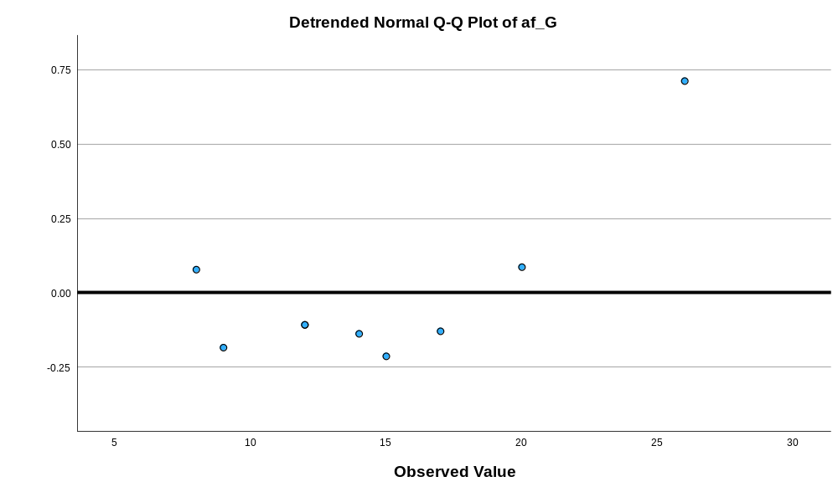

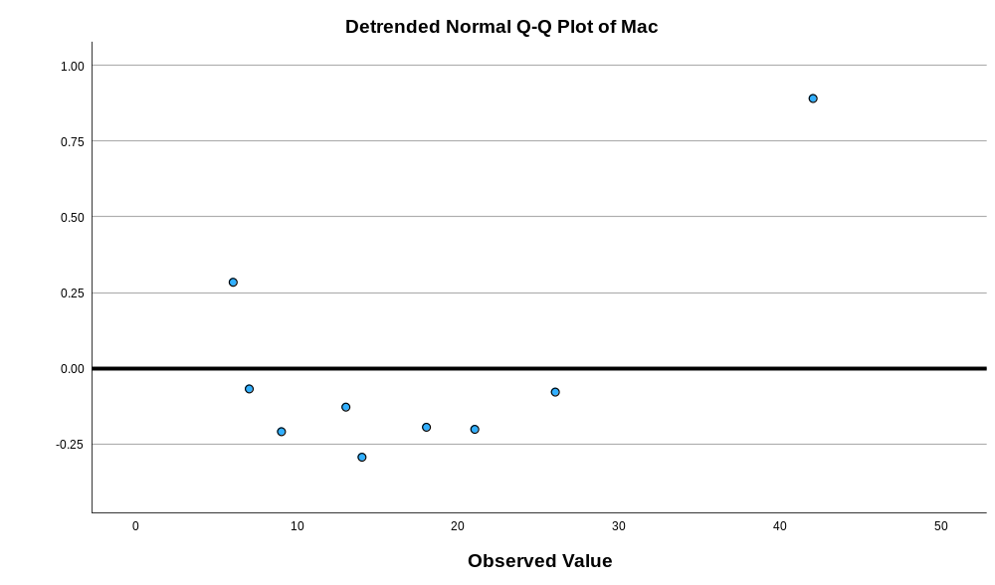

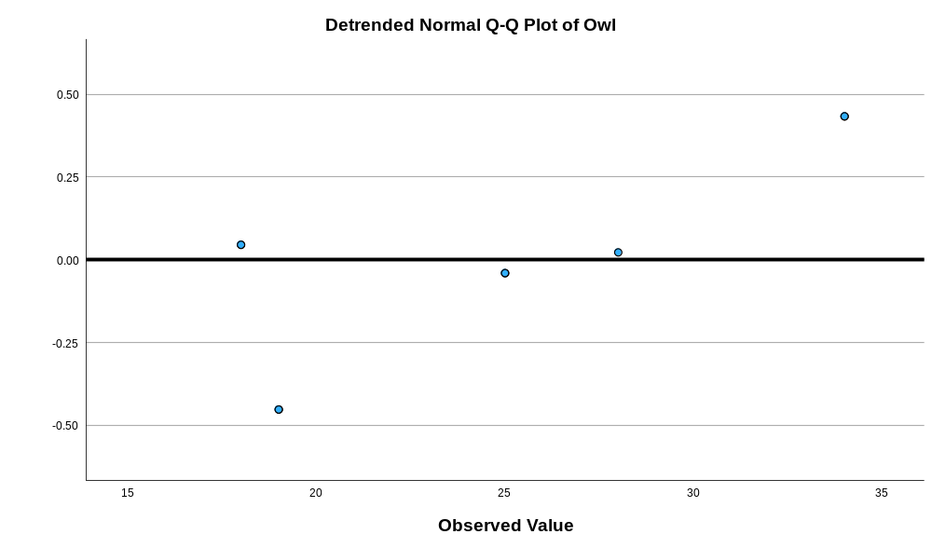
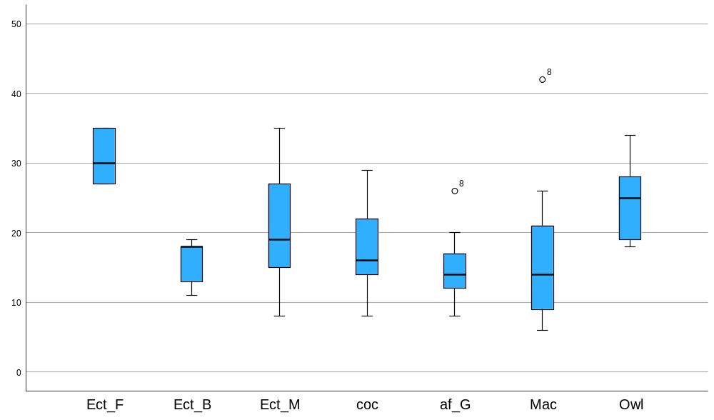

Appendix 14 Kruskal Wallis test of feathers 1cm from top of the barbules
Nonparametric Tests

Notes
Output Created |  | 17-MAR-2026 10:33:47
Comments
Input | Active Dataset | DataSet0
Input | Filter | <none>
Input | Weight | <none>
Input | Split File | <none>
Input | N of Rows in Working Data File | 324
Syntax |  | NPTESTS  /INDEPENDENT TEST (value) GROUP (group) KRUSKAL_WALLIS(COMPARE=PAIRWISE)  /MISSING SCOPE=ANALYSIS USERMISSING=EXCLUDE  /CRITERIA ALPHA=0.05 CILEVEL=95.
Resources | Processor Time | 00:00:00.61
Resources | Elapsed Time | 00:00:00.55

Hypothesis Test Summary
 | Null Hypothesis | Test | Sig.^{a,b}
1 | The distribution of value is the same across categories of group. | Independent-Samples Kruskal-Wallis Test | <.001

Hypothesis Test Summary
 | Decision
1 | Reject the null hypothesis.

a. The significance level is .050.
b. Asymptotic significance is displayed.

Independent-Samples Kruskal-Wallis Test

value across group

Independent-Samples Kruskal-Wallis Test Summary
Total N | 324
Test Statistic | 47.739ª
Degree Of Freedom | 6
Asymptotic Sig.(2-sided test) | <.001
a. The test statistic is adjusted for ties.

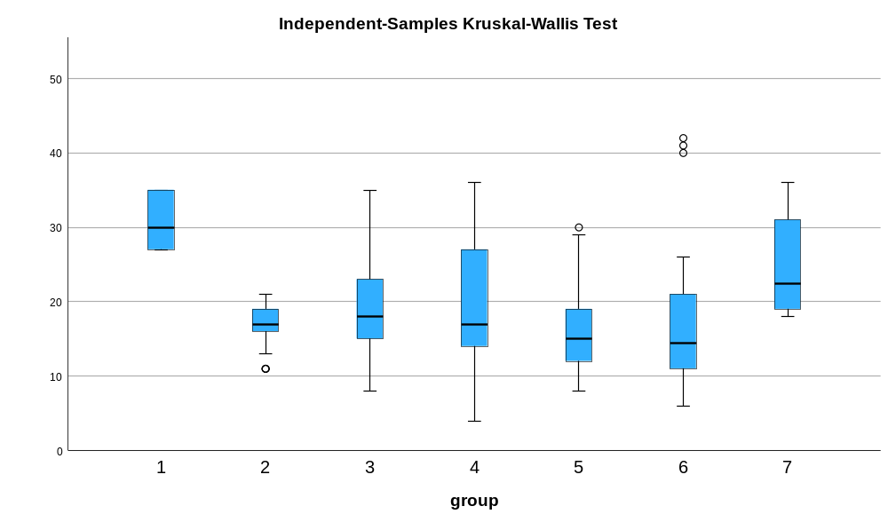

Pairwise Comparisons of group
Sample 1-Sample 2 | Test Statistic | Std. Error | Std. Test Statistic | Sig. | Adj. Sig.ª
5-6 | -2.429 | 18.468 | -.132 | .895 | 1.000
5-2 | 22.988 | 23.441 | .981 | .327 | 1.000
5-4 | 45.453 | 16.109 | 2.822 | .005 | .100
5-3 | 54.136 | 14.697 | 3.683 | <.001 | .005
5-7 | -115.542 | 29.362 | -3.935 | <.001 | .002
5-1 | 171.917 | 33.246 | 5.171 | <.001 | .000
6-2 | 20.560 | 25.006 | .822 | .411 | 1.000
6-4 | 43.024 | 18.311 | 2.350 | .019 | .395
6-3 | 51.707 | 17.082 | 3.027 | .002 | .052
6-7 | -113.113 | 30.625 | -3.693 | <.001 | .005
6-1 | 169.488 | 34.367 | 4.932 | <.001 | .000
2-4 | -22.465 | 23.318 | -.963 | .335 | 1.000
2-3 | -31.148 | 22.366 | -1.393 | .164 | 1.000
2-7 | -92.554 | 33.858 | -2.734 | .006 | .132
2-1 | 148.929 | 37.276 | 3.995 | <.001 | .001
4-3 | 8.683 | 14.500 | .599 | .549 | 1.000
4-7 | -70.089 | 29.264 | -2.395 | .017 | .349
4-1 | 126.464 | 33.159 | 3.814 | <.001 | .003
3-7 | -61.406 | 28.511 | -2.154 | .031 | .656
3-1 | 117.781 | 32.497 | 3.624 | <.001 | .006
7-1 | 56.375 | 41.257 | 1.366 | .172 | 1.000
Each row tests the null hypothesis that the Sample 1 and Sample 2 distributions are the same.
Asymptotic significances (2-sided tests) are displayed. The significance level is .050.
a. Significance values have been adjusted by the Bonferroni correction for multiple tests.

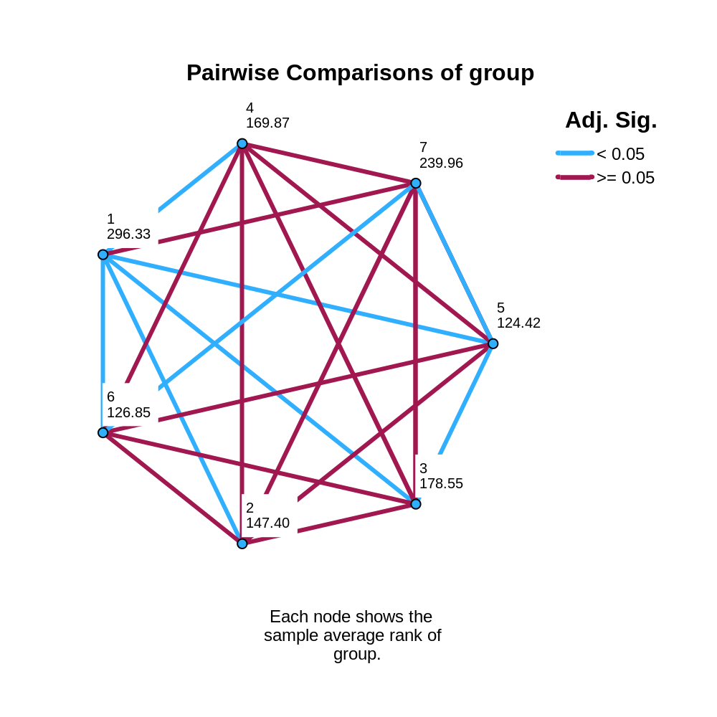

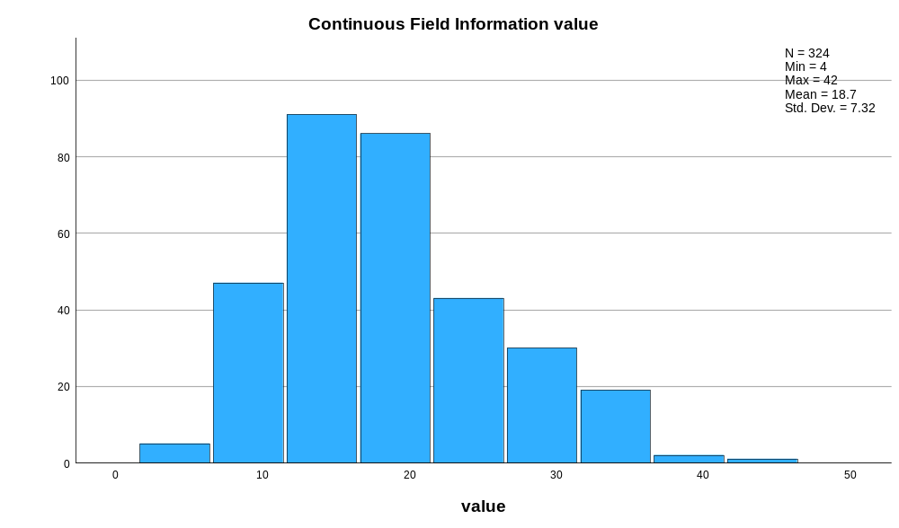

Appendix 15 raw data of widths of the widest part of the feather
Bird Number | N-Value | Widest Width of the Feather (mm)
 |  | 1 | 2 | 3
Eclectus F1 | 3 | 31 | 31 | 31
Eclectus F2 | 3 | 41 | 43 | 46
Eclectus F3 | 3 | 37 | 38 | 37
Eclectus B1 | 3 | 17 | 17 | 16
Eclectus B2 | 3 | 19 | 19 | 19
Eclectus B3 | 3 | 21 | 20 | 21
Eclectus B4 | 3 | 21 | 19 | 20
Eclectus B5 | 3 | 16 | 16 | 16
Eclectus B6 | 3 | 20 | 19 | 20
Eclectus B7 | 3 | 24 | 21 | 22
Eclectus M1 | 3 | 33 | 34 | 33
Eclectus M2 | 3 | 41 | 44 | 42
Eclectus M3 | 3 | 43 | 44 | 44
Eclectus M4 | 3 | 26 | 27 | 26
Eclectus M5 | 3 | 19 | 19 | 18
Eclectus M6 | 3 | 35 | 35 | 36
Eclectus M7 | 3 | 40 | 40 | 41
Eclectus M8 | 3 | 55 | 54 | 56
Eclectus M9 | 3 | 31 | 30 | 30
Eclectus M10 | 3 | 37 | 38 | 39
Eclectus M11 | 3 | 27 | 26 | 27
Eclectus M12 | 3 | 38 | 37 | 39
Eclectus M13 | 3 | 33 | 35 | 31
Eclectus M14 | 3 | 34 | 33 | 34
Eclectus M15 | 3 | 37 | 36 | 36
Eclectus M16 | 3 | 31 | 30 | 28
Eclectus M17 | 3 | 30 | 31 | 30
Eclectus M18 | 3 | 39 | 40 | 40
Eclectus M19 | 3 | 19 | 20 | 19
Eclectus M20 | 3 | 20 | 21 | 19
Eclectus M21 | 3 | 13 | 14 | 14
Eclectus M22 | 3 | 19 | 20 | 20
Eclectus M23 | 3 | 27 | 26 | 27
Eclectus M24 | 3 | 25 | 26 | 26
Eclectus M25 | 3 | 22 | 21 | 22
Eclectus M26 | 3 | 27 | 28 | 27
Eclectus M27 | 3 | 30 | 29 | 29
Eclectus M28 | 3 | 32 | 33 | 32
Eclectus M29 | 3 | 33 | 34 | 33
Eclectus M30 | 3 | 27 | 28 | 27
Eclectus M31 | 3 | 41 | 40 | 41
Eclectus M32 | 3 | 38 | 38 | 41
Eclectus M33 | 3 | 24 | 23 | 24
Eclectus M34 | 3 | 29 | 30 | 30
Eclectus M35 | 3 | 19 | 20 | 20
Cockatoo 1 | 3 | 24 | 23 | 24
Cockatoo 2 | 3 | 20 | 20 | 20
Cockatoo 3 | 3 | 24 | 25 | 25
Cockatoo 4 | 3 | 30 | 31 | 30
Cockatoo 5 | 3 | 21 | 20 | 20
Cockatoo 6 | 3 | 11 | 12 | 12
Cockatoo 7 | 3 | 28 | 29 | 29
Cockatoo 8 | 3 | 35 | 33 | 34
Cockatoo 9 | 3 | 22 | 25 | 28
Cockatoo 10 | 3 | 10 | 10 | 11
Cockatoo 11 | 3 | 36 | 35 | 37
Cockatoo 12 | 3 | 35 | 36 | 35
Cockatoo 13 | 3 | 45 | 44 | 44
Cockatoo 14 | 3 | 41 | 42 | 41
Cockatoo 15 | 3 | 57 | 58 | 56
Cockatoo 16 | 3 | 84 | 86 | 80
Cockatoo 17 | 3 | 49 | 50 | 49
Cockatoo 18 | 3 | 49 | 50 | 51
Cockatoo 19 | 3 | 78 | 79 | 73
Cockatoo 20 | 3 | 51 | 50 | 49
Cockatoo 21 | 3 | 41 | 50 | 47
Cockatoo 22 | 3 | 60 | 61 | 60
Cockatoo 23 | 3 | 54 | 53 | 52
African G1 | 3 | 21 | 22 | 24
African G2 | 3 | 29 | 28 | 28
African G3 | 3 | 25 | 25 | 24
African G4 | 3 | 26 | 28 | 27
African G5 | 3 | 13 | 12 | 14
African G6 | 3 | 28 | 29 | 27
African G7 | 3 | 18 | 17 | 18
African G8 | 3 | 37 | 38 | 39
African G9 | 3 | 24 | 25 | 24
African G10 | 3 | 27 | 26 | 26
African G11 | 3 | 21 | 22 | 22
African G12 | 3 | 15 | 14 | 14
African G13 | 3 | 15 | 15 | 14
African G14 | 3 | 32 | 33 | 34
African G15 | 3 | 15 | 14 | 15
African G16 | 3 | 23 | 23 | 23
African G17 | 3 | 22 | 24 | 22
African G18 | 3 | 25 | 26 | 25
African G19 | 3 | 17 | 16 | 16
African G20 | 3 | 14 | 13 | 13
African G21 | 3 | 24 | 24 | 25
African G22 | 3 | 22 | 21 | 21
Macaw 1 | 3 | 18 | 19 | 19
Macaw 2 | 3 | 24 | 23 | 25
Macaw 3 | 3 | 9 | 10 | 11
Macaw 5 | 3 | 26 | 25 | 26
Macaw 6 | 3 | 23 | 24 | 24
Macaw 7 | 3 | 50 | 50 | 51
Macaw 8 | 3 | 37 | 38 | 39
Macaw 9 | 3 | 55 | 54 | 54
Macaw 11 | 3 | 42 | 43 | 44
Macaw 12 | 3 | 42 | 42 | 42
Macaw 13 | 3 | 45 | 47 | 47
Macaw 14 | 3 | 53 | 53 | 53
Macaw 15 | 3 | 45 | 47 | 46
Macaw 16 | 3 | 48 | 47 | 48
Owl 1 | 3 | 46 | 47 | 45
Owl 2 | 3 | 41 | 40 | 43
Owl 3 | 3 | 64 | 62 | 63
Owl 4 | 3 | 87 | 89 | 87

Appendix 16 descriptive test of feathers width of the widest part
Explore

Notes
Output Created |  | 16-MAR-2026 13:26:13
Comments
Input | Active Dataset | DataSet0
Input | Filter | <none>
Input | Weight | <none>
Input | Split File | <none>
Input | N of Rows in Working Data File | 105
Missing Value Handling | Definition of Missing | User-defined missing values for dependent variables are treated as missing.
Missing Value Handling | Cases Used | Statistics are based on cases with no missing values for any dependent variable or factor used.
Syntax |  | EXAMINE VARIABLES=Ect_F Ect_B Ect_M coc af_G Mac Owl  /PLOT BOXPLOT HISTOGRAM NPPLOT  /COMPARE VARIABLES  /STATISTICS DESCRIPTIVES  /CINTERVAL 95  /MISSING LISTWISE  /NOTOTAL.
Resources | Processor Time | 00:00:02.36
Resources | Elapsed Time | 00:00:02.21

Case Processing Summary
 | Cases
 | Valid |  | Missing |  | Total
 | N | Percent | N | Percent | N | Percent
Ect_F | 9 | 8.6% | 96 | 91.4% | 105 | 100.0%
Ect_B | 9 | 8.6% | 96 | 91.4% | 105 | 100.0%
Ect_M | 9 | 8.6% | 96 | 91.4% | 105 | 100.0%
coc | 9 | 8.6% | 96 | 91.4% | 105 | 100.0%
af_G | 9 | 8.6% | 96 | 91.4% | 105 | 100.0%
Mac | 9 | 8.6% | 96 | 91.4% | 105 | 100.0%
Owl | 9 | 8.6% | 96 | 91.4% | 105 | 100.0%

Descriptives
 |  |  | Statistic | Std. Error
Ect_F | Mean |  | 37.22 | 1.832
Ect_F | 95% Confidence Interval for Mean | Lower Bound | 33.00
Ect_F | 95% Confidence Interval for Mean | Upper Bound | 41.45
Ect_F | 5% Trimmed Mean |  | 37.08
Ect_F | Median |  | 37.00
Ect_F | Variance |  | 30.194
Ect_F | Std. Deviation |  | 5.495
Ect_F | Minimum |  | 31
Ect_F | Maximum |  | 46
Ect_F | Range |  | 15
Ect_F | Interquartile Range |  | 11
Ect_F | Skewness |  | .195 | .717
Ect_F | Kurtosis |  | -1.119 | 1.400
Ect_B | Mean |  | 19.33 | .833
Ect_B | 95% Confidence Interval for Mean | Lower Bound | 17.41
Ect_B | 95% Confidence Interval for Mean | Upper Bound | 21.26
Ect_B | 5% Trimmed Mean |  | 19.26
Ect_B | Median |  | 19.00
Ect_B | Variance |  | 6.250
Ect_B | Std. Deviation |  | 2.500
Ect_B | Minimum |  | 16
Ect_B | Maximum |  | 24
Ect_B | Range |  | 8
Ect_B | Interquartile Range |  | 4
Ect_B | Skewness |  | .501 | .717
Ect_B | Kurtosis |  | .041 | 1.400
Ect_M | Mean |  | 35.89 | 3.486
Ect_M | 95% Confidence Interval for Mean | Lower Bound | 27.85
Ect_M | 95% Confidence Interval for Mean | Upper Bound | 43.93
Ect_M | 5% Trimmed Mean |  | 35.77
Ect_M | Median |  | 35.00
Ect_M | Variance |  | 109.361
Ect_M | Std. Deviation |  | 10.458
Ect_M | Minimum |  | 19
Ect_M | Maximum |  | 55
Ect_M | Range |  | 36
Ect_M | Interquartile Range |  | 14
Ect_M | Skewness |  | .227 | .717
Ect_M | Kurtosis |  | .546 | 1.400
coc | Mean |  | 23.89 | 2.270
coc | 95% Confidence Interval for Mean | Lower Bound | 18.66
coc | 95% Confidence Interval for Mean | Upper Bound | 29.12
coc | 5% Trimmed Mean |  | 23.99
coc | Median |  | 24.00
coc | Variance |  | 46.361
coc | Std. Deviation |  | 6.809
coc | Minimum |  | 11
coc | Maximum |  | 35
coc | Range |  | 24
coc | Interquartile Range |  | 9
coc | Skewness |  | -.286 | .717
coc | Kurtosis |  | 1.015 | 1.400
af_G | Mean |  | 24.56 | 2.292
af_G | 95% Confidence Interval for Mean | Lower Bound | 19.27
af_G | 95% Confidence Interval for Mean | Upper Bound | 29.84
af_G | 5% Trimmed Mean |  | 24.51
af_G | Median |  | 25.00
af_G | Variance |  | 47.278
af_G | Std. Deviation |  | 6.876
af_G | Minimum |  | 13
af_G | Maximum |  | 37
af_G | Range |  | 24
af_G | Interquartile Range |  | 9
af_G | Skewness |  | .093 | .717
af_G | Kurtosis |  | .744 | 1.400
Mac | Mean |  | 31.56 | 5.113
Mac | 95% Confidence Interval for Mean | Lower Bound | 19.77
Mac | 95% Confidence Interval for Mean | Upper Bound | 43.35
Mac | 5% Trimmed Mean |  | 31.51
Mac | Median |  | 26.00
Mac | Variance |  | 235.278
Mac | Std. Deviation |  | 15.339
Mac | Minimum |  | 9
Mac | Maximum |  | 55
Mac | Range |  | 46
Mac | Interquartile Range |  | 26
Mac | Skewness |  | .235 | .717
Mac | Kurtosis |  | -1.026 | 1.400
Owl | Mean |  | 57.89 | 6.347
Owl | 95% Confidence Interval for Mean | Lower Bound | 43.25
Owl | 95% Confidence Interval for Mean | Upper Bound | 72.53
Owl | 5% Trimmed Mean |  | 57.15
Owl | Median |  | 47.00
Owl | Variance |  | 362.611
Owl | Std. Deviation |  | 19.042
Owl | Minimum |  | 40
Owl | Maximum |  | 89
Owl | Range |  | 49
Owl | Interquartile Range |  | 33
Owl | Skewness |  | .918 | .717
Owl | Kurtosis |  | -.697 | 1.400

Tests of Normality
 | Kolmogorov-Smirnovª |  |  | Shapiro-Wilk
 | Statistic | df | Sig. | Statistic | df | Sig.
Ect_F | .205 | 9 | .200* | .907 | 9 | .292
Ect_B | .158 | 9 | .200* | .951 | 9 | .697
Ect_M | .137 | 9 | .200* | .985 | 9 | .984
coc | .173 | 9 | .200* | .968 | 9 | .877
af_G | .148 | 9 | .200* | .982 | 9 | .974
Mac | .197 | 9 | .200* | .958 | 9 | .774
Owl | .272 | 9 | .054 | .829 | 9 | .044
*. This is a lower bound of the true significance.
a. Lilliefors Significance Correction

Histograms

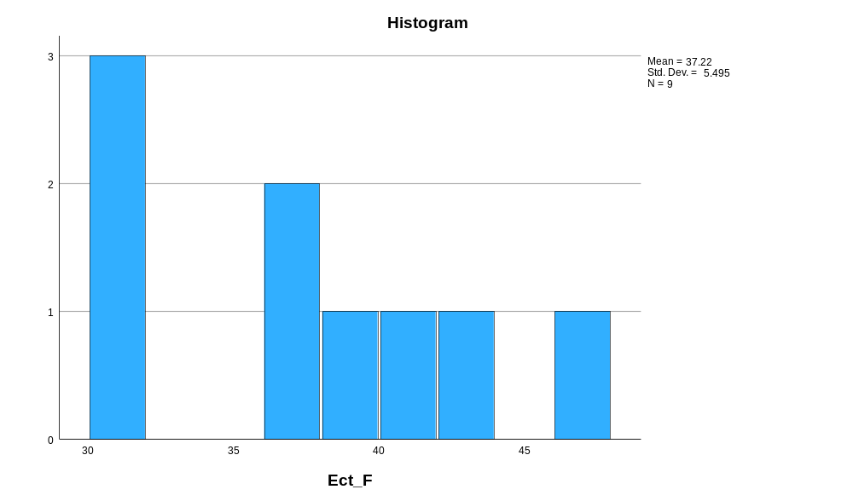

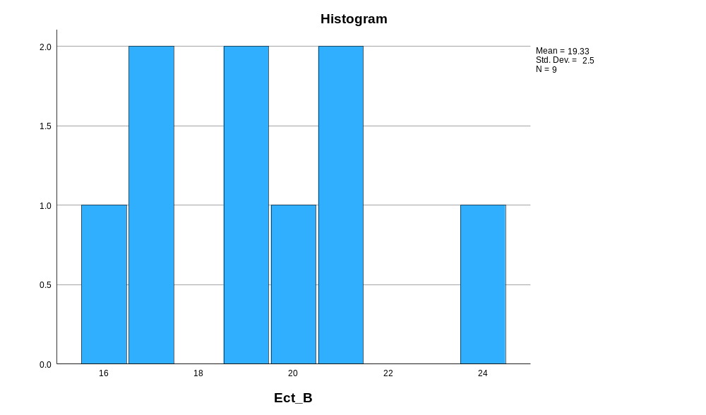

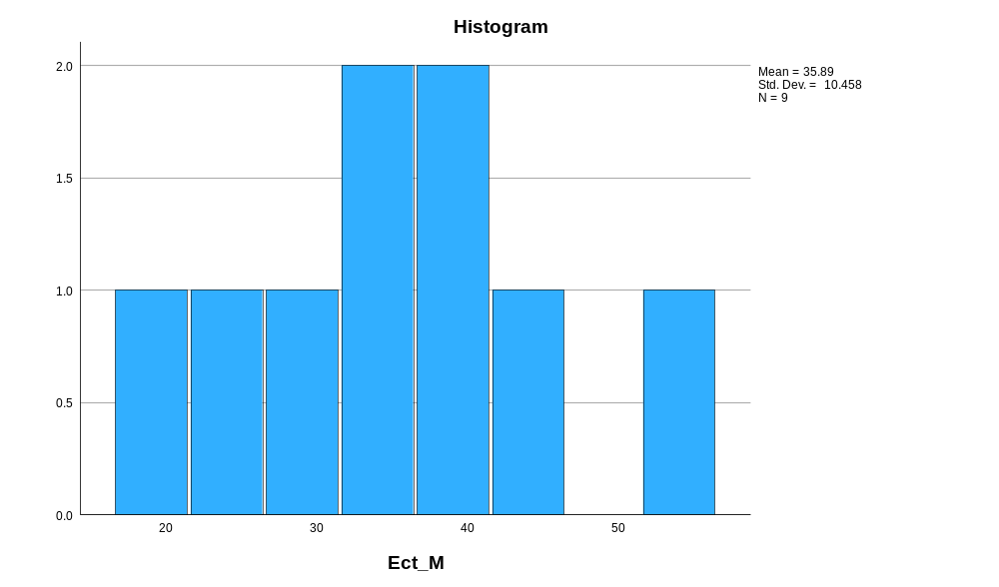

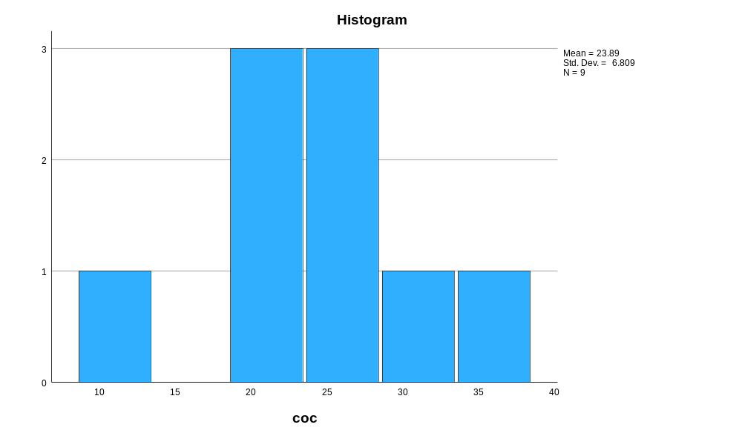

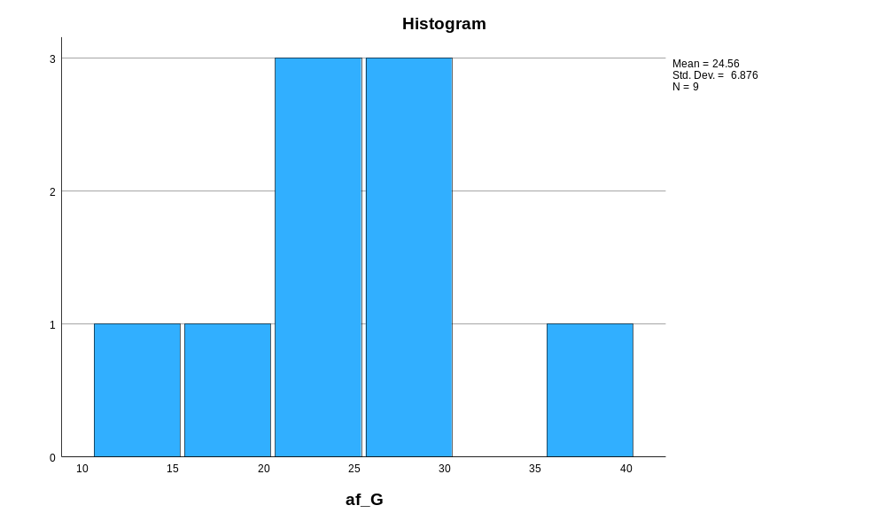

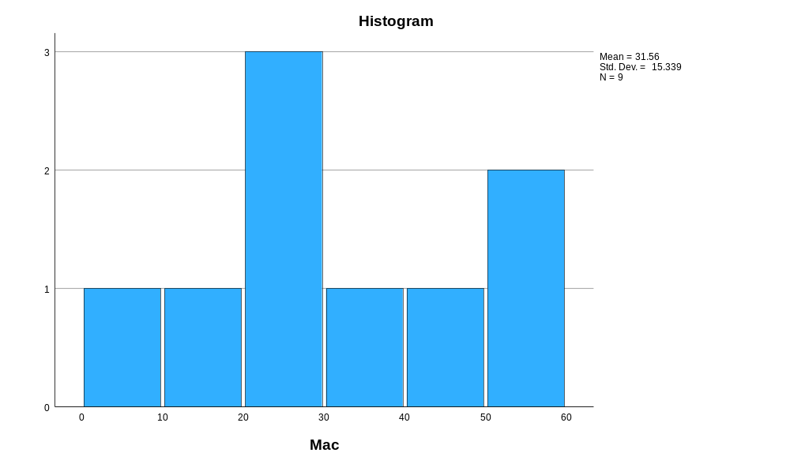

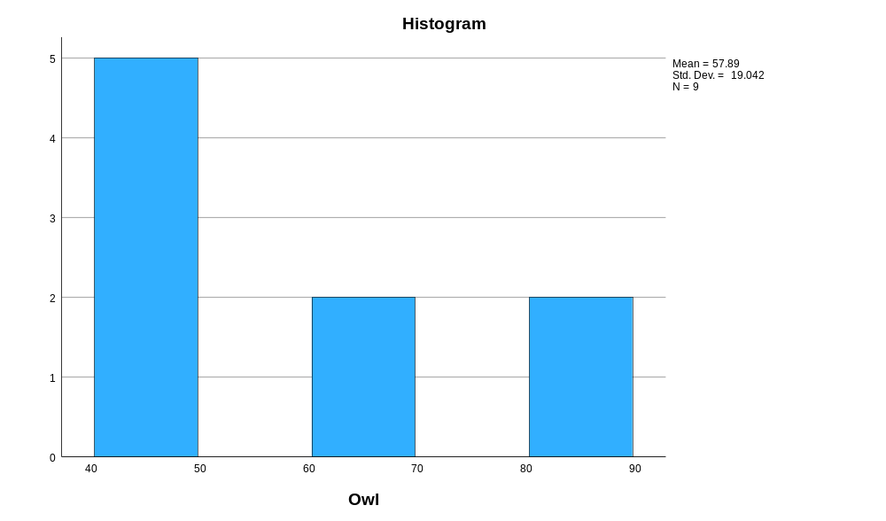

Normal Q-Q Plots

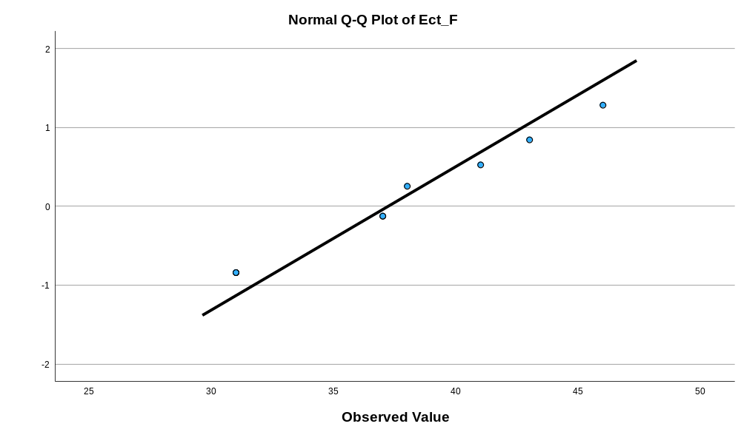

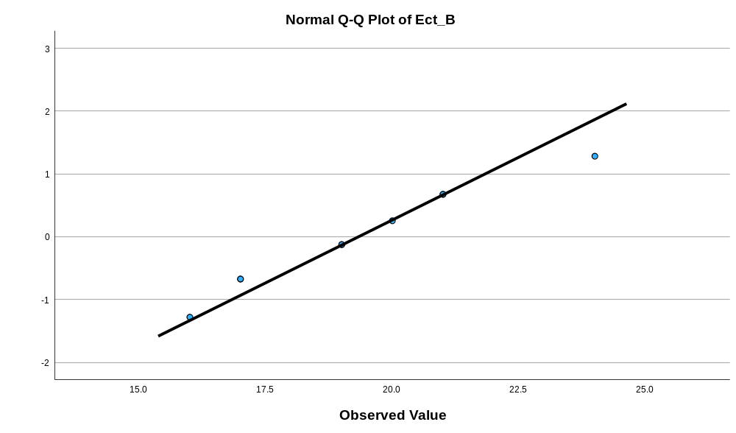

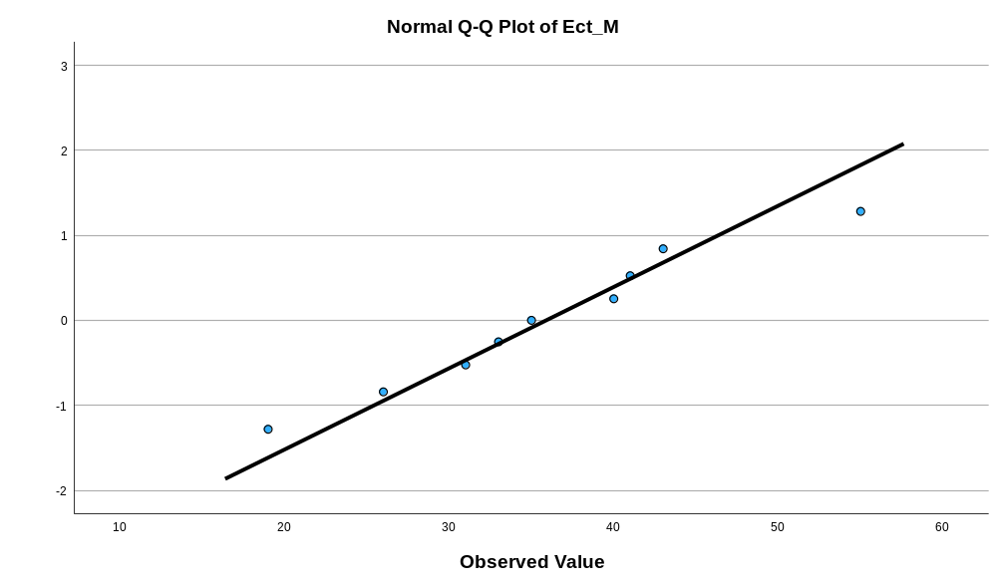

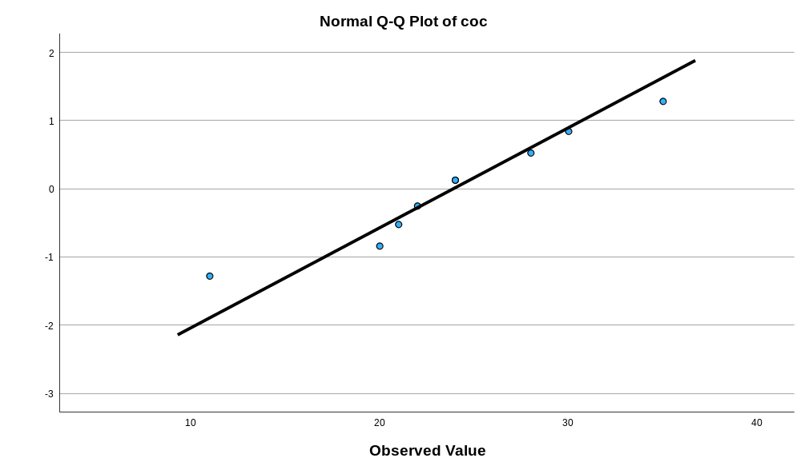

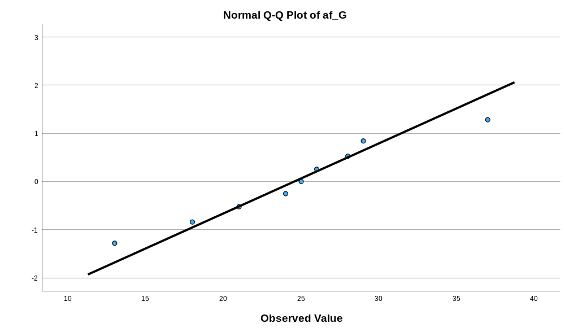

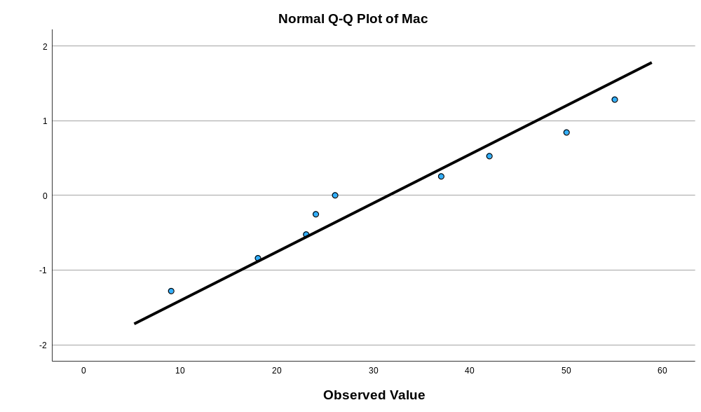

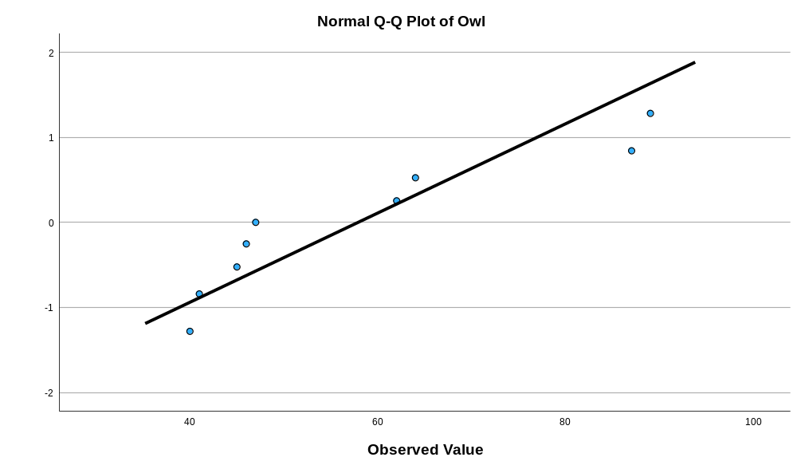

Detrended Normal Q-Q Plots

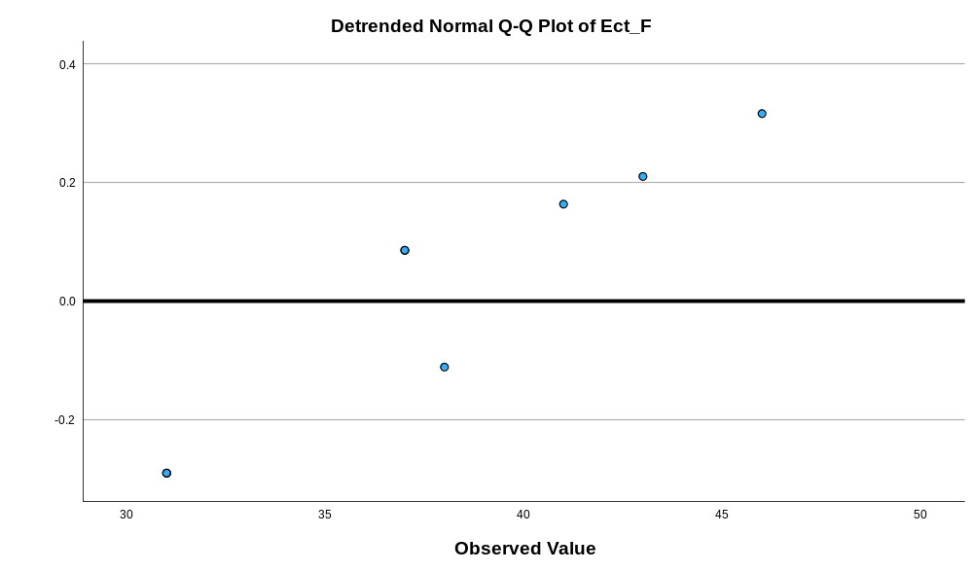

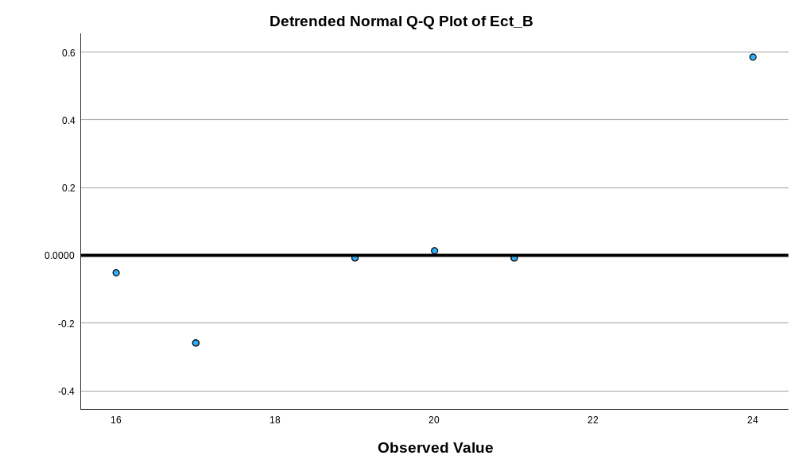

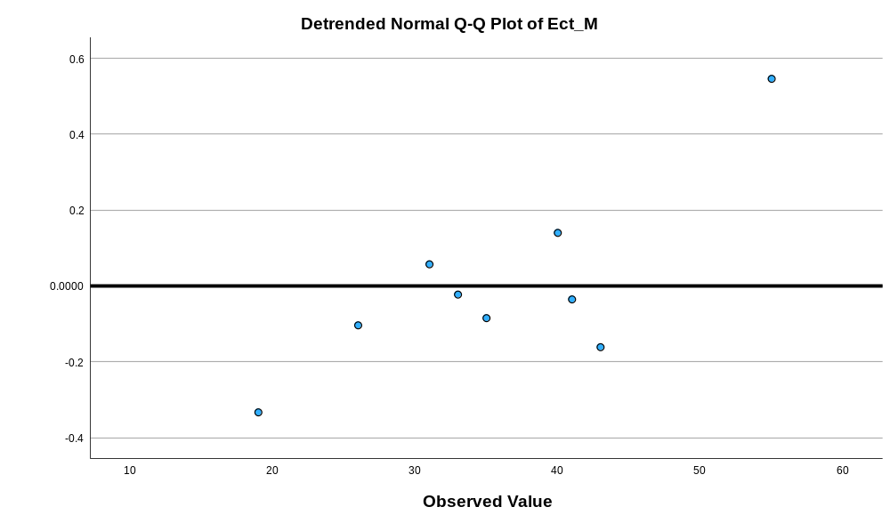

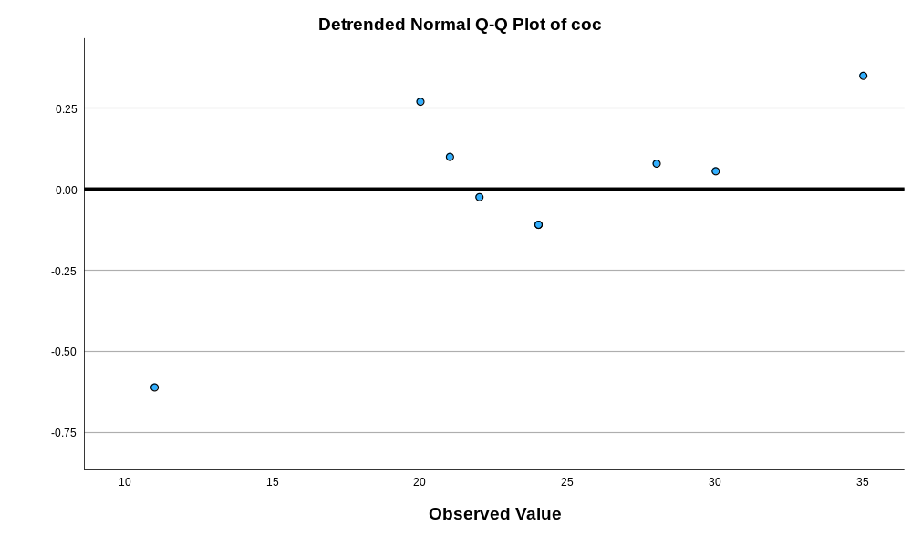

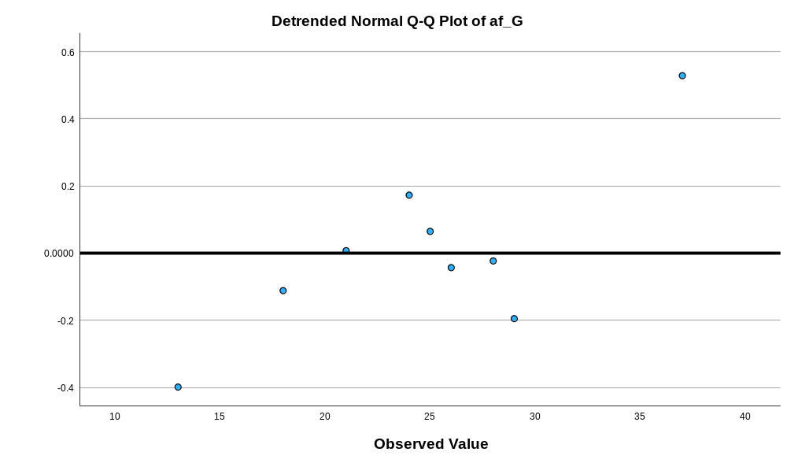

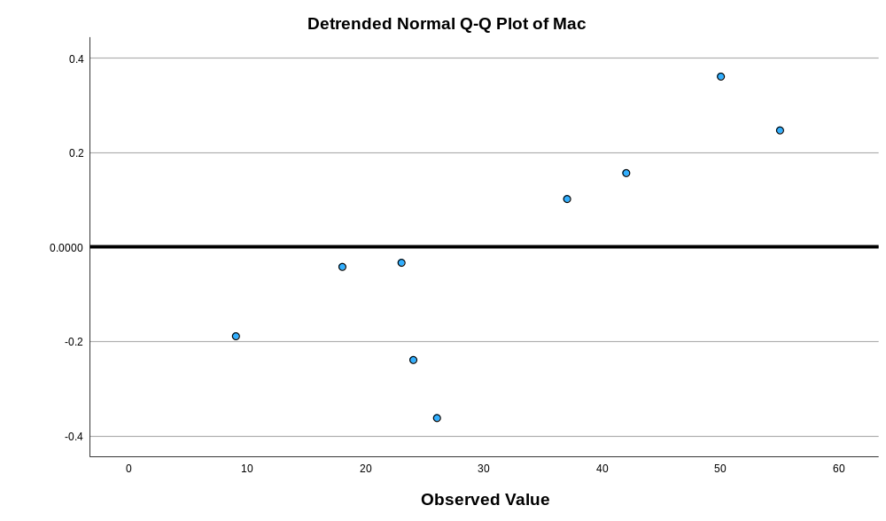

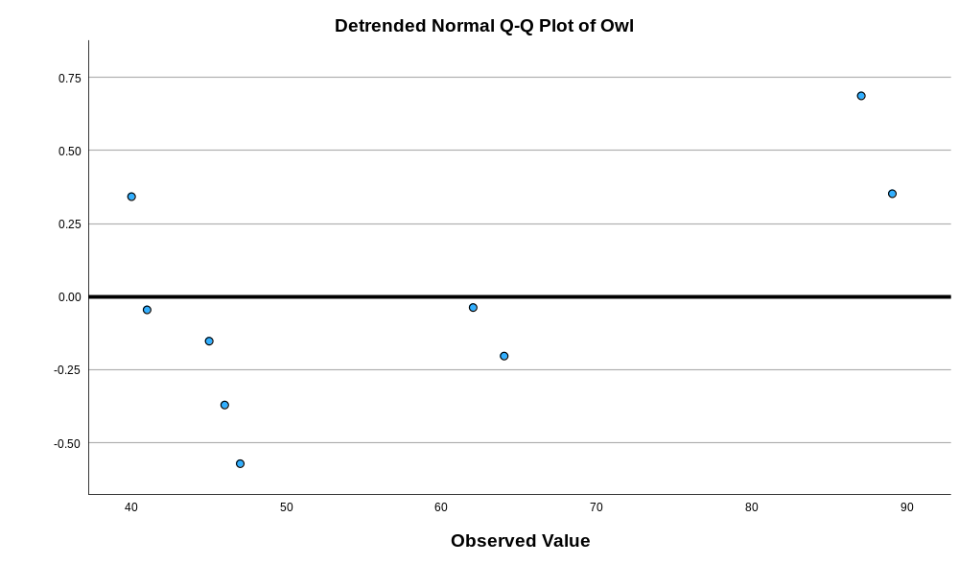

Appendix 17 Kruskal Wallis test of feathers width of the widest part
Nonparametric Tests

Notes
Output Created |  | 17-MAR-2026 10:40:15
Comments
Input | Active Dataset | DataSet0
Input | Filter | <none>
Input | Weight | <none>
Input | Split File | <none>
Input | N of Rows in Working Data File | 324
Syntax |  | NPTESTS  /INDEPENDENT TEST (value) GROUP (group) KRUSKAL_WALLIS(COMPARE=PAIRWISE)  /MISSING SCOPE=ANALYSIS USERMISSING=EXCLUDE  /CRITERIA ALPHA=0.05 CILEVEL=95.
Resources | Processor Time | 00:00:00.53
Resources | Elapsed Time | 00:00:00.52

Hypothesis Test Summary
 | Null Hypothesis | Test | Sig.^{a,b}
1 | The distribution of value is the same across categories of group. | Independent-Samples Kruskal-Wallis Test | <.001

Hypothesis Test Summary
 | Decision
1 | Reject the null hypothesis.

a. The significance level is .050.
b. Asymptotic significance is displayed.
Independent-Samples Kruskal-Wallis Test
value across group

Independent-Samples Kruskal-Wallis Test Summary
Total N | 324
Test Statistic | 107.041ª
Degree Of Freedom | 6
Asymptotic Sig.(2-sided test) | <.001
a. The test statistic is adjusted for ties.

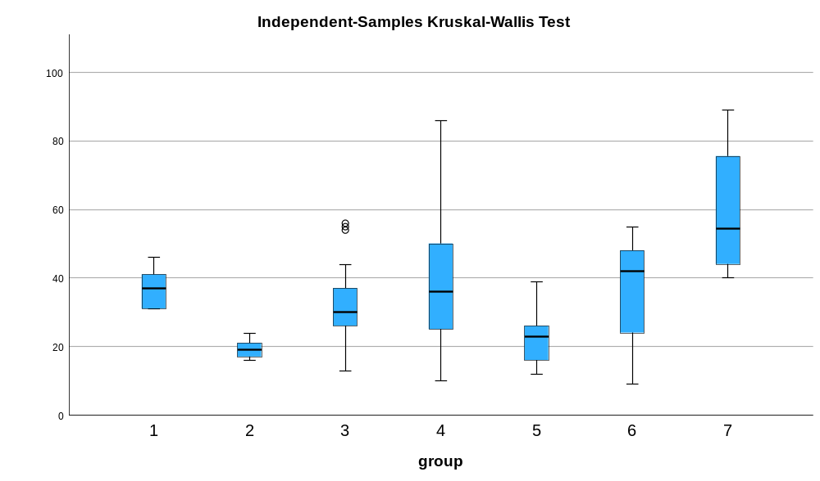

Pairwise Comparisons of group
Sample 1-Sample 2 | Test Statistic | Std. Error | Std. Test Statistic | Sig. | Adj. Sig.ª
2-5 | -38.042 | 23.460 | -1.622 | .105 | 1.000
2-3 | -108.900 | 22.384 | -4.865 | <.001 | .000
2-4 | -145.110 | 23.337 | -6.218 | <.001 | .000
2-6 | -146.464 | 25.026 | -5.852 | <.001 | .000
2-1 | 163.651 | 37.307 | 4.387 | <.001 | .000
2-7 | -232.720 | 33.885 | -6.868 | <.001 | .000
5-3 | 70.858 | 14.709 | 4.817 | <.001 | .000
5-4 | 107.068 | 16.122 | 6.641 | <.001 | .000
5-6 | -108.422 | 18.483 | -5.866 | <.001 | .000
5-1 | 125.609 | 33.273 | 3.775 | <.001 | .003
5-7 | -194.678 | 29.386 | -6.625 | <.001 | .000
3-4 | -36.210 | 14.511 | -2.495 | .013 | .264
3-6 | -37.564 | 17.096 | -2.197 | .028 | .588
3-1 | 54.751 | 32.523 | 1.683 | .092 | 1.000
3-7 | -123.820 | 28.534 | -4.339 | <.001 | .000
4-6 | -1.355 | 18.326 | -.074 | .941 | 1.000
4-1 | 18.541 | 33.186 | .559 | .576 | 1.000
4-7 | -87.611 | 29.288 | -2.991 | .003 | .058
6-1 | 17.187 | 34.395 | .500 | .617 | 1.000
6-7 | -86.256 | 30.650 | -2.814 | .005 | .103
1-7 | -69.069 | 41.291 | -1.673 | .094 | 1.000
Each row tests the null hypothesis that the Sample 1 and Sample 2 distributions are the same.
Asymptotic significances (2-sided tests) are displayed. The significance level is .050.
a. Significance values have been adjusted by the Bonferroni correction for multiple tests.

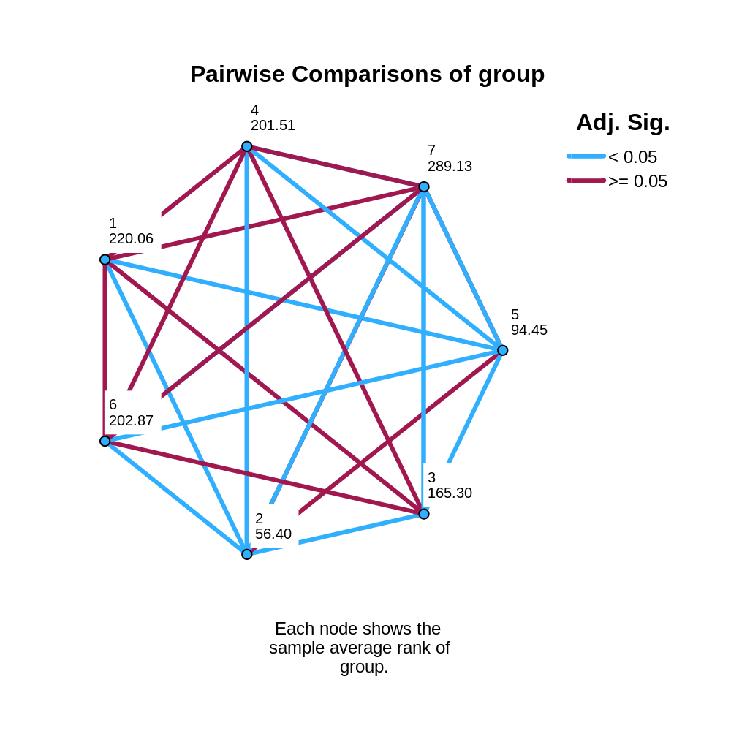

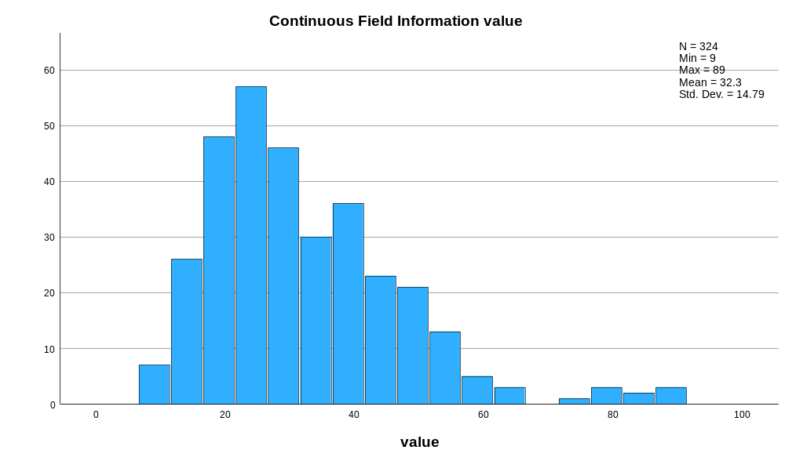

Appendix 18 raw data of widths left side of the vane at the widest point
Bird Number | N-Value | Widest Part the Feather Left Side Vane (mm)
 |  | 1 | 2 | 3
Eclectus F1 | 3 | 12 | 12 | 12
Eclectus F2 | 3 | 19 | 20 | 19
Eclectus F3 | 3 | 24 | 24 | 24
Eclectus B1 | 3 | 10 | 10 | 10
Eclectus B2 | 3 | 8 | 7 | 7
Eclectus B3 | 3 | 8 | 7 | 8
Eclectus B4 | 3 | 7 | 8 | 7
Eclectus B5 | 3 | 5 | 6 | 5
Eclectus B6 | 3 | 8 | 7 | 9
Eclectus B7 | 3 | 11 | 10 | 11
Eclectus M1 | 3 | 7 | 7 | 7
Eclectus M2 | 3 | 18 | 17 | 16
Eclectus M3 | 3 | 11 | 10 | 10
Eclectus M4 | 3 | 17 | 19 | 18
Eclectus M5 | 3 | 15 | 15 | 14
Eclectus M6 | 3 | 21 | 20 | 21
Eclectus M7 | 3 | 22 | 22 | 21
Eclectus M8 | 3 | 34 | 33 | 34
Eclectus M9 | 3 | 9 | 9 | 10
Eclectus M10 | 3 | 25 | 25 | 24
Eclectus M11 | 3 | 14 | 13 | 14
Eclectus M12 | 3 | 20 | 19 | 20
Eclectus M13 | 3 | 11 | 11 | 12
Eclectus M14 | 3 | 13 | 14 | 14
Eclectus M15 | 3 | 15 | 16 | 16
Eclectus M16 | 3 | 15 | 14 | 15
Eclectus M17 | 3 | 13 | 14 | 14
Eclectus M18 | 3 | 21 | 20 | 21
Eclectus M19 | 3 | 10 | 10 | 11
Eclectus M20 | 3 | 9 | 8 | 9
Eclectus M21 | 3 | 9 | 8 | 7
Eclectus M22 | 3 | 9 |  | 9
Eclectus M23 | 3 | 18 |  | 19
Eclectus M24 | 3 | 16 | 16 | 15
Eclectus M25 | 3 | 9 | 10 | 9
Eclectus M26 | 3 | 9 | 9 | 10
Eclectus M27 | 3 | 15 | 15 | 16
Eclectus M28 | 3 | 6 | 7 | 7
Eclectus M29 | 3 | 15 | 14 | 15
Eclectus M30 | 3 | 6 | 7 | 7
Eclectus M31 | 3 | 18 | 19 | 19
Eclectus M32 | 3 | 24 | 25 | 26
Eclectus M33 | 3 | 13 | 13 | 14
Eclectus M34 | 3 | 18 | 19 | 18
Eclectus M35 | 3 | 11 | 11 | 12
Cockatoo 1 | 3 | 4 | 4 | 4
Cockatoo 2 | 3 | 4 | 4 | 4
Cockatoo 3 | 3 | 7 | 8 | 8
Cockatoo 4 | 3 | 15 | 15 | 15
Cockatoo 5 | 3 | 13 | 12 | 12
Cockatoo 6 | 3 | 7 | 6 | 6
Cockatoo 7 | 3 | 15 | 15 | 15
Cockatoo 8 | 3 | 17 | 16 | 17
Cockatoo 9 | 3 | 14 | 15 | 14
Cockatoo 10 | 3 | 7 | 7 | 7
Cockatoo 11 | 3 | 15 | 16 | 15
Cockatoo 12 | 3 | 20 | 20 | 21
Cockatoo 13 | 3 | 25 | 25 | 25
Cockatoo 14 | 3 | 21 | 21 | 20
Cockatoo 15 | 3 | 24 | 24 | 25
Cockatoo 16 | 3 | 35 | 40 | 37
Cockatoo 17 | 3 | 29 | 29 | 29
Cockatoo 18 | 3 | 25 | 23 | 25
Cockatoo 19 | 3 | 35 | 35 | 36
Cockatoo 20 | 3 | 24 | 23 | 22
Cockatoo 21 | 3 | 21 | 21 | 21
Cockatoo 22 | 3 | 25 | 26 | 24
Cockatoo 23 | 3 | 24 | 23 | 24
African G1 | 3 | 17 | 17 | 17
African G2 | 3 | 4 | 4 | 4
African G3 | 3 | 7 | 7 | 7
African G4 | 3 | 6 | 7 | 7
African G5 | 3 | 7 | 8 | 8
African G6 | 3 | 15 | 16 | 16
African G7 | 3 | 6 | 6 | 7
African G8 | 3 | 15 | 15 | 15
African G9 | 3 | 15 | 16 | 16
African G10 | 3 | 16 | 16 | 16
African G11 | 3 | 6 | 7 | 7
African G12 | 3 | 5 | 5 | 5
African G13 | 3 | 7 | 8 | 7
African G14 | 3 | 20 | 20 | 19
African G15 | 3 | 5 | 5 | 5
African G16 | 3 | 14 | 13 | 14
African G17 | 3 | 10 | 10 | 10
African G18 | 3 | 13 | 12 | 12
African G19 | 3 | 6 | 6 | 6
African G20 | 3 | 7 | 7 | 7
African G21 | 3 | 16 | 15 | 16
African G22 | 3 | 13 | 14 | 13
Macaw 1 | 3 | 9 | 8 | 9
Macaw 2 | 3 | 12 | 12 | 12
Macaw 3 | 3 | 5 | 6 | 6
Macaw 5 | 3 | 15 | 15 | 15
Macaw 6 | 3 | 15 | 15 | 15
Macaw 7 | 3 | 31 | 30 | 30
Macaw 8 | 3 | 15 | 15 | 15
Macaw 9 | 3 | 39 | 39 | 39
Macaw 11 | 3 | 19 | 19 | 18
Macaw 12 | 3 | 21 | 21 | 22
Macaw 13 | 3 | 11 | 11 | 11
Macaw 14 | 3 | 20 | 20 | 20
Macaw 15 | 3 | 22 | 22 | 22
Macaw 16 | 3 | 35 | 35 | 36
Owl 1 | 3 | 20 | 21 | 23
Owl 2 | 3 | 21 | 21 | 21
Owl 3 | 3 | 33 | 34 | 35
Owl 4 | 3 | 45 | 45 | 44

Appendix 19 descriptive test of feathers width of the left side of the vane at the widest part
Explore

Notes
Output Created |  | 17-MAR-2026 10:49:32
Comments
Input | Active Dataset | DataSet0
Input | Filter | <none>
Input | Weight | <none>
Input | Split File | <none>
Input | N of Rows in Working Data File | 324
Missing Value Handling | Definition of Missing | User-defined missing values for dependent variables are treated as missing.
Missing Value Handling | Cases Used | Statistics are based on cases with no missing values for any dependent variable or factor used.
Syntax |  | EXAMINE VARIABLES=value BY group  /PLOT BOXPLOT STEMLEAF HISTOGRAM NPPLOT  /COMPARE GROUPS  /STATISTICS DESCRIPTIVES  /CINTERVAL 95  /MISSING LISTWISE  /NOTOTAL.
Resources | Processor Time | 00:00:03.95
Resources | Elapsed Time | 00:00:02.49

group

Case Processing Summary
 | group | Cases
 | group | Valid |  | Missing |  | Total
 | group | N | Percent | N | Percent | N | Percent
value | 1 | 9 | 100.0% | 0 | 0.0% | 9 | 100.0%
value | 2 | 21 | 100.0% | 0 | 0.0% | 21 | 100.0%
value | 3 | 105 | 100.0% | 0 | 0.0% | 105 | 100.0%
value | 4 | 69 | 100.0% | 0 | 0.0% | 69 | 100.0%
value | 5 | 66 | 100.0% | 0 | 0.0% | 66 | 100.0%
value | 6 | 42 | 100.0% | 0 | 0.0% | 42 | 100.0%
value | 7 | 12 | 100.0% | 0 | 0.0% | 12 | 100.0%

Descriptives
 | group |  |  | Statistic | Std. Error
value | 1 | Mean |  | 18.44 | 1.749
value | 1 | 95% Confidence Interval for Mean | Lower Bound | 14.41
value | 1 | 95% Confidence Interval for Mean | Upper Bound | 22.48
value | 1 | 5% Trimmed Mean |  | 18.49
value | 1 | Median |  | 19.00
value | 1 | Variance |  | 27.528
value | 1 | Std. Deviation |  | 5.247
value | 1 | Minimum |  | 12
value | 1 | Maximum |  | 24
value | 1 | Range |  | 12
value | 1 | Interquartile Range |  | 12
value | 1 | Skewness |  | -.316 | .717
value | 1 | Kurtosis |  | -1.730 | 1.400
value | 2 | Mean |  | 8.05 | .387
value | 2 | 95% Confidence Interval for Mean | Lower Bound | 7.24
value | 2 | 95% Confidence Interval for Mean | Upper Bound | 8.86
value | 2 | 5% Trimmed Mean |  | 8.05
value | 2 | Median |  | 8.00
value | 2 | Variance |  | 3.148
value | 2 | Std. Deviation |  | 1.774
value | 2 | Minimum |  | 5
value | 2 | Maximum |  | 11
value | 2 | Range |  | 6
value | 2 | Interquartile Range |  | 3
value | 2 | Skewness |  | .099 | .501
value | 2 | Kurtosis |  | -.726 | .972
value | 3 | Mean |  | 14.82 | .582
value | 3 | 95% Confidence Interval for Mean | Lower Bound | 13.66
value | 3 | 95% Confidence Interval for Mean | Upper Bound | 15.97
value | 3 | 5% Trimmed Mean |  | 14.42
value | 3 | Median |  | 14.00
value | 3 | Variance |  | 35.573
value | 3 | Std. Deviation |  | 5.964
value | 3 | Minimum |  | 6
value | 3 | Maximum |  | 34
value | 3 | Range |  | 28
value | 3 | Interquartile Range |  | 9
value | 3 | Skewness |  | .925 | .236
value | 3 | Kurtosis |  | 1.141 | .467
value | 4 | Mean |  | 18.55 | 1.097
value | 4 | 95% Confidence Interval for Mean | Lower Bound | 16.36
value | 4 | 95% Confidence Interval for Mean | Upper Bound | 20.74
value | 4 | 5% Trimmed Mean |  | 18.32
value | 4 | Median |  | 20.00
value | 4 | Variance |  | 83.045
value | 4 | Std. Deviation |  | 9.113
value | 4 | Minimum |  | 4
value | 4 | Maximum |  | 40
value | 4 | Range |  | 36
value | 4 | Interquartile Range |  | 12
value | 4 | Skewness |  | .161 | .289
value | 4 | Kurtosis |  | -.489 | .570
value | 5 | Mean |  | 10.58 | .587
value | 5 | 95% Confidence Interval for Mean | Lower Bound | 9.40
value | 5 | 95% Confidence Interval for Mean | Upper Bound | 11.75
value | 5 | 5% Trimmed Mean |  | 10.44
value | 5 | Median |  | 9.00
value | 5 | Variance |  | 22.771
value | 5 | Std. Deviation |  | 4.772
value | 5 | Minimum |  | 4
value | 5 | Maximum |  | 20
value | 5 | Range |  | 16
value | 5 | Interquartile Range |  | 8
value | 5 | Skewness |  | .285 | .295
value | 5 | Kurtosis |  | -1.404 | .582
value | 6 | Mean |  | 19.21 | 1.480
value | 6 | 95% Confidence Interval for Mean | Lower Bound | 16.23
value | 6 | 95% Confidence Interval for Mean | Upper Bound | 22.20
value | 6 | 5% Trimmed Mean |  | 18.88
value | 6 | Median |  | 16.50
value | 6 | Variance |  | 91.977
value | 6 | Std. Deviation |  | 9.590
value | 6 | Minimum |  | 5
value | 6 | Maximum |  | 39
value | 6 | Range |  | 34
value | 6 | Interquartile Range |  | 10
value | 6 | Skewness |  | .743 | .365
value | 6 | Kurtosis |  | -.316 | .717
value | 7 | Mean |  | 30.25 | 2.975
value | 7 | 95% Confidence Interval for Mean | Lower Bound | 23.70
value | 7 | 95% Confidence Interval for Mean | Upper Bound | 36.80
value | 7 | 5% Trimmed Mean |  | 30.00
value | 7 | Median |  | 28.00
value | 7 | Variance |  | 106.205
value | 7 | Std. Deviation |  | 10.306
value | 7 | Minimum |  | 20
value | 7 | Maximum |  | 45
value | 7 | Range |  | 25
value | 7 | Interquartile Range |  | 21
value | 7 | Skewness |  | .456 | .637
value | 7 | Kurtosis |  | -1.599 | 1.232

Tests of Normality
 | group | Kolmogorov-Smirnovª |  |  | Shapiro-Wilk
 | group | Statistic | df | Sig. | Statistic | df | Sig.
value | 1 | .224 | 9 | .200* | .819 | 9 | .033
value | 2 | .177 | 21 | .083 | .931 | 21 | .141
value | 3 | .097 | 105 | .016 | .934 | 105 | <.001
value | 4 | .095 | 69 | .200* | .957 | 69 | .019
value | 5 | .228 | 66 | <.001 | .889 | 66 | <.001
value | 6 | .171 | 42 | .003 | .912 | 42 | .003
value | 7 | .259 | 12 | .025 | .812 | 12 | .013
*. This is a lower bound of the true significance.
a. Lilliefors Significance Correction

value

Histograms

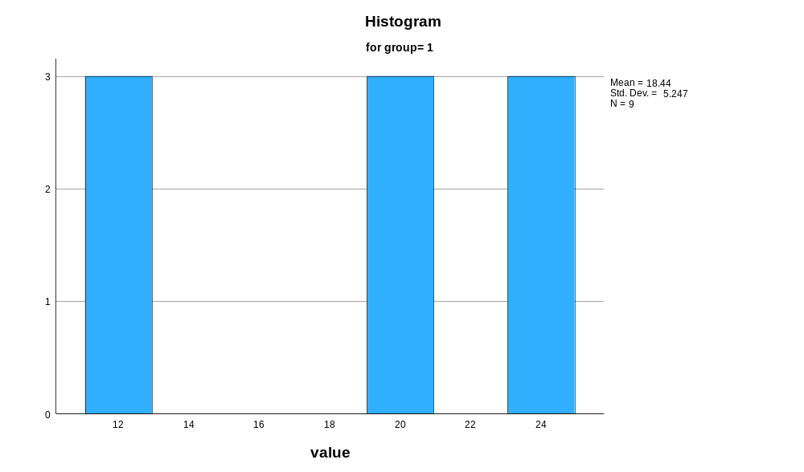

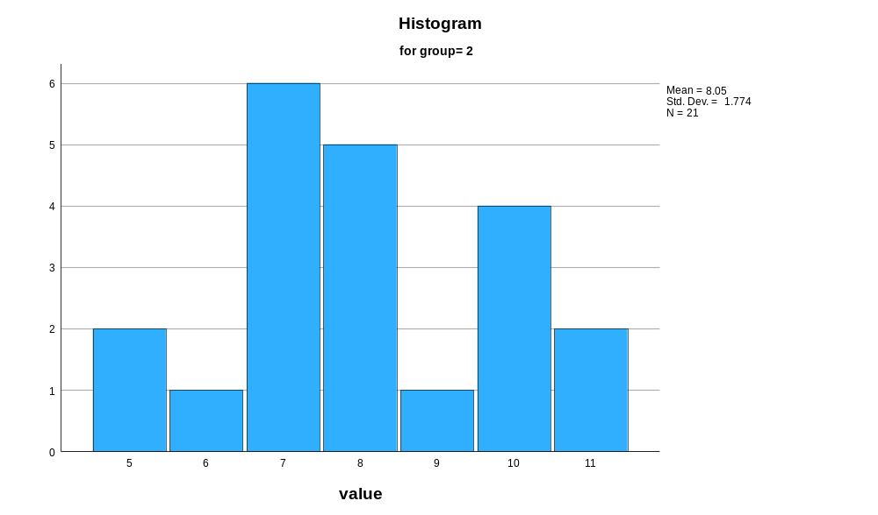

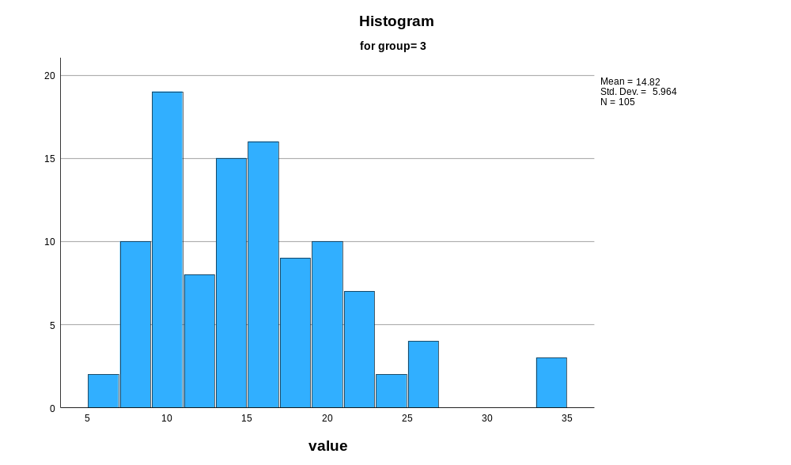

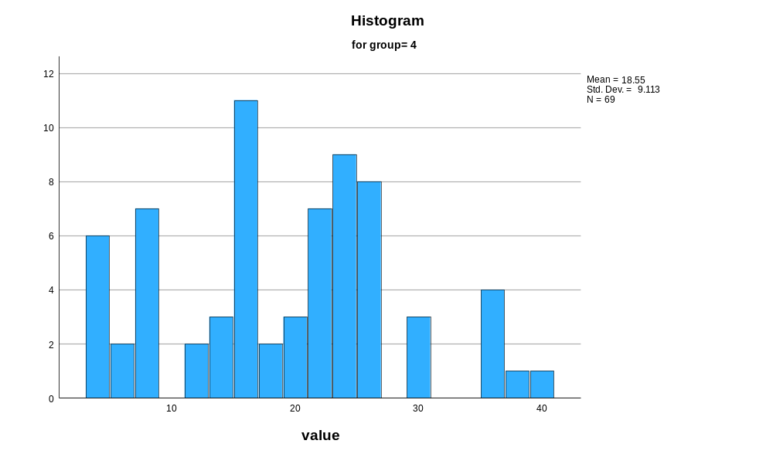

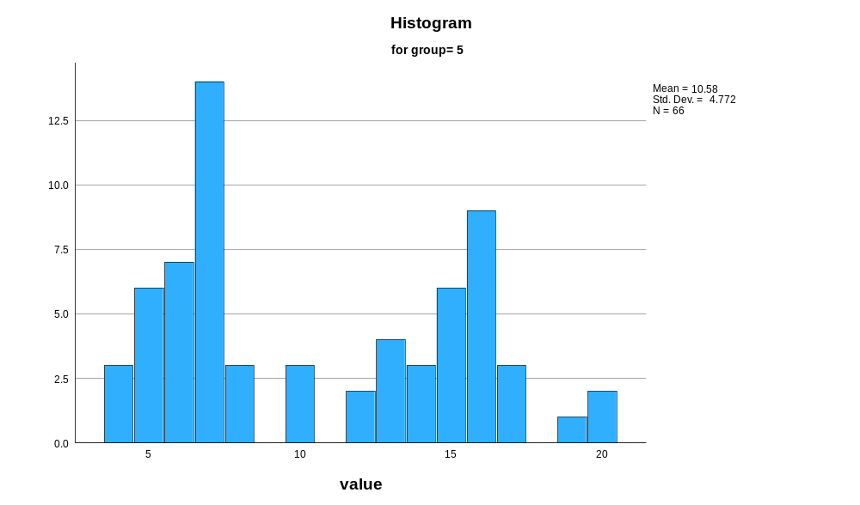

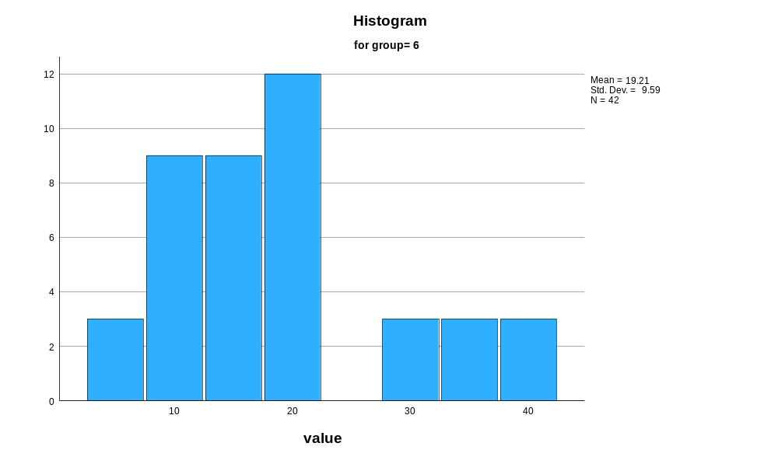

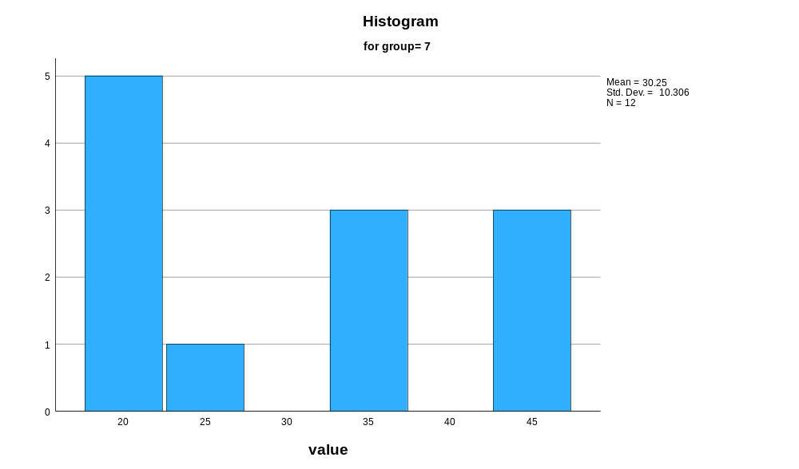

Stem-and-Leaf Plots
value Stem-and-Leaf Plot for
group= 1
Frequency Stem & Leaf
3.00 1 . 222
2.00 1 . 99
4.00 2 . 0444
Stem width: 10
Each leaf: 1 case(s)
value Stem-and-Leaf Plot for
group= 2
Frequency Stem & Leaf
2.00 5 . 00
1.00 6 . 0
6.00 7 . 000000
5.00 8 . 00000
1.00 9 . 0
4.00 10 . 0000
2.00 11 . 00
Stem width: 1
Each leaf: 1 case(s)
value Stem-and-Leaf Plot for
group= 3
Frequency Stem & Leaf
.00 0 .
10.00 0 . 6677777777
14.00 0 . 88999999999999
13.00 1 . 0000000111111
7.00 1 . 2233333
20.00 1 . 44444444445555555555
8.00 1 . 66666677
13.00 1 . 8888888999999
9.00 2 . 000011111
2.00 2 . 22
5.00 2 . 44555
1.00 2 . 6
3.00 Extremes (>=33)
Stem width: 10
Each leaf: 1 case(s)
value Stem-and-Leaf Plot for
group= 4
Frequency Stem & Leaf
6.00 0 . 444444
9.00 0 . 667777788
5.00 1 . 22344
13.00 1 . 5555555556677
19.00 2 . 0001111112333444444
11.00 2 . 55555556999
.00 3 .
5.00 3 . 55567
1.00 4 . 0
Stem width: 10
Each leaf: 1 case(s)
value Stem-and-Leaf Plot for
group= 5
Frequency Stem & Leaf
3.00 0 . 444
30.00 0 . 555555666666677777777777777888
12.00 1 . 000223333444
19.00 1 . 5555556666666667779
2.00 2 . 00
Stem width: 10
Each leaf: 1 case(s)
value Stem-and-Leaf Plot for
group= 6
Frequency Stem & Leaf
.00 0 .
6.00 0 . 566899
6.00 1 . 111222
12.00 1 . 555555555899
9.00 2 . 000112222
.00 2 .
3.00 3 . 001
3.00 3 . 556
3.00 Extremes (>=39)
Stem width: 10
Each leaf: 1 case(s)
value Stem-and-Leaf Plot for
group= 7
Frequency Stem & Leaf
6.00 2 . 011113
.00 2 .
2.00 3 . 34
1.00 3 . 5
1.00 4 . 4
2.00 4 . 55
Stem width: 10
Each leaf: 1 case(s)

Normal Q-Q Plots

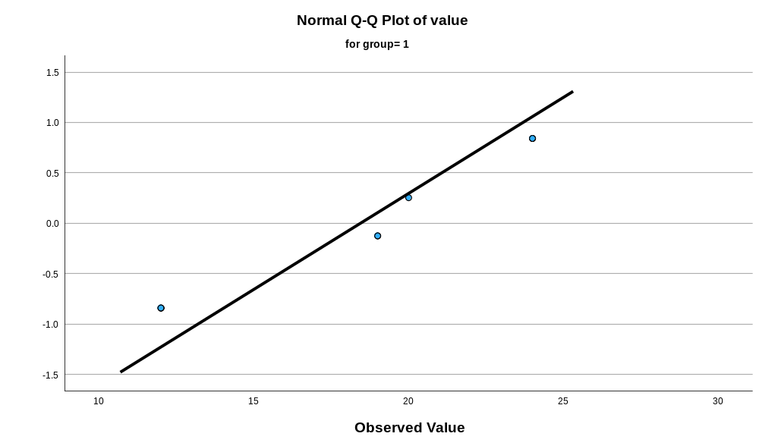

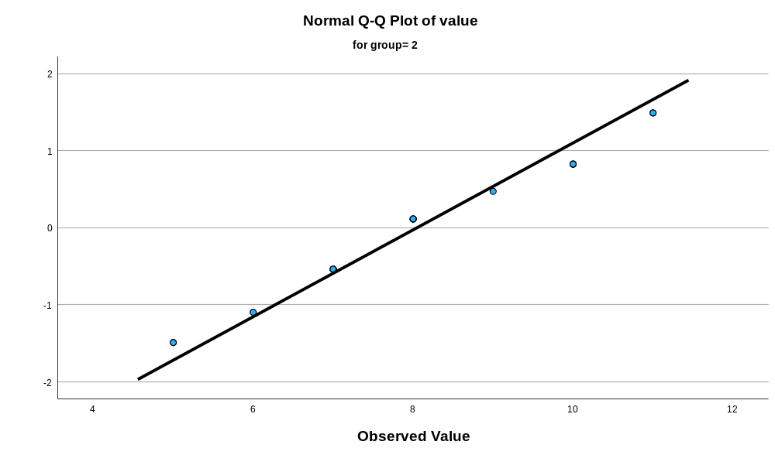

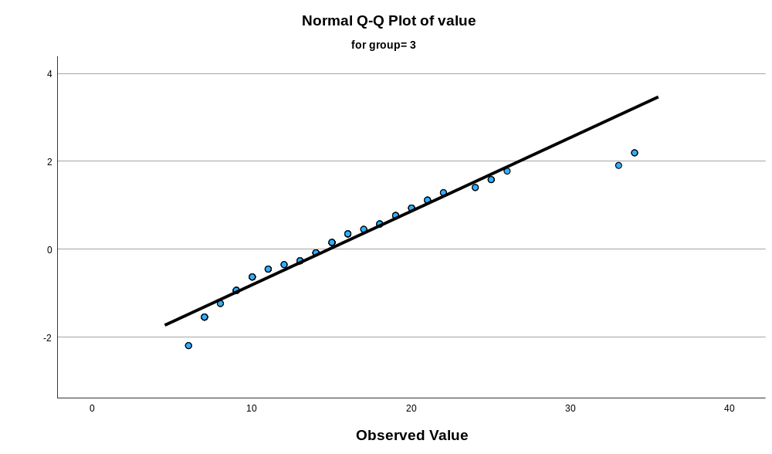

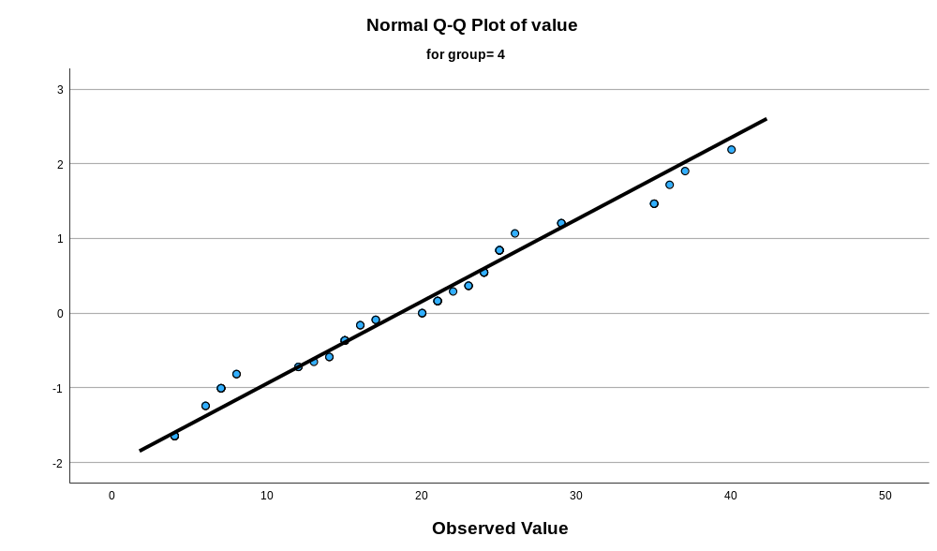

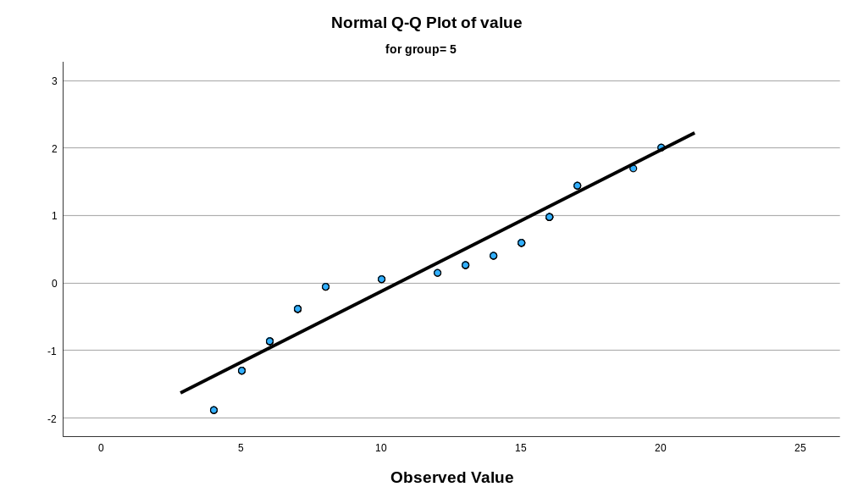

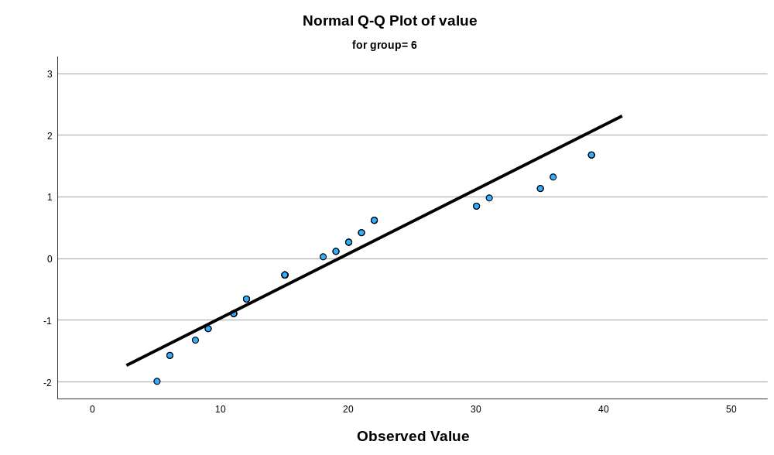

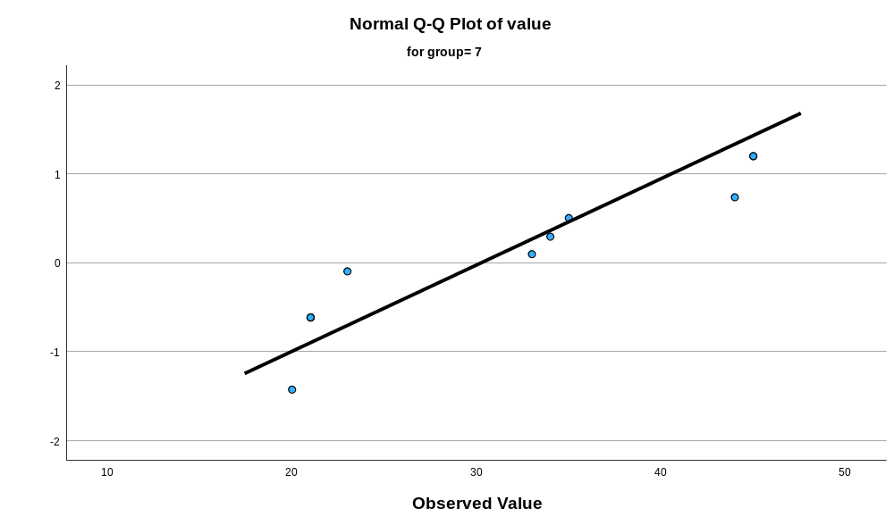

Detrended Normal Q-Q Plots

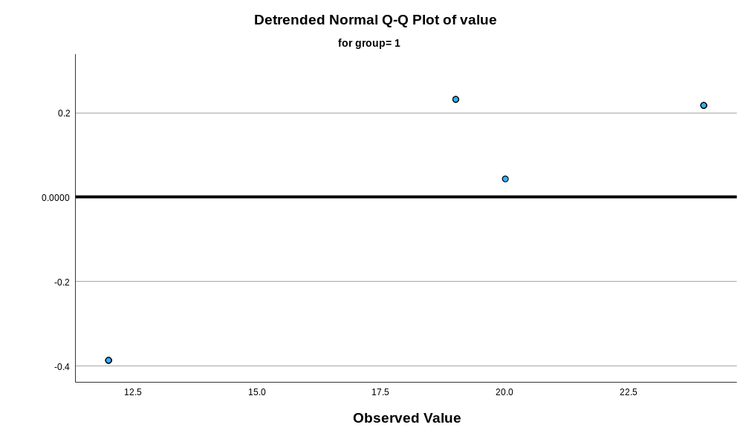

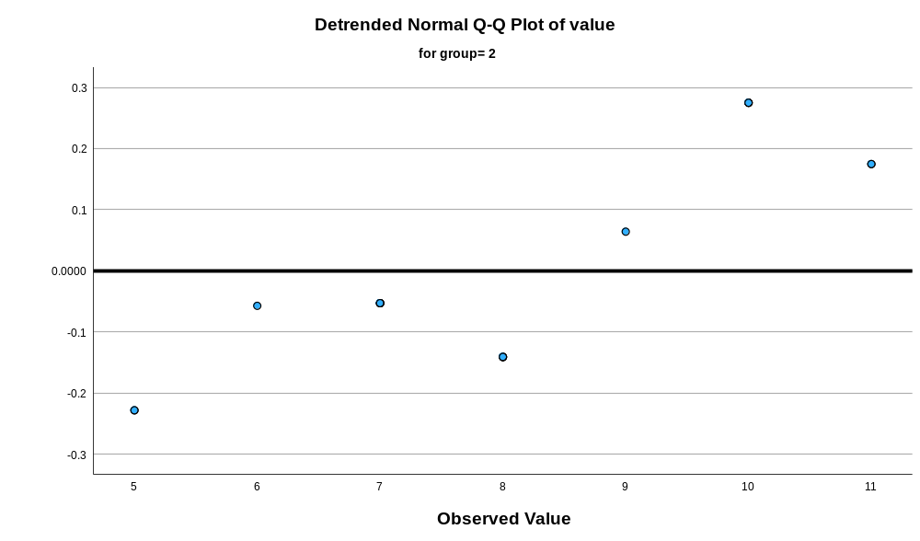

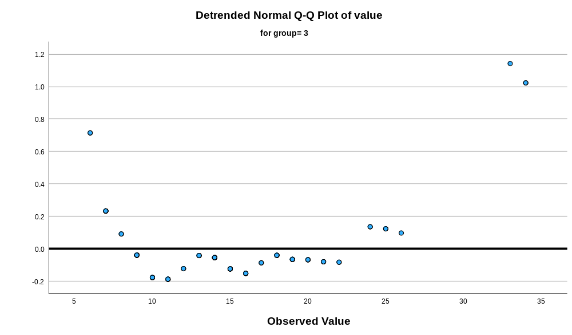

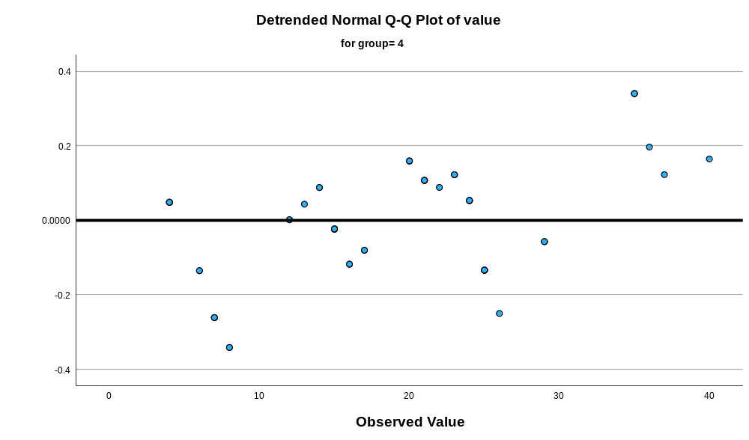

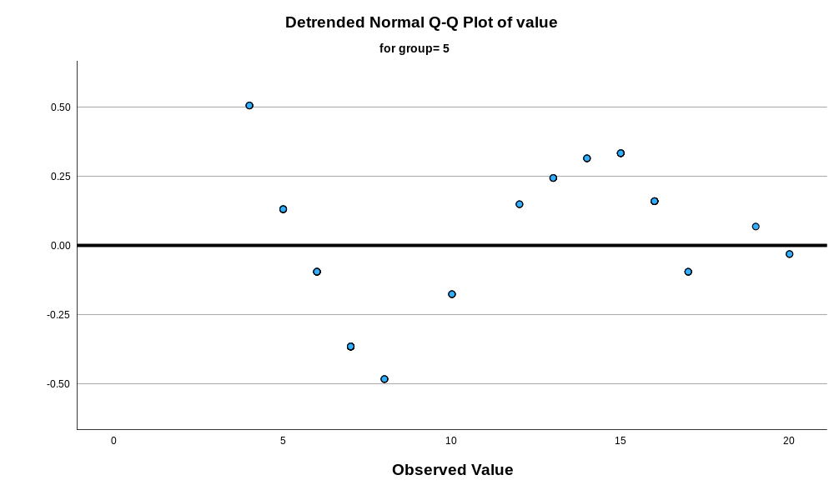

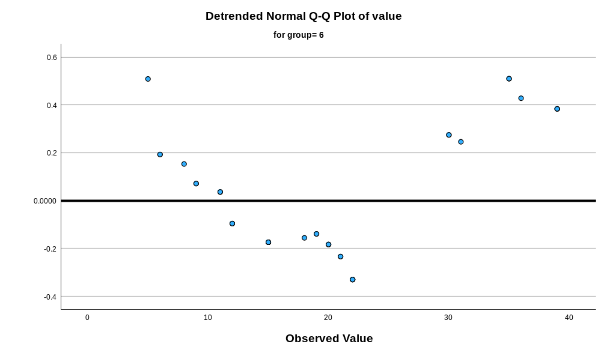

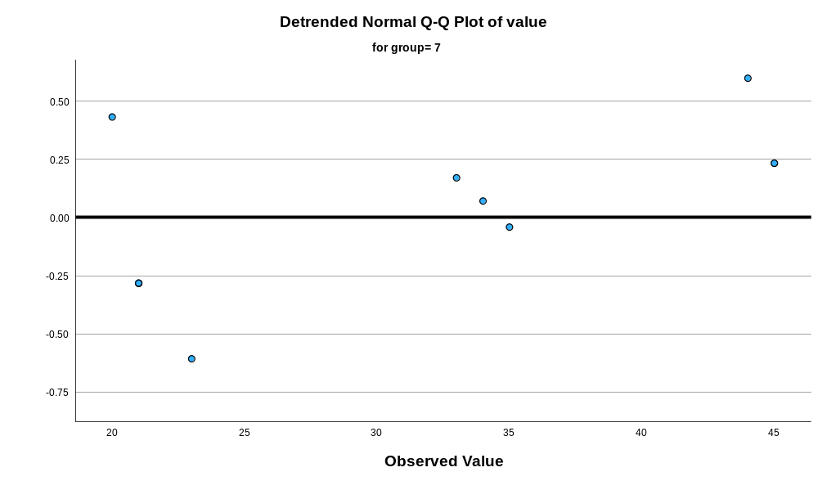

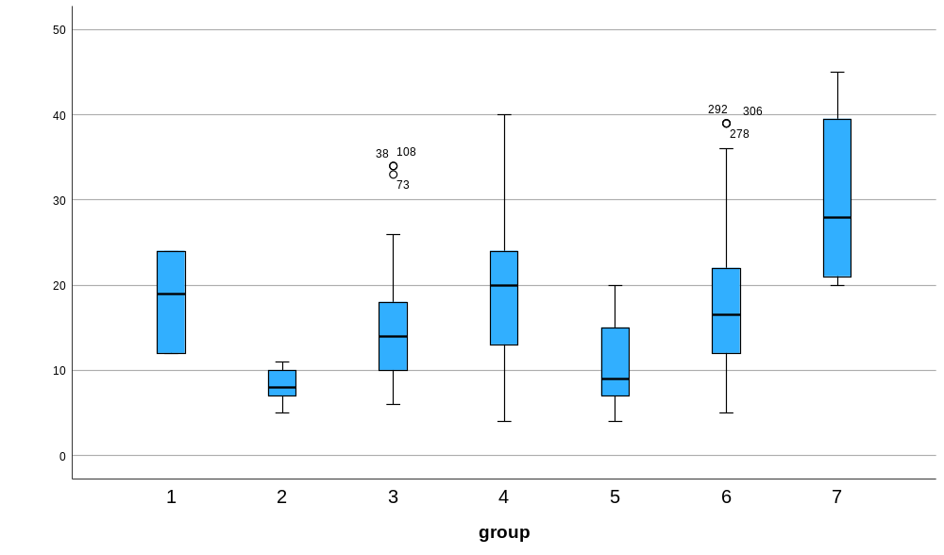

Appendix 20 Kruskal Wallis test of feathers width of the left side of the vane at the widest part
Nonparametric Tests
Notes
Output Created |  | 17-MAR-2026 10:50:49
Comments
Input | Active Dataset | DataSet0
Input | Filter | <none>
Input | Weight | <none>
Input | Split File | <none>
Input | N of Rows in Working Data File | 324
Syntax |  | NPTESTS  /INDEPENDENT TEST (value) GROUP (group) KRUSKAL_WALLIS(COMPARE=PAIRWISE)  /MISSING SCOPE=ANALYSIS USERMISSING=EXCLUDE  /CRITERIA ALPHA=0.05 CILEVEL=95.
Resources | Processor Time | 00:00:00.58
Resources | Elapsed Time | 00:00:00.52

Hypothesis Test Summary
 | Null Hypothesis | Test | Sig.^{a,b}
1 | The distribution of value is the same across categories of group. | Independent-Samples Kruskal-Wallis Test | <.001

Hypothesis Test Summary
 | Decision
1 | Reject the null hypothesis.

a. The significance level is .050.
b. Asymptotic significance is displayed.

Independent-Samples Kruskal-Wallis Test
value across group

Independent-Samples Kruskal-Wallis Test Summary
Total N | 324
Test Statistic | 86.653ª
Degree Of Freedom | 6
Asymptotic Sig.(2-sided test) | <.001
a. The test statistic is adjusted for ties.

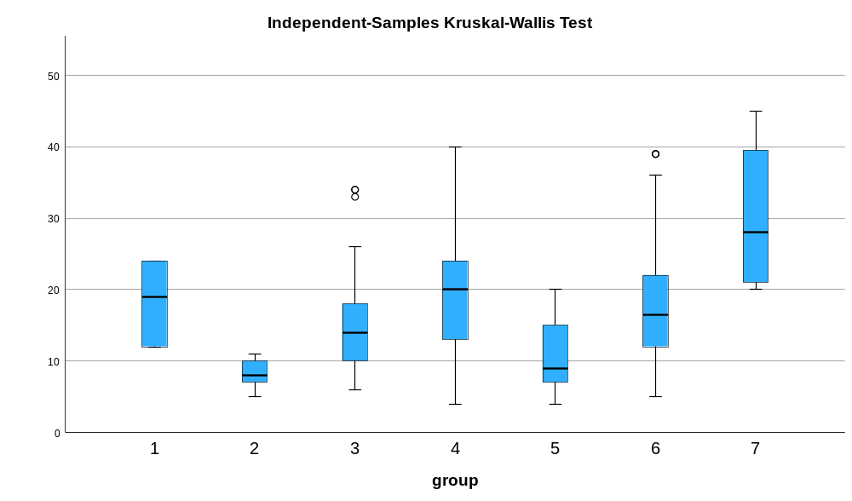

Pairwise Comparisons of group
Sample 1-Sample 2 | Test Statistic | Std. Error | Std. Test Statistic | Sig. | Adj. Sig.ª
2-5 | -36.385 | 23.430 | -1.553 | .120 | 1.000
2-3 | -94.576 | 22.355 | -4.231 | <.001 | .000
2-4 | -130.092 | 23.307 | -5.582 | <.001 | .000
2-6 | -130.964 | 24.994 | -5.240 | <.001 | .000
2-1 | 144.198 | 37.259 | 3.870 | <.001 | .002
2-7 | -217.643 | 33.842 | -6.431 | <.001 | .000
5-3 | 58.191 | 14.690 | 3.961 | <.001 | .002
5-4 | 93.707 | 16.102 | 5.820 | <.001 | .000
5-6 | -94.579 | 18.459 | -5.124 | <.001 | .000
5-1 | 107.813 | 33.231 | 3.244 | .001 | .025
5-7 | -181.258 | 29.349 | -6.176 | <.001 | .000
3-4 | -35.516 | 14.493 | -2.451 | .014 | .300
3-6 | -36.388 | 17.074 | -2.131 | .033 | .695
3-1 | 49.622 | 32.482 | 1.528 | .127 | 1.000
3-7 | -123.067 | 28.498 | -4.318 | <.001 | .000
4-6 | -.872 | 18.303 | -.048 | .962 | 1.000
4-1 | 14.106 | 33.144 | .426 | .670 | 1.000
4-7 | -87.551 | 29.250 | -2.993 | .003 | .058
6-1 | 13.234 | 34.351 | .385 | .700 | 1.000
6-7 | -86.679 | 30.611 | -2.832 | .005 | .097
1-7 | -73.444 | 41.238 | -1.781 | .075 | 1.000
Each row tests the null hypothesis that the Sample 1 and Sample 2 distributions are the same.
Asymptotic significances (2-sided tests) are displayed. The significance level is .050.
a. Significance values have been adjusted by the Bonferroni correction for multiple tests.

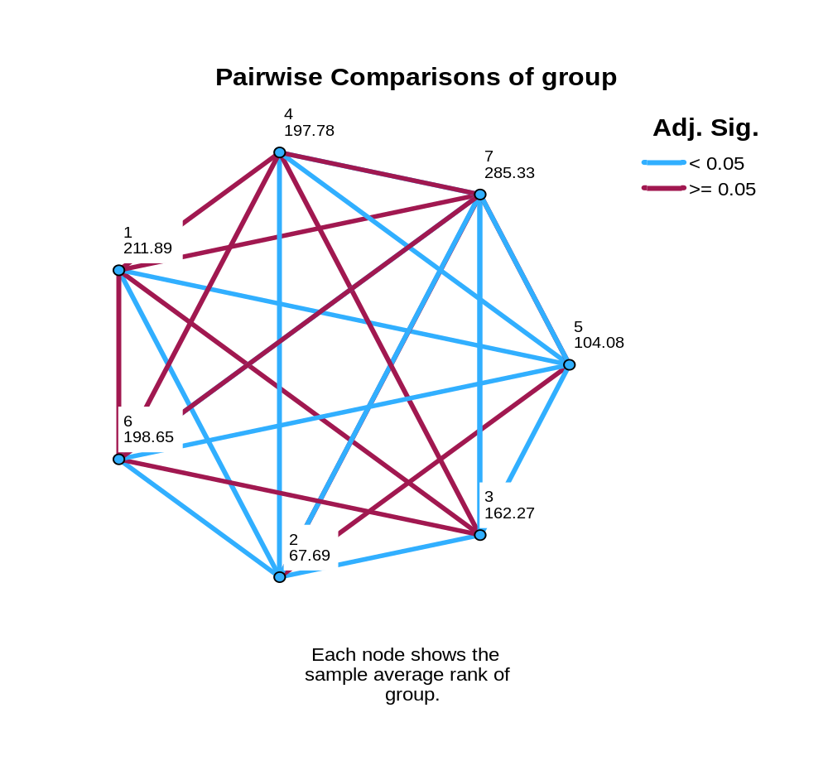

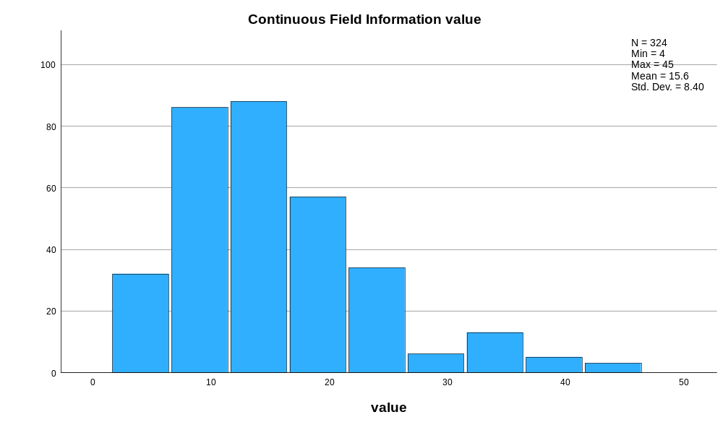

Appendix 21 raw data of widths of the right side of the vane at the widest point
Bird Number | N-value | Widest Part Feather Right Side Vane (mm)
 |  | 1 | 2 | 3
Eclectus F1 | 3 | 18 | 19 | 19
Eclectus F2 | 3 | 22 | 22 | 21
Eclectus F3 | 3 | 12 | 12 | 13
Eclectus B1 | 3 | 13 | 12 | 13
Eclectus B2 | 3 | 7 | 7 | 7
Eclectus B3 | 3 | 13 | 12 | 12
Eclectus B4 | 3 | 12 | 13 | 12
Eclectus B5 | 3 | 10 | 11 | 10
Eclectus B6 | 3 | 10 | 10 | 11
Eclectus B7 | 3 | 18 | 14 | 14
Eclectus M1 | 3 | 23 | 22 | 23
Eclectus M2 | 3 | 14 | 15 | 15
Eclectus M3 | 3 | 32 | 32 | 32
Eclectus M4 | 3 | 6 | 6 | 6
Eclectus M5 | 3 | 5 | 5 | 4
Eclectus M6 | 3 | 14 | 14 | 14
Eclectus M7 | 3 | 19 | 18 | 18
Eclectus M8 | 3 | 21 | 21 | 22
Eclectus M9 | 3 | 21 | 20 | 20
Eclectus M10 | 3 | 14 | 14 | 14
Eclectus M11 | 3 | 11 | 12 | 11
Eclectus M12 | 3 | 19 | 20 | 19
Eclectus M13 | 3 | 18 | 18 | 18
Eclectus M14 | 3 | 10 | 9 | 9
Eclectus M15 | 3 | 20 | 19 | 20
Eclectus M16 | 3 | 20 | 20 | 19
Eclectus M17 | 3 | 15 | 15 | 16
Eclectus M18 | 3 | 18 | 17 | 18
Eclectus M19 | 3 | 9 | 9 | 9
Eclectus M20 | 3 | 11 | 12 | 11
Eclectus M21 | 3 | 4 | 4 | 5
Eclectus M22 | 3 | 7 | 8 | 7
Eclectus M23 | 3 | 12 | 13 | 12
Eclectus M24 | 3 | 8 | 9 | 8
Eclectus M25 | 3 | 11 | 10 | 10
Eclectus M26 | 3 | 16 | 15 | 15
Eclectus M27 | 3 | 16 | 14 | 14
Eclectus M28 | 3 | 23 | 24 | 24
Eclectus M29 | 3 | 18 | 19 | 20
Eclectus M30 | 3 | 19 | 19 | 20
Eclectus M31 | 3 | 14 | 15 | 15
Eclectus M32 | 3 | 14 | 14 | 13
Eclectus M33 | 3 | 17 | 17 | 18
Eclectus M34 | 3 | 12 | 11 | 12
Eclectus M35 | 3 | 9 | 9 | 8
Cockatoo 1 | 3 | 18 | 19 | 19
Cockatoo 2 | 3 | 15 | 16 | 16
Cockatoo 3 | 3 | 15 | 14 | 15
Cockatoo 4 | 3 | 16 | 15 | 15
Cockatoo 5 | 3 | 8 | 9 | 8
Cockatoo 6 | 3 | 4 | 4 | 5
Cockatoo 7 | 3 | 16 | 15 | 15
Cockatoo 8 | 3 | 19 | 12 | 13
Cockatoo 9 | 3 | 17 | 16 | 15
Cockatoo 10 | 3 | 4 | 4 | 4
Cockatoo 11 | 3 | 20 | 19 | 21
Cockatoo 12 | 3 | 14 | 14 | 13
Cockatoo 13 | 3 | 19 | 18 | 20
Cockatoo 14 | 3 | 21 | 21 | 21
Cockatoo 15 | 3 | 31 | 32 | 32
Cockatoo 16 | 3 | 35 | 33 | 35
Cockatoo 17 | 3 | 20 | 21 | 20
Cockatoo 18 | 3 | 20 | 21 | 20
Cockatoo 19 | 3 | 33 | 31 | 34
Cockatoo 20 | 3 | 25 | 21 | 24
Cockatoo 21 | 3 | 25 | 26 | 26
Cockatoo 22 | 3 | 25 | 24 | 26
Cockatoo 23 | 3 | 26 | 25 | 25
African G1 | 3 | 5 | 4 | 5
African G2 | 3 | 22 | 23 | 22
African G3 | 3 | 16 | 17 | 17
African G4 | 3 | 20 | 20 | 21
African G5 | 3 | 4 | 5 | 5
African G6 | 3 | 13 | 12 | 12
African G7 | 3 | 10 | 11 | 10
African G8 | 3 | 21 | 22 | 21
African G9 | 3 | 8 | 8 | 8
African G10 | 3 | 9 | 9 | 10
African G11 | 3 | 11 | 12 | 11
African G12 | 3 | 9 | 10 | 9
African G13 | 3 | 6 | 8 | 8
African G14 | 3 | 16 | 14 | 16
African G15 | 3 | 9 | 9 | 9
African G16 | 3 | 9 | 10 | 9
African G17 | 3 | 10 | 12 | 11
African G18 | 3 | 14 | 14 | 14
African G19 | 3 | 10 | 10 | 10
African G20 | 3 | 5 | 6 | 6
African G21 | 3 | 9 | 8 | 8
African G22 | 3 | 8 | 7 | 8
Macaw 1 | 3 | 10 | 9 | 10
Macaw 2 | 3 | 10 | 11 | 11
Macaw 3 | 3 | 4 | 4 | 4
Macaw 5 | 3 | 11 | 10 | 10
Macaw 6 | 3 | 7 | 8 | 7
Macaw 7 | 3 | 20 | 20 | 20
Macaw 8 | 3 | 21 | 22 | 21
Macaw 9 | 3 | 13 | 12 | 14
Macaw 11 | 3 | 20 | 22 | 23
Macaw 12 | 3 | 19 | 20 | 19
Macaw 13 | 3 | 29 | 29 | 28
Macaw 14 | 3 | 30 | 30 | 30
Macaw 15 | 3 | 21 | 21 | 20
Macaw 16 | 3 | 10 | 10 | 11
Owl 1 | 3 | 20 | 23 | 22
Owl 2 | 3 | 23 | 20 | 22
Owl 3 | 3 | 26 | 33 | 25
Owl 4 | 3 | 43 | 42 | 45

Appendix 22 descriptive test of feathers width of the right side of the vane at the widest point
Explore
Notes
Output Created |  | 17-MAR-2026 11:02:03
Comments
Input | Active Dataset | DataSet0
Input | Filter | <none>
Input | Weight | <none>
Input | Split File | <none>
Input | N of Rows in Working Data File | 324
Missing Value Handling | Definition of Missing | User-defined missing values for dependent variables are treated as missing.
Missing Value Handling | Cases Used | Statistics are based on cases with no missing values for any dependent variable or factor used.
Syntax |  | EXAMINE VARIABLES=value BY group  /PLOT BOXPLOT HISTOGRAM NPPLOT  /COMPARE GROUPS  /STATISTICS DESCRIPTIVES  /CINTERVAL 95  /MISSING LISTWISE  /NOTOTAL.
Resources | Processor Time | 00:00:02.91
Resources | Elapsed Time | 00:00:02.31

group

Case Processing Summary
 | group | Cases
 | group | Valid |  | Missing |  | Total
 | group | N | Percent | N | Percent | N | Percent
value | 1 | 9 | 100.0% | 0 | 0.0% | 9 | 100.0%
value | 2 | 21 | 100.0% | 0 | 0.0% | 21 | 100.0%
value | 3 | 105 | 100.0% | 0 | 0.0% | 105 | 100.0%
value | 4 | 69 | 100.0% | 0 | 0.0% | 69 | 100.0%
value | 5 | 66 | 100.0% | 0 | 0.0% | 66 | 100.0%
value | 6 | 42 | 100.0% | 0 | 0.0% | 42 | 100.0%
value | 7 | 12 | 100.0% | 0 | 0.0% | 12 | 100.0%

Descriptives
 | group |  |  | Statistic | Std. Error
value | 1 | Mean |  | 17.56 | 1.386
value | 1 | 95% Confidence Interval for Mean | Lower Bound | 14.36
value | 1 | 95% Confidence Interval for Mean | Upper Bound | 20.75
value | 1 | 5% Trimmed Mean |  | 17.62
value | 1 | Median |  | 19.00
value | 1 | Variance |  | 17.278
value | 1 | Std. Deviation |  | 4.157
value | 1 | Minimum |  | 12
value | 1 | Maximum |  | 22
value | 1 | Range |  | 10
value | 1 | Interquartile Range |  | 9
value | 1 | Skewness |  | -.481 | .717
value | 1 | Kurtosis |  | -1.641 | 1.400
value | 2 | Mean |  | 11.48 | .567
value | 2 | 95% Confidence Interval for Mean | Lower Bound | 10.29
value | 2 | 95% Confidence Interval for Mean | Upper Bound | 12.66
value | 2 | 5% Trimmed Mean |  | 11.37
value | 2 | Median |  | 12.00
value | 2 | Variance |  | 6.762
value | 2 | Std. Deviation |  | 2.600
value | 2 | Minimum |  | 7
value | 2 | Maximum |  | 18
value | 2 | Range |  | 11
value | 2 | Interquartile Range |  | 3
value | 2 | Skewness |  | .134 | .501
value | 2 | Kurtosis |  | 1.127 | .972
value | 3 | Mean |  | 14.84 | .577
value | 3 | 95% Confidence Interval for Mean | Lower Bound | 13.69
value | 3 | 95% Confidence Interval for Mean | Upper Bound | 15.98
value | 3 | 5% Trimmed Mean |  | 14.66
value | 3 | Median |  | 15.00
value | 3 | Variance |  | 34.964
value | 3 | Std. Deviation |  | 5.913
value | 3 | Minimum |  | 4
value | 3 | Maximum |  | 32
value | 3 | Range |  | 28
value | 3 | Interquartile Range |  | 9
value | 3 | Skewness |  | .402 | .236
value | 3 | Kurtosis |  | .442 | .467
value | 4 | Mean |  | 19.10 | .952
value | 4 | 95% Confidence Interval for Mean | Lower Bound | 17.20
value | 4 | 95% Confidence Interval for Mean | Upper Bound | 21.00
value | 4 | 5% Trimmed Mean |  | 19.09
value | 4 | Median |  | 19.00
value | 4 | Variance |  | 62.534
value | 4 | Std. Deviation |  | 7.908
value | 4 | Minimum |  | 4
value | 4 | Maximum |  | 35
value | 4 | Range |  | 31
value | 4 | Interquartile Range |  | 10
value | 4 | Skewness |  | .039 | .289
value | 4 | Kurtosis |  | -.204 | .570
value | 5 | Mean |  | 11.29 | .621
value | 5 | 95% Confidence Interval for Mean | Lower Bound | 10.05
value | 5 | 95% Confidence Interval for Mean | Upper Bound | 12.53
value | 5 | 5% Trimmed Mean |  | 11.06
value | 5 | Median |  | 10.00
value | 5 | Variance |  | 25.439
value | 5 | Std. Deviation |  | 5.044
value | 5 | Minimum |  | 4
value | 5 | Maximum |  | 23
value | 5 | Range |  | 19
value | 5 | Interquartile Range |  | 6
value | 5 | Skewness |  | .883 | .295
value | 5 | Kurtosis |  | -.071 | .582
value | 6 | Mean |  | 16.21 | 1.203
value | 6 | 95% Confidence Interval for Mean | Lower Bound | 13.79
value | 6 | 95% Confidence Interval for Mean | Upper Bound | 18.64
value | 6 | 5% Trimmed Mean |  | 16.13
value | 6 | Median |  | 16.50
value | 6 | Variance |  | 60.758
value | 6 | Std. Deviation |  | 7.795
value | 6 | Minimum |  | 4
value | 6 | Maximum |  | 30
value | 6 | Range |  | 26
value | 6 | Interquartile Range |  | 11
value | 6 | Skewness |  | .263 | .365
value | 6 | Kurtosis |  | -1.005 | .717
value | 7 | Mean |  | 28.67 | 2.742
value | 7 | 95% Confidence Interval for Mean | Lower Bound | 22.63
value | 7 | 95% Confidence Interval for Mean | Upper Bound | 34.70
value | 7 | 5% Trimmed Mean |  | 28.24
value | 7 | Median |  | 24.00
value | 7 | Variance |  | 90.242
value | 7 | Std. Deviation |  | 9.500
value | 7 | Minimum |  | 20
value | 7 | Maximum |  | 45
value | 7 | Range |  | 25
value | 7 | Interquartile Range |  | 18
value | 7 | Skewness |  | .945 | .637
value | 7 | Kurtosis |  | -.882 | 1.232

Tests of Normality
 | group | Kolmogorov-Smirnovª |  |  | Shapiro-Wilk
 | group | Statistic | df | Sig. | Statistic | df | Sig.
value | 1 | .209 | 9 | .200* | .845 | 9 | .066
value | 2 | .151 | 21 | .200* | .924 | 21 | .107
value | 3 | .075 | 105 | .173 | .967 | 105 | .011
value | 4 | .115 | 69 | .024 | .963 | 69 | .037
value | 5 | .192 | 66 | <.001 | .898 | 66 | <.001
value | 6 | .177 | 42 | .002 | .921 | 42 | .007
value | 7 | .277 | 12 | .011 | .796 | 12 | .008
*. This is a lower bound of the true significance.
a. Lilliefors Significance Correction

value

Histograms

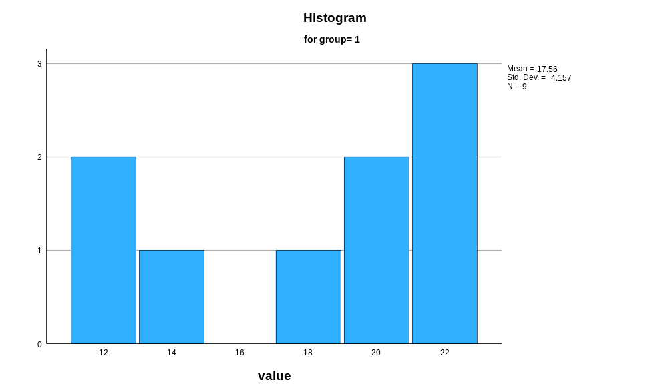

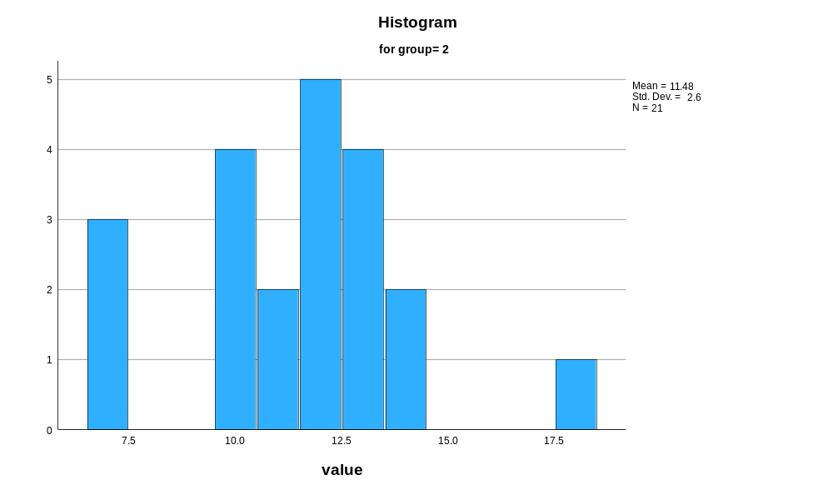

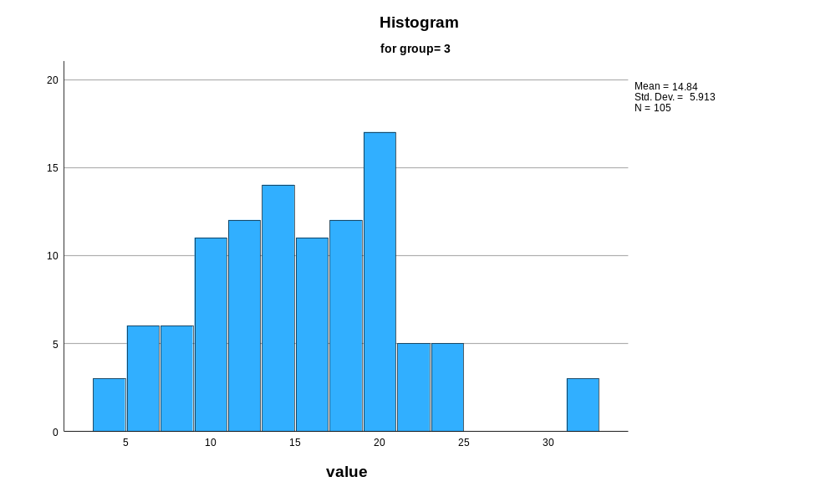

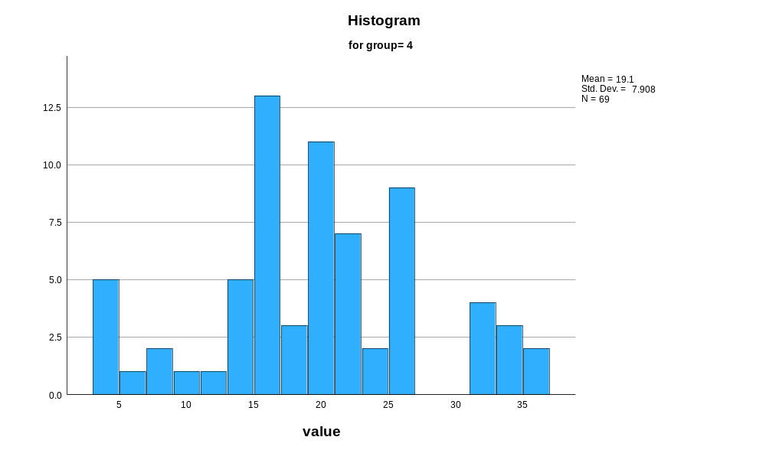

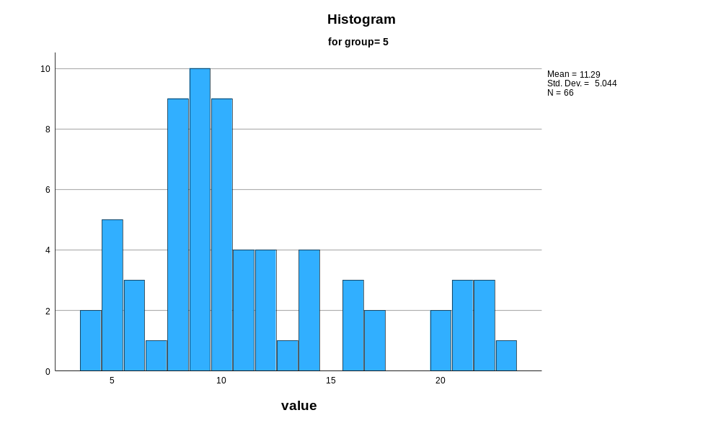

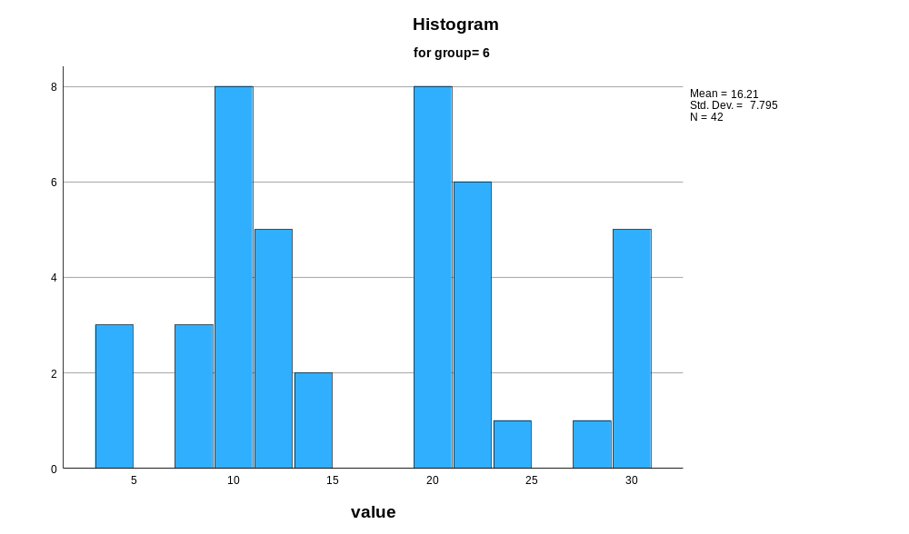

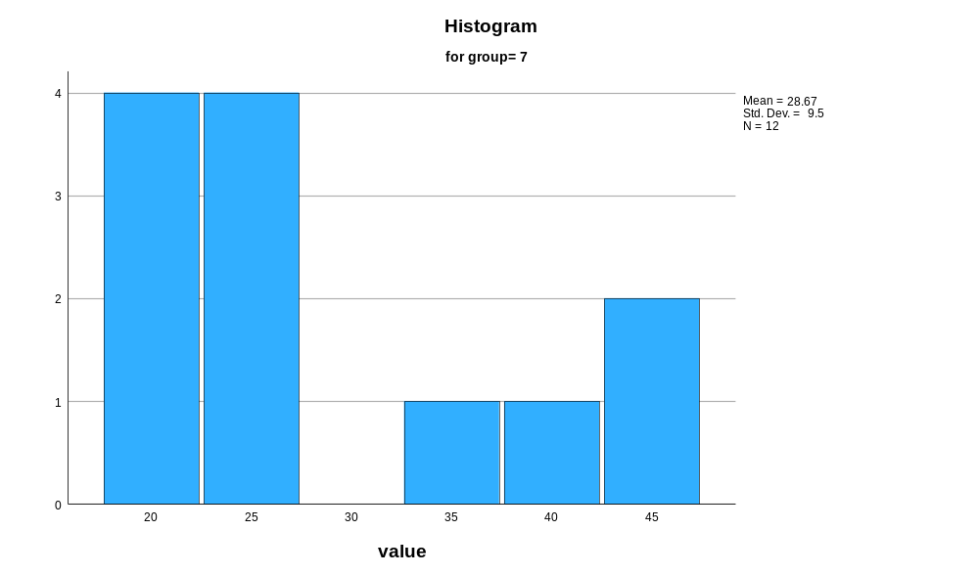

Normal Q-Q Plots

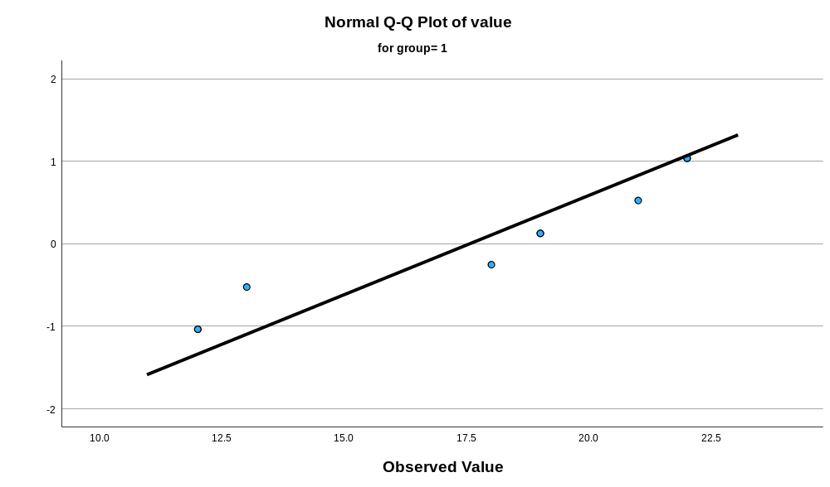

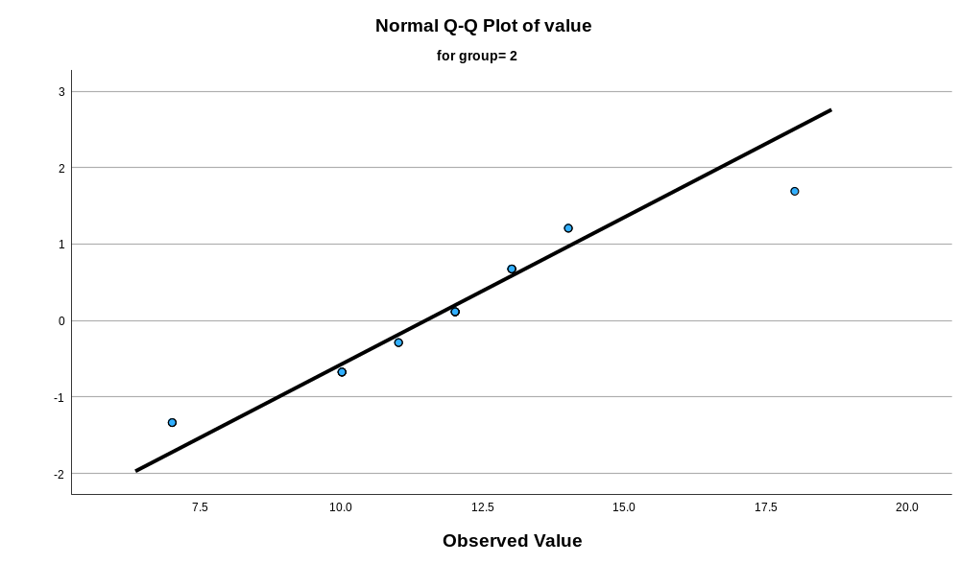

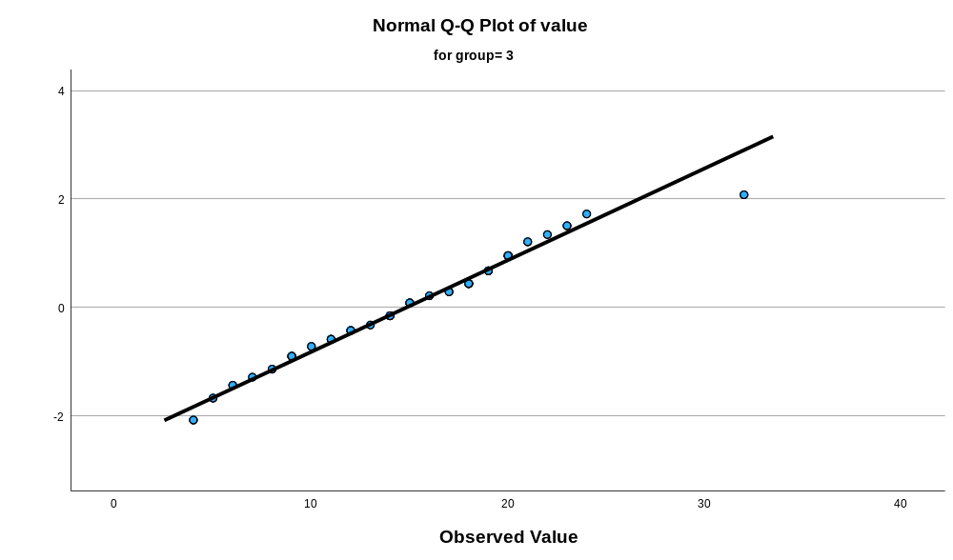

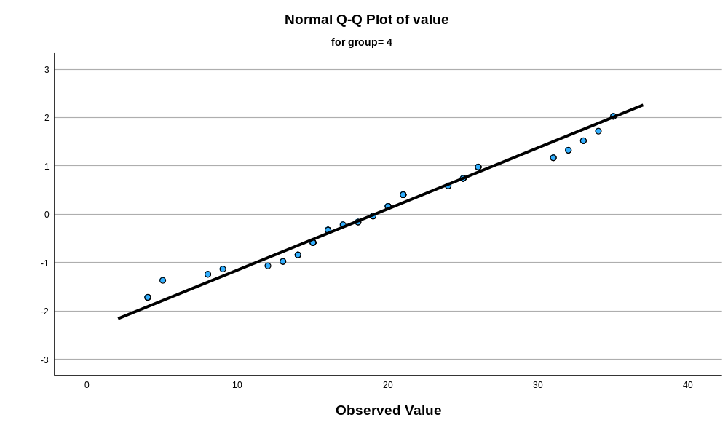

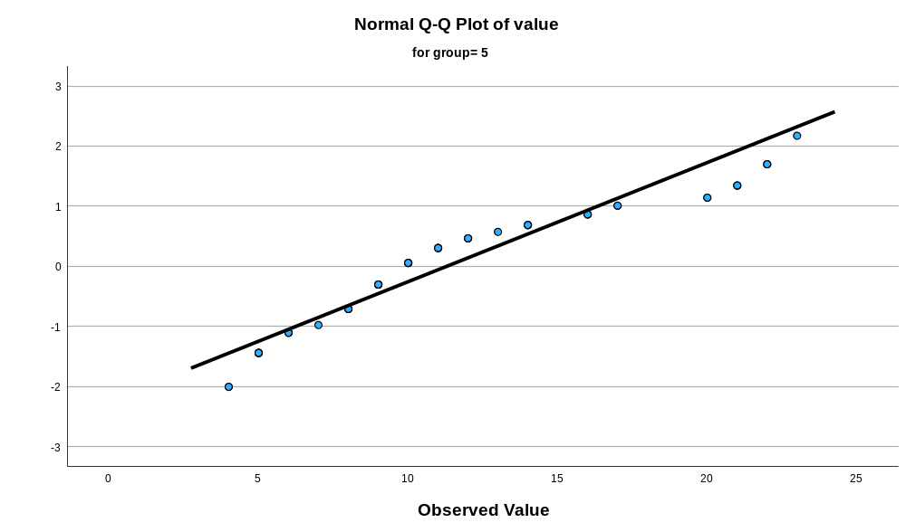

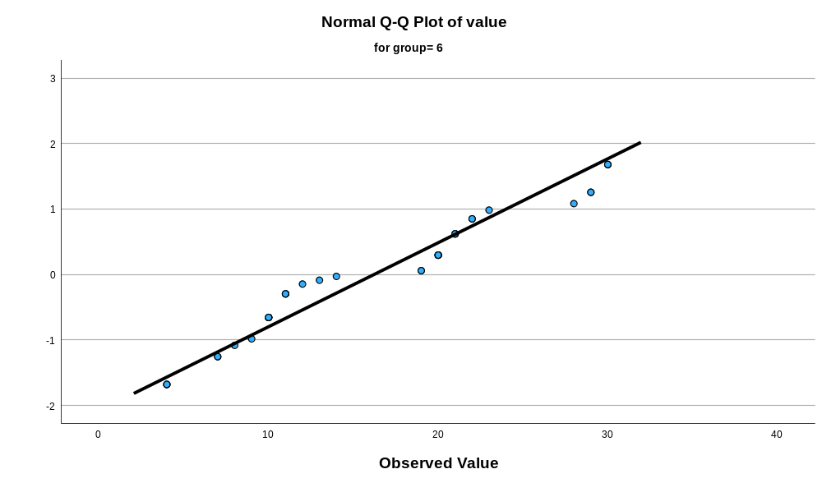

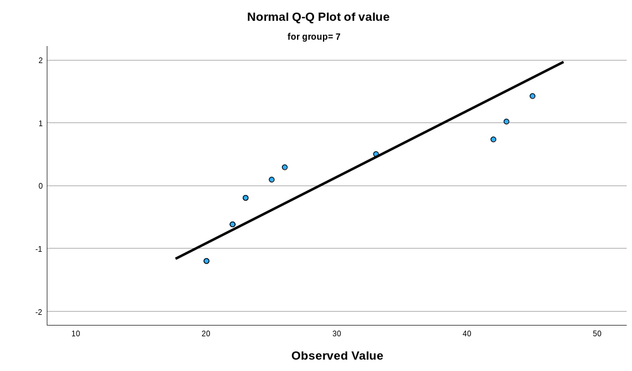

Detrended Normal Q-Q Plots

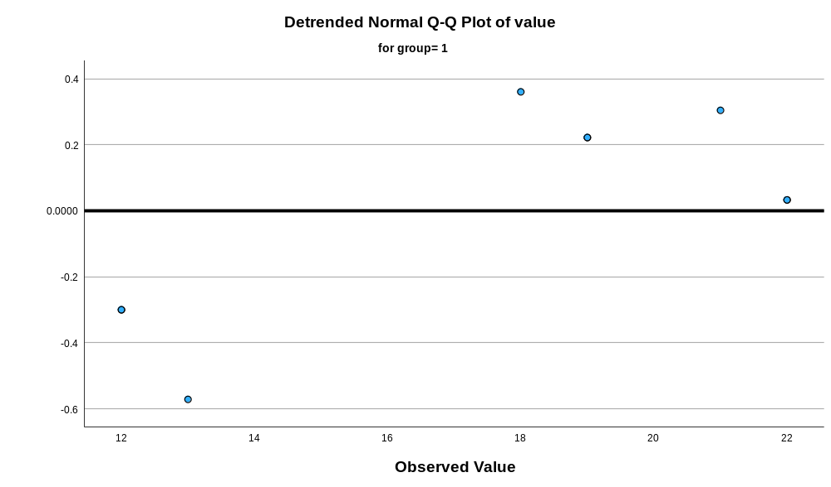

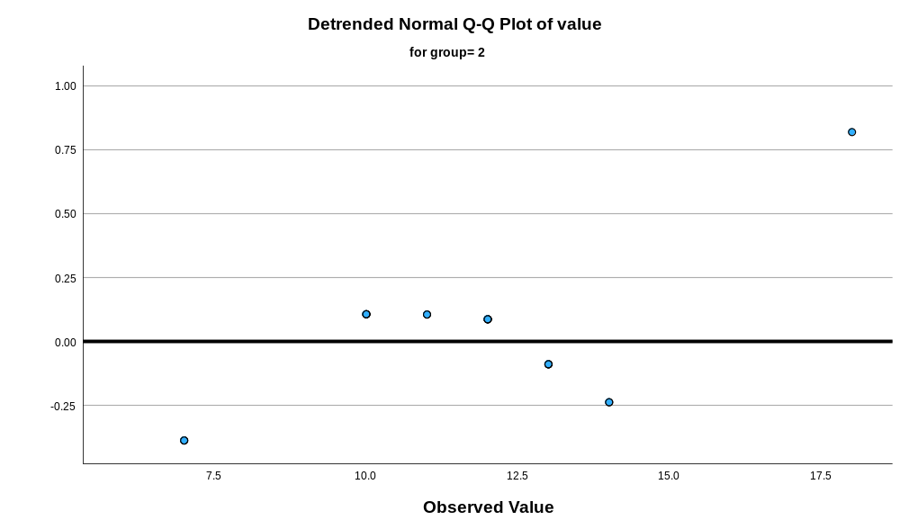

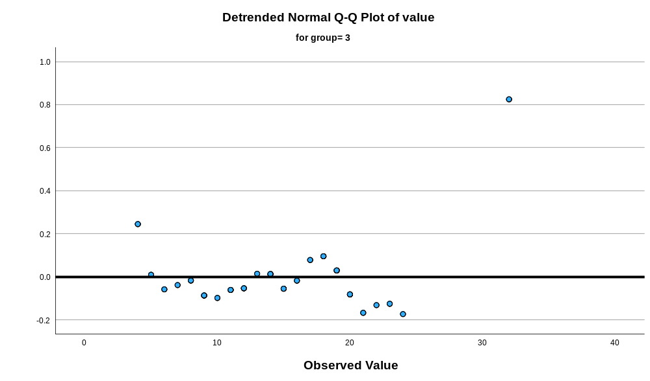

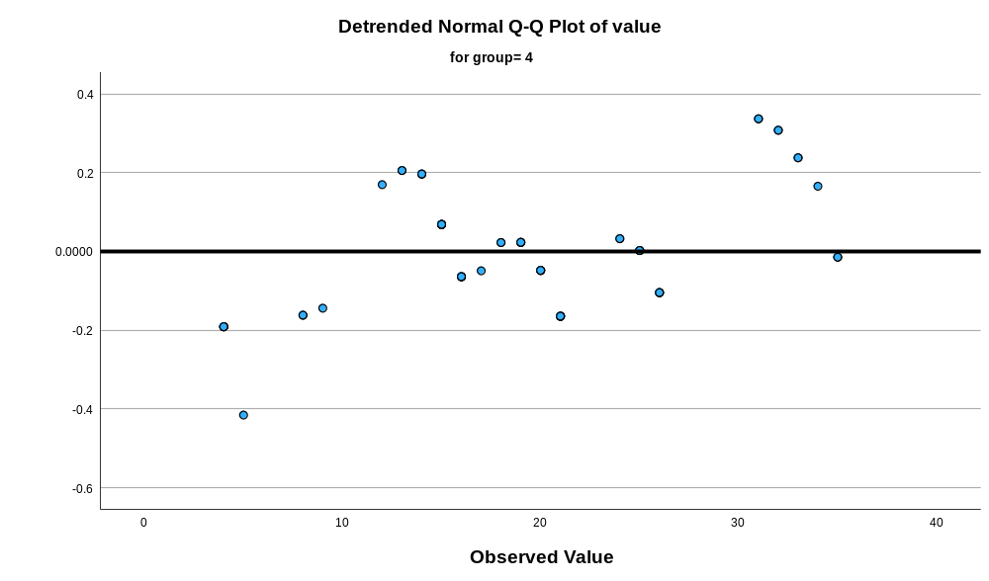

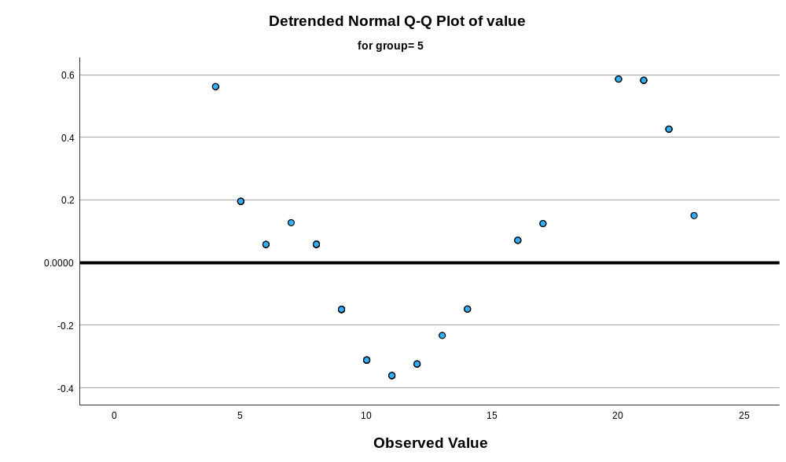

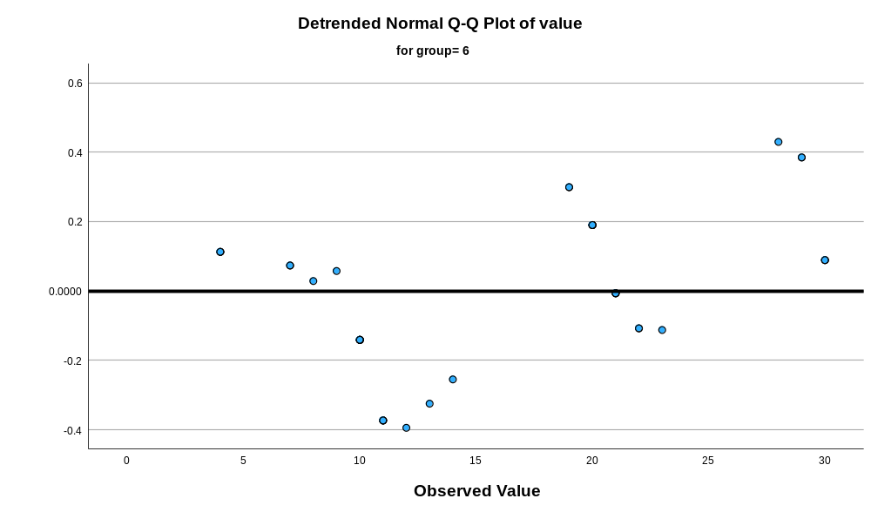

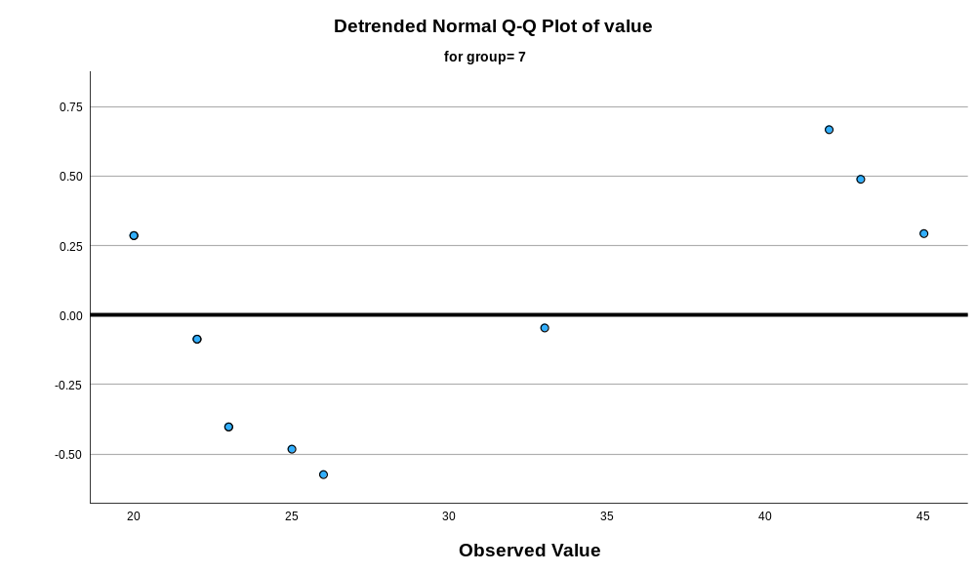
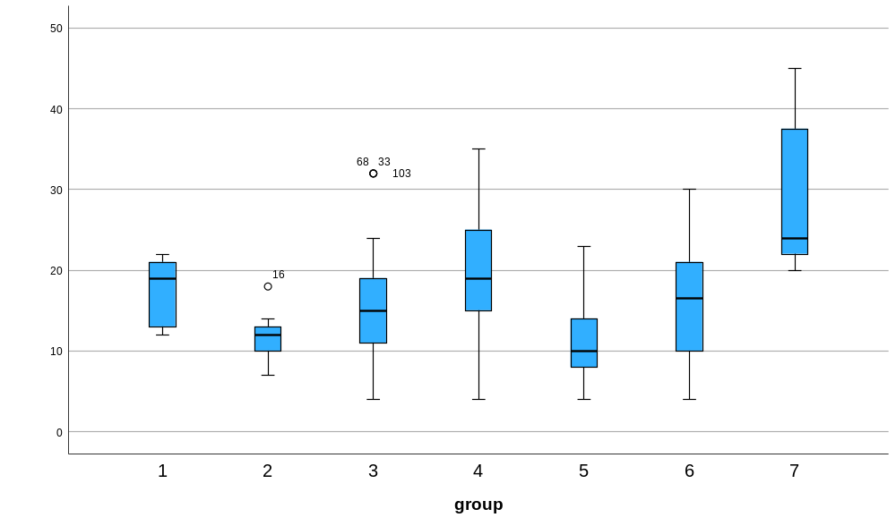

Appendix 23 Kruskal Walis test feather width of the right side of the vane at the widest point
Nonparametric Tests

Notes
Output Created |  | 17-MAR-2026 11:02:48
Comments
Input | Active Dataset | DataSet0
Input | Filter | <none>
Input | Weight | <none>
Input | Split File | <none>
Input | N of Rows in Working Data File | 324
Syntax |  | NPTESTS  /INDEPENDENT TEST (value) GROUP (group) KRUSKAL_WALLIS(COMPARE=PAIRWISE)  /MISSING SCOPE=ANALYSIS USERMISSING=EXCLUDE  /CRITERIA ALPHA=0.05 CILEVEL=95.
Resources | Processor Time | 00:00:00.59
Resources | Elapsed Time | 00:00:00.51

Hypothesis Test Summary
 | Null Hypothesis | Test | Sig.^{a,b}
1 | The distribution of value is the same across categories of group. | Independent-Samples Kruskal-Wallis Test | <.001

Hypothesis Test Summary
 | Decision
1 | Reject the null hypothesis.

a. The significance level is .050.
b. Asymptotic significance is displayed.

Independent-Samples Kruskal-Wallis Test

value across group

Independent-Samples Kruskal-Wallis Test Summary
Total N | 324
Test Statistic | 72.698ª
Degree Of Freedom | 6
Asymptotic Sig.(2-sided test) | <.001
a. The test statistic is adjusted for ties.

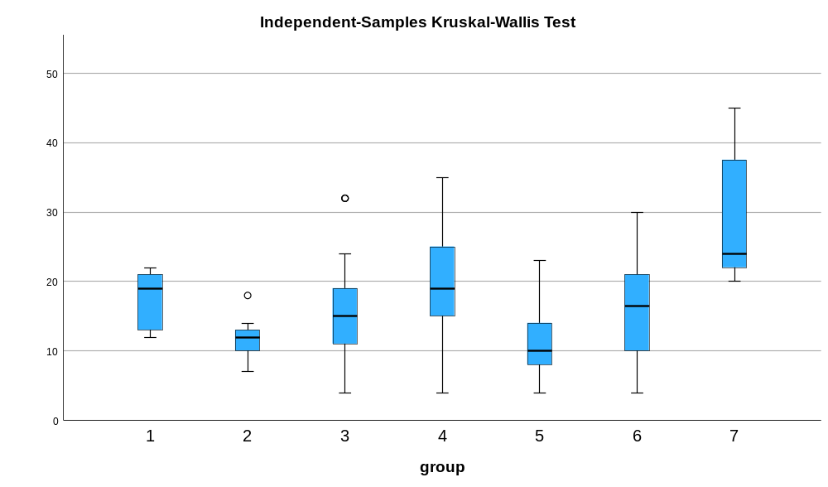

Pairwise Comparisons of group
Sample 1-Sample 2 | Test Statistic | Std. Error | Std. Test Statistic | Sig. | Adj. Sig.ª
5-2 | 4.117 | 23.439 | .176 | .861 | 1.000
5-3 | 52.107 | 14.696 | 3.546 | <.001 | .008
5-6 | -65.748 | 18.466 | -3.560 | <.001 | .008
5-1 | 97.768 | 33.243 | 2.941 | .003 | .069
5-4 | 103.256 | 16.108 | 6.410 | <.001 | .000
5-7 | -184.420 | 29.360 | -6.281 | <.001 | .000
2-3 | -47.990 | 22.364 | -2.146 | .032 | .670
2-6 | -61.631 | 25.004 | -2.465 | .014 | .288
2-1 | 93.651 | 37.273 | 2.513 | .012 | .252
2-4 | -99.139 | 23.316 | -4.252 | <.001 | .000
2-7 | -180.304 | 33.855 | -5.326 | <.001 | .000
3-6 | -13.640 | 17.081 | -.799 | .425 | 1.000
3-1 | 45.660 | 32.494 | 1.405 | .160 | 1.000
3-4 | -51.148 | 14.498 | -3.528 | <.001 | .009
3-7 | -132.313 | 28.509 | -4.641 | <.001 | .000
6-1 | 32.020 | 34.364 | .932 | .351 | 1.000
6-4 | 37.508 | 18.310 | 2.049 | .041 | .851
6-7 | -118.673 | 30.623 | -3.875 | <.001 | .002
1-4 | -5.488 | 33.157 | -.166 | .869 | 1.000
1-7 | -86.653 | 41.254 | -2.100 | .036 | .749
4-7 | -81.165 | 29.261 | -2.774 | .006 | .116
Each row tests the null hypothesis that the Sample 1 and Sample 2 distributions are the same.
Asymptotic significances (2-sided tests) are displayed. The significance level is .050.
a. Significance values have been adjusted by the Bonferroni correction for multiple tests.

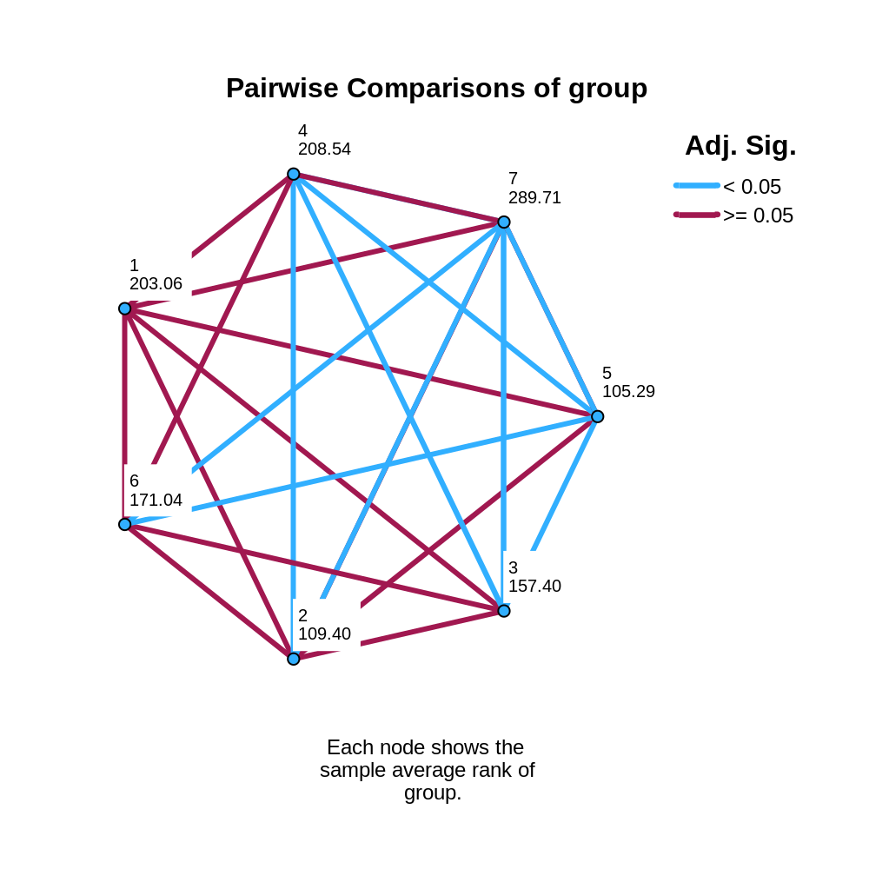

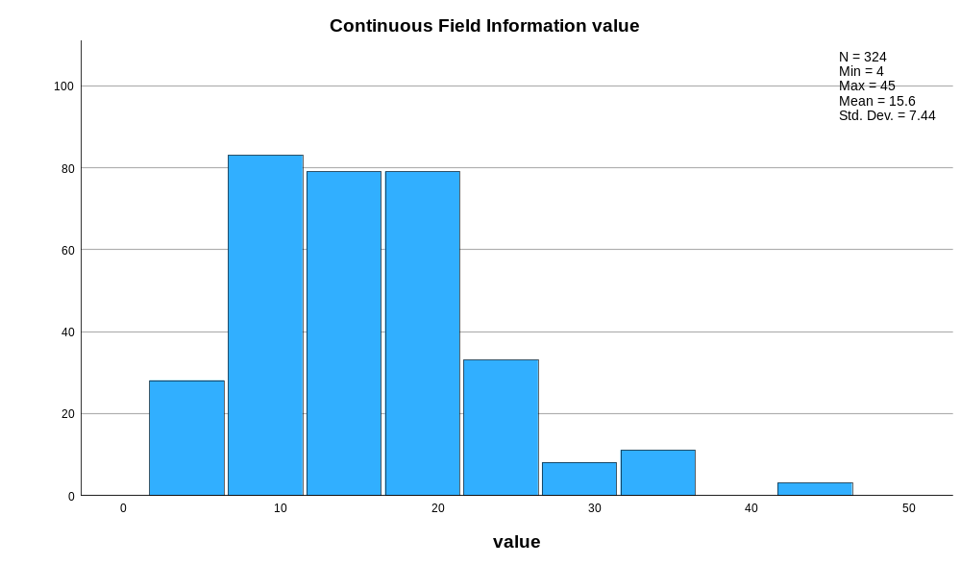

Appendix 24 raw data of weight of the feathers
Bird Number | N-Value | Weight (g)
 |  | 1 | 2 | 3
Eclectus F1 | 3 | 0.15 | 0.15 | 0.15
Eclectus F2 | 3 | 0.22 | 0.22 | 0.22
Eclectus F3 | 3 | 0.21 | 0.21 | 0.21
Eclectus B1 | 3 | 0.0055 | 0.0054 | 0.0053
Eclectus B2 | 3 | 0.003 | 0.003 | 0.0027
Eclectus B3 | 3 | 0.0054 | 0.0056 | 0.0052
Eclectus B4 | 3 | 0.0035 | 0.0034 | 0.0039
Eclectus B5 | 3 | 0.0029 | 0.0027 | 0.0028
Eclectus B6 | 3 | 0.0033 | 0.0037 | 0.0038
Eclectus B7 | 3 | 0.0049 | 0.0049 | 0.0045
Eclectus M1 | 3 | 0.37 | 0.38 | 0.37
Eclectus M2 | 3 | 0.04 | 0.04 | 0.04
Eclectus M3 | 3 | 0.2 | 0.19 | 0.2
Eclectus M4 | 3 | 0.33 | 0.33 | 0.34
Eclectus M5 | 3 | 0.41 | 0.4 | 0.42
Eclectus M6 | 3 | 0.21 | 0.21 | 0.21
Eclectus M7 | 3 | 0.07 | 0.07 | 0.07
Eclectus M8 | 3 | 0.24 | 0.24 | 0.24
Eclectus M9 | 3 | 0.21 | 0.22 | 0.21
Eclectus M10 | 3 | 0.23 | 0.22 | 0.22
Eclectus M11 | 3 | 0.0227 | 0.0225 | 0.0225
Eclectus M12 | 3 | 0.0144 | 0.0141 | 0.014
Eclectus M13 | 3 | 0.0358 | 0.0359 | 0.0357
Eclectus M14 | 3 | 0.0208 | 0.0205 | 0.0208
Eclectus M15 | 3 | 0.0607 | 0.0608 | 0.0593
Eclectus M16 | 3 | 0.0175 | 0.0175 | 0.0175
Eclectus M17 | 3 | 0.172 | 0.0173 | 0.0174
Eclectus M18 | 3 | 0.0294 | 0.0293 | 0.0296
Eclectus M19 | 3 | 0.0307 | 0.0303 | 0.0304
Eclectus M20 | 3 | 0.0043 | 0.0038 | 0.004
Eclectus M21 | 3 | 0.0102 | 0.104 | 0.0105
Eclectus M22 | 3 | 0.01 | 0.1 | 0.0102
Eclectus M23 | 3 | 0.008 | 0.0079 | 0.0081
Eclectus M24 | 3 | 0.0071 | 0.0072 | 0.0072
Eclectus M25 | 3 | 0.012 | 0.117 | 0.0117
Eclectus M26 | 3 | 0.0038 | 0.0038 | 0.004
Eclectus M27 | 3 | 0.0089 | 0.0085 | 0.0086
Eclectus M28 | 3 | 0.41 | 0.42 | 0.41
Eclectus M29 | 3 | 0.15 | 0.15 | 0.15
Eclectus M30 | 3 | 0.25 | 0.25 | 0.26
Eclectus M31 | 3 | 0.18 | 0.19 | 0.18
Eclectus M32 | 3 | 0.23 | 0.23 | 0.23
Eclectus M33 | 3 | 0.0098 | 0.012 | 0.01
Eclectus M34 | 3 | 0.0123 | 0.0122 | 0.0121
Eclectus M35 | 3 | 0.0049 | 0.0048 | 0.0048
Cockatoo 1 | 3 | 0.41 | 0.41 | 0.42
Cockatoo 2 | 3 | 0.34 | 0.35 | 0.35
Cockatoo 3 | 3 | 0.43 | 0.41 | 0.42
Cockatoo 4 | 3 | 0.2 | 0.19 | 0.2
Cockatoo 5 | 3 | 0.05 | 0.05 | 0.05
Cockatoo 6 | 3 | 0.08 | 0.08 | 0.07
Cockatoo 7 | 3 | 0.03 | 0.02 | 0.03
Cockatoo 8 | 3 | 0.02 | 0.01 | 0.01
Cockatoo 9 | 3 | 0.02 | 0.01 | 0.01
Cockatoo 10 | 3 | 0.01 | 0.01 | 0
Cockatoo 11 | 3 | 0.02 | 0.01 | 0.02
Cockatoo 12 | 3 | 0.18 | 0.16 | 0.17
Cockatoo 13 | 3 | 0.26 | 0.24 | 0.24
Cockatoo 14 | 3 | 0.28 | 0.29 | 0.29
Cockatoo 15 | 3 | 0.44 | 0.44 | 0.45
Cockatoo 16 | 3 | 0.45 | 0.44 | 0.44
Cockatoo 17 | 3 | 0.34 | 0.33 | 0.33
Cockatoo 18 | 3 | 0.27 | 0.27 | 0.26
Cockatoo 19 | 3 | 0.24 | 0.24 | 0.23
Cockatoo 20 | 3 | 0.26 | 0.26 | 0.26
Cockatoo 21 | 3 | 0.56 | 0.56 | 0.56
Cockatoo 22 | 3 | 0.23 | 0.23 | 0.24
Cockatoo 23 | 3 | 0.35 | 0.35 | 0.36
African G1 | 3 | 0.18 | 0.19 | 0.19
African G2 | 3 | 0.26 | 0.25 | 0.25
African G3 | 3 | 0.025 | 0.25 | 0.25
African G4 | 3 | 0.21 | 0.21 | 0.22
African G5 | 3 | 0.04 | 0.05 | 0.04
African G6 | 3 | 0.03 | 0.03 | 0.04
African G7 | 3 | 0.03 | 0.03 | 0.03
African G8 | 3 | 0.03 | 0.04 | 0.04
African G9 | 3 | 0.11 | 0.1 | 0.1
African G10 | 3 | 0.1 | 0.1 | 0.1
African G11 | 3 | 0.03 | 0.03 | 0.02
African G12 | 3 | 0.0022 | 0.0017 | 0.0014
African G13 | 3 | 0.0014 | 0.0014 | 0.0015
African G14 | 3 | 0.0028 | 0.0025 | 0.0024
African G15 | 3 | 0.0217 | 0.0215 | 0.0213
African G16 | 3 | 0.0013 | 0.0013 | 0.0011
African G17 | 3 | 0.0121 | 0.0125 | 0.0123
African G18 | 3 | 0.0069 | 0.0069 | 0.007
African G19 | 3 | 0.0028 | 0.003 | 0.003
African G20 | 3 | 0.0069 | 0.0069 | 0.0072
African G21 | 3 | 0.0101 | 0.01 | 0.01
African G22 | 3 | 0.3 | 0.03 | 0.03
Macaw 1 | 3 | 0.02 | 0.03 | 0.03
Macaw 2 | 3 | 0.11 | 0.1 | 0.1
Macaw 3 | 3 | 0.07 | 0.07 | 0.07
Macaw 5 | 3 | 0.15 | 0.15 | 0.15
Macaw 6 | 3 | 0.2 | 0.2 | 0.2
Macaw 7 | 3 | 0.54 | 0.53 | 0.54
Macaw 8 | 3 | 0.63 | 0.64 | 0.64
Macaw 9 | 3 | 0.96 | 0.97 | 0.95
Macaw 11 | 3 | 2.02 | 2.01 | 2
Macaw 12 | 3 | 2.32 | 2.32 | 2.31
Macaw 13 | 3 | 1.29 | 1.27 | 1.28
Macaw 14 | 3 | 1.59 | 1.59 | 1.6
Macaw 15 | 3 | 1.98 | 1.97 | 1.95
Macaw 16 | 3 | 1.5 | 1.5 | 1.54
Owl 1 | 3 | 0.03 | 0.02 | 0.02
Owl 2 | 3 | 0.03 | 0.03 | 0.03
Owl 3 | 3 | 0.06 | 0.05 | 0.06
Owl 4 | 3 | 0.04 | 0.04 | 0.04

Appendix 25 descriptive test of the weight of the feathers
Explore
Notes
Output Created |  | 16-MAR-2026 13:56:25
Comments
Input | Active Dataset | DataSet0
Input | Filter | <none>
Input | Weight | <none>
Input | Split File | <none>
Input | N of Rows in Working Data File | 105
Missing Value Handling | Definition of Missing | User-defined missing values for dependent variables are treated as missing.
Missing Value Handling | Cases Used | Statistics are based on cases with no missing values for any dependent variable or factor used.
Syntax |  | EXAMINE VARIABLES=Ect_F Ect_B Ect_M coc af_G Mac Owl  /PLOT BOXPLOT HISTOGRAM NPPLOT  /COMPARE VARIABLES  /STATISTICS DESCRIPTIVES  /CINTERVAL 95  /MISSING LISTWISE  /NOTOTAL.
Resources | Processor Time | 00:00:02.30
Resources | Elapsed Time | 00:00:02.21

Case Processing Summary
 | Cases
 | Valid |  | Missing |  | Total
 | N | Percent | N | Percent | N | Percent
Ect_F | 9 | 8.6% | 96 | 91.4% | 105 | 100.0%
Ect_B | 9 | 8.6% | 96 | 91.4% | 105 | 100.0%
Ect_M | 9 | 8.6% | 96 | 91.4% | 105 | 100.0%
coc | 9 | 8.6% | 96 | 91.4% | 105 | 100.0%
af_G | 9 | 8.6% | 96 | 91.4% | 105 | 100.0%
Mac | 9 | 8.6% | 96 | 91.4% | 105 | 100.0%
Owl | 9 | 8.6% | 96 | 91.4% | 105 | 100.0%

Descriptives
 |  |  | Statistic | Std. Error
Ect_F | Mean |  | .193333 | .0109291
Ect_F | 95% Confidence Interval for Mean | Lower Bound | .168131
Ect_F | 95% Confidence Interval for Mean | Upper Bound | .218536
Ect_F | 5% Trimmed Mean |  | .194259
Ect_F | Median |  | .210000
Ect_F | Variance |  | .001
Ect_F | Std. Deviation |  | .0327872
Ect_F | Minimum |  | .1500
Ect_F | Maximum |  | .2200
Ect_F | Range |  | .0700
Ect_F | Interquartile Range |  | .0700
Ect_F | Skewness |  | -.790 | .717
Ect_F | Kurtosis |  | -1.714 | 1.400
Ect_B | Mean |  | .004100 | .0003880
Ect_B | 95% Confidence Interval for Mean | Lower Bound | .003205
Ect_B | 95% Confidence Interval for Mean | Upper Bound | .004995
Ect_B | 5% Trimmed Mean |  | .004089
Ect_B | Median |  | .003500
Ect_B | Variance |  | .000
Ect_B | Std. Deviation |  | .0011640
Ect_B | Minimum |  | .0029
Ect_B | Maximum |  | .0055
Ect_B | Range |  | .0026
Ect_B | Interquartile Range |  | .0024
Ect_B | Skewness |  | .258 | .717
Ect_B | Kurtosis |  | -2.309 | 1.400
Ect_M | Mean |  | .231111 | .0417481
Ect_M | 95% Confidence Interval for Mean | Lower Bound | .134840
Ect_M | 95% Confidence Interval for Mean | Upper Bound | .327382
Ect_M | 5% Trimmed Mean |  | .231790
Ect_M | Median |  | .210000
Ect_M | Variance |  | .016
Ect_M | Std. Deviation |  | .1252442
Ect_M | Minimum |  | .0400
Ect_M | Maximum |  | .4100
Ect_M | Range |  | .3700
Ect_M | Interquartile Range |  | .2150
Ect_M | Skewness |  | -.150 | .717
Ect_M | Kurtosis |  | -.760 | 1.400
coc | Mean |  | .175556 | .0579538
coc | 95% Confidence Interval for Mean | Lower Bound | .041914
coc | 95% Confidence Interval for Mean | Upper Bound | .309197
coc | 5% Trimmed Mean |  | .170062
coc | Median |  | .080000
coc | Variance |  | .030
coc | Std. Deviation |  | .1738614
coc | Minimum |  | .0200
coc | Maximum |  | .4300
coc | Range |  | .4100
coc | Interquartile Range |  | .3500
coc | Skewness |  | .623 | .717
coc | Kurtosis |  | -1.670 | 1.400
af_G | Mean |  | .101667 | .0307544
af_G | 95% Confidence Interval for Mean | Lower Bound | .030747
af_G | 95% Confidence Interval for Mean | Upper Bound | .172586
af_G | 5% Trimmed Mean |  | .097130
af_G | Median |  | .040000
af_G | Variance |  | .009
af_G | Std. Deviation |  | .0922632
af_G | Minimum |  | .0250
af_G | Maximum |  | .2600
af_G | Range |  | .2350
af_G | Interquartile Range |  | .1650
af_G | Skewness |  | .805 | .717
af_G | Kurtosis |  | -1.126 | 1.400
Mac | Mean |  | .522222 | .2146041
Mac | 95% Confidence Interval for Mean | Lower Bound | .027344
Mac | 95% Confidence Interval for Mean | Upper Bound | 1.017100
Mac | 5% Trimmed Mean |  | .466914
Mac | Median |  | .200000
Mac | Variance |  | .414
Mac | Std. Deviation |  | .6438124
Mac | Minimum |  | .0200
Mac | Maximum |  | 2.0200
Mac | Range |  | 2.0000
Mac | Interquartile Range |  | .7050
Mac | Skewness |  | 1.849 | .717
Mac | Kurtosis |  | 3.588 | 1.400
Owl | Mean |  | .035556 | .0044444
Owl | 95% Confidence Interval for Mean | Lower Bound | .025307
Owl | 95% Confidence Interval for Mean | Upper Bound | .045804
Owl | 5% Trimmed Mean |  | .035062
Owl | Median |  | .030000
Owl | Variance |  | .000
Owl | Std. Deviation |  | .0133333
Owl | Minimum |  | .0200
Owl | Maximum |  | .0600
Owl | Range |  | .0400
Owl | Interquartile Range |  | .0200
Owl | Skewness |  | .661 | .717
Owl | Kurtosis |  | -.153 | 1.400

Tests of Normality
 | Kolmogorov-Smirnovª |  |  | Shapiro-Wilk
 | Statistic | df | Sig. | Statistic | df | Sig.
Ect_F | .361 | 9 | .001 | .703 | 9 | .002
Ect_B | .252 | 9 | .102 | .796 | 9 | .018
Ect_M | .180 | 9 | .200* | .941 | 9 | .597
coc | .264 | 9 | .070 | .813 | 9 | .029
af_G | .304 | 9 | .017 | .804 | 9 | .023
Mac | .247 | 9 | .120 | .778 | 9 | .011
Owl | .217 | 9 | .200* | .922 | 9 | .407
*. This is a lower bound of the true significance.
a. Lilliefors Significance Correction

Histograms

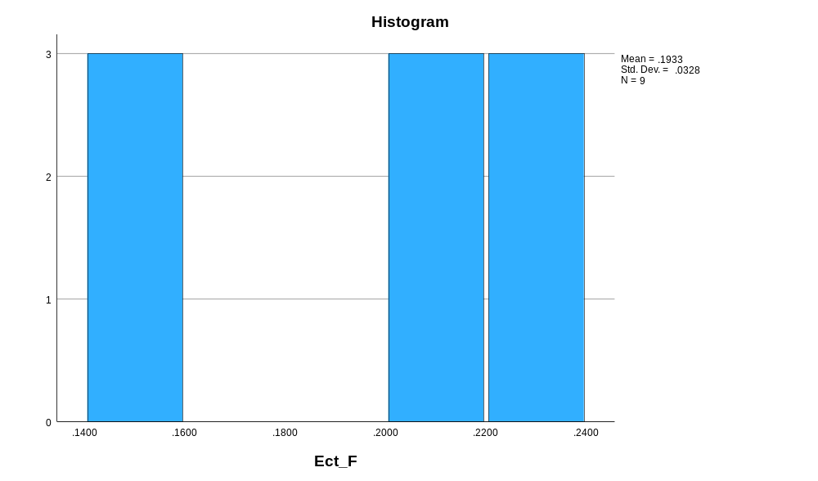

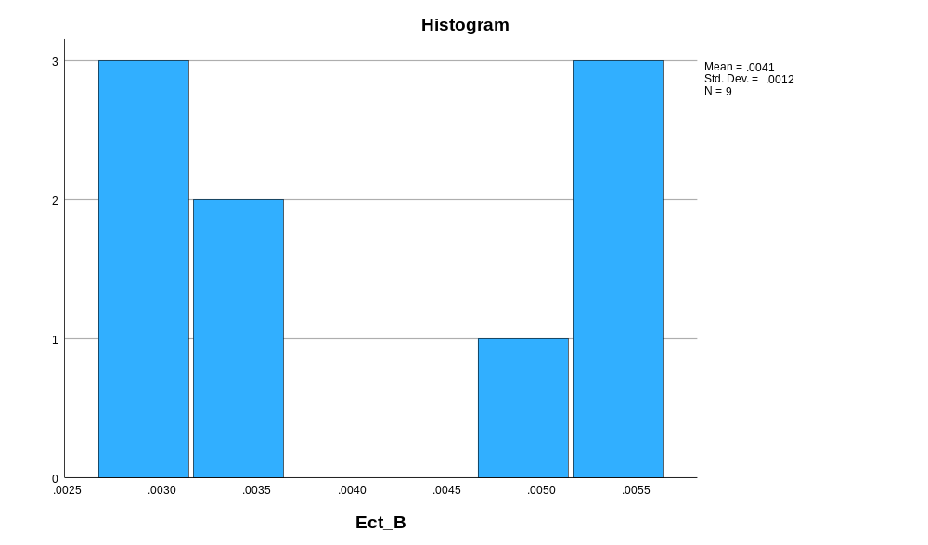

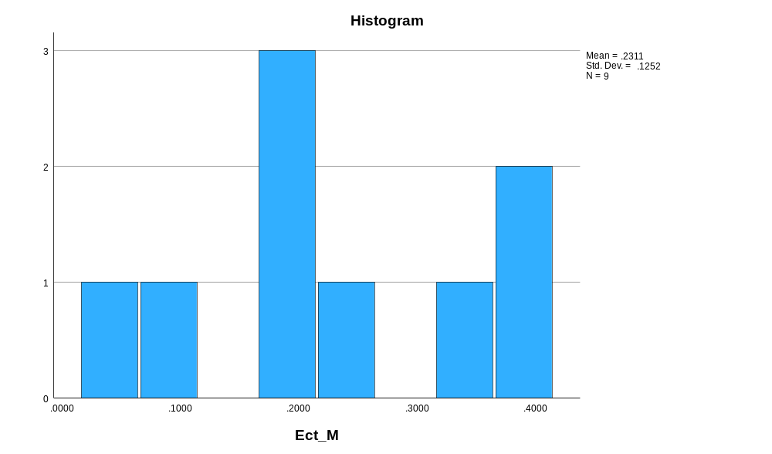

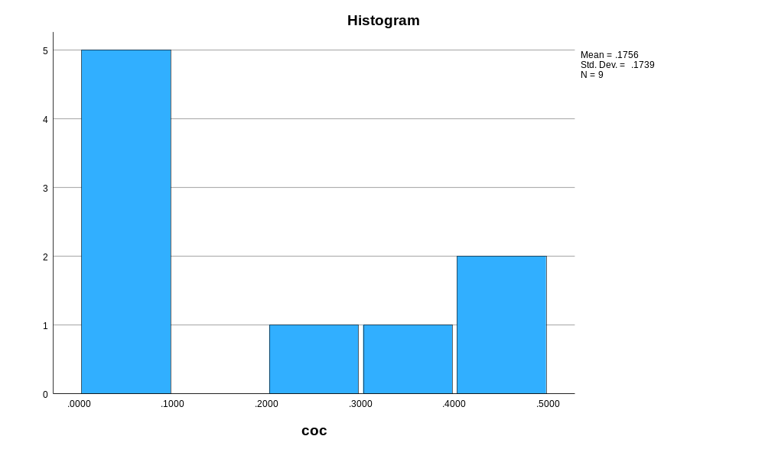

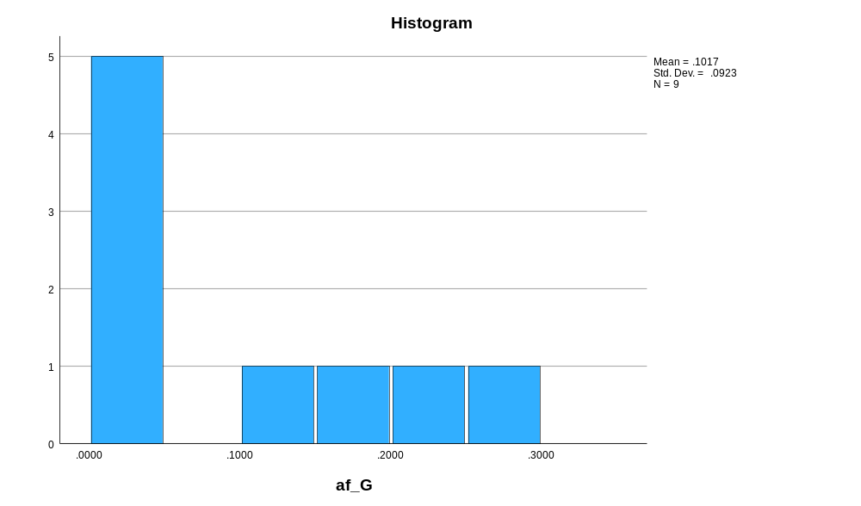

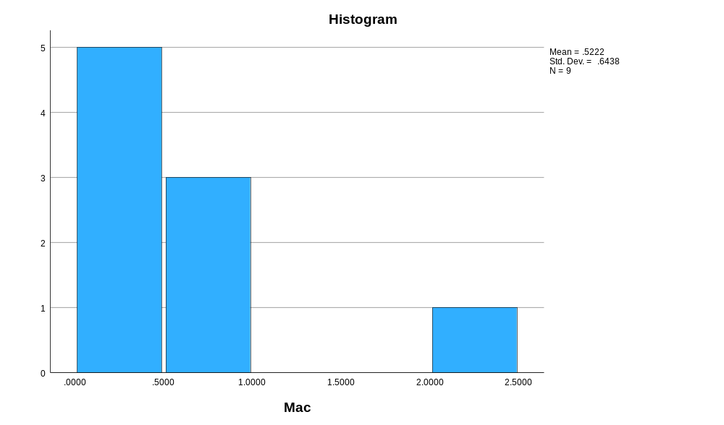

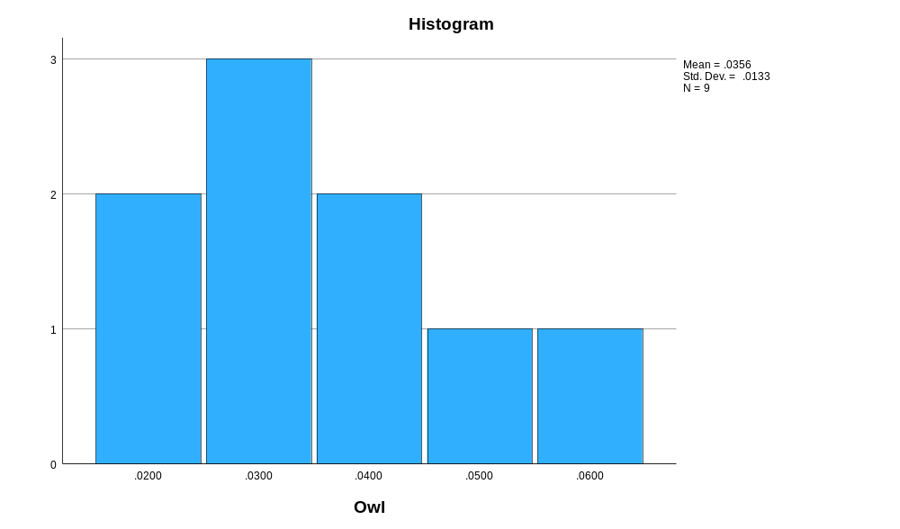

Normal Q-Q Plots

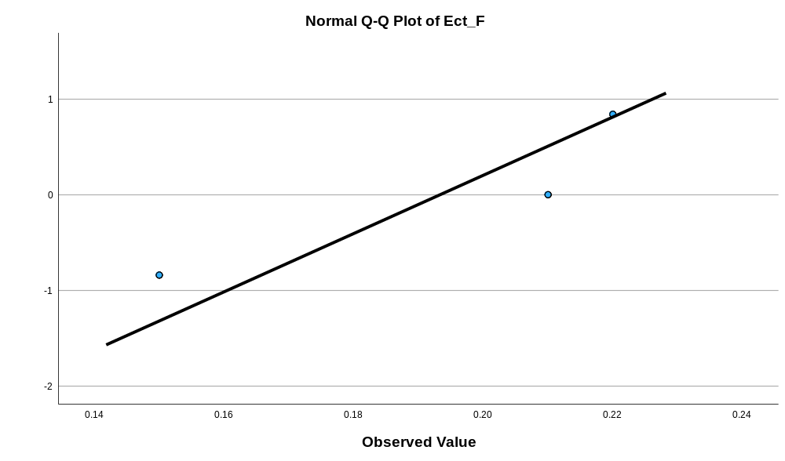

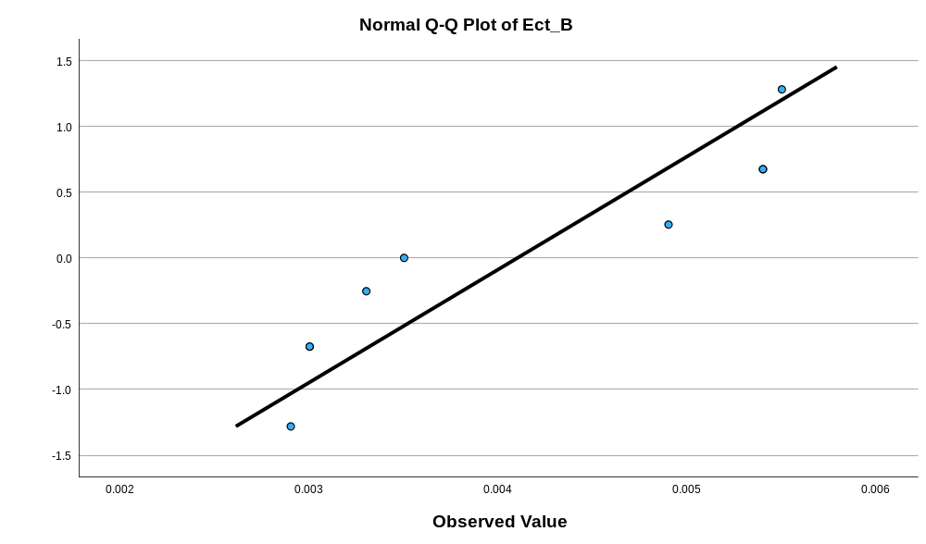

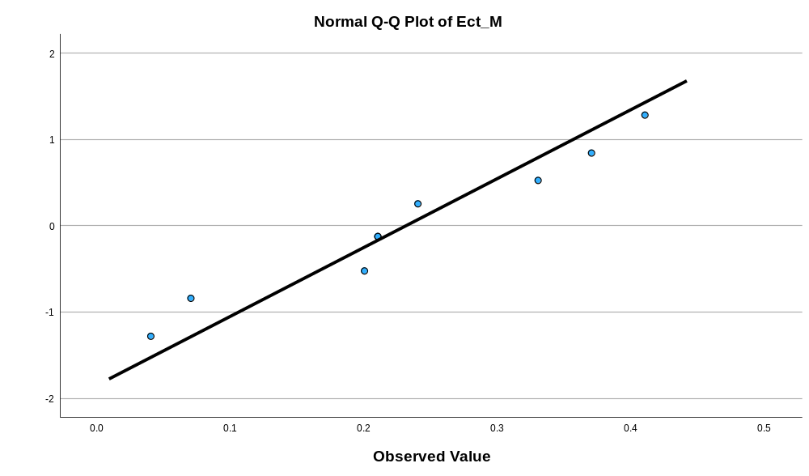

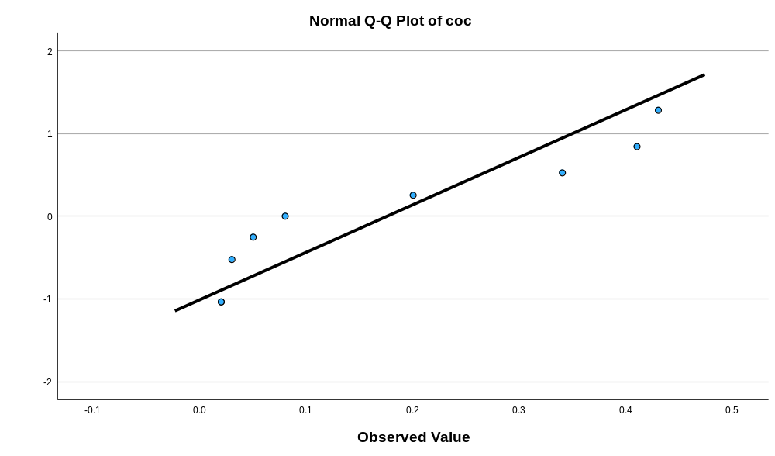

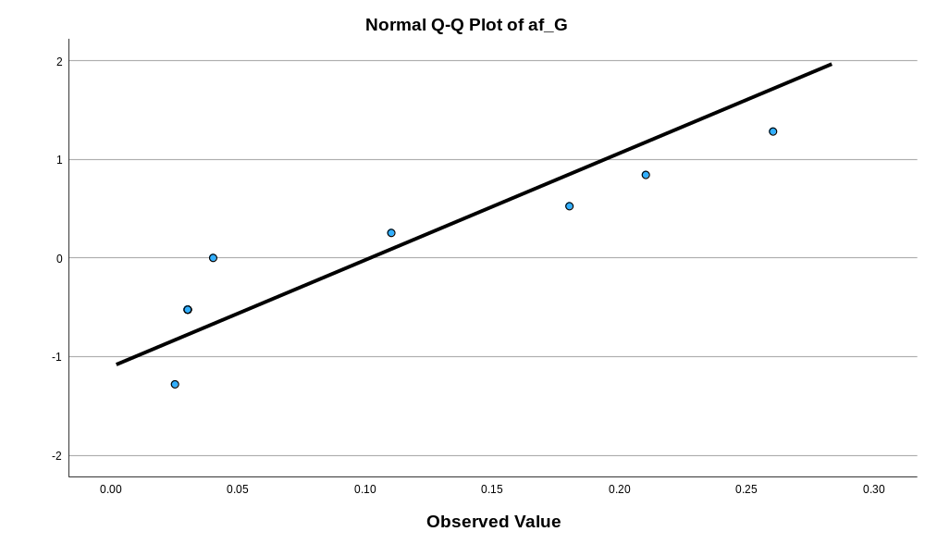

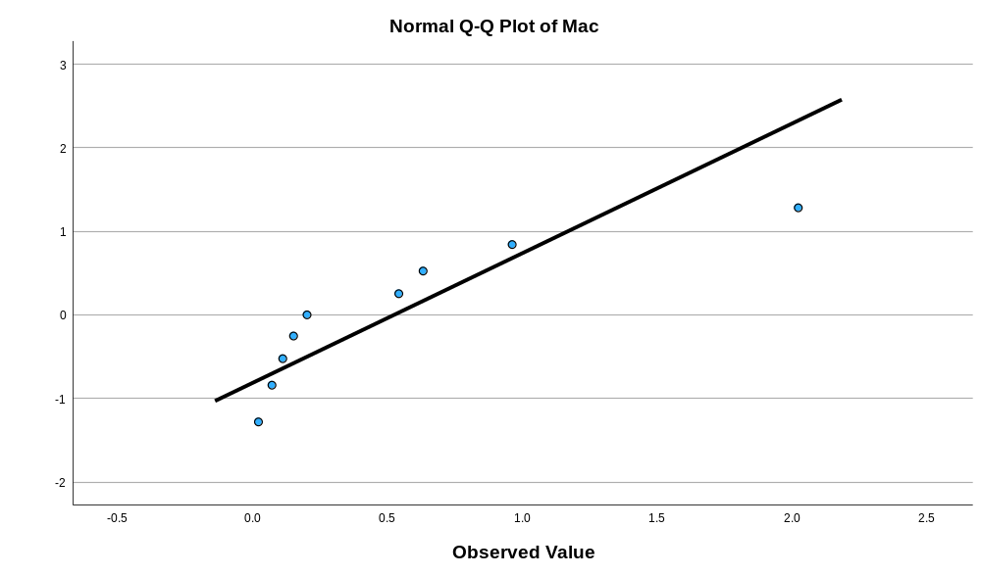

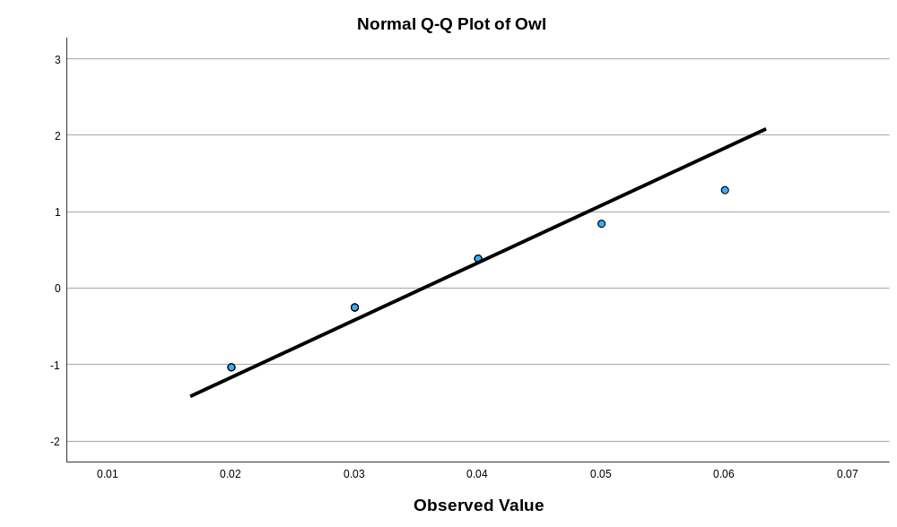

Detrended Normal Q-Q Plots

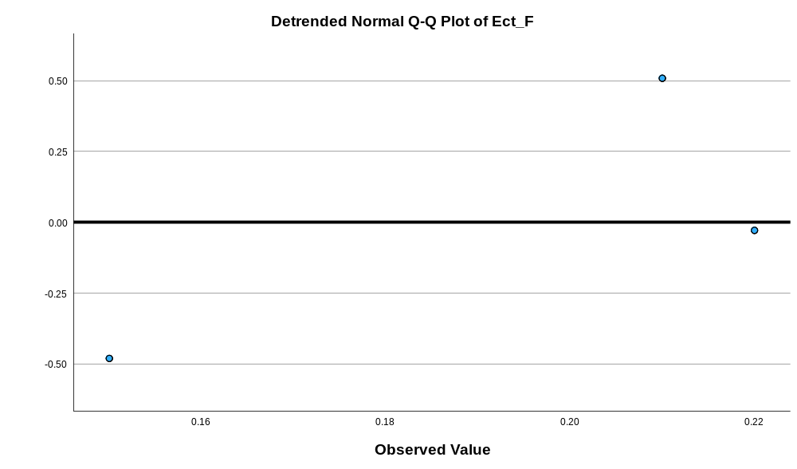

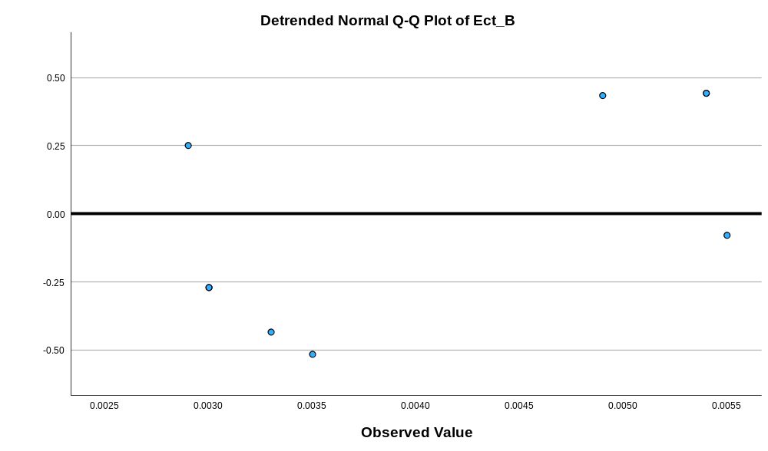

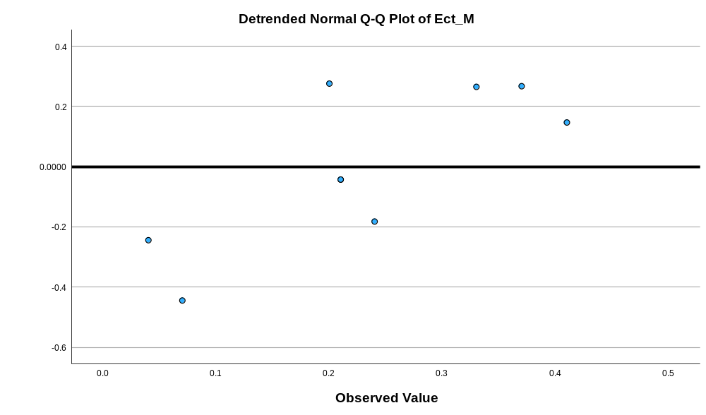

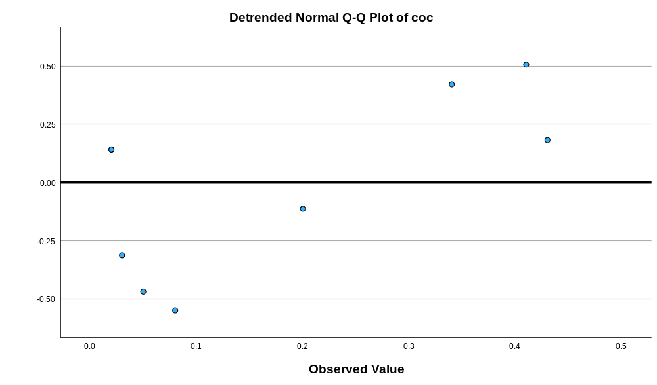

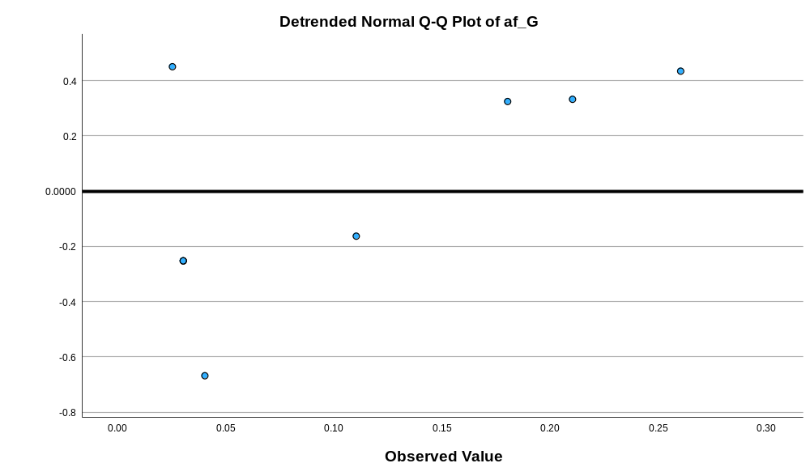

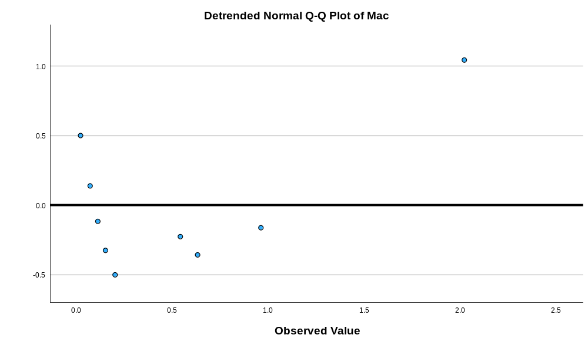

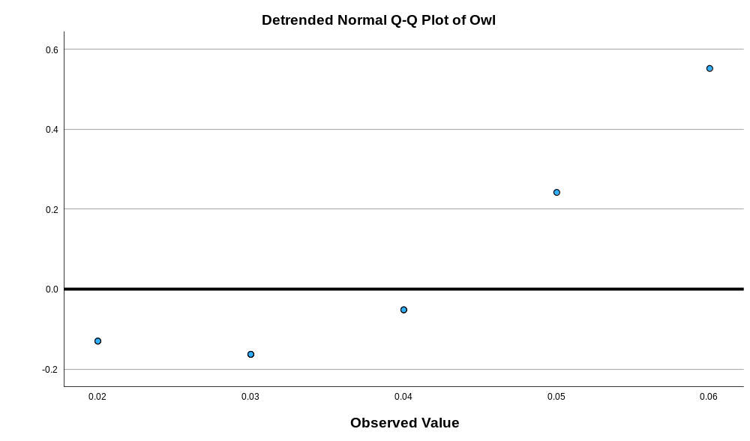
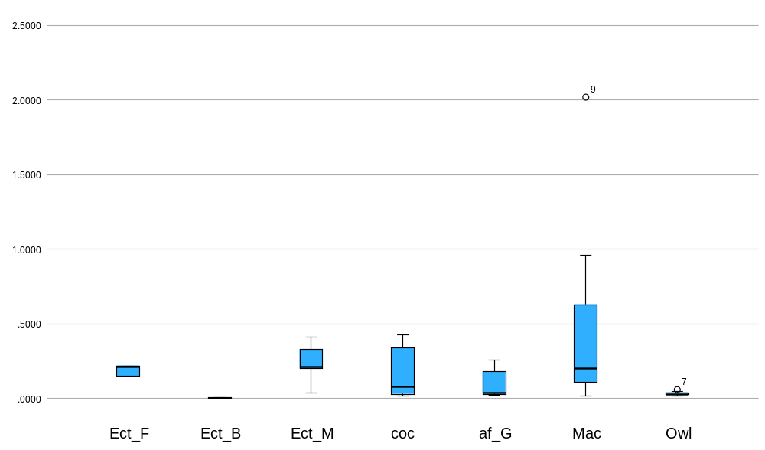

Appendix 26 Kruskal Wallis test of the weight of the feathers
Nonparametric Tests
Notes
Output Created |  | 16-MAR-2026 14:38:44
Comments
Input | Active Dataset | DataSet0
Input | Filter | <none>
Input | Weight | <none>
Input | Split File | <none>
Input | N of Rows in Working Data File | 324
Syntax |  | NPTESTS  /INDEPENDENT TEST (value) GROUP (group) KRUSKAL_WALLIS(COMPARE=PAIRWISE)  /MISSING SCOPE=ANALYSIS USERMISSING=EXCLUDE  /CRITERIA ALPHA=0.05 CILEVEL=95.
Resources | Processor Time | 00:00:00.92
Resources | Elapsed Time | 00:00:00.77

Hypothesis Test Summary
 | Null Hypothesis | Test | Sig.^{a,b}
1 | The distribution of value is the same across categories of group. | Independent-Samples Kruskal-Wallis Test | <.001

Hypothesis Test Summary
 | Decision
1 | Reject the null hypothesis.

a. The significance level is .050.
b. Asymptotic significance is displayed.

Independent-Samples Kruskal-Wallis Test

value across group

Independent-Samples Kruskal-Wallis Test Summary
Total N | 324
Test Statistic | 132.401ª
Degree Of Freedom | 6
Asymptotic Sig.(2-sided test) | <.001
a. The test statistic is adjusted for ties.

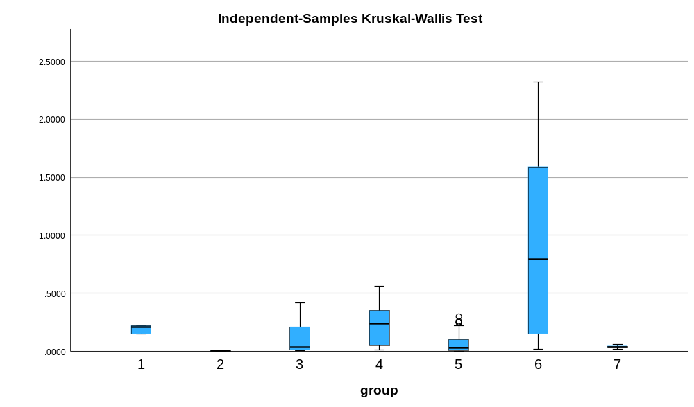

Pairwise Comparisons of group
Sample 1-Sample 2 | Test Statistic | Std. Error | Std. Test Statistic | Sig. | Adj. Sig.ª
2-5 | -82.667 | 23.464 | -3.523 | <.001 | .009
2-7 | -105.250 | 33.891 | -3.106 | .002 | .040
2-3 | -119.638 | 22.388 | -5.344 | <.001 | .000
2-1 | 179.667 | 37.313 | 4.815 | <.001 | .000
2-4 | -182.326 | 23.341 | -7.811 | <.001 | .000
2-6 | -231.464 | 25.030 | -9.247 | <.001 | .000
5-7 | -22.583 | 29.391 | -.768 | .442 | 1.000
5-3 | 36.971 | 14.712 | 2.513 | .012 | .251
5-1 | 97.000 | 33.279 | 2.915 | .004 | .075
5-4 | 99.659 | 16.125 | 6.180 | <.001 | .000
5-6 | -148.798 | 18.486 | -8.049 | <.001 | .000
7-3 | 14.388 | 28.539 | .504 | .614 | 1.000
7-1 | 74.417 | 41.298 | 1.802 | .072 | 1.000
7-4 | 77.076 | 29.292 | 2.631 | .009 | .179
7-6 | 126.214 | 30.656 | 4.117 | <.001 | .001
3-1 | 60.029 | 32.528 | 1.845 | .065 | 1.000
3-4 | -62.688 | 14.514 | -4.319 | <.001 | .000
3-6 | -111.826 | 17.099 | -6.540 | <.001 | .000
1-4 | -2.659 | 33.192 | -.080 | .936 | 1.000
1-6 | -51.798 | 34.401 | -1.506 | .132 | 1.000
4-6 | -49.138 | 18.329 | -2.681 | .007 | .154
Each row tests the null hypothesis that the Sample 1 and Sample 2 distributions are the same.
Asymptotic significances (2-sided tests) are displayed. The significance level is .050.
a. Significance values have been adjusted by the Bonferroni correction for multiple tests.

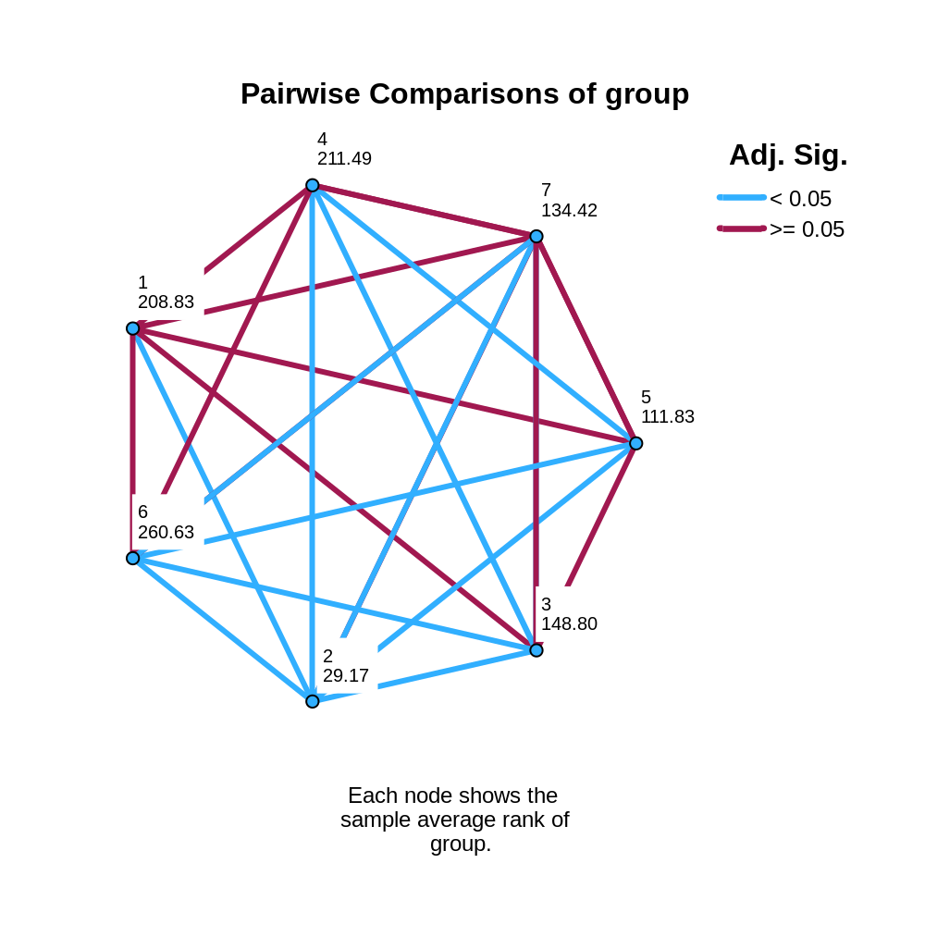

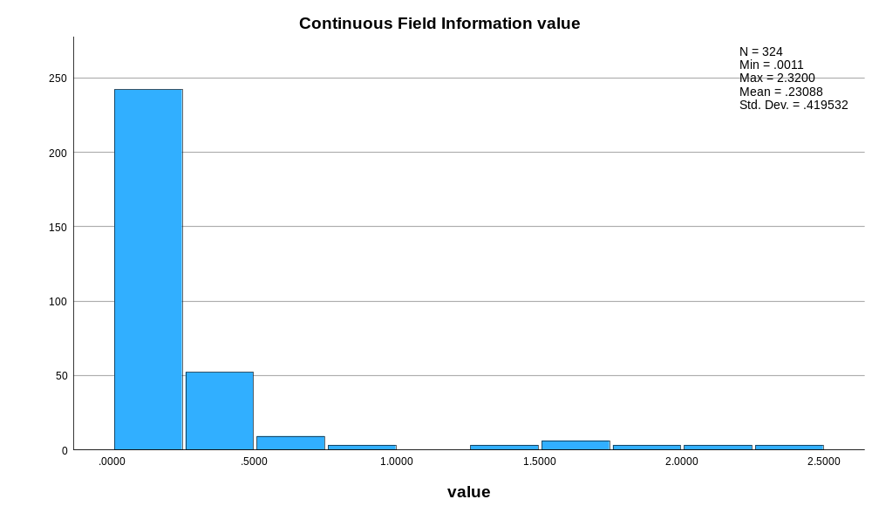

Appendix 27 colouration raw data graph
Bird Number | Pigment | RGB Values |  |  | Colour
Eclectus F1 | Orange Red | 255 | 69 | 0
Eclectus F1 | Firebrick | 255 | 34 | 34
Eclectus F1 | Black | 0 | 0 | 0
Eclectus F1 | Coral | 255 | 127 | 80
Eclectus F1 | Slate Grey | 112 | 128 | 144
Eclectus F2 | Red | 255 | 0 | 0
Eclectus F2 | Gold | 255 | 215 | 0
Eclectus F2 | Orange Red | 255 | 69 | 0
Eclectus F2 | Firebrick | 178 | 34 | 34
Eclectus F2 | Black | 0 | 0 | 0
Eclectus F2 | Slate Grey | 112 | 128 | 144
Eclectus F3 | Tomato | 255 | 99 | 71
Eclectus F3 | Gold | 255 | 215 | 0
Eclectus F3 | Orange | 255 | 165 | 0
Eclectus F3 | Firebrick | 178 | 34 | 34
Eclectus F3 | Black | 0 | 0 | 0
Eclectus F3 | Slate Grey | 112 | 128 | 144
Eclectus B1 | Dark Red | 139 | 0 | 0
Eclectus B1 | Yellow | 255 | 255 | 0
Eclectus B1 | Slate Grey | 112 | 128 | 144
Eclectus B2 | Dark Red | 139 | 0 | 0
Eclectus B2 | Yellow | 255 | 255 | 0
Eclectus B2 | Slate Grey | 112 | 128 | 144
Eclectus B3 | Firebrick | 178 | 34 | 34
Eclectus B3 | Gold | 255 | 215 | 0
Eclectus B3 | Dim Grey | 105 | 105 | 105
Eclectus B4 | Red | 255 | 0 | 0
Eclectus B4 | Orange | 255 | 165 | 0
Eclectus B4 | Gold | 255 | 215 | 0
Eclectus B5 | Red | 255 | 0 | 0
Eclectus B5 | Orange | 255 | 165 | 0
Eclectus B5 | Gold | 255 | 215 | 0
Eclectus B6 | Maroon | 128 | 0 | 0
Eclectus B6 | Light salmon | 255 | 160 | 122
Eclectus B6 | Slate grey | 112 | 128 | 144
Eclectus B7 | Dark Sea Green | 143 | 188 | 143
Eclectus B7 | Olive Drab | 107 | 142 | 35
Eclectus B7 | Gold | 255 | 215 | 0
Eclectus B7 | Firebrick | 178 | 34 | 34
Eclectus M1 | Lime | 0 | 255 | 0
 | Navy | 0 | 0 | 128
 | Sienna | 160 | 82 | 45
 | Tan | 210 | 180 | 140
Eclectus M2 | Yellow Green | 154 | 205 | 50
 | Olive Drab | 107 | 142 | 35
 | Slate Grey | 112 | 128 | 144
 | Azure | 240 | 255 | 255
Eclectus M3 | Black | 0 | 0 | 0
 | Royal Blue | 65 | 105 | 225
 | Navy | 0 | 0 | 128
 | Forest Green | 34 | 139 | 34
Eclectus M4 | Midnight Blue | 25 | 25 | 112
 | Lime Green | 50 | 205 | 50
 | Black | 0 | 0 | 0
Eclectus M5 | Lime | 0 | 255 | 0
 | Indigo | 75 | 0 | 130
 | Dark Blue | 0 | 0 | 139
 | Black | 0 | 0 | 0
Eclectus M6 | Lime | 0 | 255 | 0
 | Forest Green | 34 | 139 | 34
 | Medium Blue | 0 | 0 | 205
 | Dark Blue | 0 | 0 | 139
 | Black | 0 | 0 | 0
Eclectus M7 | Forest Green | 34 | 139 | 34
 | Lime | 0 | 255 | 0
 | Dark Slate Grey | 47 | 79 | 79
 | Tan | 210 | 180 | 140
 | Silver | 192 | 192 | 192
Eclectus M8 | Forest Green | 34 | 139 | 34
 | Blue Violet | 138 | 43 | 226
 | Midnight Blue | 25 | 25 | 112
 | Dark Slate Grey | 47 | 79 | 79
Eclectus M9 | Midnight Blue | 25 | 25 | 112
 | Dark Green | 0 | 100 | 0
 | Black | 0 | 0 | 0
 | Teal | 0 | 128 | 128
Eclectus M10 | Gold | 255 | 215 | 0
 | Khaki | 240 | 230 | 140
 | Dark Green | 0 | 100 | 0
 | Dark Slate Grey | 47 | 79 | 79
 | Dim Grey | 105 | 105 | 105
Eclectus M11 | Lime Green | 50 | 205 | 50
 | Olive Drab | 107 | 142 | 35
 | Dim Grey | 105 | 105 | 105
 | Gainsboro | 220 | 220 | 220
Eclectus M12 | Medium Spring Green | 0 | 250 | 154
 | Lime | 0 | 255 | 0
 | Dark Sea Green | 143 | 188 | 143
 | White Smoke | 245 | 245 | 245
Eclectus M13 | Olive | 128 | 128 | 0
 | Green | 0 | 128 | 0
 | Sea Green | 46 | 139 | 87
 | Olive drab | 107 | 142 | 35
 | Dark Grey | 169 | 169 | 169
 | Gainsboro | 220 | 220 | 220
Eclectus M14 | Forest Green | 34 | 139 | 34
 | Saddle Brown | 139 | 69 | 19
 | Dark Grey | 169 | 169 | 169
 | White Smoke | 245 | 245 | 245
Eclectus M15 | Lime | 0 | 255 | 0
 | Forest Green | 34 | 139 | 34
 | Dark Sea Green | 143 | 188 | 143
 | White Smoke | 245 | 245 | 245
 | Dark Grey | 169 | 169 | 169
Eclectus M16 | Lime | 0 | 255 | 0
 | Lime Green | 50 | 205 | 50
 | Olive Drab | 107 | 142 | 35
 | Light Slate Grey | 211 | 211 | 211
 | White Smoke | 245 | 245 | 245
Eclectus M17 | Lime | 0 | 255 | 0
 | Forest Green | 34 | 139 | 34
 | Dark Sea Green | 143 | 188 | 143
 | Grey | 128 | 128 | 128
 | White Smoke | 245 | 245 | 245
Eclectus M18 | Dark Olive Green | 85 | 107 | 47
 | Tan | 210 | 180 | 140
 | Grey | 128 | 128 | 128
 | White Smoke | 245 | 245 | 245
Eclectus M19 | Lime | 0 | 255 | 0
 | Dark Slate Grey | 47 | 79 | 79
 | Dark Grey | 169 | 169 | 169
 | Gainsboro | 220 | 220 | 220
Eclectus M20 | Forest Green | 34 | 139 | 34
 | Olive Drab | 107 | 142 | 35
 | Dark Sea Green | 143 | 188 | 143
 | Gainsboro | 220 | 220 | 220
Eclectus M21 | Lime Green | 50 | 205 | 50
 | Sea Green | 46 | 139 | 87
 | Dark Sea Green | 143 | 188 | 143
 | Gainsboro | 220 | 220 | 220
Eclectus M22 | Lime Green | 50 | 205 | 50
 | Dark Green | 0 | 100 | 0
 | Dark Sea Green | 143 | 188 | 143
 | Dim Grey | 105 | 105 | 105
 | Dark Grey | 169 | 169 | 169
Eclectus M23 | Lime | 0 | 255 | 0
 | Forest Green | 34 | 139 | 34
 | Dark Sea Green | 143 | 188 | 143
 | Gold | 255 | 215 | 0
 | Dark Grey | 169 | 169 | 169
Eclectus M24 | Red | 255 | 0 | 0
 | Lime Green | 50 | 205 | 50
 | Dark Sea Green | 143 | 188 | 143
 | Gold | 255 | 215 | 0
 | Dark Grey | 169 | 169 | 169
Eclectus M25 | Lawn Green | 124 | 252 | 0
 | Medium sea green | 143 | 188 | 143
 | Dark Sea Green | 143 | 188 | 143
 | Gainsboro | 220 | 220 | 220
Eclectus M26 | Green | 0 | 128 | 0
 | Dark Sea Green | 143 | 188 | 143
 | Light Grey | 211 | 211 | 211
 | White Smoke | 245 | 245 | 245
Eclectus M27 | Dark Red | 139 | 0 | 0
 | Cadet Blue | 95 | 158 | 160
 | Gold | 255 | 215 | 0
 | Ivory | 255 | 255 | 240
 | Green | 0 | 128 | 0
 | Dim Grey | 105 | 105 | 105
Eclectus M28 | Midnight blue | 25 | 25 | 112
 | Black | 0 | 0 | 0
 | Sienna | 160 | 82 | 45
 | Dim Grey | 105 | 105 | 105
Eclectus M29 | Green | 0 | 128 | 0
 | Pale Green | 152 | 251 | 152
 | Saddle Brown | 139 | 69 | 19
 | Medium Blue | 0 | 0 | 205
 | Light Grey | 211 | 211 | 211
Eclectus M30 | Navy | 0 | 0 | 128
 | Black | 0 | 0 | 0
 | Dim Grey | 105 | 105 | 105
Eclectus M31 | Green | 0 | 128 | 0
 | Saddle Brown | 139 | 69 | 19
 | Tan | 210 | 180 | 140
 | Light Grey | 211 | 211 | 211
Eclectus M32 | Sienna | 160 | 82 | 45
 | Saddle Brown | 139 | 69 | 19
 | Black | 0 | 0 | 0
 | Medium Blue | 0 | 0 | 205
 | Forest Green | 34 | 139 | 34
 | Navy | 0 | 0 | 128
Eclectus M33 | Green | 0 | 128 | 0
 | Lime Green | 50 | 205 | 50
 | Dark Sea Green | 143 | 188 | 143
 | White Smoke | 245 | 245 | 245
Eclectus M34 | Green | 0 | 128 | 0
 | Lime | 0 | 255 | 0
 | Black | 0 | 0 | 0
 | White Smoke | 245 | 245 | 245
 | Silver | 192 | 192 | 192
Eclectus M35 | Lime | 0 | 255 | 0
 | Dark Sea Green | 143 | 188 | 143
 | White Smoke | 245 | 245 | 245
Cockatoo 1 | White Smoke | 245 | 245 | 245
 | Yellow | 255 | 255 | 0
Cockatoo 2 | White Smoke | 245 | 245 | 245
 | Yellow | 255 | 255 | 0
Cockatoo 3 | White Smoke | 245 | 245 | 245
 | Yellow | 255 | 255 | 0
Cockatoo 4 | White Smoke | 245 | 245 | 245
Cockatoo 5 | Snow | 255 | 250 | 250
 | Light Golden Rod Yellow | 250 | 250 | 210
 | Yellow | 255 | 255 | 0
 | Lemon Chiffon | 255 | 250 | 210
Cockatoo 6 | Tan | 210 | 180 | 140
 | Snow | 255 | 250 | 250
Cockatoo 7 | White Smoke | 245 | 245 | 245
 | Ivory | 255 | 255 | 240
Cockatoo 8 | Snow | 255 | 250 | 250
 | Sandy Brown | 244 | 164 | 96
Cockatoo 9 | Snow | 255 | 250 | 250
 | Navajo White | 255 | 228 | 173
Cockatoo 10 | Dim Grey | 105 | 105 | 105
 | Silver | 192 | 192 | 192
 | Gainsboro | 220 | 220 | 220
Cockatoo 11 | Moccasin | 255 | 228 | 181
 | Snow | 255 | 250 | 250
 | Sandy Brown | 244 | 164 | 96
Cockatoo 12 | White Smoke | 245 | 245 | 245
 | Old Lace | 253 | 245 | 230
Cockatoo 13 | Snow | 255 | 250 | 250
Cockatoo 14 | Snow | 255 | 250 | 250
Cockatoo 15 | Snow | 255 | 250 | 250
Cockatoo 16 | Snow | 255 | 250 | 250
Cockatoo 17 | White Smoke | 245 | 245 | 245
 | Old Lace | 253 | 245 | 230
Cockatoo 18 | Snow | 255 | 250 | 250
Cockatoo 19 | Snow | 255 | 250 | 250
Cockatoo 20 | Ghost White | 248 | 248 | 255
Cockatoo 21 | Snow | 255 | 250 | 250
Cockatoo 22 | Snow | 255 | 250 | 250
 | Ghost White | 248 | 248 | 255
Cockatoo 23 | White Smoke | 245 | 245 | 245
African Grey 1 | Dim Grey | 105 | 105 | 105
 | Dark Grey | 169 | 169 | 169
 | Gainsboro | 220 | 220 | 220
 | White Smoke | 245 | 245 | 245
African Grey 2 | Dim Grey | 105 | 105 | 105
 | Silver | 192 | 192 | 192
 | White Smoke | 245 | 245 | 245
African Grey 3 | Dark Grey | 169 | 169 | 169
 | Dim Grey | 105 | 105 | 105
 | Dark Slate Grey | 47 | 79 | 79
African Grey 4 | Black | 0 | 0 | 0
 | Dim Grey | 105 | 105 | 105
 | Silver | 192 | 192 | 192
 | Gainsboro | 220 | 220 | 220
 | White Smoke | 245 | 245 | 245
African Grey 5 | Black | 0 | 0 | 0
 | Dark Grey | 169 | 169 | 169
 | Light Grey | 211 | 211 | 211
 | White Smoke | 245 | 245 | 245
African Grey 6 | Dim Grey | 105 | 105 | 105
 | Brown | 165 | 42 | 42
 | White Smoke | 245 | 245 | 245
African Grey 7 | Dim Grey | 105 | 105 | 105
 | Grey | 128 | 128 | 128
 | Silver | 192 | 192 | 192
 | White Smoke | 245 | 245 | 245
African Grey 8 | Dim Grey | 105 | 105 | 105
 | Grey | 128 | 128 | 128
 | White Smoke | 245 | 245 | 245
African Grey 9 | Black | 0 | 0 | 0
 | Grey | 128 | 128 | 128
 | White Smoke | 245 | 245 | 245
African Grey 10 | Grey | 128 | 128 | 128
 | Brown | 165 | 42 | 42
 | Silver | 192 | 192 | 192
 | Light Grey | 211 | 211 | 211
African Grey 11 | Dim Grey | 105 | 105 | 105
 | Gainsboro | 220 | 220 | 220
 | White Smoke | 245 | 245 | 245
African Grey 12 | Dim Grey | 105 | 105 | 105
 | Gainsboro | 220 | 220 | 220
 | White Smoke | 245 | 245 | 245
African Grey 13 | Grey | 128 | 128 | 128
 | White Smoke | 245 | 245 | 245
African Grey 14 | White Smoke | 245 | 245 | 245
 | Silver | 192 | 192 | 192
African Grey 15 | Dim Grey | 105 | 105 | 105
 | Dark Grey | 169 | 169 | 169
 | White Smoke | 245 | 245 | 245
African Grey 16 | Dim Grey | 105 | 105 | 105
 | White Smoke | 245 | 245 | 245
African Grey 17 | White Smoke | 245 | 245 | 245
 | Grey | 128 | 128 | 128
 | Tomato | 255 | 99 | 71
 | Dim Grey | 105 | 105 | 105
African Grey 18 | Dim Grey | 105 | 105 | 105
 | Dark Grey | 169 | 169 | 169
 | White | 255 | 255 | 255
African Grey 19 | White Smoke | 245 | 245 | 245
 | Silver | 192 | 192 | 192
 | White Smoke | 245 | 245 | 245
African Grey 20 | Black | 0 | 0 | 0
 | Dim Grey | 105 | 105 | 105
 | Silver | 192 | 192 | 192
African Grey 21 | Dim Grey | 105 | 105 | 105
 | Dark Grey | 169 | 169 | 169
 | White Smoke | 245 | 245 | 245
African Grey 22 | Silver | 192 | 192 | 192
 | Dim Grey | 105 | 105 | 105
 | Gainsboro | 220 | 220 | 220
Macaw 1 | Black | 0 | 0 | 0
 | Midnight Blue | 25 | 25 | 112
Macaw 2 | Indigo | 75 | 0 | 130
 | Midnight Blue | 25 | 25 | 112
 | Silver | 192 | 192 | 192
 | Dim Grey | 105 | 105 | 105
Macaw 3 | Dim Grey | 105 | 105 | 105
 | Silver | 192 | 192 | 192
Macaw 4
Macaw 5 | Dim Grey | 105 | 105 | 105
 | Midnight Blue | 25 | 25 | 112
 | Navy | 0 | 0 | 128
 | Black | 0 | 0 | 0
Macaw 6 | Black | 0 | 0 | 0
 | Dark Grey | 169 | 169 | 169
 | Midnight Blue | 0 | 0 | 205
Macaw 7 | Navy | 0 | 0 | 128
 | Medium Blue | 0 | 0 | 205
 | Dim Grey | 105 | 105 | 105
 | Black | 0 | 0 | 0
Macaw 8 | Navy | 0 | 0 | 128
 | Dim Grey | 105 | 105 | 105
 | Silver | 192 | 192 | 192
Macaw 9 | Midnight Blue | 25 | 25 | 112
 | Indigo | 75 | 0 | 130
 | Dark Khaki | 189 | 183 | 107
Macaw 11 | Dark Blue | 0 | 0 | 139
 | Indigo | 75 | 0 | 130
 | Dark Slate Blue | 72 | 61 | 139
 | Black | 0 | 0 | 0
Macaw 12 | Midnight Blue | 25 | 25 | 112
 | Medium Blue | 0 | 0 | 205
 | Black | 0 | 0 | 0
 | Dark Slate Grey | 72 | 61 | 139
Macaw 13 | Dark Blue | 0 | 0 | 139
 | Dark Slate Blue | 72 | 61 | 139
 | Black | 0 | 0 | 0
Macaw 14 | Dark Blue | 0 | 0 | 139
 | Midnight Blue | 25 | 25 | 112
 | Black | 0 | 0 | 0
Macaw 15 | Navy | 0 | 0 | 128
 | Indigo | 75 | 0 | 130
 | Dark Slate Blue | 72 | 61 | 139
 | Black | 0 | 0 | 0
Macaw 16 | Navy | 0 | 0 | 128
 | Dark Blue | 0 | 0 | 139
 | Dim Grey | 105 | 105 | 105
 | Light Slate Grey | 119 | 136 | 153
Owl 1 | Saddle Brown | 139 | 69 | 19
 | Linen | 250 | 240 | 230
Owl 2 | Saddle Brown | 139 | 69 | 19
 | Linen | 250 | 240 | 230
Owl 3 | Sienna | 160 | 82 | 45
 | Linen | 250 | 240 | 230
Owl 4 | Tan | 210 | 180 | 140
 | Burley Wood | 222 | 184 | 135

Appendix 28 Results Table of Colour Distribution and Pattern
Bird number | Colour Distribution | Number of Colour Bands | Shapes of Bands | Size Of Bands
Eclectus F1 | Uneven | 4 | Orange - Straight | Small 5%
 |  |  | Red - Curved | Small 25%
 |  |  | Dark red - Curved | Medium 45%
 |  |  | Black - Curved One Sided | Small 25%
Eclectus F2 | Uneven / Onesided | 4 | Yellow - Straight | Small 5%
 |  |  | Orange - Straight | Small 10%
 |  |  | Red - Irregular | Large 65%
 |  |  | Black -One Sided Straight | Small 20%
Eclectus F3 | Uneven | 5 | Yellow - Straight | Small 5%
 |  |  | Orange - Straight | Small 20%
 |  |  | Red - Straight | Medium 45%
 |  |  | Grey - Uneven | Small 20%
 |  |  | Black -Uneven | Small 10%
Eclectus B1 | Banded | 3 | Red – curved / uneven | Large 55%
 |  |  | Yellow – curved | Small 5%
 |  |  | Grey - curved | Medium 40%
Eclectus B2 | Banded | 3 | Red – curved | Large 85%
 |  |  | Yellow – curved | Small 5%
 |  |  | Grey – curved | Small 10%
Eclectus B3 | Banded | 3 | Red – curved | Large 70%
 |  |  | Yellow – curved | Small 10%
 |  |  | Grey – curved | Small 20%
Eclectus B4 | Banded | 3 | Red – curved | Large 75%
 |  |  | Yellow – curved | Small 10%
 |  |  | Grey - curved | Small 15%
Eclectus B5 | Banded | 3 | Red - irregular | Large 75%
 |  |  | Yellow-straight | Small 5%
 |  |  | Grey - irregular | Small 20%
Eclectus B6 | Banded | 3 | Red – straight | Large 75%
 |  |  | White – circular | Small 10%
 |  |  | Grey – straight | Small 15%
Eclectus B7 | Banded | 3 | Red – straight | Large 50%
 |  |  | Yellow – curved | Small 5%
 |  |  | Grey – curved | Medium 45%
Eclectus M1 | Striped | 3 | Green - Straight Vertical | Small 2%
 |  |  | Dark Blue - Straight Vertical | Medium 45%
 |  |  | Brown - Straight Vertical | Medium 53%
Eclectus M2 | Uneven | 5 | Yellow – Curved | Small 10%
 |  |  | Green - Curved | Small 10%
 |  |  | Dark Green - Straight Vertical | Small 5%
 |  |  | Brown - Straight Horizontal | Small 20%
 |  |  | White - Straight Horizontal | Medium 55%
Eclectus M3 | Striped | 5 | Green - Straight Vertical | Medium 35%
 |  |  | Light Blue - Straight Vertical | Small 5%
 |  |  | White - Straight Horizontal | Small 5%
 |  |  | Dark Blue - Straight Vertical | Small 10%
 |  |  | Black - Straight Vertical | Medium 45%
Eclectus M4 | Striped | 3 | Black - Straight Vertical | Medium 35%
 |  |  | Dark Blue - Straight Vertical | Large 63%
 |  |  | Green - Straight Vertical | Small 2%
Eclectus M5 | Striped | 3 | Black - Straight Vertical | Medium 45%
 |  |  | Dark Blue - Straight Vertical | Medium 53%
 |  |  | Green - Straight Vertical | Small 2%
Eclectus M6 | Striped | 4 | Black - Straight Vertical | Medium 40%
 |  |  | Dark Blue - Straight Vertical | Small 15%
 |  |  | Light Blue - Triangular | Small 5%
 |  |  | Green - Straight Vertical | Medium 40%
Eclectus M7 | Banded | 3 | Green -Straight Horizontal | Large 55%
 |  |  | Brown - Curved | Medium 40%
 |  |  | White - Straight Horizontal | Small 5%
Eclectus M8 | Uneven | 6 | Yellow -Straight Horizontal | Small 2%
 |  |  | Blue - Triangular | Small 5%
 |  |  | Green - Straight Horizontal | Large 80%
 |  |  | Purple - Semi-Circle | Small 4%
 |  |  | Brown - Straight Horizontal | Small 5%
 |  |  | White - Straight Horizontal | Small 4%
Eclectus M9 | Striped | 4 | Green - Straight Vertical | Medium 35%
 |  |  | Light Blue - Straight Vertical | Small 3%
 |  |  | Dark Blue - Straight Vertical | Small 17%
 |  |  | Black - Straight Vertical | Medium 45%
Eclectus M10 | Uneven | 6 | Yellow -Straight Horizontal | Small 10%
 |  |  | Black - Straight Vertical | Medium 30%
 |  |  | Dark Blue - Straight Vertical | Small 20%
 |  |  | Light Blue - Straight Vertical | Small 5%
 |  |  | White - Straight Horizontal | Small 5%
 |  |  | Green - Straight Vertical | Medium 30%
Eclectus M11 | Banded | 3 | Green - Straight Horizontal | Large 60%
 |  |  | Brown - Straight Horizontal | Medium 30%
 |  |  | White - Straight Horizontal | Small 10%
Eclectus M12 | Uneven | 3 | Green - Curved | Large 65%
 |  |  | Brown - Curved | Small 25%
 |  |  | White - Straight Horizontal | Small 10%
Eclectus M13 | Banned | 3 | Green - Straight Horizontal | Large 55%
 |  |  | Brown - Triangular | Small 25%
 |  |  | White - Triangular | Small 20%
Eclectus M14 | Banded | 3 | Green - Straight Horizontal | Large 60%
 |  |  | Grey - Straight Horizontal | Medium 35%
 |  |  | White - Straight Horizontal | Small 5%
Eclectus M15 | Banded | 3 | Green - Straight Horizontal | Large 70%
 |  |  | Brown - Straight Horizontal | Small 15%
 |  |  | White - Straight Horizontal | Small 15%
Eclectus M16 | Banded | 3 | Green - Straight Horizontal | Large 60%
 |  |  | Brown - Straight Horizontal | Medium 30%
 |  |  | White - Straight Horizontal | Small 10%
Eclectus M17 | Banded | 4 | Green - Straight Horizontal | Medium 70%
 |  |  | Brown - Straight Horizontal | Small 10%
 |  |  | Grey - Curved | Small 15%
 |  |  | White - Straight Horizontal | Small 5%
Eclectus M18 | Banded | 4 | Green - Straight Horizontal | Large 65%
 |  |  | Brown - Circular | Small 5%
 |  |  | White - Straight Horizontal | Small 15%
 |  |  | Grey - Straight Horizontal | Small 15%
Eclectus M19 | Banded | 3 | Green - Straight Horizontal | Medium 50%
 |  |  | Black - Straight Vertical | Medium 40%
 |  |  | White - Triangular | Small 10%
Eclectus M20 | Banned | 3 | Green - Straight Horizontal | Large 60%
 |  |  | Brown - Straight Horizontal | Small 20%
 |  |  | White - Straight Horizontal | Small 20%
Eclectus M21 | Uneven | 3 | Dark Green - Triangular | Small 5%
 |  |  | Green - Curved | Medium 50%
 |  |  | Brown - Straight Horizontal | Medium 45%
Eclectus M22 | Banned | 4 | Blue - Straight Horizontal | Small 20%
 |  |  | Green - Straight Horizontal | Medium 45%
 |  |  | Brown - Straight Horizontal | Small 15%
 |  |  | White - Straight Horizontal | Small 20%
Eclectus M23 | Banded | 3 | Green - Straight Horizontal | Large 65%
 |  |  | Grey - Curved | Small 20%
 |  |  | White - Curved | Small 15%
Eclectus M24 | Banded | 5 | Red - Straight Left | Medium 40%
 |  |  | Green - Straight Left | Medium 40%
 |  |  | Yellow - Straight Left | Small 3%
 |  |  | Grey - Straight Horizontal | Small 14%
 |  |  | White - Straight Horizontal | Small 3%
Eclectus M25 | Uneven | 3 | Green - Curved | Large 55%
 |  |  | Blue - Triangular | Small 5%
 |  |  | Brown - Straight Horizontal | Medium 40%
Eclectus M26 | Banded | 3 | Green - Straight Horizontal | Medium 40%
 |  |  | Brown - Curved | Medium 45%
 |  |  | White - Curved | Small 15%
Eclectus M27 | Banded | 6 | Red - Straight Left | Medium 35%
 |  |  | Green - Straight Right | Small 17%
 |  |  | Yellow -Straight Horizontal | Small 5%
 |  |  | Blue - Triangular | Small 3%
 |  |  | Brown - Straight Horizontal | Small 25%
 |  |  | White - Straight Horizontal | Small 15%
Eclectus M28 | Striped | 3 | Green - Straight Vertical | Small 2%
 |  |  | Dark Blue - Straight Vertical | Medium 35%
 |  |  | Brown - Straight Vertical | Large 63%
Eclectus M29 | Striped | 4 | Green - Straight Vertical | Large 65%
 |  |  | White - Straight Vertical | Small 10%
 |  |  | Blue - Straight Vertical | Small 5%
 |  |  | Brown - Straight Vertical | Small 20%
Eclectus M30 | Striped |  | Green - Straight Vertical | Small 2%
 |  |  | Dark Blue - Straight Vertical | Large 55%
 |  |  | Black - Straight Vertical | Medium 43%
Eclectus M31 | Striped | 4 | Green - Straight Vertical | Large 55%
 |  |  | White - Square Bottom | Small 5%
 |  |  | Blue - Straight Vertical | Small 3%
 |  |  | Brown - Straight Vertical | Medium 37%
Eclectus M32 | Striped | 5 | Brown - Straight Vertical | Medium 48%
 |  |  | Dark Blue - Straight Vertical | Small 7%
 |  |  | Light Blue - Square Top | Small 5%
 |  |  | Green - Straight Vertical | Medium 35%
 |  |  | White - Square Bottom | Small 5%
Eclectus M33 | Banded | 3 | Green - Curved | Large 55%
 |  |  | Brown - Curved | Medium 35%
 |  |  | White - Straight Horizontal | Small 10%
Eclectus M34 | Banded | 3 | Green - Straight Horizontal | Large 60%
 |  |  | Brown - Straight Horizontal | Small 33%
 |  |  | White - Curved | Small 7%
Eclectus M35 | Banded | 2 | Green - Straight Horizontal | Large 60%
 |  |  | Brown - Straight Horizontal | Medium 40%
Cockatoo 1 | Striped | 2 | White - Straight Vertical | Large 90%
 |  |  | Yellow - Straight Vertical | Small 10%
Cockatoo 2 | Striped | 2 | Yellow - Straight Vertical | Small 10%
 |  |  | White - Straight Vertical | Large 90%
Cockatoo 3 | Striped | 2 | White - Straight Vertical | Large 90%
 |  |  | Yellow - Straight Vertical | Small 10%
Cockatoo 4 | Even | 1 | White - All | Large 100%
Cockatoo 5 | Uneven | 2 | White - Curved | Large 95%
 |  |  | Yellow - Right Side Straight Vertical | Small 5%
Cockatoo 6 | Uneven | 2 | White - Curved | Large 95%
 |  |  | Grey - Straight | Small 5%
Cockatoo 7 | Uneven | 2 | Brown - curved | Small 5%
 |  |  | White - Curved | Large 95%
Cockatoo 8 | Uneven | 2 | White - Straight | Large 95%
 |  |  | Pink - Curved | Small 5%
Cockatoo 9 | Uneven | 2 | Brown - Left Side Curved | Small 10%
 |  |  | White - Curved | Large 90%
Cockatoo 10 | Banded | 2 | Grey - Straight | Medium 45%
 |  |  | White - Straight | Medium 55%
Cockatoo 11 | Uneven | 3 | Brown - Curved | Small 15%
 |  |  | White - Curved | Large 80%
 |  |  | Pink - Right Side Straight | Small 5%
Cockatoo 12 | Even | 1 | White - All | Large 100%
Cockatoo 13 | Even | 1 | White - All | Large 100%
Cockatoo 14 | Even | 1 | White - All | Large 100%
Cockatoo 15 | Even | 1 | White - All | Large 100%
Cockatoo 16 | Even | 1 | White - All | Large 100%
Cockatoo 17 | Even | 1 | White - All | Large 100%
Cockatoo 18 | Even | 1 | White - All | Large 100%
Cockatoo 19 | Even | 1 | White - All | Large 100%
Cockatoo 20 | Even | 1 | White - All | Large 100%
Cockatoo 21 | Even | 1 | White - All | Large 100%
Cockatoo 22 | Even | 1 | White - All | Large 100%
Cockatoo 23 | Even | 1 | White - All | Large 100%
African G1 | Uneven | 2 | Black - curved | Large 65%
 |  |  | Curved | Medium 35%
African G2 | Uneven | 2 | Black - Staggered | Large 55%
 |  |  | Grey - Inverted L | Medium 45%
African G3 | Uneven | 2 | Black - Inverted L | Large 55%
 |  |  | Grey - curved | Medium 45%
African G4 | Uneven | 2 | Black - Diagonal | Large 75%
 |  |  | Grey - Diagonal | Medium 25%
African G5 | Uneven | 2 | Black - Curved | Large 75%
 |  |  | Grey - Left Side Straight | Small 25%
African G6 | Banded | 4 | Grey - Straight | Small 10%
 |  |  | Red - Curved | Medium 50%
 |  |  | Light Grey - Onesided Straight | Small 25%
 |  |  | White - Straight | Small 15%
African G7 | Uneven | 3 | Black - Inverted L | Large 65%
 |  |  | Grey - Onesided straight | Medium 30%
 |  |  | White - Straight | Small 5%
African G8 | Uneven | 2 | Black - Inverted L | Large 95%
 |  |  | White - Right Sided Straight | Small 5%
African G9 | Uneven | 3 | Black - Right Side Straight | Large 50%
 |  |  | Grey - Left Side Straight | Large 45%
 |  |  | White - Straight | Small 5%
African G10 | Striped Vertical | 4 | Grey - Straight | Medium 35%
 |  |  | Red - Straight | Medium 35%
 |  |  | Grey -Straight | Small 25%
 |  |  | White - Straight | Small 5%
African G11 | Uneven | 3 | Black - Diagonal | Large 60%
 |  |  | Grey - Right Sided Straight | Medium 35%
 |  |  | White - Straight | Small 5%
African G12 | Banded | 2 | Grey - Straight | Small 5%
 |  |  | White - Straight | Large 95%
African G13 | Banned | 2 | Grey - Straight | Large 95%
 |  |  | White - Straight | Small 5%
African G14
African G15 | Uneven | 2 | Black - Inverted L | Large 80%
 |  |  | Grey - Onesided Straight | Medium 20%
African G16 | Banded | 2 | Grey - Straight | Small 5%
 |  |  | White - Straight | Large 95%
African G17 | Banded | 3 | Grey - Straight | Small 10%
 |  |  | Black - Straight | Large 75%
 |  |  | White - Straight | Small 15%
African G18 | Banded | 3 | Black - Curved | Large 65%
 |  |  | Grey - Circular | Small 15%
 |  |  | White - Straight | Small 20%
African G19 | Banded | 3 | White - V Shaped Vane | Small 5%
 |  |  | Grey - Straight | Large 80%
 |  |  | White - Straight | Small 15%
African G20 | Banded | 3 | Black - Straight | Large 75%
 |  |  | Grey - Straight | Small 20%
 |  |  | White - Straight | Small 5%
African G21 | Uneven | 3 | Black - Straight | Large 60%
 |  |  | Grey - curved | Medium 30%
 |  |  | White - Straight | Small 10%
African G22 | Uneven | 3 | Dark Grey - Curved | Large 65%
 |  |  | Light Grey - Curved | Small 25%
Macaw 1 | Banded | 3 | Black - Straight Vertical | Medium 45%
 |  |  | Blue - Straight Vertical | Small 10%
 |  |  | Black - Straight Vertical | Medium 45%
Macaw 2 | Banded | 4 | White - Staright Vertical Bottom | Small 5%
 |  |  | Black - Straight Vertical Bottom | Small 5%
 |  |  | Indigo - Straight Vertical | Medium 40%
 |  |  | Blue - Straight Vertical | Medium 50%
Macaw 3 | Banded | 2 | Blue - Straight Vertical | Large 70%
 |  |  | Black - Straight Vertical | Small 30%
Macaw 5 | Banded | 2 | Black - Straight Vertical | Small 25%
 |  |  | Blue - Straight Vertical | Large 75%
Macaw 6 | Banded | 2 | Black - Straight Vertical | Small 20%
 |  |  | Blue - Straight Vertical | Large 80%
Macaw 7 | Banded | 2 | Black - Straight Vertical | Small 25%
 |  |  | Blue - Straight Vertical | Large 50%
Macaw 8 | Banded | 2 | Blue - Straight Vertical | Large 65%
 |  |  | Black - Straight Vertical | Medium 35%
Macaw 9 | Banded | 2 | Black - Straight Vertical | Medium 35%
 |  |  | Blue - Straight Vertical | Large 65%
Macaw 11 | Banded | 3 | Blue - Straight Vertical | Large 55%
 |  |  | Indigo - Straight Vertical | Medium 30%
 |  |  | Black - Straight Vertical | Small 15%
Macaw 12 | Banded | 4 | Black - Straight Vertical Bottom | Small 15%
 |  |  | Dark Blue - Straight Vertical | Small 25%
 |  |  | Indigo - Striaght Vertical | Small 25%
 |  |  | Blue - Straight vertical | Medium 35%
Macaw 13 | Banded | 3 | Blue - Straight Vertical | Medium 40%
 |  |  | Dark Blue - Straight Vertical | Medium 45%
 |  |  | Black - Straight Vertical | Small 15%
Macaw 14 | Banded | 3 | Blue - Vertical Straight | Medium 50%
 |  |  | Dark Blue - Straight Vertical | Medium 35%
 |  |  | Black - Straight Vertical | Small 15%
Macaw 15 | Banded | 4 | black - Straight Vertical | Small 10%
 |  |  | Dark Blue - Straight Vertical | Medium 45%
 |  |  | Light Blue Straight Vertical | Medium - 30%
 |  |  | Blue - Straight vertical | Medium - 15%
Macaw 16 | Banded | 2 | Black - Straight Vertical | Medium 45%
 |  |  | Blue - Straight Vertical | Large 55%
Owl 1 | Banded | 14 | White - Irregular | Large 50%
 |  |  | Brown - Irregular | Large 50%
Owl 2 | Banded | 24 | White - Irregular | Large 50%
 |  |  | Brown - Irregular | Large 50%
Owl 3 | Banded | 26 | White - Irregular | Large 50%
 |  |  | Brown - Irregular | Large 50%
Owl 4 | Banded | 20 | White - Irregular | Large 50%
 |  |  | Brown - Irregular | Large 50%

Appendix 29 SEM images from Eclectus B, Eclectus F, Eclectus M, African Grey, Macaw, Cockatoo and Northern Hawk Owl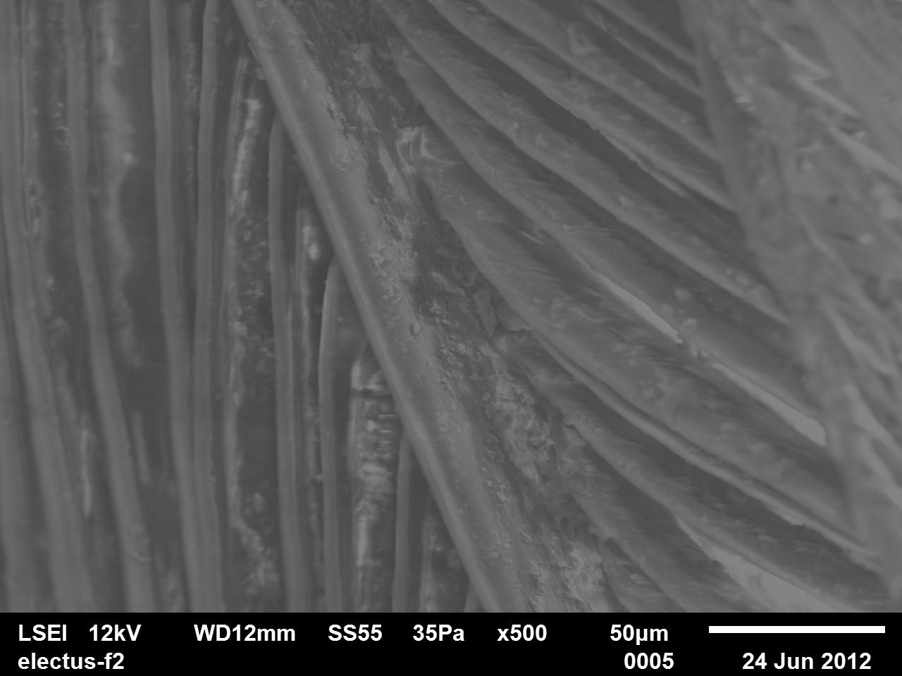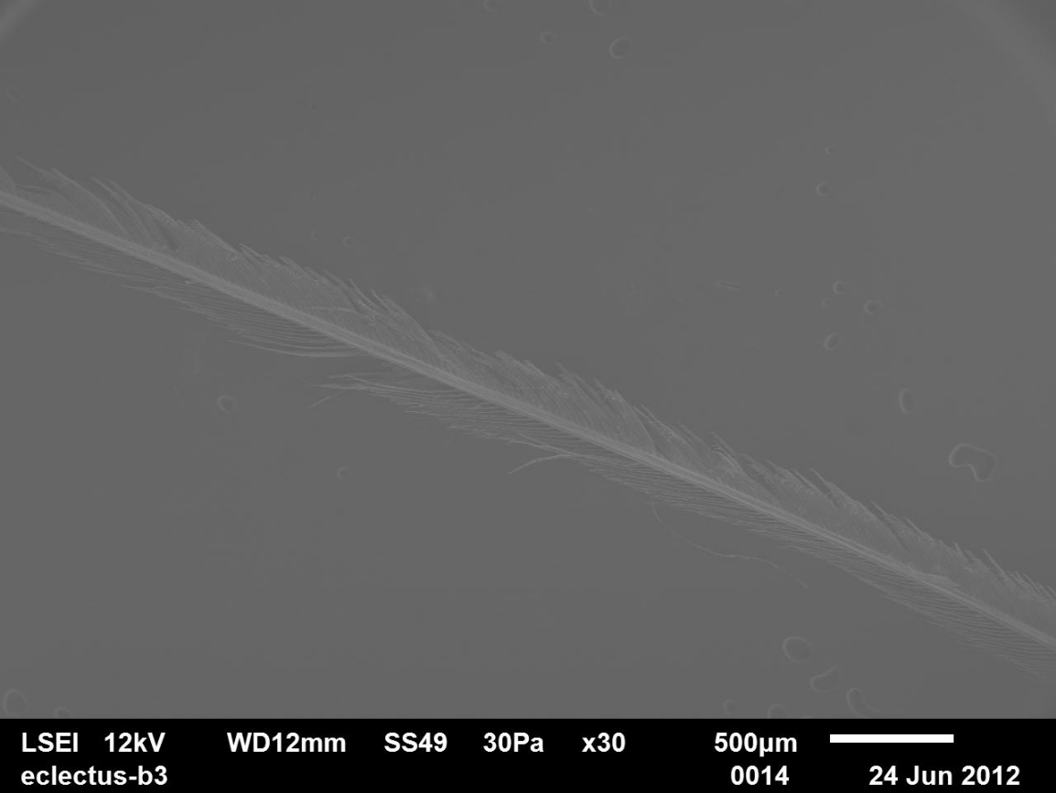
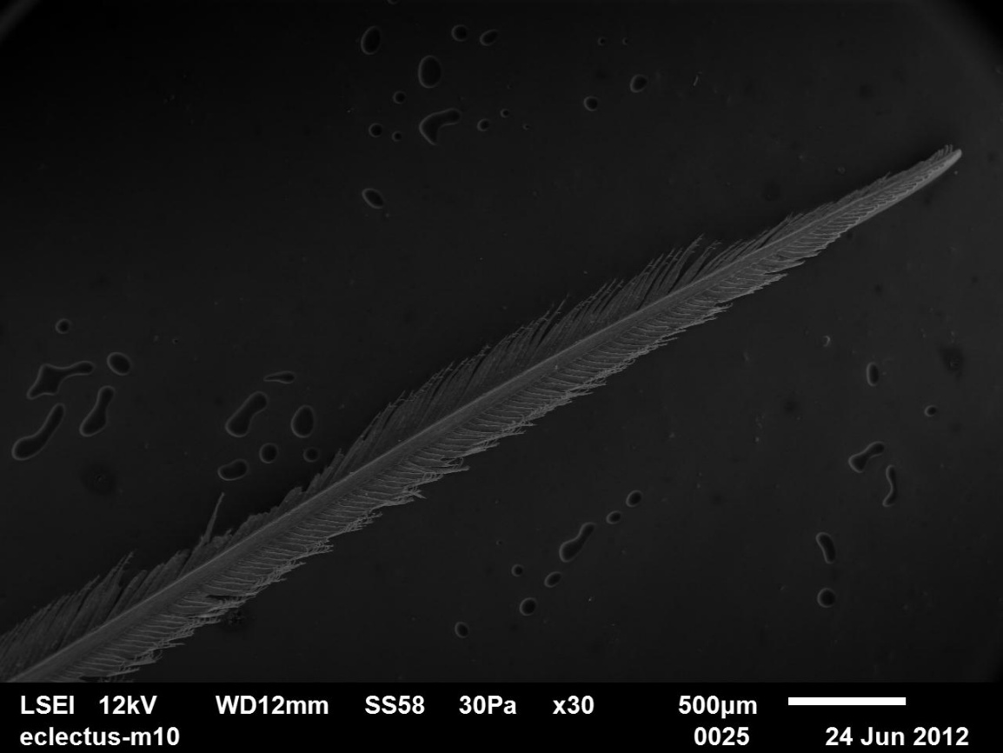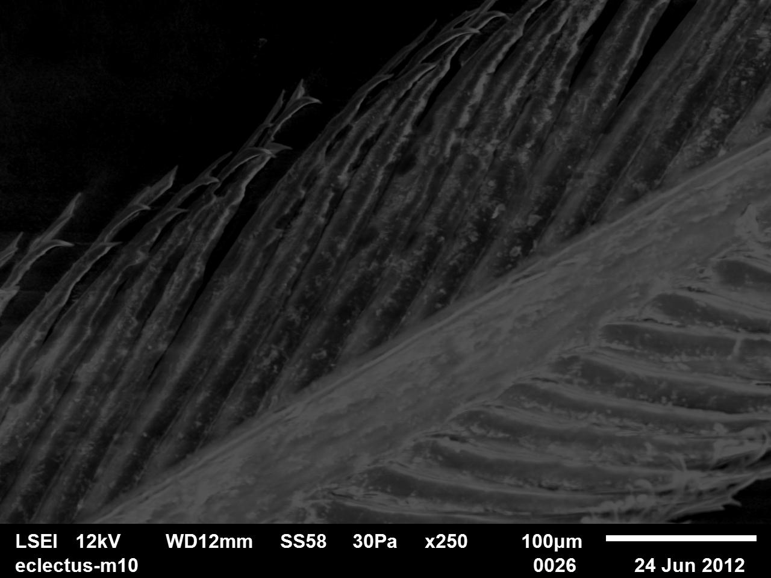
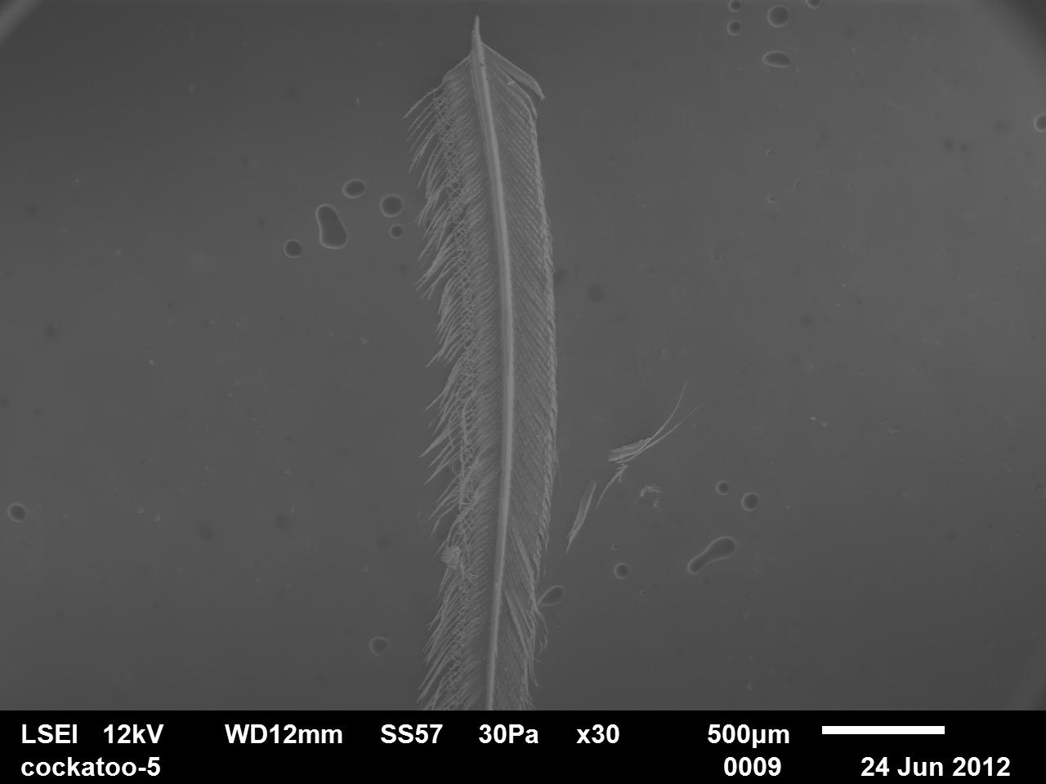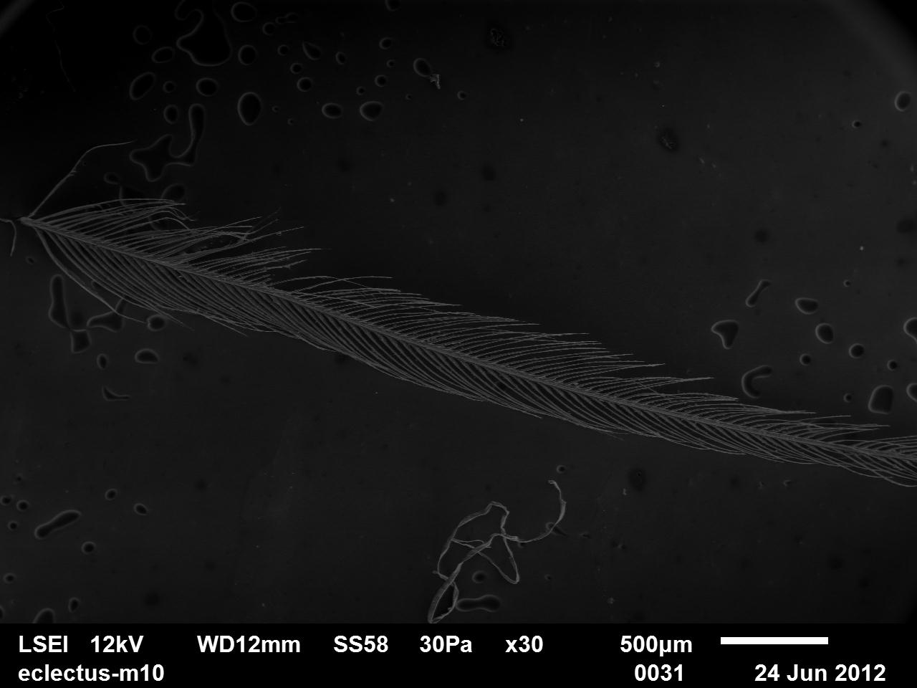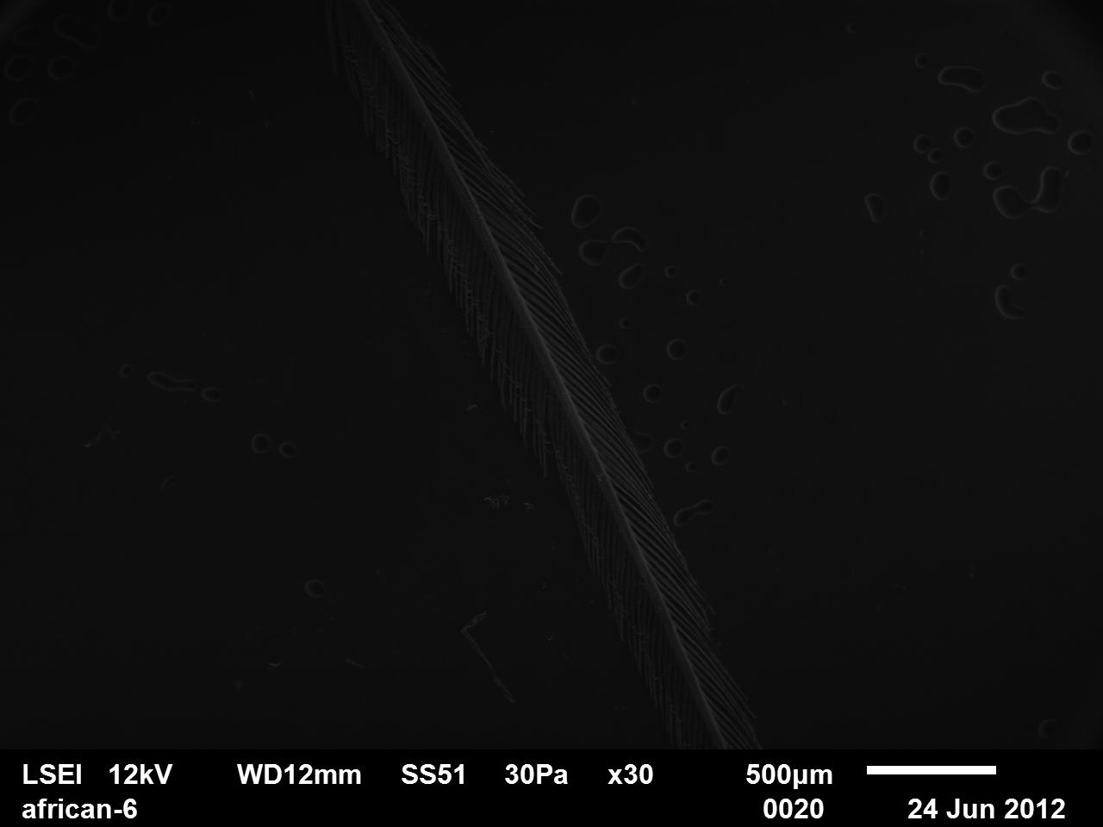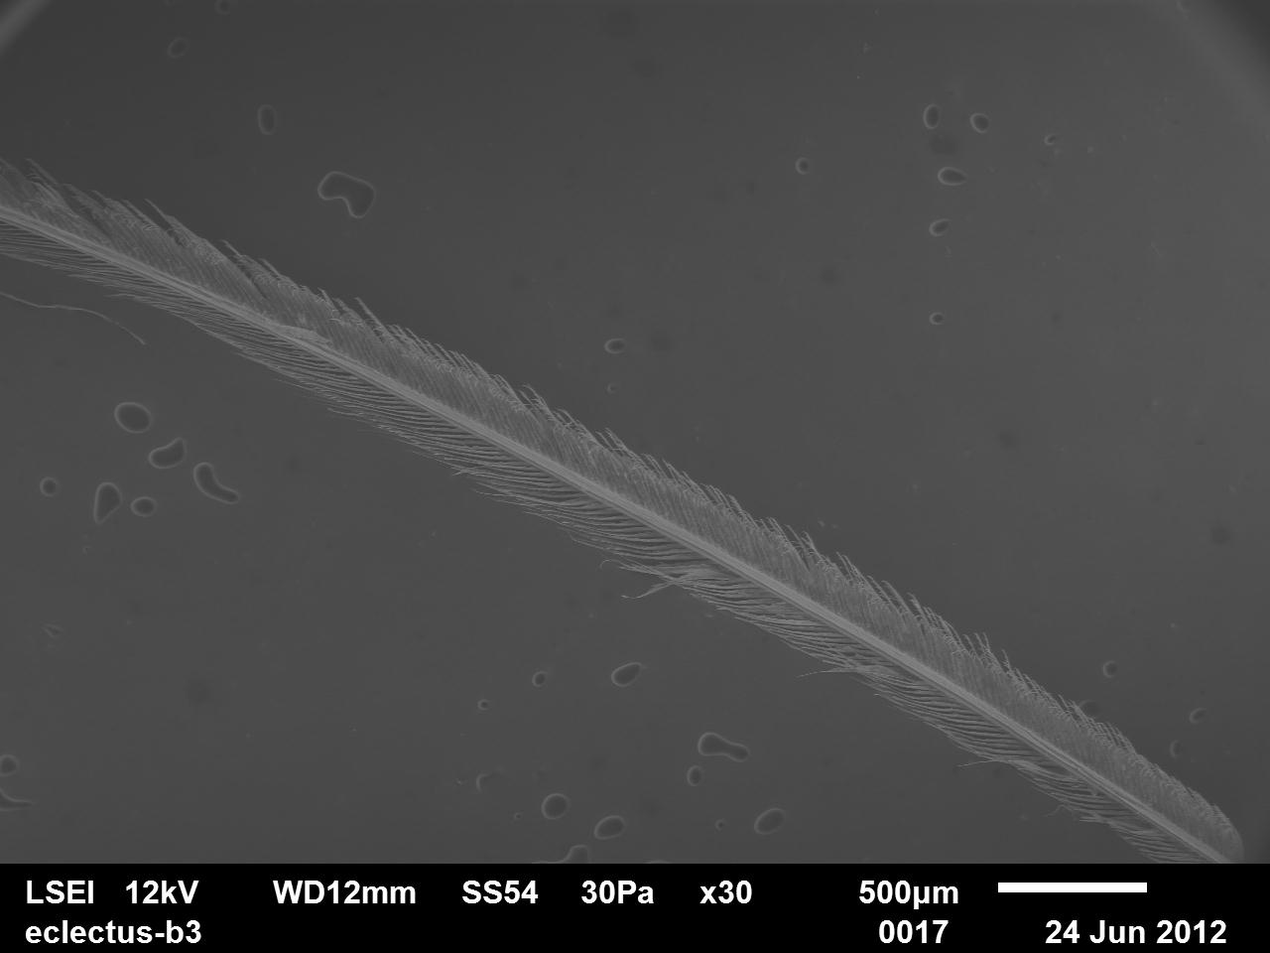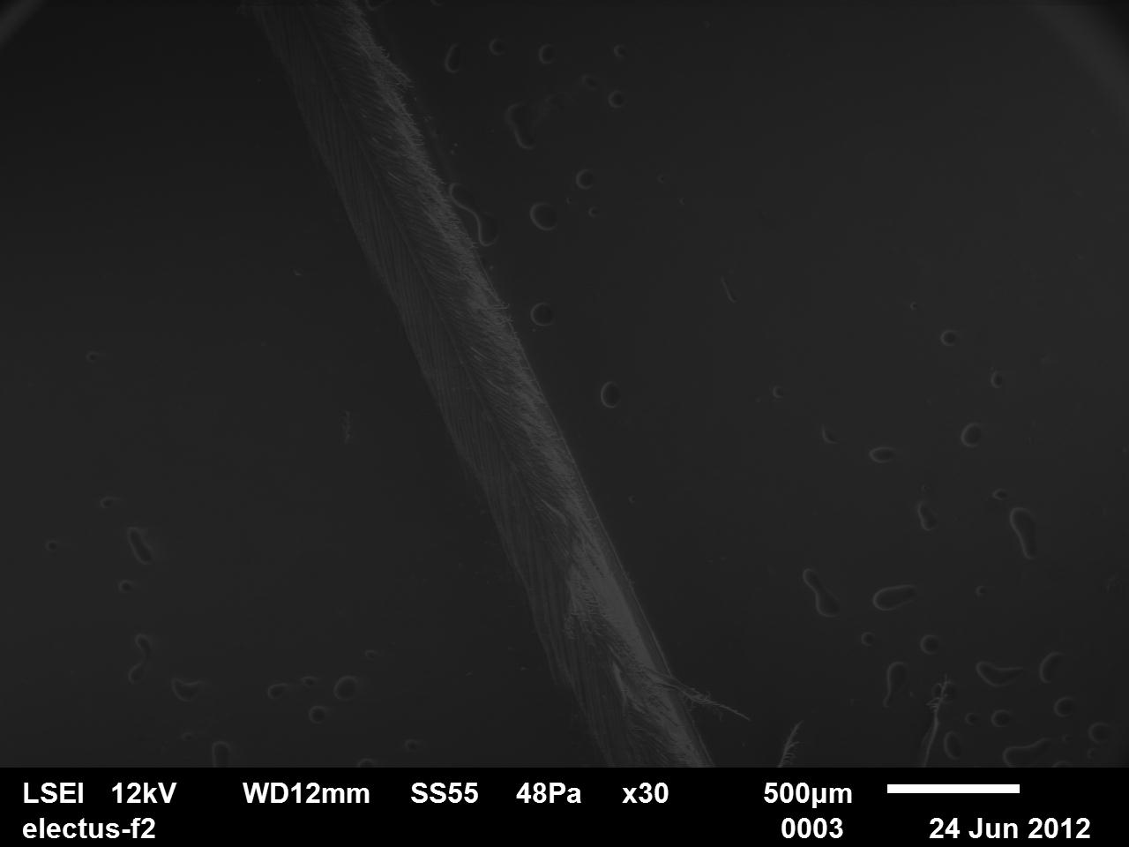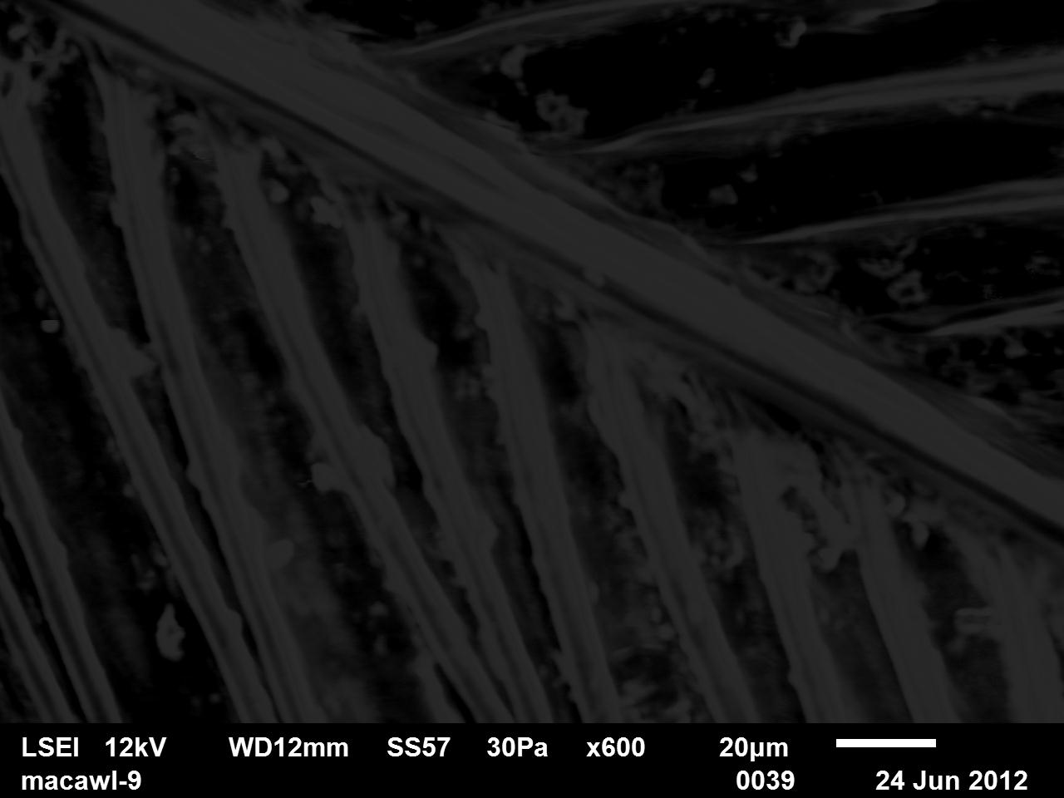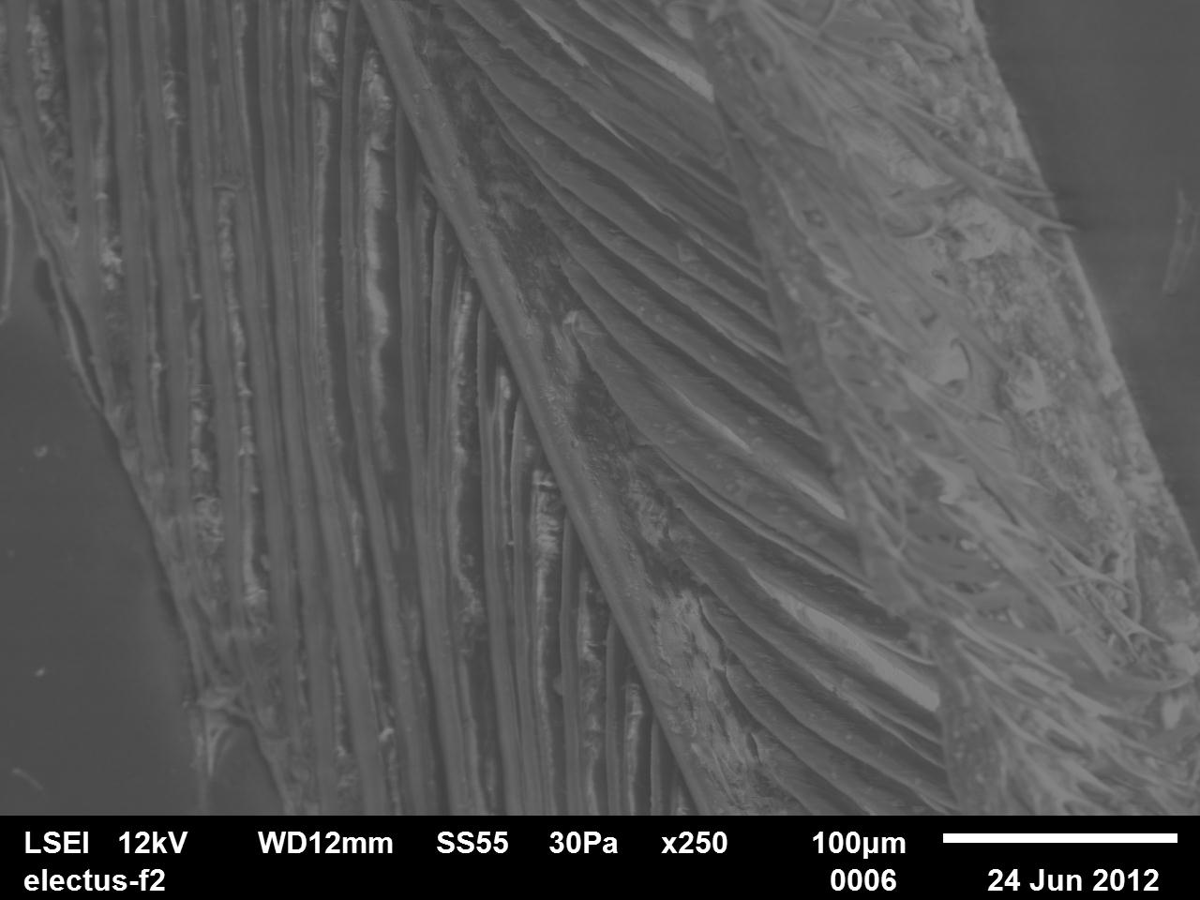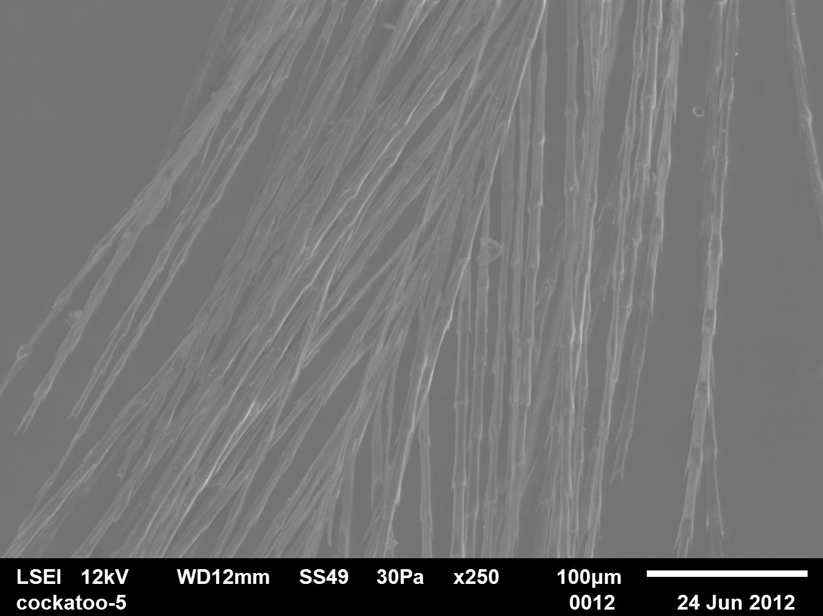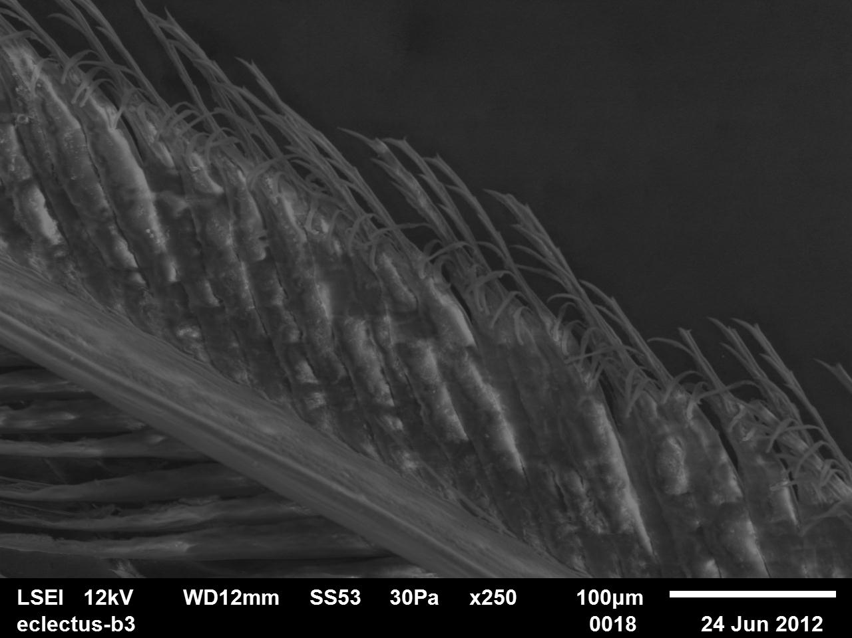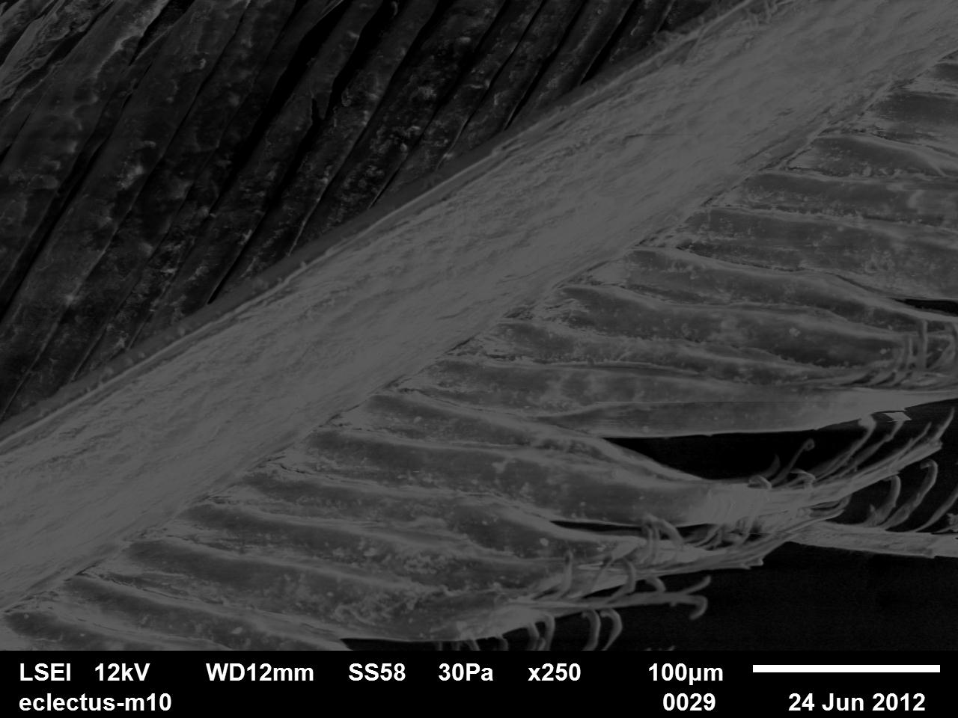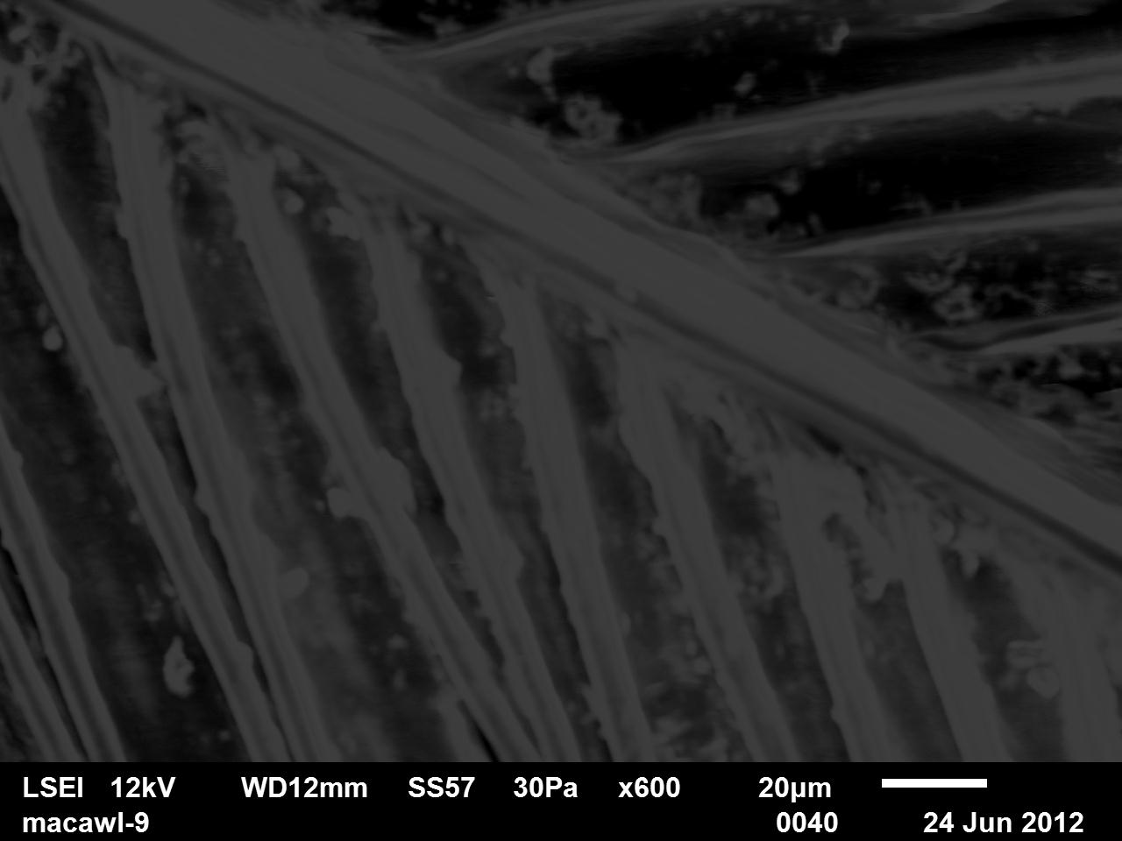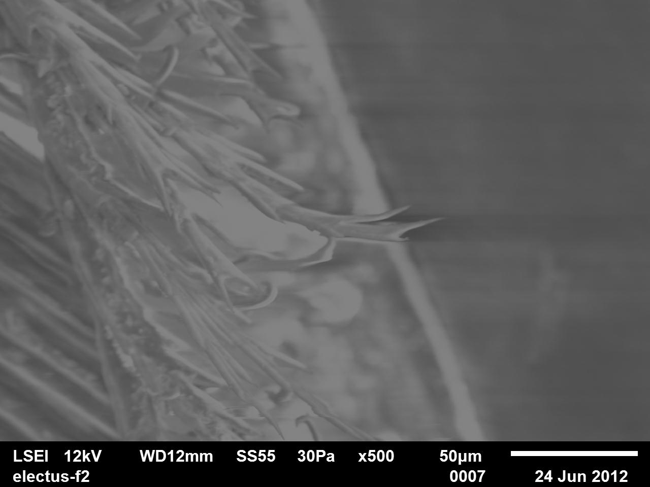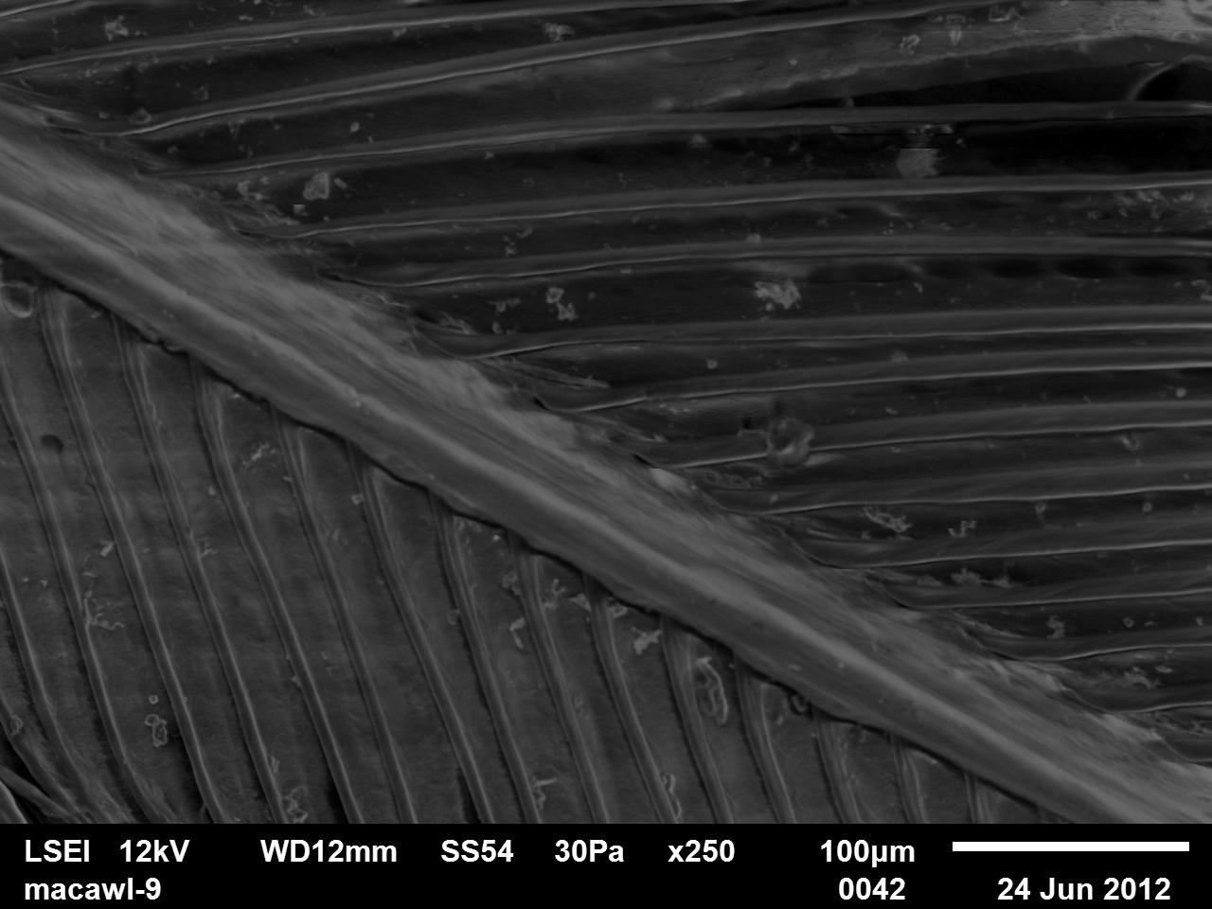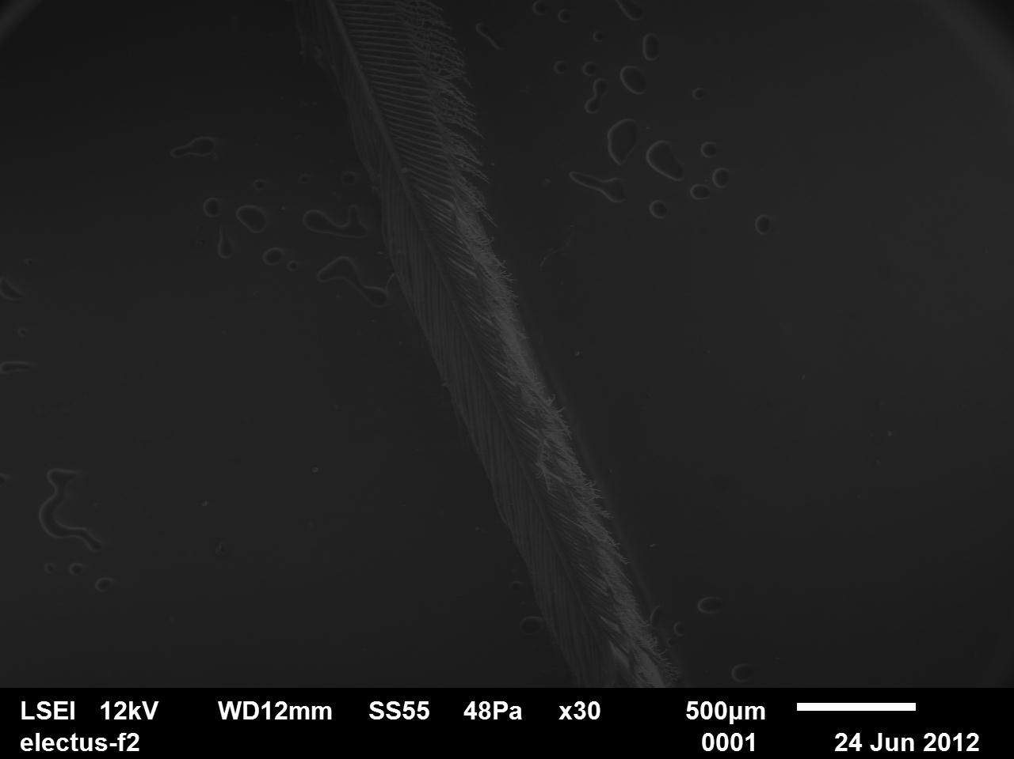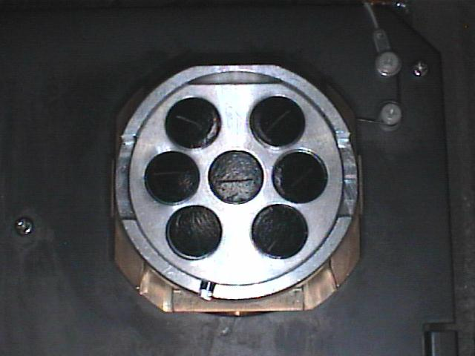

Appendix 30 Lab Notes from Laboratory
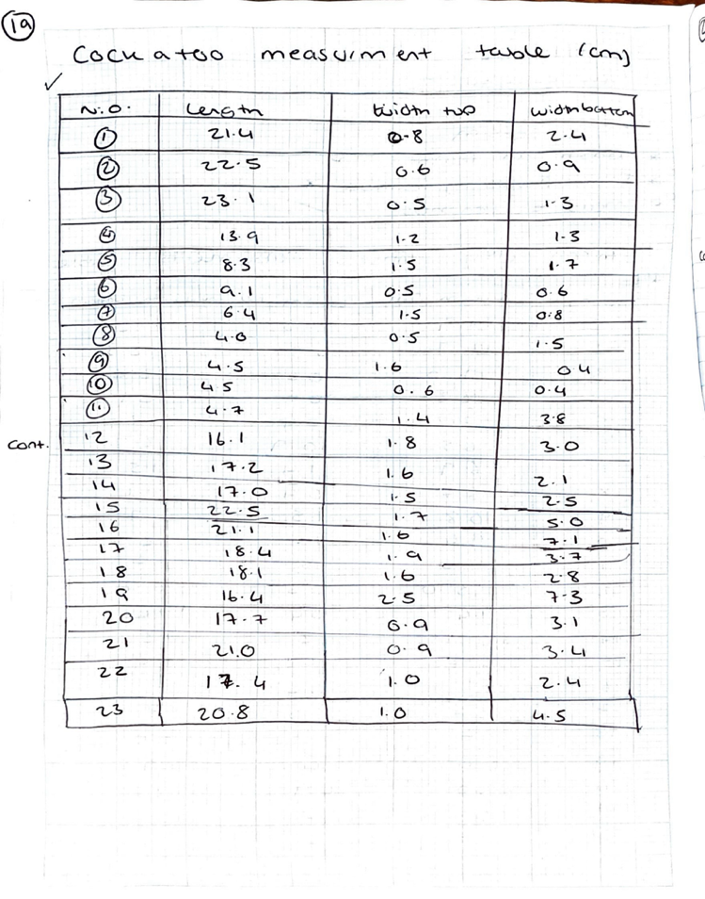
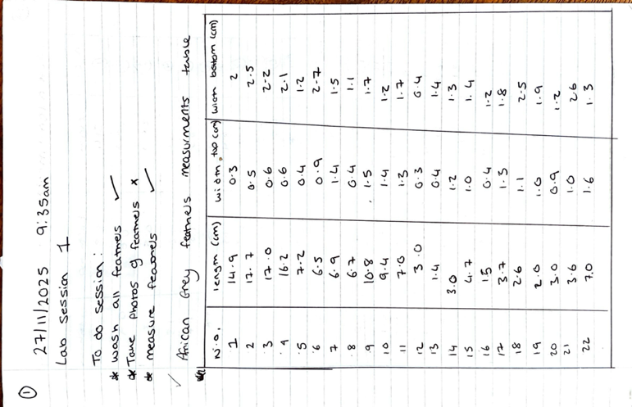
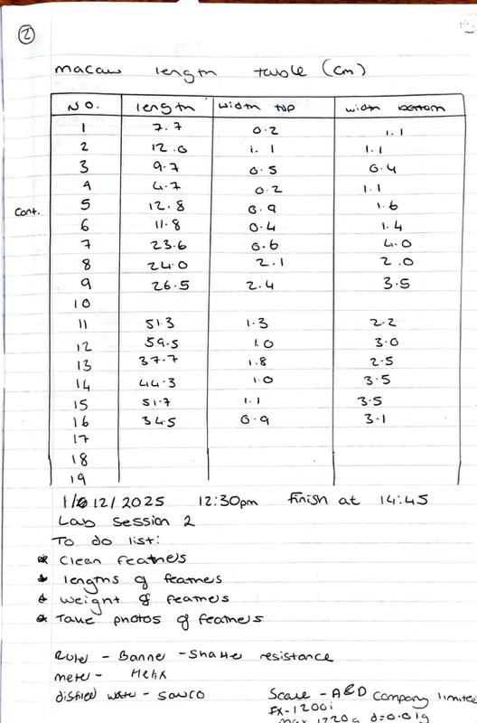
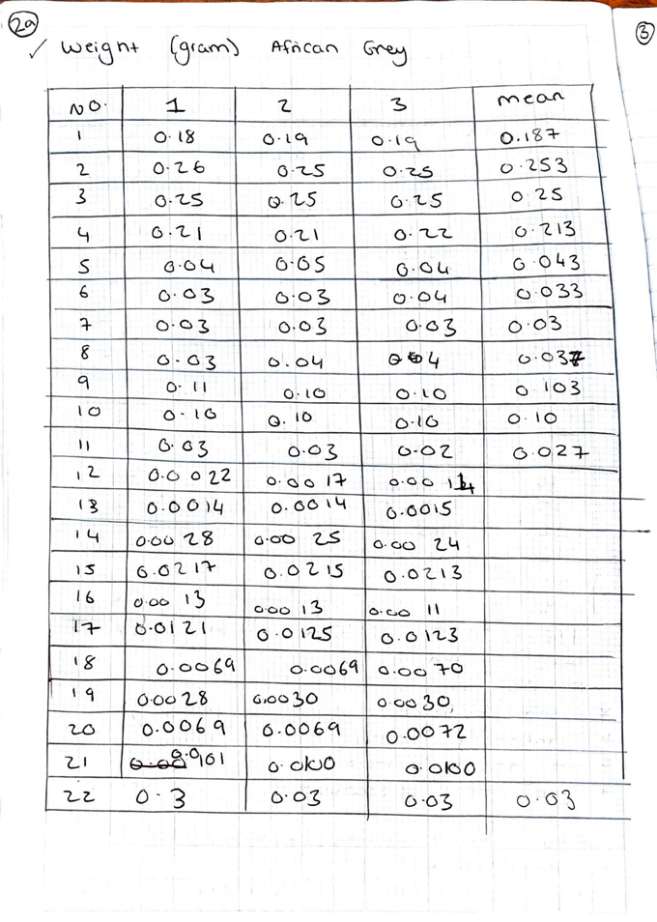
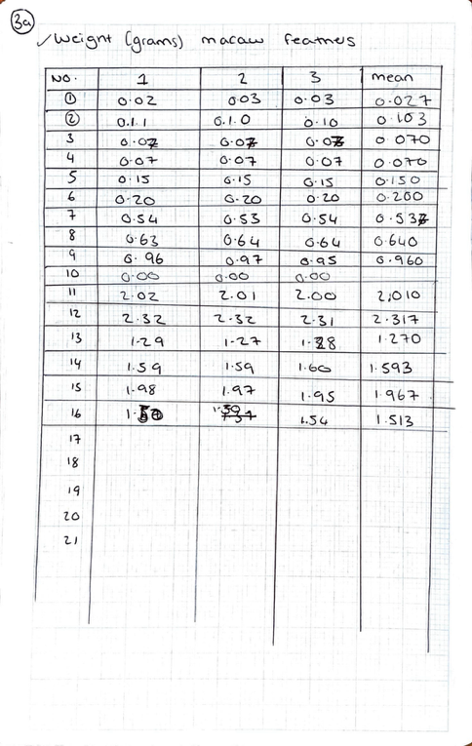
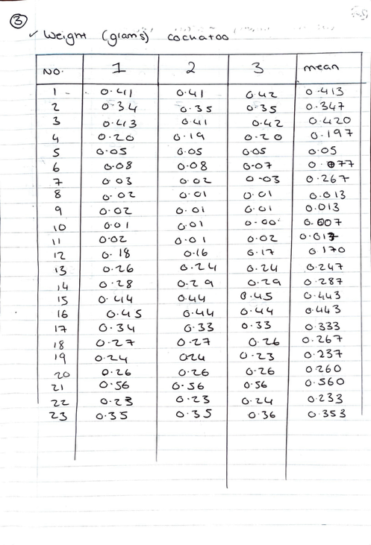

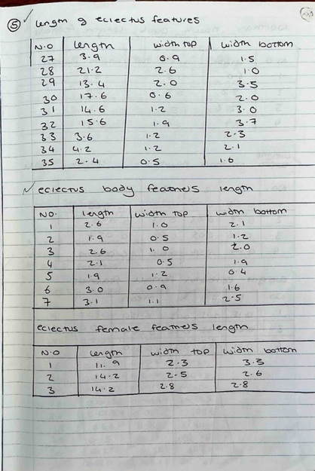
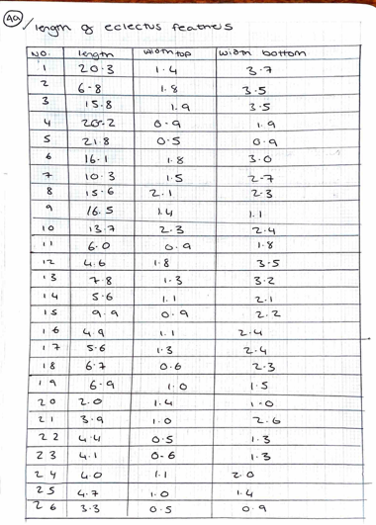
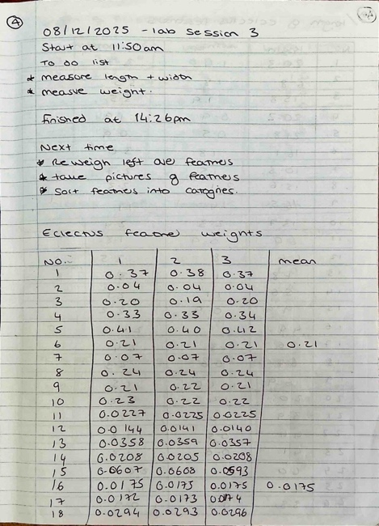
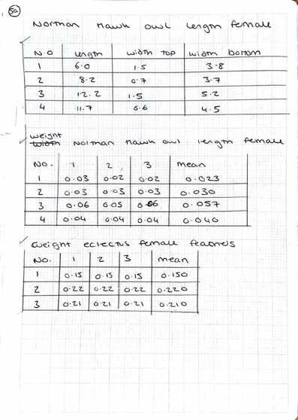
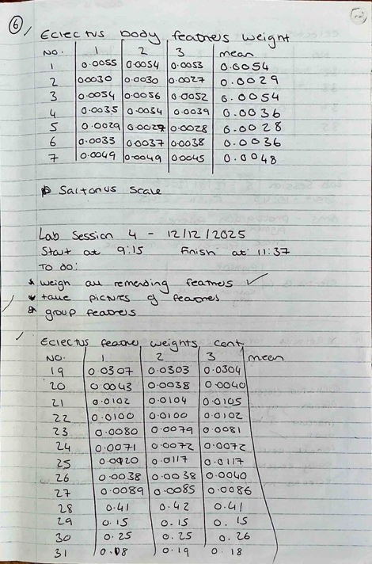
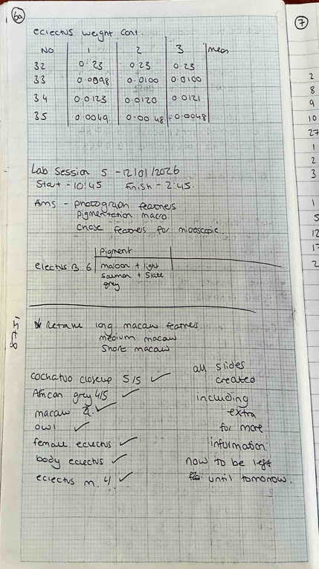

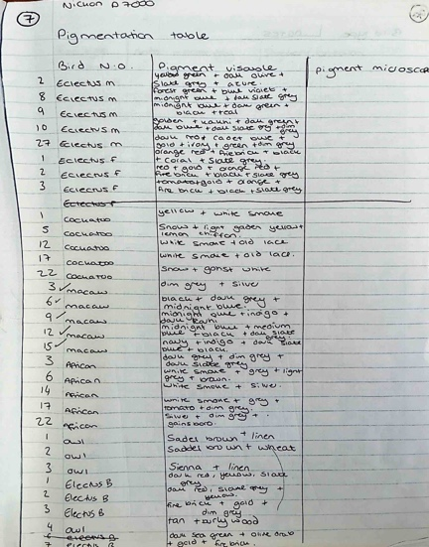
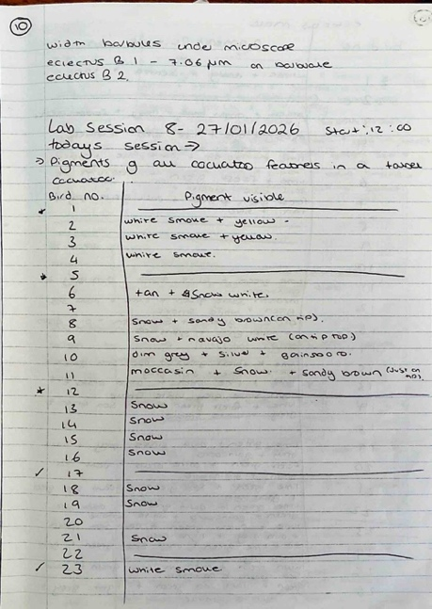

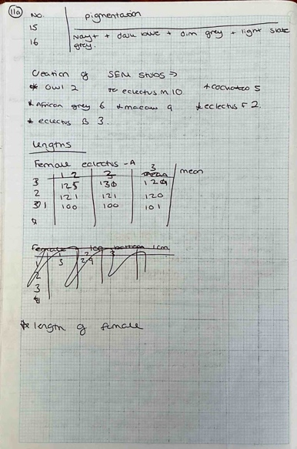
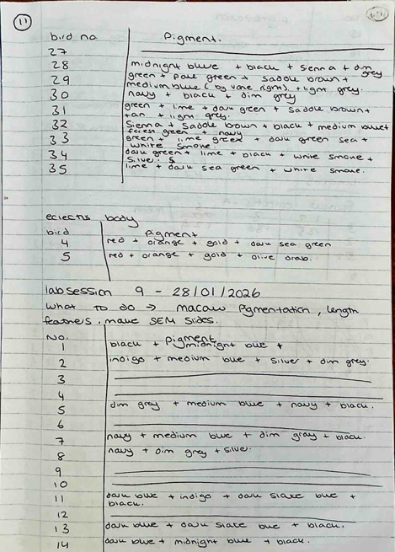
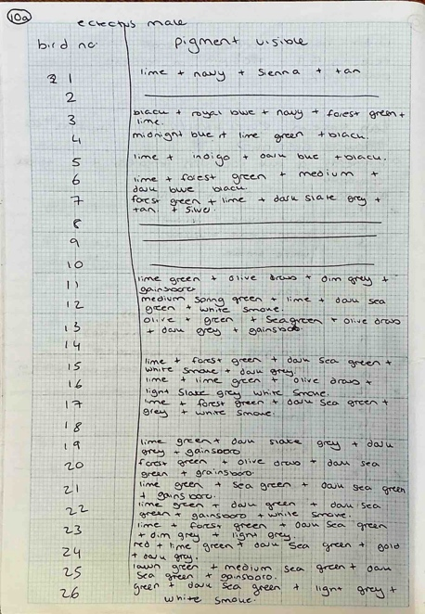
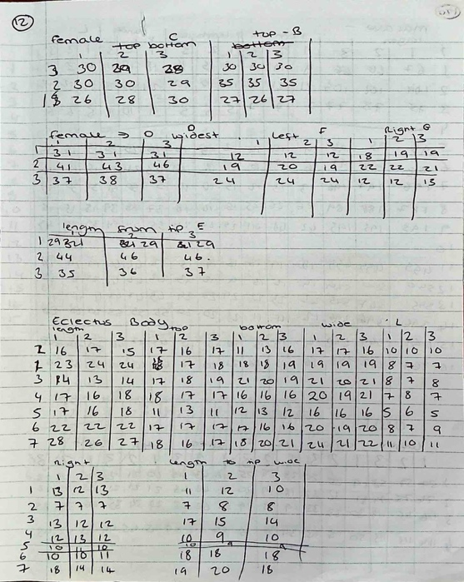

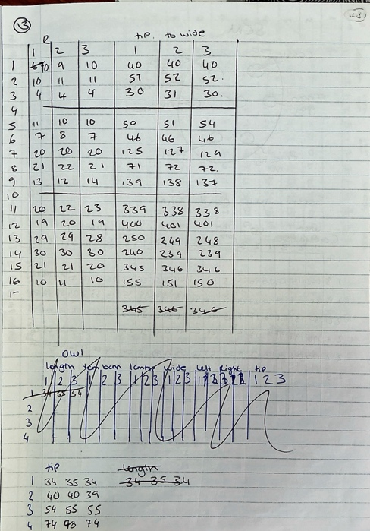
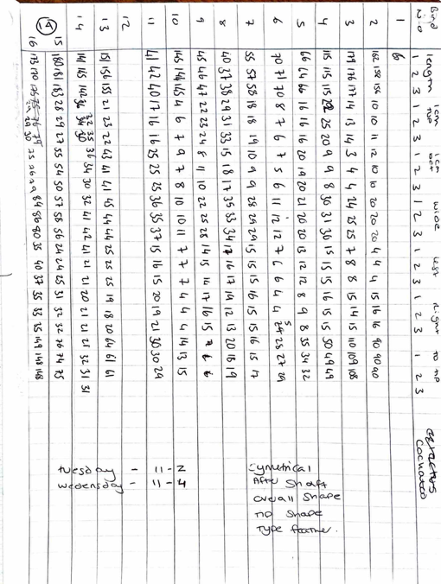

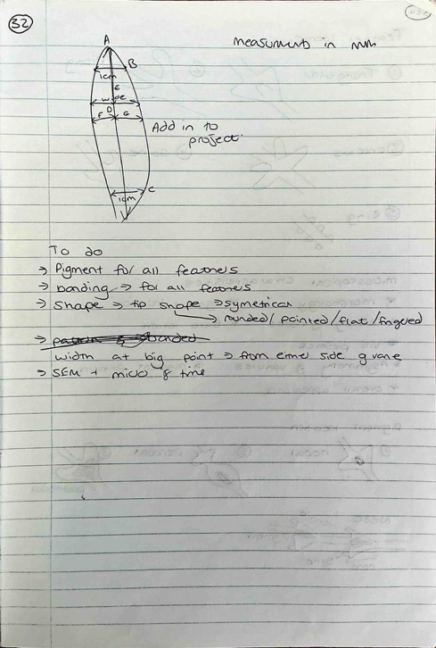
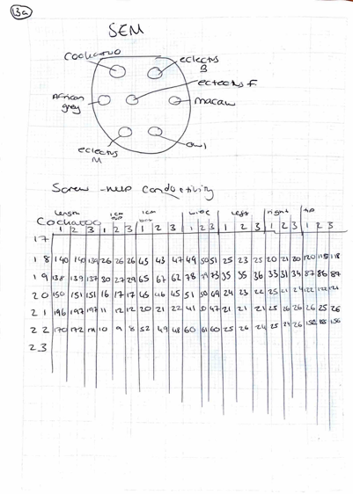
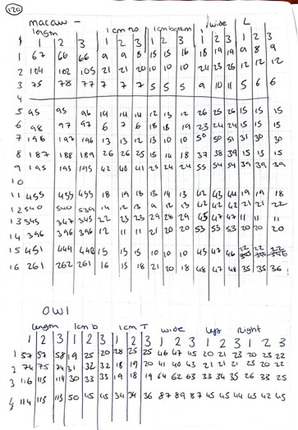

Appendix 31 Cockatoo Feathers overview
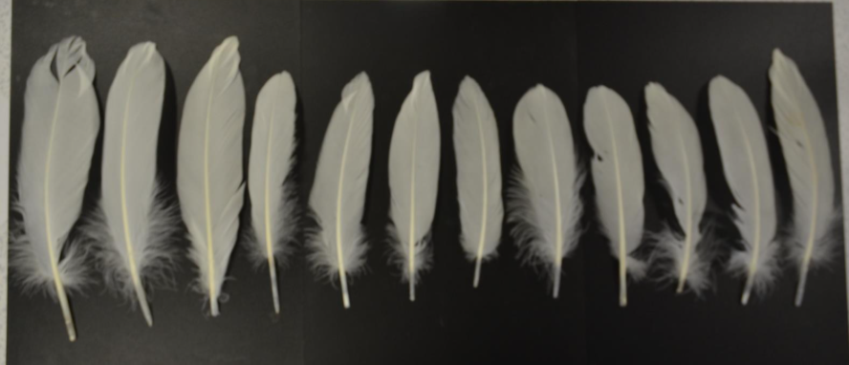
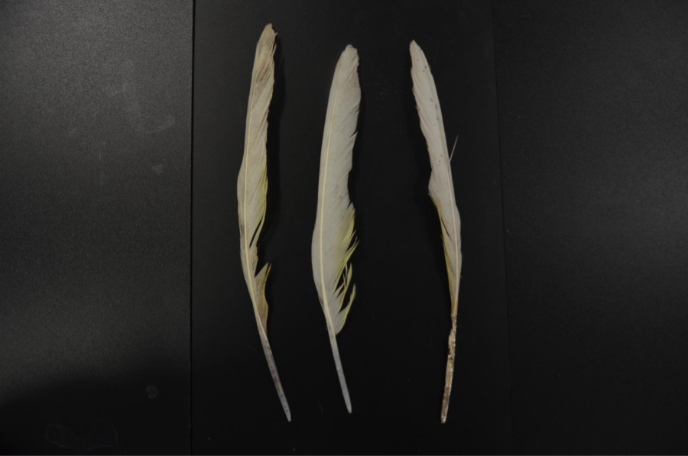
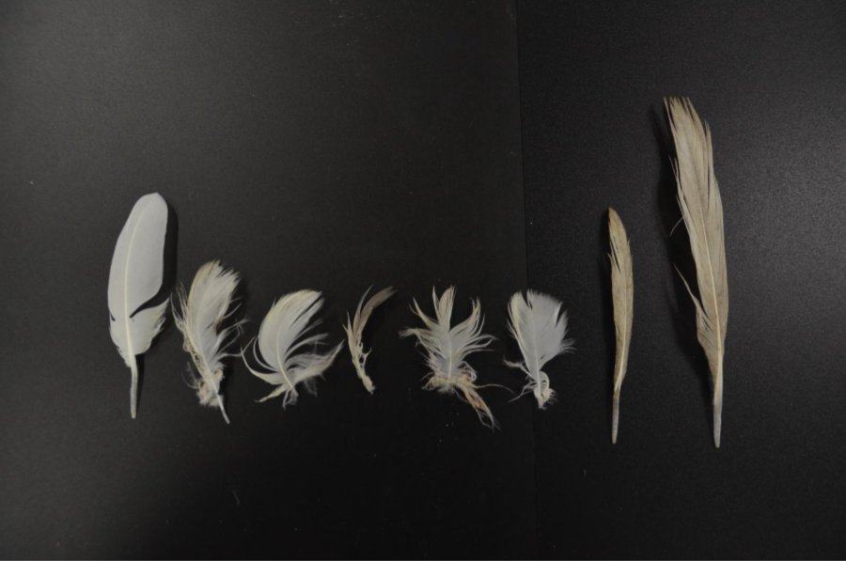
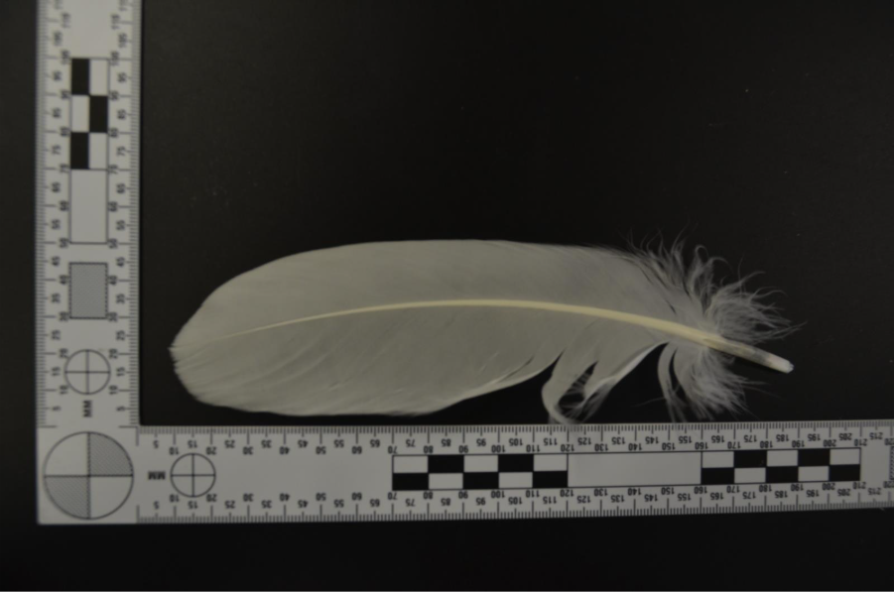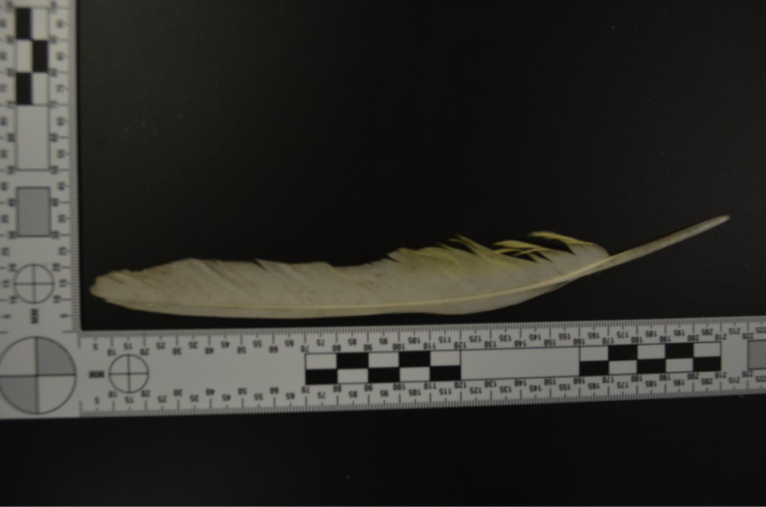

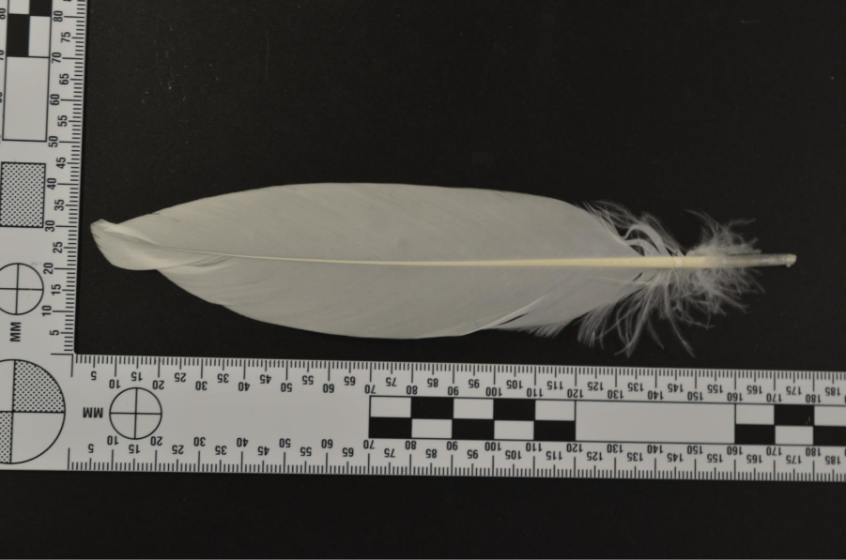
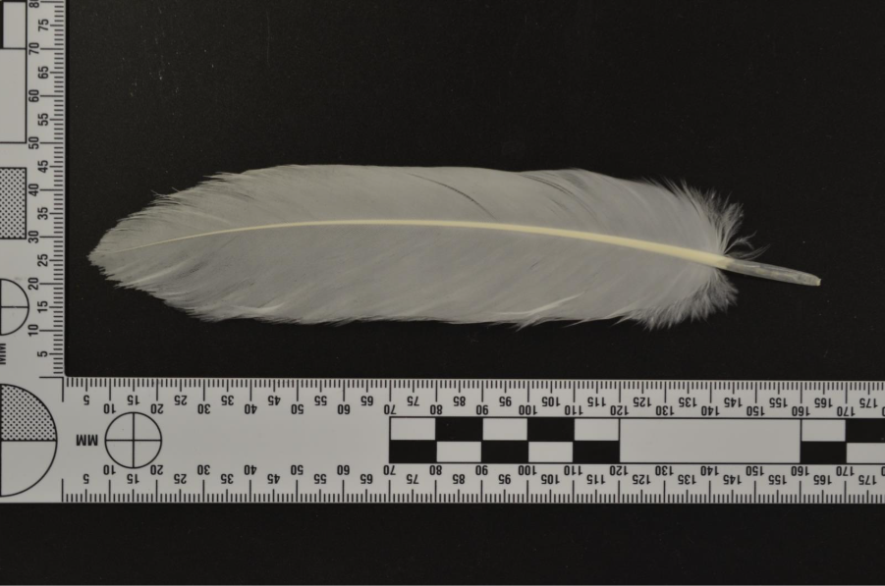

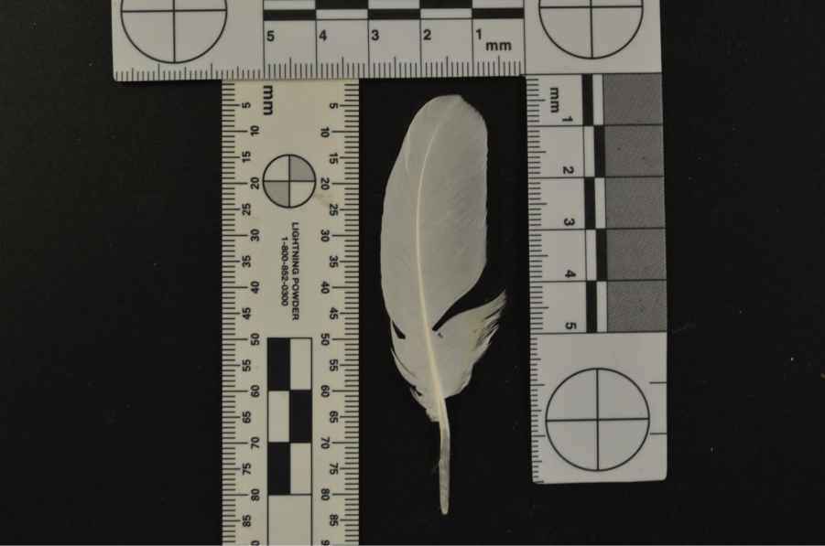

Appendix 32 macaw feathers overview
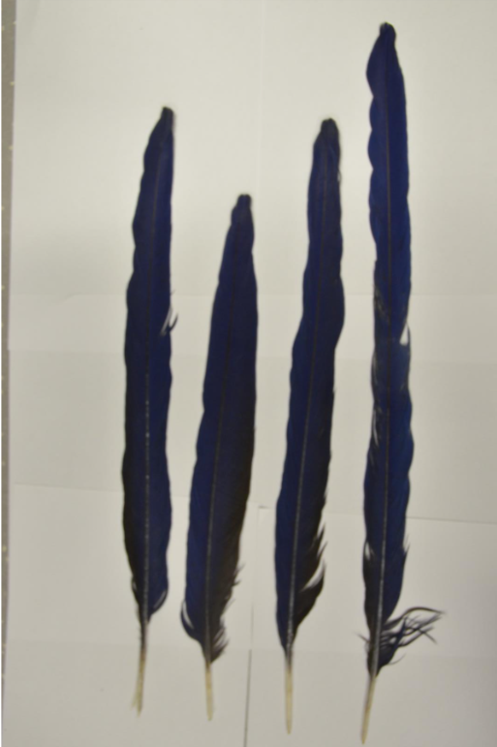
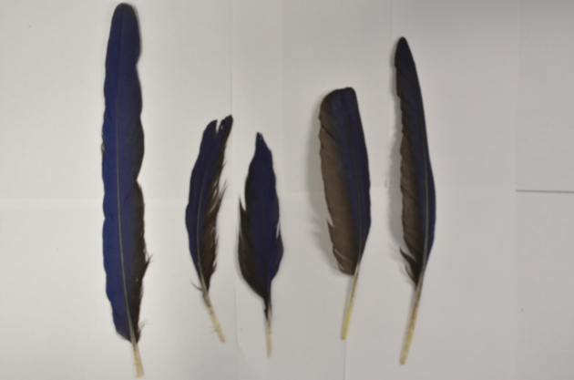
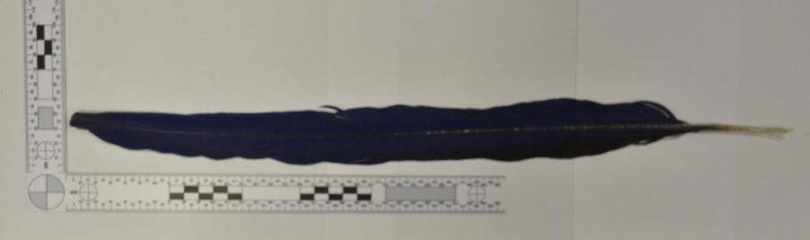
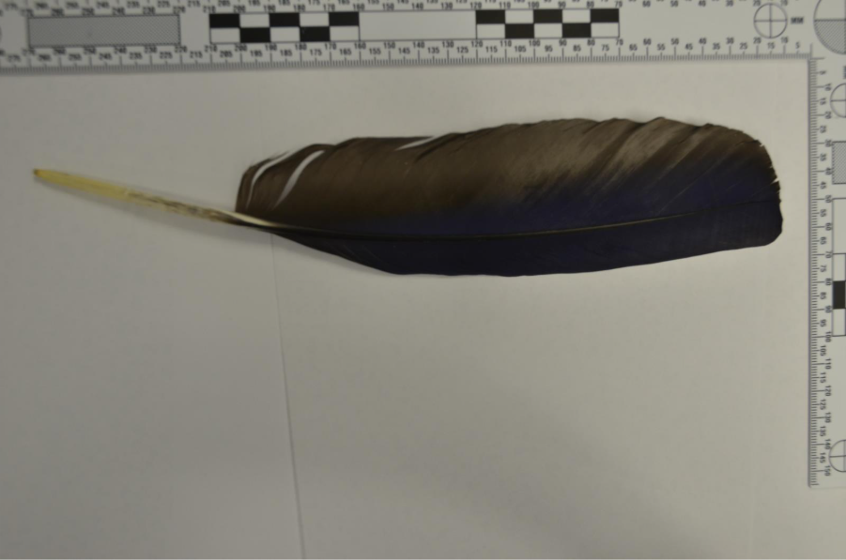
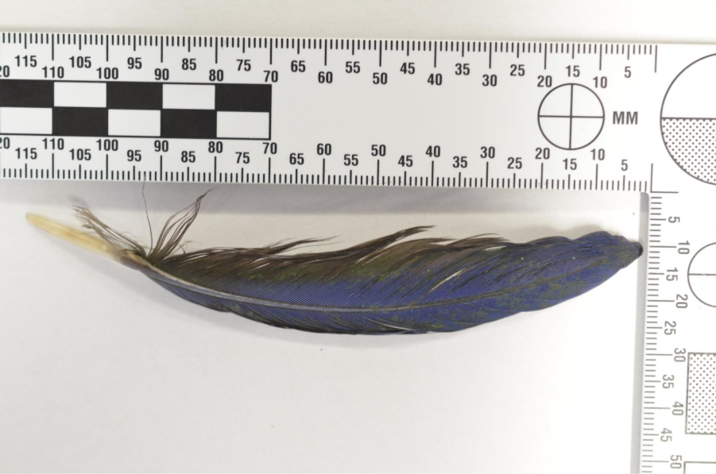

Appendix 32 Northern Hawk Owl feathers overview
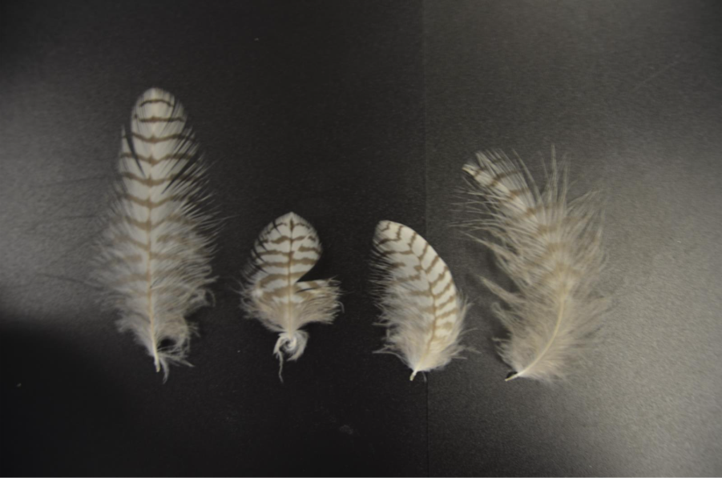
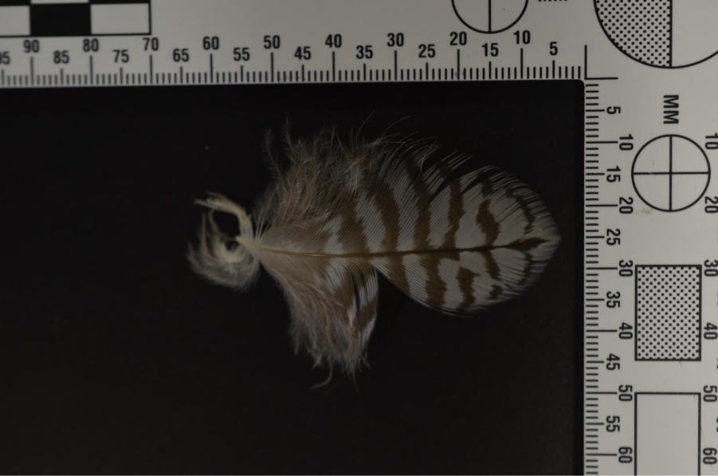
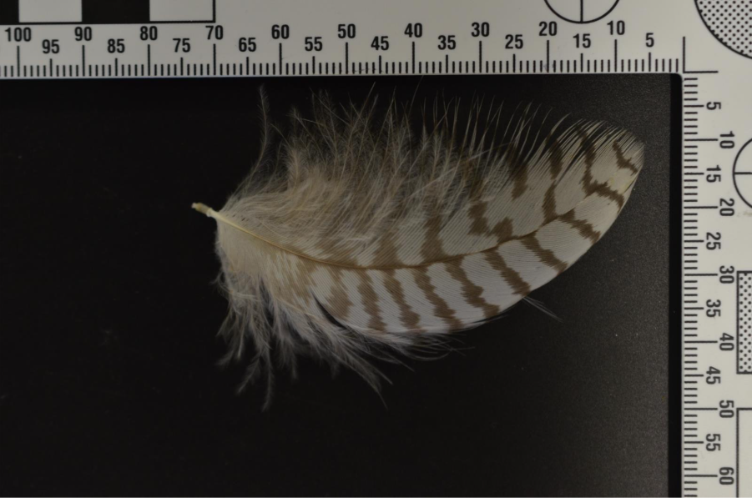

Appendix 33 Eclectus Female feathers overview

Appendix 34 Eclectus Body Feathers Overview

Appendix 35 Eclectus Male Feathers Overview

Appendix 36 African Grey Feathers Overview

References
Adam, J (2024) Calibarting a Microscope. Available at: https://microscopespot.com/calibrating-a-microscope/ (accessed: 30/12/2025).
Alger, J (2025) Male vs. Female Eclectus Parrot: Main Differences (With Pictures). Available at: https://thevetdesk.com/pet-lifestyle/birds/male-vs-female-eclectus-parrot/ (accessed: 30/11/2025).
Anderson, R (2010). Berkshire Encyclopaedia of Sustainability. Available at: https://www.oxfordreference.com/display/10.1093/acref/9780190622664.001.0001/acref-9780190622664-e-510 (accessed: 17/10/2025).
Argonne (2020). How Bird Feathers Stick Together for Superior Flight Control. Available at: https://www.aps.anl.gov/APS-Science-Highlight/2020-03-09/how-bird-feathers-stick-together-for-superior-flight-control. (accessed: 24/10/2025)
Animal Researcher (2024). How Do Owls’ Feathers Differ From Those of Other Birds? Available at: How Do Owls’ Feathers Differ From Those of Other Birds? - animalresearcher.com (accessed: 4/03/2026).

Arnould, C. et al. (2018) “Facial display and blushing: Means of visual communication in blue-and-yellow macaws (Ara Ararauna)?,” PLOS ONE, 13(8), p. e0. Available at: https://doi.org/10.1371/journal.pone.0201762.

Bachmann, T. et al. (2007) “Morphometric characterisation of wing feathers of the barn owl Tyto alba pratincola and the pigeon Columba livia,” Frontiers in zoology, 4(1). Available at: https://doi.org/10.1186/1742-9994-4-23.
Becerra, s. Marinero, J. Borghi, C, (2022). Poaching and Illegal wildlife Trade in Western Argentina. Available at: https://doi.org/10.15451/EC2022-01-11.05-1-15. (accessed: 07/11/2025).
Benson, D. (2025). Northern Hawk Owl: Companion of the Northern Winds: The Northern Natralist #15. Available at: https://northernnaturalist.substack.com/p/northern-hawk-owl-rider-of-the-northern. (Accessed; 12/04/2026).
Birdfact (2025). Temperature Regulation in Birds. Available at: https://birdfact.com/anatomy-and-physiology/circulatory-system/temperature-regulation-in-birds (accessed: 24/10/2025).
Birdlife International (2021) Tackling Illegal Killing, Taking and Trade of Birds in Sub-Saharan Africa. Available at: https://www.birdlife.org/news/2021/01/21/tackling-illegal-killing-taking-and-trade-of-birds-in-sub-saharan-africa/. (accessed: 27/10/2025).
Birdlife International (2021) Tackling the Illegal Trade and Trafficking of Birds. Available at: https://www.birdlife.org/projects/tackling-illegal-trade-inc-songbirds/. (accessed: 27/10/2025).
Bonin, J. and Homberger, D. (2012) “Possible convergent evolution of yellow psittacofulvin colors in the feathers of cockatoos (Cacatuidae) and parrots (Psittacidae),” The FASEB journal, 26(S1). Available at: https://doi.org/10.1096/fasebj.26.1_supplement.722.23.

Breed, M. Moore, J (2010). Encyclopaedia of Animal Behaviour. Available at: https://www.sciencedirect.com/referencework/9780080453378/encyclopedia-of-animal-behavior (accessed: 24/10/2025).
Cahill, A.J., Walker, J.S. and Marsden, S.J. (2006) “Recovery within a population of the Critically Endangered citron-crested cockatoo Cacatua sulphurea citrinocristata in Indonesia after 10 years of international trade control,” Oryx, 40(2), pp. 161–167. Available at: https://doi.org/10.1017/S0030605306000366.
Cavitt, J (2004). Feathers & Feather Tracts. Available at: https://faculty.weber.edu/jcavitt/Feather1.pdf. (accessed: 26/10/2025).
Carabllo, L. Delhey, K. Valcu, M. Kempenaers, B (2020). Body size and climate as predictors of plumage colouration and sexual dichromatism in parrots. Available at: https://doi.org/10.1111/jeb.13690Digital Object Identifier (DOI) (acessed: 5/03/2026)
Chen, Q. et al. (2016) “An analytical hierarchical model explaining the robustness and flaw-tolerance of the interlocking barb-barbule structure of bird feathers,” Europhysics letters, 116(2), pp. 24001–24001. Available at: https://doi.org/10.1209/0295-5075/116/24001.

Chen, C. Foley, J. Tang, P. Li, A. Jiang. Wu, P. Widelitz, R. Chuong, C. Development, Regeneration, and Evolution of Feathers. Available at: https://doi.org/10.1146/annurev-animal-022513-114127(accessed: 2017)
Chen, K. Liu, Q. Liao, G. Yang, Y. Ren, L. Yang, H. Chen, X (2012). The Sound Suppression Characteristics of Wing Feather of Owl. Available at: https://doi.org/10.1016/S1672-6529(11)60109-1. (accessed: 24/10/2024).
Coghlan, Megan Louise (2014) Development of new molecular techniques for wildlife forensic applications. (accessed: 14/11/2025).
Crandall, K. Powers, D. Tobalske, B, (2025). The Role of plumage and heat dissipate areas in thermoregulation in doves. Available at: doi: 10.1242/jeb.248200 (Accessed: 17/03/2026).
CUERVO, J.J. and MØLLER, A.P. (2009) “allometric pattern of sexually size dimorphic feather ornaments and factors affecting allometry,” Journal of evolutionary biology, 22(7), pp. 1503–1515. Available at: https://doi.org/10.1111/j.1420-9101.2009.01758.x.
Daut et, al. (2015). Illegal Domestic Bird Trade and the Tole of Export Quotas in Peru. Available at: https://doi.org/10.1016/j.jnc.2015.06.005 (accessed:10/04/2026)
David R. Eastburn (1980) Febi man wearing a white (Sulphur-crested) cockatoo-feather headdress.
McGraw, K.J. and Nogare, M.C. (2005) “Distribution of unique red feather pigments in parrots,” Biology letters (2005), 1(1), pp. 38–43. Available at: https://doi.org/10.1098/rsbl.2004.0269.
Deng, K. et al. (2023) ‘Aerodynamic vs. frictional damping in primary flight feathers of the pigeon Columba livia’, Applied physics. A, Materials science & processing, 129(2). Available at: https://doi.org/10.1007/s00339-023-06395-6.
Deng, K. Rajabi, H. Kovalev, A. Schaber, C. Dai, Z. Gorb, S (2023). The Role of Vanes in the Damping of Bird Feathers. Available at: https://doi.org/10.1007/s42235-022-00329-3 (accessed: 26/10/2025).
Deckle, S. Seewagen, C (2025) Discordancy of two common methods of measuring feather hydrophobicity. Available at: https://doi.org/10.1002/jav.03446 (accessed: 27/11/2025).
Deeming, D.C., Durkin, M. and Nudds, R.L. (2024) “Maintaining the avian wing aerofoil: Relationships between the number of primary and secondary flight feathers and under‐lying skeletal size in birds,” Journal of zoology (1987), 322(3), pp. 272–280. Available at: https://doi.org/10.1111/jzo.13139.

Dove, C. Koch, S (2010). Microscopy of feathers: A Practical Guide for Forensic Feather Identification. Available at: doi:10.1016/j.scijus.2007.08.002 (accessed: 27/10/2025)
Dove, C. Koch, S (2010). Microscopy of feathers: A Practical Guide for Forensic Feather Identification. Available at: https://www.researchgate.net/publication/289232335_Microscopy_of_feathers_A_practical_guide_for_forensic_feather_identification (accessed: 07/11/2025)
Eduardo Cesario Araújo Martínez, Rodrigo Diana Navarro and Vanair Carlos Paz (2020) “Behavior of male and female eclectus parrot (Eclectus roratus) in an artificial environment,” Acta scientiarum. Biological sciences, 42. Available at: https://doi.org/10.4025/actascibiolsci.v42i1.46431.
Espinoza, L. (2024) Species Identification of Feathers Using Proteomics. ProQuest Dissertations & Theses. Available at: https://libstaff.primo.exlibrisgroup.com/discovery/fulldisplay?vid=44STA_INST:44STA_INST&docid=cdi_proquest_journals_3116463499&lang=en&context=PC. (accessed:14/11/2025)
Featherbase (2025). Ducorps’s Cockatoo. Available at: https://www.featherbase.info/en/species/Cacatua/ducorpsii (accessed: 23/12/2026).
Featherbase (2025) Eclectus Parrot. Available at: https://www.featherbase.info/en/species/Eclectus/roratus (accessed: 23/12/2026).
Featherbase (2025). Hyacinth Macaw. Available at: https://www.featherbase.info/en/species/anodorhynchus/hyacinthinus (accessed: 23/12/2025).
Featherbase (2025) Northern Hawk-owl. Available at: https://www.featherbase.info/en/species/Surnia/ulula (accessed: 23/12/2025).
Featherbase (2025) Timneh Parrot. Available at: https://www.featherbase.info/en/species/psittacus/timneh (accessed: 23/12/2026).
Feo, T. Field, D. Prum (2015). Barb geometry of asymmetrical feathers reveals a transitional morphology in the evolution of avian flight. (accessed:26/10//2025).
Feo, T. Prum, R. (2014). Theoretical morphology and development of flight feather vane asymmetry with experimental tests in parrots. Available at: https://doi.org/10.1002/jez.b.22573?urlappend=%3Futm_source%3Dresearchgate.net%26utm_medium%3Darticle (accessed: 19/10/2026).
Foth, C. Tischlinger, H. Rauhut, O (2014). New specimen of Archaeopteryx provides insights into the evolution of pennaceous feathers. Available at: https://doi.org/10.1038/nature13467. (accessed:14/11/2025).
GALVAN, I. and SOLANO, F., 2016. Bird Integumentary Melanins: Biosynthesis, Forms, Function and Evolution. International Journal of Molecular Sciences, 17(4), pp. 520. Available at: DOI:10.3390/ijms17040520 (accessed: 30/11/2025).

Galvan, I. Gomez-Vicioso, (2025). Pigment contribution to feather mass depends on melanin form and is restricted to approximately 25. Available at: 10.1098/rsbl.2025.0299. (Accessed at: 3/04/2026)

Gouda, S. Kerry, R. Das, A. Chauhan, N (2020). Wildlife forensics: A boon for species identification and conservation implications. Available at: https://doi.org/10.1016/j.forsciint.2020.110530. (accessed: 17/10/2025).
Griffith, A (1970). Micromorphology of Feathers using the Scanning Electron Microscope. Available at: https://doi.org/10.1016/S0015-7368(70)70591-4 (accessed: 10/04/2026)
Hazzah, L. et al. (2017) “From Attitudes to Actions: Predictors of Lion Killing by Maasai Warriors,” PloS one, 12(1). Available at: https://doi.org/10.1371/journal.pone.0170796.
Heinsohn, R (2008). Ecology and Evolution of the Enigmatic Eclectus Parrot (Eclectus Roratus) Available at: 10.1647/2007-031.1 (accessed: 2/03/2026).

Hendrickx-Rodriguez, S. Lentink, D (2025). The Feathers Mulit-Functional Structure Across Nano to Macro Scales Inspires Hierarchical Design. Available at: https://doi.org/10.1098/rsif.2024.0776. (accessed: 24/10/2025).
Igic, B., D’Alba, L. and Shawkey, M.D. (2016) “Manakins can produce iridescent and bright feather colours without melanosomes,” Journal of experimental biology, 219(12), pp. 1851–1859. Available at: https://doi.org/10.1242/jeb.137182.
Jaycox, J. (2021) Macaws. Raintree Publishers.
Jenni, L. et al. (2020) “Determinants and constraints of feather growth,” PloS one, 15(4). Available at: https://doi.org/10.1371/journal.pone.0231925.
John, K (2010). Anatomy: Parts of a Feather. Available at: https://www.birdsoutsidemywindow.org/2010/07/02/anatomy-parts-of-a-feather/. (accessed: 26/10/2025).
Kashib, P (2021). How to Draw a Feather. Aviable at: https://drawingwithpri.art/blogs/blog/how-to-draw-a-feather. (accessed: 26/10/2025).
Kashyap, D. et al. (2024) ‘A Comparative Microscopic and Micrometric Analysis of Birds of Different Feather Types for Identification of Species’, Journal of international wildlife law and policy, 27(3), pp. 235–246. Available at: https://doi.org/10.1080/13880292.2024.2440189.
Kashyap, D. et al. (2024) ‘A Comparative Microscopic and Micrometric Analysis of Birds of Different Feather Types for Identification of Species’, Journal of international wildlife law and policy, 27(3), pp. 235–246. Available at: https://doi.org/10.1080/13880292.2024.2440189.
KIEFTENBELD, W.H.H.M. (2010) ‘Use of an improved mounting medium for microscope slides’.
Kingsgate (2023). Unveiling the Beauty: Exploring the Feathers of the African Grey Parrot. Available at: https://mykingsgate.co.za/info/african-gray-feathers-43445/(acessed: 09/02/2026).
Klem, J. Bouwman, H. Rijke, A (2018). Do the contour feathers of Cisticolae exhibit adaptations toannual rainfall in their habitats? Available at: DOI: 10.1111/aje.12535Afr J Ecol. 2019;57:41–50. wileyonlinelibrary.com/journal/aje © 2018 John Wiley & Sons Ltd | 41 (accessed: 27/11/2025).
Laerd Statistics (2018). Testing for Normality using SPSS Statistics. Available at: Testing for Normality using SPSS Statistics when you have only one independent variable. (accessed: 3/04.2026).
Lawler, K. What is the Structure and Function of Birds Feathers. Available at: https://www.birdful.org/what-is-the-structure-and-function-of-birds-feathers/ (accessed: 16/01/2026).
Lemieux, A. (2014) Situational Prevention of Poaching. 1st ed. Edited by A.M. Lemieux. London: Routledge. Available at: https://doi.org/10.4324/9780203094525.
Lillywhite, M (2025). Thousands of Rare Bird Eggs Seized by Police. Available at: https://www.countryfile.com/news/wild-bird-eggs-seized. (accessed: 08/11/2025).
Linacre, A.M.T. and Tobe, S.S. (2013) Wildlife DNA Analysis: Applications in Forensic Science. Wiley-Blackwell. Available at: https://libstaff.primo.exlibrisgroup.com/permalink/44STA_INST/1i7m56q/cdi_murdoch_eprints_oai_researchrepository_murdoch_edu_au_45165 (accessed:15/11/2025).
Linacre, A. and Tobe, S.S. (2013) Wildlife DNA analysis : applications in forensic science / Adrian M.T. Linacre and Shanan S. Tobe. Available at: https://libstaff.primo.exlibrisgroup.com/permalink/44STA_INST/7gb1bm/cdi_proquest_miscellaneous_1999764381 (accessed: 15/11/2025)
LI, D., ZHANG, S., TIAN, R., ZHAO, Y. and YI, G., 2025. Differences between Scaly-sided Merganser (Mergus squamatus) and Common Merganser (M. merganser) feather microstructure. Cold Spring Harbor: (accessed: 30/11/2025).
Li, A. Figueroa, S. jiang, T. Wu, P. Widelitz, R. Nie, Q. Chuong, C (2017). Diverse feather shape evolution enabled by coupling anisotropic signalling modules with self-organizing branching programme. Available at: https://pmc.ncbi.nlm.nih.gov/articles/PMC5263876/. (Accessed: 16/01/2026)
Liang, Z. et al. (2024) “Nationwide law enforcement impact on the pet bird trade in China,” Proceedings of the National Academy of Sciences - PNAS, 121(25). Available at: https://doi.org/10.1073/pnas.2321479121.
Lingham-Soliar, T. (2017) “Microstructural tissue-engineering in the rachis and barbs of bird feathers,” Scientific reports, 7(1). Available at: https://doi.org/10.1038/srep45162.

Lingham-Soliar, T. and Murugan, N. (2013) “A New Helical Crossed-Fibre Structure of β-Keratin in Flight Feathers and Its Biomechanical Implications,” PloS one, 8(6). Available at: https://doi.org/10.1371/journal.pone.0065849.

Liu, L.G. and Clark, C.J. (2025) ‘Acoustics of rubbing feathers: the velvet of owl feathers reduces frictional noise’, Journal of experimental biology, 228(2). Available at: https://doi.org/10.1242/jeb.246234.
Liu, L.G. and Clark, C.J. (2025) ‘Acoustics of rubbing feathers: the velvet of owl feathers reduces frictional noise’, Journal of experimental biology, 228(2). Available at: https://doi.org/10.1242/jeb.246234. (accessed: 30/11/2025).
Lopatka, A. (2020) ‘Barbs of a feather lock together’, Physics today, 73(4), pp. 20–21. Available at: https://doi.org/10.1063/PT.3.4449.
López, F.G. et al. (2025) “The illegal trade of wild birds in a social network: A call for action from Argentina,” Ornithological Applications, 127(2). Available at: https://doi.org/10.1093/ornithapp/duaf012.
Maje, A (2019). Animal evidence and its uses in forensic science. Available at: https://forensicfield.blog/animal-evidence-and-its-uses-in-forensic-science/. (accessed: 17/10/2025).
Marshall, E. Samuels, P (2017). Kruskal-Wallis Test in SPSS (Non-parametric equivalent to ANOVA). Available at Kruskal-Wallis in SPSS - The University of Sheffield (accessed 3/04/2026).
Matthews, C (2025). Police seize 6,000 Illegal Wild Bird Eggs From Attics and Offices in UK’s Largest-ever Raid. Available at: https://www.countryfile.com/news/wild-bird-eggs-seized. (accessed: 08/11/2025.
Matloff, L.Y. et al. (2020) ‘How flight feathers stick together to form a continuous morphing wing’, Science (American Association for the Advancement of Science), 367(6475), pp. 293–297. Available at: https://doi.org/10.1126/science.aaz3358.
McGraw, K.J. and Nogare, M.C. (2004) “Carotenoid pigments and the selectivity of psittacofulvin-based coloration systems in parrots,” Comparative Biochemistry and Physiology Part B: Biochemistry and Molecular Biology, 138B(3), pp. 229–233. Available at: https://doi.org/10.1016/S1096-4959(04)00102-2.

Minias, P. Barczyk, J. Davaasuren, B. Erdenechimeg, T. Remisiewicz, M (2024). Functional evolution of facial bristle feathers in Old World passerines. Available at: https://doi.org/10.1093/zoolinnean/zlae111. (accessed: 14/11/2025).
Anders Pape Muller (2015) “The allometry of number of feathers in birds changes seasonally,” Avian research, 6(1). Available at: https://doi.org/10.1186/s40657-015-0012-3.
Murphy, D (2025). How to Align and Calibrate Your Microscope Properly. Available at: https://microscopereviewslab.com/microscope/how-to-calibrate-microscope/ (accessed: 30/12/2025)
Muzio, F. Rubega, M (2024). What do we really know about the water repellencey of feathers? Available at: https://doi-org.ezproxy.staffs.ac.uk/10.1111/jav.03259. (accessed: 14/11/2025)
Natali, L. Troiano, C. Zoja, S. Lavorgna, A (2025). Countering Wildlife Crimes in Italy: The Case of Bird Poaching. Available at: https://www.cambridge.org/core/books/abs/criminal-justice-wildlife-conservation-and-animal-rights-in-the-anthropocene/countering-wildlife-crimes-in-italy-the-case-of-bird-poaching/8B719686BD9F63B7AA1733AB5CDDC9D9. (accessed: 14/11/2025)
Nerreddy, V. Shashidhar, E (2023). Wildlife crime: causes, consequences and countermeasures: A review. Available at: DOI url: https://doi.org/10.30574/ijsra.2024.11.1.0253. (assessed: 17/10/2025).
Ng, C.S. and Li, W.-H. (2018) “Genetic and Molecular Basis of Feather Diversity in Birds,” Genome Biology and Evolution, 10(10), pp. 2572–2586. Available at: https://doi.org/10.1093/gbe/evy180.

Nicolas Heck and Ruth Benavides-Piccione (2016) Dendritic spines: From shape to function. Frontiers Media SA. Available at: https://doi.org/10.3389/978-2-88919-766-8.

OpticsMag (2025). 6 Types of Bird Feathers – A Complete Guide (with Pictures). Available at: https://opticsmag.com/types-of-bird-feathers/. (accessed: 16/01/2026).
Pasayev, N. Kocatepe, S. Maras, N. Soylak, M. Erol, M (2017). Investigation some characteristics of chicken feather’s rachis. Available at: DOI:10.1088/1757-899X/254/19/192013. (accessed: 14/11/2025)
Price-Waldman, R. and Stoddard, M.C. (2021) “Avian Coloration Genetics: Recent Advances and Emerging Questions,” The Journal of heredity, 112(5), pp. 395–416. Available at: https://doi.org/10.1093/jhered/esab015.
Pires, S.F. and Moreto, W.D. (2011) “Preventing Wildlife Crimes: Solutions That Can Overcome the ‘Tragedy of the Commons,’” European journal on criminal policy and research, 17(2), pp. 101–123. Available at: https://doi.org/10.1007/s10610-011-9141-3.
Prum, R.O. et al. (2009) ‘Development of colour-producing β-keratin nanostructures in avian feather barbs’, Journal of the Royal Society interface, 6(Suppl 2), pp. S253–S265. Available at: https://doi.org/10.1098/rsif.2008.0466.focus.
Rahman, A (2021). SPSS: An Imperative Quantitative Data Analysis Tool for Social Science Research. Availavle at: 10.47772/IJRISS.2021.51012. (accessed:4/04/2026)

Rajaselin, A. Veeraraghavan, V. Arthanari, A, Gayathri, R. Kavitha, S. Selvaraj, J. Dinesh, Y (2022). A comparative study of different animal hairs: A microscopic analysis. Available at: DOI: 10.4103/japtr.japtr_256_22. (accessed: 17/10/2025).
RapidTables (n.d). RGB Color Codes Chart. Available at: https://www.rapidtables.com/web/color/RGB_Color.html (accessed: 13/01/2026).

Ribeiro, J. Reino, L. Schindler, S. Strubbe, D. Vall-Llosera, M. Araujo, M. Capinha, C. Carrete, M. Mazzoni, S. Monteiro, M. Rocha, R. Tella, J. Vaz, A. Vicente, J. Nuno, A (2019). Trends in illegal trade of wild birds: a global assessment based on expert knowledge. Available at: https://doi.org/10.1007/s10531-019-01825-5. (accessed: 23/10/2025).
Ribeiro, J., Reino, L., Schindler, S., Strubbe, D., Vall-llosera, M., Araújo, M.B. and Capinha, C. (2019) 'Trends in legal and illegal trade of wild birds: a global assessment based on expert knowledge', Biodiversity and Conservation, 28(12), 3343+, available: http://dx.doi.org.ezproxy.staffs.ac.uk/10.1007/s10531-019-01825-5 [accessed 22 Nov 2025].
Rijke, A. Jesser, W (2011) The Water Penetration and Repellence of Feathers Revisited. Available at: https://doi.org/10.1525/cond.2011.100113 (acessed: 2/02/2026).
Robertson, J. Harkin, C. Govan, J (1984). The Identification of Bird Feathers. Scheme for Feather Identification. Available at:https://doi.org/10.1016/S0015-7368(84)72301-2 (accessed: 15/03/2026).
Rohwer, V. Rohwer, S. Kane, L (2021). Filoplume morphology covaries with their companion primary suggesting that they are feather-specific sensors. Available at: https://doi.org/10.1093/ornithology/ukab024. (accessed: 14/11/2025).
Stavenga, D.G. et al. (2011) “Kingfisher feathers – colouration by pigments, spongy nanostructures and thin films,” Journal of experimental biology, 214(23), pp. 3960–3967. Available at: https://doi.org/10.1242/jeb.062620.

Sullivan, T.N. et al. (2017) ‘Reversible Attachment with Tailored Permeability: The Feather Vane and Bioinspired Designs’, Advanced functional materials, 27(39). Available at: https://doi.org/10.1002/adfm.201702954. (accessed: 30/11/2025).
Surmacki, A., Minias, P. and Kudelska, K. (2021) “Occurrence and function of melanin‐based grey coloration in Western Palaearctic songbirds (Aves: Passeriformes),” Ibis (London, England), 163(2), pp. 390–406. Available at: https://doi.org/10.1111/ibi.12878.

Sun, W. Fang, Y. Wu, L (2022) Preparation and properties of down feather fibers reinforced cellulose composite aerogel. Available at: https://doi.org/10.1007/s10934-022-01331-0. (accessed: 14/11/2025)
Sussex Wildlife Trust (2022). All about feathers. Available at https://sussexwildlifetrust.org.uk/news/all-about-feathers#:~:text=Tail%20feathers%20(%20retrices)%20have%20the%20same,the%20only%20ones%20that%20attach%20to%20bone. (Accessed: 4/03/2026)
Tang, D., Liu, D. and Fan, Z. (2020) “Study on the Interlocking Mechanism of Barbules of an Eagle Feather and the Corresponding Microstructures to Reconstitute Their Integrity,” Journal of testing and evaluation. Edited by M.R. Mitchell, 48(3), pp. 2494–2504. Available at: https://doi.org/10.1520/JTE20190475.
Terrell, R. Shultz, A. (2022). Feathers Function and the Evolution of Birds. Available at: https://doi.org/10.1111/brv.12918. (Accessed: 26/03/2026).
Tella, J.L. and Hiraldo, F. (2014) “Illegal and Legal Parrot Trade Shows a Long-Term, Cross-Cultural Preference for the Most Attractive Species Increasing Their Risk of Extinction,” PloS one, 9(9). Available at: https://doi.org/10.1371/journal.pone.0107546.
Toutonghi, H. (2023) Northern Hawk Owl (Surnia ulula caparoch) Movement and Habitat Use.

Tridico, S (2005). Examination, Analysis, and Application of Hair in Forensic Science - Animal Hair. Available at: https://www.researchgate.net/publication/280865631_Examination_Analysis_and_Application_of_Hair_in_Forensic_Science_-_Animal_Hair#fullTextFileContent (accessed: 17/10/2025). https://doi.org/10.1525/cond.2011.100113. (accessed:24/10/2025).
Thompson, M (2014). Everything You Need to Know About Feathers. Available at: https://academy.allaboutbirds.org/feathers-article/. (accessed:26/10/2025).
Tuner, F (2024). Types of Feathers on a Bird. Available at: https://www.animalwised.com/types-of-feathers-on-a-bird-4738.html (accessed: 18/01/2026)/
Ultimate Lexicon, 2026. Aftershaft – Definition & Quiz. Available at: https://ultimatelexicon.com/definitions/a/aftershaft/ (accessed: 18/01/2026).
United Nations Office on Drugs and Crime (2024). World wildlife crime report. Available at: https://www.unodc.org/documents/data-and-analysis/wildlife/2024/Cases_studies_all.pdf. (accessed: 17/10/2025).
United Nations Office on Drugs and Crime (2016) world wildlife crime report trafficking in protected species. Available at: https://apo.org.au/sites/default/files/resource-files/2016-05/apo-nid65084.pdf. (accessed:17/10/2025).
Veselovský, T., Maderič, B., Chavko, J. and Svetlík, J. Bird crime and the assessment of risk areas in Slovakia. Raptor Journal, Raptor Protection of Slovakia, Vol. 18 (Issue 1), (2024) pp. 63-75. https://doi.org/10.2478/srj-2024-0007
WWF (2006). Illegal and unstainable wildlife trade. Available at: https://www.unodc.org/documents/data-and-analysis/wildlife/2024/Cases_studies_all.pdf. (accessed:17/10/2025).https://wwfint.awsassets.panda.org/downloads/wildlife_trade_factsheet2006.pdf?_gl=1*g7xjll*_gcl_au*MTY1ODkzOTAyOC4xNzYwNzM3ODg3*_ga*Njk4MzkyMDA0LjE3NjA3Mzc4ODg.*_ga_9594H828Q9*czE3NjA3Mzc4ODckbzEkZzEkdDE3NjA3MzgwMDMkajYwJGwwJGgw. (accessed:17/10/2025).
Yosioka, S. Akiyama, T (2021). Mechanisms of Feathers Structural Coloration and Pattern Formation in Birds. Page 343-366. Available at: https://link.springer.com/chapter/10.1007/978-981-16-1490-3_11. (accessed:24/10/2025).
Yoshioka, S. and Akiyama, T. (2021) ‘Mechanisms of Feather Structural Coloration and Pattern Formation in Birds’, in M. Goda et al. (eds) Pigments, Pigment Cells and Pigment Patterns. Singapore: Springer Singapore, pp. 343–366. Available at: https://doi.org/10.1007/978-981-16-1490-3_11. (accessed: 27/11/2025).

