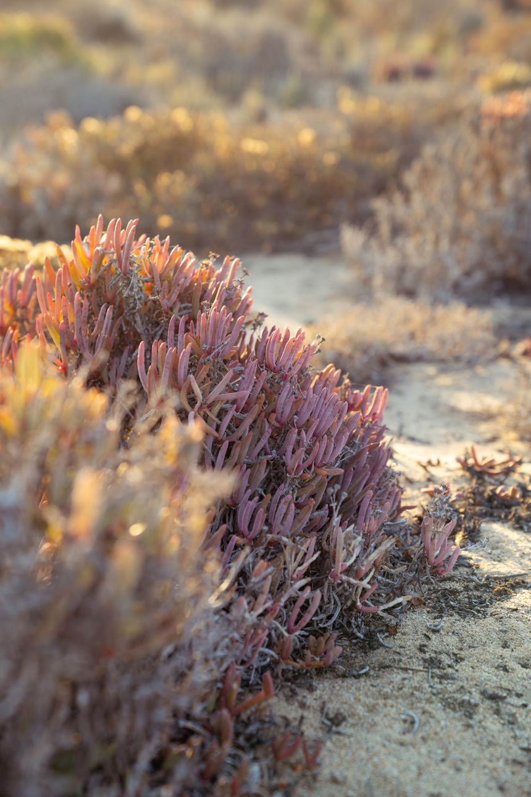


Project Succulent

by
Chloe Marie Lomas
L013602N

A dissertation submitted for the award of
BSc (Hons) Forensic Investigation

Under the supervision of Professor Claire Gwinette
in the Department of Sport and Science
University of Staffordshire

April 2026
Word count = 8836

Abstract
Wildlife forensics is crucial for combating the illegal wildlife trade (IWT) and protecting biodiversity. Biodiversity like that of the world's only arid biodiversity hotspot: The Succulent Karoo. To become a biodiversity hotspot, a region must have high levels of biodiversity and endemic species of life that cannot be found anywhere else; it must also have suffered a loss of at least 70% of its original natural vegetation. The succulents of South Africa are facing a crisis of poaching, according to SANBI. Over 1.5 million dwarf succulents have been illegally poached over the past three years. Commonly targeted species included members belonging to the Conophytum and Lithops genus. There is no standard way for law enforcement to package seized succulent plants that protects the plant long-term and preserves potential evidence left on the surface of the plant.
This project aims to develop and experimentally validate a packaging type to increase the survivability of seized succulents for local law enforcement and rangers to use whilst the succulents are transported and then stored as evidence. Many local nurseries in South Africa are not equipped to handle the increased number of succulents that are being seized at borders as a result, numerous succulents do not survive to be replanted, and the landscape becomes further scarred and devoid of life.
For this project, a grading system was designed to rate common factors of poor plant health: skin wrinkling, surface damage and the suppleness of the plant. The totals were then added together to produce an overall health score out of 20. An ethically sourced species of Lithops was obtained, graded for health and then separated into common packaging types as well as a new novel design that was created for the purpose of supporting the plant whilst also allowing for the movement of air and moisture. Six repeats were placed into each packaging type and then tested against 98% humidity, 30% humidity and mechanical damage to simulate the possible struggles the plants may face when seized by law enforcement. Each of these plants were then graded again for over all health and then split into two groups, 50% to be left on a window and the other 50% to be placed on a storage shelf. After 30 days, the plants were once again graded for overall health to determine whether the packaging type had any statistical difference in plant survivability.
No significant correlation was found between packaging types and the survivability of succulents contained in packaging for a month after being exposed to varying stressors. Future experiments should seek to expand upon this knowledge over a longer storage period using more varied packaging types. The preferable outcome would be cost-effective and sustainable packaging that could be adopted by rangers and law enforcement in a variety of ecosystems.

Acknowledgments
I would like to extend my thanks to Professor Claire Gwinette for her invaluable passion and knowledge surrounding wildlife crime and data analysis. I would also like to give my thanks to my husband. His love, support, and belief in me kept my motivation and spirits high during this process.

Table of Contents
Abstract 1
Acknowledgments 1
Table of Figures 2
Table of Tables 3
1 Introduction 5
1.2 What is Wildlife crime? 6
1.3 Succulent Crisis 6
2 Method 7
2.1 Main Experiment 11
3 Discussion 12
3.1 Reproduction in Lithops 14
3.2 Data Analysis 14
4 Results 15
4.1 Humidity at 30% 15
4.2 Humidity 98% 20
4.3 Plants subjected to 1 hour of mechanical damage 24
4.4 Statistical testing: ANOVA 29
4.4.1 Humidity 30% ANOVA 29
4.4.2 Humidity 98% ANOVA 29
4.4.3 Mechanical ANOVA 30
5 Conclusion 31
6 Further Work 31
7 Bibliography 32

Table of Figures
Figure 1 | ‘My Garden’ Brand seed Trays
figure 2 | An individual pot with a number written on a white label is being weighed for the weight of compost
Figure 3 | Cactus and Succulent Focus Repotting Mix.
Figure 4 | Lithops spp. were removed from the original container and soil, laid out ready for repotting
Figure 5 | Lithops Spp being measured against a Helix Shatter Proof Ruler
Figure 6 | Pot with a hole punched in the centre next to a paint brush with 2 inches measured out.
Figure 7 | Individual Lithops spp repotted into pots with labels and numbers assigned
Figure 8 | A&D Company Limited Balance
Figure 9 | Digitronic Calliper (value line series)
Figure 10 | Lithops spp being measured from top to tip
Figure 11 | Lithops spp being measured at the widest part
Figure 12 | Kaiser RS 1 Copy Stand
Figure 13 | Wrinkling scale
Figure 14 | Surface scarring
Figure 15 | Temperature applied sciences LTD eco MTCL 135 Environmental chamber
Figure 16 | Temperature Applied Sciences LTD eco MTCL 135 Environmental chamber with 30 degrees Celsius and 29% humidity
Figure 17 | Temperature Applied Sciences LTD eco MTCL 135 Environmental chamber, inside with packaging types.
Figure 18 | Lithops rated 5 on the wrinkled scale

Table of Tables
Table 1: Overall Health score (out of 15) of Lithops left in paper evidence bags before being exposed to 30% humidity vs after 1 hour of being exposed to 30% humidity 13
Table 2: Overall Health score (out of 15) of Lithops left in paper evidence bags 1 hour after being exposed to 30% humidity vs 1 month of being left in storage 13
Table 3: Overall Health score (out of 15) of Lithops left in plastic evidence bags before being exposed to 30% humidity vs after 1 hour of being exposed to 30% humidity 14
Table 4 Overall health Score (out of 15) of Lithops left in plastic evidence bags 1 hour after being exposed to 30% humidity vs 1 month of being left in storage 14
Table 5: Overall health score (out of 15) of Lithops before being exposed to 30% humidity versus after 1 hour of being exposed to 30% humidity in Nylon Bags 15
Table 6: Overall health score (out of 15) of Lithops after 1 hour of being exposed to 30% humidity versus after 1 month of being left in storage in Nylon Bags 15
Table 7 Overall Health Scores (out of 15) for Lithops before being exposed to 30% humidity and after 1 hour of being exposed to 30% humidity whilst being held in Novel approach 16
Table 8 Overall Health Scores (out of 15) for Lithops after 1 hour of being exposed to 30% humidity and after 1 month of being stored whilst being held in a novel approach 16
Table 9 Overall Health score (out of 15) for Lithops in Paper Evidence Bags Before and after 1 hour of being exposed to 98% humidity 17
Table 10 Overall health (out of 15) for Lithops in paper evidence bags after 1 hour of being exposed to 98% humidity and 1 month of being left in storage 17
Table 11 Overall Health score (out of 15) for Lithops in Plastic Evidence Bags Before and after 1 hour of being exposed to 98% humidity 18
Table 12 Overall Health score (out of 15) for Lithops in Plastic Evidence Bags after 1 hour of being exposed to 98% humidity and 1 month of being left in storage. 18
Table 13 Overall Health score (out of 15) for Lithops in Nylon Bags Before and after 1 hour of being exposed to 98% humidity 19
Table 14 Overall Health score (out of 15) for Lithops in Nylon Bags after 1 hour of being exposed to 98% humidity and 1 month of being left in storage. 19
Table 15 Overall Health score (out of 15) for Lithops in the novel approach, before and after 1 hour of being exposed to 98% humidity 20
Table 16 Overall Health score (out of 15) for Lithops in the novel approach after 1 hour of being exposed to 98% humidity and 1 month of being left in storage. 20
Table 17 Overall Health score (out of 15) for Lithops in Paper evidence bags, before and after 1 hour of being exposed to Mechanical Damage 21
Table 18 Overall Health score (out of 15) for Lithops in Paper Evidence Bags after 1 hour of being exposed to Mechanical damage and 1 month of being left in storage 21
Table 19 Overall Health score (out of 15) for Lithops in Plastic Evidence Bags after 1 hour of being exposed to Mechanical damage and 1 month of being left in storage 22
Table 20 Overall Health score (out of 15) for Lithops in Plastic Evidence Bags after 1 hour of being exposed to Mechanical damage and 1 month of being left in storage 22
Table 21 Overall Health score (out of 15) for Lithops in Nylon Bags after 1 hour of being exposed to Mechanical damage and 1 month of being left in storage 23
Table 22 Overall Health score (out of 15) for Lithops in Nylon Bags after 1 hour of being exposed to Mechanical damage and 1 month of being left in storage 23
Table 23 Overall Health score (out of 15) for Lithops in the novel approach after 1 hour of being exposed to Mechanical damage and 1 month of being left in storage 24
Table 24 Overall Health score (out of 15) for Lithops in the novel approach after 1 hour of being exposed to Mechanical damage and 1 month of being left in storage 24
Table 25 Comparison of the R² value for 30% humidity 25
Table 26 Comparison of the R² value for 98% humidity 25
Table 27 Comparison of the R² value for mechanical damage 25

1 Introduction
The illegal trade of ornamental plants has increased post-COVID, as demand for unique and aesthetically pleasing plants has been driven by social media trends (Burgener, Prinsloo and Marcolini 2024). The Succulent Karoo is the world's only arid biodiversity hotspot. Located in South Africa, stretching over 116000km² the biome is home to over 6356 plant species, 40% of which are endemic to the Succulent Karoo and 17% of these plants are listed in the Red Data book (UNESCO, 2016)(Crouch et al., 2022).
This massive impact on the biodiversity of the world's only arid biodiversity hotspot could have profound complications in the future, as species that rely on these plants for their various needs begin to suffer as well. In the succulent Karoo, there are more than 225 species of birds, 1 of which is endemic (only found in this location). There are 75 species of mammals, 2 are endemic to the Karoo. Of the 2 species of mammals endemic to the Succulent Karoo 1 is the critically endangered De Wintons Golden Mole (Cryptochloris wintoni). Other critically endangered mammal species include riverine rabbit (Bunolagus monticularis) and the Black Rhino (Diceros bicornis)(CEPF, 2003). The succulent Karoo is home to 15 endemic species of reptiles and 1 endemic species of frog as well as 20 species of endemic insects. Of the endemic insect species the long-tongued fly (Memestrinidae) is the exclusive pollinator of 28 species of plant in Namaqualand )(CEPF, 2003).
As demand for aesthetically pleasing plants has skyrocketed, the nurseries that sell seeds from these plants for export have seen a decrease in sales due to people's desire to have a fully grown plant. South Africa has well-established nurseries that artificially propagate succulent plants for trade to horticulturalists and collectors; however, there are concerns about plants being exported as artificially propagated plants are, in fact, wild collected. If these reports are correct, it undermines the efforts made by local nurseries to cultivate the succulents without causing damage to their wild populations (South-Africas-trade-in-succulent-plants 1998). In-demand succulent species are often not available in these nurseries, which may potentially be a repercussion of the illegal poaching of the plants, or, inversely, may be the case, as nurseries do not have access to legally gather the plants to cultivate to meet the demand due to the high number of smuggling taking place (Crouch et al., 2022). The effect of this leads to a vicious cycle of people from poorer economic backgrounds illegally harvesting popular succulent species to the point of extinction (Prinsloo, D., Burger, M., and Newton, D. 2024).
The amount of seized succulents is unwieldy, it is impossible to know where the succulents were poached from, and once removed, the reintroduction of the plant is quite difficult as they become stressed, get damaged and are unlikely to survive if replanted (Prinsloo et al., 2024). Between 2019 and 2024 more than 1.6 million succulent plants were seized by law enforcement in South Africa (Prinsloo et al., 2024) local conservation authorities and botanical gardens cannot adequately deal with the sheer volume of confiscated material due to a number of factors, such as; limited space to house the plants and the specific care the plants require to be kept alive (SANBI, 2022).
This project aims to explore packaging techniques to increase the survivability of seized succulent plants by testing individual succulent plants in various types of packaging against varying conditions and monitoring the damage caused to the plants. Once the experiment is completed, the plants will be rehabilitated by following a best practice guide and donated to spread awareness of the issues these plants face in the wild.

1.2 What is Wildlife crime?
The illegal wildlife trade (IWT) has become a global problem, reaching an approximate value of 70-213 billion USD annually (C Nellemann et al., 2014). IWT is typically defined as the smuggling, capture, or poaching of fauna and flora, as well as products or derivatives of them. The IWT deprives local economies of income through lost revenues or development opportunities as well as causing damage to populations of flora and fauna (Koutchoro, et al., 2024) (Nellermann et al, 2014).

1.3 Succulent Crisis
A succulent is any plant with thick, fleshy tissues adapted to storing water. Most succulents have deep or broad root systems and are native to desert or semi-arid regions (Petruzzello, 2019). The illegal trade of ornamental plants has increased post-COVID, as demand for unique and aesthetically pleasing plants has been driven by social media trends (Burgener, Prinsloo and Marcolini 2024). The Succulent Karoo is the world's only arid biodiversity hotspot. Located in South Africa, stretching over 116000km² the biome is home to over 6356 plant species, 40% of which are endemic to the Succulent Karoo and 17% of these plants are listed in the Red Data book (UNESCO, 2016)(Crouch et al., 2022). The Red Data Book is a system designed to focus attention on species at high risk of global extinction, put in place by the International Union for Conservation of Nature (IUCN), It has been in place for almost 30 years and is widely accepted (IUCN,2000).
South Africa has well-established nurseries that artificially propagate succulent plants for trade to horticulturalists and collectors; however, there are concerns about plants being exported as artificially propagated plants are, in fact, wild collected. If these reports are correct, it undermines the efforts made by local nurseries to cultivate the succulents without causing damage to their wild populations (South-Africas-trade-in-succulent-plants 1998). In-demand succulent species are often not available in these nurseries, which may potentially be a repercussion of the illegal poaching of the plants, or, inversely, may be the case, as nurseries do not have access to legally gather the plants to cultivate to meet the demand due to the high number of smuggling taking place (Crouch et al., 2022). The effect of this leads to a vicious cycle of people from poorer economic backgrounds illegally harvesting popular succulent species to the point of extinction (Prinsloo, D., Burger, M., and Newton, D. 2024).
Demand for succulents such as Conophytum and Lithops has been prevalent since the 1940s when it was widely acceptable for people to come to South Africa and remove wild-grown plants, amateurs gained further interest in collecting and selling these plants in the 1970s when the destruction of the Lithops Genus became known (South-Africas-trade-in-succulent-plants 1998). With all illegal poaching, the rarer a species is, the more desirable and valuable it becomes. In 2014 there was a big increase in demand for Succulent plants from East Asia as young people learned about the plants through social media influence. Species of Conophytum and Lithops can be kept in small areas, can be kept together and are aesthetically pleasing, making them popular with people who live in apartments (Welz, A 2025)

2 Method
‘My Garden’ Brand seed trays were cut to form individual pots for replanting Lithops spp. Each seed tray was cut differently due to the structure of the packaging it came from.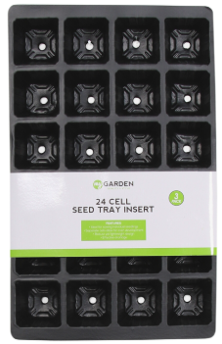
Figure 1 ‘My Garden’ Brand seed trays
using a A&D company limited balance, Growth Technology brand ‘Cactus and Succulent focus’ Compost was measured out into ‘My Garden’ brand seed trays, about 2 inches deep, as recommended for best practice in keeping Lithops alive. The pots with soil were left for a week to allow moisture to dry before repotting in accordance with the best practice for caring for Lithops. The seed trays were weighed with the soil inside and recorded on an Excel sheet. Each seed tray was given a number on a ‘NOTEZMATE’ sticky label.
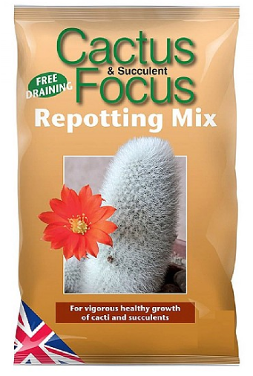
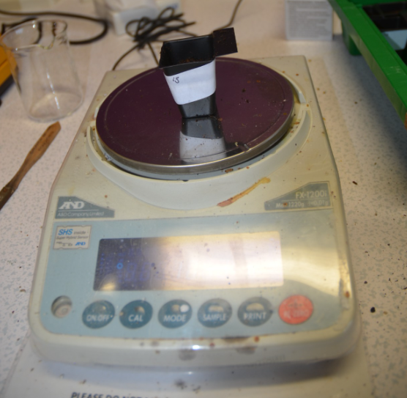
Figure 2 Individual pot with number written on
Figure 3 Cactus and Succulent Focus Repotting mix.
white label being weighed for the weight of compost

Then, following instructions on how to repot succulents (Complete guide to succulent care), individual Lithops spp were removed from the pot they were purchased in. The large clump of dry soil was slightly squeezed to detach the soil from the roots.
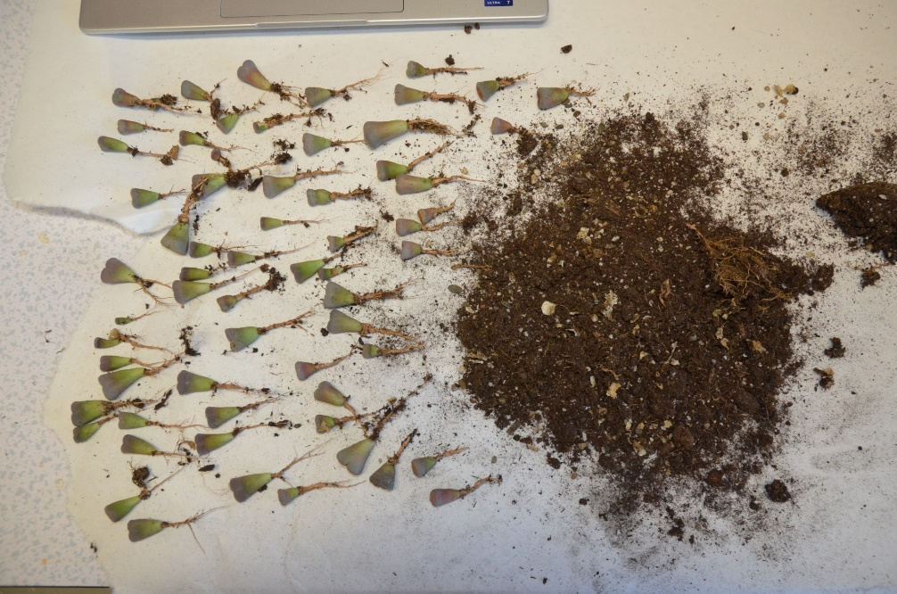
Figure 4 Lithops spp removed from original container and soil, laid out ready for repotting
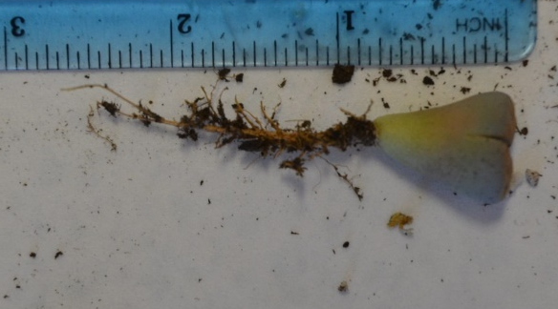
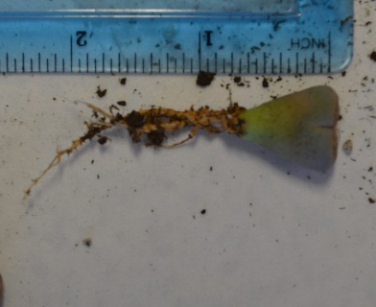
Using a Helix Shatter-resistant ruler, a selection of 10 individual Lithops was measured to produce a range of measurements from the end of the roots to the top of the plant.
Figure 5 Lithops spp being measured against a Helix Shatter Proof ruler
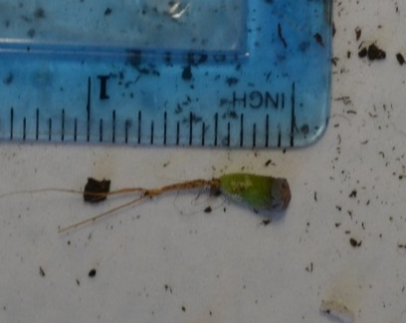
Using a Helix shatter-resistant ruler, 2 inches were measured and then marked on a paint brush to punch holes into the compost to plant the Lithops spp in. Pots of just soil were also measured as controls to measure liquid loss.
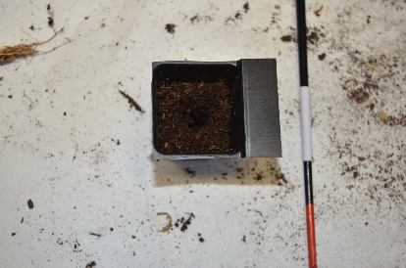
Figure 6 Pot with hole punched in centre next to paint brush with 2 inches measured out.
Next, individual Lithops spp were planted into pots and weighed again to calculate the weight of the Lithops spp, by removing the weight of the soil and the pot from the total weight. This information was recorded on an Excel sheet, and =Sum cell-cell was used to calculate the total weight.
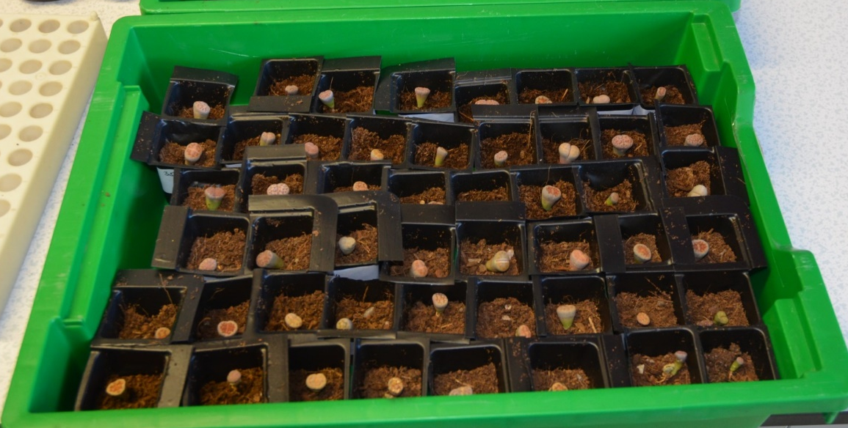
Figure7Individual Lithops spp repotted into pots with labels and numbers assigned
The Lithops spp were given a spray of water from a spray bottle, covered with clingfilm and left to recover for a few days. It is generally not recommended to repot Lithops spp during the winter as this is a time when they become dormant and attempt to conserve energy, but due to the time constraints of the experiment, it was imperative that they were repotted at this time. It is also not recommended to water Lithops during the winter; however, it is recommended to fill new soil with water when repotting Lithops (Complete guide to succulent care).
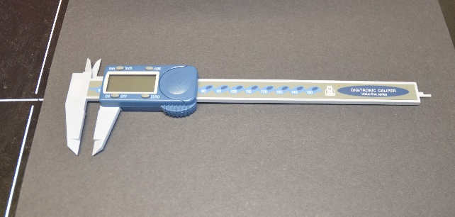
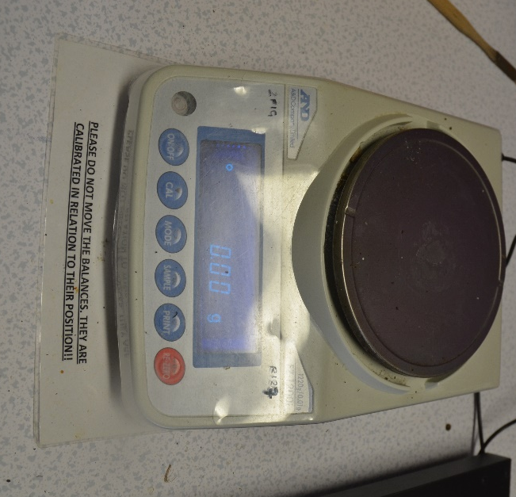
After being given a few days to recover from stress the Lithops were removed from the soil and weighed on a A&D company limited balance, their weight was recorded on an excel sheet. The Lithops were also measured in mm from the flat top to the tip of the root with a Digitronic Caliper (value line series) and recorded on the same excel sheet.
Figure 9 Digitronic Caliper (value line series)
Figure 8 A&D Company Limited Balance
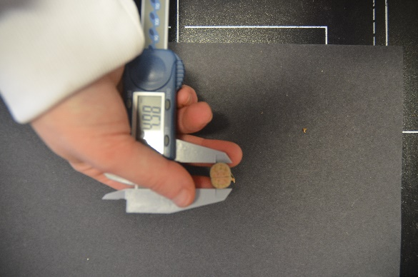
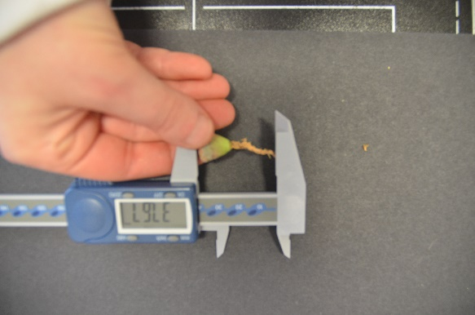
Figure 11 Lithops spp being measured at the widest part
Figure 10 Lithops spp being measured from top to tip
The Lithops spp were then graded on a damage scale based on how much wrinkling, mechanical damage over an estimated surface area and how soft the succulent was. Wrinkling was graded on a scale of 0-5, 0 being the plant is completely smooth, 1 being there is some slight wrinkling, 2 being moderate wrinkling, 3 more severe wrinkling, 4 very severe wrinkling and 5 is the plant is withered. Wrinkling can be caused by both underwatering and overwatering of plants, as underwatering leads to loss of turgor in plant cells and overwatering leads to root rot, which inhibits the plant's ability to absorb water properly. Mechanical damage is listed as potential bruising through discoloured flesh, scarring over the surface where the plant has previously sustained damage and healed, or current open wounds from recent cuts or crushes. Sponginess was measured on a scale of 0-5, 0 being no sponginess present at all. The plant offers maximum resistance when squeezed. 1 is the plant is very slightly soft, 2 the plant is moderately soft, 3 the plant is moderately-severely soft, 4 is the plant is severely soft, 5 is the plant is virtually liquid.
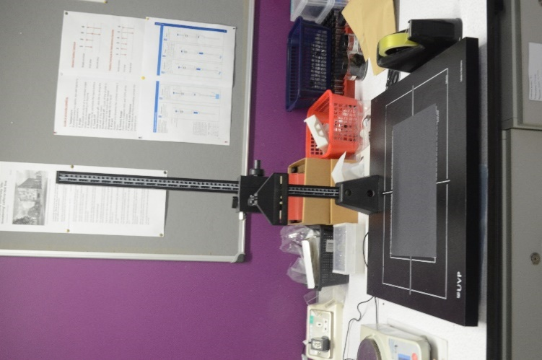
Photographs taken on Nikon digital camera, D7000 on Auto focus mode and auto mode mounted on a Kaiser RS 1 Copy Stand. Tamper proof Evidence bags, small nylon bags and small paper bags, were obtained from Crime Scene Investigation Equipment ltd. Reusable mesh produce bag purchased at Sainsburys were placed over the top of cut seed trays and then Sellotaped into place to keep the mesh over the top.
Figure 12 Kaiser RS 1 Copy Stand

2.1 Main Experiment
The objective of this project is to determine the best way to increase the survivability of seized succulent plants; as such, different packaging types will be tested under various abiotic factors. First, the packaging will be tested against ideal conditions to set a control. Control plants will be potted in Cactus and Succulent Focus Repotting mix and placed in a North-facing window. Unfortunately due to the set up of the room the control plants are being kept in, it will be impossible to monitor the exact temperature and humidity the control group is subjected to. Six repeats of plants stored in Tamper Proof evidence bags, Nylon Bags, Paper evidence bags and a novel approach designed for this experiment will be tested against varying conditions. Six of each will be tested against 98% humidity, six of each against 30% humidity and six of each against mechanical damage. Each group of six will also be split into two with one half being left on the north-facing window with the control group, and the other half being put onto a storage shelf to imitate the conditions in which evidence is normally kept.
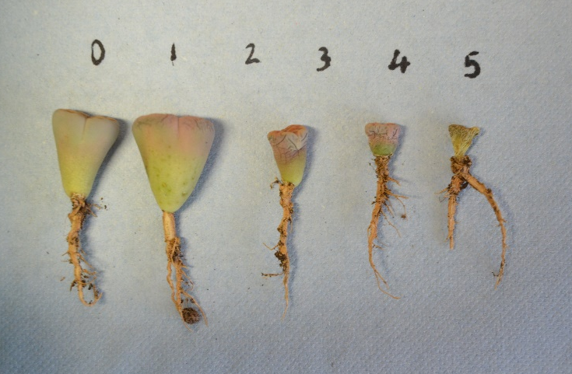
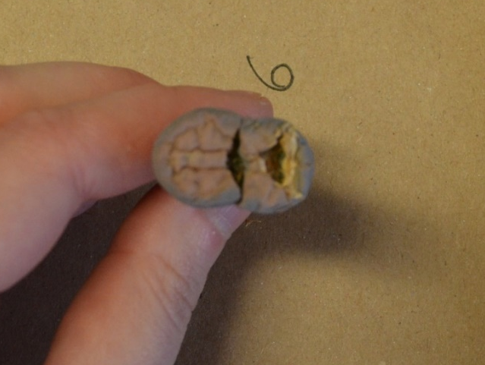
The Plants will then be measured against a scale to determine the level of damage sustained. Damage recorded will include mechanical damage to leaves such as bruising, discolouration and surface damage. The Physical damage will be recorded on a scale of 1-10 based on an estimated surface area that is occupied by mechanical damage. The degree of leaf wrinkling will be assessed on a 0-5 scale, reflecting the extent of wrinkling across the plant's surface. The guide pictured below is provided for standardised evaluation. The morphological change in the leaves is attributed to reduced turgor pressure within the plant cells due to water loss (Cooper, 1991). In addition to this, the plants firmness will be evaluated through gentle manual compression, evaluated on an identical 0-5 scale. The level of Sponginess, similar to wrinkling, is also caused by a lack of turgor pressure inside the plant's cells. The damage scales have been developed based on experience. Photographs of plants will be taken before being subjected to varying levels of damage and then after to compare the damage done.
Figure 13 Wrinkling scale
Figure 14 Surface scarring
Each individual grade will be totalled together to produce an overall health scale; the higher the number, the poorer the health the plant is in. The data of the health scale will be plotted on a scatter chart comparing the health before the plants were subjected to varying conditions versus immediately after. As well as the results from immediately after, compared to the results of the health scale after 1 month of the plants being kept inside their packaging in storage.

3 Discussion
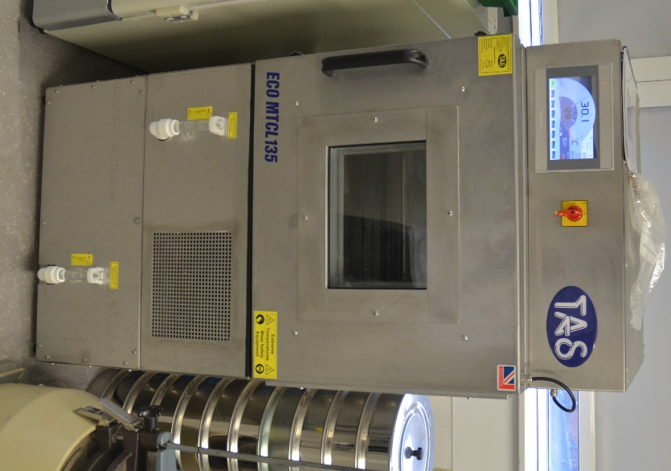
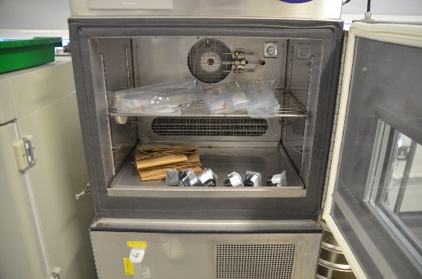
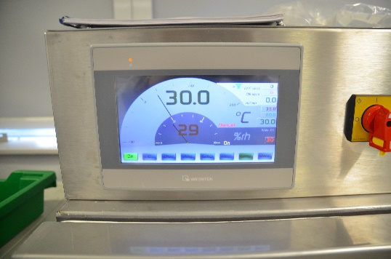
The method was chosen to simulate the conditions that poached succulent plants may potentially face when being seized. The 30-degree Celsius temperature was chosen due to being the average maximum recorded over 50 years of monthly climate data taken from the arid to semi-arid area, Karoo National Park in South Africa, where the succulents are facing poaching problems (SafariBookings 2026, WorldWeatherOnline 2026). The average humidity for the Succulent Karoo varies greatly due to the Karoo ranging from coastal regions to the undulating inland region. Microclimatic variations are pronounced across the biome (Mucina et al. 2006). As such it was decided to examine two groups of varying humidity to experience ideal humidity for succulent plants vs extremely high humidity. For the controlled environmental setting, a Temperature applied sciences LTD eco MTCL 135 Environmental chamber was used as it was accessible and allowed for the control of both temperature and humidity.
Figure 15 Temperature applied sciences LTD eco MTCL 135 Environmental chamber
Figure 16 Temperature applied sciences LTD eco MTCL 135 Environmental chamber with 30 degrees Celsius and 29% humidity
Figure 17 Temperature applied sciences LTD eco MTCL 135 Environmental chamber, inside with packaging types.
Mechanical damage was chosen to mimic the movement succulent plants might face when being transported from their place of seizure to their eventual storage. As such, it was decided that the succulents, in their method of storage, should be placed into a backpack and carried on a Reebok ZRB treadmill for an hour. It would be perfectly reasonable to suggest law enforcement seizing succulents may carry them around for longer stretches of time or even shorter; they may even perform different movements with the succulents in a different vessel. For the purposes of this experiment and the equipment available, this method was deemed suitable to produce results.

The packaging was chosen to represent methods of evidence packaging that are already in full circulation and well-used. Nylon evidence bags were used to represent the worst possible packaging type that could be used, as they do not allow for moisture escape, support the plant or allow air in or out. Sticky labels were added to allow for continuity of the chain of custody. Breathable evidence bags were used to allow moderate air flow whilst maintaining a clean chain of custody. Paper evidence bags were used as the recommended ideal way to store biological evidence (Ministry of Justice & HM Prison and Probation Service 2025,Illinois State Police n.d.,Sirchie n.d.). Paper bags allow for air flow and moisture to escape which could potentially prevent root rot, however, the packaging type does not support or protect the plant from crushing damage.
The Novel packaging developed for this project was designed to allow for airflow, allow for moisture to escape to prevent root rot and support the plant when being moved in accordance with best practice guides for caring for succulents (Patch Plants n.d. Bagley 2025). The mesh top also allows for light to enter.
Callipers were used to measure the length from root end to the top of the plant, as well as the largest width. Due to the accuracy provided by the tool, the caveat is that using the callipers proved difficult when attempting to measure roots that bend or a width that isn’t totally solid. A balance was used to weigh the succulents before they underwent mechanical damage or differing humidities, immediately after and once again after they had been left in the packaging for a month. A balance provides accurate weight to a degree; however, it should be noted that whilst due care was taken to remove any remaining soil on the plant's roots without causing damage, there is a possibility that the weight was altered due to remaining soil.
The type of succulent (Lithops sp) was chosen due to its being both highly cultivated and common in garden centres around the world, and due to the plant being a similar species to the wild succulents of the succulent karoo that are poached. Unfortunately, as the experiment progressed, it became clear that more plants would be required to have a suitable number of healthy plants. As such, more trips to the garden centre were required, and the garden centre ran out of stock of the plant. As such, the plants used may not have been the most suitable for use in this experiment due to the individual succulents already having suffered some damage or neglect. As the status of the plants was recorded before and after the tests, the scale of damage should hopefully reflect the condition the plants were in before being subjected to experiments and as such any perceived changes in their condition can be recorded. It should also be noted that all of the supplies for the succulents such as the soil, the pots and the materials to make the novel design, were purchased by the Author. This proved challenging, and if undergone again, perhaps more funding could be acquired to extend the reach of the experiment.
The grading system developed is highly subjective, based on the experience of the author. Abiotic factors such as mechanical damage or exposure to extreme weather conditions leave impacts on plants that are problematic to measure. A stunt in growth is extremely difficult to measure in a plant that typically takes three to five years to mature. and an overall health scale was given to the plants to measure their progressive damage. The health scale is out of 20, with higher numbers meaning the plant itself is in poorer health and not likely to be replanted. Due to the restricted time scale, it will not be possible to further follow up on how the plant does once removed from the packaging and replanted in soil, which would ultimately be the best measure of which packaging type did the most damage.

3.1 Reproduction in Lithops
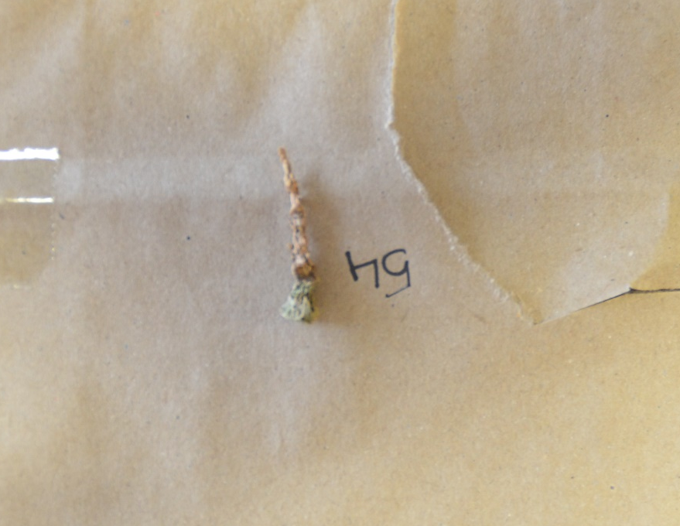
There is limited research done on reproduction on Lithops; as such, it is unknown if the plants reproduce when under duress or only if conditions are perfect. Lithops spp need to be at least three years old before they reach maturity (Afra, 2018, Mahr, n.d.), Lithops spp produce a flower towards the end of summer or the beginning of fall. When the weather in the succulent Karoo is on average between 19-26 degrees Celsius, and each month experiences approximately one rainy day (Okiep, n.d). After the Lithops spp flower has faded, the plant begins growing another new plant inside of the old leaves (Afra, 2018, Mahr, n.d.). As the new plant grows within the old leaves shrink and wrinkle, eventually, as the growth becomes large enough, the outer leaves split and reveal the new plant (Afra, 2018, Mahr, n.d.). As this experiment took place over the course of winter, the level of wrinkling present over the month-long period during which the plants were left in packaging may be a result of a natural process. As such, when analysing the data, the level of wrinkling will be left out of the results, as it is unknown if the plants were wrinkling due to their reproductive stage at the time of the experiment. It is worth noting that some Lithops spp remained at an overall health score of 0 when excluding wrinkling. These outliers may make it appear that the plant was in perfect health. However, when Lithops spp were rated 5 on the wrinkling scale, the plants were often devoid of water and, as such, unable to be ranked with either surface damage or softness as seen in the image below.
Figure 18 Lithops rated 5 on the wrinkled scale

3.2 Data Analysis
The data was recorded in Excel, with each varying condition and subsequent health scores on separate sheets. The health scores were tallied, first including wrinkling and then excluding it. The total health scores, out of 15, were tested for normality in Excel with Jarque-Bera test (JB) to determine whether the samples had skewness of Kurtosis that matched the normal distribution. The JB test statistic is defined as
Equation 1 Jarque-Bera test
^{JB =(n/6) * (S2 + (C2/4))}
Where:
n: The number of observations in the sample
S: The sample Skewness
C: The sample Kurtosis
This test uses the following hypothesis:
H₀: The data is normally distributed
H_{A}: The data is not normally distributed
If the P-Value (probability value) is less than a significant level (0.05) the null hypothesis is rejected, and the data will be considered not normally distributed, if the P-value is higher, the data will be considered normally distributed, which signifies the data is clustered around the mean (Bobbitt, 2021).
After the normality of the data is determined, a statistical test can be used to determine if there is a statistical difference between packaging types when considering plant health.
AVNOVA two-factor with repeats was used to analyse the data, as the aim of the experiment was to determine if there is a statistical difference between packaging types over a period of time. The independent variables are varying conditions (humidity 30%, humidity 98% and mechanical damage) as well as packaging types (Paper Evidence bags, plastic evidence bags, Nylon bags and the novel approach). The hypotheses are as follows:
H₀: Packaging type has no statistical significance on the survivability of Succulent plants when contained for 1 month
H₁: Packaging type has some statistical significance on the survivability of Succulent plants when contained for 1 month

4 Results

4.1 Humidity at 30%
The following charts are the results of Lithops sp. Exposed to 30% humidity and 30 degrees Celsius for one hour, and then left in their various types of packaging.

4.1.1 Paper Evidence Bags
Table 1: Overall Health score (out of 15) of Lithops left in paper evidence bags before being exposed to 30% humidity vs after 1 hour of being exposed to 30% humidity

Table 2: Overall Health score (out of 15) of Lithops left in paper evidence bags 1 hour after being exposed to 30% humidity vs 1 month of being left in storage

Table 1 shows linearity in the overall health of Lithops spp after being exposed to 30% humidity for 1 hour. The Coefficient of Determination shows 67.92% of the variation in overall health as the overall health score increases, suggesting the plants were in worse health as time progressed. Table 2 has an R² value of 0.1444, which shows that even though the overall health of Lithops spp. did decrease, it decreased with less severity. The data suggests that paper evidence bags minimise damage to plants over the course of a month.

4.1.2 Plastic Evidence Bag
The following charts show the overall health score of Lithops spp. that were kept in plastic evidence bags whilst being exposed to 30% humidity and 30 degrees Celsius heat for 1 hour before being left inside their packaging for 1 month.
Table 3: Overall Health score (out of 15) of Lithops left in plastic evidence bags before being exposed to 30% humidity vs after 1 hour of being exposed to 30% humidity

Table 4 Overall health Score (out of 15) of Lithops left in plastic evidence bags 1 hour after being exposed to 30% humidity vs 1 month of being left in storage

Table 3 shows the overall health score for Lithops spp. Increases after being exposed to 1 hour of 30% Humidity. However, the R² of 0.1489 is very low, which suggests a very low variation in health scores. Table 4 shows an increase in the overall health score to a more severe degree of 95.16%, which suggests that when Lithops spp. When kept in sealed plastic evidence bags for 1 month, their health decreases sharply.

4.1.3 Nylon Bag
The following charts show the overall health of Lithops spp kept in Nylon bags whilst being exposed to 30% humidity and 30 Degree Celsius for 1 hour and then stored for 1 month.
Table 5 Overall health score (out of 15) of Lithops before being exposed to 30% humidity versus after 1 hour of being exposed to 30% humidity in Nylon Bags

Table 6 Overall health score (out of 15) of Lithops after 1 hour of being exposed to 30% humidity versus after 1 month of being left in storage in Nylon Bags

Table 5 shows a very steady decrease in the overall health scores of Lithops spp when exposed to 30% humidity and 30 degrees Celsius heat for 1 hour whilst being contained in Nylon bags. The Coefficient of Determination shows a variation of 43.27% in overall plant health before and after being subjected to 30% humidity for 1 hour.

4.1.4 Novel Approach
The novel approach was designed for this experiment with the intent that plants require access to open air to allow respiration, and to also allow photosynthesis to occur. The following charts show the relationship between overall health scores before, immediately after and 1 month after plants were subjected to 30% humidity and 30 degrees Celsius heat for 1 hour whilst being held in the novel approach.
Table 7 Overall Health Scores (out of 15) for Lithops before being exposed to 30% humidity and after 1 hour of being exposed to 30% humidity whilst being held in Novel approach

Table 8 Overall Health Scores (out of 15) for Lithops after 1 hour of being exposed to 30% humidity and after 1 month of being stored whilst being held in a novel approach

Both tables 7 and 8 show similar coefficients of determination, which means the overall plant health continued to decline steadily.

4.2 Humidity 98%
The following charts are the results of Lithops sp. Exposed to 98% humidity and 30 degrees Celsius for one hour, and then left in their various types of packaging.

4.2.1 Paper Evidence Bag
Table 9 Overall Health score (out of 15) for Lithops in Paper Evidence Bags Before and after 1 hour of being exposed to 98% humidity

Table 10 Overall health (out of 15) for Lithops in paper evidence bags after 1 hour of being exposed to 98% humidity and 1 month of being left in storage

Table 10 has an R² value of 0.0023, which suggests a very minor decrease in the overall health score of Lithops spp when contained in paper evidence bags for 1 month after being exposed to 98% humidity for 1 hour. Table 9 has an R² value of 0.7042, which suggests a 70.42% variation in overall plant health from before to after 1 hour of being exposed to 98% humidity.

4.2.2 Plastic Evidence Bag
The following charts show the overall health score of Lithops spp. that were kept in plastic evidence bags whilst being exposed to 98% humidity and 30 degrees Celsius heat for 1 hour before being left inside their packaging for 1 month.
Table 11 Overall Health score (out of 15) for Lithops in Plastic Evidence Bags Before and after 1 hour of being exposed to 98% humidity

Table 12 Overall Health score (out of 15) for Lithops in Plastic Evidence Bags after 1 hour of being exposed to 98% humidity and 1 month of being left in storage.

Table 12 has an R² value of 0.0008. These results suggest succulents kept in plastic evidence bags after being subjected to 98% humidity for 1 hour and then being left in storage for 1 month show minimal impacts towards their overall health decline.

4.2.3 Nylon Bag
The following charts show the overall health of Lithops spp kept in Nylon bags whilst being exposed to 98% humidity and 30 Degree Celsius for 1 hour and then stored for 1 month.
Table 13 Overall Health score (out of 15) for Lithops in Nylon Bags Before and after 1 hour of being exposed to 98% humidity

Table 14 Overall Health score (out of 15) for Lithops in Nylon Bags after 1 hour of being exposed to 98% humidity and 1 month of being left in storage.

4.2.4 Novel Approach
The following charts show the relationship between overall health scores before, immediately after and 1 month after plants were subjected to 98% humidity and 30 degrees Celsius heat for 1 hour whilst being held in the novel approach.
Table 15 Overall Health score (out of 15) for Lithops in the novel approach, before and after 1 hour of being exposed to 98% humidity

Table 16 Overall Health score (out of 15) for Lithops in the novel approach after 1 hour of being exposed to 98% humidity and 1 month of being left in storage.

Tables 15 and 16 show that succulent plants kept in the novel approach suffered fairly severe health degradation, with overall health scores as high as 10,11 and 12. Lithops number 75 scored 7 on the overall health scale (excluding wrinkling) but climbed to 10 after being subjected to 98% humidity.

4.3 Plants subjected to 1 hour of mechanical damage

4.3.1 Paper evidence bag
The following charts show the overall health score of Lithops spp. that were kept in paper evidence bags whilst being exposed to mechanical damage for 1 hour before being left inside their packaging for 1 month.
Table 17 Overall Health score (out of 15) for Lithops in Paper evidence bags, before and after 1 hour of being exposed to Mechanical Damage

Table 18 Overall Health score (out of 15) for Lithops in Paper Evidence Bags after 1 hour of being exposed to Mechanical damage and 1 month of being left in storage

4.3.3 Plastic Evidence bag
The following charts show the overall health score of Lithops spp. that were kept in paper evidence bags whilst being exposed to mechanical damage for 1 hour before being left inside their packaging for 1 month.

Table 21 Overall Health score (out of 15) for Lithops in plastic evidence Bags after 1 hour of being exposed to Mechanical damage and 1 month of being left in storage

Table 22 Overall Health score (out of 15) for Lithops in Plastic evidence Bags after 1 hour of being exposed to Mechanical damage and 1 month of being left in storage

4.3.2 Nylon Bag
The following charts show the overall health of Lithops spp kept in Nylon bags whilst being exposed to mechanical damage for 1 hour and then stored for 1 month.
Table 19 Overall Health score (out of 15) for Lithops in Nylon Bags after 1 hour of being exposed to Mechanical damage and 1 month of being left in storage

Table 20 Overall Health score (out of 15) for Lithops in Nylon Bags after 1 hour of being exposed to Mechanical damage and 1 month of being left in storage

4.3.4 Novel approach
The following charts show the relationship between overall health scores before, immediately after and 1 month after plants were subjected to mechanical damage for 1 hour whilst being held in the novel approach.

Table 23 Overall Health score (out of 15) for Lithops in the novel approach after 1 hour of being exposed to Mechanical damage and 1 month of being left in storage

Table 24 Overall Health score (out of 15) for Lithops in the novel approach after 1 hour of being exposed to Mechanical damage and 1 month of being left in storage

The tables below contain the R² values from the above charts.
Table 25 Comparison of the R² value for 30% humidity
Packaging type | R² Value before, followed by immediately after | R² Value immediately after versus after 1 month
Paper Evidence Bag | 0.6792 | 0.1444
Plastic Evidence bag | 0.4785 | 0.9516
Nylon Bag | 0.6769 | 0.3846
Novel Approach | 0.7403 | 0.6769

Table 26 Comparison of the R² value for 98% humidity
Packaging type | R² Value before, followed by immediately after | R² Value immediately after versus after 1 month
Paper Evidence Bag | 0.7042 | 0.0023
Plastic Evidence bag | 0.7225 | 0.008
Nylon Bag | 0.8412 | 0.2311
Novel Approach | 0.9642 | 0.8211

Table 27 Comparison of the R² value for mechanical damage
Packaging type | R² Value before, followed by immediately after | R² Value immediately after versus after 1 month
Paper Evidence Bag | 0.7406 | 0.8794
Nylon Bag | 0.1455 | 0.6947
Plastic Evidence bag | 0.6503 | 0.9091
Novel Approach | 0.6605 | 0.9560

All of the scatter charts were plotted with the overall health score for plant health without wrinkling, and all of them show a positive trend. This indicates that overall plant health always declined after 1 hour and 1 month of being left in their packaging.

4.4 Statistical testing: ANOVA
To determine if there is any statistical difference in the method of packaging on the overall health of plants, ANOVA tests were run using the mean health scores for before, immediately after and 1 month after. A P-Value of over 0.05 means the null hypothesis is accepted, and packaging type has no difference in survivability on succulents.

4.4.1 Humidity 30% ANOVA
SUMMARY
Groups | Count | Sum | Average | Variance
Column 1 | 6 | 20.01 | 3.335 | 3.335
Column 2 | 6 | 21 | 3.5 | 3.412
Column 3 | 6 | 15.66 | 2.61 | 1.665
Column 4 | 6 | 16 | 2.667 | 1.646
ANOVA
Source of Variation | SS | df | MS | F | P-value | F crit
Between Groups | 3.734 | 3 | 1.245 | 0.495 | 0.69 | 3.098
Within Groups | 50.29 | 20 | 2.514
Total | 54.02 | 23
For Succulents exposed to 30% humidity, the P-value is 0.69. We accept the null hypothesis: Packaging has no effect on succulents after being exposed to 30% humidity for 1 hour.

4.4.2 Humidity 98% ANOVA
SUMMARY
Groups | Count | Sum | Average | Variance
Column 1 | 6 | 28.32 | 4.72 | 2.2406
Column 2 | 6 | 17.98 | 2.996667 | 1.961787
Column 3 | 6 | 16.3 | 2.716667 | 3.219267
Column 4 | 6 | 30.32 | 5.053333 | 3.791267
ANOVA
Source of Variation | SS | df | MS | F | P-value | F crit
Between Groups | 25.29393 | 3 | 8.431311 | 3.007713 | 0.05446 | 3.098391
Within Groups | 56.0646 | 20 | 2.80323
Total | 81.35853 | 23
For succulents exposed to 98% humidity for 1 hour, the P-value is over 0.05; as such we accept the null hypothesis and packaging types have no effect on the overall health of succulents.

4.4.3 Mechanical ANOVA
SUMMARY
Groups | Count | Sum | Average | Variance
Column 1 | 6 | 41.657 | 6.942833 | 13.2096
Column 2 | 6 | 27.324 | 4.554 | 5.719756
Column 3 | 6 | 25.664 | 4.277333 | 2.906239
Column 4 | 6 | 22.317 | 3.7195 | 4.318182
ANOVA
Source of Variation | SS | df | MS | F | P-value | F crit
Between Groups | 36.42811 | 3 | 12.1427 | 1.857124 | 0.169419 | 3.098391
Within Groups | 130.7689 | 20 | 6.538443
Total | 167.197 | 23
For Succulents that underwent 1 hour of mechanical damage, the p-value is 0.169419, which is over 0.05; thus, we accept the null hypothesis, and once again, packaging type has no effect on the health of succulents.

5 Conclusion
This study aimed to develop a packaging method that would increase survivability for seized succulent plants that are currently facing a poaching crisis in South Africa. The methods of packaging were chosen to represent packaging types commonly used by law enforcement: paper evidence bags, Plastic evidence bags and Nylon bags. However, another packaging type was developed to maintain steady airflow to the plants, allow sunlight to enter, and prevent the plants from being damaged in transit. The developed packaging also had space on the surface for continuity to allow law enforcement to properly maintain a chain of custody. A health scale was developed based on common types of damage that can be found on succulent plants.
The findings indicate that packaging type has no statistically significant impact on the survivability of Lithops spp when subjected to stressful conditions and left in storage for 1 month. It is possible that the succulent plants, Lithops spp. Tested are very resistant to the level of stress placed on them during this study. It is also possible that the health scale developed was unsuitable for this particular species of plant. When working with living organisms, it is crucial to consider the history. Succulents that were obtained for this study were obtained from a garden centre local to the author by the author. It is also worth noting that Lithops spp are slow-growing plants, and whilst the exact age of the plants used for this experiment is unknown, most Lithops spp must be at least 3 years old before they reproduce, as some individuals used for this did.
This study had many limitations, including sample size, as some of the plants obtained were already in poor condition. Due to how the plants were obtained at the time, obtaining more samples was not possible. It should also be noted that the exact species of Lithops spp. use was entirely unknown, and researching the exact conditions for care proved challenging. The length of the investigation proved to be a challenge, as when evidence is stored, it can often be for extended periods of time. As such, this study was performed over the course of a month; as such, there is a possibility that damage had yet to develop. This study was performed in controlled conditions that may not match the conditions for the intended target for which the packaging is designed.

6 Further Work
This study has highlighted many potential topics for further exploration that may be beneficial. Several areas of limited information were highlighted during the literature review, such as reproduction in Lithops as well as weather conditions in the Succulent Karoo. Future studies might look to expand on how the plants would react when subjected to the conditions they were briefly exposed to for a longer period, to mimic the natural conditions where the plants would be kept.
This study was performed over winter due to the limitations in place. The end of Autumn and throughout the winter is when Lithops typically tend to reproduce. Performing this study again in a different time period may yield different results.
Poaching affects more plant species than just succulents; for example, Orchids, Cacti, and some species of carnivorous plants. As this study focuses solely on the effect of packaging on succulent types, further work could explore the effect of packaging on orchids, cacti, or carnivorous plants.
Further exploration of the effects of different packaging types as well as expanding on the novel idea crafted for this experiment. Perhaps learning from the poachers who remove the plants as they need the plants to survive, being packaged for extended periods of time whilst they are moved from one location to the next.

7 Bibliography
Afra, A. (2018) Lithops 101 – What you need to know to keep them alive. Sucs for You!, 19 May. Available at: https://sucsforyou.com/2018/05/19/lithops-101-what-you-need-to-know-to-keep-them-alive/ (Accessed: 10 March 2026).
Bagley, J. 2025, How to care for succulents, BBC Gardeners’ World Magazine, 1 April 2025, accessed 11 February 2026, https://www.gardenersworld.com/house-plants/succulent-care/.
Timeline
Bobbitt, Z. (2021) How to perform a normality test in Excel (step-by-step). Statology. Available at: http://statology.org/normality-test-excel/ (Accessed: 27 March 2026).
Cooper, S. (1991) '7 - Density and Turgor during the Division Cycle', in Cooper, S. (ed.) Bacterial Growth and Division San Diego: Academic Press, pp. 247–252.
Esler, K.J. (1993) Vegetation patterns and plant reproductive processes in the succulent Karoo. PhD thesis. University of Cape Town. Available at: https://open.uct.ac.za/server/api/core/bitstreams/1968a9e5-4738-4230-8f75-b6e356a99910/content (Accessed: 10 March 2026)
Illinois State Police n.d., Division of Forensic Services, Illinois State Police, Springfield, IL.
Koutchoro, A. M., Amahowe, O. I., Houessou, L. G. & ougbegnon, T. O., 2024. Role of local markets in illegal wildlife trade and conservation efforts for trafficked species.
Kurland, J., Pires, S.F., McFann, S.C. and Moreto, W.D., 2017. Wildlife crime: a conceptual integration, literature review, and methodological critique. Crime Science, 6(1), p.4. https://doi.org/10.1186/s40163-017-0066-0
Mahr, S. (n.d.) Living stones: Lithops. Wisconsin Horticulture, Division of Extension, University of Wisconsin–Madison. Available at: https://hort.extension.wisc.edu/articles/living-stones-lithops/ (Accessed: 10 March 2026).
Ministry of Justice & HM Prison and Probation Service 2025, The Management and Handling of Evidence Policy Framework (PDF), re-issue date 31 July 2025, GOV.UK, accessed 11 February 2026, https://assets.publishing.service.gov.uk/media/6889f54a8b3a37b63e738ff6/management-handling-evidence-pf.pdf
Mucina, L., Jürgens, N., le Roux, A., Rutherford, M.C., Schmiedel, U., Esler, K.J., Powrie, L.W., Desmet, P.G. & Milton, S.J. 2006, Succulent Karoo Biome, in L. Mucina & M.C. Rutherford (eds), The Vegetation of South Africa, Lesotho and Swaziland, South African National Biodiversity Institute, Pretoria, pp. 221–299
Nellermann et al, C., 2014. The environmental crime crisis : threats to sustainable development from illegal exploitation and trade in wildlife and forest resources, Arendal, Norway.: United Nations Environment Programme.
Newton, D.J. and Chan, J., 1998. South Africa’s trade in southern African succulent plants. Cambridge: TRAFFIC International, June.
Patch Plants n.d., Complete guide to succulent care, Patch Plants, accessed 11 February 2026, https://www.patchplants.com/pages/plant-care/complete-guide-to-succulent-care/
Prinsloo, D., Burger, M. and Newton, D., 2024. A succulent trade: the legal and illegal trade in succulent flora stemming from South Africa. December. Cambridge: TRAFFIC International.
SafariBookings, Weather & Climate in Karoo National Park (Incl. Climate Chart), accessed 11 February 2026, .
Sirchie n.d., Evidence Packaging (PDF booklet), Sirchie, Youngsville, NC, accessed 11 February 2026, https://www.sirchie.com/media/resourcecenter/item/i/n/intl_10-17_evidence_packaging_booklet.pdf.
South African Government, 2022. National response strategy and action plan to address the illegal trade in South African succulent flora. Pretoria: South African Government.
United Nations Environment Programme and INTERPOL, 2016. The environmental crime crisis: a rapid response assessment – threats to sustainable development from illegal exploitation and trade in wildlife and forest resources. Nairobi: United Nations Environment Programme.
WorldWeatherOnline, Okiep Weather Averages – Northern Cape, ZA, accessed 11 February 2026, https://www.worldweatheronline.com/okiep-weather-averages/northern-cape/za.aspx

Appendix

Equipment used
Treadmill | Reebok ZRB
Nikon Camera | D7000 Auto Focus, Auto mode
Packaging (Nylon, Plastic Evidence bag, Paper evidence bag) | Crime scene investigation equipment limited
Environmental chamber | Temperature applied Sciences LTD Eco MTCL 135
Balance | A&D company limited
Calliper | Digitronic Calliper value series
Seed Tray | ‘My Garden’ Brand seed tray
Soil | Cactus and Succulent focus repotting mix

Raw Excel Data

Lithops Weight chart.pdf
Lithops Weight chart30.pdf
Lithops Weight chart M.pdf
Lithops Weight chart Control.pdf
Raw Data.pdf

Photographs
Before
Straight after
1 month after

Ethics and PRA Form
https://staffsuniversity-my.sharepoint.com/:w:/r/personal/l013602n_student_staffs_ac_uk/_layouts/15/Doc.aspx?sourcedoc=%7B85A7993C-A03B-4C7C-9C40-21EFD9DFBC4A%7D&file=TS-Science-PRA-Form-CLomas.docx&action=default&mobileredirect=true

