

Quantitative Analysis of MDMA Powders from V-Festival Amnesty Bins Using HPLC, UV-Vis, and Mass Loss Analysis
by
Chloe Evans
23017176

A dissertation submitted for the award of
MSci Forensic Investigation

Under the supervision of Jodie Dunnett
in the Department of Sport and Science
University of Staffordshire

April 2026
Word count = 4149

Abstract
This study evaluates the quantification of MDMA in seized powder samples collected from V-Festival amnesty bins using High Performance Liquid Chromatography, Ultraviolet -Visible Spectroscopy, and Mass Loss Analysis. The research aims to assess the accuracy, precision and practical applicability of each method for the potential use in harm reduction settings, where rapid and accessible drug testing may support informed decision-making and reduce drug-related harm.
HPLC was employed as the reference analytical technique due to its high selectivity and established use in forensic drug analysis. UV-Vis spectroscopy was investigated as a rapid, low-cost alternative based upon the Beer-Lambert law, whilst mass loss analysis was explored as a simplified solvent-based extraction method. Calibration curves and validation procedures were developed for HPLC and UV-Vis to quantify MDMA content across multiple festival-derived samples.
Results demonstrated substantial variability in MDMA across samples ranging from approximately 39 mg to 213 mg per tablet (HPLC) and similar variability when using UV-Vis. HPLC provided the most reliable and specific quantification, while UV-Vis showed strong repeatability, but a statistically significant difference in measured concentrations compared to HPLC (p < 0.001), indicating systematic analytical bias. In contrast, mass loss analysis produced highly inconsistent and, in some cases, physically impossible values, rendering it unsuitable for reliable quantification.
Overall, HPLC remains the most accurate method for confirmatory analysis, UV-Vis spectroscopy demonstrates potential as a rapid screening tool in harm reduction contexts where portability and speed are prioritised instead of achieving high accuracy. Mass loss analysis, as implemented in this study, is not recommended due to poor reliability and methodological limitations.
Table of Contents
Abstract 2
Acknowledgements 6
List of figures 6
Introduction 6
What is MDMA? 6
Research Aim 8
Methods of Quantification 9
High Performance Liquid Chromatography 9
Ultraviolet-Visible Spectroscopy (UV-Vis) 10
Mass Loss Analysis 11
Aims and Objectives 11
Materials 12
Method 13
Method for the mobile phase buffer preparation to be used for HPLC analysis 13
Method for mass loss analysis 14
UV-Visible spectroscopy method preparation 14
Results 15
HPLC Results and Discussion 15
UV-Vis Results and Discussion 17
Mass Loss Results and Discussion 17
Discussion 18
Conclusion and further work 18
References 20
Appendices 23
Appendix 1: Approved Ethics disclaimer form 23
Appendix 2: Approved Practical Risk Assessment 23
Appendix 3: Completed Project lab induction 27
Appendix 4: Completed Analytical lab induction 28
Appendix 5: Completed HPLC Competency 28
Appendix 6: Completed UV-Vis Competency 29
Appendix 7: Completed Laboratory cupboard cleanout sheet 30
Appendix 8: HPLC Chromatogram 280126 Blank Methanol 013 30
Appendix 9: HPLC Chromatogram 280126 MDMA Standard 100ul 31
Appendix 10: HPLC Chromatogram 280126 MDMA Standard 200ul 32
Appendix 11: HPLC Chromatogram 280126 MDMA Standard 300ul 33
Appendix 12: HPLC Chromatogram 280126 MDMA Standard 400ul 34
Appendix 13: HPLC Chromatogram 280126 MDMA Standard 500ul 35
Appendix 14: HPLC Chromatogram 280126 VFID 35
Appendix 15: HPLC Chromatogram 280126 VFIA 36
Appendix 16: HPLC Chromatogram 280126 VFIB 37
Appendix 17: HPLC Chromatogram 280126 VFIC 37
Appendix 18: HPLC Chromatogram 280126 VFIE 38
Appendix 19: HPLC Chromatogram 280126 VFIF 38
Appendix 20: HPLC Chromatogram 280126 VFIG 39
Appendix 21: HPLC Chromatogram 280126 VFIH 39
Appendix 22: HPLC Chromatogram 280126 VFII 40
Appendix 23: HPLC Chromatogram 280126 VFIJ 41
Appendix 24: HPLC Chromatogram 050226 Blank Methanol 002 42
Appendix 25: HPLC Chromatogram 050226 MDMA Standard 100ul 43
Appendix 26: HPLC Chromatogram 050226 MDMA Standard 200ul 44
Appendix 27: HPLC Chromatogram 050226 MDMA Standard 300ul 45
Appendix 28: HPLC Chromatogram 050226 MDMA Standard 400ul 46
Appendix 29: HPLC Chromatogram 050226 MDMA Standard 500ul 47
Appendix 30: HPLC Chromatogram 050226 VF22A 48
Appendix 31: HPLC Chromatogram 050226 VF23B 48
Appendix 32: HPLC Chromatogram 050226 VF24A 49
Appendix 33: HPLC Chromatogram 050226 VF25A 49
Appendix 34: HPLC Chromatogram 050226 VF26A 50
Appendix 35: HPLC chromatogram 050226 VF27D 50
Appendix 36: HPLC Chromatogram 050226 VF28A 51
Appendix 37: HPLC Chromatogram 050226 VF29A 51
Appendix 38: HPLC Chromatogram 050226 VF30B 52
Appendix 39: HPLC Chromatogram 050226 VF31E 52
Appendix 40: HPLC Chromatogram 060226 Blank Methanol 001 53
Appendix 41: HPLC Chromatogram 060226 MDMA Standard 100ul 54
Appendix 42: HPLC Chromatogram 060226 MDMA Standard 500ul 55
Appendix 43: HPLC Chromatogram 060226 VF32D 55
Appendix 44: HPLC Chromatogram 060226 VF33A 56
Appendix 45: HPLC Chromatogram 060226 VF34A 56
Appendix 46: HPLC Chromatogram 250226 Blank Methanol 004 57
Appendix 47: HPLC Chromatogram 250226 MDMA Standard 100ul 58
Appendix 48: HPLC Chromatogram 250226 MDMA Standard 200ul 59
Appendix 49: HPLC Chromatogram 250226 MDMA Standard 300ul 60
Appendix 50: HPLC Chromatogram 250226 MDMA Standard 400ul 61
Appendix 51: HPLC Chromatogram 250226 MDMA Standard 500ul 61
Appendix 53: HPLC Chromatogram 250226 VF32D 62
Appendix 54: HPLC Chromatogram 250226 VF33A 62
Appendix 55: HPLC Chromatogram 250226 VF34A 63
Appendix 56: HPLC Chromatogram 250226 VFIA 63
Appendix 57: HPLC Chromatogram 250226 VF23B 1 64
Appendix 58: HPLC Chromatogram 250626 VF32b 2 64
Appendix 59: HPLC Chromatogram 250626 VF32b 3 65
Appendix 60: HPLC Chromatogram 250626 VF32b 4 65
Appendix 61: HPLC Chromatogram 250626 VF32b 5 66
Appendix 62: HPLC Chromatogram 250626 VF32b 6 66
Appendix 63: HPLC Chromatogram 250626 VF32b 7 67
Appendix 64: HPLC Chromatogram 250626 VF32b 8 67
Appendix 65: HPLC Chromatogram 250626 VF32b 9 68
Appendix 66: HPLC Chromatogram 250626 VF32b 10 69
Appendix 67: UV-Vis Spectra VFIC 69
Appendix 68: UV-Vis Spectra MDMA Standard 500ul 70
Appendix 69: UV-Vis Spectra MDMA Standard 400ul 71
Appendix 70: UV-Vis Spectra MDMA Standard 300ul 72
Appendix 71: UV-Vis Spectra MDMA Standard 200ul 73
Appendix 72: UV-Vis Spectra MDMA Standard 100ul 74
Appendix 73: UV-Vis Spectra VFII 75
Appendix 74: UV-Vis Spectra VFIF 76
Appendix 75: UV-Vis Spectra VFID 77
Appendix 76: UV-Vis Spectra VFIE 78
Appendix 77: UV-Vis Spectra VFII 79
Appendix 78: UV-Vis Spectra VFIG 80
Appendix 79: UV-Vis Spectra VFIB 81
Appendix 80: UV-Vis Spectra VFIA 82
Appendix 81: UV-Vis Spectra VF29A 83
Appendix 82: UV-Vis Spectra MDMA Standard 100ul 84
Appendix 83: UV-Vis Spectra MDMA Standard 200ul 85
Appendix 84: UV-Vis Spectra MDMA Standard 300ul 86
Appendix 85: UV-Vis Spectra MDMA Standard 400ul 87
Appendix 86: UV-Vis Spectra MDMA Standard 500ul 88
Appendix 87: UV-Vis Spectra V28A 89
Appendix 88: UV-Vis Spectra VF26A 90
Appendix 89: UV-Vis Spectra VF30B 91
Appendix 90: UV-Vis Spectra VF27D 92
Appendix 91: UV-Vis Spectra VF31E 93
Appendix 92: UV-Vis Spectra VF24A 94
Appendix 93: UV-Vis Spectra VF33A 95
Appendix 94: UV-Vis Spectra V22A 96
Appendix 95: UV-Vis Spectra VF23B 1 97
Appendix 96: UV-Vis Spectra VF23B 11 98
Appendix 97: UV-Vis Spectra VF32D 99
Appendix 98: UV-Vis Spectra VF25A 100
Appendix 99: UV-Vis Spectra MDMA Standard 100ul 101
Appendix 100: UV-Vis Spectra MDMA Standard 200ul 102
Appendix 101: UV-Vis Spectra MDMA Standard 300ul 103
Appendix 102: UV-Vis Spectra MDMA Standard 400ul 104
Appendix 103: UV-Vis Spectra MDMA Standard 500ul 105
Appendix 104: UV-Vis Spectra VF32D 106
Appendix 105: UV-Vis Spectra VF23B 2 107
Appendix 106: UV-Vis Spectra VF23B 3 108
Appendix 107: UV-Vis Spectra VF23B 4 109
Appendix 108: UV-Vis Spectra VF23B 5 110
Appendix 109: UV-Vis Spectra VF23B 6 111
Appendix 110: UV-Vis Spectra VF23B 7 112
Appendix 111: UV-Vis Spectra VF23B 8 113
Appendix 112: UV-Vis Spectra VF23B 9 114
Appendix 113: UV-Vis Spectra VF23B 10 115
Appendix 114: HPLC Mass Percentage Calculations 115
Appendix 115: UV-Vis Mass Percentage Calculations 116
Appendix 116: Mass Loss Analysis Mass Percentage Calculations 116
Appendix 117: Paired Sample T-Test comparing HPLC and UV-Vis 116

Acknowledgements
I would like to extend my thanks to my supervisor Dr Jodie Dunnett, for her support and guidance throughout this research. All of the analytical technical support team for supporting me within the laboratory on long days and equipment malfunctions. The technical team in the research project lab for encouragement throughout the preparation stages of the research.

List of figures
Figure 1: VF23B 5 HPLC Chromatogram
Figure 2: HPLC Calibration Curve 250226
Figure 3: Paired Sample T-Test between HPLC and UV-Vis

Introduction

What is MDMA?
MDMA (3-4 methylenedioxymethampvhetamine) is a synthetic psychoactive drug with a similar structure to the stimulant drug Methamphetamine and the hallucinogen Mescaline. MDMA’s street name is most known as ‘Ecstasy’ or ‘Molly’ (Anderson, 2014). Common effects of MDMA may include a ‘loved up’ sensation of heightened emotions, increased energy and alertness. However, other reported effects include anxiety, confused episodes, paranoia and even psychosis after taking the drug. Physical symptoms (of someone having taken MDMA) include dilated pupils, tingling sensations, gurning of the jaw, increased body temperature, a faster heartbeat and nausea (Alcohol and Drug Foundation, 2023). On average, it takes 20-30 minutes from consumption for the effects to take place, which can last for up to 5 hours. The appearance of the drug can vary, it can be in either a pill or powder form. The colour and shape of the pill also vary, and sometimes there are different images stamped onto the pill depending on the supplier. The drug is typically either swallowed as a pill or rubbed into the gums when in powder form (“Ecstasy | FRANK”). Due to these effects, UK government has classified MDMA as a Class A drug, which means that the maximum penalty for possession is up to 7 years in prison and an unlimited fine, whilst the maximum penalty for supply and production is up to life in prison and an unlimited fine (GOV.UK). The reason for being class A and not B is because of the high potential for drug abuse and addiction which can lead to severe health complication and societal issues.
MDMA related deaths within England and Wales over the years has remained relatively high, with a record in 2018 of 92 deaths as a result of MDMA use. The most recent statistics for MDMA related deaths are from 2024, with a recorded amount of 78 (Stewart, 2021). Compared to 2024 the number of ecstasy seizures has increased by 18%, from 1,919 to 2,265 in the financial year ending 2025 (Office, 2026). According to the European Drug Report 2025, most of the European supply source originated in the Netherlands and Belgium. However, MDMA production sites have also been dismantled in Spain, France, Poland and Sweden. Although monitoring the trends in the production of MDMA may be challenging, there are signals suggesting that the production within Europe is increasing, following the decline during the COVID-19 pandemic. During 2023, at least 36 laboratories were dismantled within the European Union, slightly less than the reported 48 in 2022. However, seizures of the precursor to the MDMA chemical, piperonyl methyl ketone and its glyceric derivatives have increased for a second year in a row, with 63.1 tonnes seized in 2023 compared to 19.9 tonnes in 2022. These figures may suggest why there were not as many laboratories dismantled in 2023 compared to 2022, because there may not have been a ready supply of the precursor during the time due to the ongoing seizures (European Drug Report 2025). In the year ending March 2024, the number of ecstasy seizures increased by 22%, from 1,576 to 1919, compared to the previous year within England and Wales (Home Office, 2025).
Over the years, 2012-2021, the MDMA content of ecstasy tablets has increased from on average 84 mg per tablet to 158 mg per tablet. There has also been reports of up to 350 mg of MDMA within tablets in Europe. Whilst the current average is not as high as the peak seen in 2019 of 170 mg of MDMA, the availability of high strength MDMA products increases the risk of adverse health effects associated with the consumption of the substance (Measham, 2024). According to the latest United Kingdom drug situation focal point annual report in 2019, the number of MDMA seizures in the UK has remained stable in the last decade however, the quantity seized in England and Wales in 2018 to 2019 was the highest since 2006 to 2007 with 2,248,850 doses seized. The potency of MDMA tablets has seen an increase over the recent years, with certain batches having an increased strength. Testing by WEDINOS found that the mean average strength of an MDMA tablet rose from 129.48 mg in 2016 to 156.05 mg in 2017 (GOV.UK, 2021). These statistics are important as the samples that have been produced for this research were collected from V-Festival Chelmsford amnesty bins on the 20th and 21st August 2016.

Research Aim
The aim of this research is to aid in the harm reduction of people taking drugs that are unknown in concentration. Harm reduction refers to policies and practices that try to reduce the harm that people may cause to themselves or others from drug use. Harm reduction focuses on safer drug use and has been developed as a way of educating young people about drug use and its effects rather than the ‘Just Say No’ ideology which is often not a realistic approach (DrugWise, 2022). There are a range of harm reduction initiatives in place across the UK such as needle exchange schemes, drug consumption rooms, drug testing in clubs and accessible information on safe drug use. These initiatives are important to help reduce the harm caused by taking substances either unknowingly or incorrectly. The need for harm reduction measures in settings such as festivals is because across the years 2017 to 2023 there were a total of 32 potential drug-related deaths, 18 of which are confirmed drug related deaths (Cooney and Measham, 2023). Of the 18 confirmed deaths, MDMA was implicated in 15 of drug related deaths. A survey sampling over 2000 UK festival attendees between 2016 and 2019 showed that almost two-thirds of attendees were taking drugs over the course of the festival. These figures show that testing drugs at festivals is necessary implement harm reduction procedures to ensure that users are able to make informed decisions, reducing likelihood of adverse effects, such as overdoses or poisoning. On-site testing provides immediate, accessible information to users that may typically not seek healthcare services, effectively promoting safer drug-use practices (Janes, 2025). Alongside the immediate in person information, the results can be shared as an early warning system to other festivals or people on the streets to unusually high strength tablets.

Methods of Quantification
The quantification of MDMA in seized materials is an important aspect of forensic drug analysis, as it enables the determination of drug purity, assists law-enforcement investigations, and supports public health monitoring initiatives aimed at understanding drug supply and potential harm to users. (Wallace et al., 2020) There are a variety of techniques that are available for the identification and quantification of MDMA in forensic laboratories. Highly sensitive instrumental methods such as gas chromatography-mass spectroscopy (GC-MS) and high-performance liquid chromatography (HPLC) are a widely used confirmatory technique due to their high analytical precision and the ability to differentiate between structurally similar compounds. However, these techniques require specialist training, equipment and lengthy sample preparation procedures, making rapid analysis at a scene not feasible with these techniques because they are not easily portable to outside locations, nor are they cheap to run, limiting who may be able to acquire the equipment. The techniques that will be discussed within this paper are HPLC as a control laboratory method, Ultraviolet-Visible Spectroscopy and Mass Loss Analysis.

High Performance Liquid Chromatography
High-Performance Liquid Chromatography (HPLC) is one of the most widely used analytical techniques for the separation, identification and quantification of chemical compounds in complex mixtures. The technique is a fundamental tool in pharmaceutical, environmental and forensic chemistry due to its high sensitivity, selectivity and reproducibility. In forensic drug analysis, HPLC is often employed for the determination of illicit substances and their impurities in seized materials, biological samples and pharmaceutical formulations. HPLC operates on the principal of chromatographic separation, in which components of a mixture are distributed between a stationary phase and a mobile phase (Dong, 2005). A study on the validation of HPLC as a method of quantification of MDMA was completed in 2005 with similar parameters as this study (Muller and Windberg, 2005). The article states that it is successfully used for routine quantification of MDMA and has used validation procedures such as repeat same-day testing and control samples that have been tested by multiple laboratories. The benefits of using HPLC are that the technique is highly fast and accurate when sampling a range of analytes, and has a high sensitivity for trace impurities, which is crucial when analysing unknown drug samples (Dong and Llanas, 2013). Disadvantages of HPLC as a method of quantification are that it is costly to set up and run and is also not able to be easily moved from one place to another for a portable setup due to the complex machine. HPLC is considered as a destructive method due to the analyte being ‘used up’ during the separation and detection process however, the amount of sample required for this technique is very minimal and thus if there were a trace amount of sample then this technique would be necessary as it is a confirmatory method of analysing unknown samples if analysis were to be taken to court.

Ultraviolet-Visible Spectroscopy (UV-Vis)
UV-Vis Spectroscopy is an analytical technique that is based on the interaction between the structure of a compound and their interactions with ultraviolet and visible light (Ghosh and Nandi, 2024). The quantitative application of UV-Vis spectroscopy is based on the Beer-Lambert law, which describes the linear relationship between the absorbance of a solution and the concentration of the solution (Pathum Wathudura et al., 2025). Under controlled experimental conditions, absorbance measured at a specific wavelength is directly proportional to the concentration of the analyte in the solution. This relationship allows for the construction of calibration curves using standard solutions of known concentration, enabling the concentration of unknown samples to be determined through spectrophotometric measurements. Advantages of UV-Vis spectroscopy are that it allows for fast and efficient analysis of a broad range of analytes both organic and inorganic. The method itself is simple to use and cost effective whilst also being non-destructive to the sample. Disadvantages of the method are that it is sensitive to the experimental conditions, meaning temperature and pH can affect the absorbance readings along with interference of outside light or contaminants in the sample (Shravani S. More, Sandhya P. Kadam and Dr. Vivekkumar K.Redasani, 2025). A validation study completed by (Munawar et al., 2024) concluded that reliable quantification of MDMA is possible through use of UV-Vis. The method was compared with Gas Chromatography-Mass Spectroscopy and Fourier-transform infrared spectroscopy to ensure that the results obtained from the UV-Vis were accurate.

Mass Loss Analysis
Mass Loss Analysis (MLA) is a technique that can be used to aid in the quantification of substances through a variety of different processes. The method that this research includes is the use of a solvent extraction-based procedure. MDMA is highly soluble in methanol whilst the other components within the sample are not, allowing the methanol and MDMA to filter through whilst the others staying on the paper. The difference in mass from before and after rinsing correlates to the MDMA content within the sample. (The Loop, n.d.) Currently there is a lack of research within the scope of implementing extraction-based MLA of MDMA samples, the only references for this topic are The Loop Drug Checking Service and a preprint article assessing the suitability of the technique. (Pascoe et al., 2025b) This article discusses the accuracy of the method being overestimated by an average of 14mg/tablet, increasing with MDMA content. The article further concludes that the method is sufficient to implement in harm reduction temporary laboratories with the benefit of low equipment cost and consumables. Whilst this research is important to acknowledge, the article has not been peer reviewed, its findings should be interpreted cautiously when comparing to results of this paper.

Aims and Objectives
The primary objective of this study is to evaluate and compare the effectiveness of HPLC, UV-Vis, and mass loss analysis for the quantification of MDMA in seized powder samples obtained from V-Festival amnesty bins. The study also aims to assess the suitability of the methods for potential application in harm reduction settings, where rapid and accessible drug testing may support informed decision-making and reduce drug-related harm.

Materials
Materials that have been used for HPLC analysis:
Machine used:
PerkinElmer series 200 autosampler
Series 200 column oven
Flexar LC pump
TotalChrom V6.2.0.0.1 with LC instrument control
All samples are run through the TotalChrom system on the computer.
Column used:
HyperClone 5um (C18) 120
250 x 4.6mm
Serial number: H22-339957
Batch number: 5411-0126
Brand: Phenomenex

Chemicals:
Sigma Aldrich Sodium Phosphate Monobasic Monohydrate
Fisons Analytical Reagent Orthophosphoric Acid
Fischer Scientific Methanol
Fischer Scientific Acetonitrile
Mettler Toledo Technical Buffer solution pH 4.01
Quartz Cuvette for UV-Vis analysis

Method

Method for the mobile phase buffer preparation to be used for HPLC analysis
The electrode had a pH slope calibration of 101.1%
13.8007g of Sigma Aldrich sodium phosphate monobasic monohydrate was weighed and decanted into a 2L Fischerbrand Volumetric flask and made up to volume with ultra-pure water by using purelab option Q Elga deioniser. This was transferred into an Aldrich 2L Duran. Using a Thermo Scientific Orion Star A211pH meter with a SLS model PHE1000 electrode, the electrode was calibrated using a 4.0 pH calibration standard. The duran was placed on a magnetic stirrer and a magnetic bead was added to the bottom along with the electrode. Fisons Scientific ortho phosphoric acid was added until the pH reached 3.10. The mixture was then filtered under a vacuum using 0.20mm nylon membrane (25 filters, 47mm) hydrophilic, non-sterile filters before being decanted back into the Duran.
To create the samples used for HPLC analysis, approximately 0.0100g of the sample was weighed into a 10 ml volumetric flask. Fischer Scientific Analytical Grade Methanol was then added to make the sample up to volume of 10mg / 10ml. 1 ml of the sample was then transferred using a SARTORIUS Proline Plus 100-1000ul pipette into a HPLC headspace vial. Initial HPLC analysis of a sample identified that the dilution of the sample was too strong and a calibration curve of the standard was created by following the above method and then further diluting the sample by taking 100ul, 200ul, 300ul, 400ul, and 500ul from the initial standard and diluting each with methanol by making each up to volume using a 10 ml volumetric flask. Once the calibration standards were run through HPLC, it had been determined that all samples needed to be diluted to 500ul of 10ml/10mg.
The HPLC instrument method that was used is based on the UNODC method for amphetamines.
Column used | hyperclone 5 um ods c18 120A 250x4.6 mm
A | 50mM Sodium Phosphate pH 3.1 flow of 0.25 ml
B | Acetonitrile flow of 0.75 ml
Flow | 1.0 ml / minute
Oven temperature | 30 degrees Celsius
UV | 210 nm
Sample run time | 15 minutes
An increased injection wash to ensure no samples get mixed in the injection needle.
Method for mass loss analysis
Sample to be weighed out to 0.0100 g in a 10 ml volumetric flask. A watch glass and filter paper was weighed together on a 4 dp balance. A vacuum filtration system was set up using 2 Buchner flasks and an appropriately sized funnel that fit the filter paper. The weighed sample was made up to volume using methanol. The sample was left to dissolve for 5 minutes, occasionally inverting to mix. After 5 minutes, the solution was poured over the filter and allowed to separate for 10 minutes under the vacuum. 5 ml of methanol was added to the volumetric flask and mixed to remove any leftover sample from the flask and pour with into the filter. This step was repeated one more time immediately. After the 10 minutes was over, the filter paper was removed from the vacuum set up and placed on the watch glass to dry for 1 hour. Once the sample was dry, the sample was weighed on the filter paper and watch glass. The total mass of the sample lost compared to the initial mass was the weight of MDMA within the sample.
UV-Visible spectroscopy method preparation
Approximately 0.0100 g of the sample was weighed into a 10 ml volumetric flask. Methanol was then added to make the sample up to volume of 10 mg / 10 ml. 500 ul of the sample was then taken and added to a new 10 ml volumetric flask and made up to volume with methanol. The sample was added to the UV-Vis quartz cuvette and run through the machine (ThermoScientific Evolution 201 UV-Visible Spectrophotometer) following the parameters below. Each sample takes approximately 90 seconds from adding it to the cuvette and running the machine.
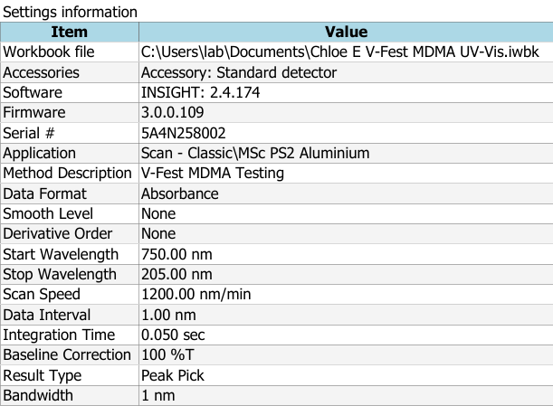

Results

HPLC Results and Discussion
MDMA was successfully quantified in all analysed samples using HPLC, with well defined peaks observed at consistent retention times, indicating reliable chromatographic separation. The method demonstrated good selectivity with no significant interfering peaks observed at the retention time corresponding to MDMA as shown in Figure 1.
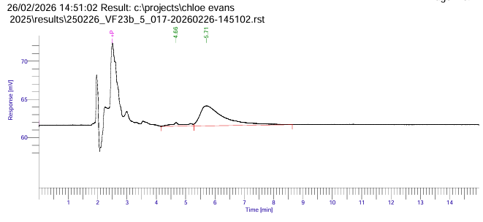
Figure 1: VF23B 5 HPLC Chromatogram
A calibration curve as shown in Figure 2 exhibited strong linearity, supporting the suitability of the method for quantitative analysis.

Figure 2: HPLC Calibration Curve 250226

The MDMA content across all tablet samples showed substantial variability, ranging from 39.4586 mg to 213.4468 mg per tablet. This highlights the inconsistency within tablet composition, which is commonly reported in illicit drug markets and presents as significant risk in terms of dosing and potential harm. This variability reinforces the importance of testing in harm reduction contexts, where users may otherwise be unaware of dosage strength.
To assess the repeatability of the HPLC method, sample VF23B was analysed 10 times with a mean MDMA content of 43.42mg per tablet. This has given a relative standard deviation of 8.15% indicating an acceptable repeatability of the methods, although some variability between the repeats were observed. The variation in the results may be an indication of inaccurate sample preparation or instrumental fluctuations. Despite this, the method demonstrates sufficient precision for quantitative analysis in the context of harm reduction.

UV-Vis Results and Discussion
MDMA was successfully quantified using UV-Vis spectroscopy, with absorbance values showing a consistent relationship with concentration across all samples. The method enables rapid quantification without the need for chromatographic separation. Across all samples, the MDMA content ranged from 37.85 mg to 232.91 mg per tablet, demonstrating substantial variability in tablet composition. This aligns with the HPLC findings and reinforces the unpredictability of illicit drug content.
The precision of the UV-Vis method was assessed using a repeat of ten measurements of sample VF23B. The mean MDMA content was 51.70 mg per tablet, giving an RSD of 1.20%. This low RSD indicates excellent repeatability, with minimal variation between repeated measurements, demonstrating a high degree of consistency in the analytical response.

Mass Loss Results and Discussion
Mass loss analysis was used as an alternative approach to estimate the MDMA content by measuring the difference in mass before and after extraction. The calculated MDMA content showed extreme variability, ranging from large positive results of 299.01 mg to -81209.4850 mg per tablet.
Without using the negative results, the average MDMA content obtained from this method was 205.76 mg per tablet.
Unlike HPLC and UV-Vis, the mass loss analysis method produced highly inconsistent and physically unrealistic results, including negative MDMA values. Since negative mass of MDMA is not chemically possible, this is a clear indication of significant methodological error.
The large variability and invalid results may be attributed to several limitations such as the sensitivity of balances as the method relies on measuring very small differences in mass, the assumption that all that is lost is the mass of MDMA and it not being other substances such as fillers or binders, incomplete evaporation of solvents and incomplete extraction of MDMA. Because of these limitations, any small error can be the result in negative values or extremely high values as the end result.
Because of the current unreliability of the method, it would not be advised to be used in a harm reduction setting as inaccurate quantification could lead to dangerous misinterpretation of drug strength, potentially increasing the risk of drug overdose.

Discussion
A paired samples T-Test was conducted using SPSS to compare MDMA quantification obtained by HPLC and UV-Vis spectroscopy. The results showed that there is a statistically significant difference between the two methods (p <0.001) indicating that the average values produced by HPLC and UV-Vis are not equivalent as shown in Figure 3.
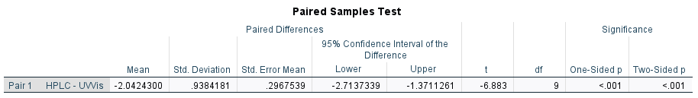
Figure 3: Paired Sample T-Test between HPLC and UV-Vis
The highly significant result suggests that UV-Vis spectroscopy systematically produces different MDMA concentrations compared to HPLC. This discrepancy is likely due to differences in analytical specificity.
Although UV-Vis spectroscopy demonstrated excellent precision, the significant difference from HPLC suggests that it cannot directly replace HPLC for accurate quantification. However, UV-Vis is still valuable in on-site settings for rapid screening purposes provided that its deviation from HPLC is understood and accounted for. In the context of harm reduction, it is better to overestimate the concentration of the drug present than to underestimate the concentration as the only negative would be the user may not have as much of the effects upon taking the drug.
Due to the mass loss analysis method exhibiting inconsistent results, comparisons with the other methods were not possible.

Conclusion and further work
The comparative evaluation of HPLC, UV-Vis and mass loss analysis highlights clear differences in analytical performance, practicality, and suitability for harm reduction applications.
High performance liquid chromatography demonstrated the highest level of analytical accuracy, specificity and reproducibility. The technique provided reliable quantification of MDMA with well-established chromatographic peaks and strong calibration linearity. However, despite its suitability as a confirmatory forensic method, HPLC is limited by its lack of portability, high operational cost requirement for specialist training and reliance on laboratory infrastructure. As a result, it is unsuitable for on-site or festival-based drug checking environments where rapid results are required.
UV-Vis spectroscopy showed a strong potential as a compromise between analytical reliability and operational practicality. While it demonstrated lower specificity than HPLC and produced a statistically different concentration value, it achieved excellent repeatability consistent quantitative trends. Importantly, UV-Vis instruments are significantly more portable, cost-effective and easier to operate than chromatographic systems, making them more feasible for on-site harm reduction services.
Mass loss analysis proved to be the least reliable method. although it is highly accessible, inexpensive and requires minimal technical expertise or instrumentation, the method produced inconsistent results and, in some cases, physically impossible results. the techniques heavy reliance on assumptions regarding solubility and complete separation of MDMA from the sample makes it unsuitable for accurate quantification in its current form.
Further work that could be implemented is to conduct onsite research of the implementation of UV-Vis Spectroscopy to assess the applicability of this research out of a laboratory setting to aid in harm reduction. Another area of research is into the limitations of the Mass Loss Analysis method to determine why the method is inconsistent with its results. If this method proves reliable it would be a cheaper and more efficient method compared the UV-Vis method of analysis.

References
Alcohol and Drug Foundation (2023). MDMA - Alcohol and Drug Foundation. [online] Adf.org.au. Available at: https://adf.org.au/drug-facts/mdma/ [Accessed 9 Apr. 2026].
Anderson, L. (2014). MDMA. [online] Drugs.com. Available at: https://www.drugs.com/illicit/mdma.html [Accessed 6 Oct. 2025].
Cooney, T. and Measham, F. (2023). Counting and accounting for drug-related deaths at UK music festivals 2017–2023: A commentary. Drug Science, Policy and Law, [online] 9. doi:https://doi.org/10.1177/20503245231211444.
Dong, M.W. (2005). 3 HPLC instrumentation in pharmaceutical analysis: Status, advances, and trends. Separation Science and Technology, pp.47–75. doi:https://doi.org/10.1016/s0149-6395(05)80047-9.
Dong, M.W. and Llanas, A. (2013). The Essence of Modern HPLC: Advantages, Limitations, Fundamentals, and Opportunities. [online] ResearchGate. Available at: https://www.researchgate.net/publication/342885307_The_Essence_of_Modern_HPLC_Advantages_Limitations_Fundamentals_and_Opportunities [Accessed 17 Apr. 2026].
DrugWise (2022). Harm Reduction. [online] DrugWise. Available at: https://www.drugwise.org.uk/harm-reduction-2/ [Accessed 25 Mar. 2026].
Eric (2025). HPLC Methods for Pharmaceutical Research and Development - GL Tec. [online] Gl-tec.com. Available at: https://www.gl-tec.com/industry-articles/264-hplc-methods-for-pharmaceutical-research-and-development.html [Accessed 19 Dec. 2025].
Europa.eu. (2025). MDMA – the current situation in Europe (European Drug Report 2025) | www.euda.europa.eu. [online] Available at: https://www.euda.europa.eu/publications/european-drug-report/2025/mdma_en [Accessed 21 Nov. 2025].
Ghosh, S. and Nandi, S. (2024). A Comprehensive Review on UV-Visible Spectroscopy and Its Application. International Journal of All Research Education & Scientific Methods, [online] 12(1), pp.1501–1507. doi:https://doi.org/10.56025/IJARESM.2023.1201241025.
GOV.UK (2025). Drugs Penalties. [online] Gov.uk. Available at: https://www.gov.uk/penalties-drug-possession-dealing [Accessed 12 Nov. 2025].
GOV.UK. (2021). United Kingdom drug situation 2019: Focal Point annual report. [online] Available at: https://www.gov.uk/government/publications/united-kingdom-drug-situation-focal-point-annual-report/united-kingdom-drug-situation-focal-point-annual-report-2019#mdma [Accessed 25 Mar. 2026].
Home Office (2025). Seizures of drugs in England and Wales, financial year ending 2024. [online] GOV.UK. Available at: https://www.gov.uk/government/statistics/seizures-of-drugs-in-england-and-wales-financial-year-ending-2024/seizures-of-drugs-in-england-and-wales-financial-year-ending-2024 [Accessed 25 Mar. 2026].
Janes, J. (2025). Welfare first: transforming harm reduction at UK festivals. Harm Reduction Journal, [online] 22(1). doi:https://doi.org/10.1186/s12954-025-01184-1.
L.C. Passos, M. and M.F.S. Saraiva, M.L. (2019). Detection in UV-visible spectrophotometry: Detectors, detection systems, and detection strategies. Measurement, 135(135), pp.896–904. doi:https://doi.org/10.1016/j.measurement.2018.12.045.
Measham, F. (2024). ‘SIZE MATTERS’: High strength ecstasy pills are back, so harm reduction communications need to adapt. [online] Drug Science. Available at: https://www.drugscience.org.uk/size-matters-high-strength-ecstasy [Accessed 25 Mar. 2026].
Muhammad Taufik, Miranda, R.A.F. and Andriayani Andriayani (2025). Validation Method of 3,4-Methylenedioxymethamphetamine (MDMA) Analysis Using Gas Chromatography Mass Spectroscopy. Journal of Chemical Natural Resources, [online] 7(1), pp.71–79. doi:https://doi.org/10.32734/jcnar.v7i1.21032.
Muller, I.B. and Windberg, C.N. (2005). Validation of an HPLC Method for Quantitation of MDMA in Tablets. Journal of Chromatographic Science, 43(8), pp.434–437. doi:https://doi.org/10.1093/chromsci/43.8.434.
Munawar, K.S., Sameer, M., Javed, M., Abbas, S.M., Javid, J., Ahmad, T. and Hussain, S. (2024). A new analytical methodology for the detection of Methamphetamine using UV-Vis, FTIR, and GC-MS techniques. NUST Journal of Natural Sciences, [online] 9(1). doi:https://doi.org/10.53992/njns.v9i1.157.
Office, H. (2026). Seizures of drugs in England and Wales, financial year ending 2025. [online] GOV.UK. Available at: https://www.gov.uk/government/statistics/seizures-of-drugs-in-england-and-wales-financial-year-ending-2025/seizures-of-drugs-in-england-and-wales-financial-year-ending-2025 [Accessed 9 Apr. 2026].
Pascoe, M., Jones, G., Simmons, H., Radley, S., Thomas, J., Blagbrough, I., Cozier, G. and Measham, F. (2025a). Assessing the suitability of ‘mass loss analysis’ as a low cost, low technology test to approximate MDMA content in ecstasy tablets, using laboratory and field comparisons . [online] doi:https://doi.org/10.21203/rs.3.rs-7670422/v1.
Pascoe, M., Jones, G., Simmons, H., Radley, S., Thomas, J., Blagbrough, I., Cozier, G. and Measham, F. (2025b). Assessing the suitability of ‘mass loss analysis’ as a low cost, low technology test to approximate MDMA content in ecstasy tablets, using laboratory and field comparisons . Harm Reduction Journal. [online] doi:https://doi.org/10.21203/rs.3.rs-7670422/v1.
Pathum Wathudura, Pham, H., Kumudu Siriwardana, Sumudu Athukorale, Udaya Jayasundara, Gunatilake, S.R., Cao, Z.-Y., Collier, W.E., Moon, A. and Zhang, D. (2025). Expanding the Horizons of UV–vis Spectroscopy Education: Beyond the Beer–Lambert Law. Journal of Chemical Education. doi:https://doi.org/10.1021/acs.jchemed.5c00255.
SAFETY DATA SHEET. (2023). [online] Sigma Aldrich . Sigma Aldrich. Available at: https://www.sigmaaldrich.com/GB/en/sds/sial/270997?userType=undefined [Accessed 6 Nov. 2025].
Shravani S. More, S.S.M., Sandhya P. Kadam, S.P.K. and Dr. Vivekkumar K.Redasani, Dr.V.K.Redasani. (2025). A Comprehensive Review of UV-visible spectroscopy. International Journal of Pharmaceutical Research and Applications, 10(3), pp.114–134. doi:https://doi.org/10.35629/4494-1003114134.
Stewart, C. (2021). England, Wales: MDMA deaths 1993-2018. [online] Statista. Available at: https://www.statista.com/statistics/470824/drug-poisoning-deaths-mdma-ecstasy-in-england-and-wales/ [Accessed 14 Nov. 2025].
The Loop. (n.d.). Our Laboratory Methods. [online] Available at: https://wearetheloop.org/our-laboratory-methods [Accessed 30 Jan. 2026].
Wallace, B., van Roode, T., Pagan, F., Phillips, P., Wagner, H., Calder, S., Aasen, J., Pauly, B. and Hore, D. (2020). What is needed for implementing drug checking services in the context of the overdose crisis? A qualitative study to explore perspectives of potential service users. Harm Reduction Journal, 17(1). doi:https://doi.org/10.1186/s12954-020-00373-4.
www.talktofrank.com. (n.d.). Ecstasy | FRANK. [online] Available at: https://www.talktofrank.com/drug/ecstasy#how-do-people-take-it [Accessed 12 Nov. 2025].

Appendices

Appendix 1: Approved Ethics disclaimer form
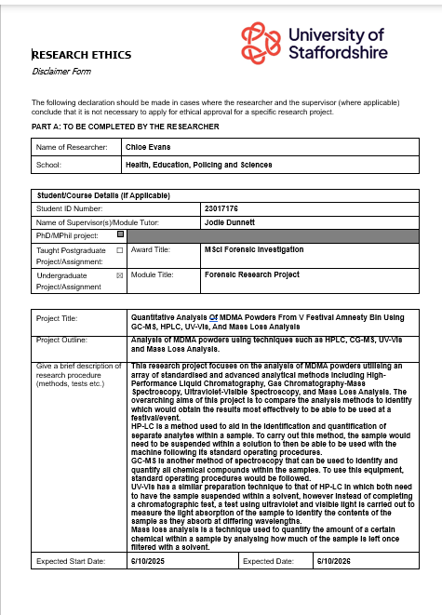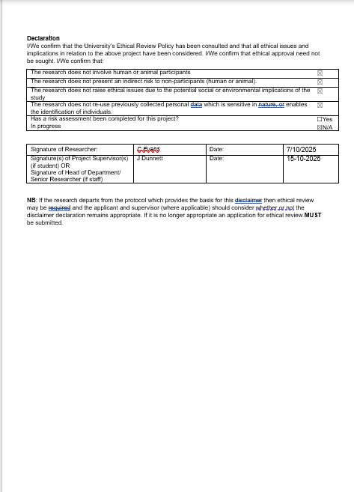

Appendix 2: Approved Practical Risk Assessment
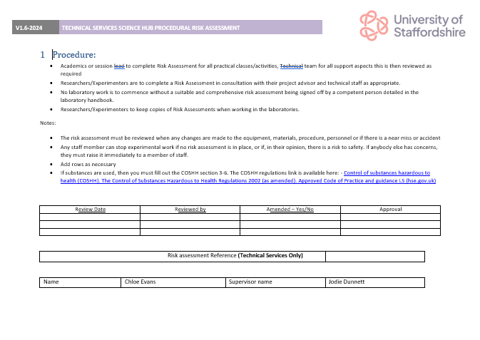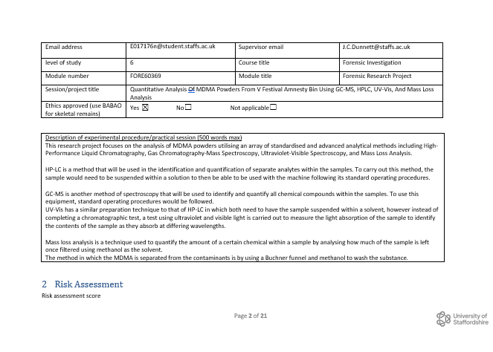
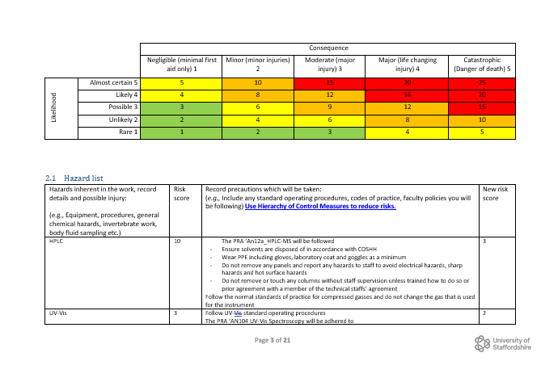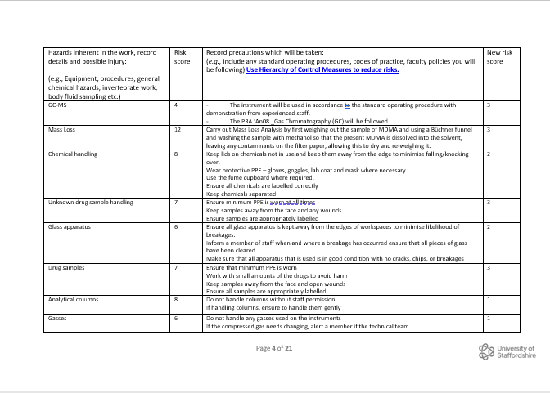

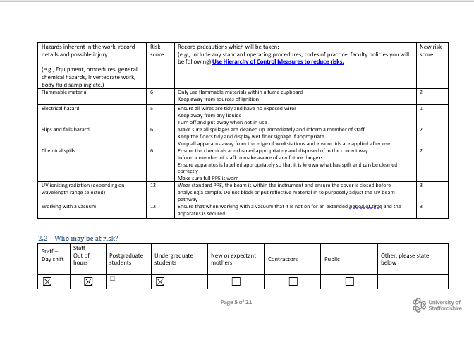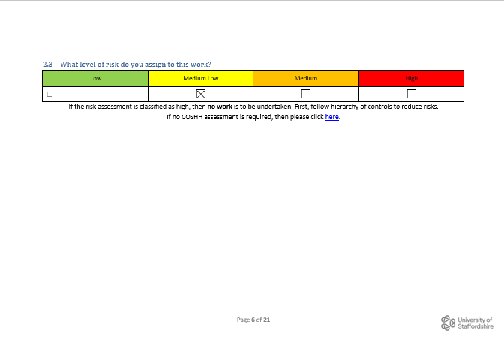

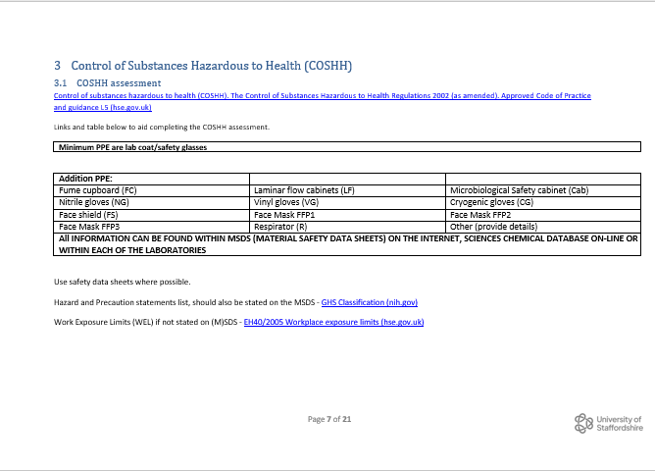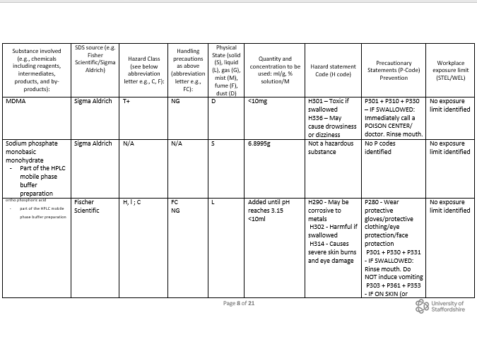

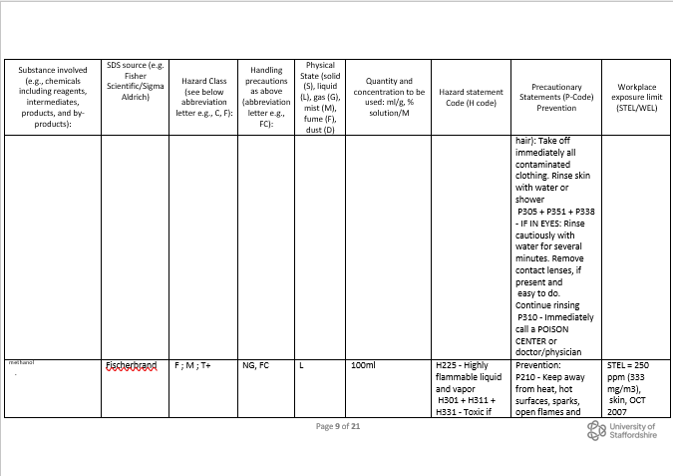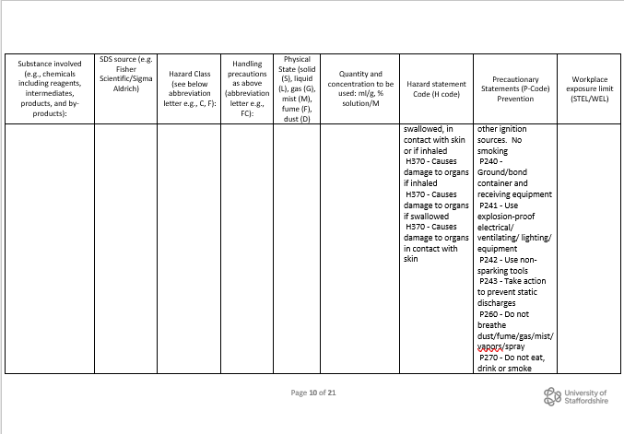

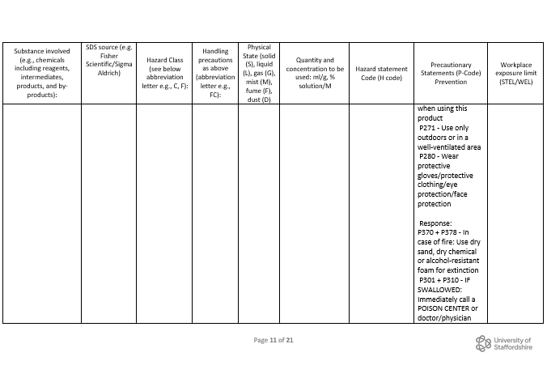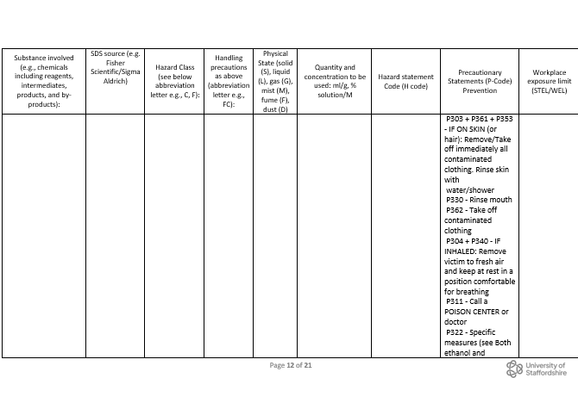

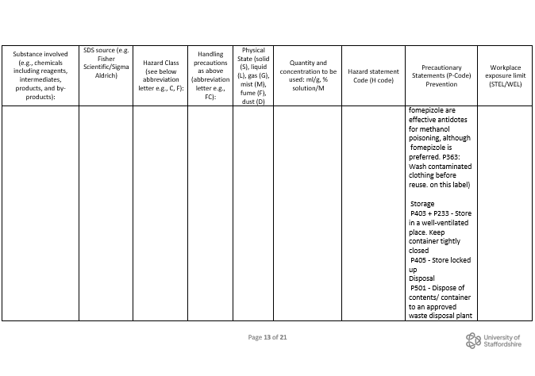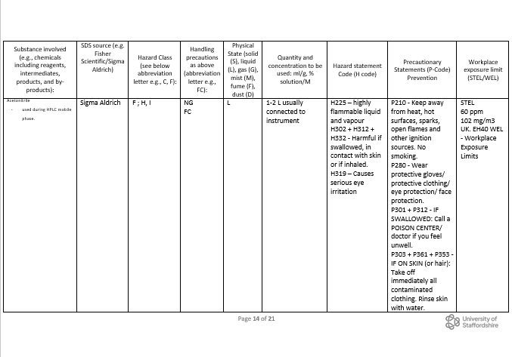

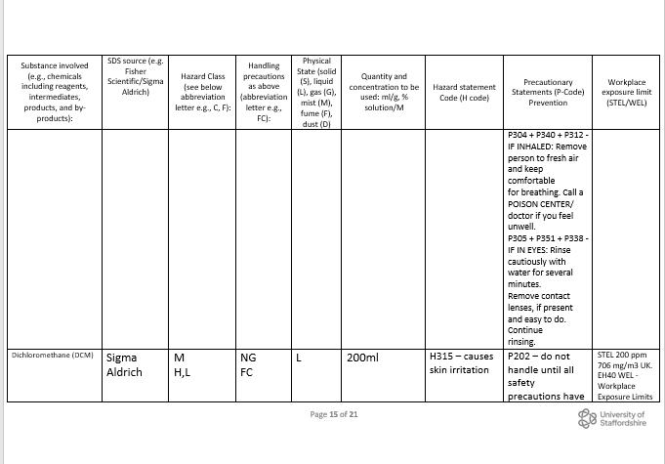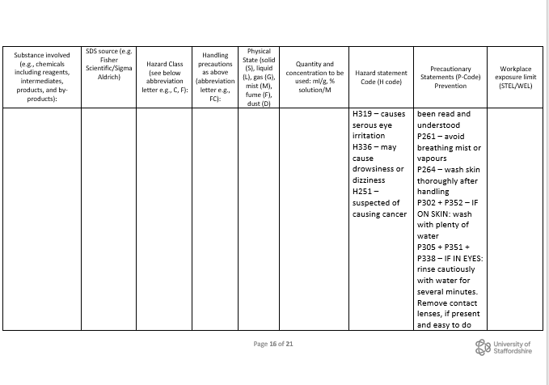

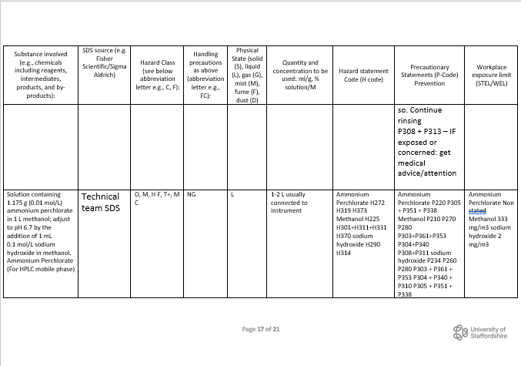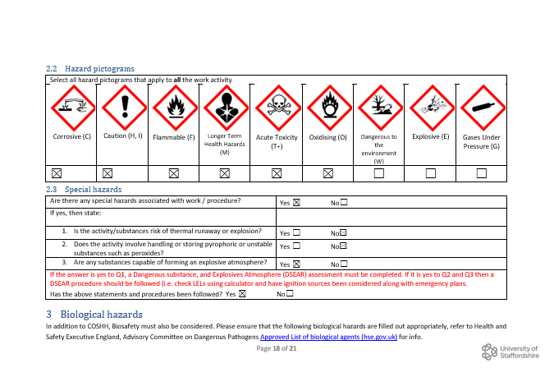

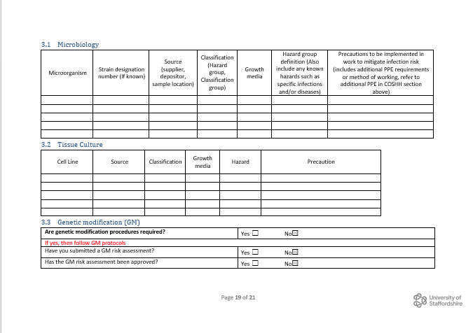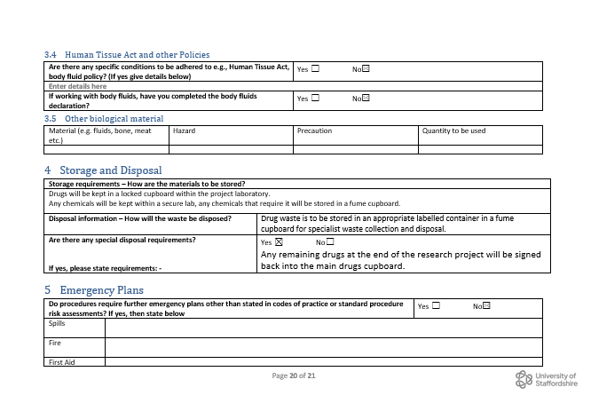

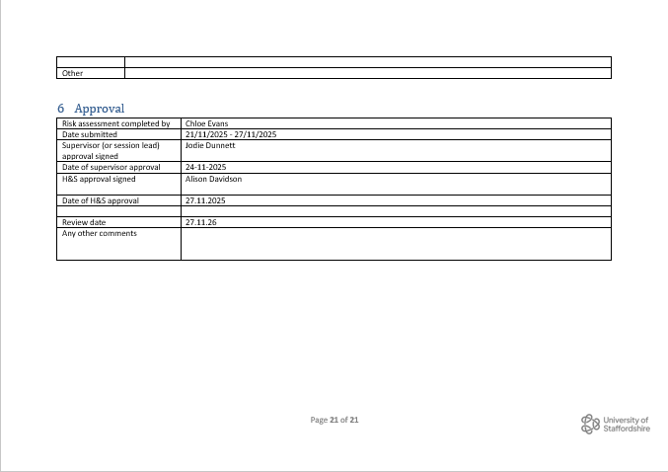

Appendix 3: Completed Project lab induction
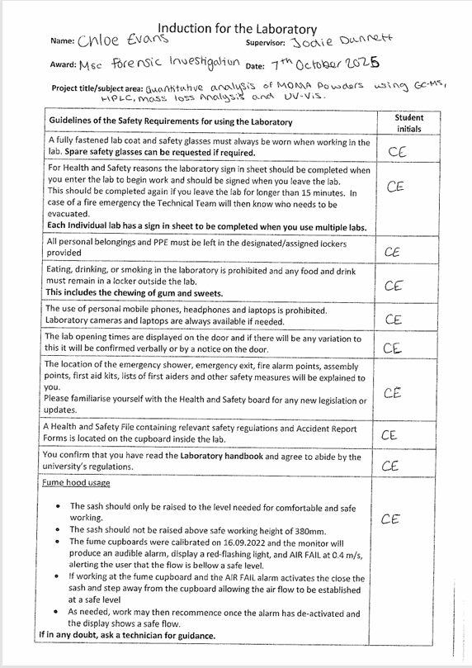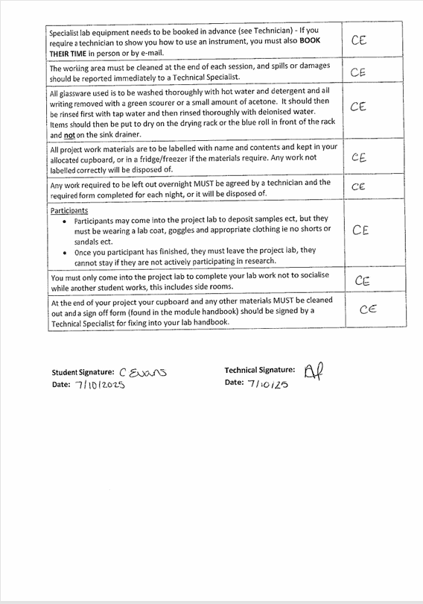

Appendix 4: Completed Analytical lab induction
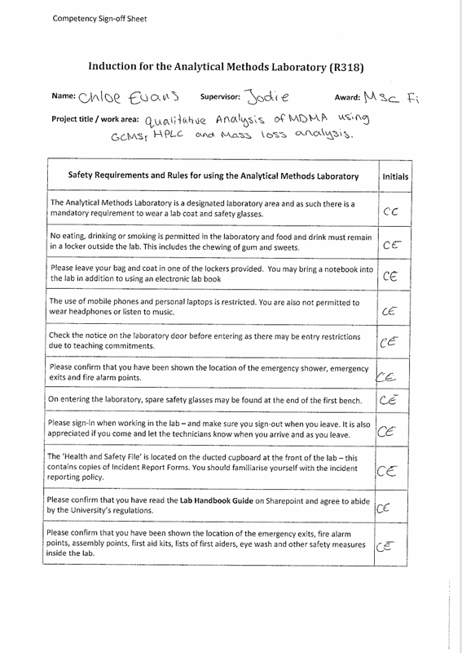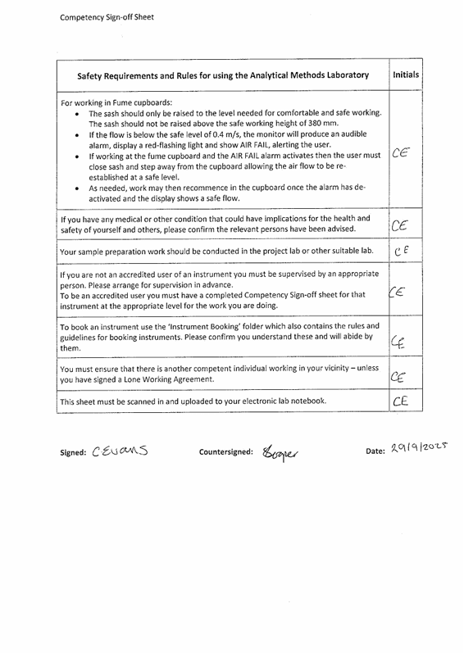

Appendix 5: Completed HPLC Competency

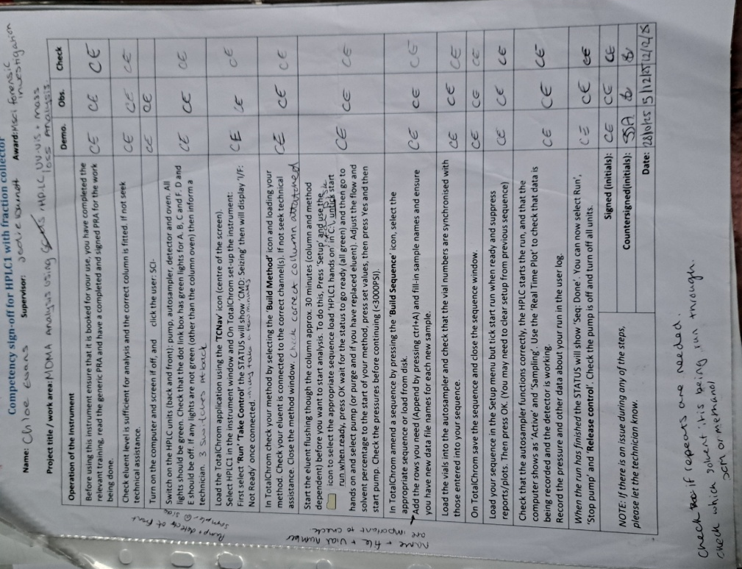

Appendix 6: Completed UV-Vis Competency
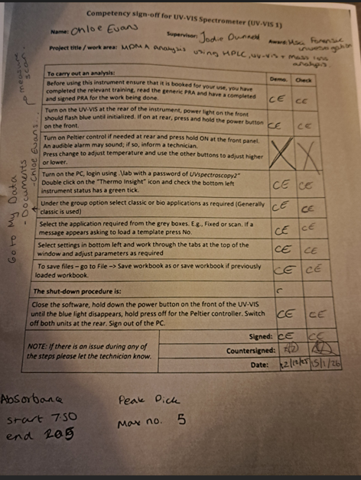

Appendix 7: Completed Laboratory cupboard cleanout sheet
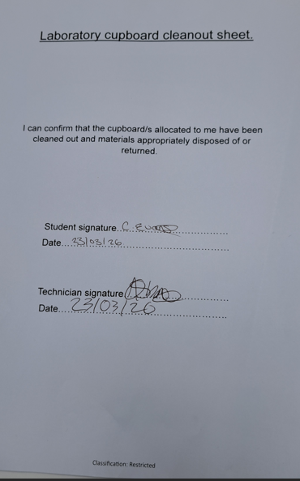

Appendix 8: HPLC Chromatogram 280126 Blank Methanol 013
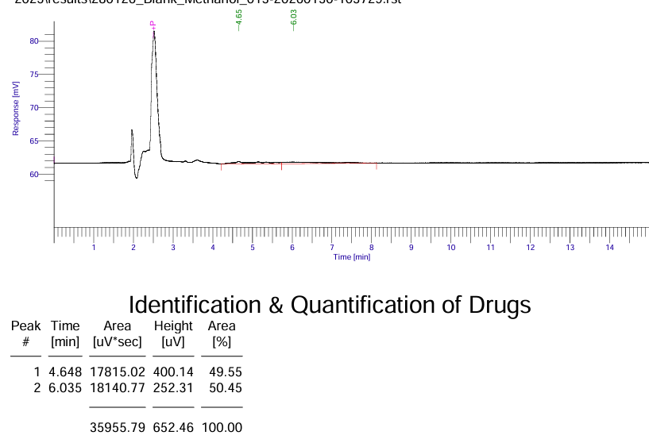

Appendix 9: HPLC Chromatogram 280126 MDMA Standard 100ul
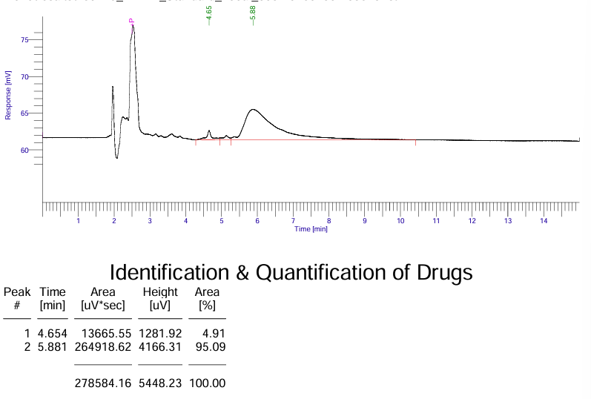

Appendix 10: HPLC Chromatogram 280126 MDMA Standard 200ul
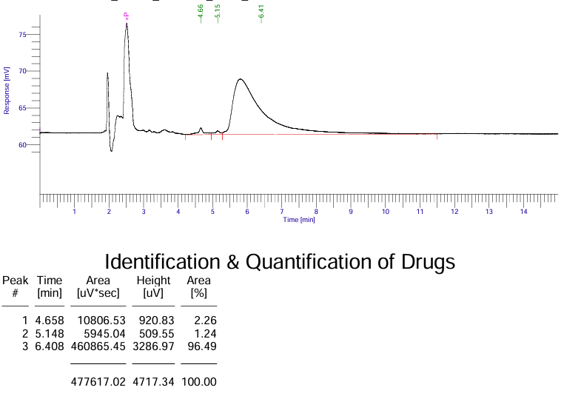

Appendix 11: HPLC Chromatogram 280126 MDMA Standard 300ul
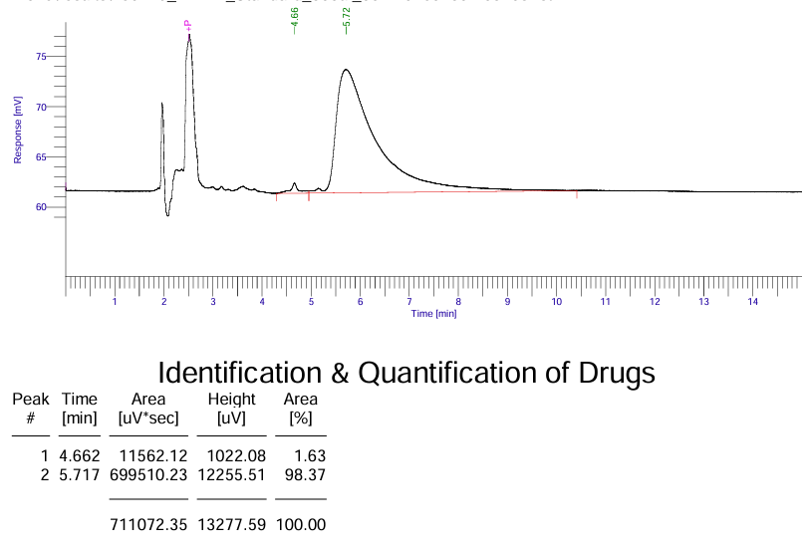

Appendix 12: HPLC Chromatogram 280126 MDMA Standard 400ul
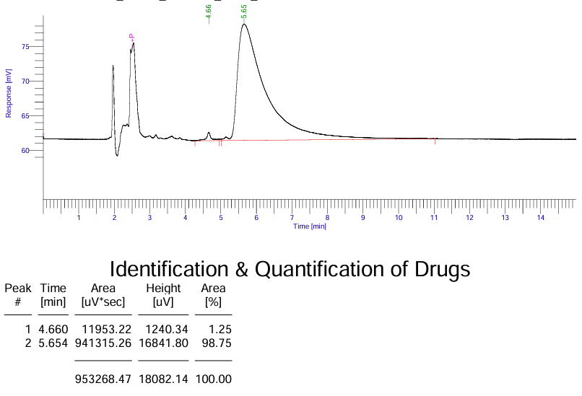

Appendix 13: HPLC Chromatogram 280126 MDMA Standard 500ul
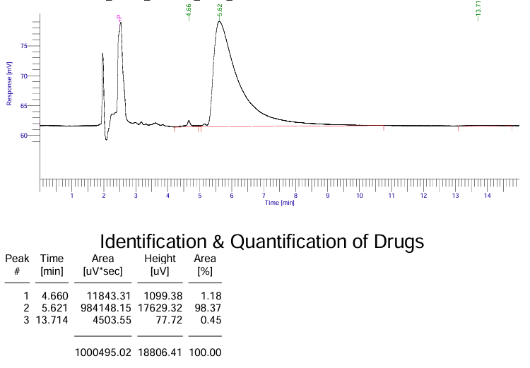

Appendix 14: HPLC Chromatogram 280126 VFID
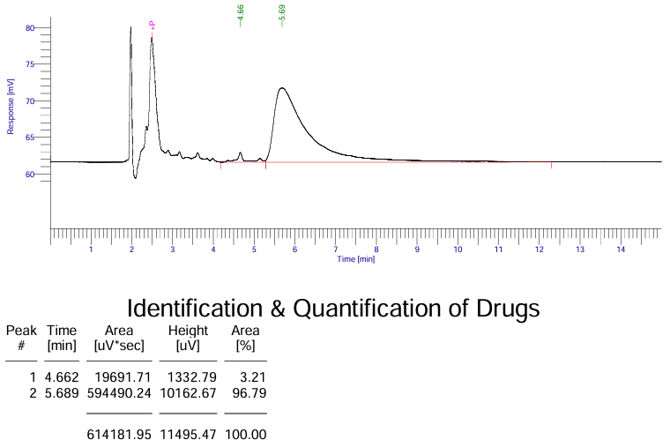

Appendix 15: HPLC Chromatogram 280126 VFIA
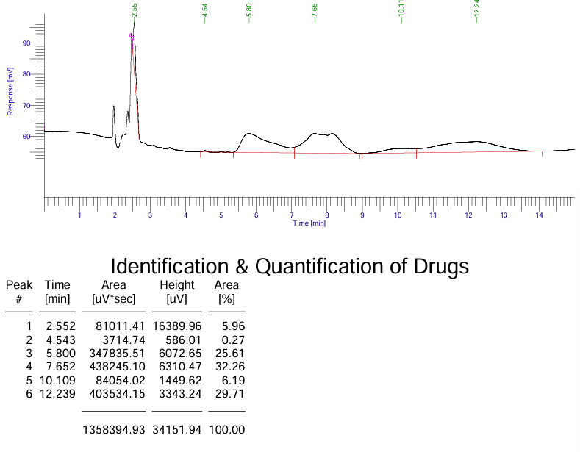

Appendix 16: HPLC Chromatogram 280126 VFIB
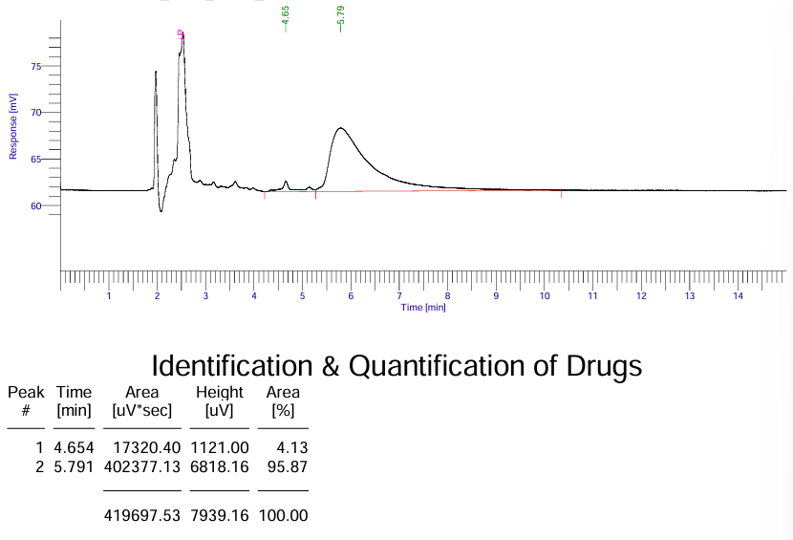

Appendix 17: HPLC Chromatogram 280126 VFIC
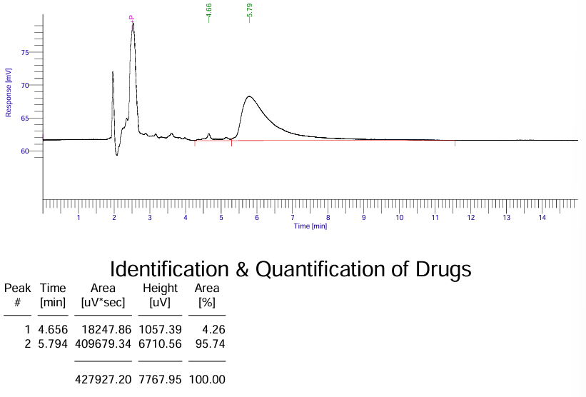

Appendix 18: HPLC Chromatogram 280126 VFIE
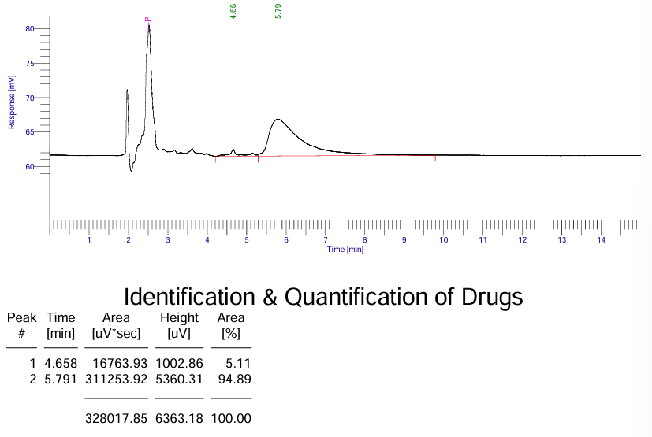

Appendix 19: HPLC Chromatogram 280126 VFIF
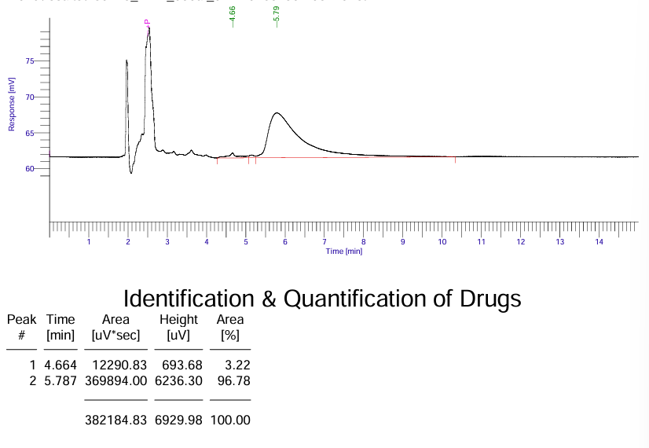

Appendix 20: HPLC Chromatogram 280126 VFIG
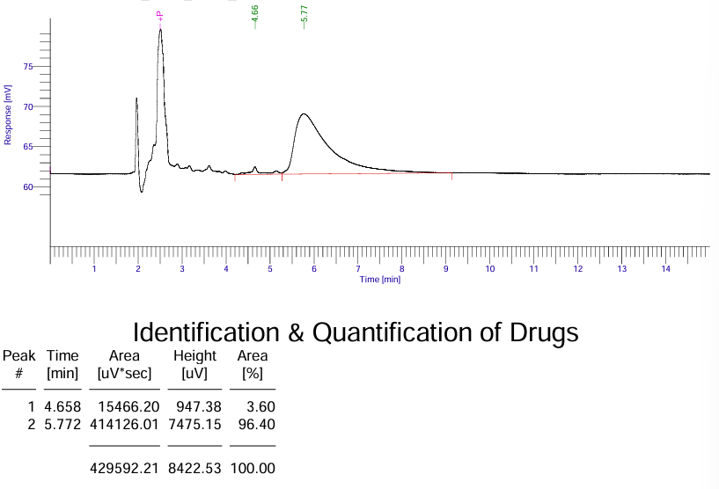

Appendix 21: HPLC Chromatogram 280126 VFIH
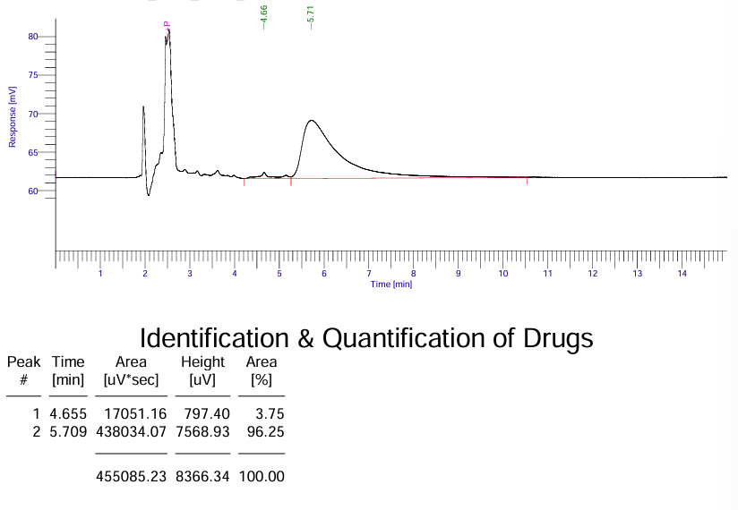

Appendix 22: HPLC Chromatogram 280126 VFII
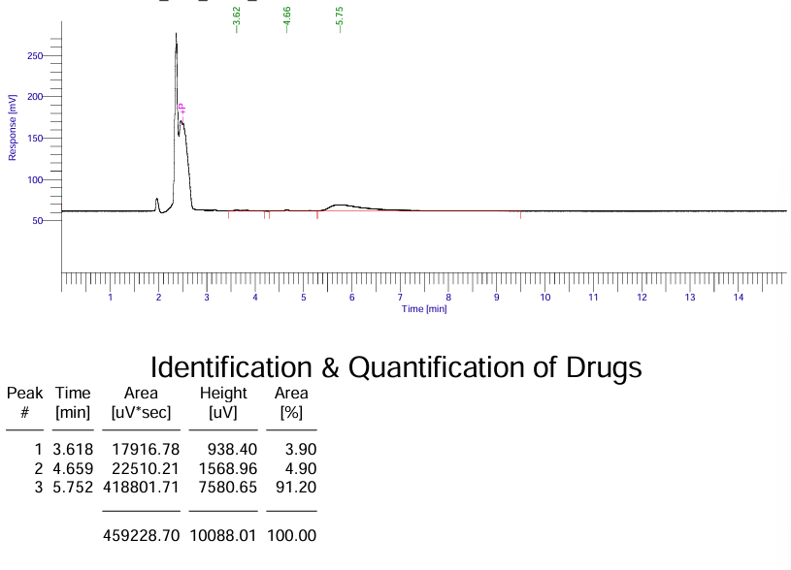

Appendix 23: HPLC Chromatogram 280126 VFIJ
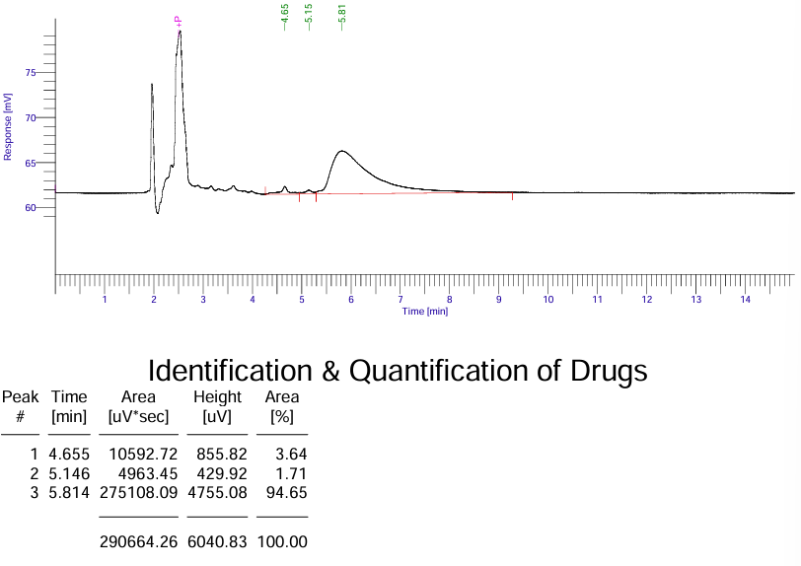

Appendix 24: HPLC Chromatogram 050226 Blank Methanol 002
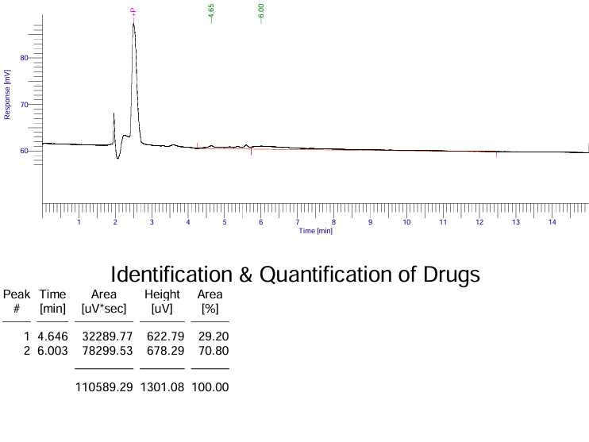

Appendix 25: HPLC Chromatogram 050226 MDMA Standard 100ul
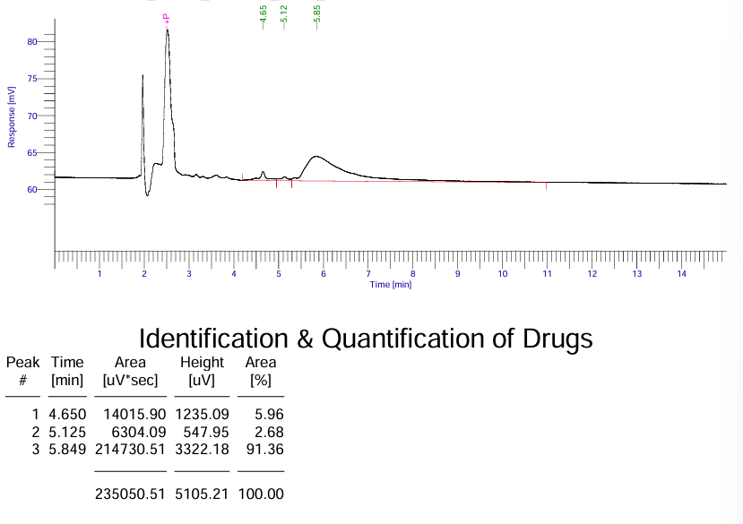

Appendix 26: HPLC Chromatogram 050226 MDMA Standard 200ul
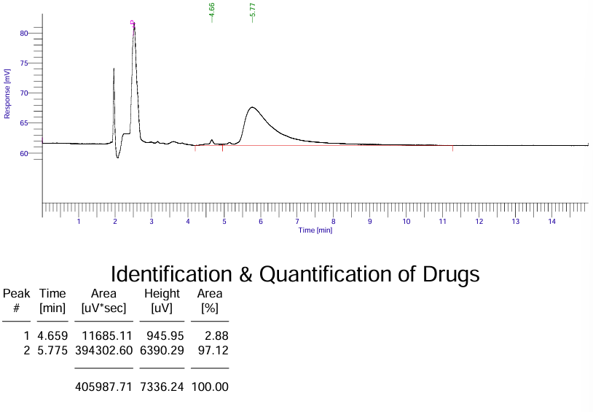

Appendix 27: HPLC Chromatogram 050226 MDMA Standard 300ul
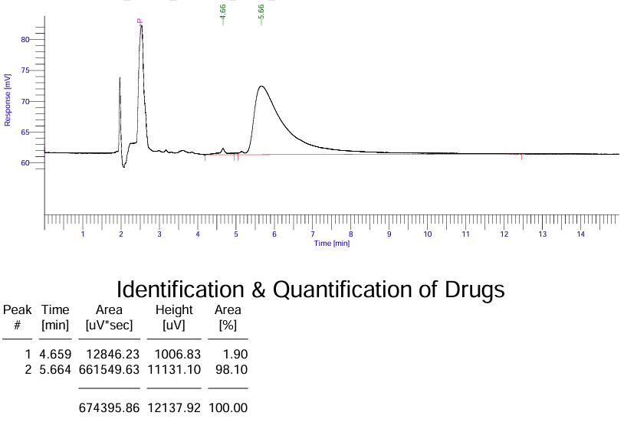

Appendix 28: HPLC Chromatogram 050226 MDMA Standard 400ul
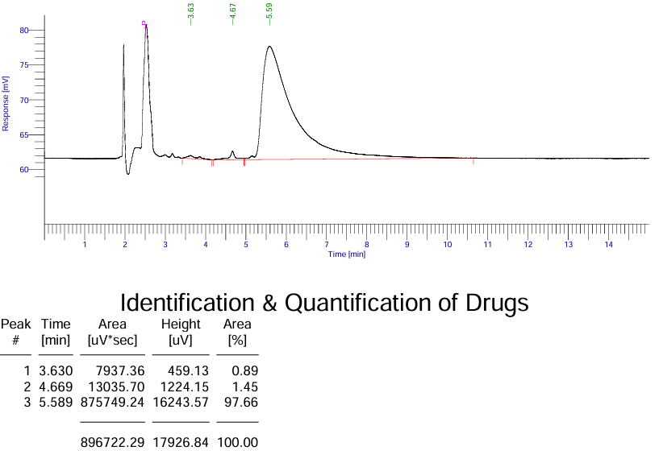

Appendix 29: HPLC Chromatogram 050226 MDMA Standard 500ul
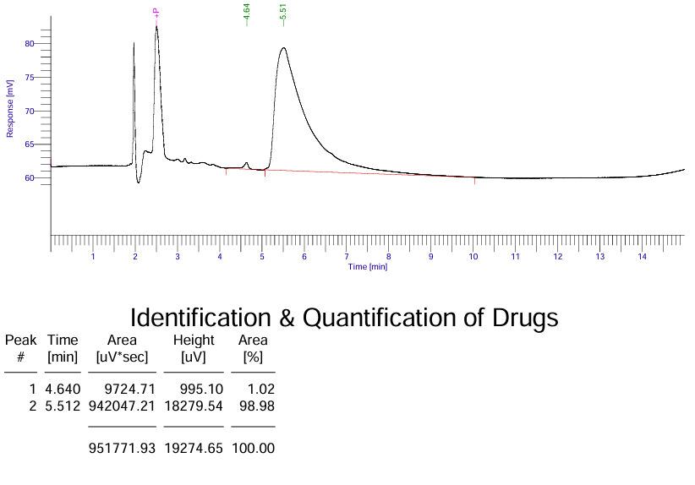

Appendix 30: HPLC Chromatogram 050226 VF22A
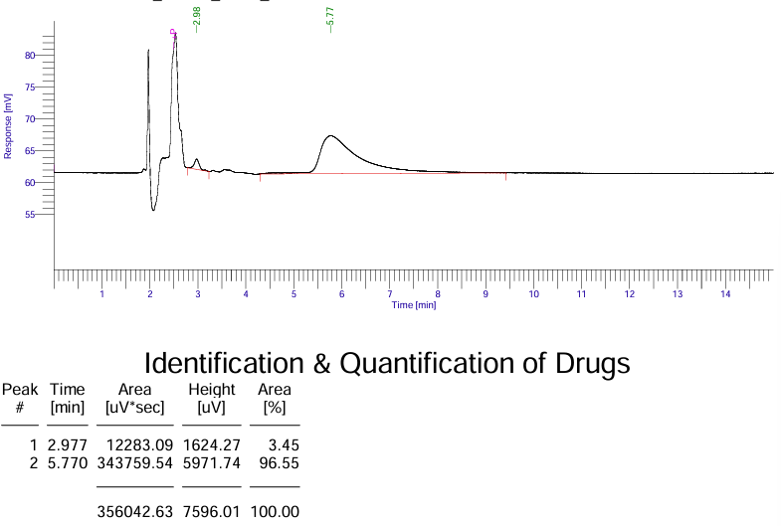

Appendix 31: HPLC Chromatogram 050226 VF23B
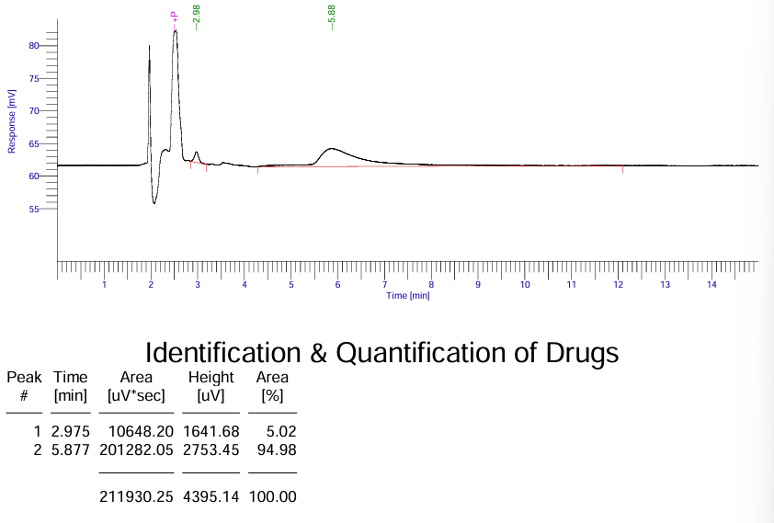

Appendix 32: HPLC Chromatogram 050226 VF24A
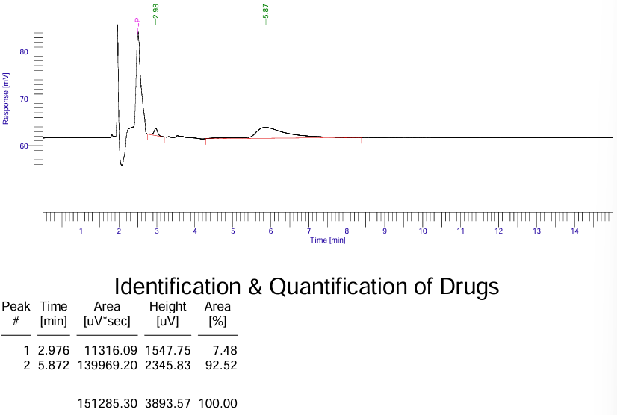

Appendix 33: HPLC Chromatogram 050226 VF25A
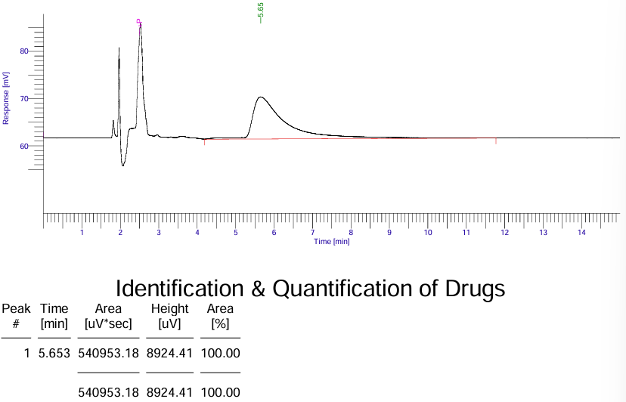

Appendix 34: HPLC Chromatogram 050226 VF26A
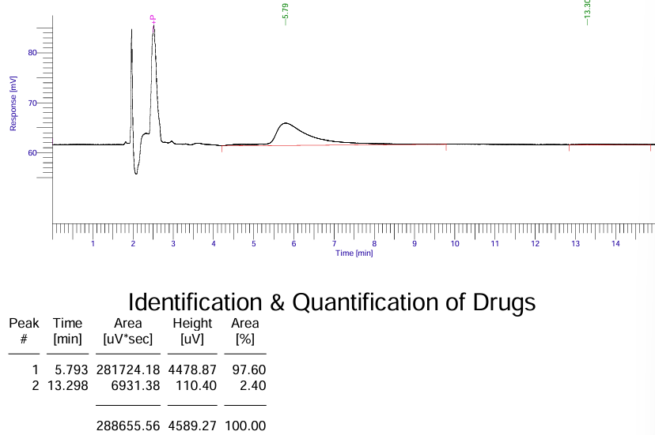

Appendix 35: HPLC chromatogram 050226 VF27D
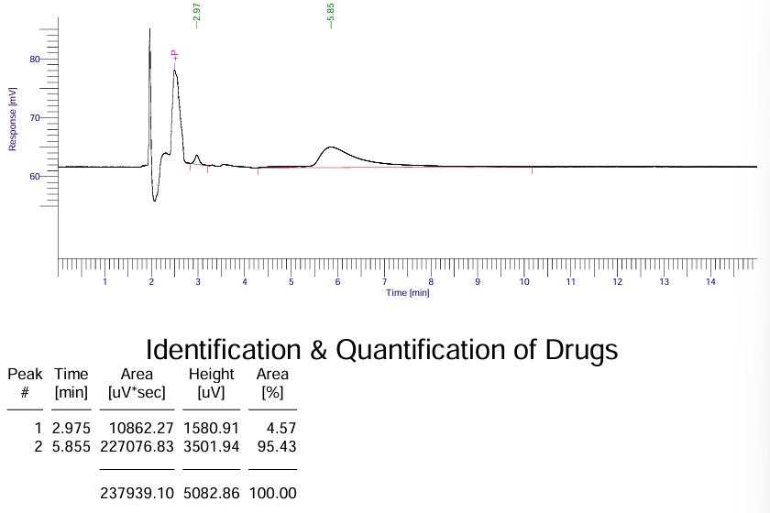

Appendix 36: HPLC Chromatogram 050226 VF28A
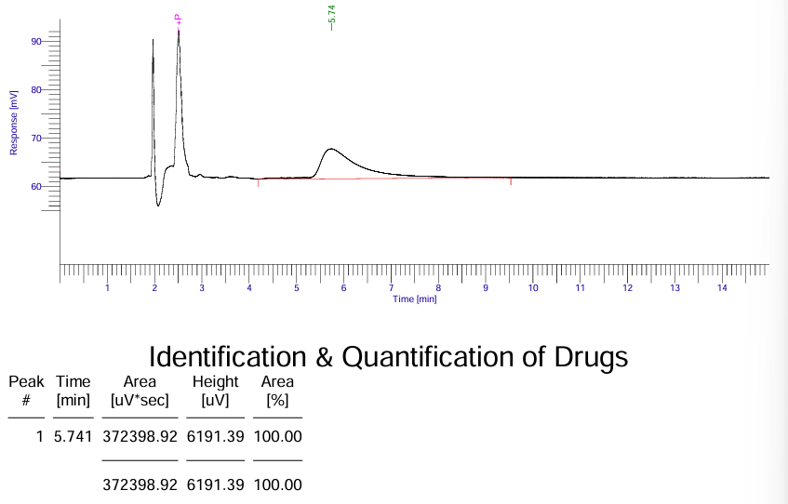

Appendix 37: HPLC Chromatogram 050226 VF29A
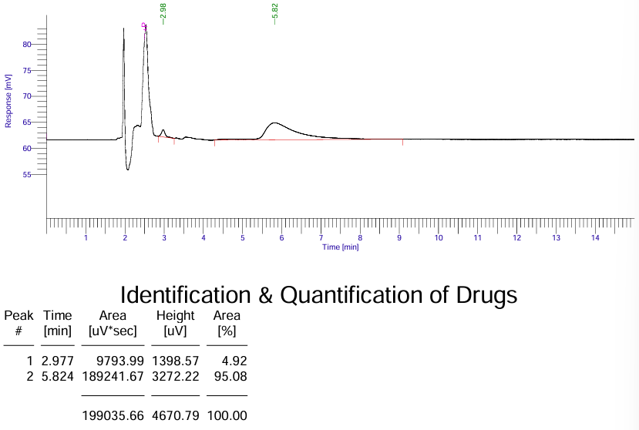

Appendix 38: HPLC Chromatogram 050226 VF30B
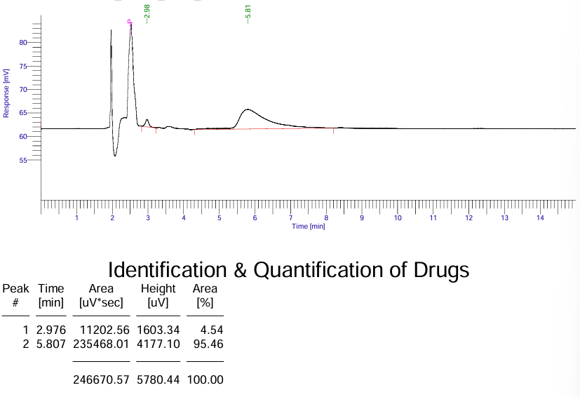

Appendix 39: HPLC Chromatogram 050226 VF31E
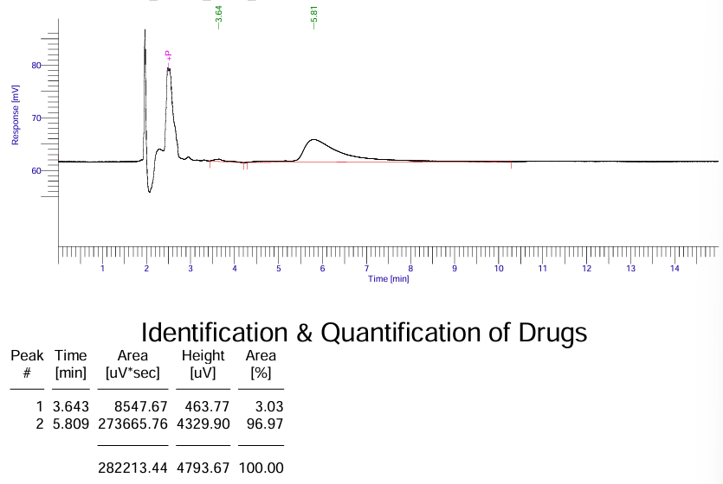

Appendix 40: HPLC Chromatogram 060226 Blank Methanol 001
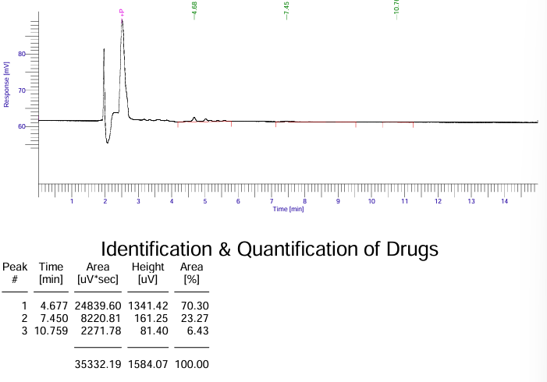

Appendix 41: HPLC Chromatogram 060226 MDMA Standard 100ul
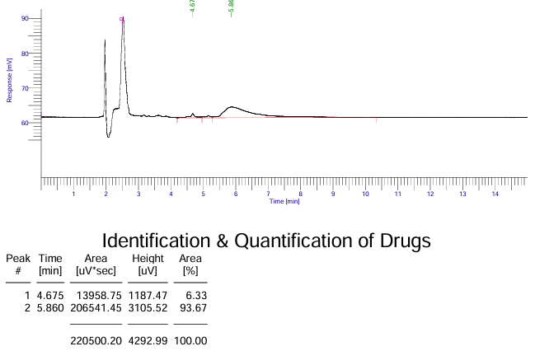

Appendix 42: HPLC Chromatogram 060226 MDMA Standard 500ul
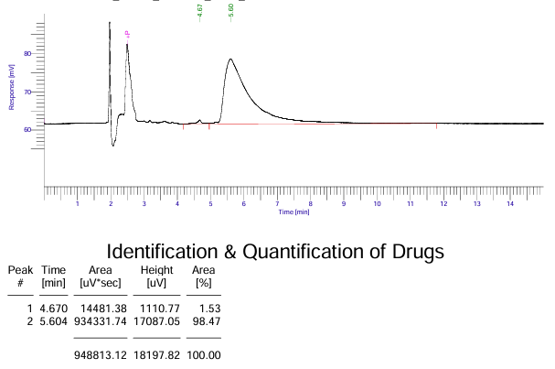

Appendix 43: HPLC Chromatogram 060226 VF32D
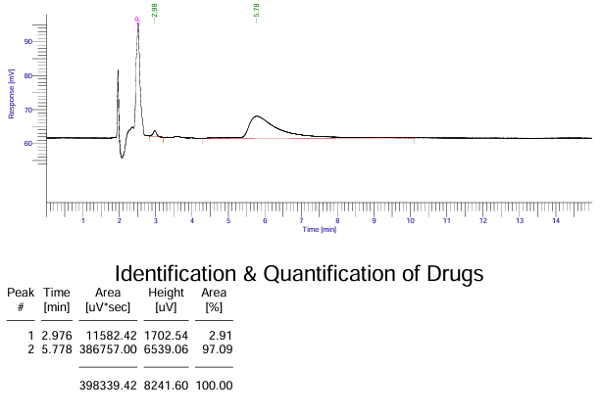

Appendix 44: HPLC Chromatogram 060226 VF33A
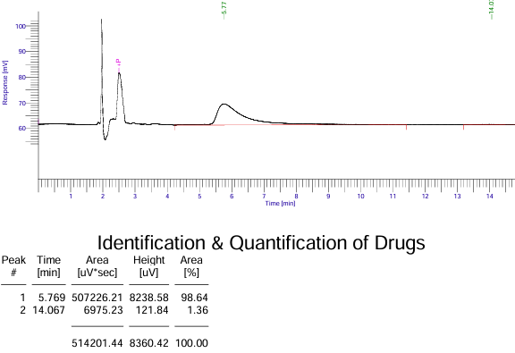

Appendix 45: HPLC Chromatogram 060226 VF34A
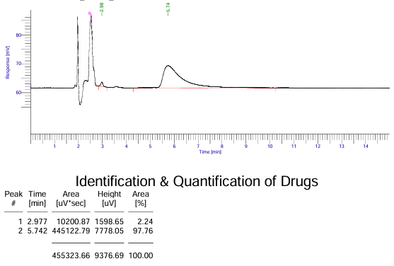

Appendix 46: HPLC Chromatogram 250226 Blank Methanol 004
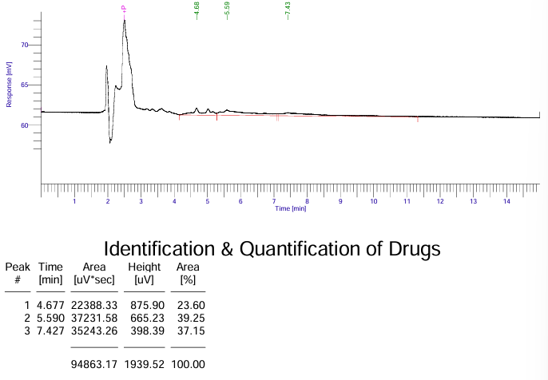

Appendix 47: HPLC Chromatogram 250226 MDMA Standard 100ul
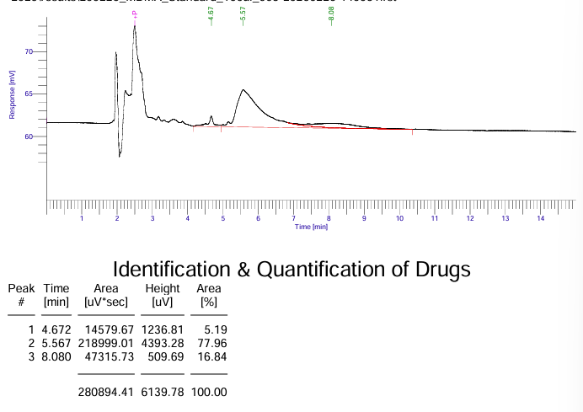

Appendix 48: HPLC Chromatogram 250226 MDMA Standard 200ul
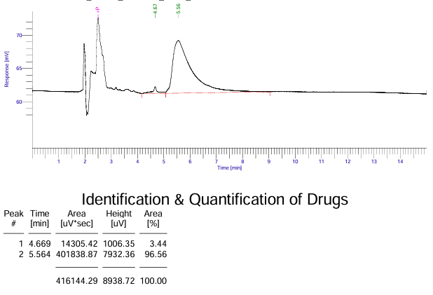

Appendix 49: HPLC Chromatogram 250226 MDMA Standard 300ul
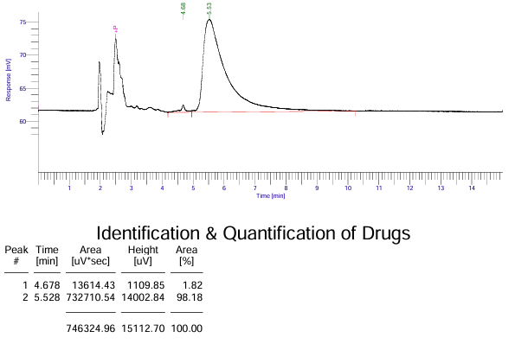

Appendix 50: HPLC Chromatogram 250226 MDMA Standard 400ul
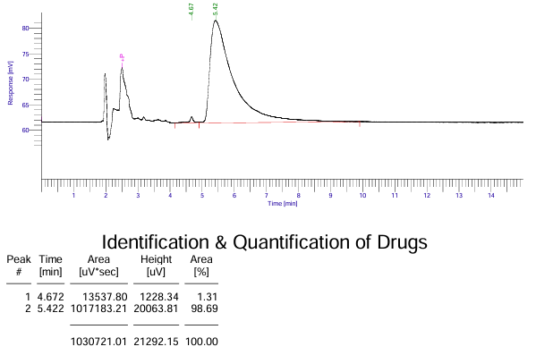

Appendix 51: HPLC Chromatogram 250226 MDMA Standard 500ul
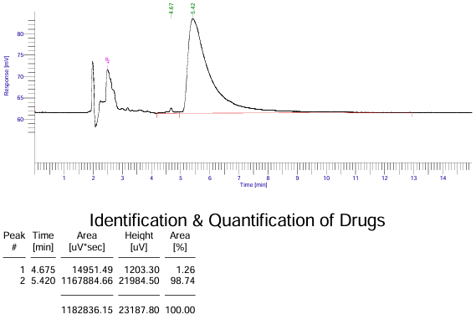

Appendix 53: HPLC Chromatogram 250226 VF32D
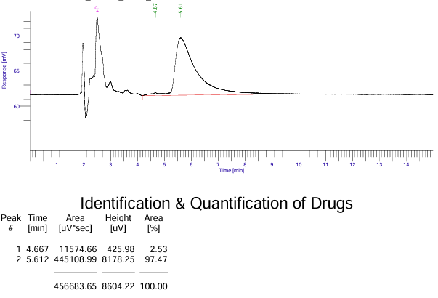

Appendix 54: HPLC Chromatogram 250226 VF33A
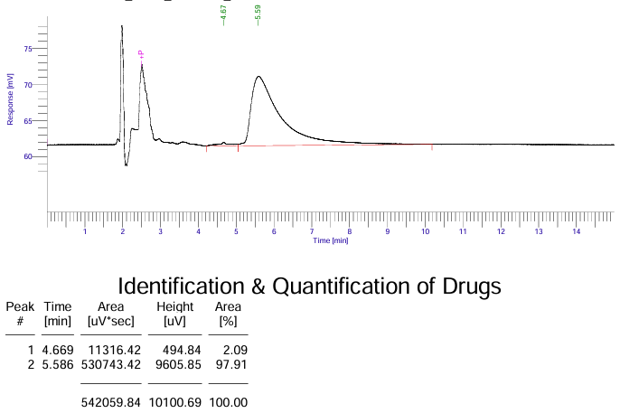

Appendix 55: HPLC Chromatogram 250226 VF34A
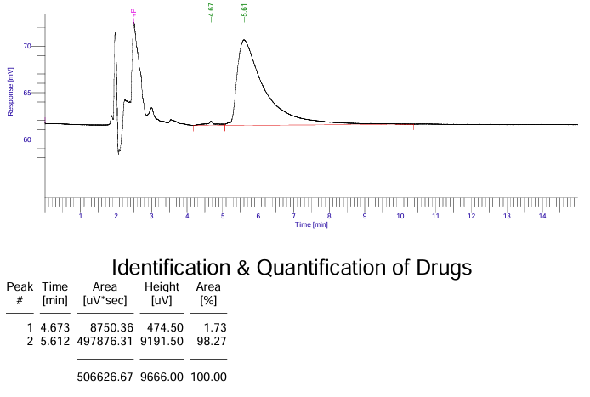

Appendix 56: HPLC Chromatogram 250226 VFIA
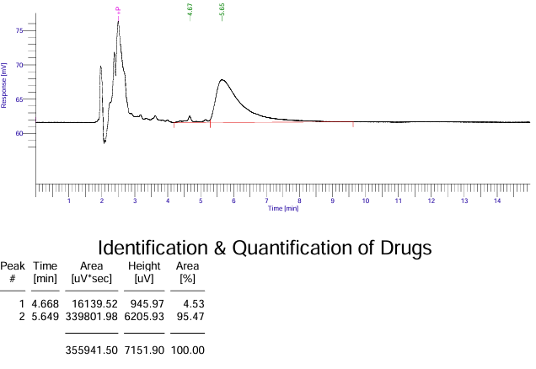

Appendix 57: HPLC Chromatogram 250226 VF23B 1
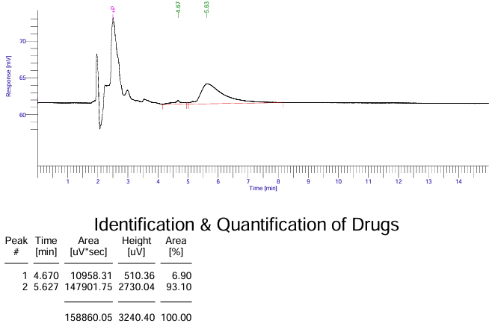

Appendix 58: HPLC Chromatogram 250626 VF32b 2
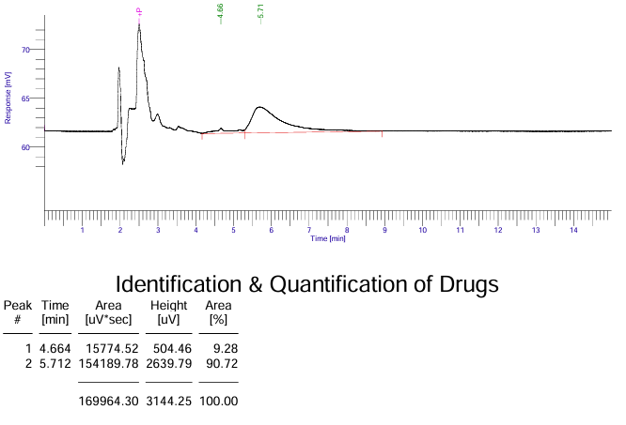

Appendix 59: HPLC Chromatogram 250626 VF32b 3
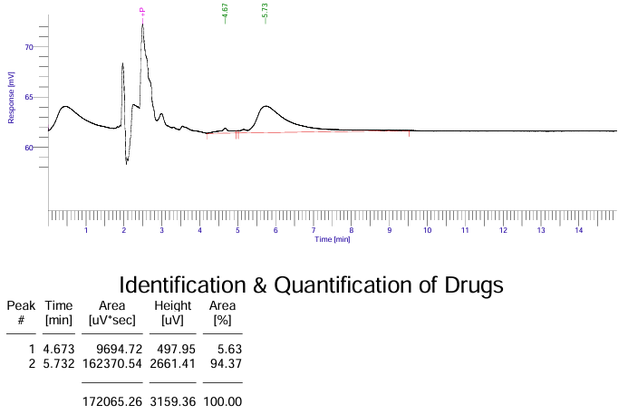

Appendix 60: HPLC Chromatogram 250626 VF32b 4
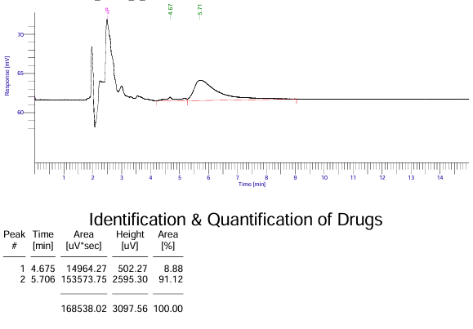

Appendix 61: HPLC Chromatogram 250626 VF32b 5
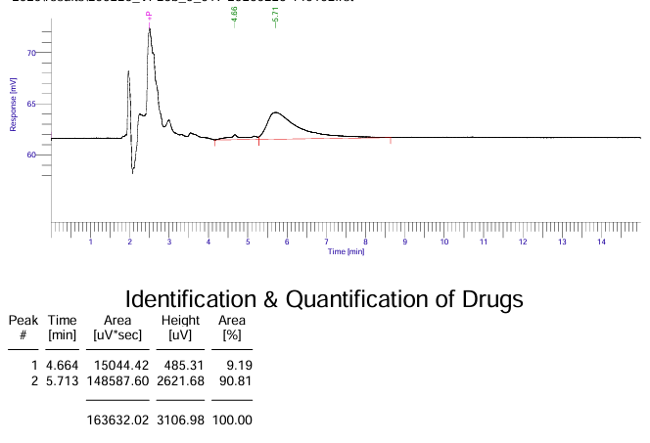

Appendix 62: HPLC Chromatogram 250626 VF32b 6
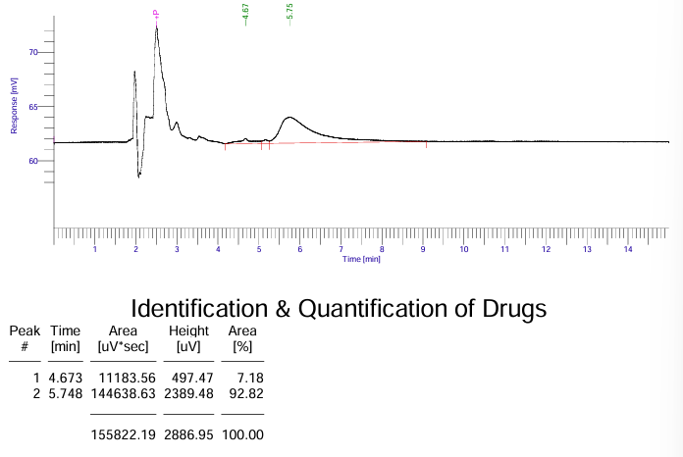

Appendix 63: HPLC Chromatogram 250626 VF32b 7
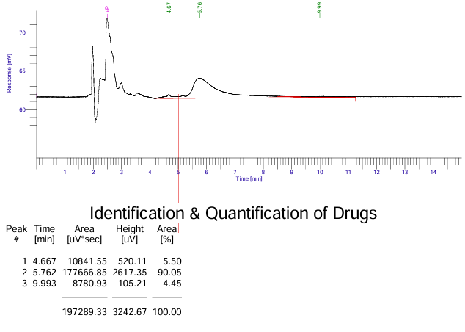

Appendix 64: HPLC Chromatogram 250626 VF32b 8
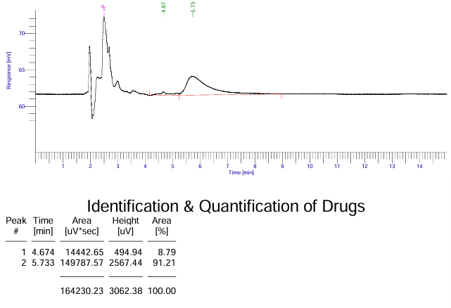

Appendix 65: HPLC Chromatogram 250626 VF32b 9
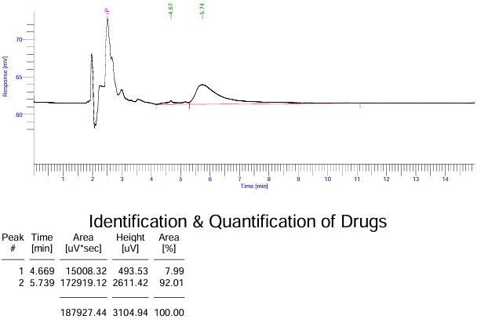

Appendix 66: HPLC Chromatogram 250626 VF32b 10
67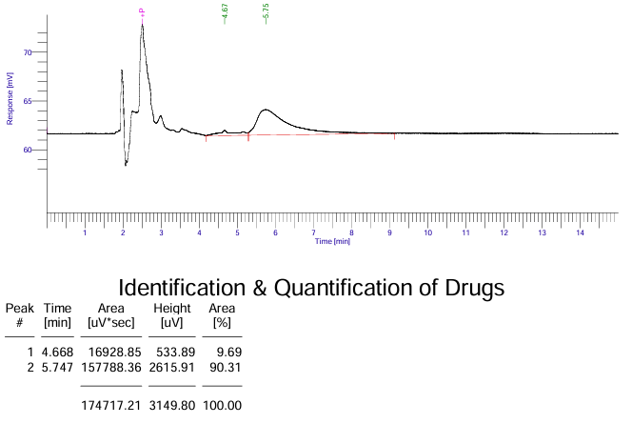

Appendix 67: UV-Vis Spectra VFIC
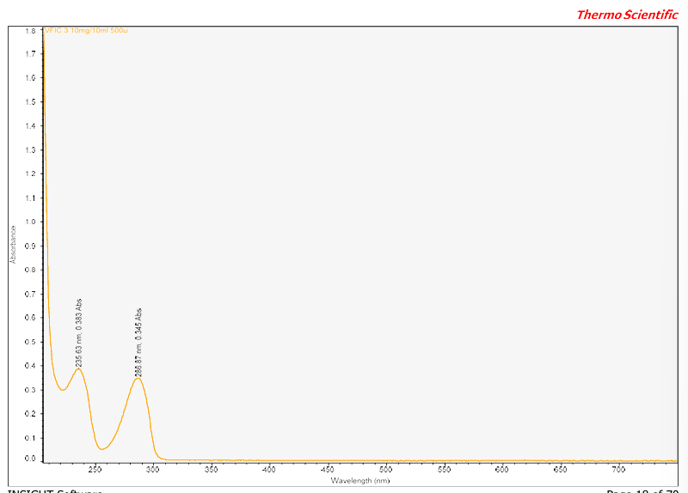

Appendix 68: UV-Vis Spectra MDMA Standard 500ul
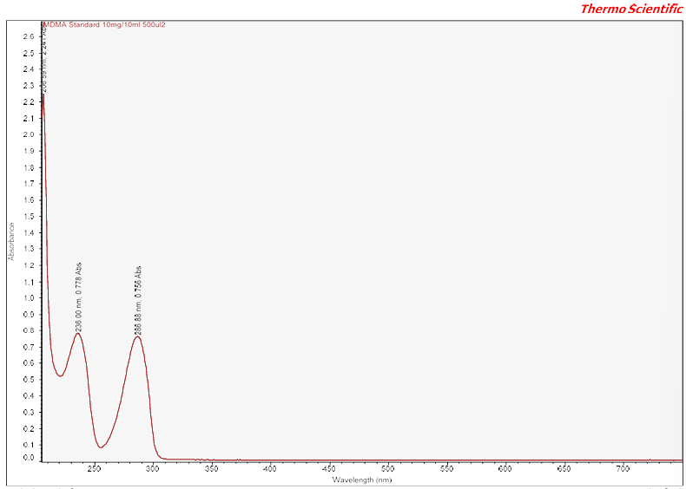

Appendix 69: UV-Vis Spectra MDMA Standard 400ul
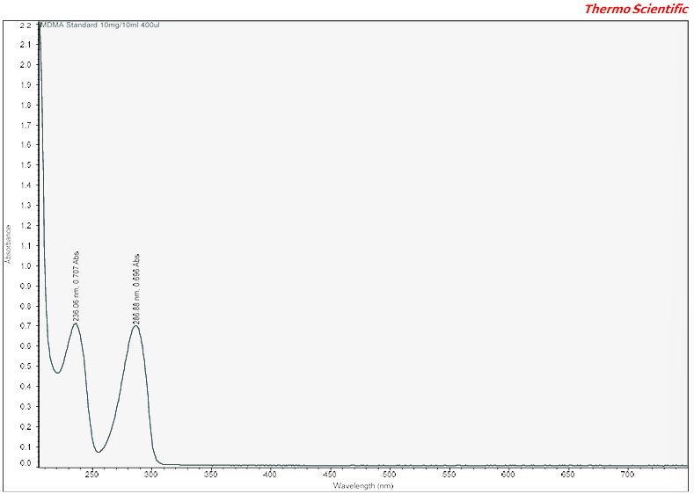

Appendix 70: UV-Vis Spectra MDMA Standard 300ul
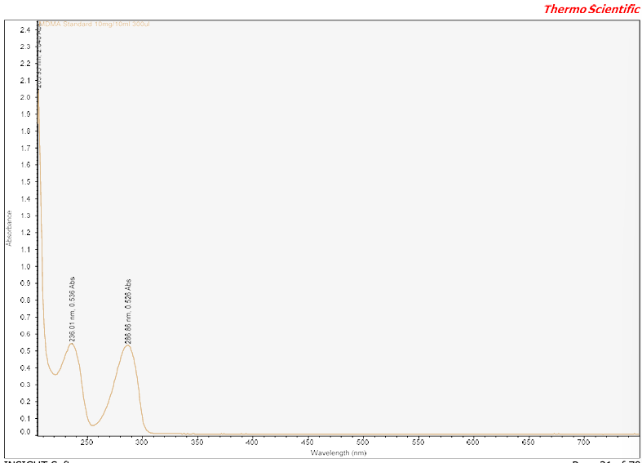

Appendix 71: UV-Vis Spectra MDMA Standard 200ul
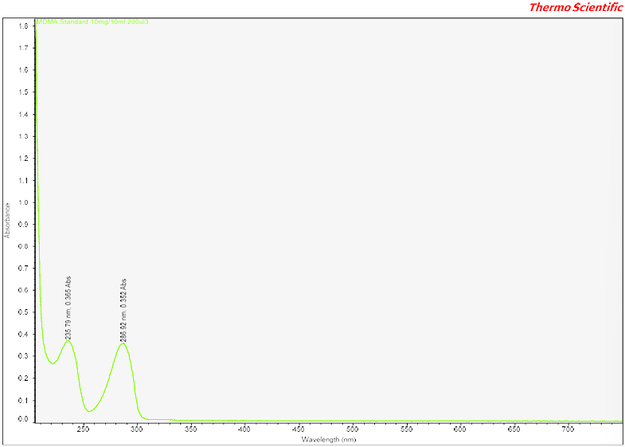

Appendix 72: UV-Vis Spectra MDMA Standard 100ul
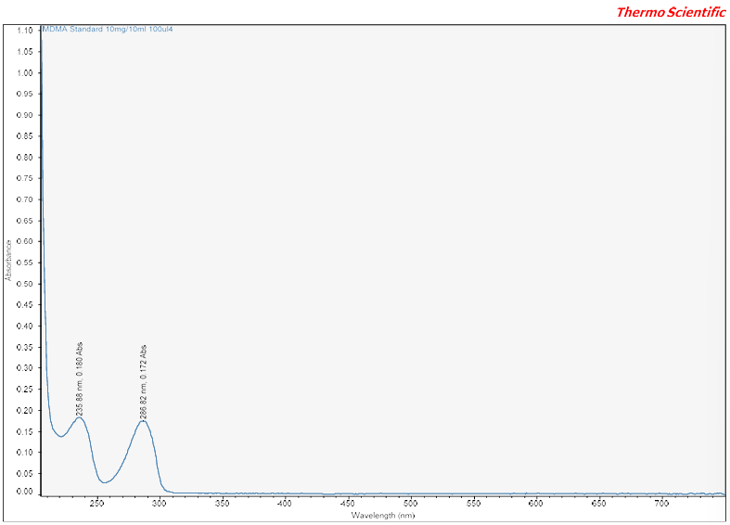

Appendix 73: UV-Vis Spectra VFII
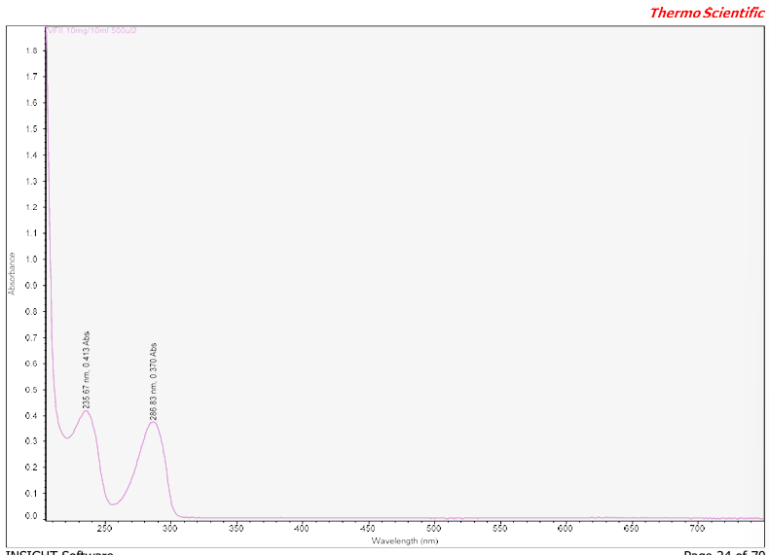

Appendix 74: UV-Vis Spectra VFIF
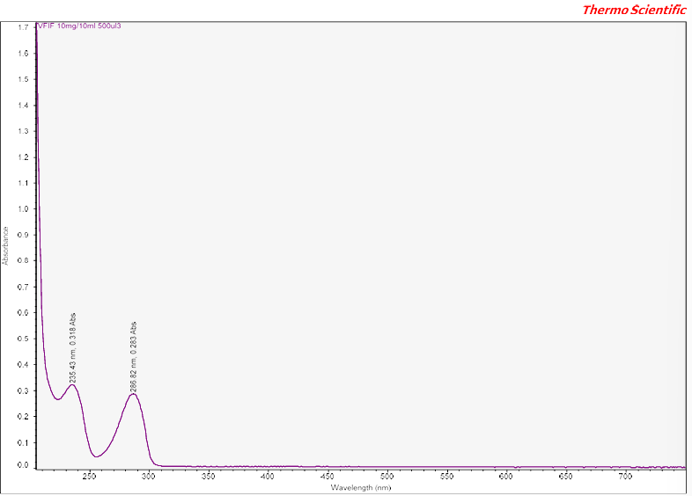

Appendix 75: UV-Vis Spectra VFID
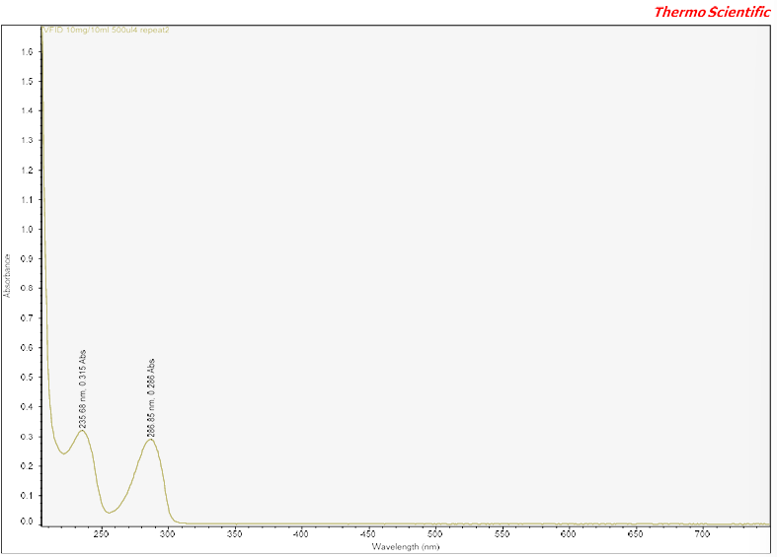

Appendix 76: UV-Vis Spectra VFIE
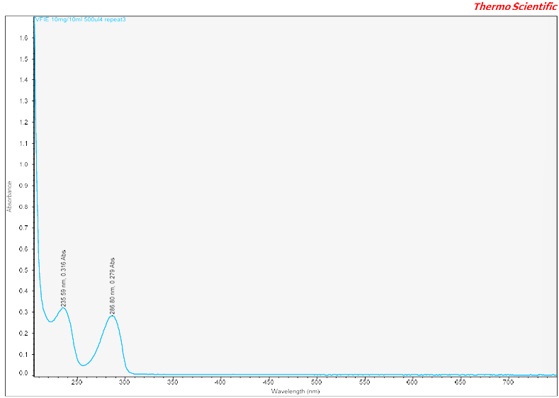

Appendix 77: UV-Vis Spectra VFII
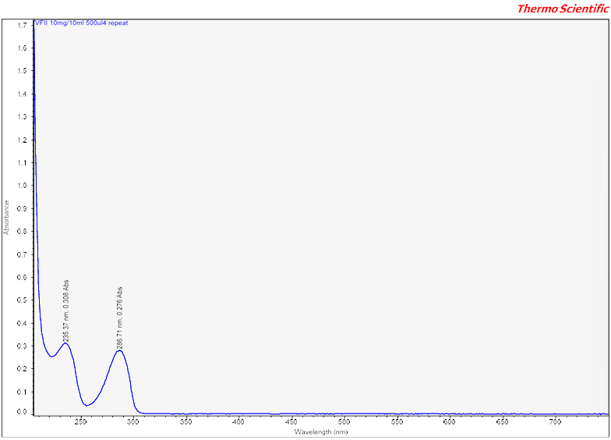

Appendix 78: UV-Vis Spectra VFIG
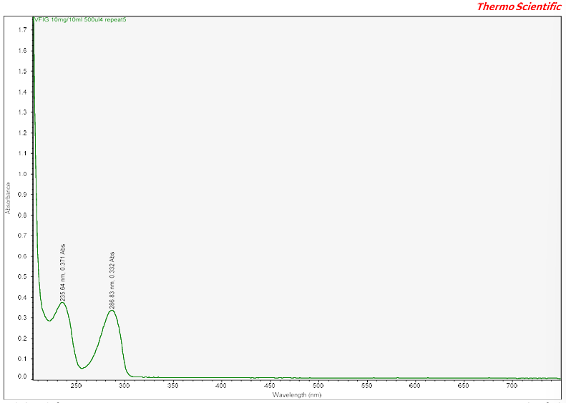

Appendix 79: UV-Vis Spectra VFIB
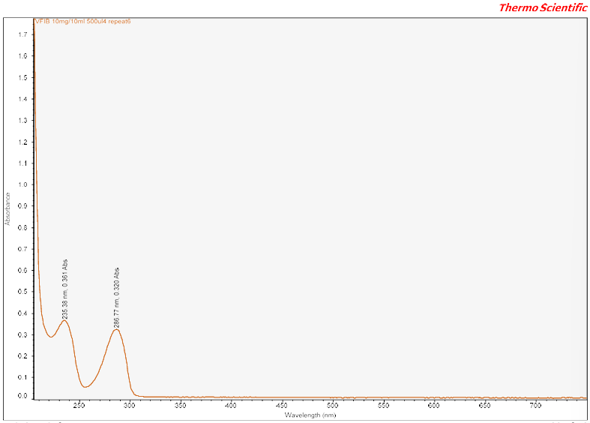

Appendix 80: UV-Vis Spectra VFIA
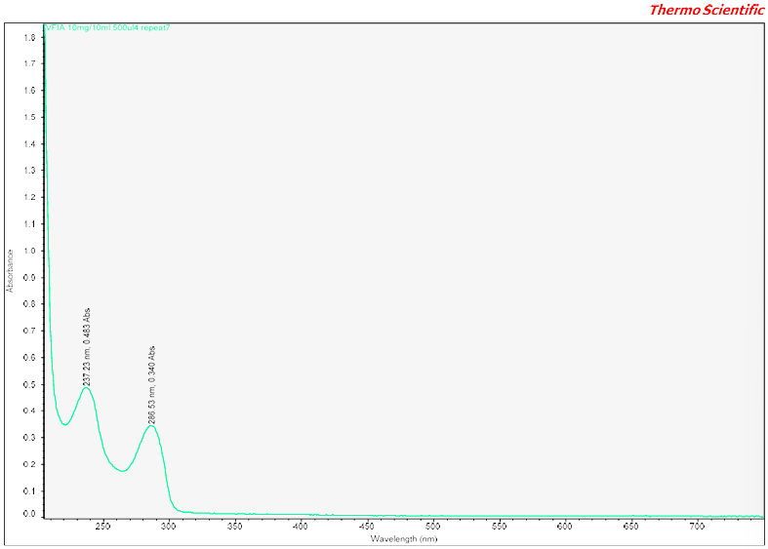

Appendix 81: UV-Vis Spectra VF29A

Appendix 82: UV-Vis Spectra MDMA Standard 100ul
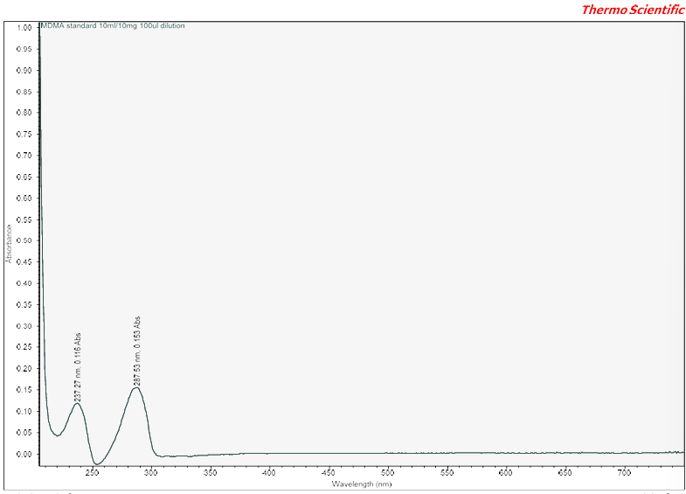

Appendix 83: UV-Vis Spectra MDMA Standard 200ul
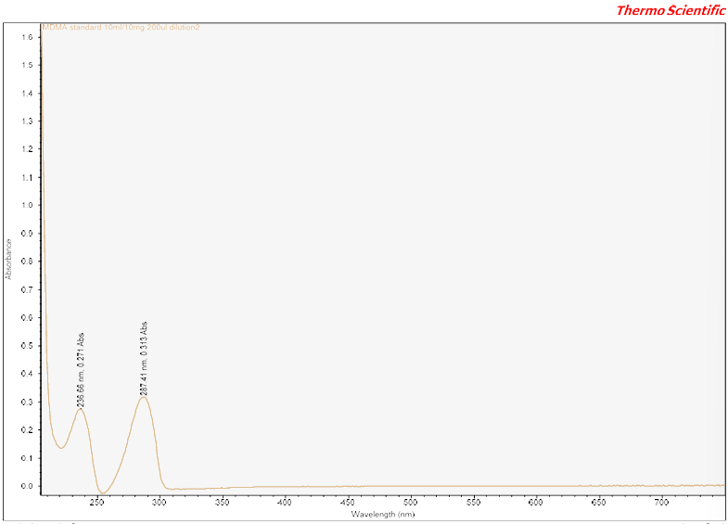

Appendix 84: UV-Vis Spectra MDMA Standard 300ul
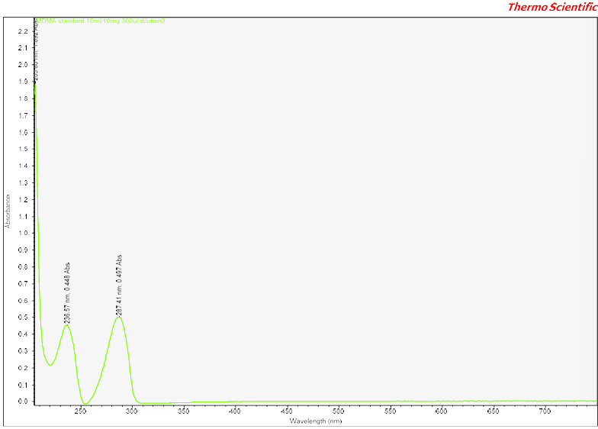

Appendix 85: UV-Vis Spectra MDMA Standard 400ul
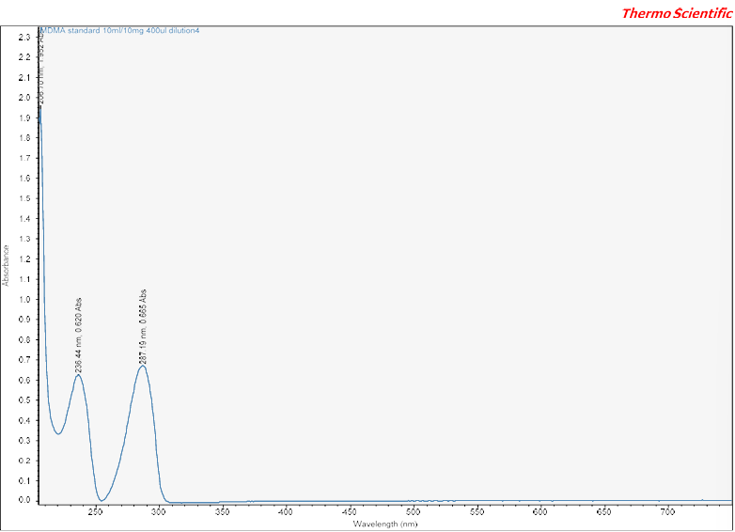

Appendix 86: UV-Vis Spectra MDMA Standard 500ul
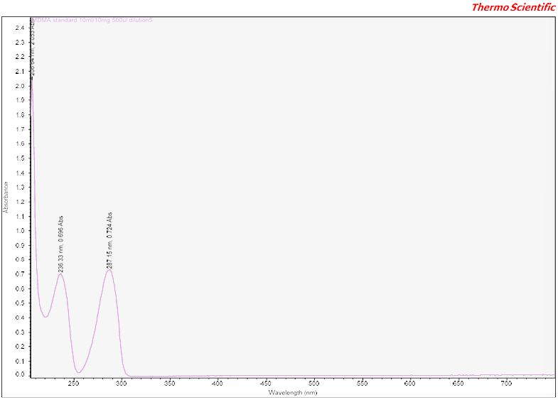

Appendix 87: UV-Vis Spectra V28A
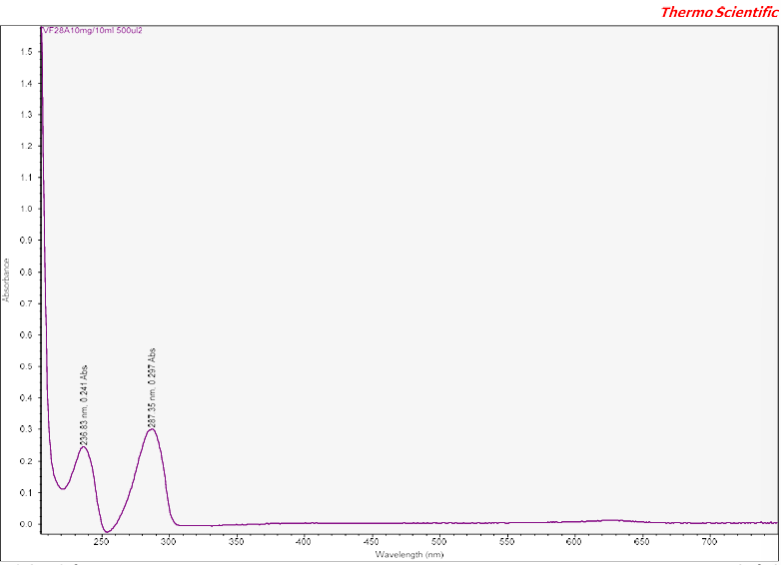

Appendix 88: UV-Vis Spectra VF26A
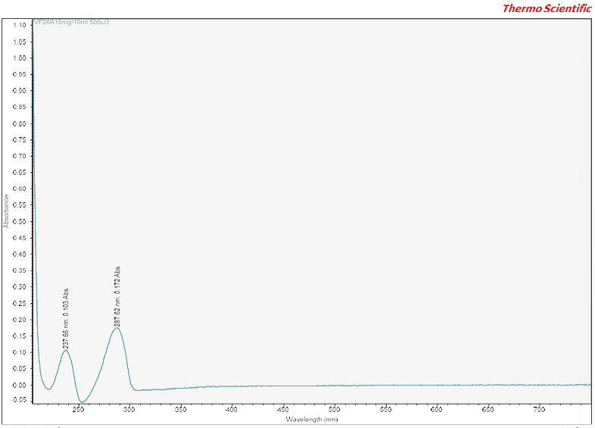

Appendix 89: UV-Vis Spectra VF30B
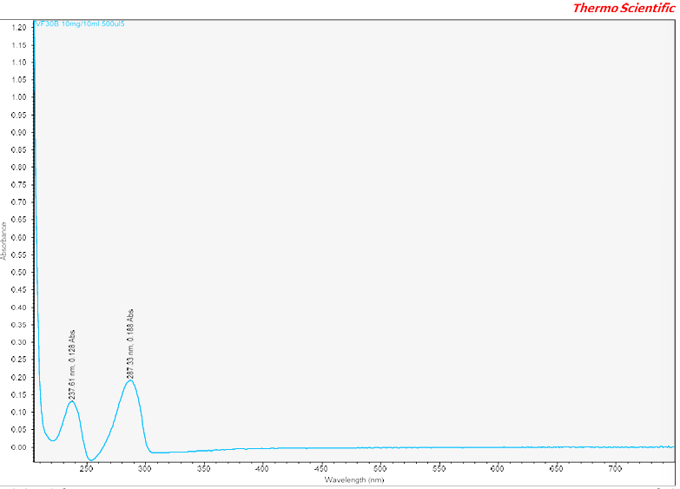

Appendix 90: UV-Vis Spectra VF27D
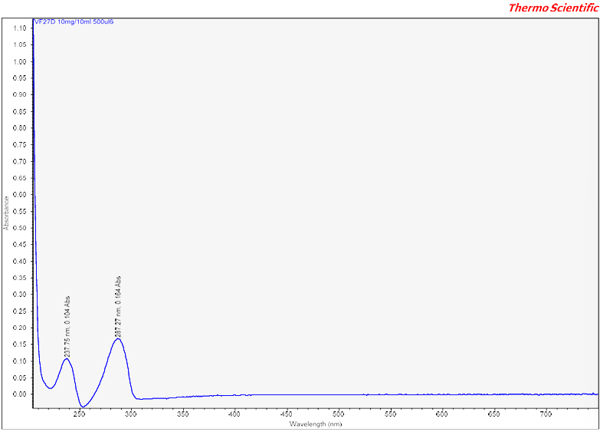

Appendix 91: UV-Vis Spectra VF31E
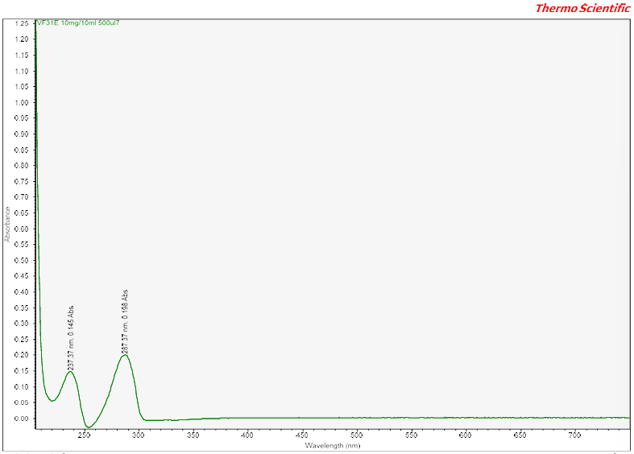

Appendix 92: UV-Vis Spectra VF24A
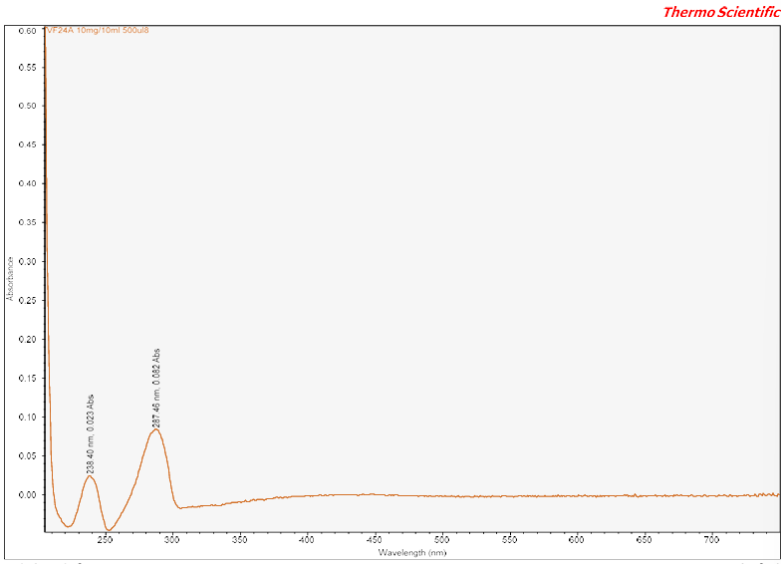

Appendix 93: UV-Vis Spectra VF33A
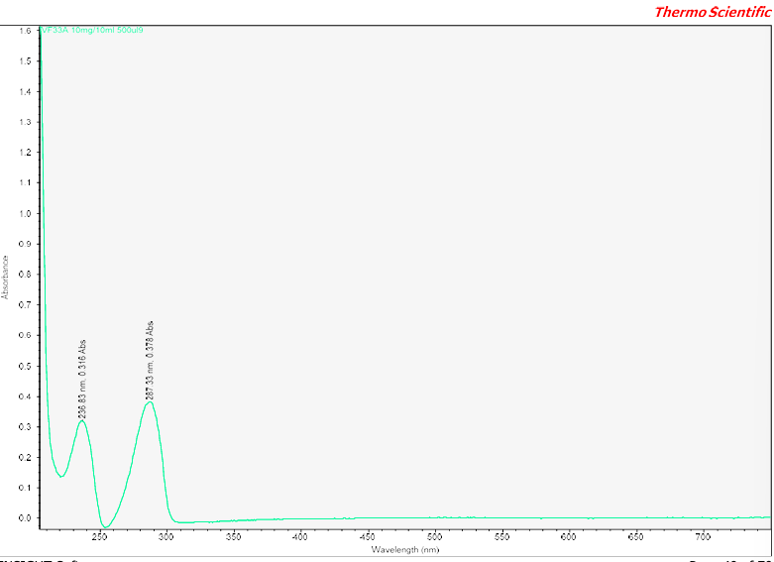

Appendix 94: UV-Vis Spectra V22A
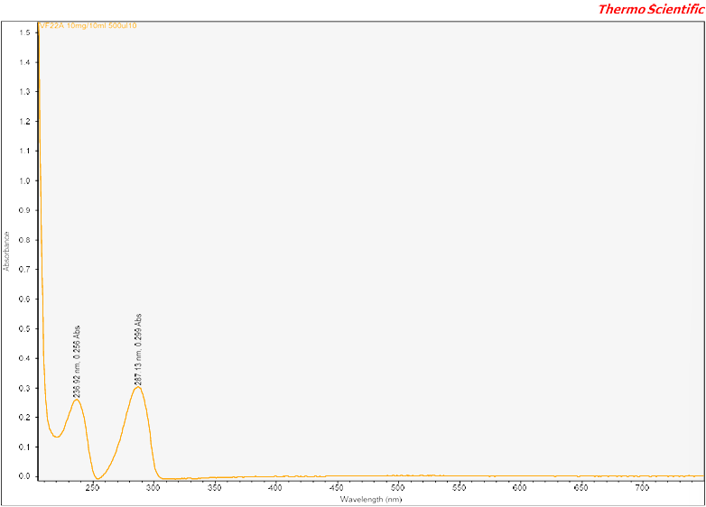

Appendix 95: UV-Vis Spectra VF23B 1
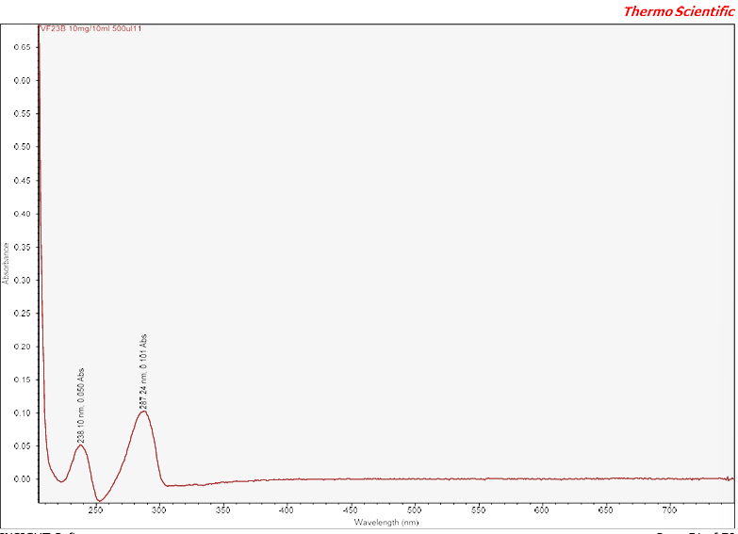

Appendix 96: UV-Vis Spectra VF23B 11
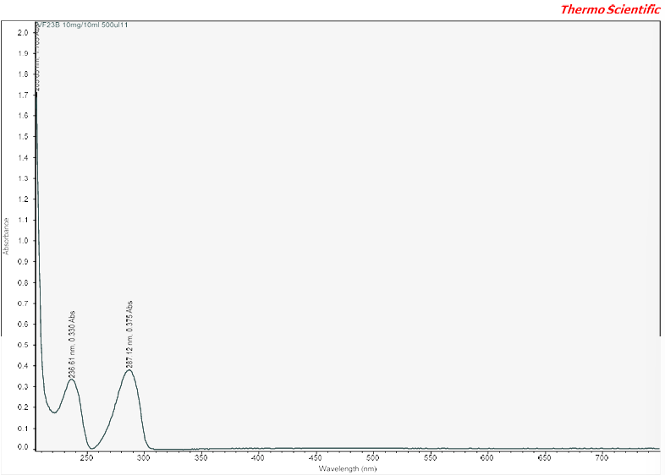

Appendix 97: UV-Vis Spectra VF32D
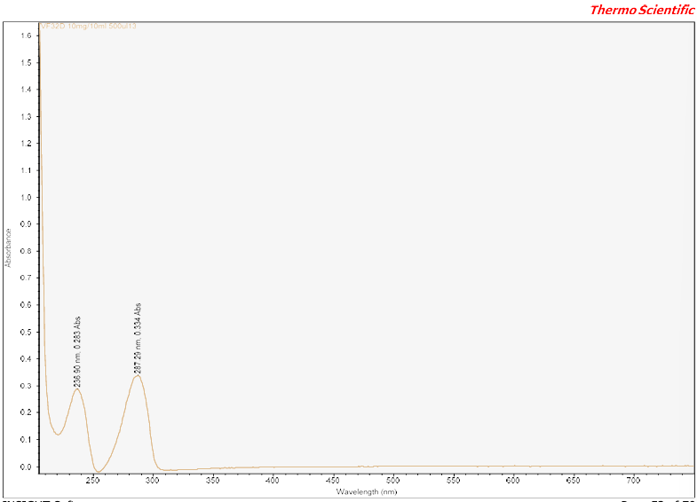

Appendix 98: UV-Vis Spectra VF25A
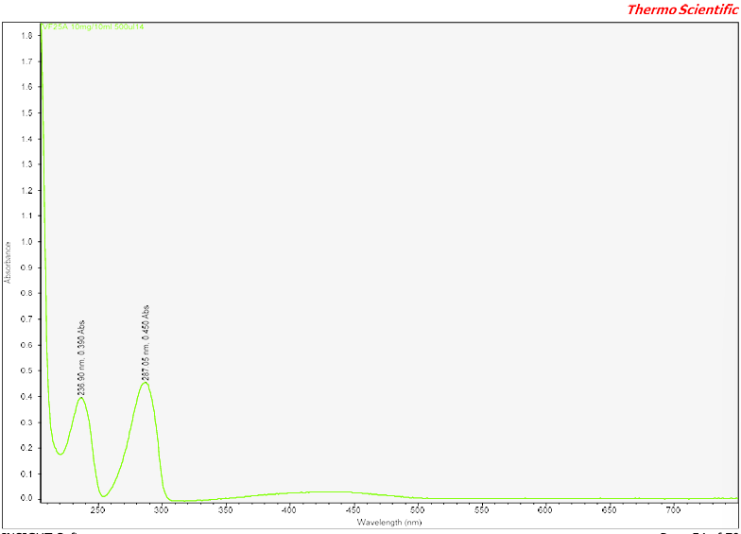

Appendix 99: UV-Vis Spectra MDMA Standard 100ul
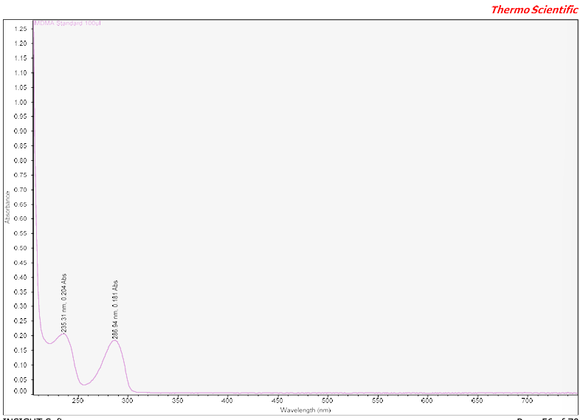

Appendix 100: UV-Vis Spectra MDMA Standard 200ul
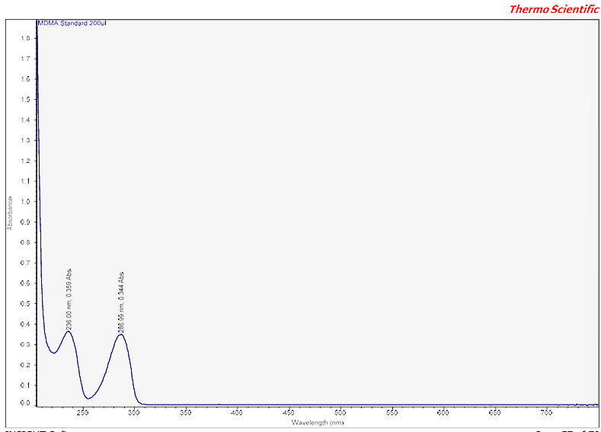

Appendix 101: UV-Vis Spectra MDMA Standard 300ul
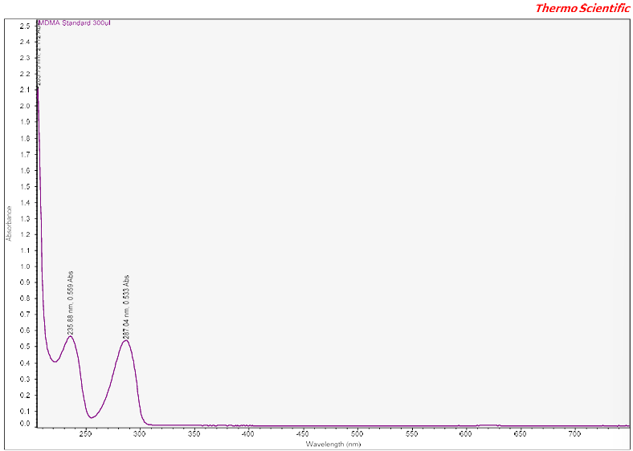

Appendix 102: UV-Vis Spectra MDMA Standard 400ul
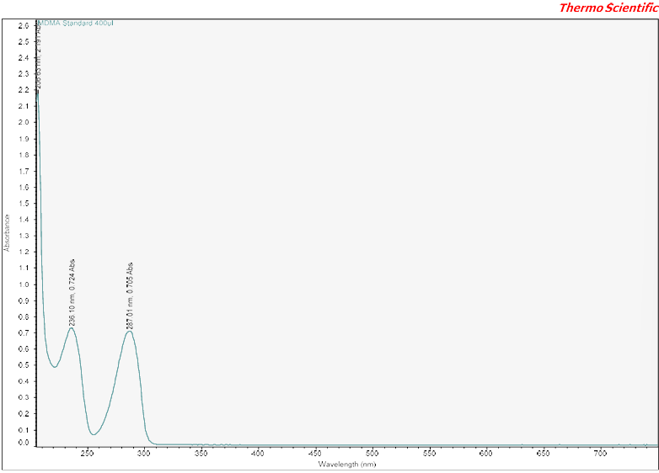

Appendix 103: UV-Vis Spectra MDMA Standard 500ul
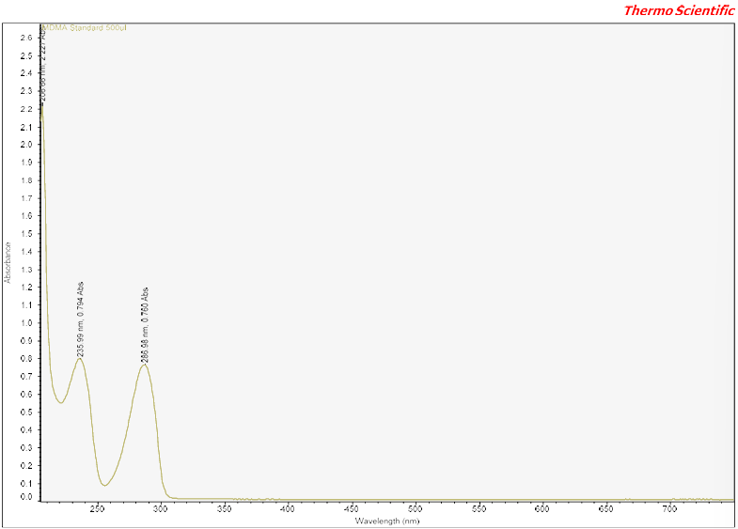

Appendix 104: UV-Vis Spectra VF32D
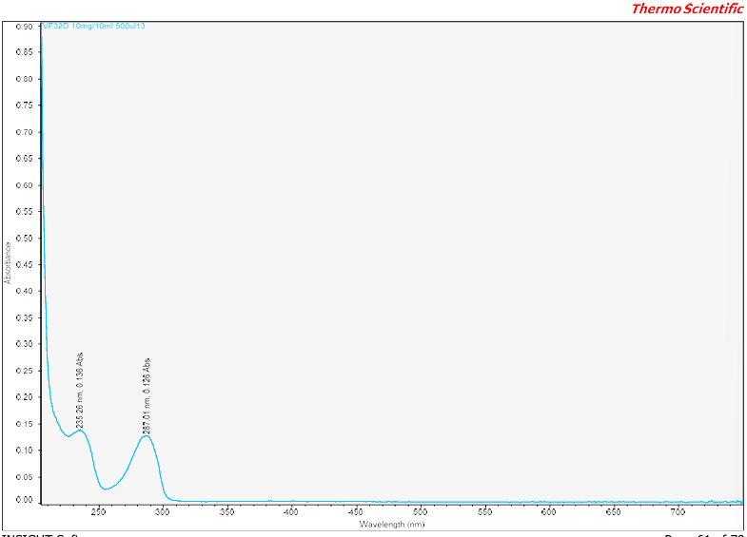

Appendix 105: UV-Vis Spectra VF23B 2
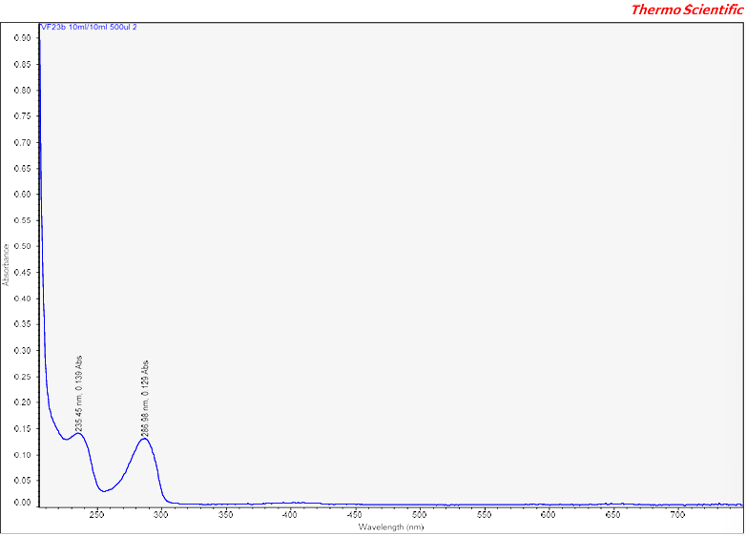

Appendix 106: UV-Vis Spectra VF23B 3
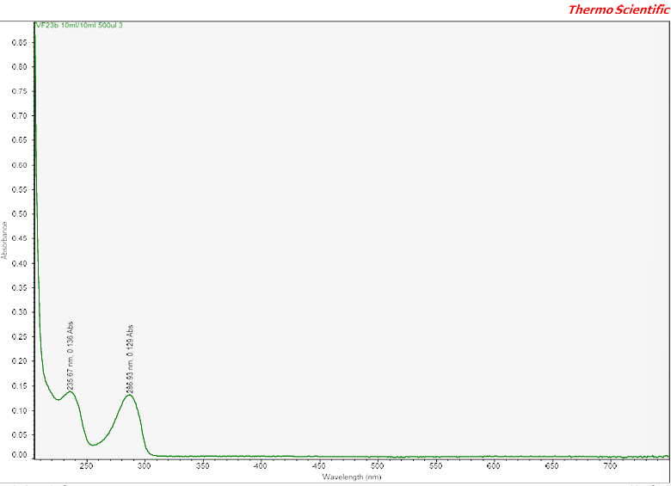

Appendix 107: UV-Vis Spectra VF23B 4
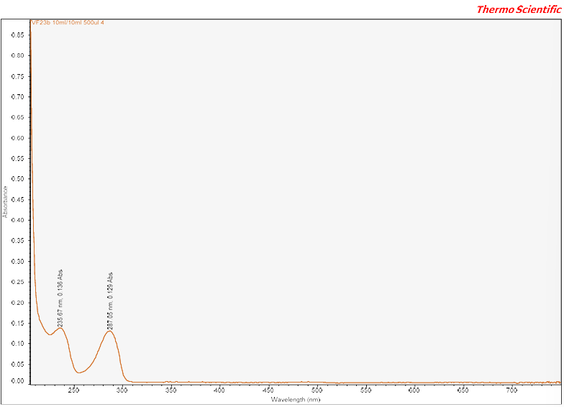

Appendix 108: UV-Vis Spectra VF23B 5
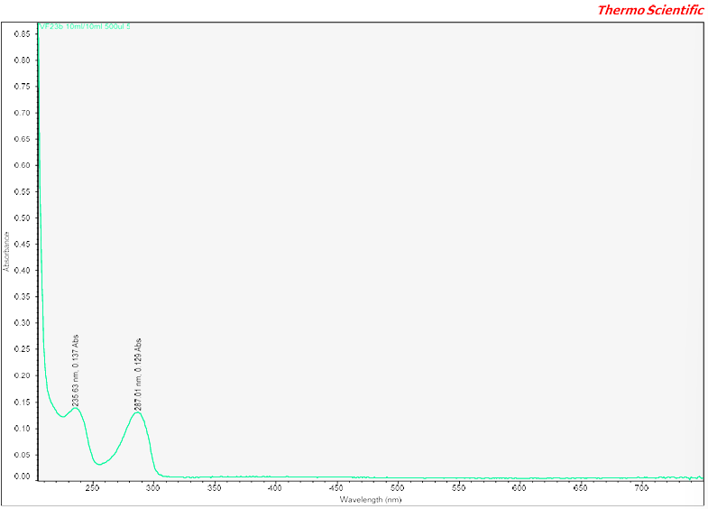

Appendix 109: UV-Vis Spectra VF23B 6
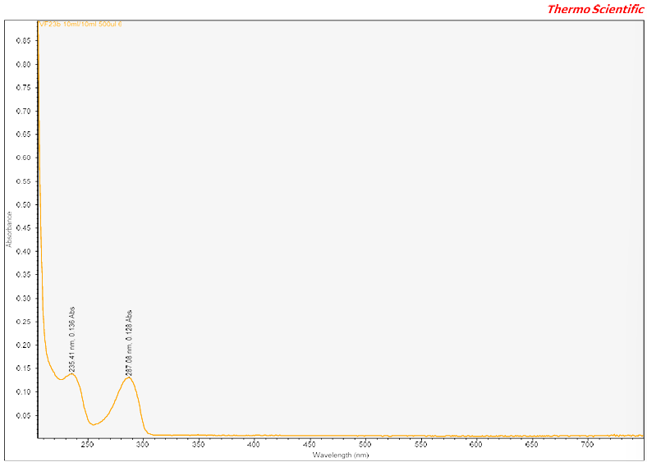

Appendix 110: UV-Vis Spectra VF23B 7
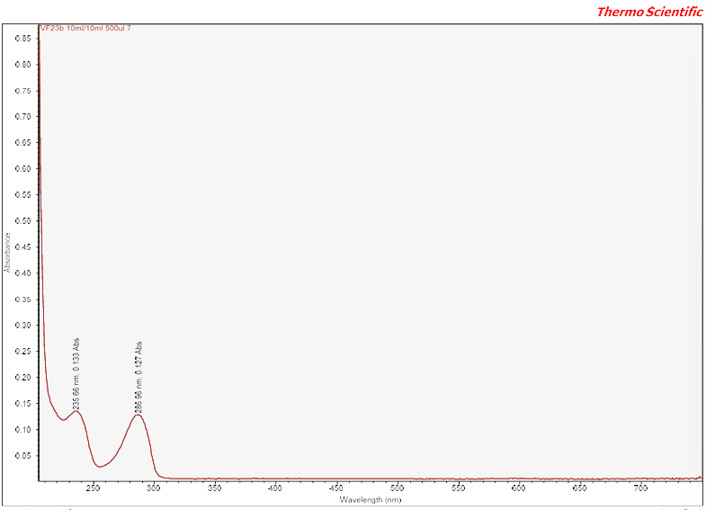

Appendix 111: UV-Vis Spectra VF23B 8
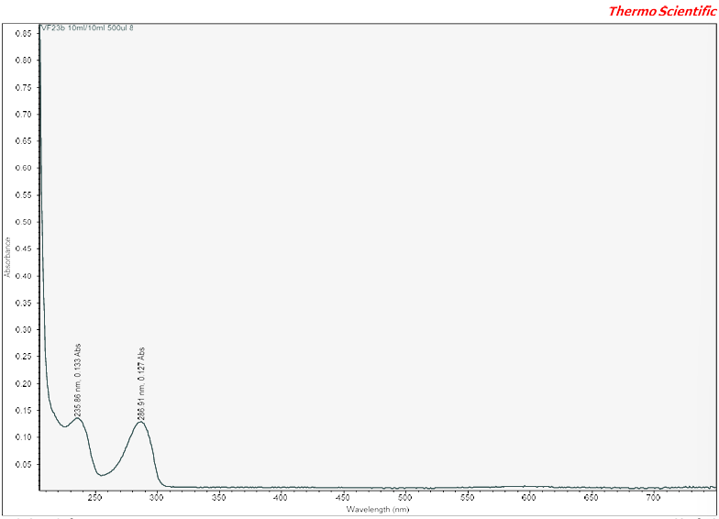

Appendix 112: UV-Vis Spectra VF23B 9
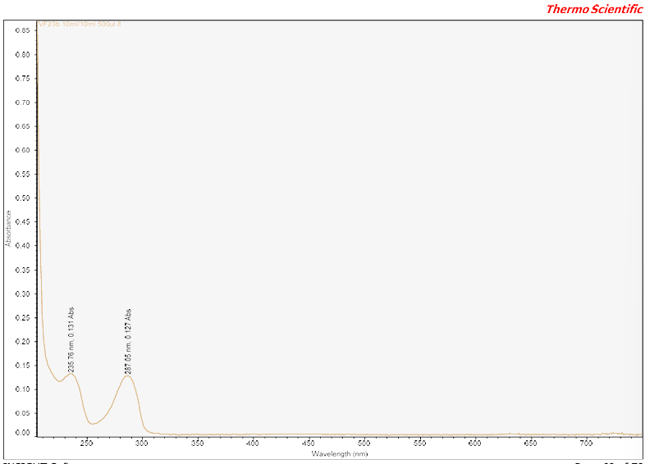

Appendix 113: UV-Vis Spectra VF23B 10
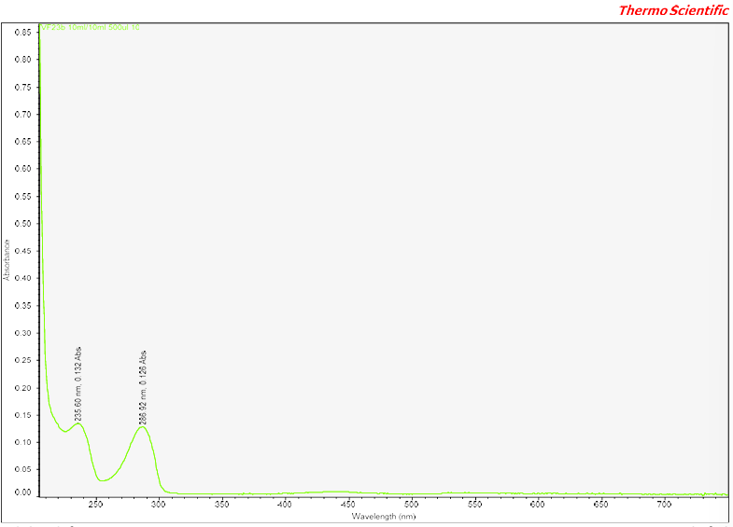

Appendix 114: HPLC Mass Percentage Calculations
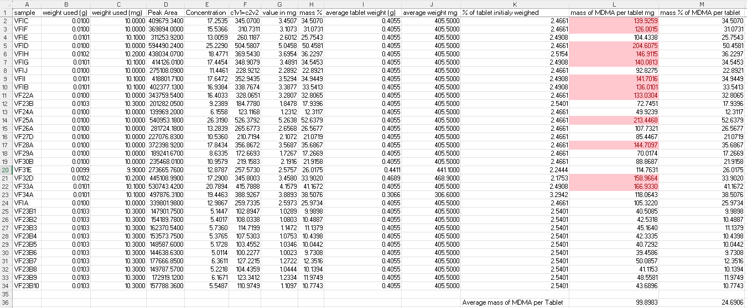

Appendix 115: UV-Vis Mass Percentage Calculations
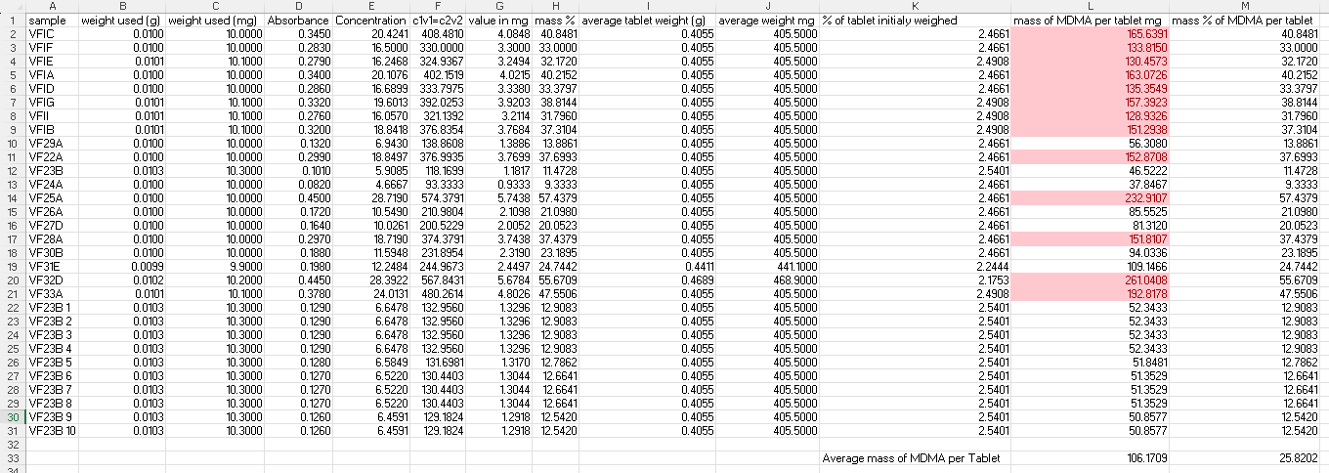

Appendix 116: Mass Loss Analysis Mass Percentage Calculations
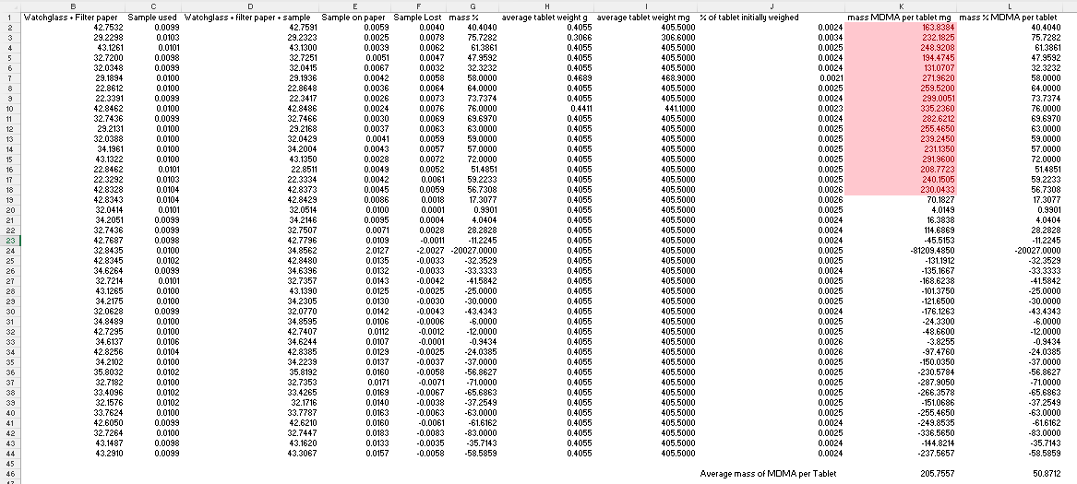

Appendix 117: Paired Sample T-Test comparing HPLC and UV-Vis

