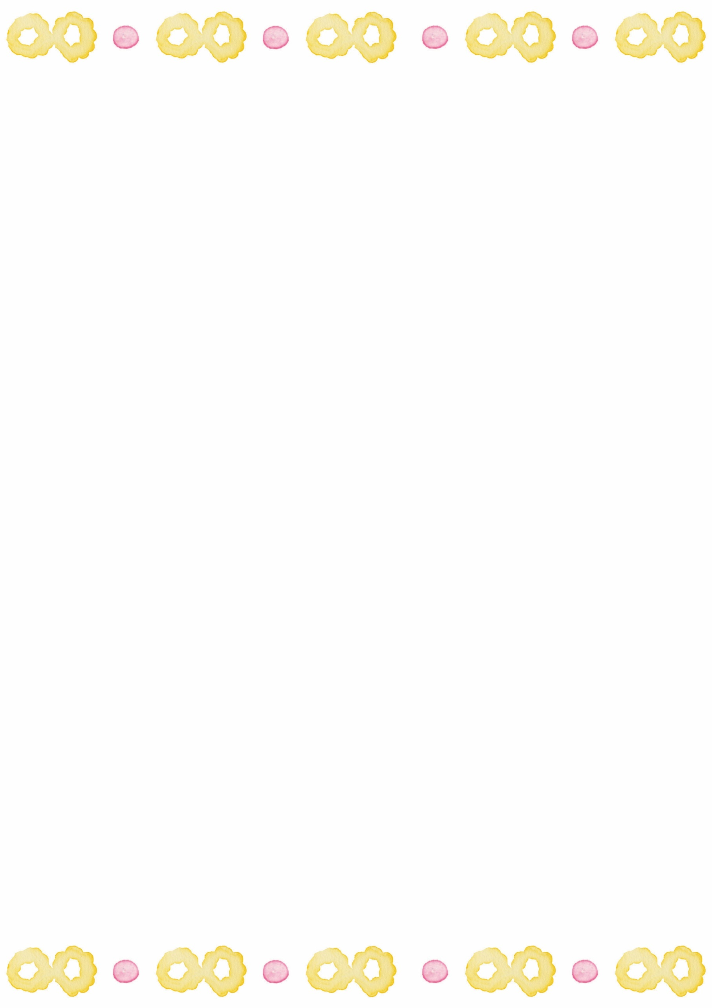
ANNALISE FRIEND
SURFACE PATTERN DESIGNER
PRESS RELEASE
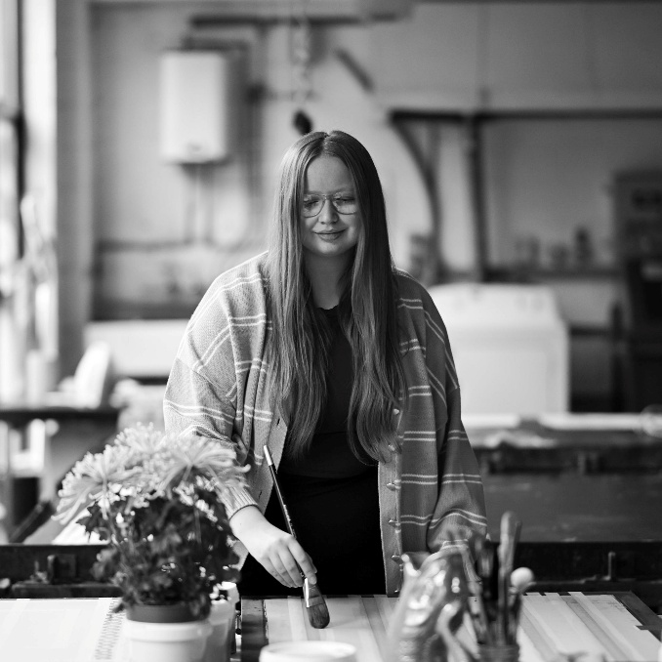
BOBBLES AND BLOOMS
A vibrant, nature-inspired homeware collection featuring painterly floral patterns, expressive colour, and hand-painted, screen-printing techniques.
Her latest homeware collection, Bobbles and Blooms, is designed for women seeking a soft, nature-inspired interior. Inspired by the romantic gardens of Marie Antoinette, the collection pairs vibrant, uplifting colour palettes with bobbly floral motifs and gentle stripes. Painterly influences run throughout the designs, with loose marks and layered forms creating a thoughtful balance between expressive energy and structured pattern.
All designs were developed using hand-painted screen-printing techniques, allowing fluid movement, organic mark-making, and natural variation to remain visible within the final outcomes. Floral motifs—timeless in appeal and particularly relevant to spring-led interiors—ensure the collection remains both visually engaging and commercially considered.
By transforming everyday homeware into decorative yet comforting objects, Bobbles and Blooms brings a sense of calm, femininity, and connection to nature into the contemporary home.

Annalise Friend is a third-year BA (Hons) Surface Pattern and Textile Design student at the University of Staffordshire, with a strong passion for handmade design and a keen interest in trend and colour forecasting. Her practice focuses on expressive surface pattern, drawing on painterly approaches to colour and mark-making to create contemporary design outcomes.

Website: a-friend-prints.my.canva.site/
Email: annalise0302@icloud.com
Instagram: @annalise.creative_
LinkedIn: Annalise Friend

