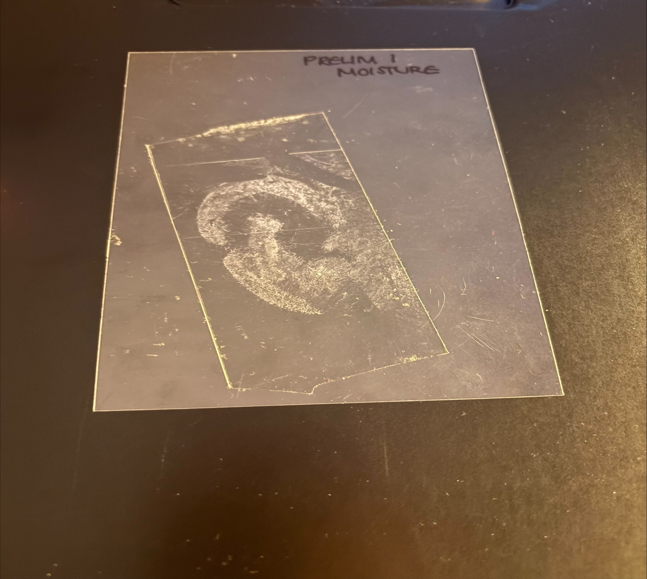
Reference List
Kaush Abbas, A. and Rutty, G.N. (2005a). Ear Piercing Affects Earprints: The Role of Ear Piercing in Human Identification. Journal of Forensic Sciences, 50(2), pp.1–7. doi: https://doi.org/10.1520/jfs2003374
Abbas, A. and Rutty, G.N. (2005a). Ear Piercing Affects Earprints: The Role of Ear Piercing in Human Identification. Journal of Forensic Sciences, 50(2), pp.1–7. doi: https://doi.org/10.1520/jfs2003374
Vijiaprabu Manikam, Ramalinggam Rajamanickam, Nur Khalidah Dahlan and Nur Khalidah Dahlan (2025). Importance and Reliability of Ear Print Analysis as Evidence. Journal of Posthumanism, 5(3). doi: https://doi.org/10.63332/joph.v5i3.736
Ragan, E.J., Johnson, C., Milton, J.N. and Gill, C.J. (2016). Ear biometrics for patient identification in global health: a cross-sectional study to test the feasibility of a simplified algorithm. BMC Research Notes, 9(1). doi: https://doi.org/10.1186/s13104-016-2287-9
Kaushal, N. and Kaushal, P. (2011). HUMAN EARPRITS: A REVIEW. Journal of Biometrics & Biostatistics, 02(05). Doi: https://doi.org/10.4172/2155-6180.1000129

Results and Discussion
The results from this study show that the ear lengths and widths measured from all of the participants remained relatively similar, however, although all 54 deposited prints were developed and recovered following the same method, some of the recovered prints appeared visually better than others. In addition to this, figure 1 shows that the error bars across all of the measurements were small, which indicates a low variability, suggesting a high degree of precision in the data collection. Therefore, the overall most important finding through this project was the physical deposited print, due to the visual pockets of negative space which were created from the presence of jewellery throughout the ear.
Introduction
In forensic investigations different prints are recovered, including ear prints. An ear print is a two-dimensional representation of an ear which is created when the external ear is pressed against a surface due to the skin’s natural oils and waxes transferring (Kaushal, N. and Kaushal, P, 2011). However, ear prints vary as some people have their ears pierced with a range of jewellery, in which these piercings can then serve as a distinctive marker throughout the prints (Abbas and Rutty, 2005). Therefore, meaning that ear print impressions which have jewellery present are harder to manipulate and falsify than fingerprints (Vijiaprabu Manikam et al., 2025). Ear prints are also important within forensics due to their high potential for individual identification due to the shape and structure of the ears as they are highly unique (Ragan et al., 2016).
Figure 1: Length and Width Recovered from all Participants.

Word Count: 498
Student Number: 23013086
Figure 2: Ear Print recovered using Moisturiser and Aluminium Powder.
Methods
A total of 6 participants and 54 ear prints were recovered and developed throughout this project by using the aluminium powder dusting method. This method was selected for this project as aluminium powder is able to adhere well to any moisture and oily components of prints, therefore capturing high-quality prints (Kaushal and Kaushal, 2011). However, due to the aluminium powder sticking best to moisture and oils, before the participant deposited their print they received 2cm of Vaseline cocoa radiant moisturiser in which they used to saturate their ear so that when the print was being recovered there would be more moisture left on the surface for the powder to adhere to. In addition to this it was also important to select a suitable depositing surface so that the ear prints could be deposited to the highest of quality, therefore, by using a glass slab as the depositing surface, this allowed the aluminium powder to successfully glide over the smooth surface, allowing the powder to adhere to the recovered print effortlessly.
Conclusion
This study found that ear impressions which have been deposited by people who have jewellery present portray an extra segment of negative space where the jewellery blocks the ear from making contact to the depositing surface. In addition to revealing that the amount of time and amount of pressure which is used to deposit the print is also important as this can alter the complete size of the print. Overall, while ear print evidence is able to provide high potential evidence within forensic investigations, its reliability is highly dependent on the recovery conditions, therefore highlighting the need for further standardisation and validation.
Recovery and Development of Ear Prints
Paige Rigby, David Flatman-Fairs
School of Health, Education, Policing & Sciences, University of Staffordshire



