

Morphological Mapping of Eurasian Brown Bear Hair Using Multiple Microscopic Techniques
by
Hayden Paul Leigh
22012792

A dissertation submitted for the award of
BSc (Hons) Forensic Science

Under the supervision of Prof Claire Gwinnett
in the Department of Sport and Science
University of Staffordshire

May 2026
Word count = 15745

Table of Contents
List of Figures 4
List of Tables 4
List of Equations 5
S.1. Introduction 7
1.1. Wildlife Crime 7
1.1.1. Human Wildlife Conflict 8
1.1.2. Human Bear Conflict 9
1.2. Trace Evidence 10
1.3. Hair as Evidence 11
1.3.1. Structure of Hair 13
1.3.2. Analysis Methods for Hair 15
1.4. Bear Hair 17
1.5. Preservation of Samples (Taxidermy) 18
1.6. Rationale for Project 19
1.7. Aims and Objectives 19
1.7.1. Aim 19
1.7.2. Objectives 19
S.2. Methods 20
2.1. Ethics and Risk Assessment 20
2.2. Preliminary Studies 20
2.2.1. Comparison of Comb versus Manual Extraction for Hair Collection 20
2.2.2. Comparison of Mounting Mediums: Depex versus Entellan 20
2.2.3. Scale Casting 20
2.3. Sample Collection 21
2.4. Macroscopic Hair Analysis 22
2.5. Microscopic Hair Analysis 23
2.6. Scale Casting 25
2.7. Scanning Electron Microscopy 25
2.8. Statistical Tests 26
2.8.1. Shapiro-Wilk 26
2.8.2. Kruskal-Wallis H Test 26
S.3. Results and Discussion 27
3.1. Preliminary Studies 27
3.1.1. Comparison of Hair Extraction Methods 27
3.1.2. Mounting Mediums 28
3.1.3. Scale Casting 28
3.2. Rationale for Methods 28
3.2.1. Macroscopic Examination 28
3.2.2. Microscopic Examination 29
3.3.3. Scanning Electron Microscope 30
3.4. Hair Width Variation of a Bears Body 30
3.4.1. Hair Width Variation of the Whole Body 30
3.4.2. Overall Width Variation over the Body using SEM 32
3.5. Medulla Variation over a Bears Body 35
3.5.1. Medulla Width 35
3.5.2. Medulla Ratio 37
3.5.3. Medulla Type 40
3.5.4. Medulla Fragmentation 40
3.6. Cortex Width Variation over a Eurasian Brown Bears Body 43
3.7. Interscale Distance Variation over a Eurasian Brown Bears Body 45
3.8. Macroscopic Colour Variation Over Anatomical Regions 48
3.9. Pigmentation Across the Body of a Bear 49
3.10. Using Museum Taxidermy Samples for Forensic Science 51
S.4. Conclusion 52
S.5. Further Work 54
S.6. References 55
S.7. Appendix 71
7.1. Raw Data 71
7.2. Procedural Risk Assessment (PRA) 72
7.3. Proportionate Ethics Form 77
7.4. Hair Comb used for all Sampling 79
7.5. Example Email to Museums 80
7.6. Example Email to Zoo 81
7.7. List of Museums and Zoos Contacted 82
7.8. Email received back from Sarah Harvey after initially reaching out 84
7.9. Tables of Mean Width of Hairs Across the Body 85
7.10. Results from Shapiro Wilk Test for Overall Width 87
7.11. Results from Kruskal Wallis H Test Results for Overall Width 88
7.12. Results from Post-Hoc Pairwise Comparisons with Bonferroni Correction of Overall Width 5 89
7.13. Results from Shapiro Wilk Test for Overall Width using SEM 90
7.14. Results from Kruskal-Wallis H Test for Overall Width using SEM 91
7.15. Results from Post-Hoc Pairwise Comparisons with Bonferroni Correction of Overall Width using SEM 92
7.16. Result from Shapiro Wilk Test of Medulla Width 93
7.17. Results from Kruskal-Wallis H Test of Medulla Width 94
7.18. Results from Post-Hoc Pairwise Comparisons with Bonferroni Correction of Medulla Width 95
7.19. Results from Shapiro-Wilk Test of Medulla Ratio 96
7.20. Results from Kruskal-Wallis H Test of Medulla Ratio 97
7.21. Results from Post-Hoc Pairwise Comparisons with Bonferroni Correction of Medulla Ratio 98
7.22. Results from Shapiro Wilk Test of Cortex Width 99
7.23. Results from Kruskal-Wallis H Test of Cortex Width 100
7.24. Results from Post-Hoc Pairwise Comparisons with Bonferroni Correction of Cortex Width 101
7.25. Results from Shapiro-Wilk Test of Interscale Distance 102
7.26. Results from Kruskal-Wallis H Test of Interscale Distance 103
7.27. Results from Post-Hoc Pairwise Comparison with Bonferroni Correction of Interscale Distance 104

List of Figures
Figure 1 Various Scale Pattern Features (Vinayasheela et al, 2025) 15
Figure 2 Schematic for Sampling 22
Figure 3 Hair Colour Chart (Neal and Wolf, 2026) 23
Figure 4: Distribution of Medulla Type 40
Figure 5: Medulla Fragmentation (magnification = x400) 41
Figure 6: Frequency Distribution of Observed Colour Numbers in the Analysed Hair Samples, showing the relative occurrence of each colour category 48

List of Tables

Table 1: Numerical coding used to represent different body sections for hair sample collection 27
Table 2: Demonstrating Averages of the Overall Width Across All Regions of the Body 30
Table 3: Descriptive Statistics about Varying Regions on the Body measured using SEM 32
Table 4: Descriptive Statistics for the Medulla Width Across the Body 35
Table 5: Summary statistics of medulla ratio measurements from hair samples collected from different body regions 37
Table 6: Cross-tabulation of medulla fragmentation grades (Stage 1 vs. Stage 2) across different body sections, showing the frequency distribution of samples for each grading category. 41
Table 7: Summary statistics of cortex width measurements from hair samples collected from different body regions, including median, mean, standard deviation, minimum, and maximum values. 43
Table 8: Summary statistics of interscale distance measurements in hair samples from different body regions, including median, mean, standard deviation, minimum, and maximum values. 46
Table 9: Frequency distribution of pigment distribution types observed over all the hairs analysed through this study 49
Table 10: Frequency distribution of pigment granule shapes observed within each pigment distribution type in the analysed hair samples. 50
Table 11: Distribution of pigmentation patterns and pigment granule characteristics across different body regions in the analysed hair samples. 50

List of Equations

Equation 1 Medulla Ratio Calculation (Sahajpal et al., 2008) 24

Abstract
This study was conducted to address the need for more cost-effective and reliable methods of species identification in wildlife forensic science, particularly where DNA analysis is not feasible. It also aims to fill the research gap concerning intra-individual variation in Eurasian Brown Bear hair and its impact on forensic interpretation.
Hair samples were collected from six anatomical regions of a taxidermy specimen and analysed using macroscopic and microscopic techniques, including light microscopy, scale casting, and scanning electron microscopy. Quantitative measurements and categorical characteristics were statistically analysed using Shapiro–Wilk and Kruskal–Wallis tests to assess variation between body regions.
The results demonstrated significant morphological variation across the body, with the lower back and rear leg regions consistently exhibiting greater overall and medulla widths compared to anterior regions such as the neck. Medulla ratio and cortex width also varied significantly, while most hairs displayed a narrow-vacuolated medulla type with universal evidence of fragmentation, likely due to specimen age. SEM analysis further confirmed variation in interscale distance and surface structure across anatomical regions. These findings highlight the importance of considering anatomical origin in forensic hair comparisons and contribute valuable data towards improving wildlife forensic identification and reference databases. These findings support the conclusion that anatomical origin must be considered in forensic hair analysis to improve accuracy and interpretation. Further work should focus on analysing multiple specimens, incorporating fresh samples, and expanding morphological databases to strengthen the reliability and applicability of these findings in wildlife forensic investigations.

Acknowledgements
I would like to express my sincere gratitude to everyone who supported me during the completion of this dissertation.
First and foremost, I am grateful to my supervisor, Prof. Claire Gwinnett, for her invaluable guidance, encouragement, and patience throughout this research. Her expertise and mentorship have been instrumental in shaping both this project and my development as a researcher.
I would also like to thank Sarah Harvey of the Museum of Chelmsford for providing access to the hair samples that were essential to this study. Her assistance and generosity in sharing these resources made a significant contribution to the research.
Finally, I am profoundly thankful to my family for their unwavering support, understanding, and encouragement throughout this journey. Their belief in me made all the difference.

S.1. Introduction

1.1. Wildlife Crime
Wildlife crime is defined as any illegal activity that involves wildlife. This includes a range of activities such as poaching, trafficking, and other such acts that violate laws which aim to protect wild flora and fauna (Lyman et al, 2025; Kasimbazi, 2015). According to other literature, the definition of wildlife crime encompasses behaviours of cruelty to or persecution of wildlife, interference with protected domestic species or trade in endangered species (Wellsmith, 2012; Kurland et al, 2017). Previous studies suggested that wildlife crime is considered complex and a highly profitable form of organised crime that involves many individuals which include local poachers, to large, organised crime groups that have a global supply chain (Giri et al, 2022; Moreto et al, 2021). It has an annual cost of between $7-23 billion and is considered the fourth most profitable illegal trade after arms, drug, and human trafficking (Rao et al, 2024). Wildlife crime is an issue that continues to prove difficult to prosecute due to the nature of the evidence collection and presentation (Giri et al, 2022; Tobe et al, 2011), it has been shown to be a global epidemic (Tremori et al, 2024) (Kitpipit et al, 2013), it is primarily focused in rural areas (Wisniewski et al, 2018). It is also difficult due to the victims in the crime being non-human and therefore unable to provide oral testimony, which makes physical forensic evidence a vital part for the prosecution to gather to prove someone is guilty (Giri et al, 2022). Illegal bear poaching is indicated to be a major problem as demonstrated between 2015 and 2019, there were 116 seizures of bear parts in Russia, despite regulations being in place to make it illegal (Gomez et al, 2023).
Several different European countries have a large bear population, including Romania, Bulgaria, Slovakia (Reljic et al, 2018). The European Union have established a law referred to as the habitats directive which refers to bears as a protected species (Council Directive 92/43/EEC, 1992) (Ciucci et al, 2008). In Romania, Law No.407/2006, which is the Law of Hunting and the Protection of Hunting Resources regulates the management, protection and use of hunting fauna in Romania (Ionescu-Lupeanu, 2023). Bulgaria protects Eurasian Brown Bears (Ursus Arctos) under the Bulgarian Biological Diversity Act which was brought into use in 2002. The aim of the Bulgarian Biological Diversity Act was to regulate the conservation and sustainable use of the large amounts of biological diversity in country (Biological Diversity Act, 2002, Bulgaria). Eurasian Brown Bears (Ursus Arctos) are covered under the strict level of protection with the aim to reduce the amount of poaching that takes place (Biological Diversity Act, 2002, Bulgaria). Bear poaching is also shown to be a major problem, as demonstrated in a report by Burgess et al (2014) where 694 seizures incidents involving bears and their parts were recorded across Asia. This represented over 2800 individual bears involved in the illegal trade. One of the main causes for wildlife crime is human wildlife conflict (Viollaz et al, 2021).

1.1.1. Human Wildlife Conflict
Human Wildlife conflict is defined as the direct interaction between humans and wildlife that result in a negative outcome for either party (Basak et al, 2023; Mekonen, 2020; Chakuya et al, 2025). These conflicts will arise as a result of competition over food and resources which lead to negative consequences such as wildlife damage, economic losses and threats to human safety (Nyhus, 2016; Abrahms, 2021). One of the main causes for human wildlife conflict is the overlapping needs and behaviour of humans and wildlife. This is due to the competition for limited resources in shared area, which has intensified by human activities such as human settlement (Mekonen, 2020; López-Bao et al, 2021).
There are several common examples of human wildlife conflict such as elephants in Africa, Lions in countries like Zimbabwe, Kenya or Tanzania. Elephants are involved in human wildlife conflict because of the elephants go across fields of vegetation, such as maize, rice, and bananas and destroy the entire field overnight. This leads to severe economic losses for farmers, which can lead to retaliation killings by the farmers to protect their crops (Montero Botey, 2023). Lions are involved in human wildlife conflict due to them often being involved in the killing of cattle, sheep, and goats which are kept nearby by farmers (LeFlore et al, 2020). As a result of the lions killing the livestock, retaliatory killings of the lions occur. There have been community-based programmes aimed to reduce the conflict where non-lethal livestock protection has been implemented. A study by Sibanda et al (2022) has shown that this has decreased retaliatory killing of lions by 41% since 2013 in Zimbabwe. Human wildlife conflict is also prolific in bear species as seen in Bulgaria and Romania (Toncheva et al, 2021).

1.1.2. Human Bear Conflict
Bears are often related to several human wildlife conflicts, in eastern European countries like Bulgaria and Romania. This behaviour is frequently attributed to the destruction of crops and the scavenging of rubbish bins, which is driven by the presence of food odours (Smith et al, 2023; Dai et al, 2019). Whilst human bear conflicts do happen, they are uncommon, with approximately 2.6 per year in Alaska between 1880 to 2015, though it has shown an increase to 7.6 per year in the time period between 2010 and 2015 (Smith et al, 2018). However, this can be put down to humans spreading out closer to environments that the bears used to live in undisturbed, such as forested areas (Cimpoca et al, 2022; Boudreau et al, 2022)
Another cause for human bear conflict is hunting, in Scandinavia between 1977 and 2016 there were only 42 injuries and 2 fatalities related to bears. However, these have been linked to adult men engaged in the hunting of the bears. Non-hunter fatalities are far less common and often were suggested because of the encounter being with a female bear with cubs nearby (Støen et al, 2018). Similarly, in Russia between 1932 and 2017, there were 338 reported cases of bear injuries or fatalities. Again, similar to the study by Støen (2018) a large proportion occurred when the bears were provoked due to the hunting of them. Compared to only 18% being linked to unprovoked attack, which is less than 1 per year throughout the length of the study (Kudrenko et al, 2020).
Like lions, bears have been shown to kill livestock, which can result in the conflict, and cause retaliatory killing of the bears in countries such as Romania (Pop, 2023). This has been shown to reduce where there are large areas of forest blocks which humans do not often venture to, as well as following traditional livestock management practices, such as at night placing the animals in a fenced off area (Dorresteijn et al, 2014).
In Romania, there were 55 incidents of human bear conflict in the Brasov City. Of these incidents 19 involved people, 4 people were killed and 32 others injured between 2004 and 2018 (Cimpoca et al, 2022). The geographical area of Brasov lends itself to increased numbers of human bear conflict due to the entire south side of the city being surrounded by forested area, which have been shown to lend themselves to increased amount of conflict due to the constant encroaching on the bears habitat (Cimpoca et al, 2022; Boudreau et al, 2022)
There have been several recent bear attacks including in Anchorage, where it was said that a hiker is lucky to be alive due to a bear attacking someone as it was described to have chewed someone’s head and arm causing extensive nerve damage (Mattson et al, 2025).

1.2. Trace Evidence
Trace Evidence is defined in several way include small or microscopic materials that can be used in forensic investigations to establish connections between suspects, victims, articles of evidence, and crime scenes (Buzzini et al, 2019).
In forensic science, trace evidence is defined as the microscopic materials transferred between people, objects, or environments during contact that can be recovered and analysed to establish associations or reconstruct events (Trejos et al., 2020). Trace evidence also includes substances so small they require specialized forensic techniques; such as microscopy, spectroscopy, or chemical analysis for detection and identification, encompassing materials like hairs, fibers, paint, glass, and soil (Pascali et al., 2017). Finally, it is often defined in terms of transfer and persistence, describing how materials move between surfaces and how long they remain detectable, which is critical for accurate forensic interpretation (Van et al., 2021).
For wildlife crime to be successful prosecuted it heavily relies on trace evidence (Giri et al, 2022). Trace evidence encompasses a variety of different smaller topics, for example hair, fibres, soil, pollen (Webster, 2014) (Lorenzini et al, 2021) glass and cosmetic materials (Desiderio et al, 2020; Elkins, 2019) as well as many more sub-topics. The term trace evidence is also discussed as being a broad category of physical evidence (Caddy, 2001), which often makes use of some form of microscopy to be analysed (Houck et al, 2005). Some of the main forms of trace evidence that are used in wildlife crimes are fur, feathers, scales (Giri et al, 2022) as well as biological evidence, such as blood and saliva
One of the key principles in trace evidence is the transfer and persistence of evidence. Transfer refers to the process of evidence moving from one object or person to another, this can involve both direct and indirect contact (Taylor, 2023). Persistence describes how long a material remain detectable before they degrade or are removed through different events, which includes environmental exposure and handling (Taylor, 2023). For example, the transfer and persistence of hair on clothing would be considered by examining how well the hairs stay attached to the fibres of the clothing (Aberle et al, 2022; Schwartz et al, 2020).
Another key piece of forensic science in wildlife crime is the use of DNA (Ogden et al, 2009), from several different mediums, such as skin, feathers, scales, and claws (Webster, 2014) to determine what animal is present within the crime.
Within Wildlife crime hair is a common form of trace evidence (Liu et al, 2023)

1.3. Hair as Evidence
Hair is a common form of trace evidence used in all types of crime including crimes involving both humans and animals (Liu et al, 2023 Hair is easily transferred between individuals, animals, and environments, making it a valuable form of associative trace evidence in criminal investigations. Studies have shown that both human and animal hairs can be shed during contact and persist on clothing, furniture, and other surfaces, often going unnoticed (Deedrick et al., 2004; Houck et al., 2010). Casework research demonstrates how hairs can be exchanged between victim, suspect, and environment, providing evidence of contact and movement (Taupin, 1996). Similarly, research on animal hair highlights that pet hairs are frequently transferred between people and locations and can be used to link suspects to specific environments (Halverson et al., 2005). Because of this ability to transfer and persist, hair evidence can establish connections between people, animals, and crime scenes, supporting Locard’s Exchange Principle and aiding in the reconstruction of events.
Hair is considered a significant source of physical evidence in wildlife crime investigations, particularly for species identification (Sahajpal et al, 2009; Pilli et a;, 2014). It has proven valuable in numerous studies involving mammals (Pilgrim et al, 2005; Tremori et al, 2018; Tremori et al, 2024).
Hair is a flexible filament consisting primarily of a protein called keratin that grows from a follicle in the skin of animals (An et al, 2022; Kiani et al, 2018). Its primary function is insulation, protection and sensory perception (Klaassen van Oorschot et al, 2024) and its physical and microscopic characteristics make it highly valuable for forensic and species identification purposes (Ahmed et al, 2018)
Species identification can be conducted through several methods, including morphological analysis under a microscope (Trail, 2021), photo documentation, zoo morphology, hair identification, and genetic testing (Dawnay et al, 2007). Morphological analysis is an established technique for wildlife identification (Kitpipit, 2013; Sahajpal et al, 2008), but it is often underutilized due to a shortage of trained specialists and limited reference samples (Trail, 2021). Creating a global database with morphological data on hairs from different species and body regions could address this gap (Kitpipit et al, 2013; Ahmed et al, 2018). Microscopic examination allows detailed comparison of known and unknown samples for species determination (Airlie et al, 2021).
Genetic analysis further strengthens wildlife crime investigations by providing DNA evidence of the species (Dawnay et al, 2007; Fornazari et al, 2018). While roots are the preferred source for DNA due to the nuclear DNA being present here, other hair sections such as the shaft can also yield usable DNA in the form of mitochondrial DNA (Kalbe et al, 1988; Guan et al, 2013). Some species, such as Eurasian Brown Bears (Ursus Arctos), possess sufficient genetic uniqueness to individualize the animal from which the hair originated (Lorenzini et al, 2004). Currently, microscopic analysis is the most common identification method (Safiya et al, 2022), whereas DNA testing, though highly accurate, is costly, ranging from £430 to £1350 depending on sample age and quality (Rozendal et al, 2024).
Hair characteristics can be categorized as macroscopic or microscopic. Macroscopic traits are observable without magnification and include shaft profile, length, colour (Ogle et al, 1999; Wheeler, 2021). Microscopic traits require magnification and are essential for species identification and forensic analysis. Area of analysis include the cuticle scales, medulla, pigmentation and overall hair width (Sahajpal et al, 2008; Sreerag et al, 2025; Petraco et al, 2004). Within the medulla, the fragmentation, medulla ratio, medulla type are all analysed (Sahajpal et al, 2008). Pigmentation is measured in several ways, including its density, distribution, granule shape, and aggregate size as set out in the hair analysis guide by Wilkinson (2022)
Mammals possess different types of hair across their bodies, such as guard hairs, underfur, whiskers, and specialized hairs for specific functions (Fauteux et al, 2025).
Guard hairs, over hairs, and under hairs are the three main types of fur that make up a mammal’s coat, each serving a distinct purpose (Chernova, 2002). Guard hairs are the longest and coarsest outer layer, designed to protect the animal from environmental elements such as rain, dirt, and physical damage (Liwanag et al, 2012); they are also the type of hair most often used in species identification because their structure, colour patterns, and microscopic features vary between species (De Marinis et al., 2006). Beneath them lie the over hairs, which are slightly shorter and softer, helping to provide additional protection while also contributing to the coat’s overall appearance and texture (Chernova, 2002). Closest to the skin are the under hairs, often referred to as the undercoat; these are fine, dense, and insulating, trapping air to help regulate body temperature and keep the animal warm in colder conditions (Ivlev, 2019). Together, these three layers form an effective system for protection, insulation, and identification (Chernova, 2002). This study focused on guard hairs collected from various regions of a bear's body, as shown in appendix 7.1.

1.3.1. Structure of Hair
Hair consists of three main sections: root, shaft, and tip (Yang et al, 2014; Bailey et al, 2016). The root is the part of hair that lies beneath the surface of the skin, It is the living portion of hair where growth begins (Lin et al, 2022). At the base of the root is a hair bulb which contains rapidly dividing cells that produce new hair (Lee et al, 2024). It is here that also determines the colour of hair by pigment cells that produce melanin (Yang et al, 2014; Bailey et al, 2016).
The shaft is the majority of the visible part of the hair that is above the surface of the skin (Yang et al, 2014). The shaft consists of three main layers: the cuticle, cortex, and medulla. It is mainly made of a protein called keratin (Yang et al, 2014).
The tip is the very end section of the hair, that is the oldest part of the hair strand. The tip is often the most damaged part of the hair, it can be split at the end, as well as just broken off at the end (Yang et al, 2014).
The hair is composed of three internal components: cuticle, cortex, and medulla, each offering distinctive features useful for species identification (Hua et al, 2020).
The cuticle consists of overlapping scales that usually lack pigment and protect the inner hair structure (Ishikawa et al, 2016; Rogers, 2019). The cortex forms the bulk of the hair and is made of spindle-shaped cells, providing structural integrity (Popescu et al, 2009). The medulla runs through the centre and contains shrunken cells with air-filled spaces, varying greatly in size, shape, and structure among different animal hairs (Journal of Investigative Dermatology, 2010).
All hairs consist of three main sections: root, shaft, and tip. The root is particularly important for DNA analysis, yielding approximately 1000 ng of nuclear DNA when freshly extracted (Hue et al, 2013; Kalbe et al, 1988; Guan et al, 2013). The shaft provides trace evidence about the species and environmental exposures (Seta et al, 1988; Boumba et al, 2006) and plays a key role in morphological analysis, which examines features such as colour, diameter, and scale patterns (Fatima et al, 2024). The tip can also contribute to morphological analysis and, in some cases, provide individualizing information based on damage patterns like curvature (Robertson, 2021). However, in wildlife crime cases hairs are unlikely to have a root attached due to the nature of the crime (Jose et al, 2024). Due to the structure of hair several methods of analysis are available.
Figure 1 below, presents a systematic classification of scale morphology, emphasizing three principal dimensions: margin form, spacing, and overall pattern. Variations in scale margin form such as smooth, crenate, rippled, scalloped, and dentate are widely recognized as important diagnostic traits in comparative hair morphology and have been shown to reflect functional adaptations (Sire et al, 2004; Vickaryous et al, 2009). The spacing between scale margins, categorized as distant, near, or close, further contributes to understanding integument organization, with scale density influencing mechanical protection, flexibility, and environmental interactions (Chen et al., 2008). Additionally, the diversity of scale patterns illustrated including coronal, diamond petal, mosaic, wave-like, and chevron arrangements highlights the geometric complexity of surface structures, which can therefore assist in the species identification process (Wu et al., 2004). Collectively, this classification framework underscores the significance of scale architecture in morphological analysis, providing a structured basis for interpreting variation across species and linking form to function within integumentary systems.
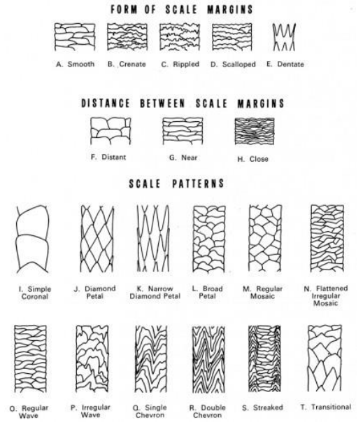
Figure 1 Various Scale Pattern Features (Vinayasheela et al, 2025)

1.3.2. Analysis Methods for Hair
There are several different types of analysis methods including DNA analysis and microscopic techniques. Microscopic techniques that are used in the forensic analysis of animal hair include stereomicroscopy, high powered light microscopy and scanning electron microscopy (SEM).
DNA analysis is applied in the forensic examination of animal hair, particularly in wildlife crime investigations where microscopic characteristics alone may be insufficient for definitive species identification (Corradini et al., 2024). DNA is typically extracted from the hair root or mitochondrial DNA within the shaft and analysed using polymerase chain reaction (PCR) amplification and sequencing to determine taxonomic identity (Corradini et al., 2024). This molecular approach can provide highly specific and objective results, often allowing species and sometimes individual identification, which is crucial for prosecuting illegal wildlife trade and poaching cases (Kanthaswamy, 2024). However, despite its analytical power, DNA analysis presents significant challenges in wildlife forensic applications; it is considerably more expensive than conventional microscopy, requiring specialised equipment, reagents, and highly trained personnel (Corradini et al., 2024). Furthermore, the process can be technically complex, as successful amplification often depends on the selection and validation of appropriate primers that can work across diverse taxa, sometimes necessitating multiple primer sets to target different species or degraded samples (Corradini et al., 2024). These factors not only increase costs but also extend processing times and elevate the risk of contamination or amplification failure, especially when dealing with trace or degraded DNA from crime scenes (Kanthaswamy, 2024). Consequently, while DNA analysis is a powerful tool in wildlife forensic investigations, it is often used alongside more cost-effective morphological approaches and is not always practical for routine casework in resource-limited settings (Corradini et al., 2024).
Stereomicroscopy is a quick and easy way of visualising microscopic characteristics of animal hairs. However, it is not effective due to not having as powerful of magnification as a high powered light microscope (Muthanandam et al, 2024).
High powered light microscopy is the preferred methods for visualising the microscopic characteristics of hair, due to it having a higher magnification than a stereomicroscope and therefore providing greater detail for comparison (Muthanandam et al, 2024).
SEM is considered the gold standard when it comes to the visualisation of the cuticle later of hair to enable analysis of scale patterns and interscale distance (Berg et al, 2025).
Scale casting is a microscopic technique used to observe the cuticle scale patterns on animal hair, which is made of overlapping keratin scales (Deedrick et al, 2004). The method involves coating a glass slide with a thin layer of a transparent medium such as clear nail polish or liquid latex. A hair sample is then placed onto the semi-dry surface, allowing the outer cuticle scales to imprint into the medium. Once dry, the hair is removed, leaving behind a detailed cast of its surface structure (Ahmed et al, 2018). This cast is then examined under a high powered light microscope to study the shape, arrangement, and pattern of the scales (Ahmed et al, 2018). One of the main advantages of scale casting is that it provides a clear and permanent record of the hair’s cuticle pattern, which can be used for comparison between species. It is a relatively simple, low-cost, and non-destructive method that produces accurate scale details. Scale casting is therefore widely used in forensic analysis, wildlife biology, and veterinary studies for species identification. However, the technique has some limitations. It only reveals the external cuticle structure and not the internal features such as the cortex or medulla. The process can also be time-consuming and may produce distorted casts if the medium is applied unevenly or the hair is moved during drying (Ahmed et al, 2018).
Optical Light Microscopy is a technique that works based on visible light and a system of lenses to magnify so they can be seen in detail by the human eye. The basic principle works by light passes through or reflects off the specimen. This light is then focused by the objective lens to form a magnified image (Stanciu, 2016).
There is a small amount of research that suggests that it is possible to distinguish between infrared spectrums from different types of animal hairs using chemometric methods. It suggests that the concept of using Attenuated Total Reflectance – Fourier Transform Infrared (ATR-FTIR) spectroscopy could be used to identify the species a hair has come from (Rao et al, 2024).
Out of all of the discussed analysis methods, microscopic techniques are preferred due to them being highly cost effective for species identification.

1.4. Bear Hair
There is a large amount of research surrounding bear hair sampling using hair traps including the effectiveness of them (Berezowska-Cnota et al, 2017). However, there is only a small amount of research that shows the morphological features of Eurasian Brown Bear (Ursus Arctos) hair (Sahajpal et al, 2008).
The guard hair of a Eurasian Brown Bear (Ursus Arctos) can have several different types of roots, which include white spheres, black hooks, and white hooks (Jimbo et al, 2020). However, there is no research into the mapping of a Eurasian Brown Bear (Ursus Arctos) and how the morphological characteristics of Eurasian Brown Bear (Ursus Arctos) hair vary across the body
Similar to other animals Eurasian Brown Bears (Ursus Arctos) have several types of hairs, which include whiskers and eyelashes. However, within the main coat of Eurasian Brown Bears (Ursus Arctos) there are three types of hair: guard hairs, under hairs, and over hairs (Jimbo et al, 2020). Guard hairs are a seasonal growth hair, which grow from late spring to early autumn. These types of hairs aim to provide protections and keep moisture and dirt away from the skin of the bear (Hilderbrand et al, 2025). Under Hair beings to grow later in the year and acts as an insulation device to help keep the bear warm in the colder months. The underfur acts as an insulation device due to its soft, dense layer of hair which is close to the skin (Jimbo et al, 2020). Over hairs have a variable growth pattern depending on the individual bear, they typically last three to five months (Jimbo et al, 2020).
The application of these microscopic and analytical techniques enables the identification and comparison of animal hair characteristics. This is particularly relevant to the present study, as the morphological variation of Eurasian brown bear (Ursus Arctos) hair across different anatomical regions remains largely unstudied.

1.5. Preservation of Samples (Taxidermy)
Taxidermy is a practice of preserving an animals body through either mounting or stuffing (Péquignot, 2006). It is primarily for the purpose of display and study (Livingston, 2020). Methods of Taxidermy have evolved. However, the process was originally created by Charles Wateron (Logan, 1983).
The taxidermy process started of with the immersion of the animal skin in a corrosive sublimate (Bichloride of mercury) for between 3 to 9 hours, depending on skin thickness, this allowed the skin to harden (Logan, 1983). Other examples of preservatives are powders, soap, pastes, and liquid infusions (Péquignot, 2006). Then the skin was partially dried using fire. It was then stuffed with finely cut chaff to roughly shape the animals natural proportions. Then the specimen was placed in a cardboard box, which was supported with packing materials to allow for a natural posture to be made. It was the allowed to finish drying slowly over several weeks or months. As the skin stiffened it was manipulated daily by hand to ensure a natural, life like posture was
achieved. Once the skin had fully dried the chaff was removed to leave the specimen entirely hollow (Logan, 1983).

1.6. Rationale for Project
The rationale for this research arises from the need to develop species identification methods that are simultaneously cost-effective, rapid, and reliable. Enhanced understanding of Eurasian brown bear (Ursus Arctos) hair characteristics, including both intra- and interspecific variation. This is essential for improving the accuracy and confidence of biological and ecological studies. Furthermore, if significant intra-individual variation exists, the ability to determine the anatomical origin of a hair sample will provide more precise data for ecological monitoring, forensic analysis, and conservation management. This study aims to address these gaps by systematically characterizing hair morphology and variation, thereby contributing to more robust and informed interpretations in species identification.

1.7. Aims and Objectives

1.7.1. Aim
The aim of this study was to investigate the intra-variation of macroscopic and microscopic characteristics present in the guard hairs of a Eurasian brown bear (Ursus Arctos) across different anatomical regions of the body.

1.7.2. Objectives
- Identify possible sources of Eurasian Brown Bear (Ursus Arctos) hair through both museums and zoos
- Design and implement a recovery method of hairs from across different anatomical regions across the body of a taxidermy Eurasian brown bear (Ursus Arctos)
- Characterise the macroscopic and microscopic morphological features of Eurasian brown bear (Ursus Arctos) from different anatomical regions across the body.
- To analyse and compare both macroscopic and microscopic characteristics of bear hair using a range of different techniques, including high powered light microscopy and scanning electron microscopy.
- Produce scale casts of the hairs to determine whether the outer cuticle layer of the hair are different on different anatomical regions parts of the body, including scale pattern and interscale distance.
- Critique the use of a taxidermy exhibit for the use of investigating macroscopic and microscopic characteristics of hair

S.2. Methods

2.1. Ethics and Risk Assessment
Prior to commencing this research, ethical approval and risk assessments were obtained. A procedural risk assessment was completed, with only relevant sections filled, and was approved on 22nd January 2026 (Appendix 7.2). Due to the collection of hair samples from museum and zoo specimens, a proportionate ethics form was submitted and approved on the 1st December 2025 (Appendix 7.3).

2.2. Preliminary Studies

2.2.1. Comparison of Comb versus Manual Extraction for Hair Collection
A pilot study was conducted to evaluate whether a comb or manual extraction with fingers was more effective for removing loose hairs from pelts. Hair removal efficiency and practical usability were assessed using a small comb (Superdrug, Appendix 7.4).

2.2.2. Comparison of Mounting Mediums: Depex versus Entellan
The hairs were mounted on glass microscope slides (Fisher, 1.0–1.2 mm thick, Cat. No. 7101) using a small volume of Entellan or Depex and a Fisherbrand seeker. Hairs were placed to ensure complete coverage by the medium, and a coverslip was applied with light pressure to remove air bubbles.

2.2.3. Scale Casting
Cuticular scale impressions were prepared using a nail polish technique. Microscope slides were cleaned with deionised water and wiped to remove grease. A thin layer of clear nail polish (Rimmel Nailpolish 60 Seconds Clear). was applied to the slide centre, and individual hairs were positioned using tweezers (Fisherbrand, 45° curved taper). Hairs were pressed to ensure full contact and alignment, then left at room temperature for approximately 20 minutes to harden. Hairs were subsequently removed, leaving a scale impression. Prepared slides were examined under transmitted light microscopy at 100 - 400× magnification (Simonsen, 1970).

2.3. Sample Collection
Initial contact was made with multiple museums and zoos via email (sample correspondence provided in Appendices 7.5 and 7.6). Several institutions did not respond or replied too late to participate (full list in Appendix 7.7). Following communication with Sarah Harvey from Chelmsford Museum (Appendix 7.8), hair samples were collected on 25th December 2016 (16/12/25) from multiple pelt regions (Appendix 7.1).
For collection, the pelt was gently combed using a small comb (Superdrug, Appendix 7.4), ensuring no damage or excessive tension on the fur. Individual hairs were removed from the comb with high-precision tweezers (Fisherbrand, 45° curved taper) and placed into labelled envelopes. Samples were collected to represent all hair colours present in each section, with a minimum of 10 hairs per section. The comb was cleaned between sections to prevent cross-contamination. This process was repeated across six defined anatomical regions, see figure 1 below.
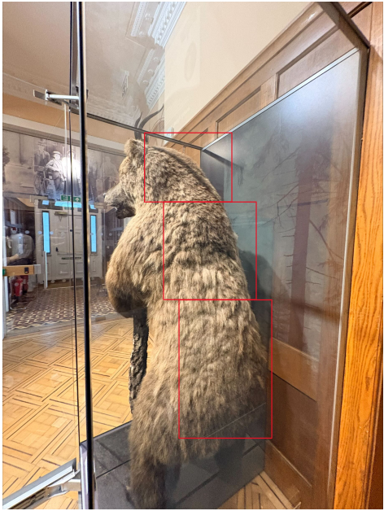
Neck
Middle of the back
Lower Back
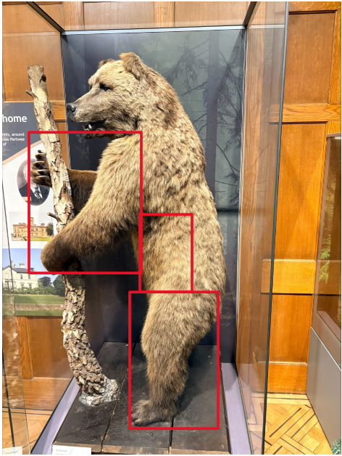
Right Front Leg
Right Side

Right Back Leg
Figure 2 Schematic for Sampling

2.4. Macroscopic Hair Analysis
Macroscopic characteristics of the hairs, including length, colour, shaft profile, and presence of colour banding, were recorded. Hairs were retrieved from envelopes using clean tweezers (Fisherbrand, 45° curved taper) and measured with a 30 cm plastic ruler. A representative proportion of each colour was selected. Hair colour was determined using the Neal and Wolf Hair Colour Numbering System (Neal and Wolf, 2026), and colour banding was noted. All data were recorded in an Excel spreadsheet (Appendix 7.1).
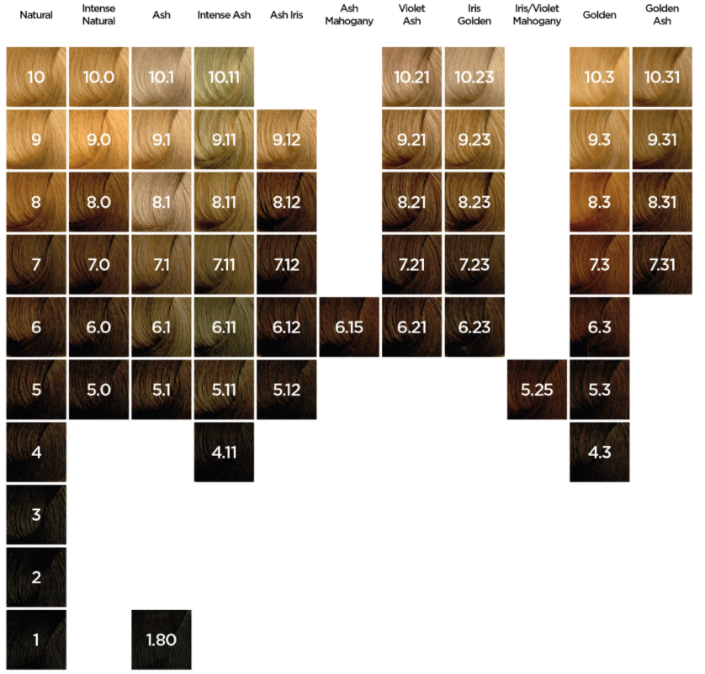
Figure 3 Hair Colour Chart (Neal and Wolf, 2026)

2.5. Microscopic Hair Analysis
Hairs were mounted on glass microscope slides (Fisher, 1.0–1.2 mm thick, Cat. No. 7101) using a small volume of Entellan and a Fisherbrand seeker. Hairs were placed to ensure complete coverage by the medium, and a coverslip was applied with light pressure to remove air bubbles. Slides were labelled with section and hair number according to the format: section number–hair number. For example, 1.9 would mean it came from the neck and was the 9th hair. The section numbers can be seen in table 1 below.
Analyses were conducted using a calibrated LEICA DM750P light microscope at 40× magnification. Hair width measurements included overall width, cortex width, and medulla width. Medulla type was classified according to Tridico (2009), and medulla ratio was calculated as:
$$\text{Medulla Ratio}=\frac{\text{Medulla Width}}{\text{Overall Width}}$$
Equation 1 Medulla Ratio Calculation (Sahajpal et al., 2008)
All measurements were recorded in the hair analysis form and Excel spreadsheet. The data gathered during this study included:
- Macroscopic Analysis
  - Length
  - Colour
  - Colour Number
  - Presence of Colour Banding
  - Shaft Profile
- Microscopic Analysis
  - Root Presence
  - Root Growth Stage
  - Tip Shape
  - Pigmentation
    - Density
    - Distribution
    - Granule shape
    - Aggregate size
  - Medulla
    - Distribution
    - Fragmentation stage 1 and 2
    - Medulla type
    - Colour bands present in the medulla
    - Medulla opacity
    - Medulla Width
    - Medulla Ratio
  - Presence of Damage
  - Overall Width
  - Cortex Width
- Scanning Electron Microscopy
  - Width of Hair
  - Interscale Distance
All the microscopic features analysed were graded using a grading system as shown in the study by Wilkinson (2022)
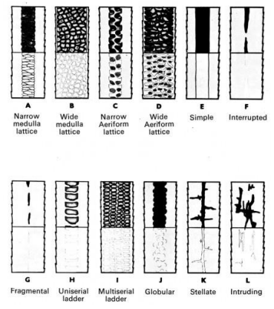
Figure 4 Various Medulla Types of Animals (Tridico, 2009)

2.6. Scale Casting
Cuticular scale impressions were prepared using a nail polish technique. Microscope slides were cleaned with deionised water and wiped to remove grease. A thin layer of clear nail polish was applied to the slide centre, and individual hairs were positioned using tweezers (Fisherbrand, 45° curved taper). Hairs were pressed to ensure full contact and alignment, then left at room temperature for ~20 minutes to harden. Hairs were subsequently removed, leaving a scale impression. Prepared slides were examined under transmitted light microscopy at 100 - 400× magnification (Simonsen, 1970).

2.7. Scanning Electron Microscopy
Hair samples were mounted on aluminium stubs using circular carbon adhesive tabs, ensuring that each hair strand was positioned horizontally and fully adhered. The stubs were inserted into the SEM chamber, evacuated, and operated in low vacuum mode to accommodate the non-conductive nature of the samples. Imaging parameters were set as follows: spot size 55, accelerating voltage 8 kV, and vacuum 40 Pa.
Measurements were systematically conducted along the entire length of each hair strand. For each hair, overall width and interscale distances were recorded continuously from the tip to the base to ensure comprehensive coverage of structural variations. Following completion of imaging and measurement for one hair, the stage was repositioned to the next hair, and the procedure was repeated until all mounted hairs had been analysed. After data collection, the SEM chamber was vented, and the stubs were removed.

2.8. Statistical Tests

2.8.1. Shapiro-Wilk
All statistical analyses within this study were carried out using IBM SPSS Statistics (Version 31.0.0.0 117). Prior to performing any statistical testing, a test for normality was carried out for each set of continuous measurements. Within this study, this was done on both width and interscale distance gathered through SEM, as well as overall width, medulla width, cortex width, and medulla ratio, which were obtained through microscopic analysis using a high-powered light microscope (LEICA DM750P Light Microscope). The Shapiro-Wilk test is a statistical test used to assess whether a dataset is normally distributed. It works by comparing the order statistics, or the sorted values of the sample, to the expected values if the data were perfectly normal, producing a p-value that reflects how closely the sample matches a normal distribution. To test for normality, the p-value was examined, where a p-value greater than 0.05 indicates that the data is normally distributed, whereas a p-value less than 0.05 indicates that the dataset is not normally distributed (Pallant, 2020).

2.8.2. Kruskal-Wallis H Test
The Kruskal-Wallis H test is a non-parametric statistical test used to determine whether there are statistically significant differences between the distributions of three or more independent groups when datasets are not normally distributed. It works by ranking all data points across groups and comparing the sum of ranks between them, rather than relying on the raw data values, and produces a p-value that indicates whether any observed differences between groups are likely to have occurred by chance. In this study, the Kruskal-Wallis H test was employed to determine whether statistically significant differences existed between groups, where in most instances the dependent variable analysed was the width of a microscopic feature (Pallant, 2020).
Prior to statistical analysis, all datasets were screened for outliers, and the level of statistical significance was set at p = 0.05. Where the Kruskal-Wallis H test indicated a statistically significant difference between groups, post-hoc pairwise comparisons were conducted to determine which groups differed (Pallant, 2020). The resulting output provided the test statistics, including the Kruskal-Wallis H value, degrees of freedom, and the associated significance value, or p-value. A p-value less than 0.05 indicated that at least one group differed significantly from the others, whereas a p-value greater than 0.05 indicated no statistically significant differences between groups (Pallant, 2020).
For a Kruskal Wallis H Test the group must be in numerical format rather than text. Therefore table 1, below demonstrates what each number will represent.
Table 1: Numerical coding used to represent different body sections for hair sample collection
Section of Body | Numerical Number
Neck | 1
Middle of the back | 2
Lower Back | 3
Right Side | 4
Right Front Leg | 5
Right Back Leg | 6

S.3. Results and Discussion

3.1. Preliminary Studies

3.1.1. Comparison of Hair Extraction Methods
Both the comb and manual collection methods yielded a comparable quantity of hairs within a fixed time period. However, the comb sampled a larger surface area, resulting in a more representative and proportionate sample. Consequently, the comb was selected as the preferred method for the remainder of the study.

3.1.2. Mounting Mediums
No significant difference in drying time was observed between the methods; however, Entellan was selected due to its lower content of volatile solvent.

3.1.3. Scale Casting
Due to the brittleness of the hairs, because of the age of the sample (128 years old) when scale casting was attempted the hair would just snap. This was determined due to when visualising under a microscope you could still visibly see large proportions of the hair left. As a result of this the number of samples measured using scanning electorn microscopy was increased from 1 from each anatomical region to 3 from each anatomical region with 3 widths and 15 interscale distances being take from each hair.
Due to the age of the samples, scale patterns, form and distance between scale margins, as displayed in figure 1 above, couldn’t be analysed due to the lack of scales present. However in section 3.7 below interscale scale distance was analysed.

3.2. Rationale for Methods
4 methods of analysis were carried out; macroscopic examination, microscopic examination, scale casting and SEM all of which measured and analysed different characteristics.

3.2.1. Macroscopic Examination
Within the macroscopic examination procedure, several results were collected, including length of hair (mm), colour based off colour number (Neal and Wolf, 2026), whether there is presence of any colour banding.
Hair length was analysed in this study, however showed to be not relevant due to there being no roots present on the samples nor there being a tip. Therefore, the length wouldn’t give any direct information.
Hair Colour and colour was analysed within this study because it can be distinct to a specific animal discussed in Jones (1923), which suggested that bear species can have different hair colours, such as orange, brown with some silvering on the tip. The colour is also key because it can help with an animals camouflage, as shown in Tan (2011) and Rchida et al (2023).

3.2.2. Microscopic Examination
In this study the standard measurements were made, which are the overall width of the hair, as well as this medulla width (Elgmork et al, 1991; De et al, 2006; Sahajpal et al, 2008). However, to make this study different the cortex was also measured, as this is not a standard measurement made (De Marinis et al, 2006). These measurements were used as they have been shown to have the ability to allow for species identification (Elgmork et al, 1991; Sahajpal et al, 2008).
All categorical data was determined using the hair analysis guide developed and displayed in a study by Wilkinson (2022).
The pigment within the hairs was also examined, in terms of density, distribution, granule shape, and aggregate size. Pigment was looked at under the microscope to determine if there is any similarities in appearance underneath a microscope as there is high levels of inter-species variation as shown in a study by Lasisi (2016), it however hasn’t been tested as to whether across the same Eurasian Brown Bear (Ursus Arctos) the pigmentation stays the same and therefore was determine to be worth investigating.
The medulla was analysed in several ways, which included detailing the fragmentation, type and opacity of it. This data was important to collect due to the taxidermy bear the samples originated from was killed in 1898 according to S.Harvey (personal communication, 12th February 2026). Therefore, due to the age of the sample fragmentation of the medulla was important to measure to see if statistically certain area of the body have a more damaged medulla. The age of the sample would be important due to medulla being made of soft keratin, with some air-filled spaces (Yang et al, 2014). Making it less dense than the cortex and cuticle, therefore making it fragment at a faster rate than the rest of the hairs structure as suggested in a study by Chang et al (2005).
The presence of any damage was also investigated due to the age of the specimen being 128 years old (as of 2026). The damaged that was analysed during this study was the cuticle layer.
Based on the results of the study, 100% of the samples showed no root present and out of 60 samples no hairs showed a natural taper. Therefore, based on these observations, it was assumed that the samples consisted solely of the hairs shaft.

3.3.3. Scanning Electron Microscope
A scanning electron microscope (SEM) was used in this study because it provides very high-resolution images of very small structures that cannot be clearly seen with a standard light microscope (Kaliyadan et al, 2016) The SEM allowed detailed photographs of the animal hair surface to be taken, making the cuticle scale patterns clearly visible, as shown in a study by Pavlov (2000). These high-magnification images (up to 10,000 times magnification) made it possible to accurately measure features such as the interscale distance and the width of the hair, which are important characteristics when analysing animal hair samples. Using SEM therefore ensured that precise measurements and detailed observations of the hair structure could be obtained (Davis et al, 2020).

3.4. Hair Width Variation of a Bears Body

3.4.1. Hair Width Variation of the Whole Body
Table 2 demonstrates several descriptive statistics of Hair width variation across the body of a Eurasian Brown Bear (Ursus Arctos).
Table 2: Demonstrating Averages of the Overall Width Across All Regions of the Body
Region | Sample Size (n) | Median Hair Width (μm) | Mean Hair Width (μm) | Standard Deviation (μm) | Min (μm) | Max (μm)
Neck | 50 | 51.45 | 52.53 | 6.65 | 41.65 | 66.15
Middle of the back | 50 | 51.45 | 53.56 | 13.00 | 37.98 | 78.40
Lower Back | 50 | 71.66 | 71.47 | 14.95 | 49.00 | 102.90
Right Side | 50 | 47.78 | 55.03 | 16.68 | 36.75 | 86.98
Right Front Leg | 50 | 49.00 | 49.27 | 18.97 | 26.95 | 90.65
Right Back Leg | 50 | 73.50 | 74.46 | 16.00 | 41.65 | 66.15

Across all of the body the variation in the width of the individual hairs is extremely low (as seen in appendix 7.9.). This can be seen with the standard deviation of the individual widths being between 1 and 3, and the range varying from 2.45μm to 4.90μm within the same hair. This is also shown in a study by Sahajpal et al (2008) which suggested that the variation in the width of individual bear hair fibres is low. The results of the study by Sahajpal et al (2008) showed the hair to have a width of 200μm ± 14μm which is an extremely low amount of variation in hair widths across a sample size of 30 hairs.
Across the body of a bear there is some variation in the mean hair width with a standard deviation across the entire bear being 17.33μm. However, there is a significant difference that is suggested that the rear of the bear has wider hairs than the front of the body. This can be seen in table 7 where the means are all approximately 50.00μm apart from the lower back and right rear leg which were both higher with mean widths of greater than 70.00μm.
One of the reasons for the thicker hairs around the lower part of the body of a bear could be linked to the fact that bears have been shown to rub their body up against trees (Green et al, 2003) which could have caused adaptations where the hairs on the lower back become thicker to enable it to withstand more rubbing to enable it to mark its territory (Green et al, 2003).
However, this interpretation should be treated with caution. The use of a taxidermy specimen introduces potential confounding factors, as prolonged environmental exposure and preservation processes may have altered the structural integrity of the hairs. Consequently, it is difficult to determine whether the observed differences reflect true biological adaptation or post-mortem artefacts.
From a forensic perspective, this variation is highly significant. If anatomical origin is not considered during hair comparison, differences in width could be misinterpreted as inter-species variation rather than intra-individual variation. This highlights a critical limitation in current morphological comparison approaches and reinforces the need for anatomically informed reference datasets.
It is possible to explain why the lower back, and right back leg hairs are thicker because of the way bears scratch there back up against tree and other objects. However, if this was the case, it would be expected that the front leg would also have thicker hairs from when they rub up against the side of a tree with the side of their body. However, one reason why the hairs on the front legs of bears may be smaller in width is to allow for the hairs to dry faster (Petrovicova et al, 2019). This would be an environmental adaptation due to the weather and climate the bear lives in. The climate where Eurasian Brown Bear (Ursus Arctos) live is variable with heavy snowfall in the winter (November to May) and wet cool summers (May to November) (Grits, 2015).
According to a study by Elgmork et al (1991), leg hairs particularly those from the front leg are thicker, which is the opposite of what the data in table 2 shows which suggests that the right front leg in fact has the thinnest hairs across the body. This is further proven by the thinnest hair in this study coming from the right front leg, measuring at mean of 28.18μm and the thickest hair coming from the lower back region measuring at an average thickness of 100.45μm. However, the results of Elgmork et al. (1991) may differ due to intraspecies variation, as their study sampled North American and Scandinavian bears, whereas this study focuses on Eurasian Brown Bears (Ursus Arctos).
The distribution of overall width variation was tested for normality using Shapiro-Wilk and was found to be not normally distributed (p < 0.05) in all area of the body, as shown in Appendix 7.10. Consequently, a Kruskal–Wallis H test was conducted to determine whether the results are statistically significant across different anatomical areas of the body. The test indicated a statistically significant differences between anatomical regions (p< 0.05), as shown in Appendix 7.11.
Post-hoc pairwise comparisons with Bonferroni correction revealed that the lower back differed significantly from the neck (p = .000), middle of the back (p = .000), right side (p = .000), and right front leg (p = .000). Similarly, the right rear leg differed significantly from the neck (p = .000), middle of the back (p = .000), right side (p = .000), and right front leg (p = .000). However, there was no statistically significant difference between the lower back and right rear leg (p = 1.000), as demonstrated in Appendix 7.12.

3.4.2. Overall Width Variation over the Body using SEM
Table 3 shows several descriptive statistics of Overall Width using SEM.
Table 3: Descriptive Statistics about Varying Regions on the Body measured using SEM
Region | Sample Size (n) | Median Width (μm) | Mean Width (μm) | Standard Deviation (μm) | Minimum (μm) | Maximum (μm)
Neck | 9 | 60.008 | 61.334 | 12.844 | 43.775 | 85.536
Middle of the back | 9 | 73.684 | 69.720 | 14.817 | 49.323 | 86.135
Lower Back | 9 | 65.583 | 69.241 | 8.584 | 56.586 | 80.141
Right Side | 9 | 101.797 | 96.358 | 11.570 | 80.416 | 109.817
Right Front Leg | 9 | 62.610 | 60.093 | 13.241 | 43.020 | 78.535
right Back LEg | 9 | 92.741 | 95.459 | 7.772 | 85.241 | 106.843
Overall, the results show a large amount of variation in width across the different regions, as demonstrated by the large variation in minimum and maximum values shown in table 3. The Right Side (Between Legs) exhibited the largest measurements, with a median width of 101.797μm and a mean width of 96.358μm. This region also showed the greatest maximum value at 109.817μm and a standard deviation of 11.570μm, indicating moderate variability among the samples.
The Right Back Leg also demonstrated relatively large widths compared to most other regions, with a mean of 95.459μm and a median of 92.741μm. This region had the lowest variability, as indicated by the smallest standard deviation (7.772μm), suggesting that measurements were more consistent across the samples. The Middle of the back and Lower Back showed moderate width values. The Middle of the back had a median of 73.684μm and a mean of 69.720μm, with the highest standard deviation (14.817μm), indicating greater variation in this region. The Lower Back had a similar mean (69.241μm) but a smaller standard deviation (8.584μm), suggesting more consistent measurements.
Smaller widths were observed in the Neck and Right Front Leg regions. The Neck had a median width of 60.008μm and a mean of 61.334μm, with measurements ranging from 43.775μm to 85.536μm. Similarly, the Right Front Leg showed a median of 62.610μm and a mean of 60.093μm, with a range between 43.020μm and 78.535μm and a standard deviation of 13.241μm. Across all regions, the overall minimum measurement recorded was 43.020μm in the Right Front Leg, while the maximum measurement was 109.817μm in the Right Side, demonstrating considerable variation in width depending on the anatomical location.
When compared with previous research, the widths observed in this study appear larger than those reported for some other bear species. In a study conducted by Farag (2015), it was shown that American black bear hair has an overall diameter between 30.3μm and 56.6μm, which is thinner than all regions measured in the present study. In contrast, Yang (2020) reported an average bear hair diameter of approximately 80μm, although the specific bear species sampled was not specified. The measurements recorded in the current study range from 43.020μm to 109.817μm, with several regions exceeding this reported average, suggesting potential species differences or variation depending on anatomical location. However, the overall average for the samples analysed was 75.368μm, which is similar to what the study by Yang (2020) reported.
The distribution of area measurements for each body region was tested for normality using the Shapiro Wilk test. Most areas, including the Neck, Lower Back, Right Front Leg, and Right Rear Leg, were approximately normally distributed (p > 0.05). The Middle of the back was marginally over the limit of being classified as being not normally distributed (p = 0.058), while the Right Side was well over the limit of being classified as being not normally distributed (p = 0.028), as shown in Appendix 7.13. Consequently, a Kruskal-Wallis H test was conducted to determine whether overall width differed significantly across different sections. The test showed a statistically significant difference between sections (p < 0.001) as shown in appendix 7.14. Due to the results differing significantly a Post-hoc pairwise comparisons with a Bonferroni correction was used. The statistical significance values for the post hoc pairwise comparison are shown in Appendix 7.15. The test indicated that the neck and middle of the back were statistically similar (p = 1.000), as were the lower back and right front leg (p = 1.000). Similarly, the right side and right rear leg showed no statistically significant difference (p = 1.000). In contrast, several other comparisons demonstrated significant differences. The neck showed significantly lower scores than both the right side (p = 0.002) and the right rear leg (p = 0.001). The lower back also had significantly lower scores than the right side (p = 0.029) and the right rear leg (p = 0.021). Additionally, the right front leg differed significantly from the right side (p = 0.001) and the right rear leg (p = 0.001). Comparisons involving the middle of the back were statistically different after Bonferroni adjustment, indicating intermediate values relative to the other sections.

3.5. Medulla Variation over a Bears Body

3.5.1. Medulla Width
Table 4 shows descriptive statistics of the medulla width across several anatomical regions.
Table 4: Descriptive Statistics for the Medulla Width Across the Body
Region | Sample Size (n) | Median Width (μm) | Mean Medulla Width (μm) | Standard Deviation (μm) | Min (μm) | Max (μm)
Neck | 50 | 17.15 | 17.32 | 2.19 | 12.25 | 22.05
Middle of the back | 50 | 17.15 | 17.66 | 4.52 | 9.80 | 26.95
Lower Back | 50 | 28.79 | 31.65 | 9.97 | 17.15 | 51.45
Right Side | 50 | 20.83 | 21.56 | 5.41 | 12.25 | 29.40
Right Front Leg | 50 | 20.83 | 20.87 | 7.79 | 11.03 | 40.43
Right Back Leg | 50 | 26.95 | 27.32 | 7.31 | 14.70 | 40.43

The neck and middle of the back show very similar medians and mean, as shown in table 4. Both have a median width of 17.15μm, with means of 17.32μm and 17.66μm respectively, indicating similar medulla widths in these areas. The median values are also very close to their corresponding mean values, suggesting that there is very little skew in the distribution of medulla width measurements for these regions. In addition, both this study and the study carried out by Elgmork et al. (1991) suggest there is very little variation between the neck and the middle of the back. This is demonstrated in the present data by the small difference of only 0.34μm between the mean medulla widths of these two regions. However, the neck shows less variability overall, with a standard deviation of 2.19μm compared with 4.52μm for the middle of the back. Their ranges also reflect this difference in variability: the neck ranges from 12.25μm to 22.05μm, while the middle of the back extends more widely from 9.80μm to 26.95μm. Due to the lower variation and greater consistency between these areas, hairs from the neck and middle of the back may be more reliable for forensic identification purposes.
The right side and the right front leg also show comparable central measurements. Both regions have a median width of 20.83μm and very similar mean values (21.56μm and 20.87μm respectively), suggesting that typical medulla widths in these locations are almost identical. Despite these similar central tendencies, the spread of the data differs. The right front leg shows greater variability with a standard deviation of 7.79μm, compared with 5.41μm for the right side. The ranges also highlight this difference, with the right front leg extending from 11.03μm to 40.43μm, while the right side ranges from 12.25μm to 29.40μm. When comparing limb regions, this study and the work of Elgmork et al. (1991) both suggest that there can be considerable variation between the front and rear legs.
In contrast, the lower back and right back leg display noticeably larger medulla widths than the other regions and are therefore like each other in terms of overall magnitude. The lower back has the highest median (28.79μm) and mean (31.65μm), while the right back leg has a median of 26.95μm and a mean of 27.32μm. Like the overall width of the hair, the lower back and right back leg had the thickest medulla across the body of the bear. Both regions also show relatively large variability, with standard deviations of 9.97μm and 7.31μm respectively. Their ranges are also among the widest in the dataset: the lower back extends from 17.15μm to 51.45μm, while the right back leg ranges from 14.70μm to 40.43μm. A study by De et al. (2006) suggested that the mean medulla width of bear hair was approximately 24.34μm, which lies within a similar range to the mean medulla widths recorded in this study.
Overall, the data suggest three general groupings based on similarity. The neck and middle of the back have the smallest medulla widths and relatively lower variability, the right side and right front leg show moderate widths with moderate to high variation, and the lower back together with the right back leg exhibit the largest measurements and the greatest spread of values. Across all regions, the width of hairs varies considerably, with an overall range of 41.65μm (from 9.80μm to 51.45μm). This highlights the importance of comparing several measurements when analysing an unknown hair sample to ensure accurate identification. Such variation is expected because hair across the body performs different functions and therefore varies in thickness depending on body location, as also demonstrated in the study by Elgmork et al. (1991).
Statistical testing was conducted to assess differences in medulla width across body areas, normality was first assessed using a Shapiro Wilk test, which indicated that all but the right rear leg was not normally distributed (p < 0.05; Appendix 7.16.). Even though the right rear leg was normally distributed, due to the requirement for comparing the different sections of the body a non-parametric test was selected. The appropriate test was therefore the Kruskal–Wallis H test. The test revealed a statistically significant difference in medulla width between anatomical areas (p < 0.05) as shown in Appendix 7.17.
Post-hoc pairwise comparisons with a Bonferroni correction revealed several significant differences between body areas, as shown in Appendix 7.18. No statistically significant difference was observed between the neck and the middle of the back (p = 1.000). However, the neck differed significantly from the right front leg (p = 0.028), right side (p = 0.002), and right rear leg (p = 0.000).
Similarly, the middle of the back differed significantly from the right front leg (p = 0.047), right side (p = 0.003), and right rear leg (p = 0.000), but not from the neck (p = 1.000). The right front leg showed no significant difference compared with the right side (p = 1.000), but differed significantly from the right rear leg (p = 0.016) and the lower back (p = 0.000).
The right side differed significantly from the lower back (p = 0.000), but not from the right rear leg (p = 0.101). Likewise, no statistically significant difference was observed between the right rear leg and the lower back (p = 0.543).

3.5.2. Medulla Ratio
Table 5 shows multiple descriptive statistics of the medulla ratio from several anatomical regions.
Table 5: Summary statistics of medulla ratio measurements from hair samples collected from different body regions
Region | Sample Size (n) | Median Medulla Ratio | Mean Medulla Ratio | Standard Deviation | Min | Max
Neck | 50 | 0.33 | 0.33 | 0.04 | 0.24 | 0.40
Middle of the back | 50 | 0.33 | 0.33 | 0.03 | 0.25 | 0.42
Lower Back | 50 | 0.41 | 0.45 | 0.11 | 0.29 | 0.70
Right Side | 50 | 0.43 | 0.42 | 0.15 | 0.18 | 0.80
Right Front Leg | 50 | 0.43 | 0.43 | 0.07 | 0.27 | 0.63
Right Back Leg | 50 | 0.39 | 0.37 | 0.09 | 0.20 | 0.53
The medulla ratio across the entire bear shows a similar overall pattern, with a total range of 0.62, as shown in Table 5. The mean medulla ratio recorded in this study was 0.39, which closely aligns with the value reported by Sahajpal et al. (2009), who found a mean medulla ratio of 0.38 for Eurasian Brown Bears (Ursus Arctos). This close agreement suggests that the measurements obtained in the present study are consistent with previously published data.
The medulla ratios measured across different regions of the body (Table 5) also show a clear pattern of anatomical variation, which corresponds with previously documented intraspecific differences in Eurasian Brown Bear (Ursus Arctos) guard hairs. Mean values in the neck and middle of the back were identical (0.33) and exhibited low standard deviations (0.04 and 0.03 respectively), indicating relatively uniform hair structure in these forward regions of the body. This observation is consistent with findings by Elgmork et al. (1991), who reported that hairs from the neck, back, and right side tend to show relatively stable medulla ratios and less variability compared with hairs from the limbs. As a result, when comparisons are made in hair analysis studies, it is recommended that samples are taken from the upper body regions, such as the neck or middle of the back, to ensure greater consistency.
In contrast, higher mean medulla ratios were observed in the lower back (mean 0.45; median 0.41) and the right side between the legs (mean 0.42; median 0.43), as presented in Table 5. These regions also displayed substantially greater variability, as reflected by their larger standard deviations (0.11 and 0.15 respectively) and wider ranges of values.
Limb-associated regions also demonstrated increased variation. The right front leg exhibited a relatively high mean medulla ratio (0.43) with a moderate degree of variation (SD = 0.07), while the right back leg showed a slightly lower mean (0.37) but still displayed moderate variability (SD = 0.09), as shown in Table 5. Both the limb-associated regions show higher medulla ratios that the average that is suggested in a study carried out by Elgmork et al. (1991).
Overall, the results in Table 5 demonstrate that variation in medulla ratio is strongly influenced by body region, supporting the conclusion of Elgmork et al. (1991) that anatomical origin is a major source of intraspecific variation in Eurasian Brown Bear (Ursus Arctos) hair structure. The overlap in medulla ratios across the body further highlights the importance of standardised sampling locations when hair morphology is used in forensic analysis, particularly from consistent upper body regions such as the neck or upper back.
Biologically, variation in medulla ratio is thought to reflect adaptations in hair structure related to insulation, strength, and flexibility. Hairs with thicker or more continuous medullae, such as those observed in the limbs and lower back, may provide additional mechanical support and resilience in regions subjected to more friction or environmental exposure. In contrast, the more uniform and thinner medullae of the neck and upper back may optimize insulation and reduce heat loss, consistent with the primary role of guard hairs in thermoregulation and protection of the underfur. This functional perspective helps explain why medulla ratios differ systematically across body regions (Greco et al., 2024; Wagner et al, 2007).
The Shapiro-Wilk test was conducted, the normality of the medulla ratio data for the lower back, right front leg and right rear leg was not normally distributed (p < 0.05) as shown in Appendix 7.19. Even though some section of the body are normally distributed, to allow for effective comparison of all data a Kruskal-Wallis H test was selected to test for statistically significant differences. The Kruskal-Wallis H Test indicated that the data was statistically different (p < 0.05) as shown in Appendix 7.20. Therefore, to determine whether any groups were statistically similar a post-hoc pairwise comparison with Bonferroni correction was used. The statistical significance values for the post hoc pairwise comparison are shown in appendix 7.21. The test indicated that the neck and middle of the back were statistically similar (p = 1.000), as were the lower back and right front leg (p = 1.000). Similarly, the right side and right rear leg showed no statistically significant difference (p = 1.000). In contrast, several other comparisons demonstrated significant differences, including the middle of the back with the right rear leg (p = 0.004), the neck with the right rear leg (p = 0.011), and both the neck and middle of the back with the right side, lower back, and right front leg (p = 0.000).

3.5.3. Medulla Type
Figure 1 demonstrates the distribution of varying medulla types in the analysed hair in this study.
Figure 4: Distribution of Medulla Type
Over 90% of the hairs, have a medulla type of a narrow vacuolated. This is also demonstrated in a study carried out by Sahajpal et al (2008), where he suggested Eurasian Brown Bears (Ursus Arctos) have a narrow-vacuolated medulla. This is compared to other bears in the study by Sahajpal et al (2008) where it was suggested that Sloth Bears, Himalayan black bars and sun bears all had Amorphous, narrow medullas.
Whilst a small proportion aren’t a narrow vacuolated medulla, this study suggests that typically it can be expected that if a Eurasian Brown Bear (Ursus Arctos) hair is found then it can be expected to have a narrow vacuolated medulla type, based on the fact that as previously mentioned over 90% of the medulla analysed in this study had a narrow vacuolated medulla structure.

3.5.4. Medulla Fragmentation
100% of of all 60 medulla looked at under a microscope showed some form of fragmentation, as shown in figure 2, where the medulla has fragmented within the centre of the image. Table 6 shows both stages of analysis of medulla fragmentation that were analysed. A 2-stage process was chosen to allow for a greater amount of detail and differentiation to be gathered. The process was taken from a study by Wilkinson (2022).
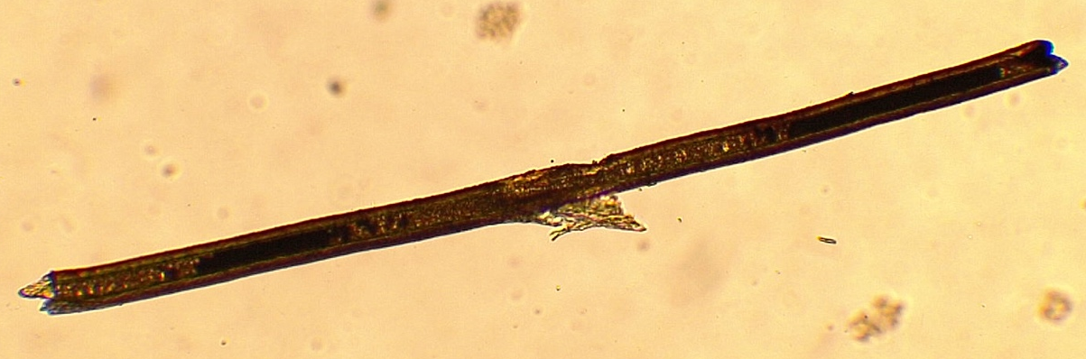
Figure 5: Medulla Fragmentation (magnification = x400)
Figure 5 shows partial medulla fragmentation in the centre of the photo where damage to the overall structure of the hair has occurred. All other samples as shown in table 6, where medulla fragmentation St. 1 has no grade 0. Therefore, all hairs had some form of medulla fragmentation, which could have occurred due to the time since the Eurasian Brown Bear (ursus arctos) was killed.
Table 6 demonstrates both stage 1 and stage 2 analysis of medulla fragmentation across several sections of the body.
Table 6: Cross-tabulation of medulla fragmentation grades (Stage 1 vs. Stage 2) across different body sections, showing the frequency distribution of samples for each grading category.
Region | Sample Size | Medulla Fragmentation Grading St.1 | Medulla Fragmentation Grading St.2 |  |  |  |  | Grand Total
Region | Sample Size | Medulla Fragmentation Grading St.1 | 0 | 1 | 2 | 3 | 4 | Grand Total
Neck | 10 | 0 |  |  |  |  |  | 0
Neck | 10 | 1 | 4 | 1 | 1 |  |  | 6
Neck | 10 | 2 |  |  | 2 |  |  | 2
Neck | 10 | 3 |  | 1 |  | 1 |  | 2
Neck | 10 | 4 |  |  |  |  |  | 0
Middle of the Back | 10 | 0 |  |  |  |  |  | 0
Middle of the Back | 10 | 1 | 1 | 8 |  |  |  | 9
Middle of the Back | 10 | 2 |  |  |  | 1 |  | 1
Middle of the Back | 10 | 3 |  |  |  |  |  | 0
Middle of the Back | 10 | 4 |  |  |  |  |  | 0
Lower Back | 10 | 0 |  |  |  |  |  | 0
Lower Back | 10 | 1 |  | 2 | 4 |  |  | 6
Lower Back | 10 | 2 |  |  | 1 |  |  | 1
Lower Back | 10 | 3 |  |  | 1 |  | 2 | 3
Lower Back | 10 | 4 |  |  |  |  |  | 0
Right Side | 10 | 0 |  |  |  |  |  | 0
Right Side | 10 | 1 |  | 3 | 3 |  |  | 6
Right Side | 10 | 2 |  | 1 | 1 |  |  | 2
Right Side | 10 | 3 |  |  |  | 1 | 1 | 2
Right Side | 10 | 4 |  |  |  |  |  | 0
Right Front Leg | 10 | 0 |  |  |  |  |  | 0
Right Front Leg | 10 | 1 |  | 2 | 4 |  | 1 | 7
Right Front Leg | 10 | 2 |  |  | 1 |  |  | 1
Right Front Leg | 10 | 3 |  | 1 |  |  | 1 | 2
Right Front Leg | 10 | 4 |  |  |  |  |  | 0
Right Rear Leg | 10 | 0 |  |  |  |  |  | 0
Right Rear Leg | 10 | 1 | 1 | 3 | 4 | 2 |  | 10
Right Rear Leg | 10 | 2 |  |  |  |  |  | 0
Right Rear Leg | 10 | 3 |  |  |  |  |  | 0
Right Rear Leg | 10 | 4 |  |  |  |  |  | 0

As demonstrated in Table 6, approximately 73% of all samples have a Medulla Fragmentation St.1 grade of 1 or 2, with far less having grade on either extreme ends of the spectrum.
The neck and right back leg exhibit the greatest variability. In the neck, St.1 counts are 4 in grade 0, 2 in grade 1, 3 in grade 2, 1 in grade 3, and 0 in grade 4; St.2 counts are 1, 4, 1, 1, and 0, respectively. The right back leg shows a similar spread across grades in both steps: St.1 and St.2 counts are 1 in grade 0, 3 in grade 1, 4 in grade 2, 2 in grade 3, and 0 in grade 4. Both regions display broader fragmentation across grades compared to other areas, indicating higher variability.
The middle of the back and right side primarily shows low to moderate fragmentation. In the middle of the back, St.1 counts are 1 in grade 0, 8 in grade 1, 0 in grade 2, 1 in grade 3, and 0 in grade 4, while St.2 counts are 1, 8, 0, 0, and 0. The right side has slightly more spread: St.1 counts are 0 in grade 0, 4 in grade 1, 4 in grade 2, 1 in grade 3, and 1 in grade 4, and St.2 counts are 3, 3, 0, 1, and 2. Despite minor differences, both regions are dominated by grades 0-2, showing generally low amounts of fragmentation, as shown in table 6.
The lower back and right front leg are similar, both dominated by mid-range fragmentation in grades 1 and 2. For the lower back, St.1 counts are 0 in grade 0, 2 in grade 1, 6 in grade 2, 0 in grade 3, and 2 in grade 4; St.2 counts are 1, 2, 4, 0, and 0. The right front leg shows similar counts: St.1 has 0 in grade 0, 3 in grade 1, 5 in grade 2, 0 in grade 3, and 2 in grade 4; St.2 has 0, 2, 4, 1, and 0. These numerical similarities indicate that both regions share a consistent moderate fragmentation profile.
Overall, the two-step analysis highlights consistent patterns within regions. The neck and right back leg show higher variability across grades, the middle of the back and right side are largely low-to-moderate, and the lower back and right front leg are concentrated in mid-range fragmentation. Minor differences between St.1 and St.2 suggest small shifts between analysis steps, but overall trends remain consistent.

3.6. Cortex Width Variation over a Eurasian Brown Bears Body
Table 7 demonstrates several descriptive statistics of the cortex width across several anatomical regions across the body of a Eurasian Brown Bear (Ursus Arctos).
Table 7: Summary statistics of cortex width measurements from hair samples collected from different body regions, including median, mean, standard deviation, minimum, and maximum values.
Region | Sample Size (n) | Median Cortex Width (μm) | Mean Cortex Width (μm) | Standard Deviation (μm) | Min (μm) | Max (μm)
Neck | 50 | 17.15 | 17.15 | 3.41 | 12.86 | 22.66
Middle of the back | 50 | 17.46 | 17.42 | 4.63 | 11.64 | 26.95
Lower Back | 50 | 20.52 | 19.07 | 5.10 | 8.58 | 30.63
Right Side | 50 | 13.48 | 16.35 | 8.93 | 3.68 | 31.85
Right Front Leg | 50 | 13.48 | 13.79 | 6.28 | 6.13 | 26.95
Right Back Leg | 50 | 20.83 | 22.71 | 6.91 | 15.31 | 38.59

The cortex width of the bear shows clear variation across different regions of the body, as demonstrated in table 7. The neck and middle of the back regions exhibit relatively consistent thickness, with mean and median values nearly identical (17.15μm and 17.42μm respectively), which indicates symmetric distributions. Both regions also have low standard deviations (3.41μm for the neck, 4.63μm for the middle of the back) and relatively narrow ranges, suggesting minimal variability between individuals. The neck has the lowest range of any section at 9.8μm, consistent with findings by Elgmork et al. (1991), who reported that the neck shows limited variation in hair width. This supports the recommendation that neck hairs are most suitable for species comparison.
In contrast, the lower back and right back leg have the highest cortex widths, with means of 19.07μm and 22.71μm respectively. These regions also display greater variability, with standard deviations of 5.10μm and 6.91μm and wider ranges, reflecting structural diversity across samples. The right side shows the highest overall range of any section, with a standard deviation of 8.93μm and a range of 3.68–31.85μm, indicating substantial variation in thickness across this area. The right front leg and right side generally have thinner cortices, with median values of 13.48μm for both, consistent with their reduced mechanical load compared to posterior regions. These patterns align with functional and anatomical differences across the body, where posterior, weight-bearing regions require thicker cortices.
Across the entire body, the average cortex width was 18.33μm, which is lower than the 31μm estimated by Elgmork et al. (1991). In this study, only 5% of cortex measurements exceeded 31μm, which could reflect seasonal effects on hair thickness. According to S. Harvey (Personal Communication, 2026), the bear was killed during winter, when melatonin levels increase, stimulating the growth of a thicker winter coat (Ware et al., 2013). The observed variation in cortex width is consistent with this seasonal change, likely occurring during the transition from summer to winter coat around September–October. However, without historical weather data from 1898, it is difficult to fully quantify the influence of environmental factors on hair thickness, as daylight hours and weather have been shown to impact melatonin levels and hair growth (Babadjouni et al., 2023).
Overall, the median and mean cortex widths across the body indicate moderate skew (0.5 < skew < 1.0), demonstrating that the data is not normally distributed. The combined results reveal a clear pattern that the rear of the body, such as the lower back and right back leg, have the thickest cortices with moderate to high variability, central regions like the neck and middle of the back are moderately thick and highly consistent, and regions on the side, including the right front leg and right side, tend to be thinner and more variable. These findings reflect both functional differences in hair structure and seasonal influences on cortex width.
Importantly, these findings have forensic and ecological applications. The high consistency of neck hair supports its use as a reliable marker in species identification, wildlife forensics, and population studies, where hair evidence is frequently the only available sample. Conversely, the observed variability in lateral and posterior regions highlights the need to sample multiple body regions for accurate hair-based analyses, particularly in estimating age, season of death, or individual identification. Integrating these patterns with established literature, the study confirms general trends in functional hair morphology while providing updated data on seasonal and regional variability, emphasizing the importance of context when interpreting hair characteristics in both research and forensic investigations.
Based on the results from the Shapiro Wilks statistical test, it can be determined that all sections other than the lower back are not normally distributed (p < 0.05) as shown in Appendix 7.22. Therefore, like the medulla ratio to ensure effective statistical testing the Kruskal-Wallis H test was carried out. It shows there is statistical differences between body areas (p < 0.05) as shown in Appendix 7.23.
As a result of this a post-hoc pairwise comparison with Bonferroni correction was used. It showed the neck, middle of the back and lower back are all statistically similar to each other (p = 1.000) as shown in appendix 10.25. It shows that the lower back is statistically similar to the right rear leg (p = 0.406) as shown in Appendix 10.25. It also shows that the middle of the back and neck are statistically similar to the right side (neck–right side p = 0.688; middle of the back–right side p = 0.683) as shown in Appendix 7.24. However, the lower back isn’t statistically similar to the right side (p = 0.010) as shown in Appendix 7.24. All other sections are statistically different with varying p-values as shown in appendix 7.24.

3.7. Interscale Distance Variation over a Eurasian Brown Bears Body
Table 8 shows a set of descriptive statistics about the interscale distance measurements from several anatomical regions across the body.
Table 8: Summary statistics of interscale distance measurements in hair samples from different body regions, including median, mean, standard deviation, minimum, and maximum values.
Region | Sample Size (n) | Median Interscale distance (μm) | Mean Interscale distance (μm) | Standard Deviation (μm) | Min (μm) | Max (μm)
Neck | 45 | 9.374 | 9.945 | 4.999 | 3.578 | 27.601
Middle of the back | 45 | 7.823 | 11.211 | 16.129 | 3.423 | 17.565
Lower Back | 45 | 9.677 | 9.734 | 4.209 | 3.453 | 19.003
Right Side | 45 | 9.767 | 11.211 | 5.610 | 4.919 | 32.160
Right Front Leg | 45 | 7.603 | 8.284 | 4.308 | 2.263 | 21.734
Right Back Leg | 45 | 7.529 | 8.859 | 3.910 | 3.441 | 19.601
Overall, the neck, lower back, and right side demonstrate comparable median interscale distances, all between 9.3μm and 9.8μm. as shown in table 8. The mean values for the neck (9.945μm) and lower back (9.734μm) are also very similar to their medians, suggesting relatively symmetrical distributions in these regions. In contrast, the right side has a noticeably higher mean (11.211μm) compared with its median (9.767μm), indicating the presence of higher values influencing the average. This region also shows the largest maximum value (32.160μm), suggesting occasional extreme measurements compared with other areas.
The leg regions exhibit broadly similar interscale distance patterns to each other, but lower central values compared with the back and neck regions. Both the right front leg and right back leg have medians around 7.5μm and 7.6μm and means between 8.284μm and 8.859μm. These relatively close values indicate similar distributions and moderate variability in both leg regions. Their standard deviations (4.308μm and 3.910μm) are also comparable, suggesting consistent variability between the two areas. However, the right front leg shows the lowest minimum value (2.263μm), indicating that this region includes some particularly small interscale distances compared with the rest of the body.
The middle of the back differs from the other regions in terms of variability and central tendency. While its median interscale distance (7.823μm) is closer to the values observed in the leg regions, the mean is substantially higher at 11.211μm. This difference suggests a skewed distribution with larger values influencing the average. Additionally, the middle of the back displays the highest standard deviation (16.129μm), indicating a much greater spread in measurements compared with all other regions.
In terms of overall variability, most regions including the neck, lower back, and both leg regions demonstrate moderate and relatively consistent variation, with standard deviations generally around 4μm and 5μm. In contrast, the right side and particularly the middle of the back section show greater spread in measurements, as reflected by the higher maximum values and larger standard deviations. These results suggest that while interscale distances are broadly comparable across several body regions, certain areas show greater variability.
These observed regional variations in interscale distances likely reflect functional and mechanical adaptations of the bear’s fur. The relatively uniform and moderately spaced scales on the neck, lower back, and legs suggest these areas experience consistent friction or insulation demands, maintaining optimal hair density for protection and thermoregulation. In contrast, the right side and middle of the back, which show greater variability and occasional extreme distances, may correspond to regions subjected to more irregular mechanical stress or movement-related strain, such as rubbing against trees or other environmental surfaces. The extreme high values on the right side could also indicate occasional localized hair damage or variability in hair growth cycles. Such spatial heterogeneity in scale spacing reflects a combination of environmental interaction, grooming behaviour, and intrinsic growth patterns, highlighting how hair morphology is not uniform but finely tuned to functional requirements across the body. Morphological features of mammalian hair, including cuticular scale spacing and structure, are known to vary across body regions and between species, reflecting adaptations linked to insulation, abrasion resistance, and other functional demands (Meyer et al, 2002; Greco et al, 2024).
A Shapiro Wilks test for normality was conducted, showing some data to be normally distributed, which were the right front leg and right rear leg (p > 0.05) as shown in appendix 7.25.
Therefore, due to only some of the data being normally distributed a Kruskal Wallis H test was run to determine if the data was statistically different. The results of this test as shown in appendix 7.26 show that the data is just above the normal significance threshold of 0.05. Therefore, to fully assess the different regions, a pairwise comparison with Bonferroni correction was used. This indicated that the right front leg and right side showed statistically significant different (p = 0.036), as shown in appendix 10.28. Whilst all other pairwise comparisons showed statistically similar results (p > 0.05), as shown in appendix 7.27.

3.8. Macroscopic Colour Variation Over Anatomical Regions
As demonstrated by figure 3, there is variation around the colour of the hair found in the Eurasian Brown Bear (Ursus Arctos). However, a significant amount more hairs had colour number values either 7 or 7.1 (colour number gathered using colour chart (Neal and Wolf, 2026)).

Figure 6: Frequency Distribution of Observed Colour Numbers in the Analysed Hair Samples, showing the relative occurrence of each colour category
Within Eurasian Brown Bear (Ursus Arctos) hair there is a range of colours, which can be defined as light brown to dark brown. Within this study a colour chart has also been used (Neal and Wolf, 2026). 28% of all hairs samples had a colour number of 7 and 19% has a colour number of 7, which would both be referred to as medium brown, as shown in figure 3. The medium brown colour in bear hair is related to environmental adaptation, in terms of camouflage, this is because it assists in the concealment of the bear when it is hunting prey (Tan, 2011; Rchida et al, 2023). This study shows that the hair on a Eurasian Brown Bear (Ursus Arctos) is all of a shade of brown with varying colours, which is also suggested in a study carried out by Sahajpal et al (2008), which also suggest Eurasian Brown Bear (Ursus Arctos) have a hair colour of brown but that study doesn’t suggest the shade of brown (was it light brown or dark brown hairs).

3.9. Pigmentation Across the Body of a Bear
Table 9 demonstrates the frequency of different pigment distribution types analysed in the hair samples.
Table 9: Frequency distribution of pigment distribution types observed over all the hairs analysed through this study
Pigment Distribution Type | Count of Pigment Distribution
One Sided | 12
Peripheral | 2
Random | 8
Uniform | 38
As shown in Table 9, 63% of all samples exhibited a uniform distribution of pigment along the hair shaft. This uniformity is attributable to the presence of a winter coat, consistent with observations communicated by S. Harvey (personal communication, 2026). Hair growth during the summer months typically accumulates higher levels of melanin, which results in uniform pigmentation along the hair shaft (Hong et al, 2025; Ferreira et al, 2017).
A previous studies have also demonstrated that Eurasian Brown Bear (Ursus Arctos) coat colouration can be influenced by eumelanin dilution (Puckett et al, 2023). Future quantification of hair pigmentation could benefit from advanced techniques such as spectrophotometry or chemical pigment analysis using high-performance liquid chromatography (HPLC) as shown in the study by Puckett et al (2023).
Table 10 shows the distribution of pigment granule shapes for all hairs, categorized according to their pigment distribution type.
Table 10: Frequency distribution of pigment granule shapes observed within each pigment distribution type in the analysed hair samples.
Pigment Granule Shape Based on Pigment Distribution | Count of Pigment
One Sided - Clumped | 8
One Sided - Mixed | 2
One Sided - Streaked | 2
Peripheral - Clumped | 1
Peripheral - Streaked | 1
Random - Clumped | 3
Random - Mixed | 5
Uniform - Clumped | 9
Uniform - Mixed | 2
Uniform - Obscured | 1
Uniform - Streaked | 26

As demonstrated in Table 10, 43% of all samples exhibited both a uniform pigment distribution and a streaked granule shape, making this the most frequently observed combination.
A more detailed breakdown of pigmentation across different body regions is provided in Table 11. The first number in each pigmentation colour represents pigment density, followed by distribution type and granule shape.
Table 11: Distribution of pigmentation patterns and pigment granule characteristics across different body regions in the analysed hair samples.
PIGMENTATION | NECK | MIDDLE OF THE BACK | LOWER BACK | RIGHT SIDE | RIGHT FRONT LEG | RIGHT REAR LEG | GRAND TOTAL
1 UNIFORM OBSCURED |  |  | 1 |  |  |  | 1
1 UNIFORM STREAKED |  |  |  |  | 1 |  | 1
2 RANDOM CLUMPED |  |  |  |  | 1 |  | 1
2 ONE SIDED CLUMPED |  |  |  |  | 1 |  | 1
2 UNIFORM STREAKED |  |  |  | 1 | 1 |  | 2
3 RANDOM MIXED | 1 | 1 |  |  |  |  | 2
3 ONE SIDED CLUMPED |  |  |  |  |  | 3 | 3
3 UNIFORM CLUMPED |  |  |  |  | 1 |  | 1
3 UNIFORM STREAKED | 2 | 4 |  | 1 | 1 |  | 8
4 ONE SIDED CLUMPED |  |  |  |  |  | 1 | 1
4 ONE SIDED MIXED |  |  | 1 |  | 1 |  | 2
4 ONE SIDED STREAKED |  |  |  | 1 |  |  | 1
4 PERIPHERAL CLUMPED | 1 |  |  |  |  |  | 1
4 PERIPHERAL STREAKED |  |  |  |  | 1 |  | 1
4 RANDOM CLUMPED |  |  |  |  |  | 2 | 2
4 RANDOM MIXED |  |  | 1 | 2 |  |  | 3
4 UNIFORM CLUMPED | 1 |  | 3 | 1 | 1 |  | 6
4 UNIFORM MIXED |  |  |  | 1 |  |  | 1
4 UNIFORM STREAKED | 5 | 4 | 3 | 2 |  | 1 | 15
5 ONE SIDED CLUMPED |  |  |  | 1 |  | 2 | 3
5 ONE SIDED STREAKED |  | 1 |  |  |  |  | 1
5 RANDOM CLUMPED |  |  |  |  |  | 1 | 1
5 UNIFORM CLUMPED |  |  | 1 |  |  | 1 | 2
5 UNIFORM MIXED |  |  |  |  | 1 |  | 1
SAmple Size | 10 | 10 | 10 | 10 | 10 | 10 | 60

The most common pigmentation, as indicated in Table 11, is hair with a density rating of 4, a uniform distribution type, and a streaked granule shape. While variability in pigmentation makes it challenging to statistically define a single characteristic pigmentation pattern for bear hair as also suggested in a study by Puckett et al (2023). However, the results of this study indicate that Eurasian Brown Bears (Ursus Arctos) are most likely to exhibit a uniform pigment distribution and a streaked granule shape.
Certain patterns are localised, with one sided clumped occurring on the legs, while uniform streaked and uniform clumped pigmentation patterns are more distributed across multiple regions, with uniform streaked appearing most commonly on the neck and middle of the back and uniform streaked appearing most frequently on the lower back. Random pigmentation patterns appear as they suggest randomly cross the body. The peripheral type appears on limited areas, such as the neck and lower back.

3.10. Using Museum Taxidermy Samples for Forensic Science
Out of 60 samples, 23 were found to have visible damage under a microscope. This backs up the fact that the hairs are significant old and therefore fragile.
One of the challenges of this project was the access to samples. Out of 18 institutions only 1 has been able to assist with the project. However, due to the age of the specimen extreme caution had to be taken was sampling from the specimen. Therefore, the specimen wasn’t removed from its container and only easily accessible areas of the specimen were sampled, that is why only 1 side of the specimen has been analysed.
Another significant challenge encountered during this study was the structural fragility of the hair samples. Initially, the experimental design specified that one hair would be examined using SEM, followed by the analysis of five additional hairs using the scale casting method. However, the hairs proved to be extremely delicate. During preparation for scale casting, each hair was embedded in clear nail varnish and allowed to dry prior to removal. Upon attempting to gently extract the hair from the hardened varnish, the strands consistently fractured, with portions of the hair remaining embedded in the cast. This fragmentation rendered the scale casts unsuitable for analysis, thereby preventing the intended examination of cuticular scale patterns using this method. Therefore, as discussed above the method was adapt.
The reliance on a single taxidermy specimen represents a significant limitation. Chemical preservation, environmental exposure, and the age of the specimen (128 years) may have altered both the physical and microscopic properties of the hair, particularly features such as medulla fragmentation and cuticle integrity. As a result, it is not possible to fully disentangle natural biological variation from degradation-related artefacts. As this study is based on a single individual, the findings cannot be generalised to the wider Eurasian brown bear population. Observed variation may reflect individual-specific characteristics rather than species-wide patterns.

S.4. Conclusion
This study successfully addresses its aim of investigating morphological characteristics of Eurasian Brown Bear (Ursus Arctos) hair across the entire body. This was done using a Eurasian Brown Bear (Ursus Arctos) from the museum of Chelmsford, where 15 hairs were analysed macroscopically and microscopically, for several features to characterise the hair morphology of several anatomical section of a Eurasian Brown Bear (Ursus Arctos). It revealed distinct patterns that the Posterior regions, such as the lower back and right rear leg, consistently exhibited the thickest hairs and cortices, with the largest medulla widths and higher medulla ratios. These findings indicate adaptation to mechanical stress, as these areas are more frequently engaged in rubbing against surfaces or supporting body weight. In contrast, anterior and lateral regions, including the neck, middle of the back, and right front leg, displayed thinner, more uniform hairs with narrower medullas and more consistent pigment distribution, highlighting regions of structural consistency that are potentially more dependable for forensic analysis and wildlife crime animal identification.
Both macroscopic and microscopic characteristics were analysed across all sampled body regions using a combination of light microscopy, SEM, and image-based colour analysis. Hair width, cortex thickness, medulla structure, interscale distances, and pigmentation all demonstrated statistically significant variation between regions. Medulla type was overwhelmingly narrow vacuolated (>90%), and all hairs displayed some degree of fragmentation, primarily moderate, indicating consistent structural patterns across the body while also reflecting functional stress and wear. Colouration ranged from light to dark brown, with a predominance of medium brown, supporting camouflage and seasonal adaptations. Pigment analysis further revealed that most hairs had a uniform distribution and streaked granule shapes, consistent with winter coat growth and previously documented patterns in Eurasian Brown Bears (Ursus Arctos).
Although the third objective of producing scale casts was limited by the fragility of the 128-year-old museum samples, SEM analysis provided detailed structural measurements, compensating for the inability to examine cuticular scales. These measurements included interscale distances across the body, which showed that the neck, lower back, and right side had median distances between 9.3μm and 9.8μm, whereas the leg regions displayed slightly smaller medians of between 7.5μm and 7.6μm, with the middle of the back exhibiting the highest variability (SD = 16.13μm). This data highlights regional variation in hair structure, supporting the conclusions drawn from overall width and pigmentation analyses. Attempts at scale casting further emphasised the challenges of working with historical specimens and demonstrated the need for careful adaptation of methodologies. Together, these results underscore both the potential and limitations of using historical taxidermy material for forensic and morphological research.
Overall, the findings confirm that Eurasian Brown Bear (Ursus Arctos) guard hairs vary across anatomical regions, with posterior regions adapted for mechanical stress and anterior regions for consistency and environmental factors. The study demonstrates the importance of anatomical location in hair analysis and supports the use of standardized sampling for forensic investigations. The findings also show that the anterior region of the body has less variation, due to the lower standard deviation values across all measurements in this study.
This study will aid wildlife crime investigations by allowing for comparison to varying regions of a Eurasian brown bear’s (Ursus Arctos) body to determine whether the hair has come from a Eurasian brown bear (Ursus Arctos) through several different morphological characteristics instead of just measurements such as hair width, medulla width and medulla ratio.

S.5. Further Work
While this study has provided valuable insights into hair morphology of a Eurasian Brown Bear (Ursus Arctos), several avenues remain for further investigation to enhance the robustness and applicability of the findings.
Firstly, increasing the sample size would allow for a stronger conclusion to be drawn and could help capture greater variability within the population, as this study has only use 1 bear to take all the samples from. A larger dataset would improve confidence in observed trends and reduce potential biases associated with limited sample representation. There are several ways this could be done. It could be done by comparing several Eurasian brown bears (Ursus Arctos) from similar regions, or by comparing several brown bears from other areas of the planet, such as Scandinavia or North America as shown by them having different hair structure in a study by Elgmork et al (1991).
Secondly, incorporating seasonal comparisons could shed light on variations in hair morphology. Seasonal factors such as temperature, humidity, and diet may influence hair growth and structural characteristics, and examining these differences would provide a more comprehensive understanding of hair variation over time.
A future study should compare the current specimens (128 years old) to live bears would help clarify the role of postmortem index in shaping hair morphology. By assessing whether differences observed in the study are primarily age-related or influenced by other factors, it would be possible to quantify the impact of aging on hair characteristics and refine interpretations of morphological data.
Following this study, sampling both sides of the specimen would ideally allow for detection of asymmetries in pigmentation. However, it was not possible to obtain samples from the left side because the bear was housed within a glass display cabinet and was too fragile to remove. Consequently, all analyses were restricted to the right side and other anatomical regions of the body, preventing a comparison being made to determine whether both side of the body follow the same trend as would be expected.
In a study by Jimbo et al (2020) it was suggested that bears have multiple different types of hair roots. This would be interesting to map due to their potentially being both intra and interspecies variation taking place within the root of the hair.
For future studies, more precise analysis of pigmentation could be achieved using quantification of eumelanin and pheomelanin through high-performance liquid chromatography mass spectrometry (HPLC-MS) as shown in a study by Puckett et al (2023) and Ultraviolet Visible Spectroscopy (UV-Vis) as shown in a study by Sobral et al (2022). These techniques allow for the separation and quantification of individual pigment molecules, providing detailed chemical profiles beyond, which are shown to be more objective due to the methods quantifying pigmentation molecules rather than estimating pigmentation through a grading system which can lead to subjectivity. Applying HPLC-MS and UV-Vis would enable more rigorous comparisons across samples, improve reproducibility.

S.6. References
- Aberle, M.G. et al. (2022) ‘A fresh scientific look at transfer and persistence: From a materials science and tribology perspective’, Journal of forensic sciences, 67(1), pp. 9–27. Available at: https://doi.org/10.1111/1556-4029.14833.
- Abrahms, B. (2021) ‘Human-wildlife conflict under climate change’, Science (American Association for the Advancement of Science), 373(6554), pp. 484–485. Available at: https://doi.org/10.1126/science.abj4216.
- Ahmed, Y.A., Ali, S. and Ghallab, A. (2018) “Hair histology as a tool for forensic identification of some domestic animal species,” EXCLI journal, 17, pp. 663–670. Available at: https://doi.org/10.17179/excli2018-1478.
- Airlie, M., Robertson, J. and Brooks, E. (2021) ‘Forensic hair analysis – Worldwide survey results’, Forensic science international, 327. Available at: https://doi.org/10.1016/j.forsciint.2021.110966.
- An, S.Y. et al. (2022) “Keratin-mediated hair growth and its underlying biological mechanism,” Communications Biology, 5(1). Available at: https://doi.org/10.1038/s42003-022-04232-9.
- Babadjouni, A. et al. (2023) “Melatonin and the Human Hair Follicle,” Journal of drugs in dermatology, 22(3), pp. 260–264. Available at: https://doi.org/10.36849/JDD.6921.
- Bailey, D. et al. (2016) Practical veterinary forensics. 1st ed, Practical veterinary forensics. 1st ed. Edited by D. Bailey. Wallingford, UK: CABI. Available at: https://doi.org/10.1079/9781780642949.0000.
- Basak, S.M. et al. (2023) “Perceptions and attitudes to understand human-wildlife conflict in an urban landscape – A systematic review,” Ecological indicators, 151. Available at: https://doi.org/10.1016/j.ecolind.2023.110319.
- Berezowska-Cnota, T. et al. (2017) ‘Effectiveness of different types of hair traps for brown bear research and monitoring’, PloS one, 12(10). Available at: https://doi.org/10.1371/journal.pone.0186605.
- Berg, C. van den, Khumalo, N.P. and Ngoepe, M.N. (2025) ‘Quantifying whole human hair scalp fibres of varying curl: A micro‐computed tomographic study’, Journal of microscopy (Oxford), 297(2), pp. 227–251. Available at: https://doi.org/10.1111/jmi.13365.
- Biological Diversity Act 2002 (Bulgaria) [Online]. Available at: https://www.wipo.int/wipolex/en/legislation/details/20078 (Accessed: 5 November 2025).
- Boudreau, M.R. et al. (2022) ‘Using habitat suitability and landscape connectivity in the spatial prioritization of public outreach and management during carnivore recolonization’, The Journal of applied ecology, 59(3), pp. 757–767. Available at: https://doi.org/10.1111/1365-2664.14090.
- Boumba, V.A., Ziavrou, K.S. and Vougiouklakis, T. (2006) ‘Hair as a Biological Indicator of Drug Use, Drug Abuse or Chronic Exposure to Environmental Toxicants’, International Journal of Toxicology, 25(3), pp. 143–163. Available at: https://doi.org/10.1080/10915810600683028.
- Burgess, E.A.; Stoner, S.S.; Foley, K.E. (2014) Brought to Bear: An Analysis of Seizures Across Asia (2000-2011). Available at: https://www.traffic.org/site/assets/files/2552/brought_to_bear_report.pdf (Accessed: 11 March 2026).
- Buzzini, P., Kammrath, B.W. and De Forest, P. (2019) “Trace evidence? The term trace from adjective to noun,” WIREs. Forensic science, 1(5), pp. e1342-n/a. Available at: https://doi.org/10.1002/wfs2.1342.
- Caddy, B. (2001) ‘What is trace evidence?’, in Forensic Examination of Glass and Paint. United States: CRC Press LLC.
- Chakuya, J. et al. (2025) “Patterns of human-wildlife conflicts and management: insights from areas adjacent to Mid Zambezi protected areas,” BMC ecology and evolution, 25(1). Available at: https://doi.org/10.1186/s12862-025-02484-7.
- Chang, B.S. et al. (2005) “Ultramicroscopic observations on morphological changes in hair during 25 years of weathering,” Forensic science international, 151(2), pp. 193–200. Available at: https://doi.org/10.1016/j.forsciint.2004.12.037.
- Chen, P.-Y. et al. (2008) “Structure and mechanical properties of selected biological materials,” Journal of the Mechanical Behavior of Biomedical Materials, 1(3), pp. 208–226. Available at: https://doi.org/10.1016/j.jmbbm.2008.02.003.
- Chernova, O.F. (2002) “Architectonic and diagnostic significance of hair cuticle,” Izvestiia Akademii nauk. Seriia biologicheskaia, (3), p. 296.
- Cimpoca, A. and Voiculescu, M. (2022) ‘Patterns of Human–Brown Bear Conflict in the Urban Area of Brașov, Romania’, Sustainability, 14(13). Available at: https://doi.org/10.3390/su14137833.
- Ciucci, P. and Boitani, L. (2008) ‘The Apennine Brown Bear: A Critical Review of Its Status and Conservation Problems’, Ursus (International Association for Bear Research and Management), 19(2), pp. 130–145. Available at: https://doi.org/10.2192/07PER012.1.
- Corradini, B. et al. (2024) “Forensic species identification: practical guide for animal and plant DNA analysis,” International journal of legal medicine, 138(6), pp. 2271–2280. Available at: https://doi.org/10.1007/s00414-024-03284-2.
- Council Directive 92/43/EEC on the conservation of natural habitats and of wild fauna and flora (1992) Official Journal, L206/7
- Dai, Y. et al. (2019) ‘Summary comments on human-bear conflict mitigation measures and implications to Sanjiangyuan National Park’, Ecological Frontiers, (22), p. 8310.
- Davis, C. et al. (2020) “Critical assessment on structural analysis of scalp hair using scanning electron microscope (SEM) and compound microscope,” in Materials today : proceedings. Elsevier Ltd, pp. 244–249. Available at: https://doi.org/10.1016/j.matpr.2020.05.538.
- Dawnay, N. et al. (2007) ‘Validation of the barcoding gene COI for use in forensic genetic species identification’, Forensic science international, 173(1), pp. 1–6. Available at: https://doi.org/10.1016/j.forsciint.2006.09.013.
- De Marinis, A.M. and Asprea, A. (2006) “Hair Identification Key of Wild and Domestic Ungulates from Southern Europe,” Wildlife Biology, 12(3), pp. 305–320. Available at: https://doi.org/10.2981/0909-6396(2006)12[305:HIKOWA]2.0.CO;2.
- De Marinis, A.M. and Asprea, A. (2006) “Hair Identification Key of Wild and Domestic Ungulates from Southern Europe,” Wildlife Biology, 12(3), pp. 305–320. Available at: https://doi.org/10.2981/0909-6396(2006)12[305:HIKOWA]2.0.CO;2.
- De, J.K. and Chakraborty. (2006). Identification of Dorsal Guard Hairs of Four Indian Species of Bear (Mammalia: Carnivora: Ursine). Zoological Survey of India. 106(3), pp.19-26.
- Deedrick, D.W. and Koch, S.L. (2004) ‘Microscopy of hair Part II: a practical guide and manual for animal hairs’, Forensic science communications.
- Deedrick, D.W. and Koch, S.L. (2004) “Microscopy of hair Part II: a practical guide and manual for animal hairs,” Forensic science communications, 1 July.
- Desiderio, V.J., Taylor, C.E. and Daéid, N.N. (2020) Handbook of Trace Evidence Analysis. 1st edition. Hoboken, NJ: John Wiley & Sons, Ltd. Available at: https://doi.org/10.1002/9781119373438.
- Dorresteijn, I. et al. (2014) ‘Human-carnivore coexistence in a traditional rural landscape’, Landscape Ecology, 29(7), pp. 1145–1155. Available at: https://doi.org/10.1007/s10980-014-0048-5.
- Elgmork, K. and Riiser, H. (1991) “Hair structure of brown bears (Ursus arctos L.) from North America and Scandinavia,” Canadian journal of zoology, 69(9), pp. 2404–2409. Available at: https://doi.org/10.1139/z91-337.
- Elkins, K.M. (2019) ‘Trace evidence’, in Introduction to Forensic Chemistry. 1st edn. United Kingdom: CRC Press, pp. 167–189. Available at: https://doi.org/10.4324/9780429454530-10.
- Farag, M.R. (2015) “Forensic Identification of some Wild Animal Hair using Light and Scanning Electron Microscopy,” Advances in animal and veterinary sciences, 3(10), pp. 559–568. Available at: https://doi.org/10.14737/journal.aavs/2015/3.10.559.568.
- Fatima, T., Munawar, A. and Yaseen, J. (2024) ‘Potential of hair analysis in the field of forensic sciences’, Forensic Insights and Health Sciences Bulletin, 2(1), pp. 23–28. Available at: https://doi.org/10.56770/fi2024214.
- Fauteux, D., Khidas, K. and Fontaine-Topaloff, J. (2025) “Trichomorphology,” in Hair Atlas of Canadian Mammals. Switzerland: Springer, pp. 23–41. Available at: https://doi.org/10.1007/978-3-032-00006-4_2.
- Ferreira, M.S. et al. (2017) “The transcriptional landscape of seasonal coat colour moult in the snowshoe hare,” Molecular ecology, 26(16), pp. 4173–4185. Available at: https://doi.org/10.1111/mec.14177.
- Fornazari, F. et al. (2018) ‘Leptospira reservoirs among wildlife in Brazil: Beyond rodents’, Acta tropica, 178, pp. 205–212. Available at: https://doi.org/10.1016/j.actatropica.2017.11.019.
- Giri, R., Verma, A. and Saxena, S. (2022) ‘Wildlife Crime and Forensics (Bridging the Gapbetween Prosecution and Conviction of Wildlife Criminals)’, NeuroQuantology, 20(12), p. 779. Available at: https://doi.org/10.14704/nq.2022.20.12.NQ77061.
- Gomez, L., Toropov, P. and Shepherd, C.R. (2023) “Bears in the Russian Far East illegally exploited for meat, medicine and trophies,” Tropical conservation science, 16. Available at: https://doi.org/10.1177/19400829231191061.
- Greco, G. and Rising, A. (2024) “Structural interspecies variability of mammals’ hairs,” Biophysics reviews, 5(3). Available at: https://doi.org/10.1063/5.0225513.
- Green, G.I. and Mattson, D.J. (2003) “Tree rubbing by Yellowstone Grizzly Bears Ursus arctos,” Wildlife Biology, 9(1), pp. 1–9. Available at: https://doi.org/10.2981/wlb.2003.002.
- Grits, A.A. (2015) “VARIABILITY OF THE WINTER SNOWINESS AT THE SOUTHEAST OF KAMCHATKA PENINSULA,” Lëd i sneg, 52(3), pp. 62–66. Available at: https://doi.org/10.15356/2076-6734-2012-3-62-66.
- Guan, Z. et al. (2013) ‘A Simple Method to Extract DNA from Hair Shafts Using Enzymatic Laundry Powder’, PloS one, 8(7). Available at: https://doi.org/10.1371/journal.pone.0069588.
- Halverson, J.L. and Basten, C. (2005) “Forensic DNA identification of animal-derived trace evidence: Tools for linking victims and suspects,” Croatian medical journal, 46(4), pp. 598–605.
- Hilderbrand, G.V. et al. (2025) Brown Bears in Alaska’s National Parks: Conservation of a Wilderness Icon. 1st edn. Edited by D.D. Gustine et al. Chicago: University of Alaska Press.
- Hong, Z. et al. (2025) “RNA Sequencing-Based Transcriptome Analysis of Seasonsal Coat Color Change in Arctic Fox (Vulpes lagopus),” Russian journal of genetics, 61(1), pp. 77–87. Available at: https://doi.org/10.1134/S1022795424701424.
- Houck, M.M. and Bowen, R.B. (2005) ‘An Argument for Light Microscopy - A Review of Forensic Microscopy for Trace Evidence Analysis’, Forensic science review, 17(1), p. 1.
- Houck, M.M. and Siegel, J.A. (2010) Fundamentals of forensic science. 2nd ed. London: Academic.
- Hua, Y. et al. (2020) “What determines the success of the species identification? The identification of 10 deer (Cervidae) species in China based on multiple parameters of hair morphology,” Wildlife Biology, 2020(3). Available at: https://doi.org/10.2981/wlb.00673.
- Hue, N.T. and Linh, N.T.T. (2013) ‘Evaluation of the Human Genomic DNA Extraction from Hair Root Method’, in V.V. Toi et al. (eds) 4th International Conference on Biomedical Engineering in Vietnam. Berlin, Heidelberg: Springer Berlin Heidelberg, pp. 190–194. Available at: https://doi.org/10.1007/978-3-642-32183-2_49.
- Ionescu-Lupeanu, M.B. (2023) ‘REGIMUL JURIDIC AL SPECIEI URS BRUN (URSUS ARCTOS) ÎN ROMÂNIA’, Revista Universul juridic, (2), pp. 135–158.
- Ivlev, Yu.F. (2019) “Biomechanical Analysis of Fur as a Tool for Study of Thermal Insulation in Semi-Aquatic Mammals,” Biology bulletin of the Russian Academy of Sciences, 46(7), pp. 763–779. Available at: https://doi.org/10.1134/S1062359019070057.
- Jimbo, M. et al. (2020) ‘Hair Growth in Brown Bear
- JONES S. V. H (1923) “Color variations in wild animals,” J. Mammal, 4, pp. 172–177.
- Jose, S.A. et al. (2024) “Discrimination of mongoose hair from domestic cattle hair, human hair, and synthetic fiber using FTIR spectroscopy and chemometric analysis: a rapid, cost-effective, and field-deployable tool for wildlife forensics,” RSC advances, 14(5), pp. 36937–36944. Available at: https://doi.org/10.1039/d4ra06981a.
- Journal of Investigative Dermatology (2010) “The Keratins of the Human Beard Hair Medulla: The Riddle in the Middle,” 130(6), p. 1750. Available at: https://doi.org/10.1038/jid.2010.30.
- Justin Mattson, & Jordan Gartner. (2025). ‘Chewed on my head’: Hiker lucky to be alive after brutal bear mauling. 12 on Your Side. [Online]. 27th November 2025. Available at https://www.12onyourside.com/2025/11/27/chewed-my-head-hiker-lucky-be-alive-after-brutal-bear-mauling/ [Accessed 27th November 2025].
- KALBE, J. et al. (1988) ‘Isolation and Characterization of High-Molecular Mass DNA from Hair Shafts’, Biological Chemistry Hoppe-Seyler, 369(1), pp. 413–416. Available at: https://doi.org/10.1515/bchm3.1988.369.1.413.
- Kaliyadan, F. et al. (2016) “Scanning electron microscopy study of hair shaft damage secondary to cosmetic treatments of the hair,” International journal of trichology, 8(2), pp. 94–98. Available at: https://doi.org/10.4103/0974-7753.188035.
- Kanthaswamy, S. (2024) “Review: Wildlife forensic genetics—Biological evidence, DNA markers, analytical approaches, and challenges,” Animal genetics, 55(2), pp. 177–192. Available at: https://doi.org/10.1111/age.13390.
- Kasimbazi, E.B. (2015) ‘The Lusaka Agreement Task Force as a mechanism for enforcement against wildlife crime’, in M. Faure, A. Stas, and P. De Smedt (eds) Environmental Enforcement Networks. United Kingdom: Edward Elgar Publishing, pp. 239–262. Available at: https://doi.org/10.4337/9781783477401.00022.
- Kiani, M.T., Higgins, C.A. and Almquist, B.D. (2018) “The Hair Follicle: An Underutilized Source of Cells and Materials for Regenerative Medicine,” ACS biomaterials science & engineering, 4(4), pp. 1193–1207. Available at: https://doi.org/10.1021/acsbiomaterials.7b00072.
- Kitpipit, T. and Thanakiatkrai, P. (2013) ‘Tiger hair morphology and its variations for wildlife forensic investigation’, Maejo international journal of science and technology, 7(3), pp. 433–443. Available at: https://doi.org/10.14456/mijst.2013.36.
- Klaassen van Oorschot, B. et al. (2024) “Functional fibrillar interfaces: Biological hair as inspiration across scales,” Beilstein journal of nanotechnology, 15(1), pp. 664–677. Available at: https://doi.org/10.3762/BJNANO.15.55.
- Kudrenko, S. et al. (2020) ‘Human injuries and fatalities caused by brown bears in Russia, 1932–2017’, Wildlife biology, 2020(1). Available at: https://doi.org/10.2981/wlb.00611.
- Kurland, J. et al. (2017) “Wildlife crime: a conceptual integration, literature review, and methodological critique,” Crime science, 6(1). Available at: https://doi.org/10.1186/s40163-017-0066-0.
- Lasisi, T. et al. (2016) “Quantifying variation in human scalp hair fiber shape and pigmentation,” American journal of physical anthropology, 160(2), pp. 341–352. Available at: https://doi.org/10.1002/ajpa.22971.
- Lee, J.H. and Choi, S. (2024) “Deciphering the molecular mechanisms of stem cell dynamics in hair follicle regeneration,” Experimental & molecular medicine, 56(1), pp. 110–117. Available at: https://doi.org/10.1038/s12276-023-01151-5.
- LeFlore, E.G. et al. (2020) ‘Human dimensions of human–lion conflict: a pre- and post-assessment of a lion conservation programme in the Okavango Delta, Botswana’, Environmental conservation, 47(3), pp. 182–189. Available at: https://doi.org/10.1017/S0376892920000120.
- Lin, X., Zhu, L. and He, J. (2022) “Morphogenesis, Growth Cycle and Molecular Regulation of Hair Follicles,” Frontiers in cell and developmental biology, 10. Available at: https://doi.org/10.3389/fcell.2022.899095.
- Liu, Z. et al. (2023) ‘DNA and protein analyses of hair in forensic genetics’, International journal of legal medicine, 137(3), pp. 613–633. Available at: https://doi.org/10.1007/s00414-023-02955-w.
- Livingston, M. (2020) “An Exploration of the Potential Risks Associated with Allowing Taxidermy in Healthcare Settings,” American journal of infection control, 48(8), pp. S25–S26. Available at: https://doi.org/10.1016/j.ajic.2020.06.093.
- LIWANAG, H.E.M. et al. (2012) “Morphological and thermal properties of mammalian insulation: the evolution of fur for aquatic living,” Biological journal of the Linnean Society, 106(4), pp. 926–939. Available at: https://doi.org/10.1111/j.1095-8312.2012.01900.x.
- LOGAN, B.M. (1983) “CHARLES WATERTON’S METHOD OF TAXIDERMY,” British journal of anaesthesia : BJA, 55(3), pp. 229–230. Available at: https://doi.org/10.1093/bja/55.3.229.
- López-Bao, J.V. and Mateo-Tomás, P. (2021) ‘Animal welfare’s role in human-wildlife conflict’, Science, 373(6559), p. 1097. Available at: https://doi.org/10.1126/science.abl8293.
- Lorenzini, R. and Garofalo, L. (2021) ‘Wildlife Forensics: DNA Analysis in Wildlife Forensic Investigations’, in A. Berti and E. Pilli (eds) Forensic DNA Analysis. 1st edn. CRC Press, pp. 357–384. Available at: https://doi.org/10.1201/9781003043027-16.
- Lorenzini, R. et al. (2004) ‘Non-invasive genotyping of the endangered Apennine brown bear: a case study not to let one’s hair down’, Animal conservation, 7(2), pp. 199–209. Available at: https://doi.org/10.1017/S1367943004001301.
- lshikawa, K., Okamoto, M. and Aoyagi, S. (2016) “Structural analysis of the outermost hair surface using TOF-SIMS with gas cluster ion beam sputtering,” Biointerphases, 11(2). Available at: https://doi.org/10.1116/1.4940770.
- Lyman, E. and Fromherz, N. (2025) ‘Wildlife crime’, in J.E. Schaffner (ed.) Elgar Concise Encyclopedia of Animal Law. United Kingdom: Edward Elgar Publishing, pp. 425–428. Available at: https://doi.org/10.4337/9781803923673.00119.
- Mekonen, S. (2020) ‘Coexistence between human and wildlife: the nature, causes and mitigations of human wildlife conflict around Bale Mountains National Park, Southeast Ethiopia’, BMC ecology, 20(1). Available at: https://doi.org/10.1186/s12898-020-00319-1.
- Mekonen, S. (2020) “Coexistence between human and wildlife: the nature, causes and mitigations of human wildlife conflict around Bale Mountains National Park, Southeast Ethiopia,” BMC ecology, 20(1). Available at: https://doi.org/10.1186/s12898-020-00319-1.
- Meyer, W., Schnapper, A. and Hülmann, G. (2002) “The hair cuticle of mammals and its relationship to functions of the hair coat,” Journal of zoology (1987), 256(4), pp. 489–494. Available at: https://doi.org/10.1017/S0952836902000535.
- Mistek, E. et al. (2019) “Toward Locard’s Exchange Principle: Recent Developments in Forensic Trace Evidence Analysis,” Analytical Chemistry, 91(1), pp. 637–654. Available at: https://doi.org/10.1021/acs.analchem.8b04704.
- Montero Botey, M. (2023) Human-elephant conflict in the Selous-Niassa Wildlife Corridor : analysis of causes and mitigation strategies. E.T.S.I. Montes, Forestal y del Medio Natural (UPM).
- Muthanandam, S. et al. (2024) “A review on stereomicroscope,” International dental journal of student’s research, 12(1), pp. 13–17. Available at: https://doi.org/10.18231/j.idjsr.2024.004.
- Neal and Wolf. (2026). The Neal & Wolf Hair Colour Numbering System. [Online]. Neal and Wolf. Last Updated: 2026. Available at: https://www.nealandwolf.com/pages/colour-shade-chart-numbering-system?srsltid=AfmBOop4aPBb5-OtH85Sxz G47svmVKZpFQsO4IicHh7u5yBfwqpo_58U [Accessed 19 January 2026].
- Nyhus, P.J. (2016) ‘Human-Wildlife Conflict and Coexistence’, Annual Review of Environment and Resources, 41(1), pp. 143–171. Available at: https://doi.org/10.1146/annurev-environ-110615-085634.
- Ogden, R., Dawnay, N. and McEwing, R. (2009) ‘Wildlife DNA forensics—bridging the gap between conservation genetics and law enforcement’, Endangered species research, 9(3), pp. 179–195. Available at: https://doi.org/10.3354/esr00144.
- Ogle, J. and Fox, M.J. (1999) ‘Human Hair Macroscopic Characteristics’, in Atlas of Human Hair. United Kingdom: CRC Press, pp. 18–21. Available at: https://doi.org/10.1201/9781420048360-7.
- Pavlov, I.V. (2000) “Study of cuticle patterns of head hairs by scanning electron microscopy,” Sudebno-meditsinskaia ekspertiza, 43(4), p. 31.
- Péquignot, A. (2006) “The History of Taxidermy: Clues for Preservation,” Collections (Walnut Creek, Calif.), 2(3), pp. 245–255. Available at: https://doi.org/10.1177/155019060600200306.
- Petraco, N. and Kubic, T. (2004) ‘Animal Hair Identification’, in Color Atlas and Manual of Microscopy for Criminalists, Chemists, and Conservators. CRC Press, pp. 83–90. Available at: https://doi.org/10.1201/9780203494394-9.
- Petrovicova, E. and Kamath, Y.K. (2019) “Heat transfer in human hair,” International journal of cosmetic science, 41(4), pp. 387–390. Available at: https://doi.org/10.1111/ics.12553.
- Pilgrim, K.L. et al. (2005) ‘Felid sex identification based on noninvasive genetic samples’, Molecular ecology notes, 5(1), pp. 60–61. Available at: https://doi.org/10.1111/j.1471-8286.2004.00831.x.
- Pilli, E. et al. (2014) “Pet fur or fake fur? A forensic approach,” Investigative genetics, 5(1). Available at: https://doi.org/10.1186/2041-2223-5-7.
- Giri
- Popescu, C. and Höcker, H. (2009) “Chapter 4 Cytomechanics of Hair. Basics of the Mechanical Stability,” International Review of Cell and Molecular Biology, 277(C), pp. 137–156. Available at: https://doi.org/10.1016/S1937-6448(09)77004-2.
- Puckett, E.E. et al. (2023) “Genetic architecture and evolution of color variation in American black bears,” Current biology, 33(1), pp. 86-97.e10. Available at: https://doi.org/10.1016/j.cub.2022.11.042.
- Puckett, E.E. et al. (2023) “Genetic architecture and evolution of color variation in American black bears,” Current biology, 33(1), pp. 86-97.e10. Available at: https://doi.org/10.1016/j.cub.2022.11.042.
- Rao, S. et al. (2024) ‘A rapid and non-destructive identification of animal hairs using ATR-FTIR and chemometrics: aproof-of-concept for wildlife forensic applications’, Problems of forensic sciences, (138), pp. 137–152. Available at: https://doi.org/10.4467/12307483PFS.24.009.20182.
- Rchida, L. et al. (2023) “Two dimensions modelization of radiative exchange in polar bears’ fur,” Physica scripta, 98(3). Available at: https://doi.org/10.1088/1402-4896/acb8ed.
- Reljic, S. et al. (2018) ‘Challenges for transboundary management of a European brown bear population’, Global ecology and conservation, 16. Available at: https://doi.org/10.1016/j.gecco.2018.e00488.
- Robertson, J.R. (2021) A Practical Guide To The Forensic Examination Of Hair: From Crime Scene To Court. 1st edn. Edited by E. Brooks. United States: CRC Press. Available at: https://doi.org/10.4324/9781315210650.
- Rogers, G.E. (2019) “Known and Unknown Features of Hair Cuticle Structure: A Brief Review,” Cosmetics (Basel), 6(2). Available at: https://doi.org/10.3390/cosmetics6020032.
- Rozendal, P. et al. (2024) ‘Abstract 1299: Cost-effectiveness analysis of circulating tumor DNA-based molecular profiling platforms for the detection of EGFR mutations in lung cancer’, Cancer research (Chicago, Ill.), 84(6_Supplement), pp. 1299–1299. Available at: https://doi.org/10.1158/1538-7445.AM2024-1299.
- s and Its Application to Ecological Studies on Wild Bears’, MAMMAL STUDY, 45(4), pp. 337–345. Available at: https://doi.org/10.3106/ms2020-0021.
- Safiya, S. et al. (2022) ‘Comparison of human and animal hair - A microscopical analysis’, Journal of Advanced Pharmaceutical Technology and Research, 13(5), pp. 112–116. Available at: https://doi.org/10.4103/japtr.japtr_258_22.
- Sahajpal, V. et al. (2008) “Hair characteristics of four Indian bear species,” Science & justice, 48(1), pp. 8–15. Available at: https://doi.org/10.1016/j.scijus.2007.05.001.
- Sahajpal, V. et al. (2009) ‘Dealing wildlife offences in India: Role of the hair as physical evidence’, International journal of trichology, 1(1), pp. 18–26. Available at: https://doi.org/10.4103/0974-7753.51928.
- Schwartz, T.R., Rothenberg, D.S. and Clark, B.L. (2020) ‘Trace Evidence Recognition, Collection, and Preservation’, in V.J. Desiderio, C.E. Taylor, and N. Nic Daéid (eds) Handbook of Trace Evidence Analysis. United Kingdom: John Wiley & Sons, Incorporated, pp. 1–31. Available at: https://doi.org/10.1002/9781119373438.ch1.
- Seta, S., Sato, H. and Miyake, B. (1988) ‘Forensic Hair Investigation’, in A. Maehly and R.L. Williams (eds) Forensic Science Progress. Germany: Springer Berlin / Heidelberg, pp. 47–166. Available at: https://doi.org/10.1007/978-3-642-69403-5_3.
- Sibanda, L. et al. (2022) ‘Effectiveness of community-based livestock protection strategies: a case study of human–lion conflict mitigation’, Oryx, 56(4), pp. 537–545. Available at: https://doi.org/10.1017/S0030605321000302.
- Simonsen, H.B. (1970) “Examination of the Hair Cuticle by Differential Interference Microscopy,” Acta veterinaria scandinavica, 11(3), pp. 491–493. Available at: https://doi.org/10.1186/BF03547975.
- Sire, J.-Y. and Akimenko, M.-A. (2004) “Scale development in fish: a review, with description of sonic hedgehog (shh) expression in the zebrafish (Danio rerio),” The International journal of developmental biology, 48(2–3), pp. 233–247. Available at: https://doi.org/10.1387/ijdb.15272389.
- Skrbinšek, T. et al. (2019) “From science to practice: genetic estimate of brown bear population size in Slovenia and how it influenced bear management,” European journal of wildlife research, 65(2). Available at: https://doi.org/10.1007/s10344-019-1265-7.
- SMITH, T.S. and HERRERO, S. (2018) ‘Human–Bear Conflict in Alaska: 1880–2015’, Wildlife Society bulletin, 42(2), pp. 254–263. Available at: https://doi.org/10.1002/wsb.870.
- Smith, T.S. et al. (2023) ‘Anthropogenic food: an emerging threat to polar bears’, Oryx, 57(4), pp. 425–434. Available at: https://doi.org/10.1017/S0030605322000278.
- Sobral, G. and Souza-Gudinho, F. (2022) “Fluorescence and UV–visible reflectance in the fur of several Rodentia genera,” Scientific reports, 12(1). Available at: https://doi.org/10.1038/s41598-022-15952-7.
- Sreerag, M., Amarnath, K., Kishore, CB. (2025) ‘Hair Histology as a Tool for Forensic Identification of Various Animals’, INTERANTIONAL JOURNAL OF SCIENTIFIC RESEARCH IN ENGINEERING AND MANAGEMENT, 9(4), pp. 1–9. Available at: https://doi.org/10.55041/IJSREM44146.
- Stanciu, S.G. (2016) Microscopy and analysis. Edited by S.G. Stanciu. Rijeka, Croatia: IntechOpen.
- Støen, O.-G. et al. (2018) ‘Brown bear (Ursus arctos) attacks resulting in human casualties in Scandinavia 1977–2016; management implications and recommendations’, PloS one, 13(5). Available at: https://doi.org/10.1371/journal.pone.0196876.
- Tan, M. (2011) “Undercover Animals Cool Camouflage,” New moon (Duluth, Minn.), p. 24.
- Taupin, J. (1996) “Hair and Fiber Transfer in an Abduction Case-Evidence from Different Levels of Trace Evidence Transfer,” Journal of forensic sciences, 41(4), pp. 697–699. Available at: https://doi.org/10.1520/JFS13982J.
- Taylor, D. (2023) Forensic DNA Trace Evidence Interpretation: Activity Level Propositions and Likelihood Ratios. 1st edn. Edited by B. Kokshoorn. United Kingdom: Taylor & Francis. Available at: https://doi.org/10.4324/9781003273189.
- Tobe, S.S., Govan, J. and Welch, L.A. (2011) ‘Recovery of human DNA profiles from poached deer remains: A feasibility study’, Science & justice, 51(4), pp. 190–195. Available at: https://doi.org/10.1016/j.scijus.2011.06.002.
- Toncheva, S. and Fletcher, R. (2021) “From Conflict to Conviviality? Transforming Human–Bear Relations in Bulgaria,” Frontiers in conservation science, 2. Available at: https://doi.org/10.3389/fcosc.2021.682835.
- Trail, P.W. (2021) ‘Morphological analysis: A powerful tool in wildlife forensic biology’, Forensic science international. Animals and environments, 1. Available at: https://doi.org/10.1016/j.fsiae.2021.100025.
- Tremori, T. et al. (2018) ‘Hair Analysis of Mammals of Brazilian Wildlife for Forensic Purposes’.
- Tremori, T.M. et al. (2024) ‘Forensic genetics associated with hair analysis as a tool for jaguar (Panthera onca) identification’, Global ecology and conservation, 52. Available at: https://doi.org/10.1016/j.gecco.2024.e02956.
- Tridico, S.R. (2009) “Natural animal textile fibres: Structure, characteristics and identification,” in Identification of Textile Fibers, pp. 27–67. Available at: https://doi.org/10.1533/9781845695651.1.27.
- Vickaryous, M.K. and Sire, J. (2009) “The integumentary skeleton of tetrapods: origin, evolution, and development,” Journal of Anatomy, 214(4), pp. 441–464. Available at: https://doi.org/10.1111/j.1469-7580.2008.01043.x.
- Vinayasheela, S. Purushotham, G. (2025) 'Hair Shaft Anatomy of Mammals: A Comprehensive Overview', Journal of Veterinary Science, 9(1).
- Vinayasheela, S. Purushotham, G. (2025) 'Hair Shaft Anatomy of Mammals: A Comprehensive Overview', Journal of Veterinary Science, 9(1).
- Viollaz, J.S., Thompson, S.T. and Petrossian, G.A. (2021) “When Human–Wildlife Conflict Turns Deadly: Comparing the Situational Factors That Drive Retaliatory Leopard Killings in South Africa,” Animals (Basel), 11(11). Available at: https://doi.org/10.3390/ani11113281.
- Wagner, R. and Joekes, I. (2007) “Hair medulla morphology and mechanical properties,” Journal of cosmetic science, 58(4), pp. 359–368.
- Ware, J.V. et al. (2013) “Endocrine rhythms in the brown bear (Ursus arctos): Evidence supporting selection for decreased pineal gland size,” Physiological reports, 1(3), pp. e00048-n/a. Available at: https://doi.org/10.1002/phy2.48.
- Webster, L.M.I. (2014) ‘Wildlife: DNA’, Wiley Encyclopedia of Forensic Science. Edited by A. Moenssens and A. Jamieson. Chichester, UK: John Wiley & Sons, Ltd. Available at: https://doi.org/10.1002/9780470061589.fsa1085.
- Wellsmith, M. (2012) ‘Preventing wildlife crime’, Criminal justice matters, (90), p. 18.
- Wheeler, B.P. (2021) ‘Experiment 17: Hair Examinations’, in B.B. Wheeler (ed.) Practical Forensic Microscopy. United Kingdom: John Wiley & Sons, Incorporated, pp. 183–194. Available at: https://doi.org/10.1002/9781119154525.ch17.
- Wilkinson, L. (2022) An investigation into the interpretation of hair evidence in casework. Staffordshire University.
- WISNIEWSKI, K. et al. (2018) ‘Wildlife crime: The application of forensic geoscience to assist with criminal investigations.’
- Wu, P. et al. (2004) “Molecular Shaping of the Beak,” Science, 305(5689), pp. 1465–1466. Available at: https://doi.org/10.1126/science.1098109.
- Yang, F.-C., Zhang, Y. and Rheinstädter, M.C. (2014) “The structure of people’s hair,” PeerJ (San Francisco, CA), 2(1). Available at: https://doi.org/10.7717/peerj.619.
- Yang, W. et al. (2020) “On the Strength of Hair across Species,” Matter, 2(1), pp. 136–149. Available at: https://doi.org/10.1016/j.matt.2019.09.019.

S.7. Appendix

7.1. Raw Data
https://staffsuniversity-my.sharepoint.com/:x:/g/personal/l012792m_student_staffs_ac_uk/IQB8sEfn2oIiT4tlGiAptykRATyg8ukbivyHcc5-jODrCgM?e=WBpBs7

7.2. Procedural Risk Assessment (PRA)
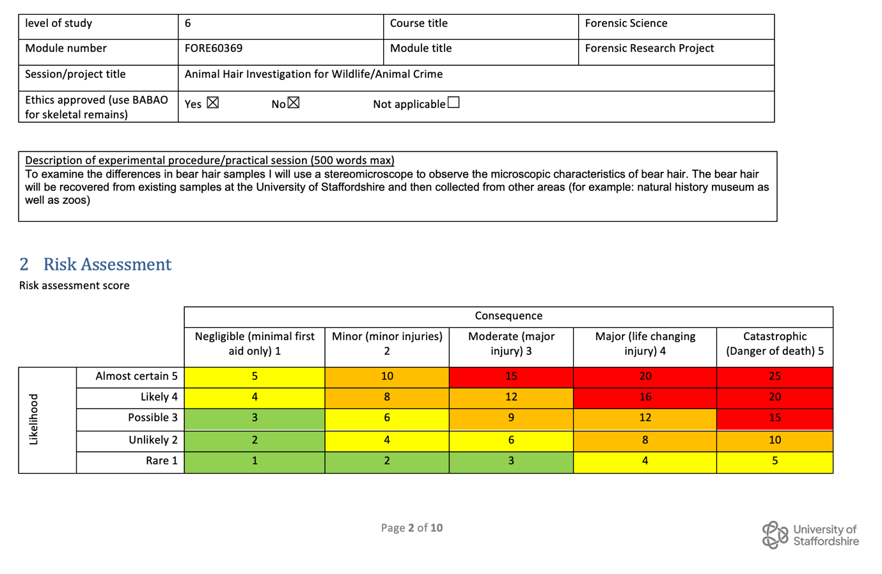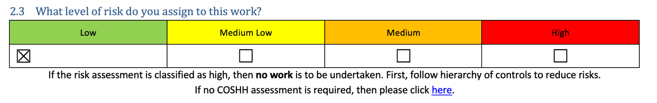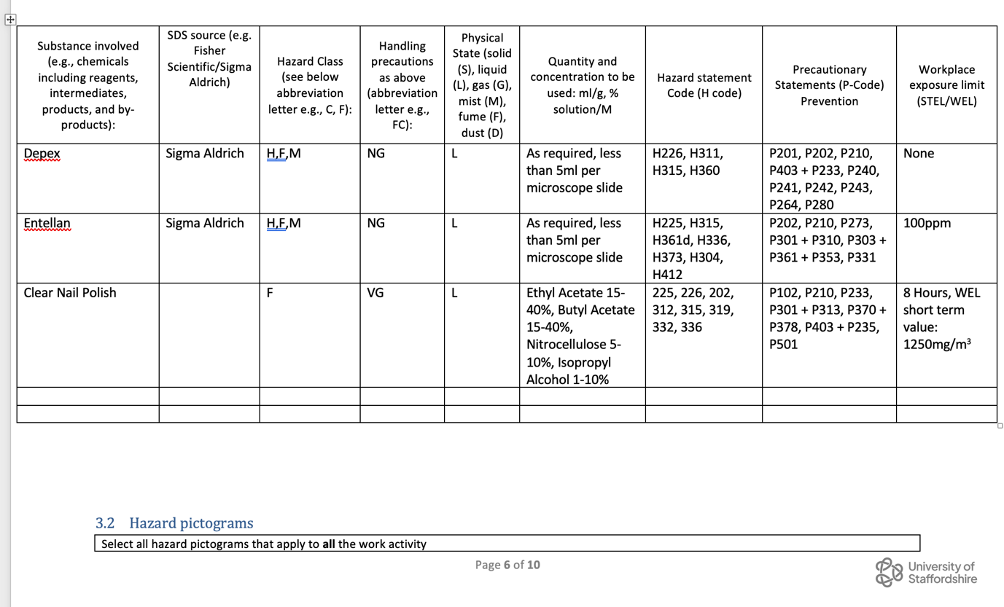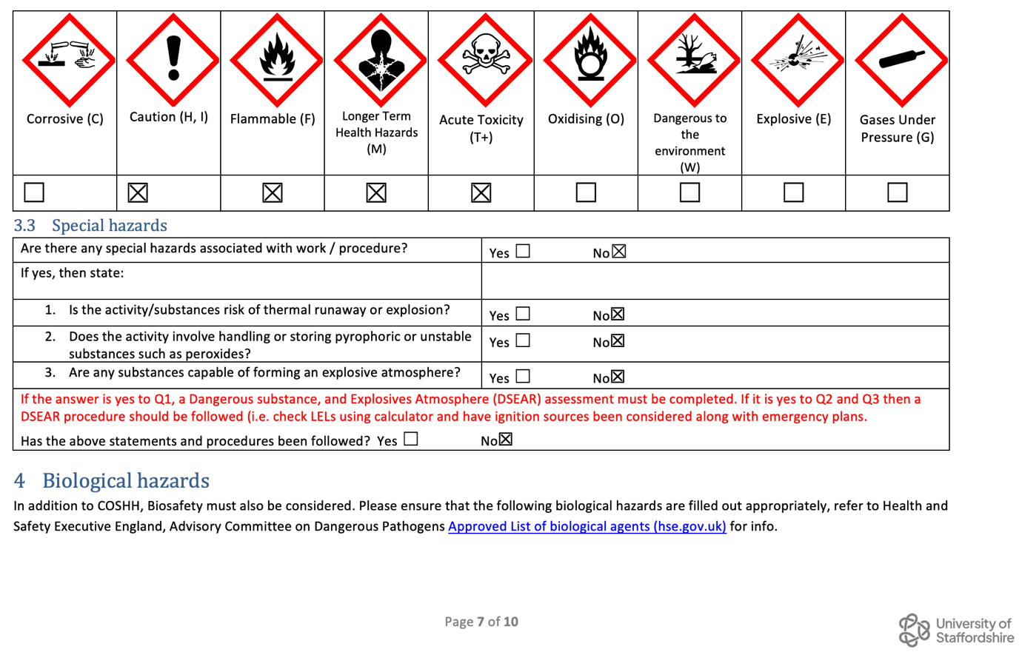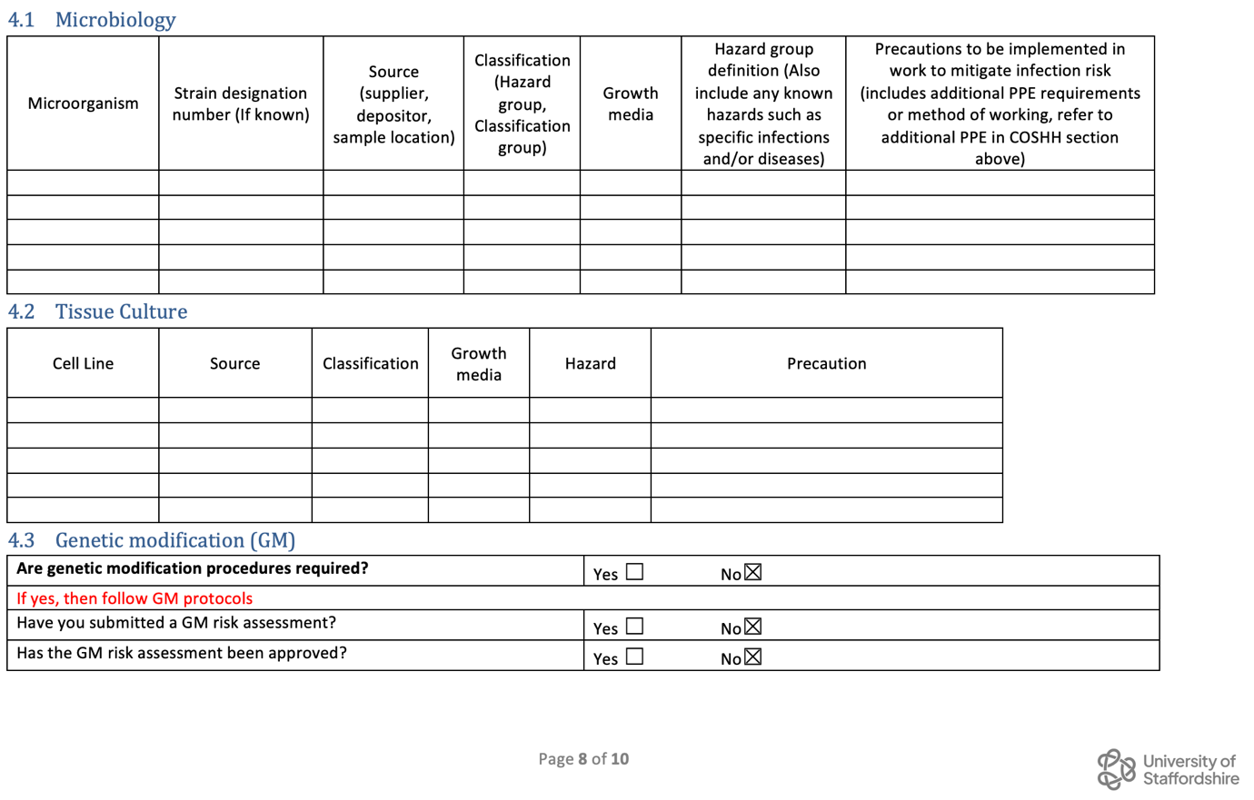

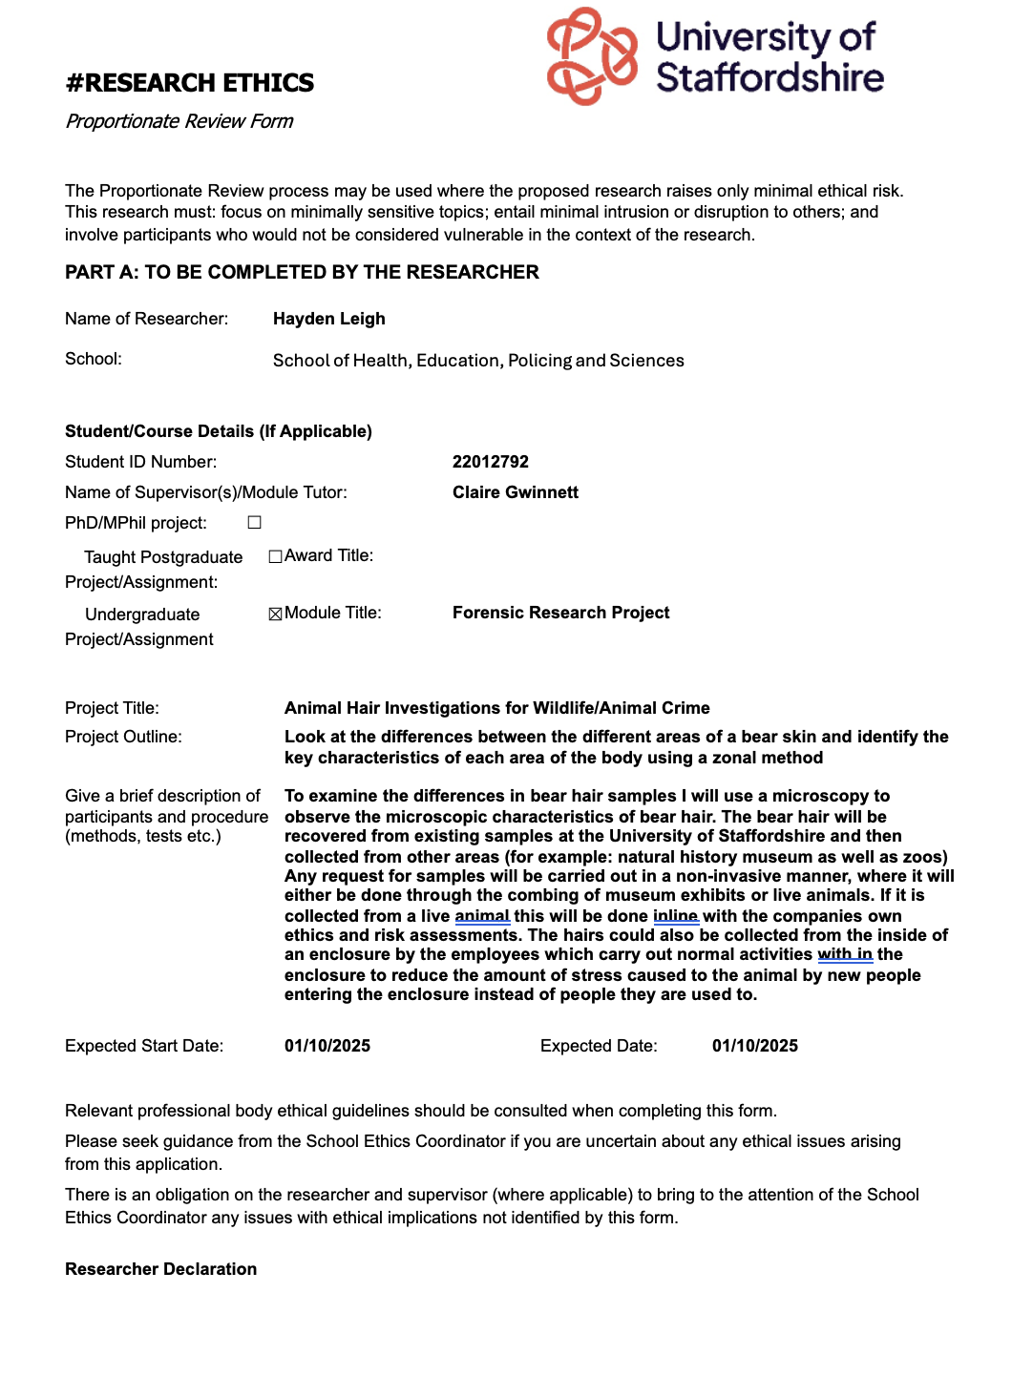
7.3. Proportionate Ethics Form
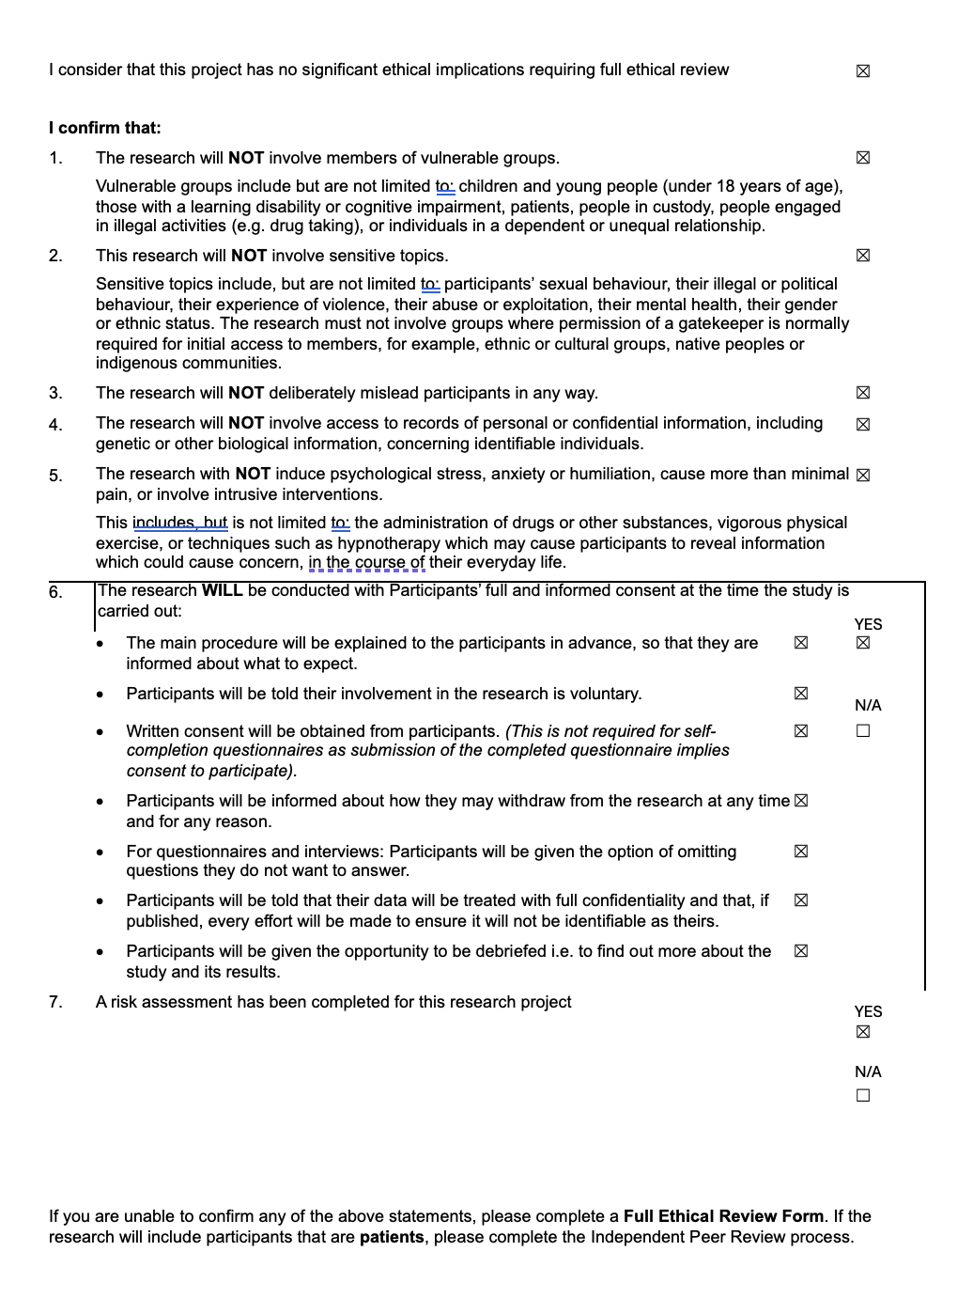

7.4. Hair Comb used for all Sampling
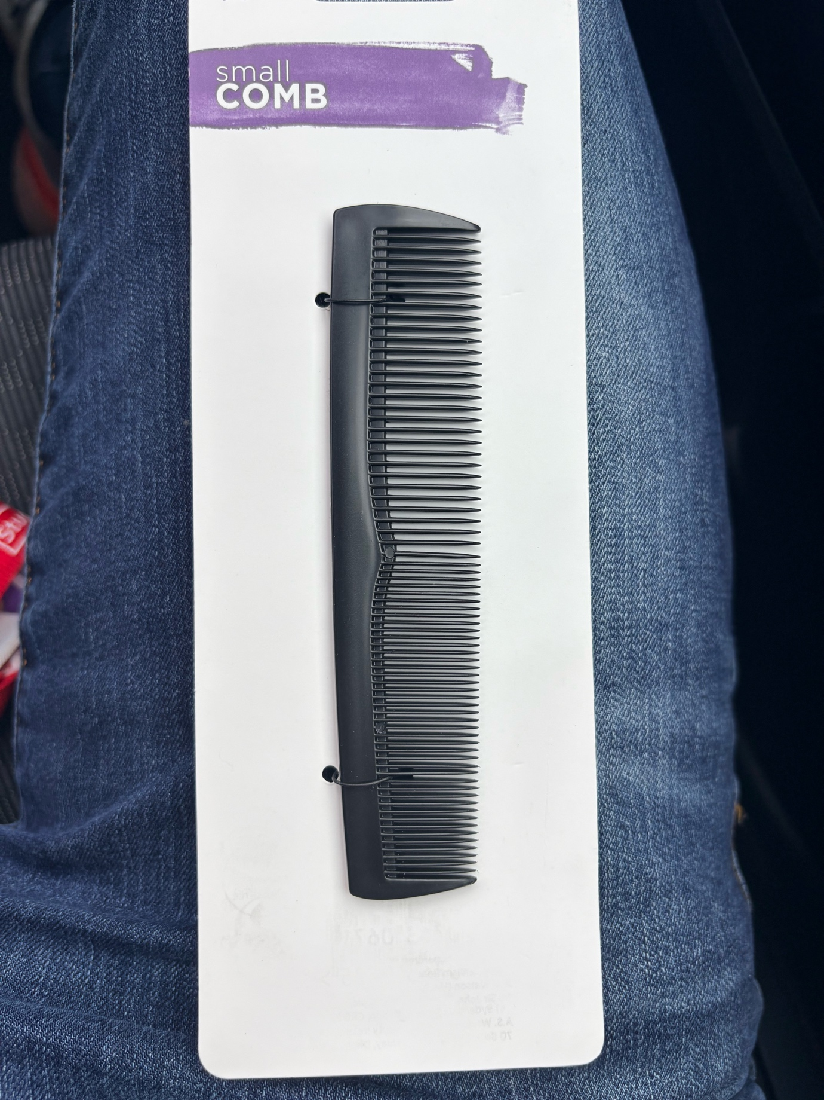

7.5. Example Email to Museums
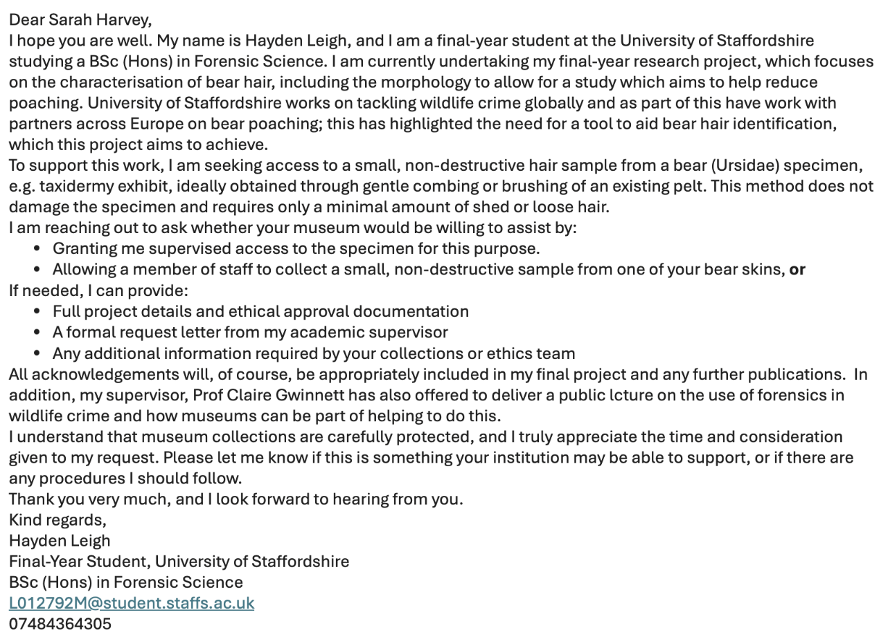

7.6. Example Email to Zoo


7.7. List of Museums and Zoos Contacted




7.8. Email received back from Sarah Harvey after initially reaching out
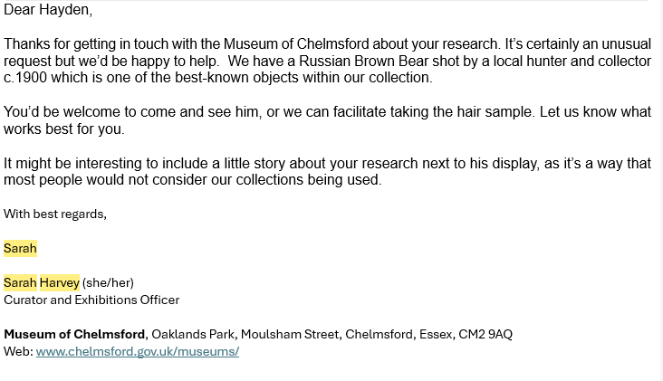

7.9. Tables of Mean Width of Hairs Across the Body
Section of Body | Hair Number | Mean | SD | Minimum Value | Maximum Value | Range
Neck | 1.0 | 50.47 | 2.19 | 49.00 | 53.90 | 4.90
Neck | 1.1 | 48.02 | 2.19 | 44.10 | 49.00 | 4.90
Neck | 1.2 | 64.44 | 2.05 | 61.25 | 66.15 | 4.90
Neck | 1.3 | 45.82 | 1.64 | 44.10 | 47.78 | 3.68
Neck | 1.4 | 43.12 | 1.60 | 41.65 | 45.33 | 3.68
Neck | 1.5 | 49.98 | 1.34 | 49.00 | 51.45 | 2.45
Neck | 1.6 | 56.35 | 2.45 | 53.90 | 58.80 | 4.90
Neck | 1.7 | 61.25 | 1.73 | 58.80 | 63.70 | 4.90
Neck | 1.8 | 53.41 | 1.10 | 51.45 | 53.90 | 2.45
Neck | 1.9 | 52.43 | 2.19 | 49.00 | 53.90 | 4.90
Middle of the back | 2.0 | 53.90 | 1.73 | 51.45 | 56.35 | 4.90
Middle of the back | 2.1 | 52.43 | 2.01 | 49.00 | 53.90 | 4.90
Middle of the back | 2.2 | 48.02 | 2.79 | 44.10 | 51.45 | 7.35
Middle of the back | 2.3 | 44.59 | 1.40 | 42.88 | 46.55 | 3.68
Middle of the back | 2.4 | 40.18 | 1.02 | 39.20 | 41.65 | 2.45
Middle of the back | 2.5 | 38.96 | 1.02 | 37.98 | 40.43 | 2.45
Middle of the back | 2.6 | 50.47 | 1.02 | 49.00 | 51.45 | 2.45
Middle of the back | 2.7 | 55.13 | 1.23 | 53.90 | 56.35 | 2.45
Middle of the back | 2.8 | 76.93 | 1.34 | 75.95 | 78.40 | 2.45
Middle of the back | 2.9 | 74.97 | 1.02 | 73.50 | 75.95 | 2.45
Lower Back | 3.0 | 86.98 | 1.23 | 85.75 | 88.20 | 2.45
Lower Back | 3.1 | 76.93 | 1.34 | 75.95 | 78.40 | 2.45
Lower Back | 3.2 | 72.28 | 1.22 | 71.05 | 73.50 | 2.45
Lower Back | 3.3 | 100.45 | 1.73 | 98.00 | 102.90 | 4.90
Lower Back | 3.4 | 74.73 | 1.23 | 73.50 | 75.95 | 2.45
Lower Back | 3.5 | 71.54 | 1.40 | 69.83 | 73.50 | 3.68
Lower Back | 3.6 | 52.68 | 1.23 | 51.45 | 53.90 | 2.45
Lower Back | 3.7 | 63.95 | 1.82 | 61.25 | 66.15 | 4.90
Lower Back | 3.8 | 50.72 | 1.10 | 49.00 | 51.45 | 2.45
Lower Back | 3.9 | 64.44 | 1.10 | 63.70 | 66.15 | 2.45
Right Side | 4.0 | 40.92 | 1.10 | 39.20 | 41.65 | 2.45
Right Side | 4.1 | 52.68 | 1.23 | 51.45 | 53.90 | 2.45
Right Side | 4.2 | 50.23 | 1.23 | 49.00 | 51.45 | 2.45
Right Side | 4.3 | 43.37 | 1.10 | 41.65 | 44.10 | 2.45
Right Side | 4.4 | 38.71 | 1.40 | 36.75 | 40.43 | 3.68
Right Side | 4.5 | 85.26 | 1.40 | 83.30 | 86.98 | 3.68
Right Side | 4.6 | 71.30 | 1.02 | 69.83 | 72.28 | 2.45
Right Side | 4.7 | 77.42 | 1.02 | 75.95 | 78.40 | 2.45
Right Side | 4.8 | 45.57 | 1.02 | 44.10 | 46.55 | 2.45
Right Side | 4.9 | 44.84 | 1.10 | 44.10 | 46.55 | 2.45
Right Front Leg | 5.0 | 50.23 | 1.23 | 49.00 | 51.45 | 2.45
Right Front Leg | 5.1 | 28.18 | 1.23 | 26.95 | 29.40 | 2.45
Right Front Leg | 5.2 | 71.54 | 1.40 | 69.83 | 73.50 | 3.68
Right Front Leg | 5.3 | 29.16 | 2.19 | 26.95 | 31.85 | 4.90
Right Front Leg | 5.4 | 31.85 | 0.87 | 30.63 | 33.08 | 2.45
Right Front Leg | 5.5 | 87.96 | 1.82 | 85.75 | 90.65 | 4.90
Right Front Leg | 5.6 | 54.64 | 1.10 | 53.90 | 56.35 | 2.45
Right Front Leg | 5.7 | 49.00 | 1.94 | 46.55 | 51.45 | 4.90
Right Front Leg | 5.8 | 48.76 | 1.82 | 46.55 | 51.45 | 4.90
Right Front Leg | 5.9 | 41.41 | 1.34 | 39.20 | 42.88 | 3.68
Right Back Leg | 6.0 | 91.39 | 1.10 | 90.65 | 93.10 | 2.45
Right Back Leg | 6.1 | 96.29 | 1.64 | 94.33 | 98.00 | 3.68
Right Back Leg | 6.2 | 76.44 | 2.54 | 73.50 | 79.63 | 6.13
Right Back Leg | 6.3 | 78.16 | 1.82 | 75.95 | 80.85 | 4.90
Right Back Leg | 6.4 | 50.72 | 2.05 | 49.00 | 53.90 | 4.90
Right Back Leg | 6.5 | 95.31 | 2.19 | 93.10 | 93.10 | 0.00
Right Back Leg | 6.6 | 70.32 | 2.05 | 68.60 | 73.50 | 4.90
Right Back Leg | 6.7 | 61.01 | 1.82 | 58.80 | 63.70 | 4.90
Right Back Leg | 6.8 | 58.07 | 1.64 | 56.35 | 60.03 | 3.68
Right Back Leg | 6.9 | 66.89 | 2.05 | 63.70 | 68.60 | 4.90

7.10. Results from Shapiro Wilk Test for Overall Width
Tests of Normality
 | Kolmogorov-Smirnovª |  |  | Shapiro-Wilk
 | Statistic | df | Sig. | Statistic | df | Sig.
Neck | .158 | 50 | .003 | .947 | 50 | .025
Middle of the back | .212 | 50 | <.001 | .854 | 50 | <.001
Lower Back | .138 | 50 | .019 | .940 | 50 | .014
Right side | .228 | 50 | <.001 | .826 | 50 | <.001
Right Front Leg | .160 | 50 | .003 | .896 | 50 | <.001
Right Back Leg | .153 | 50 | .005 | .932 | 50 | .006

7.11. Results from Kruskal Wallis H Test Results for Overall Width
Test Statistics^{a,b}
 | Score
Kruskal-Wallis H | 96.293
df | 5
Asymp. Sig. | <.001
a. Kruskal Wallis Test
b. Grouping Variable: BodyArea

7.12. Results from Post-Hoc Pairwise Comparisons with Bonferroni Correction of Overall Width 5
Pairwise Comparisons of Body Area
Sample 1-Sample 2 | Test Statistic | Std. Error | Std. Test Statistic | Sig. | Adj. Sig.ª
5-4 | 20.970 | 17.331 | 1.210 | .226 | 1.000
5-1 | 21.980 | 17.331 | 1.268 | .205 | 1.000
5-2 | 23.060 | 17.331 | 1.331 | .183 | 1.000
5-3 | 113.480 | 17.331 | 6.548 | <.001 | .000
5-6 | -124.710 | 17.331 | -7.196 | <.001 | .000
4-1 | 1.010 | 17.331 | .058 | .954 | 1.000
4-2 | 2.090 | 17.331 | .121 | .904 | 1.000
4-3 | 92.510 | 17.331 | 5.338 | <.001 | .000
4-6 | -103.740 | 17.331 | -5.986 | <.001 | .000
1-2 | -1.080 | 17.331 | -.062 | .950 | 1.000
1-3 | -91.500 | 17.331 | -5.279 | <.001 | .000
1-6 | -102.730 | 17.331 | -5.927 | <.001 | .000
2-3 | -90.420 | 17.331 | -5.217 | <.001 | .000
2-6 | -101.650 | 17.331 | -5.865 | <.001 | .000
3-6 | -11.230 | 17.331 | -.648 | .517 | 1.000
Each row tests the null hypothesis that the Sample 1 and Sample 2 distributions are the same.
Asymptotic significances (2-sided tests) are displayed. The significance level is .050.
a. Significance values have been adjusted by the Bonferroni correction for multiple tests.

7.13. Results from Shapiro Wilk Test for Overall Width using SEM
Tests of Normality
 | Kolmogorov-Smirnovª |  |  | Shapiro-Wilk
 | Statistic | Df | Sig. | Statistic | df | Sig.
Neck | .140 | 9 | .200* | .966 | 9 | .860
Middle of the back | .254 | 9 | .097 | .840 | 9 | .058
Lower Back | .174 | 9 | .200* | .924 | 9 | .425
Right Side | .297 | 9 | .022 | .812 | 9 | .028
Right Front Leg | .207 | 9 | .200* | .905 | 9 | .284
Right Rear Leg | .192 | 9 | .200* | .924 | 9 | .422
*. This is a lower bound of the true significance.
a. Lilliefors Significance Correction

7.14. Results from Kruskal-Wallis H Test for Overall Width using SEM

Test Statistics^{a,b}
 | Width
Kruskal-Wallis H | 34.625
Df | 5
Asymp. Sig. | <.001
a. Kruskal Wallis Test
b. Grouping Variable: Section

7.15. Results from Post-Hoc Pairwise Comparisons with Bonferroni Correction of Overall Width using SEM
Pairwise Comparisons of Section
Sample 1-Sample 2 | Test Statistic | Std. Error | Std. Test Statistic | Sig. | Adj. Sig.ª
5-1 | 1.556 | 7.416 | .210 | .834 | 1.000
5-3 | 7.000 | 7.416 | .944 | .345 | 1.000
5-2 | 9.111 | 7.416 | 1.229 | .219 | 1.000
5-4 | 30.000 | 7.416 | 4.045 | <.001 | .001
5-6 | -30.667 | 7.416 | -4.135 | <.001 | .001
1-3 | -5.444 | 7.416 | -.734 | .463 | 1.000
1-2 | -7.556 | 7.416 | -1.019 | .308 | 1.000
1-4 | -28.444 | 7.416 | -3.835 | <.001 | .002
1-6 | -29.111 | 7.416 | -3.925 | <.001 | .001
3-2 | 2.111 | 7.416 | .285 | .776 | 1.000
3-4 | -23.000 | 7.416 | -3.101 | .002 | .029
3-6 | -23.667 | 7.416 | -3.191 | .001 | .021
2-4 | -20.889 | 7.416 | -2.817 | .005 | .073
2-6 | -21.556 | 7.416 | -2.907 | .004 | .055
4-6 | -.667 | 7.416 | -.090 | .928 | 1.000
Each row tests the null hypothesis that the Sample 1 and Sample 2 distributions are the same.
Asymptotic significances (2-sided tests) are displayed. The significance level is .050.
a. Significance values have been adjusted by the Bonferroni correction for multiple tests.

7.16. Result from Shapiro Wilk Test of Medulla Width
Tests of Normality
 | Kolmogorov-Smirnovª |  |  | Shapiro-Wilk
 | Statistic | df | Sig. | Statistic | df | Sig.
Neck | .187 | 50 | <.001 | .915 | 50 | .002
Middle of the back | .206 | 50 | <.001 | .903 | 50 | <.001
Lower Back | .232 | 50 | <.001 | .845 | 50 | <.001
Right Side | .126 | 50 | .046 | .936 | 50 | .009
Right Front Leg | .176 | 50 | <.001 | .861 | 50 | <.001
Right Rear Leg | .086 | 50 | .200* | .958 | 50 | .076
*. This is a lower bound of the true significance.
a. Lilliefors Significance Correction

7.17. Results from Kruskal-Wallis H Test of Medulla Width
Test Statistics^{a,b}
 | Medulla Width
Kruskal-Wallis H | 111.444
Df | 5
Asymp. Sig. | <.001
a. Kruskal Wallis Test
b. Grouping Variable: Section

7.18. Results from Post-Hoc Pairwise Comparisons with Bonferroni Correction of Medulla Width
Pairwise Comparisons of Body Areas
Sample 1-Sample 2 | Test Statistic | Std. Error | Std. Test Statistic | Sig. | Adj. Sig.ª
1-2 | -2.590 | 17.008 | -.152 | .879 | 1.000
1-5 | -52.850 | 17.008 | -3.107 | .002 | .028
1-4 | -63.744 | 16.617 | -3.836 | <.001 | .002
1-6 | -110.036 | 17.474 | -6.297 | <.001 | .000
1-3 | -147.591 | 17.474 | -8.446 | <.001 | .000
2-5 | -50.260 | 17.008 | -2.955 | .003 | .047
2-4 | -61.154 | 16.617 | -3.680 | <.001 | .003
2-6 | -107.446 | 17.474 | -6.149 | <.001 | .000
2-3 | -145.001 | 17.474 | -8.298 | <.001 | .000
5-4 | 10.894 | 16.617 | .656 | .512 | 1.000
5-6 | -57.186 | 17.474 | -3.273 | .001 | .016
5-3 | 94.741 | 17.474 | 5.422 | <.001 | .000
4-6 | -46.292 | 17.094 | -2.708 | .007 | .101
4-3 | 83.847 | 17.094 | 4.905 | <.001 | .000
6-3 | 37.556 | 17.928 | 2.095 | .036 | .543
Each row tests the null hypothesis that the Sample 1 and Sample 2 distributions are the same.
Asymptotic significances (2-sided tests) are displayed. The significance level is .050.
a. Significance values have been adjusted by the Bonferroni correction for multiple tests.

7.19. Results from Shapiro-Wilk Test of Medulla Ratio
Tests of Normality
 | Kolmogorov-Smirnovª |  |  | Shapiro-Wilk
 | Statistic | df | Sig. | Statistic | df | Sig.
Neck | .132 | 50 | .030 | .962 | 50 | .104
Middle of the back | .092 | 50 | .200* | .979 | 50 | .524
Lower Back | .172 | 50 | <.001 | .882 | 50 | <.001
Right Side | .095 | 50 | .200* | .963 | 50 | .116
Right Front Leg | .170 | 50 | <.001 | .936 | 50 | .009
Right Rear Leg | .147 | 50 | .008 | .921 | 50 | .002
*. This is a lower bound of the true significance.
a. Lilliefors Significance Correction

7.20. Results from Kruskal-Wallis H Test of Medulla Ratio
Test Statistics^{a,b}
 | M.edulla Ratio
Kruskal-Wallis H | 79.777
Df | 5
Asymp. Sig. | <.001
a. Kruskal Wallis Test
b. Grouping Variable: Section

7.21. Results from Post-Hoc Pairwise Comparisons with Bonferroni Correction of Medulla Ratio
Pairwise Comparisons of Body Areas
Sample 1-Sample 2 | Test Statistic | Std. Error | Std. Test Statistic | Sig. | Adj. Sig.ª
2-1 | 4.260 | 17.334 | .246 | .806 | 1.000
2-6 | -62.910 | 17.334 | -3.629 | <.001 | .004
2-4 | -78.220 | 17.334 | -4.513 | <.001 | .000
2-3 | -107.220 | 17.334 | -6.186 | <.001 | .000
2-5 | -112.070 | 17.334 | -6.465 | <.001 | .000
1-6 | -58.650 | 17.334 | -3.384 | <.001 | .011
1-4 | -73.960 | 17.334 | -4.267 | <.001 | .000
1-3 | -102.960 | 17.334 | -5.940 | <.001 | .000
1-5 | -107.810 | 17.334 | -6.220 | <.001 | .000
6-4 | 15.310 | 17.334 | .883 | .377 | 1.000
6-3 | 44.310 | 17.334 | 2.556 | .011 | .159
6-5 | 49.160 | 17.334 | 2.836 | .005 | .069
4-3 | 29.000 | 17.334 | 1.673 | .094 | 1.000
4-5 | -33.850 | 17.334 | -1.953 | .051 | .763
3-5 | -4.850 | 17.334 | -.280 | .780 | 1.000
Each row tests the null hypothesis that the Sample 1 and Sample 2 distributions are the same.
Asymptotic significances (2-sided tests) are displayed. The significance level is .050.
a. Significance values have been adjusted by the Bonferroni correction for multiple tests.

7.22. Results from Shapiro Wilk Test of Cortex Width
Tests of Normality
 | Kolmogorov-Smirnovª |  |  | Shapiro-Wilk
 | Statistic | df | Sig. | Statistic | df | Sig.
Neck | .124 | 50 | .051 | .937 | 50 | .010
Middle of the back | .160 | 50 | .003 | .908 | 50 | <.001
Lower Back | .081 | 50 | .200* | .966 | 50 | .164
Right Side | .296 | 50 | <.001 | .834 | 50 | <.001
Right Front Leg | .135 | 50 | .022 | .897 | 50 | <.001
Right Rear Leg | .192 | 50 | <.001 | .881 | 50 | <.001
*. This is a lower bound of the true significance.
a. Lilliefors Significance Correction

7.23. Results from Kruskal-Wallis H Test of Cortex Width
Test Statistics^{a,b}
 | Cortex Width
Kruskal-Wallis H | 59.333
Df | 5
Asymp. Sig. | <.001
a. Kruskal Wallis Test
b. Grouping Variable: Section

7.24. Results from Post-Hoc Pairwise Comparisons with Bonferroni Correction of Cortex Width
Pairwise Comparisons of Section
Sample 1-Sample 2 | Test Statistic | Std. Error | Std. Test Statistic | Sig. | Adj. Sig.ª
5-4 | 21.810 | 17.335 | 1.258 | .208 | 1.000
5-1 | 56.420 | 17.335 | 3.255 | .001 | .017
5-2 | 56.470 | 17.335 | 3.258 | .001 | .017
5-3 | 80.860 | 17.335 | 4.665 | <.001 | .000
5-6 | -119.180 | 17.335 | -6.875 | <.001 | .000
4-1 | 34.610 | 17.335 | 1.997 | .046 | .688
4-2 | 34.660 | 17.335 | 1.999 | .046 | .683
4-3 | 59.050 | 17.335 | 3.406 | <.001 | .010
4-6 | -97.370 | 17.335 | -5.617 | <.001 | .000
1-2 | -.050 | 17.335 | -.003 | .998 | 1.000
1-3 | -24.440 | 17.335 | -1.410 | .159 | 1.000
1-6 | -62.760 | 17.335 | -3.620 | <.001 | .004
2-3 | -24.390 | 17.335 | -1.407 | .159 | 1.000
2-6 | -62.710 | 17.335 | -3.618 | <.001 | .004
3-6 | -38.320 | 17.335 | -2.211 | .027 | .406
Each row tests the null hypothesis that the Sample 1 and Sample 2 distributions are the same.
Asymptotic significances (2-sided tests) are displayed. The significance level is .050.
a. Significance values have been adjusted by the Bonferroni correction for multiple tests.

7.25. Results from Shapiro-Wilk Test of Interscale Distance
Tests of Normality
 | Kolmogorov-Smirnovª |  |  | Shapiro-Wilk
 | Statistic | df | Sig. | Statistic | df | Sig.
Neck | .148 | 40 | .027 | .911 | 40 | .004
Middle of the back | .127 | 40 | .100 | .929 | 40 | .015
Lower Back | .101 | 40 | .200* | .932 | 40 | .019
Right Side | .144 | 40 | .035 | .939 | 40 | .033
Right Front Leg | .093 | 40 | .200* | .968 | 40 | .322
Right Rear Leg | .100 | 40 | .200* | .960 | 40 | .171
*. This is a lower bound of the true significance.
a. Lilliefors Significance Correction

7.26. Results from Kruskal-Wallis H Test of Interscale Distance
Test Statistics^{a,b}
 | Interscale Distance
Kruskal-Wallis H | 10.913
Df | 5
Asymp. Sig. | .053
a. Kruskal Wallis Test
b. Grouping Variable: Section

7.27. Results from Post-Hoc Pairwise Comparison with Bonferroni Correction of Interscale Distance
Pairwise Comparisons of Section
Sample 1-Sample 2 | Test Statistic | Std. Error | Std. Test Statistic | Sig. | Adj. Sig.ª
5-6 | -14.122 | 16.462 | -.858 | .391 | 1.000
5-2 | 16.922 | 16.462 | 1.028 | .304 | 1.000
5-1 | 29.233 | 16.462 | 1.776 | .076 | 1.000
5-3 | 31.256 | 16.462 | 1.899 | .058 | .864
5-4 | 50.000 | 16.462 | 3.037 | .002 | .036
6-2 | 2.800 | 16.462 | .170 | .865 | 1.000
6-1 | 15.111 | 16.462 | .918 | .359 | 1.000
6-3 | 17.133 | 16.462 | 1.041 | .298 | 1.000
6-4 | 35.878 | 16.462 | 2.179 | .029 | .439
2-1 | 12.311 | 16.462 | .748 | .455 | 1.000
2-3 | -14.333 | 16.462 | -.871 | .384 | 1.000
2-4 | -33.078 | 16.462 | -2.009 | .045 | .668
1-3 | -2.022 | 16.462 | -.123 | .902 | 1.000
1-4 | -20.767 | 16.462 | -1.261 | .207 | 1.000
3-4 | -18.744 | 16.462 | -1.139 | .255 | 1.000
Each row tests the null hypothesis that the Sample 1 and Sample 2 distributions are the same.
Asymptotic significances (2-sided tests) are displayed. The significance level is .050.
a. Significance values have been adjusted by the Bonferroni correction for multiple tests.

