Hussnain Ali
Supervisor: Luke Barsby
Second supervisor: Shaun Reeves
Cheating AI
GDEV60001 Games development project

Contents
Abstract 3
Introduction 3
Aims and Objectives 5
Literature Review 6
Artificial Intelligence: Foundations and Context 6
What is Artificial Intelligence? 6
A Brief History of AI 6
General Applications of AI 7
Artificial Intelligence: Summary 8
Fairness and Probability in AI Systems 9
Understanding Fairness 9
Probability, Randomness, and Fairness Models 9
Fairness in Games 10
Understanding Fairness & Probability: Summary 11
Player Experience and Perception 11
Links Between Fairness and Player Experience 12
Enhancing Player Experience 13
AI Design in Games: Techniques and Applications 14
Common AI Techniques in Games 14
Real-World Examples 15
AI Design Methodologies and Patterns 16
Towards Cheating and Adaptive AI 16
Adaptive Difficulty and Player Trust 17
Positioning This Project 18
Research Methodologies 19
Results, Discussion, and Analysis 20
Type A Findings – Players Unaware of Cheating 20
Type A Performance and Outcome Trends 21
Type B Findings – Players Aware of Cheating 26
Analysis 31
Comparing Accusations Across Groups 32
Enjoyment Differences Between Groups 32
Did Awareness Change Behaviour or Just Interpretation? 33
Recommendations and Future Work 33
Conclusion 36
References 38
Appendices 41
Appendix 1 – Empty Questionnaires 41
Appendix 2 – Questionnaires 41
Appendix 3 – Raw Data Group 1 41

Abstract
This dissertation investigates how partial cheating in artificial intelligence influences player engagement, enjoyment, and perceptions of fairness. The project examines whether an opponent granted limited access to a player’s intended actions can create experiences that feel intelligent and challenging without breaking trust. The study contributes to ongoing discussions in adaptive and player-centred AI design by analysing how knowledge asymmetry affects emotional and psychological responses during play.
A Unity prototype was developed featuring three AI archetypes operating under identical rules: a random “Wildcard,” an adaptive “Strategist,” and a partially cheating “Minister.” Two groups of participants were recruited. Type A players were unaware that cheating could occur, while Type B players were informed in advance. Quantitative data such as win/loss outcomes, number of attempts, and difficulty ratings were collected alongside qualitative written feedback describing suspicion, enjoyment, frustration, and motivation.
Findings reveal a clear escalation in perceived difficulty and reduced confidence as players progressed through the encounters. The Wildcard was commonly interpreted as fair and winnable, preserving agency even in defeat. The Strategist encouraged analytical play but began to generate uncertainty regarding prediction and counterplay. The Minister most strongly triggered accusations of cheating, with many players reporting diminished control, although a minority valued the dramatic intensity.
Comparison between groups showed that awareness primarily altered interpretation rather than raw performance. Knowledge of possible deception accelerated suspicion and reframed resistance as confirmation of unfairness. The project therefore demonstrates that the success of partially cheating AI depends heavily on presentation and player belief.
These results highlight the delicate balance required when designing adaptive opponents and offer practical insight into maintaining challenge while protecting trust.

Introduction
Artificial intelligence (AI) has become an important part of modern video games, shaping how players experience challenge, immersion, and engagement. As games improve to deliver increasingly personalised and dynamic experiences, the design of enemy AI systems has become a critical area of study. While many games rely on fixed difficulty levels (Mortazavi, et al., 2024) or predictable enemy behaviours, these approaches often fail to adapt to players improving at the game or the different ways they could be playing, leading to repetitive gameplay and diminishing excitement over time. On the other hand, highly adaptive or AI that cannot be beaten risks feeling unfair or frustrating, creating a disconnect between perceived and actual difficulty. This balance between fairness, adaptability, and engagement forms the bases of this investigation.
The concept of a cheating AI, one that possesses access to hidden player information or future actions, challenges the idea of fair play. In most competitive situations, the idea of cheating is perceived negatively; however, in game design, selective or controlled cheating can be a valuable design tool (Wiersma, 2023). Many developers have long employed subtle cheats in AI systems to maintain tension and fun, such as rubber-banding in racing games (where the speed or performance of opponent racers are changed based on their position in the race to keep it entertaining) or AI opponents missing shots deliberately to maintain balance (Wiersma, 2023). These methods manipulate player perception, maintaining the illusion of fairness while adjusting the difficulty to maintain player enjoyment. Despite this, the psychological impact of such techniques remains underexplored. Understanding how players respond emotionally and cognitively to AI that actively breaks the rules could lead to more compelling, memorable experiences.
The challenge lies in finding a balance, creating AI that feels intelligent, reactive, and fair without appearing omniscient or scripted. Players value challenge, but only when they believe success or failure comes from their own decisions rather than the hand of the developer. When AI behaviours too predictably, the sense of mastery diminishes; when it feels too perfect, frustration sets in. Therefore, exploring the space between these ends is crucial for advancing AI design in video games.

Aims and Objectives
The main aim of this project is to explore how partial cheating in artificial intelligence, where the AI possesses limited access to a player’s intended actions, influences player engagement, enjoyment, and perceptions of fairness. The purpose of the study is to identify whether this controlled form of cheating can enhance enjoyment by creating opponents that feel more intelligent, reactive, and challenging without breaking the player’s trust or them realising that the AI is cheating at all. In doing so, the project seeks to establish a clearer understanding of how subtle manipulations of AI knowledge and behaviour can affect the psychological and emotional experience of play.
Through this process, the project aims to contribute to broader discussions around adaptive difficulty and player-centred AI design. It seeks to provide actionable insights for developers regarding how to integrate adaptive and deceptive AI techniques responsibly, maintaining challenge and tension without undermining player trust. To achieve these aims, the following objectives have been established:
- First, to conduct an in-depth literature review to critically analyse existing research on artificial intelligence, fairness, and player experience within games and related systems. This will establish the theoretical foundation for understanding how partial cheating might influence engagement and perceived fairness.

- The next objective is to design and develop a Unity prototype featuring three AI systems. One random, one adaptive, and one that partially cheats, which will act under identical gameplay conditions. This will provide a consistent environment for observing and comparing player reactions to different AI behaviours.

- The penultimate, and most essential, objective would be to undertake playtesting sessions to gather both quantitative and qualitative data from participants. This will include statistical analysis of performance alongside analysis of player feedback to evaluate how awareness and detection of cheating influence enjoyment and trust.

- The final objective would be to evaluate and interpret the collected data to determine the relationship between AI behaviour, player perception, and overall engagement. The findings will be discussed in the context of existing literature discussed in objective two, in order to draw meaningful conclusions about the design and implementation of partially cheating AI systems.

Literature Review
The purpose of this literature review is to provide context for the investigation of partially cheating artificial intelligence (AI) within the wider body of research on game design, fairness, and player experience. It explains current thinking, identifies research gaps, and establishes how this study builds upon existing knowledge and research. The review moves from broad to narrow topics: beginning with the history and function of AI in general computing, then focusing on its role in games, followed by an examination of fairness, player engagement, and the use of adaptive or deceptive AI as a design tool.

Artificial Intelligence: Foundations and Context
This section begins by examining foundational AI theory and its early development and sets a basis for understanding how computational decision making has shaped gameplay systems.
What is Artificial Intelligence?
AI is an important part of how modern games deliver challenge and immersion. As Bakkes, Spronck, and van Lankveld (2012) note, game AI has progressed from static rule-based systems to dynamic models that are capable of responding to players. However, many commercial games continue to use fixed or pre-set difficulty levels (Mortazavi, et al., 2024), which can reduce replay value and limit the sense of evolving mastery. To understand how AI behaviour influences player experience, it is first necessary to define artificial intelligence in both a broader computational context and within the specialised domain of game design.
From a computer science perspective, artificial intelligence refers to the creation of systems capable of performing tasks that typically require human cognitive abilities, such as learning, reasoning, pattern recognition, and decision-making (Russell & Norvig, 2024). Classical AI, often referred to as symbolic AI, relies on explicit rules and logic-based structures to model intelligence. These systems operate using predefined parameters, logic frameworks, and search algorithms, making decisions by judging possible outcomes against coded rules (Nilsson, 1998). In contrast, modern approaches include modern machine learning approaches, particularly neural networks and reinforcement learning, enable systems to learn patterns and behaviours from data, adapting over time without being explicitly programmed for every scenario (Goodfellow, et al., 2016) (Sutton & Barto, 2018). This shift from rule-based to data-driven intelligence has significantly transformed AI’s capabilities across multiple domains, from speech recognition to autonomous navigation (LeCun, et al., 2015).
In game design, the definition of AI is more specialised. Rather than aiming to replicate human cognition in full, game AI focuses on simulating believable and responsive behaviours that create engaging gameplay. As Togelius and Yannakakis (2018) note, game AI prioritises challenge, fairness, and computational efficiency rather than perfect accuracy or intelligence. This has led to the development of behavioural AI systems, such as finite state machines, behaviour trees, and utility-based decision models, that allow non-player characters (NPCs) to act with purpose while remaining predictable and controllable for designers. These systems simulate decision making in a way that appears intelligent to players, even when the underlying logic is intentionally simplified or constrained.
Together, these perspectives show that AI in games exists at the intersection of technological capability and design intention. Understanding this distinction is essential when examining techniques such as adaptive or cheating AI, as these systems intentionally manipulate behaviour not to achieve optimal performance, but to shape player perception, challenge, and engagement.
A Brief History of AI
The development of artificial intelligence has progressed through several major phases, each shaped by the available technology and theories of its time. Early AI research in the 1950s and 1960s focused on symbolic reasoning, where intelligence was thought of as logical problem solving performed through explicitly defined rules and representations. Newell and Simon’s (1958) (1971) work on the Logic Theorist and General Problem Solver established the bases for rule based systems, making symbolic AI as the dominant idea for decades (Russell & Norvig, 2024). During the 1970s and 1980s, systems such as MYCIN showcased how codified expert knowledge could be used to perform specific reasoning in a given field (Nilsson, 1998). Although powerful, these systems were limited by their reliance on hand crafted rules, making them brittle and unable to generalise beyond predefined scenarios.
The emergence of machine learning in the late 1980s and 1990s marked a significant shift away from rigid symbolic approaches. Instead of manually designing rules, researchers began developing systems that could learn patterns from data. Neural networks, revitalised by the backpropagation algorithm (a mathematical algorithm used to train artificial neural networks by adjusting their internal weights), enabled AI models to adjust internal parameters through experience, laying the groundwork for modern deep learning (Goodfellow, et al., 2016). This transition introduced probabilistic methods such as Bayesian networks and reinforcement learning, which allowed AI to operate under uncertainty and adapt dynamically to changing environments (Sutton & Barto, 2018).
Several landmark achievements demonstrate how these advances transformed both AI research and game development. IBM’s Deep Blue defeated world chess champion Garry Kasparov in 1997 through brute-force search combined with expert evaluation functions, showcasing the power of symbolic and search-based methods (IBM, n.d.). Nearly two decades later, Google DeepMind’s AlphaGo defeated Lee Sedol in 2016 using deep neural networks and Monte Carlo Tree Search, illustrating the capabilities of hybrid learning-based systems (Silver, et al., 2016). In the commercial game industry, procedural generation techniques such as those used in No Man’s Sky (2016) leverage algorithmic and probabilistic processes to create vast, dynamic environments that would be impossible, or extremely time consuming, to design manually.
Together, these developments show how AI has evolved from deterministic, rule-driven systems to adaptive, data-driven models capable of making complex decisions under uncertainty. This historical progression forms the foundation for understanding contemporary game AI, including adaptive and cheating systems designed to enhance player experience.
General Applications of AI
Artificial intelligence has become deeply integrated into a wide range of industries due to its versatility and ability to perform complex tasks that traditionally required human judgement. In healthcare, AI systems are used for diagnostic support, medical imaging analysis, and predictive modelling of patient outcomes. Machine learning algorithms can identify patterns in medical scans with accuracy comparable to human specialists, supporting early detection of diseases such as cancer (Esteva , et al., 2017). In finance, AI is used for fraud detection, credit scoring, algorithmic trading, and risk assessment, where high-volume data analysis and real time decision making are essential (Bishop, 2006). Meanwhile, autonomous vehicles rely on a combination of computer vision, reinforcement learning, and sensor fusion techniques to navigate environments, interpret road conditions, and make split-second decisions that prioritise safety (Bojarski, et al., 2016). These examples highlight the adaptability of AI across tasks that demand precision, pattern recognition, and dynamic responses.
Within video games, the purpose of artificial intelligence differs significantly from these fields. Rather than optimising for accuracy or real world correctness, game AI focuses on delivering engaging, believable, and responsive gameplay experiences. Togelius and Yannakakis (2018) argue that game AI is designed not to be perfect, but to appear intelligent in ways that enhance player enjoyment. AI for gameplay agents, non-player characters (NPCs), enemies, or dynamic systems, relies on techniques that balance efficiency, predictability, and believability. Common examples include pathfinding systems such as the A* algorithm, which allow agents to navigate complex environments efficiently (Russell & Norvig, 2024). Behaviour trees are widely used in modern games for structuring layered decision making, offering designers modular control over how agents select and sequence actions. Fuzzy logic enables AI to make decisions that account for uncertainty or approximate reasoning, allowing characters to respond more fluidly to changing conditions. In more advanced systems, reinforcement learning has been used experimentally to train agents capable of adapting to player behaviour or mastering complex mechanics, as demonstrated in games like Dota 2 and StarCraft II (Vinyals, et al., 2019).
AI is also used behind the scenes as a production tool, supporting tasks such as procedural content generation, automated testing, game balancing, and asset creation. Systems like those in No Man’s Sky (2016) use procedural algorithms to generate planets, ecosystems, and creatures at a large scale, demonstrating how AI can assist developers as well as control gameplay behaviours. These tools emphasise that AI in games serves two parallel roles: enabling intelligent in-game agents and supporting developers in creating diverse, responsive worlds.

Artificial Intelligence: Summary
This section introduced the foundational concepts needed to understand artificial intelligence within the context of game design. It began with definitions of AI from both computer science and game development perspectives, highlighting the differences between real-world intelligence objectives and player-oriented design goals. The historical overview traced AI’s evolution from symbolic reasoning and expert systems to modern machine learning and neural networks, emphasising milestones such as Deep Blue, AlphaGo, and procedural generation technologies. Finally, the general applications of AI demonstrated its adaptability across healthcare, finance, transportation, and games, while clarifying the differences between AI for gameplay agents and AI as a production tool. Together, these subsections establish the theoretical context for examining fairness, player experience, and adaptive or cheating AI systems in later parts of the literature review.

Fairness and Probability in AI Systems
In games, fairness is used to refer to the perception that the outcome of an event comes from a player’s own skill and the game’s stated mechanics rather than hidden manipulation (Tekinbaş & Zimmerman, 2003). Fairness is an important tool used to sustain player engagement, which involves the investment and fun a player feels when taking part in a balanced challenge, often described through the concept of flow (Csikszentmihalyi, 1990). Maintaining a balance between fairness and engagement is crucial: when difficulty feels unearned or random, players see the system as unfair; when it is too predictable, engagement declines.
Understanding Fairness
Fairness is a central concept in both computing and game design, and it can be understood as a combination of balance, transparency, and perceived justice within a decision making system. In interactive systems, such as video games, fairness is not only defined by whether the rules are objectively equal, but also by whether users believe those rules are being applied consistently and without hidden manipulation. As Salen and Zimmerman (2003) argue, fairness is crucial for maintaining trust between player and system, forming the foundation on which meaningful challenge and engagement are built.
Algorithmic fairness in computing provides a useful lens through which to understand how fairness is constructed in games. In computational contexts, fairness concerns the extent to which decisions generated by algorithms are unbiased, predictable, and explainable (O'Neil, 2016). Bias can emerge from unequal data representation, unbalanced rule systems, or probabilistic models that disadvantage particular outcomes. When algorithms rely on randomness, fairness becomes closely tied to whether this randomness is perceived as genuine or manipulated. For example, pseudo-random number generators must not only function mathematically but must also appear believable to users, as perceived bias can undermine confidence even when outcomes are technically fair (Devroye, 1986).
In games, fairness is equally rooted in perception. Players expect that success is determined by their skill and understanding of the game’s mechanics, not by hidden systems that favour or penalise them unpredictably. When players sense inconsistency, such as AI opponents demonstrating unrealistic precision or improbable luck, they may interpret this as unfair, even when systems are intentionally designed to maintain difficulty (Hunicke, 2005). Conversely, systems that are mathematically unbalanced may still be perceived as fair if they support enjoyable and meaningful play experiences. This highlights the distinction between formal fairness (mathematical equality) and experienced fairness (player trust and satisfaction).
Understanding fairness as both a computational and psychological construct is essential when evaluating adaptive or cheating AI techniques. It reveals that fairness is not solely a property of a system’s rules but also a product of the player's perception of justice and transparency. This perspective provides a crucial foundation for examining how controlled AI deception can influence engagement without undermining the player's belief in a fair and trustworthy game world.
Probability, Randomness, and Fairness Models
Randomness and probability play a crucial role in shaping how fairness is constructed and perceived within interactive systems. In computational terms, randomness is used to introduce uncertainty and variability, but its impact on fairness extends beyond the mathematical and into the realm of player psychology. The perception of fairness is often influenced by how predictable, transparent, and believable probabilistic outcomes appear to users. Even when randomness is statistically balanced, players may interpret repeated or extreme outcomes as evidence of unfairness, demonstrating that fairness is not solely a mathematical property but also a perceptual one (Devroye, 1986).
Real-world systems such as casinos illustrate the relationship between randomness, fairness, and engagement. Casino games, including slot machines and roulette, operate with fixed probabilities that favour the house, yet they are designed to appear fair through clear rules and transparent odds (Harrigan & Dixon, 2009). These systems rely on the psychological appeal of chance. Players accept a degree of loss because the distribution of outcomes feels consistent within the rules. Lotteries work similarly: although the probability of winning is extremely low, the fairness of the system is upheld by the transparency of draws and the uniform distribution of odds among participants. Both examples demonstrate that perceived fairness can be maintained even when systems are mathematically unbalanced, provided the randomness is understandable and visually justifiable.
In digital games, randomness is used not only to shape challenge but also to maintain engagement. Gacha mechanics, common in mobile and free-to-play games, use probability-based reward systems to create anticipation and excitement. Studies show that players tolerate these systems when probabilities are clearly disclosed or when outcomes align with expected reward frequencies but perceive them as unfair when drop rates feel deceptive or inconsistent (Chen & Fang, 2023). Similarly, random number generation in combat systems, such as critical hits or loot drops, can create memorable experiences, but poor tuning or visible manipulation can quickly erode trust.
Understanding these models of randomness and fairness is essential when analysing adaptive and cheating AI. Both rely on managing player expectations: randomness must feel legitimate, and probabilistic adjustments must not visibly violate the implicit rules of play. This highlights that fairness emerges from the alignment between mathematical probability and player perception, forming a foundation for evaluating how AI behaviours influence trust and engagement.

Fairness in Games
Fairness in games operates at the intersection of system balance, player perception, and challenge. In both competitive and single-player contexts, fairness determines whether players feel that outcomes result from their skill and decision making rather than arbitrary or invisible forces. Salen and Zimmerman (2003) emphasise that fairness is not merely a mechanical property of game rules but a perceptual one rooted in player expectations of consistency, integrity, and justice. When games violate these expectations, intentionally or not, players may perceive the experience as manipulative, even if the underlying system is mathematically balanced.
In competitive games, fairness is closely tied to symmetrical conditions and predictable rule sets. Players expect equal opportunities and transparent mechanics, particularly when competing against other humans. Any deviation from symmetry, such as hidden advantages for particular roles or characters, can undermine trust and result in accusations of imbalance or pay-to-win design (Hamari, et al., 2017). However, single-player games complicate this understanding of fairness, as developers often manipulate difficulty behind the scenes to maintain excitement or prevent frustration. In these cases, fairness becomes less about equality and more about sustaining a satisfying emotional experience.
Several well-known examples illustrate how games intentionally bend fairness for the sake of engagement. Mario Kart famously uses rubber-banding, enabling computer opponents to gain speed boosts when trailing behind the player. While technically unfair, this mechanic prevents early leads from trivialising the race and keeps tension high until the finish line (Mi & Gao, 2022). Similarly, Resident Evil 4 employs a dynamic difficulty adjustment (DDA) system that increases enemy aggression, damage, and frequency based on player performance. If the player struggles, the system quietly reduces difficulty to maintain flow (Elias & Salaimeh, 2024). Valve’s Left 4 Dead uses an AI Director that alters pacing, enemy spawns, and item distribution to orchestrate emotional highs and lows rather than provide a fixed challenge curve (Booth, 2009). These systems demonstrate that fairness in games is often intentionally subverted if doing so produces a more enjoyable or compelling experience.
The concept of cheating AI emerges within this tension between strict fairness and designed challenge. Cheating AI refers to systems in which the game grants opponents hidden information or advantages, such as perfect accuracy, knowledge of player inputs, or inflated statistics. While such techniques can support difficulty balancing, they risk crossing the line into deception if players feel the AI’s behaviour violates their expectations of the game’s rules. The distinction between balancing and cheating therefore depends not only on what the AI does, but on whether its behaviour aligns with what players perceive as legitimate within the game’s fiction and mechanics.
Understanding fairness in games requires recognising that it is both a technical design challenge and a psychological effect. Designers must balance transparency, challenge, and player expectations, navigating the fine line between systems that feel supportive and those that feel manipulative. This understanding is vital for examining the role of partially cheating AI in shaping engagement and trust.
Understanding Fairness & Probability: Summary
This section examined fairness as a perceptual construct shaped by balance, transparency, and player expectations. Competitive games emphasise equality of opportunity, while single-player experiences often rely on hidden difficulty adjustments to maintain flow. Examples such as Mario Kart rubber-banding, Resident Evil 4's dynamic difficulty, and Left 4 Dead’s AI Director illustrate how games intentionally manipulate fairness to heighten engagement. Finally, the section explored cheating AI and the threshold at which deliberate balancing becomes perceived deception.

Player Experience and Perception
Player experience refers to the overall psychological, emotional, and cognitive response a player has while interacting with a game system. It encompasses feelings of enjoyment, engagement, frustration, satisfaction, and immersion, all of which contribute to how meaningful and compelling a gameplay session becomes. One of the most influential frameworks for understanding player experience is Csikszentmihalyi’s (1990) concept of Flow, a mental state in which individuals become fully absorbed in an activity because challenge and ability are closely matched. When games successfully achieve this balance, players experience heightened focus, reduced self-consciousness, and an intrinsic sense of enjoyment. Flow therefore serves as a foundational model for designing game systems that maintain engagement across varying skill levels.
Immersion is another crucial component of player experience. It describes the sensation of being present in a virtual world, supported by coherent mechanics, audiovisual fidelity, and intuitive interactions. Jennett et al. (2008) suggest that immersion is sustained when players feel a loss of awareness of the real world and a strong sense of involvement in the game environment. Emotional engagement further reinforces this immersion, as players respond to narrative stakes, challenge, tension, and uncertainty. These elements work together to create an experience that feels both meaningful and personally impactful.
Difficulty, feedback, and agency are central to shaping these aspects of player experience. Difficulty influences how players perceive fairness and competence; overly challenging systems may induce frustration, while insufficient challenge leads to boredom and disengagement. Feedback, such as visual cues, sound effects, or reward structures, helps players understand the consequences of their actions and supports their sense of progression. When feedback is clear and immediate, players feel more connected to the system. Agency, the degree to which players feel in control of their actions and outcomes, is equally vital. Players who perceive strong agency are more likely to feel responsible for their successes and failures, reinforcing satisfaction and emotional involvement.
Together, these interconnected aspects highlight that player experience is not determined by single mechanics but by the relationship between challenge, perception, control, and emotional resonance. Understanding these factors is essential for analysing how adaptive or partially cheating AI may influence player immersion, engagement, and overall satisfaction.

Links Between Fairness and Player Experience
Fairness is a fundamental determinant of how players interpret and emotionally respond to game systems. When players believe that outcomes arise from their own skill and informed decision-making, they are more likely to experience satisfaction, trust, and long-term engagement. Conversely, when outcomes feel manipulated or unjust, frustration and disillusionment often follow. As Salen and Zimmerman (2003) argue, fairness is not simply a rule-based property, but a perceptual construct shaped by the player’s interpretation of how consistently and transparently the system behaves.
Perceived fairness strongly influences player trust, which is essential to maintaining meaningful engagement. Trust allows players to commit to learning the game’s systems, take risks, and remain motivated through failure. Research by Consalvo (Consalvo, 2007) shows that players develop an implicit contract with the game, an expectation that challenge will be legitimate and rules will be predictable. When this contract is broken, such as when AI opponents behave with unexplained advantages, players often attribute failures to unfairness rather than their own actions, damaging their willingness to continue playing.
Frustration is another key outcome of perceived unfairness. Studies in human-computer interaction demonstrate that players tolerate challenge when it aligns with expected rules but react negatively to outcomes that feel arbitrary or deceptive (Sjöblom & Hamari, 2017). For example, AI that rubber bands too aggressively or exhibits unrealistic accuracy is often criticised as unfair, even if such behaviours are mathematically balanced. In contrast, moderate or well-disguised difficulty adjustments, such as those used in Resident Evil 4 or Left 4 Dead, can heighten excitement without provoking frustration, because they maintain the illusion of player control.
Importantly, players do sometimes accept or even appreciate certain forms of AI cheating, provided they enhance emotional engagement or narrative drama. Research by Andrade et al. (2005) suggests that players tolerate adaptive difficulty when it improves pacing and prevents stagnation, even if this involves hidden adjustments to AI strength or game parameters. Similarly, studies on dynamic difficulty adjustment show that players prefer systems that respond subtly to their performance, so long as the adjustments remain unobtrusive and support an experience of fairness and flow (Hunicke, 2005). This indicates that perceived fairness depends less on strict equality of rules and more on whether the AI’s behaviour feels coherent within the game’s design.
Replayability is also shaped by fairness perceptions. When players trust that the challenge is legitimate, they are more likely to re-engage with a game to improve their skills or explore alternative strategies. Conversely, if outcomes feel predetermined or manipulated, replay motivation declines sharply. Fairness therefore plays a dual role: supporting emotional investment in the moment and sustaining long-term engagement with the game.
Overall, fairness and player experience are deeply interconnected. Fairness shapes trust, trust shapes emotional responses, and these responses ultimately shape the player’s willingness to continue engaging with the game. Understanding this relationship is essential for evaluating whether partially cheating AI can support, rather than detract from, meaningful and enjoyable gameplay.
Enhancing Player Experience
Enhancing player experience requires careful design of challenge, responsiveness, and variety to maintain engagement throughout gameplay. Modern game design increasingly adopts player-centred philosophies, emphasising experiences that adapt to individual skill levels, emotional states, and preferred playstyles. One of the most effective techniques for achieving this is adaptive difficulty, which dynamically adjusts game parameters in response to player performance. Hunicke (2005) argues that adaptive systems help maintain the Flow state by preventing difficulty spikes or plateaus that disrupt immersion. When implemented effectively, adaptive difficulty ensures that players remain challenged but not overwhelmed, preserving both enjoyment and a sense of mastery.
Procedural variation is another key technique used to enhance player engagement. Procedural generation, as seen in games such as No Man’s Sky or Hades, introduces unpredictability by producing environments, items, or encounters through algorithmic rules (Togelius & Yannakakis, 2018).This variation prevents experiences from becoming repetitive and encourages exploration, as players cannot rely solely on memorisation but must instead adapt dynamically to new situations. Procedural systems also support replayability by ensuring that each playthrough feels distinct, thereby sustaining long-term interest.
Challenge scaling further contributes to improved player experience by tailoring difficulty curves to ensure gradual progression. This can involve increasing enemy complexity, introducing new mechanics, or adjusting resource availability in line with the player's advancing competence. As Sweetser and Wyeth (2005) highlight in the GameFlow model, appropriately scaled challenge is essential for maintaining engagement, as it aligns with players’ growing abilities and sustained expectations for meaningful progress. When challenge scaling is transparent and well-integrated, players perceive their advancement as earned, reinforcing motivation and satisfaction.
These techniques collectively support player-centred design by emphasising responsiveness to player behaviour and emotional needs. Rather than imposing a fixed experience, modern game design increasingly supports experiences that evolve based on individual learning curves and play patterns. Adaptive difficulty maintains balance, procedural variation ensures freshness, and challenge scaling reinforces progression. When combined, these elements create rich, player-responsive systems that enhance immersion, autonomy, and long-term engagement. Understanding how these techniques interact is crucial for evaluating the potential of partially cheating AI to enrich, rather than undermine, player experience.

AI Design in Games: Techniques and Applications
The final part of this review narrows its focus to adaptive and cheating AI systems, which selectively access information they shouldn’t know about or subtly change their behaviour to maintain tension. While these systems can appear unfair, developers and researchers have demonstrated that controlled cheating can be used intentionally to heighten excitement and immersion (Wiersma, 2023). Examining these debates provides the conceptual foundation for the present study, which explores how limited AI cheating might enhance enjoyment without undermining perceived fairness.
Common AI Techniques in Games
Artificial intelligence in games relies on a variety of practical, efficient, and designer-controlled techniques that enable non-player characters (NPCs) to behave responsively while maintaining predictable performance. Among the most widely used approaches are finite state machines (FSMs), which structure NPC behaviour into discrete states such as patrol, chase, or attack. FSMs are valued for their simplicity, clarity, and low computational cost, allowing designers to script tightly controlled behaviours that are easy to implement and debug (MILLINGTON & FUNGE, 2009). Their predictability ensures that NPCs behave consistently, supporting both player learning and designer intent.
Behaviour trees expand on FSMs by offering modular, hierarchical structures that allow more nuanced decision-making. Originating in robotics, behaviour trees are now a standard in modern game engines because they separate logic into reusable nodes, enabling complex behaviours to be constructed from simple components (Isla, 2005). This structure allows designers to create more expressive and reactive agents without sacrificing control or transparency.
Fuzzy logic provides another method for modelling NPC decision-making, particularly in situations involving uncertainty or degrees of truth. Instead of binary conditions, fuzzy logic evaluates decisions along gradients, for example, slightly threatened or very hungry, allowing characters to behave more naturally in dynamic environments (Kosko, 1993). This flexibility can make NPCs appear more lifelike while still offering predictable performance.
Utility AI adopts a scoring-based approach, where potential actions are evaluated according to weighted criteria such as risk, reward, or urgency. This allows NPCs to select the action with the highest utility at any moment, enabling adaptive behaviour without the complexity of learning systems (Rabin, 2013). Utility AI is particularly well-suited to games requiring many concurrent decisions, such as strategy and simulation titles.
Although neural networks and reinforcement learning have achieved impressive results in research contexts, their use in commercial games is limited. Systems like those demonstrated in AlphaGo or StarCraft II show how learning-based agents can outperform humans (Silver, et al., 2016), yet these techniques often lack the predictability and tunability required for game design. Complex learning systems can behave unpredictably, making them difficult to balance or correct, and they frequently demand significant computational resources unsuited to real-time game environments.
As Togelius and Yannakakis (2018) note, simpler rule-based techniques often outperform learning-based systems in games because they offer greater designer control, clearer debugging, and consistent player experience. In commercial game development, predictability and intentionality are often more valuable than raw intelligence; players expect enemies to behave believably, not optimally. Rule-based systems also ensure that challenge remains fair and readable, reducing frustration while supporting difficulty tuning.
Thus, common AI techniques in games prioritise efficiency, transparency, and designer oversight. While advanced learning systems continue to influence research, practical development favours techniques that balance expressive behaviour with performance and predictable outcomes, an important consideration when analysing adaptive or cheating AI systems.
Real-World Examples
Real-world applications of game AI illustrate how designers balance challenge, unpredictability, and fairness through carefully engineered systems. A useful example is the AI used in the Pokémon Battle Tower, were decision-making blends deterministic logic with controlled randomness. Summerville et al. (2017) analyse how Pokémon’s AI evaluates move effectiveness and player behaviour while deliberately incorporating probabilistic variation to avoid appearing overly precise or “perfect.” This design ensures that the AI feels competent without becoming predictable, though players sometimes perceive rare but advantageous AI outcomes as unfair. This highlights the importance of aligning adaptive behaviour with player expectations to maintain trust.
A second prominent example is the Mario Kart series, where rubber-banding and item distribution algorithms are used to maintain pacing and excitement. Rabin (2015) demonstrate how Mario Kart’s AI adjusts the speed of computer racers and the probability of receiving specific items based on a player’s position. Players in the lead receive weaker items, while those behind are given more powerful tools to close the gap. This system is intentionally unbalanced, designed not to ensure competitive fairness but to maximise tension and accessibility. While effective for maintaining engagement, it can frustrate highly skilled players who feel penalised for strong performance, illustrating how adaptive AI can conflict with individual perceptions of fairness.
Another influential design approach can be seen in Tomb Raider: Underworld, where adaptive pacing is driven by player-modelling techniques rather than fixed encounter scripts. Drachen, Canossa, and Yannakakis (2009) show how the game analyses player behaviour, including performance, movement patterns, and interaction style, to dynamically adjust challenge and content delivery. By using self-organising models to interpret player actions, the system adapts enemy placement, environmental pressure, and gameplay intensity to create a rhythm of tension and release. This approach demonstrates how adaptive AI can support emergent emotional experiences without relying on predetermined sequences. Crucially, the system functions subtly, ensuring that adjustments remain largely invisible to the player, thereby maintaining a strong sense of agency and fairness.
Finally, Resident Evil 4 employs a dynamic difficulty system that adjusts enemy aggression, damage, and item drops based on player performance. Hunicke (2005) shows that this hidden scaling mechanism helps maintain Flow by reducing difficulty when players struggle and increasing it when they succeed. Because the system operates invisibly, most players perceive it as fair, demonstrating how adaptive systems can support engagement if they do not disrupt player expectations.
Across these examples, common themes emerge. Adaptive AI is most effective when it enhances emotional engagement, preserves player agency, and respects the implicit fairness contract between player and game. Systems that are too visible or feel punitive, such as overly aggressive rubber-banding, risk breaking trust, whereas subtle, supportive interventions reinforce satisfaction and replayability. These lessons inform the design of partially cheating AI by highlighting the delicate balance between adaptation, challenge, and perceived fairness.

AI Design Methodologies and Patterns
AI design in games is often guided by established industry methodologies that emphasise iteration, modularity, and responsiveness to player experience. One widely adopted approach is iterative prototyping, in which designers build simplified versions of AI systems, test them in real gameplay scenarios, and refine behaviours based on observed outcomes. Fullerton (2018) notes that iteration allows developers to identify unintended behaviours early and adjust AI logic to ensure it supports the intended emotional and mechanical experience. This methodology is especially important in AI development, where small behavioural changes can significantly affect player perception of fairness, challenge, and engagement.
A second key methodology is player-centred AI design, which prioritises how players interpret and respond to AI behaviour rather than focusing solely on computational optimality. As Togelius and Yannakakis (2018) argue, game AI must be understandable, readable, and aligned with player expectations to maintain trust. This approach privileges clarity and predictability over raw intelligence, ensuring the AI behaves in ways that enhance rather than disrupt the gameplay experience. In practice, player-centred design encourages the use of transparent difficulty systems, well-signalled state changes, and AI behaviours that support player agency.
Finally, many studios rely on modular design patterns, such as behaviour trees, state machines, and component-based architectures. These patterns allow designers to construct complex behaviours from simple, reusable units, improving maintainability and enabling targeted adjustments without rewriting large portions of code (MILLINGTON & FUNGE, 2009). Modularity also supports scalability, making it easier to add new actions, conditions, or decision layers during development.
These methodologies directly inform the development of the Unity prototype for this project. Iterative prototyping will guide the refinement of the random, adaptive, and partially cheating AI systems; player-centred design will ensure behaviours remain readable and fair; and modular patterns will structure the AI logic so that components can be modified independently. Together, these approaches create a robust foundation for analysing how different AI behaviours influence player experience.

Towards Cheating and Adaptive AI
Cheating in game AI refers to situations in which an artificial agent is given access to information, abilities, or resources unavailable to the player. While cheating is often viewed negatively, it can function as an intentional design tool used to shape difficulty, maintain pacing, or heighten emotional engagement. Consalvo (2007) argues that cheating in games exists on a spectrum, from player-driven exploits to designer-embedded behaviours intended to preserve challenge and narrative coherence. When properly implemented, cheating AI can support the designer’s goals by compensating for computational limitations or ensuring that encounters remain tense and exciting.
From a design perspective, cheating becomes valuable when it enhances challenge without breaking the player’s trust. Many AI systems rely on privileged information to simulate intelligence, such as knowing the player's location despite lacking a line of sight, or adjusting accuracy and aggression based on player performance. Developers justify these practices by noting that AI agents must overcome inherent computational disadvantages, such as slower reaction times or limited strategic reasoning (MILLINGTON & FUNGE, 2009). In these cases, cheating functions as a form of handicapping that allows AI opponents to behave in a way players interpret as competent or lifelike.
However, cheating AI can also undermine immersion if it becomes too visible or contradicts the game's established rules. Players expect AI behaviour to operate within the constraints of the game's fiction; when opponents demonstrate impossibly precise aim, unrealistic knowledge, or improbable luck, players may interpret this as unfair manipulation. Research on dynamic difficulty adjustment suggests that players tolerate hidden balancing when it feels natural and supports Flow but react negatively when adjustments feel punitive or arbitrary (Hunicke, 2005). This highlights the ethical tension between using cheating to shape experience and preserving the player's sense of agency and fairness.
Both academic and developer perspectives emphasise that deceptive AI is most effective when subtle, consistent, and aligned with player expectations. The goal is not to deceive players maliciously, but to create encounters that feel engaging and emotionally resonant. When cheating is invisible and supports the intended experience, it becomes a powerful design tool. When it disrupts immersion, it risks damaging trust. Understanding this balance is crucial when evaluating partially cheating AI systems, which must enhance challenge without compromising perceived fairness.
Adaptive Difficulty and Player Trust
Adaptive difficulty systems adjust the level of challenge in real time based on player performance, emotional state, or behavioural patterns. These systems are intended to sustain engagement by keeping challenge aligned with the player’s evolving skill level, thereby supporting Flow and reducing frustration. As Hunicke (2005) argues, dynamic difficulty adjustment (DDA) can enhance player experience when used judiciously, preventing long periods of stagnation or overwhelming difficulty spikes. However, adaptive systems also raise critical questions about perceived fairness and trust, since much of their operation is intentionally hidden from the player.
Player trust plays a central role in determining whether adaptive difficulty is perceived as supportive or manipulative. Salen and Zimmerman’s (2003) definition of fairness, rooted in predictable rules and perceived justice, helps explain why some adjustments are tolerated while others are rejected. When adaptive systems subtly tune enemy behaviour or resource distribution, players often interpret the challenge as natural rather than externally manipulated. This is evident in games such as Tomb Raider: Underworld, where self-organising player models adjust pacing while maintaining an illusion of authored experience (Drachen, et al., 2009). Because the system’s interventions align with player expectations of gradual progression, trust remains intact.
However, when adaptive systems become too visible or contradict the player’s understanding of the game’s mechanics, trust rapidly deteriorates. Consalvo (2007) notes that players possess a strong sense of the magic circle of game rules; when AI behaviour breaches this circle, through improbable accuracy, sudden difficulty spikes, or obviously manipulated outcomes, players interpret these actions as cheating. Even mathematically fair systems may be rejected if players perceive them as violating implicit contracts of agency and skill-based progression. Thus, trust hinges not only on what the system does, but on how convincingly it maintains the illusion of fairness.
Despite these risks, players often appreciate adaptive systems when they enhance emotional engagement or narrative tension. As earlier examples illustrate, players tolerate rubber-banding in racing games or pacing adjustments in action titles when these systems contribute to excitement and challenge. The key factor is whether manipulation aligns with player expectations and supports their experience rather than undermining it.
Understanding player trust in adaptive AI is therefore essential for analysing partially cheating systems. Adaptive difficulty succeeds when it preserves a sense of fairness while shaping challenge invisibly, reinforcing the idea that emotional honesty, not mechanical transparency, is the foundation of effective game AI.
Positioning This Project
The existing literature demonstrates that adaptive difficulty, deceptive AI behaviour, and fairness perceptions are deeply interconnected, yet empirical research into how players interpret partially cheating AI remains limited. Studies such as Hunicke’s (2005) work on dynamic difficulty adjustment and Consalvo’s (2007) exploration of cheating highlight the complexity of balancing challenge with perceived fairness, but they do not directly examine how players react when AI is granted selective access to player actions or intentions. Similarly, research on player modelling and adaptive pacing (Drachen, et al., 2009) provides insight into responsive systems but stops short of analysing systems that intentionally bend the rules in subtle ways.
This lack of focused empirical investigation represents a clear research gap. While designers frequently use hidden advantages or information asymmetries to simulate intelligence, little is known about how players detect, tolerate, or emotionally respond to these techniques when implemented in controlled gameplay scenarios. Understanding this relationship is essential, as fairness perception strongly influences player trust, engagement, and replayability.
This project aims to address this gap by experimentally comparing player responses to random, adaptive, and partially cheating AI systems within a controlled Unity prototype. By analysing both quantitative performance metrics and qualitative feedback, the study will provide empirical insight into how limited AI cheating affects enjoyment and perceived fairness, contributing valuable evidence to an underexplored area of game AI research.

Research Methodologies
To investigate the impact of cheating on player engagement and perceptions of fairness, this study will utilise practice-based research. This approach is well-suited to game development research as it involves iterative creation, testing, and evaluation of an interactive prototype to generate insights. By developing and testing a functioning demo, the project can observe player reactions in a controlled, repeatable setting, ensuring that findings are grounded in direct experience rather than purely theoretical assumptions. This type of research bridges the gap between creative experimentation and first-hand evaluation, allowing for both qualitative and quantitative data to be collected through interaction with the prototype.
The prototype will be a turn-based Unity artefact modelled of rock-paper-scissors. This structure provides a simple and transparent framework in which the only variable is the behaviour of the AI opponents. The prototype will feature three AI systems operating under the same conditions: a random AI that selects actions at random, an adaptive AI that bases its decisions on the player’s previous moves, and a cheating AI that occasionally sees the player’s action before choosing its own. By separating these into three separate AI, it becomes possible to measure how differing levels of intelligence and access to player information influence player enjoyment, trust, and perceived fairness. Unity will serve as the development environment due to its flexibility, accessibility, and the ease with which it allows iteration, which make it ideal for iterative prototyping and user testing in academic research contexts.
The sample strategy will involve voluntary participation from a small group of university students with varying degrees of gaming experience. This demographic is appropriate because participants are likely familiar with game mechanics and can give more informed feedback regarding gameplay fairness and challenge. To account for bias and ensure the data can be properly compared, participants will be divided into two groups: one group will be informed that one of the AI opponents cheats, while the other group will not. This distinction is essential to assess how knowledge of AI behaviour influences responses to gameplay. The sample size will be kept moderate to allow for in-depth qualitative feedback while still providing enough quantitative data for meaningful interpretation.
Data collection will consist of both quantitative and qualitative methods to achieve a balanced understanding of player experience. Quantitative data will include win/loss ratios, total play times, and the (Ask for help coming up with a third), enabling comparison between AI types. Qualitative data will be obtained through post-session questionnaires designed to capture subjective experiences such as enjoyment, frustration, and perceived fairness.
By adopting this methodology, the project ensures that its findings are both grounded and informed. The combination of controlled prototype testing, a carefully considered sample strategy, and mixed-method data collection provides a strong foundation for assessing how limited AI cheating influences player engagement and fairness perception. This structured and transparent approach will allow others to evaluate the credibility of the research process and the validity of its conclusions.

Results, Discussion, and Analysis
This chapter presents a combined account of the project’s results, discussion, and analysis in order to provide a coherent and critically informed evaluation of the investigation. Due to the mixed-methods approach adopted in this study, which integrates quantitative gameplay data with qualitative player feedback, merging these sections allows empirical findings to be reported clearly before being examined in relation to player perception, relevant academic literature, and the project’s stated aims and objectives. This structure supports a clear progression from observation to interpretation, ensuring that results are contextualised rather than considered in isolation.
The findings discussed in this chapter are drawn from playtesting data collected across two participant groups. Players who completed the Type A feedback form were not informed that one of the AI opponents possessed the ability to partially cheat, while players who completed the Type B form were made explicitly aware of this behaviour prior to gameplay. This distinction forms a core component of the experimental design and directly supports the investigation’s focus on perceived fairness, player trust, and awareness of adaptive or deceptive AI systems.
By comparing player responses across these two groups, the chapter examines how transparency and knowledge of AI behaviour influence enjoyment, engagement, and emotional response. These themes align closely with concepts explored in the literature review, particularly discussions of fairness as a perceived construct rather than a purely mechanical one (Tekinbaş & Zimmerman, 2003), and prior work examining how rule-bending and hidden systems shape player trust (Consalvo, 2007). The chapter therefore not only reports what was observed during testing but critically evaluates what these observations reveal about the design and impact of partially cheating AI within interactive experiences.

Type A Findings – Players Unaware of Cheating
The Type A dataset consists of responses from ten participants who completed the play session without being informed that any of the AI opponents were capable of cheating. This group therefore interacted with the prototype under the assumption that all outcomes were generated through legitimate or rule-bound behaviour. Observing this condition allows the study to capture natural player reactions formed without expectation of manipulation or hidden assistance.
Data collected from this group included both quantitative and qualitative measures. Numerical responses were gathered through rating scales relating to perceived difficulty, enjoyment, and judgements of opponent behaviour. These provide a measurable overview of how players evaluated each AI encounter. In addition, participants supplied written comments that offer further insight into emotional reactions, moments of confusion, and personal interpretations of why certain outcomes occurred.
Together, these forms of data provide a baseline for understanding how partially cheating AI is experienced when players believe the system to be fair.

Type A Performance and Outcome Trends
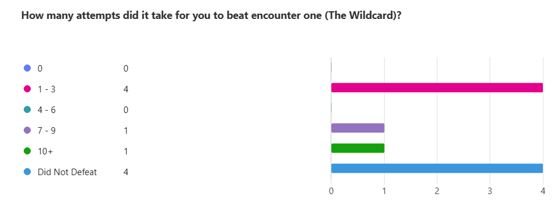
Figure 1 Number of attempts taken to beat AI 1
Across the Type A participants, outcomes against the Wildcard varied considerably. Several players defeated it within one to three attempts, while others reported needing seven or more, and a number were unable to secure a win at all. This wide distribution immediately positioned the encounter as inconsistent in its demands. Some participants described quick victories, while others experienced repeated losses, suggesting that success often depended on moment-to-moment variation rather than a clearly readable pattern of behaviour.
For many, this variability translated into an expectation that victory remained achievable. Even when participants lost, they rarely described the Wildcard as shutting them down completely. Instead, defeats were framed as near misses, unlucky exchanges, or the result of limited experimentation. The presence of both early wins and prolonged failures created an environment in which players could believe that another attempt might reverse their fortunes.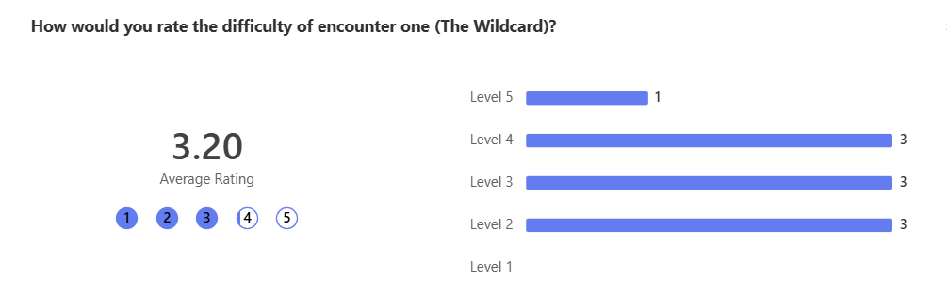
Figure 2 Difficulty level of AI 1
Difficulty ratings typically sat in the low-to-mid range compared with the other encounters. Many comments described the fight as feeling random or unpredictable, with some players noting they could repeat limited strategies successfully. Others felt the back-and-forth nature created close battles. Overall, players often reported feeling capable of success even when they lost, suggesting the encounter communicated the possibility of victory without creating a sense of being mechanically overwhelmed.
Written responses reinforce this interpretation. Players frequently used terms such as fair, close, or medium. Several stated they could sometimes “trick” the AI, or that repeating options could still produce wins. Where frustration appeared, it was mild and usually attached to luck rather than design. Importantly, accusations of cheating were rare here. Even participants who later suspected another opponent tended to describe the Wildcard as operating within acceptable expectations of randomness.
Emotionally, the fight generated tension but not hopelessness. A number of players highlighted that trading blows or finishing with low health made the encounter exciting. Losses did not commonly reduce motivation; instead, they seemed to reinforce the idea that a different sequence of inputs might be enough next time. In this sense, the Wildcard maintained player confidence and preserved the belief that mastery or persistence could lead to improvement.
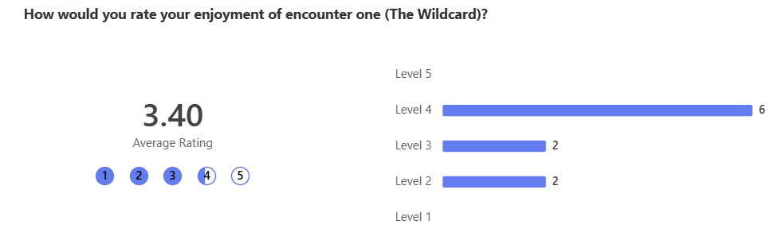
Figure 3 Enjoyment of AI 1
Enjoyment of the Wildcard was generally stable even when players were unsuccessful. A large number of participants rated the encounter positively and described it as entertaining because it felt winnable. The sense that outcomes could swing in either direction helped losses feel temporary rather than punishing. Players often mentioned close fights, moments of luck, or short bursts of success as highlights. Because they believed they had agency, frustration rarely escalated into anger. Instead, many participants appeared willing to retry, expecting that a slightly different approach or better fortune could quickly produce a victory.
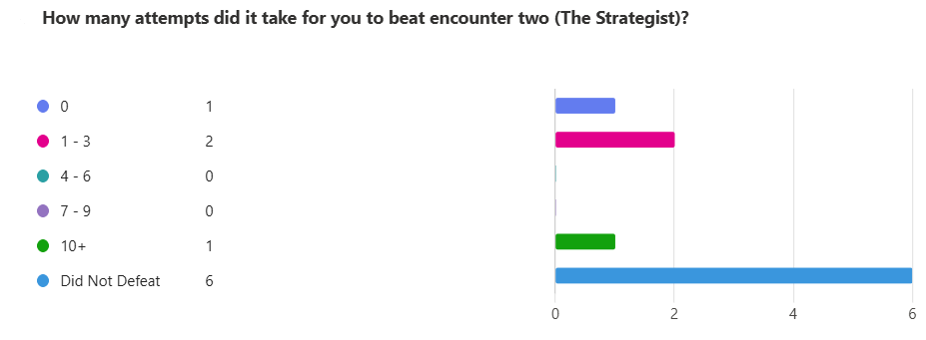
Figure 4 Number of attempts taken to beat AI 2
Results for the Strategist showed a noticeable shift in perceived success. A large portion of participants reported being unable to defeat this AI, despite multiple attempts. Where victories did occur, they were usually achieved within a small number of tries. Compared with the Wildcard, fewer players described comfortable or repeatable wins.
The data suggests that by this stage players were beginning to question why outcomes were happening. Rather than attributing failure to simple bad luck, many participants began to search for patterns in the AI’s behaviour, producing more analytical play.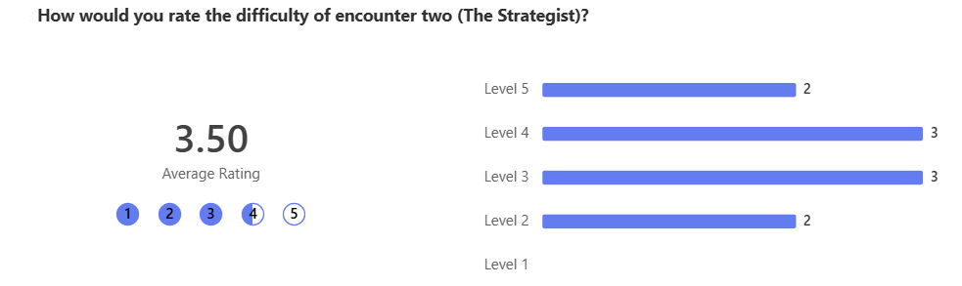
Figure 5 Difficulty level of AI 2
Difficulty ratings were frequently higher than those given to the Wildcard. Players commonly described the enemy as responding strongly to their choices, leading to extended exchanges, repeated draws, or the feeling that good moves were being answered effectively. Even when losses occurred, several participants framed the encounter as engaging or tense. The overall pattern suggests players felt pressure increasing here, with success appearing less certain.
The written feedback shows a mixture of admiration and suspicion. Some participants enjoyed attempting to “figure out” how the AI worked and reported satisfaction when they believed they understood its plan. Others, however, expressed confusion. Statements such as the opponent being “too good at predicting” or seeming to know what would be needed to win appeared more frequently than in the Wildcard encounter.
Despite this, frustration was often productive. Many players still described the fight as fun precisely because it resisted easy solutions. Rather than giving up, they tended to frame defeat as a challenge to overcome, increasing tension and curiosity.
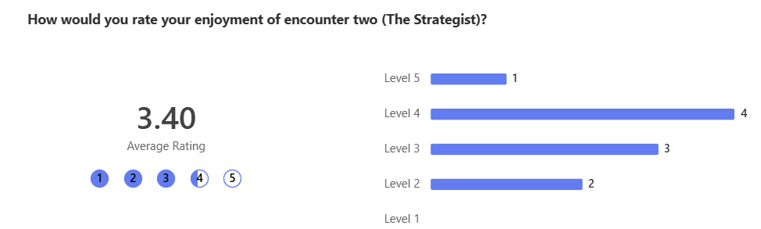
Figure 6 Enjoyment of AI 2
Enjoyment here became more divided. Some players reported that the heightened resistance made victories feel meaningful and described satisfaction when they believed they had worked out part of the AI’s behaviour. Others began to experience irritation, particularly when repeated counters disrupted their plans. Even so, the encounter frequently maintained engagement. Participants might complain about difficulty yet still praise the drama of long exchanges or the excitement of almost winning. The Strategist therefore occupied a middle ground where frustration and enjoyment often existed together rather than replacing one another.
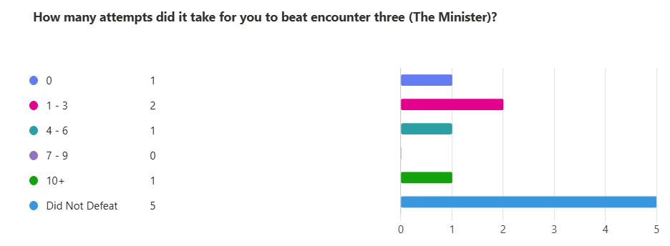
Figure 7 Number of attempts taken to beat AI 3
The Minister produced the strongest reports of players feeling overpowered or shut down. Most participants indicated that they did not defeat this encounter, and difficulty ratings were commonly at the top end of the scale. A few players achieved wins, typically within one to three attempts, but these were exceptions rather than the norm.
Unlike the earlier encounters, repeated failure here rarely strengthened confidence that improvement would lead to success. Instead, many players described feeling as though their options were being removed. Losses accumulated quickly and attempts to vary strategy often failed to change the outcome.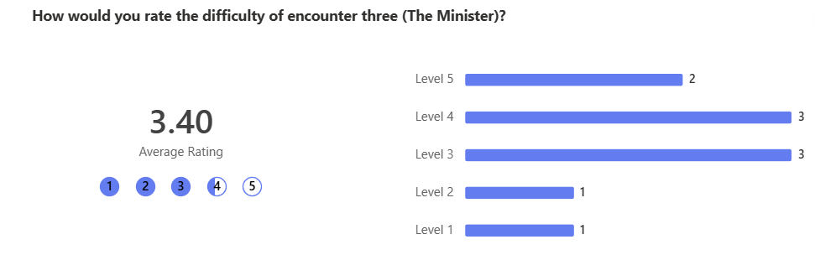
Figure 8 Difficulty level of AI 3
Comments repeatedly referenced moves being matched, blocked, or predicted, and some players described rapid defeats. Compared with the previous fights, far fewer responses expressed confidence in discovering a reliable path to victory. The dominant trend was a perception of escalating challenge, with many players experiencing reduced expectations of success.
Here, suspicion became far more explicit. Numerous participants questioned whether the system had access to their inputs, while others openly accused the encounter of being unfair. Phrases implying inevitability appeared regularly, including feelings that nothing they tried could break through. For some, this created strong frustration and even resignation.
However, not all reactions were negative. A minority of players reported enjoying the intensity or treated the extreme resistance as a dramatic spike in difficulty. In these cases, anger and excitement coexisted. Yet overall, compared to the Wildcard and the Strategist, emotional responses leaned more heavily toward feeling restricted rather than empowered.
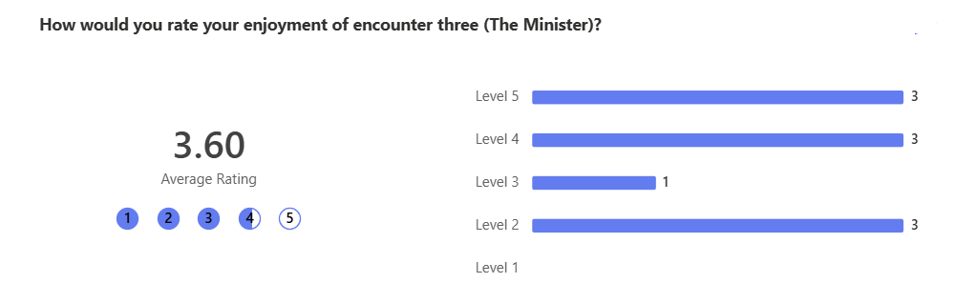
Figure 9 Enjoyment of AI 3
Reactions to enjoyment in this encounter were the most extreme, despite it receiving the highest enjoyment rating. For many players, the perception of constant prediction reduced satisfaction and replaced motivation with fatigue. Some participants indicated they would rather avoid replaying the fight, particularly if they believed success depended on information the AI should not possess. At the same time, a smaller group appreciated the brutality of the challenge and valued finally overcoming it or simply surviving longer than expected.

Across the encounters, a clear progression in outcomes was visible. The Wildcard generated the greatest spread of results, with some players winning within a few attempts while others required many tries or failed to defeat it. Reports around the Strategist showed fewer victories overall, with many participants indicating repeated losses and higher difficulty ratings, alongside increased attempts to analyse behaviour. The Minister produced the most consistent pattern of defeat, with the majority of players unable to win and frequently describing their actions as being anticipated.
As the sequence advanced, confidence generally declined while suspicion rose. Early uncertainty often motivated experimentation, but later experiences more commonly produced doubt about fairness. Although challenge remained engaging for some participants, others began to interpret resistance as evidence that the system might be operating beyond normal expectations of play.
A similar progression could be observed in reported enjoyment. The Wildcard was frequently described as entertaining because defeats still carried the belief that improvement or luck might quickly reverse the outcome. With the Strategist, enjoyment became more conditional; players often valued the tension and the sense of learning, yet irritation began to surface when counterplay felt too consistent. By the time participants reached the Minister, positive reactions were less dominant. While a minority appreciated the intensity of the challenge, many indicated that satisfaction diminished once they felt their decisions had limited influence. In this way, rising suspicion appeared to correspond with a gradual reduction in emotional reward for a substantial portion of players, despite the quantitative feedback indicating that the minister was the most well received AI.

Type B Findings – Players Aware of Cheating
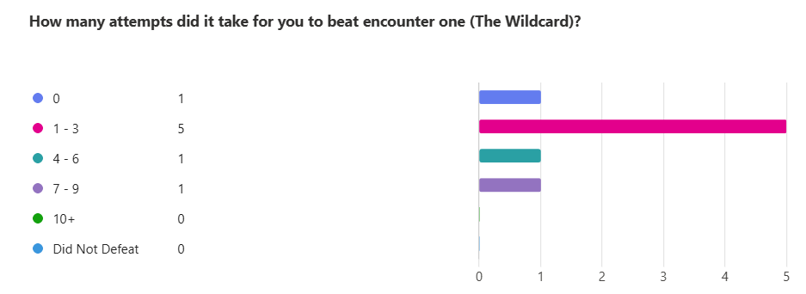
Figure 10 Number of attempts taken to beat AI 1
Across Type B participants, outcomes against the Wildcard showed a mixture of early victories and moderate resistance. Many players reported defeating the encounter within one to three attempts, while others required four to six or occasionally more. Compared with later fights, fewer participants described being completely unable to win. This distribution positioned the Wildcard as challenging but manageable.
Because players had been warned that one AI might cheat, some entered the encounter already alert for unusual behaviour. However, early results often reassured them. Wins were common enough that players could attribute defeats to timing, luck, or imperfect decision making rather than to systemic unfairness. Even participants who struggled typically believed that improvement or persistence could change the outcome.
The variability of results helped maintain optimism. Success appeared possible, and most players felt they retained meaningful influence over what happened.
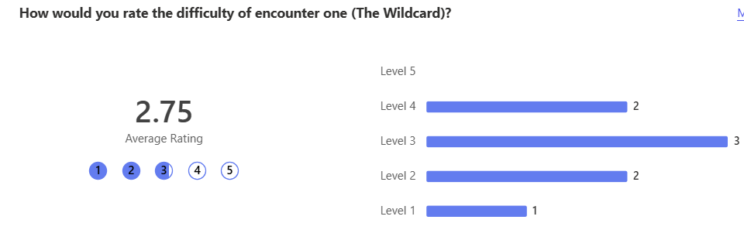
Figure 11 Difficulty level of AI 1
Difficulty ratings for the Wildcard most often occupied the lower or middle part of the scale. Players regularly described the fight as random, fair, or back-and-forth. Several reported that they could influence outcomes by repeating actions or by attempting to mislead the AI. This had led this encounter to being the lowest rated amongst all the AI between both groups.
Importantly, accusations of cheating were limited. Even though participants knew deception might exist somewhere in the system, the Wildcard rarely triggered strong suspicion. Where frustration appeared, it was usually tied to unlucky exchanges rather than the belief that the AI possessed extra knowledge.
Emotional responses therefore leaned toward excitement rather than defeat. Close health values and alternating successes produced tension, but not hopelessness. Players commonly felt that if they lost, another attempt could quickly reverse their fortunes.
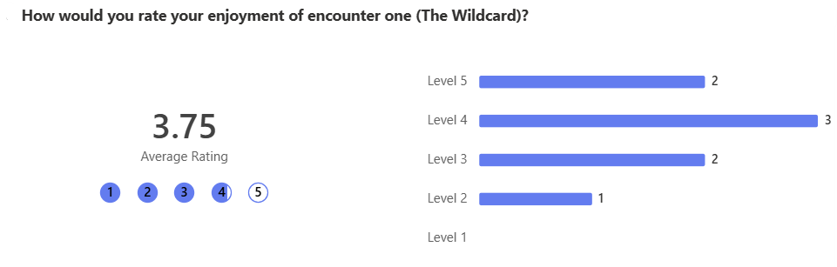
Figure 12 Enjoyment of AI 1
Enjoyment of the Wildcard remained generally positive. Many participants appreciated the balance between unpredictability and opportunity, noting that fights felt competitive. Because victories occurred regularly, frustration rarely escalated into anger.
Even players who were cautious due to the cheating warning tended to relax here. The encounter supported the idea that the game could still operate within acceptable boundaries. As a result, motivation to retry remained strong, and the emotional tone surrounding defeat was usually temporary rather than discouraging.

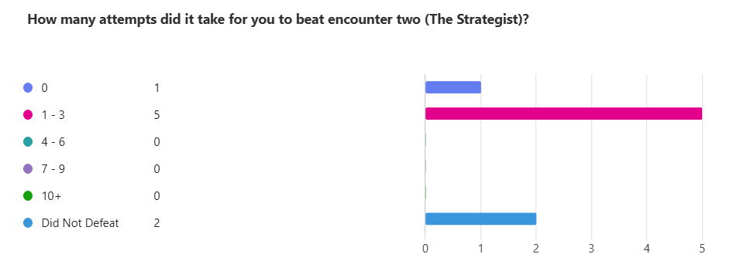
Figure 13 Number of attempts taken to beat AI 2
Against the Strategist, reports of success became more uneven. Most participants achieved victories within a few attempts, yet many others failed repeatedly. Compared with the Wildcard, players were less certain about why outcomes were occurring.
Because they had prior knowledge of potential cheating, participants were more likely to interpret consistent losses as meaningful. Instead of attributing failure purely to randomness, they began analysing behaviour, searching for evidence of prediction or adaptation.
This produced a noticeable shift in mindset. Attempts were not simply retries; they became investigations into how the AI might be working.
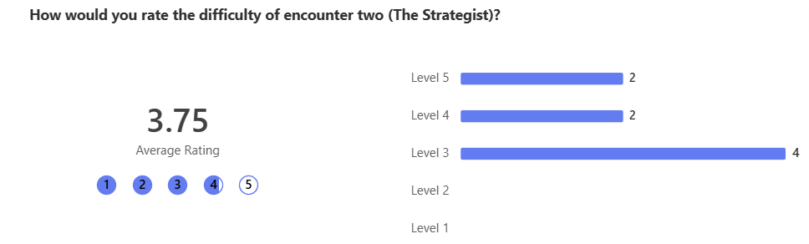
Figure 14 Difficulty level of AI 2
Difficulty ratings increased in comparison with the first encounter. Numerous players described the Strategist as countering effectively or appearing unusually well informed. Statements suggesting that the AI “knew” the correct answer appeared frequently.
Reactions, however, were mixed. Some participants enjoyed the opportunity to read the system and felt rewarded when they believed they had partially understood it. Others experienced confusion or irritation, particularly when adaptation seemed too reliable.
Unlike the Wildcard, suspicion was now active rather than distant. Players were testing the limits of fairness.
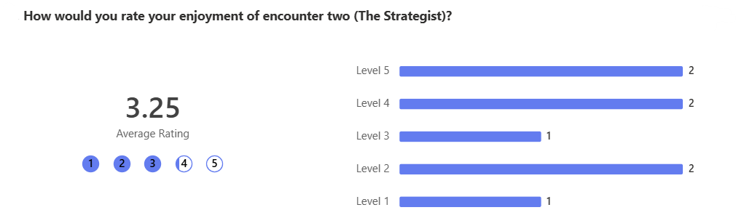
Figure 15 Enjoyment of AI 2
Enjoyment became more divided. A portion of participants reported strong satisfaction, especially when they believed planning or observation led to improvement. For them, the encounter created drama and intellectual engagement.
At the same time, repeated counters sometimes weakened enthusiasm. When players felt that understanding the AI did not reliably translate into success, enjoyment could shift toward frustration. Nevertheless, many still remained willing to retry, suggesting the encounter maintained emotional investment even when it generated doubt.

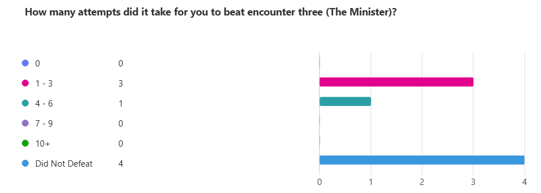
Figure 16 Number of attempts taken to beat AI 3
The Minister produced the clearest concentration of unsuccessful outcomes. A large share of participants reported failing to defeat the encounter, and several described being unable to land effective attacks across multiple attempts.
Because players already expected cheating, these failures were rarely interpreted as coincidence. Instead, they reinforced the belief that the AI had access to superior information. Variation in strategy did not consistently improve results, which weakened confidence in experimentation.
Here, the sense of agency began to narrow.
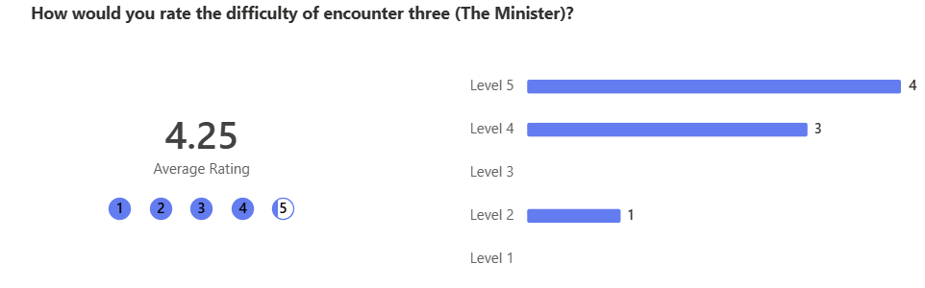
Figure 17 Difficulty level of AI 3
Difficulty ratings were commonly at the highest end of the scale, with this encounter being considered the most difficult between both groups. Participants repeatedly described their moves being predicted, blocked, or perfectly answered. The language of inevitability appeared more often than in earlier encounters.
For many players, awareness of cheating transformed surprise into confirmation. Rather than asking if the AI was unfair, they reacted to evidence that it was. This created stronger emotional responses, including anger and resignation.
However, a minority still valued the intensity. For them, extreme resistance amplified stakes rather than undermining them.
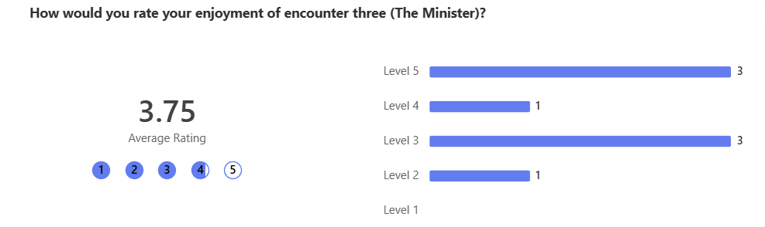
Figure 18 Enjoyment of AI 3
Enjoyment responses were the most polarised. Some players appreciated the brutality of the challenge and enjoyed testing themselves against an opponent they knew had an advantage. Others felt that once prediction became too consistent, motivation declined.
Where victories occurred, they were memorable. Yet for many, repeated failure reduced the desire to continue. Knowledge of cheating sometimes softened disappointment, but it could also validate feelings that success was outside their control.
Across the encounters, a progression in perceived control was visible. The Wildcard preserved confidence, the Strategist stimulated analysis, and the Minister most strongly triggered acceptance that the AI possessed superior power.
Because participants were informed in advance, suspicion emerged earlier and more openly than in Type A. Players actively searched for proof, and emotional reactions intensified as evidence appeared to confirm their expectations.
A parallel trend could be seen in enjoyment. Early battles were entertaining because players felt competitive despite the warning. Midway through, satisfaction depended on whether understanding seemed possible. By the final encounter, enjoyment increasingly relied on personal tolerance for extreme challenge. For some this heightened drama; for others it diminished reward.
The earlier sections presented how each participant group responded to the three AI opponents. This section moves beyond description to interpret what those responses reveal about perception, trust, and the psychological meaning of cheating in games. Because both Type A and Type B players interacted with identical systems, any differences between them cannot be attributed to mechanics. Instead, variation reflects how knowledge, expectation, and belief shape player experience.
The contrast between the groups therefore provides a direct way of examining a key argument raised throughout the literature review: that fairness in games is not simply a property of rules, but a judgement formed in the mind of the player (Salen & Zimmerman, 2004). By analysing who was accused of cheating, why those accusations appeared, and how they related to enjoyment, it becomes possible to see how the same behaviours can be interpreted in radically different ways.

Analysis
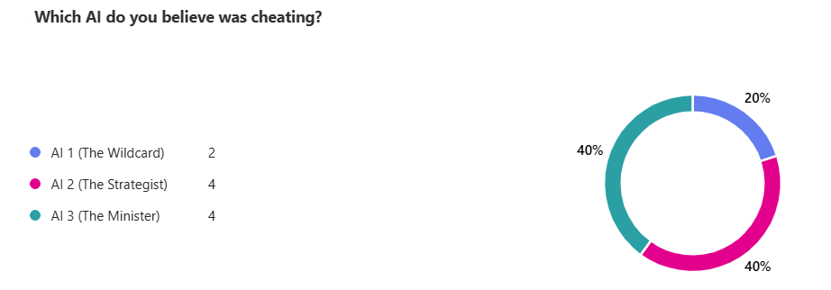
Figure 19 The AI Type A Believed Where Cheating
Participants who were unaware that cheating existed did not begin with distrust. Instead, suspicion accumulated gradually as encounters became harder. In this group, the strategist and the Minister attracted the strongest and most consistent accusations. Players frequently described being matched, blocked, or countered in ways that appeared too precise to be coincidence. Language implying inevitability became common, with several participants suggesting that nothing they attempted could meaningfully alter the outcome.
This is important because these conclusions were not prompted externally. They arose from emotional reactions to repeated failure. As Consalvo (2007) argues, players often search for explanations when outcomes feel disproportionate to effort. When mastery fails to produce improvement, rule legitimacy becomes vulnerable.
The Strategist produced a different kind of response. Here, many players noticed effective counterplay, yet reactions were divided. Some interpreted adaptation as intelligence and found enjoyment in attempting to decipher the pattern. Others felt prediction occurred too reliably, shifting admiration toward doubt. In other words, suspicion appeared, but it competed with curiosity.
The Wildcard rarely triggered strong accusations. Its variability allowed defeat to be rationalised as luck, preserving the assumption that the game remained fair. Because uncertainty remained external rather than personal, players maintained confidence in eventual success.

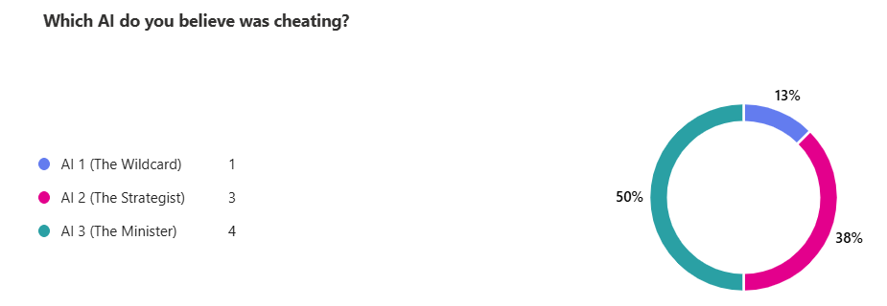
Figure 20 The AI Type B Believed Where Cheating
The informed group entered play already primed to look for deception. As a result, accusations emerged earlier and with greater certainty. Experiences that Type A players might have debated internally were, for Type B, interpreted as confirmation.
Again, the Minister stood out most clearly. Participants repeatedly described it as predicting every move, often treating this as direct evidence of the promised cheating behaviour. However, unlike in Type A, revelation did not always produce shock. Instead, it often validated pre-existing caution.
More interesting is the rise in accusations directed toward the Strategist. Because players knew one AI cheated, intelligent adaptation itself became suspicious. Situations where the AI responded effectively were sometimes judged not as skilful design, but as proof of hidden advantage.
Even the Wildcard was not immune. Some participants mistrusted randomness, interpreting unexpected losses as potential manipulation. Awareness therefore widened the field of suspicion.

Comparing Accusations Across Groups
When the two datasets are placed together, a pattern becomes visible. The Minister is consistently the most accused in both conditions. However, the route toward that accusation differs dramatically.
For Type A, suspicion is a destination reached after frustration.
For Type B, it is a starting assumption.
This difference supports Hunicke’s (2005) argument that player interpretation mediates system meaning. Mechanics alone do not define experience; understanding emerges from context.
Furthermore, adaptive behaviour in the Strategist highlights a grey zone between intelligence and illegitimacy. Players enjoy being challenged, yet only while they believe they can read and respond. When adaptation becomes opaque, it risks being interpreted as cheating.

Enjoyment Differences Between Groups
Perhaps the most striking outcome is that high difficulty did not automatically destroy enjoyment. Instead, emotional response depended on whether players believed their actions still mattered.
In Type A, even strong resistance could remain engaging if players felt they might eventually uncover a strategy. Suspicion sometimes increased motivation. Discovery functioned almost like a narrative twist, transforming confusion into meaning.
In Type B, however, confirmed cheating occasionally reduced incentive to experiment. If advantage was assumed to be permanent, persistence appeared less valuable. This created polarisation: some players enjoyed the honesty of the challenge, while others disengaged.
This mirrors Csikszentmihalyi’s (1990) concept of Flow. Engagement thrives when challenge stretches ability but remains attainable. Once players feel incapable of influence, anxiety shifts toward helplessness.

Did Awareness Change Behaviour or Just Interpretation?
The quantitative patterns between groups show more similarity than difference. The same encounters tended to produce success or failure regardless of prior knowledge. What changed was the explanation players attached to those outcomes.
Type A participants often blamed luck first, then gradually considered unfairness. Type B participants moved to that explanation immediately. Awareness therefore accelerated interpretation rather than transforming performance.
This demonstrates that the emotional meaning of cheating can outweigh its mechanical effect.
Salen and Zimmerman (2003) emphasise that rules create meaning through player belief. The present study demonstrates this clearly. Identical algorithms were described as fair, unfair, exciting, or broken depending on expectation.
Fairness was not calculated mathematically; it was negotiated emotionally. When players believed they retained agency, even disadvantage could be tolerated. When agency seemed removed, legitimacy collapsed. Trust developed differently across groups. Unaware players began with confidence that deteriorated over time. Aware players began cautiously, evaluating whether behaviour justified the warning. Revealing deception can therefore function in two opposing ways. It may heighten drama by framing the opponent as powerful, or it may provide permission for dissatisfaction. Cheating heightened intensity in nearly every case. Yet intensity alone did not guarantee enjoyment. Engagement survived only while players believed victory, however unlikely, remained possible.
This investigation demonstrates that partial cheating is less about advantage and more about interpretation. Players respond not just to what the AI does, but to what they believe it is allowed to do. Awareness reshapes judgement, amplifies suspicion, and can either enhance drama or weaken motivation.
Most importantly, agency emerged as the critical factor. If players felt they could influence outcomes, challenge remained compelling. When that belief failed, enjoyment declined.

Recommendations and Future Work
The findings of this investigation highlight the complexity of designing AI systems that deliberately operate with informational advantages. While the prototype successfully revealed how partial cheating influences perception, trust, and engagement, it also exposed several areas where the experimental design and the AI implementation could be refined. This section reflects on those limitations and proposes improvements for both future research and practical application within the games industry.
Although the study generated valuable insights, the scale and structure of the experiment inevitably constrained the strength of its conclusions. The participant pool, while sufficient to reveal visible trends, remained relatively small. A larger and more diverse sample would provide stronger statistical reliability and allow comparisons across age, genre familiarity, and playstyle preference. Different types of players may tolerate or even enjoy cheating behaviour differently, particularly when competitive experience or expectations of mastery vary.
Exposure time also represented a limitation. Participants engaged with each AI for a short period, often only a handful of attempts. Longer sessions might reveal adaptation on the player’s side, including whether initial suspicion fades, intensifies, or transforms into strategic experimentation. Over extended play, users might develop coping strategies that were not visible within the timeframe of this study.
In addition, the prototype’s simplicity, while essential for experimental control, may have amplified perceptions of unfairness. Because the interaction model was highly transparent, repeated counters were more obvious than they might be in a richer system with additional mechanics, audiovisual feedback, or narrative framing. A more complex environment could conceal adaptation more naturally, potentially altering how players interpret resistance.
Further refinement could also be made in the collection of behavioural metrics. Automated tracking of decision times, strategy variation, or hesitation patterns would provide deeper evidence of cognitive and emotional response beyond self-reported impressions. Such data could reveal how players react moment by moment, strengthening claims about engagement and perceived agency.
Beyond methodological adjustments, the AI system itself presents opportunities for improvement. The Minister demonstrated that strong predictive behaviour quickly leads players toward accusations of illegitimacy. While this confirmed the study’s premise, it also suggests that future implementations should consider moderation. Rather than consistently countering the player, a cheating AI might operate probabilistically, blending accurate reads with intentional mistakes. This would preserve challenge while maintaining uncertainty about whether extra knowledge exists.
Opacity is equally important. When adaptation becomes too visible, players may abandon attempts to learn. Introducing noise, delayed reactions, or misleading behaviours could help the AI feel intelligent without appearing omniscient. By disguising advantage within plausible imperfection, designers may protect the player’s belief in agency.
Dynamic control offers another promising avenue. Instead of applying cheating uniformly, the system could respond to emotional indicators such as consecutive losses or reduced experimentation. If frustration rises too sharply, the AI might temporarily relinquish its advantage, restoring hope and sustaining engagement. In this sense, the purpose of the system is not simply to win, but to produce drama, tension, and the feeling of rivalry.
Looking forward, this project opens several pathways for further investigation. One potential direction would be examining how presentation alters tolerance. Players might react differently if cheating were framed narratively, for instance through an opponent described as psychic or supernatural. Context could legitimise behaviours that would otherwise be rejected, transforming deception into character.
Another opportunity lies in cooperative or multiplayer settings. Understanding whether knowledge of AI advantage changes communication, blame, or shared strategy could extend insights into social dynamics beyond individual experience. Researchers might also explore gradual disclosure, where players discover cheating over time rather than being told in advance. This approach could reveal whether surprise enhances emotional engagement or damages trust.
Finally, future studies could benefit from integrating physiological measures such as heart rate or galvanic skin response to capture objective indicators of tension. When combined with player reports, these measures might clarify the difference between enjoyable stress and discouraging frustration.
For industry practitioners, the implications are significant. Modern development increasingly prioritises player-centred design, yet opponents must still challenge, surprise, and escalate tension. This study demonstrates that informational advantage can be effective, but only while players believe they retain influence. When that belief collapses, immersion quickly follows.
The central lesson is therefore not simply about whether AI should cheat, but about how that cheating is perceived. Adaptive or deceptive techniques must be implemented with careful attention to communication, framing, and emotional pacing. Done well, they can create memorable rivalry and dramatic intensity. Done poorly, they risk alienating the very audience they are meant to engage.

Conclusion
This project set out to explore how partial cheating in artificial intelligence influences player engagement, enjoyment, and perceptions of fairness. More specifically, it aimed to determine whether an AI granted limited access to a player’s intended actions could appear intelligent and challenging while maintaining trust and avoiding clear detection. Through the combination of theoretical grounding, controlled prototype design, and structured playtesting, the investigation has demonstrated that such systems are both powerful and fragile. They can intensify drama and heighten tension, but only while players continue to believe their own decisions meaningfully matter.
The literature review established that fairness in games is not defined purely by mechanical equality, but by perception. Authors such as Salen and Zimmerman emphasise that players accept disadvantage provided the system appears coherent and readable, while Consalvo highlights how rule-breaking becomes problematic when it violates the implicit contract between player and game. These frameworks proved essential when interpreting the findings. The same underlying mechanic, AI access to player intent, produced very different reactions depending on how visible, consistent, or extreme the advantage appeared.
The prototype fulfilled its purpose as a controlled testing environment. By presenting three AI archetypes operating under identical conditions, a random Wildcard, an adaptive Strategist, and the information-advantaged Minister, it became possible to isolate how behaviour influenced interpretation. Across both participant groups, the Wildcard most reliably preserved confidence. Players saw variability, luck, and opportunity. Even defeat often reinforced the belief that improvement or persistence would eventually lead to success.
The Strategist shifted this balance. Participants increasingly analysed behaviour and searched for patterns, moving from casual play toward investigation. For some, this deepened engagement, producing intellectual satisfaction and heightened drama. For others, reliable counterplay began to erode belief in fairness. Suspicion emerged not because the AI was unbeatable, but because its competence felt increasingly targeted.
It was the Minister, however, that most clearly revealed the limits of tolerance. In both groups, this AI generated the strongest accusations of cheating and the greatest sense of restricted agency. Repeated prediction, matched responses, and the apparent removal of viable alternatives weakened the motivational loop that had sustained earlier encounters. While a minority of players valued the brutality and intensity, many experienced fatigue, resignation, or reduced desire to continue.
One of the most important discoveries of the study is that awareness altered interpretation more reliably than outcome. Performance differences between the groups were present, but not dramatic. What shifted more substantially was how players explained events. Type A participants often moved gradually from curiosity to suspicion, whereas Type B participants began analysing almost immediately, treating resistance as potential confirmation of prior warning. Knowledge therefore acted as a lens, shaping emotional response even when the mechanical challenge remained comparable.
This finding has direct implications for player-centred AI design. It suggests that the success of adaptive or deceptive systems depends less on the advantage itself and more on how convincingly that advantage is framed, disguised, or justified. When players can rationalise behaviour within the fiction of the game, tension thrives. When actions appear to violate the boundaries of possibility, trust deteriorates rapidly.
All four objectives of the project were achieved. A critical review of scholarship provided theoretical anchors for interpreting fairness, agency, and adaptation. The Unity prototype delivered a stable platform for comparison. Playtesting generated a rich mixture of numerical and descriptive data. Finally, analysis of those results in relation to the literature allowed meaningful conclusions about how partial cheating shapes experience.
Perhaps the most surprising outcome is that the most extreme AI often produced the strongest emotional reactions in both directions. It generated anger and admiration, exhaustion and excitement. This duality reveals why such techniques remain attractive to designers despite their risks. Cheating can create memorable moments, but it must be handled with restraint and sensitivity to player psychology.
Ultimately, this investigation demonstrates that partial cheating is neither inherently harmful nor automatically beneficial. It is a tool. Used carefully, it can amplify rivalry, produce uncertainty, and push players toward deeper engagement. Used carelessly, it can undermine agency and dissolve immersion. The responsibility therefore lies not simply in engineering intelligent behaviour, but in shaping how that intelligence is perceived.
By clarifying the relationship between system knowledge, player interpretation, and emotional reward, this project contributes practical insight into the design of believable, challenging opponents. It reinforces the importance of transparency, pacing, and trust, and it provides a foundation for future work seeking to balance adaptation with fairness in interactive systems.

References
Andrade, G., Ramalho, G., Santana, H. & Corruble, V., 2005. Challenge-sensitive action selection: an application to game balancing. s.l., Intelligent Agent Technology.
Bakkes, S. C., Spronck , . P. H. & Lankveld , G. v., 2012. Player behavioural modelling for video games. Entertainment Computing, Volume 3, pp. 71-79.
Bishop, C., 2006. Pattern Recognition and Machine Learning. s.l.:Springer.
Bojarski, M., Testa, D. D. & Dworakowski, D., 2016. End to End Learning for Self-Driving Cars. arXiv.
Booth, M., 2009. The AI Systems of Left 4 Dead. s.l., s.n.
Chen, C. & Fang, Z., 2023. Gacha Game Analysis and Design. Proceedings of the ACM on Measurement and Analysis of Computing Systems, Issue 7, pp. 1-45.
Consalvo, M., 2007. Cheating: Gaining Advantage in Video Games. s.l.:MIT Press.
Csikszentmihalyi, M., 1990. Flow: The Psychology of Optimal Experience.
Devroye, L., 1986. Non-uniform Random Variate Generation. International Encyclopedia of Statistical Science, p. 1758–1765.
Drachen, A., Canossa, A. & Yannakakis, G., 2009. Player modeling using self-organization in Tomb Raider: Underworld. s.l., IEEE Xplore.
Elias, S. K. & Salaimeh, O., 2024. Adaptive Difficulty and its Impact on Inclusivity in Action Games. Digitala Vetenskapliga Arkivet.
Esteva , A. et al., 2017. Dermatologist-level classification of skin cancer with deep neural networks. Nature, p. 115–118.
Fullerton, T., 2018. Game Design Workshop: A Playcentric Approach to Creating Innovative Games. 4th ed. New York: A K Peters/CRC Press.
Goodfellow, I., Bengio, Y. & Courville, A., 2016. Deep Learning. s.l.:The MIT Press.
Hamari, J., Hanner, N. & Koivisto, J., 2017. Service quality explains why people use freemium services but not if they go premium. International Journal of Information Management: The Journal for Information Professionals, 37(1), pp. 1449 - 1459.
Harrigan, K. A. & Dixon, M. J., 2009. PAR Sheets, probabilities, and slot machine play: Implications for problem and non-problem gambling. Journal of Gambling Issues, Issue 23, pp. 81-110.
Hello Games, 2016. No Mans Sky. [Online]
Available at: https://www.nomanssky.com/
[Accessed 18 November 2025].
Hunicke, R., 2005. The case for dynamic difficulty adjustment in games. ACE '05: Proceedings of the 2005 ACM SIGCHI International Conference on Advances in computer entertainment technology, pp. 429 - 433.
IBM, n.d. Deep Blue. [Online]
Available at: https://www.ibm.com/history/deep-blue
[Accessed 18 November 2025].
Isla, D., 2005. GDC 2005 Proceeding: Handling Complexity in the Halo 2 AI. [Online]
Available at: https://www.gamedeveloper.com/programming/gdc-2005-proceeding-handling-complexity-in-the-i-halo-2-i-ai
[Accessed 10 December 2025].
Jennett, C., Cox, A. L. & Cairns, P., 2008. Measuring and Defining the Experience of the Immersion in Games. International Journal of Human-Computer Studies, pp. 641-661.
Kosko, B., 1993. Fuzzy Thinking: The New Science of Fuzzy Logic. New York: Hyperion.
LeCun, Y., Bengio, Y. & Hinton , G., 2015. Deep learning. nature, p. 436–444.
MILLINGTON, I. & FUNGE, J., 2009. Artificial Intelligence for Games. 2nd ed. s.l.:MORGAN KAUFMANN.
Mi, Q. & Gao, T., 2022. Adaptive rubber-banding system of dynamic difficulty adjustment in racing games. ICGA Journal, Volume 1, pp. 18-38.
Mortazavi, F., Moradi, H. & Vahabie, A.-H., 2024. Dynamic difficulty adjustment approaches in video games: a systematic literature review. Multimedia Tools and Applications, 12 March, Volume 83, p. 83227–83274.
Nilsson, N. J., 1998. Artificial Intelligence: A New Synthesis. s.l.:Morgan Kaufmann Publishers Inc..
O'Neil, C., 2016. Weapons of Math Destruction. s.l.:Penguin.
Rabin, S., 2013. Game AI Pro: Collected Wisdom of Game AI Professionals. s.l.:A K Peters/CRC Press.
Rabin, S., 2015. Game AI Pro 2: Collected Wisdom of Game AI Professionals. s.l.:A K Peters/CRC Press.
Russell , S. R. & Norvig, P. N., 2024. Artificial Intelligence: A Modern Approach, 4th edition. 4th edition ed. s.l.:Pearson.
Silver, D. et al., 2016. Mastering the game of Go with deep neural networks and tree search. Nature, Issue 529, p. 484–489.
Simon, H. A. & Newel, A., 1958. Elements of a theory of human problem solving. Psychological Review, 3(65), pp. 151-166.
Simon, H. A. & Newel, A., 1971. HUMAN PROBLEM SOLVING: THE STATE OF THE THEORY IN 1970. Prentice-Hall.
Sjöblom, M. & Hamari, J., 2017. Why do people watch others play video games? An empirical study on the motivations of Twitch users. Computers in Human Behavior, pp. 985-996.
Summerville, A., Osborn, J., Samuel, B. & Mateas, M., 2017. Towards General RPG Playing. The Workshops of the Thirteenth AAAI Conference on Artificial Intelligence and Interactive Digital Entertainment, 13(2).
Sutton, R. S. & Barto, A. G., 2018. Reinforcement Learning: An Introduction. 2nd Edition ed. s.l.:The MIT Press.
Sweetser, P. & Wyeth, P., 2005. GameFlow: A Model for Evaluating Player Enjoyment in Games. Computers in Entertainment, p. 3.
Tekinbaş, K. S. & Zimmerman, E., 2003. Rules of Play: Game Design Fundamentals. MITPress.
Togelius, J. & Yannakakis, G. N., 2018. Artificial Intelligence and Games. s.l.:Springer.
Vinyals, O., Babuschkin, I., Czarnecki, W. M. & Mathieu, M., 2019. Grandmaster level in StarCraft II using multi-agent reinforcement learning. Nature, Issue 575, p. 350–354.
Wiersma, D., 2023. https://filmstories.co.uk/. [Online]
Available at: https://filmstories.co.uk/features/game-ai-the-tricks-designers-use-to-make-non-player-characters-seem-real/
[Accessed 05 November 2025].

Appendices

Appendix 1 – Empty Questionnaires
Please see the two attached PDFs of the full non-filled questionnaires for the methodology.

Appendix 2 – Questionnaires
Please see the two attached PDFs of the full completed questionnaires for the analysis.

Appendix 3 – Raw Data Group 1
Please see the attached Excel sheets which provide the full raw data from the questionnaires.

