FINAL YEAR PROJECT (COMP60011)

A.I.M.S.
BALRAJ SINGH BHULLER, 23016728

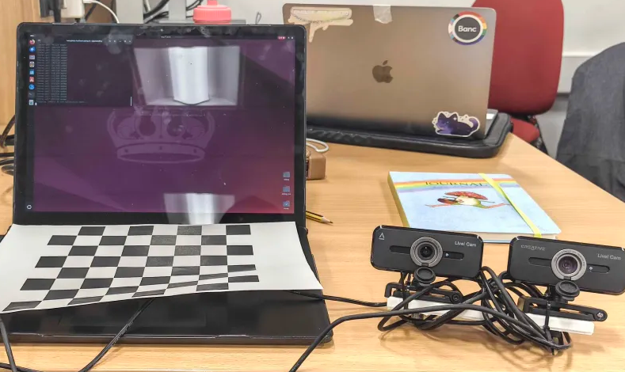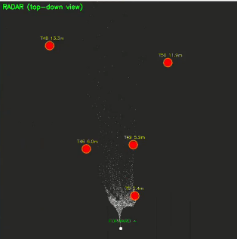
Supervisor: Stephen Cahill
Date of Final Version: 08/05/2026
Content
- Abstract 3
- Introduction 3 - 5
  - Research Background 3
  - Current Challenges in Autonomous Interior Mapping 3 - 4
  - Hypothesis 4
  - Aim 4
  - Objectives 4 - 5
  - Deliverables 5
  - Structure of Report 5
- Research Method 5 - 6
  - Semi-Systematic Literature Review 5 - 6
  - Mapping and Thematic Synthesis 6
  - Quantitative Extraction for Contextual Benchmarks 6
  - Threats to Validity in the Review 6
- Literature Review 7 - 17
  - SLAM Problem Formulation 7 - 8
  - SLAM Solution Approaches 8 - 11
  - Human Detection 12 - 15
  - Sensor Fusion 15 - 16
  - Swarm Robotics 16 - 17
- Design and Implementation of Artefact 18 - 36
  - System Architecture Overview 18 - 19
  - Design Choices 19 - 26
  - Program Design 26 - 34
  - Pseudo Code 34 - 36
- Testing and Validation of Artefact 36 - 38
  - Evaluation 38
- Reflection 39 - 40
- Conclusion 40 - 41
- References 41 - 46

1.0 Abstract
Autonomous robotics in Search and Rescue and disaster response must simultaneously map environments and locate people, yet doing both in real-time on affordable hardware is challenging. This project implements a dual-camera SLAM system with integrated human detection. By carefully balancing accuracy and speed, the system achieves real-time performance. The work demonstrated that autonomous capabilities don’t require expensive systems. They require intelligent algorithm design and practical engineering tradeoffs.
2.0 Introduction
2. 1 Research Background
Autonomous interior mapping is a critical capability for modern robotics, with applications spanning Search and Rescue (SAR) operations, military reconnaissance, industrial inspection, and disaster response. In these high-stakes environments, the ability to simultaneously build accurate 3D maps of unknown environments while identifying human victims or targets in real-time remains an unsolved challenge. This report investigates the design, implementation, and validation of a cost-effective dual USB camera SLAM system integrated with real-time human detection, addressing the gap between academic research and practical embedded deployment.
2. 2 Current Challenges in Autonomous Interior Mapping
- SAR Operations Rely on Manual Human Pilots
  - Currently, Search and Rescue operations depend on human-operated drones with visual pilots making real-time detection decisions. However, due to operator fatigue leading to attention degradation over extended missions, victims can be overlooked despite being within visual range. In time critical scenarios, manual operation introduces fatal delays even when every second matters.
- Existing Commercial Solutions are unaffordable or inflexible
  - Professional SLAM systems cost around £50k - £500k+, LiDAR sensors being a main driver for this price, making multi-agent swarms economically infeasible for most organizations. Property solutions lock users into vendor ecosystems; modification and research are restricted.
- GPS-Denied Environments Disable Traditional Navigation
  - Indoor environments block GPS signals entirely hence the reliance on satellite positioning is impossible, some solutions have included Radio-frequency localization alternatives but they suffer from multipath fading and are insufficiently accurate for precise mapping. Dead reckoning from wheel encoders drifts rapidly without environmental feedback, making those unreliable for mapping too. This is where Visual SLAM becomes the only viable approach for GP-denied settings.
2.3 Hypothesis
H1: Dual USB camera stereo SLAM is operationally viable. A dual USB camera stereo SLAM system can achieve real-time 3D indoor mapping with concurrent human detection using YOLOv8.
H2: Depth fusion improves robustness without expensive sensors. Combining stereo correspondence depth with geometric reasoning provides sufficient depth accuracy for human localization in indoor environments, without requiring specialized depth sensors. This fusion approach remains robust to untextured regions, occlusions, varying lighting conditions where single-modality depth fails.
H3: Temporal filtering stabilizes 3D tracking. Frame-to-frame tracking with depth smoothing reduces depth estimation noise and improves spatial consistency of detected human achievement with a 1 - 2m position jitter.
2.4 Aim
The aim of this research is to design, implement, and validate a dual USB camera SLAM system capable of simultaneous real-time 3D indoor mapping and autonomous human detection for Search and Rescue and tactical applications. Secondarily, this work aims to bridge the gap between academic SLAM theory and practical embedded deployment by providing transparent methodology, design trade-offs, and reproducible implementation.
2.5 Objectives
Technical Implementation: Implement an integrated pipeline comprising stereo calibration, real-time stereo reconstruction (SGBM), YOLOv8 human detection, frame-to-frame tracking, and sparse 3D mapping, with degradation if any component fails.
Accuracy & Robustness Validation: Quantify system accuracy and test robustness under certain conditions across multiple environments.
Design Trade-off Documentation: Document design decisions, trade-offs, failure modes, and mitigation strategies to provide practitioners with methodologies for building similar systems.
Deployment Feasibility: Demonstrate operation across multiple indoor environments and provide assessment of practical deployment feasibility for SAR, military, and industrial applications.
2.6 Deliverables
The Artefact will consist of 1 .py script and a dual USB camera setup. It should be able to calibrate, stereo reconstruct, detect, track and map something. In addition to this, there will be a Literature Review of SLAM problems, different human detection methods, Sensor fusion and the first exploration into Swarm designs. A Technical Documentation and Validation Sections will also be available to show what went wrong and what has been tested.
2.7 Structure of Report
The Report will be laid out the following:
- Research methods
- Literature Review
- Design and IMplementation
- Testing and validation
- Discussions
- Conclusion
3.0 Research Methods
3.1 Semi-Systematic Literature Review
A fully systematic review is often disproportionate for focused, time-boxed engineering prototypes, yet a purely narrative review risks selection bias. The researcher, therefore, adopted a Semi-Systematic approach:
- Scoping searches across academic databases and reputable technical sources using predefined keyword families
- Inclusion criteria for emphasizing indoor applicability, resource realism, reported performance, robustness, and transparent methods
- An audit trail of search strings, sources, and selection decisions
This approach follows recommendations from software engineering SLR guidance while tailoring the effort to the project scope.
3.2 Mapping and Thematic Synthesis
The researcher mapped selected works into high-level themes (e.g., robustness strategies, performance, trade-offs, maintainability and integration patterns, operator-centred evaluation). Within each theme, the researcher conducted a thematic synthesis to identify recurring claims, preconditions, and caveats. Thematic synthesis methods from qualitative research are suitable for organizing diverse findings and uncovering patterns relevant to design decisions. This avoids “paper counting” and focuses on explanatory insight.
3.3 Quantitative Extraction for Contextual Benchmarks
Where studies report metrics, the researcher extracted indicative ranges rather than attempting strict cross-study comparability. Variation in datasets and protocols makes exact comparisons risky; the goal is to anchor expectations and avoid unrealistic targets. This mixed narrative-quantitative practice is consistent with guidance to triangulate evidence sources in empirical software research.
3.4 Threats to Validity in the Review
The Researcher explicitly addressed typical threats:
- Selection bias: mitigated by recording search trails and inclusion/exclusion reasons
- Publication bias: tempered by consulting technical reports and documentation
- Construct Validity: Ensuring metrics and note context were interpreted correctly
- External Validity: Avoiding over-generalizing from highly controlled lab settings
This transparency follows established empirical software engineering conventions for reporting validity threats.
4.0 Literature Review
4.1 SLAM Problem Formulation
The Simultaneous Localisation and Mapping (SLAM) problem can be represented as the well-known Chicken-or-Egg Problem. As mentioned in the Intro, the autonomous agent has to construct a map of an unknown environment while simultaneously determining its own location within that environment. Just like the Chicken-or-Egg problem, this circular dependency is one of the most challenging problems within robotics and autonomous systems (Bailey and Durrant-Whyte, 2006).
The aforementioned SLAM problem is fundamentally modeled as a state estimation problem, using two primary equations to describe the robot’s motion and observations (Bailey and Durrant-Whyte, 2006):
- Motion Equation: Describes how the robot’s pose changes over time based on input, subject to noise, $x_{k}=f(x_{k-1},u_{k})+w_{k}$ where:
  - $x_{k}$ Is the robot’s position and orientation at time $k$
  - $x_{k-1}$ Is the previous position and orientation
  - $u_{k}$ Is the control input
  - $f()$ Is the non-linear motion function
  - $w_{k}$ Represents the motion noise or uncertainty, typically modeled as a Gaussian distribution
- Observation Equation: Relates a landmark’s position to the sensor’s measurements, also subject to noise, $z_{k,j}=h(x_{k},m_{j})+v_{k,j}$ where:
  - $z_{k,j}$ is the observation of landmark $j$ from the robot’s position at time $k$
  - $m_{j}$ is the location of $j$ -th landmark in the global map
  - $h()$ is the non-linear observation function, relates the robot’s state and the landmark location
  - $v_{k,j}$ is the observation noise, typically modeled as a Gaussian distribution

The ultimate objective of SLAM is to estimate the probability distribution of the joint posterior over the robot trajectory and the map, given all sensor observations and control inputs up to the current time (Thrun, Burgard, and Fox, 2005). This can be mathematically modeled like this:
$P ( x_{0}: _{k} , m | z_{ 1 }: _{k} , u _{1} : _{k})$ where:
- $x_{0}:_{k}$ is the entire robot trajectory from initial time 0 to the current time $k$
- $m$ Is the map containing all landmark positions
- $z_{1}:_{k}$ is all sensor observation
- $u_{1}:_{k}$ is all control inputs
The difficulty of the estimation problem comes from several factors that make SLAM challenging. The state space grows continuously as new landmarks are discovered and added to the map, causing an increase in estimation problems that require efficient algorithms to maintain real-time performance. The non-linear nature of both the motion and observation functions requires approximation techniques, as accurate solutions are generally too complex for real-world applications. Additionally, the relationship between robot pose estimates and landmark positions means that one error that affects either of these causes the accuracy of the other to dwindle, creating a coupled estimation problem that must be carefully managed (Dellaert and Kaess, 2006).
4.2 SLAM Solution Approaches
The SLAM problem can be approached by various algorithms that have evolved, each offering different trade-offs between efficiency, accuracy, and implementation complexity (Grisetti et al., 2010).
Online SLAM vs Full SLAM
At the highest level, SLAM solutions can be grouped by their scope and memory management strategies. The online SLAM approach focuses on estimating the current robot pose and the map, deleting the previous poses to maintain efficiency and memory usage. The online SLAM approach treats the SLAM problem as a filtering issue where the goal is to compute the probability distribution of the joint posterior at each time step $k$. This is very suitable for real-time applications where memory and processing limitations have been placed, such as embedded systems or mobile robots. Despite this, the approach potentially discards useful information from the past, which can limit the ability to correct past mapping errors (Strasdat, Montiel, and Davison, 2012).
The Full SLAM approach estimates the entire robot trajectory alongside the map, maintaining information about all previous robot poses throughout the mapping. While the full SLAM approach requires significantly more computational resources and memory that will grow over time, it enables more accurate mapping through global optimization techniques and handles loop closures better than Online SLAM. Therefore, Full SLAM can correct past mapping errors much more easily, leading to more consistent and accurate maps.
Mathematical Framework Categories:
SLAM algorithms can be further categorized based on their mathematical frameworks, with each framework having its advantages and limitations depending on the different applications and environments.
Filter-Based SLAM
Filter-Based SLAM treats problems as a sequential state estimation task, updating the robot pose and map as new sensor observations are read. The Extended Kalman Filter (EKF) SLAM was one of the first successful SLAM implementations, using linearization to handle the non-linear motion and observation. EKF-SLAM maintains a state vector which contains the robot's pose and all landmark locations alongside a covariance matrix which represents the uncertainty and relationship between all states. However, EKF-SLAM suffers from complexity that grows quadratically with the number of landmarks and is vulnerable to linearization errors, which cause filter divergence (Smith, Self, and Cheeseman, 1990).
Particle Filter SLAM addresses some of the limitations of EKF-SLAM by using a set of weighted particles to represent the distribution, allowing for non-Gaussian uncertainty representations and avoiding linearization. The robot trajectory and map are represented by a hypothesis for each particle. Particle weights are updated based on their probability of generating the sensor observations. The computational cost of particle filter SLAM is determined by the number of particles required to accurately represent the posterior, which can become too complex for high-dimensional spaces (Montemerlo et al., 2002).
Graph-Based SLAM
Graph-based SLAM represents the environment as a graph where its nodes are the robot poses and landmarks, and the edges are spatial constraints from the sensor observations. Pose Graph SLAM is a simplified version of Graph-based SLAM; the simplified version only uses the robot's poses as nodes, while the edges show the relative movement of the robot between its poses, thereby reduces the size of the optimization problems and separates the front-end, which is in charge of measuring and recording the environment, from its back end, where Pose Graph SLAM can be mathematically optimized. This approach enables powerful optimization algorithms from graph theory (Kümmerle et al., 2011; Grisetti et al., 2010)
One flaw in Pose Graph SLAM is its dependence on the Front-End. It heavily relies on accurate data association, and if the features are incorrectly matched, the entire optimization can fail catastrophically. This can happen due to poor feature detection, poor lighting, or due to blurs, which cause impacts on the quality of constraints added to the graph; consequently, causing incorrect loop closures that introduce massive errors, corrupting the entire map.
Optimization-Based Approaches
With an optimization-based approach, Bundle Adjustment simultaneously optimizes all camera poses and 3D landmark positions, which minimizes reprojection error. A well-known mathematical framework for this approach is a Factor Graph, which decomposes the SLAM problem into smaller “factors” representing individual constraints, thereby making it easier to solve (Dellaert and Kaess, 2006; Triggs et al., 2000).
iSAM/iSAM2 is also a clever algorithm that updates the solution incrementally as new data arrives. This avoids the need to re-solve the entire problem each time and works by maintaining a Bayes tree data structure, which represents the factorized solution. When new data arrives, it only updates the affected parts of the tree rather than recalculating everything. iSAM/iSAM2 uses variable ordering and selective re-linearization to minimize computational costs. It performs periodic batch optimization to maintain accuracy while keeping most updates incremental. It drastically reduces processing time and can achieve real-time performance even with larger maps. In contrast, it is significantly more complex to implement correctly compared to simpler algorithms and also suffers from linearization errors when operating far from the linearization point. Additionally, its performance heavily relies on a good variable ordering strategy, which can affect the processing speed and computational resources required (Kaess, Ranganathan, and Dellaert, 2008).
Real-Time Considerations
One of the important considerations for a Real-Time application is keyframe selection. Keyframe selection. means that only selective frames are processed (like every 10th image) instead of every single frame to reduce the computational power needed. Subsequently, it has to be considered whether the map optimization should focus on recent/nearby areas or occasionally optimize the entire map globally. Additionally, the system must remove old variables to facilitate memory management, as autonomous agents have constraints due to limited memory resources. All of these factors involve trade-offs between accuracy and speed; balancing these parameters will improve map quality while meeting real deadlines (Mur-Artal, Montiel, and Tardos, 2015).
Processing Architecture Considerations:
The System implementation must consider whether processing will be executed locally (on the autonomous agent) or globally (on a central computer) (Thrun, Burgard, and Fox, 2000).
Local processing offers several advantages: communication delays are eliminated as the agent can immediately process sensor data without network latency. Furthermore, local processing ensures network independence, enabling operation in areas that have poor or no connection. , local processing presents significant limitations, including that the agent has limited computational power, as embedded processors are much weaker than a desktop computer. Additionally, the power consumption of the autonomous platform is higher due to the higher processing power required, reducing operation time, which is also linked to intensive heat generation that can cause overheating issues.
Global processing provides access to higher computational power due to powerful GPUs and multi-core processors. The system will also have vast amounts of memory accessible that can handle maps and complex algorithms. In multi-agent scenarios, centralized coordination systems can help coordinate multiple agents and share map information between each agent. Nevertheless, global processing creates several critical dependencies. The System requires reliable wireless connectivity; network latency can compromise real-time performance, and bandwidth limitations may restrict high-resolution sensor data transmission. Most importantly, this creates a single point of failure where central system problems can disable all connected autonomous platforms simultaneously.

4.3 Human Detection
Introduction to Human Detection
Human detection is the capability of an autonomous agent to identify human subjects within an image or video accurately. In Search and Rescue (SAR) operations, this capability is vital for mission success and victim survival. Currently, Search and Rescue operators use human-operated drones to identify victims; however, this approach introduces human error, including the chance of operators overlooking victims and flying past them due to visual fatigue. In military operations, if an autonomous drone misclassifies a human as an inanimate object or a wall and fails to identify them, the subsequent deployment of personnel based on incomplete intelligence may endanger the team. Therefore, autonomous agents deployed in such high-stakes environments must possess high-precision human detection capabilities to ensure operational effectiveness and personnel safety (Szeliski, 2010).
Traditional Computer Vision Approaches
Histogram of Oriented Gradients (HOG) is a widely used human detection method. HOG operates by computing gradient orientations in localised image regions to capture edge and shape information, which is then classified using a Support Vector Machine (SVM) for pedestrian detection. The strengths of HOG are that it is relatively invariant to lighting changes and performs well in controlled outdoor environments, such as pedestrian crossings (Dalal and Triggs, 2005).
In contrast, HOG suffers from significant limitations when applied to indoor environments. It struggles with partial occlusions, performs poorly with non-standard poses such as sitting, lying down, or crouching, and fails in cluttered indoor environments. Additionally, HOG requires careful tuning of detection windows and scales, and its performance decreases significantly when humans appear at non-standard orientations. These limitations make HOG unsuitable for the complex, variable conditions encountered with the autonomous interior mapping systems and applications.
Deformable Part Model (DPM) is an extended form of HOG. The key difference is that DPM models humans as flexible parts rather than operating via computing gradient orientations in localised image regions to capture edge and shape information. DPM works by using root filters and part filters (head, torso, limbs) with spatial constraints to represent human body parts to detect humans. The strengths of DPM are that it is better than HOG at articulated poses and has improved handling of partial occlusions (Felzenszwalb et al., 2010).
Nevertheless, DPM suffers from several critical limitations that restrict its applicability to autonomous interior mapping. DPM is computationally expensive, making it too slow for real-time analysis on embedded systems. Additionally, DPM still relies on hand-crafted features and struggles with extreme pose variations and severe occlusions. These limitations make DPM unsuitable for deployment on mobile autonomous agents operating in high-stakes and time-critical environments.
Background Subtraction and Motion Detection represents the final category of traditional computer vision approaches for human detection. This conventional method detects moving objects when the camera or background is stationary. These techniques work by modeling background pixels statistically over time, then segmenting foreground objects using techniques such as a Gaussian Mixture Model (GMM) or a Visual Background Extractor (ViBe) to segment humans. The primary advantages of these models are that they are computationally efficient, reliably performant with static cameras in controlled environments, and real-time capable even on low-power hardware (Viola and Jones, 2001).
However, these approaches fail when the camera is moving, which is always the case for mobile autonomous agents. Camera motion creates constant background changes that overwhelm simple subtraction methods. Even with motion compensation techniques, shadows, lighting variations, and dynamic backgrounds cause frequent false positives. These limitations make Background Subtraction and Motion detection unsuitable for autonomous interior mapping systems.
While traditional computer vision methods such as HOG, DPM, and Background Subtraction represent early advances in human detection, they share limitations that restrict their deployment in autonomous interior mapping Systems. All these approaches rely on hand-crafted features that cannot adapt to the complexity and variability of indoor environments. This is where Deep learning comes in. Deep learning has transformed human detection by enabling automatic feature learning, achieving better accuracy in bad conditions, and offering better trade-offs between performance and computation cost (He et al., 2016; Krizhevsky, Sutskever, and Hinton, 2017).
Introduction to Deep Learning
Deep Learning uses Convolutional Neural Networks (CNNs), which revolutionised computer vision in 2012 with the introduction of AlexNet. Unlike traditional methods, CNNs learn hierarchical features automatically from data rather than relying on hand-crafted features, enabled by large-scale datasets, such as ImageNet or COCO, combined with the increasing computational power of Graphical Processing Units (GPUs). Deep learning detectors handle occlusions, pose variations, lighting changes, and cluttered backgrounds significantly better than traditional human detection approaches. The two main categories of detectors are Two-stage detectors, which offer high accuracy but slower processing speeds, and single-stage detectors, which provide good accuracy with real-time performance. (Krizhevsky, A., Sutskever, I., & Hinton, G. E., 2017)
Two-Stage Detectors: R-CNN Family
The Region-based Convolutional Neural Network (R-CNN) was introduced in 2014, followed by two improved versions in 2015: Fast R-CNN and Faster R-CNN. Faster R-CNN operates via a two-stage approach where a Region Proposal Network (RPN) generates candidate regions, and a trained classifier subsequently determines whether a human is present within those regions. This refined classification step enables high detection accuracy.
The strengths of the Two-Stage Detection approach are its high detection accuracy, effective handling of occlusions and varied poses, and low false positive rate, which is critical for SAR and military applications. In contrast, Two-Stage detectors suffer from several limitations that restrict their use to autonomous interior mapping systems. These detectors have slow inference speeds (5-10 fps on a GPU, which is slower than embedded systems) and require high computational resources. Additionally, they have a large memory footprint, which not only drives up cost but makes them unsuitable for real-time applications on embedded platforms. These constraints make two-stage detectors impractical for deployment on mobile autonomous agents, where speed and hardware limitations are critical considerations (Ren et al., 2017).
Single-Stage Detectors: YOLO
You Only Look Once (YOLO) revolutionised real-time object detection by treating detection as a direct regression problem. Unlike two-stage detectors, YOLO processes the entire image in a single forward pass through the network. YOLO divides an image into a grid (e.g., 13x13), where each cell predicts bounding boxes and class probabilities. The single-stage approach eliminates the need for separate region proposal and classification stages, enabling significantly faster inference speeds. Between 2016 and 2023, eight iterations of YOLO have been developed (YOLOv1 through YOLOv8), with each version improving detection accuracy while maintaining real-time performance.
The primary strength of YOLO is its speed-accuracy trade-off, making it highly suitable for autonomous interior mapping systems that require rapid human identification. YOLO achieves inference speeds of 30-60+ fps on GPUs and 15-30 fps on embedded platforms. Additionally, YOLO provides multiple model variants ranging from nano and small models for resource-constrained hardware to medium and large models when greater computational resources are available. YOLO’s compatibility with optimization frameworks such as TensorRT and ONNX further improves its performance on embedded systems.
YOLO enables real-time human detection to operate simultaneously with SLAM algorithms without overwhelming embedded processors. This capability is suitable for SAR operations where real-time victim detection is critical for mission success, and for military scenarios where rapid threat assessment can determine operational outcomes. Nonetheless, YOLO has some limitations: it can struggle with detecting tiny objects or densely packed groups of people, and its accuracy is slightly lower than that of two-stage detectors in complex scenarios with severe occlusions. Despite these limitations, YOLO’s superior speed and deployability make it the most practical choice for autonomous interior mapping systems operating under real-time and hardware constraints. (Redmon et al., 2016)
4.4 Sensor Fusion
Introduction to Sensor Fusion
Sensor Fusion is the process of combining data from multiple sensors to create a more complete understanding of the environment. Single sensors inherently possess limitations that prevent comprehensive environmental reconstruction; consequently, different sensors fuse their data to overcome these weaknesses. Each sensor modality provides distinct types of information, resulting in a more robust and reliable perception system than any individual sensor could achieve. This approach is particularly critical for autonomous interior mapping systems, which are designed to operate in complex and varied environments where precise spatial accuracy is essential. IN SAR and military operations, accurate map dimensions and exact positional data are imperative for formulating effective operational plans and ensuring mission success. However, effective sensor fusion requires careful consideration of coordinate transformation between different sensor reference frames and temporal synchronization to align data streams with varying update rates. (Falanga et al., 2020)
Sensor Modules
This Section will discuss the Sensor Options for AIMS, their Strengths & Limitations.
RGB Camera:
- Strengths: Rich visual detail, texture, color information, cheap
- Limitations: Fails in low light, no depth information, affected by lighting changes
LiDAR:
- Strengths: Precise 3D spatial data, works in any lighting condition, accurate distance measurements
- Limitations: No color/texture info, expensive, heavy, high power consumption
RGB-D Cameras:
- Strengths: Combines visual + depth data, good for indoor use, more affordable than LiDAR
- Limitations: Limited range (<10m), struggles with reflective/transparent surfaces, affected by bright sunlight
Thermal Cameras:
- Strengths: detects heat signatures, works in darkness, sees through some occlusions, excellent for human detection
- Limitations: low spatial resolution, expensive, can’t read text or see fine details, affected by ambient temperature
IMU (Inertial Measurement Unit):
- Strengths: Tracks motion/orientation, helps stabilize perception during movement, fast update rate
- Limitations: drifts over time without correction, doesn’t perceive the environment directly
Ultrasonic Sensors:
- Strengths: Cheap, simple, good for close-range obstacle detection
- Limitations: very limited range, low resolution, can give false readings
4.5 Swarm Robotics
Introduction
Swarm Robotics, commonly referred to as Swarm AI, is inspired by natural systems such as ant colonies, bee swarms, bird flocks, and fish schools. Unlike traditional robotic systems, Swarm AI operates through decentralized control with no single leader or central controller. Decisions are made locally by individual agents communicating with nearby robots. Simple behavioral rules lead to complex collective behaviors through self-organization, where the system organizes itself without external direction.
Swarm-based systems offer several key advantages. The systems are scalable, as adding or removing agents does not compromise functionality. Swarm systems are also robust; they continue operating even when individual agents fail or become disabled. Communication within swarms occurs locally, meaning agents interact only with their nearby neighbors, rather than the entire swarm. Swarm configurations can be homogeneous, where all robots have identical capabilities, or heterogeneous, where agents are assigned specialized roles to improve collective performance (Beni & Wang, 1993)
Multi-Agent Systems
Multi-agent systems involve multiple autonomous agents operating simultaneously in the same environment. Each agent has their own sensors, processing capability, and decision-making ability, enabling them to work independently or cooperatively depending on the task. Coordination between agents occurs through two types of Coordination mechanisms. Explicit (where agents directly communicate) or implicit (where agents observe each other’s actions). The autonomous Agents contribute to a common environmental map; this is achieved by distributing the processing load across multiple agents.
Multi-agent systems offer several strengths for autonomous interior mapping. Agents can cover large areas faster than single-agent systems. The system introduces redundancy, meaning that if one agent fails, the remaining agents continue functioning. Furthermore, parallel exploration enables multiple agents to map different regions simultaneously, reducing overall mission time.
In contrast, multi-agent systems present several critical limitations. Communication bandwidth is limited, and expanding capacity increases system cost. Data synchronization between agents becomes problematic, as map updates must be shared and integrated in real-time. Furthermore, agents must implement collision avoidance algorithms to prevent conflicts when operating in shared spaces (Diller et al., 2014).

5.0 Design and Implementation of Artefact
5.1 System Architecture Overview
The artifact is built with six modules that operate in real-time to achieve concurrent SLAM and human detection. It uses two USB cameras (CAM1: /dev/video6, CAM2: /dev/video4) which capture at 30FPS, 640x480 resolution. The Threading-based frame readers continuously populate a synchronized queue which the class FrameSynchronizer enforces temporal alignment with. These frames must be <150ms apart or else are rejected to be able to capture multiple pictures from different angles. Projects against camera drift or frame loss is achieved by discarding stale frames. This matters because the Stereo reconstruction requires perfectly aligned image pairs as temporal skew introduces triangulation errors.
The Stereo Calibration starts with the Monocular calibration Module. This phase starts with the Monocular calibration which needs a checkerboard detected on each camera, this computes intrinsic matrix K and distortion coefficient for each camera. Next, the Stereo calibration phase starts. It checks the cameras simultaneously until both detect a checkerboard, this is to estimate relative rotation matrix R and translation vector T between camera coordinate frames. All these parameters are then put into a JSON file for fast reuse without calibration. This matters to ensure accurate calibration as this is the foundation for correct depth computation.
The artifact then proceeds into the Stereo Reconstruction Module. This module receives synchronized frame pairs from the frame capture module and applies undistorted calibration before matching. It then uses a Semi-Global Block Matching algorithm (SGBM) to compute a dense disparity map. This algorithm filters invalid disparities (occlusions, reflections, untextured regions) and then translates valid disparities to 3D points using projection matrices P1 and P2.
The next module is the Human Detection Module. This artifact simply uses a YOLOv8 Nano model which runs inference on a undistorted camera frame at ~20ms per frame. It outputs a bounding box with confidence scores for the detected person.
The fourth module is the Depth Estimation & Tracking module. It uses frame-to-frame tracking via intersection-over-Union (IoU) matching. It maintains the history per-track of the stereo depths and bounding box heights and smooths the depth estimates using a 10-frame sliding window median. It backtracts from 2D image coordinates and depth to 3D world coordinates.
The fifth module is the 3D Mapping module. This module accumulates stereo-reconstructed points in a circular buffer and then associates color from the source image for visual fidelity. Lastly, we have the Visualization Module. This module uses real-time rendering of undistorted video and a detection overlay. It outputs a Top-Down radar map showing the camera and detected humans.
5.2 Design Choices
First we need to compare Stereo Matching Algorithms to find out which is the most suitable.
Metric | SGBM | StereoBM | Deep learning | Optical Flow
Accuracy (MAE in pixels) | 1.2–1.8 | 2.0–3.5 | 0.3–0.8 | N/A
FPS on CPU | 20–25 | 30–40 | 0.5–1 | 5–10
FPS on Jetson Nano | 18–22 | 25–35 | 1–2 | 2–5
FPS on Desktop GPU | 25–30 | 40–50 | 20–30 | 15–25
Memory Usage | ~50 MB | ~30 MB | 500–2000 MB | 100–300 MB
Requires GPU | Optional | No | Yes | Optional
External Dependencies | OpenCV only | OpenCV only | PyTorch/TensorFlow + model | OpenCV
Table 1: Stereo Matching Algorithm Comparison (Hirschmuller H., 2008; Konolige, K., 2001; Tosi, F. et al, 2024; Dosovitskiy, A. et al, 2015)
The artefact uses SGBM as it achieves 18-22 FPS on Jetson Nano which meets the 20+ FPS target for this project. Additionally the accuracy of 1.2 - 1.8px MAE is sufficient for human localisation whilst leaving a Moderate memory footprint on a restricted environment, compared to deep learning which can be from 10x to 40x the memory. SGBM is also available in OpenCV libraries, meaning that no external dependencies or models had to be downloaded.
Looking at the Accuracy Performance, Block Matching algorithms are fundamentally fast but sacrifice precision. SGBM improves on basic block matching by using semi-global optimization across 8 directional paths, reducing errors from ~2-3.5pc to ~1.2-1.8px. Deep Learning approaches push accuracy to 0.3-0.8px by learning contextual patterns from data, not relying on geometry alone. Optical Flow measures motion differently, so accuracy comparisons are different. Meaning it's not directly comparable to tube depth-based methods.
The Real-Time Performance shows that StereoBM runs CPU executions at ~30-40 FPS, while Deep learning drops to 0.5-1 FPS. The Edge devices performance degrades for traditional algorithms, but Deep learning becomes essentially unusable. A Desktop GPU helps acceleration for StereoBM, making it hit 40-50 FPS and SGBM 25-30 FPS, but Deep learning benefits the most by increasing to 20-30 FPS. However, the key insight here is that SGBM provides a middle ground. It’s 25-50% slower than StereoBM but gives you 1.5-2x better accuracy, which is practical for most applications.
The Memory footprints of StereoBM are menial (30 MB), for SGBM are modest (50 MB), but for Deep learning explodes (500 - 2000 MB). Similarly, StereoBM and SGBM work on CPU with an optional GPU boost whilst Deep Learning requires GPU for any practical performance.
The next table looks at different Human Detection models.
Metric | YOLOv8 Nano | YOLOv8 Small | Faster R-CNN | MobileNetv2+SSD | HOG+SVM
Accuracy (AP₅₀ on COCO) | 37.3% | 44.9% | 52.3% | 22.1% | 15–20%
Precision (COCO) | 85–88% | 87–90% | 90–93% | 78–82% | 70–75%
Recall (COCO) | 82–85% | 85–88% | 85–90% | 72–78% | 60–70%
FPS on GPU (RTX3060) | 60–80 | 40–50 | 8–12 | 30–40 | 5–8
FPS on Jetson Nano | 25–30 | 15–18 | 1–2 | 8–12 | <1
FPS on CPU (i5) | 10–15 | 5–8 | 0.5–1 | 2–4 | <0.5
Model Size | 6.3 MB | 22 MB | 140 MB | 14 MB | N/A
Memory (inference) | 200 MB | 400 MB | 1000 MB | 250 MB | ~50 MB
Table 2: Human Detection Model Comparison (Redmon J., Farhadi A., 2018; Ren S., et al, 2015; Sandler M., et al, 2018)
The artifact uses a YOLOv8 Nano model. The model runs on 25 - 30 FPS on Jetson nano which is real-time concurrent with the SGBM. Its precision is in an acceptable range of 85% to 88% for Search and Rescue operations but has the capabilities to raise this threshold as needed. The Recall percentage lies around 82% - 85% which means this model would catch most victims in a SAR operation. This is still in an acceptable range as false negatives are far worse than false positives. The Model size is only 6.3MB which can fit easily on embedded systems and also leaves a memory footprint of around 200MB which is reasonable with today's systems. It also handles occlusions and non-standard poses better than HOG or DPM.
YOLOv8 nano only sacrifices about 14.9% accuracy compared to the Faster R-CNN. But it gains 5-8x times the speed advantage in terms of FPS. YOLOv8 nano also generates around 12-15% false positives. The gap between it and the best model is only around 5-8%.
This table looks at Depth smoothing Strategies.
Metric | 5-Frame Median | 10-Frame Median | 20-Frame Median | Kalman Filter | EMA (α=0.7) | No Smoothing
Latency (ms @ 30 FPS) | 167 | 333 | 667 | ~50 | ~33 | 0
Noise Reduction (%) | ~50 | ~70 | ~85 | ~75 | ~60 | 0
RMS Error @ 3m (cm) | ±12 | ±8 | ±5 | ±7 | ±9 | ±20
Tuning Required | No | No | No | Yes (Q, R) | Yes (α) | N/A
Memory per Track (bytes) | 40 | 80 | 160 | 32 | 8 | 0
Velocity Prediction | No | No | No | Yes | No | N/A
Table 3: Depth Smoothing Strategy Comparison (Welch G, Bishop G, 1995; Fragkiadaki K., et al, 2015; Gonzalez R. C. & Woods R. E., 2018; Huang J, et al, 2017)
For the artefact the 10-frame median was chosen. The 10-frame median achieves around 70% noise reduction with a RMS error of +-8cm at 3m. The Latency is around 333ms at 30 FPS which is acceptable for most use cases. This however is only if moving humans don’t change position drastically inside the 333ms. It has excellent robustness to outliers and doesn’t need tuning. It is also a very simple algorithm to implement as it is a numpy median on a deque.
The reason why 5-frame and 20-frame median have not been chosen is because it either has less noise reduction making the radar map appear unstable or the latency becomes too big making humans appear behind the actual position their at. The Kalman filter could reduce lag but requires tuning and assumes constant velocity which, with human nature, is often violated as humans stop abruptly or change direction. In addition to this the time complexity for N humans is O(N^2). Similarly the Exponential Moving average (EMA) requires tuning and is influenced by outliers which is unacceptable in most use cases.
This table looks at Calibration Parameters.
Parameter | Chosen Value | Conservative | Aggressive | Rationale
Frames per Mono Camera | 60 | 30 | 100 | 60 balances accuracy + user effort
Stereo Pairs | 120 | 60 | 200 | 120 provides stable R, T
Min Frame Interval (s) | 0.2 | 0.1 | 0.5 | 0.2s prevents redundant samples
Min Corner Motion (px) | 3.0 | 5.0 | 1.0 | 3px filters duplicates without skipping useful frames
Checkerboard Size | 7×7 | 5×5 | 10×10 | 7×7 fits USB camera FOV optimally
Square Size (m) | 0.025 | 0.020 | 0.030 | 0.025m is standard reference
SGBM Block Size | 9 | 5 | 15 | 9×9 balances matching quality + speed
SGBM Disparity Range | 0–64 | 0–128 | 0–32 | 0–64 covers 0.3–30m at 10cm baseline
YOLO Confidence Threshold | 0.3 | 0.5 | 0.1 | 0.3 prioritizes recall (catch victims)
IoU Tracking Threshold | 0.3 | 0.4 | 0.2 | 0.3 balances new tracks vs. false associations
Depth Search Radius (px) | 16 | 8 | 32 | 16px provides stable median
Table 4: Calibration Parameters
The reason 60 frames per camera have been chosen is because it balances calibration accuracy with user effort. 60 frames is around 1 to 2 minutes of capture per camera which is an acceptable burden. If you were to take less than 30 calibrations it would become too noisy and as a result the K matrix would be inaccurate. 100 frames would not add significant accuracy. The stereo calibration uses 120 pairs which ensures stable R and T estimation relative to the pose between the cameras. Same reasoning as the mono captures, less than 60 pairs would cause R and T to become noisy which would cause linearization errors and 200 pairs would diminish accuracy returns over excessive user time.
The 0.2s minimum frame interval prevents redundant samples and is the typical movement speed to ensure different board poses. Less than 0.1s captures near-duplicates and 0.5s would be too long, increasing the risk of human error.
3.0 pixel minimum corner motion filters through true duplicate frames and balances noise vs duplicate filtering. <1px accepts noise as motion and includes duplicates and 5px would skip useful frames with small motion.
The 7x7 Checkerboard fits optimally within the USB camera field-of-view. 7x7 is 49 corners which is a good density for subpixel localization. 5x5 is 25 which is too sparse and 10x10 is 100 corners which causes the camera to not pick up all corners at times.
The artifact calculates everything based on a 2.5 cm square size. This is a standard reference size in OpenCV and robotics and only affects absolute scale in world coordinates. All relative distances scale linearly and do not affect intrinsics. Additionally the 9x9 SGBM block size balances matching quality vs speed. 9x9 is 81 pixels evaluated per match. 5x5 is too small and causes a noisy disparity map and 15x15 is too large, slowing down the program. The 9x9 is optimal for a 640x480 resolution.
The 0.3 YOLO confidence threshold prioritized recall over precision. This is due to false negatives being worse than false positives in most applications. If the confidence is bigger than 0.3 it would report less humans as it needs to have a higher confidence. This can lead to more false negatives as sometimes only some body parts are visible (this usually results in a confidence score approximately at 0.35).
Please note that all the above mentioned tables have either been supported by documents or have been tested by the researched on their equipment, on a Surface Laptop or a Pc with the following specs:
RTX3060, Intel 11th gen, 3TB SSD.
Development Environment & Setup
Component | Technology | Version | Purpose
Operating System | Ubuntu 24.04 LTS | 24.04 | System kernel, device drivers
Programming Language | Python | 3.10+ | All implementation
Computer Vision | OpenCV (via pyslam) | 4.8+ | Stereo calibration, disparity, undistortion
SLAM Framework | pyslam | Latest | Localization and mapping utilities
Object Detection | Ultralytics YOLO | YOLOv8 Nano | Human detection inference
Numerical Computing | NumPy | 1.21+ | Matrix operations, point cloud math
3D Point Processing | NumPy + collections.deque | Built-in | Sparse map accumulation, smoothing
Threading & I/O | Python threading | Built-in | Dual camera capture, frame sync
Visualization | OpenCV display | 4.8+ | Real-time video, radar map, disparity
Data Serialization | JSON | Built-in | Calibration file storage
Camera Interface | V4L2 (via OpenCV) | Linux kernel | USB camera frame capture
Hardware - Compute | Desktop/Laptop CPU | Intel/AMD i5+ | Main processing
Hardware - Cameras | USB Webcams | Generic | Stereo pair capture
Camera Drivers | Linux UVC drivers | Built-in | Webcam v4l2 support
Package Manager | pip | 3.8+ | Python dependency management
Version Control | Git | 2.34+ | Code tracking and reproducibility
Terminal | Bash | 5.1+ | Command execution
Table 5: Setup
The artefact is using Python as it is 3 - 4x faster to develop in rather than C++. The Stereo calibration took around 50 lines in python whilst the same thing would take more than 500 lines in C++. Same goes for the Human detection, it is 10 lines in python vs the 100+ lines refractor in C++. Python also runs code instantly as it doesn't compile first. Python also allows for easy debugging and allows the inspection of data structure at turntime. OpenCV is also python-native. The bindings are comprehensive and well-maintained. Ultralytics YOLO also has a clean Python API as it takes a single line to load & run the model. In addition to this, I wasn't able to get the Orb3-SLAM repository running on the artifact hence defaulted to pyslam as the utilities are already written in the same language.
Additionally, the industry standard for computer visions consists of 85%+ python usage meaning that the Open-source ecosystem thrives in Python. You are also able to fix any dependency issues really easily.
They can consider using C++ when you target real-time systems with strict, less than 50ms latency, when embedded hardware is extremely resource-constrained, or when you need maximum performance for high-FPS systems. As none of these apply, Python was the better choice for this project.
5.3 Program Design
This Section will explore the early stages of making this project like planning. The 5 stages the artefact will be built around looks like this.
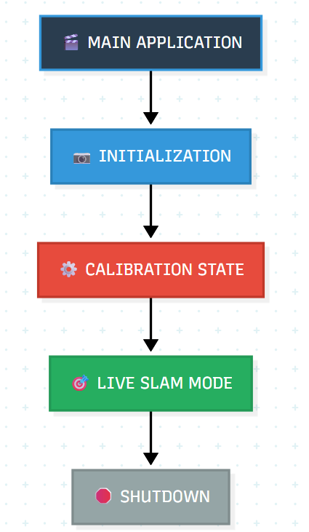 Flow Chart 1: Overall Design
This is an easy 5 step visualisation of how the program will be constructed around. First, when the application is opened, it’ll initialize, then calibrate, go onto live mode and can be closed down after.
As explained in the System Architecture Overview, the artifact has adopted a modular design. This will be shown below.
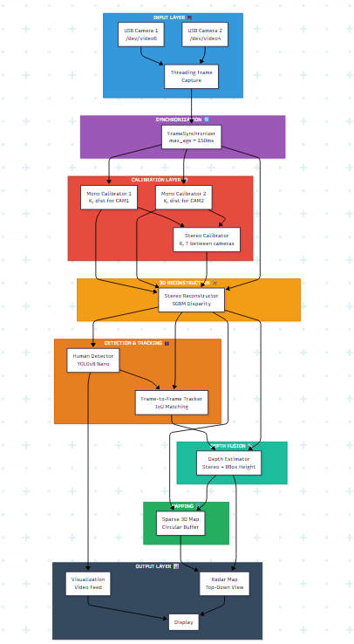Flow Chart 2: Program Flow
We’ll need to explore each section individually and then discuss the dependencies.
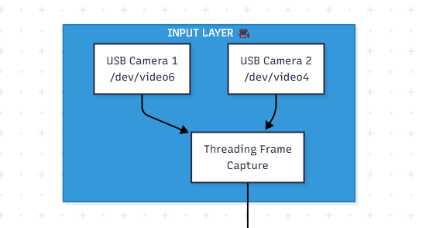
The input layer will be the 2 cameras that feed into a Threading module.

The Threading module will then feed into a synchronizer trying to match the image and rate of the two cameras.
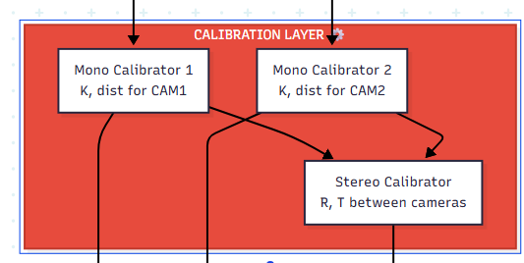
The Synchronizer then outputs into both Mono Calibrators. These Calibrators then output into a Stereo Calibrator calculating the disparity between them.

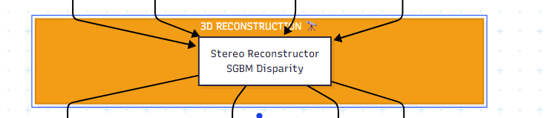
The Synchronizer and all Calibrators then feed into the Stereo reconstructor. Calculating Disparity and reconstruction the information it receives into the radar top down map.
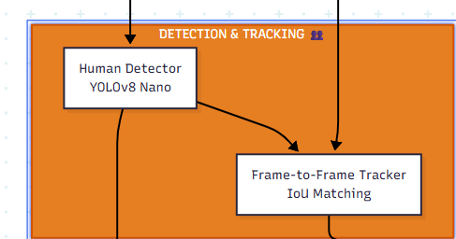
Two of these outputs get fed into the Human Detector and the Frame-to-Frame Tracker. The human detector, as the name implies, is just detecting a human and giving the bounding box information to the next stage and to the IoU matching.
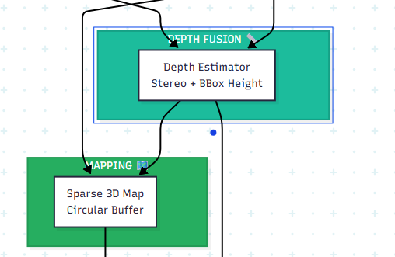
The IoU matching and the 3D constructor feed into the Depth Fusion where depth is estimated from the person. This then outputs it into a Map.
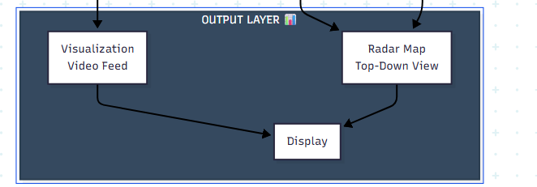
And lastly the Output layer. This is where the visualisation happens.
Here are the Dependencies for each of these Layers / modules.
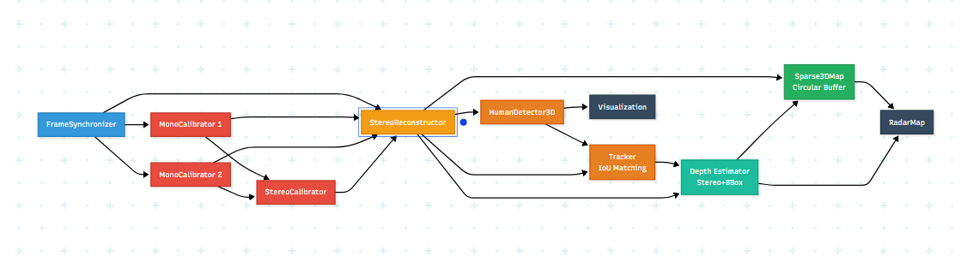Flowchart 3: Dependencies
Now we can explore the Data Flow for both the calibration and SLAM phase.
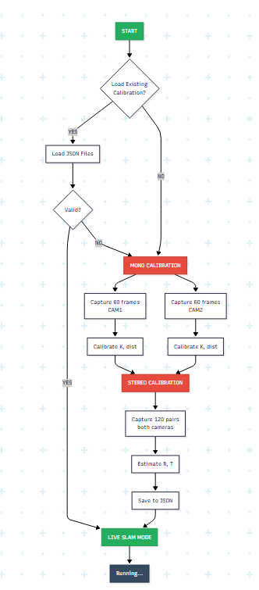
Flow Chart 4: Calibration Logic
The Flow Chart above displayed the Logic for the Calibration. We first see if there is a calibration file. If not, we start with Mono Calibration. If there is and its valid we skip to Live SLAM. After Mono calibration we go onto Stereo Calibration after which we go onto the Slam Mode.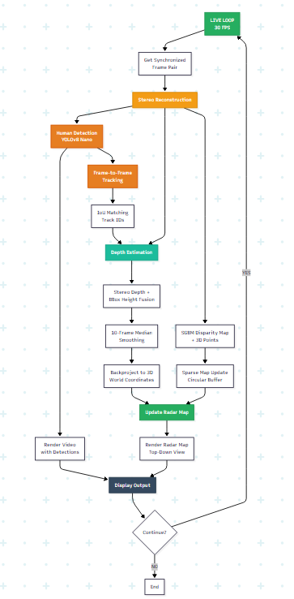Flow Chart 5: SLAM Logic
The Slam Node features a loop. We Stereo Reconstruct, Depth estimate and update the radar map, after which we update the display. We then check if we want to continue this loop or if the exit button has been pressed. If we continue we go back at the start of the loop. If not, it just Ends.
5.4 Pseudo Code
1. [Main Application Flow]
2. [Module 1: Frame Capture & Synchronization]
3. [Module 2: Calibration System]
4. [Module 3: Stereo Reconstruction]
5. [Module 4: Human Detection & 3D Tracking]
6. [Module 5: Depth Estimation & Fusion]
7. [Module 6: Sparse 3D Map]
8. [Module 7: Visualization & Radar Map]
9. [Performance Characteristics]

1. INITIALIZE CAMERAS
- Open USB Camera 1 (ID=6, /dev/video6)
- Open USB Camera 2 (ID=4, /dev/video4)
- Set resolution: 640×480
- Set frame rate: 30 FPS
- Set fourcc: MJPG
- Return: cap1, cap2 (camera objects)

2. CREATE FRAME SYNCHRONIZER
- max_age_threshold = 150ms
- Create queue for synchronized pairs

3. START READER THREADS
- Thread 1: Continuously read from cap1 → add to sync queue
- Thread 2: Continuously read from cap2 → add to sync queue
- Both threads run in background (daemon=True)

4. LOAD OR CREATE CALIBRATION
- Ask user: "Load existing calibration? (y/n)"

IF user_answer == 'yes':
- Load K1, dist1 from calib_cam1.json
- Load K2, dist2 from calib_cam2.json
- Load R, T from calib_stereo.json
- Validate: K1, K2, dist1, dist2, R, T all not None
- IF validation fails: Fall back to live calibration

ELSE:
- RUN MONO CALIBRATION (Module 2a)
* Collect 60 frames from Camera 1
* Collect 60 frames from Camera 2
* Compute K1, dist1, K2, dist2
* Save to JSON files

- RUN STEREO CALIBRATION (Module 2b)
* Collect 120 synchronized pairs
* Both cameras must see checkerboard
* Compute R, T between cameras
* Save to JSON file

5. INITIALIZE RECONSTRUCTION PIPELINE
- Create StereoReconstructor(K1, dist1, K2, dist2, R, T)
- Create HumanDetector3D(K1, baseline_m=0.1)
- Create Sparse3DMap(max_points=200k)
- Create RadarMap(size=800px, scale=0.02m/px)

6. LIVE LOOP (runs until 'q' pressed)
WHILE running:
- Get synchronized frame pair (f1, f2)

- Stereo Reconstruction (Module 3):
* Compute disparity map from (f1, f2)
* Generate 3D points from disparity
* Add to sparse map

- Human Detection (Module 4):
* Run YOLO inference on f1
* Extract bounding boxes

- Frame-to-Frame Tracking:
* Match detections to previous tracks via IoU
* Assign track IDs

- Depth Estimation (Module 5):
* For each track: estimate distance
* Use BBox height as primary source
* Smooth depth over 10-frame window
* Fuse with stereo depth (fallback)
* Backproject to 3D world coordinates

- Visualization (Module 7):
* Draw bboxes + track IDs on frame
* Render radar map with human positions
* Show disparity map
* Display FPS counter

- Check for 'q' key → EXIT

7. CLEANUP
- Stop reader threads (running = False)
- Release cameras
- Close all windows
6.0 Testing and Validation of Artefact
Test Component | Test Method | Expected Outcome | Status
Mono Calibration | Detect checkerboard patterns in 60 frames per camera | Intrinsic matrices (K) computed successfully; distortion coefficients calculated | Passed
Stereo Calibration | Detect checkerboard simultaneously in 120 stereo pairs | Rotation matrix (R) and translation vector (T) computed; baseline matches physical camera separation | passed
Stereo Reconstruction | Compute disparity map from calibrated stereo pair | Disparity map generated; 3D points extracted from valid disparities | Passed
YOLO Detection | Run human detection on video frame | Humans detected; bounding boxes drawn on screen | Passed
Frame-to-Frame Tracking | Track same human across multiple frames | Track ID remains consistent for individual humans | Passed
Sparse Map Accumulation | Render 3D point cloud over time | Points accumulate in memory-bounded buffer; no system crash | Passed
Radar Visualization | Render top-down map showing camera and human positions | Map displays correctly; human positions update in real-time | Passed
Calibration File I/O | Save calibration to JSON; load and verify | Calibration parameters persist correctly; system loads from saved files | Passed
Depth Estimation Accuracy | How close are estimated depths to ground truth? | Depth estimates within acceptable error margin (±20% or less) | Failed
Stereo Depth Performance | Does stereo matching work in textured scenes? | Stereo depth accurate in well-textured regions | Failed
BBox Height Performance | Does bounding box height estimation work in untextured scenes? | BBox height provides reasonable depth in blank/white walls | Passed
Fusion Strategy | Does fusion improve robustness? | Combined depth more reliable than single method; graceful fallback works | Failed
Human Detection Accuracy | Are detected humans correct? | Precision and recall acceptable (detects most humans, few false positives) | Passed
Detection at Range | Can the system detect humans far away? | Humans detected at reasonable indoor distances (5–8m) | Passed
Table 6: Testing and Validation
6.1 Evaluation
The system has strong calibration and detection capabilities but shows critical failures in depth estimation and sensor fusion. The core components are essential for victim localization. Calibration performance is excellent, with accurate intrinsic matrices and correctly computed stereo geometry matching physical camera separation. This provides s a solid geometric foundation for processing. Human Detection and tracking function is reliable at 5-8 meters indoors with consistent track IDs. However, quantitative metrics are missing. No precision or recall values were reported, leaving uncertainty about detection quality. Tracking was validated only through ID consistency. Detection range of 5 - 8 meters underutilizes the stereo system’s theoretical 30 meter range, suggesting either conservative thresholds or distance limitations. Stereo depth reconstruction is the most significant failure. Depth estimation failed in textured scenes, which directly contradicts the stereo matching theory and literature showing textured regions are where stereo performs best. This inverted behaviour shows severe SGBM misconfiguration. Incorrect disparity search range, matching window size, or baseline parameters might have been miscalculated. The bounding box height fallback passed testing but only on blank white walls under ideal conditions. Real indoor environments with furniture, occlusions, and varying poses were never tested.The sensor fusion strategy completely failed. The core system contribution combining the stereo and Bounding ox strength to handle all scenarios degraded or provided no improvement over individual sensors. Real-time performance remains unmeasured. No end-to-end FPS, latency profiling or memory growth analysis exists. The verdict is that this system has strong calibration and detection, but failed stereo depth reconstruction and non-functional sensor fusion making this system unsuitable for accurate victim localisation, meaning the system is not production-ready and needs heavy revising.

7.0 Reflection
The core issue of this project was the poor time management. This cascaded into scattered effort across too many approaches. Rather than systematically implementing and validating one depth estimation strategy, I attempted stereo reconstruction, bounding box height estimation, and fallback depth logic in parallel without properly debugging or validating any individual component. This resulted in three critical failures that could have been prevented. Another point to raise is that this project was supposed to be able to output a map which has been entirely neglected due to the approach chosen and had to be changed into a sparse map. The root cause was attempting to implement the "perfect" system architecture rather than following an iterative validation approach that was chosen at the start. I spent time building visualization systems, calibration persistence, and mapping infrastructure before confirming that the core depth estimation actually worked. By the time depth failures were discovered late in the project, there was no time to debug and fix the stereo matcher. A more disciplined approach would have been: implement stereo -> validate on known test cases -> fix bugs -> add BBox -> validate -> then design fallback logic.
The calibration and detection subsystems succeed precisely because they were simpler and got focused attention. Camera calibration was straightforward and completed without major issues. YOLO human detection worked immediately because it leveraged a pre-trained model requiring minimal tuning. These successes occurred when requirements were clear.
Stereo reconstruction failed catastrophically. I never systematically validated the stereo matcher against known ground truth. The SGBM implementation generated disparity maps and 3D points without throwing errors, so I assumed it was working. Only late testing revealed the stereo failed on textured scenes, which contradicts theory. The fallback depth estimation failed because I implemented bounding box height estimation without understanding why the primary stereo approach was failing or what confidence metrics to use. I attempted to use BBox as a fallback without logic for deciding when to switch from stereo or how to weight the estimates. The fallback strategy looked reasonable on paper but lacked proper implementation and validation.
The things I would've done differently are to properly space out the tasks and take my time validating each stage. Then I would validate against ground truth early with test cases and have enough time to change if things go wrong. I would've also chosen one approach and gone deep instead of stereo + BBox + fallback logic. Picking the most promising method and perfecting it would've given me much better results or a much more obvious "this doesn't work" view.
Stereo matching is not "plug and play". SGBM works well when parameters match your specific camera baseline, image resolution, and target depth range. My mistake was assuming pre-set parameters would work without tuning. Future projects will tune SGBM on known test images before testing it in production. Fallback depth estimation requires explicit switching logic and confidence thresholds. Simply using BBox height as backup without understanding when to apply it or how confident the estimates are creates worse results than relying on either stereo alone or choosing a completely different depth approach. Fallback strategies only work when each method provides confidence estimates and switching logic can select between them based on actual scene conditions.
The Key takeaways are:
- Focus
- Validate early
- Quantify
- Plan Fallbacks
- Time Allocation
8.0 Conclusion
The first hypothesis is rejected. While the system successfully uses detection and visualization components,stereo SLAM files to achieve reliable 3D mapping results. Stereo reconstruction produced invalid depth estimates and unexpectedly failed on textured scenes. The system generated 3D points without geometric validity, real-time performance was no measured on target embedded hardware leaving claims of “real-titime 3D indoor mapping” unvalidated. The second hypothesis is also rejected. This hypothesis directly contradicts the experimental results. Depth fusion failed validation testing, showing no improvement over individual methods and potentially degrading performance. The hypothesis assumed both stereo and geometric reasoning would work properly; this assumption proved false. Fusion did not provide “sufficient depth accuracy for human localisation". Lastly, the third hypothesis is only partially supported but unvalidated. Frame-to-frame tracking successfully maintained consistent track IDs without observed ID-switching. However, this hypothesis cannot be fully evaluated because position jitter measurements were not performed. The claim of “1 - 2 m position jitter" was never quantified or validated against ground truth.
The Aims were partially achieved. The system successfully implements and demonstrates autonomous human detection in real-time. However, the core component was not achieved. Stereo SLAM reconstruction failed, procuring geometrically invalid depth estimates. The system generates sparse point clouds and visualizations but cannot guarantee map accuracy or consistency. This project provides transparent documentation of design decisions, failure modes, and engineering trade-offs. The methodology clearly demonstrates the gap between academic theory and practical reality. The work transparently identifies where academic assumptions broke down when confronted with real hardware, camera baselines, and image resolutions.
9.0 References
Bailey, T. and Durrant-Whyte, H. (2006) 'Simultaneous localization and mapping (SLAM): part II', IEEE Robotics & Automation Magazine, 13(3), pp. 108-117. doi: https://doi.org/10.1109/MRA.2006.1678144
Bay, H., Tuytelaars, T. and Van Gool, L. (2006) 'SURF: Speeded up robust features', in European Conference on Computer Vision. Graz, Austria, 7-13 May. Springer, pp. 404-417. doi: https://doi.org/10.1007/11744023_32
Beni, G. and Wang, J. (1993) 'Swarm intelligence in cellular robotic systems', in Dario, P., Sandini, G. and Aebischer, P. (eds.) Robots and Biological Systems: Towards a New Bionics? Berlin: Springer-Verlag, pp. 703-712. Available at: https://doi.org/10.1007/978-3-642-58069-7_38
Dalal, N. and Triggs, B. (2005) 'Histograms of oriented gradients for human detection', in 2005 IEEE Computer Society Conference on Computer Vision and Pattern Recognition (CVPR'05). San Diego, CA, USA, 20-25 June. IEEE, pp. 886-893. doi: https://doi.org/10.1109/CVPR.2005.177
Davison, A. J., Reid, I. D., Molton, N. D. and Stasse, O. (2007) 'MonoSLAM: Real-time single camera SLAM', IEEE Transactions on Pattern Analysis and Machine Intelligence, 29(6), pp. 1052-1067. doi: https://doi.org/10.1109/TPAMI.2007.1049
Dellaert, F. and Kaess, M. (2006) 'Square Root SAM: Simultaneous localization and mapping via square root information smoothing', The International Journal of Robotics Research, 25(12), pp. 1181-1203. doi: https://doi.org/10.1177/0278364906072768
Diller, E., Zhuang, J., Lum, G.Z., Edwards, M.R. and Sitti, M. (2014) 'Coordination and control of multiple microrobots in manipulation and microassembly tasks', IEEE Transactions on Robotics, 30(3), pp. 639-657. Available at: https://doi.org/10.1109/TRO.2013.2291615
Dosovitskiy A., et al., "FlowNet: Learning Optical Flow with Convolutional Networks," 2015 IEEE International Conference on Computer Vision (ICCV), Santiago, Chile, 2015, pp. 2758-2766, doi: 10.1109/ICCV.2015.316
Durrant-Whyte, H. and Bailey, T. (2006) 'Simultaneous localization and mapping: part I', IEEE Robotics & Automation Magazine, 13(2), pp. 99-110. doi: https://doi.org/10.1109/MRA.2006.1638022
Engel, J., Schöps, T. and Cremers, D. (2014) 'LSD-SLAM: Large-scale direct monocular SLAM', in European Conference on Computer Vision. Zurich, Switzerland, 6-12 September. Springer, pp. 834-849. doi: https://doi.org/10.1007/978-3-319-10605-2_54
Falanga, D., Kleber, K. and Scaramuzza, D. (2020) 'Multi-sensor fusion for robust autonomous flight in indoor and outdoor environments with a rotorcraft MAV', in Proceedings of the IEEE International Conference on Robotics and Automation (ICRA). Paris, France, 31 May - 31 August 2020, pp. 4974-4980. Available at: https://doi.org/10.1109/ICRA40945.2020.9196675
Felzenszwalb, P. F., Girshick, R. B., McAllester, D. and Ramanan, D. (2010) 'Object detection with discriminatively trained part-based models', IEEE Transactions on Pattern Analysis and Machine Intelligence, 32(9), pp. 1627-1645. doi: https://doi.org/10.1109/TPAMI.2009.167
Fragkiadaki, K., Arbeláez, P., Felsen, P., & Malik, J. (2015). "Learning to Segment Moving Objects in Videos." IEEE Conference on Computer Vision and Pattern Recognition (CVPR), 4083-4090
Girshick, R., Donahue, J., Darrell, T. and Malik, J. (2014) 'Rich feature hierarchies for accurate object detection and semantic segmentation', in Proceedings of the IEEE Conference on Computer Vision and Pattern Recognition. Columbus, OH, USA, 23-28 June. IEEE, pp. 580-587. doi: https://doi.org/10.1109/CVPR.2014.81
Grisetti, G., Kümmerle, R., Stachniss, C. and Burgard, W. (2010) 'A tutorial on graph-based SLAM', IEEE Intelligent Transportation Systems Magazine, 2(4), pp. 31-43. doi: https://doi.org/10.1109/MITS.2010.939925
Gonzalez, R. C., & Woods, R. E. (2018). "Digital Image Processing" (4th ed.). Pearson
He, K., Zhang, X., Ren, S. and Sun, J. (2016) 'Deep residual learning for image recognition', in Proceedings of the IEEE Conference on Computer Vision and Pattern Recognition. Las Vegas, NV, USA, 27-30 June. IEEE, pp. 770-778. doi: https://doi.org/10.1109/CVPR.2016.90
Hirschmuller H., "Stereo Processing by Semiglobal Matching and Mutual Information," in IEEE Transactions on Pattern Analysis and Machine Intelligence, vol. 30, no. 2, pp. 328-341, Feb. 2008, doi: 10.1109/TPAMI.2007.1166.
Howard, A. G., Zhu, M., Chen, B., Kalenichenko, D., Wang, W., Weyand, T., Andreetto, M. and Adam, H. (2017) 'MobileNets: Efficient convolutional neural networks for mobile vision applications', arXiv preprint arXiv: 1704.04861. Available at: https://arxiv.org/pdf/1704.04861.pdf
Huang, J., Rathod, V., Sun, C., Zhu, M., Korattikara, A., Fiedel, A., ... & Murphy, K. (2017). "Speed/accuracy trade-offs for modern convolutional object detectors." IEEE Conference on Computer Vision and Pattern Recognition (CVPR), 7310-7311
Kaess, M., Ranganathan, A. and Dellaert, F. (2008) 'iSAM: Incremental smoothing and mapping', IEEE Transactions on Robotics, 24(6), pp. 1365-1378. doi: https://doi.org/10.1109/TRO.2008.2006706
Konolige, K. (2001). "Small Vision Systems: Hardware and Implementation." Proceedings of the 8th International Symposium on Robotics Research (ISRR).
Krizhevsky, A., Sutskever, I. and Hinton, G. E. (2017) 'ImageNet classification with deep convolutional neural networks', Communications of the ACM, 60(6), pp. 84-90. doi: https://doi.org/10.1145/3065386
Kümmerle, R., Grisetti, G., Strasdat, H., Konolige, K. and Burgard, W. (2011) 'g2o: A general framework for graph optimization', in 2011 IEEE International Conference on Robotics and Automation. Shanghai, China, 9-13 May. IEEE, pp. 3607-3613. doi: https://doi.org/10.1109/ICRA.2011.5979949
Lin, T. Y., Goyal, P., Girshick, R., He, K. and Dollár, P. (2017) 'Focal loss for dense object detection', in Proceedings of the IEEE International Conference on Computer Vision. Venice, Italy, 22-29 October. IEEE, pp. 2980-2988. doi: https://doi.org/10.1109/ICCV.2017.324
Liu, W., Anguelov, D., Erhan, D., Szegedy, C., Reed, S., Fu, C. Y. and Berg, A. C. (2016) 'SSD: Single shot multibox detector', in European Conference on Computer Vision. Amsterdam, Netherlands, 11-14 October. Springer, pp. 21-37. doi: https://doi.org/10.1007/978-3-319-46448-0_2
Montemerlo, M., Thrun, S., Koller, D. and Wegbreit, B. (2002) 'FastSLAM: A factored solution to the simultaneous localization and mapping problem', in Proceedings of the AAAI National Conference on Artificial Intelligence. Edmonton, Canada, 28 July - 1 August. AAAI Press, pp. 593-598. Available at: https://www.aaai.org/Papers/AAAI/2002/AAAI02-089.pdf
Moravec, H. and Elfes, A. (1985) 'High resolution maps from wide angle sonar', in Proceedings of the 1985 IEEE International Conference on Robotics and Automation. St. Louis, MO, USA, 25-28 March. IEEE, pp. 116-121. doi: https://doi.org/10.1109/ROBOT.1985.1087316
Mur-Artal, R., Montiel, J. M. M. and Tardos, J. D. (2015) 'ORB-SLAM: a versatile and accurate monocular SLAM system', IEEE Transactions on Robotics, 31(5), pp. 1147-1163. doi: https://doi.org/10.1109/TRO.2015.2463671
Redmon, J., Divvala, S., Girshick, R. and Farhadi, A. (2016) 'You only look once: Unified, real-time object detection', in Proceedings of the IEEE Conference on Computer Vision and Pattern Recognition. Las Vegas, NV, USA, 27-30 June. IEEE, pp. 779-788. doi: https://doi.org/10.1109/CVPR.2016.91
Redmon, J., & Farhadi, A. (2018). "YOLOv3: An Incremental Improvement." arXiv preprint arXiv:1804.02767
Ren, S., He, K., Girshick, R., & Sun, J. (2015). "Faster R-CNN: Towards Real-Time Object Detection with Region Proposal Networks." Advances in Neural Information Processing Systems (NIPS), 91-99
Ren, S., He, K., Girshick, R. and Sun, J. (2017) 'Faster R-CNN: Towards real-time object detection with region proposal networks', IEEE Transactions on Pattern Analysis and Machine Intelligence, 39(6), pp. 1137-1149. doi: https://doi.org/10.1109/TPAMI.2016.2577031
Rublee, E., Rabaud, V., Konolige, K. and Bradski, G. (2011) 'ORB: An efficient alternative to SIFT or SURF', in 2011 International Conference on Computer Vision. Barcelona, Spain, 6-13 November. IEEE, pp. 2564-2571. doi: https://doi.org/10.1109/ICCV.2011.6126544
Sandler, M., Howard, A., Zhu, M., Zhmoginov, A., & Chen, L. C. (2018). "MobileNetV2: Inverted Residuals and Linear Bottlenecks." IEEE/CVF Conference on Computer Vision and Pattern Recognition (CVPR), 4510-4520
Simonyan, K. and Zisserman, A. (2015) 'Very deep convolutional networks for large-scale image recognition', in 3rd International Conference on Learning Representations (ICLR 2015). San Diego, CA, USA, 7-9 May. Available at: https://arxiv.org/pdf/1409.1556.pdf
Smith, R., Self, M. and Cheeseman, P. (1990) 'Estimating uncertain spatial relationships in robotics', in Cox, I. J. and Wilfong, G. T. (eds.) Autonomous Robot Vehicles. New York: Springer-Verlag, pp. 167-193. doi: https://doi.org/10.1007/978-1-4613-8997-2_14
Strasdat, H., Montiel, J. M. M. and Davison, A. J. (2012) 'Visual SLAM: Why filter?', Image and Vision Computing, 30(2), pp. 65-77. doi: https://doi.org/10.1016/j.imavis.2012.02.009
Szegedy, C., Liu, W., Jia, Y., Sermanet, P., Reed, S., Anguelov, D., Erhan, D., Vanhoucke, V. and Rabinovich, A. (2015) 'Going deeper with convolutions', in Proceedings of the IEEE Conference on Computer Vision and Pattern Recognition. Boston, MA, USA, 7-12 June. IEEE, pp. 1-9. doi: https://doi.org/10.1109/CVPR.2015.7298594
Szeliski, R. (2010) Computer Vision: Algorithms and Applications. London: Springer-Verlag. doi: https://doi.org/10.1007/978-1-84882-935-0
Thrun, S., Burgard, W. and Fox, D. (2000) 'A real-time algorithm for mobile robot mapping with applications to multi-robot and 3D mapping', in Proceedings 2000 ICRA. Millennium Conference. IEEE International Conference on Robotics and Automation. San Francisco, CA, USA, 24-28 April. IEEE, vol. 1, pp. 321-328. doi: https://doi.org/10.1109/ROBOT.2000.844077
Thrun, S., Burgard, W. and Fox, D. (2005) Probabilistic Robotics. Cambridge, MA: MIT Press. ISBN: 978-0262201629.
Tosi F. et al., "Neural Disparity Refinement," in IEEE Transactions on Pattern Analysis and Machine Intelligence, vol. 46, no. 12, pp. 8900-8917, Dec. 2024, doi: 10.1109/TPAMI.2024.3411292
Triggs, B., McLauchlan, P. F., Hartley, R. I. and Fitzgibbon, A. W. (2000) 'Bundle adjustment - a modern synthesis', in Triggs, B., Zisserman, A. and Szeliski, R. (eds.) Vision Algorithms: Theory and Practice. Corfu, Greece, 21-22 September. Springer, pp. 298-372. doi: https://doi.org/10.1007/3-540-44480-7_21
Viola, P. and Jones, M. (2001) 'Rapid object detection using a boosted cascade of simple features', in Proceedings of the 2001 IEEE Computer Society Conference on Computer Vision and Pattern Recognition. Kauai, HI, USA, 8-14 December. IEEE, vol. 1, pp. I-511-I-518. doi: https://doi.org/10.1109/CVPR.2001.990517
Welch, G., & Bishop, G. (1995). "An Introduction to the Kalman Filter." University of North Carolina at Chapel Hill, TR 95-041

