Learning Theories

Behaviourism

Summary
Behaviourism is primarily interested in observable and measurable metrics of human behaviour, and how stimuli affects behaviour. Behaviourists are far more interested in physical behaviour and are less interested in thought or emotions, which are separate fields of study. Behaviourism was first posed by John B. Watson, who believed that human behaviour resulted from specific stimuli that caused a response.

B.F. Skinner developed these ideas with his theories of operant conditioning. Operant Conditioning is a method of behaviourism based around rewarding desired behaviour and punishing undesired behaviour. Similar to classical conditioning posed by Ivan Pavlov and his dogs. He concluded that rewarded behaviours are more likely to be repeated and that behaviours with negative consequences cease over time.

Contracts: Behavioural contracts are decided between educator and pupil, they set out the terms of how each will behave in order to assist the other
e.g. Should a pupil be routinely late, the Pupil and teacher will have a discussion and form a contract such as The Student will try to be punctual, while a teacher could say that if the student is not late then they will avoid detention.

The Teachers terms in this case is an example of negative reinforcements

Methods(definitions and in practice examples in games)

Positive reinforcement: is the practice of presenting stimulus that increases the likelihood of a desired response
- Rewarding a player in a skating game with bonus points if they do cool moves
- Rewarding a player with a kill streak if they can eliminate other players
- If the player fully explores an area they get cool items

Negative reinforcement: Is the Practice of removing an unpleasant consequence if the subject exhibits the desired behaviour
- If the Player Dodges in time they avoid damage
- If the player refrains from breaking the law the guards aren't called
- If the player avoids detection the enemies don’t get alerted

Punishment: Is the practice of presenting a strong stimuli that decreases the likelihood of an undesired behaviour. There are both negative and positive punishments
- Killing the player if they fall off a tall building - Negative
- Alerting the guards if the player is discovered - Positive
- Lose points for not completing objectives - Negative

Extinction: Decreasing the probability of an action be removing the previously reinforced stimuli
- Removing a bug from a game that allowed the player to exploit a certain area
- Removing bushes and foliage so players don’t camp so much
- Blocking access to the enemy players spawn so players can’t kill them as they spawn

Modeling - Observational Learning, if a pupil sees a behaviour they may end up replicating it by learning it from their peers

Shaping - Gradually increasing the requirements to earn rewards, to cause learners to grow and develop

Cueing - Introducing a verbal or non verbal cue before a behaviour should be carried out ie. a student must raise their hand before asking a question

Behaviour Modification
Behaviour Modification has 6 basic components
- Specification, Laying out the problem and how it will be measured
- Development of a positive, nurturing environment, removing negative stimuli from the learning environment
- Identification of appropriate reinforcers
- Reinforcement of behaviour
- Reduction in frequency of rewards
- Evaluation of the effectiveness of the approaches

Pros of Behaviourism
- Centred around physical behaviour and so helps to build new positive behaviour
- Non invasive of the pupils internal state, avoids pushing blame onto the subject but rather onto their environment which can cause tension
- In most use cases it is effective in tackling issues, if people are rewarded for what they do they are more likely to do it

Cons of Beviourism
- Doesn’t account for the internal state of Pupils, perhaps instead of stimuli causing a student to misbehave it could be due to their thinking behaviour. A student who is predisproposed to anger due anger management issues is unlikely to be as receptive to positive and negative stimuli. A heightened emotional state can cloud better judgement and interfere with learned behaviour
- Can cause tension with people around the student if the educator is not careful, in analysing why a student might act the way they do, the educator must be careful not to put the blame on others
- Conditioning can not be applied to everyone, some are far more or less receptive to it than others.

Conclusion
Ultimately behaviourism seems like a solid and fundamentally effective form of education however it is not without its flaws. It should absolutely be applied in conjunction with analysis of the internal state of the subject in the education field. As for wider implications in my project it is important to me that I follow the principles of reinforcement, Punishment and extinction to tackle managing player behaviour and helping them learn, however it is important for me to understand that not all players will respond to stimuli in the same way, where some will react with enthusiasm for learning others will simply feel frustrated. This is apparent in games like dark souls for example where some will thrive in their in game deaths learning the ins and outs of the systems while others will meet every death with a level of frustration which can not be discounted.

Cognitivism
Cognitivism is a theory of learning based around the internal processes of the learner, and how they process and develop their understanding of a problem. Cognitivism in practice is all about thinking, reflecting and problem solving using prior knowledge. Instead of stressing repetition or memorisation, cognitivism instead strives for students to come to their own conclusions through what they have learned.

Guiding Principles of cognitivism:
- Learning should be well structured and focused with clear targets to reach and relevant exercises
- Self Directed learning is vital for student development, allowing them to take ownership of their learning
- Students should learn through analysing and questioning knowledge, not just from gathering information
- Constructing diagrams aid students in forming a mental model that aids understanding
- Encoding information into long-term memory is strengthened when content is chunked, revisited, and connected across lessons. - Information should be segmented, revisited and interlinked with other topics to truly commit to long term memory

Differences between Cognitivism and Behaviourism:

Behaviourism holds that Associating stimuli and responses lead to new behaviours forming while cognitivism stresses the Learner processing the information they receive and seeking ways to understand it related to prior knowledge with memory.

Reflection:
Cognitivism is an intriguing learning theory about building from a foundation through reasoning and problem solving. It also pertains to stages 3-6 of bloom taxonomy through it encouraging analysis and synthesis based upon what the student has learned, as a result my project will likely only broach on the more simplistic stages of cognitivism, as it will be difficult for the game to truly test their analysis skills. However simplistic problem solving based on the previously acquired language knowledge in the game along with some grammar based learning from the users own language, will certainly mean I will be implementing elements of Cognitivism

Constructivism
Constructivism follows similar principles to cognitivism stressing the importance of problem solving and evaluations, however where the two differ most prominently is the emphasis constructivism places on prior knowledge and experiences. The Theory holds that a learner's environment has a large impact on how the learner receives and processes information, though it does not prevent them in the sharing of the common knowledge. People's learning is shaped by their context and this contextual learning in turn shapes the learner causing them to update their personal “map” of the world. With every meaningful interaction a learner refines and reorganises their own mental model actively constructing their own understanding of reality.
More than a specific learning theory, constructivism is a dissection of how we learn and how that learning affects us based on our environment and context

Types of Constructivism

Cognitive Constructivism
Cognitive constructivism says that knowledge is created by learners based on their existing knowledge base. Therefore their learning is relative to their stage of cognitive development

Social Constructivism
Social Constructivism says that learning is a collaborative process, and knowledge is developed through an individual's interaction with culture and society

Radical Constructivism
Radical Constructivism states that all knowledge is created rather than perceived by an individual. Learners construct new knowledge on the foundations of existing knowledge. Radical constructivism believes that the knowledge individuals form is independent of reality and only helps to function in their environment. It also argues that objective reality is inaccessible and knowledge can only be understood through the lens of the individual's subjective interpretation of their experiences. It asserts that individuals hold their own interpretations of reality and that their knowledge is always incomplete and subjective.

Constructivism in teaching
Constructivism in learning emphasizes active learning, collaboration between learners and breaking down a problem from multiple perspectives, reflection and assessment.

Reflections
Constructivism is a theory that focuses on the environment of the student and how that interacts with them building their knowledge based, Unfortunately, I Believe that this means that it will be difficult to implement into my game loop due to the fact that there is no chance for open endedness or collaboration in my project, due to the fact it is a singleplayer experience, so learning must be done purely by the player

Discovery Learning
Discovery learning is a subset of Cognitive principles that emphasize that students learn far more effectively and retain information for longer when they discover knowledge and the relationship between information for themselves. In essence, discovery learning encapsulates methods of self directed learning and steps away from traditional instruction based approaches.For example, instead of telling a student how an experiment will turn out, it is up to the students to gather their own data and come to their own conclusions about the outcome.

In discovery learning, learning is an active process that demands learner engagement and participation. It is most effective when the learning is relative to the learner's life and interests and can be enhanced through problem solving and critical thinking. The very act of conducting this research is in essence, Discovery Learning. I, the researcher, was given the task of studying these learning behavioural theories and through that I have built my own understanding. Discovery learning is student centred in nature, with the educator taking on a guiding role, pushing the student in the correct direction, without merely transmitting knowledge

Discovery learning has a myriad benefits, as it lets the learner independently come to their own conclusions and enhances the motivation to learn. The Students will engage deeper with the material leading to an enhanced understanding of the concepts. It also promotes autonomy and self direction, aiding in maturing the student and giving them confidence in their own learning abilities.

However its open ended nature can cause issues for some, Even if the material fits their interests students can find it difficult to process the open ended nature of the task before them, feeling overwhelmed by the free nature. It can also lead to incorrect conclusions should proper guidance not be given. Some students will require more structured guidance and so it is not a one size fits all method of learning, It can also be a lot more time consuming, and so in some cases can’t be applied in timer constrained environments. It also puts more stress on the educator as they themselves must be able to be well versed on the field so that they can properly guide their student. And gauging a student's progress through such an environment can be difficult as their learning will be unique to them.

Reflection
Discovery based learning as a whole is something I wish to broach with the players of my game, especially when it comes to the puzzles, the player will need to find out for themselves how to solve the puzzle and how their previous knowledge will be able to be applied to allow them to progress. Due to the nature of the game specific guidance will be limited, and so discovery learning will have to naturally be implemented so that the players can come to their own conclusions but having some form of hint system could be important for giving players assistance

Humanism
Humanistic learning theory places the learners individual growth and wellbeing at the centre, focusing on the Affective domain. Ego and self respect, motivation and attitude, curiosity and values and mental health are all at the core of humanism.

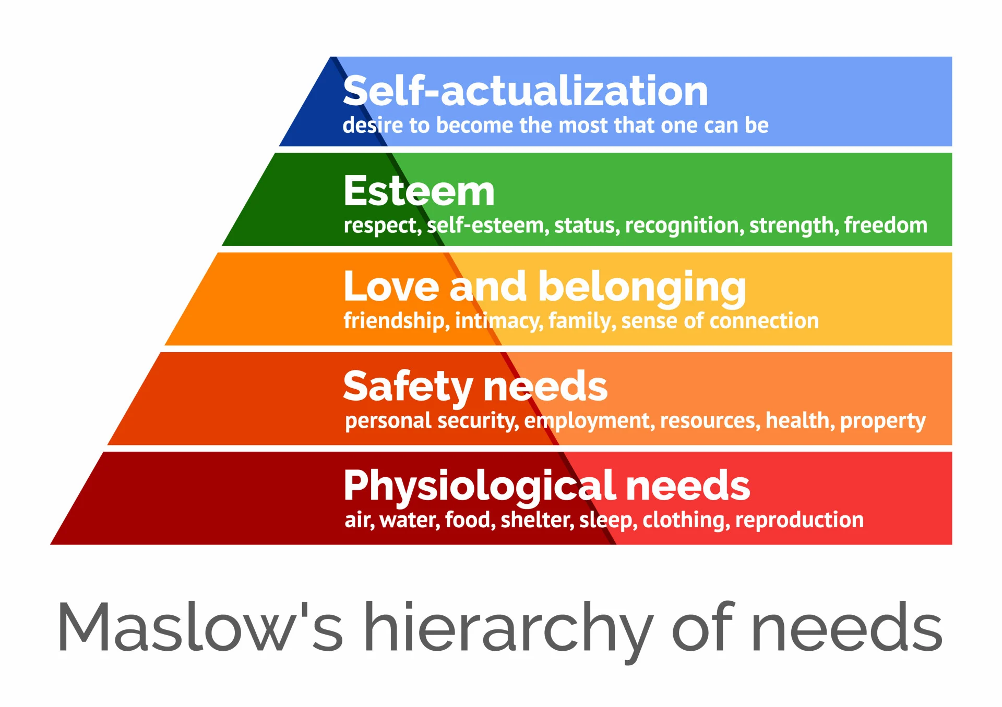
Part of humanism is Maslow's hierarchy of needs which proposes that self actualisation can only be achieved once a learner's basic needs are met.Humanism places the learner directly in the driving seat, championing freedom choice and learner autonomy. This means the learner decides what they need to learn, how they will learn and what to use to learn.
Key Assumptions of Humanistic Learning theory
- Learners can be trusted to find their own goals and should choose what they learn at school (and beyond).
- Learners should set their standards and evaluate their work and progress themselves.
- Learning experiences should help learners to develop positive relations with their peers.

Humanism focuses on teaching students as a whole, not just teaching skills, but nurturing minds and emotional growth. It puts heavy emphasis on maintaining a students emotional wellbeing and teaching students in a way that best suits them

The Role of the Learner in Humanism, is to self direct their own study, by choosing what needs to be done when and how. For their own personal growth a student under humanism could attend lectures, read articles, undertake practical activities or much.

The Role of an educator in Humanism, is that of a guide. Helping the students meet their own goals and learning targets. Instead of supplying informations, a Humanistic educator should provide guidance on how to learn that information, and allow students to use their knowledge in relevant and useful contexts.

Strengths | Weakness
Inherent Positivity | Lack of structure
Stresses inner belief | No Guidance
Considers emotional Impact | Too Much Choice
Holistic learning | Different outcomes for each student
Self-fulfillment

Reflection
Humanism is a fascinating approach to learning that places learners at the helm of knowledge gathering, focusing on a much wider approach that caters to the needs of the student. Unfortunately due to its unstructured free form nature, it is not fit for my purposes as self directed study is difficult to implement into a game setting without a certain level of procedural generation that will not be present in my game. The Confines of current games overall is unlikely to allow a humanistic education based game As of yet.

Blooms Taxonomy -

Summary
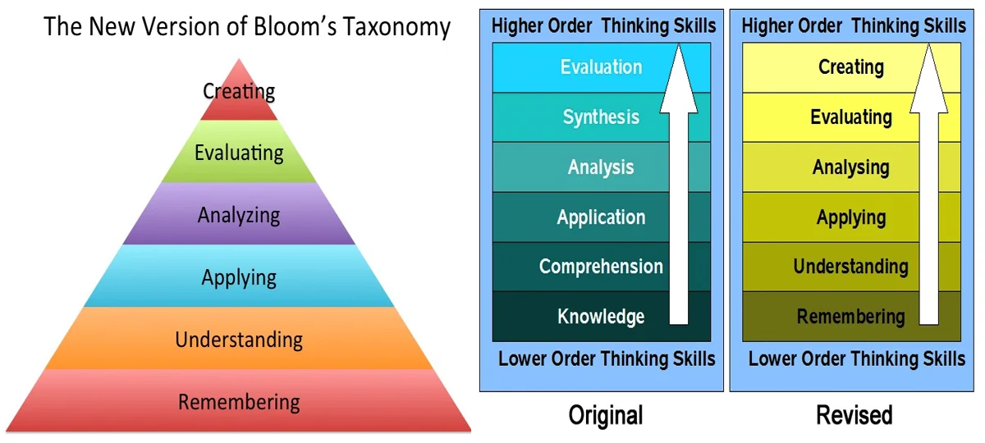
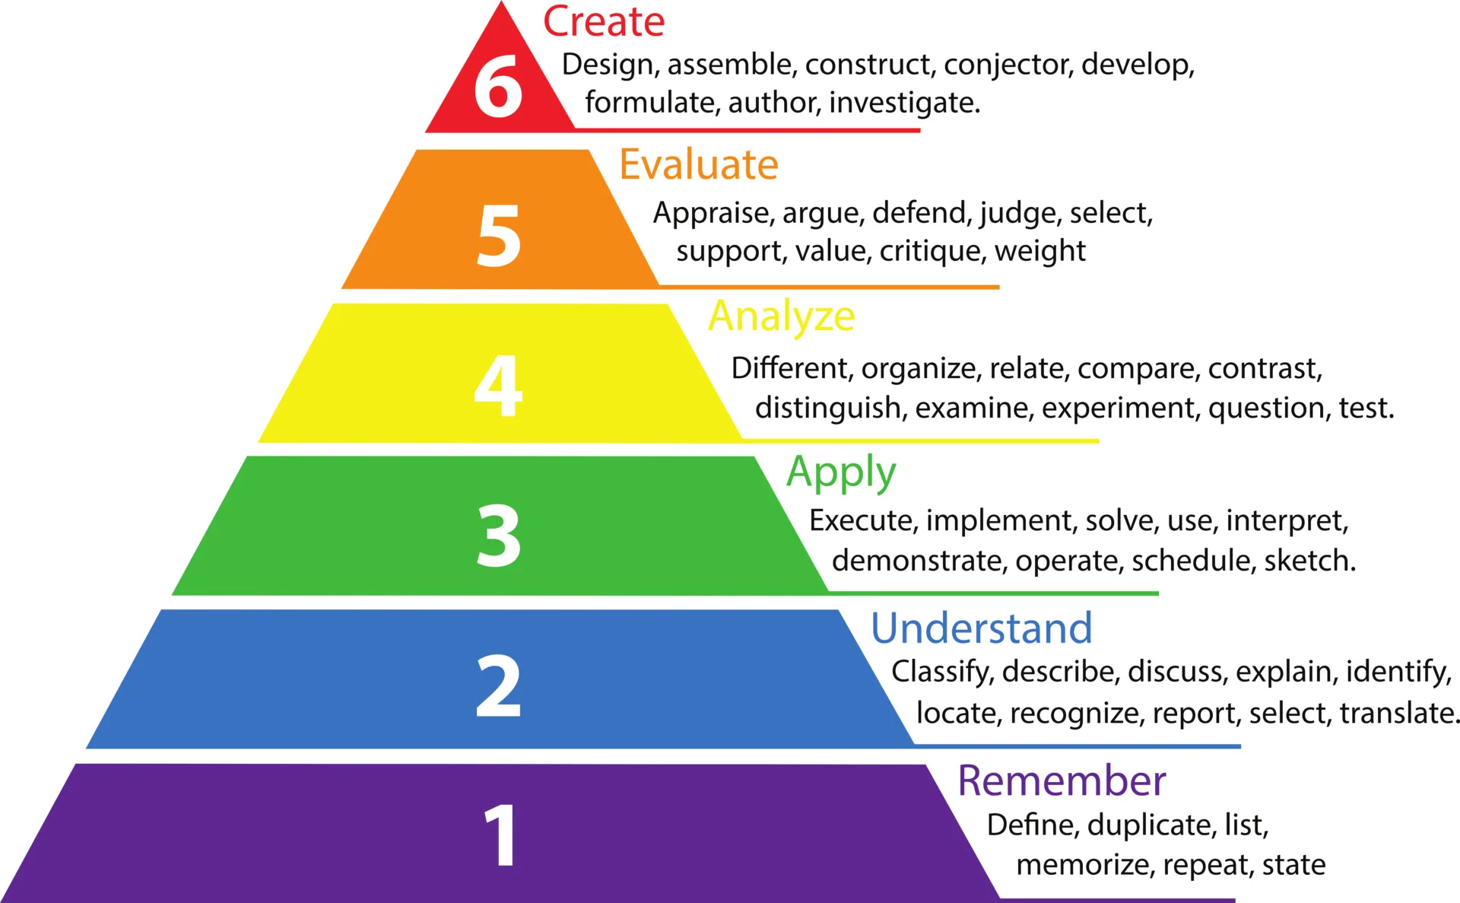

Created in 1956 by Dr Benjamin Bloom in order to promote higher forms of thinking in education. It is a framework for designing lesson objectives, learning goals beyond just remembering facts (rote learning), promoting evaluation of one's own knowledge in order to fabricate new and interesting ideas. Bloom's taxonomy represents a school of thought that education should facilitate development of any given field, something which is a target of many higher education courses. Education at its height should push what's known to the limits and discover deeper understanding. Bloom's taxonomy has developed with a new variant published in 2001 beyond the initial version, changing from each stage being defined by nouns to verbs, and switching the 2 final stages.

Bloom identified three domains of educational activities or learning:
- Cognitive domain: mental skills (knowledge)
- Psychomotor Domain: manual or physical skills (skills)
- Affective domain: growth in feelings or emotional areas (attitude)

My Game will be focused on developing the cognitive domain rather than the other 2

Reflection
Bloom's taxonomy represents a useful framework through which I will try to design my language learning system. As with most language learning programs it will be largely focused on the first three stages, Remembering, Understanding, Applying, however as a stretch goal I would like to encourage at least the 4th stage of Analyzing, urging the players to play around with what they know to progress. I partially agree with some critics that while the first 3 stages are in the correct order, the hierarchy of the top 3 can become muddled and learners should ideally float between the analysing, evaluating and creation stages, in my opinion it is hard to put them in a satisfying hierarchy.

Research Reflection
Through my research into Behaviourism, Cognitivism, Constructivism, Discovery Learning, Humanism and Bloom's Taxonomy, I have delved deep into the theory of education and pedagogy. This has led me to believe that certain theories are more relevant to my Project than others. While Constructivism, Discovery Learning, Humanism and the Higher tiers of Bloom's taxonomy are all vital learning theories, in practice they are not fit for purpose for the project I will be producing, unfortunately deeply analysing, evaluating and Synthesising will be difficult to implement in an effective way, especially since my game is aiming to mostly focus on Problem solving with what they know rather than breaking down what they know to deepen their understanding. These 4 theories also place a lot of emphasis on free form development directed by the user which is something that will likely not be feasible. The Users of my game will require direction.

In contrast, my understanding of other learning theories, (Behaviourism, Cognitivism and the Lower stages of Bloom's Taxonomy [Remembering, Understanding, Applying and Some Analysing]) will all be vital in how I approach the development of my artifact. Implementing stimuli to motivate the player and problem solving to develop understanding will be at the core of my gameplay loop, the character should progress and get stronger as they get more proficient with the learning in order to reward the player and complete the feel of the gameplay loop.

Thought Point: Experiment with whether those higher levels of Bloom taxonomy are being met organically. Check the areas where users start to build their own knowledge, lean more into that

Game Theories

Types of Game Mechanics
Five Different Types of Mechanics
The term mechanics has come to indicate many different types of underlying relationships between entities in games. Here are five different types of mechanics that you might expect to find in a game:

• Physics. Game mechanics sometimes define physics—the science of motion and force—in the game world (which can be different from the physics of the real world). In games, characters commonly move from place to place, jump up and down, or drive vehicles. Computing a game element’s position, the direction in which it is moving, and whether it intersects or collides with other elements makes up the bulk of the calculations in many games. Physics plays a large role in many modern games, from ultrarealistic first-person shooters to the popular physics-puzzle games such as Angry Birds. The implementation is seldom strict; however, games with so-called cartoon physics use a modified version of Newtonian mechanics so that characters can do non-Newtonian things such as change direction while in midair. (We also consider such things as timing and rhythm challenges to be part of a game’s physics.)

• Internal economy. The mechanics of transactions involving game elements that are collected, consumed, and traded constitute a game’s internal economy. The internal economy of a game typically encompasses items easily identified as resources: money, energy, ammunition, and so on. However, a game’s economy is not limited to concrete, tangible items; it can also include abstractions such as health, popularity, and magical power. In any Zelda game, Link’s hearts—a visible measure of his life energy—are part of the internal economy. Skill points and other quantified abilities in many role-playing games also qualify; these games have very complex internal economies.

• Progression mechanisms. In many games, level design dictates how a player can move through the game world. Traditionally, the player’s avatar needs to get to a particular place to rescue someone or to defeat the main evil-doer and complete the level. In this type of game, the progress of the player is tightly controlled by a number of mechanisms that block or unlock access to certain areas. Levers, switches, and magical swords that allow you to destroy certain doors are typical examples of such progression mechanisms.

• Tactical maneuvering. Games can have mechanics that deal with the placement of game units on a map for offensive or defensive advantages. Tactical maneuvering is critical in most strategy games but also features in some role-playing and simulation games. The mechanics that govern tactical maneuvering typically specify what strategic advantages each type of unit may gain from being in each possible location. Many games restrict the location of units to discrete tiles, as is the case for a classic board game like chess. Even modern strategy games played on the computer often implement tiles, although they do a good job of hiding them behind a detailed visual layer. Tactical maneuvering appears in many board games such as chess and Go but also in computer strategy games such as StarCraft or Command & Conquer: Red Alert.

• Social interaction. Until recently, most video games did not govern social interaction among the players, apart from prohibiting collusion or requiring that players keep certain knowledge secret. Now, however, many online games include mechanics that reward giving gifts, inviting new friends to join, and participating in other social interactions. In addition, role-playing games might have rules that govern the play-acting of a character, and a strategy game might include rules that govern the forming and breaking of alliances between players. Board games and folk games played by children have a longer history of game mechanisms that guide the interactions among players.

Bartles Player Types

Game Inspirations
- Mage Arena
  - Voice controlled Mage FPS
  - Users use their voice to Cast spells and kill the enemy
- YapYap
  - Voice controlled Mage style horror co-op game
  - You are a minion of a wizard, who sends you into a rivals wizard tower in order to sabotage them while avoiding the wizards guardians
- Lethal Company
  - Horror co-op game with voice recognition elements
  - Certain enemies in the game react to your voice such as the blind dogs which react to any noise you make
- Noun Town Language Learning
  - Language Learning puzzle Game

Inspirations other than games
- Duolingo
  - Language Learning app, which implements a behaviourist approach to learning, rewarding success with progress and xp and punishing failure with losing hearts and failing the question
  - Also Implements elements of blooms Taxonomy (stages 1 - 3) helping users

