Comic UI Project
By Lily Page

Design Justification
Health Bar
For the health bar, I made a heart-based health system. The health is made up of 5 hearts or 10 15 hit points. It has 3 states, Full, Half/Cracked and Empty. When you get below or have 2 hearts remaining the bar will shake and an opaque red vignette will appear around the edge of the screen. It also has a sound effect of heart beating when you lose and gain hearts.
The health bar creates multimodal feedback through its animations and sound effects, when you heal or lose health the hearts shake from left to right, scale up and then down again. When the player loses a heart, they get confirmatory feedback of through the heart becoming either cracked or empty. Loosing or gaining a heart is exaggerated to make it clear of the state change, allowing players to focus on gameplay rather than having to constantly look at their heath. This creates focus of attention. The health bar creates harmony with the rest of UI as it’s in the same art style and the border follows the same design as the stamina bar.
I chose to use the same dot’s pattern across all my widgets so they would be cohesive and have a comic style. The loss and gain of hearts happen when you walk up enemies as you take damage. The gain of hearts happens when you press 1 and use the heal ability. This creates relevant feedback.
Stamina Bar
The stamina bar creates feedback in its actions, when you press shift, you run faster and the bar decreases. This creates thematic coherence by making the player run around the map at a faster speed than walking normally. The feedback from the bar decreasing creates feedback coherence as the when the bar is empty or close to empty, it shakes, flashes red and the background of the progress bar turns grey. Which in contrast to the bar’s original bright blue, shows the player the bar’s state has changed and it needs their attention. This tells them bar is about to run out and they will stop sprinting. Thus, creating exaggeration and focus of attention.
The art of the bar is in the same style as the rest of the widgets; this makes visual harmony and ambient feedback between the systems and makes the HUD look polished. The bar is unambiguous as it links only to the sprint function and the dash. These both drain the bar and link to the stamina, so it can’t be interpreted any other way. The bright blue I used for the bar fill is also used in the dash icon; this is so the player knows they are similar and have the same uses. This creates gameplay coherence.

Ability Bar
The ability bar is made up of 4 abilities; these are triggered through pressing numbers 1-4 on the keyboard. The controls presented on the bar shows how the player triggers them. This gives the player confirmatory feedback. When an ability is triggered, an animation starts on said slot. The slot rises and the icon inside expands, drains (it works on a progress bar), scales back down and then the slot lowers back to its original spot on the bar. This confirms to the player it’s been used, giving confirmatory feedback, relevance and supplementary feedback. When an ability is triggered animations and mechanics happen as a result, they all do different things, but the icon and result make them relevant to each other.
The animation allows the player to know which ability they’ve used easily as it’s exaggerated and calls the players focus. It’s not subtle and due to where it is the screen, the player will always be able to see it. The bar creates visual harmony as it uses the same style as the health and stamina bar. It uses bright colours to emulate a comic style and to draw the players attention to it. I chose to use the primary colours for each ability as they fit with the overall theme. I thought they would pop on screen and grab the player attention.
Heal Ability
The heal ability heals the player completely. Its game feel is created from animations. When it’s triggered the icon in the ability bar moves upwards, the icon expanding slightly, drains and then falls back to where it was. It then refills over 6 seconds. While this happens, green cross icons fly up from the bottom of the screen, disappearing at random points and a green vignette appears around the screen. Similarly to the low health vignette. When the icon refills a speech bubble appears telling you the ability is ready to use again.
The heal ability is triggered when you press the 1 key. The animation fires immediately, creating feedback coherence and letting the player know they’ve used that ability. This draws the players attention to it through exaggeration. The style across the icons is the same, they all have a colour and imagery assigned to them that relates to what they do. Green commonly means health, so I made it green. The use of the cross is common in other games like Overwatch and Sunset Overdrive as a representation of health. So, I used that to adhere to standardisation.
The way the ability works is increasing the players hearts, but they update quicker than when you lose health. I did this to make the ability impactful, creating confirmatory feedback. This makes sure the player knows it’s happening. The animation is accompanied by the same SFX as when you take damage, I thought it would be better to leave that as is, so the player knows the ability its related to health without having to look at the bar. The ability creates relevancy as it gives response immediately by starting the animation and replacing the empty hearts in the bar.

Bolts Ability
The bolt's ability is like the health as it uses the same triggered animation, but lightning bolt icons appear around the sides of the ability bar. These are animated and move and appear in and out. This ability also uses a vignette but in yellow. When the player is facing an enemy and they use the ability, they will take damage and an icon will appear above their head. Like the heal, a speech bubble appears when it’s ready again.
Like the health in that it has colours and iconography relating to its function. As the ability is bolts of lightning, I chose to make that the icon. I chose the colour yellow as its one of the primary colours. It pops out against the background, grabbing the players attention and lighting is commonly presented as yellow, as it’s associated with danger. Using the same styles as the other abilities helps to highlight that they are in the same vein as each other. When the ability is shot at the enemies in the level, they get the bolts icon above their head and their health bar decreases. This is to show they’ve been shocked/hit; this creates ambient and confirmatory feedback. The animation that plays around the ability bar/the vignette is another way to show feedback coherence; it’s not a small animation so it makes clear that the ability has been triggered. I added an electrical sounding SFX to convey multimodal feedback as well.
Dash Ability
This works on the same triggered animation as the other two, but it launches the player forward and a speed line effect appears momentarily. This uses all the stamina up and triggers the shake animation. When it’s recharged it uses the same speech bubble effect. It also has a SFX that plays when triggered.
The dash ability uses the same style as the others, adding to the visual harmony and highlighting that the abilities are tied together. The dash creates feedback though thematics, as it’s like other abilities with its UI. The speed lines that appear on the screen also fit the games overall comic themes. Feedback coherence is made through launching the player forwards quicky. It shows the player the power of the ability and the difference between the sprint and the dash. The dash as whole is exaggerated, the bright white lines at flash on the screen, the SFX, the amount you move in such a short time and the bar stamina bar draining. When they come together it creates an impact. It grabs the players attention and highlights how they all intertwine to make the ability juicy.
Invisibility Ability
Like the previous 4, this uses the same triggered animation. It uses a vignette that goes up and down the screen, whilst changing opacity. I chose to use a progress bar for this; it seemed like the best way to make the vignette go up and down seamlessly. I wanted to make the enemy react to this as well, so question marks appear above its health bar and disappear when the effect is over. Like the others, a speech bubble appears when it’s ready to use again.
The ability creates mechanic coherence confirmatory feedback through the vignette and the question marks that appear over the top of the enemy. These elements translate that the player is now invisible. The question marks are meant to amplify that, showing that the enemies are confused/looking for the player. These also make feedback coherence by being the animation being very visible and exaggerated. They vignette is transparent but only slightly to allow players to see the ability is triggered. The question marks do the same thing, but they in turn alert the player that when they become visible again, the enemies will be able to see them. This draws the players attention and makes them react by getting out of sight. The animations are similar to the other abilities, it uses a vignette, the same triggered animation and the question marks, which is like the lightning that appears when you use the bolts ability. As well as these elements I also added a SFX that emulates the invisibility creating multimodal feedback. It sounds like a laser beam being shot but I thought it also worked for my purposes.
Enemy
The enemy can take damage and has a health bar. When they are damaged, as well as the health bar decreasing, they spawn a VFX made up of broken hearts. I thought it would be fun as well to add in speech bubbles that make it look like they’re reacting to you damaging them. I went with onomatopoeia phrases to tie into the comic theme. When they die spawn another Niagara system that’s just empty hearts and a speech bubble that says AGHHH!!
The speech bubbles link to mechanic coherence, when the player attacks, they appear and change for every hit. They also tie into thematic coherence as they follow the comic style of the rest of the UI. They display words that indicate the enemy is hurting, making feedback coherence and confirmatory feedback. This is also relevant to the VFX that spawn on hit. The hearts indicate you have hit them, grabbing the players attention and that you’ve done damage to enemy. The health bar decreases the more you hit them and tells the player when they are almost dead making relevant feedback. I added in a SFX of a man saying ow, this spawns on hit and creates multimodal feedback.
Playtesting
My playtesting occurred over the course of 2 of the in-class sessions and had 7 people test it. The main way I’m creating game feel is through the UI and animations, so it was important to get feedback on how they felt to use. I asked players 3 questions for each widget. If they understood what the widget was, if they didn’t know what they thought it was and how the interaction on each widget felt on a scale from 1-5. 5 Being very good and 1 being very bad. I asked the first question because I wanted to know if the UI was readable and players understood what each thing was.
People seemed to mostly understand they were, barre 2 people. One didn't understand what the stamina bar was and thought it was a mana bar. This could be down to the bars colour as it's not green which is used a lot when depicting stamina. This is something I will change as it's good practice to use standardised design. The other person didn't know what the invisibility ability was and mistook it for a shield. I found this was the most common misconception as when I was making the project, when I would ask my peers what they thought it was they often said shield or invisibility. I tried to rectify this by adding in question marks above the enemies' heads to show them becoming confused when you use the ability as if they didn't know where you'd gone.
The last question was the most important one because it told me how people felt about the UI's animation. Most people said they were either good and very good but there were a few neutrals and 2 bads. The neutrals were on the bolt's, dash and invisibility ability, and the health bar. The 2 bads came from the invisibility and the dash. Looking at what people thought I should change, the issue with the invisibility goes back to it not being clear enough, but as I said I have made changes to make it. They said the dash lines came onto the screen too early which is an easy tweak.
Below are images of the testing results:
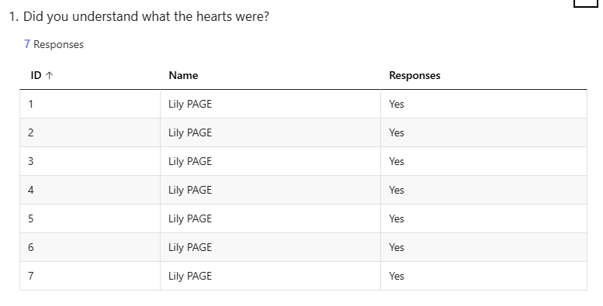
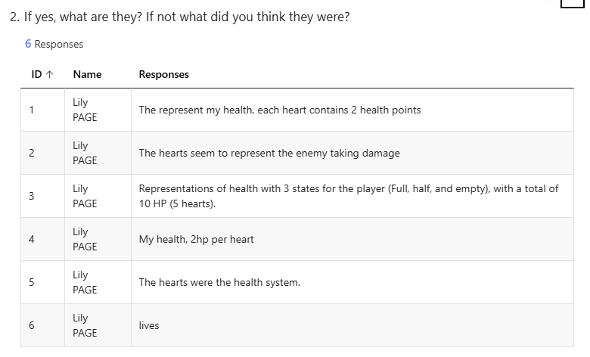
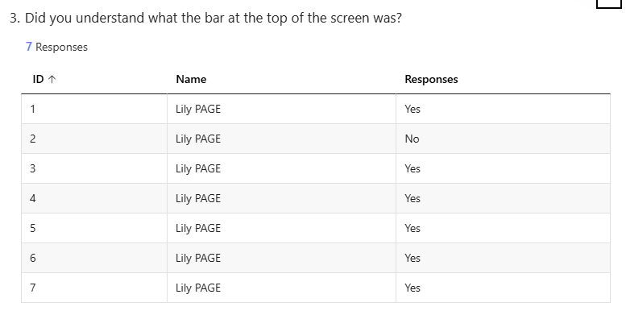
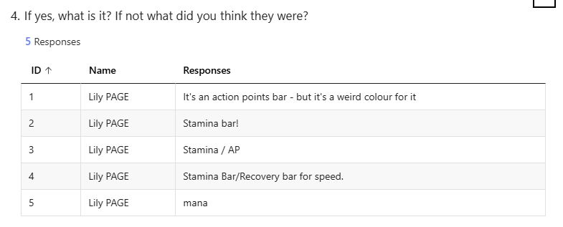
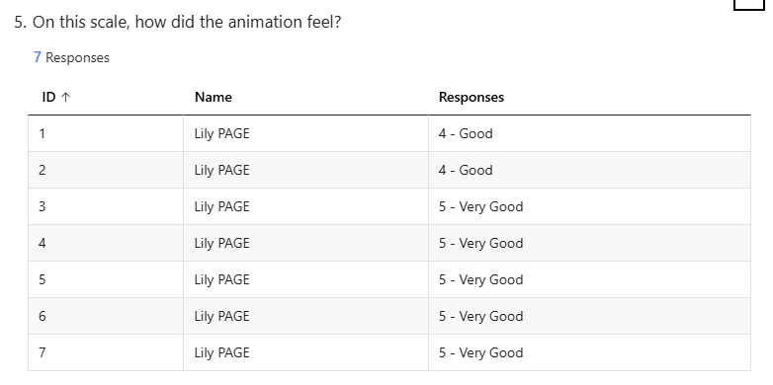
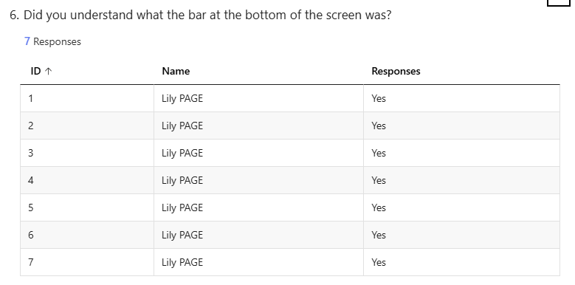

Bibliography
- Making Sure You’re Not a Bot! https://opus4.kobv.de/opus4-haw/frontdoor/index/index/docId/2186. Accessed 5 Feb. 2026.
- - YouTube. https://www.youtube.com/watch?si=3lzI5qzop1DO2PlO&v=0bexLf_oNOc&feature=youtu.be. Accessed 5 Feb. 2026.
- - YouTube. https://www.youtube.com/watch?si=LovOEmO1bEPPyc8w&v=hTPqwKFLapY&feature=youtu.be. Accessed 5 Feb. 2026.
- - YouTube. https://www.youtube.com/watch?v=QhDQNO1-eVE . Accessed 9 Feb. 2026.
- - YouTube. https://www.youtube.com/watch?v=uzPiVzT1-gY . Accessed 9 Feb. 2026.
- “Why We Play : Affect and the Fun of Games—Designing Emotions for Games, Entertainment Interfaces, and Interactive Products.” Human Computer Interaction Handbook, CRC Press, 2012, pp. 725–47. www.taylorfrancis.com , https://doi.org/10.1201/b11963-ch-31.
- “Hi-Fi Rush Is Fun Even If You Suck at Rhythm Games.” Frostilyte Writes, 8 Feb. 2023, https://frostilyte.ca/2023/02/08/hi-fi-rush-is-fun-even-if-you-suck-at-rhythm-games/.
- https://www.reddit.com/r/NoStupidQuestions/comments/yyvngl/why_do_we_usually_depict_lightning_as_yellow_when/

