Cabin in the Clearing

How weather affects a player’s perception of coziness

Rafe Maidment

Contents

Research question and prototype description 3
Summary of research conducted 3
Documentation 4
Testing, iteration and changes 1 18
Testing, iteration and changes 2 23
Conclusion 25
Sources 25

Research question and prototype description
Weather is not often the focal point of games, especially not cozy games. While some games have utilized weather as a while of making the player feel a sense of calm in some situations, there is surprisingly little research done as to how or why weather is used in ways to make players feel a sense of coziness.
The purpose of this prototype is to test the effect of weather and players’ perception of coziness. The intention of the prototype is to place players in a cabin in a forest clearing, in the level, they will be given a set of daily tasks to do, but the primary features of the game will be the day-to-night cycle and the weather system.
The day/night cycle will reset the tasks in the players’ To-Do list and pick new random weather at the beginning of each day, these weathers consist of sunny, rainy, foggy and snowy. The weather will be purely cosmetic, its only purpose being ambience and affecting how the player feels, making them feel cozy, safe or cold. The tasks will be designed in a way that requires the player to leave the warm-feeling cabin and into the weather outside, this should help with players experiencing the contrast between the cold weather outside and the warm interior of the cabin.
The prototype should be built to be expandable, allowing new systems to be integrated without requiring major refactoring. The weather and task systems specifically should be handled by managers that give me the ability to easily make new weather types or tasks and easily implement them without requiring restructuring of core systems.

Summary of research conducted
Rain is referred to as a “pink noise”, research has found that pink noise can help a person relax by soothing the nervous system and increase a person’s ability to focus, especially in people with ADHD[1].
In a study by Maria Önnberg[2], ‘listening to rain’ was mentioned multiple times by different participants as a means of keeping and feeling calm. Even a study of Left 4 Dead 2’s safe room compared the sound of zombies clawing at the door to “heavy rain outside while one is safe indoors”[3], going on to write “cold rain against a window emphasizes the warmth of a reading nook without threatening to disrupt it”.
The association of rainy weather and cosiness is a common connection to be made, so my project will be looking closer at that connection.
Another paper by Jooa Julia Lee, Francesca Gino, and Bradley R. Staats [4] goes over the link between bad weather and good productivity. While this paper did not come up with anything particularly related to my question, the theory of bad weather affecting productivity by reducing our want to leave our homes for activities could be a point to look at when testing. Maybe showing a potential decrease in tasks completed during rainy weather due to players preferring the coziness of staying indoors.

Documentation
The very first design I made when starting production of the prototype was the design for the map and house that the player would reside in, along with the initial locations for all the tasks that the player would be able to complete.
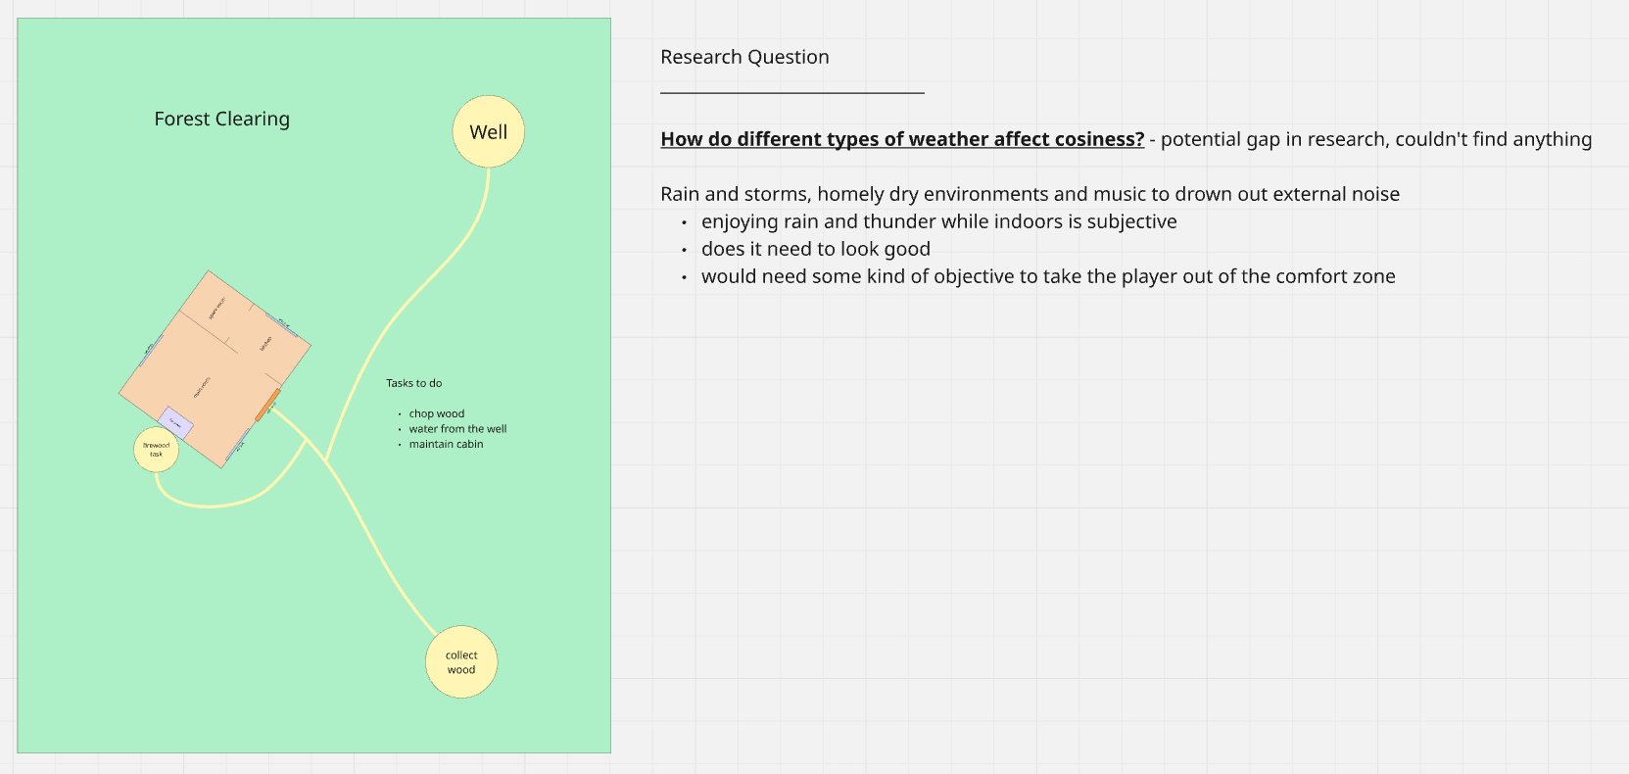
After the initial design, I created a small prototype for the prototype. I experimented with implementing a short and simple day-to-night cycle and added a small landscape with foliage and grass.
The house was a small block out that consisted of the rooms shown in the design diagram and had a chair that could be sat on and a toggleable light blueprint that could be copied and pasted into each room.
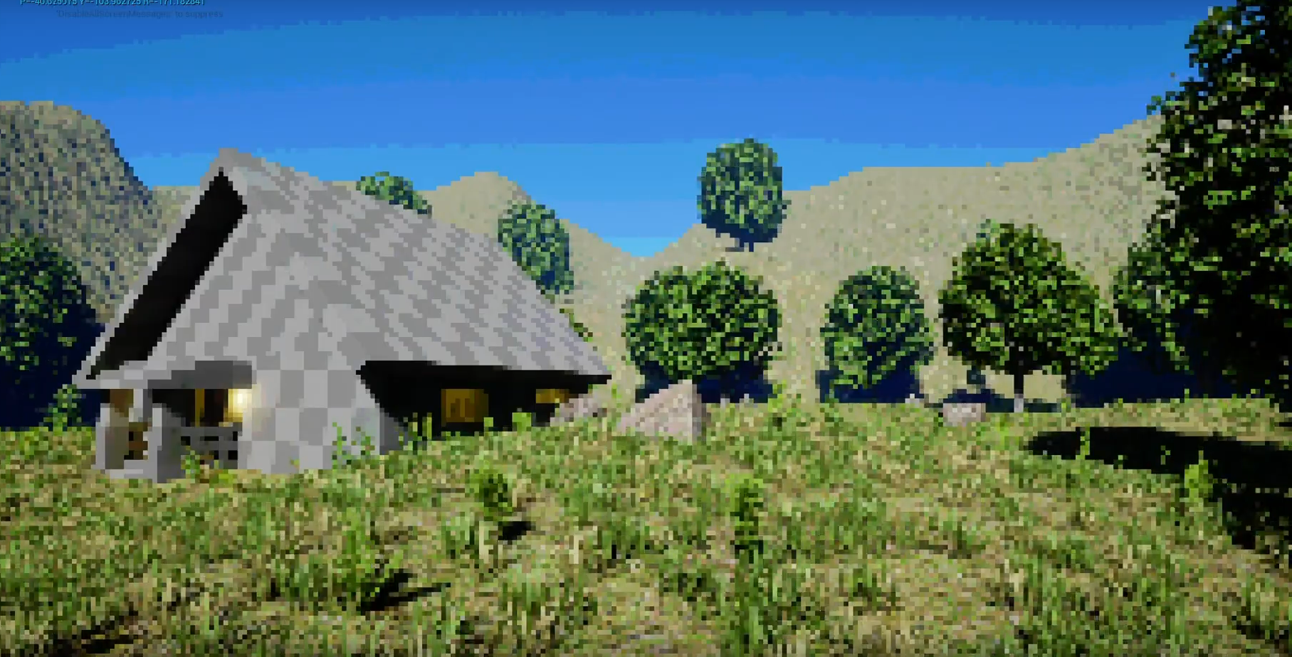

When developing the day/night cycle, I wanted to nail the colour shift that occurs after the sun sets with cold blue skies and the background reducing to simple silhouettes.
I did this by disabling the sky sphere and using a custom skylight, height fog and directional light that brighten and dim on a timeline
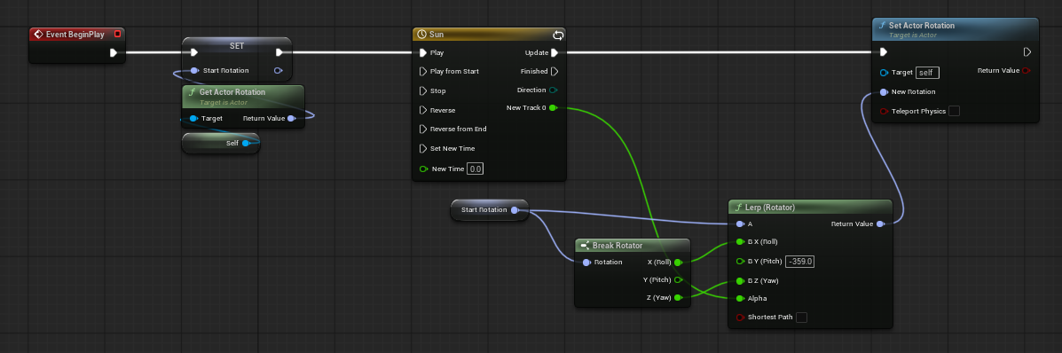
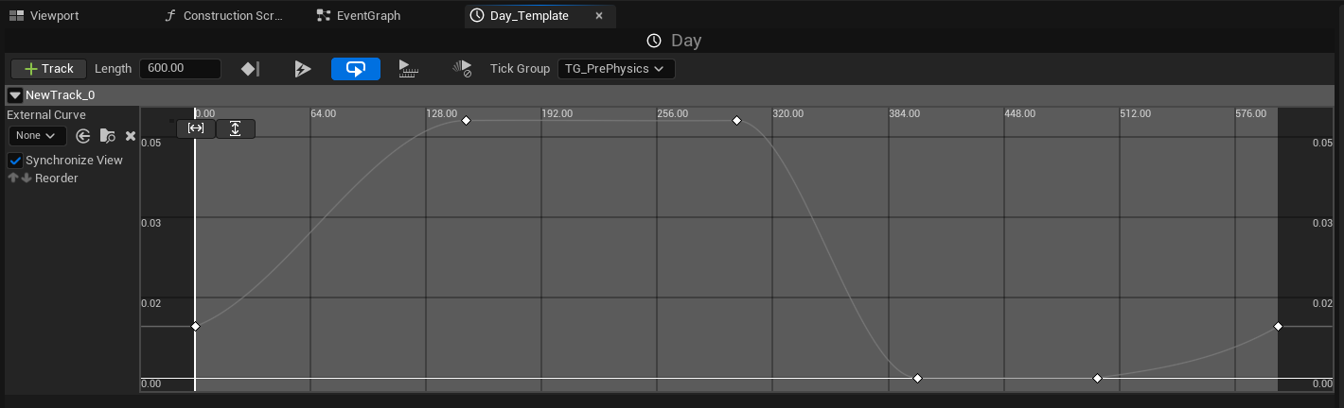
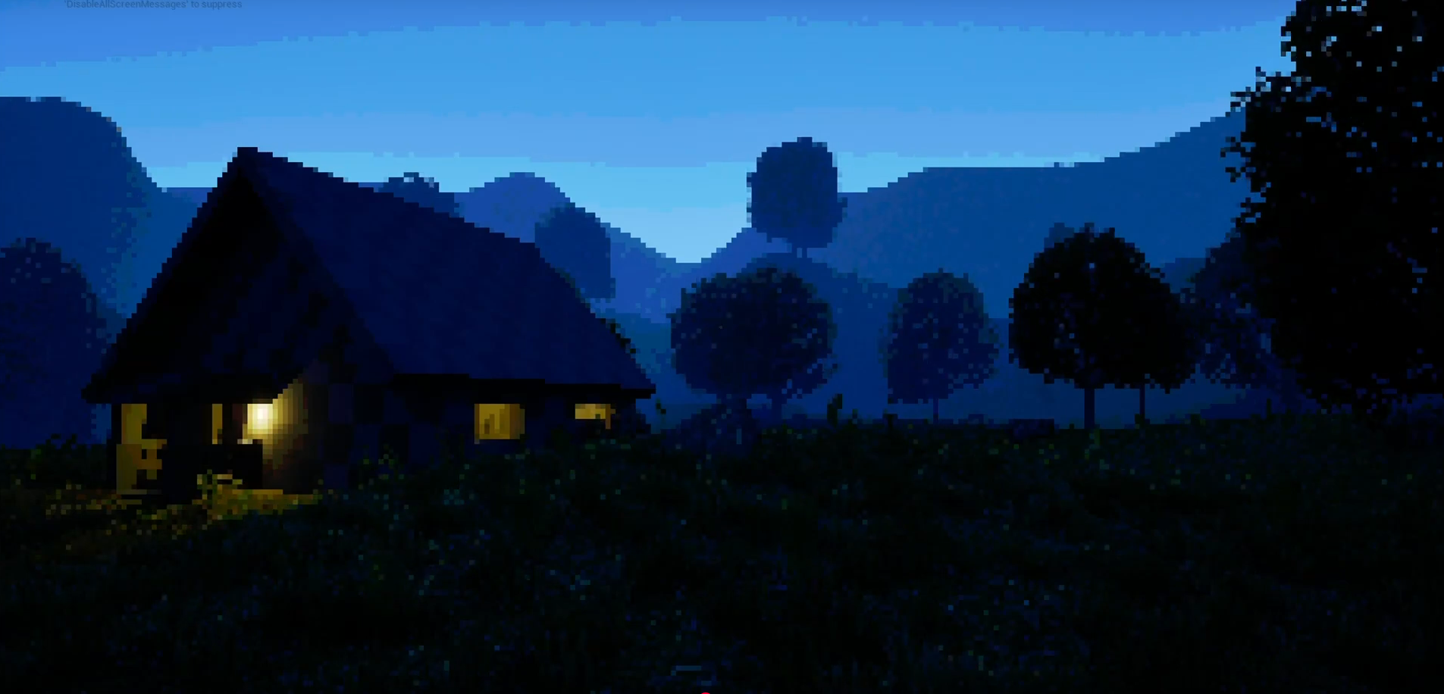Reference images used:
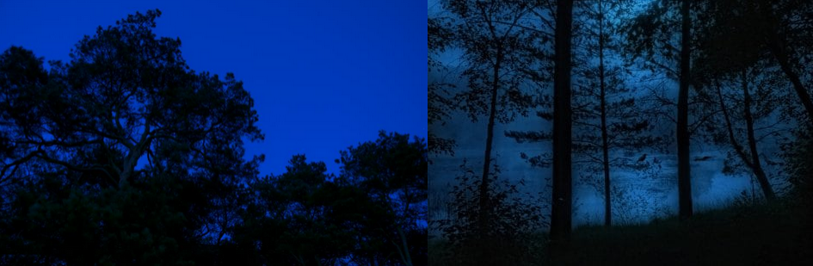
You can see how the blue gradient darkens and more distant objects lose detail through the fog. This was also a consideration I would have when making the first weather for the prototype: rain.
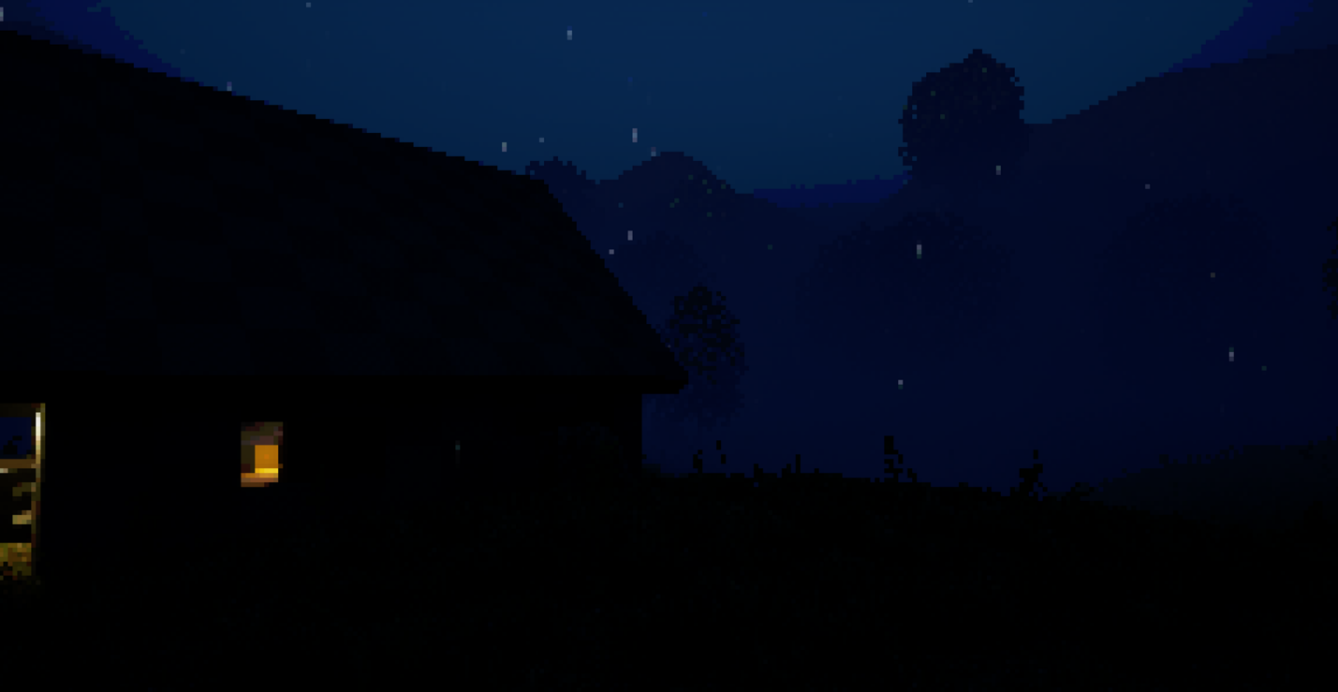
Above is the first iteration of the rain weather. With this first iteration, I used a Niagara particle system to create the rain and a local fog volume that would fade in and out to increase the intensity of the blue gradient and give the outside a colder appearance and by keeping the sky a lighter colour, farther objects are reduced to a silhouette.
I came across the problem of the rain fog causing the world to become far too dark due to me disabling the sunlight when rain began.
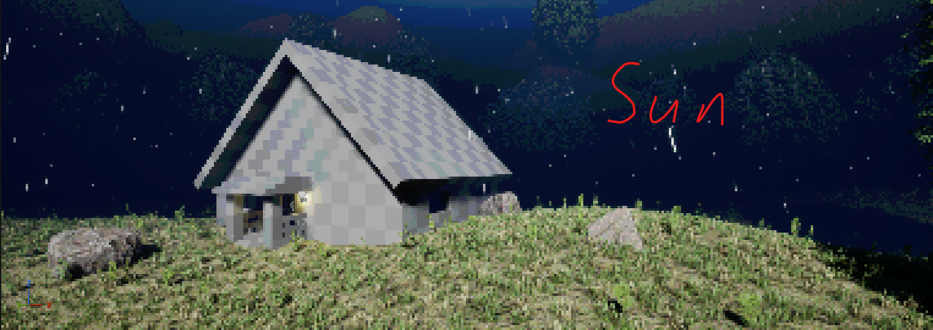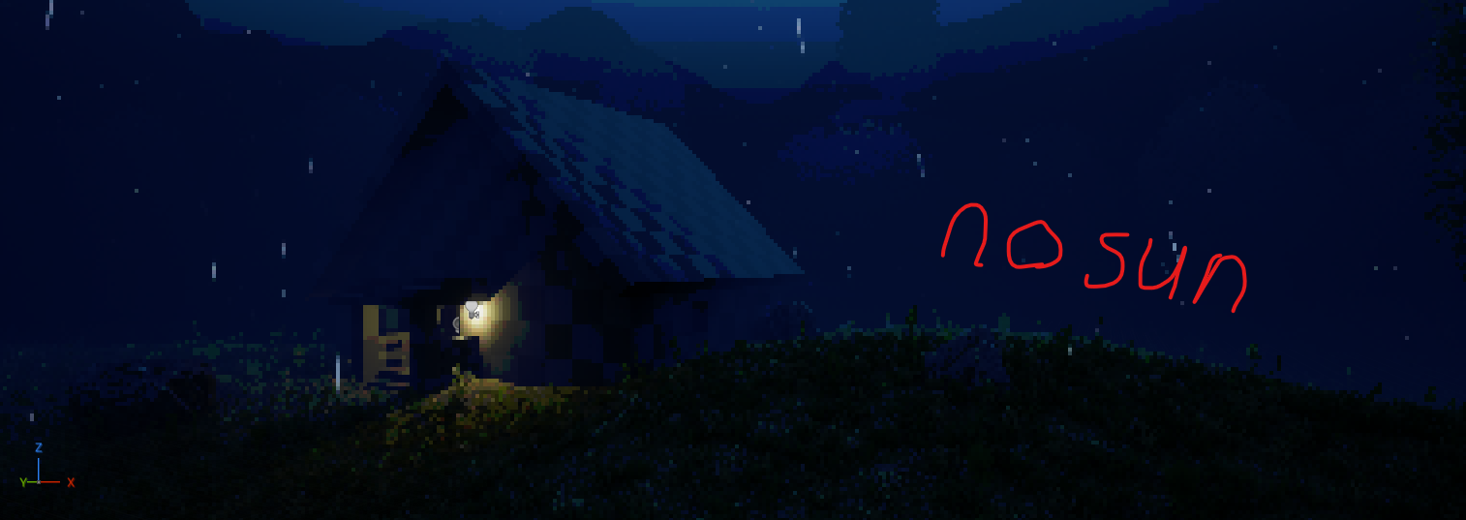
I solved this by adding a custom skylight that used a timeline to dim and brighten with time.
This was the result, now the world is lit during rain and gives off the appearance of an overcast day:
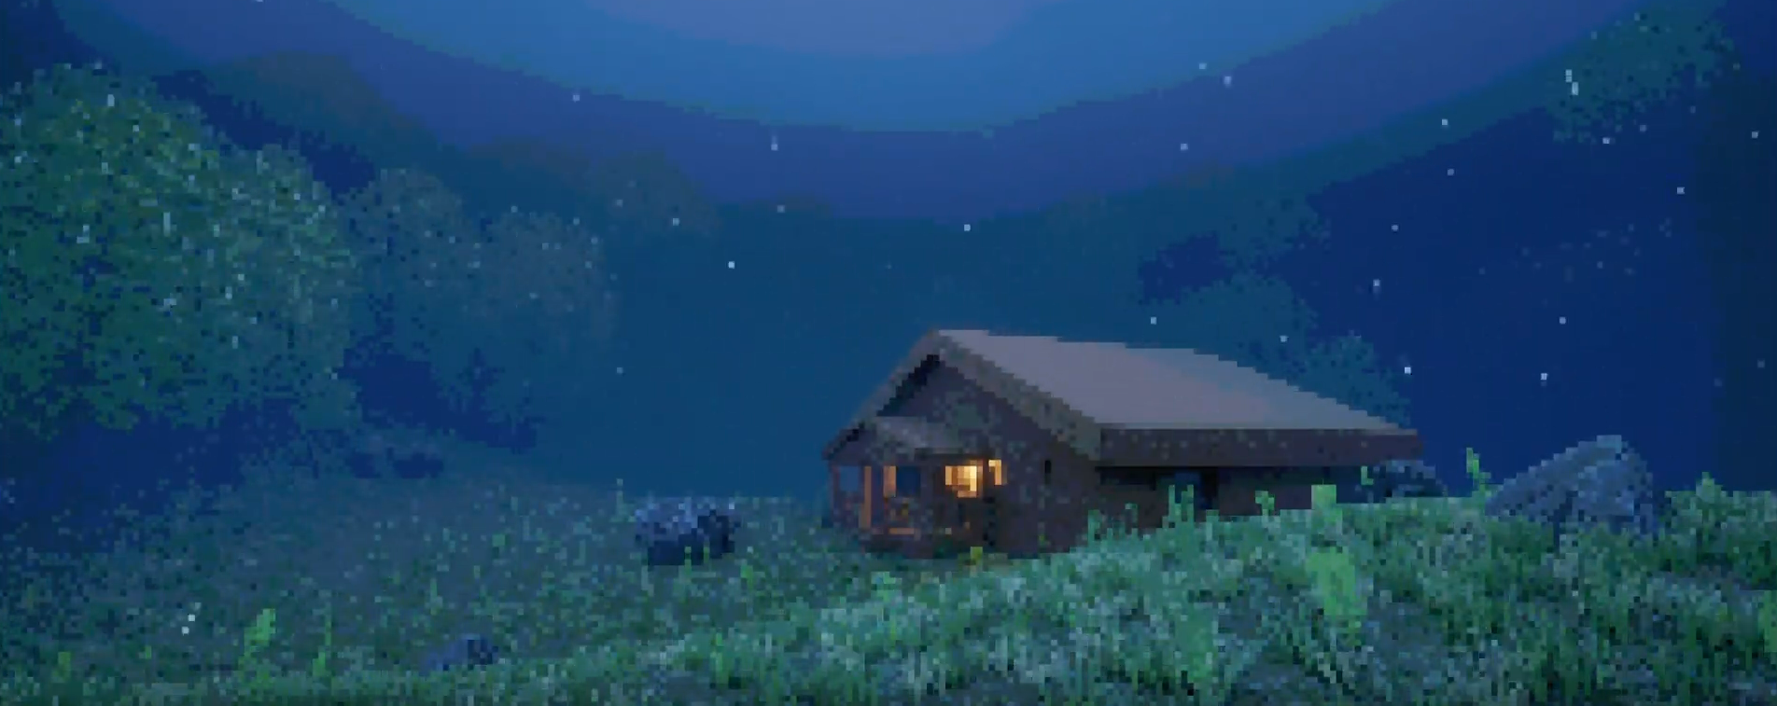
After this, I created a Moscow chart, giving myself goals and stretch goals to aim for during development:
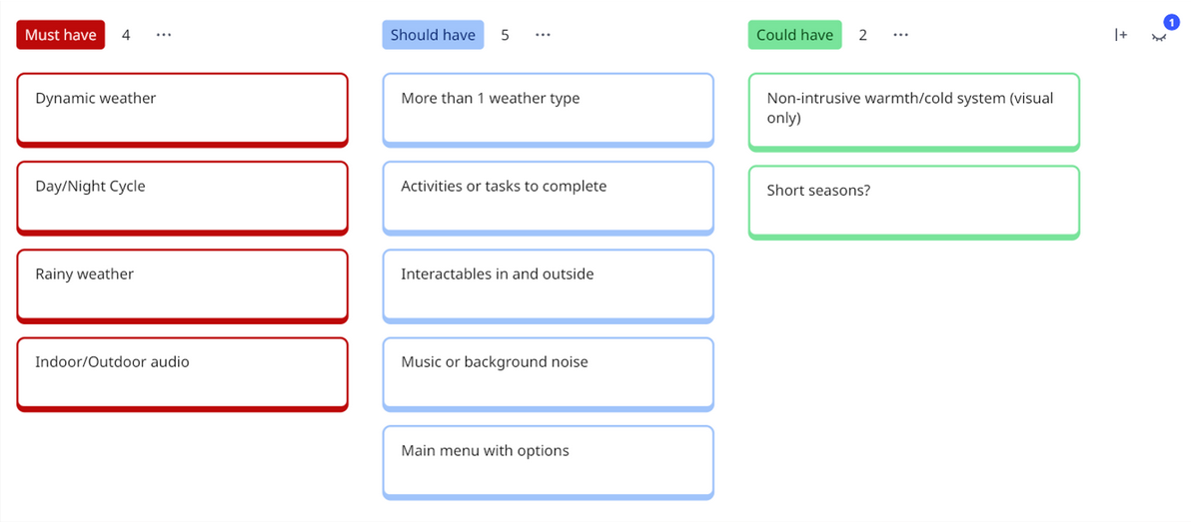
At that time, I also added an ambient daytime background noise, rain sound effects and footstep sounds, each of these sounds also change based on whether the player is indoors or outside.
At this point I started to design the gameplay loop. This project was made to be more of an experience, but I still wanted to start developing my skills with quest lists, game loops, etc.
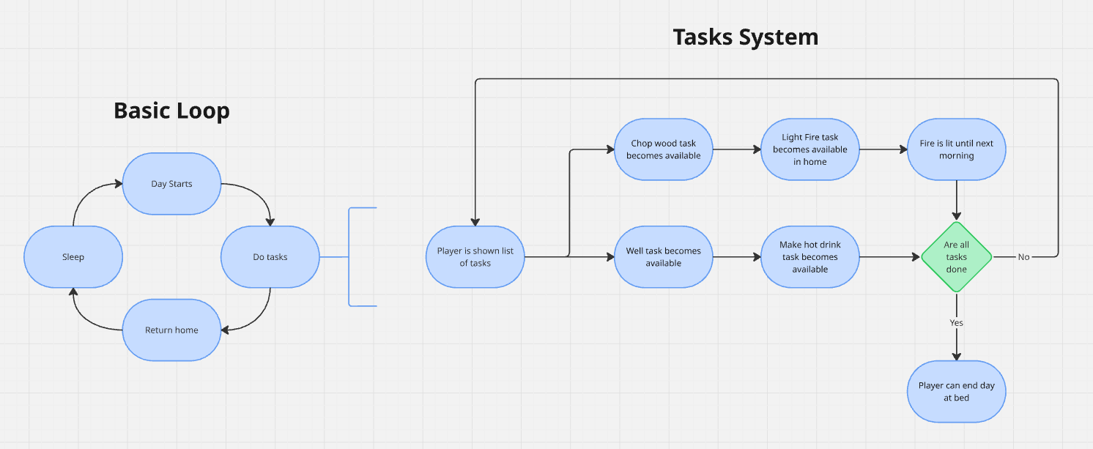

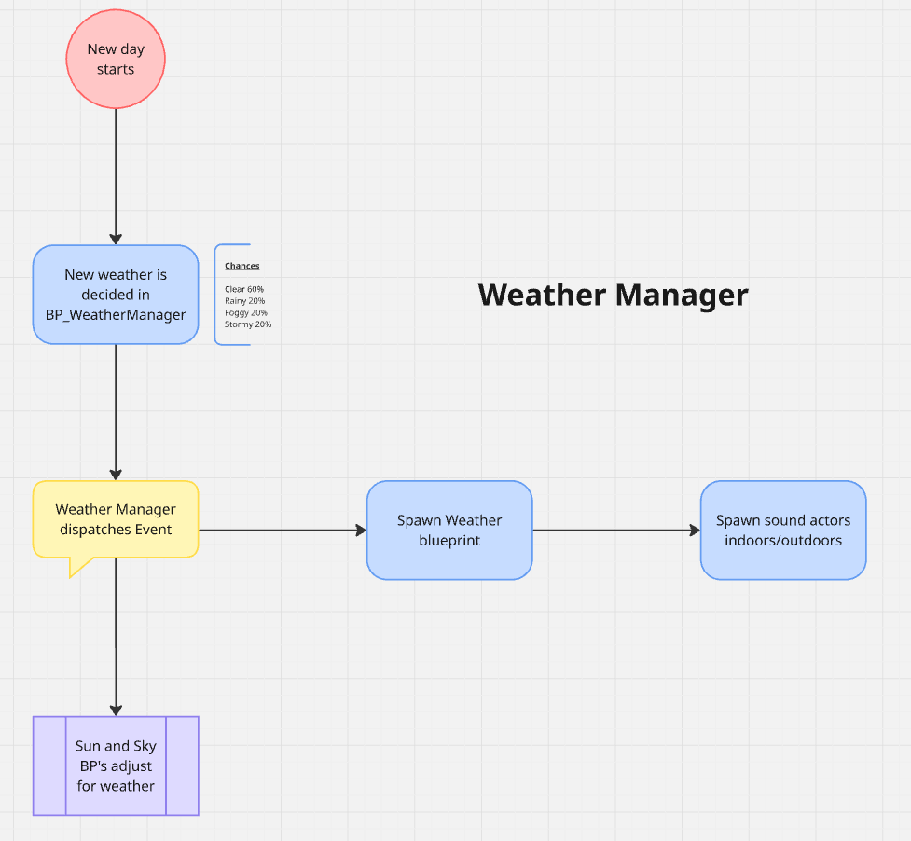
I then decided to start using audio volumes instead of my own audio system. This reduced my insane audio manager blueprint (shown below) to just 8 nodes that enabled and disabled sound actors in the world depending on the weather chosen by the weather manager.

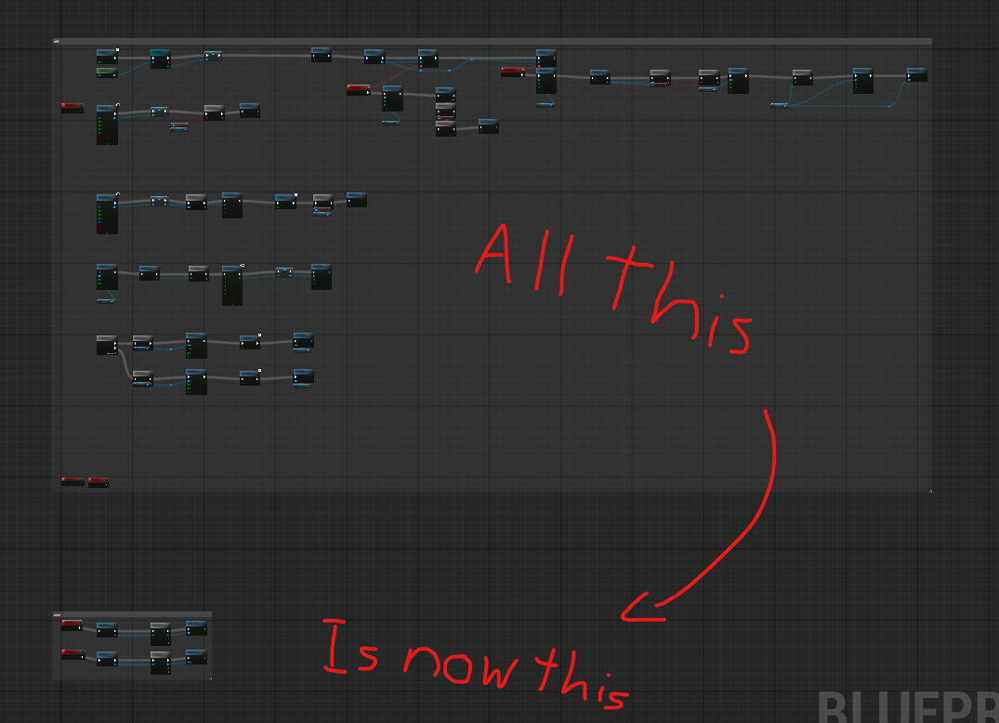
(sound manager blueprint)
I then started to develop the snowy weather. I racked my brain on a couple ways to do this, but I then settled on duplicating the landscape, reimporting it as a static mesh and having it slowly rise whenever it snows. This gives off the impression that snow is slowly accumulating on the ground, I also added noise to the mesh to add the effect of the snow slowly growing in piles rather than evenly spreading.
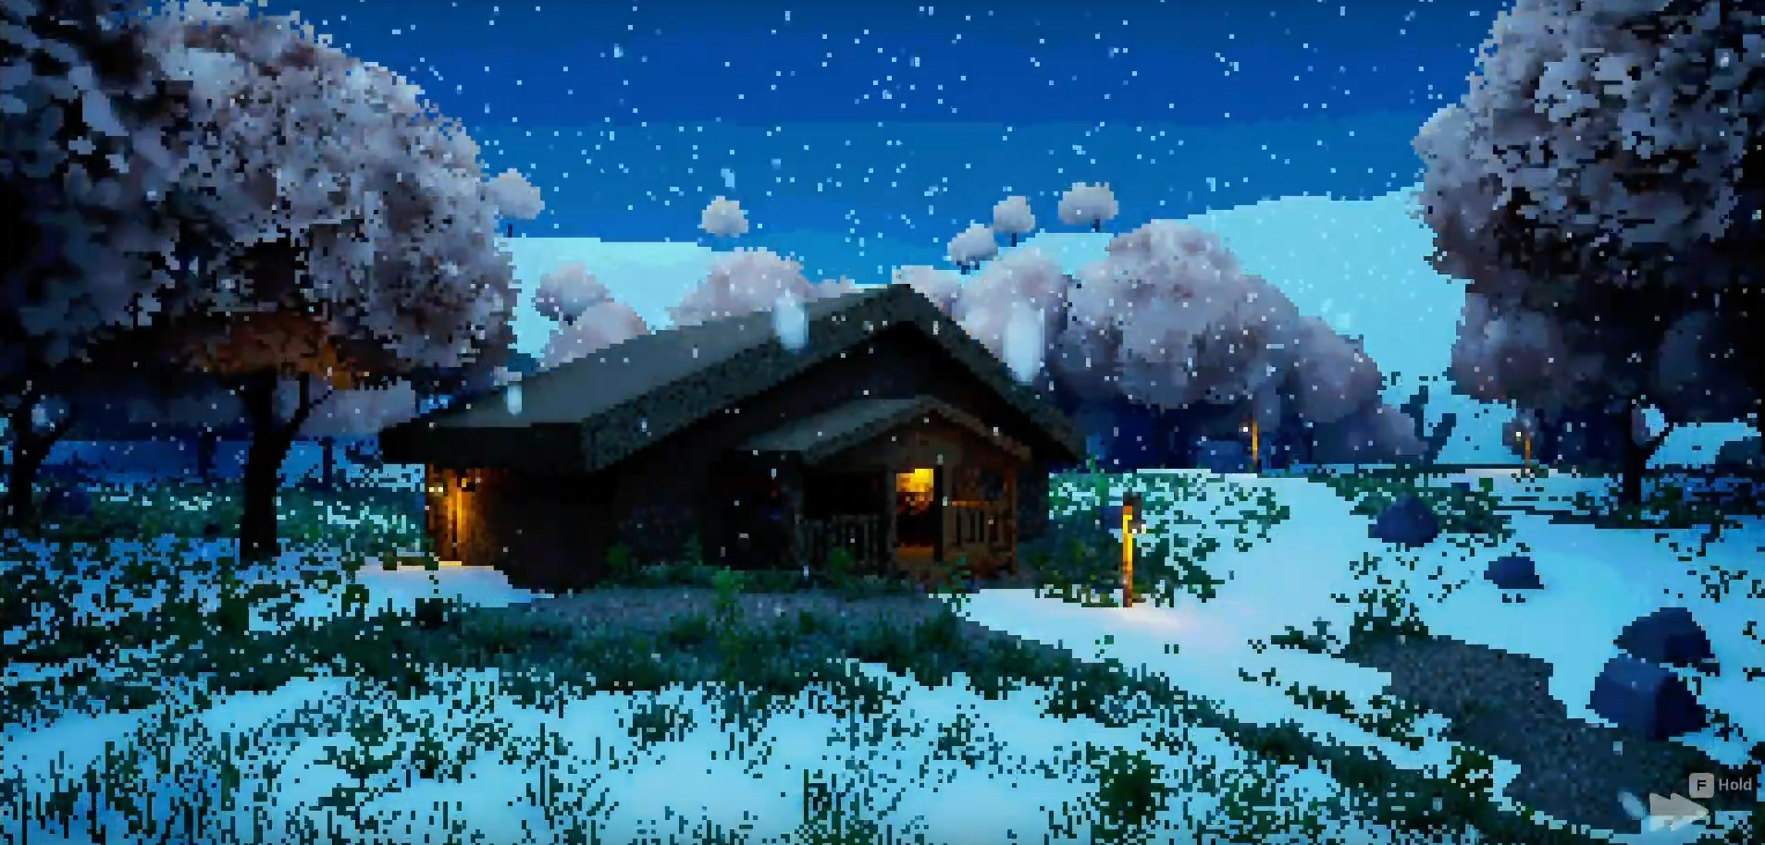
For the snow on the trees I tried a few different disgusting methods, such as adding an object to the world that has the material on it for me to reference because foliage can’t be referenced. Eventually though I discovered an asset called a Material Parameter Collection, this could be given a value and then placed in a material as a scalar parameter. This could then be referenced in a blueprint without requiring access to the in-world object.
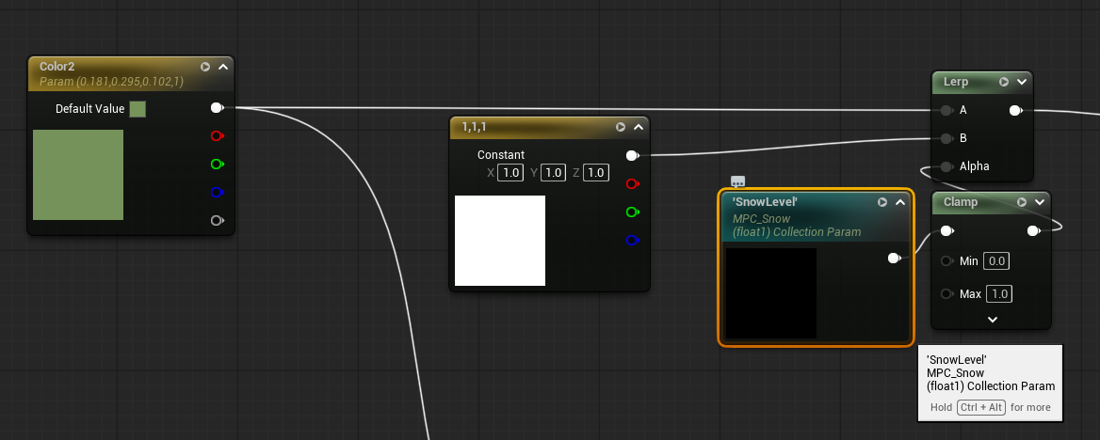
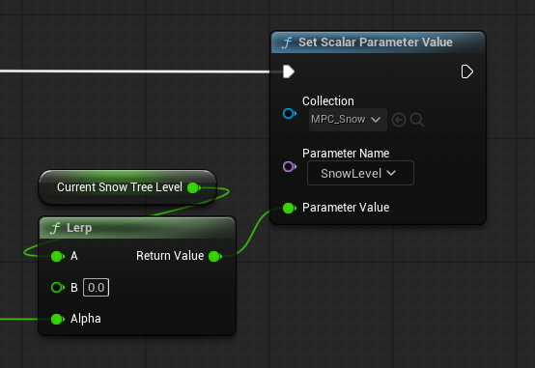
This allowed me to have snow slowly build on the trees on a timeline along with the rest of the snow. I also added snow to the roof using the same method as the landscape and changed the environment to an Autumn theme as it would make more sense for snow to be falling later in the year.
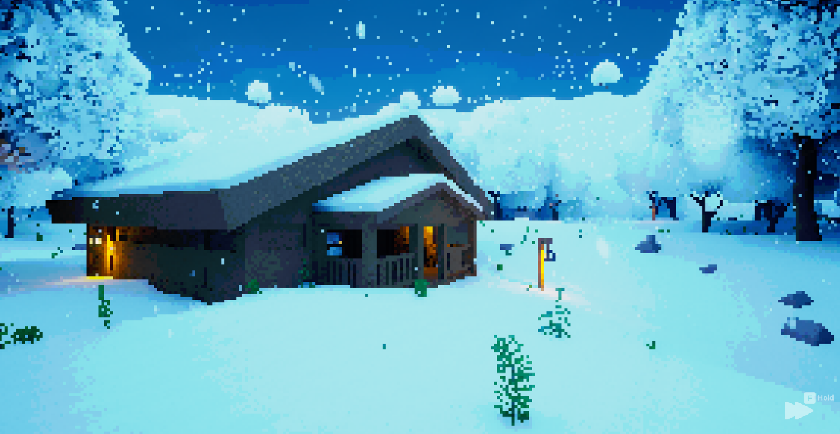

(autumn trees)
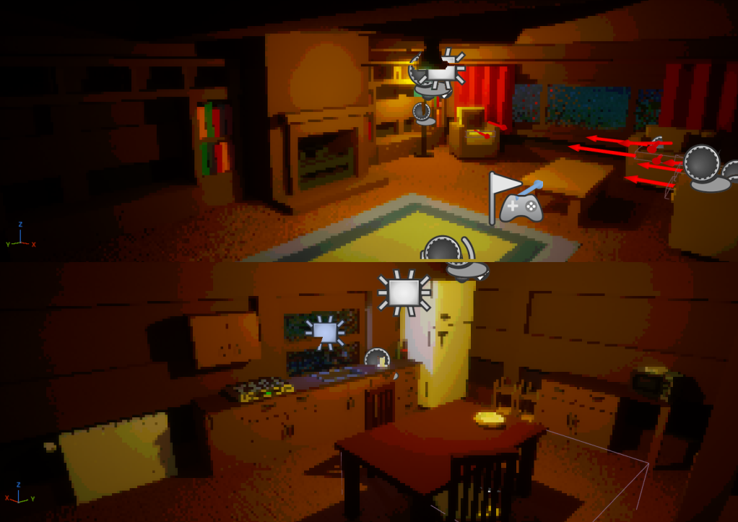
Then, I began importing art assets from FAB. I focused on low poly assets and found a pack called Isometric Interiors that had the perfect style, I made the walls, windows and doors using cubegrid in engine

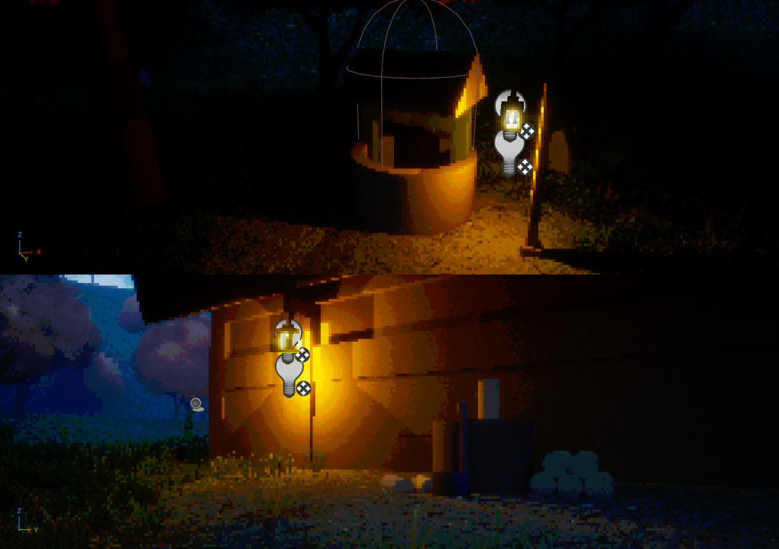
I also realized that there would be a lack of information for players due to the lack of a tutorial, so I made an information panel in the living room: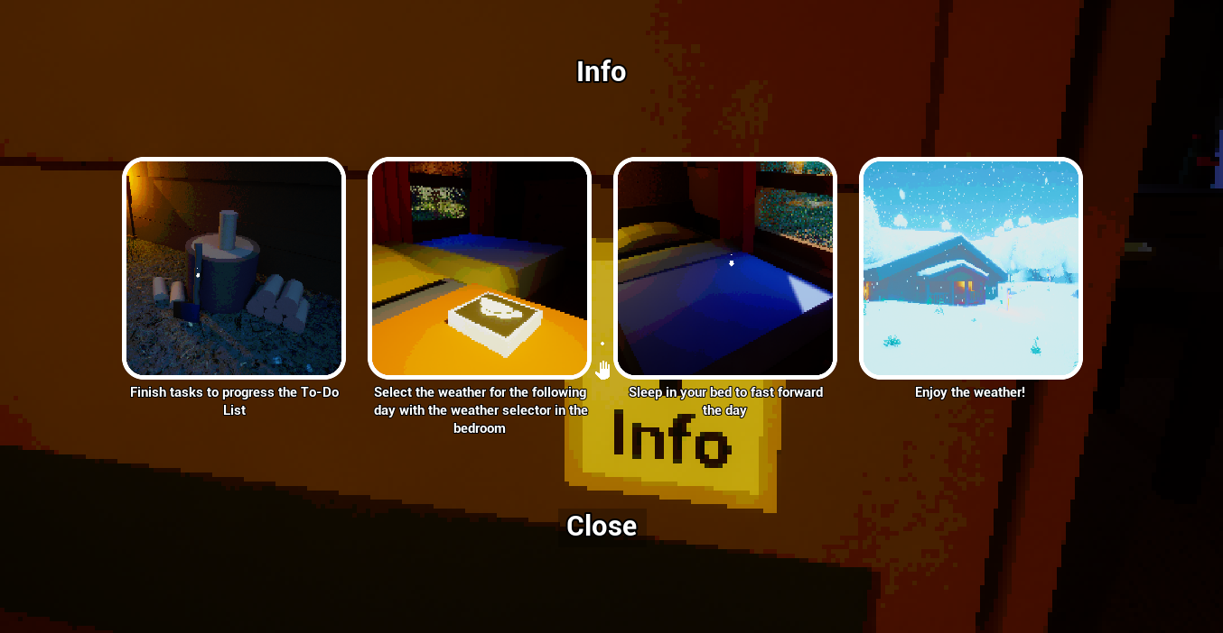
I then added a weather selection menu that allowed players to select the weather for the following day.
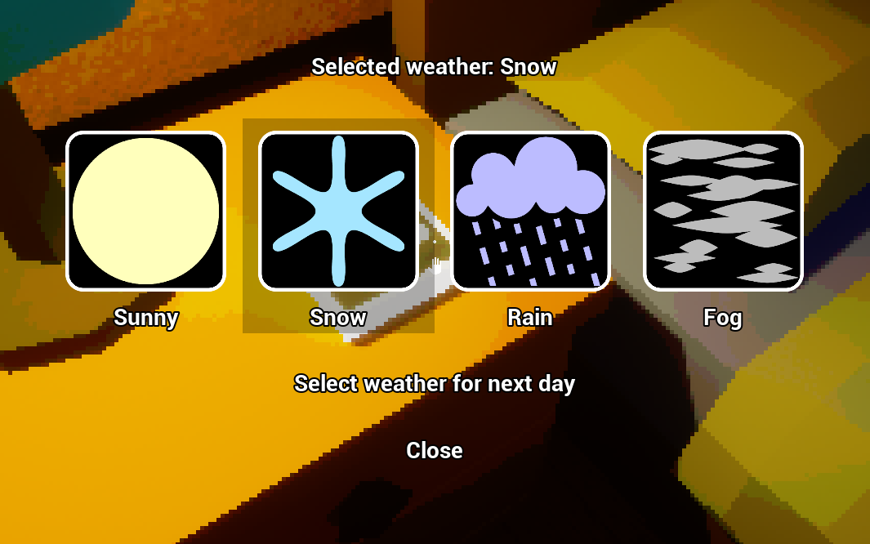
After that I designed the To-Do list. It was originally supposed to be “Tasks”, but ‘tasks’ makes them sound too required than they are which goes against the cozy vibe I’m going for.
I added some contextual text on screen when the player interacts with a task that can’t be completed yet to hopefully prevent them from getting confused.
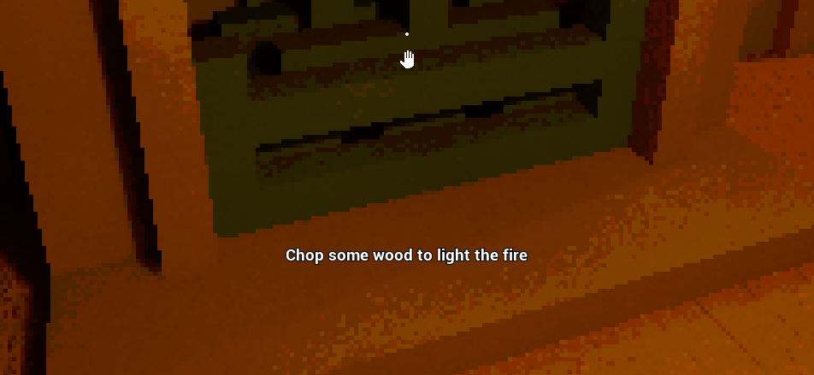
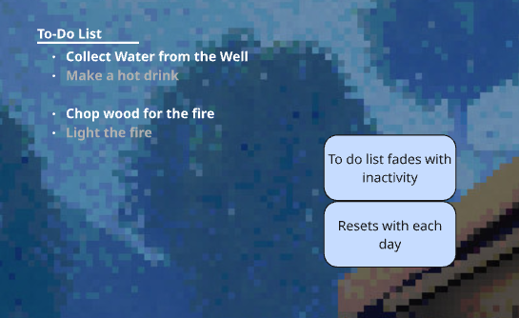
When implementing this, I added some more visual flair and a pen scratching sound when the task is complete to add to the juiciness of the feature to make it feel more rewarding, as well as an animation that displays the tasks onscreen when one is completed to ensure that the player doesn’t miss it and doesn’t get confused.
The list is also off screen by default and is displayed by holding the Q key. This is to keep the screen as clutter free as possible.
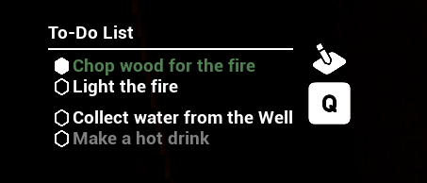
At this point I felt the game was ready to be tested, so I moved on to that phase.

Testing, iteration and changes 1
Ready for testing I implemented a simple main menu and a pause menu so that the test could be easily reset between players.
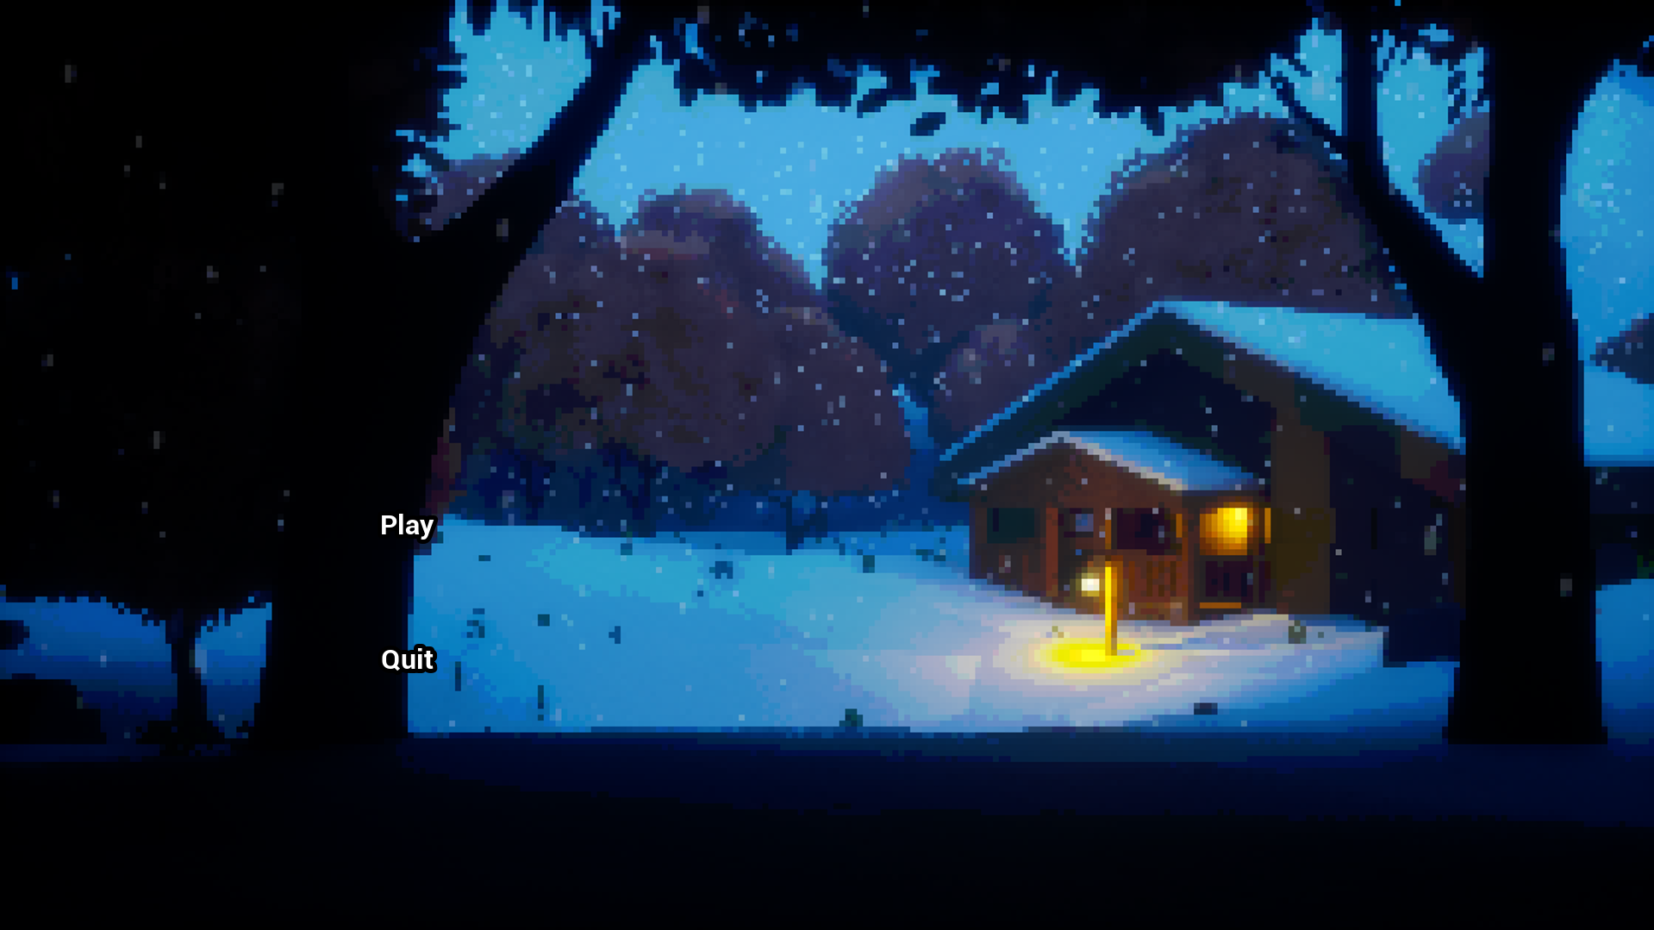
The feedback came in 2 sets over 2 days.
The feedback from the first testing session is as follows.
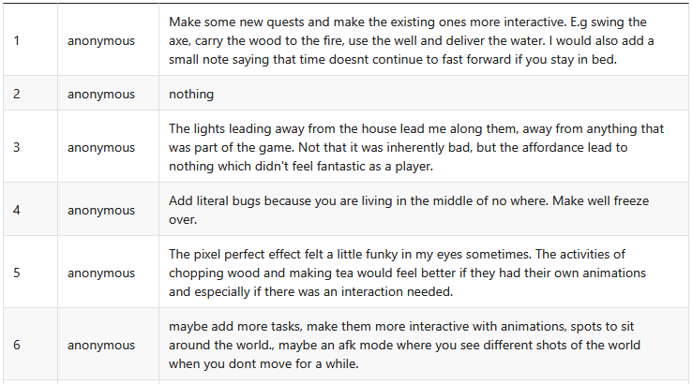
(Asking for improvement suggestions)
Some people asked for the tasks to be more interactive with animations. While I absolutely will do this, it will have to be after the semester as I simply just don’t have the time to do that.
One person mentioned the lights led them to nowhere, but there was only one instance of this out of 15 testers, so I will leave it for now and focus on more important issues.
The last on the list was to add more places to sit around the world such as benches and an AFK mode where you see a montage camera. I added benches around the world but would save the AFK suggestion for another feature.
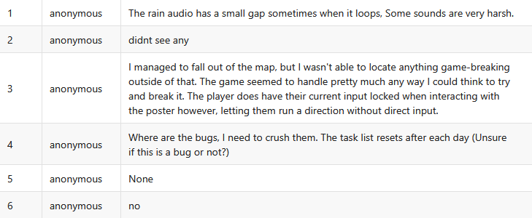
(Asking for bugs)
Someone mentioned a gap in the looping rain audio, will have to fix this.
One player mentioned falling out of the map but didn’t mention where so I couldn’t recreate it.
Not many bugs were found on day one.
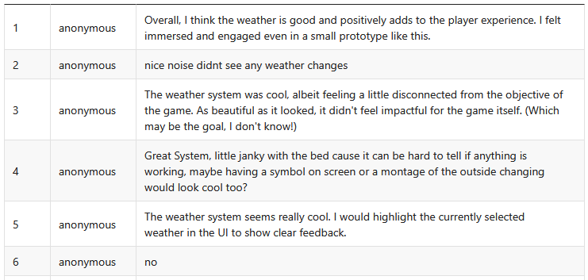
(Weather system feedback)
Two main feedback points for this segment:
Highlighting the current weather on the HUD would be a nice touch for quality of life.
It’s hard to tell if sleeping is doing anything due to the hard limit of UE5’s time dilation so I’ll and the AFK camera suggestion from earlier to this so the player can see the outside world.
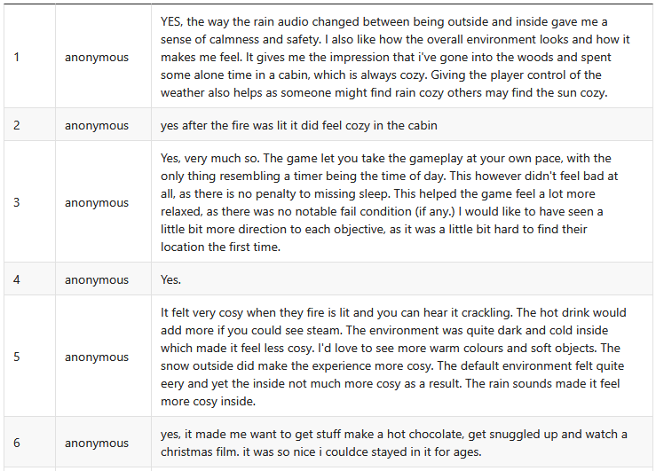
(but did it feel COZY???)
Feedback so far has been positive. The design decisions I took seem to have paid off for the vibe of the game.
So, following the first day I made a couple of changes.
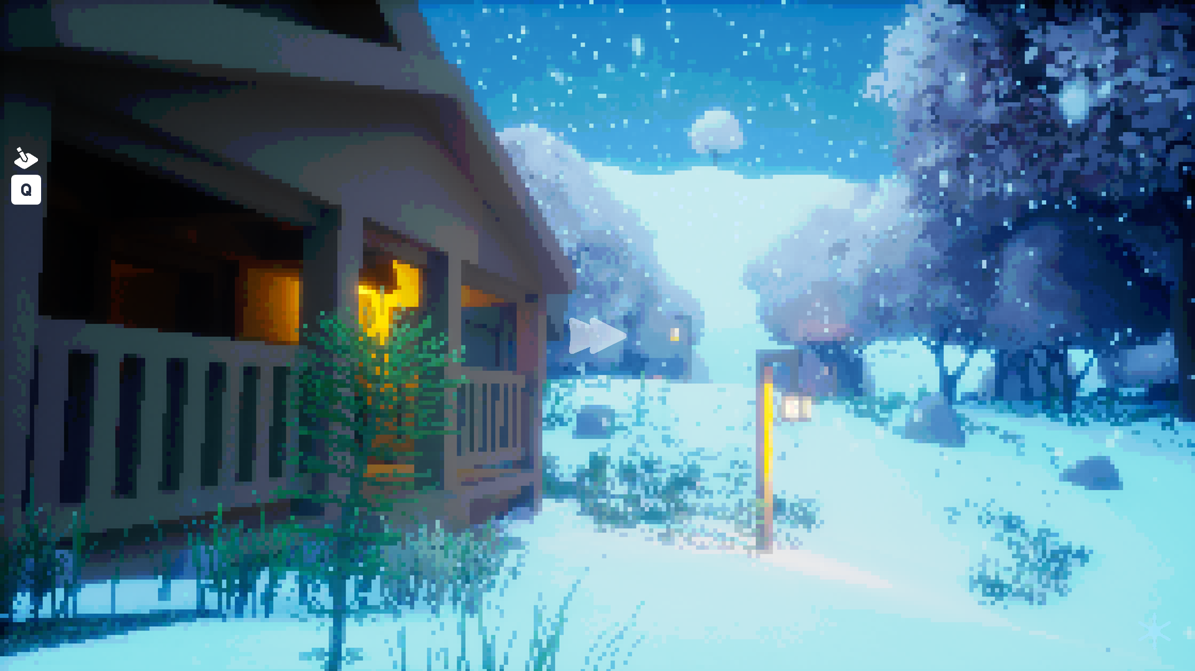
When the player sleeps in the bed, it will now switch to a camera showing the outside world and time passing quickly, along with a fast forward indicator so that the player knows what is happening.
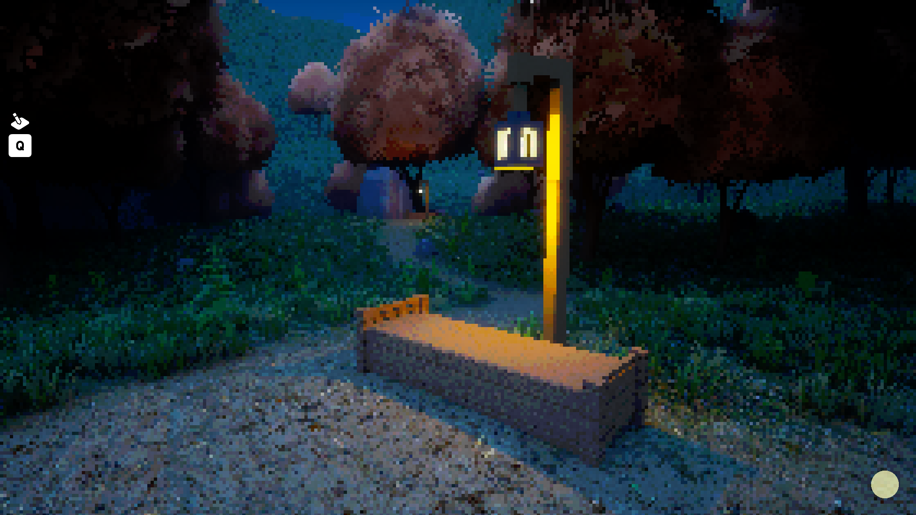
I added a few benches around the world for the player to rest at. In future, this could be expanded to be a time of POI system, such as the meditation points in Assassin’s Creed: Shadows.

Testing, iteration and changes 2
There is not a lot to say about day two.
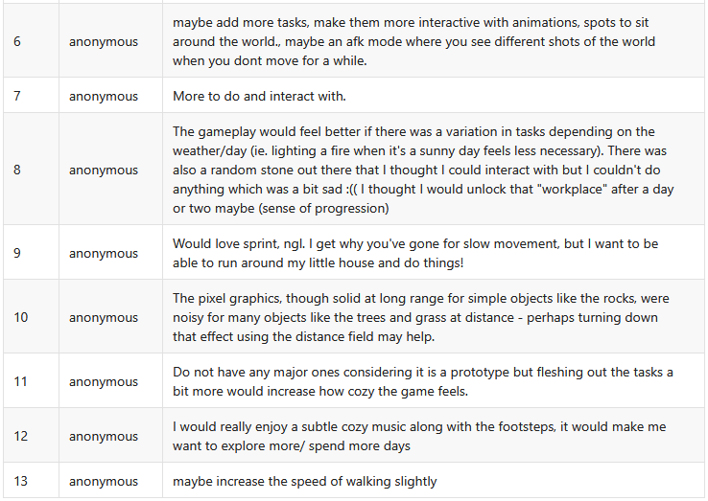
Main criticisms were once again the tasks which need expanding on.
Also, the “random stone” that I placed out of boredom turned out to be quite a point of interest for people. This could be a good place to expand on the game with points of interest and add some intractability.
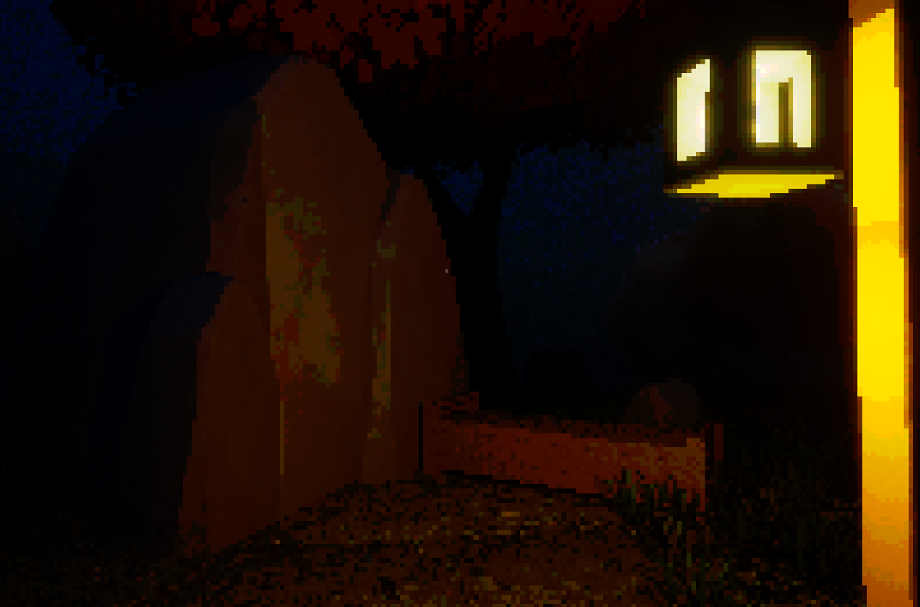
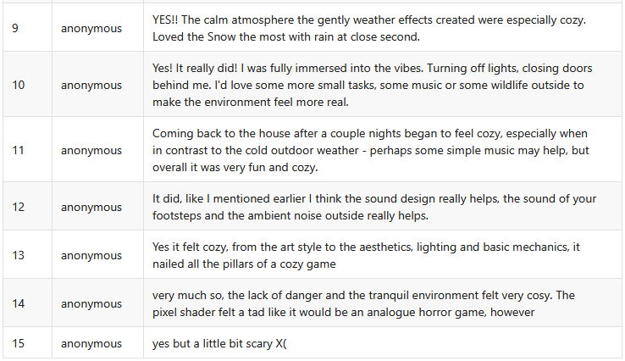
Overall, the feedback was quite positive, and I am happy with the results. There are good and clear points for me to work from in future.

Conclusion
In conclusion, users felt the sound of weather from the inside of the house, specifically the rain on the roof, made the game feel a lot cozier, more so after lighting the fire in the house. The outdoors seeming colder also contributed to people feeling cozier, with some preferring one weather over the other, that being said, no one preferred sunny weather, for what reason I am not sure, but this could be an avenue for further research. What I can say however is that snow is the preferred weather for many of the participants, and the mention of it feeling ‘gentler’ from one user could be a factor as to why that is. Lastly, one participant said that coming back to the house after a few nights felt cozier as they had begun to feel more familiar with the cabin, this could be another area to look at in future.
One participant said they were scared of the dark.

Sources
[1] Nigg, J.T., Bruton, A., Kozlowski, M.B., Johnstone, J.M. and Karalunas, S.L. (2024) ‘Systematic Review and Meta-Analysis: Do White Noise or Pink Noise Help With Task Performance in Youth With Attention-Deficit/Hyperactivity Disorder or With Elevated Attention Problems?’, Journal of the American Academy of Child and Adolescent Psychiatry, 63(8), pp. 778–788.
[2] Önnberg, M. (2024) Cozy games and their impact: An exploration study of coziness in games. Dissertation.
[3] Smith, C. (2024) ‘Getting Cozy with the Zombie Apocalypse: The Saferoom as Capitalist Breakroom in Left 4 Dead and Back 4 Blood’, Replay The Polish Journal of Game Studies.
[4] Lee, J.J., Gino, F. and Staats, B.R. (2014) ‘Rainmakers: Why bad weather means good productivity’, Journal of Applied Psychology, 99(3), pp. 504–513.

