James Paton
Supervisor: James Banton
Second supervisor: Shaun Reeves
Optimising Cloth Physics for Accurate Background Simulation
GDEV60001 Games development project

Contents
Abstract 2
Introduction 2
Aims and Objectives 3
Literature Review 4
Research Methodologies 13
How the artefact was implemented: 15
Results and Findings 17
Discussion and Analysis 22
Conclusion 24
Recommendations 25
References 27
Appendices 33
Appendix 1 – Raw Data from Simulation at 50 Iterations 33
Appendix 2 – Raw Data from Simulation at Optimum Iterations 33

Abstract
Real-time cloth simulation is a computationally expensive problem in video games, where maintaining high frame rates while preserving physical accuracy is essential for players’ immersion and experience. This investigation explores the current methods of both simulating and optimising cloth physics simulation, implements a real-time cloth physics simulation using a mass spring model and compute shader to perform calculations as the main optimisation technique to improve performance. The results of the simulation focus on comparing CPU-based computation against GPU-based computation, but focuses on accuracy being maintained.
The paper first researches into existing methods and optimisation techniques to define a knowledge base from which the artefact was created. The artefact developed simulates cloth as a grid of particles connected by structural, shear, and bend springs, with changeable variables, allowing the cloth’s physical properties and simulation method to be adjusted dynamically. The simulation on the GPU employed the Jacobi method to resolve spring constraints in parallel, which involved solving all displacement calculations first before then applying them all in a second dispatch.
Performance was evaluated by measuring frame rates across a range of cloth sizes and iteration counts, with tests conducted on a fixed hardware platform to ensure data consistency. Results demonstrated that GPU-based simulation significantly outperformed the CPU as cloth size and computational complexity increased. For larger cloths, the compute shader achieved substantial performance gains, maintaining frame rates suitable for real-time applications where CPU-based approaches became more unstable or inaccurate. However, GPU simulations exhibited greater frame-to-frame variation, indicating reduced stability when very large cloth sizes were simulated.
The findings confirmed that compute shaders are an effective optimisation technique for real-time cloth simulation, enabling accurate, non-baked cloth physics to be computed on a background thread, without significantly impacting overall application performance. While stability was a problem for large simulations, the results suggest that GPU based cloth physics is a universal solution for real-time applications, particularly when combined with additional optimisation strategies.

Introduction
Real-time cloth physics simulations have become an increasingly important component of modern interactive applications, particularly within the games industry (Rudomin and Castillo, 2002). They state games being accurate and immersive is vital to a player’s experience and can determine the whole feel of a game. Because stability and accuracy are so important, it is vital that every element in a game is able to provide and sustain this immersion. In regards to cloth physics, current methods and optimisations can sometimes result in unstable or inaccurate simulations, which can break a game’s immersion.
Within the industry, cloth is usually implemented utilising a mass-spring damper model (Va et al. 2021), where particles are connected with springs which simulate the elasticity of a cloth. There is a limit to how far they can stretch, which is simulated with a spring constant and a maximum stretch. There are three main types of spring, which control structure, bending and oscillating respectively, and all three are required for an accurate simulation. The issue, however, is the number of calculations required to model all the springs in a cloth can take a long time to solve. This can cause the frames per second (FPS) to drop which can cause visual issues for the player and ruin the experience of the game.
To address this, optimisations have started to be implemented to speed up the simulation, however, many of these have separate issues that come with them. The main optimisation technique is baking the physics into the solution prior to simulating, or when the user does not have the cloth in their field of view (Unity, 2021). This can cause some inaccuracies as a heuristic is applied to the calculations. A heuristic is an assumption in the calculation, which sometimes can be inaccurate or wrong (Romanycia and Pelletier, 1985). In certain cases, this can lead to breaks in the immersion, hence not solving the initial problem.
Other methods of simulating cloth, for example, finite elements, which divides the cloth into smaller sections and solves them separately, can create different outcomes in terms of accuracy but are generally slower to compute (Harders et al. 2003). Other optimisation techniques exist which can optimise the solution in specific use cases, but few blanket optimisation techniques exist for all cloth simulations. One universal technique that exists is using compute shader, which runs on the GPU of a device. This can compute the calculations quicker than the CPU, and speed up the simulation effectively (Huynh, 2011).
This research paper will investigate methods of simulating cloths and existing optimisation techniques to attempt to find a method of simulating cloth that can accurately model cloths of multiple sizes while maintaining a high stable FPS rate throughout. This means identifying an efficient method of simulating cloth physics which avoids heuristics and baking the simulation.

Aims and Objectives
This dissertation paper investigates methods of simulating cloth physics and determines which method can be optimised to be able to run continuously without requiring excess computation time from the CPU. Based on Hairsova’s (2020) findings that cloth physics are baked and optimised when not in the player’s view, which improves performance but causes inaccuracies, this study aims to optimise a cloth simulation that maintains continuous simulation while minimising these inaccuracies. This will be achieved by following these research questions (RQ):
- (RQ1) Which method of simulating cloth physics would be optimal to be the focus of the paper? For instance, which method is used most in industry, and which method is used in other industries outside of games. Furthermore, which method can be optimised, and which method will have the most impact on the industry if it is optimised?
- (RQ2) How will the selected method of cloth physics be optimised so it can run continuously in the background of a physics update loop? This would look at compute shaders and threads to identify ways in which the simulation can be sped up or solved asynchronously.
- (RQ3) Does the outcome of the implementation run consistently and efficiently enough that it can be utilised in games? This involves comparing the speeds of the simulation and comparing it with current methods to evaluate how successful the simulation is.
These research questions will be answered through conducting an in-depth literature review which details current methods of cloth physics, compares them and discovers optimisation techniques used to speed them up. Furthermore, a simulation of the chosen method of cloth physics will be created, and data will be collected from the simulation about vertex count and computation speeds. Evaluating this data will lead to the confirmation that it can run in the background of any game’s physics update loop.

Literature Review
Cloth physics simulations are mechanical simulations of cloth materials, with the intention of most accurately recreating a piece of cloth (Yang and Shang, 2013). They state cloth physics are used in many situations, including simulating flags in the wind; clothes on people or furniture and curtains being interacted with. Stuyck (2022) suggests there is more emphasis on accurate cloth physics being in games now due to AAA games needing to look more beautiful for customer satisfaction, meaning accurately simulating cloth is required to not break players out of the immersion, therefore, improving their overall experience.
However, this is a very difficult task due to the complex mathematical equations involved, like integration and elastic force calculations (Volino and Thalmann, 1997). Furthermore, Runia et al. (2020) state that additional complications occur depending on what material the cloth is made of, as this affects and changes the elasticity and the requirements and effects of tearing the fabric. These calculations are only a problem due to the physics update needing to be completed within a very small time step (Baraff and Witkin, 2023). For a 60 FPS game, the update loop is 16 milliseconds a frame. Meaning the calculation must be performed efficiently and frequently. A current method of reducing computation time is to bake the physics simulation while the player is not looking at it (Hairsova, 2020). However, this reduces the accuracy of the simulation but does speed up the calculation with heuristics and predictions. This literature review will assess the current methods of implementing cloth physics and their optimisations to see if there is a different way to implement them to maintain accuracy of the simulation at all times.
One key part of any method of simulating physics is through Lagrangian formulae (Bennett, 2006). Lagrangian expands upon Newtonian particle dynamics with conservation laws of mass, momentum and energy. Dirac (2005) describes the Lagrangian method as expressing all the equations of motion as the property of a certain action. This means modelling a particle using its previous motion and integrating it with respect to time.
Vries and Döös (2001) explain Lagrangian is the main equation $L=T-V$ where L is the Lagrangian, T is the kinetic energy and V is the potential energy of a system. They also state if Hamilton’s principles are applied to Lagrangian then the equations of motion are derived. Hamilton (1834) integrated the Lagrangian equation for a specific action over time with the equation:
$$S{[q]}^{def}=\int_{t_{1}}^{t_{2}}{L\left(q\left(t\right), \dot{q}\left(t\right),t\right) dt}$$
where $S$ is the action (or function that returns a scalar) and $L\left(q\left(t\right), \dot{q}\left(t\right),t\right)$ is the Lagrangian equation for the action. Hamilton also stated his principle $\frac{δS}{δq(t)}=0$ meaning the taken path between two points in time should make the action stationary. This means it takes the most efficient path as anything less efficient would require more effort than 0. Byrne (1854) explained how using Hamilton’s principle and Lagrange’s equation, Euler and Lagrange derived the Euler-Lagrange equation:
$$\frac{∂L}{∂q}-\frac{d}{dt}\frac{∂L}{∂\dot{q} }=0$$
Which when rearranged and the forces are replaced in the Lagrangian, it derives the equations of motion. Torby (1984) had previously discovered this works in a system with no electromagnetic fields and cloth physics should not have one in most situations. Forshaw and Smith (2014) state some of the equations of motion as:
$$\text{v }= \frac{d\text{r}}{dt}, \text{a = }\frac{d\text{v}}{dt} = \frac{d^{2}\text{r}}{{dt}^{2}}$$
where v is velocity, r is displacement and a is acceleration. They are the kinematic equations stating that velocity is the first derivative of displacement and acceleration is the second, all with respect to time. This means the velocity of a particle is the displacement of the particle over time. Baraff and Witkin (2023) used this to change Newton’s second law of motion from $F=ma$ to $F=m\frac{d^{2}\text{r}}{{dt}^{2}}$ and combined this with other methods which define the force as both the external and internal forces combined, resulting in a more accurate calculation to simulate cloth physics.
The principles of Lagrange, Euler and Hamilton are used in many different physics simulations due to them building on core particle physics and kinetic equations (Brizard, 2014). One major example is when simulating water physics, as the movement of each particle must be calculated separately to accurately model the liquid’s movement and Lagrangian’s method allow for this (Haertel, 2012). Long et al. (2011) claim that water physics and cloth physics are very similar in how they are simulated, with the only differences being how cloth acts when compressed or stretched to the point of tearing. Stuyck (2022) also states that water physics are similar to cloth physics in how they apply Lagrangian and mass spring dampers, and also hair simulation which uses a similar method to create the flowing movement.
A mass spring model is a fast and flexible way to accurately simulate cloth in real-time environments (Mozafary and Payvandy, 2016). They state a real-time environment is a system that responds to external influences and interacts with the surrounding. This includes forces like gravity or collisions. Liu et al. (2013) describe a mass spring cloth model as a grid simulation where each node is connected to adjacent nodes with springs. These springs simulate the elasticity and create the rigid structure for the grid. Ji et al. (2006) explain there are three types of springs. The first is structural springs, which connect a node to the four directly adjacent nodes, which resist planar stretching/compression deformation. The second is shear springs, which connect a node to each of its diagonal nodes and reduce plane shifting. They also provide the ability to oscillate with external forces. The third type of spring Ji et al. (2006) describe are bend springs, which connect to the four second-in-line neighbours. Meaning the node connects bend springs to the node two up, two left, two right and two down. These springs create rigidity meaning the cloth does not flop freely or appear to look too soft.
Newton’s second law of motion ( $F=ma$ ) is used to simulate the movement of the cloth by calculating the force being acted on each vertex from both internal and external forces (Bayraktar, 2002). The internal forces derive from Hooke’s law ($F= -kx$) which states the force exerted on an elastic material is proportional to the stress imposed on it (Giuliodori et al., 2009). This means if the spring is stretched then the two nodes will pull towards each other, and if the spring is compressed then they will push apart. Provot (1995) explains the formula to model the total internal force on each vertex is:
$$F_{int}\left(P_{i,j}\right)= - \sum_{\left(k,l\right)ϵR}{K_{i,j,k,l}[I_{i,j,k,l}- l_{i,j,k,l}^{0}\frac{l_{i,j,k,l}}{\left\|l_{i,j,k,l}\right\|}]}$$
where:
$F_{int}\left(P_{i,j}\right)$ means the total internal force on each vertex.
$K_{i,j,k,l}$ means the spring coefficient, which determines how stretchy each spring is.
$I_{i,j,k,l}- l_{i,j,k,l}^{0}$ means the current length of the spring subtract the original rest length of the spring. $\frac{l_{i,j,k,l}}{\left\|l_{i,j,k,l}\right\|}$ means the formula to calculate the direction of the spring.
The spring coefficient is one of the damping factors used in a mass spring damper system, which helps stabilise the simulation (Oh et al., 2006). The damping forces are artificial forces which help reduce internal deformations. Choi and Ko (2005) describe internal deformations as unwanted buckling or gathering in the cloth simulation, therefore creating instability. Another problem dampers help with are super elastic effects (Song and Zhou, 2003). They state super elastic effects are where there is no damper to the stretch limit, meaning the cloth can stretch forever but still return to normal, which is very inaccurate to real-life. However, a real-time simulation of cloth with external forces is also affected by these dampers and can therefore lead to different inaccuracies. Provot (1995) further explains external forces like gravity or wind can be modelled with the formula $F=ma$, where the acceleration is the force applied and the springs will maintain the structure of the curtain. He then states by using Lagrangian’s principles, these forces can be interpolated with integration with respect to time to model the cloth accurately over a time period.
Va et al. (2022) researched the speed of implementing a mass spring damper on a modern strength computer and found it ran very quickly. They experimented with constraints being used throughout the integration of the forces, finding that it improved stability but slowed the program down considerably.
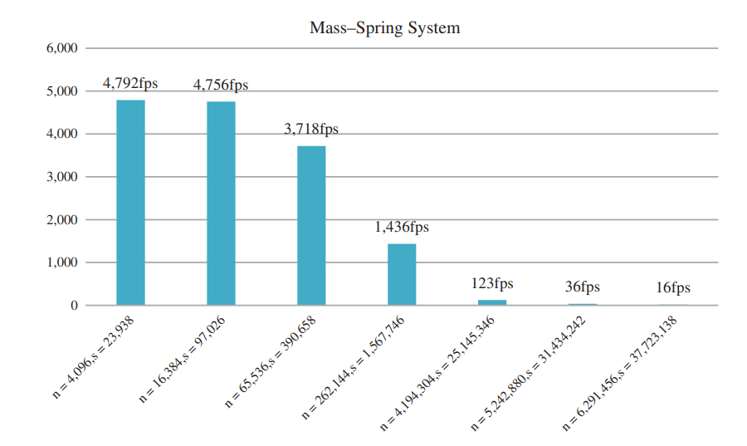
Figure 1: the speeds of the simulating a mass spring system where n is the number of vertices and s is the number of springs (Va et al., 2022, p.239)
The simulation completed the calculations on the CPU main thread, demonstrating how efficient a mass spring damper model can be, maintaining over 120 FPS at all times with 262,144 vertices. The next step up wavered from above and below 120 FPS, with an average of 123 FPS but not consistent. There will only be a few times that a cloth will he that large, unless it is a complex skirt or clothing item, meaning it would be possible to run in the background of any game. This, however, is with no damping forces included in the calculations. Rasheed (2021) explains how not involving damping forces will cause problems in the simulation. Noting these problems could be super elasticity, over stretching and tearing at places there should not be. All these will make the cloth simulation inaccurate, therefore using a mass spring system with no damper is not a viable solution to the overall problem.
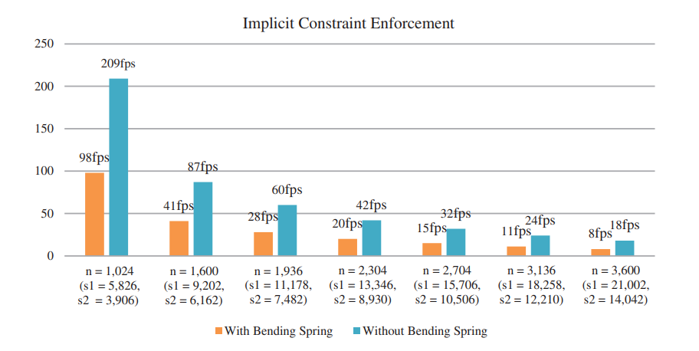
Figure 2: Performance data on a mass spring damper where n is the number of vertices, s1 is the number of springs with bending springs included and s2 is the number of springs without bending springs included (Va et al., 2022, p.239)
This graph more accurately represents what a mass spring damper’s performance will be. Integrating the damping forces, and applying them, requires much more computation time than a base mass spring system. What originally ran at 4,792 FPS will now run at around 5 FPS. The blue bars demonstrate the performance of a basic mass spring damper, where the springs which prevent free flowing and create rigidity are not included. While this does massively improve performance, it does decrease the accuracy of simulation for a life-like cloth, but may be sufficient for other art styles.
Baraff et al. (2003) state the average vertex count can vary depending on what the item is. A complex garment could be 100,000 vertices, whereas a still bed sheet could be only 64. The average for a small curtain would be between 1,024 and 5,000. However, a medium one could be closer to 15,000 and up to 100,000 for a more complex curtain. This means a curtain would simulate at 98 FPS for a low poly cloth and barely anything for a detailed one. This demonstrates that a mass spring damper cannot run on a CPU thread in the background of a game and maintain the needed FPS.
Mass spring dampers are the most commonly utilised method of simulating cloth physics (Mozafary and Payvandy, 2017). This is seen within the games industry as both Unreal and Unity’s cloth systems are derived from a mass spring damper model (Brakensiek, 2023; Unity, 2025). This is not only the base of cloth physics in game engines, but also in modelling tools, for example in Blender (Blender, 2025).
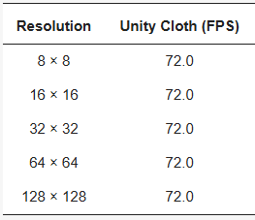
Figure 3: a table which contains the speeds of simulating cloth using Unity’s inbuilt mass spring damper system, based on Kim et al (2025, p.11)
This demonstrates that Unity’s inbuilt cloth system can run a cloth with 16,384 vertices in the background of a game. This is due to the optimisations they implement when the player does not look at the cloth. The program was limited to a maximum of 72 FPS from other functions. These optimisations clearly speed up computation as the simulation can handle a much larger resolution of cloth compared to Va et al.’s (2022) data. However, these optimisations are done through assumptions which causes inaccuracies in the simulation.
Other more specific use cases of mass spring dampers are in simulating woven fabric or yarn fabric. Zhang et al. (2012) used a particle pair system to simulate the interlaced structure of the cloth, where each particle had a different role for the one vertex. There were springs attached to both particles from adjacent vertices. This made more realistic simulations for this specific material. Ahmadi et al. (2021) modelled a bridge with a mass spring damper to simulate vibrations caused when a person walked on it to improve the design and safety.
This research demonstrates that the mass spring damper model is the most user-friendly and the easiest to implement for both a variety of specific and general use cases. Therefore, it must be an efficient way of simulating cloth physics which achieves accurate results.
The other common method of simulating cloth physics is utilising a finite elements method (FEM) (Ascough et al., 1996). They state this provides realistic and sufficient results when used in animations of cloth, as well as accurate draping when dropped from a horizontal position and landing over a model. Reddy and Chamkha (2018) define FEM as a numerical technique which solves problems by dividing a larger domain into multiple smaller elements. This is seen in Salon et al.’s (1995) analysis of magnetic vibrations by simulating them with a FEM to separate the areas of vibration. They note using a FEM allowed them to model the complex geometry of the problem, and catered for the saturable materials by giving regions different properties.
Tan et al. (1999) state when using a FEM to simulate the cloth, the cloth is usually divided into triangles, because when the program draws the curtain, it will draw it triangle by triangle. Kang and Yu (1995) explain that the external forces of the cloth are modelled similarly to a mass spring damper model. They both use Lagrangian’s derived equations of motion to calculate the force with the equation:
$$M\ddot{x}+C\dot{x}+Kx=f_{ext}$$
Kang and Yu (1995) explain how each triangle in the FEM is modelled as a tiny spring shell, where each vertex affects the other two. This means the mass is modelled as a matrix of all the vertices’ mass in that triangle. Therefore, in the equation:
$M$is the mass matrix, meaning how the mass is distributed per vertex in the finite element.
$C$ is the damping matrix, which represents the energy loss or internal friction.
$K$ is the stiffness matrix, which represents the material’s resistance to deformation.
$x$ is the vertex displacement, so $\dot{x}$is the velocity and $\ddot{x}$ is the acceleration of each vertex.
To calculate the internal forces, Bender and Deul (2013) state that it must be calculated step by step. First, the deformation gradient ($F$) needs to be calculated with the equation:
$$F= D_{s}D_{m}^{-1}$$
where $D_{m}$ is the matrix of rest configuration and $D_{s}$ is the matrix of the current position. The deformation gradient is then used in calculating the strain tensor ($ε$). The strain tensor defines how much the triangle has stretched and can be calculated with one of two formulae. The first is used in small deformations, and the second for large deformations:
$$ε= \frac{1}{2}\left(F+F^{T}\right)-I, ε= \frac{1}{2}(F^{T}F-I)$$
where:
$ε$ is the strain tensor.
$F$ is the deformation gradient.
$I$ is the identity matrix.
This equation means that if the deformation gradient is positive, then the strain tensor is also positive, meaning it stretches the finite element. The opposite happens if it is negative, causing it to compress. If it is purely a rotation force, then the identity matrix will approximate to 0, therefore, no stretch occurs. This strain tensor is then used in calculating the stress tensor using equation ($σ=D : ε$) where $D$ is the stiffness matrix and $σ$is the stress tensor. This is used in one final equation to calculate the internal force:
$$f_{int}=\int{B^{T}σ dA}$$
where $B$ is the strain displacement matrix. There are several steps needed to calculate the internal force acting on a vertex. Finally, the internal force needs to be integrated to model the movement over time, which requires a lot of computation (Marinkovic and Zehn 2019). Furthermore, matrix calculations take longer than float point calculations, which further extends the computation time compared to a mass spring damper model (DeLorimier and DeHon, 2005).
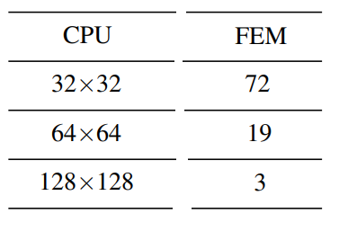
Figure 4: a table that compares resolution of a FEM cloth to the frame rate in the simulation, based on Rodríguez-Navarro and Susín (2006, p.7)
This table illustrates that a cloth with 1,024 vertices will run capably in the background of a simulation. However, as the number of vertices increases, the frame rate drops exponentially in comparison. As a cloth will have roughly 10,000 vertices on the lower end of complexity, and it can only run at 9 FPS with a cloth that size, it is not a viable solution without any optimisations.
Okereke and Keates (2018) suggest there are many scenarios where a FEM method would be suitable to implement. They state one major benefit of using a FEM is the ability to model more complex shapes and topologies. Furthermore, the finite shapes that it is divided into can be customised, meaning it can be applied to many problems. One specific case of this is when Gallagher et al. (1975) used a finite elements method to showcase fluids, and how they wrap around surfaces, and concluded that a FEM approach allowed for more accurate surface cohesion. Pargana et al. (2010) also used a FEM method to simulate fabric in many situations. They found it presented accurate results in all simulations, but excelled when the cloth was taught or had tension in it. Eischen et al. (1996) found that FEM methods give the programmer more control in the flexible parts of the fabric, and allowed for more life-like modelling of the cloth. This shows the wide potential that FEM has to be utilised in not only cloth physics simulations, but all physics simulations.
Comparing the two methods, both are able to simulate not only cloth but a multitude of physics objects accurately (Payandeh and Azouz, 2001). Both are implementable into games, but which to use is down to the developer and the situation in which the object is being simulated. As FEM simulations can compute more complex topologies, and behave more complexly, this may be better for the specific situation the object is needed (Foucault et al., 2008). They used FEM to model computer-aided design models of varying sizes and shapes and found accurate results.
However, using the data from the tables, the frame rate is slower in using FEM than a mass spring damper in small topologies. In a cloth with 1024 vertices, a FEM model is 26.53% slower than the mass spring damper with all springs included. On the other hand, in larger objects, a mass spring damper is slower. In a 64 X 64 resolution, a FEM approach is 137.5% faster. This further demonstrates that the method implemented should depend on the situation.
A mass spring damper model is implemented more in industry compared to finite elements, due to the reduced memory usage (Hong et al. 2016). FEM requires much more ram space to store all the vertex matrices and compute more complex calculations. This led to game engines, and most games themselves, implementing a mass spring damper model, so the RAM was free to compute other parts of the game (Figueiredo, 2020). Hairsova (2020) stated game engines opt for an optimised mass spring damper model where some of the calculations are baked when the player does not look at the cloth. Many games use an optimised model of either approach, but usually a mass spring damper model is adopted, depending on the situation.
One major way these methods are optimised is by offloading the work to the GPU with a compute shader (Huynh, 2011). He states GPUs are much faster at completing mathematical equations, meaning one main optimisation technique is to write a shader that is sent all the physics calculations at the start of the physics update loop. This calculates the physics in the background of the rest of the update loop and then batches it back to the CPU to draw the result to the screen.
There are two main ways of simulating the physics on a GPU, and the main one is Jacobi (Frâncu and Moldoveanu, 2014). They state Jacobi uses the previous position data, along with neighbouring position data, to determine where the particle should go. This allows for parallelisation of the computation which makes it ideal for a GPU to solve. Li et al. (2020) suggest this can be used in a cloth by computing all the spring constraint forces and then, using Jacobi, look at the adjacent spring information and use it to move the individual vertices. Li et al. (2023) used this method and stated it is better to calculate all the spring maths in one dispatch and then resolve the springs in another dispatch to avoid the race condition of moving the same particle. Kim and Lee (2024) further improved this by using a Jacobian Projective Dynamic algorithm which took Jacobi and made it more reactive and accurate. However Lan et al. (2024) suggest that while Jacobi is easier to implement and is perfect for parallelisation, it can be very inaccurate and look more elastic than just force based solving. This is because it converges very slowly with the constraints of the springs meaning it takes longer for the cloth to settle which makes it look bouncy and elastic.
The other main method used for simulating cloth physics on a GPU is called Gauss-Seidel (Fratarcangeli et al., 2016). They describe Gauss-Seidel as dividing the cloth into sections and colouring them to identify each section. That section is then solved fully by the compute shader and another coloured section is passed in. This makes it a much more iterative solver and therefore converges quicker. Quan et al. (2020) states this is a much more complex and harder to develop method of simulating cloth physics but can be beneficial in more complex cloth shapes or conditions as it can be more accurate.
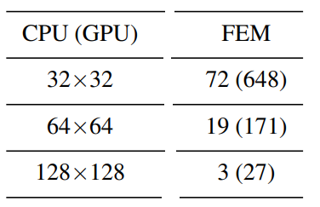
Figure 5: shows part of the table that compares resolution of a FEM cloth to the frame rate in the simulation, now including GPU simulation data, based on Rodríguez-Navarro and Susín (2006, p.7)
The GPU data in this table comes from the equations for the cloth simulation being calculated on a compute shader using Jacobi. This shows a flat 800% increase in frame rate when a FEM model is simulated with a compute shader instead of just on the CPU.
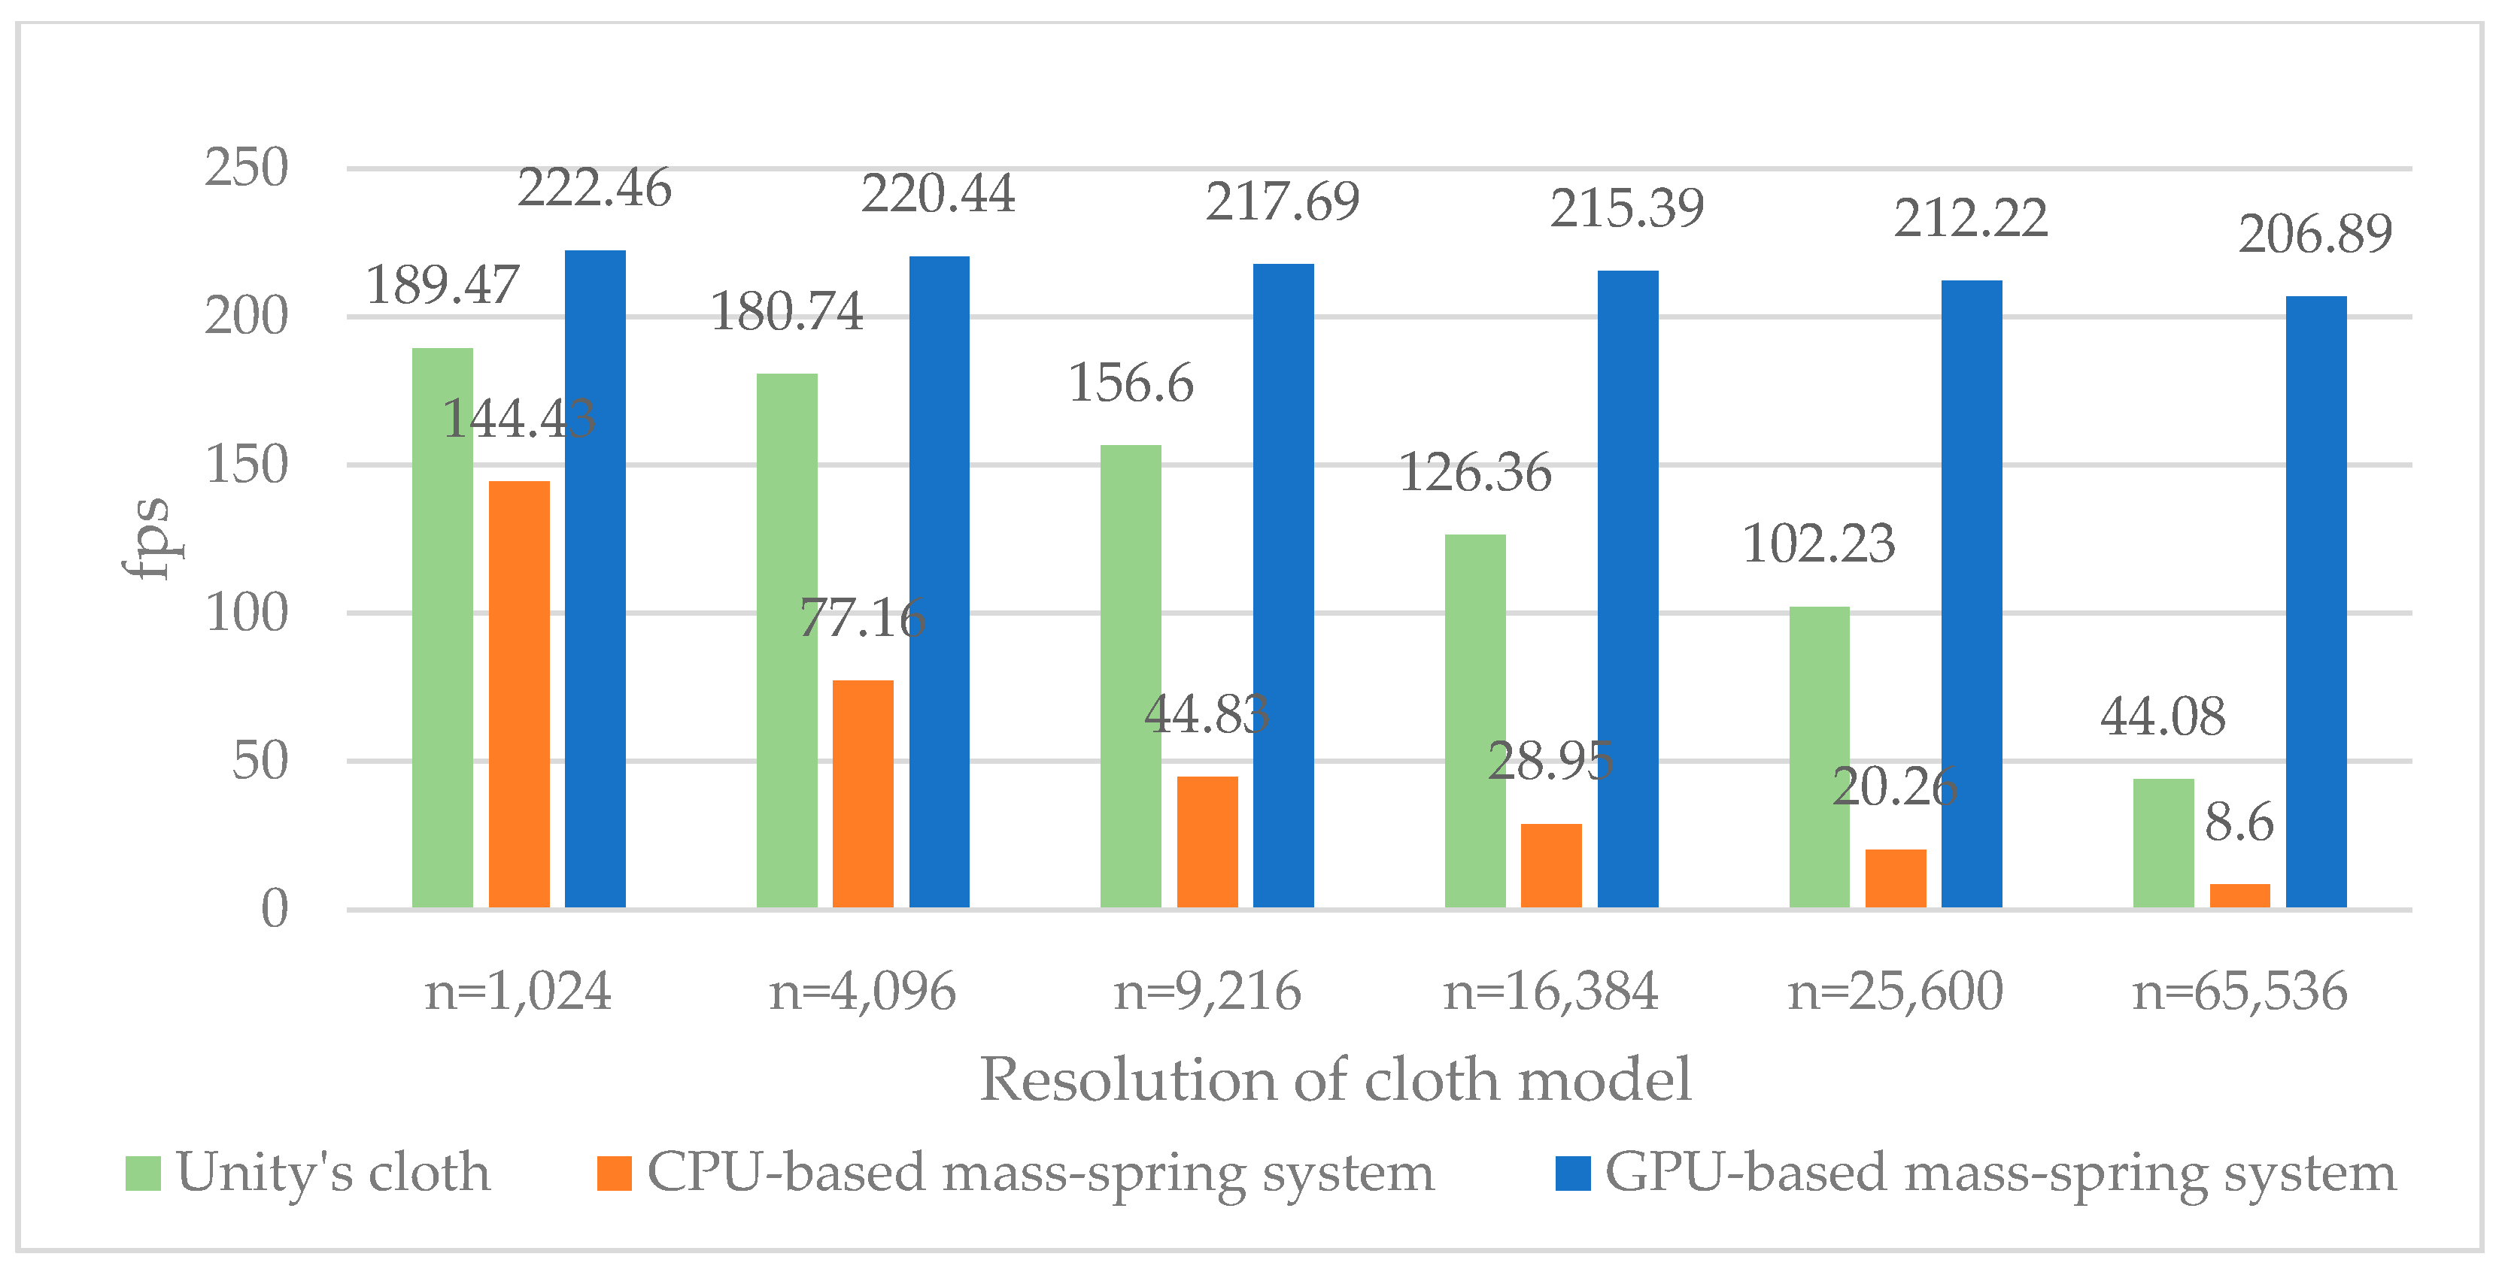
Figure 6: shows a comparison of FPS to number of vertices across a variety of implementations of mass spring damper cloth (Va et al., 2021, p.14)
The orange bars demonstrate the performance when computing all calculations on the main thread, and the expected exponential decrease in FPS when the number of vertices increase is seen. The green bars are how the game engine Unity applies its cloth physics. As Unity uses a mass spring damper model with optimisations, an increase in performance is seen in comparison. At 65,536 vertices, Unity can perform 412.558% quicker and almost maintain a 60 FPS simulation. Furthermore, Unity is able to run basic cloths in most simulations at 120 FPS or more, which is the current refresh rate of most consoles, and what most games in the industry perform at (Huhti, 2019). However, Unity is one of the examples Harisova (2020) found that optimised the cloth when players do not look at it, which creates the inaccuracies, therefore, while it performs much better than a CPU-based simulation, it still is not perfect.
The GPU performance data, represented by the blue bars, is consistently able to perform at high FPS, no matter the size of the tested cloth. There is a noticeable difference from not only CPU-based simulation but also in the optimised version Unity uses. Moreover, the method of implementing mass spring dampers on a GPU compute shader is capable of performing at the required FPS rate for all games and all consoles, even when the cloth is complex. Simulating a cloth with 4,096 vertices, a FEM using a compute shader runs at 171 FPS, whereas a mass spring damper runs the simulation at 220.44 FPS. This is a 28.9% increase. Furthermore, when simulating a cloth with 16,384 vertices, FEM ran at 27 FPS, and the mass spring damper ran at 215.39 FPS. This is almost a 700% increase. This highlights when the size of the cloth increases, the mass spring damper is more efficient to simulate when using a compute shader.
Another optimisation technique is built around the situation the cloth is in (Ozcan et al., 2023). They used a mass spring damper to model vibrations running through the front of a car to test stability. However they struggled to maintain a stable frame rate, meaning the physics of the simulation were not accurate. As they were testing the safety of a car in a physical environment, this was not good. They decided to use non-linear equations with the assumption of what the front of the car originally looked like. Using tools such as Carmaker, they could use arbitrary numbers for spring tension and rigidity to speed up calculations, based on the model and shape of the car. This showcases how the environment a cloth simulation is in may allow for some numbers to be predetermined in the calculations to speed them up.
Denimal et al. (2023) suggest the simulation could be optimised by changing the topology of the objects. They state different geometries allow for clustering of vertices, where forces are just applied to an area of the cloth, rather than having to calculate every individual vertex’s update for the same force to be returned due to them being so close together. They also found that some of the topologies resulted in needing weaker damping forces, which made calculations quicker to perform. Both these improvements seen from topologies would only affect mass spring damper models, due to FEMs being able to take any shape already.
Murugaratnam et al. (2015) state a coupling method can be used where FEM is used with discrete element methods (DEM). DEM models each individual shape within the cloth as its own object, whereas FEM is a continuous approach, where the objects are all connected into one cloth. Combining the two methods allows for certain calculations on some vertices to be irrelevant and therefore cut out. This reduction in the required number of calculations speeds up the program.
Munjiza and Jhon (2002) state that size plays a big part in FEM’s optimisations. Shrinking the object while maintaining the same geometry reduces the weight, thickness, length and cross-section size. All of these reductions reduce the size of the numbers in the equations and leads to them being performed quicker. While this is true for mass spring dampers as well, FEMs use matrix calculations, therefore it affects them a lot more.
In summary, this literature review researched the problem of cloth physics needing to be completed in a small time step. It demonstrates that both mass spring dampers and finite element methods can accurately model cloth behaviour, with each method offering distinct advantages. Mass spring dampers are lightweight, easy to implement, and are used in many places in the games industry due to their lower memory requirements, especially when used with a compute shader. On the other hand, FEMs provide higher accuracy and more control over the material’s properties and complexities. However, this does come at a cost of increased computational demand, even when modelled with a compute shader.

Research Methodologies
Alharahsheh and Pias (2020) define research paradigms as the approach taken to gain knowledge or the method used to research an area. Furthermore, it is how the research is then used in the project to gain further outcomes and what data the project produces. Park et al. (2020) describe one approach as positivism, where there is a single, objective reality being measured and the data is collected through measurement and quantitative measures. Ryan (2018) describes a different research methodology as interpretivism, where knowledge is accumulated through extensive interviews and qualitative data.
This project has and will mostly incorporate a positivism approach. This is due to the key questions and objectives outlined at the start. The aim is to optimise a cloth physics simulation to run efficiently and accurately in the smallest time step possible. The only way to test this is by measuring FPS and frame times, monitoring if it can sustain above 120 FPS at all points of the simulation. This is data-driven quantitative research. Furthermore, to learn what current methods exist, and how they perform, will require their FPS’s quantitative data. In regards to optimisation techniques, quantitative data is used to measure how much better they perform. Additionally, the data precured from this project will be quantitative measurements of the FPS counts from simulating varying complexities and sizes of the simulated cloth.
However, there are points where qualitative research is needed. Learning the optimisation techniques, and how they affect certain simulations better than others, was learnt through in-depth accounts of the methods used. Furthermore, testing accuracy of the cloth is down to the user’s interpretation as there is no metric to measure it. This means interpretivism will be required to fully assess the success of the project, while not necessarily being the main focus, as the one main measured component is quantitative.
After conducting the in-depth literature review, a mass spring damper model will be adopted for the project’s simulation. This is mostly due to the performance capabilities of it compared to the FEM. Mass spring dampers are able to perform at high FPS counts while simulating simple and complex cloth, whereas FEMs would have higher frame time differences and occasionally drop under 120FPS when simulating larger cloths. This shows mass spring dampers are more capable of being simulated in the background of a game as it requires less computation time to calculate the forces each frame.
Another main factor for deciding on utilising a mass spring damper is the more widespread use cases within the games industry. With both the main game developing engines using an optimised version, and market-leading modelling software also using a mass spring damper, it will be more beneficial to the industry to explore potential optimisation methods for a mass spring damper. FEMs do have the benefit of modelling more complex meshes and topologies, but this finds more use cases in engineering problems rather than within games. This is due to the key element in modelling is to reduce vertex count where possible, making the cloth object less complex (Lohikoski-Håkansson and Rudén, 2013). One final deciding factor was mass spring dampers are easier to implement, meaning more developers will understand what the code is doing and be able to alter it to suit their requirements, making it even more usable.
The project simulation will aim to optimise the cloth by using a compute shader on the GPU. This is due to the clear performance increase seen from the research. It will also use a Jacobi method on the GPU as this is the industry average and what Unity, Nvidia and many companies use as it’s primary method. Bader et al. (2023) state that most laptops and computers have a dedicated graphics card, and the few laptops still with integrated graphics are improving rapidly. This indicates that almost every device is able to run a compute shader for the cloth and this will only improve as graphics cards improve. This means that it is a suitable solution for the industry now and will improve further over time. Furthermore, running the physics through a compute shader was the only optimisation possible across all cloths, no matter the topology or size, and therefore would benefit all simulations of cloth physics.
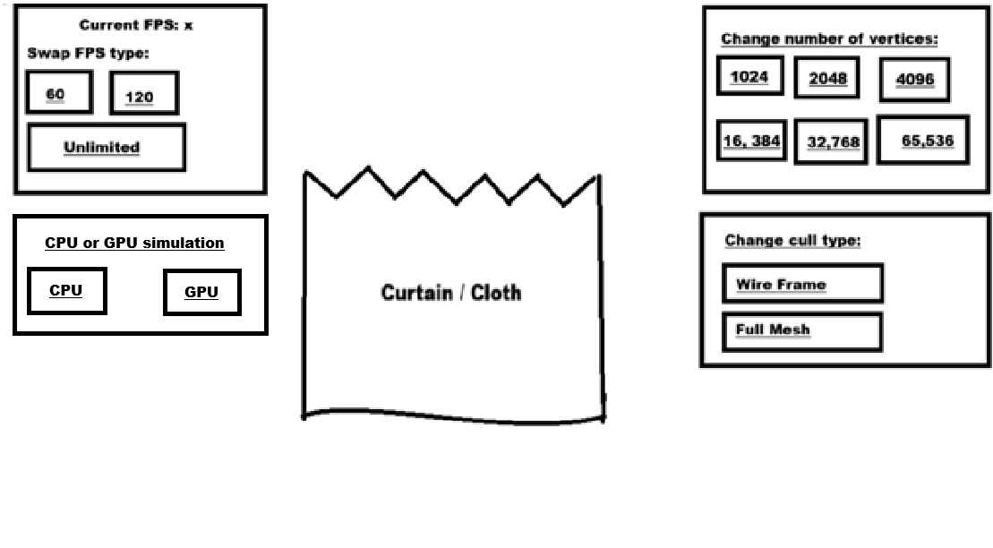
Figure 7 the wireframe diagram of the simulation, demonstrating where the buttons and cloth will sit from the camera’s perspective
The simulation will be made in Visual Studio, using DirectX11 to draw the graphics to the screen. This is because it does not limit the FPS with the draw call, unlike OpenGL which limits the program to 60FPS with the draw function callback. The compute shader will be written in high-level shader language in Visual Studio, and all the data will be batched over to it at the start of the update call. It will then calculate all the required data and batch it back for the CPU to use and draw.
The simulation will have multiple options to change the simulation in different ways. One of these options will be swapping from simulating on the CPU to the GPU, as this showcases the optimisation’s speed difference. Another is swapping the FPS limit. There will also be a number of options that affect the FPS of the simulation. Two of them are used to limit the simulation to 60 FPS and 120 FPS, as these are standard benchmarks for games. The other button will leave it unlimited to see the full capability of the simulation. The third option will change the number of vertices in the cloth to predefined amounts that work with the cloth ratio of height and width. The last option will be swapping the mesh rasterizer into wireframe to see the individual vertices and how they are connected with the springs. These options will be changed at run time with buttons presented to the screen with ImGui. This is a bloat free library imported into projects that works as a user interface library in C++. This means the buttons will be displayed to the screen and when the user presses them it updates the data at run time, and changes the simulation. Furthermore, the simulation should have further user interactions as they can drag the cursor over the cloth to act as dragging a hand across it. This will showcase how the springs stretch and move when the cloth is touched.

How the artefact was implemented:
The artefact window is created through DirectX. The DirectX window itself was created with buffers that are instantiated, leading to the pipeline data being initiated before any update frames are called. The program then calls update every frame, before drawing to the screen to present the frame to the window. The camera is locked in place and looks forward in the scene. All the pixels were globally lit, so no shadows were cast, and every part of the cloth was visible at all times. There were three rasteriser states made on start which were: line, fill and no cull. The line rasteriser is used to view each of the springs and witness the gathering of the cloth. The fill rasteriser is used for a front facing cloth, and the no cull rasteriser is accurate to real life, as the cloth is a grid of particles and it should be two-sided, which no cull displays.
The cloth was made with a grid of particles. Particles was a struct which contains position data, velocity data and data required to draw each of the particles. This grid was made with a width and a height determined by the user. It pins every eighth particle, so they does not move, like it was a curtain hung on those particles. Each particle is then connected with springs. The springs were a struct that contains a rest length, spring constant and current length. It also contains which two particles it connects. All structure springs were made first, as these have the highest spring constant. They directly attach to both the horizontal and vertical adjacent particles. Then the shear springs were made with a constant that is 75% of the structural ones. These attach diagonally adjacent particles. Finally the bend springs were made at half the spring constant of the structural springs. They attached to the neighbours’ neighbouring particles. These were all given their data, as the rest length was calculated by getting the distance between the two particles before any update frames were called, and stored into a vector. The cloth is then divided into triangles for an indices buffer meaning it can be drawn.
The compute shader buffers were then created that map the spring and particle vectors to the compute shader. At the end of a GPU update it maps back to the CPU vectors leading to the draw function being called. Variables were then sent to the GPU, such as gravity, which allows the GPU to accurately model the cloth when simulating on it.
To update the cloth, it first checks whether the cloth is being simulated on the CPU or GPU. Both operate in the same manner, but the GPU simulations must first dispatch to the compute shader. Firstly gravity was added to all the particles that are not pinned. Then, for a set number of loops, it checked to see if the spring is overstretched beyond the set stretch maximum. This means it checked the current length and identified if it was longer than the maximum stretch allowed by the spring. It then used the unit direction of the spring, and the inverse mass of the particle, to apply a position correction to each particle to simulate the spring constraints between the particles. This is calculated multiple times per update frame; as if multiple springs affect one particle then it would only use the last position correction which makes the cloth stretch downward over time. Looping the calculation for a set number of iterations means an average between the two springs is used, making it more accurate. The draw function was then called to update the screen with the new positions of the particles. In a GPU update, the gravity is added in the first dispatch. Then, to model the springs, the new positions must be calculated in one dispatch, and then applied in a different dispatch. This is because the GPU calculates each of the springs’ corrections simultaneously as it is solved with threads. This means if two springs are both attached to the same particle trying to change the position of the same particle, then the correction position gets overwritten. To utilise the iteration loops, it must be dispatched in two separate GPU calls. This is the Jacobi method of simulating on the GPU.
The variables can be changed to affect the cloth simulation and model different types of cloth. The more iterations leads to a more stable and rigid cloth. A lower amount of iterations would make a stretchier elastic cloth. A higher spring stretch limit also creates a more elastic cloth. Dependent on what the cloth simulating is used for will affect these values, for example, a thin curtain would be more elastic and stretch further than modelling denim clothing which would need a more rigid cloth with a smaller maximum spring length.
To further highlight the accuracy of the cloth, it has been given a red velvet texture as it looks more cloth like. The light is also a directional light that looks towards the cloth, slightly down and slightly right. It reflects the light with the inverse dot product in the pixel shader. The curves in the cloth reflect the light in different directions which helps show when the cloth gathers and simulates accurately. Furthermore, the shadows cast when the user moves the cloth with the cursor help in showing the accuracy of the simulation.
The user interface used ImGui to change the Boolean flags, which changes the parameters of the simulation. It also displays the cloth simulation data to the screen. The buttons allowed the user to change the FPS cap, the size of the cloth, the rasteriser state and how it is being simulated from CPU to GPU. This allowed the user to fully simulate and test the simulation. The user was also able to interact with the cloth by using the mouse. The program tracked the previous location of the mouse, transforms it into world space, calculated the vertex from that position to the current position and then applied that same vector to the vertices around the mouse as a force. This helped showcase the accuracy of the simulation, and the user can clearly see the spring forces between particles.
To model a 60 FPS or 120 FPS capped simulation, the artefact used the chrono library to measure the time difference between frames and add it to an accumulator. When the accumulator is larger than the time step used in the respective simulation limits, it updated the frame. This library was also used in measuring the FPS of the whole simulation and is displayed to the screen.
This data was collected because the FPS is a helpful way of measuring the performance of a program, and if it can sustain 60 FPS or more, then it will be stable enough for a fast-paced game (Joorabchi and Nasr, 2011). This means if the simulation can sustain 60 FPS, then it will be sufficient for an action game or a fast-paced game without causing any performance issues, which could affect the user’s experience. Furthermore, this data was collected for eight different sizes of cloth to test how the complexity or size of the cloth affects the FPS, and if the simulation can be sustained at 60 FPS or higher. The FPS was collected from a CPU and a GPU simulation of the same cloth instance, as this will test the optimisation of using a compute shader. White and Drew (2011) suggest an average of the data across multiple recordings is better to get an overall view of the success of a project. Therefore, ten different FPS measurements will be collected from each simulation, and the average of the ten will be used when comparing against other simulations.
This simulation was run on a PC with 32 GB RAM, 11th Gen Intel® core™ i7-11700 2.5GHz with a 3080 RTX NVidia graphics card. It is important to know the specifics of the device and it’s capabilities that the simulation is running on for data continuity in further research. Furthermore, when comparing this project’s data to other projects’ data, there may be differences due to the variations device’s components and their powers.

Results and Findings
The results were collected by measuring the frame time of the update loop in the artefact and then using this to calculate the FPS. This was repeated ten separate times, and the average of those ten was then used in creating graphs to represent the findings.
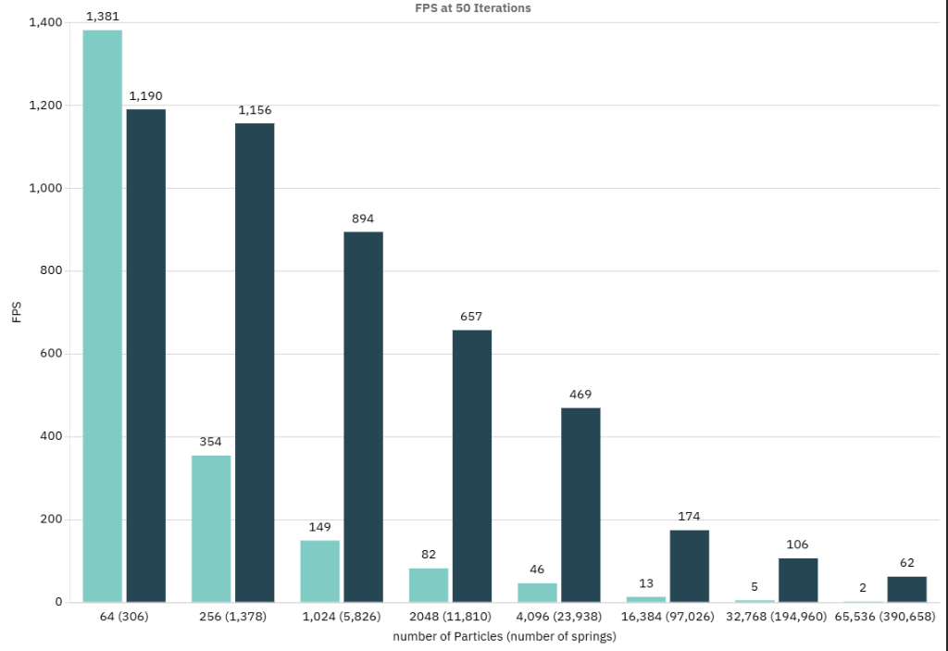
Figure 8 FPS results of the simulation in which 50 spring-calculation iterations were performed per update frame (see Appendix 1 for raw data)
The graph illustrates the average FPS counts compared to the size of the cloth for both CPU and GPU based update loops. The lighter blue demonstrates the CPU data and the darker blue demonstrates the GPU data. The x-axis shows the spring count in brackets next to the vertex count. These directly match up to the options available to simulate in the artefact.
The trend of the data demonstrated that GPU-based computation is usually quicker at simulating cloth physics, except in one instance where cloths have 64 vertices. This is due to the computational cost of dispatching to the compute shader, and then mapping it back to the CPU to draw, which is higher than the cost cut by solving the physics on the GPU. Above 64 vertices, every simulation of cloth physics was solved more quickly when dispatched to a GPU, as the average FPS of the simulation was much higher. The simulations showed a cloth with 256 vertices, the GPU solved the physics 326% faster than on the CPU. For a cloth with 1,024 vertices, the GPU solved the physics 601% faster. This percentage increase further improves as the cloth gets larger, with the largest cloth simulation running 3100% faster on the GPU. This clearly shows the GPU is much more efficient at simulating cloth physics compared to a CPU-based solution.
The data also demonstrates that the size of the cloth drastically affects the FPS rate. This is very important because if the FPS gets too small, then the time step between frames becomes too big which increases the size of the forces, making the simulation very unstable. The simulations showed when the FPS dropped below 50, the cloth became inaccurate and showcased stretching and over-elastic behaviours. The further it decreased, the stretchier and more inaccurate the simulation became. This meant the cloth with 4096 vertices was starting to stretch too far, therefore, the cloth with 32,768 vertices was very inaccurate when being simulated entirely on the CPU. On the other hand, when using a GPU to simulate the cloth physics the cloth was able to calculate all the physics within a quick enough time to maintain an average FPS higher than 60.
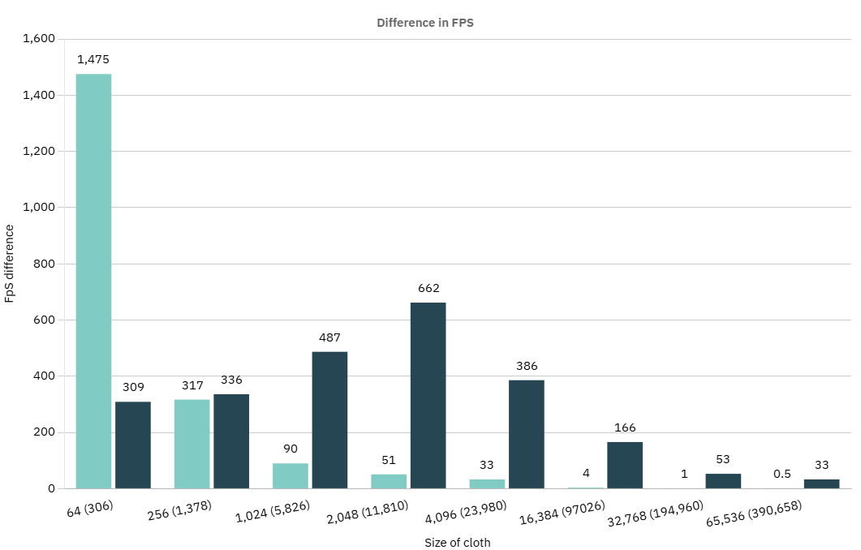
Figure 9 difference in the highest and lowest recorded FPS in simulations performed at a constant 50 iterations (see Appendix 1 for raw data)
The graph indicates how stable the simulations were, as the larger the difference between the highest and lowest recorded FPS, the lower the stability. This is due to the unpredictability of the FPS would be at any point during runtime. In a cloth with 2,048 vertices that is being simulated on the GPU, it ran at a lowest recorded FPS of 209 and a highest of 871. This makes it very hard to predict what the cloth would consistently be running at. In the biggest cloth simulation, there were points at which the simulation dropped below 50 FPS, and it started to become inaccurate. While the average FPS of the largest cloth was high enough to indicate a stable simulation throughout, the raw data collected has measurements of under 50 FPS, which shows it could have moments of inaccuracy.
This variance is higher when simulating on the GPU due to how it works. When dispatching to the GPU, it spools up threads. The number of threads varies based on the number of particles and the number of springs. The threads then solve the physics calculations for each of the vertices and springs and then map back to the CPU. The time required to do this varies due to some particles having smaller or fewer forces to calculate, like no user interactions, or certain springs may be slack, and therefore no forces would need to be calculated. This decreases the time required to update on that frame. However, on the next frame, there may be more springs which require solving, and this results in a longer time step to solve all the calculations.
Since the CPU is only one thread, the amount of variance decreased proportionally to the average FPS of the simulation. On the other hand, the GPU will have more threads spooled on bigger cloths, which causes the initial increase of variance in the simulation. As the cloth gets even larger, the average FPS is lower, and the variance decreases. If all the simulations could run at a higher FPS the trend would show a constant increase as the cloth size increased. So while the GPU may solve all the physics faster, it is less reliable in keeping a consistent FPS count. This only matters however, in very large cloths as this is the only time it starts to appear inaccurate at points in the simulation.
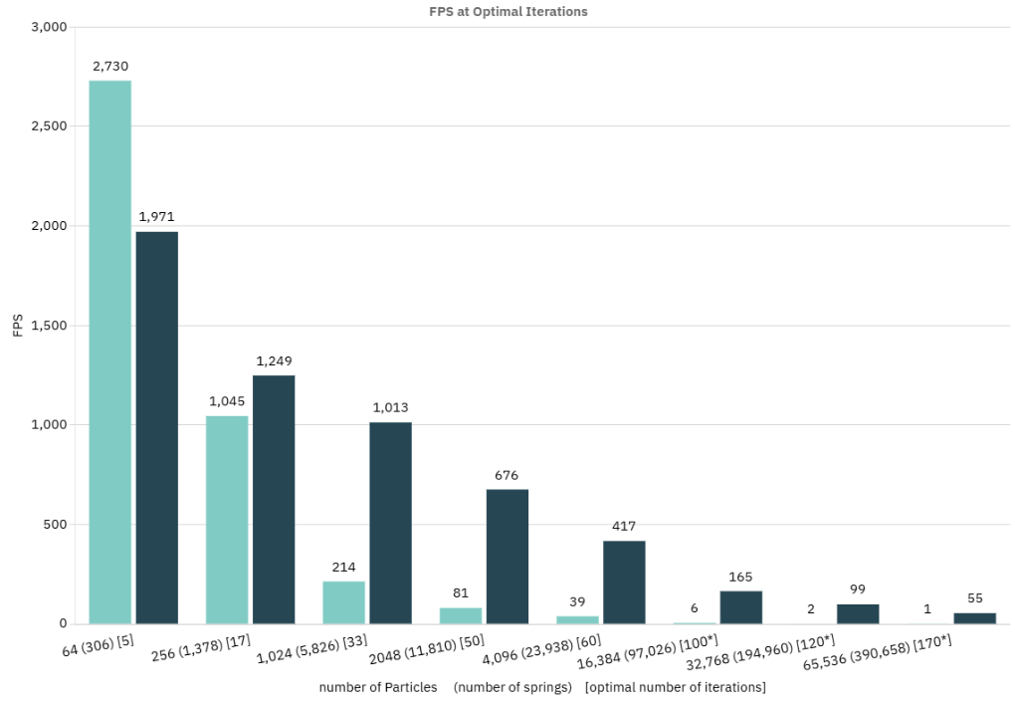
Figure 10 FPS results of the simulation in which the optimal number of spring-calculation iterations were performed, where the cloth still looked accurately simulated, per update frame (see Appendix 2 for raw data)
This graph also illustrates the average FPS counts compared to the size of the cloth for both CPU and GPU based update loops. However, the x-axis now shows the optimal number of iterations in square brackets next to the spring counts. The optimal number of iterations was the lowest amount of iterations required to make the cloth simulate accurately, meaning no excess calculations were being performed. The biggest three cloth simulation sizes had too large an optimal iteration count for the CPU to simulate the cloth accurately. This was due to the amount of calculations required each update, and therefore led to a very large time step between frames. The chosen numbers were predicted based on calculations that used the trend of the previous data gathered. This is demonstrated on the graph by the asterisk next to the iteration count.
This graph exaggerates the same trends seen when simulating at a constant 50 iterations. The smallest cloth was simulated much quicker on the CPU due to the costs of the dispatch function calls. Instead, this time it was 800 FPS quicker rather than the 200 FPS seen before. This demonstrates how the number of iterations can affect the FPS as it needs to calculate excess equations that do not affect the overall simulation. This is further seen in the cloth with 256 vertices, as the CPU ran at 1,045 FPS, which is 296% quicker than before because it used 17 iterations instead of 50. The graph also shows the FPS decreased as the cloth size increased, along with the GPU generally outperformed the CPU in every simulation except with the smallest cloth.
Figure 10 does show that the CPU is not able to model larger cloths, no matter how many iterations are used. This is because it is either inaccurate due to the iteration number being too small and therefore not modelling the springs accurately, or because the iteration count needed is so high that the time step becomes too big also making the cloth looks inaccurate. However, the GPU is still able to model the cloth physics accurately for all sizes of cloth, as the average FPS of the simulations was consistently high enough to keep a small enough time step.
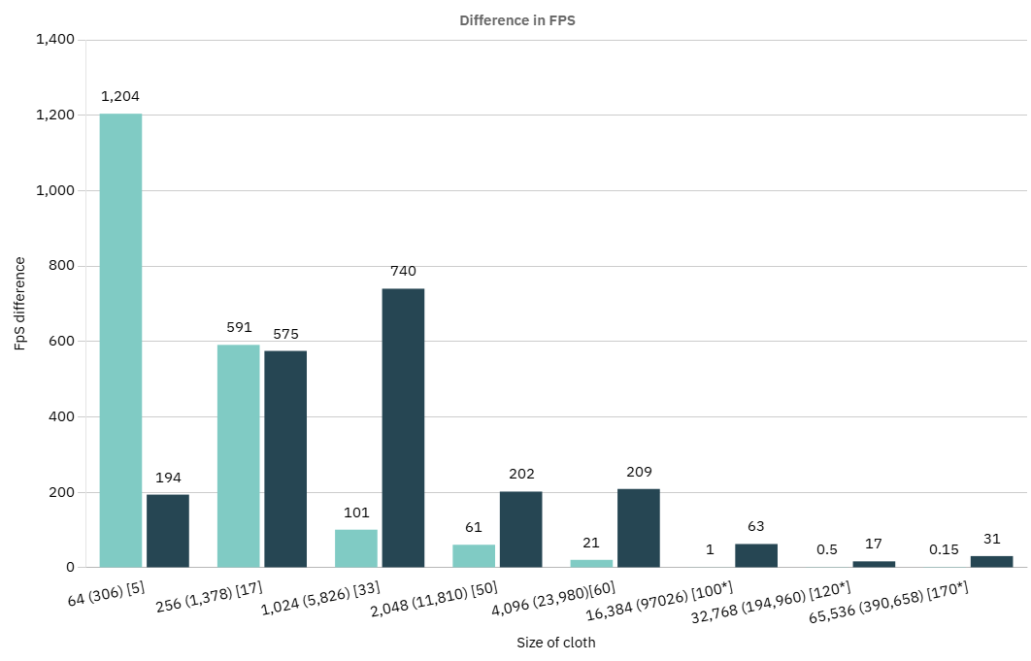
Figure 11 difference in the highest and lowest recorded FPS in simulations performed with the optimal number of iterations used (see Appendix 2 for raw data)
This data further shows what was seen at 50 iterations. As the number of vertices increases, then the variance increases in the GPU simulations. However, it does break the trend in the 4,096 vertices simulation as it is much lower than the previous size, which is the opposite of what was recorded at 50 iterations. This is likely due to the threads and the workload being more consistent in that instance. This further indicates the instability of the GPU simulations, but it is able to simulate all the cloths, except the largest, above 60 FPS at all times. In the largest cloth simulations, it dropped to a low of 35 FPS, which is not high enough for accurate simulation. However, the average was still high enough, even at 170 iterations.
Figures 8 - 11 demonstrate how the GPU outperformed the CPU in most situations because it handled higher iteration counts and larger vertex counts than the CPU. It maintained a high enough FPS average for all sizes of cloth to keep the simulation accurate. However, it is much less stable and has much higher variations in FPS from frame to frame. The data collected showcased the CPU was much more stable with smaller variance and was more efficient at solving small cloth simulation due to the smaller amount of calculation required and the cost of dispatching to the compute shader. The data across the two sets of iteration counts followed similar trends of computation speeds decreasing as the cloth increased, but it decreased less for the GPU than the CPU.

Discussion and Analysis
The results in figures 8-11 clearly indicate the GPU can simulate cloth physics must quicker on average than a CPU. This matches what was expected from the research as it is consistent with what Va et al. (2022) believed. They stated the GPU was much faster at simulating the cloth physics due to the GPU being able to compute equations quicker than the CPU, since cloth physics requires a lot of calculations to simulate. This means the GPU should be expected to perform better, which was seen in the results.
Rodríguez-Navarro and Susín’s (2006) data and Va et al.’s (2021) data indicate that the GPU will simulate the cloth quicker than the CPU, and the general simulation speed decreases as the cloth gets larger. Their data sets also show the percentage difference of FPS data between GPU and CPU increases as the size of the cloth increases. These trends were supported and mirrored in data collected from the artefact, as the cloth was simulated quicker on the GPU in all simulations except 1 (seen in figures 8 and 10). This confirms the investigation went successfully and the artefact’s data has validity.
There were some contradictions and differences in the data collected from what was expected. One of these is how cloth with 64 vertices being simulated quicker on the CPU than on the GPU. No research was found specifically on GPU simulating cloth at such small sizes, however, Han et al. (2025) suggest there is a large overhead cost in dispatching to the GPU. This is due to the fact that moving data around in large batches takes a lot of time for it to get to its destination. This overhead cost takes longer than simulating the fewer number of calculations needed in smaller cloths on the CPU, resulting in lower FPS measurements. Another difference shown in the results was the rate at which the simulation speed decreased for both CPU and GPU based simulations (seen in comparing figure 2 and 6 to figure 8 and 10). As the method of implementation was similar to both Provot (1995) and Va et al. (2021), this difference in results is likely due to a change in device specifications.
One new finding gathered from the investigation was that GPU has a greater difference in FPS from frame to frame (seen in figure 9 and 11). This means the stability is much lower than on the CPU, which was unexpected. However, upon further research, it was found that GPUs generally have much more varied frame times when used in simulations (Örmecioğlu et al. 2025). They state that because the GPU solves through threads simultaneously, if there is a smaller amount of calculations to solve then it will solve them a lot quicker, and this speed increase proportionally decreases as the number of equations increase. Therefore, as each frame could have differing amounts of equations, based on what particles are currently being affected, the time spent on each update frame can vary drastically. This variance in frame time makes the GPU much less stable, as one frame, the simulation could run at 120 FPS, and the next 80 FPS. As most modern devices can run at 120 FPS, this potential fluctuation could cause problems for the user’s experience, and there could be frames where the cloth looks very inaccurate. However, this is only a problem with very large cloths, meaning in the vast majority of use cases, a GPU simulation would maintain above 120 FPS, making the cloth appear accurate and realistic at all times.
One major effector of the results for this artefact was what device the simulation was run on. Singh (2016) states the specifications of a computer will drastically affect how quickly a device can sort memory, perform calculations and refresh the screen in an update loop. The device used for a simulation may have a limited cap on the FPS, so it may never simulate quicker than 60FPS. It could also mean if a device has a smaller RAM, or a GPU with less power than more current models, then it will perform the calculations at different speeds. The higher-end device parts will calculate the equations of the cloth physics quicker, and therefore update the cloth more often, as the delta time between frames will be smaller, which results in a higher FPS. This is why all the data that has been collected about cloth physics throughout different studies have different results for the exact FPS numbers, however, the trends all match.
Furthermore, the bandwidth capability of dispatching to a GPU can change from device to device. Smaller bandwidth means smaller data transfer, meaning it takes longer to dispatch. It also means if the amount being dispatched in one go is too big, then it will not map the data back to the buffers correctly. This results in some simulations of larger clothes not visually updating, but still calculating all the equations needed. It only cannot map the data back to the CPU with the amount needed to be sent back in a smaller bandwidth resulting in it not getting drawn. This does, however, still produce accurate FPS data, as all the lines of code are being executed, but the result is not visually correct.
Another element in the artefact that could have affected the results collected are the variables that control the stretchiness and strength of the cloth. Most importantly, the iteration count of the number of times it loops through the spring constraint calculations. Modelling firm fabrics, like denim, will require a higher number of iterations, which will take longer to perform per update frame. This will affect the FPS of the simulation. Furthermore, the larger the cloth, the more iterations needed to converge on the average position for the vertices, as the number of total springs affecting the cloth in one direction increases with the number of total particles in that direction.
The simulation used the Jacobi method to simulate movement on the GPU. This method allowed for a similar implementation to the full force modelling on the CPU. This made the cloth behave similarly on both the CPU and GPU, which was visually appealing to see the accuracy in the artefact. However, this method may require less or more calculations than other methods, like Gauss-Seidel. Sbîrnă and SBÎRNĂ (2024) state Gauss-Siedel is usually quicker than Jacobi, as it modifies the data while it is used, as opposed to Jacobi, which calculates everything and then applies it after in a secondary dispatch. This allows Gauss-Siedel to converge on the average position for the update frame between the two springs faster. This design choice will of influenced and affected the results of the artefact and made the FPS lower than its potential but made a smoother artefact to observe and was easier to implement while still generating accurate results.
The design choice to use DirectX11 in the artefact will also have affected the FPS measurements of the simulation. Törnblom and Hellman (2020) researched different application programming interfaces (API) and how the backend of each of them affected the speed of a program. They found DirectX11 is the easier to set up and has very little difference compared to DirectX12. DirectX12 did perform quicker on multithreaded programs over at least four cores, however, in most situations they were both very similar in performance. They also found OpenGL did not provide enough customisation to the backend and forced the program down certain function paths, which caused it to perform slower. Vulcan, on the other hand, allowed for much more customisation of the rendering pipeline, which reduced the time required in the draw function, meaning actually produced better FPS values, but is much more complex to set up and create in. Therefore, DirectX11 was chosen for the project as there was more prior experience in this API, and the rendering pipeline and buffers were easier to create than in Vulcan, whilst still giving more freedom than OpenGL. This decision will of impacted the results obtained in the artefact.
Due to all the decision choices and selected approaches, an artefact was produced that was able to achieve the main goal of the investigation. A simulation of cloth physics was produced that performed at the required FPS for almost every simulation, and the optimisation technique of dispatching to a compute shader allowed the program to perform at this speed. The change in FPS recorded when using a compute shader compared to not using one showcased the optimisation technique worked as intended, and allowed the artefact to simulate at higher speeds. It did this while still simulating accurately without overstretching or appearing distorted or incorrect. Furthermore, as it dispatched and solved on the GPU, the cloth physics were solved on a separate thread to the main thread. Based on the artefact’s results, the cloth was able to be simulated continuously in the background of a game on a separate thread, while maintain a high enough FPS to avoid having to bake the cloth, therefore solving the initial problem outlined in the main aim.

Conclusion
The purpose of this investigation was to research methods of implementing cloth physics and how they could be optimised to potentially run in the background of a game, without affecting the frame rate, whilst maintaining accurate modelling at all points during runtime. These goals were outlined in the research questions (RQ), and the investigation explored the answers for each one (see Aims and Objectives).
RQ1 and RQ2 were solved by the in-depth literature review which created a wider knowledge base to base the research and artefact on. This research developed an understanding of how cloth physics works in general and how it should look compared to real life. It demonstrated multiple methods of simulating cloth physics and how they are implemented. First, when using a mass spring damper and how the springs simulate the stretch in cloth (Provot, 1995). The second was FEM, which divided the cloth into subsections and solved them separately, which took longer to calculate the equation but was more accurate (Okereke and Keates, 2018). The literature review then describes multiple methods of simulating cloth physics on a GPU and the benefits of each. Jacobi is simple and effective, but slower than gauss-seidel which affects data at the same time as it is calculated to converge quicker. It then explored optimisation techniques for both forms of cloth physics on the CPU and how they can be optimised on a GPU. Different techniques had specific optimisations that worked for their respective implementations but using a compute shader was universally effective at improving computation speeds of cloth physics simulation.
Furthermore, the literature review compared simulation data between methods of simulating cloth physics to come to a decision of which method to attempt to optimise with a compute shader. This data also provided a baseline of trends to compare against the gathered results. Information was also gathered about current industry methods of simulating and optimising cloth physics, and why it is not accurate to bake the physics while the player does not look at the cloth.
After conducting the literature review, the aim of the project switched to creating an artefact that implemented what was learnt to create a simulation of cloth that did not bake anything, or use a heuristic, at any point. This meant choosing an optimisation technique that would most effectively speed up the program. To know the cloth would work as intended, it must perform every calculation it needs in every update call and frame. The goal was to create a simulation of cloth physics that is able to maintain above a minimum of 60 FPS, but preferably 120 FPS at all times, and this would be achieved with a compute shader.
The data collected from the artefact demonstrates that a compute shader greatly improved the FPS of the simulation (see figures 8 and 10). The graphs show the simulation was able to maintain an average above 120FPS in cloths as big as 64 X 64 vertices. Furthermore, it could maintain an average FPS above 60 in cloths up to 256 X 256 vertices. Although, the actual frame times in these simulations varied more than when simulating on the CPU, and meant at points in the simulation it dropped below these benchmarks (see appendices 1 and 2). However, overall it performed more efficiently than on the CPU and therefore did work as an optimisation technique that could be applied to all simulations of cloth. This means the artefact did fulfil the requirements of RQ3 because it ran much better through a compute shader than a CPU so would improve the cloth simulation in games, but in very large cloth sizes, the stability could cause some problems (see figures 9 and 11). A potential solution to this could be to apply multiple optimisation techniques that are specific to the type of cloth being implemented, or the situation it is in. A compute shader works across all simulations of cloth, so specific optimisations for mass-spring dampers could be used alongside this to fully achieve a result that maintains above 60 FPS for very large cloths at all times.
The main aim of the investigation was to identify an optimisation of cloth physics that could be utilised to run on a background thread to maintain accurate simulation of the cloth throughout running the program. Furthermore, investigating specifically using the optimisation to avoid baking or applying a heuristic to the calculations, allowing it to maintain accuracy throughout. Figures 8 and 10 show the compute shader has mostly achieved this with the FPS of the program being far superior to just running it on a CPU in all cloth sizes except the smallest. It also runs on a background thread, as the CPU can dispatch to a GPU and leave it perform all the calculations, while continuing the main thread’s update loop. It then batches the data back at the end of the update call. This means the performance of the CPU is not affected from simulating the cloth this way and therefore, keeps it free for updating the game state. This means it would be able to be used in games and solves the problem of baking the cloth while the player does not look at it, maintaining the crucial immersion for players.

Recommendations
Many further experiments and investigations that could be performed to further develop the findings and expand the finding from this paper. These range from testing different types of cloth to comparing results of different methods of simulating.
Testing if different types of material are simulated would advance this research further, as it would test if using a compute shader could be used to improve the FPS of more complex arrangements of particles. For example, woven fabrics have multiple springs between particles to simulate the intertwined nature of yarn. Furthermore, more complex shapes could be modelled, for instance dresses with multiple frills, or how multiple pieces of fabric join to each other, and how this affects the stability of the simulation. This could test whether the GPU can be used to maintain a stable FPS whilst modelling more complex clothing, intricate designs or particle arrangements. This could then be utilised to model fashion for adverts, or on shopping websites in a 3D space, providing a more interactive experience.
A different angle to advance the knowledge gained could be testing this on a cloth simulation that uses FEM. Investigating if more complex situations that require a FEM model, like engineering problems which require high accuracy, could be sped up or have their accuracy improved by incorporating a compute shader optimisation. This could potentially free up the CPU to perform more equations for the engineering problem that may allow for more complex scenarios to be modelled, which could test the safety of more building options, or potentially have the power to simulate more complex buildings.
Similarly, a simulation could be tested using a Gauss-Seidel technique for the compute shader and comparing the speeds and FPS recorded with a simulation using Jacobi. This could potentially create a faster solution for cloth physics and open more doors for increased complexity or size of the cloth itself.
There are also more optimisation techniques which could mean an investigation into comparing a compute shader technique to other optimisation techniques, to test which makes more of an impact to the FPS, could be performed. This could help provide multiple solutions for developers based on the context of the cloth simulation. This could be performed for both compute shaders and FEM methods. Additionally, more optimisation techniques could be applied to a simulation with a compute shader to make a further optimised version of cloth simulation. This could potentially optimise even bigger cloths to maintain an average FPS above 60 FPS and remove any inaccuracies seen in the artefact at very large sizes of cloth. This opens many possibilities for all industries, as more power and more accuracy in complex simulations can allow for more complex solutions to be achievable.
The software the artefact was simulated on was DirectX11. This would have influenced the results, so testing the same implementation of cloth with Vulcan or DirectX12 could lead to different results. This is due to the back end pipeline requiring different steps and could be quicker as less initialised data is being moved around the computer. Exploring which software is best for cloth physics simulations could provide developers with better options for their specific simulation scenarios.
As the specification of the device are known to affect the FPS of the simulation, an investigation into what the minimum requirements are for a simulation of cloth at certain sizes. Another similar area that could be investigated would be testing what the limit is on current best performing devices, or on supercomputers, and how the speed increase affects the stability of the cloth. Furthermore, how the device can affect the number of iterations required for the cloth to simulate accurately could be investigated, as quicker simulations will require fewer iterations to reach a converged result.
Finally, combinations of these recommendations could be used to create the optimum user experience. For example, background simulation using a mass spring damper, but if the user has to interact with it, swapping to a FEM for a more accurate simulation in response to the user. This could provide more accuracy at key moments while still remaining generally accurate throughout the whole simulation. This could be done with different optimisations in future, or potentially swapping to the CPU for more accurate force modelling at points. All of these recommendations would build on knowledge gained in this investigation and potentially provide more comparative data, or different user experiences, that could be more tailored to a developer’s environment in which they are simulating cloth physics.

References
Ahmadi, E., Caprani, C., Živanović, S. and Heidarpour, A., 2021, February. Experimental validation of moving spring-mass-damper model for human-structure interaction in the presence of vertical vibration. In Structures (Vol. 29, pp. 1274-1285). Elsevier.
Alharahsheh, H.H. and Pius, A., 2020. A review of key paradigms: Positivism VS interpretivism. Global academic journal of humanities and social sciences, 2(3), pp.39-43.
Ascough, J., Bez, H.E. and Bricis, A.M., 1996. A simple finite element model for cloth drape simulation. International Journal of Clothing Science and Technology, 8(3), pp.59-74.
Bader, M., Ltaief, H., McInnes, L.C. and Yokota, R., 2023. How We Can All Play the High-performance Game: From Laptops to Supercomputers. Collections, 56(10).
Baraff, D. and Witkin, A., 2023. Large steps in cloth simulation. In Seminal Graphics Papers: Pushing the Boundaries, Volume 2 (pp. 767-778).
Baraff, D., Witkin, A. and Kass, M., 2003. Untangling cloth. ACM Transactions on Graphics (TOG), 22(3), pp.862-870.
Bayraktar, S., 2002. Simulating cloth behavior by using mass-spring networks. Bilkent Universitesi (Turkey).
Blender Manual, 2025. Available at: https://docs.blender.org/manual/en/latest/physics/cloth/settings/ (Accessed 18 October 2025).
Bender, J. and Deul, C., 2013. Adaptive cloth simulation using corotational finite elements. Computers & Graphics, 37(7), pp.820-829.
Bennett, A., 2006. Lagrangian fluid dynamics. Cambridge University Press.
Brakensiek, T. 2023. Chaos Cloth Tool Properties Reference. Available at: https://dev.epicgames.com/community/learning/tutorials/jOrv/unreal-engine-chaos-cloth-tool-properties-reference (Accessed 18 October 2025).
Brizard, A.J., 2014. Introduction To Lagrangian Mechanics, An. World Scientific Publishing Company.
Byrne, C., 1854. Notes on The Calculus of Variations. Lowell MA.
Choi, K.J. and Ko, H.S., 2005. Stable but responsive cloth. In ACM SIGGRAPH 2005 Courses (pp. 1-es).
DeLorimier, M. and DeHon, A., 2005. Floating-point sparse matrix-vector multiply for FPGAs. In Proceedings of the 2005 ACM/SIGDA 13th international symposium on Field-programmable gate arrays (pp. 75-85).
Denimal, E., Renson, L., Wong, C. and Salles, L., 2022. Topology optimisation of friction under-platform dampers using moving morphable components and the efficient global optimization algorithm. Structural and Multidisciplinary Optimization, 65(2), p.56.
Dirac, P.A., 2005. The Lagrangian in quantum mechanics. In Feynman's Thesis—A New Approach To Quantum Theory (pp. 111-119).
Eischen, J.W., Deng, S. and Clapp, T.G., 1996. Finite-element modeling and control of flexible fabric parts. IEEE Computer Graphics and Applications, 16(5), pp.71-80.
Figueiredo Assunção, R., 2020. Cloth Simulation Framework (Master's thesis, Universidade do Porto (Portugal)).
Foucault, G., Cuillière, J.C., François, V., Léon, J.C. and Maranzana, R., 2008. Adaptation of CAD model topology for finite element analysis. Computer-Aided Design, 40(2), pp.176-196.
Forshaw, J. and Smith, G., 2014. Dynamics and relativity. John Wiley & Sons.
Frâncu, M. and Moldoveanu, F., 2014. Minimum residual methods for cloth simulation. In 2014 18th International Conference on System Theory, Control and Computing (ICSTCC) (pp. 550-555). IEEE.
Fratarcangeli, M., Tibaldo, V. and Pellacini, F., 2016. Vivace: a practical gauss-seidel method for stable soft body dynamics. ACM Trans. Graph., 35(6), pp.214-1.
Gallagher, R.H., Oden, J.T., Taylor, C. and Zienkiewicz, O., 1975. Finite element. Analysis: Fundamentals. Prentice Hall, Englewood Cliffs.
Giuliodori, M.J., Lujan, H.L., Briggs, W.S., Palani, G. and DiCarlo, S.E., 2009. Hooke's law: applications of a recurring principle. Advances in physiology education, 33(4), pp.293-296.
Haertel, P., 2012. A Lagrangian method for simulating geophysical fluids. Lagrangian Modeling of the Atmosphere, 200, pp.85-98.
Hairsova, E. 2020. Cloth Simulation for Games: Difficulties and Current Solutions. Available at: https://80.lv/articles/cloth-simulation-for-games-difficulties-and-current-solutions (Accessed: 17 October 2025).
Hamilton, W.R., 1834. On a general method in dynamics (p. 247). United Kindom: Richard Taylor.
Han, M., Chen, R., Shen, W., Zhang, H., Yang, J. and Chen, H., 2025. Real-time, work-conserving gpu scheduling for concurrent dnn inference. ACM Transactions on Computer Systems, 44(1), pp.1-42.
Harders, M., Hutter, R., Rutz, A., Niederert, P. and Székely, G., 2003. Comparing a simplified FEM approach with the mass-spring model for surgery simulation. In Medicine Meets Virtual Reality 11 (pp. 103-109). IOS Press.
Hong, M., Jeon, J.H., Yum, H.S. and Lee, S.H., 2016. Plausible mass-spring system using parallel computing on mobile devices. Human-centric Computing and Information Sciences, 6(1), p.23.
Huhti, J.P., 2019. The Effect of High Monitor Refresh Rate on Game Experience.
Huynh, D., 2011. Cloth simulation using hardware tessellation.
Ji, F., Li, R. and Qiu, Y., 2006. Three-dimensional garment simulation based on a mass-spring system. Textile Research Journal, 76(1), pp.12-17.
Joorabchi, M.E. and El-Nasr, M.S., 2011. Measuring the impact of knowledge gained from playing FPS and RPG games on gameplay performance. In International Conference on Entertainment Computing (pp. 300-306). Berlin, Heidelberg: Springer Berlin Heidelberg.
Kang, T.J. and Yu, W.R., 1995. Drape simulation of woven fabric by using the finite-element method. Journal of the Textile Institute, 86(4), pp.635-648.
Kim, J.H. and Lee, J., 2024. Advanced GPU Techniques for Dynamic Remeshing and Self-Collision Handling in Real-Time Cloth Tearing. IEEE Access.
Kim, T., Ma, J. and Hong, M., 2025. Real-Time Cloth Simulation in Extended Reality: Comparative Study Between Unity Cloth Model and Position-Based Dynamics Model with GPU. Applied Sciences, 15(12), p.6611.
Lan, L., Lu, Z., Long, J., Yuan, C., Li, X., He, X., Wang, H., Jiang, C. and Yang, Y., 2024. Efficient GPU cloth simulation with non-distance barriers and subspace reuse. arXiv preprint arXiv:2403.19272.
Li, C., Tang, M., Tong, R., Cai, M., Zhao, J. and Manocha, D., 2020. P-cloth: interactive complex cloth simulation on multi-GPU systems using dynamic matrix assembly and pipelined implicit integrators. ACM Transactions on Graphics (TOG), 39(6), pp.1-15.
Li, X., Fang, Y., Lan, L., Wang, H., Yang, Y., Li, M. and Jiang, C., 2023, December. Subspace-preconditioned gpu projective dynamics with contact for cloth simulation. In SIGGRAPH Asia 2023 Conference Papers (pp. 1-12).
Liu, T., Bargteil, A.W., O'Brien, J.F. and Kavan, L., 2013. Fast simulation of mass-spring systems. ACM Transactions on Graphics (TOG), 32(6), pp.1-7.
Lohikoski-Håkansson, L. and Rudén, E., 2013. Optimization of 3D Game Models: A qualitative research study in Unreal Development Kit.
Long, J., Burns, K. and Yang, J., 2011, July. Cloth modeling and simulation: a literature survey. In International Conference on Digital Human Modeling (pp. 312-320). Berlin, Heidelberg: Springer Berlin Heidelberg.
Marinkovic, D. and Zehn, M., 2019. Survey of finite element method-based real-time simulations. Applied Sciences, 9(14), p.2775.
Mozafary, V. and Payvandy, P., 2017. A novel method based on loop shape for simulating knitted fabric using mass spring model. Fibers and Polymers, 18(3), pp.533-541.
Mozafary, V. and Payvandy, P., 2016. Study and comparison techniques in fabric simulation using mass spring model. International Journal of Clothing Science and Technology, 28(5), pp.634-689.
Munjiza, A. and John, N.W.M., 2002. Mesh size sensitivity of the combined FEM/DEM fracture and fragmentation algorithms. Engineering Fracture Mechanics, 69(2), pp.281-295.
Murugaratnam, K., Utili, S. and Petrinic, N., 2015. A combined DEM–FEM numerical method for Shot Peening parameter optimisation. Advances in Engineering Software, 79, pp.13-26.
Oh, S., Ahn, J. and Wohn, K., 2006. Low damped cloth simulation. The Visual Computer, 22(2), pp.70-79.
Okereke, M. and Keates, S., 2018. Finite element applications. A Practical Guide to the FEMA Process. TextBook. Publisher: Springer.
Örmecioğlu, T.O., Aydoğdu, İ. and Örmecioğlu, H.T., 2025. GPU-based parallel programming for FEM analysis in the optimization of steel frames. Journal of Asian Architecture and Building Engineering, 24(3), pp.1404-1425.
Ozcan, D., Sonmez, U., Guvenc, L., Ersolmaz, S.S. and Eyol, I.Y., 2023. Optimisation of Nonlinear Spring and Damper Characteristics for Vehicle Ride and Handling Improvement. arXiv preprint arXiv:2306.08222.
Park, Y.S., Konge, L. and Artino Jr, A.R., 2020. The positivism paradigm of research. Academic medicine, 95(5), pp.690-694.
Pargana, J.B., Lloyd-Smith, D. and Izzuddin, B.A., 2010. Fully integrated design and analysis of Tensioned Fabric Structures: Finite elements and case studies. Engineering Structures, 32(4), pp.1054-1068.
Payandeh, S. and Azouz, N., 2001. Finite elements, mass-spring-damper systems and haptic rendering. In Proceedings 2001 IEEE International Symposium on Computational Intelligence in Robotics and Automation (Cat. No. 01EX515) (pp. 224-229). IEEE.
Provot, X., 1995, May. Deformation constraints in a mass-spring model to describe rigid cloth behaviour. In Graphics interface (pp. 147-147). Canadian Information Processing Society.
Quan, W., Teng, D., Li, H. and Han, C., 2020, May. An extended position based dynamics method for cloth simulation. In Journal of Physics: Conference Series (Vol. 1550, No. 3, p. 032083). IOP Publishing.
Rasheed, A.H., 2021. Inverse Dynamic Modeling of Cloth-Deep Learning using Physics based Simulations (Doctoral dissertation, Université Grenoble Alpes).
Reddy, P.S. and Chamkha, A.J., 2018. Heat and mass transfer characteristics of nanofluid over horizontal circular cylinder, Ain Shams Eng. J, 9(4), pp.707-716.
Rodríguez-Navarro, J. and Susín Sánchez, A., 2006. Non structured meshes for cloth GPU simulation using FEM. In 3rd Workshop in Virtual Reality Interactions and Physical Simulation (pp. 1-7). EUROGRAPHICS.
Romanycia, M.H. and Pelletier, F.J., 1985. What is a heuristic?. Computational intelligence, 1(1), pp.47-58.
Rudomin, I. and Castillo, J.L., 2002. Real-Time Clothing: Geometry and Physics. In WSCG (Posters) (pp. 45-48).
Runia, T.F., Gavrilyuk, K., Snoek, C.G. and Smeulders, A.W., 2020. Cloth in the wind: A case study of physical measurement through simulation. In Proceedings of the IEEE/CVF conference on computer vision and pattern recognition (pp. 10498-10507).
Ryan, G., 2018. Introduction to positivism, interpretivism and critical theory. Nurse researcher, 25(4), pp.41-49.
Salon, S.J., Slavik, C.J., DeBortoli, M.J. and Reyne, G., 1995. Analysis of magnetic vibrations in rotating electric machines. In Finite Elements, Electromagnetics and Design (pp. 116-178). Elsevier Science BV.
Sbîrnă, S. and SBÎRNĂ, L.S., 2024. IMPLEMENTING JACOBI ALGORITHM VERSUS GAUSS-SEIDEL ALGORITHM IN SOLVING A DISCRETIZED PROBLEM. ICAMS 2024, p.238.
Singh, R., 2016.An Approach to Enhance Performance of computer- Literature Review. IJSDR 1(5)
Song, Q. and Zhou, Y., 2003. Deformation constraints in the draping of cloth-like objects. In Third International Conference on Virtual Reality and Its Application in Industry (Vol. 4756, pp. 72-78). SPIE.
Stuyck, T., 2022. Cloth simulation for computer graphics. Springer Nature.
Tan, S.T., Wong, T.N., Zhao, Y.F. and Chen, W.J., 1999. A constrained finite element method for modeling cloth deformation. The Visual Computer, 15(2), pp.90-99.
Torby, B.J., 1984. Advanced dynamics for engineers.

Törnblom, S. and Hellman, P., 2020. DirectX12: A Resource Heap Type Copying Time Analysis.
Unity, 2021. Occlusion Culling. Referenced: 10.11.2022. Available at: https://docs.unity3d.com/Manual/OcclusionCulling.html
Unity documentation, 2025. Available at: https://docs.unity3d.com/6000.2/Documentation/Manual/class-Cloth.html (Accesseed: 18 October 2025).
Va, H., Choi, M.H. and Hong, M., 2021. Real-time cloth simulation using compute shader in Unity3D for AR/VR contents. Applied Sciences, 11(17), p.8255.
Va, H., Choi, M.H. and Hong, M., 2022. Parallel Cloth Simulation Using OpenGL Shading Language. Comput. Syst. Sci. Eng., 41(2), pp.427-443.
Volino, P. and Thalmann, N.M., 1997. Developing simulation techniques for an interactive clothing system. In Proceedings. International Conference on Virtual Systems and MultiMedia VSMM'97 (Cat. No. 97TB100182) (pp. 109-118). IEEE.
Vries, P. and Döös, K., 2001. Calculating Lagrangian trajectories using time-dependent velocity fields. Journal of Atmospheric and Oceanic Technology, 18(6), pp.1092-1101.
White, J. and Drew, S., 2011. Collecting data or creating meaning?. Qualitative research journal, 11(1), pp.3-12.
Yang, J.D. and Shang, S.Y., 2013. Cloth modelling simulation based on mass spring model. Applied Mechanics and Materials, 310, pp.676-683.
Zhang, J., Baciu, G., Cameron, J. and Hu, J.L., 2012. Particle pair system: An interlaced mass-spring system for real-time woven fabric simulation. Textile Research Journal, 82(7), pp.655-666.

Appendices

Appendix 1 – Raw Data from Simulation at 50 Iterations
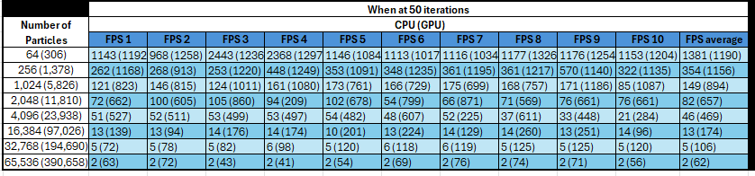

Appendix 2 – Raw Data from Simulation at Optimum Iterations
