Pitch, Review & Planning

ADVANCED PROTOTYPING: GDEV70003

Student Name & Number: Yousaf Zafar, 24023496

Project Title: Off Road Safari Simulator

Date: 15 February 2025

Contents

Project Description 3

Introduction 3

Game Description 3

Resources used: 3

Playthrough Video 4

Forum Link 4

Web Links 4

Literature/Contextual Review 5

Introduction 5

Methodology​ 5

Findings 5

Summary 6

Conclusion 6

References 7

Development Process 7

Sprint 1 7

Goals for Sprint 1 7

Sprint 2 8

Goals for Sprint 2 8

Sprint 3 10

Goals for Sprint 3 10

Playtesting & Feedback 11

Time Management 13

Development Conclusion 13

Evaluation of Work Produced 13

Relevance to the brief 14

Creativity & Scope 14

Further Work 14

References 15

# Project Description

## Introduction

Take control of a heavy 4x4 vehicle specially engineered to tackle the most difficult and dangerous terrains in the world. Have complete control over your vehicle with manual transmission and simulation braking. Stay wary of dangerous objects in your path and manoeuvre the path to get to the top of the hill, a feat worthy of the most skilled drivers.

The gaming industry is littered with racing games. A lot of them are off road and rally racing games. Out of these a very small number are 4x4 safari style games. In this genre, even fewer are simulation style. This project aims to create a satisfying off-road driving experience through a rugged and difficult jungle terrain using a 4x4 vehicle.

## Game Description

A third person driving game with realistic physics and vehicle suspension. The vehicle features manual transmission to provide greater control over the vehicle. The environment features beautiful trees and vegetation to simulate an actual jungle safari.

Key features

**Manual Transmission** – Players will have more control over the vehicle.

**Realistic Suspension** – Players will be able to see the car’s body and suspension react realistically to the terrain.

**Rich Environment** – Players will feel they are immersed in the dense jungle environment.

Game genre

Game falls under the racing category, and somewhat simulation. Game features gameplay that involves exploring the area to reach the objective.

Platform / Technologies

Game is developed using Unity and Visual Studio primarily for PC.

### Resources used:

The project makes use of some free assets from the Unity Asset Store. These include some texture packs and of course the physics and vehicle model used in this project. The list of assets is detailed below:

* Edy’s Vehicle Physics Pro Community Edition – Utilized provided vehicle mesh along with dashboard UI and vehicle physics/controller:
  1. Configured vehicle mesh with vehicle controller and physics settings
  2. Followed source documentation to adjust wheel colliders and apply to vehicle
  3. Re-adjusted vehicle centre of mass and weight distribution to create desired suspension effect.
  4. Adjusted tyre friction coefficients.
  5. Adjusted gears and gear ratios to suit steep mountain driving
  6. Changed steering angle to improve manoeuvrability and turning radius
  7. Changed some values for torque and acceleration to suit mountain climbing
* Unity Technologies Terrain Sample Asset Pack – Used to sculpt and design terrain plus adding textures to the terrain
* ALP Grass Flowers Pack – Used some grass models and textures
* FORST Conifers [BOTD] – Used tree models to create forest environment
* Free unlicensed PNGs – Used as flag and other icons on compass UI.

Target audience

Fans of racing and motorsports in general. Rally fans and people who like realistic physics in games. Gameplay wise, players who prefer simulation racing games rather than arcade games.

# Playthrough Video

Click [here](https://www.youtube.com/watch?v=OcWBfArnoDw) for a gameplay preview.

# Forum Link

Click [here](https://digitalacademy.staffs.ac.uk/forum/index.php?/topic/73562-zafar-yousaf-z023496o/) to open the forum page.

# Web Links

Click [here](https://yousaf559.itch.io/) for my itch.io portfolio page.

# Literature/Contextual Review

## Introduction

Physics is a large aspect of modern videogame development. Every game that releases nowadays has been meticulously polished to mimic real world physics barring rare cases where the actual point of the game is to defy the laws of physics. Open world and adventure games focus on ragdoll and destruction physics, whereas games in the driving genre focus on spring dynamics and weight distribution etc. Bearing this in mind, depicting as close physics as possible to real life physics is the goal in this project. This literature review takes a comprehensive dive into the world of videogame physics and why it is implemented the way it is.

## Methodology​

Research was mostly conducted through online sources such as Google Scholar and simple Google searches that led to journalism websites and other game design resources. Papers were chosen based on their relevance to the project. Articles that skewed towards physics in driving and racing games were given preference over those which discussed physics in videogames in general. Articles of this category were essential to form a basic understanding of how physics works in racing games. Researching to form an overall understanding of how physics works in videogames was also essential to make sure physics in the Off-Road Safari project was up to standard.

## Findings

Physics works in videogames using real world fundamentals. Based on the ideas of classical mechanics, physics simulation in video games uses mathematical models to simulate actual physical behaviours in a virtual setting. Fundamental concepts include Newtonian mechanics, collision detection, and rigid body dynamics, which together provide the framework for accurately depicting motion, object interactions, and environmental reactions (Advancements in Realistic Physics Simulation for Games, 2022). Physics is used in modern video games to create realistic effects and behaviour. Games use basic dynamics concepts to represent everything from billiard balls to flying trash to tactical fighter planes (Bourg, 2004).

A genre that involves a lot of computations about stiff things and the forces acting on them is racing. Cars knocking into each other and obstacles, tires hitting the road, chassis connecting to the wheels, and several other solid things must all be taken into account while calculating collisions, both actively and passively (Cal Jeffrey, 2019). Simulated races such as Gran Turismo and Assetto Corsa consider a number of elements that arcade racers overlook, and their forces acting on automobiles are more realistic. Five-point tires, for instance, were included to the game in Assetto Corsa Competizione (Cal Jeffrey, 2019). These models and implementations provide a deeper understanding of how physics works in the racing genre and helps to form a basic knowledge of how to go about implementing and tweaking physics inside game engines.

Taking care of the lateral and longitudinal forces independently is one of the most important aspects of simplifying vehicle physics. The automobile body is the direction in which longitudinal forces act (or in the exact opposite direction). Wheel force, braking force, rolling resistance, and drag (also known as air resistance) are these. When combined, these forces regulate the car's acceleration and deceleration and, consequently, its speed. The car can turn because of lateral forces. The wheels' sideways friction is the source of these forces (Marco, 2003).

The physics model used for this project also has an in-depth explanation of each component and how videogame physics is simulated within the given physics model. The model used called “Edy’s Vehicle Physics Pro,” provides an in-depth explanation of all the mathematical models used to achieve the desired effect. These include centre of mass, inertia, suspension damping and torque just to name a few. All of the formulas used are provided and can be adjusted to tweak different effects. All of these settings are defined with mathematical equations and variables. It provides a very deep understanding of the inner workings of the physics system (Vehicle Physics Pro).

## Summary

The studies conducted by Cal Jeffries provide an exceptionally good in-depth look into how modern simulation racing games use physics. Of course, these games are made by Triple-A studios with a lot of funding and resources, so they are able to achieve very realistic results by adding things such as multiple contact points for tyres etc. There is not enough research for off road games as they are a niche category and mostly overlooked when it comes to physics. Players prefer smoother animations and visual flair over simulation style physics when it comes to these types of games. In regard to Vehicle Physics Pro, they provide a lot of in-depth explanation on how they created each system with the source code available. This gives a valuable insight into a working model that is used by some big studios as well. This greatly contributes into configuring and adjusting the physics model into the current project as well.

## Conclusion

Overall, physics is a huge part of modern videogame development. Whether it's any genre, physics is essential to make a game feel good and realistic. Companies pour a lot of resources into figuring out the best way to implement and showcase their unique physics models. Although this field and its use is more prominent in the simulation track based racing genre, its use can just as easily be justified in the off-road style driving videogames. These games also rely heavily on physics acting on the vehicle and the terrain it is driving on. In order to display realistic driving, it is essential to make sure the vehicle uses an as accurate as possible physics model. When everything is said and done, it is still a simulated space in a videogame, therefore it’s not fully possible to implement very realistic physics. There is always going to be some unpredictability to the objects behaviour which makes working with physics so interesting.

## References

Cal Jeffrey (2019) And Action! An Examination of Physics in Video Games, TECHSPOT. Available at: <https://www.techspot.com/article/1960-video-game-physics/#:~:text=The%20granddaddy%20of%20video%20games,paddles%20was%20not%20calculated%20accurately>. (Accessed: February 3, 2025).

Bourg, D.M. (2004) “How physics is used in video games,” Physics Education, 39(5), pp. 401–406. Available at: <https://doi.org/10.1088/0031-9120/39/5/002>.

Advancements in Realistic Physics Simulation for Games (2022) ARGENTICS. Available at: <https://www.argentics.io/advancements-in-realistic-physics-simulation-for-games#:~:text=Increased%20integration%20of%20deep%20learning,personalized%20and%20dynamic%20physics%20responses>. (Accessed: February 3, 2025).

Marco Monster (2003) Car Physics for Games, Marco Monster. Available at: <https://www.asawicki.info/Mirror/Car%20Physics%20for%20Games/Car%20Physics%20for%20Games.html> (Accessed: February 3, 2025).

Vehicle Setup Guide (no date) Vehicle Physics. Available at: <https://vehiclephysics.com/user-guide/vehicle-setup/#vehicle-setup-guide> (Accessed: February 3, 2025).

# Development Process

## Sprint 1

### Goals for Sprint 1

Establish framework for development:

* Create initial scope and design of game.
* Research similar games to gather inspiration.
* Create project file with configured input settings.
* Import necessary assets and models to Project.
* Start configuring vehicle.

Initial scope of the project and deliverables for the end of sprint 1 were kept simple and easy to achieve. These included a playable prototype with basic movement mechanics and UI. The brunt of time and effort was spent in setting up the vehicle and its associated UI.

#### Vehicle Setup:

Due to time constraints, a free asset pack from the Unity Asset Store was used called “Vehicle Physics Pro” by “Edy”. The asset pack contained a base physics model and vehicle mesh to work with. The entirety of the remaining sprint was spent in configuring the vehicle using the documentation. Since one of the USP’s is 4x4 capability, the model provides handy functionality to configure the torque and differential settings.

As a base all the vehicle settings were set for city driving, resulting in the car’s suspension being very stiff, and the car having very long gears and high top speed. Since the project is catered towards mountain and off-road driving, all these settings had to be tested and adjusted from the ground up. Gears were lowered from 5 to 3 as 3 was the maximum gear that was reached upon testing on steep terrain.

Considerable tweaks had to be made on the vehicle suspension to make the car feel less rigid.

Initial Problems

The most obvious problem was the vehicle suspension, the car kept feeling too rigid. The cause was determined to be the centre of mass and its positioning. Since the terrain was going to be uneven and steep, raising the centre of mass to a higher point would result in the vehicle being more prone to flipping. In order to combat this, the centre of mass was lowered by 200 and moved closer to the front of the vehicle to simulate real life vehicle weight distribution. Apart from realistic weight distribution, this change made the car a little more stable on uneven terrain and made the suspension feel less stiff. New centre of mass location:

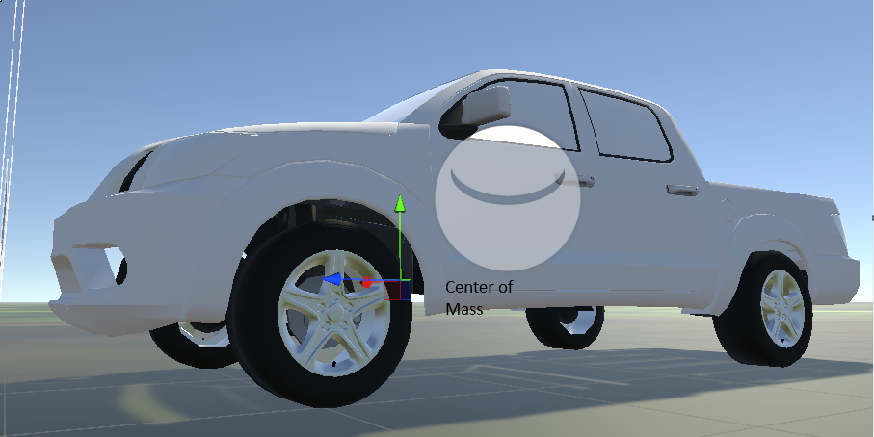

Figure 1. New Centre of Mass Position

For future projects of a similar nature, leaning more towards source documentation instead of endlessly experimenting will be a better approach and save a lot of time.

## Sprint 2

### Goals for Sprint 2

* Working on the vehicle and fine tuning it more.
* Set up dashboard UI to help player see their current selected gear and RPM/Speed.
* Test with varying heights in terrain.

The goals for sprint 2 revolved around perfecting the vehicle up to a standard. Once the suspension was tweaked to an acceptable standard, the transmission was thoroughly adjusted.

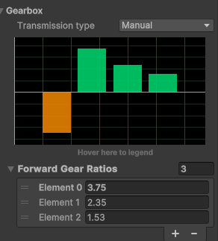

Figure 2. Updated and re-configured gear ratios

The base setup had the car use 5 forward gears with the shortest being the first gear. In this project’s case, a lot of scenarios are going to require the player to move from a stand still, therefore the most used gear will be the first. The first gear is also essential for climbing steep terrain; therefore it was adjusted to make it slightly longer to make the climb easier.

After the transmission was adjusted, the car felt like it was understeering when the throttle button was pressed. An easy fix was to increase the steering angle from 35 degrees to 50 degrees. This much steering angle is usually found on real life drift cars but in this case, it made sense because the car could manoeuvre more easily from tight spots.

Unity’s new input system also makes setting multiple buttons and actions for one category a lot easier. This allows the car to be controlled by multiple button inputs at once. This offers better control over the car because the engine doesn’t ignore multiple button inputs of the same type, for example pressing the accelerate button and the brake button will be depicted accurately.

After the car was deemed to be at an acceptable standard, visual feedback was necessary to show the player how the vehicle was responding. Luckily the asset pack contains a very simple dashboard design that can be hooked up to the car. Only the gear number, speed and rpm were configured as they are the only things needed for the scope of this project.

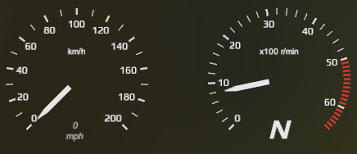

Figure 3. Screencap of dashboard UI

Further testing was pushed to sprint 3 as the vehicle seemed to be working at a desired level and accurate testing would need the actual environment to be created.

## Sprint 3

### Goals for Sprint 3

* Create actual gameplay level with terrain and environment.
* Create gameplay UI such as compass and finish line.
* Test vehicle on new terrain and tweak as needed.

Terrain creation was an important part of the project because it needed to be challenging enough for the player to navigate while not being too tedious and frustrating. Initial terrain design included very sharp edges and pointed hills that kept making the vehicle stuck.

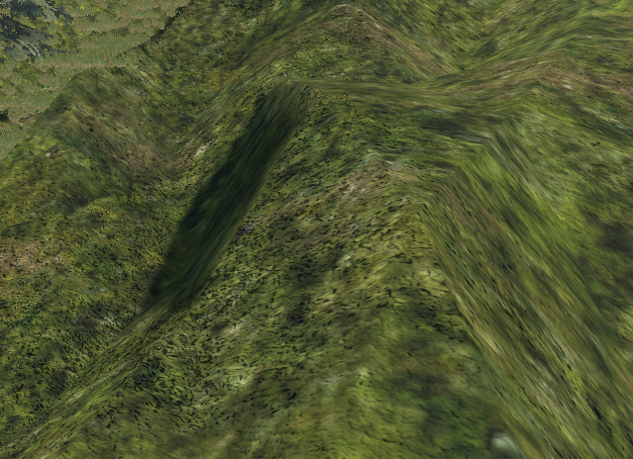

Figure 4. Example of rough terrain edges

The terrain was balanced and tweaked by thoroughly testing the vehicle over each section. This led to smoothing out the terrain a lot to make it manageable for the vehicle. Grass and mud textures were painted over the terrain to give it a more realistic look. A physics material to simulate grass was created which initially led to the vehicle finding no grip at all on the surface.

The friction settings were quickly tweaked and balanced to let the car find a little more grip, otherwise the car would endlessly spin its wheels in the same place.

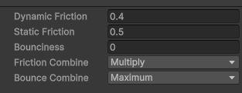

Figure 5. Balanced friction settings

Initially, the plan was to create 2 separate physics materials to simulate grass and mud, but since the majority of the terrain was grassy and green with only a subtle pathway of mud, a decision was made to keep the muddy area with standard friction values.

A simple compass was made from scratch to guide the player towards the objective, initially the player cannot see the finish marker but as the player gets closer the marker starts becoming visible in the compass and keeps getting larger as the player gets closer to the finish. Initially this was considered a bug because the finish marker was supposed to always be visible, but this was later deemed to be a feature as it contributes to the feeling of being lost in a jungle environment and exploring the area to find the way to go.



Figure 6. Final compass design

Once everything was working as intended, simple logic was implemented to show the player a UI that has text with tutorials about how to use the vehicle, then they are left to reach the finish line. Once they are near the finish, a flag can be seen and once they reach the flag, the level ends and the screen turns black with some text.

# Playtesting & Feedback

Mostly the playtesting included repeated trial and error. Areas of the project were thoroughly tested, and conclusions were drawn to root out the cause. Since the entire project relied heavily on vehicle physics, a lot of time and effort was spent on creating rigorous test environments to drive the car over and see how it responds.

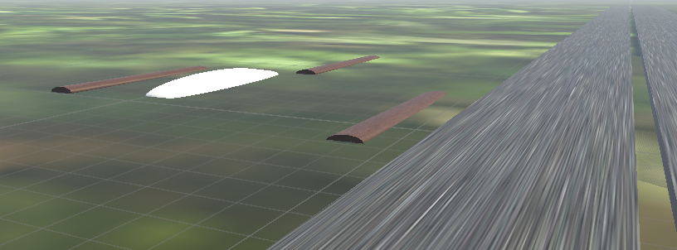

Figure 7. Vehicle testing environment example

This led to the discovery of a design flaw. The vehicle was not capable of crossing difficult terrain; therefore, the terrain was made smoother and easier.

After some more feedback I eventually added a distance to finish UI text to further guide the player towards the finish. I also changed the colour of the car to blue to make it look more natural instead of just plain white.

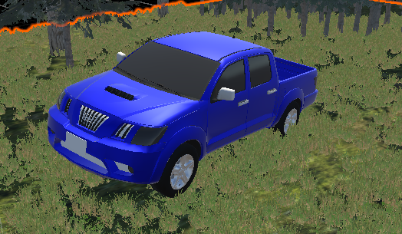

Figure 8. New car colour

Figure 9. Distance to Finish UI Text

# Time Management

As 3 projects were due to be created in the same time frame. Time management was essential to achieve the desired goals. This led to some scoping adjustments along the way. The initial plan was a little over scoped with the inclusion of implementing a timer or time limit for the player to complete the course. This was later removed because firstly it would require time to implement, and secondly it was deemed to be unnecessary as the player should be allowed enough time to complete the course at their own pace. The bulk of time was spent on perfecting the driving experience as that is the core gameplay. The car’s physics and behaviour were tweaked repeatedly to get the desired result, and the environment was polished and shaped to match the car’s capabilities. Other gameplay elements such as the compass and dashboard UI did not need much effort as they were easy enough to implement. Overall, time was utilized effectively for the most part, there could have been a couple more features implemented with the availability of more time. These features include a rewind system like the one found in Forza Horizon 5. This was implemented halfway but had a lot of bugs and inconsistencies, so it was eventually scrapped and removed from the project to avoid time wastage and instead focus on the more important aspects of the project.

# Development Conclusion

The development process can be considered successful as it fits under the preset scope. Some deviations were made according to the situation at the time but still the overall scope of the project was achieved. Some things that can be done differently in the future include planning in advance how the environment is going to be instead of adjusting it on the fly with the car. This leads to better time management as not much time is wasted on testing every area of the terrain to make sure the vehicle can handle it.

## Evaluation of Work Produced

I’m satisfied enough that even with my very limited and beginner level knowledge compared to my peers, I was able to create a playable experience. Of course, it is not very good but at least I was able to dig deep and learn along the way. I can confidently say I learned much more and have more knowledge now than when I started. Considering the time-constraint and workload, it can be said that the work produced does meet a standard, if not a very high one.

## Relevance to the brief

The project resembles the initial pitch very closely as it is indeed a simulation style driving experience. The main USP was manual transmission which is included in the game. There were some slight deviations such as the absence of logs and rocks in the environment, but they were only made to create the scope a little more realistic according to the timeframe. In the case of the absence of logs, the terrain provided enough variation in elevation to be difficult enough as it is.

## Creativity & Scope

The unique interactions are the manual transmission which isn’t found in many off-road games, the second is the compass UI that gets bigger as the player gets closer to the objective. These can be considered playful experiences as they are strictly tied to the core gameplay.

Level design theories are very important to implement in a game like this. It’s essential to make the level engaging and challenging enough so the player does not lose interest quickly. This is why a lot of time was spent perfecting the terrain so that the vehicle can handle the various dips and inclines yet still feel a little challenging to overcome. The Flow Theory by Mihaly Csikszentmihalyi (1997) was carefully considered while designing the level so the player is in that constant state of flow while controlling the vehicle. At least that is the intention, if it completely works or not depends on each player. For visual art, the level is given a strong sense of a dense forest with some fog and dense trees. This contributes to immersion and a feeling of navigating difficult terrain. For future approaches, more game design theories such as Nicole Lazzaro’s 4 Keys of Fun (2009) can be more closely implemented to make sure the game fits within the four points highlighted in the theory.

## Further Work

The project definitely has room for improvement, the camera system for one is not fully optimized; the camera sometimes clips through the ground at certain angles of elevation. Further development could include separate levels with their own theme such as snowy mountains or river crossings. The option to choose a different car can also intrigue players. In terms of replay ability, a time limit could incentivize players to learn the map by playing it again and again and finding out the most optimal route to the finish. The knowledge gained throughout this project is transferrable to all future projects as it gave me a great opportunity to implement some game design theories I learned previously. I also gained valuable skills regarding using game engines.

# References

Vehicle Setup Guide (no date) Vehicle Physics. Available at: <https://vehiclephysics.com/user-guide/vehicle-setup/#vehicle-setup-guide> (Accessed: February 3, 2025).

Csikszentmihalyi, M., 1997. Flow and the psychology of discovery and invention. *HarperPerennial, New York*, *39*, pp.1-16.

Lazzaro, N., 2009. Why we play: affect and the fun of games. *Human-computer interaction: Designing for diverse users and domains*, *155*, pp.679-700.