Esports vs The Market

A Comparative Publisher Analysis
ESPO60014

Abstract
Since the prevalence of Covid-19, The global growth of the Esports industry has raised questions about its financial impact and sustainability. This dissertation aims to examine whether publisher run Esports tournaments influence investor perceptions and stock performance. This study investigates the impacts of publisher-run Esports tournaments on stock prices of EA, Tencent and Nintendo, focussing on two game titles from each, and then comparing and analysing the results.
Using the Event Study Methodology (ESM), abnormal returns, and cumulative abnormal returns (CARs) are analysed around tournament events for EAFC, Apex Legends, Valorant, league of Legends, Super Smash Bros. Ultimate and Mario kart 8 Deluxe to evaluate the markets abnormal reactions.
The results indicate that while certain tournaments, particularly for Tencent’s league of Legends and Valorant show positive abnormal returns, likely due to the use of the Games as a Service model (GaaS), none of the findings were statistically significant at the 5% boundary, outside influences may have had an impact on this, but as a limitation of the ESM, we are unable to determine this. Nintendo’s tournaments had a minimal market impact, but both games utilised the old video game model. Whilst EA utilised both models, and the game without the GaaS model (EAFC) had the lowest abnormal return results.
To Summarise, the study suggests that Esports tournaments are not consistently perceived as financial material by investors in short term, revealing a disconnect between investors priorities and the growing cultural significance of Esports. Further investigation should be made to determine how events influence long-term market value and how the decision making by Esports publishers should be adapted for economic benefit.

Table of Contents
Abstract 2
1.0 Introduction 8
2.0 Background Literature 9
2.1 The Rise of Esports 9
2.2 Publisher Control 9
2.3 Esports Ecosystem Model 10
2.4 Event Studies and Market Reactions 10
2.4.1 Efficient Market Hypothesis (EMH) 11
2.5 The Research Gap 11
3.0 Methodology 12
3.1 Event Study Methodology 12
3.1.1 Calculate Returns 13
3.1.2 Estimate the market model 13
3.1.3 Linear regression 13
3.1.4 Expected returns 13
3.1.5 Abnormal returns 14
3.2 T-Test 14
4.0 Results 15
4.1 Linear Regression Results 15
4.1.1 EA: Linear regression 15
4.1.2 Tencent: Linear regression 16
4.1.3 Nintendo: Linear regression 17
4.2 Cumulative Abnormal Returns 17
4.2.1 EA CAR 17
4.2.2 Tencent CAR 17
4.2.3 Nintendo CAR 18
4.3 T-tests For Significance 18
4.3.1 EA T-test results 18
4.3.2 Tencent T-test results 19
4.3.3 Nintendo t-test results 19
5.0 Discussion 20
5.1 Interpretation 20
5.1.1 EA 20
5.1.2 Tencent 21
5.1.3 Nintendo 21
5.2 Timescale 21
5.3 Literature Connection 22
6.0 Conclusion 23
7.0 References 24
8.0 Appendices 25
8.1 Appendix A: Reflective Diary 25
8.2 Appendix B: Signed Ethics Disclaimer 27
8.3 Appendix C: Raw SPSS Data (ordered chronologically by date) 29
8.4 Appendix D: SPSS Linear Regressions (output column highlights dataset) 54
8.5 Appendix E: T-test (output columns highlights dataset) 57

Table 1: EA linear regression 15
Table 2: Tencent linear regression 16
Table 3: Nintendo linear regression 17
Table 4: FC Pro Open T-test 18
Table 5: ALGS Split 2 Playoffs T-test 18
Table 6: ALGS Championship T-test 18
Table 7: VCT T-test 19
Table 8: LoL World Championship T-test 19
Table 9: Legends Championship T-test 19

1.0 Introduction
The global video game industry has evolved beyond recreational gaming, to global competitions being streamed online to attract millions of viewers. As publishers continue to invest in Esports tournaments as a means of marketing and brand-reinforcement, questions remain as to whether these efforts translate into financial outcomes. This study investigates whether publisher-run Esports tournaments influence the price of the publishers’ stocks, providing an insight on how events are perceived by the markets.
Focussing on 3 publicly traded publishers (EA, Tencent and Nintendo) this study examines the stock market reactions surrounding tournaments run by these publishers over a set timescale. These games were selected due to their guarantee to have an online player base.
Using the Event Study Methodology (ESM), this research identifies abnormal returns during the time of the vents, the aim is to determine whether these events are influential enough on their own, to significantly impact the market.
This study is positioned within the context of existing academic marketing literature. Previous research suggests that media events can influence a markets performance, but this has not been expanded upon in relation to Esports tournaments. By focusing on publisher-run events, this research can act as a foundation for marketing, investing and other areas in the Esports ecosystem, to promote financial growth and limit the impact of the Esports bubble.
The ultimate goal of this analysis is to understand the difference between different publishers and how their events impact the stock markets, and to determine if there is a method in which that is more financially beneficial than others, for Esports publishers to pursue under the pretence of expanding the industry in a positively sustainable manner.

2.0 Background Literature
The purpose of this literature review is to identify gaps in previous literature to justify the research, and to provide context on the theoretical framework behind the methodology, guiding the design of the study to further advance the knowledge of Esports and its financial impacts.

2.1 The Rise of Esports
With the advancement of current technology, in raw power and affordability, Esports has expressed levels of growth previously unexpected, in a plethora of different social, political and economic backgrounds. Current students have seen a rise in the use of Esports both recreationally and for academic benefit, impacting skills such as social interaction, critical thinking and team -based skills (Delello et al., 2021).
Alongside this global rise, publishers are incentivised to act upon the growth of Esports. With different marketing strategies undertaken, positive correlations between the total revenue, and Esports event marketing is proved by the data that Parshakov et al., (2017) obtained. With the suggested influence, to compete with other publishers, a continuous innovation is required to remain relevant in the Esports market.
Esports, now an established part of virtual society, has reached this point majorly through external growth factors, with the only publisher-made impact being marketing strategies. Key factors that elevated the growth of Esports was the influx of streamers and YouTube content during the Covid-19 pandemic and the pushing of traditional sports and televised motorsports into the virtual industry, with examples such as the Formula 1 mini league performed online (Block & Haack, 2021). The new-found form of escapism took the word by storm dramatically changing the trajectory of Esports’ future (Hamari & Sjöblom, 2017).

2.2 Publisher Control
The task of the publisher is not as simple as marketing an already existing product, to make it successful in the Esports industry. There are a limited number of successful Esports titles, and a smaller number of these are on a global scale. Ashton, G., (2024) elaborates on the different requirements, and needs of the community, with different video-game models, in-particular the GaaS (games as a service) model, which promotes quicker change and bug fixes, in return for a monetisation method aimed towards microtransactions and the old gameplay model, that involves the sale of a full price video-game, generating the majority of the revenue in release sales, and then following up with downloadable content (DLC) packs to further expand on the return on investment (ROI) whilst producing a sequel or spin-off of the desired games universe, repeating the cycle.
Different video-game models require different strategies when aiming for a competitive scene, GaaS models can promote constant change throughout the lifecycle of the game with “seasonal” changes, including mechanical changes influencing the games “meta”, bug fixes, and constant control over the games eco-system, allowing for a quicker response to the community. The GaaS model appears to be the way publishers are moving when relating to Esports, due to the ease of impact they can have over a competitive scene without the requirement of extra resources and development time that the old gameplay model needs to implement these changes.

2.3 Esports Ecosystem Model
The Esports Ecosystem is an in-depth definition of all stakeholders involved in the community, both primary and secondary. The retrospective takes by Carrillo Vera & Antón, (2024) identifies an eco-system by that of a natural, biological construct found in nature, where any organism and physical environment share interrelationships and where “Esports players may be the most important entity but only represents one stakeholder or actor in the ecosystem”. Following this, an exploration is continued into the definitions proposed by other academics into what produces and defines an eco-system, for example Scholz (2020).
Central to these ecosystems, in multiple different academic accounts, are the publishers, who hold intellectual property rights over the games and thereby exert a level of control unmatched in traditional sports. “Traditional sports ecosystems centre around human rights and needs in their development, whereas Esports ecosystems primarily focus on entertainment and lack the principles of equality fundamental to modern sports” (Yuan, 2024).
Sponsorships, fundraising and content creation are currently the three primary sources of income for esports clubs, due to the lack of training in economic sustainability (Nyström et al. 2022). Publishers can mandate the way their events impact the entire ecosystem, without promoting the growth of an “Esports Bubble”. This current unsustainable business model leads to detrimental impacts on teams, and every actor involved in the ecosystem due to the interrelationships. Li et al., (2024) showed an in-depth analysis on the bubble theory in the Chinese Esports market and proved with evidence that there were multiple instances of bubbles residing. Due to the Chinese Esports market being in the early stages of development, a suggestion was made to improve government policies to prevent the cause and inflation of these bubbles. There is room for further expansion on this, leaving a question whether Esports publishers can have an impact on these bubbles, or if it is down to stakeholders and governing bodies. If publishers can promote beneficial market changes on their own stocks, they may have the influence necessary to promote a healthier environment for the ecosystem, and in doing so, reduce the impact and occurrence of bubbles in the sector.

2.4 Event Studies and Market Reactions
Event study methodology (ESM) is a widely used empirical approach to finance and economics for assessing the impact of a specific event on the stock price value of a firm. At its core, the aim of an ESM is to determine how significant an event is towards the abnormal returns of a stocks price, these events historically vary between product launches, mergers and public statements. The data is then extrapolated and analysed through different regressions and tests, to further explore significance (Binder, 1998).

2.4.1 Efficient Market Hypothesis (EMH)
“A capital market is said to be efficient if it fully and correctly reflects all relevant information in determining security prices.” (Malkiel, 1989). This theory suggests that the market cannot be beaten, as the market shows all information, including incorporating any new information such as press release reactions into the stock price of the firm. Therefore, if markets are efficient, observing a statistically significant change in stock price immediately after an event suggests that investors perceived the information as materially relevant to the value.
Building on this foundation, MacKinlay (1997) formalised the event study framework, outlining the structured methodology for measuring abnormal returns. The standard approach of identifying the window, estimating the normal returns, calculating the abnormal returns and then testing for significance arose here. Mackinlay also provided a list of limitations to the methodology, including the sampling interval, as stock market data can be sampled at different time frames, event date uncertainty, market robustness and other possible external bias. The event methodology is not without its flaws, but when used alongside the EMH theory, the results can be used as an accurate prediction, not an exact result.
Earlier studies such as Brown and Warner (1985) validated market robustness of ESM’s by using daily stock data, emphasizing on the method’s sensitivity to model specifications, and the importance of controlling for factors like market return trends. A daily data interval was shown to be more robust than others, allowing the ESM to provide less externally influenced results. Despite the simplicity of the methodology, the ESM has shown reliable performance rates when events are clearly defined with no overlapping news.
Following the findings of this, Event studies have been conducted to a range of corporate and macroeconomic announcements. An example of a conducted study would be for dividend changes (AHARONY & SWARY, 1980). These studies generally confirm that stock prices react quickly and measurably to newsworthy events, validating the use of the ESM.
Critiques of event studies include concerns over market efficiency assumptions and difficulty isolating the effects of single events in news-rich environments. There is an argument to be made that stock price volatility is too high to be explained without the impact of psychological and irrational factors affecting the market, directly challenging the EMH (Shiller,R.J. 1981).
E. Fama, credited for formally developing and popularising the EMH, later acknowledged anomalies such as the small firm effect and January effect, but argued the occurrence of anomalies was not persistent enough to outright refute the EMH (FAMA, 1991).

2.5 The Research Gap
The event study methodology has been widely applied across various industries to assess the impact of corporate events on firm value, particularly in relation to macroeconomic news (MacKinlay, 1997). However, there is a noticeable gap in the academic literature concerning its application to the video game industry which is becoming an increasingly important component of the global media economy. Despite the prevalence of publisher-driven events such as digital showcases and Esports tournaments, few studies have investigated their effects on market returns further.
While event studies have examined the broader market and the influence of events (Chen et al., 2001) there is little research isolating the unique nature of vide game events, which simultaneously serve investors, publishers, consumers and media. Events like E3 and Nintendo direct are likely to influence investors, yet their financial implications are under researched, alongside that of publisher-run tournaments.
This dissertation aims to address part of this gap by using the ESM to assess whether publisher tournaments can result in statistically significant abnormal returns, by focussing specifically on publicly traded firms. The study aims to offer theoretical contributions to event study literature, and serve as an insight for analysts, investors, and governing bodies who aim to promote a healthy ecosystem and reduce the impacts of the Esports bubble. A foundation of financial research can lead to more in-depth studies to further excel the industry.

3.0 Methodology

3.1 Event Study Methodology
The Event Study Methodology (ESM) is employed to analyse the impact of specific events on stock prices. This approach is widely used in financial research to assess how certain corporate, or market events affect the stock prices of firms (Sorescu et al., 2017). The focal point of the methodology is abnormal returns, defined as the difference between the expected return based on historical market data, and the actual return. These results can be used to infer whether the event had a positive, negative or neutral impact on the stock values relevant to general market movement.
The three chosen publisher stocks will be EA, Tencent (owners of Riot Games) and Nintendo. All of the market data for these is publicly available. To minimise human error, all data will be taken from TradingView (TradingView, 2024), as they allow users to download market history, with any desired timeframe, directly. This data will then be processed through SPSS to provide the required results.
Publisher-run events will be utilised as the individual timeframes for the ESM. A total of six videogame titles will be studied and compared to provide a more accurate result. The chosen titles from each developer are:
EA
- EA SPORTS FC
- Apex Legends
Riot Games
- Valorant
- League of Legends
Nintendo
- Mario Kart 8 Deluxe
- Super Smash Bros. Ultimate
As an extra comparison, the release of EA SPORTS FC fits within this timeframe, and will also be studied to compare alongside the events.

3.1.1 Calculate Returns
Before undertaking the ESM, it is mandatory to calculate the returns as a variable in SPSS, as this is the data required to perform all future functions. The formula for basic returns is as follows:
$$R_{t}=\frac{P_{t}-P_{t-1}​}{P_{t-1}}$$
Where:
$R_{t}$= Return at time (t) (the time measurement for this study is the date)
$P_{t}$ = Closing Price at time (t)
$P_{t-1}$ = Closing Price at time (t-1)

3.1.2 Estimate the market model
The first step to take to complete the ESM, is to estimate the market model, to determine the expected returns of the stock in relation to standardised market movement. The timeframe for the ESM will date from the 27th of August 2024 and finish on the 25^{th of} February 2025, providing a 6-month window of analysis. to estimate the market model, the standard market data from 6-months prior to the ESM timeframe will be the estimation window. This will determine how the individual stocks perform relative to the S&P 500 Market Index.

3.1.3 Linear regression
To begin the analysis, a linear regression must be performed. The purpose of a linear regression is to estimate the expected market returns without an event occurring, also giving us values for the intercept and slope coefficients (α and β). The intercept coefficient is the expected return when the market return is zero. The slope coefficient is a measure of the sensitivity a stock price in relation to standard market returns. If β = 1, the stock moves one-for-one with the market, if β < 1, the stock is less volatile less than the market, and if β > 1, the stock is more volatile within standard market movement.
α and β can then be used in further formulae to find abnormal returns (AR) and cumulative abnormal returns (CAR). The CAR over event periods will be used to determine the impact an event has on the stock price.
The p-value of this linear regression will also determine the statistical significance between the independent and dependent variable, showing us if the movement of β is relevant to the market return, or if it is likely to be seen through random chance.

3.1.4 Expected returns
To calculate the expected returns for each stock, the formula required is:
$${\hat{R}}_{it}={\hat{α}}_{i}+{\hat{β}}_{i}R_{mt}$$
Where:
$R_{it}$ = the predicted return of stock $i$ at time $t$ (expected return without an event)
$α_{i}$ = the intercept term from regression, representing average return when the market return is zero
$β_{i}$ = Slope (beta) shows how sensitive stock $i$ is to market returns (systematic risk)
$R_{mt}$ = market return at time $t$ (S&P 500 returns for the day)
$i$ = index for security (EA, Tencent, Nintendo)
$t$ = time index
$\hat{R}$ = the caret above the symbol indicates an estimated value of regression.

3.1.5 Abnormal returns
To calculate the abnormal returns (AR), expected returns are subtracted from actual returns, and with this we can sum the returns over the event periods to present us with cumulative abnormal returns (CAR) during the event periods, providing us with a positive or negative outcome over the course of the event.

3.2 T-Test
For each event, a T-test will be undertaken, to identify the significance of the outcome in relation to the event. Events that span over only one day will not be tested, as a T-test will not provide accurate results based on a single data piece. The significance will be analysed against other potential influences, which may impact the results.

4.0 Results
All the results following were made after the initial variable for the returns of each stock, and the market index (see Appendix B: Raw SPSS DATA) were produced as this was the mandatory requirement before running the ESM.

4.1 Linear Regression Results
The following data shows the outcome of each linear regression performed on the individual stocks, to find the numerical representation for α and β.

4.1.1 EA: Linear regression
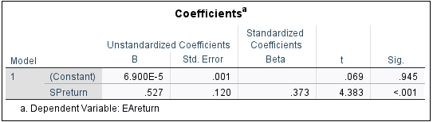
Table 1: EA linear regression

- α = 6.900E-5 (0.00006900)
- β = .527
- p-value = .945
α in EA’s stock return is not significantly different from 0, suggesting when the market is “flat” there is no abnormal performance from EA stock.
β suggests that EA’s stock is less volatile than the overall market. If the market moves up 1%, EA is expected to change by 0.527%
the p-value being significantly above 0.05 fails to reject the null hypothesis, meaning there is no evidence to conclude that the market index return has a meaningful effect on EA stock.
EA stock returns are positively correlated with market returns but have a low to moderate sensitivity to market movement. Indicating EA stock acts conservatively in relation to market movements however the p-value suggests that the market movement doesn’t directly influence the EA stock.

4.1.2 Tencent: Linear regression
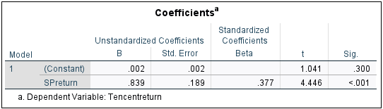
Table 2: Tencent linear regression

- α = .002
- β = .839
- p-value = .300
α suggests a 0.2% outperformance of the baseline, when based solely on standard market movement (if the market is flat, a 0.2% comparative increase is expected over the given time).
β indicates that Tencent stock has a moderate sensitivity to market movement, however as the result is 1>, it shows us it is less volatile than the market overall, but more than EA, with an expected .839% increase per 1% total market increase.
The p-value proposes insignificance between the variables, failing to reject the null hypothesis, but to a much lesser extent than EA.
The stock values of Tencent in correlation to the market are much more positive when compared to EA but still do not suggest significance between their returns, and the market index returns.

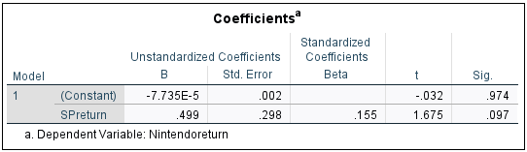
4.1.3 Nintendo: Linear regression
Table 3: Nintendo linear regression

- α = -7.735E-5 (-0.00007735)
- β = .499
- p-value = .974
α in Nintendo’s stock return is not significantly different from 0, suggesting when the market is static, there is no abnormal performance from Nintendo stock.
β suggests that Nintendo’s stock is less volatile than the overall market. If the market moves up 1%, Nintendo is expected to change by 0.499%
the p-value being significantly above 0.05, likewise to that of EA, fails to reject the null hypothesis, meaning there is no evidence to conclude that the market index return has a meaningful effect on Nintendo stock.
Nintendo and EA stocks act similarly, both correlating with market movement, with a low to moderate sensitivity. The high p-value predicts a lack of significance in response to the market index returns.

4.2 Cumulative Abnormal Returns
The CAR of each event will be listed alongside the time, as both a decimal (to five decimal places for accuracy) and a percentage.

4.2.1 EA CAR
- EA SPORTS FC RELEASE (27th of September 2024): .00862 or 0.862%
- FC Pro Open (25th of November 2024 – 1st of February 2025): -.27952 or -27.952%
- ALGS Split 2 Playoffs (29th of august 2024 – 15th of September 2024): .00081 or 0.081%
- ALGS Championship (28th January 2025 – 2nd February 2025): .04098 or 4.098%

4.2.2 Tencent CAR
- VCT (11th of January 2025 – 25th of February): .18942 or 18.942% (coincides with Legends Championship, and continued past ESM timeframe)
- LoL World Championship (25th of September 2024 – 2nd of November 2024): -.04145 or -4.145%
- Legends Championship (15th of January 2025 – 23rd of February 2025): .24214 or 24.214% (Coincides with VCT)

4.2.3 Nintendo CAR
- Smash Bros European Summer Showdown (30th of August 2024): -.00403 or -0.403%
- Mario-Kart 8 open (27th of December 2024 – 29th of December 2024): .00641 or 0.641% (two of the three days for this event were during closed market hours so there is no data).

4.3 T-tests For Significance
T-tests were run for all events that include AR data for multiple days. A T-test cannot be performed on a single data entry. The aim of the t-test is to determine significance of the AR during the event period, or if the event did not significantly impact them.

4.3.1 EA T-test results

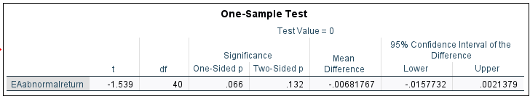
4.3.1.1 FC Pro Open
Table 4: FC Pro Open T-test
- p-value = .132

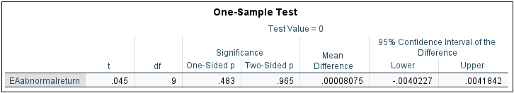
4.3.1.2 ALGS Split 2 Playoffs
Table 5: ALGS Split 2 Playoffs T-test
- p-value = .965

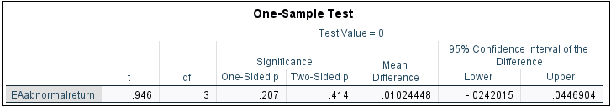
4.3.1.3 ALGS Championship
Table 6: ALGS Championship T-test
- p-value = .414

4.3.2 Tencent T-test results

4.3.2.1 VCT
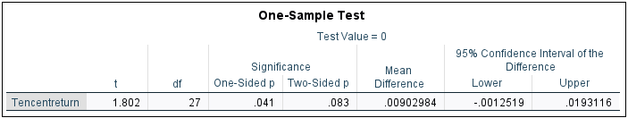
Table 7: VCT T-test
- p-value = .083 (Running alongside legends championship, and continued running outside of data range, so actual p-value is expected to be lower)

4.3.2.2 LoL World Championship
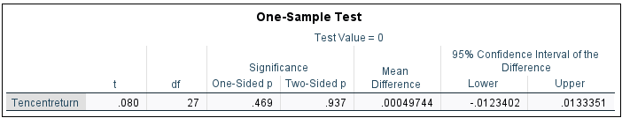
Table 8: LoL World Championship T-test
- p-value = .937

4.3.2.3 Legends Championship
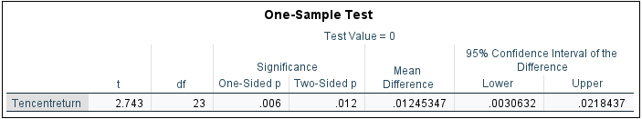
Table 9: Legends Championship T-test
- p-value = .012 (Running alongside VCT, so actual value is expected to be lower)

4.3.3 Nintendo t-test results
T-tests were not applicable for Nintendo as one of the events was only one day long, giving a single data set, and the other event only provided with one data set due to running during closed market conditions.

5.0 Discussion
This study employed an ESM to investigate the impacts publisher-run Esports tournaments had on the stock prices of their overhead firms. The results suggest that while most events did not yield statistically significant abnormal returns, there were notable patterns for Tencent and EA – especially with regards to their use of the GaaS model. The games utilising this model, showed much higher CAR, hinting at potential significance of ongoing game engagement and monetisation strategies in driving market perception.

5.1 Interpretation
All of the events resulted in a p-value over 0.05, suggesting that Esports tournaments did not produce statistically significant abnormal returns. However, when looking at individual companies and event characteristics, notable results emerged.

5.1.1 EA
For EA, the results were mixed, two of the events produced positive CAR results, but the FC Pro Open resulted in a significant -27.952% abnormal return, the largest negative return in the sample. The FC Pro open does not involve a GaaS title, which likely played a critical role in explaining the negative market response (Ashton, G. 2024). EAFC is not a GaaS-based game, lacking the continuous revenue model associated with regular updates and in-game purchases. Thus, leading investors to perceive this as a less impactful event in terms of long-term revenue. EAFC have attempted to incorporate microtransactions into their game, but constant community backlash is caused by the use of in-game purchases alongside the purchase of a “full” game. The launch of EAFC also yielded >1% in abnormal returns, which could be tied to the expectancy of the game releasing the same time each year, with no anticipated innovation.
The significant negative return is likely tied to external factors, which is a limitation of the ESM. EA’s Q3 report showed a weaker performance on its sports titles, and a poorly received dragon age release led to a sharp, unexpected drop in market value. This is consistent with prior literature (MacKinlay 1997), which highlights the challenges of measuring event impacts whilst other confounding factors are also occurring.
In contrast, the other two events tied to Apex legends showed much smaller abnormal returns, but both with a positive outcome. These results align to the expectation that GaaS based tournaments are likely to have more significant financial impact due to their ongoing monetisation through content updates and in-game purchases. However, the modest CARs observed suggest that while the GaaS events may signal sustained revenue potential, they did not create significant short term market movements, and the p-values also showed that the events were not significant in impacting the markets returns.

5.1.2 Tencent
For Tencent, both games monitored utilise the GaaS model, and both events that provided the highest CAR were both Tencent owned. These games are a key focal point in relation to Tencent’s long-term monetisation strategy, as the firm appears to always lean towards this video game model. The High CARs associated with these events suggest that investors viewed the tournaments positively as an ability to generate long-term revenue, reinforcing the value of their GaaS-based strategy.
However, the statistical significance of these CARs is not entirely conclusive, the p-values for the two events (0.83 for VCT and 0.12 for the Legends Championship) appeared slightly above the common threshold of 0.05 for statistical significance, this suggests that although the returns were large, they were not statistically significant. To add to this, these two events ran simultaneously, further complicating the analysis, as it is difficult to attribute the CARs to an individual event. The VCT event continued to run outside our data range, which could have provided a more accurate depiction of the p-value and the significance of the event, as a larger timeframe where the events did not overlap would have been available for study. It is plausible that the overlapping event timings compounded the market reaction, with investors responding more positively to the combined public responses to these events.
Despite having high CARs, the p-values exceeding 0.05 cannot be ignored, suggesting that other factors beyond the esports events themselves may have contributed to these market reactions. We cannot determine for certain however, that the overlapping of the events was not the sole cause of this result. This once again underlines the challenges in isolating the impact of a single esports event with other factors in play. Nevertheless, the positive abnormal returns, although technically not statistically significant, still indicate that the GaaS model implemented by Tencent gives a positive image towards investors, deeming it a reliable revenue stream, even if the statistical significance is somewhat weak.

5.1.3 Nintendo
For Nintendo, the abnormal returns were minimal, and not enough data was provided for us to run an accurate T-test to test for significance. We can assume from previously determined results however, that due to the nature of Nintendo and their lack of GaaS models, the main source of market return and investor influence would be much more likely to occur around the time of a Nintendo direct announcement, or the initial release date of a video game title, usually exclusive to the Nintendo console.
A factor to consider when comparing Nintendo events to those such as EA and Tencent, is the community outreach of these games. Although Nintendo is also a global brand, the Esports community for their video game titles is much smaller than the likes of Valorant or League of Legends, alongside the use of the GaaS model, this likely impacted the CAR that Nintendo received during the events.

5.2 Timescale
Although no relevant literature indicated this would have an effect on the results, the events that lasted the longest period of time, also yielded the largest abnormal returns, be it positive or negative. This implies that Esports events are not seen as impactful on the market in the short-term but may have larger influence over market movement the longer the events run for. With the addition that these events were also all GaaS models, it only adds to the incentive for Esports publishers to utilise this game model, as its benefits outweigh that of the old gameplay model (Ashton, G. 2024) when considering ROI on Esports events.

5.3 Literature Connection
The findings of this study can relate back to the broader academic discourse of the ESM and the EMH, and how the limitations derived from them is still applicable in this study. The results align with several of the critical perspectives highlighted in the appraised literature, particularly those that involve the difficulty of isolating singular events, in highly volatile, news-rich environments (Shiller,R.J. 1981).
The ESM remains a foundational tool for analysing how markets react to new information, but within the Esports industry, struggles to determine singular events from external relevancies in the market. This furthers in relevancy within the context of the Esports ecosystem, where many tournaments emphasise brand-building over direct revenue generation. This disconnect can weaken the measurable financial signals that events provide and can provide evidence to suggest that psychological impacts come into play when determining outcomes of the ESM within Esports once again challenging the EMH (Shiller,R.J. 1981) due to the community focus.
Overall, the study validates critiques in the literature that question the applicability of the ESM and the EMH in the context of Esports and digital entertainment, where there are consistently more variables and volatile external components in play. However, it does not dispute the ability the ESM has on determining abnormal returns themselves, as the ability to determine the CARs was still validated, but the lack of statistical significance indicates that the markets response was influenced by factors beyond rational valuation, of which the ESM struggles to differentiate.

6.0 Conclusion
This study set out to examine the impact of publisher-run Esports tournaments on the stock prices of major video game publishers EA, Tencent and Nintendo using the ESM. By analysing abnormal returns during the event periods for 6 different games (EAFC, Apex Legends, Valorant, league of Legends, Mario Kart 8 and Super Smash Bros. Ultimate) the study aimed to determine whether the tournaments presented investors with value-relevant data, and whether differences in game models impacted market reactions.
The findings revealed that none of the observed results reached statistical significance at the 5% boundary, even though there were some abnormal returns much larger than anticipated. Nintendo’s events showed minimal market impact, perhaps due to the lack of a GaaS model, and EAFC produced the lowest abnormal returns, once again not utilising the GaaS model. The events with the largest abnormal return statistics all prefer the GaaS implications over the old gameplay model and also lasted the longest periods of time. This provides evidence that the market does not perceive esports as capable of influencing firm valuation in the short term and also suggests that when looking to make the most impact, the GaaS model is more positively revered by investors.
Although evidence does suggest that one model is more effective than the other, the overall results reinforce the existing critiques towards the ESM and EMH in the context of digital industries. The limitations of the ESM such as difficulties in isolating events and overlapping influences were evident in this study. Likewise, the assumptions of the EMH, particularly that all relevant information is priced in almost immediately, seems misaligned with how the data suggests the market reacts to Esports activity. This could be due to the usual ties to brand-value and long-term engagement rather than immediate revenue.
From a practical perspective, this study implies that Esports is valuable for user engagement and long-term equity but are not deemed as financially beneficial in the short term by investors. This insight may inform future marketing and publishing directors, in the direction they should take their Esports decisions, and produce a new outlook on how Esports can be positively monetised.
To summarise, this study highlights the difficulties of measuring Esports’ financial impact and suggests that traditional marketing models may need innovating and adapting to cater to the dynamic of the online gaming landscape.

7.0 References
- AHARONY, J. and SWARY, I. (1980) ‘Quarterly dividend and earnings announcements and stockholders’ returns: An empirical analysis’, The Journal of Finance, 35(1), pp. 1–12. doi:10.1111/j.1540-6261.1980.tb03466.x.
- Ashton, G., (2024). Esports Developers, Publishers, and Game Design Considerations. In Routledge Handbook of Esports (pp. 54-64). Routledge.
- Binder, J. (1998) Review of Quantitative Finance and Accounting, 11(2), pp. 111–137. doi:10.1023/a:1008295500105.
- Block, S. and Haack, F. (2021) ‘ESports: A new industry’, SHS Web of Conferences, 92, p. 04002. doi:10.1051/shsconf/20219204002.
- Carrillo Vera, J.A. and Antón, M. (2024) ‘Esports ecosystems and stakeholders’, Routledge Handbook of Esports, pp. 30–41. doi:10.4324/9781003410591-5.
- Chen, N.F., Roll, R. and Ross, S.A., (1986). Economic forces and the stock market. Journal of business, pp.383-403.
- Delello, J.A. et al. (2021) ‘The Rise of Esports’, International Journal of eSports Research, 1(1), pp. 1–19. doi:10.4018/ijer.20210101.oa5.
- FAMA, E.F. (1991) ‘Efficient Capital Markets: II’, The Journal of Finance, 46(5), pp. 1575–1617. doi:10.1111/j.1540-6261.1991.tb04636.x.
- Hamari, J. and Sjöblom, M. (2017) ‘What is esports and why do people watch it?’, Internet Research, 27(2), pp. 211–232. doi:10.1108/intr-04-2016-0085.
- Li, X. et al. (2024) ‘Chinese esports industry’s boom and recession: Evidence from Bubble Detection Framework’, Sage Open, 14(1). doi:10.1177/21582440231218110.
- MacKinlay, A.C., (1997). Event studies in economics and finance. Journal of economic literature, 35(1), pp.13-39.
- Malkiel, B.G. (1989) ‘Efficient market hypothesis’, Finance, pp. 127–134. doi:10.1007/978-1-349-20213-3_13.
- Nyström, A.G., McCauley, B., Macey, J., Besombes, N., Cestino, J., Hiltscher, J., Stephanie, O., Rumble, R. and Törmänen, M., (2022). Current issues of sustainability in esports. International Journal of Esports, 1(1).
- Parshakov, P., Naidenova, I. and Barajas Alonso, Á. (2017) ‘The effectiveness of event marketing: Evidence from Game Publishers and Esports tournaments’, SSRN Electronic Journal [Preprint]. doi:10.2139/ssrn.3547858.
- Scholz, T. M. (2020). Deciphering the world of eSports. International Journal on Media Management, 22(1), 1–12. https://doi.org/10.1080/14241277.2020.1757808
- Shiller, R.J., (1981). Do stock prices move too much to be justified by subsequent changes in dividends?.
- Sorescu, A., Warren, N.L. and Ertekin, L. (2017) ‘Event study methodology in the marketing literature: An overview’, Journal of the Academy of Marketing Science, 45(2), pp. 186–207. doi:10.1007/s11747-017-0516-y.
- TradingView (2024) Free Stock Charts, Stock Quotes and Trade Ideas, TradingView. TradingView. Available at: https://www.tradingview.com/.
- Yuan, S. (2024) ‘The ecosystem of esports and traditional sports: A comparative analysis’, Asian Journal of Sport History &amp; Culture, 3(3), pp. 266–288. doi:10.1080/27690148.2024.2380307.

8.0 Appendices

8.1 Appendix A: Reflective Diary
A ten-week reflective diary leading up to the completion of the study.
- Week – 1: Determining the goal for the dissertation, looking for a gap in literature and also finding something I am passionate about to promote for further research, begin marking down literature that I deem relevant whilst looking for a gap/research question I can aim to answer. Begin to produce a reference tree in class filled with Esports related academia that can be used for a variety of purposes once reviewed correctly.
- Week – 2: The research question has been determined, the goal in question is to understand how Esports events effect the publishers stock values, and to compare this with other publishers and events to determine the best method for future financial returns and ROI rates. Proceed to find a location to collect data, somewhere I can collect all the data for the chosen publishers with minimal human error, with backup publishers if necessary. Begin to think about the ethics wavers required for the secondary data collection.
- Week – 3: Further specify the research topic, limit it to 3 publishers, the 3 publishers originally chosen are EA, Tencent and Epic Games. The backup publishers are Activision and Nintendo as they both have public stocks and an online gaming scene. Determine the time scale for the data collection and how it will be undertaken. Begin writing up the research proposal whilst finishing up with the ethics disclaimer. Continue looking into literature, as there is now a topic in which I can compare and contrast the literature with.
- Week – 4: whilst finishing up the proposal, I have determined I will use an Event Study Methodology (ESM) to collect the results. Now the methodology has been chosen, the proposal and ethics form can be finished and submitted. The timescale for the ESM is next to be chosen, as this will be the decider for the events that will be analysed, so it must be a timescale that has at least one event for each of the 6 chosen video games. I am aiming to do it over either a 6-month or 9-month period of data collection.
- Week – 5: have a meeting with the quantitative lead, to discuss how the project is coming along and to ensure the question is feasible. In doing so, also submit the ethics and proposal with the completed methodology and chosen stocks. Decided to go to a 6-month event period as 9-months would not give me enough time for the write-up. Begin collecting the data for EA after decision was made for the time period. Study how to perform an event study methodology and what analytical programmes will be required.
- Week – 6: Received results on the proposal and ethics disclaimer allowing me to continue with the project. Begin to review literature on market theories and how to utilise it, including the limitations and gaps which can be filled by results from my project, or limitations that can be further proven by my results. Have a second meeting with Quantitative lead to make sure I am on the right track and my research question is still applicable.
- Week – 7: Research poster is started, the research poster will include the methodology, a review on some background literature of which I have already gone through in my time leading up to this week of the project, involving the Esports bubble and the efficient market hypothesis, proceed to transfer all EA data across to Excel, so it can be easily formatted into SPSS. Understand the limitations of the event study methodology and where this may impact my results, prepare to include this in the discussion.
- Week – 8: Hand in Research poster to show I’m on track, in finalising the research poster, I realised Epic games od not publicly trade their stock, so I changed my data collection to Activision. TradingView do a premium plan where members can export the market data from specific dates and times straight to Excel, so this provided me with quick access to the necessary stock information, whilst removing the risk of human error, giving me more time to look into market literature, and leaving the stock market data to be collected in the near future.
- Week- 9: After beginning to transfer the data over to excel, it showed Activision had removed there data from being publicly tradable and they are now private, so Nintendo as a backup must be used, with this data, it is all transferred into SPSS as an annual market data sheet, with all 3 stocks for the full year, as well as the S&P500 market index, to act as a market baseline to calculate expected returns. Begin to compute the variables on SPSS to provide me with the expected returns and the abnormal returns, alongside flagging all the event dates so it is easily distinguishable when selecting cases, begin writing up my final project.
- Week – 10: All the data on SPSS is computed into correct variables, with an understanding of how to run an ESM, a linear regression is run, and with the abnormal returns a T-test is run to determine the significance in relation to market movement, these results are transferred to my study document ready to be analysed in the discussion, with an understanding of standard market literature and the limitations of the ESM, the results will determine if the limitations are further proven correct or if market data is influenced enough by Esports events that I can come to an accurate conclusion.

8.2 Appendix B: Signed Ethics Disclaimer

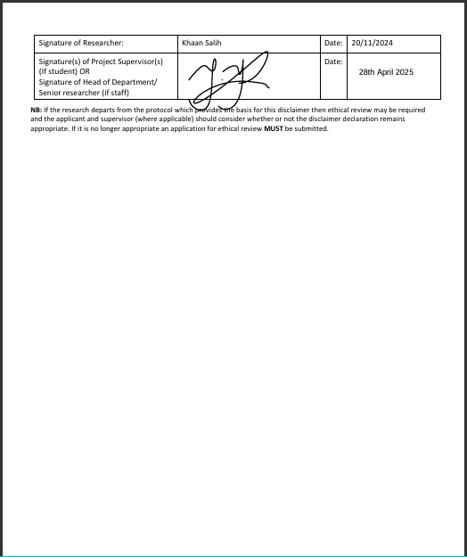

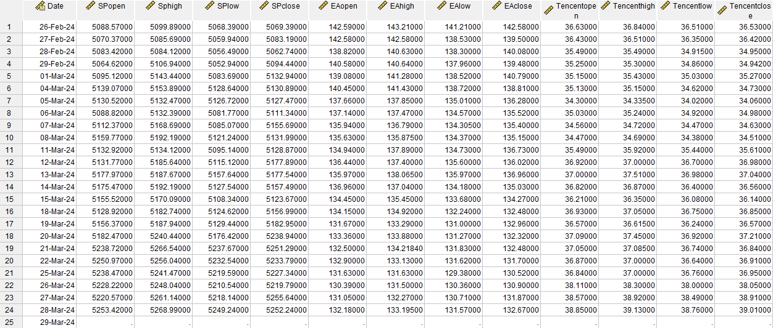
8.3 Appendix C: Raw SPSS Data (ordered chronologically by date)
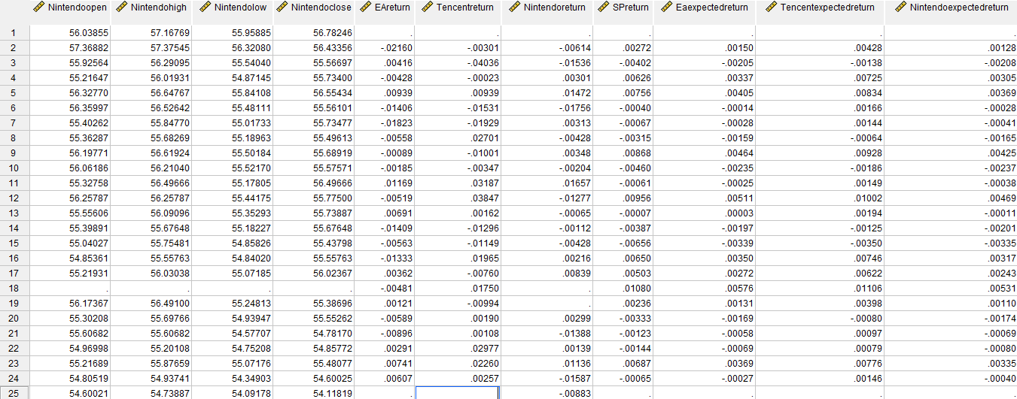

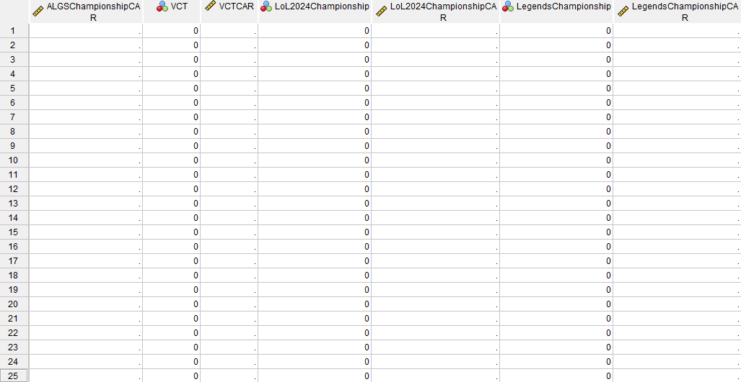
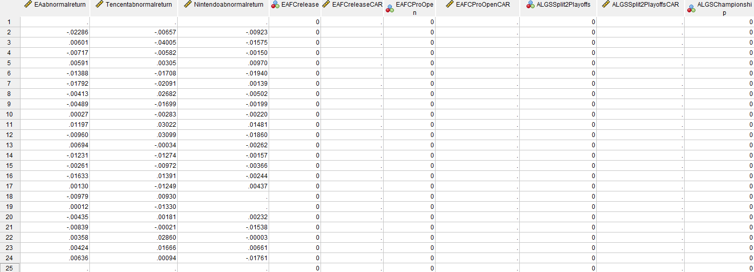
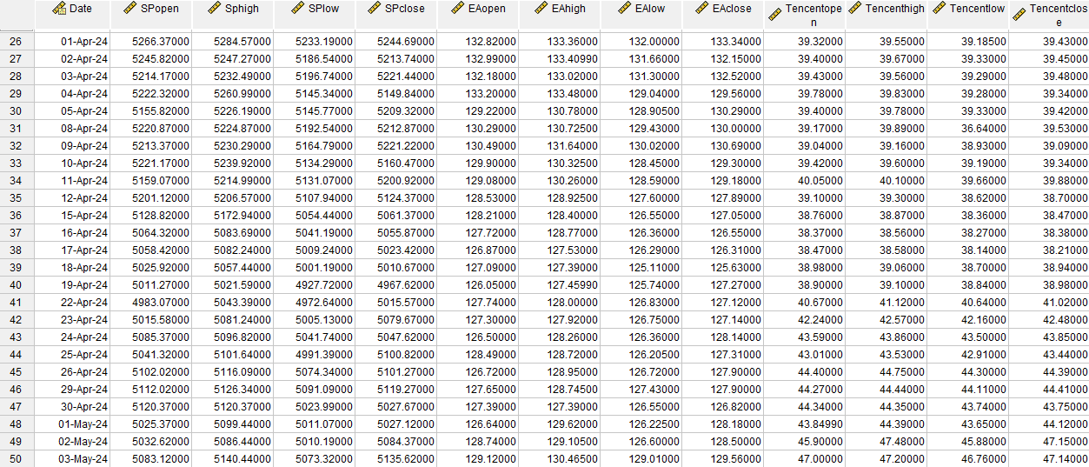
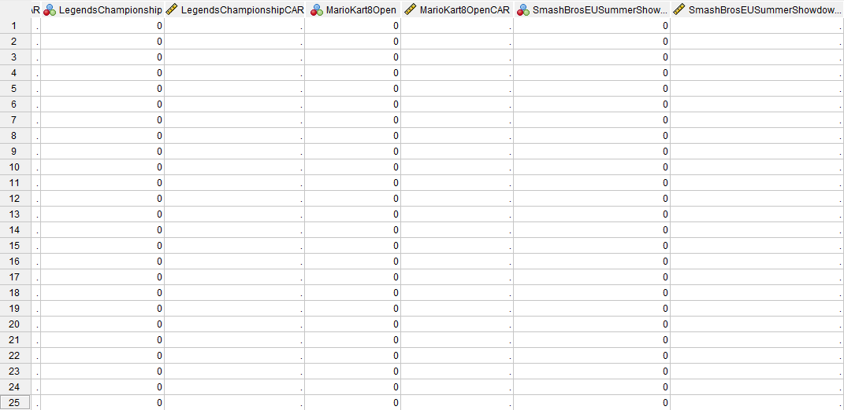
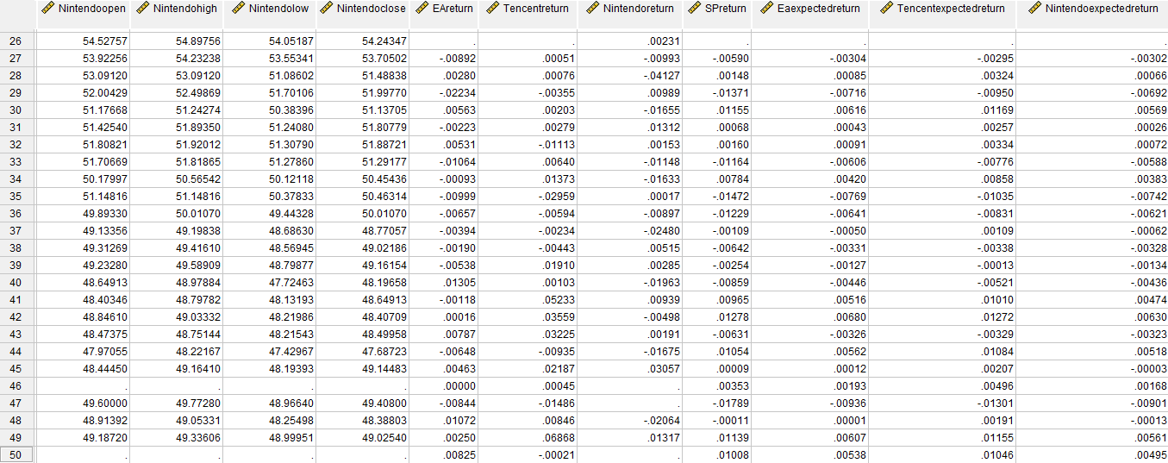
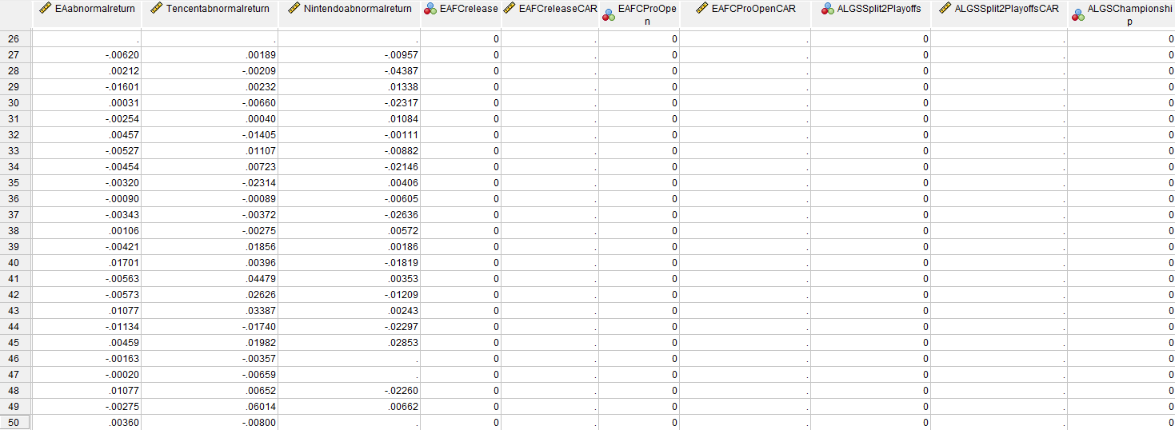
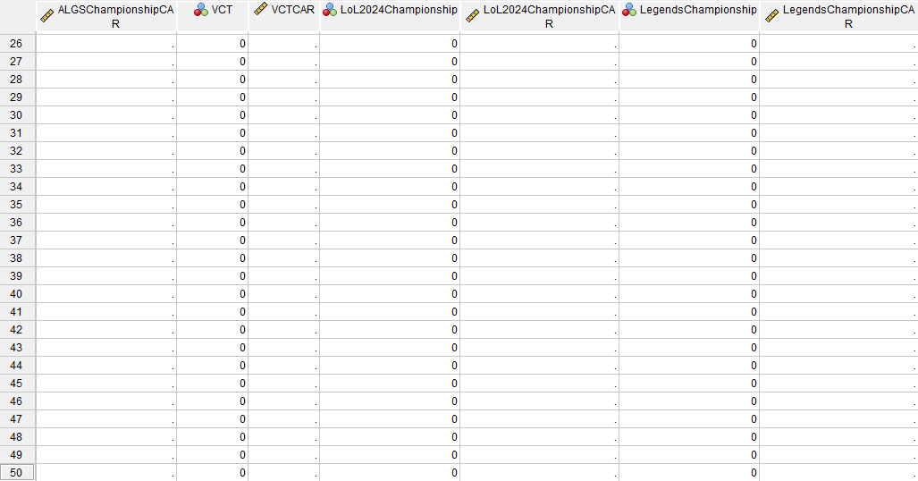
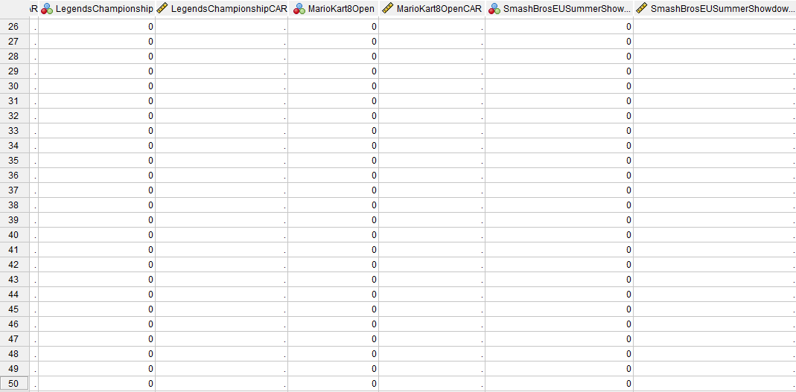
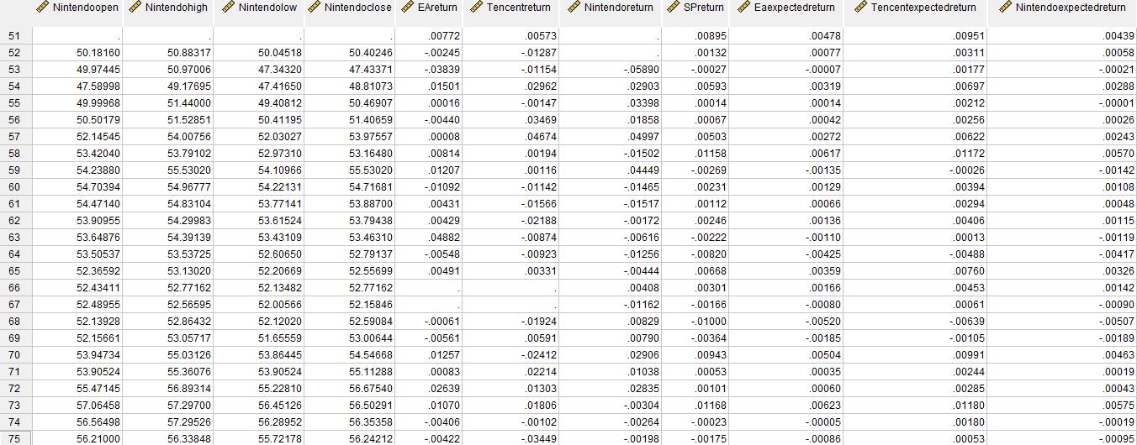
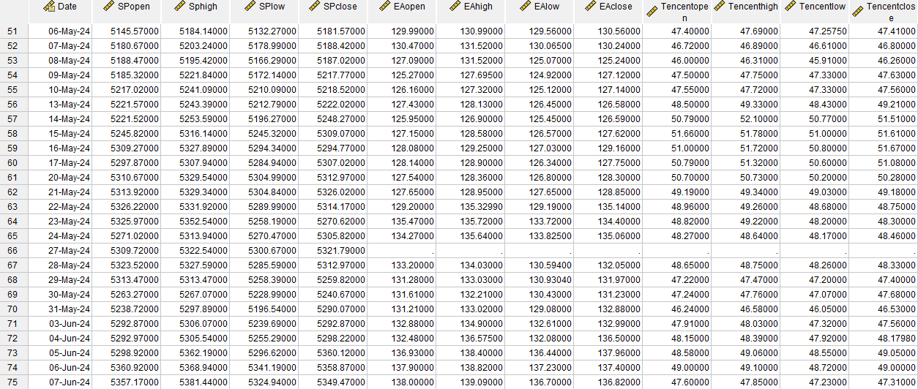
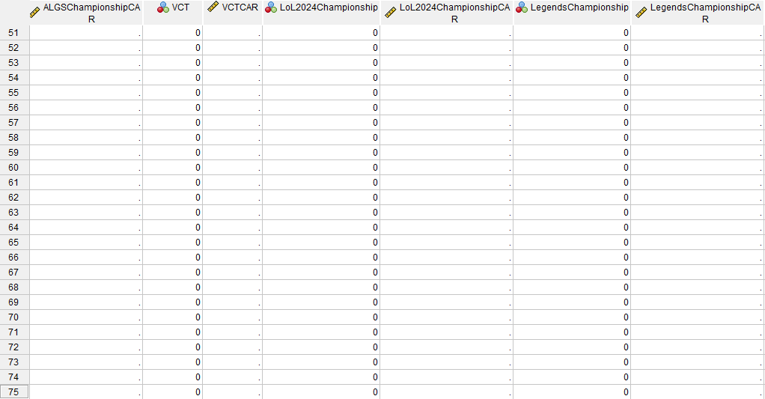
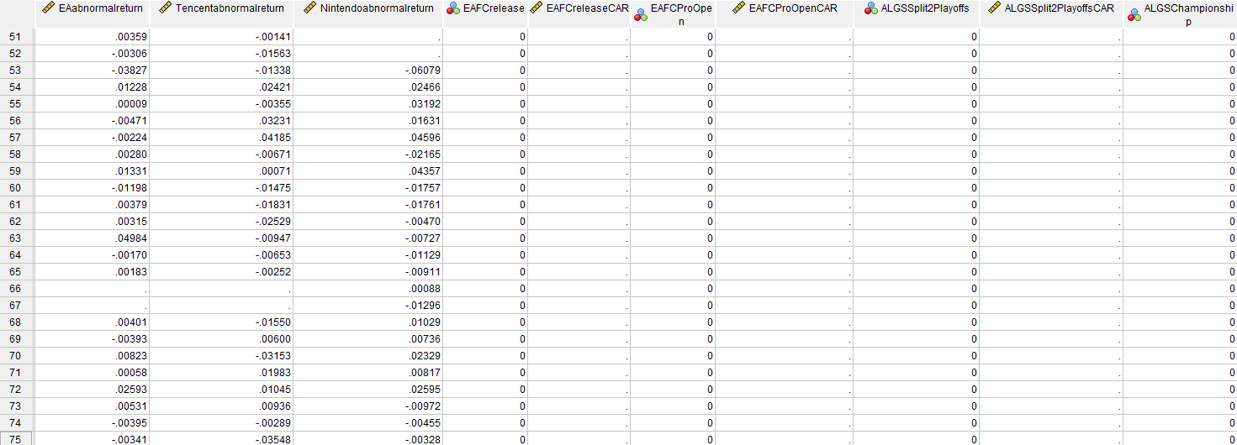
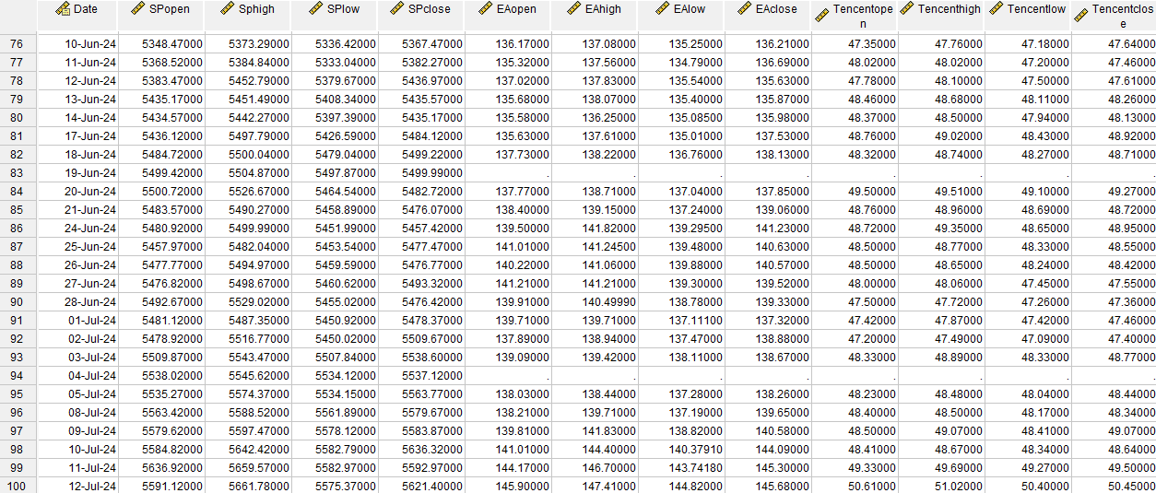
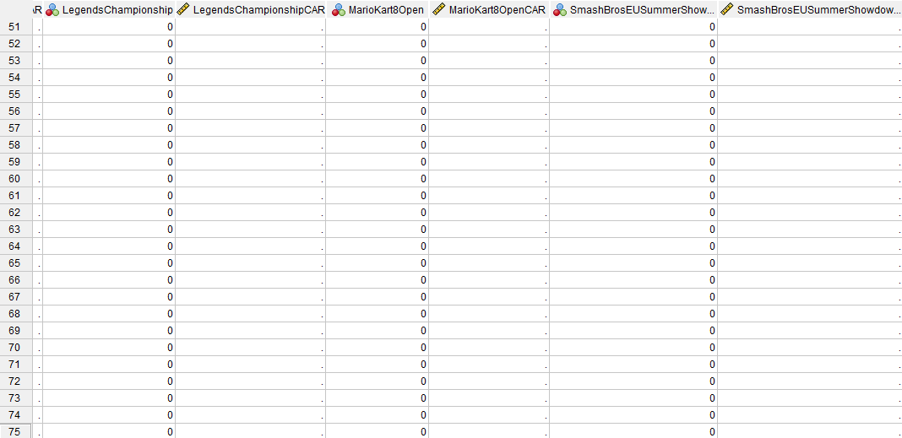
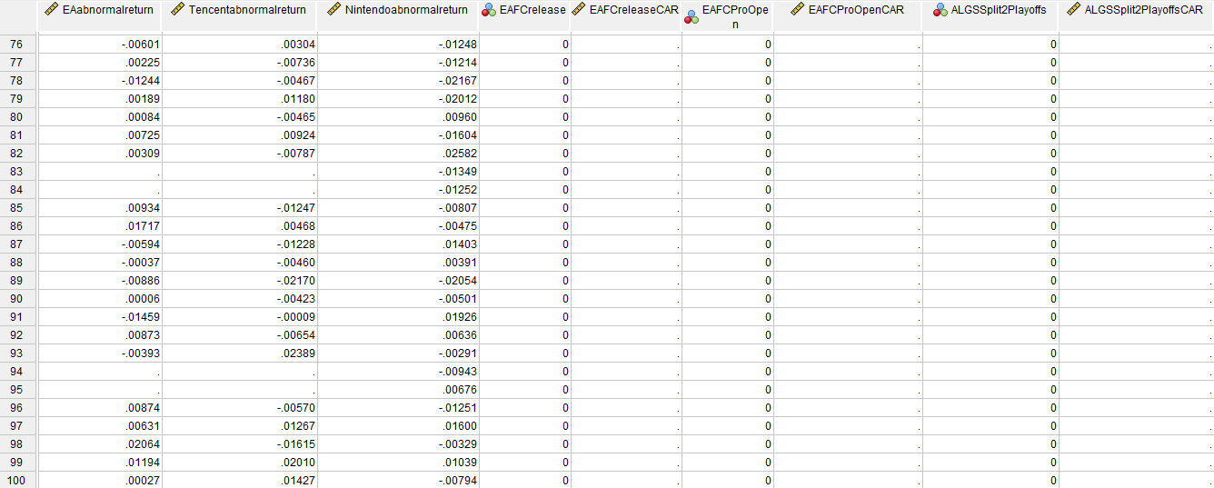
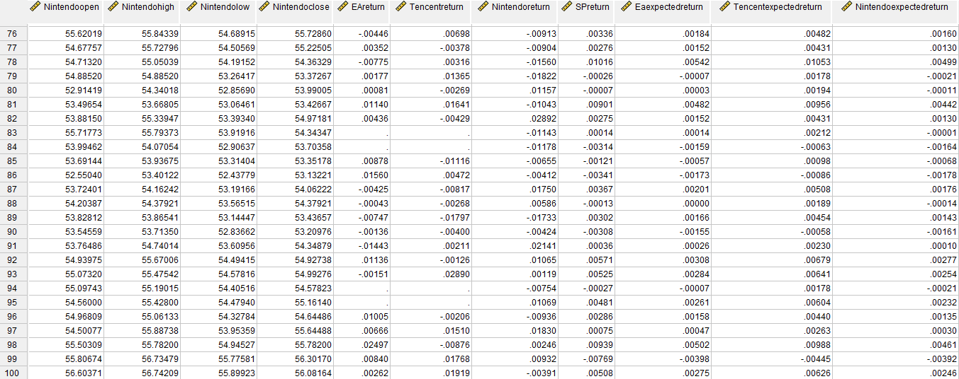
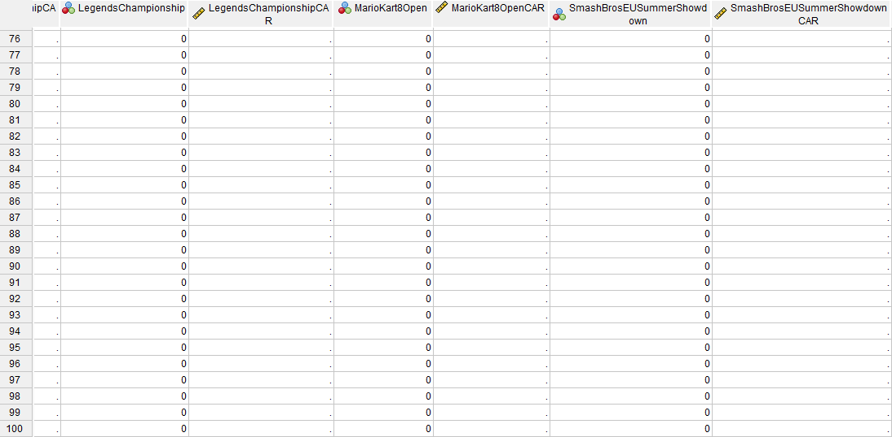
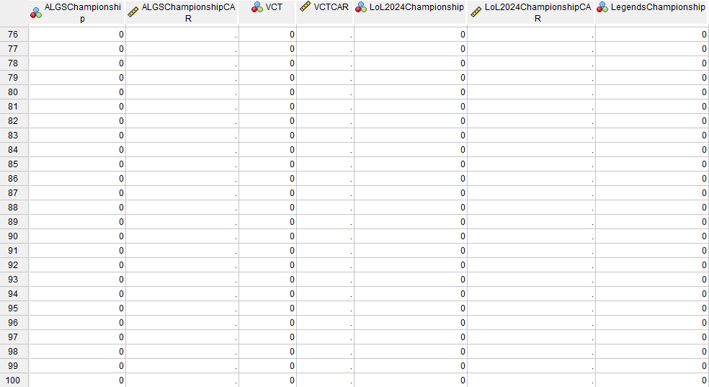
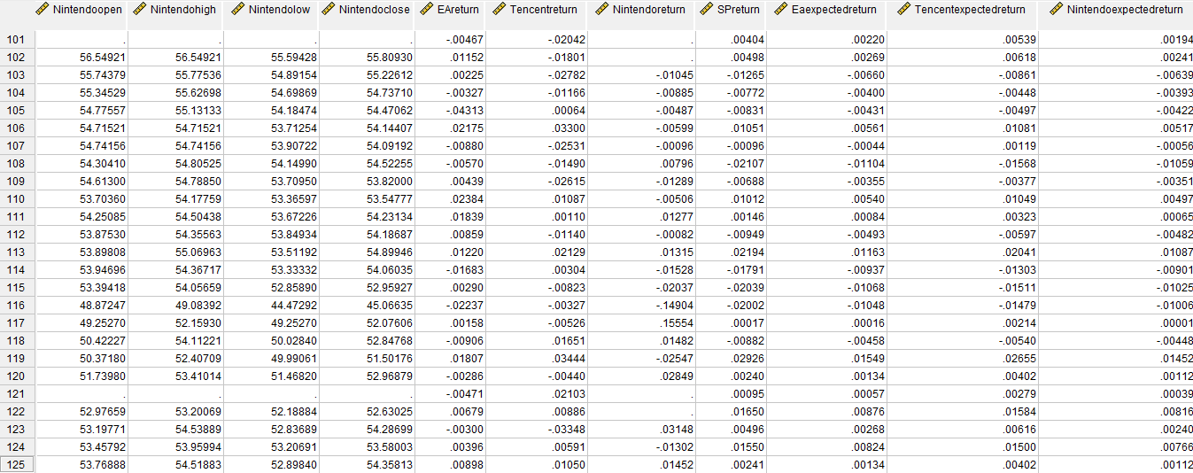
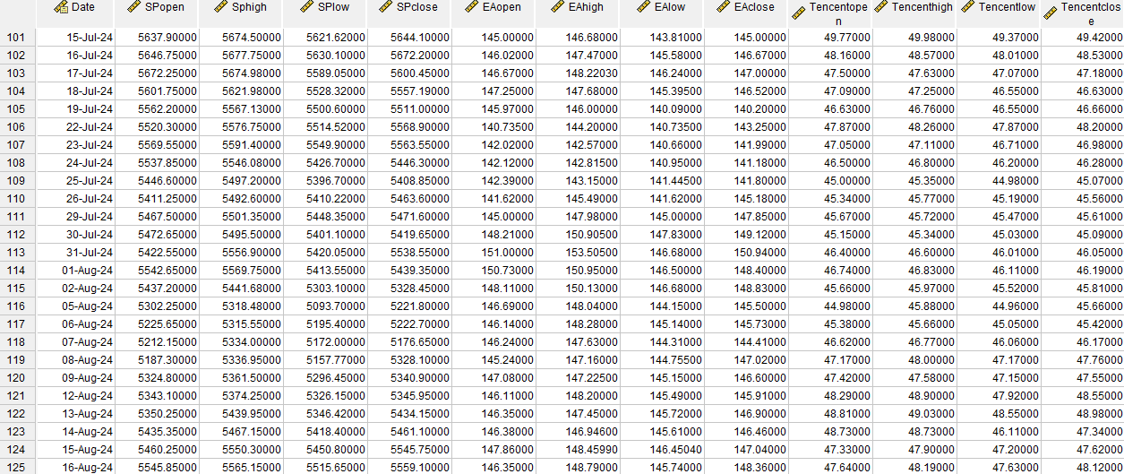
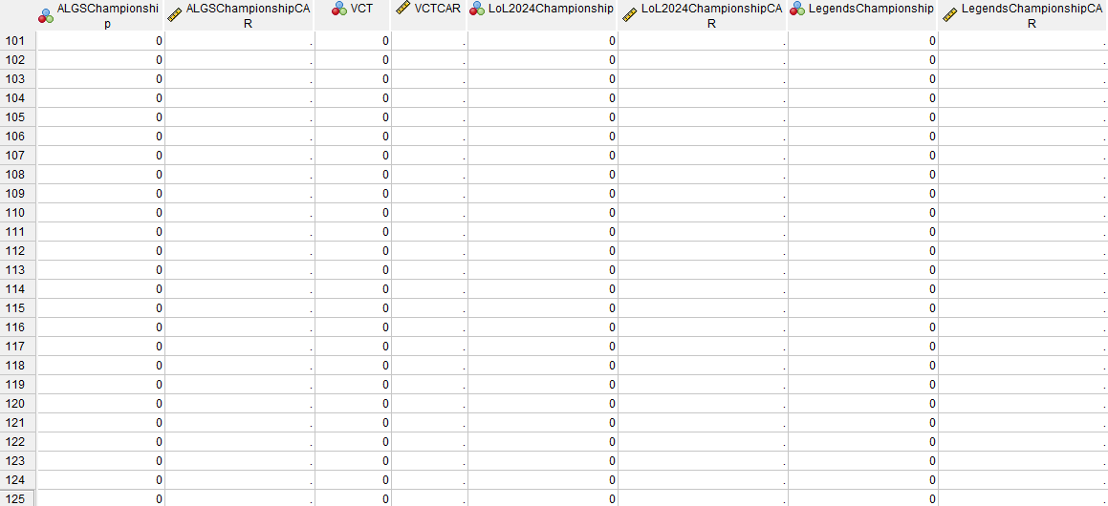
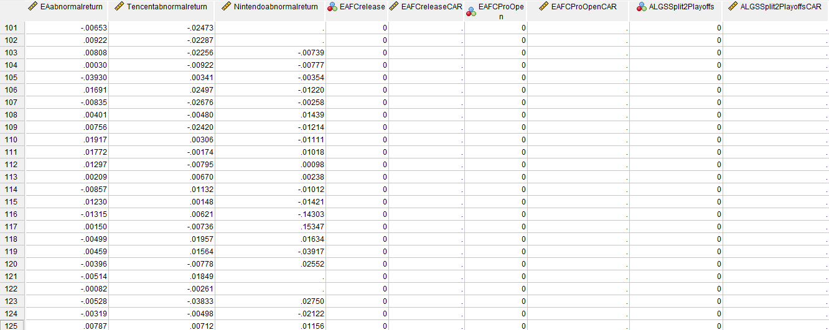
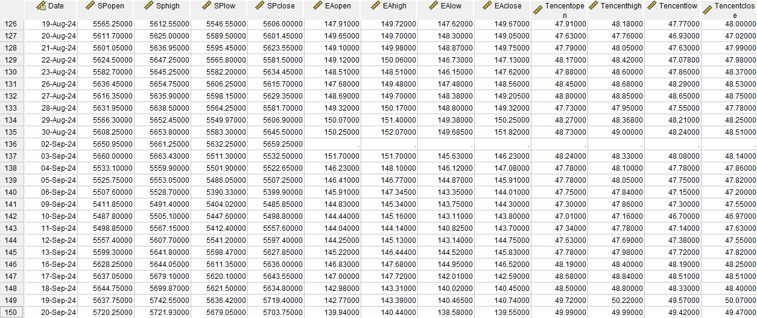
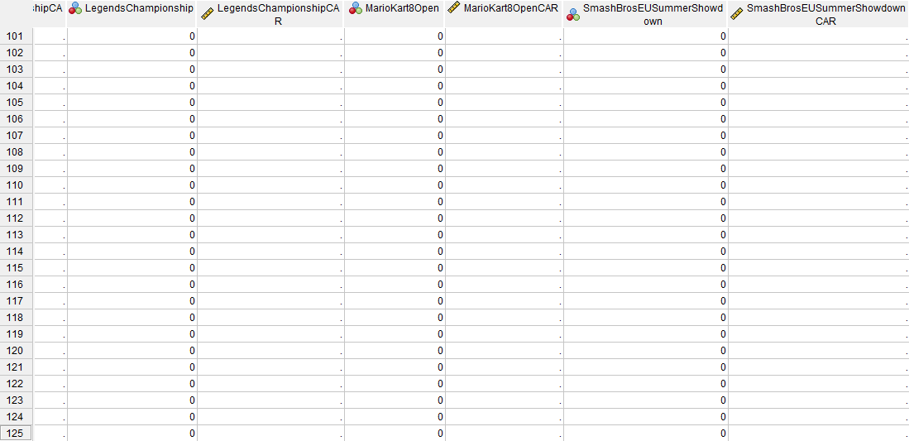
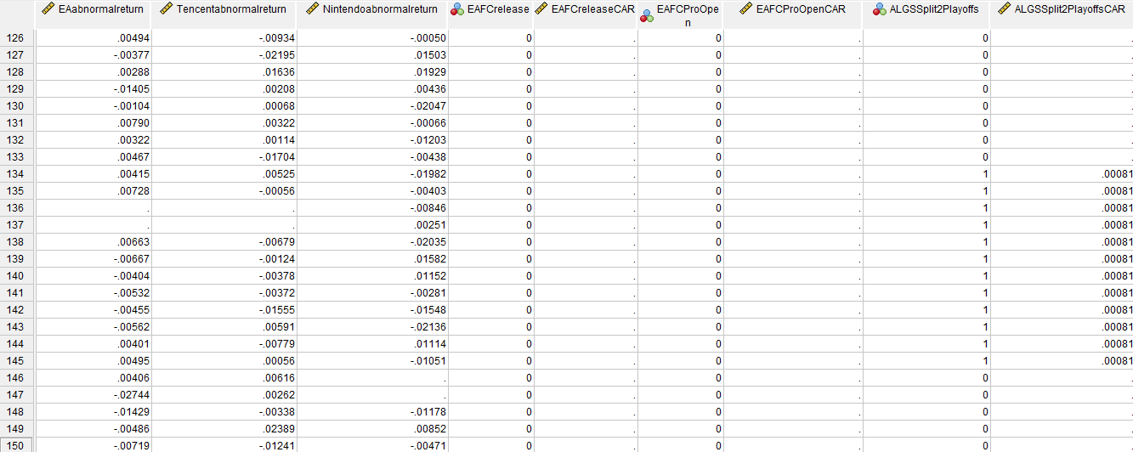
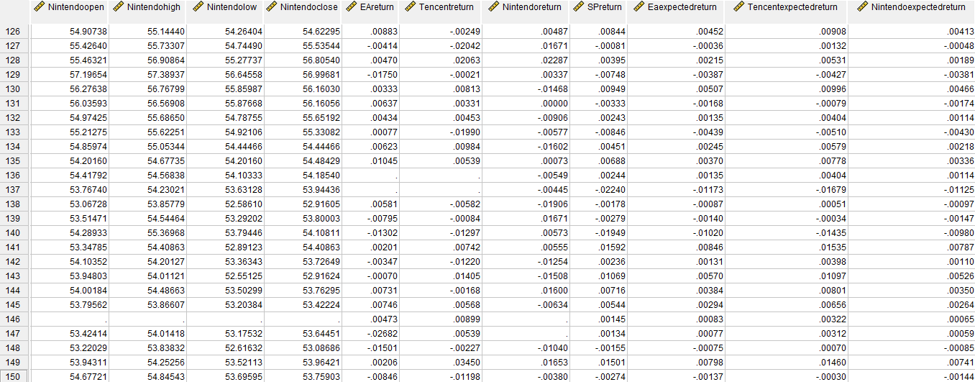
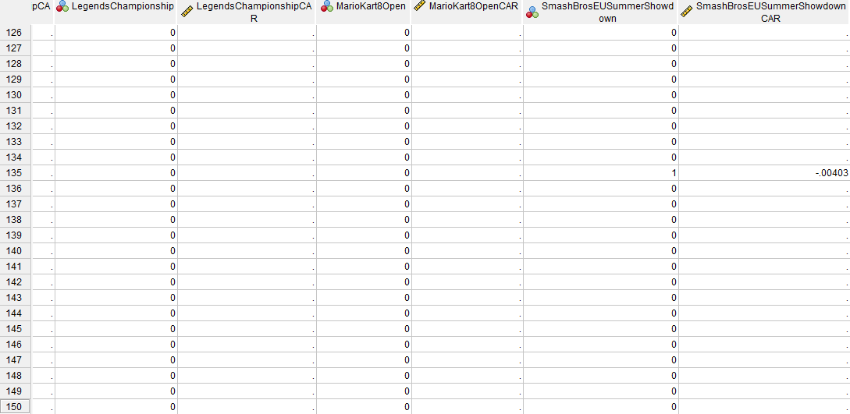
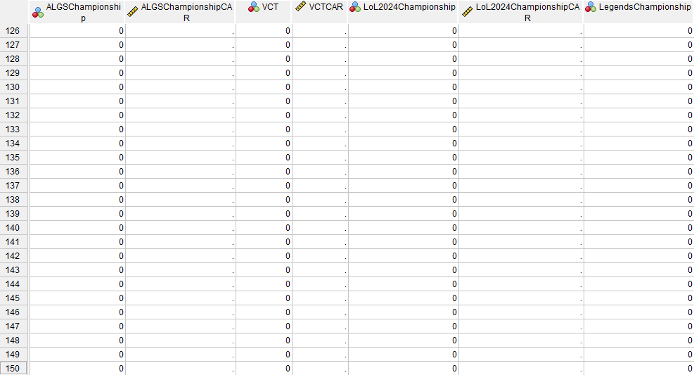
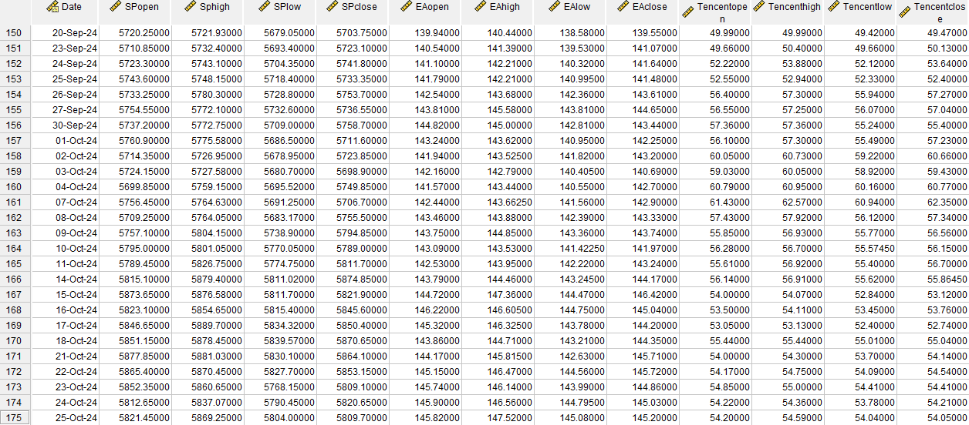
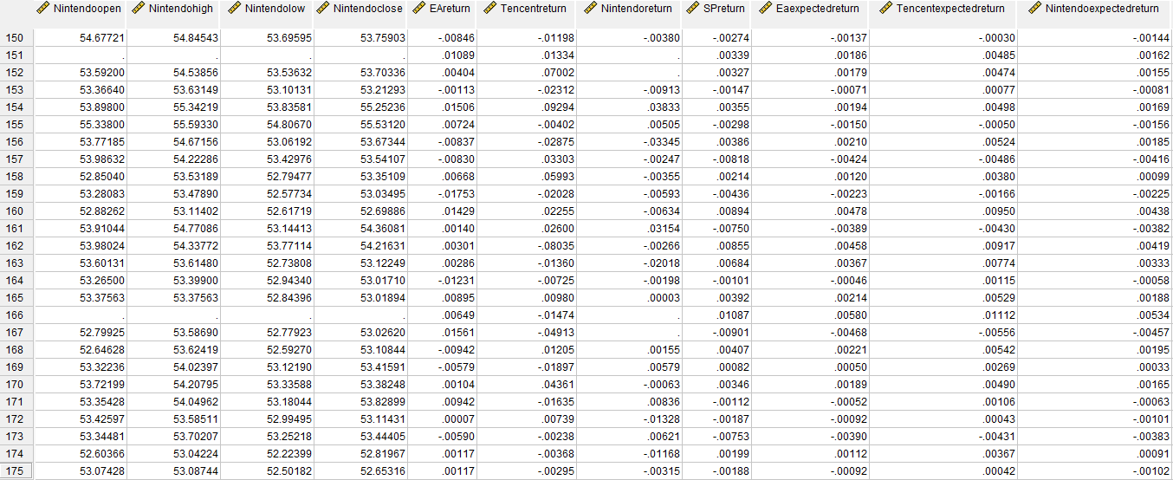
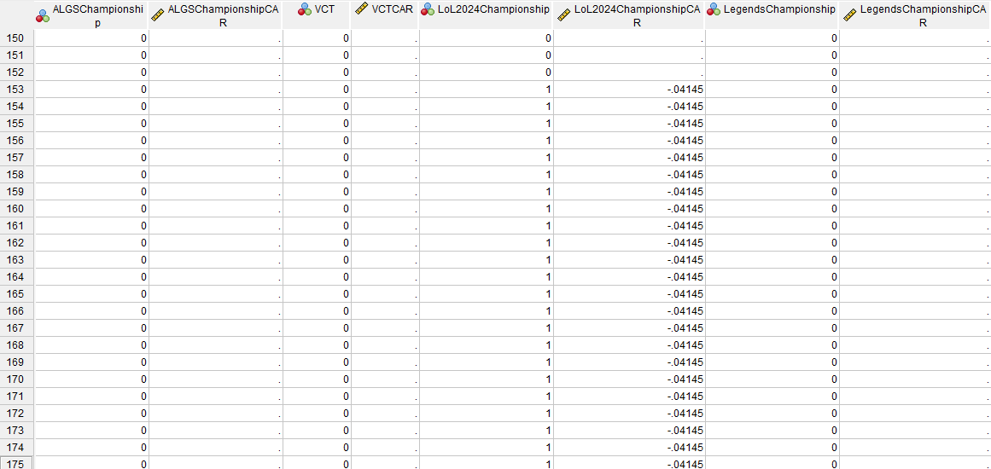
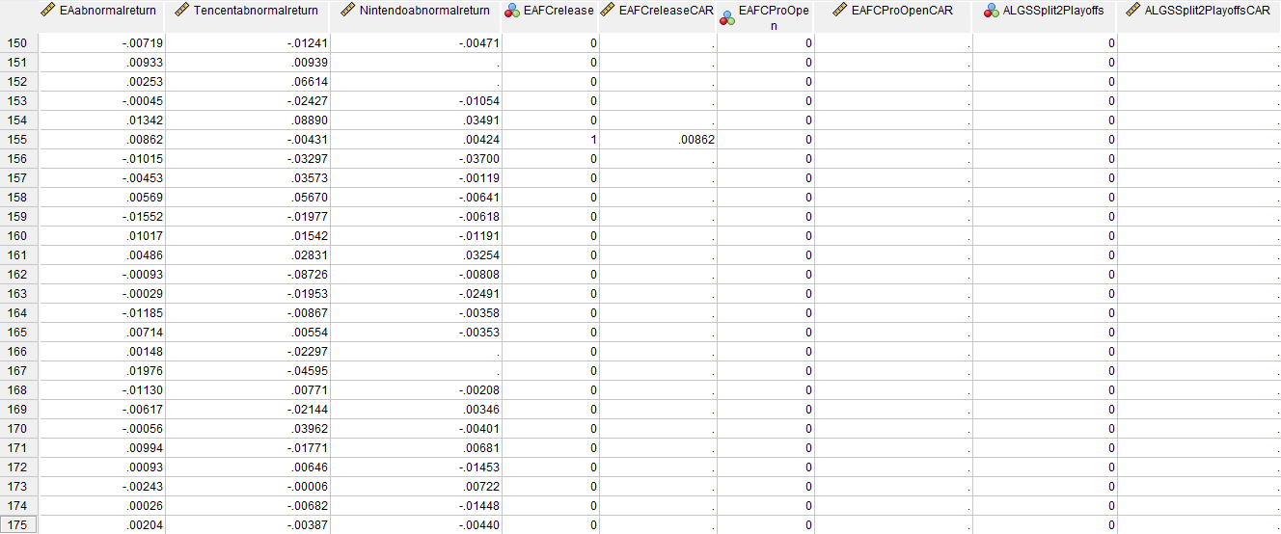
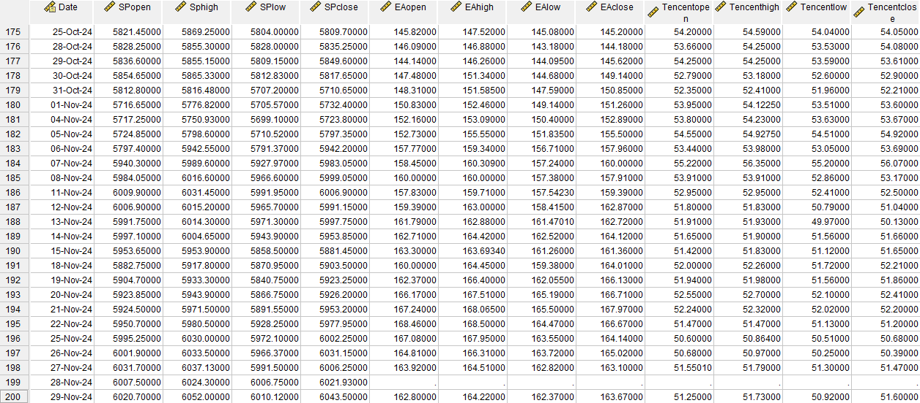
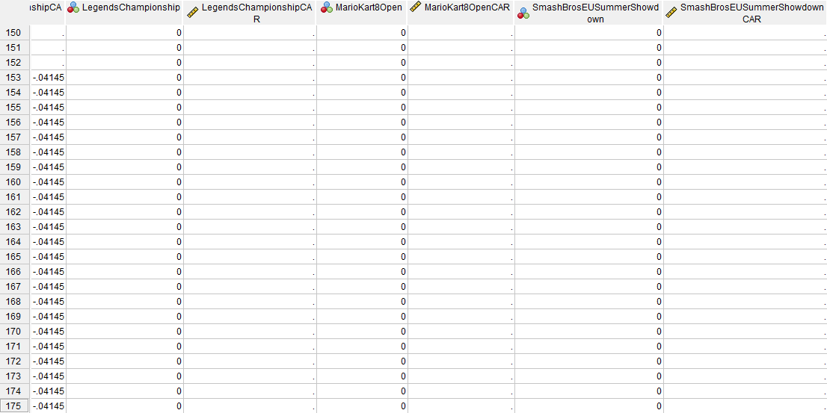
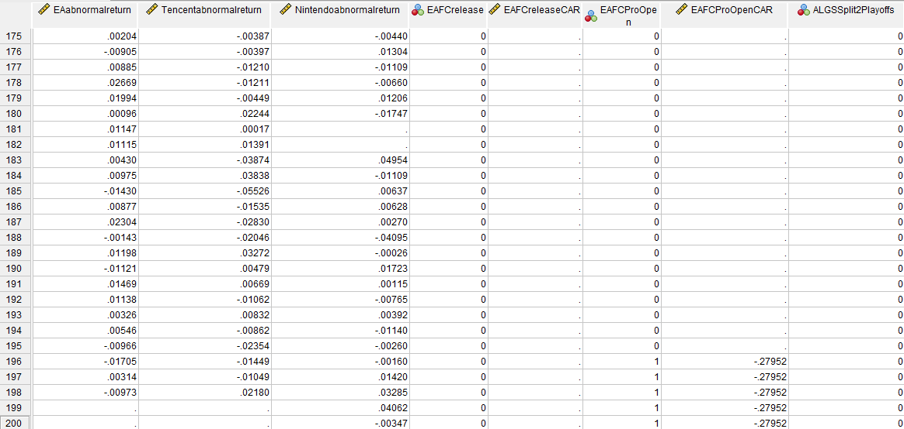
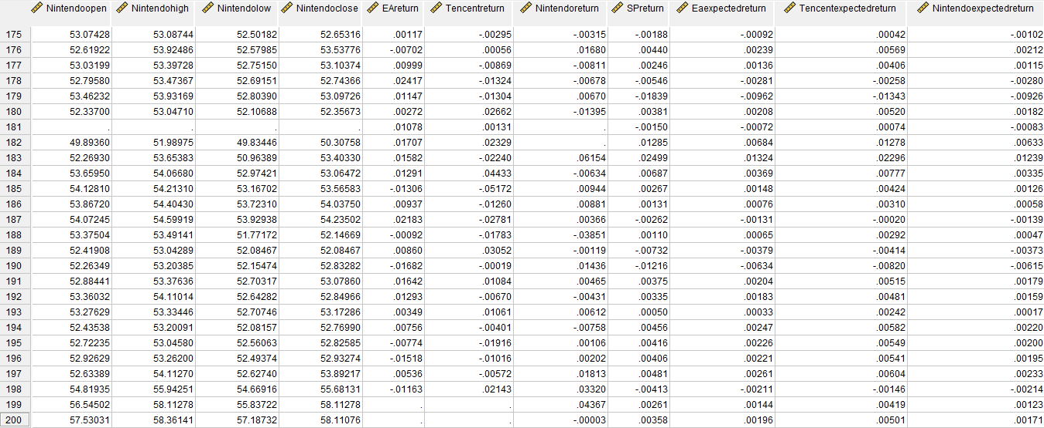
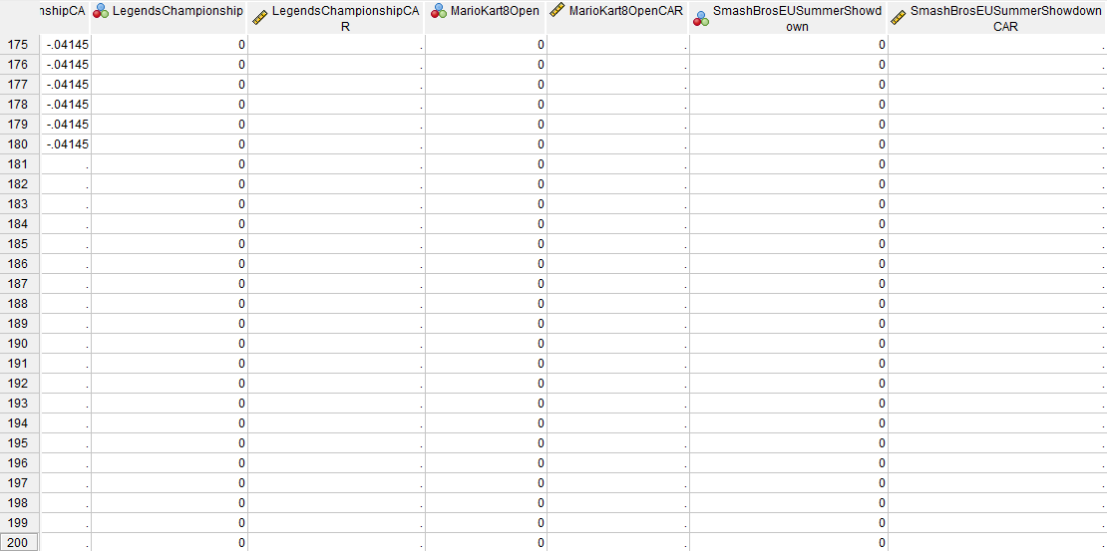
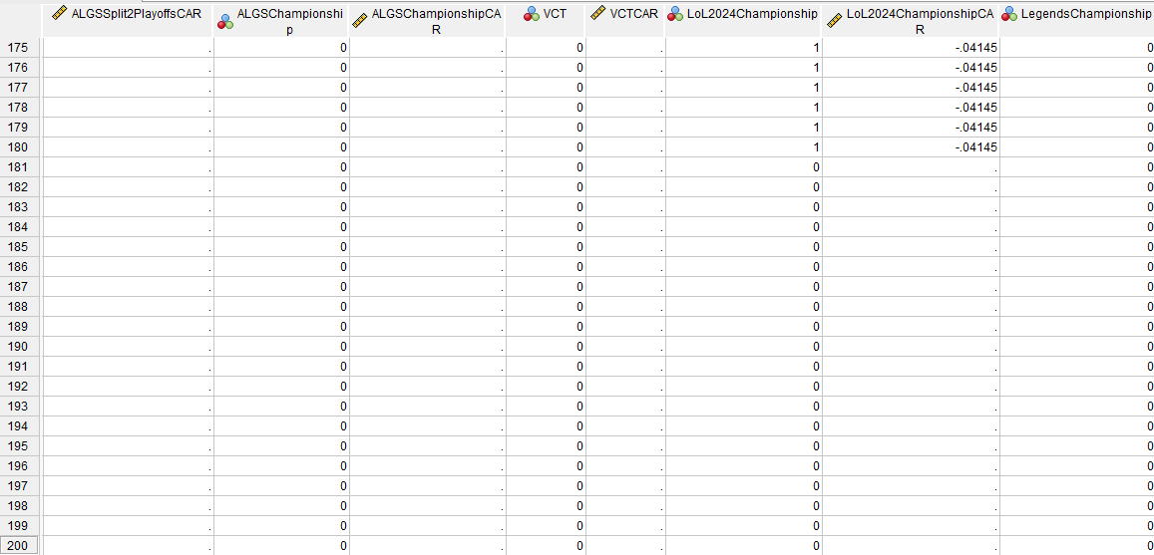
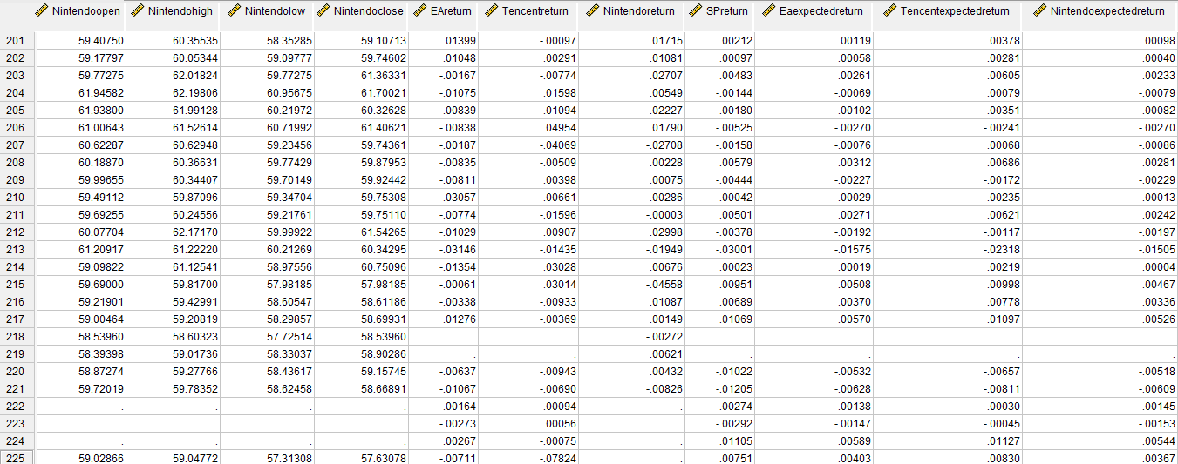
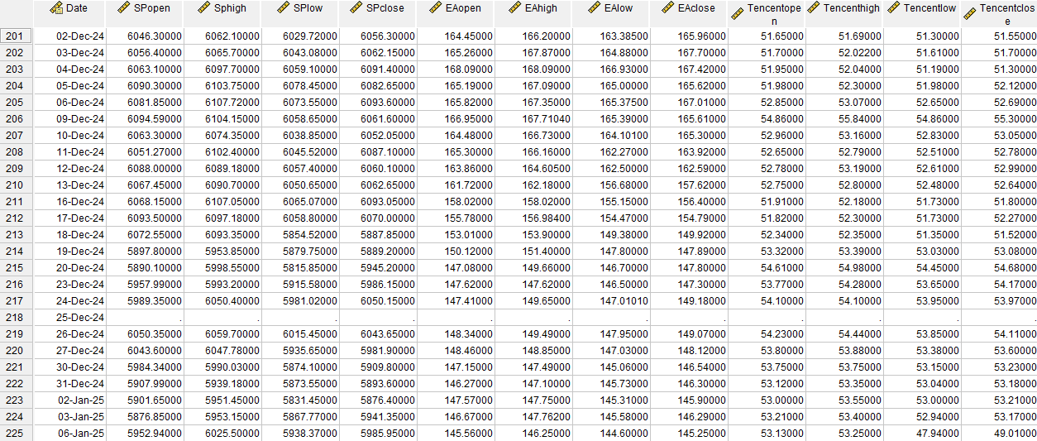
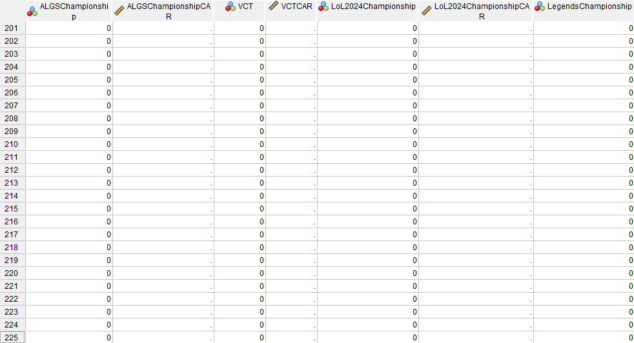
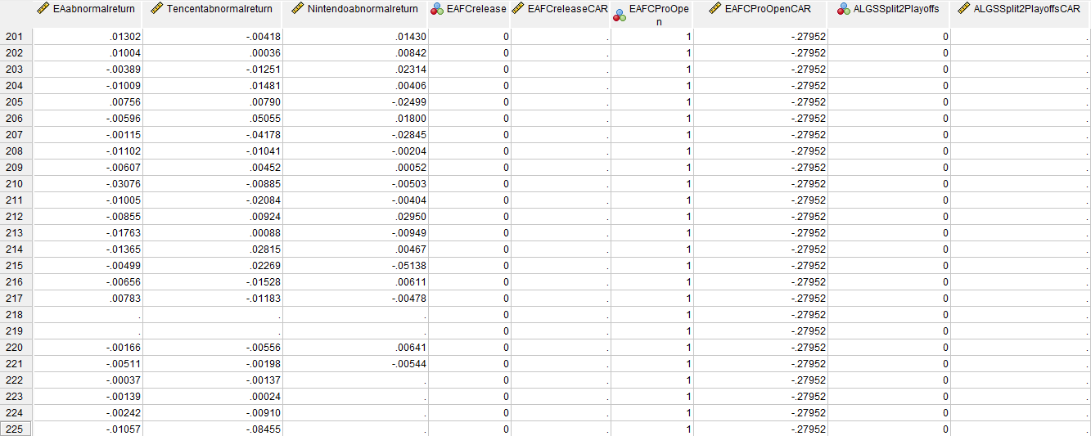
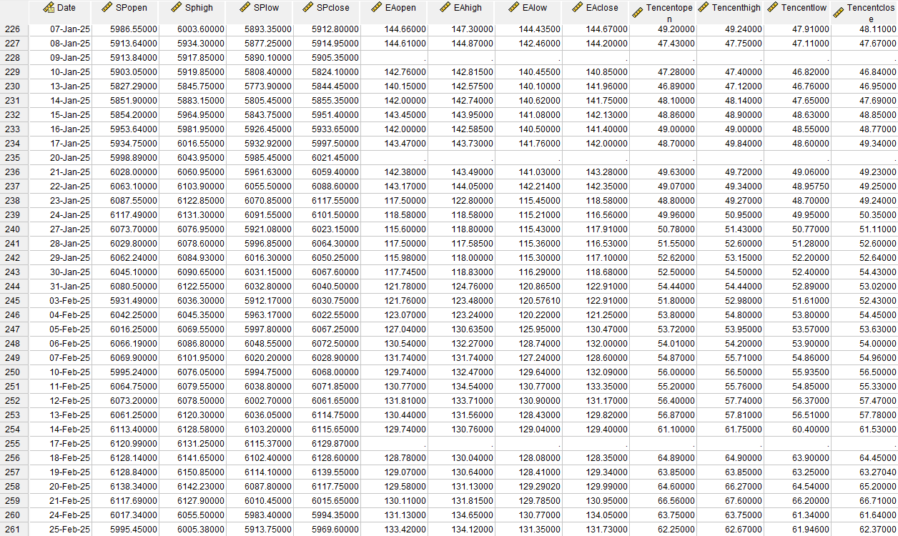
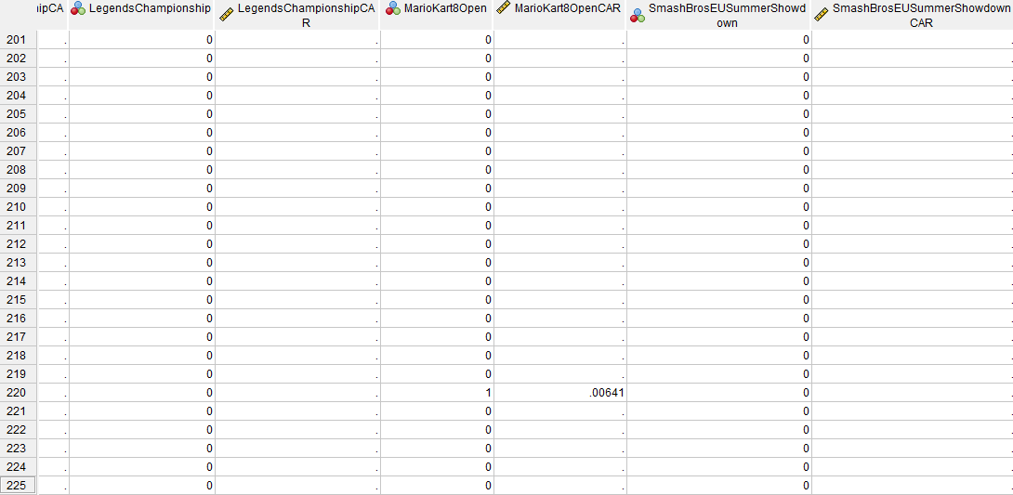
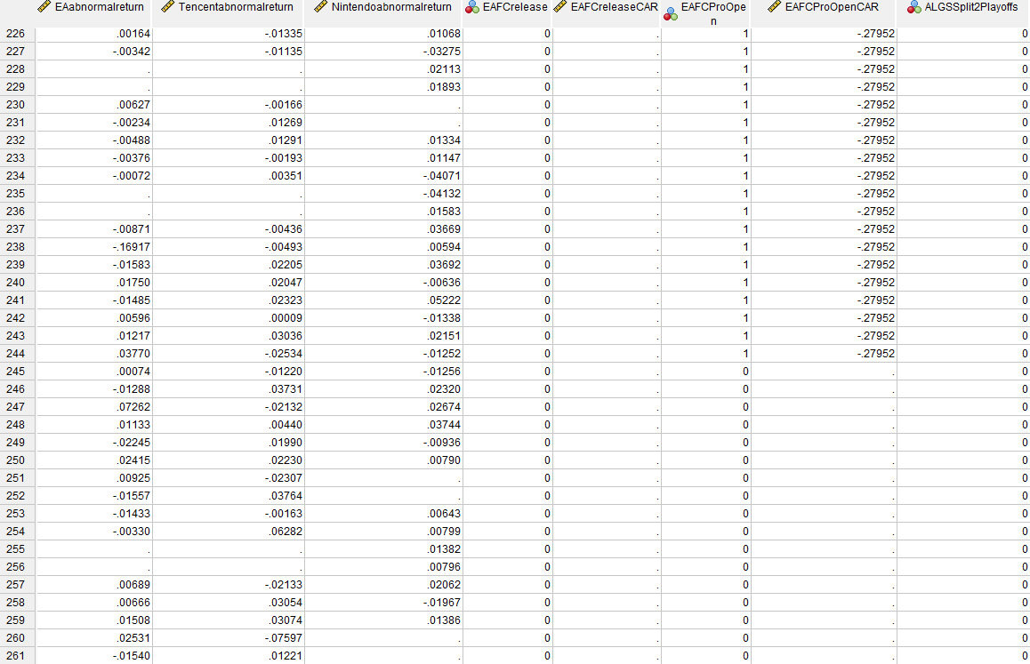
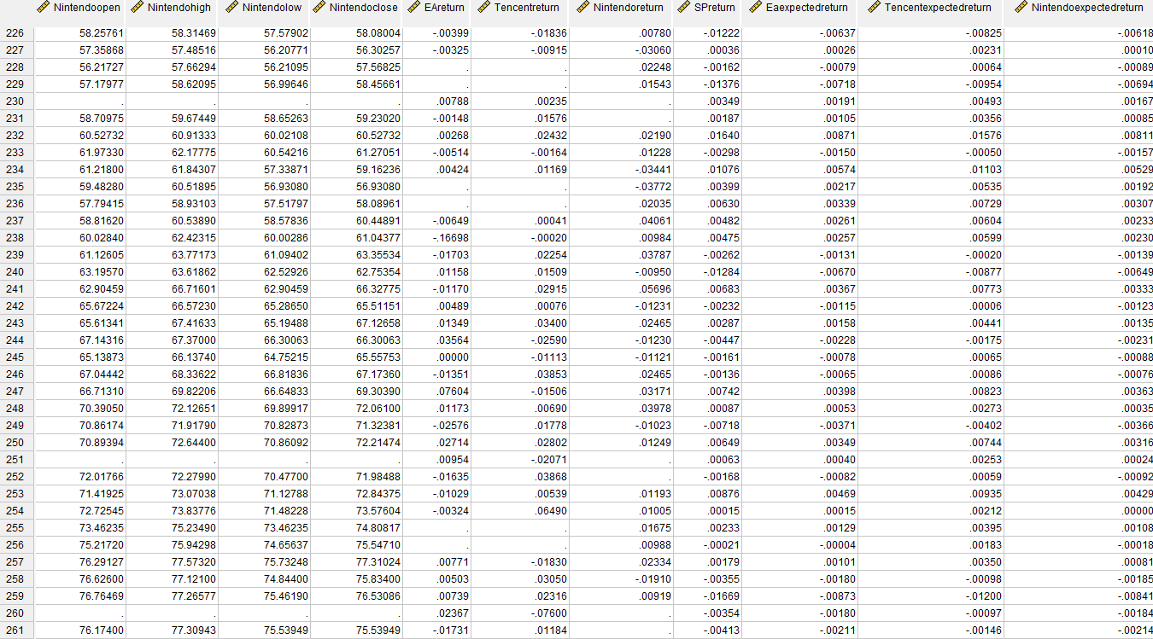
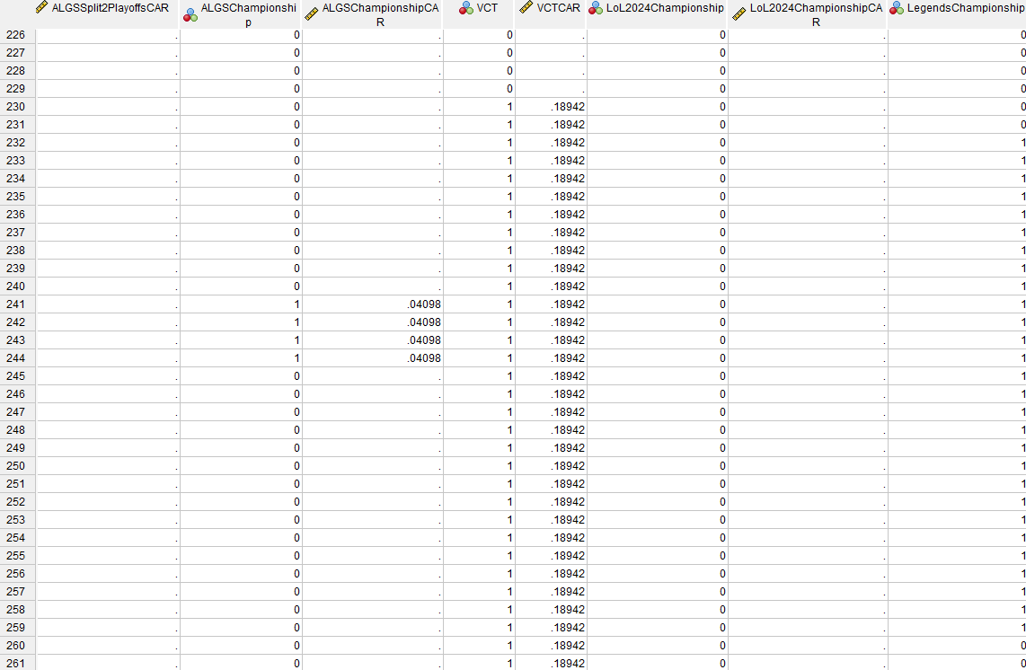
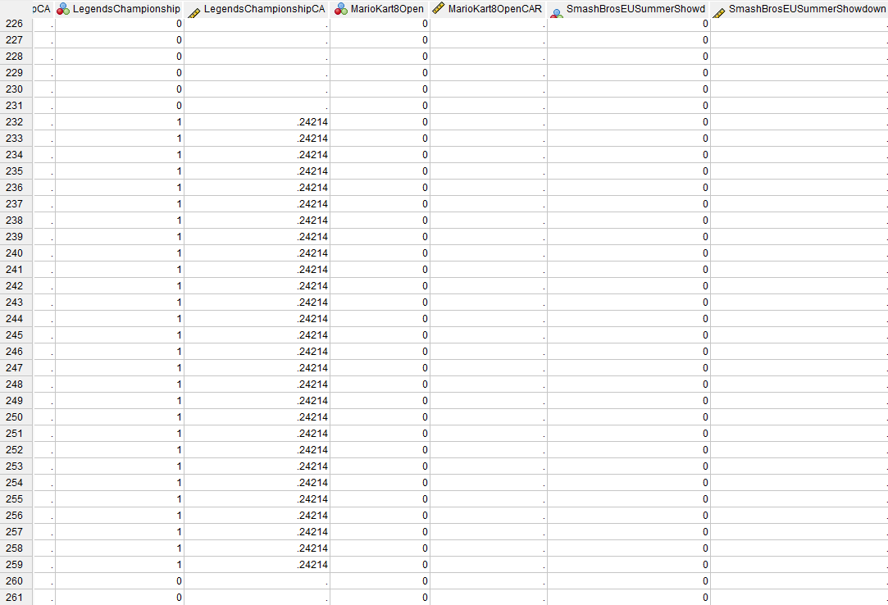

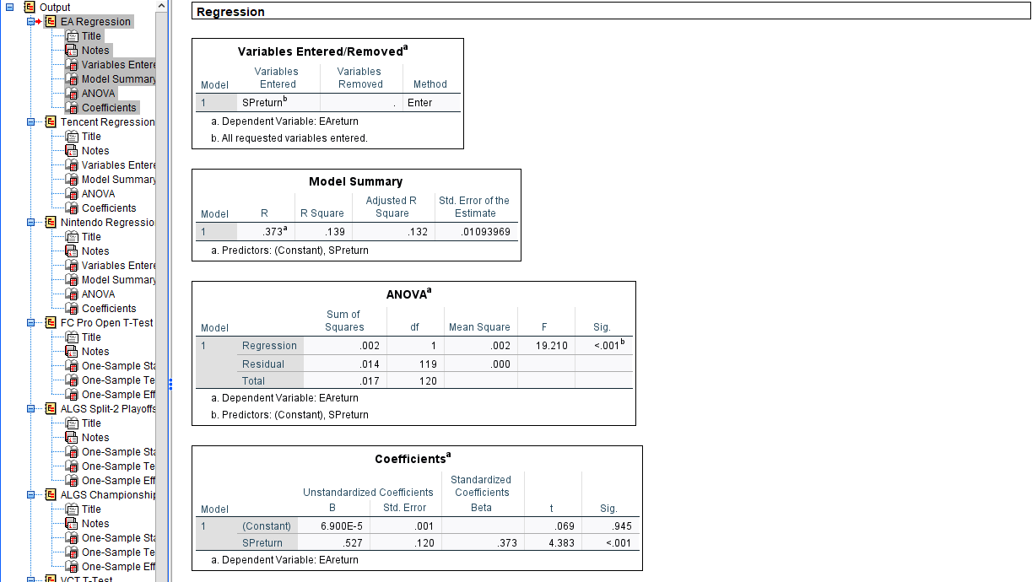
8.4 Appendix D: SPSS Linear Regressions (output column highlights dataset)

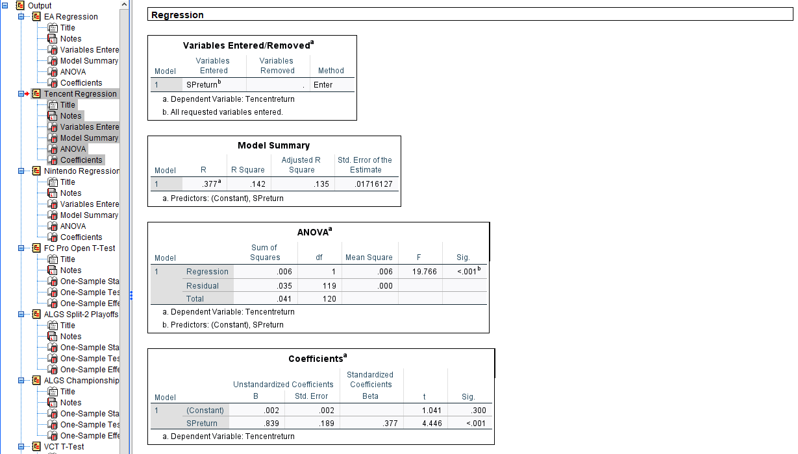

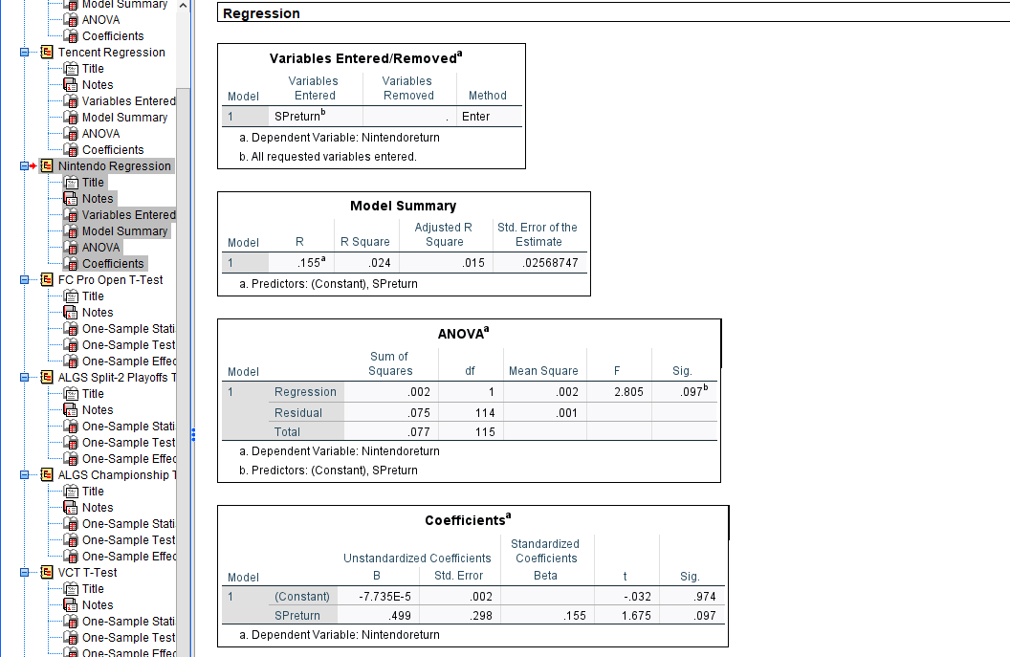

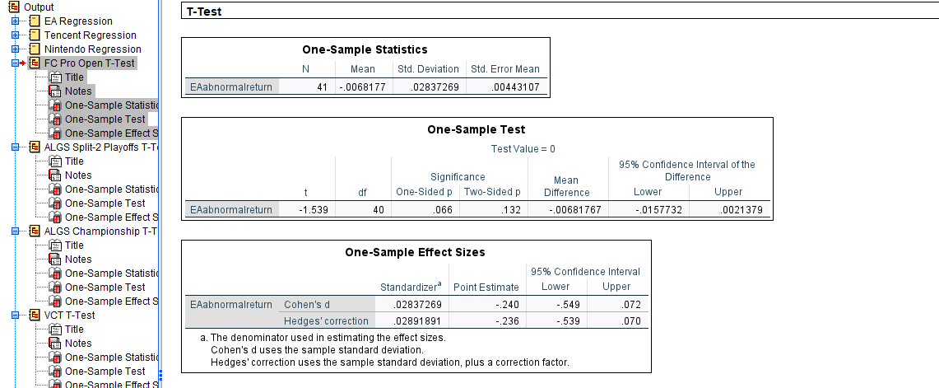
8.5 Appendix E: T-test (output columns highlights dataset)
