**Stakes on the game:** Exploring the influence betting has on spectatorship and viewing behaviour of esports

ByKevin Pan

Student number:22018704

Department of study:Esports

Date of submission:02/05/2025

# Abstract

This dissertation aims to explore how betting affects spectatorship and viewing behaviour within esports communities, looking at the views around the integration of gambling sponsorship, and whether gambling/betting affects the teams, players, game, and the engagement of watching esports. The data was collected through an online survey with open-ended questions. This was sent out to two different social media, being Twitter (X) and Discord. There were 13 responses at the end. Using Braun and Clarke’s thematic analysis, 5 core themes were generated, them being: normalisation of betting through comparison with traditional sports; financial benefits of sponsorship; ethical concerns toward the impact on young viewers; increased engagement and emotional investment; differing views on non-monetary betting,; and then community interest versus financial interest. The result highlights the normalisation of gambling and betting sponsorship in esports, with comparison to traditional sports, but there were concerns that it affecting young viewers. The results also indicated that gambling/betting increased engagement and investment when watching the game. This was seen in non-monetary gambling, but some argue that it is less engaging when partaking in this form of betting. Finally, how gambling has taken away the communal aspect of watching esports because people who bet on the game are more financial driven than wanting to support the teams/players/game.

Contents

Abstract 2

Introduction 5

Research Question 6

Research Aims 6

Literature review 6

Esports spectatorship and viewer motivations 7

Relationship between betting and spectatorship 8

Conclusion 10

Methods 11

Research Design 11

Data Collection 11

Participant 12

Sampling method 12

Procedure 12

Data Analysis 13

Results 13

Normalisation of betting through comparison with traditional sports 13

Ethical concerns towards the impact on young viewers 14

Increased engagement and emotional investment in the viewing experience 15

Differing perspectives on non-monetary betting 15

Community interest versus financial interest 16

Conclusion 16

Discussion 16

Normalisation of betting through comparison with traditional sports 17

Ethical concerns towards the impact on young viewers 17

Increased engagement and emotional investment in the viewing experience 18

Differing perspectives on non-monetary betting 19

Community versus financial interest 19

Limitations 20

Conclusion 20

References 22

Appendices 25

Appendix 1- Research proposal 25

Appendix 2 – Signed Ethics 39

Appendix 3 – Reflective Diary 44

Appendix 4 – Gantt Chart 46

Appendix 5 – Supervisor Meeting Agendas 47

5.1 – 20/02/2025 47

Appendix 5.2 – 27/02/2025 49

Appendix 5.3 – 20/03/2025 51

Appendix 5.4 – 01/05/2025 53

Appendix 6 – Survey Question 55

Appendix 7 – Survey results 56

# Introduction

Esports is a rapidly expanding industry that is gaining increasing recognition on a global scale (Funk, Pizzo, and Baker, 2018; Jenny et al., 2024) with an estimated 532.1 million global viewers in 2022 and projections of reaching 640 million by 2025 (Ruby, 2022; Newzoo, 2022**)** displaying the massive growth of esports spectatorship. Some major esports titles like Counter-Strike 2, Valorant, and League of Legends (LoL) have consistently drawn over a million peak viewership during big events like LoL Worlds, Valorant Champions Tour (VCT), and CS Majors. Unlike traditional sports, which requires the user to have a paid subscription or cable television to watch the game, esports thrives on having their event streamed free on streaming platforms like Twitch and YouTube, making it more accessible for global audiences to consume (Qian et al., 2019; Cheung and Huang, 2011).

Similar to traditional sport, esports has cultivated a competitive environment, developed dedicated fan bases, achieved viewership comparable to some traditional sports (Tooker, 2021), and runs large-scale events, making it attractive for businesses. Among these businesses, gambling and betting have established a strong presence in the esports scene, growing alongside the industry itself (Mangat et al., 2023). With viewership comparable to traditional sports, there have been concerns that betting/gambling influences the way people interact with the broadcast, with long-term impacts. CSGO and its sequel, CS2, have heavily integrated gambling elements within their games and esports. One such case is “skin betting”, which uses in-game gun skins as gambling currency on third-party platforms (Greer et al., 2022; Holden et al., 2016). Within esports and broadcast, teams are seen wearing jerseys with betting sponsors displayed, embracing third-party betting sites, and integrating betting elements within their broadcast, like displaying betting odds, similar to traditional sports like American football.

A recent shift in the esports industry was Riot Games, the developer of two major esports titles, League of Legends (LoL) and Valorant, decision to allow teams within their franchise to have betting sponsors starting in 2025. A major shift from the company’s previous stance on betting sponsors, preventing teams from displaying any forms of gambling or betting sponsors on their jerseys and broadcasts (Šimić, 2024).

Given the rapid growth and the increasing presence of gambling and betting within the industry, academic research on these topics has become ever more important. Current literature around betting and spectatorship has continued to grow, with several studies finding that betting has an increase in viewer engagement and investment in the viewing experience compared to non-bettors (Macey and Hamari, 2018; Mangat et al., 2023). Despite that, current research only focuses on the general relationship between betting and spectatorship rather than investigating how spectators perceive the growing presence of betting within esports and how it has influenced the spectatorship of the sport.

This dissertation addresses these gaps by using an open-ended question survey to explore esports spectators’ views, attitudes, and behaviours on betting and gambling within the industry. Specifically, exploring the presence of gambling and betting sponsorship during broadcasts, their views on how it may influence engagement with events, and their thoughts on future impacts on esports spectatorship. This research is being done in the hopes of expanding the existing literature and understanding of gambling and spectatorship within esports, presenting a new perspective on the topic. Also, providing more information for the industry within esports to understand the current views on gambling/betting from a viewer’s perspective, possibly making informed decisions based on this research.

## Research Question

The research question that is guiding this study is: How does betting affect spectatorship and viewing behaviour in esports communities?

## Research Aims

The aims of this research are:

* To understand the current views on betting among esports fans
* To explore the impact that betting has on the spectatorship and viewing behaviour within the esports community
* To analyse the positive and negative responses that viewers experience in terms of engagement when watching esports
* To critically examine how esports betting influences viewers’ connections to players, teams, or match outcomes, and whether this fosters deeper engagement with the sport

# Literature review

Esports has grown into a major global industry with thousands to millions of viewers and a strong spectator culture. Alongside this growth, gambling and betting have also become more common. This has happened both through traditional betting platforms and third-party sites, like those using CS2 skins for gambling (Greer et al., 2022; Holden et al., 2016). Betting is becoming more visible in esports broadcasts and sponsorships, with some companies now openly working with betting brands (Esports Insider, 2022). As a result, the connection between gambling and esports spectatorship is getting stronger. It is important to understand how this might be changing the way people watch and engage with events, and views on betting sponsors.

This literature review will cover several studies covering topics on esports spectatorship and the motivations for why people watch, and the relationship between betting and spectatorship. Through summarising and analysing existing literature, this review will identify the research gap that establishes the aim of this research, and the development of the research question, “How does betting affect the spectatorship and viewing behaviour in esports communities?”.

## Esports spectatorship and viewer motivations

Understanding the motivation behind spectatorship within esports is an important groundwork for examining how betting influences people’s enjoyment of watching the game. Several researchers have explored the reasons why people watch esports (Cheung and Huang, 2011; Hamari and Sjöblom, 2017), the importance of spectatorship, and identified key aspects of motivation that drive viewership. With parallels between traditional sports and esports, as a form of entertainment media, sports studies are used by academics, applying theoretical methods from their study (Wagner, 2006) into esports studies.

Cheung and Huang's (2011) early research into esports spectatorship has established the importance of spectators, identifying them as emerging stakeholders within the esports ecosystem. Using a grounded theory approach, they aimed to identify who and why people watch esports and what spectators find interesting. Drawing on 127 online data points, ranging from comments to video content from people sharing stories of spectating StarCraft, they examined how audiences engaged with matches. Their studies identified nine types of personas, each with different motivations for watching. Each persona had different motivations for watching esports, with some engrossed by gameplay and finding enjoyment in the competitiveness aspect, others watch to learn from more experienced players like professionals or learning new information about the game, and others were motivated by being part of a community. These insights give a clearer understanding of why people watch esports, establishing a foundation, but still need development of the study. Their sample focused exclusively on one esports title, and with new factors, since their study, has changed the way people consume esport, like the rise of Twitch as the main esports streaming platform or the increase of online betting.

Building on this, Hamari and Sjöblom (2017) further explore the motivations for why people watch esports on the internet. Their study identified previous and new key motivators for esports spectatorship while also discovering other motivators having less effect on spectatorship. Their main findings indicate that entertainment, escapism, game knowledge, and athletes' aggressiveness were the main appeals for increased esports spectatorship and highlighting these reasons for why people watch esports. Whilst finding motivators, like social opportunity, played less of a factor in spectatorship, contradicting earlier studies like Cheung and Huang (2011). Since then, other studies have defended that social motivation of spectatorship remains important (Qian et al, 2019), revealing uncertainties with the current knowledge of understanding esports audiences.

Qian et al. (2019) further expand on the knowledge of spectator motivations in esports by developing a scale to measure online spectator motivation, to understand what motivates people to watch online. Their research provides further expansion on the types of motivators compared to previous research on esports spectatorship (Hamari and Sjöblom, 2017; Lee et al., 2014; Pizzo et al., 2018; Cheung and Huang, 2011), discovering two new motivational factors that are unique to esports viewers: skill improvement and vicarious sensation. While Qian et al. (2019) discovered two new unique motivational factors influencing esports spectatorship, they finished their studies before addressing external factors, like betting, influencing viewer motivation.

Another contribution Qian et al.’s (2019) study made was comparing the motivational factors between traditional sports and esports. They had found common motivators, some found in previous papers, like social opportunity and skill appreciation, which were built upon in this research. Understanding that there are similarities between traditional sports and esports, in terms of spectatorship, there are possibilities of similarities being drawn from betting and its spectatorship from traditional sports that could be applied to esports.

Following the comparison between traditional sports and esports motivators, a study by Trent and Shafer (2020) uses disposition theory by Zillmann and Cantor (1976) in a sports spectatorship lens, applying it to esports spectatorship to see whether it is possible to extend the principle of disposition theory. The result shows that the theory of disposition can be applied to esports and that the enjoyment of watching esports was similar to traditional sports. Their findings indicate that viewers who familiarised and followed the narrative about the teams, players, and the game being viewed had more enjoyment out of watching the game. This builds upon the motivation of spectatorship and brings up new ways in which betting or gambling can affect the viewing behaviour of esports, especially when it comes to viewers who familiarise themselves with the sport, teams and players through betting.

Together, these studies progressively deepen the understanding of esports spectatorship by identifying different and common motivational factors that contribute to spectatorship from both sports and esports. Understanding the shift in how motivation can affect spectatorship, consideration of external influences that affect spectatorship should be explored.

## Relationship between betting and spectatorship

As betting continues to be implemented into esports, either through new forms of betting or implementation into the esport broadcast, there are concerns about how it will affect the spectatorship of esports. Some researchers have conducted studies on betting in esports (Mangat et al., 2023; Abarbanel et al., 2020; Greer et al., 2022; Holden et al., 2016; Jenny et al., 2024; Macey and Hamari, 2018), expanding the current academic studies around this topic.

Mangat et al. (2023) conducted a systematic review on esports betting, looking at all available empirical studies focused on esports gambling. 30 empirical studies were used in this review, highlighting the current research into esports gambling and betting and pointing out key problems surrounding gambling in esports, especially among young adults, which makes up a large demographic of esports viewers. Their findings identified the motivations for esports gambling and the relationship between gambling and spectatorship. The main motivators found for esports gambling were financial reasoning, enhancement (such as feeling excitement from winning, thrill, entertainment), competition/challenge, and escapism among cash bettors (Greer et al., 2022; Lelonek-Kuleta and Bartczuk, 2021). Some motivators found in esport bettors, such as escapism, entertainment, and competitiveness, overlap with motivation found in earlier spectatorship studies (Hamari and Sjöblom, 2017; Qian et al., 2019). This may suggest that there is a link between gambling and spectatorship, and that betting may increase pre-existing spectator motivation.

Later findings also support the idea that there is a relationship between esports betting and spectatorship. In the review, Mangat et al. (2023) found that six studies found a positive relationship between esports betting and spectatorship, with three of those studies reporting that the frequency of watching esports was a significant predictor for esports gambling. This suggests that an increased consumption of esports, especially where gambling and betting are shown on broadcast (i.e. sponsorship, gambling/betting elements), influences viewers' engagement with gambling and betting in esports. This is supported by Abarbanel and Phung’s (2019) findings that esports bettors and spectators have seen gambling advertisements in esports before compared to non-esports bettors and spectators. They also found that these esports bettors and spectators found these advertisements to be appropriate.

These findings are further supported by Greer et al. (2022), who focused their study on motivation within esports betting and skin gambling, aiming to find how it affects gambling frequency, problems, and harm. Their findings identified several motivators that can be found in esports betting, finding parallels with traditional gambling motivation, but also found that different forms of gambling had different sets of motivations that drive them. Cash bettors' main motivation was financial reasoning, like winning money, and also enhancement motivations, more towards excitement instead of enhancement in viewing esports. Another key motivator was competition/challenge with the challenging the odds instead of competition/challenge with other people. These findings suggest that although there are overlaps between betting and spectatorship motivation, there are differences in how they are perceived, which may affect how betting influences spectatorship in esports.

Abarbanel et al. (2020) further explore the relationship between esports spectatorship and gambling, focusing on event wagering and how that affects viewing behaviour among people who play games (Gamers). In their study, their findings found that people who engaged with esports betting had a higher frequency of esports spectating, and also social esport spectating, compared to non-bettors. Their finding suggest that there is a significant relationship between an increase in esport spectatorship with participation in wagering among gamers. They suggest the reasoning for this is due to the amount of gambling-related advertising presented on broadcasting, encouraging people who watch esports to engage in wagering. This is supported by Marcey, Abarbanel and Hamari’s (2020) research, in which they also found increased consumption of esport had a positive correlation to increased betting activity, giving another suggestion as to why this is the case, comparing it to practices in traditional sports. The consumption of sports increases the knowledge that is used for betting.

Although the main focus of the literature is towards traditional sports, Lopez-Gonzales et al. (2016) explore how online betting marketing has integrated itself into traditional sports. Some of the findings in this study show how online betting companies have integrated themselves into the sports ecosystem and broadcast through media content, live odds display, and sponsorships. One of their findings was that bettors were aware of the advertisement, but also related deeply to the narratives presented. They discuss that the integration of these companies has normalised gambling but also intrudes into sporting events through means from sponsorship banners or broadcasts. These findings closely resemble esports in the way betting sponsors have slowly integrated themselves into certain esports, through sponsorship, jersey placement and live-betting odds on esports websites and broadcasts. The reason for the similarities may be due to esports adopting the structure and culture of traditional sports, making them similar to one another (Wagner, 2006). As both are forms of entertainment, they capture the eyes of betting companies, who find the potential market in both industries.

## Conclusion

Throughout this review, findings from different literature have found that there are several motivators for different types of spectators which drive them to watch esports. Several motivations overlap with the motivation found in esports betting, such as escapism, competition, and enjoyment. Also, findings on the relationship between the two have been positive, with studies showing that gambling increases the frequency of watching esports, and the frequency of watching esports results in more gambling.

However, there are gaps in academic research on the relationship between esports spectatorship and betting, specifically in exploring how the general people in the esports community feel about betting and gambling sponsors and their integration into spectatorship. This study aims to explore the current views shared among general esports viewers on the integration of betting and gambling sponsors within esports and broadcast, and analyse how betting influences spectatorship.

# Methods

## Research Design

This research aims to answer the research question “How does betting affect spectatorship and viewing behaviour in esports communities?”. It will be done as a qualitative study to explore the themes of betting and spectatorship within esports. It will look at the viewers’ perceptions of betting within esports and its broadcast, the influence it has on spectatorship, and the potential future impact it will have on esport spectatorship.

This study will adopt an exploratory descriptive qualitative approach (EDQ), which has been recognised by other academics as a viable qualitative methodology (Hunter et al., 2019; Sandelowski, 2010). Since this is looking at the viewers’ views, instead of recalling lived experience, on betting in esports and how it affects spectatorship, the EDQ approach seemed more appropriate for this study. As themes appear through viewers’ responses, a descriptive approach is better to learn about the current phenomenon around betting and its influence on esports spectatorship. This choice of approach over the initial approach of phenomenology approach was made as the study had shifted from viewers’ experience to viewers’ views on the topic. Another reason for this choice is that this is an undergraduate study, so approaches like the phenomenology approach that tackle topics about gambling are not approved.

The benefit of using the EDQ approach is that it provides flexibility in terms of data collection and analysis (Kahlke, 2014), making it a reliable tool when looking at themes from participants’ responses, and it is a suitable research method for areas that have a lack or no attention (Hunter et al. 2019).

## Data Collection

This study collects primary qualitative data from esports communities. This is done through an online survey using open-ended questions. The justification for using this method of collection over interviews, where you can collect in-depth data, is that online surveys are a reliable method for collecting large amounts of data in a smaller time frame, and since it is an open-ended survey, it encourages participants to express their thoughts thoroughly. This method of collection has been used by other researchers (Braun et al., 2020) and justified through the benefits of using it. Notable advantages of using online surveys include gathering data quickly online, which does not require the participant or the researcher to be physically present, and it is a flexible method with numerous applications (Braun et al., 2020).

### Participant

This research is about looking at the general esports community to find themes around betting and spectatorship in esports. So, for the participants, there are criteria that need to be met for the responses to be accepted. There are not many criteria as we were looking at the general esports community as a whole. The criteria include:

* **Must be 18+** - As the study addresses the themes of betting and gambling, participants under the age of 18 are excluded due to ethical guidelines.
* **Part of the esport community** – Participants need to be part of the esports community, meaning consuming esports through either watching games or participating in them. The reason for this is that this is a study about esports communities' views on the topic.
* **Have watched esports before** – As this study focuses on spectatorship in esports, participants must have watched an esports broadcast before. This criterion was made to ensure that the responses were informed by watching the broadcast.

### Sampling method

The sampling method chosen for this research was convenience sampling, which then led to snowball sampling. This method was used to get responses from communities that are easily accessible through social media platforms like Twitter (X) and Discord. This was done due to time constraints.

Following convenience sampling, snowball sampling was also implemented in the hopes of getting more responses from those outside of the already convenient participants. This was done during the posting of the survey, asking participants if they were willing to share the survey, using the features on Twitter (X), or through sharing it with other people they know who would partake in the survey.

### Procedure

The survey was created using Microsoft Forms. The reason for that is that Microsoft Forms encrypts the data collected and ensures that the responses remain anonymous. The data collected is then stored in Excel and saved on the university-provided OneDrive and personal computer.

The online survey was posted on both personal Twitter (X) and in a Discord server filled with esports students. It was posted on March 17th. The goal was for the survey to be open at the start of March and end at the end of March, but due to problems, it was pushed back to March 17th and lasted till April 5th. A total of 13 participants volunteered to partake in the survey, and all of them met the criteria.

## Data Analysis

The data analysis method that was chosen was Braun and Clarke’s (2006) thematic analysis. This was chosen as it works with the EDQ approach (Hunter et al, 2017). There are six steps to thematic analysis to draw out the themes that lie within what esports views are on the betting influence on spectatorship. Using the six steps to thematic analysis, it will draw out the themes necessary for this research, aiming to answer the research question.

The first step with this is to familiarise with the responses gained from the survey, by reading what participants have answered to each question, to gain a comprehensive understanding of the participants’ views and opinions. After familiarising with the data, initial coding through highlighting relevant phrases and applying a label from the responses will be done. These labels break down what the phrases are saying into key words or phrases that describe the idea or feeling. Then, looking at the labels and identifying patterns, the labels are combined to create initial themes. These themes are generally broad or vague and represent general ideas from shared responses, making them unreliable on their own.

The themes will be reviewed by going back to the dataset and comparing them with the responses, seeing if the theme aligns with what the responses have said and checking if anything is missing, like important themes. If there is a problem, then the responses, labels and themes are looked over again and fixed. After reviewing the themes, each theme will be defined and given a name to represent the themes of this research. These themes will be used as discussion points in the results and discussion section.

# Results

The purpose of this research is to explore how betting affects the spectatorship and viewing behaviour among the esport community, in the hopes of expanding current knowledge around this topic. Following the thematic analysis (Braun and Clarke, 2006), five core themes were found from the 13 responses collected through the online survey. These themes show the participants’ views, feelings and attitudes towards betting in esports broadcasts and how it affects the spectatorship and viewing behaviour. The five core themes are:

## Normalisation of betting through comparison with traditional sports

When asked about the integration of gambling and betting sponsorship in esports broadcasts, several participants made references to traditional sports. Some of the points made talked about the normalisation of gambling and betting sponsorship in traditional sports, and that it is natural for esports to adopt it. Participant 3's response was:

*“I think its fine. Traditional sports has always had it and ultimately no ones*

*forcing people to start gambling.”*

Participant 4 also responds:

*“Honestly I don't mind it, football has used gambling and alcoholic sponsorship*

*for years and have a proven track record…* *I view it like advert, if I'm interested I'll*

*buy into it if not it will just be another thing I've seen that day.”*

Both responses talk about how traditional sports always had gambling sponsorship, and that it is just like any other advertisement, showing how it has been normalised.

Participant 4 also adds:

*“Gambling is everywhere and in most countries, there will always be a place for*

*these…* *it's always been apart of the competition”*

Explaining that it is everywhere and the presence of it will always be part of the competitive culture. Additionally, several talked about the benefits of these sponsorships, such as growing esports, with participant 4 exclaiming:

*“Betting is sustainable and will be a key to the growth of Esports, look at football*

*there's, stadiums, teams, leagues all built around betting companies”*

## Ethical concerns towards the impact on young viewers

Some respondents have noted concerns around the impact that the integration of gambling and betting sponsors has on young viewers, noting that it is dangerous and that it does not require age verification to watch the broadcast, exposing them to gambling and betting advertisements. This is seen in respondents 5 and 10’s responses:

*“gambling is an epidemic and young people's exposure to the more 'casual'*

*element of gambling…* *is incredibly dangerous”* (Participant 5)

*“it advertises betting and gambling to a younger demographic as they can watch*

*broadcasts without age verification”* (Participant 10)

## Increased engagement and emotional investment in the viewing experience

Many participants, when asked whether betting encourages viewers to become more invested in the players, teams, or outcome of the game, expressed that there is an increase in engagement and emotional investment. Some responses include participants 12:

*“The more someone understands about a game and the players in it the more*

*likely the chance to get a correct prediction. So for some if there is benefit*

*learning they will”*

and participant 2:

*“It will cause monetary incentive always does a part in it, you're much happier if*

*you win and angry if you lose. I believe this type of investment in the team and the*

*sport is mostly unhealthy tho”*

Participant 12’s response also addresses that this type of investment is not healthy.

Also, participant 8 mentions that esports betting is what got them into esports:

*“Esports betting is what got me into pro cs so I guess you can say it gets you invested!”*

## Differing perspectives on non-monetary betting

When asked about their views on betting for non-monetary rewards, there were several perspectives among the participants. Several responded with it being fun to partake in, as there is no risk to it , which is seen from participant 9’s response:

*“Oh I love it, it's a bit of fun and a really good way to involve people who don't*

*want to spend money”*

Whilst some felt that it felt different from betting with real money, as seen in participant 1’s response

*“Less engaging as actual money as there is less attachment to these*

*"currencies" but it can still be fun if there's some sort of reward”*

And then some are concerned about gambling for non-monetary rewards, addressing the concern that this can act as a gateway to gambling problems, as seen in participant 2’s response

*“I think it is a bit of a gateway into actual betting. As if you keep winning with*

*these you might start to consider using actual money”*

## Community interest versus financial interest

Some respondents have expressed concerns about the influence of gambling and betting within esports spectatorship, addressing the problem that, instead of community-driven motivation to watch and engage with the broadcast and supporting the teams/players, it is replaced by financial motivation. As expressed by participants 5:

*“I would argue that it encourages viewers to become less invested in the players*

*and teams…you focus on your own monetary outcome, then the feeling of*

*community you get when you support a team without betting”*

And participant 7:

*“Esports was born from a strong sense of community - there was originally no*

*money in it, and spectators, sponsors and TOs were doing it purely for the love of*

*the game”*

*“No, investment comes from personal connection. not financial.”*

## Conclusion

In conclusion, the findings suggest that many of the participants have already recognised the normalisation of betting within esports broadcasts, drawing parallels with traditional sports. Additionally, betting was seen to enhance emotional investment and engagement, although some have recognised that this is not healthy. Although responses were different when it came to gambling with non-monetary rewards. While some expressed that it is fun to partake in, others felt differently, as it is not the same as betting with real money. Then, some expressed concern over this type of betting. Financial benefits were seen from some participants’ responses, with benefits towards tournament organisers and production staff to run events. Finally, some respondents felt concerned about the influence that gambling and betting in esports have on spectatorship, addressing problems that they felt were less community-driven when supporting the teams/players and more financially motivated.

# Discussion

This study aims to explore how betting affects spectatorship and viewing behaviour among esports communities, focusing on how viewers perceive the integration of gambling and betting sponsorship in esports broadcasts. Using Braun and Clarke’s (2006) thematic analysis on the survey responses, five core themes were found: normalisation of betting through comparison with traditional sports, financial benefits of sponsorship, ethical concerns toward the impact on young viewers, increased engagement and emotional investment, differing views on non-monetary betting, and then community interest versus financial interest. This discussion will explore the implications of these insights, address the limitations of the research and suggest potential future research.

## Normalisation of betting through comparison with traditional sports

One of the themes that was observed when participants were asked about the integration of gambling and betting sponsorship in esports broadcasts was the normalisation of it. Several participants justified these sponsorships, suggesting that it is a natural progression of competitive culture and comparing it to traditional sports such as football. For example, participant 4 responded with *“Gambling is everywhere and in most countries, there will always be a place for these… it's always been a part of the competition”*. The normalisation was received with some acceptance, with talks about the potential benefit, such as growing the scene, and it pays the people who run events. The results from this research suggest that for some esports fans, the inclusion of gambling and betting sponsorship in esports broadcasts felt appropriate and was expected due to the competitive nature of esports.

This finding aligns with Lopez-Gonzalez & Griffitts’s (2016) work, which explored the presence of betting within traditional sports and the integration within the ecosystem, such as broadcasts, sponsorship, and content. Similar to the results found in this study, both cases found that people were aware of the gambling advertisement on broadcast and the feeling of it being normal to be there. Abarbanel and Phung's (2019) findings also support this, with esports viewers and esports bettors being aware of the advertisement but also being tolerant of it, finding it appropriate to be there.

This theme contributes to the research question by highlighting esport fans and their views on betting within esports, and how it feels accepted within some communities.

## Ethical concerns towards the impact on young viewers

Another core theme that was observed throughout participant responses was ethical concern about the impact that gambling and betting sponsorship has on young viewers. While some of the participants accepted the normalcy of gambling sponsorship in the esports broadcast, some expressed concern that it might cause problems with young viewers. A key point raised by participant 10 was addressing the issue that “*they can watch broadcasts without age verification”,* showing the concern over how easily young viewers can get access to gambling-related content. The results suggest that there are ethical issues with the integration of gambling sponsorship in esports broadcasts, as it is harmful to young viewers, especially since they are susceptible to these kinds of advertisements.

This theme is consistent with some of the literature found in the literature review. Mangat et al.’s (2023 ) systematic review expresses the growing concerns with gambling in esports. Their findings highlight the characteristics of the average esports bettor, finding many of them are young and can cause harm, especially since they are exposed to several types of gambling, which aligns with the current view of some of the participants. Holden et al. (2016) and Greer et al. (2022) have also expressed the harm that exposure to gambling-related activities and content can cause.

This theme contributes to the research by showing the influence that betting and gambling can have, and shows the views that some esport fans have on the integration of betting and gambling in esports broadcasts.

## Increased engagement and emotional investment in the viewing experience

Several participants highlighted enhanced emotional investment when watching esports. Several have mentioned the difference in mood, describing how it affects the mood when it comes to the outcome of the game, suggesting that gambling incentivises the game. In addition to the emotional aspect, participants expressed that there is more investment in the game, with some expressing there is a desire to learn more about the game, teams and players, to have a higher chance of winning, fuelling the competitive motivation. For example, participant 12 mentions, “*The more someone understands about a game and the players in it, the more likely the chance to get a correct prediction.*”, suggesting that betting can not only enhance emotional investment but also encourage viewers to learn more about the game.

This finding aligns with Cheung and Huang’s (2011) research, where they identified types of spectators who watch esports, and one of them is motivated by wanting to learn the game. Betting appears to increase this motivation by putting an incentive to learn and understand the game, so that they can win more. Furthermore, this fits with Greer et al. (2022) motivation research, which found that enhancement and competition/challenges are some of the motivator that drives esports betting, as it can be viewed as a challenge to win against the odds.

Another connection is with the research by Abarbanel et al. (2020), who found a link between betting and increased esports consumption, which supports the idea that it can influence the spectatorship of esports viewers, which can be seen from participant 2’s response – “*It will cause monetary incentive always does a part in it, you're much happier if you win and angry if you lose”.*

This theme explored the ideas of the impact that betting has on spectatorship, with an increase in engagement and investment, and shows the positive and negative impact it has on the viewer's engagement with the esport broadcast.

## Differing perspectives on non-monetary betting

Another core theme that was discovered was the differing perspectives there were from participants had about non-monetary betting. Several responses described this form of betting as enjoyable and harmless to partake in, as there is no financial risk. This is mentioned by participant 9, who enjoys partaking in it, finding it fun and encourages others to get involved without the risk of losing real money. This suggests that for certain viewers, non-monetary betting provides a way to increase excitement, as seen in real money betting, and motivate social involvement without the financial risk.

However, not all participants share this view. A few participants emphasised that non-monetary gambling does not feel the same as betting with real money, expressing that it is less engaging as there is less attachment to the non-monetary rewards compared to real money, where there is the risk. This is evident with participant 1's perspective, stating that it is less engaging than betting with real money, as there is less attachment to these virtual fake currencies, but also stating that it can be fun if there were rewards. This suggests that for some viewers, the thrill and investment associated with betting with real money cannot be replicated with betting for non-monetary rewards.

This aligns with Greer et al.’s (2022) paper, finding that people felt less motivated to bet when it came to skin gambling as there was less motivation for competition/challenge.

This theme explores an area that not many researchers have looked at, uncovering the motivation behind non-monetary gambling and understanding the views around that. Understanding the perspective of how it affects the spectatorship and viewing behaviour.

## Community versus financial interest

Finally, the last core theme identified the community-driven motivation versus the financially driven motivation that some participants mentioned. They argue that gambling and betting, when watching esports, shift the focus from the team, players, and the enjoyment of the game to more financial reasons. Some participants felt that the purpose of spectating has changed from a communal aspect, and the drive to watch because of a passion for the game, to more about watching for the outcome and hoping to win money. Participant 5 expresses this, saying that it encourages viewers to become less invested in the team and player, countering earlier points made in the increasing engagement theme, and pointing out that the focus is on the monetary outcome then the feeling from being part of the community and supporting the team.

This concern aligns with Trent and Shafer's (2020) work. Their findings emphasised the importance of emotional and narrative engagement when it comes to watching the game. Qian et al. (2019) note that social motivation is also a reason why people watch esports. Making the point that the involvement of betting loses that drive and instead is shadowed by the motivation of winning money.

This theme tackles the idea of communal motivation and financial motivation of spectatorship, addressing the point that not everyone is a fan of gambling, as it drives away the communal and social drive that makes esports fun to watch. This contributes to the research as we can see the views some participants have about gambling in esports and how that influences the spectatorship of it.

## Limitations

There are several limitations to this research. Since this is an undergraduate study, there were limitations to the type of questions that could be included in the survey, which limits some insight within this research. Another problem was the type of approach this research initially had, which could not be done because of it being an undergraduate study.

As for data collection, the choice of going with convenience sampling may have skewed the data towards more esport students than people outside of the university, in the esport communities. This is also affected by the choice of using just Twitter (X) and Discord, limiting the sources of data. This resulted in fewer participants, as the initial goal was 15-20 participants, but instead, only 13 participants partook in the survey. Also, the participant demographic was skewed towards more males, which the result might have looked different if there were more female participants. The number of participants and the demographics might have affected the data analysis.

These are problems faced from being an undergraduate student, but there is potential in delving deeper into this topic.

# Conclusion

In conclusion, the results have shown that 5 core themes explored the various aims and questions around how betting affects the spectatorship and viewing behaviour in the esports community. The key findings revealed that gambling and betting sponsorship in esports broadcasts is widely seen and normalised, and is expected to be part of competitive entertainment like traditional sports. However, the study also uncovered that there are concerns with the integration of betting sponsorship with ethical issues surrounding young viewers, the differing levels of engagement towards non-monetary gambling, and there is tension between watching due to financial motivation due to and gambling community-driven motivation.

These findings contribute to the existing literature by offering new insight into how esports fans perceive betting within esports and how it affects the emotional investment and engagement in viewing behaviour, affecting the spectatorship, and looking at areas of gambling that have not gotten a lot of attention, like non-monetary gambling. Also further exploring into the communal aspect of spectatorship and how gambling can ruin it.

Overall, this research needs further research, with an expansion on participants and data collection. Also, there should be more research around gambling with non-monetary value, like Twitch predictions, to see the effect it has on viewers long-term. Esports will continue to grow as more people watch, so requirement for future studies around gambling is needed.

# References

Abarbanel, B., Macey, J., Juho Hamari and Melton, R. (2020). ‘Gamers Who Gamble: Examining the Relationship Between Esports Spectatorship and Event Wagering’. *Journal of Emerging Sport Studies*, 3(1), p.1. Available at: <https://www.researchgate.net/publication/342260874_Gamers_Who_Gamble_Examining_the_Relationship_Between_Esports_Spectatorship_and_Event_Wagering> (Accessed: 17/03/2025)

Abarbanel, B. and Phung, D. (2019). ‘EXPLORING GAMERS’ PERCEPTIONS OF ESPORTS BETTING ADVERTISING’. *Gaming Law Review*, 23(9), pp.640–644. Doi: <https://doi.org/10.1089/glr2.2019.2394>. (01/05/2025)

Braun, V. and Clarke, V. (2006)*. ‘*Using thematic analysis in psychology’*.* *Qualitative Research in Psychology, 3(2),* pp. 77–101. Doi: 10.1191/1478088706qp063oa. (Accessed: 30/04/2025)

Braun, V., Clarke, V., Boulton, E., Davey, L., McEvoy, C.(2020)*.* ‘The online survey as a qualitative research tool’. *International Journal of Social Research Methodology, 24(6)*, pp. 641–654. Doi: 10.1080/13645579.2020.1805550. (Accessed: 30/04/2025)

Cheung, G. and Huang, J. (2011). ‘Starcraft from the Stands: Understanding the Game Spectator’. In: *Proceedings of the International Conference on Human Factors in Computing Systems*. pp.763–772. Available at: <https://www.researchgate.net/publication/221514708_Starcraft_from_the_Stands_Understanding_the_Game_Spectator>. (Accessed: 28/04/2025)

Esports Charts (2025). ‘Esports Events Statistics for 2025’. *Escharts.com*. Available at: <https://escharts.com/tournaments?login=153284549&order=peak&status=recent>. (Accessed: 27/03/2025)

Esports Insider (2022). ‘Analysing how betting companies are impacting the esports sponsorship landscape’. *Esports Insider*. Available at: <https://esportsinsider.com/2022/05/analysing-how-betting-companies-are-impacting-the-esports-sponsorship-landscape>. (Accessed: 27/04/2025)

Funk, D.C., Pizzo, A.D. and Baker, B.J. (2018) 'eSport management: Embracing eSport education and research opportunities', *Sport Management Review,* 21(1), pp. 7–13. Available at: 10.1016/j.smr.2017.07.008. (Accessed: 27/03/2025).

Greer, N., Hing, N., Rockloff, M., Browne, M. and King, D.L. (2022). **‘**Motivations for Esports Betting and Skin Gambling and Their Association with Gambling Frequency, Problems, and Harm’*. Journal of Gambling Studies*, 39(1). Doi: <https://doi.org/10.1007/s10899-022-10137-3>. (Accessed: 27/03/2025)

Hamari, J. and Sjöblom, M. (2017). ‘What is eSports and why do people watch it?’ *Internet Research*, 27(2), pp.211–232. Doi: <https://doi.org/10.1108/intr-04-2016-0085>. (Accessed: 28/04/2025)

Holden, J.T., Rodenberg, R.M. and Kaburakis, A. (2016). ‘Esports Corruption: Gambling, Doping, and Global Governance’. *SSRN Electronic Journal*, 32(1). doi: <https://doi.org/10.2139/ssrn.2831718>. (Accessed: 27/03/2025)

Hunter, D.J., McCallum, J. and Howes, D. (2019). ‘Defining Exploratory-Descriptive Qualitative (EDQ) research and considering its application to healthcare’. *Journal of Nursing and Health Care*, 4(1). Available at: <https://eprints.gla.ac.uk/180272/> (Accessed: 30/04/2025)

Jenny, S.E., Besombes, N., Brock, T., Cote, A.C. and Scholz, T.M. (2024). ‘Routledge Handbook of Esports’. 1st ed. *Routledge eBooks*, Informa, pp.509–517. Doi: <https://doi.org/10.4324/9781003410591>. (Accessed: 27/04/2025)

Kahlke, R. M., (2014). ‘Generic Qualitative Approaches: Pitfalls and Benefits of Methodological Mixology’. *International Journal of Qualitative Methods*, *13*(1), 37-52. Doi: <https://doi.org/10.1177/160940691401300119> (Accessed: 30/04/2025)

Lee, J.Y., An, J.W. and Lee, S.W. (2014).’ Factors Affecting eSports Audience Satisfaction - The case of League of Legends. *Journal of Korea Game Society’*, 14(3), pp.35–46. Doi: https://doi.org/10.7583/jkgs.2014.14.3.35. (Accessed: 28/04/2025)

Lelonek-Kuleta, B. and Bartczuk, R.P. (2021). ‘Online Gambling Activity, Pay-to-Win Payments, Motivation to Gamble and Coping Strategies as Predictors of Gambling Disorder Among e-sports Bettors’. *Journal of Gambling Studies*, 37(4). Doi: <https://doi.org/10.1007/s10899-021-10015-4>. (Accessed: 28/04/2025)

Lopez-Gonzalez, H. and Griffiths, M.D. (2016). Understanding the convergence of markets in online sports betting. *International Review for the Sociology of Sport*, 53(7), pp.807–823. Doi: <https://doi.org/10.1177/1012690216680602>. (Accessed: 28/04/2025)

Lopez-Gonzalez, H., Griffiths, M.D. and Estévez, A. (2018). ‘In-Play Betting, Sport Broadcasts, and Gambling Severity: A Survey Study of Spanish Sports Bettors on the Risks of Betting on Sport While Watching It’. *Communication & Sport*, 8(1). Doi: <https://doi.org/10.1177/2167479518816338>. (Accessed: 28/04/2025)

Mangat, H.S., Griffiths, M.D., Yu, S., Katalin Felvinczi, Ngetich, R., Zsolt Demetrovics and Czakó, A. (2023). **‘**Understanding Esports-related Betting and Gambling: A Systematic Review of the Literature’. *Journal of Gambling Studies*. Doi: <https://doi.org/10.1007/s10899-023-10256-5>. (Accessed: 27/02/2025)

Macey, J., Abarbanel, B. and Hamari, J. (2020). ‘What predicts esports betting? A study on consumption of video games, esports, gambling and demographic factors.’ *New Media & Society*, 23(6), p.146144482090851. Doi: <https://doi.org/10.1177/1461444820908510>. (01/05/2025)

Macey, J. and Hamari, J. (2018). **‘**Investigating relationships between video gaming, spectating esports, and gambling*. Computers in Human Behavior’,* 80(1), pp.344–353. doi: <https://doi.org/10.1016/j.chb.2017.11.027>. (Accessed: 27/03/2025)

Newzoo (2022). ‘Newzoo Global Esports & Live Streaming Market Report’. *Newzoo*. Available at: <https://newzoo.com/resources/trend-reports/newzoo-global-esports-live-streaming-market-report-2022-free-version> (Accessed: 27/03/2025).

Pizzo, A., Baker, B., Na, S., Lee, M.A., Kim, D. and Funk, D. (2018). ‘eSport vs Sport: A Comparison of Spectator Motives’*. Sport Marketing Quarterly*, 27(2). Doi: <https://doi.org/10.32731/smq.272.062018.04>. (Accessed: 28/04/2025)

Qian, T.Y., Wang, J.J., Zhang, J.J. and Lu, L.Z. (2019).’ It is in the game: dimensions of esports online spectator motivation and development of a scale. *European Sport Management Quarterly*, 20(4), pp.1–22. Doi: <https://doi.org/10.1080/16184742.2019.1630464>. (Accessed: 27/04/2025)

Ruby, D. (2022). ‘38+ eSports Statistics for 2022 (All Trends, Facts & Data)’. *DemandSage.* Available at: https://www.demandsage.com/esports-statistics/ (Accessed: 27/03/2025).

Sandelowski, M. (2010). ‘What’s in a name? Qualitative Description Revisited’. *Research in Nursing & Health*, 33(1), pp.77–84. Doi: <https://doi.org/10.1002/nur.20362>. (Accessed: 30/04/2025)

Šimić, I. (2024). ‘Riot Games confirms betting sponsors coming in’. *Esportsinsider.* Available at: <https://esportsinsider.com/2024/12/riot-games-betting-lol-valorant>. (Accessed 31/03/2025)

Tooker, L. (2021). ‘Esports vs Sports Viewership sees a monumental shift in 2021’. *Esports.net.* Available at: <https://www.esports.net/news/esports-vs-sports-viewership/>. (Accessed: 31/03/2025).

Trent, L.D. and Shafer, D.M. (2020). ‘Extending Disposition Theory of Sports Spectatorship to Esports’. *International Journal of Communication,* pp. 1049-. Available at: <https://go-gale-com.ezproxy.staffs.ac.uk/ps/i.do?p=LitRC&u=staffordshire&id=GALE%7CA632440216&v=2.1&it=r&sid=summon> (Accessed: 28/04/2025)

Wagner, M.G. (2006).’On the Scientific Relevance of Esports. In: *Proceedings of the 2006 International Conference on Internet Computing & Conference on Computer Games Development,* ICOMP 2006. Available at: <https://www.researchgate.net/publication/220968200_On_the_Scientific_Relevance_of_eSports> (Accessed: 28/04/2025)

Zillmann, D. and Cantor, J.R. (1976). A Disposition Theory of Humour and Mirth. *Humor and Laughter*, pp.93–115. Doi: <https://doi.org/10.4324/9780203789469-6>. (Accessed: 28/04/2025)

# Appendices

## Appendix 1- Research proposal

## Appendix 2 – Signed Ethics

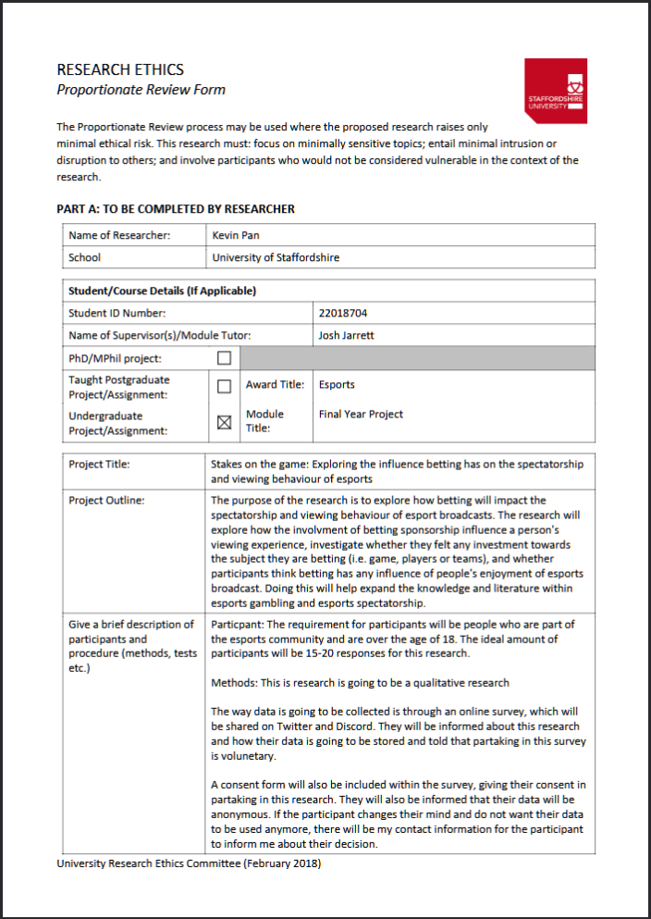

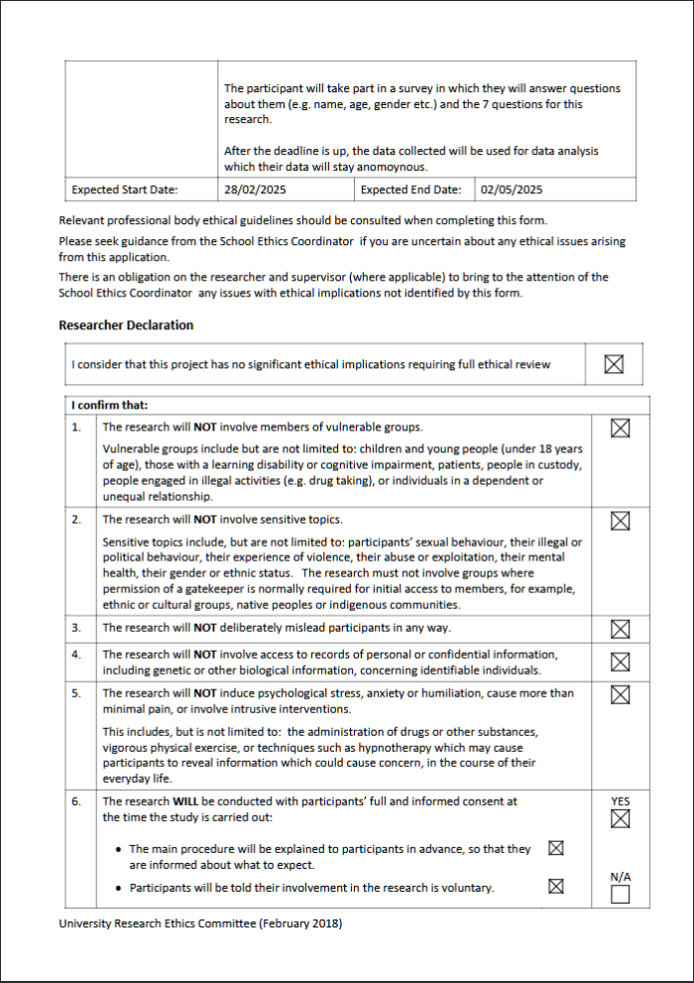

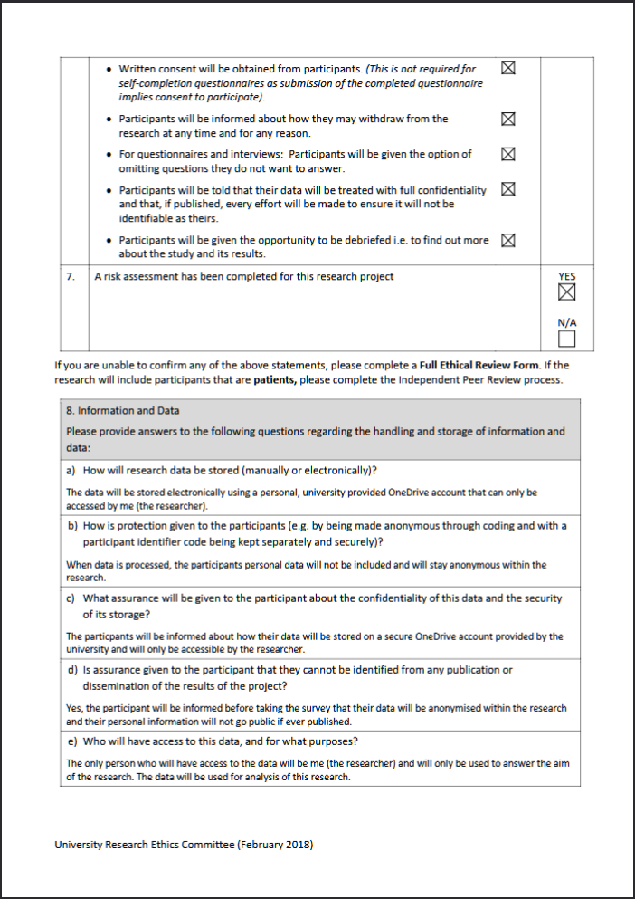

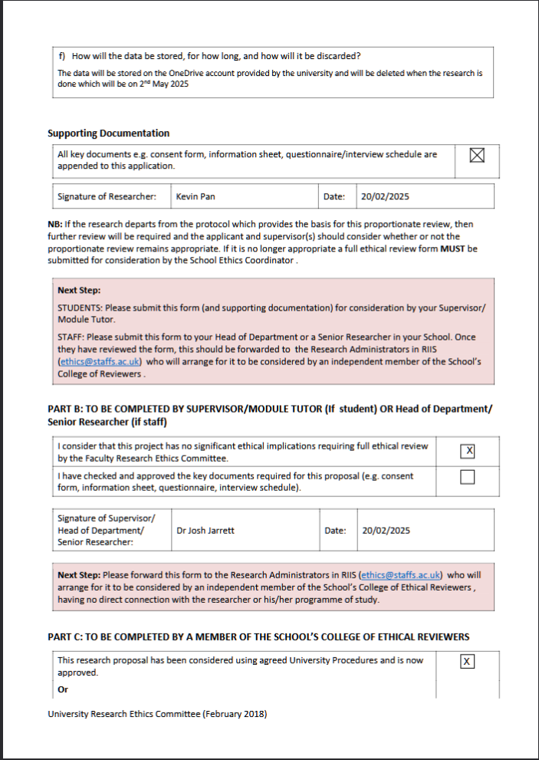

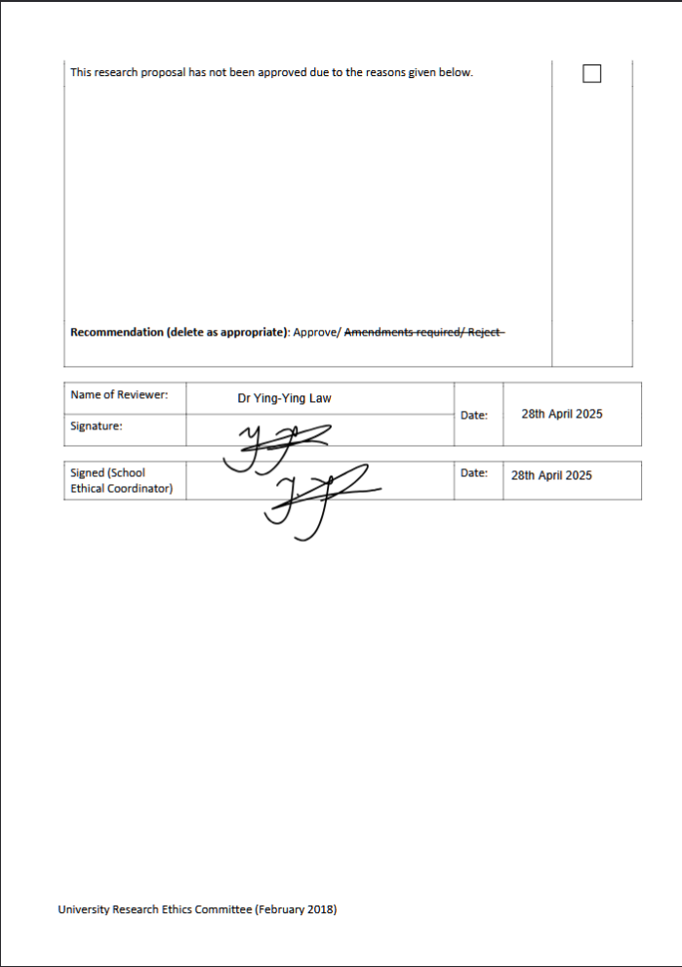

(Appendix 2 – Ethics Form)

## Appendix 3 – Reflective Diary

## Appendix 4 – Gantt Chart

## Appendix 5 – Supervisor Meeting Agendas

### 5.1 – 20/02/2025

### Appendix 5.2 – 27/02/2025

### Appendix 5.3 – 20/03/2025

### Appendix 5.4 – 01/05/2025

## Appendix 6 – Survey Question

## Appendix 7 – Survey results

[STAKES ON THE GAME 1.xlsx](https://staffsuniversity-my.sharepoint.com/:x:/g/personal/p018704m_student_staffs_ac_uk/EchxnTAqt-FIiggmkeaHwbIBs43H8frdkXzTHEpHtGYLeA?e=6J0zeZ)