Pitch, Review & Planning

**Supporting Document Template**

ADVANCED PROTOTYPING : GDEV70003

Student Name & Number: Sam Dyson | D010941K

Project Title: InfiniRacers

Date: 18/02/2025

Contents

1. Project Description 3

**Introduction** 3

**Key features** 3

**Game genre** 3

**Platform / Technologies** 3

**Target audience** 3

**Playthrough Video** 3

**Forum Link** 3

**Web Links** 3

**2. Literature/Contextual Review** 4

**Introduction** 4

**Methodology​** 4

Findings 4

Dawn of racing 4

Early Safety 5

Shift to Permanent Tracks 6

Tragedy forces Safety 8

Imola 1994 8

Daytona 2001 9

Modern Era 10

Summary 13

Conclusion 13

References 13

3. Development Process 14

Sprint 1 14

Sprint 2 16

**Sprint 3** 17

Playtesting & Feedback 18

Time Management 19

Development Conclusion 19

4. Evaluation of Work Produced 20

Relevance to the brief 20

Creativity & Scope 20

Contextualising your work within a wider theoretical practice 20

Further Work 20

# 1. Project Description

## **Introduction**

InfiniRacers is a multiplayer racing game where all of the tracks are totally random. Before each race, a procedural Content Generation (PCG) system creates an entirely random course for players to compete on, meaning that each race is new an unique for everyone

## **Key features**

The USP for InifiRacers is the PCG system that allows for totally random tracks every time the game is played. Every single race is new and unique, making for fun, frantic gameplay, as everyone learns the layout while they race.

## **Game genre**

Arcade / Racing / Party Game

## **Platform / Technologies**

Infinracers is currently only on PC, and is built in Unreal Engine 5.4

## **Target audience**

InfiniRacers is targeted towards a casual audience who enjoy playing local multiplayer party games. The game should also appeal to fans of real life motorsport, due to its visual similarity to real life motorsport series such as *Indycar* and *Formula 1*

## **Playthrough Video**

https://www.youtube.com/watch?v=L5ztGuqK2nQ

## **Forum Link**

https://digitalacademy.staffs.ac.uk/forum/index.php?/topic/73519-dyson-sam-d010941k/

## **Web Links**

<https://silverdarlin.itch.io/infiniracers>

https://silverdarlin.itch.io/

# **2. Literature/Contextual Review**

## **Introduction**

The design and quality of a racing circuit is fundamental to the enjoyment of any form of motor racing, for both those spectating and those competing in the event. the layout of a venue, the condition of the road surface and the climate conditions can all contribute to both exciting or boring racing. Understanding the evolution of motor racing facilities, and how they’ve changed overtime, can contribute to understanding the importance of quality track design, and inform design choices made when creating motor racing video games, to ensure that the in-game circuits are of a high quality, and produce fun racing for all players.

# **Methodology​**

The history of motorsport track design is a long and complex one, with no definitive sources detailing the entire evolution from the earliest years of exhibition racing between two distant towns, to the modern phenomenon taking place on state-of-the-art facilities. Often, the best sources for changes being made to tracks, or detailing how new venues are being designed or constructed is via print media, with magazines such as *Motor Sport*, which has run since 1924, as well as historical societies such as the *Brooklands Society* have dedicated sections of their archives available to study online, which allow reading of first hand sources, published when major changes were happening to the sport of automobile racing throughout the decades.

Some sources, however, have to be discounted due to lack of otherwise available information. Often, announcements get made concerning a future project, with little in the way of funding being available. Sometimes, this is done so that funding can be secured, or as a political tactic to force changes somewhere else. Determining which sources can and can’t be discounted is often difficult, as older articles have little available context for why they were written, and often scant details survive as to why a certain project failed.

# Findings

## Dawn of racing

​The early years of auto racing were often unorganised, with races being held frequently on public roads, with little to no consideration made for the safety of participants or spectators. Many early races were held illegally, such as the first recorded race between two self-propelled vehicles, held in August 1867, run between Ashton-under-Lyne and Old Trafford, a distance of roughly 8 miles. The race was started at 04:30 in the morning, in an attempt to avoid recently introduced legislation limiting vehicles to a top speed of only 4mph (Grace's Guide, 2016). Most early races were held as point-to-point time trials, with competitors racing from one destination to another, such as the Paris-Rouen race of 1894. (Johnson, 1927).

The first permanent racing circuit wouldn’t open until 1906, at Aspendale, a suburb of Melbourne, Australia. Built inside a pre-existing Horse Racing track, the 1-mile (1.6km) course was constructed using crushed concrete, and was laid out in a Trapezoid shape. The venue would host both auto racing as well as horse racing until 1939, when it was closed due to the outbreak of the Second World War. After the war, the land was cleared, and is now residential housing (Hahn, 2018)

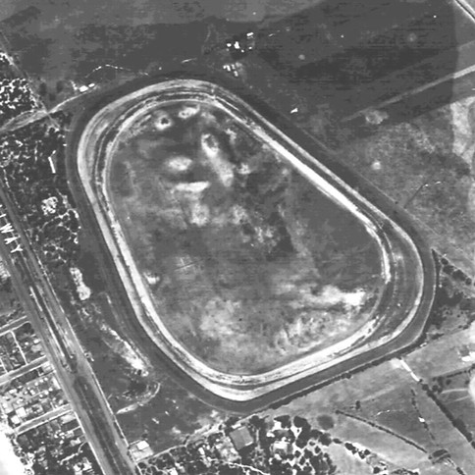

Figure - An Aerial Photograph of Aspendale Racecourse, taken in 1945

Other purpose-built tracks would begin to appear in other countries, with Brooklands opening in Surrey in 1907, the Indianapolis Motor Speedway opening in 1909, (Fisher, 2014) and the Autodromo Nazionale di Monza opening in Italy in 1922. Along with purpose-built tracks, many other racing venues, such as the Milwaukee Mile and Nashville Fairgrounds opened on converted Horse Racing tracks, while street circuits such as Circuit de Spa-Francorchamps, the Circuit de Monaco and the Circuit de la Sarthe begun hosting formally organised events.

## Early Safety

During the early stages of motorsports development, safety was not a major consideration. Often, tracks would have limited safety precautions, with bales of hay often serving as crash barriers, limited medical or fire personnel to respond to an accident, and spectators lining the side of the track, just yards away from the cars (SCCA, 2016). As a consequence of this Laissez-faire attitude towards safety, serious injury and even death was a regular occurrence, with tracks such as the Nürburgring gaining a reputation for an uncompromising lack of safety. Jackie Stewart, three times World Champion, coined the name *‘The Green Hell’* (Stewart, 1968) to describe the 14 mile (22km) ribbon of asphalt and concrete laid out amongst the Eifel Mountains in Western Germany, while Niki Lauda, who nearly lost his life in an accident at the track in 1976 once said *“Anybody who says he loves the Nürburgring, is because he hasn’t driven there fast enough”* (Lauda, 2019)

Tragically, steps to improve motorsport safety, especially the safety of tracks and facilities, were often only taken after the deaths of drivers and fans during events. One of the most infamous examples of this practice was the 1955 Le Mans disaster, where, during the 2nd hour of the famous 24 Hours of Le Mans motor race, the Mercedes-Benz of Pierre Levegh collided with an Austin-Healey being driven by Lance Macklin. Levegh’s car was launched into the air, throwing the driver from the car and killing him almost instantly. Due to the proximity of the crowd in relation to the track, debris from the crash was launched into the spectators, killing 83 and injuring at least 120 others, before the remains of the car caught fire, burning for several hours. (Spurring, 2011) Duncan Hamilton, who was watching from the pits described the scene in his autobiography “*The scene on the other side of the road was indescribable. The dead and dying were everywhere; the cries of pain, anguish, and 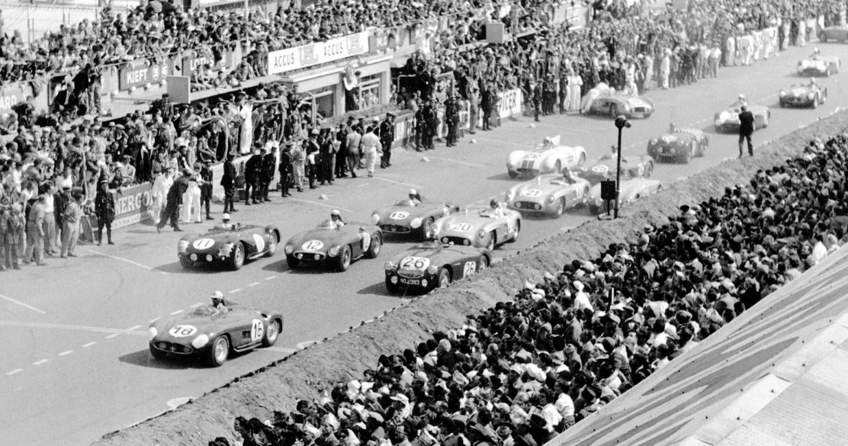despair screamed catastrophe. I stood as if in a dream, too horrified to even think."* (Hamilton, 1960)

Figure - The Start of the 1955 24 Hours of Le Mans. Pierre Levegh, driving car No. 20 would crash 2 hours later with Car No. 26

A government inquiry blamed the Le Mans disaster on the poor condition of the circuit, with the track being relatively unchanged since it begun hosting racing in 1923. To improve the safety of the facility, crowds were moved back a greater distance from the circuit, and the main straight was widened. Similar changes were instituted at other circuits around the world in response to the disaster, and the 1955 Le Mans Disaster remains the largest loss of life in a motorsport event.

## Shift to Permanent Tracks

The earliest years of motor racing saw little outside investment coming into the sport, with the majority of teams being private enterprises, who continued operation solely through prize money and race winnings. Some major car companies would also enter races, attempting to raise awareness of their brand via success on track. Due to this lack of funding, building permanent circuits tended to be a rare endeavour in the post war years. In the first European Formula 1 season in 1950, only Monza in Italy was originally constructed as a racing circuit. The Monaco, Swiss, Belgian and French Grand Prix’s were all held on street circuits, while the British Grand Prix was held at Silverstone, a converted Royal Air Force Base (Formula 1, 2025). By 1975, the sport had begun a push to be much more professional. While many teams continued to be privately run, sponsorship had become an integral part of the sport, with firms spending large amounts of money to place their logos on cars and equipment. With this influx of money came an increase in the standard of the facilities. That year’s world championship featured only two street circuits, with circuits such as Interlagos in Brazil, Kyalami in South Africa and Circuit Paul Ricard in Southern France beginning to play host to top tier motor racing. In America, a similar trend towards permanent facilities begun to emerge, with the National Association of Stack Car Auto Racing (NASCAR) hosting it’s last race on dirt in 1970, with all tracks being mandated to have concrete or tarmac surfaces from 1971 onwards. (Fielden, 2004).

Despite this shift towards permanent facilities, safety continued to be inadequate. A frequent issue was the proximity of crash barriers to the track edge, meaning that in the event of an accident, there was inadequate time for a car to slow down before hitting a wall. To rectify this, some circuits begun installing chicanes (Slower Speed Corners that alternate direction quickly) in an attempt to lower the speed of cars, Examples of this include the Woodcote Chicane at Silverstone and the Acque Mineralli chicane at Imola in Italy.

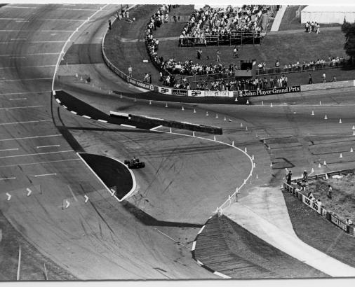

Figure - The Woodcote Chicane at Silverstone. Installed in 1975, this corner served to slow cars down before the high-speed straight into Copse

Other improvements would be made as well, such as the introduction of Fire Marshal posts around the circuit, to better combat car fires. Tyre barriers were introduced to slow cars down that left the track, softening the impact for cars before they collided with solid barriers. Gravel traps were installed at the edge of some circuits, the loose stones slowing down cars that left the racing surface. Despite these changes, injury and death continued to plague motorsports, with drivers such as Gilles Villeneuve, Tiny Lund, Jarno Saarinen and many others losing their lives in racing accidents throughout the 1970s and 1980s.

## Tragedy forces Safety

Two tragic events shifted the understanding of safety in motorsports, the 1994 San Marino Grand Prix weekend, and the 2001 Daytona 500. Both events shattered pre-existing safety notions and forced championships to update their protocols and regulations, to ensure even greater safety for competitors.

### Imola 1994

The weekend of April 29th to May 1st 1994 is regarded by fans of Grand Prix motor racing as the darkest weekend in the history of the sport (Anderson, 2020). During Fridays practice session, Rubens Barrichello would be injured in an accident when his car left the circuit at the high speed *Variante Bassa* corner, launching into the air, before landing upside down on the tyre barrier at the edge of the track. Worse was to come, however, as during Saturday qualifying, the Simtek of Roland Ratzenberger left the track at the high-speed *Villeneuve Curva*, striking the outside concrete wall at 140 miles per hour, killing him almost instantly. Despite Ratzenbergers death, the race was allowed to continue on the Sunday morning, where one further tragedy still took place. On lap 7 of the Grand Prix, the Williams car of 3 times world champion Ayrton Senna left the track at the fast turn 1 Tamburello corner. Similar to Ratzenbergers accident, Senna’s car struck the outside concrete wall at high speed. He would die 6 hours later in a nearby hospital. (Thompson, 1994)

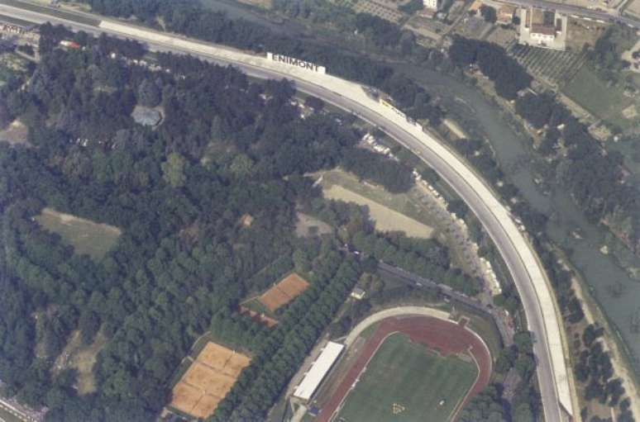

Figure - Tamburello Curve in 1994, before the fateful weekend of May 1st

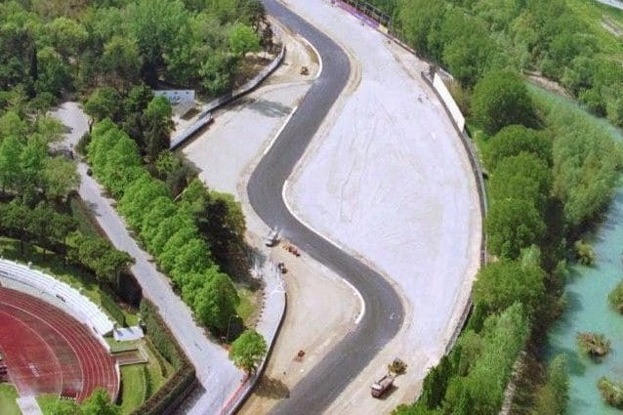

Figure - Tamburello in 1995. Note the addition of a chicane to slow cars down, as well as gravel traps and increased run off area

These accidents forced a number of circuits to change their designs, moving walls to be further from the edge of tracks, as well as installing more gravel traps around the edge of circuits in an effort to slow cars down. Some circuits made layout changes to eliminate faster corners, such as at Silverstone, where a Chicane was added to the fast left-handed Abbey Corner, or at the Circuit Gilles Villeneuve in Montreal, where the Casino corner was removed entirely, creating a longer back straight. While these changes didn’t entirely eliminate the danger of Grand Prix racing, it would be a further 20 years before another driver was killed in a Formula 1 Grand Prix, with the post-Imola 1994 safety improvements being cited as the reason a number of drivers walked away from major accidents (Burti, 2019)

### Daytona 2001

Less than 7 years after the death of Ayrton Senna rocked Formula 1, the top category of Stock Car racing, NASCAR, suffered a similar tragedy that forced major change in the safety protocols. On the final lap of the 2001 Daytona 500, the first race of the season, the No. 3 GM Goodwrench Chevrolet, driven by 7 time champion Dale Earnhardt collided with the No. 36 M&M’s Pontiac of Ken Schrader. Earnhardts car hit the outside concrete wall at an estimated 160 miles per hour, killing him instantly. The death of Earnhardt forced NASCAR to institute changes to their venues, with a number of older venues such as Rockingham Speedway and Pikes Peak International Raceway losing their place on the schedule, while other tracks like Atlanta underwent modifications and resurfacing of their surface, to reduce speeds and make them safer. The most important change was the addition of ‘SAFER’ barriers at almost all tracks. These are constructed from steel tubes, welded together, then strapped in place against the existing concrete wall. Separating the tubing and the wall are Polystyrene foam blocks that absorb the force of the impact, dissipating the energy. (United States of America Patent No. US 6,926,461 B1, 2005) The installation of SAFER barrier technology was made mandatory throughout North American stock car racing and has contributed immeasurably to 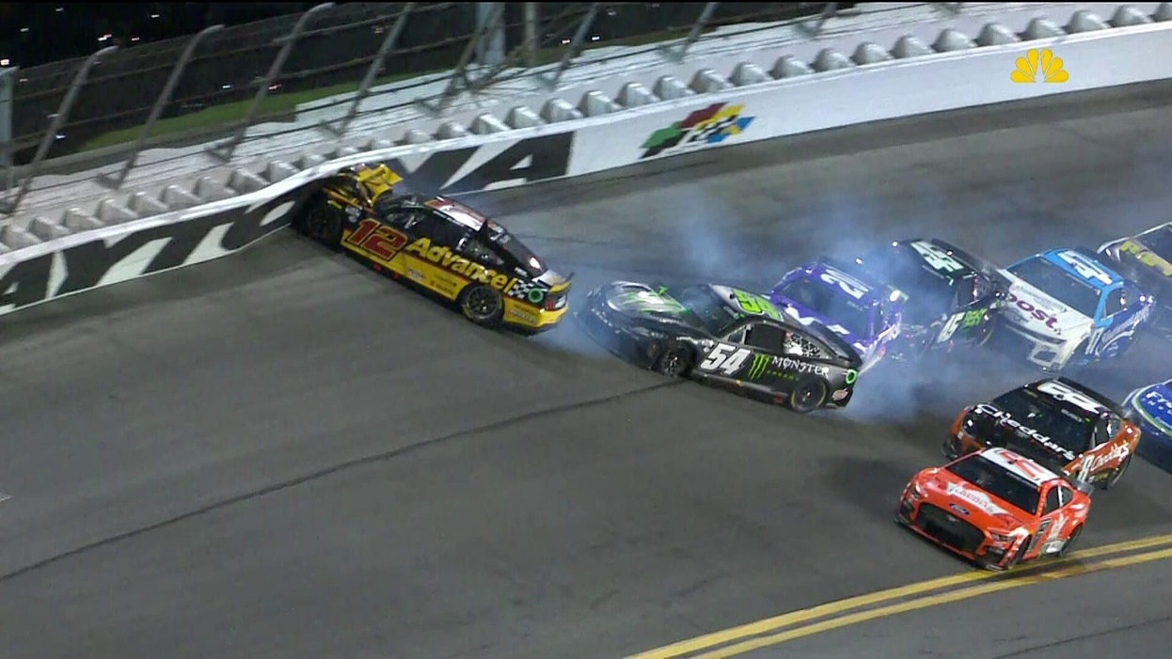the safety of the sport, with NASCAR suffering no driver fatalities since the death of Earnhardt in 2001.

Figure - No. 12 Advanced Auto Parts Ford of Ryan Blaney sustains a heavy impact with the SAFER barrier at the 2023 Coke Zero 400 at Daytona International Speedway

## Modern Era

As understanding of what made track safe advanced rapidly in the aftermath of the deaths of Senna and Earnhardt, the early 2000’s saw a flurry of new tracks being constructed, as well as long-established circuits getting redesigns, some minor, but some being near total changes to the existing layouts. These changes were done for multiple reasons, with some circuits aiming to improve the quality of the racing held, while others made modifications in an attempt to attract new series and championships. Perhaps the most notable redesign of this era was at the Hockenheimring in Germany, performed in late 2001 and early 2002.

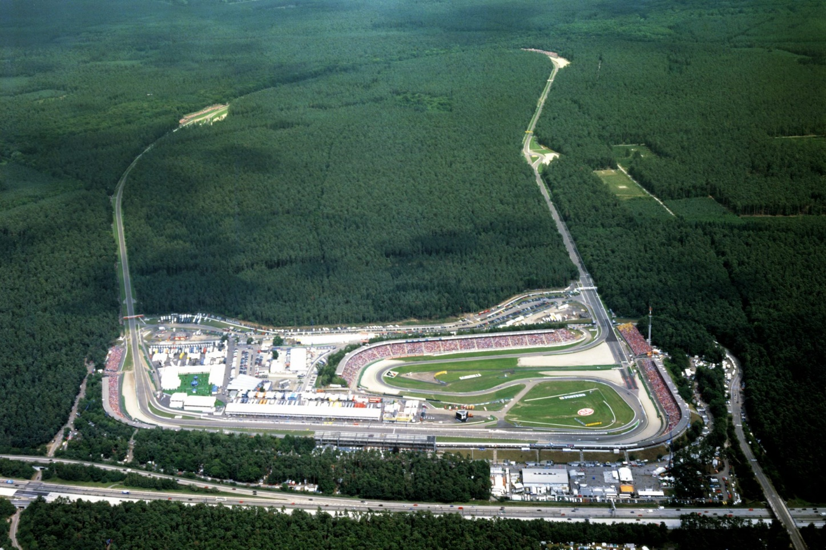

Figure - The Hockenheimring in Germany as it appeared in 2001

Previously notable for its highspeed straights through heavily wooded forest, the Hockenheimring was one of the longest and fastest circuits on the Formula 1 calendar. The circuit was made up of three long straights, linked by slow speed chicanes, with a slow speed ‘stadium’ section at the end of the lap to reduce overall speed. In 2000, the race was plagued by a number of issues, such as a large accident at Turn 1, as well as a protestor gaining access to the track in the forest section. (Evans, 2000). The tracks length also meant that, during a late race rain-storm, one half of the circuit was nearly water logged, while the other half remained nearly totally dry. In the aftermath of the race, it was decided to modify the venue to make it safer, as well as improve fan access, as much of the on-track action took place in the nearly inaccessible forest. Hermann Tilke, who had previously been responsible for redesigns of the Österreichring and Sachsenring, as well the all new Sepang International Circuit in Malaysia. The redesign saw the circuit drastically shortened from 4.2 miles to 2.8 miles, with the new layout featuring a long sweeping corner, a trademark of Tilke’s design, and a slow speed hairpin corner that serves as an overtaking opportunity.

Figure - The Hockenheimring after its 2002 redesign

While the redesign of the Hockenheimring was perhaps the most radical change of a circuit in this era, it wasn’t the only historic track to see major change. Silverstone circuit constructed a new infield section called ‘The Loop’ to allow the venue to host MotoGP Motorcycle racing, while Indianapolis Motor Speedway, one of the oldest venues in the world, constructed an infield circuit, letting the track host more than oval racing for the first time in its history (GrandPrix.Com, 1998).

Along with historic circuits being updated to bring them in-line with modern standards, the early 2000’s saw a number of new tracks being constructed, many of which were built in countries that not previously seen international motorsport. Nations such as Malaysia, China, India, South Korea and Russia all saw circuits constructed capable of hosting World Championship level racing. Many of these tracks features similar elements seen in European Track redesigns, with high-speed sections followed by slow speed corners, designed to encourage overtaking.

## Summary

The evolution of the modern racing circuit can be traced through countless different trends and changes, with the evolution of safety being just one trend that has changed circuit design. Individual designers, such as Hermann Tilke, have begun design trends that seen are multiple tracks worldwide, and have transformed race track design from the simple act of connecting roads together to make a loop, to building multi-million pound works of art (Leporati, 2024). Due to the long and complex history of motorsport, and the fact there’s been hundreds of both documented and undocumented racetracks throughout the history of motorsport, there is no one definitive source on the total history of racetrack design, instead, it has often fallen to individual fans of certain series, or dedicated attendees of certain tracks, to document the changes tracks undergo throughout their long histories.

Studying how race tracks have changed allows for greater understanding of how they are now designed to create exciting racing, which can create more exciting and enthralling gameplay for people who drive simulated versions of tracks

## Conclusion

In Conclusion, designing racing circuits is not a simple process, and the 100 years of evolution that have gone into creating the modern track have contributed to creating some of the greatest pieces of circuit design ever, with modern arenas such as the Circuit of the Americas and the Jeddah Corniche Circuit being regarded as world class facilities, while other modern tracks, like the Miami International Autodrome or the Losail International Circuit being derided for creating boring and unexciting racing. Circuit quality can be affected greatly by small things such as quality of the road surface, the prevailing weather conditions, or the altitude at which their built, which can help or hinder their impression to fans and drivers alike.

# References

Anderson, G. (2020, October 30). Gary Anderson on Imola 1994 and Barrichello’s crash.

Burti, L. (2019, February 4). Burti: Senna safety improvements saved me in 2001 Belgian GP crash. (E. Straw, Interviewer)

Evans, B. (2000, July 30). Barrichello takes maiden win as Mercedes protester disrupts race. *RaceFans.com*. Hockenheim, Baden-Württemberg, Germany.

Faller, R. K., Sicking, D. L., Rohde, J. R., Reid, J. D., Keller, E. A., Bielenberg, R. W., . . . Polivka, K. A. (2005). *United States of America Patent No. US 6,926,461 B1.*

Fielden, G. (2004, September). NASCAR Cleans Up. *Speedway Illustrated*.

Fisher, J. M. (2014). *The Pacesetter: The Complete Story.* Altona: FriesenPress.

Formula 1. (2025, January 25). *1950 Grand Prix Results*. Retrieved from Formula 1: https://www.formula1.com/en/results/1950/races

Grace's Guide. (2016, July 27). *Isaac Watt Boulton | Grace's Guide.* Retrieved from Grace's Guide: https://www.gracesguide.co.uk/Isaac_Watt_Boulton

GrandPrix.Com. (1998, December 7). Formula 1 goes to Indy. *GrandPrix.com*. Indianpolis, Indiana, United States of America: GrandPrix.com.

Hahn, V. (2018, June 27). *Aspendale Park Racecourse - Kingston Local History*. Retrieved from Kingston Local History: https://localhistory.kingston.vic.gov.au/articles/93

Hamilton, D. (1960). *Touch Wood!* London: Good Reads.

Johnson, C. (1927). *The Early History of Motoring .* London: Ed J Burrow & Co Ltd.

Lauda, N. (2019, May 21). Niki Lauda on Rush, the real James Hunt, and the crash that changed his life. (C. Iley, Interviewer)

Leporati, G. (2024). *Formula 1 relies on this father-and-son duo to design iconic racetracks like the Las Vegas Strip Circuit.* New York: Business Insider.

SCCA. (2016, October 17). *SportsCar Feature: Racetrack Barriers - Sports Car Club of America.* Retrieved from Sports Car Club of America: https://www.scca.com/articles/2003216-sportscar-feature-racetrack-barriers

Spurring, Q. (2011). *Le Mans: The Official History of the World's Greatest Motor Race.* Sherborne: Evro Publishing.

Stewart, J. (1968, August 4). 1968 German Grand Prix - Post Race Interview.

Thompson, I. (1994, May 2). Suddenly, Death Returns to Formula One. *New York Times*. New York City, New York, United States of America: The New York Times.

# 3. Development Process

## Sprint 1

The first sprint was dedicated to the creation of the playable vehicle that would be controlled by the player for the duration of this game. At first, the car was represented by a plain square, however later a 3D model was added which better represents a car, giving the player a more relatable vehicle to control. The car decision to create a new car, as opposed to making use of a pre-existing car that comes packaged with the engine was made so that the featured car was more suitable for the game being created, and better adapted for an arcade style racing game, as opposed to a more simulated vehicle physics sandbox, as the pre-packaged car was designed for.

There were some issues presented with the development of the car, as the car would sometimes launch into the air when moving too fast. To fix this, the top speed of the car was clamped, which limits the top speed, so the car never reaches a speed that is too fast for the engine to mange. There were still some issues with the way the car collides with certain objects that need to be fixed as part of Sprint 2. This is issue is being caused by the cars collision box, which is in a position that causes it to drag along the ground, which makes it more susceptible to objects in the road that make it act strangely. The car also has no animations at this time, which will need to be modified by creating a system that allows the wheels to spin based on the speed at which the car is travelling. This small change will create a more visually interesting vehicle which looks more like a realistic car when travelling along the ground.

Figure - The Car as it appeared at the end of Sprint 1

The decision to create the car first, as opposed to beginning work immediately on the PCG system that the game will rely on, was made to do a consciousness of time. Development of this project began two weeks before the Christmas Holiday, and as such, it was decided that working on the car, which should be in a nearly finished condition after the two weeks would be a more reliable use of time, as starting on the PCG system, only to not work on it for roughly two weeks would hamper development, as it would take quite a while to remember where the development process was.

Along with working on the car, much of Sprint 1 was also spent researching race track design, furthering understanding of how modern circuits have evolved, which provides details for how to design individual elements of the track, and enhance the quality of the project.

## Sprint 2

The main goal of sprint 2 was to begin work on the Procedural Content Generation (PCG) system, which would create the different track layouts. Having never worked on PCG before, it was important to dedicated a long period of time researching and understanding how they work, and what make a successful PCG system work, along with examples and uses of PCG in different games to understand how they have been used to enhance other game experiences previously.

When developing the PCG system, there were two different techniques that could be used to achieve Procedural roads. These were to either make use of Splines or use pre-built elements. Each area has benefits and negatives, and deciding which to use would affect the overall progress of the project. Splines would allow for an even more dynamic creation of tracks, as splines can be randomly attached to each other, in almost every direction, and spline systems can be used to close shapes in a much more simple technique, which would allow for lap based racing, more similar to traditional racing games.

Figure - Some of the Blueprints for the PCG System

The pre-built track elements have a number of different benefits as opposed to splines. Pre-built components allow for greater detailed to be added to each individual element. This allows for the game to have a much higher visual quality. It also allows for the faster creation of new components. One issue with the pre-built system is that it doesn’t allow for looping of different tracks, meaning that tracks must be point-to-point. While this system does have limitations, for a short term project with limited development time, pre-built systems are better, as splines, while capable of doing more, are far more complex, and have many more issues. One of the biggest issues with using Splines is that they are relatively resource intensive when called at Run-time, which causes significant performance issues. This was the primary motivation for selecting the pre-built components, to allow for better technical performance.

The main system itself works through multiple different functions to create the track parts. First, a line trace is generated, spawning from the origin piece. This trace determines if the new part is going to overlap with an existing part. If this is the case, then the origin part is deleted, and a new part spawns. This process then repeats until the overlaps don’t happen, allowing the track to continue spawning, until 50 parts have been spawned, at which time, the track is marked as ‘complete’ and the finish area is spawned.

Figure - One of the Prebuilt sections of Trac as viewed in Editor

Overall, this system is fairly reliable, and very rarely has issues. While getting the original set-up working was long and tedious, and required a great deal of trial and error, when the system was fully implemented, it has worked very well, with the only minor issues being occasional clipping of certain decorative pieces into nearby areas. To fix this, those decorative pieces will be moved closer to the track, which means they won’t overlap with other parts of the track.

The biggest issue with creating the PCG system was that, unfortunately, it ran longer than the two week sprint schedule allowed for. This was due to the complexity of the system, and underestimating how complex it would be to put it into working order. For future development, it may be useful to start working on the PCG system earlier, as it would allow for better scoping of other elements of the project.

## **Sprint 3**

The development cycle for Sprint 3 was scheduled to be focused primarily on implementing gameplay elements into *InfiniRacers.* This included implementing the multiplayer features that allow this game to be played by multiple people, as well as items, which allows for far greater engagement, and more enthralling gameplay for players.

However, due to issues with the PCG system development, the start of Sprint 3 was focused on completing that system, as it still needed some modifications and refinements to make sure it worked as intended as much as possible. The main task for this was to ensure that all of the line traces for different track components didn’t overlap, allowing the track to generate correctly. This was a more time intensive process than first planned, causing the delay in development, however, when this was completed, development could begin on the multiplayer system.

Figure - The Player Controller System, rewritten to allow Multiplayer

Implementing the multiplayer system for this game required some back-end rewrites for the car, as the controlling of the car was being handled by the actor itself, as opposed to a player controller. As part of this re-write, a controller was created through which all inputs are received, which allows them to be better organised for the multiple cars on screen. While this was a time intensive process, it was vital to the development of the project, and without it, multiplayer implementation would not have been possible.

Along with multiplayer implementation, the other primary task for sprint 3 was to implement all of the items that players would use during the race. Due to the limited development schedule afforded for this project, only three items were able to be developed, tested and implemented. These items were as follows

|  |  |
| --- | --- |
| Item | Description |
| Speed Boost | Grants the player a temporary top speed increase, allowing their car to go much faster than normal |
| Tyre | Can be thrown in front of the player. If it collides with a car, that car stops for a few seconds |
| Barrell | Can be dropped behind the player. If a car drives into it, that car stops for a few seconds |

Each item fulfils a different role and supports the player in a different way. The speed boost allows players to catch up on track, while the tyre allows them to slow down the cars ahead of them. The Barrell helps leading cars maintain their lead and defend against players throwing tyres at them.

Along with creating these systems, Sprint 3 also included a number of playtesting sessions, to allow for bugs and issues to be found and rectified before the conclusion of the project development.

## **Playtesting & Feedback**

As *InfiniRacers* is designed as a multiplayer experience, much of the playtesting for this project was conducted with small focus groups, asking those involved to play a handful of races, and provide feedback on details such as handling, track generation and item quality. A number of these play testing sessions were performed, to allow for as much feedback as possible to be collected, and after each test, changes were made to the game based on the feedback provided.

After the first test, the biggest change that was made was the addition of a drifting mechanic, to allow cars to carry more speed around corners. The was in response to feedback from testers who found that, due to the track generation, they would lose far too much speed and have to drive the car *“Like a racing sim, not an arcade game*”. To provide a more arcade-like experience, the drift system was implemented, which now allows players to carry far more speed through corners, meaning they can go much faster.

Along with gaining feedback from the play test, these sessions were also a useful opportunity to find bugs and issues with the PCG system and allow testers to find issues with the generation so that they can be fixed and modified, allowing the system to function at a higher standard, and be less likely to break or have issues.

### **Testing Feedback**

Most of the feedback from the playtesting sessions was positive, with most feedback highlighting performance of the PCG system, as well as some mixed feelings surrounding the handling of the car. While some testers enjoyed how the cars handled, others reported it feeling too heavy and hard to turn. As these feelings are a matter of personal opinion on behalf of the user, they aren’t going to be immediately acted upon and instead will remain as they are.

Time Management

As development of this project required working in new and unique areas, a large amount of the time spent on this project was research and testing based, allowing for experimentation with the PCG system. Due to this, certain aspects of the game were not allocated the correct amount of time required for their succesful development, and have not been placed in a position where they are satisfactorily completed. While this was necessary to ensure the completion of the project, it showcases that time management is an area that requires improvement, and that for future projects, tighter restrictions must be put in place to ensure that each element of the project receives the correct amount of time needed to complete it fully.

Figure - A Rough Breakdown of how much time in hours was dedicated to each section of Development

Development Conclusion

In Conclusion, the development of *InfiniRacers* was an overall success, as I was able to produce a fun and infinitely repayable experience in a limited amount of time, and expand my knowledge on PCG systems, allowing me to create an entirely new system that I have never previously worked with, and bring a novel game concept to life.

While there are some aspects of the project that have not been finished to a completely satisfying standard, the vast majority of the tasks set for this project have been completed, and to a high standard.

### 4. Evaluation of Work Produced

Overall, I am incredibly satisfied with the quality of work that has been produced as part of this module. I have successfully been able to produce a high-quality procedural generation system, which has expanded my knowledge of PCG systems, and will allow me to be more comfortable when working with them in future. The work I have produced, with some further polish that was beyond the scope of the projects timeframe, should server as a high quality portfolio piece, and showcase my knowledge of programming and PCG systems within the wider games industry.

Relevance to the brief

This project managed to hit all of the targets originally laid out in the project pitch, and has remained close to the brief provided before development started. This game features all of the originally planned elements, in varying forms of completion. Along with this, the brief was to create an advanced game prototype, which I believe this game is. While it is not in a completely finished state, it is making use of advanced systems and designs to create a new and exciting gameplay style for players.

### Creativity & Scope

This project makes use of a novel and proprietary PCG system to create a racing title that has an infinite amount of tracks. As far my research suggests, no commercially available titles feature this gameplay element, making *InfiniRacers* unique amongst racing titles. While many other aspects of the title borrowed elements from already established racing titles, they have been implemented into a new way to create a new and exciting gaming experience.

In terms of the scope of the project, I believe that this game was well scoped for the development time allocated to it, and, despite the development setbacks caused by the PCG system, the game accurately showcases the amount of time placed into its development.

### Contextualising your work within a wider theoretical practice

This titles development was primarily inspired by the theory that gamers wish for more content within the titles they play, and that their demands for more content are difficult to achieve for any game studio, to the disproportionate ratio of gamers to developers. Creating a game system that can allow for infinite generation of levels allows for an unlimited playtime, as players are never going to be able to experience every single possible layout of track presented by this title. Presenting players with unlimited opportunities to experience new things provides them with the opportunity to continue playing for as long as they’d like, with no opportunity or reason for them to stop due to lack of content.

### Further Work

This project, while already in a good position, could benefit from further refinement and polish, which would feature the inclusion of more particle effects, sounds, and visual elements, to enhance the gameplay environment for the player. Further changes could be made to the car, related to further play feedback and more extensive playtesting within a wider audience. Further work can also be performed to the PCG system, with the implementation of more track components, allowing for an even greater variety of tracks to be created, giving players a greater variety of gameplay. Work can also be done to implement AI controlled cars, which would allow players to play a single player experience, instead of having to play specifically with friends, which would open the game to a wider audience.