Bunker

Level Design Documentation

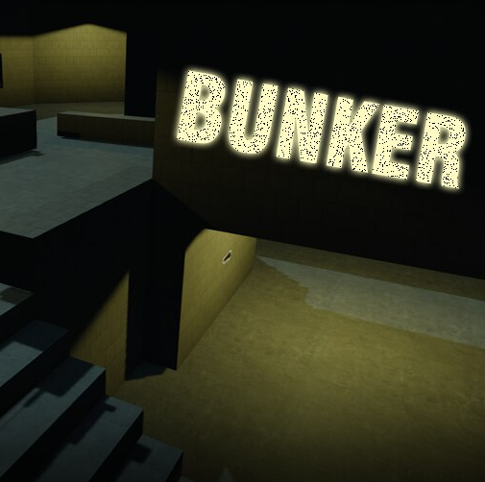

Ryan Banks

Contents

High Level Overview 3
Design Motivations, considerations and Goals 3
Key Elements 3
Expected Player Experience 4
Map Structure 4
Scale 6
Bubble Map + Beats and Pacing 6
Agency + Experience 8
Mechanics / MDA 10
Map Overview 12
Player Paths 12
Enemy Placements 13
Zones 14
Doors 15
Elevation 16
Gobblegum Machines 17
Mystery Boxes 18
Perk Locations 19
Zombie Shield 20
Wall Weapon Chalk-Buys 21
Aesthetic, Look and Feel 22
Visual Development 22
Affordance 24
Balance 26
Considerations 26
Expected Issues 27
Testing 28
Testing Plan 28
Evidence of Testing 29
Level Development Log 30

High Level Overview

Design Motivations, considerations and Goals
My goal when creating this level was to make a fun and interesting zombies map for Call of Duty: Black Ops 3. I wanted to achieve this by following existing zombie map design conventions and implement them into my custom map.
I had briefly used the Radiant Editor in the past, but it was a great way to learn a new editor and broaden my portfolio employability. As I focused on the level design for this custom map, I did not add any custom weapons or mechanics to my level, but instead focus on creating an engaging environment with core zombies gameplay. However, with that in mind, I still wanted to add all the main systems into my map (for example the mystery box, perks, wall buys, and purchasable doors.
From researching other vanilla and custom zombie maps, I found out that many custom zombie maps took the mode’s core gameplay and alter it slightly with either systems or map layout and conventions. For my map, I avoided this and wanted to make a map that would technically be able to be put into the base game.

Key Elements
To achieve the above goals, I focused on some main points to create the zombie map:
- Different room shapes and sizes to add variation and interest to the map.
- Varied elevation to make gameplay more interesting. This will affect how players can take shortcuts, as well as combat with zombies.
- Implementing all the core systems to create a natural, relatedness feeling for the player from vanilla zombie maps.
- Varied challenge and difficulty throughout the map. This will come through the room shape and size, as well as the door costs. Early game, the player will have to budget their points correctly to survive and set themselves up for the high rounds.
- A main element I wanted to add was making a map that forced players to move out of comfort. This will be done by having things of player use, such as the zombie shield, far away from the easier more comfortable rooms. Therefore, players will have to decide when to best move to re-grab a shield as it’s dangerous to move through the tight corridors mid-round.

Expected Player Experience
The player is expected to find the early game very challenging as they must conserve points well to get through the bunker to the power room. Once power is turned on, the map becomes easier as rooms open with shortcuts, as well as the ability to buy perks and Pack-a-Punch. The mid to late game experience should be easier and more casual for the players as they have access to all the weapons featured in Black Ops 3, including wonder weapons. This means that high rounds are more achievable, and to balance this, room sizes and corridors are smaller. Meaning if the player does not use a wonder weapon in the high rounds, they may struggle from the overwhelmingly fast spawns and tight play spaces.
There are many ways the player will be motivated to play the level. Intrinsically, they will be motivated through challenge and personal fulfilment because the nature of my gamemode means that the game will become more challenging as the game progresses. Extrinsically, the player will be motivated through recognition/ acknowledgement from peers when reaching a high round on the map. I have designed with autonomy motivation by providing players with meaningful choices throughout the game by allowing them to choose which doors they open and keep closed, by having multiple routes to get around the map.

Map Structure
My map is structured like multiple loops within a large ring with central rooms to help with traversal and shortcuts. I took inspiration form Der Eisendrache, which is a vanilla map made by Treyarch with a similar layout.
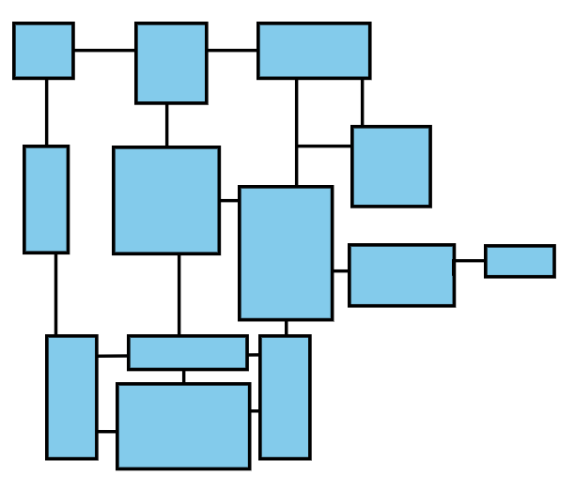
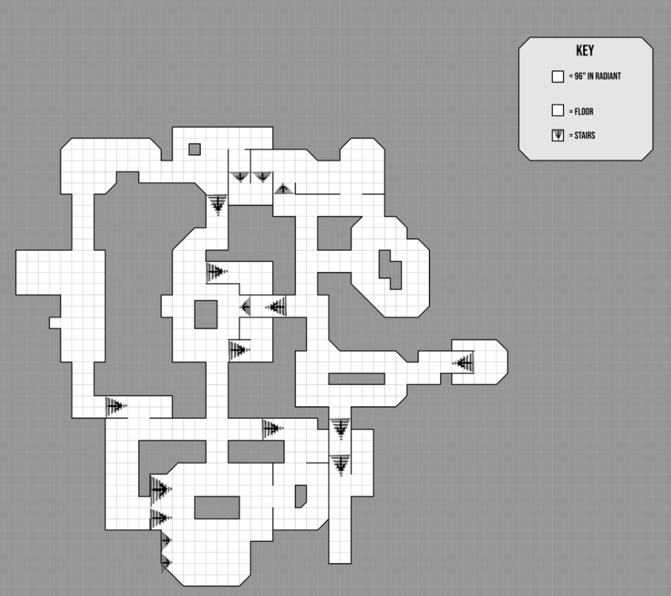

Scale
As radiant measures in inches, I chose to make one grid space equal to 96”. However, the editor only snaps to 64” or 128”, so I originally scaled it to 64” and scaled the map up with a multiplier of x1.5. This was done because the original grid size was too large or small and felt poor to play, whereas 96” is closer to the gameplay feel of vanilla maps.

Bubble Map + Beats and Pacing
Below is my bubble map for my level. Each of the main rooms are listed with their connections. The arrowed connection displays a one-way corridor. As you can see, the larger open rooms have the least amount of intense combat because the player can easily maneuver around zombies. Even though ‘E’ is a small room, the intensity is low because of the catwalk and easy camping strategy present in the room.

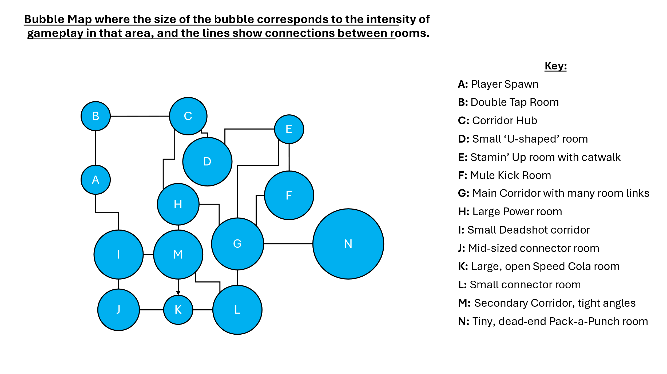
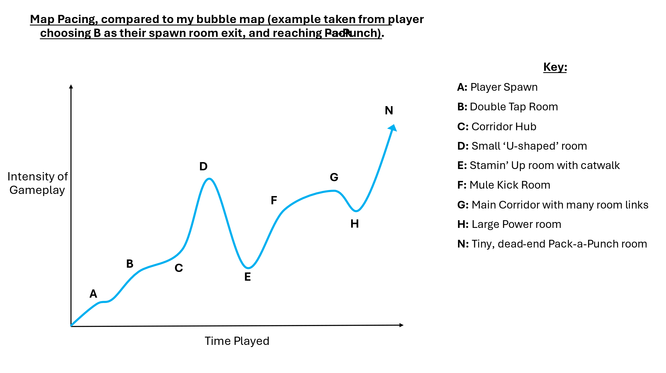
As my zombie map has an infinite hoard-based game mode, I split the playthroughs into the win/loss conditions, as they all play significantly different.
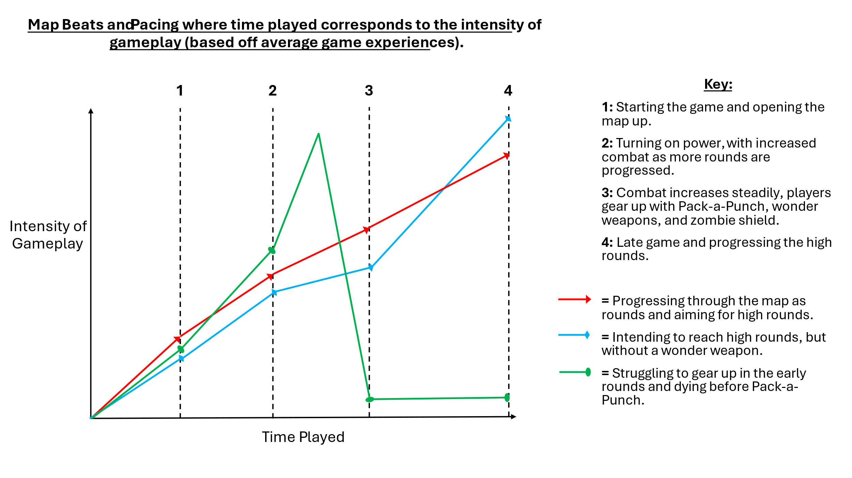

Agency + Experience
My level encourages player agency by having multiple choices out of spawn. This way the map isn't linear, and the player can mover their preferred way through the map. This point is enhanced all throughout the map as for many of the main rooms, there are multiple entrances to them, which not only helps for player choice, but also helps so players can run away from zombies without getting stuck in a one-way room.

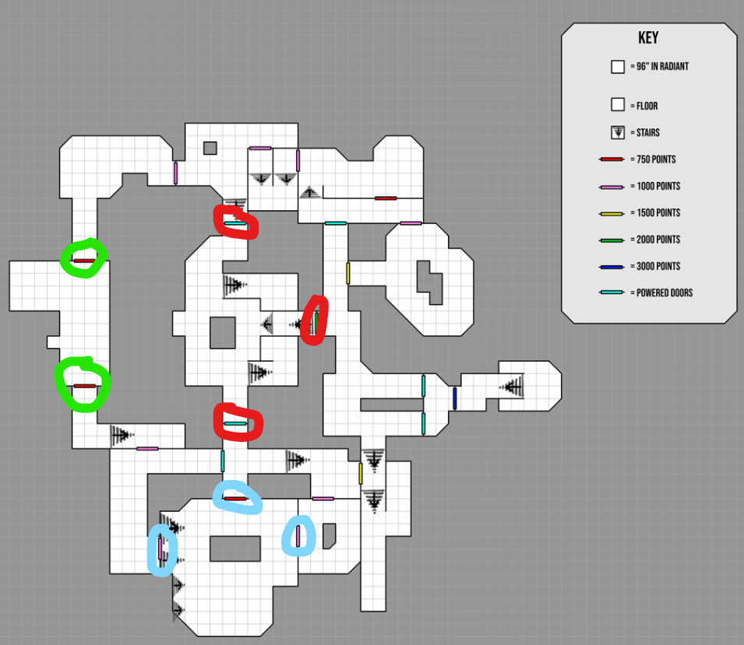
Diagram to show rooms with multiple exits for improved gameplay.

As the map can be played with different playstyles, I’ve accommodated for both types of players: People who run around and train zombies, and those who like to camp. By having large open rooms with limited hard cover, the players can run around freely. Alternatively, the corridors and catwalks promote camping if you sit at the end of one and fire down. This can also be done if the player decides not to open a door and uses it as a safe wall to camp at instead. By having multiple of these around the map, I can accommodate for multiplayer, so multiple people can train zombies or camp without struggling in a non-ideal room.

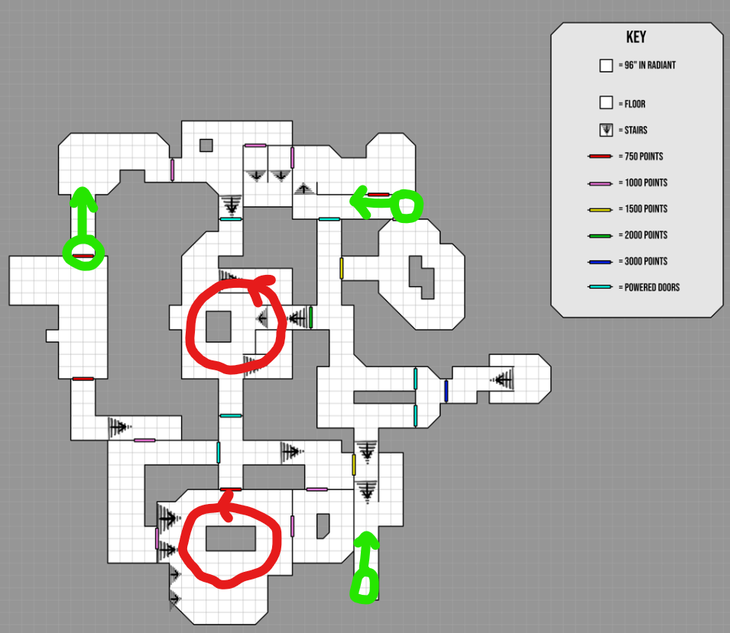
Diagram to show specialized rooms for training zombies or camping.

Mechanics / MDA
The table below shows the mechanics inside of my level and how they resonate with each other. The green means they work well with each other, whereas Red means that the mechanics do not have direct/indirect interactions with each other. As I'm making a zombies map, it only has basic fps mechanics and is more focused on killing enemies, but I have placed them into the table below:
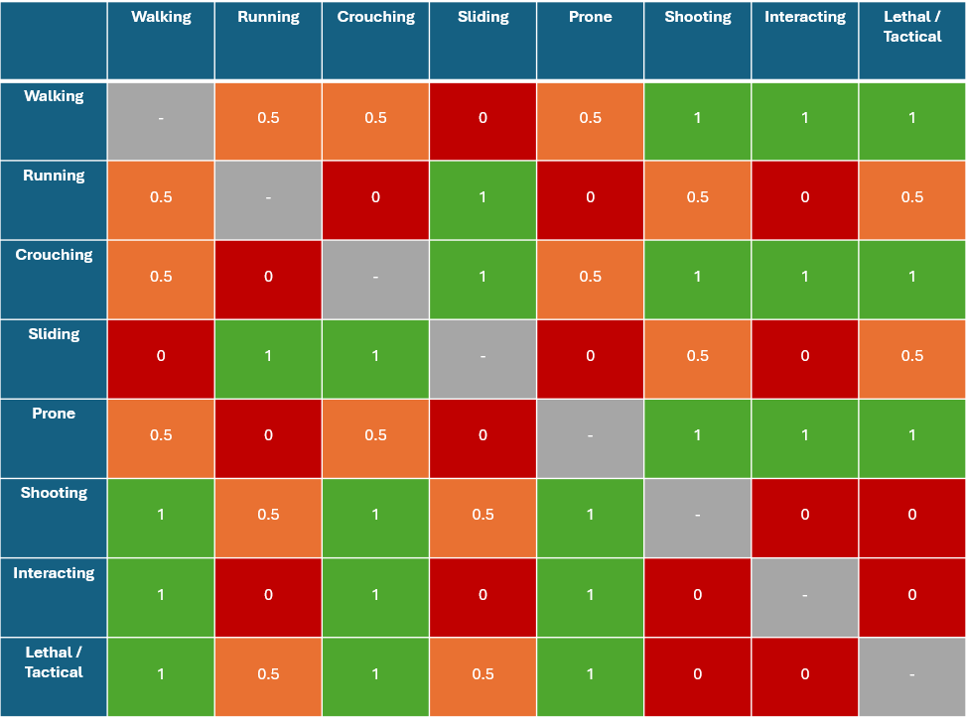
By looking at how Treyarch have made their zombie maps in the past, some things are seen throughout most (if not all) of their maps. With these, the players feel more comfortable playing my level as they will expect certain things to be present as they are in vanilla maps.
- Multiple entrances and paths around the map. This is a reoccurring theme throughout zombie maps because it helps the player traverse around the map without having to leave a room through the door they entered, which will be filled with zombies blocking it. Over time, players will find their favorite paths through the map and find the quickest, or safest way to traverse around my map.
- Pack-a-Punch. This is seen throughout almost all of Treyarch maps and can be given to the player after opening the map, or even completing an entire quest. For my map, I’ve added Pack-a Punch, but as I'm focused on level design, I have not added an unlock quest for it. My idea is that the player will gain access once power has been turned on, and they have progressed to the end of the map.
- Mystery Box. In most maps, there are many different spawns for the box around the map. This is present around my map with multiple spawns and a guaranteed initial spot. This means the players will learn their favorite root out of spawn if they want to get to the box.
- Perks. All maps in zombies history, have at least some perks around the map. Some of the maps have just the basic perks like Juggernogg or Quick Revive, whereas bigger maps may have more specialized perks. For my map, I have added 7 of the perks around the map. Additionally, I have made it so there is no perk limit o my map. This is the only rule that I broke for vanilla zombie design conventions because I feel that the community prefer being able to get all the perks in a game. It’s also more enjoyable to play late game because there are more things to set up and pay for.
- Gobble-Gums. This feature was added in Black ops 3 specifically and they added multiple machines around the map to use. They are usually quite frequent and seen around the edges of rooms within clear line of sight of the player.
- Buildables. These are seen throughout many of the complex maps and are usually popular for players to use, especially the zombie shield because of its extra protection. Therefore, I have added the zombie shield to my map with multiple parts spots and a build table.
As my level is focused on making a conventional Treyarch zombie map, I have not added any modded mechanics for the map. However, one thing I would like to focus on, is making the player move. This will be done by having favorable rooms where players would like to train zombies and having useful systems like perks and pack a punch far away. This will force players to move strategically if they need to get their perks between rounds and will add more challenge because they need to run across the map through tight corridors filled with zombies.
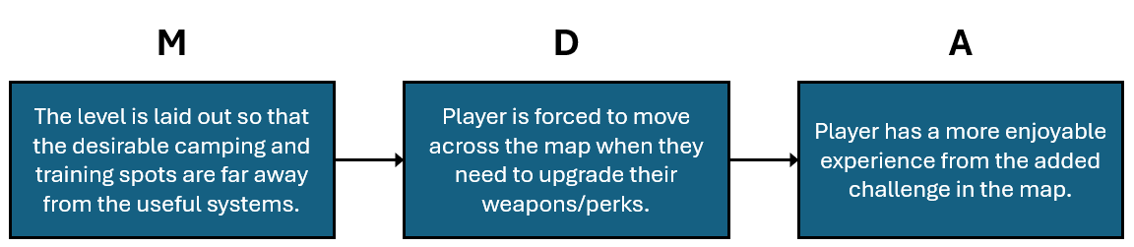

Map Overview

Player Paths
In most vanilla zombie maps, the power doors act as shortcuts between areas. Therefore, I made it so that the player must traverse the entire map before getting to power, then all the power doors open and they can now use the shortcuts. This makes it so the player has seen all the map and will hopefully not get lost as easily as they have already learnt the paths. The green and red paths are the main golden paths towards power, and the blue crosses are to powered doors that will open afterwards.
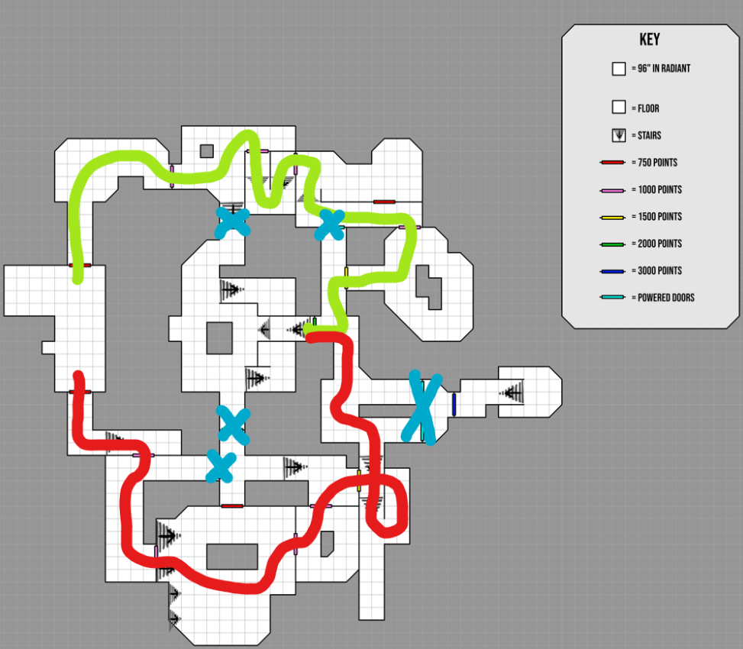
Diagram to show the golden paths to power.
Having this feature in map, it makes it feel more natural and like a real zombie map as it follows the same design principles/conventions. The only area of the map blocked off my power is the Pack-a-Punch room; however, this is intended because I want the player to have to turn on power first before meeting the machine as they are at different points of progression in a match.

Enemy Placements
In my map, I have a variety of different zombie spawns around the map, as well as dog spawns in every room. The parts where I added riser zombies, I placed a mud texture to diegetically communicate to the player that this was an area of the map where zombies spawn from the ground, so be careful. Additionally, the zombies that come through barricades spawn instantly. This means that the pop into the map instantly and attack the barriers, making the spawns fast and more enjoyable. The only downside to this is that it's jarring for zombies to pop into existence, so I have placed the spawns around the corner from barricades so players cannot see them spawn in.
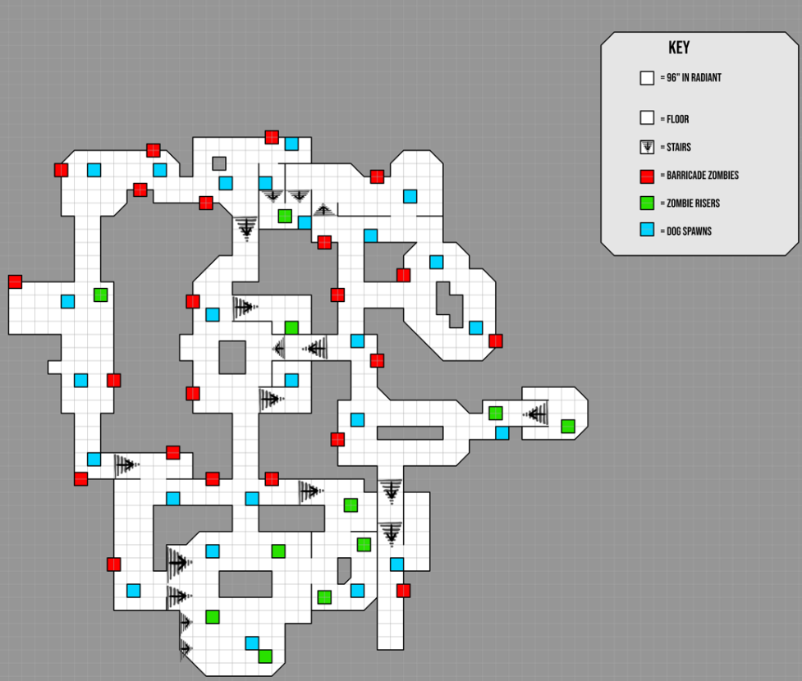

Zones
In Radiant, Zones are invisible volumes that tell the game what part of the map the player is in. The zones are around every room in the map, and zombies will spawn in the zone the player is stood in, as well as any adjacent rooms/zones. Zones are activated when a door has been opened, making sure that zombies do not spawn outside of the play area.
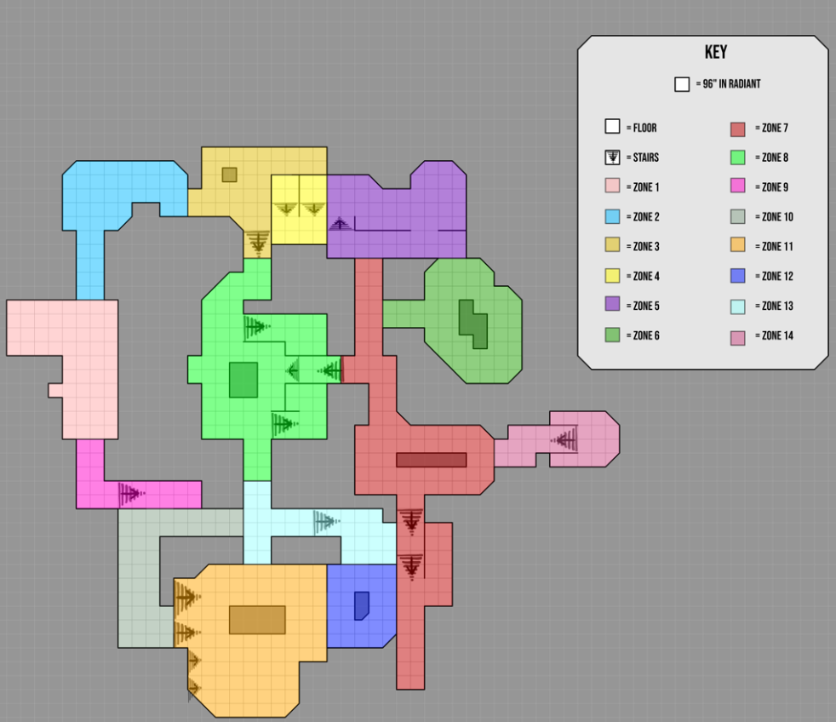

Doors
I made the map difficult by splitting up rooms so that the player has to open more doors. This leads to an overall map cost increase, adding a greater challenge to the map as the early game can be unforgiving if you cannot maximize points and get to power before the later rounds. There are two different ways to get to the power switch around the map, and both ways have the same point costs, making it fair and up to player choice which way they choose to go. To get to power, it will cost the player 8250 points.
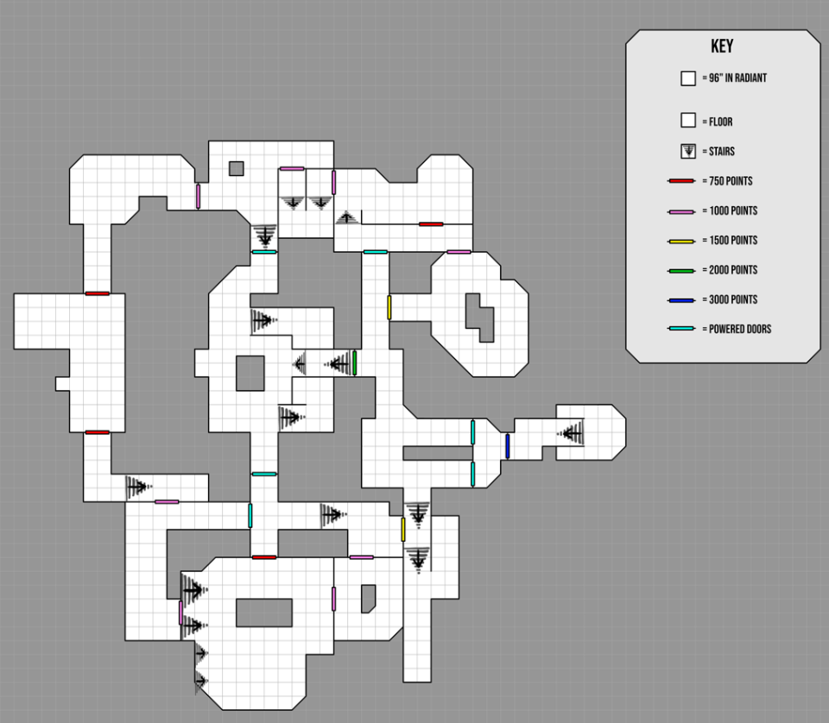

Elevation
The elevation throughout the map makes traversing between the rooms more interesting to play in. Additionally, the rooms with built-in elevation are memorable with improved combat and movement. By raising/sinking the floors/roofs I can play with a player’s feelings and convey certain emotions. If an area is more open, it tells the player that it is safer, whereas if a corridor has claustrophobic roofs, that makes the player feel more tense and uneasy.
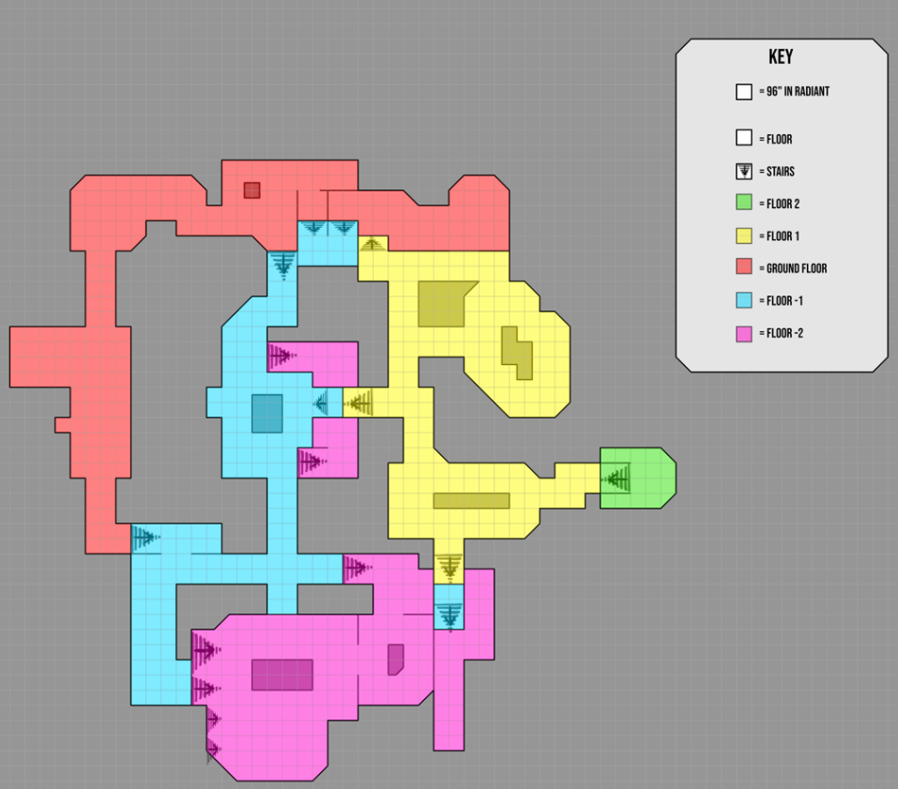

Gobblegum Machines
I have sparsely added Gobblegum machines throughout the map so that players must move to reach one if needed, completing my main design goal of the map. The specific locations of the Gobblegum machine are in main rooms where the player has high foot traffic, so they are easy to find and reach.
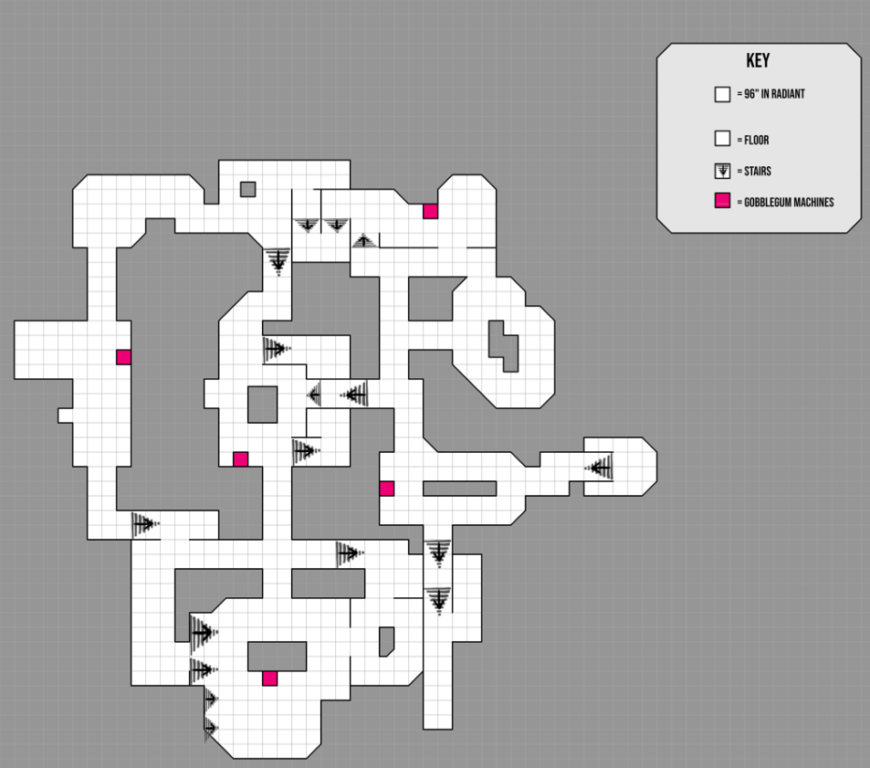

Mystery Boxes
Mystery boxes are dotted around the map similarly to the Gobblegum machines; however, the main difference is that only one is activated at a time. With this feature, I have made it so that the most southern box location is always active first. This is so the player can learn over time over multiple playthroughs that if they want the mystery box, they must go right at spawn.
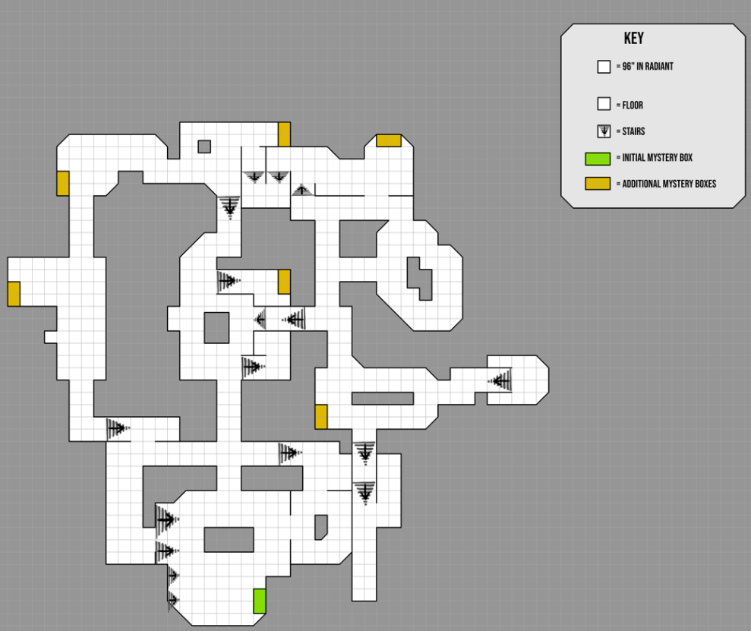
This is a necessity because my map is all indoors, meaning that they cannot see the light beam to track the box’s location. Therefore, by having the box spawn consistent, players can play the map with less struggle trying to find the box by random chance. It’s also useful because I can position the box far enough into the map so that when the player reaches the box, they are in slightly higher rounds, and the box weapons are balanced for the zombie difficulty.

Perk Locations
Perks are in all the major rooms in the map. I have situated them in order of when they are usually found in other zombie maps. Additionally, the core 4 perks should be found by the player on their way towards power, so they will know where to find them after power has been turned on.
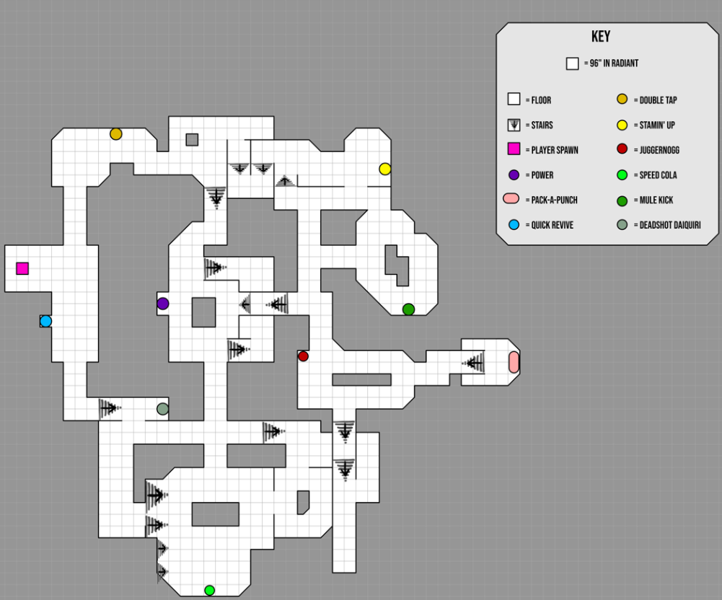
Pack-a-Punch is intentionally places at the dead end of a small room as that the player gets a high risk-high reward challenge if they attempt to upgrade their weapons. Its also a perfect time to use the powerful weapon they’ve acquired because they will have to fight their way back the way they came through a large horde, creating a satisfying, memorable moment for players as a reward for Pack-a-Punching.

Zombie Shield
The zombie shield is a strong upgrade for the player in zombies, therefore I have made it so that the player has to open up most of the map to find all of the pieces. Each part has 3 spawn location, like vanilla maps, which makes for varied gameplay between playthroughs and allows for mastery and knowledge for hardcore players who learn all shield part locations.
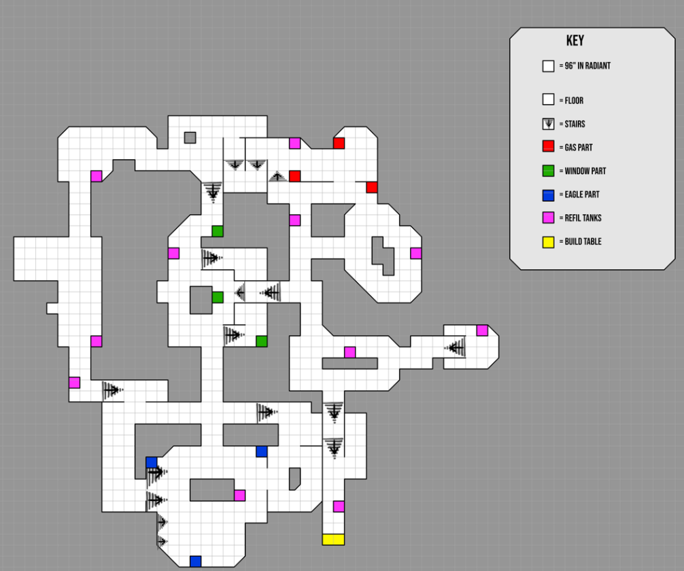
Additionally, by having the build table and parts of the shield found on the way to power, the player is slowly taught to look for pieces around the map as it acts as a subtle form of tutorialisation.

Wall Weapon Chalk-Buys
Wall weapons are spread across the entire map, with the more expensive and useful ones being deeper into the map. Originally, this was a feature seen withing vanilla zombie maps, but this is also done so that the weapons are balanced to the difficulty of zombies at that part of the game.
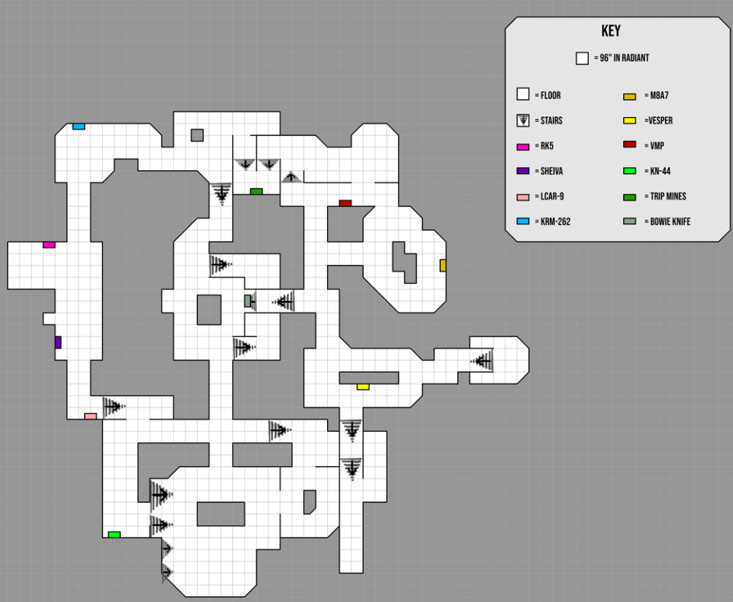

Aesthetic, Look and Feel

Visual Development
For the type of genre my map is for, narrative isn't a main feature. However, there is one main narrative element I wanted to get across to player, and that is the power of the bunker. The player is told implicitly how to get towards power. They must follow a subtle direction through the rooms and open the doors that require a cost and avoid the blocked doors that require power. This is also told explicitly to the player through the UI popup that tells players that the doors will only activate when power is turned on. Additionally, this follows a linear structure because the player only has one way to get to power (from both ways from spawn). I have created a vista moment for the player when they finally reach the power room. They go down a grand staircase into a large, symmetrical room where the power switch is held. This is supposed to communicate a sense of relief but also a wow moment when they finally reach the room.
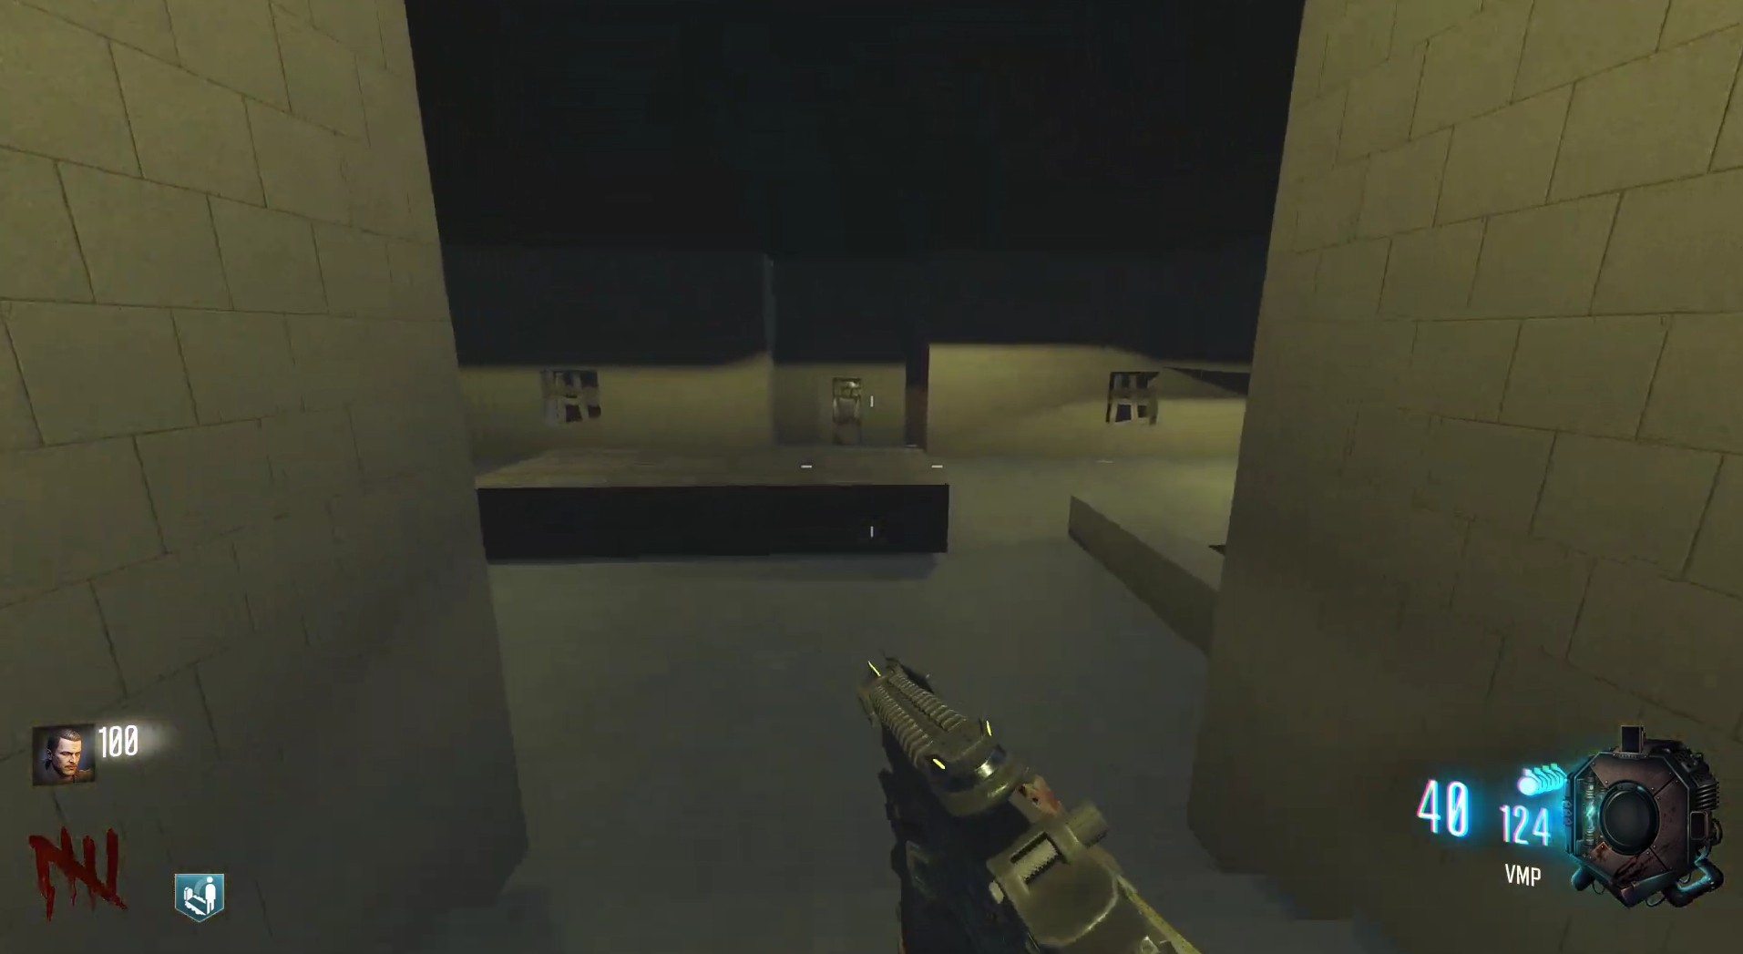

The map is supposed to be a dark, grungy experience which will give players a sense of uneasiness, through the creepy and dark atmosphere. This style matches with many vanilla zombie maps and therefore would fit naturally into that map pool. Additionally, the unique style of the bunker itself gives the map a memorable feature for the Friends Test.
For lighting, certain areas have been purposely lit up more than others so that you can see them better and guide players towards or away from them. Examples include dark corners in rooms, versus a bright room center where players are encouraged to train so they don’t get stuck between a wall and a zombie.

Affordance
Inside the game, I have added diegetic guidance to direct the player. This is in the form of lightning chalk arrows. These are popularly known in the zombies community to direct player behavior towards the power switch. Therefore, I added them to my map so that the players do not get lost.
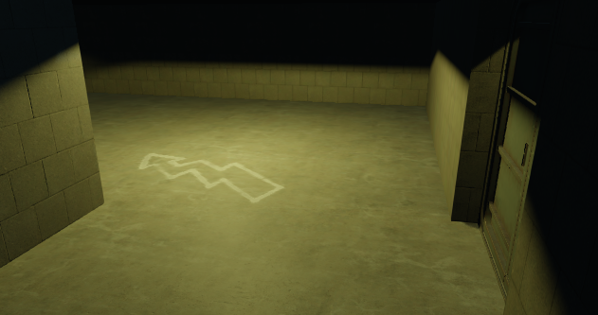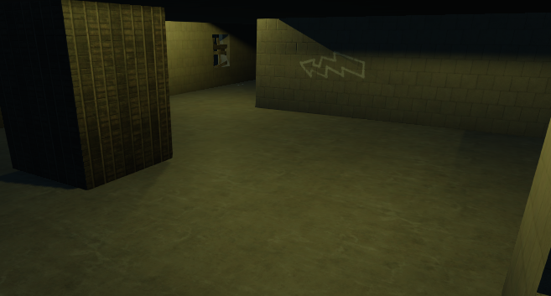
Specific rooms, such as the Juggernogg room have their items placed in priority order. This is done so that the players have direct eye contact with the most important things in the room first (like perks), and the least important lings last (like wall weapons).
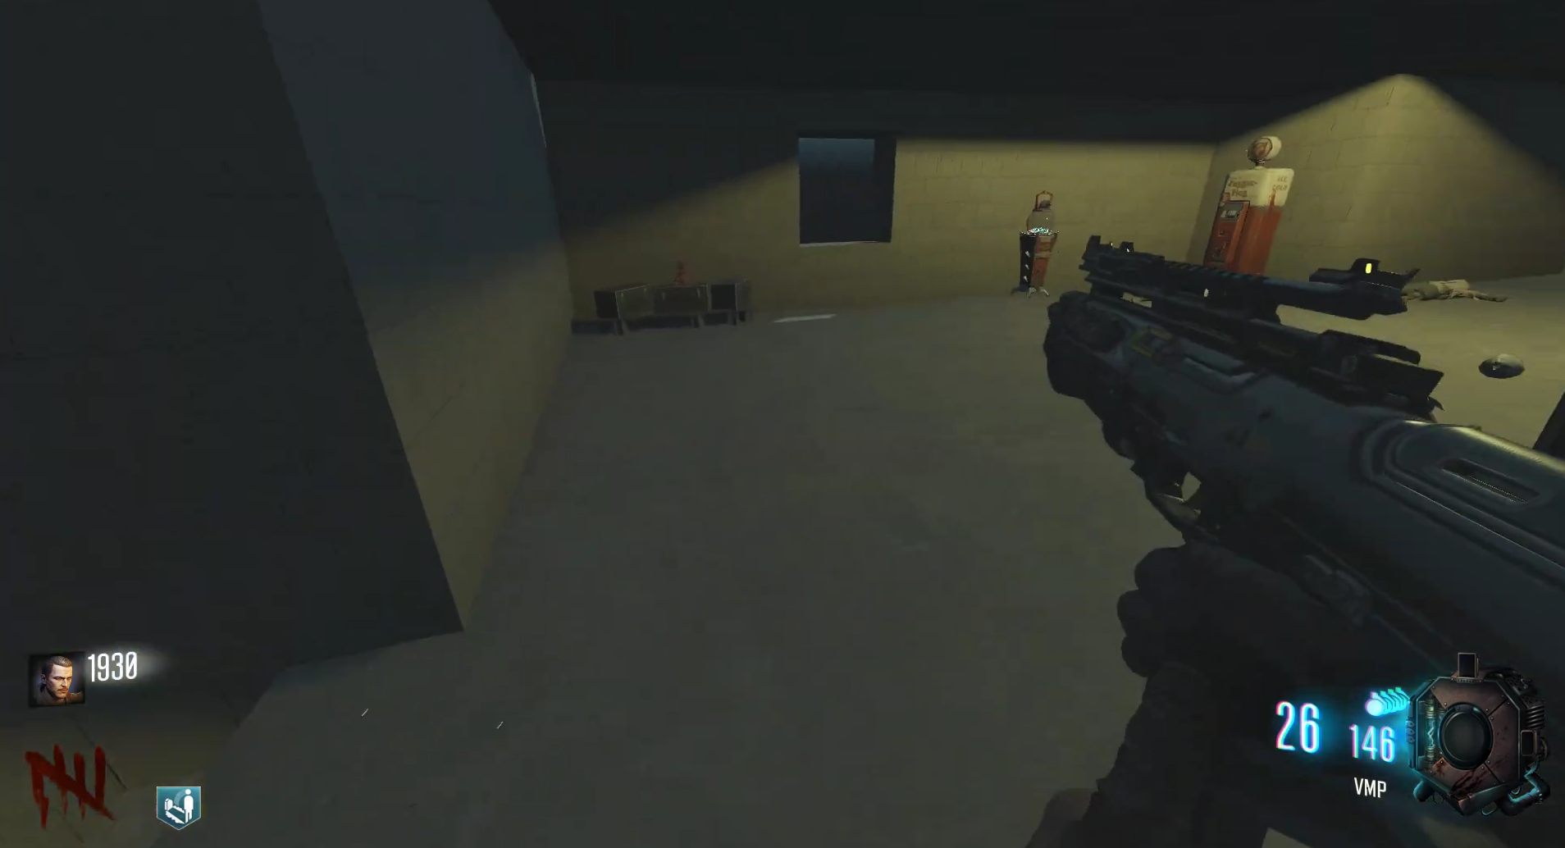

In certain rooms, I have used shape theory and funneling to guide players towards intended areas. For example, the path towards Pack-a-Punch uses angled walls to direct the player’s attention to the hallway ahead into the next room.
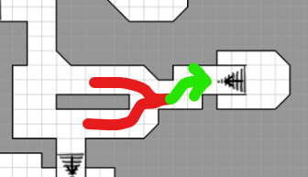
Diagram to show funneling the player into the Pack-a-Punch room.

Additionally, the doors within the map are all split into one of 3 categories: Paid, paid but drop-down, and powered. These all have different models so the player can visually tell the differences in game. The paid doors use a bunker door mesh, the drop-down doors are not necessary and are a form of shortcut, so these are a metal fence, and the powered doors are industrial with a grated window so that the player can see what they will have access to once power is enabled. This was done so that player could distinguish each door type form each other so players aren’t forced to walk up to it to see if they could interact with it or not.
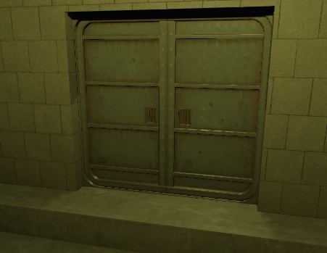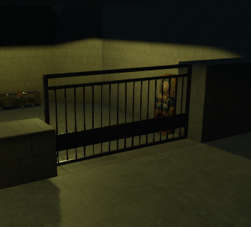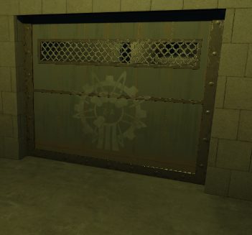

Balance

Considerations
I have improved the balance of the map by changing the door costs and shrinking room sizes. However, after more playtesting is considered, I will be able to tell if the map is too easy or hard for different audiences (different skill levels). For me personally, I feel that the door points are challenging but not hard, making it fair and fun to play. For a zombies veteran, the map will still feel slightly too big, however, for more casual players this may be okay, or too small. With a larger testing group, I would be able to find out what balancing will need to be done. As well as adding challenge for competitive players, I have balanced for causal players by having some larger rooms where it’s easy to train zombies, and long catwalks to camp.
Additionally, the smaller rooms are still manageable to play inside of because the mystery box holds lots of powerful weapons for the player to use and take advantage of.

Expected Issues
As I was learning the Radiant editor for the first time during this, most time went into research and tutorials, but If I had more time during this map creation, I would like to fix these known issues:
- Detailing the map. With more detail and add environmental storytelling elements (like making the southern room look like a cave-in, or environment art tech pieces to give each room its own character). This would help this map with the Friends Test as people are more likely to remember it if it had a distinct look.
- Improve individual room elevation. Even though the map has elevation, making elevation variance inside of rooms would be interesting to play with. I could lower the center of a room or raise the roof height in areas.
- Improve on the lighting. I could have flickering lights in areas, lights that only turn on once power is on, making it scarier early-game, or even use lighting as a form of affordance for the player with spotlights above certain doors, shield pickups, or perks, for example.
- Add a boss enemy. Currently the map only has zombies and dogs. However, because the map has so many powerful weapons from BO3, it makes it incredible easy to reach high rounds once the player is set up. A boss zombie would be perfect for the map to make it more challenging. Something like the Panzer from 'Der Eisendrache', or Brutus from 'Mob Of The Dead' are powerful mini bosses that will dominate in the small corridors of this map and really give a challenge. Additionally, the added boss zombie would make the map feel more relatable to other zombie maps as many modern maps have at least one.
- Additional Cover. The map has lots of powerful weapons stated above, therefore it is easy to traverse the rooms and corridors without much issue. A fix to this would be to add more objects around the walls of the rooms to bring the play space in and the overall room smaller. This would add more challenge without making a room feel smaller because the outer walls would still be the same distance away.
- Additional systems. Although these are not necessary, traps and a Wunderfizz Machine would make this map even more complete and polished as many vanilla maps feature these. With the increased difficulty from the smaller rooms seen in the above point, the extra perks and traps would be there to balance out this difficulty too.

Testing

Testing Plan
Testing has been carried out on 2 different occasions, giving crucial feedback on how I can positively iterate my map. I published my map on Steam and sent out a MS Form with the same questions both times to get consistent feedback throughout all the development. After receiving feedback, I analyzed the comments and listed all points to change and work on for the next playtest build for Steam. Playtest questions are listed below:
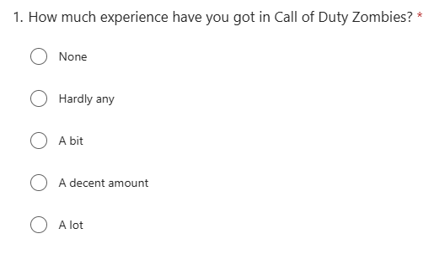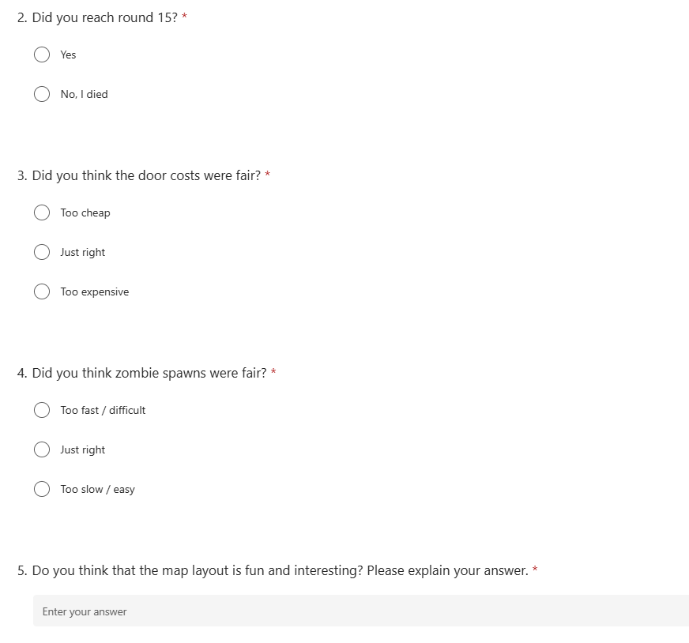
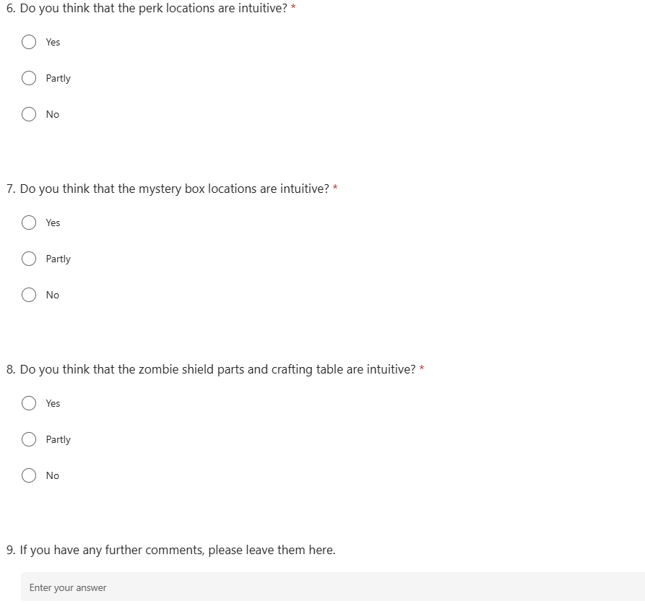

Evidence of Testing
After my first playtest, I made a list of the main takeaways of what I should change/improve about the map. This list included:
- Make map harder
- Add extra doors/increase overall door costs
- Switch out zombie spawns for faster alternatives
- Split up larger boring rooms
- Make map less symmetrical
- Add elevation
- Fix barricade bugs
- Add lightning arrow power decals

For my second playtest, I got a nice range of experienced players for the playtest which is great to see as they will know what to looks for and follow other zombie map design conventions. In the future, more inexperienced feedback would be helpful, so I know that my map is still enjoyable for a casual experience. There was a perfect balance between reaching and dying at round 15, meaning that the map is in a good spot for difficulty as players should not always be able to reach that round on their first attempt. I'm happy to see that the rest of the feedback was all positive and all the system placements seemed intuitive, and that players loved the branching pathways. The only outlier being one player thought the shield was partly intuitive because they only opened half of the map, so only found half of the parts. After this feedback, I feel the map is in a good spot for its layout and design.

Level Development Log

My initial paper layout with the base looping format:
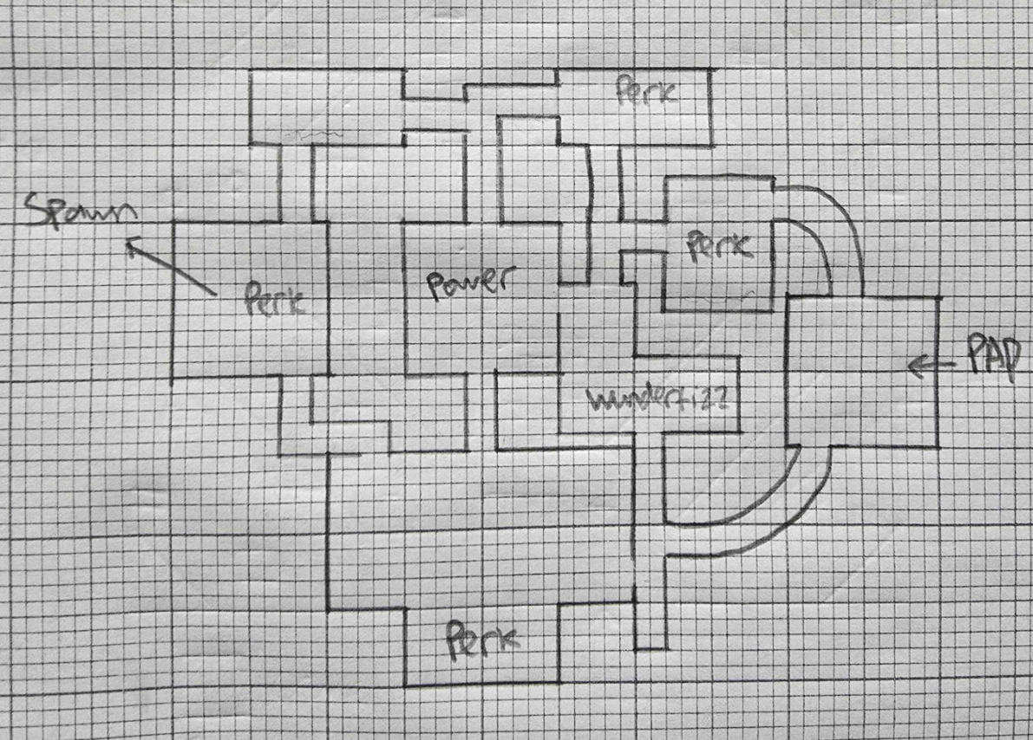

Second iteration with a digital layout:
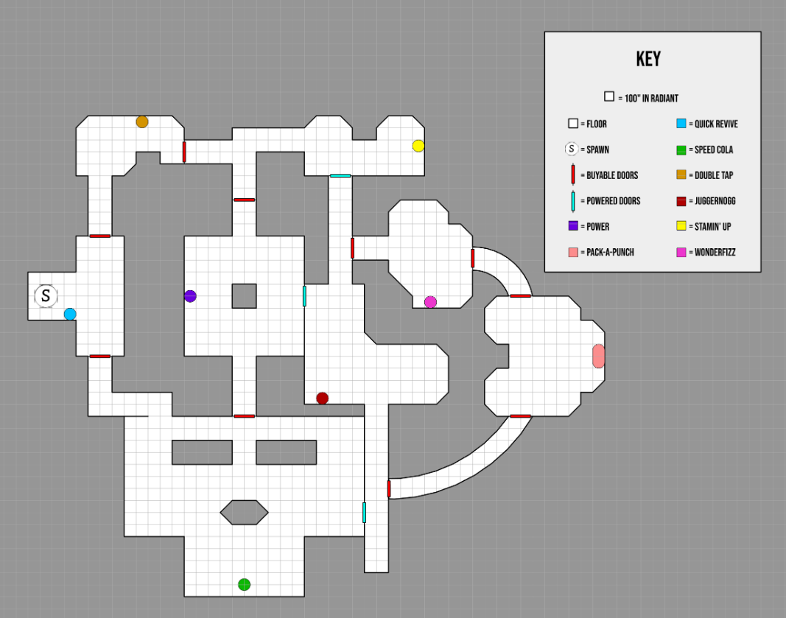
Initial map structure:
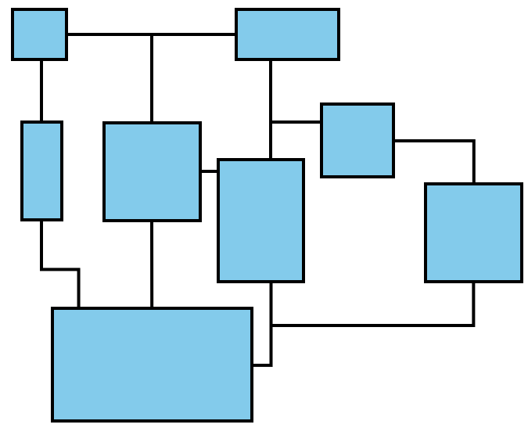
Scale Changes. I initially made my map grid at 128” and scaled it down, to around 76”. This change makes the map feel more interesting, as the rooms feel significantly different in scale, as well as some rooms being challengingly small:
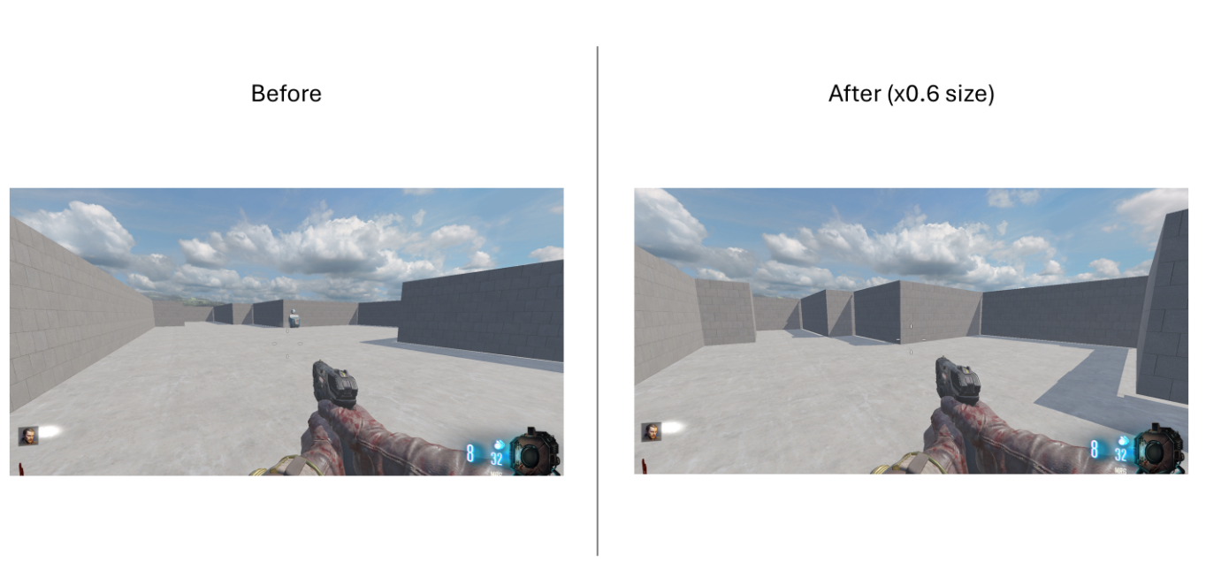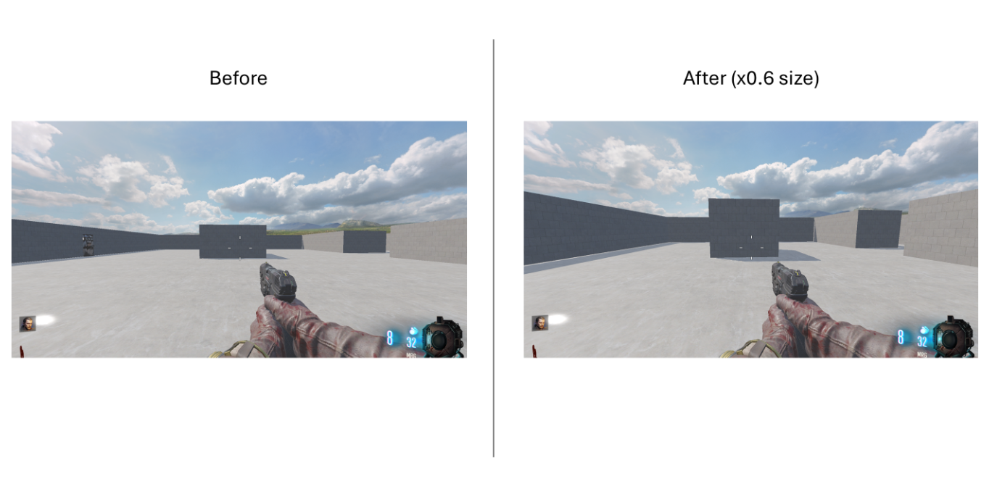
The original map did have a good scale to it and gave a fun challenge. However, it was too small for if I wanted to add any debris or props to the edges of rooms. Therefore, I have since increased the size of the map grid to 96” and updated my grid metric on the map key to be accurate. The map scale is incomprehensible in engine, but it feels different in game.

2.5 Map iteration. This was created with the additional systems added to the map, as well as a change to the pathways to Pack-a-Punch:
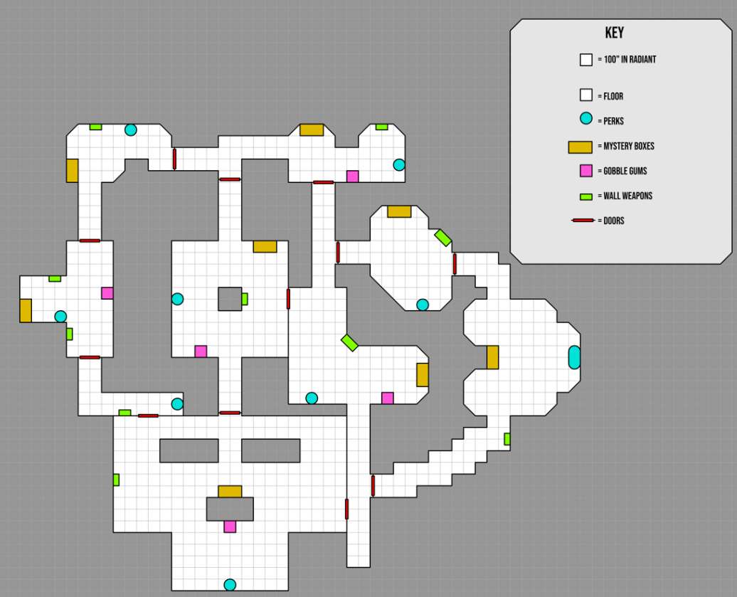
Before and after (Speed Cola room):
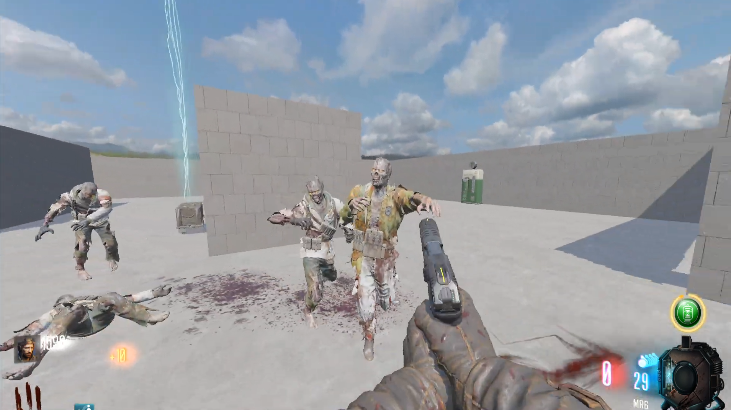
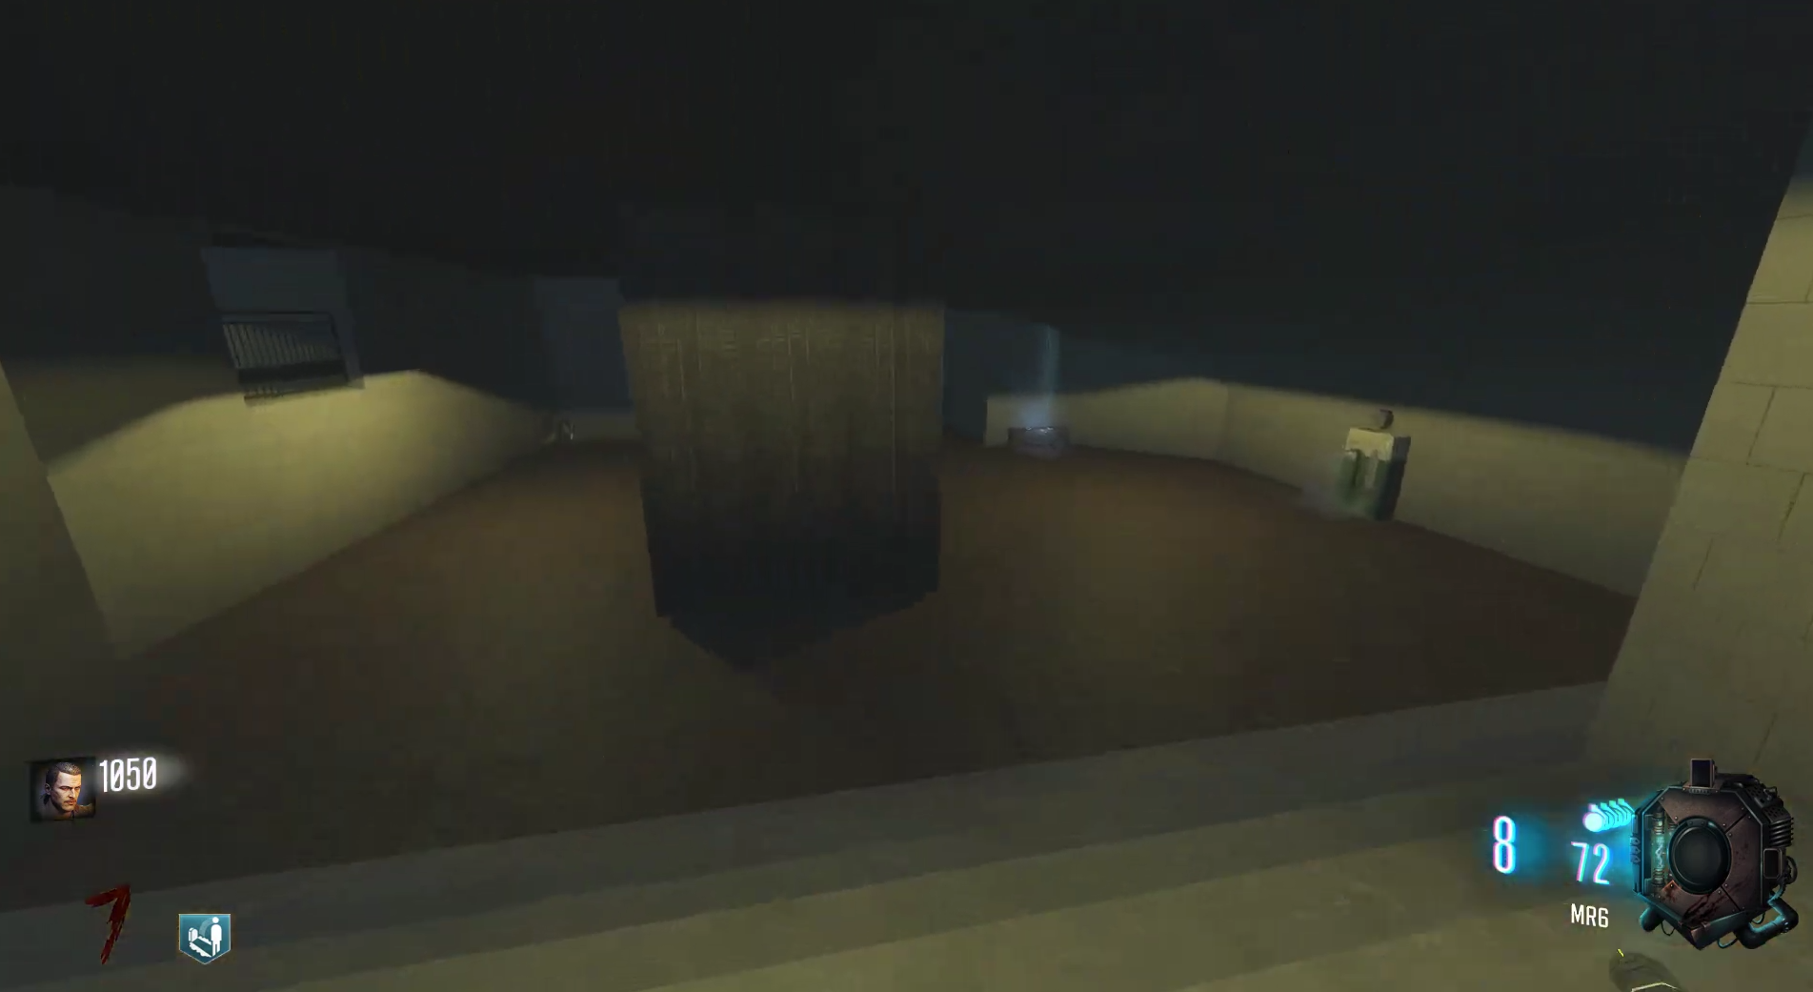

3rd Map Iteration. This was made after taking my first playtest’s feedback into consideration as this version encompasses all the feedback changes:
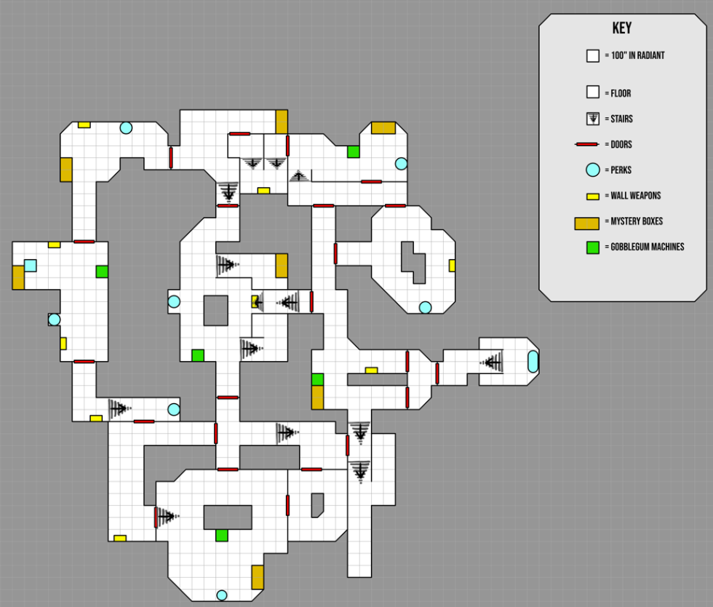

4th (and final) Map Iteration. This Is the most up-to-date version of my map and shows all the main systems together in one map. The second playtest feedback was made from this build of the map:
