|  |  |  |  |  |
| --- | --- | --- | --- | --- |
| **STAFFORDSHIRE UNIVERSITY – (E-coversheet)**  **Please complete all grey shaded boxes and insert your assignment text on page 3.** Please ensure you record your student number as failure to do so will result in the loss of your anonymity.  **If you have a Learning Support Agreement, please also check whether you need to fill in**  **any of the Blue/Yellow shaded boxes.**  By attaching this cover sheet, you declare that:  *I have read the University’s Academic Misconduct Regulations (including plagiarism) and the work I am submitting does NOT breach those regulations.* | | | | |
| **Student Number:**  22013232 | **Word Count ()**:  7053 | | | |
| **Assignment Title:**  Do high levels of parental burnout, parental gender, and children’s gender predict children’s anxiety related emotional disorders? | | | | |
| **Disability Allowance:** Please only tick if appropriate.  *Written expression allowance*: If you have been formally assessed as having circumstances which affect your written expression (such as dyslexia or hearing impairment), tick the Written Expression Allowance box. Your learning support agreement will be checked, and sympathetic allowance will be made for spelling and written expression when marking.  *Negotiated deadline*: For students who have a support statement that recommends negotiated deadlines you should negotiate with these with the MODULE LEADER via email, in advance of the original submission date. You will need to include a copy of the extension confirmation email at the end of your work. | | Written expression allowance | | |
|  | Negotiated Deadline: |  |
|  | Negotiated Deadline Date (dd/mm/yy): [INSERT HERE IF APPLICABLE] |  |

|  |
| --- |
| **REFLECTION ON FEEDBACK**  We want to help you to produce good assignments and to develop a wide range of skills while you are at university. To help us, to help you, please provide some answers to the following questions before submitting your assessment. This will help you reflect on feedback already received, develop your skills, and help us to provide you with relevant and personalised feedback.  This is an optional opportunity. We will still mark your work if you do not use this opportunity to help us give you more personalised feedback. |
| **1a. From your feedback on previous assessments what have you focused *most* on improving for this assessment?**  Previous feedback has mentioned keeping my writing formal and using multiple citations to back up a point. |
| **1b. What actions have you taken in making this improvement?**  I have carefully read academic journals and made notes on how they are written, focusing on formality. I have also added more than one citation in multiple places to show my wider reading. |
| **2. What did you find most challenging when preparing this assessment?**  Finding participants was the hardest part for me. |
| **3. What would you particularly like the marker to comment / give feedback on?**  General feedback please. |

**Do** **high levels of parental burnout, parental gender, and children’s gender predict children’s anxiety related emotional disorders?**

**Abstract**

Anxiety-related emotional disorders are among the most prevalent mental health concerns in children, often impacting their social, academic, and overall functioning. Research suggests that family dynamics, particularly parental burnout and gender, significantly influence a child's vulnerability to anxiety. This study investigates whether parental burnout, parental gender, and child gender predict symptoms of anxiety-related emotional disorders in children aged 7-11 years. Using a quantitative, within-subjects design, parents completed the Parental Burnout Assessment (PBA) and the Screen for Child Anxiety Related Emotional Disorders (SCARED-P). Multiple regression analysis assessed the predictive value of these factors on child anxiety. Findings will inform strategies for identifying early signs of parental burnout and guide interventions that support both parental well-being and children's emotional health. By considering gender diversity among parents and children, this study provides insights for more inclusive and context-specific mental health interventions.

**Introduction**

Childhood anxiety-related emotional disorders are characterised by excessive and persistent fear and worry that significantly impairs a child’s daily functioning including school, social interactions and even family life (Rapee et al., 2023). These disorders often disrupt normal childhood development and can have lasting effects into adolescence and adulthood, with anxiety being among the most prevalent mental health concerns in early development (Pollard et al., 2023). Studies show that these disorders can significantly impact and hinder academic success, social functioning, and overall psychological well-being (Cresswell et al., 2014). Approximately 15%–20% of children and adolescents meet the criteria for an anxiety disorder (Beesdo et al., 2009) but estimates as high as 31.9% have been cited among youths aged 13–18 years (Merikangas et al., 2011). Anxiety-related disorders in children can manifest in several ways including excessive fear, irritability, avoidance behaviours and physical complaints such as headaches and stomach-aches, often interfering with their ability to engage in normal developmental activities and overall daily functioning (Chiu et al., 2016). The cause of childhood anxiety is multifaceted, involving biological, cognitive, and environmental factors. Among these, parental influences, particularly parental burnout and gender, are increasingly recognised as critical predictors of child emotional well-being (Roskam, 2017).

Parental burnout is defined as a state of chronic physical and emotional exhaustion in one’s role as a parent, typically characterised by emotional distancing from one’s children, feelings of inefficacy and an overwhelming sense of fatigue (Mikolajczak et al., 2018; Saavedra Rionda et al., 2021). Unlike temporary stress, burnout is not simply the result of occasional stress but emerges from prolonged exposure to parenting- related stressors which may include elevated expectations and lack of support and insufficient coping resources (Hubert & Aujoulat., 2018). Parents in high-pressure environments, or those balancing multiple demanding roles without adequate resources, are particularly vulnerable to burnout. Recent global challenges, such as the COVID-19 pandemic, have amplified these stresses, with many parents facing intensified responsibilities and a heightened sense of burnout (Griffith, 2020). The long-term impact of parental burnout is concerning, as it not only affects the well-being of parents but also extends to children’s emotional and developmental health (Maslach & Leiter, 2016).

It is important to look at this research because it offers practical benefits to parents by increasing self-awareness. When answering questions about their own burnout, parents may begin to recognise the symptoms and seek support. (Grose, 2020; Maslach & Leiter, 2016). Beyond self-awareness, understanding parental burnout is crucial, not only because it affects parental mental health, but also because of its downstream effects on children. Children of burned-out parents are more likely to experience emotional instability, difficulties in emotional regulation and a heightened vulnerability to anxiety- related emotional disorders (Wang et al., 2023). These outcomes are often driven by reduced emotional availability and increased irritability that often accompany burnout, which in turn can impair the development of secure attachment bonds and effective emotional coping strategies in children (Bowlby, 1988; Mikolajczak et al., 2019).

Moreover, research suggests that parental burnout may not only influence behavioural responses but could also affect children’s psychological stress responses. Chronic exposure to emotionally distant or dysregulated caregivers has been associated with altered functioning in the hypothalamic-pituitary-adrenal (HPA) axis, leading to heightened cortisol reactivity in children (Gunnar & Quevedo, 2007). Such dysregulation may increase susceptibility to anxiety, as children’s biological stress systems become hypersensitive over time. This neurobiological perspective adds depth to the current study’s framework by highlighting the interplay between parental emotional exhaustion and children’s physiological vulnerability to anxiety (Lupien et al., 2009)

Beyond burnout itself, the gender of the parent plays a significant role in how children experience and internalise parental behaviour. Mothers and fathers often differ in how they express emotional and manage parenting stress (Bögels & Phares., 2008). For instance, mothers are generally more likely to display more nurturing behaviours, while fathers may be more inclined to adopt more authoritative or controlling approaches, each influencing child anxiety levels in distinct ways (Teetsel et al., 2015). Research has shown that maternal overprotection has been associated with heightened anxiety risk as overprotection can lead to the reassurance-seeking behaviours which in turn can reinforce a child’s fear and avoidance behaviours (Murray et al., 2009). On the other hand, elevated levels of controlling behaviours from fathers can cause their child to be more prone to developing anxiety symptoms, particularly in boys (Breaux et al., 2016). These gendered patterns in parenting underscore the importance of examining parental gender in the context of childhood emotional outcomes.

Parenting style more broadly may also interact with burnout to amplify the risk of anxiety in children. Authoritarian or overprotective parenting has long been associated with anxiety symptoms in youth (Wood et al., 2003). Parents experiencing burnout may unintentionally intensify these behaviours, fluctuating between disengagement and overcontrol, in an effort to maintain a sense of order or manage their own stress. From a family systems perspective, dysfunction in one member affects the functioning of the whole system (Minuchin, 1974). Thus, parental burnout should be understood not only as an individual issue but as a systemic stressor capable of influencing the emotional tone of the household.

A child’s gender also plays a significant role in their susceptibility to anxiety-related emotional disorders. Several studies suggest that girls are more prone to anxiety than boys, potentially due to heightened sensitivity to social stressors, biological factors, and socialisation patterns that encourage emotional expressiveness (Zahn-Waxler et al., 2008). Girls may be socialised to value emotional openness, which might make anxiety more noticeable and lead to earlier diagnosis (Craske, 2003). Boys, on the other hand, often externalise distress, which can lead to underdiagnosis or misclassification of anxiety symptoms (Eschenbeck et al., 2007). These gender differences in emotional expression and coping styles further illustrate the complex factors influencing child anxiety, with girls tending to engage in overthinking behaviours and boys tending to suppress emotions or engage in distraction (Eschenbeck et al., 2007). These patterns necessitate a closer look at how gender dynamics shape the expression and identification of anxiety symptoms in children.

Research also suggests that protective factors, such as social support, are crucial in mitigating the impact of parental burnout and childhood anxiety. Parents who feel supported emotionally and practically are less likely to experience burnout symptoms (Le Vigouroux et al., 2017). This support can foster a more emotionally available environment for children, which, in turn, buffers them against the development of anxiety disorders. Likewise, children with access to additional supportive figures, such as extended family members, teachers, or mentors, are more likely to exhibit resilience against anxiety, especially when their primary caregivers are emotionally unavailable or overburdened (Rueger et al., 2016). These findings highlight the importance of systemic and community-based approaches to mental health, where the entire family system, including extended networks, plays a crucial role in supporting children’s emotional well-being.

Theoretical frameworks such as attachment theory (Bowlby, 1969) and social learning theory (Bandura, 1977) provide valuable lenses through which to understand how parental burnout and gender roles impact child anxiety. From an attachment perspective, children need secure, responsive caregiving to develop emotional stability. Parental burnout can compromise this secure base, leading to increased anxiety and difficulty with emotional regulation (Ribas et al., 2024). Social learning theory highlights the role of modelling, where children internalise emotional behaviours from their parents. If a parent is overwhelmed or emotionally distant, children may come to view these responses as typical and model them in their own emotional experiences (Bandura, 1977).

While parental and child factors are central, it is also critical to acknowledge external influences such as the school environment. Academic pressures, peer conflicts and bullying are all well-established contributors to childhood anxiety (Essau et al., 2010). Parental burnout may compound these external stressors, as burned-out parents may be less engaged in their child's school-related matters or social life, potentially overlooking early signs of anxiety or failing to advocate for their child’s needs. Therefore, school based mental health initiatives must consider the home context and encourage collaboration between educators and parents to ensure that children’s emotional well-being is holistically supported.

Although the relationship between parental stress and child anxiety has been well documented, most research in this area has been conducted in individualistic societies such as the United States (Abramson, 2021; ) and China (Wang et al., 2023; Yang et al., 2021), where societal values emphasise competition, which increases stress levels among parents (Mikolajczak & Roskam., 2018). Additionally, much of the existing research focuses on adolescents aged 12- 18 (Wang et al., 2023; Zhang et al., 2023) or asking adults to think back to their childhood (Ensanimehr et al., 2024) leaving a gap in understanding how parental burnout affects children younger than 13.

Wu et al. (2022) highlighted this limitation, noting that early and middle childhood is a critical period for the development of emotional regulation skills. In younger children (ages 7-11), the parent-child relationship remains central to their emotional development, making this age group particularly vulnerable to the impacts of parental distress. Therefore, studying this age group offers important insights into early interventions that may prevent the escalation of anxiety symptoms.

There is also a lack of UK-based studies on this topic, despite growing concern about rising anxiety rates among British children. Anxiety disorders in pre-adolescence are probably the most common serious disorder of childhood, affecting around 1 in 30 British children (Cartwright-Hatton, 2013). This statistic underscores the urgent need for localised research to inform context-specific interventions. The UK context offers unique insights due to its specific cultural, educational and healthcare systems, which may interact differently with parental burnout and child anxiety compared to other countries. Local research is essential for developing culturally appropriate interventions that reflect the unique stressors British families face.

Furthermore, recent research has drawn attention to the need for inclusivity in family studies, particularly regarding gender diversity. Most studies continue to operate within binary frameworks, neglecting the experiences of nonbinary or gender-diverse parents and children (Westwater et al., 2019). Parents who do not conform to traditional gender roles may encounter unique stressors, such as lack of support or discrimination, that influence their experience of burnout (Goldberg et al., 2019). Similarly, gender-diverse children may face unique stressors that interact with parenting styles in distinct ways (Warner et al., 2021). Including diverse gender identities in psychological research is essential for creating inclusive and effective mental health interventions.

The current study aims to address these gaps by investigating whether parental burnout, parental gender and children’s gender predict anxiety-related emotional disorders in children aged 7-11, using a UK based sample. By focusing on younger children, this study seeks to capture early manifestations of anxiety and understand how parental gender and burnout influence their development. Understanding these factors can aid in developing effective interventions to mitigate the impact of parental burnout on children’s emotional health.

Based on existing literature, this study hypothesises that higher levels of parental burnout will predict higher levels of anxiety-related emotional disorders in children aged 7-11. It is further anticipated that the gender of both the parent and child will interact in unique ways to influence children’s anxiety levels, particularly that children of mothers with higher burnout levels may exhibit more anxiety symptoms, especially if they are female. This study aims to address gaps in existing research, including a focus on younger children and the role of gender diversity, within a UK-based context. By examining these factors, the present study seeks to contribute meaningful data to the field of developmental and family psychology and inform interventions that support both parental well-being and children’s emotional resilience.

In conclusion, understanding the factors that contribute to childhood anxiety is critical for developing early intervention strategies. By examining the roles of parental burnout, gender, and child gender, this research aims to shed light on how these elements interact to influence children’s emotional well-being. Given the complex and multifaceted nature of anxiety disorders in children, the findings of this study could inform both clinical practices and public health strategies aimed at supporting families, especially those who are most vulnerable. As parental burnout continues to rise globally, exploring its impact on child development has never been more urgent. The following study aims to add to the growing body of evidence and provide valuable insights for mental health professionals, educators and policymakers alike.

**Method**

**Design**

The current study employed a quantitative, cross-sectional design using a within subject's approach. This design was selected to examine how individual differences in parental burnout, parental gender and child gender predict children’s anxiety related emotional disorder symptoms. A multiple regression analysis was conducted to investigate whether parental burnout, parental gender and child gender could predict children’s anxiety-related emotional disorders. A within-subject approach was used, meaning all participants provided data on all variables, allowing for more efficient use of a relatively small sample.

The outcome variable was children’s anxiety-related emotional disorders, as measured by parental report. The three predictor variables were parental burnout (Continuous), parental gender (categorical) and child gender (categorical). Gender categories for both parents and children included male, female and non-binary, although no non-binary individuals were ultimately represented in the sample. Cross sectional designs are commonly used in developmental and psychological research to explore correlational relationships at a single point in time (Bryman, 2016). This design allowed for the simultaneous investigation of multiple predictors while maintaining ecological validity in a real-world parenting context.

Parental burnout was assessed using ‘The Parental Burnout Assessment’ (Roskam & Mikolajczak, 2018), a 23-item self-report scale measuring emotional exhaustion and contrast with precious parental self. Children’s anxiety related emotional disorder was measured using ‘Screen for Child Anxiety Related Emotional Disorders (SCARED)- Parent Version’ (Birmaher et al., 1999). This 41-item questionnaire assess anxiety symptoms across five domains including generalised anxiety, separation anxiety, social phobia, school phobia, and panic/somatic symptoms.

These validated measures were selected due to their high reliability and previous use in cross-cultural and developmental research (Rapee et al., 2009; Hale et al.,2011), their strong psychometric properties and ability to capture relevant dimensions of parental and child psychological functioning. The combination of self and parent report methods allowed for comprehensive assessment of both caregiver and child emotional wellbeing. Also, the use of these instruments reduces measurement error and increases the generalisability of findings across different populations (DeVellis, 2016).

All statistical analyses were conducted using IBM SPSS Statistics. A multiple linear regression analysis was performed to determine the extent to which parental burnout, parental gender and child gender predicted children’s anxiety symptoms. This method was chosen for its ability to assess the unique and shared variance explained by each predictor while controlling others (Field, 2018).

Although the questions within each scale followed a fixed order and were not randomised, steps were taken to minimise potential context effects (when responses to earlier questions influence responses to later ones; Podsakoff et al., 2003). This included careful ordering of the questionnaire sequence so that demographic and neutral questions proceeded more emotionally charged content. The questionnaire was also designed to be anonymous, and participants were instructed to respond as honestly as possible, helping to reduce social desirability effects (Paulhus,1991).

In future studies, randomisation of item presentation or inclusion of observational or child reported data could further reduce common method variance (bias) and increase the robustness of the findings (Conway & Lance, 2010).

**Participants**

A priori power analysis was calculated using Cohen’s ƒ² formula (Cohen, 1988), which suggested that a minimum of 36 participants were required to detect a medium effect size (ƒ² = 0.15) with a power level of 0.80 and an alpha of 0.05, assuming a standard regression model with three predictor variables. This approach aligns with recommendations from statistical power literature, which emphasises the importance of planning for adequate sample sizes in order to minimise the likelihood of Type II errors and to enhance the reliability and validity of inferential findings (Cohen, 1992). and to enhance the reliability of regression estimates (Faul et al., 2007; Green,1991). However, due to logistical challenges, limited recruitment time and challenges in accessing a larger sample of parents within the given timeframe, the final sample comprised of 24 participants.

While smaller than the ideal threshold, this sample still offers preliminary insights into the associations between parental burnout, gender and children’s anxiety. Nevertheless, the study is potentially underpowered, which may reduce its ability to detect small-to-moderate effect sizes and raises the risk of Type II error (Button et al., 2013). Furthermore, smaller samples may compromise external validity and limit the generalisability of the findings to the wider population (Maxwell, 2004). Despite these limitations, this study provides a valuable foundation for future research that can build on the findings with larger and more diverse samples.

Participants were recruited using voluntary (non-probability) sampling, a commonly used strategy in psychological research due to its accessibility and efficiency (Etikan et al., 2016). Recruitment took place via multiple online social media platforms including Facebook, X (formally Twitter), and Reddit, as well as through word-of-mouth. These digital spaces were selected for their ability to reach parents from diverse backgrounds and to increase participant reach in a cost effective and timely manner (Topolovec-Vranic & Natarajan, 2016). However, voluntary sampling can introduce self-selection bias, as individuals who choose to participate may differ systematically from those who do not, potentially limiting generalisability (Bornstein et al., 2013).

Eligibility criteria specified that participants must be aged 18 or older, reside in the United Kingdom, and be the parent or guardian of at least one child between the ages of 7 and 11 years. This specific age range was chosen as it represents middle childhood, a developmental period where anxiety-related symptoms tend to increase in salience and become more recognisable to parents (Rapee et al., 2009; Costello et al.,2003). Additionally, at the developmental stage, children typically begin school and experience growing cognitive awareness, which can increase vulnerability to internalising symptoms such as anxiety (Muris et al., 2002).

The final sample included 24 parents. The mean age of the parents was 35.7 years (SD = 5.7), and the mean age of the children was 9.1 years (SD = 1.2). Gender distribution among parents included 11 males and 13 females, with no participants identifying as non-binary. Among children, there were 12 boys and 12 girls, again with no non-binary children represented in the sample. Incomplete or partially completed questionnaires were excluded from analysis to maintain data quality and integrity. (See Appendix A for demographic breakdown.)

**Materials**

The study utilised several online materials to facilitate informed participation, accurate data collection, and ethical standards. All materials were administered via Qualtrics, an online survey platform that ensures secure data handling. This method allowed participants to engage with the study at a time and location convenient to them, reducing potential barriers to participation and increasing ecological validity (Evans & Mathur, 2018).

*Information sheet (appendix B)*

Participants were presented with an electronic information sheet prior to commencing the survey. This document outlined the study’s aims, procedures, estimated time commitment, and potential psychological risks. It also included a statement that clarified the voluntary nature of participation, the right to withdraw at any time without consequence, and assurances of confidentiality and anonymity. These steps align with the British Psychological Society’s (BPS, 2021) Code of Human Research Ethics, which emphasises the importance of informed voluntary consent and participant protection.

*Consent form (appendix C)*

To proceed, participants were asked to electronically tick a series of boxes on a consent form confirming their understanding of the information provided and their voluntary agreement to participate. Online consent procedures have been found to be as effective as traditional face to face methods in ensuring comprehension and voluntary participation, especially when clear instructions and contact details for the researcher are included (Clemens et al., 2018; Nierkens et al.,2013).

*Debrief form (appendix D)*

After completing the study, participants were directed to an online debrief form. The form offered a full explanation of the study’s aims and the purpose behind the research. The debrief also served to alleviate any potential distress by contextualising the questions and offering reassurance about confidentiality. It included contact information for the researcher and signposted mental health resources such as Mind and Samaritans. Including such support aligns with the best ethical practices for studies involving psychological variables (Allen et al., 2020; BPS, 2021).

*Demographics Questionnaire (appendix E)*

Basic demographic information was collected through a short questionnaire developed specifically for this study. Participants were asked to report their age and gender and the age and gender of their child. These variables were vital to classify predictor variables and ensuring the sample matched the study’s inclusion criteria. The inclusion of demographic questions also enables future subgroup analyses and allows more generalisability of findings (Furr, 2021; Sedgwick, 2012). For example, considering parental age in analyses may help contextualise how life stage influences burnout levels.

*Parental Burnout Assessment (PBA) (Appendix F)*

Parental burnout was measured using the Parental Burnout Assessment (Roskam & Mikolajczak, 2018), a 23 item self-report questionnaire designed to capture emotional exhaustion, contrast with previous parental self and emotional distancing from one’s children. Participants rated how frequently they experienced various symptoms of burnout (e.g., “I feel completely exhausted by my role as a parent”) on a 7-point Likert scale ranging from 0 (never) to 6 (everyday). Total scores could range from 0 to 138, with higher scores indicating greater burnout. Score ranges were categorised as follows: 23-50 (mild burnout), 51-80 (moderate), 81-110 (severe) and 111+ (extreme).

The PBA has been found to demonstrate strong reliability and construct validity across diverse cultural populations (Roskam et al., 2021). Its cross-cultural adaptability has been supported in studies from Indonesia (Abidin et al., 2024), Finland (Aunola et al., 2020), and Spain (Suárez et al., 2021), making it a robust tool for international research. The digital self-report format is user-friendly and time-efficient, promoting participant compliance and data completeness (Van Bakel et al., 2018).

*SCARED- Parent Version* (appendix G)

Children’s anxiety-related emotional disorders were measured using ‘Screen for Child Anxiety Related Emotional Disorders (SCARED)- Parent Version’ (Birmaher et al., 1999). This questionnaire consists of 41 sentences, rated on a 3-point Likert scale, that are designed to identify the presence of generalised anxiety, social anxiety, separation anxiety, panic disorder, and school avoidance based on parental observation. The parents were asked to decide if the sentences were ‘not/hardly ever true, somewhat/sometimes true or very/often true, regarding their child in the last 3 months. An example item is: ‘My child gets really scared for no reason at all.’ The tool has demonstrated excellent internal consistency across subscales and is widely used in both clinical and community settings (Hale et al., 2011)

Each item is scored 0-2 and a total score of 25 or more suggests the presence of an anxiety disorder. Scores higher than 30 are more specific. For example, a score of 9 for items 5, 7, 14, 21, 23, 28, 33, 35, 37 may indicate Generalized Anxiety Disorder. This questionnaire was used as it has shown to exhibit excellent internal consistency and parent/child responses showed moderate to large correlations (Runyon et al., 2018), making it a robust choice for screening anxiety symptoms in children based on parental report. Its use in online surveys has been supported in previous studies due to its brevity and clarity (De Los Reyes et al., 2015). The SCARED-P has also been validated in digital formats, making it ideal for remote data collection (In-Albon et al., 2015).

**Procedure**

The study was conducted entirely online using the Qualtrics platform, which provided accessibility and convenience for participants while ensuring ethical standards were upheld. Online research methods are increasingly recognised as valid and reliable and cost-effective tools for psychological data collection especially for parent-reported measures (Hewson et al., 2020; Wright, 2005). Conducting the study online also allowed participants to complete the survey in a comfortable, familiar environment, potentially reducing social desirability bias and enhancing the honesty of their responses (Joinson, 1999)

Participants accessed the study through a survey link distributed via social media platforms (e.g. Facebook, X and reddit) and word of mouth. Upon clicking the link, the participants were presented with an electronic information sheet (see appendix B) which detailed the purpose of the study, their rights as participants and what participation would involve.

Following the information sheet, participants were required to provide informed consent by electronically ticking a series of boxes to conform their understanding and voluntary agreement to take part (see appendix C). Online consent procedures have been shown to be comparable to traditional face-to-face methods in securing truly informed participation, provided that instructions are clear and researcher contact information is available (Clemens et al., 2018).

Once consent was obtained, participants completed the Demographic Questionnaire (Appendix E), where they provided basic information about themselves and their child, including age and gender.

Subsequently, participants completed the Parental Burnout Assessment (Appendix F), a 23-item measure of parental exhaustion. Finally, the participants completed the SCARED – Parent Version (Appendix G), providing data on their child’s anxiety-related emotional symptoms across various domains including generalised anxiety, panic disorder, separation anxiety, social anxiety and school avoidance.

The order of the questionnaires was fixed rather than randomised, to ensure a logical flow and reduce confusion. While fixed ordering can raise the possibility of order effects or context effects, where responses to one set of questions may influence answers to later questions (Podsakoff et al., 2003), care was taken to group the materials thematically and use clear transitions between sections to minimise cognitive fatigue or carry-over effects (Bowling, 2005). Such structuring aimed to reduce cognitive fatigue and maintain participant engagement throughout. The average time to complete the survey was approximately 6 minutes and 53 seconds, balancing the need for comprehensive data collection with the considerations of participant burden. Shorted survey durations are associated with reduced attrition rates and higher quality responses (Galesic & Bosnjak, 2009)

Upon completing all the required tasks, the participants were immediately directed to a debrief form (see appendix D). The debrief form reiterated the purpose of the study, assured participants of the anonymity and confidentiality of their responses and signposted them to anxiety helplines if they felt like they needed to talk to someone following the study (E.g., Mind, Samaritans). Providing access to support services is a crucial component of ethical research practice, particularly when sensitive topics such as mental health are involved (Allen et al., 2020).

Finally, participants were also reminded that they could withdraw their data up to two weeks after the study by contacting the researcher via the email provided. This withdrawal window reinforced ethical transparency and ensured participant autonomy over their data even after survey completion, aligning with recommendations for ethical online research practices (BPS, 2021; Buchanan & Hvizdak, 2009).

**Results**

Prior to analysis, the dataset was screened for accuracy and completeness. No missing values or illogical data points were identified. Z-scores were calculated for all continuous variables, and all values fell within the acceptable range of ±3 (see Appendix H), indicating no outliers were present.

Descriptive statistics were calculated to summarise the sample characteristics and key study variables. As shown in Table 1, the average parental age was 35.75 years (SD = 5.71), and the average child age was 9.12 years (SD = 1.29). Mean scores for the Parental Burnout Assessment and SCARED-Parent Version were 40.79 (SD = 25.02) and 32.75 (SD = 19.57), respectively, suggesting moderate levels of both parental burnout and child anxiety symptoms within the sample.

*Table 1:*

*The mean and SD scores for parental age, children’s age, Parental Burnout Assessment and SCARED-parent version.*

|  |  |  |
| --- | --- | --- |
|  | Mean | SD |
| Parental age | 35.75 | 5.71 |
| Children's age | 9.12 | 1.29 |
| Parental Burnout Assessment | 40.79 | 25.02 |
| SCARED- parent version | 32.75 | 19.57 |

All parametric assumptions for multiple linear regression were checked prior to conducting the regression analysis. The skewness and kurtosis values for each continuous variable were between -1 and 1 indicating acceptable normality. Visual inspection of histograms further supported the assumption of normal distribution (see appendix I). Linearity and homoscedasticity were assessed using scatterplots of each predictor variable against the dependent variable (see appendix J). The relationships were mostly linear, and the spread of residuals appeared consistent across all levels of the predictors, meeting both assumptions of linearity and homoscedasticity. To check for multi-collinearity a multiple linear regression was conducted (appendix K). The tolerance values were greater than .1 and the Variance Inflation Factor (VIF) values were less than 10, therefore, there was no multi-collinearity.

A multiple linear regression was conducted to examine whether parental burnout, parental gender, and child gender significantly predicted children’s anxiety-related emotional disorder symptoms, as measured by SCARED scores.

The overall regression model was statistically significant, F(3, 23) = 5.454, p = .007, R² = .450, indicating that the three predictor variables collectively explained 45.0% of the variance in children’s anxiety scores. This suggests a large effect size, according to Cohen’s (1988) guidelines.

**Parental Burnout**

Parental burnout was a significant predictor of children’s SCARED scores (β= .56, p=,003). The regression equation was y = 14.77 + 0.44x, indicating that higher parental burnout scores were associated with higher levels of anxiety symptoms in children. Parental burnout alone accounted for approximately 31.7% of the variance in anxiety scores (R² = .317).

**Parental Gender**

Parental gender was also a statistically significant predictor (β = −.38, p = .021). Parental gender was coded as 1 = fathers and 2 = mothers. The regression equation was y = 56.45 - 14.73x, suggesting that children of fathers had higher anxiety scores compared to children of mothers. Parental gender explained 14.1% of the variance in SCARED scores (R² = .141), suggesting that parental gender plays a meaningful role in children’s emotional outcomes.

**Child Gender**

Child gender, however, was not a statistically significant predictor of SCARED scores (β = −.17, p = .319). Gender was coded as 1 = boys and 2 = girls. The regression equation was y = 43.75 - 3.93x. Although girls had slightly lower average anxiety scores than boys, the difference was not statistically meaningful. This variable only accounted for 2.7% of the variance (R² = .027), suggesting a minimal effect in this sample.

Together, the results of this study suggest that parental burnout and parental gender significantly predict the presence of anxiety-related emotional symptoms in children aged 7–11. Specifically, higher levels of burnout were associated with higher anxiety scores in children, and children of fathers reported higher anxiety scores compared to those of mothers. In contrast, the child’s gender was not a significant predictor, indicating that within this sample, child anxiety symptoms were not strongly influenced by gender alone.

**Discussion**

The present study set out to explore the predictive relationship between parental burnout, parental gender, and child gender in the development of anxiety-related emotional disorders in children aged 7–11. The findings align with the premise outlined in the introduction, confirming that parental burnout is a significant predictor of children's anxiety, thereby reinforcing the notion that family dynamics and parental well-being play a critical role in shaping children's emotional health. As noted in the introduction, the theoretical foundation for this study drew heavily on emotional contagion theory (Hatfield et al., 1994), which posits that children's emotional responses can be shaped by the emotional states of their caregivers. This theory was validated by the results, which demonstrated that children of parents experiencing high levels of burnout exhibited heightened anxiety, particularly in relation to separation anxiety and generalised anxiety.

The overall regression model was statistically significant and explained a substantial 45% of variance in children’s anxiety scores, (R² = .450), indicating that the examined predictors collectively contribute meaningfully to understanding anxiety in middle childhood. This suggests that familial and parental dynamics play a vital role in children’s emotional development, particularly during this sensitive developmental window.

As hypothesised, parental burnout was a significant predictor of children's anxiety. This finding supports existing literature suggesting that heightened parental stress and emotional depletion can have spillover effects on child emotional wellbeing (Mikolajczak et al., 2018; Roskam et al., 2017). From a theoretical standpoint, this can be understood through emotional contagion theory (Hatfield et al., 1994), which posits that children may unconsciously mirror the affective states of their caregivers, particularly when those emotional signals are consistent and intense. When caregivers experience chronic exhaustion, irritability and disengagement, it can send signals of instability or threat to children, potentially triggering anxiety-related responses.

Additionally, attachment theory (Bowlby, 1969) provides a valuable lens for understanding the mechanisms behind this relationship. Parents experiencing burnout may struggle to provide the consistent emotional availability and sensitive responsiveness necessary to foster secure attachment. Insecure attachment, in turn, has been robustly linked to higher levels of internalising symptoms, including anxiety (Brumariu & Kerns, 2010). Therefore, it is plausible that parental burnout creates a relational context in which children feel emotionally unsupported, thereby increasing their vulnerability to anxiety.

Moreover, the finding that parental burnout predicted children's anxiety aligns with the introduction's discussion of the spillover effects of parental stress on children's emotional well-being. The work of Mikolajczak et al. (2018) and Roskam et al. (2017) supports these findings, showing that parental burnout, particularly when parents experience emotional depletion, directly impacts children's emotional development. The present study’s results confirm that emotional exhaustion in parents serves as a key predictor of heightened anxiety in children, underscoring the need for interventions that target both parental and child emotional health.

Additionally, the study's findings on the relationship between parental gender and child anxiety offer new insights into the gendered nature of parental involvement. As discussed in the introduction, paternal involvement is often overlooked in research, even though paternal emotional unavailability can have unique effects on children’s emotional development. The significant role of father’s emotional availability in shaping child anxiety was highlighted in the introduction through the work of Möller et al. (2016), which suggested that fathers may have a particularly pronounced impact on boys’ emotional well-being. This study supports those findings, demonstrating that children of fathers, rather than mothers, exhibited higher levels of anxiety, particularly in relation to separation anxiety and generalized anxiety. This aligns with the theoretical framework of Social Role Theory (Eagly, 1987), which suggests that gendered expectations and roles shape parental behaviours, and consequently, children’s emotional outcomes.

In addition to examining the overall relationship between parental burnout and child anxiety, an exploratory analysis of the specific anxiety domains measured by the SCARED subscales provided further insights into the nuanced nature of children’s symptoms. Notably, separation anxiety and generalised anxiety emerged as particularly elevated among the sample, suggesting that emotional security and pervasive worry may be especially sensitive to the impacts of parental emotional exhaustion. This finding aligns with the attachment-based models of anxiety development, which highlight the critical role of disrupted caregiver emotional availability in fuelling a child’s sense of safety and separation related fears (Murray et al.,2009; Colonnesi et al., 2011). When parental burnout compromises the caregiver’s responsiveness, children may experience heightened fears of abandonment and uncertainty, which are hallmark features of separation anxiety (Woodruff-Borden et al., 2002).

Similarly, the internalisation of chronic familial stress, unpredictable emotional climates and inconsistent caregiving may contribute to the manifestation of broad-based generalised anxiety symptoms in children (Hudson & Rapee, 2004). Generalised anxiety often reflects a child's attempt to manage a perceived uncontrollable environment, and exposure to parental distress could exacerbate this tendency. These patterns highlight the indirect yet profound ways in which parental psychological health can shape child emotional development (Barrett, 1998; Muris & Merckelbach, 2001).

Conversely, scores relating to panic disorder, social anxiety and school avoidance were comparatively lower across the sample. This may indicate that symptoms more strongly tied to peer contexts or external stressors are less immediately reactive to parental emotional states. Research suggests that social anxiety, for example, is heavily influenced by peer rejection, social skills deficits and negative evaluation fears, factors that extend beyond the immediate family environment (La Greca & Lopez, 1998). Similarly, panic disorder is often linked to biological predispositions and specific cognitive styles, while school avoidance is commonly driven by situational stressors within educational settings rather than exclusively home dynamics (Last, 1998; Craske, 2005).

Understanding these specific anxiety profiles has meaningful implications for intervention. Tailoring support to address separation fears and generalised worry, particularly through strengthening parent-child emotional bonds and enhancing parental emotional regulation, may yield more effective outcomes (Morelen et al., 2016). Moreover, interventions could benefit from specifically targeting parental self-efficacy and stress resilience to buffer children against anxiety development (Jones & Prinz, 2005; Cohen & Mannarino, 2008). Future research could benefit from continuing to differentiate between subtypes of child anxiety rather than treating anxiety symptoms as a homogenous construct. Such differentiation could support the creation of more targeted, personalised prevention and treatment programs that consider the specific pathways through which parental burnout affects child emotional well-being.

Parental gender also significantly predicted children’s anxiety symptoms, with children of fathers reporting higher anxiety scores than those of mothers. While somewhat unexpected, this finding may reflect gendered differences in parenting roles and expression of emotional support and availability. Fathers may engage in more autonomy-promoting or play-oriented interactions, which may be less emotionally expressive than the nurturing behaviours typically associated with mothers (Bögels & Phares, 2008). Alternatively, this result might reflect perceptual differences in how mothers and fathers report symptoms. Previous research suggests that fathers often underreport emotional difficulties in themselves but may overattribute emotional difficulties to their children due to a lack of familiarity with subtle behavioural cues (Phares et al., 2005); Lamb, 2010). Moreover, in households where the fathers are not primary caregivers, their observations may reflect more externalised expressions of distress rather than internalised symptoms, possibly inflating anxiety ratings.

Social role theory (Eagly, 1987) further contextualises these gendered differences in parental engagement. Traditionally, a caregivers role emphasises emotional nurturing for mothers and autonomy- promotion or discipline for fathers. These patterns can influence how children develop emotion regulation strategies and interpret parental behaviour. Research also suggets that paternal emotional unavailability is uniquely predictive of anxiety and behavioural problems, especially in boys (Möller et al.,2016), which might partially explain the present findings.

Contrary to expectations, child gender did not significantly predict anxiety levels. This finding contrasts with existing research indicating that girls generally report higher levels of internalising symptoms (Zahn-Waxler et al., 2000; Else-Quest et al., 2006). Several explanations are plausible. First, the small sample size in this study reduces the statistical power, possibly obscuring real gender differences. Second, the reliance on parental reports may introduce bias if parents interpret or report their sons’ and daughters’ behaviours differently. Third, the growing influence of gender-neutral parenting and shifting norms around emotional expression may be narrowing gender differences in mental health, particularly in younger children (Hyde, 2005). Finally, the gender similarities hypothesis (Hyde, 2005) posits that the psychological differences between boys and girls are often minimal, which may be especially true in middle childhood.

**Practical Implications**

These findings carry important practical implications. Given the strong relationship between parental burnout and child anxiety, there is a clear need for early intervention programs that target parental wellbeing as a preventative measure for childhood mental health concerns. School-based and community interventions could incorporate parent-focused components, such as stress management or emotional regulation training. Moreover, the influence of parental gender suggests the importance of including fathers in child mental health support strategies, a population often overlooked in family-focused interventions (Phares et al., 2005). Programs such as parents-focused cognitive behavioural therapy, mindfulness-based stress reduction and parental self-care education could reduce burnout and in turn alleviate children’s emotional distress (Crnic & Low,2002). Interventions that encourage emotional attunement and promote secure parent-child relationships, particularly for fathers, may be especially valuable.

Additionally, the significance of parental gender as a predictor suggests a need to better engage fathers in mental health services and parenting support programs. Despite playing a critical role in children’s development, fathers are often underrepresented in parenting research and interventions (Panter-Brick et al.,2014). Tailoring support strategies to include paternal needs and communication styles could enhance program effectiveness.

**Limitations and Future Directions**

Despite its contributions, the present study is not without limitations. The cross-sectional design precludes causal conclusions making it unclear whether parental burnout leads to child anxiety or whether highly anxious children contribute to greater parental burnout, a possibility supported by bidirectional models of parent-child interaction (Sameroff, 2009). Longitudinal data would be necessary to understand the directionality of effects. Additionally, the reliance on parent-reported measures may introduce bias, especially in emotionally stressed parents who may over- or under-report their child’s symptoms. Finally, the relatively small sample size, only 24 participants took part in this study, limits generalisability and may have contributed to the lack of statistical significance for child gender.

Future research should aim to employ multi-informant, longitudinal designs, exploring how parental burnout evolves over time and how it interacts with parenting styles, co-parenting dynamics, and socio-economic stressors. It may also be beneficial to explore whether attachment security moderates the relationship between burnout and child anxiety, or whether emotion socialisation practices mediate it.

**Conclusion**

In conclusion, the present study provides strong evidence for the predictive role of parental burnout and gender in the development of children’s anxiety-related emotional disorders, as well as the importance of addressing parental emotional health in intervention strategies. The findings validate theoretical models, such as emotional contagion theory and attachment theory, that emphasize the significance of parental emotional availability in shaping children’s anxiety responses. Moreover, this study underscores the need for more nuanced intervention approaches that consider the gendered aspects of parenting and the specific anxiety profiles of children. Future research should continue to explore the complex interactions between parental burnout, parenting styles, and child emotional development, aiming to refine intervention strategies and support both parental well-being and child mental health.

**References**

Abramson, A. (2021). The impact of parental burnout. *Monitor on Psychology, 52(7)*. <https://www.apa.org/monitor/2021/10/cover-parental-burnout>

Abidin, F. A., Fitriana, E., Anindhita, V., Agustiani, H., Fadilah, S. H., & Purba, F. D. (2024). Parental burnout assessment: Validation in Indonesian parents. *Mental Health & Prevention, 200372.* <https://doi.org/10.1016/j.mhp.2024.200372>

Allen, B., Johnson, J. C., & Phillips, S. M. (2020). Ethical considerations in online psychological research: Risks, benefits, and participant support. *Journal of Empirical Research on Human Research Ethics, 15(4), 313–326*. <https://doi.org/10.1177/1556264620942230>

Aunola, K., Sorkkila, M., & Tolvanen, A. (2020). Validity of the Finnish version of the Parental Burnout Assessment (PBA). *Scandinavian Journal of Psychology, 61(5), 714–722*. <https://doi.org/10.1111/sjop.12654>

Bandura, A. (1977). *Social learning theory*. Prentice-Hall.

Barrett, P. M. (1998). Evaluation of cognitive-behavioral group treatments for childhood anxiety disorders. *Journal of Clinical Child Psychology, 27(4), 459–468*. <https://doi.org/10.1207/s15374424jccp2704_10>

Beesdo, K., Knappe, S., & Pine, D. S. (2009). Anxiety and anxiety disorders in children and adolescents: Developmental issues and implications for DSM-V. *The Psychiatric Clinics of North America, 32*(3), 483. <https://doi.org/10.1016/j.psc.2009.06.002>

Birmaher, B., Khetarpal, S., Cully, M., Brent, D., & McKenzie, S. (n.d.). Western Psychiatric Institute and Clinic, University of Pittsburgh. Retrieved from <https://www.tn.gov/content/dam/tn/mentalhealth/documents/Pages_from_CY_BPGs_445-453.pdf>

Bögels, S. M., & Phares, V. (2008). Fathers' role in the etiology, prevention, and treatment of child anxiety: A review and new model. *Clinical Psychology Review, 28(4), 539-558.* <https://doi.org/10.1016/j.cpr.2007.07.011>

Bornstein, M. H., Jager, J., & Putnick, D. L. (2013). Sampling in developmental science: Situations, shortcomings, solutions, and standards. *Developmental Review, 33(4), 357–370.* <https://doi.org/10.1016/j.dr.2013.08.003>

Bowlby, J. (1969)*. Attachment and loss: Vol. 1. Attachment.* Basic Books.

Bowlby, J. (1988). *A secure base: Parent-child attachment and healthy human development.* Basic Books.

Bowling, A. (2005). Mode of questionnaire administration can have serious effects on data quality. *Journal of Public Health, 27(3), 281–291*. <https://doi.org/10.1093/pubmed/fdi031>

British Psychological Society (BPS). (2021). *Code of Human Research Ethics (4th ed.).* <https://www.bps.org.uk/news-and-policy/bps-code-human-research-ethics-2nd-edition-2014>

Breaux, R. P., Harvey, E. A., & Lugo-Candelas, C. I. (2016). The role of parental control in the relation between parental ADHD symptoms and child anxiety. *Journal of Abnormal Child Psychology, 44(2), 375-386.*

Brumariu, L. E., & Kerns, K. A. (2010). Parent–child attachment and internalizing symptoms in childhood and adolescence: A review of empirical findings and future directions. *Development and Psychopathology, 22(1), 177–203*. <https://doi.org/10.1017/S0954579409990344>

Bryman, A. (2016). *Social research methods (5th ed.).* Oxford University Press.

Buchanan, E. A., & Hvizdak, E. E. (2009). Online survey tools: Ethical and methodological concerns of human research ethics committees. *Journal of Empirical Research on Human Research Ethics, 4(2), 37–48*. <https://doi.org/10.1525/jer.2009.4.2.37>

Button, K. S., Ioannidis, J. P. A., Mokrysz, C., Nosek, B. A., Flint, J., Robinson, E. S. J., & Munafo, M. R. (2013). Power failure: Why small sample size undermines the reliability of neuroscience. *Nature Reviews Neuroscience, 14(5), 365–376.* <https://doi.org/10.1038/nrn3475>

Cartwright-Hatton S. (2013). Treating anxiety in early life. *The British journal of psychiatry: the journal of mental science, 203(6), 401–402.* <https://doi.org/10.1192/bjp.bp.113.129635>

Chiu, A., Falk, A., & Walkup, J. T. (2016). Anxiety disorders among children and adolescents. *Focus, 14(1), 26-33.* <https://doi.org/10.1176/appi.focus.20150029>

Clemens, E. V., Begany, J. J., & Lorah, K. S. (2018). Informed consent in online research: A study of its effectiveness and perceptions. *Ethics & Behavior, 28(6), 457–472.* <https://doi.org/10.1080/10508422.2017.1365300>

Cohen, J. (1992). A power primer. *Psychological Bulletin, 112(1), 155–159.* DOI: <https://doi.org/10.1037/0033-2909.112.1.155>

Cohen, J. E. (1988). *Statistical power analysis for the behavioral sciences (2nd ed.)*. Lawrence Erlbaum Associates.

Cohen, J. A., & Mannarino, A. P. (2008). Treatment of childhood trauma: A review of evidence-based interventions. *Trauma, Violence, & Abuse, 9(4), 175–190*. <https://doi.org/10.1177/1524838008325553>

Colonnesi, C., Draijer, E. M., Stams, G. J. J. M., Van der Bruggen, C. O., Bögels, S. M., & Noom, M. J. (2011). The relation between insecure attachment and child anxiety: A meta-analytic review. *Journal of Clinical Child & Adolescent Psychology, 40*(4), 630–645. <https://doi.org/10.1080/15374416.2011.581623>

Conway, J. M., & Lance, C. E. (2010). What reviewers should expect from authors regarding common method bias in organizational research. *Journal of Business and Psychology, 25*(3), 325–334. <https://doi.org/10.1007/s10869-010-9181-6>

Costello, E. J., Egger, H. L., & Angold, A. (2003). Developmental epidemiology of anxiety disorders. In T. H. Ollendick & J. S. March (Eds.), *Phobic and anxiety disorders in children and adolescents (pp. 61–91*). Oxford University Press.

Craske, M. G. (2003). *Origins of phobias and anxiety disorders: Why more women than men?* Elsevier.

Craske, M. G., & Waters, A. M. (2005). Panic disorder, phobias, and generalized anxiety disorder. A*nnual Review of Clinical Psychology, 1, 197–225*. <https://doi.org/10.1146/annurev.clinpsy.1.102803.143802>

Creswell, C., Murray, L., & Cooper, P. (2014). Interpretation and expectation in childhood anxiety disorders: Age effects and social specificity. *Journal of Abnormal Child Psychology, 42(3), 453–465.* <https://doi.org/10.1007/s10802-013-9795-z>

Crnic, K. A., & Low, C. (2002). Everyday stresses and parenting. In M. H. Bornstein (Ed.), *Handbook of parenting: Vol. 5. Practical issues in parenting (2nd ed., pp. 243–267).* Lawrence Erlbaum Associates.

De Los Reyes, A., Augenstein, T. M., Wang, M., Thomas, S. A., Drabick, D. A. G., Burgers, D. E., & Rabinowitz, J. (2015). The validity of the multi-informant approach to assessing child and adolescent mental health. *Psychological Bulletin, 141(4), 858–900*. <https://doi.org/10.1037/a0038498>

DeVellis, R. F. (2016). *Scale development: Theory and applications (4th ed.).* SAGE Publications.

Eagly, A. H. (1987). *Sex differences in social behavior: A social-role interpretation.* Lawrence Erlbaum Associates.

Else-Quest, N. M., Hyde, J. S., Goldsmith, H. H., & Van Hulle, C. A. (2006). Gender differences in temperament: A meta-analysis. *Psychological Bulletin, 132(1), 33–72.* <https://doi.org/10.1037/0033-2909.132.1.33>

Ensanimehr, N., Dehshiri, G. R., & Mousavi, S. F. (2024). Childhood Trauma and Parental Burnout: The Mediating Role of Difficulties in Emotion Regulation and Reflective Functioning. *Psychological reports, 332941241282569. Advance online publication*. <https://doi.org/10.1177/00332941241282569>

Eschenbeck, H., Kohlmann, C.-W., & Lohaus, A. (2007). Gender differences in coping strategies in children and adolescents. *Journal of Individual Differences, 28(1), 18–26*. <https://doi.org/10.1027/1614-0001.28.1.18>

Essau, C. A., LeBlanc, S. S., & Ollendick, T. H. (2010). *The Wiley-Blackwell handbook of the treatment of childhood and adolescent anxiety*. Wiley-Blackwell.

Etikan, I., Musa, S. A., & Alkassim, R. S. (2016). Comparison of convenience sampling and purposive sampling. *American Journal of Theoretical and Applied Statistics, 5(1), 1–4.* <https://doi.org/10.11648/j.ajtas.20160501.11>

Evans, J. R., & Mathur, A. (2018). The value of online surveys: A look back and a look ahead. *Internet research, 28(4), 854-887*. <https://doi.org/10.1108/IntR-03-2018-0089>

Faul, F., Erdfelder, E., Lang, A.-G., & Buchner, A. (2007). G*Power 3: A flexible statistical power analysis program for the social, behavioral, and biomedical sciences. *Behavior Research Methods, 39*(2), 175–191. <https://doi.org/10.3758/BF03193146>

Field, A. (2018). *Discovering statistics using IBM SPSS statistics (5th ed.*). SAGE Publications.

Furr, R. M. (2021). *Psychometrics: An introduction (3rd ed.).* SAGE Publications.

Galesic, M., & Bosnjak, M. (2009). Effects of questionnaire length on participation and indicators of response quality in a web survey. *Public Opinion Quarterly, 73(2), 349–360*. <https://doi.org/10.1093/poq/nfp031>

Green, S. B. (1991). How many subjects does it take to do a regression analysis? *Multivariate Behavioral Research, 26(3), 499–51*0. <https://doi.org/10.1207/s15327906mbr2603_7>

Grose, J. (2020). *School’s out. Parental burnout isn’t going away.* The New York Times.

Goldberg, A. E., Allen, K. R., Ellawala, T., & Ross, L. E. (2019). Queer parents' gender role attitudes and gender socialization practices: The role of perceived gender conformity. *Sex Roles, 80(7–8), 397–412.* <https://doi.org/10.1007/s11199-018-0943-6>

Griffith, A. K. (2020). Parental burnout and child maltreatment during the COVID-19 pandemic. *Journal of Family Violence, 37, 725–731*. <https://doi.org/10.1007/s10896-020-00172-2>

Gunnar, M. R., & Quevedo, K. (2007). The neurobiology of stress and development*. Annual Review of Psychology, 58, 145–173*. <https://doi.org/10.1146/annurev.psych.58.110405.085605>

Hale, W. W., Raaijmakers, Q. A. W., Muris, P., van Hoof, A., & Meeus, W. H. J. (2011). Developmental trajectories of adolescent anxiety disorder symptoms: A five-year longitudinal community study. J*ournal of the American Academy of Child and Adolescent Psychiatry, 50(3), 259–268.* <https://doi.org/10.1016/j.jaac.2010.12.006>

Hatfield, E., Cacioppo, J. T., & Rapson, R. L. (1994). *Emotional contagion*. Cambridge University Press.

Hewson, C., Vogel, C., & Laurent, D. (2020). Internet research methods (2nd ed.). SAGE Publications.

Hubert, S., & Aujoulat, I. (2018). Parental burnout: When exhausted mothers open*. Frontiers in Psychology, 9, 1021.* <https://doi.org/10.3389/fpsyg.2018.01021>

Hudson, J. L., & Rapee, R. M. (2004). From anxious temperament to disorder: An etiological model of generalized anxiety disorder. In R. G. Heimberg, C. L. Turk, & D. S. Mennin (Eds.), Generalized anxiety disorder: *Advances in research and practice (pp. 51–74*). Guilford Press.

Hyde, J. S. (2005). The gender similarities hypothesis. *American Psychologist, 60(6), 581–592.* <https://doi.org/10.1037/0003-066X.60.6.581>

In-Albon, T., Meyer, A. H., & Schneider, S. (2015). Same or different? Comparison of mother and child report on emotional and behavioral problems and their associations with family functioning. *Child Psychiatry & Human Development, 46*(3), 452–464. <https://doi.org/10.1007/s10578-014-0480-2>

Joinson, A. N. (1999). Social desirability, anonymity, and Internet-based questionnaires. B*ehavior Research Methods, Instruments, & Computers, 31(3), 433–438*. <https://doi.org/10.3758/BF03200723>

Jones, L., & Prinz, R. J. (2005). Parental depression and anxiety: The role of parenting in the development of child anxiety. *Clinical Child and Family Psychology Review, 8(2), 13–23.* <https://doi.org/10.1007/s10567-005-3469-9>

Lamb, M. E. (2010). *The role of the father in child development (5th ed.).* Wiley.

La Greca, A. M., & Lopez, N. (1998). Social anxiety among adolescents: Linkages with peer relations and friendships. *Journal of Abnormal Child Psychology, 26*(2), 83–94. <https://doi.org/10.1023/A:1022684520514>

Last, C. G., Hansen, C., & Franco, N. (1998). Cognitive-behavioral treatment of school phobia. *Journal of the American Academy of Child & Adolescent Psychiatry, 37(4), 404–411.* <https://doi.org/10.1097/00004583-199804000-00018>

Le Vigouroux, S., Bernat, A., Charbonnier, E., & Rusu, P. P. (2017). The role of social support and self-compassion in the relationship between parental burnout and parental sense of competence. *Psychologie Française, 62(4), 231–243*. <https://doi.org/10.1016/j.psfr.2017.07.001>

Lupien, S. J., McEwen, B. S., Gunnar, M. R., & Heim, C. (2009). Effects of stress throughout the lifespan on the brain, behaviour and cognition. *Nature Reviews Neuroscience, 10(6), 434–445.* <https://doi.org/10.1038/nrn2639>

Maslach, C., & Leiter, M. P. (2016). Understanding the burnout experience: recent research and its implications for psychiatry. *World psychiatry: official journal of the World Psychiatric Association (WPA), 15(2), 103–111.* <https://doi.org/10.1002/wps.20311>

Maxwell, S. E. (2004). The persistence of underpowered studies in psychological research: Causes, consequences, and remedies. *Psychological Methods, 9*(2), 147–163. <https://doi.org/10.1037/1082-989X.9.2.147>

Merikangas, K. R., He, J. P., Burstein, M., Swendsen, J., Avenevoli, S., Case, B., ... & Olfson, M. (2011). Service utilization for lifetime mental disorders in US adolescents: results of the National Comorbidity Survey–Adolescent Supplement (NCS-A). *Journal of the American Academy of Child & Adolescent Psychiatry, 50(1), 32-45. DOI:* [*https://doi.org/10.1016/j.jaac.2010.10.006*](https://doi.org/10.1016/j.jaac.2010.10.006)

Mikolajczak, M., Roskam, I., & Szczygieł, D. (2018). Parental burnout: A review of the literature and the development of a new scale. *European Journal of Psychological Assessment, 34(3), 240–247.* <https://doi.org/10.1027/1015-5759/a000477>

Mikolajczak, M., Roskam, I., & Van der Linden, M. (2019). Parental burnout: A systematic review of the literature. *Child and Family Studies, 28(3), 617–633.* <https://doi.org/10.1007/s10560-019-00611-x>

Mikolajczak, M., & Roskam, I. (2020). Parental burnout: Moving the focus from children to parents. *New Directions for Child and Adolescent Development, 2020(174), 7-13*. <https://doi.org/10.1002/cad.20376>

Minuchin, S. (1974)*. Families and family therapy.* Harvard University Press.

Möller, E. L., Majdandžić, M., & Bögels, S. M. (2016). Parental anxiety, parenting behavior, and infant anxiety: Differential associations for fathers and mothers. *Journal of Child and Family Studies, 25, 350–363.* <https://doi.org/10.1007/s10826-015-0225-7>

Morelen, D., Suveg, C., & Thomassin, K. (2016). Emotion regulation parenting in the context of anxiety and depression. *Journal of Child and Family Studies, 25(7), 2342–2350*. <https://doi.org/10.1007/s10826-016-0383-2>

Muris, P., & Merckelbach, H. (2001). The etiology of childhood anxiety disorders: A review. *Clinical Psychology Review, 21(3), 387–40*6 <https://doi.org/10.1016/S0272-7358(99)00052-9>

Muris, P., Meesters, C., & van den Berg, F. (2003). The Strengths and Difficulties Questionnaire (SDQ)–further evidence for its reliability and validity in a community sample of Dutch children and adolescents. European Child & Adolescent Psychiatry, 12(1), 1–8. <https://doi.org/10.1007/s00787-003-0298-2>

Murray, L., Creswell, C., & Cooper, P. J. (2009). The development of anxiety disorders in childhood: An integrative review. *Psychological Medicine, 39(9), 1413-1423.* <https://doi.org/10.1017/S0033291709005157>

Nierkens V, Hartman MA, Nicolaou M, Vissenberg C, Beune EJAJ, Hosper K, et al. (2013) Effectiveness of Cultural Adaptations of Interventions Aimed at Smoking Cessation, Diet, and/or Physical Activity in Ethnic Minorities. A Systematic Review. *PLoS ONE 8(10): e73373.* <https://doi.org/10.1371/journal.pone.0073373>

Panter-Brick, C., Burgess, A., Eggerman, M., McAllister, F., Pruett, K., & Leckman, J. F. (2014). Engaging fathers: Recommendations for a game change in parenting interventions based on a systematic review of the global evidence. Journal of Child Psychology and Psychiatry, 55(11), 1187–1212. <https://doi.org/10.1111/jcpp.12280>

Paulhus, D. L. (1991). Measurement and control of response bias. In J. P. Robinson, P. R. Shaver, & L. S. Wrightsman (Eds.), Measures of personality and social psychological attitudes (pp. 17–59). Academic Press.

Phares, V., Fields, S., Kamboukos, D., & Lopez, E. (2005). Still looking for poppa. *American Psychologist, 60(7), 735–736.* <https://doi.org/10.1037/0003-066X.60.7.735>

Podsakoff, P. M., MacKenzie, S. B., Lee, J.-Y., & Podsakoff, N. P. (2003). Common method biases in behavioral research: A critical review of the literature and recommended remedies. *Journal of Applied Psychology, 88(5), 879–903*. <https://doi.org/10.1037/0021-9010.88.5.879>

Pollard, J., Reardon, T., Williams, C., Creswell, C., Ford, T., Gray, A., ... & Violato, M. (2023). The multifaceted consequences and economic costs of child anxiety problems: A systematic review and meta‐analysis. *JCPP advances, 3(3), e12149.* DOI: <https://doi.org/10.1002/jcv2.12149>

Rapee, R. M., Schniering, C. A., & Hudson, J. L. (2009). Anxiety disorders during childhood and adolescence: Origins and treatment. Annual Review of Clinical Psychology, 5, 311–341. <https://doi.org/10.1146/annurev.clinpsy.032408.153628>

Rapee, R. M., Creswell, C., Kendall, P. C., Pine, D. S., & Waters, A. M. (2023). Anxiety disorders in children and adolescents: A summary and overview of the literature. *Behaviour Research and Therapy, 168, 104376. DOI:* [*https://doi.org/10.1016/j.brat.2023.104376*](https://doi.org/10.1016/j.brat.2023.104376)

Ribas, L. H., Montezano, B. B., Nieves, M., Kampmann, L. B., & Jansen, K. (2024). The role of parental stress on emotional and behavioral problems in offspring: a systematic review with meta-analysis. *Jornal de pediatria, 100(6), 565–585*. <https://doi.org/10.1016/j.jped.2024.02.003>

Roskam, I., Brianda, M. E., & Mikolajczak, M. (2018). A step forward in the conceptualization and measurement of parental burnout: The Parental Burnout Assessment (PBA). *Frontiers in Psychology, 9, 758.* <https://doi.org/10.3389/fpsyg.2018.00758>

Roskam, I., Raes, M. E., & Mikolajczak, M. (2017). Exhausted parents: Parental burnout and child outcomes. J*ournal of Child and Family Studies, 26(11), 3219-3229*. <https://doi.org/10.3389/fpsyg.2017.00163>

Rueger, S. Y., Malecki, C. K., Pyun, Y., Aycock, C., & Coyle, S. (2016). A meta-analytic review of the association between perceived social support and depression in childhood and adolescence. *Psychological Bulletin, 142(10), 1017–1067*. <https://doi.org/10.1037/bul0000058>

Runyon, K., Chesnut, S. R., & Burley, H. (2018). Screening for childhood anxiety: A meta-analysis of the screen for child anxiety related emotional disorders. *Journal of Affective Disorders, 240, 220-229.* <https://doi.org/10.1016/j.jad.2018.07.049>

Saavedra Rionda, I., Cortés-García, L., & de la Villa Moral Jimenez, M. (2021). The role of burnout in the association between work-related factors and perceived errors in clinical practice among Spanish residents. *International Journal of Environmental Research and Public Health, 18(9), 4931.* <https://doi.org/10.3390/ijerph18094931>

Sameroff, A. (2009). The transactional model of development: How children and contexts shape each other. *American Psychological Association*. <https://doi.org/10.1037/11877-000>

Sedgwick, P. (2012). Pearson’s correlation coefficient*. Bmj, 345.* DOIi: <https://doi.org/10.1136/bmj.e4483>

Suárez, N., Núñez, J. C., Cerezo, R., Rosário, P., & Rodríguez, C. (2022). Psychometric properties of Parental Burnout Assessment and prevalence of Parental Burnout: A person-centered approach. *International Journal of Clinical and Health Psychology, 22(1), 100280.* <https://doi.org/10.1016/j.ijchp.2021.100280>

Teetsel, R. N., Ginsburg, G. S., & Drake, K. L. (2014). Anxiety-promoting parenting behaviors: a comparison of anxious mothers and fathers. *Child psychiatry and human development, 45(2), 133–142.* <https://doi.org/10.1007/s10578-013-0384-8>

Topolovec-Vranic, J., & Natarajan, K. (2016). The use of social media in recruitment for medical research studies: A scoping review. *Journal of Medical Internet Research, 18(11), e286*. <https://doi.org/10.2196/jmir.5698>

Van Bakel, H. J., Van Engen, M. L., & Peters, P. (2018). Validity of parental burnout as a distinct syndrome. *New Directions for Child and Adolescent Development, 2018(161), 11–27.* <https://doi.org/10.1002/cad.20244>

Wang, Q., Lin, Y., Teuber, Z., Li, F., & Su, Y. (2023). Parental burnout and prosocial behavior among Chinese adolescents: The role of empathy. *Behavioral Sciences, 14(1), 17.* <https://doi.org/10.3390/bs14010017>

Wang, W., Chen, S., Wang, S., Shan, G., & Li, Y. (2023). Parental burnout and adolescents’ development: Family environment, academic performance, and social adaptation. *International Journal of Environmental Research and Public Health, 20(4), 2774*. DOI: <https://doi.org/10.3390/ijerph20042774>

Warner, A., Dorsen, C., Navarra, A. D., & Cohen, S. (2021). An Integrative Review of Experiences Parenting Transgender and Gender Diverse Children. *Journal of family nursing,* 27(4), 304–326. <https://doi.org/10.1177/10748407211001559>

Westwater, J. J., Albers, A. M., & Patel, V. (2019). The impact of gender and sexual diversity on family mental health: Toward inclusive research and practice. *Journal of Family Psychology, 33(6), 721–732.* <https://doi.org/10.1037/fam0000555>

Westwater, J. J., Riley, E. A., & Peterson, G. M. (2019). What about the family in youth gender diversity? A literature review. *The international journal of transgenderism, 20(4), 351–370.* <https://doi.org/10.1080/15532739.2019.1652130>

Wright, K. B. (2005). Researching internet-based populations: Advantages and disadvantages of online survey research, online questionnaire authoring software packages, and web survey services. *Journal of Computer-Mediated Communication, 10(3), JCMC1034*. <https://doi.org/10.1111/j.1083-6101.2005.tb00259.x>

Wood, J. J., McLeod, B. D., Sigman, M., Hwang, W., & Chu, B. C. (2003). Parenting and childhood anxiety: Theory, empirical findings, and future directions. *Journal of Child Psychology and Psychiatry, 44(1), 134–151.* <https://doi.org/10.1111/1469-7610.00106>

Woodruff-Borden, J., Morrow, C., Bourland, S. L., & Cambron, S. (2002). The behavior of anxious parents: Examining mechanisms of transmission of anxiety from parent to child. *Journal of Clinical Child and Adolescent Psychology, 31(3), 364–374*. <https://doi.org/10.1207/S15374424JCCP3103_08>

Wu, K., Wang, F., Wang, W., & Li, Y. (2022). Parents’ education anxiety and children’s academic burnout: The role of parental burnout and family function. *Frontiers in Psychology, 12, 764824.* <https://doi.org/10.3389/fpsyg.2021.764824>

Yang, B., Chen, B. B., Qu, Y., & Zhu, Y. (2021). Impacts of parental burnout on Chinese youth’s mental health: The role of parents’ autonomy support and emotion regulation. *Journal of Youth and Adolescence, 50(8),* 1679-1692. <https://doi.org/10.1007/s10964-021-01450-y>

Zahn-Waxler, C., Shirtcliff, E. A., & Marceau, K. (2000). Disorders of childhood and adolescence: Gender and psychopathology. *Annual Review of Clinical Psychology, 4, 275–303.* <https://doi.org/10.1146/annurev.clinpsy.4.022007.141190>

Zahn-Waxler, C., Shirtcliff, E. A., & Marceau, K. (2008). Disorders of childhood and adolescence: Gender and psychopathology. *Annual Review of Clinical Psychology, 4, 275-303.* <https://doi.org/10.1146/annurev.clinpsy.3.022806.091358>

**Appendices**

**Appendix A- Mean and Standard deviation of participants age, parental burnout score and SCARED score.**

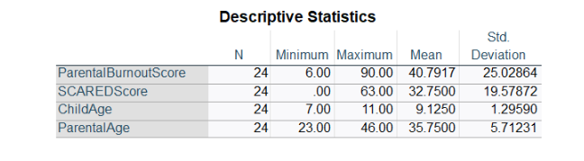

**Appendix B- Information Sheet**

|  |  |
| --- | --- |
| **INFORMATION SHEET**  **Project Title:** ‘Do high levels of parental burnout, parental gender, and children’s gender predict children’s anxiety related emotional disorders?’ |  |
| **Researcher Name: Jessica Arrowsmith-Gray**  **Researcher Contact Details:** [**a013232m@student.staffs.ac.uk**](mailto:a013232m@student.staffs.ac.uk) | **Supervisor Name: Hannah Robinson**  **Supervisor Contact Details:** [**hannah.robinson@staffs.ac.uk**](mailto:hannah.robinson@staffs.ac.uk) |

Text Box

**INVITATION PARAGRAPH**

I would like to invite you to participate in this research project, which forms part of my undergraduate psychology degree at University of Staffordshire. The research will be conducted by Jessica Arrowsmith-Gray. Before you decide whether you want to take part, it is important for you to understand why the research is being done and what your participation will involve. Please take time to read the following information carefully.

**What is the purpose of the study?**

I am conducting a study to investigate if parental burnout and parental and child gender have an influence on a child’s likelihood of experiencing anxiety related emotional disorders.

**Who has given approval for this study?**

Approval for this study has been granted by the University of Staffordshire Psychology Department Psychology Ethics Committee.

**TAKING PART**

**Why have I been invited to take part?**

I am recruiting participants over 18 years of age to take part in this study. Participants should also meet the following criteria: live in the UK and have a child who is between the ages of 7 and 11 who does not have a formal anxiety diagnosis.

**What will happen if I take part?**

I am asking you to take part in a study lasting approximately 30 minutes. This will involve filling out a ‘parental burnout assessment’ along with answering a questionnaire screening for anxiety related emotional disorders in your child aged 7-11 years old.

The study/experiment will take place online

**Do I have to take part?**

Participation is completely voluntary. You should only take part if you want to and choosing not to take part will not disadvantage you in anyway. Once you have read this information sheet, please feel free to ask any questions that will help you decide about taking part. If you decide to take part, we will ask you to sign a consent form.

**Incentives**

There are no incentives for taking part in the study.

**What are the possible risks of taking part?**

There may be some small risks to taking part. These could include discomfort or distress from discussing sensitive topics such as anxiety.

**What if I am upset by anything during the course of the study?**

If this happens you might like to take a break or, if you prefer, you can withdraw from the study at any point. To withdraw during the questionnaire please continue straight to the debrief page without completing any additional questions. Any answers you have provided will then be withdrawn from the data.

If you decide to withdraw, you will be shown a copy of the debriefing sheet, which contains information about sources of support you can access if there is anything you wish to talk about in confidence.

**What are the possible benefits of taking part?**

There are no direct benefits to you as a participant. However, the research may help us to better understand how parental burnout and gender can predict children’s mental and emotional health.

**What if I change my mind about taking part?**

You are free to withdraw at any point of the study, without having to give a reason. Withdrawing from the study will not affect you in any way.

You can also withdraw your data from the study after you have finished participating, up to two weeks after, after which withdrawal of your data will no longer be possible as the data will already have been processed. To withdraw from the study, please email the researcher providing the unique code you will be given.

If you choose to withdraw from the study, we will not retain any information you have provided us.

**What if I don’t want to answer any particular questions?**

You are free to skip any questions you would prefer not to answer, without penalty.

**DATA HANDLING AND CONFIDENTIALITY**

**Will the information I give you be kept confidential?**

The information obtained will be treated with the strictest confidence throughout the study and the data will be stored safely in a secure location to which only the researcher and their supervisor has access. Your data will be processed in accordance with data protection law and will comply with the General Data Protection Regulation 2018 (GDPR).

**Data Protection Statement**

The data controller for this project will be University of Staffordshire. The University will process your personal data for the purpose of the research outlined above. The legal basis for processing your personal data for research purposes under data protection law is a ‘task in the public interest.’ You can provide your consent for the use of your personal data in this study by completing the consent form that will be provided to you.

**Who will have access to my data?**

Only the researcher and the researcher’s supervisor will have access to the raw data. You have the right to access information held about you. Your right of access can be exercised in accordance with the General Data Protection Regulation. You also have other rights including rights of correction, erasure, objection, and data portability. Questions, comments, and requests about your personal data can also be sent to the University of Staffordshire Data Protection Officer. If you wish to lodge a complaint with the Information Commissioner’s Office, please visit [www.ico.org.uk](http://www.ico.org.uk/)

**Who will see the finished report?**

All data in the finished report will be presented in the form of group statistics. The final report will be seen by the researcher’s supervisor and a second marker from the Psychology department, and possibly by an external examiner. In addition, the completed report may also be made available to future University of Staffordshire students for teaching/reference purposes.

**What will happen to my responses to the study?**

All data will be kept in secure storage (to which only the researcher has access) for ten years, according to departmental policy, and it will be destroyed after that.

**What will happen to the results of the study?**

The results of the study will be disseminated in the final written report and in a student conference presentation. There is a possibility that results might be disseminated more widely, for example at a research conference or in an article published in a research journal. If the research is written up for academic journal publication your anonymised data may be stored permanently in an online research data repository.

**FURTHER QUESTIONS**

**Is there anyone I can talk to about the study before I take part?**

You can contact me directly on the details provided at the top of this form. If you wish to talk to someone else about my study before taking part, please feel free to contact my project supervisor (contact details also available at the top of this form).

**What if I have further questions, or if something goes wrong?**

If this study has harmed you in any way, or if you wish to make a complaint about the conduct of the study, you can contact the study supervisor or the Chair of the University of Staffordshire Ethics Committee for further advice and information:

Ethics Committee  
Research, Innovation, and Impact Services  
University of Staffordshire  
Cadman Building  
College Road  
Stoke-on-Trent  
ST4 2DE

[ethics@staffs.ac.uk](mailto:ethics@staffs.ac.uk)

**I know a friend who may be interested; can they participate in your study?**

Yes, if your friend meets the criteria mentioned above. Your friend can access the study using the same link that you have used.

**If you have any further questions, please do not hesitate to contact me. Thank you for your time.**

**Thank you for reading this information sheet and for considering taking part in this research.**

**Appendix C- Consent form**

**Project title: ‘Do high levels of parental burnout, parental gender, and children’s gender predict children’s anxiety related emotional disorders?’**

|  |  |
| --- | --- |
| **Researcher Name: Jessica Arrowsmith-Gray**  **Researcher Contact Details:** [**a013232m@student.staffs.ac.uk**](mailto:a013232m@student.staffs.ac.uk) | **Supervisor Name: Hannah Robinson**  **Supervisor Contact Details:** [**Hannah.robinson@staffs.ac.uk**](mailto:Hannah.robinson@staffs.ac.uk) |

|  |  |
| --- | --- |
| I am over 18 years of age, and I voluntarily agree to participate in a research project conducted as part of a psychology undergraduate degree by Jessica Arrowsmith-Gray, an Undergraduate Psychology student at University of Staffordshire. | **Yes/No** |
| I understand that I am being asked to participate in a study lasting approx. 30 minutes and I will be asked to fill out a ‘parental burnout assessment’ as well as answering questions that screen for anxiety related emotional disorders in my child aged 7-11. | **Yes/No** |
| I understand that, if I wish, I may withdraw from participating at any time and my data will be destroyed. I have been informed that withdrawal after two weeks of completing the study will not be possible. | **Yes/No** |
| I understand that I will be fully protected in accordance with the Data Protection Act of 2018, and in compliance with the British Psychological Society ethical guidelines, and that any personal details will be kept confidential. | **Yes/No** |
| I understand that in the case that a report is published based on this study, the fully anonymised data may be made available for the use of other researchers for an indefinite period of time. Otherwise, they will be kept until ten years after the article has been published and then destroyed. | **Yes/No** |
| I understand that any personal details will be anonymised in any report based on this study and if the research is written up for academic journal publication my anonymised data may be stored permanently in an online research data repository. | **Yes/No** |

If you have any further questions about this study, please contact the researcher or the Project Supervisor (details above).

**Unique Identifier**

Because we are not collecting your name or other identifying information, we need a way to identify your data if you wish to withdraw it after participation. Please enter a five-digit code, made of any numbers and/or letters of your choosing, and make a note of it. If you wish to withdraw your data in future, you must provide this code.

**Appendix D- Participant Debrief**

**Project Title: ‘Do high levels of parental burnout, parental gender, and children’s gender predict children’s anxiety related emotional disorders?’**

**Researcher Name: Jessica Arrowsmith-Gray**

**Researcher Contact Details:** [**a013232m@student.staffs.ac.uk**](mailto:a013232m@student.staffs.ac.uk)

**Supervisor Name: Hannah Robinson**

**Supervisor Contact Details:** [**hannah.robinson@staffs.ac.uk**](mailto:hannah.robinson@staffs.ac.uk)

Thank you for taking part in this study. The purpose of this study was to investigate if parental burnout and parental and child’s gender has an effect on their child's likelihood of developing anxiety related emotional disorders. The research question for this study was ‘‘Do high levels of parental burnout, parental gender, and children’s gender predict children’s anxiety related emotional disorders?’

For more detailed explanations, or if you wish to know the results of the study, please contact the researcher using the contact details above.

Your details will be kept confidential at all times, and complete anonymity will be maintained. Raw data will be kept on University SharePoint system, which will only be accessible to me and academic staff. Raw data will be destroyed after ten years. In the case that a report is published based on this study, the fully anonymised data may be made available for the use of other researchers for an indefinite period of time. Otherwise, they will be kept by University of Staffordshire until ten years after the article has been published and then destroyed.

If you wish to withdraw your data you need to contact the researcher using the code you provided earlier, up to two weeks after participating. No other information is required, and you will not be asked to provide a reason.

If you have been affected by any of the issues raised in this study, and would like to talk to someone in confidence about it, you may wish to contact the following organisation(s): If you are a student at University of Staffordshire you can contact the student wellbeing support team here: <https://www.staffs.ac.uk/students/support/student-wellbeing-and-safeguarding>

Alternatively, there are many anxiety helplines you can contact including:

* Samaritans <https://www.samaritans.org/how-we-can-help/contact-samaritan/>
* CALM <https://www.thecalmzone.net/contact-us>
* Shout 85258 <https://giveusashout.org/get-help/>

Thank you again for your participation

**Appendix E- Demographics Questionnaire**

What is your gender?

* Male
* Female
* Nonbinary/ Third gender
* Prefer not to say

What is your age?

|  |
| --- |
|  |

What is the age of your child?

* 7
* 8
* 9
* 10
* 11

What is the gender of your child?

* Male
* Female
* Nonbinary/ Third gender
* Prefer not to say

**Appendix F- ‘The Parental Burnout Assessment’ (Roskam & Mikolajczak, 2018)**

Children are an important source of fulfilment and joy for their parents. At the same time, they may also be a source of exhaustion for some parents. (This is not contradictory: self-fulfilment and exhaustion can co-exist, and it is possible to love your children, yet feel exhausted in your role as a parent). The questionnaire below concerns the feeling exhaustion that can be experienced as a parent. Choose the answer that best matches what you feel personally. There is no right or wrong answer. If you have never had this feeling, choose “Never.” If you have had this feeling, indicate how often you feel it by choosing “A few times a year” to “Every day” that best describes how frequently you feel that way.

1. I’m so tired out by my role as a parent that sleeping doesn’t seem like enough

Never

A few times a year

Once a month or less

A few times a month

Once a week

A few times a week

Every day

1. I feel as though I’ve lost my direction as a dad/mum
2. I feel completely run down by my role as a parent
3. I have zero energy for looking after my child(ren)
4. I don’t think I’m the good father/mother that I used to be to my child(ren)
5. I can’t stand my role as father/mother any more
6. I feel like I can’t take any more as a parent
7. I have the impression that I’m looking after my child(ren) on autopilot
8. I have the sense that I’m really worn out as a parent
9. When I get up in the morning and have to face another day with my child(ren), I feel exhausted before I’ve even started
10. I don’t enjoy being with my child(ren)
11. I feel like I can’t cope as a parent
12. I tell myself that I’m no longer the parent I used to be
13. I do what I’m supposed to do for my child(ren), but nothing more
14. My role as a parent uses up all my resources
15. I can’t take being a parent any more
16. I’m ashamed of the parent that I’ve become
17. I’m no longer proud of myself as a parent
18. I have the impression that I’m not myself anymore when I’m interacting with my child(ren)
19. I’m no longer able to show my child(ren) how much I love them
20. I find it exhausting just thinking of everything I have to do for my child(ren)
21. Outside the usual routines (lifts in the car, bedtime, meals), I’m no longer able to make an effort for my child(ren)
22. I’m in survival mode in my role as a parent

**Appendix G- Screen for Child Anxiety Related Emotional Disorders (SCARED) Parent Version- (To be filled out by the PARENT)**

Directions: Below is a list of sentences that describe how people feel. Read each phrase and decide if it is “Not True or Hardly Ever True” or “Somewhat True or Sometimes True” or “Very True or Often True” for your child. Then for each sentence, fill in one circle that corresponds to the response that seems to describe your child for the last 3 months. Please respond to all statements as well as you can, even if some do not seem to concern your child. 0 Not True or Hardly Ever True 1 Somewhat True or Sometimes True 2 Very True or Often True

1. When my child feels frightened, it is hard for him/her to breathe.

2. My child gets headaches when he/she is at school.

3. My child doesn’t like to be with people he/she doesn’t know well.

4. My child gets scared if he/she sleeps away from home.

5. My child worries about other people liking him/her.

6. When my child gets frightened, he/she feels like passing out.

7. My child is nervous.

8. My child follows me wherever I go.

9. People tell me that my child looks nervous.

10. My child feels nervous with people he/she doesn’t know well.

11. My child gets stomach-aches at school.

12. When my child gets frightened, he/she feels like he/she is going crazy.

13. My child worries about sleeping alone.

14. My child worries about being as good as other kids.

15. When my child gets frightened, he/she feels like things are not real.

16. My child has nightmares about something bad happening to his/her parents.

17. My child worries about going to school.

18. When my child gets frightened, his/her heart beats fast.

19. He/she gets shaky.

20. My child has nightmares about something bad happening to him/her.

21. My child worries about things working out for him/her.

22. When my child gets frightened, he/she sweats a lot.

23. My child is a worrier.

24. My child gets really frightened for no reason at all.

25. My child is afraid to be alone in the house.

26. It is hard for my child to talk with people he/she doesn’t know well.

27. When my child gets frightened, he/she feels like he/she is choking.

28. People tell me that my child worries too much.

29. My child doesn’t like to be away from his/her family.

30. My child is afraid of having anxiety (or panic) attacks.

31. My child worries that something bad might happen to his/her parents.

32. My child feels shy with people he/she doesn’t know well.

33. My child worries about what is going to happen in the future.

34. When my child gets frightened, he/she feels like throwing up.

35. My child worries about how well he/she does things.

36. My child is scared to go to school.

37. My child worries about things that have already happened.

38. When my child gets frightened, he/she feels dizzy.

39. My child feels nervous when he/she is with other children or adults and he/she has to do something while they watch him/her (for example: read aloud, speak, play a game, play a sport.)

40. My child feels nervous when he/she is going to parties, dances, or any place where there will be people that he/she doesn’t know well.

41. My child is shy.

**Appendix H- Checking for sensible values**

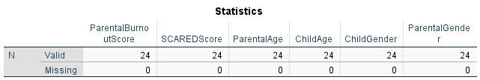

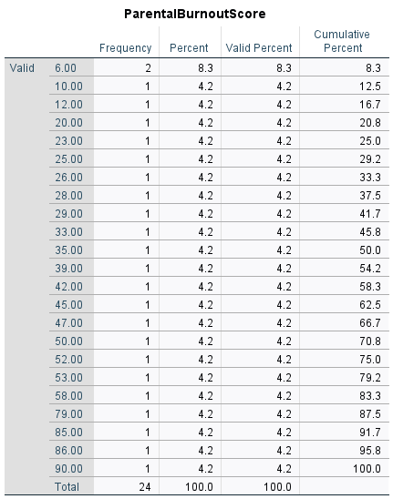

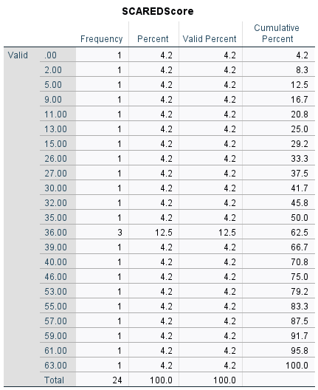

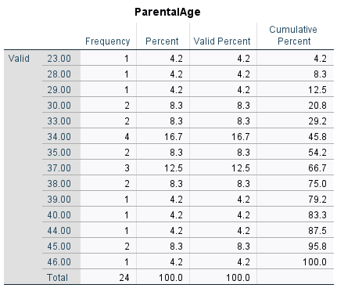

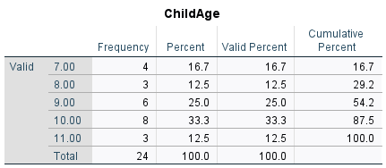

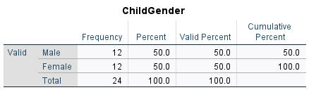

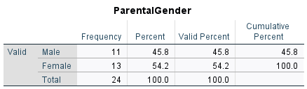

**Appendix I: Checking for normal distribution**

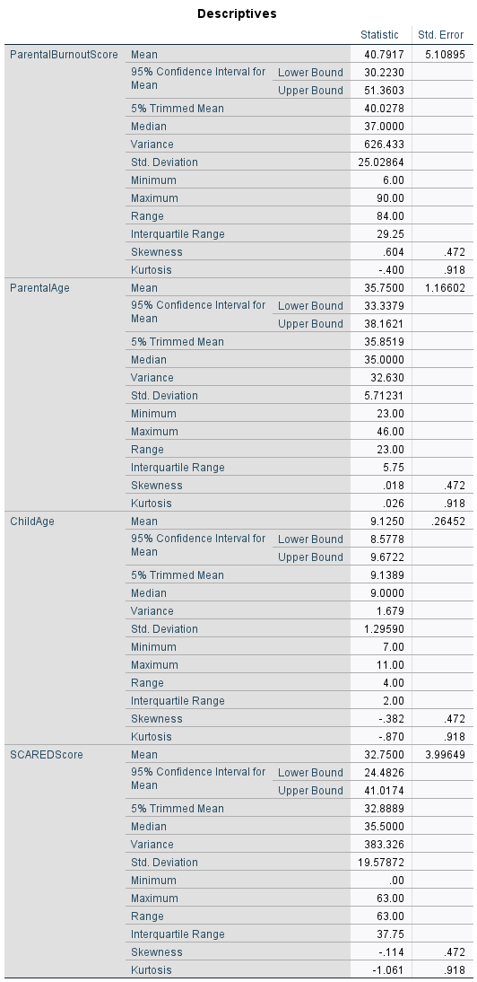

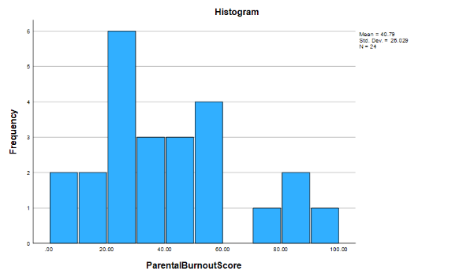

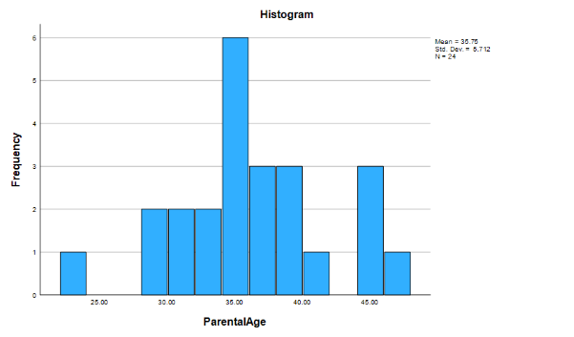

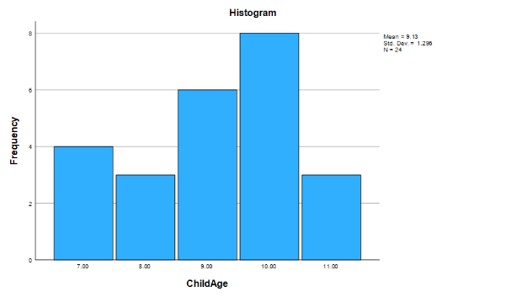

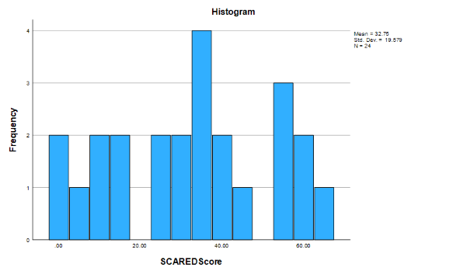

**Appendix J- Checking for linearity and homoscedasticity**

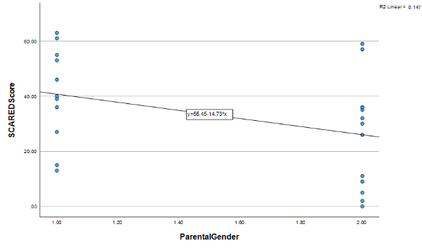

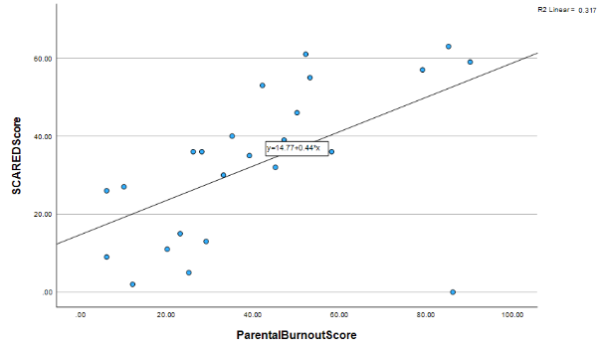

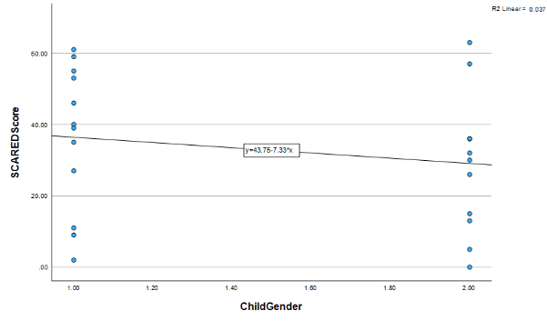

**Appendix K- Checking for multi- collinearity**

