
University of Staffordshire London
BSc (Hons) Computer Science

EduFusion: Optimising a Gamified Micro-Learning Framework – From Development to Performance Evaluation

Sanjay Sathiyaratnam
S014717M

Supervisor: Dr Viraj Dawarka
May 2025

Abstract

This project investigates the design, development, and evaluation of EduFusion, a science education mobile app aimed at improving knowledge retention among Generation Z learners. The app integrates short-form video content with interactive quizzes and gamification features which offers a dynamic learning experience tailored to modern digital consumption habits. A mixed-methods evaluation approach which combined quantitative testing such as pre- and post-test comparisons and with qualitative user feedback, was used to assess the app’s effectiveness. Comparative A/B testing between a non-interactive version (App A) and the gamified version (App B) demonstrated that interactive, gamified learning significantly enhances both engagement and knowledge retention. The results highlight the potential of microlearning and gamification in shaping the future of digital education.

Acknowledgement

I would like to express my deepest gratitude to Dr Viraj Dawarka for his consistent support, guidance, and insightful feedback throughout this project. His mentorship played a vital role in helping me stay focused and motivated during the dissertation journey.

Special thanks to Olasunkanmi Matthew Alofe, who constantly challenged my thinking and helped me reflect critically in the early stages of the dissertation, and to Joshua Lindsey, who always responded to my endless questions and offered help when others couldn’t.

I am also incredibly thankful to my family and friends for being there when I needed someone to talk to and for their help proofreading the final report.

Lastly, I’d like to thank the students who participated in my experiment for testing my app and providing valuable feedback that helped shape the outcome of this research.

Table of Contents
Abstract 2
Chapter 1: Introduction 8
1.1 Background 8
1.2 Problem Statement 9
1.3 Hypothesis 9
1.4 Aim 9
1.5 Objectives 9
1.6 Scope 10
1.7 Justification 10
1.8 Overview of Report 14
Chapter 2: Literature Review 16
2.1 Gen Z And Educational Needs 16
2.2 Mobile Learning and Its Impact on Education 16
2.3 Short-Form Content in Education 17
2.4 Retention in Educational Apps 19
2.5 Hybrid Mobile Applications for Education 21
2.6 Gamification and Interactive Learning in Educational Apps 22
2.7 User Engagement and Retention Strategies 22
2.8 Challenges and Ethical Considerations 23
2.9 Market Gap 25
2.10 Summary and Connection 25
Chapter 3: Development and Research Methodology 27
3.1 Introduction 27
3.2 Review of Current Methodologies 27
3.3 Proposed Methodology 28
3.3.1 Approach 28
3.3.2 Strategy 28
3.3.3 Time Horizon 28
3.3.4 Implementation Strategy 28
3.3.5 Rationale 30
3.4 Conclusion 30
Chapter 4: Edu-Fusion Optimised Gamified Micro-Learning Framework 31
4.1 Introduction 31
4.2 Edu-Fusion Optimised Gamified Micro-Learning Framework 31
4.3 Overview of Key Components 32
4.3.1 Gamification 32
4.3.2 Responsive User Interface 33
4.3.3 Data Management 33
4.3.4 Mobile Operation 33
4.3.5 Content & Interaction Storage 34
4.3.6 Performance Efficiency 34
4.4 Conclusion 35
Chapter 5: Design, Implementation & Testing 36
5.1 Introduction 36
5.2 Design Requirements 36
5.2.1 Functional Requirements 36
5.2.2 Non-Functional Requirements 36
5.2.3 User Requirements 36
5.2.4 App Architecture and Interaction Diagram 37
5.3 System Architecture 40
5.3.1 Overview of Architecture 40
5.3.2 System Components 40
5.3.3 Technologies 40
5.4 UI/UX Design 41
5.4.1 Wireframes and Prototypes 41
5.4.2 User Journey Mapping 43
5.5 Application Development Process 46
5.5.1 Frontend Development 46
5.5.2 Backend Development 53
5.5.3 Database Integration 57
5.6 Features and Functionalities 59
5.6.1 Short-Form Content Delivery 59
5.6.2 Gamification Features 60
5.7 Challenges in Design and Development 61
5.7.1 Technical Challenges 61
5.7.2 Design Challenges 61
5.8 Testing Framework 61
5.8.1 Testing Objectives 61
5.8.2 Tools and Techniques Used 61
5.9 Test Cases and Scenarios 62
5.9.1 Functional Testing 62
5.9.2 Usability Testing 62
5.9.3 Performance Testing 62
Chapter 6: Evaluation 63
6.1 Validation Methods 63
6.1.1 Knowledge Retention Validation 63
6.1.2 User Engagement Validation 63
6.2 Evaluation Methodology 63
6.2.1 Evaluation Approach 63
6.2.2 Participants 63
6.2.3 Evaluation Procedure 64
6.2.4 Evaluation Metrics 64
6.2.5 Data Collection Methods 64
6.2.6 Data Analysis Methods 64
6.2.7 Ethical Considerations 65
6.3 User Testing 65
6.3.1 Participant Demographics 65
6.3.2 Pre-Test and Post-Test Results 65
6.3.3 Feedback Analysis 67
6.4 Test Results 67
6.4.1 Results Analysis 67
6.4.2 Success Metrics 70
6.5 Summary of Findings 70
6.5.1 Key Insights from Research 70
6.5.2 Results from Testing 70
6.6 Contributions 71
6.6.1 Academic Contributions 71
6.6.2 Practical Contributions 71
6.7 Limitations 71
6.7.1 Technical Limitations 71
6.7.2 Resource Constraints 71
Chapter 7: Conclusion 72
7.1 Conclusion 72
7.2 Future Work 72
Chapter 8: References 73
Chapter 9: Appendices 83
9.1 Project Plan 83
9.2 User Consent Form 84
9.3 Information Sheet 85
9.4 Risk Assessment 89
9.5 Ethics Form 90
9.6 User Feedback Form 95
9.7 Baseline Test, Post App A and B Test 96
9.8 Full Length Code 100

Table of Figures
Figure 1: Mark Trend before TikTok Usage 11
Figure 2: Mark Trend after TikTok Usage 11
Figure 3: Comparison of Traditional e-learning and micro-learning 12
Figure 4:Ebbinghaus forgetting curve 13
Figure 5: Zufic Study 19
Figure 6: Ebbinghaus forgetting curve 20
Figure 7: Market Gap Analysis 25
Figure 8: Agile LifeCycle 29
Figure 9: Edu-Fusion Framework 32
Figure 10: Use Case Diagram 37
Figure 11: Activity Diagram 37
Figure 12: Class Diagram 38
Figure 13: Data Flow Diagram 39
Figure 14: Sequence Diagram 39
Figure 15: main.dart 46
Figure 16: login_page.dart 47
Figure 17: register_page.dart 48
Figure 18: video_feed_page.dart 49
Figure 19: quiz_popup.dart 50
Figure 20: config.dart 51
Figure 21: account_page.dart 51
Figure 22: settings_page.dart 52
Figure 23: login.php 53
Figure 24: register.php 54
Figure 25: get_quiz.php 54
Figure 26: db.php 55
Figure 27: get_stats.php 55
Figure 28: submit_answer.php 56
Figure 29: update_profile.php 56
Figure 30: PHPMyAdmin 57
Figure 31: Quiz Tables 57
Figure 32: Videos 58
Figure 33: Questions 58
Figure 34: Users 58
Figure 35: Test Scores 66
Figure 36:EduFusion App User Feedback 67
Figure 37: Participant Test Scores Throughout Testing 68
Figure 38: Time Spent on App 68
Figure 39: User Engagement 69
Figure 40:Time Spent Across Apps 69

Table of Tables:
Table 1: Prototype A 41
Table 2: Prototype B 43
Table 3: App A user journey 44
Table 4: App B user journey 45
Table 5:Short Form Content 58
Table 6: Quiz Questions Working 59

Chapter 1: Introduction

1.1 Background
The growing use of smartphones and mobile applications has transformed how education is delivered, particularly to Generation Z. Generation Z learners, who are digital natives, have shorter attention spans and prefer interactive, visually appealing, and bite-sized content. This project aims to address these learning behaviours by developing a hybrid mobile application that provides short-form science education. The app applies microlearning principles to improve knowledge retention while taking into consideration the target audience's digital habits. TikTok and Instagram have demonstrated how short videos can effectively convey complex information. The application's goal is to provide an engaging and effective science learning experience by combining these traditional methods and techniques with gamification and interactive features.

1.2 Problem Statement
The current education system frequently fails to meet the preferences and needs of Generation Z students. Traditional long-form content struggles to maintain people's attention, resulting in low engagement and knowledge retention. Furthermore, educational mobile apps often prioritise functionality over educational design. This study investigates how a hybrid mobile application with short-form content and gamification can increase Gen Z students' engagement and retention of scientific principles.

1.3 Hypothesis
Short-form educational content and gamification in a hybrid mobile application will significantly increase user engagement and knowledge retention in science education among Gen Z learners when compared to traditional long-form content.

1.4 Aim
To create and launch a hybrid mobile application that uses short-form educational content and gamification to help Gen Z students retain science knowledge.

1.5 Objectives
1. Investigate Generation Z students' learning preferences and challenges in science education.
2. Develop a hybrid mobile app that features engaging short-form science content.
3. Use gamification elements such as quizzes and progress tracking to boost user engagement.
4. To evaluate the application's effectiveness in improving knowledge retention through user
testing.
5. Evaluate the benefits and drawbacks of short-form content in science education.

1.6 Scope
This project will create and implement a hybrid mobile application that delivers concise, science-based educational content. The app is geared towards Generation Z learners (ages 18-22) and emphasises the use of short videos, quizzes, and gamification features to boost engagement and retention.

1.7 Justification
The implementation of a science educational hybrid mobile application tailored for Generation Z (Gen Z), using short-form content, is justified by the need to align educational strategies with the evolving learning habits of younger generations. These digital natives have grown up in an era dominated by smartphones, social media, and short-form content platforms, significantly shaping their consumption preferences and learning styles. To ensure that educational tools remain relevant and effective, it is essential to adopt these preferences while maintaining the quality and rigour of traditional science education.

Micro Learning: Microlearning is an effective educational approach that uses short, time-limited web-based activities (Singh, 2014). According to Giurgiu (2017), these short learning activities should function independently but also build upon one another, allowing learners to integrate the information into a broader context. This balance between independent tasks and cumulative learning helps learners grasp concepts more effectively while engaging with short, focused content.
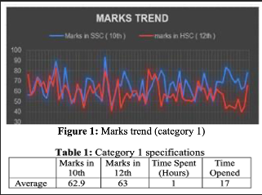
Figure 1: Mark Trend before TikTok Usage

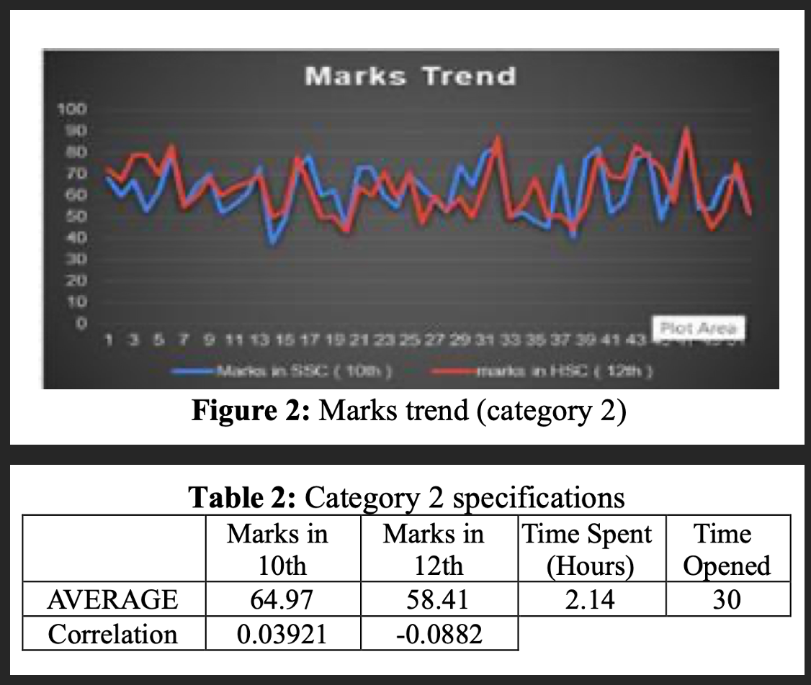
Figure 2: Mark Trend after TikTok Usage
Figure 1 in Asif et al. (2023) illustrates after an hour of TikTok usage the marks the students get are the baseline. Figure 2 in Asif et al. (2023) illustrates the students were given 2 hours to scroll on the app and when they took the test the younger cohort got a slightly positive mark increase whereas the older cohort had a slight negative mark decrease. This proves to us that applications such as TikTok and Instagram reels can negatively affect academic performance.

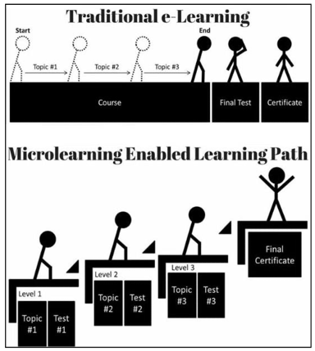
Figure 3: Comparison of Traditional e-learning and micro-learning
Figure 3 in Javorcik, Kostolanyova & Havlaskova (2024) shows us how traditional and microlearning works and compares the steps. The top half shows how traditional learning progresses through a continuous course which covers multiple topics all at once which then ends with a test and a certificate. The bottom half shows how microlearning advances through small and more focused learning units with a test for each topic. Which then also ends with a final certificate. The graph emphasises that microlearning provides frequent opportunities for progress and shows that the learning journey is also more interactive and manageable.

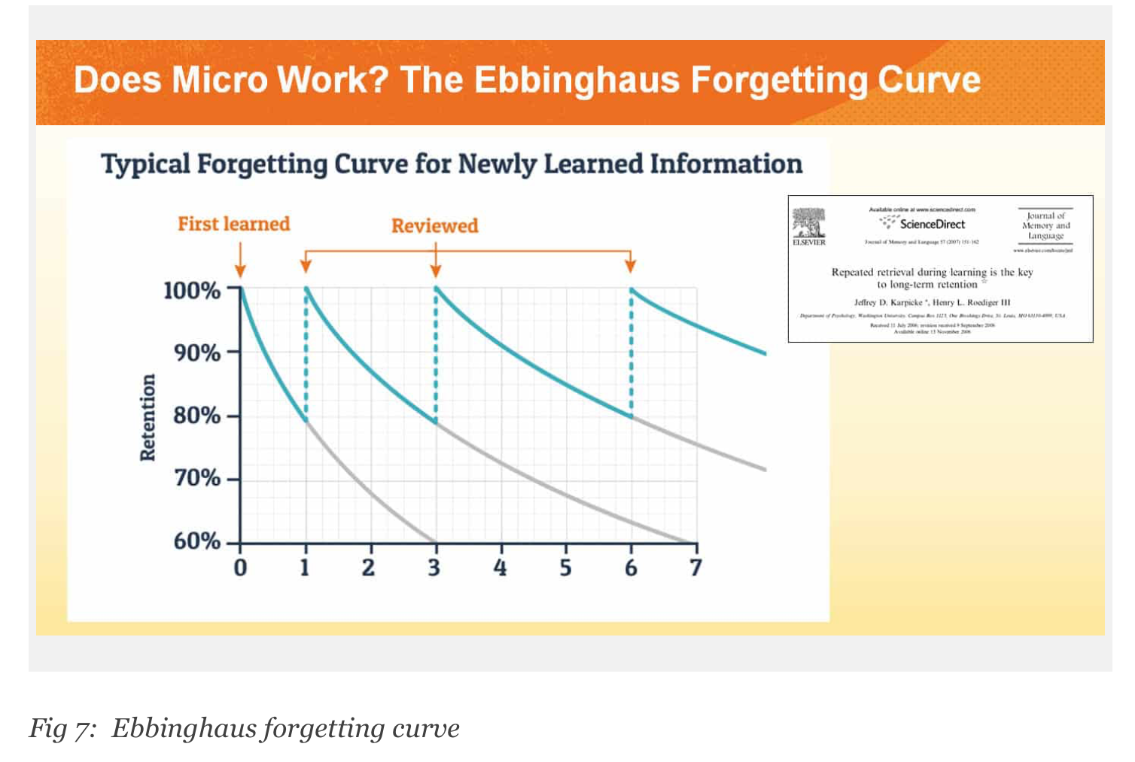
Figure 4:Ebbinghaus forgetting curve
Figure 4 shows the Ebbinghaus forgetting curve which illustrates how newly learned information rapidly fades from memory unless it is regularly reviewed. The grey curve represents this natural memory decay, while the blue curve demonstrates how repeated reviews can strengthen retention over time. To counteract this decline, the use of active recall such as quizzes promotes deeper cognitive engagement by encouraging the brain to retrieve and reinforce memory pathways. This aligns with the principles of digital learning, which emphasise short, engaging bursts of content followed by reinforcement activities to sustain attention and improve knowledge retention (Bersin, 2017). In the application, this strategy would be adopted by pairing short videos with quizzes to enhance learning effectiveness and retention.

Attention span refers to how long a person can focus without becoming distracted. In educational apps, it’s crucial to design content that engages users and promotes retention. Gen Z, with an average attention span of 8 seconds (Williams, 2019), often multitasks, reducing their ability to focus (Seemiller & Grace, 2016). To address this, the content should be short and to the point. Gen Z prefers brief videos over longer ones (Wotapka, 2017), which is why the proposed app will feature 30-second concise videos to maintain engagement.

The rise of mobile devices has contributed to the global growth of educational mobile applications which offered new ways for students to access and interact with content (Chang et al., 2018; Kearney et al., 2020). Research suggests that mobile devices help students engage more deeply with learning materials and increase their confidence as learners (Gikas & Grant, 2013; Heath et al., 2005). Features such as dynamic quizzes, videos, and engagement loops have shown success in enriching the student experience and promoting active learning (Oates et al., 2016). These findings highlight the potential of well-designed mobile apps to support more flexible, accessible, and interactive education.

Users frequently highlight the gamification elements in free educational apps, noting the pleasure, enjoyment, and surprise these features bring to learning. By incorporating gamification, visual elements, and animations, these apps make learning both productive and enjoyable. As a result, learners engage with educational content in a way that feels rewarding rather than pressured, allowing them to absorb knowledge more willingly. (Dastane, Fandos-Roig & Sánchez-García, 2023)

1.8 Overview of Report
The Report is divided into the following chapters:
Chapter 1: Introduction - This chapter will introduce the project with its aims and objectives and a background on the subject.

Chapter 2: Literature Review - Presents current research on Gen Z educational needs, mobile learning, short-form content, gamification, and hybrid apps. It focuses on challenges, emerging trends, and research gaps.

Chapter 3: Research Methodologies - Outlines the research methods and approaches used to evaluate the effectiveness of short-form content and hybrid educational applications. Focuses on data collection, testing, and analysis techniques.

Chapter 4: Propose Model – Outlines the dual-app framework, comparing a passive learning app (App A) with an interactive gamified app (App B). It covers feature integration, evaluation metrics, and implementation strategies, detailing the technologies and methodologies used to develop and test both apps.

Chapter 5: Design, Implementation and Testing - Covers the app’s development process, feature implementation, user interface design, and use of the Agile methodology. It also includes manual testing carried out during the development phase to ensure functional stability and user readiness.

Chapter 6: Evaluation - Presents the evaluation process, including participant testing, pre- and post-test analysis, and feedback. The chapter compares App A and App B to determine the effectiveness of gamified learning and user engagement through data-driven results.

Chapter 7: Conclusion - Summarises the research findings and contributions, emphasising the app's relevance to Gen Z audiences. It also makes recommendations and identifies potential future work.

Chapter 8: References - Lists all sources and references used in the report in Harvard referencing style.

Chapter 9: Appendices - Contain additional resources such as raw data, survey questions, additional charts, and supporting documentation.

Chapter 2: Literature Review

2.1 Gen Z And Educational Needs
Generation Z who are often referred to as “digital natives" grew up immersed in technology which shaped unique learning styles and expectations. They tend to favor self-directed, visual, and interactive learning experiences, which has challenged traditional educational methods (Moore et al., 2017; Bucăța, 2023). This generation is highly adaptable and creative, often excelling in multitasking and collaborative environments (Velički & Velički, 2016). However, they prefer fast and easily accessible content which has led to concerns about reduced attention spans (Alruthaya et al., 2021). Educators must therefore rethink conventional teaching strategies to better engage Generation Z, emphasising flexibility, interactivity, and the integration of digital tools into learning (Moore et al., 2017).

Generation Z, having grown up with digital technology, demonstrates distinct learning characteristics that influence their engagement with educational apps. They prefer interactive and visually appealing teaching methods, such as lectures with audience response clickers, to traditional methods like assigned reading (Hampton et al., 2019). Gen Z students prioritise skill development and prefer a mix of innovative lectures, simulations, videos, and case studies (Hampton et al., 2019). Sanalan and Taşlıbeyaz (2020) found that students prefer collaborative work and multitasking, as well as flexible learning environments with online discussions and access to materials outside of the classroom. User preferences are important in engaging with online learning because personalised content delivery based on individual preferences can boost motivation (Ilin, 2021). The incorporation of digital technologies into higher education has transformed learning experiences for Generation Z, necessitating a thorough understanding of their unique features to optimise educational outcomes (Ali Alruthaya et al., 2021).

2.2 Mobile Learning and Its Impact on Education
Mobile learning provides numerous educational benefits, including time and location flexibility, increased motivation, and improved collaboration (Mehdipour & Zerehkafi, 2013; Dias & Victor, 2017). It allows for immediate access to resources and supports both formal and informal learning environments (Sattler et al., 2010). However, implementing mobile learning is not without its challenges. These include adequate training and support for teachers and students, potential interface issues, and infrastructure concerns (Dias & Victor, 2017; Sattler et al., 2010). Cost and cultural differences can also be barriers to adoption (Sattler et al., 2010). Despite these challenges, mobile learning has the potential to transform education by providing learner-centred content and meeting a variety of learning needs (Ally, 2013; Mehdipour and Zerehkafi, 2013). Notebooks, tablets, and smartphones are popular mobile learning devices due to their low cost and wide range of applications. Overall, mobile learning appears to be a promising avenue for providing flexible and accessible learning experiences in today's digital world.

Mobile learning provides numerous educational benefits, including flexibility, accessibility, and learner-centred content (Mehdipour & Zerehkafi, 2013). However, several barriers prevent its effective implementation. (Khaddage & Hernández Cosío, 2014) Identify technical limitations, a lack of infrastructure, and the need for proper integration into the curriculum. Emotional and motivational barriers also present difficulties, especially for adult literacy learners (Palalas & Wark, 2017). To address these concerns, educational app design should prioritise three key principles: mobility, learner-determined features, and context (Palalas and Wark, 2017). Additionally, institutions and educators must consider the readiness of learners and instructors, as well as appropriate learning management and support systems (Sophonhiranrak, 2021). Understanding barriers and implementing targeted solutions can improve mobile learning integration in higher education, leading to better learning outcomes (Sophonhiranrak, 2021; Khaddage & Hernández Cosío, 2014).

Mobile learning implementation presents numerous challenges across educational institutions. Common barriers include technological issues such as inadequate infrastructure, a lack of appropriate devices, and limited storage capacity (Shonola & Joy, 2014; Andrawes & Asstt Prof, 2011).

2.3 Short-Form Content in Education
Short-form content in education refers to brief, engaging materials that aim to capture students' attention and improve learning outcomes. This format includes YouTube music clips for teaching phonetics (Safir, 2022) and short videos under 60 seconds used in biology education (Lê Ngọc Minh Thư et al., 2024). Short-form content has grown in popularity because it can reduce boredom and increase student engagement when compared to traditional teaching methods (Safir, 2022). According to research, breaking down long-form online learning modules into smaller chunks increases completion rates and improves learning outcomes (Mendez-Carbajo & Wolla, 2019). While short-form content provides advantages such as increased communication opportunities and ease of content creation, there are concerns about the possibility of shallow communication and the production of "poor images" with limited depth (Kim et al., 2021). Short-form content can effectively promote educational subjects on social media platforms (Lê Ngọc Minh Thư et al., 2024).

Recent research indicates that short-form content on platforms such as TikTok can effectively improve learning, particularly for Gen Z students. TikTok's brief video format is consistent with nano-learning principles, breaking down complex topics into manageable chunks (Mariappan, 2024). This approach has demonstrated promise in a variety of educational settings, including English language teaching (Wijaya et al., 2023) and strategic management (Middleton, 2022). The platform's popularity among younger users makes it a desirable tool for educators looking to engage this demographic (Dasoo, 2022). To maximise effectiveness, educational content on TikTok should follow the principles of the Cognitive Theory of Multimedia Learning to reduce cognitive load (Wijaya et al., 2023). While challenges exist, the potential benefits of incorporating TikTok into educational strategies are significant, providing a novel approach to teaching and learning in the digital age (Middleton, 2022; Mariappan, 2024).

People learn best through a combination of words and images. Instead of relying solely on one channel, instructional designers should incorporate both words (text or narration) and visuals (images, animations, or videos). Presenting information in multiple formats allows learners to process and integrate information more effectively.

Short-form content provides several benefits in education. When long-form online learning modules are broken down into shorter segments, completion rates increase and pre-test to post-test scores improve statistically significantly (Mendez-Carbajo and Wolla, 2019). Short-form videos, especially those under 60 seconds, are gaining popularity on social media and are being studied as effective teaching tools to enhance student engagement (Lê Ngọc Minh Thư et al., 2024). Using YouTube music clips as short-form content in phonetics education led to improved student performance and interest in the subject (Safir, 2022).

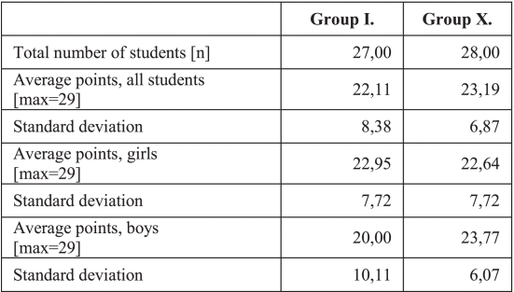
Figure 5: Zufic Study
Figure 5 shows a study comparing short (13:27 minutes) and very short (0:27 to 2:59 minutes) videos in primary school informatics classes found that video length influences learning effectiveness (Zufic & Bodiš, 2023). These results suggest that short-form content can improve student engagement, learning outcomes, and retention in a variety of educational settings.

2.4 Retention in Educational Apps
Research shows that cognitive theories such as spaced repetition and active recall, as well as gamification and feedback, can significantly improve knowledge retention in educational apps. Spaced repetition learning (SRL) and active recall have been shown to improve long-term retention in medical and dental education when compared to traditional lecture-based learning (LBL) (Marinelli et al., 2022; Nadakkavukaran Santhosh et al., 2024). Mobile flashcard applications that use SRL have shown superior knowledge retention among dental students (Nadakkavukaran Santhosh et al., 2024). Gamification of educational activities has also been shown to improve knowledge retention in secondary and tertiary education (Putz et al., 2020). Furthermore, incorporating visual cues and detailed feedback into educational games can improve student learning and information retention in online settings (Zeglen, 2018). These findings indicate that incorporating these cognitive theories and features into educational apps can improve learning outcomes and knowledge retention across a variety of educational contexts.

Short-form learning has demonstrated promising results in terms of student engagement and knowledge retention. Multimedia learning tools can significantly reduce learning time for undergraduate students while maintaining knowledge retention (Steedman et al., 2012). According to Mendez-Carbajo and Wolla (2019), breaking down long-form content into shorter modules improves completion rates and pre-test to post-test score differences. Micro-learning on mobile applications can help mitigate the Ebbinghaus forgetting curve, increase retention, and speed up the learning process by avoiding mental fatigue (Shail, 2019).

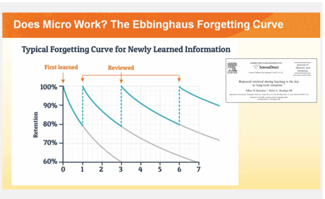
Figure 6: Ebbinghaus forgetting curve
Figure 6 shows the Ebbinghaus forgetting curve which illustrates how newly learned information rapidly fades from memory unless it is regularly reviewed. The grey curve represents this natural memory decay, while the blue curve demonstrates how repeated reviews can strengthen retention over time. To counteract this decline, the use of active recall such as quizzes promotes deeper cognitive engagement by encouraging the brain to retrieve and reinforce memory pathways. This aligns with the principles of digital learning, which emphasise short, engaging bursts of content followed by reinforcement activities to sustain attention and improve knowledge retention (Bersin, 2017). In my application, I adopt this strategy by pairing short videos with quizzes to enhance learning effectiveness and retention.

Research suggests several effective strategies for improving long-term memory retention. Chunking, or grouping information into larger units, can improve information transfer from working memory to long-term memory (Baker, 2010). According to studies, dividing information into 2-3 chunks is more effective for retention than presenting it all at once (Suppawittaya & Yasri, 2021).

2.5 Hybrid Mobile Applications for Education
Hybrid mobile applications have several advantages for educational purposes, including cross-platform functionality and interactive learning features. They offer adaptable tools for mobile learning approaches in universities (Holotescu et al., 2018) and can deliver multimedia content to students in m-learning environments (Karadimce & Bogatinoska, 2014). Hybrid apps are a good choice for mobile learning systems because they can be built for multiple platforms using frameworks like PhoneGap and Sencha Touch (Litayem et al., 2015). These applications use push mechanisms to enable distributed and frequent learning activities, and they can also activate learners during classroom lectures (Pimmer et al. 2016). Furthermore, hybrid designs enable students to create multimodal representations outside of the classroom and share their experiences with peers and educators, bridging formal and informal learning environments (Pimmer et al., 2016). However, scientific proof for the widespread use of mobile learning in higher education is limited (Pimmer et al., 2016).

The key differences between hybrid and native mobile apps have a significant impact on educational app design. Native apps designed specifically for each platform typically provide better performance and user experience (Olusola Olajide et al., 2018). They enable more efficient use of device capabilities such as sensors and cameras (Seungho Lim, 2015). However, hybrid apps built with cross-platform frameworks and HTML5 have lower development costs and faster development times (P. Que et al. 2016). They make maintenance easier across multiple platforms, but they may have lower performance than native apps (Olusola Olajide et al., 2018). The choice between hybrid and native approaches is determined by factors such as device features, performance requirements, and development resources (Tena Vilcek & Tomislav Jakopec, 2017). Developers of educational apps must balance performance and development efficiency while considering the specific needs of the educational content and target audience.

2.6 Gamification and Interactive Learning in Educational Apps
Gamification techniques have shown promise in increasing student engagement and learning outcomes in educational settings. According to research, including game elements such as experience points, levels, badges, challenges, and leaderboards can significantly improve attention to course materials, online participation, and proactivity (Barata et al., 2013). These techniques can also help students improve their grades (Barata et al., 2013). Leaderboards have been shown to increase student engagement in course projects and improve academic performance (Landers & Landers, 2014). In physics education, gamified quizzes with elements such as points, streaks, and achievements increased engagement with course content outside of the classroom (Rose et al., 2016). Gamification and learning analytics in university courses have also shown promise for increasing student engagement (Cassano et al. 2018). Overall, gamification appears to be a successful strategy for increasing student motivation and participation in educational settings.

Gamification in educational apps has yielded mixed results in terms of motivation and learning outcomes. While some studies found no significant difference in motivation between gamified and non-gamified apps (Thamrongrat & Law, 2020), others found that gamification elements such as badges, levels, and points can boost learning participation and engagement (Mohammed & Ozdamli, 2021). The impact of specific gamification elements varies, with points having greater learning effects than badges or timers (Thamrongrat & Law, 2020). Gamification can also have an impact on perceived usability, student engagement, and learning performance, depending on the elements used. However, a longitudinal study found that gamification may reduce motivation, satisfaction, and empowerment over time, potentially leading to lower academic performance (Hanus & Fox, 2015). These findings indicate that careful consideration is required when implementing gamification in educational settings to ensure positive results.

2.7 User Engagement and Retention Strategies
There are a variety of strategies for increasing user engagement and retention in educational apps. Personalised adaptive interfaces have been shown to increase user sessions, usage time, and app retention (Xuan-Lam Pham & Gwo-Dong Chen, 2019). Adaptive learning environments that tailor content and strategies to each learner can boost engagement, satisfaction, and learning outcomes (Graf, 2023). Usability, availability of learning experiences, features that facilitate learning, interpersonal interaction, and completion incentives are all important factors that influence learner engagement (Liu and Correia, 2021). Successful retention strategies in mobile health apps that can be applied to educational apps include feedback, appropriate reminders, in-app support from peers or coaches, and compensation (Amagai et al., 2021). However, obstacles such as technical difficulties and a lack of perceived usefulness can impede retention (Amagai et al., 2021). Implementing these strategies can help to create more effective and learner-centred educational tools.

Adaptive learning technologies can tailor content to individual learning styles and needs using a variety of approaches. Machine learning techniques, particularly artificial neural networks, are increasingly being used to automatically detect and adapt to learner styles (Gutta Essa et al., 2023). The Felder-Silverman Learning Style Model is widely used to map learning objects to various styles (Sensuse et al., 2020). Personalisation strategies include tailoring story problems to students' interests, which has been shown to improve problem-solving speed and accuracy, particularly among struggling learners (Walkington, 2013). These technologies seek to improve learning outcomes by constantly improving student performance through personalisation (Banerjee et al., 2021). While research indicates that adaptive learning based on learning styles can improve learning performance, more empirical research is needed to compare the effectiveness of various deep learning algorithms in classifying learning styles (Gutta Essa et al., 2023).

2.8 Challenges and Ethical Considerations
Data privacy concerns, screen time management, and accessibility issues are among the ethical challenges faced when developing educational apps for Generation Z. According to Jabar et al. (2024), AI and IoT technologies pose risks to privacy, confidentiality, and anonymity. Educational technology can create inequalities among students, affecting their privacy, values, and cognitive functions (İnayet Aydın, 2024). Generational differences influence innovation processes and application design in higher education, necessitating consideration of Gen Z's specific requirements (Ashcroft, 2021). Power dynamics, lack of voluntariness, cognitive manipulation, and social comparison are some of the ethical challenges in gamified education (Klock et al., 2023). To address these issues, researchers recommend proper education and techno capacity-building for students (Jabar et al., 2024), responsible and safe technology use by educators (İnayet Aydın, 2024) and incorporating generational research into the innovation process (Ashcroft, 2021). Guidelines for ethical gamification planning, implementation, and communication are also proposed (Klock et al., 2023).

Educational app developers face significant challenges in addressing data privacy concerns among younger users, particularly Generation Z. Third-party libraries and SDKs pose privacy risks, and the education sector is a common target for malware and ransomware attacks (Vijaya Geeta Dharmavaram, 2023; Ekambaranathan et al., 2023). Developers face limited monetisation opportunities and a lack of guidance in navigating privacy-friendly alternatives (Ekambaranathan et al., 2021). To address these issues, developers can take precautionary measures and adhere to privacy regulations (Krasznay et al., 2020). Developers can use tools like DataAvalanche.io to understand the privacy implications of SDKs (Ekambaranathan et al., 2023). To encourage healthy digital habits, educational apps can raise privacy awareness among children and parents (Krasznay et al., 2020). However, due to market pressures and limited resources, developers face barriers to implementing privacy-friendly practices (Ekambaranathan et al., 2021, 2023).

2.9 Market Gap
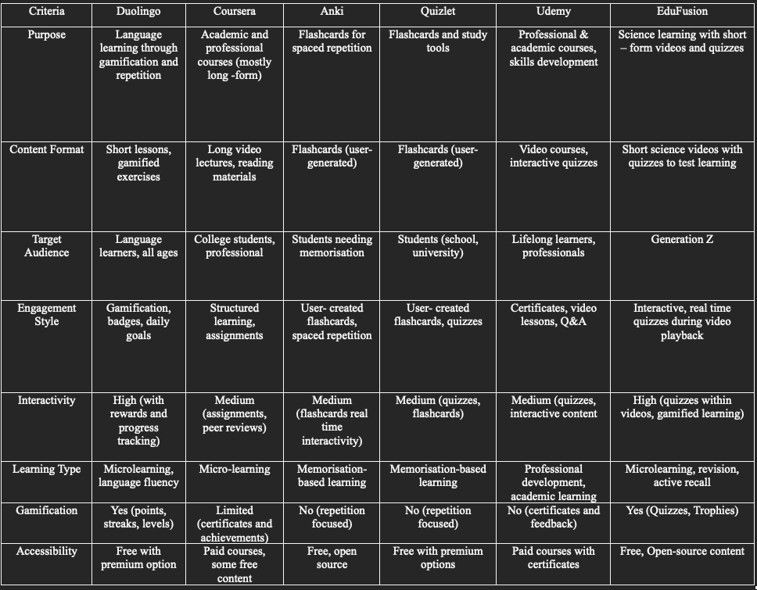
Figure 7: Market Gap Analysis
Figure 7 shows the market apps and the criteria they follow. EduFusion identifies a clear gap in the market by focusing specifically on Generation Z learners with a highly interactive, gamified learning experience using short-form videos and quiz-based reinforcement. Unlike other platforms which may lack either strong interactivity, gamification elements, or real-time quiz integration, EduFusion blends microlearning, video-based content, and active recall techniques with clear progress tracking and rewards.

2.10 Summary and Connection
The literature review emphasises the importance of customised educational tools for Generation Z learners, highlighting their unique traits such as a preference for interactive, visually engaging, and short-form content. Mobile learning studies highlight the potential for accessible and engaging learning experiences, but they also reveal challenges such as distraction and technical limitations.

Short-form content is effective in increasing engagement and retention, supporting theories such as cognitive load theory and spaced repetition. However, gaps remain in fully incorporating these theories into hybrid educational apps. Similarly, while gamification and interactive features are widely recognised as effective motivators, their application in science education is understudied.

To address these gaps, this project combines short-form content, gamification, and interactive learning into a hybrid mobile app designed for Gen Z preferences. The findings inform the app's design, ensuring that it not only follows existing educational frameworks but also pushes limits by combining these elements in unconventional ways.

Chapter 3: Development and Research Methodology

3.1 Introduction
This chapter outlines the development, research methodology and testing methods used to evaluate two versions of a science education app. One app will include gamification features such as quizzes and rewards whereas the other app will not include any gamification but only include short-form video content. Additionally, the chapter discusses the use of the agile development methodology, which enabled iterative planning, development, and refinement of the app based on continuous feedback and testing.

3.2 Review of Current Methodologies
Duolingo, a gamified education app, uses a mixed-methods research approach, combining quantitative data (e.g., test scores, and engagement metrics) with qualitative insights (e.g., user surveys) to effectively assess learning outcomes (Duolingo Whitepaper, 2023). Duolingo uses A/B testing to improve user engagement and retention by comparing various learning strategies and features based on real-time user performance (Duolingo Fandom, 2025.). Spaced repetition algorithms reinforce memory through tailored learning schedules, while adaptive learning adjusts difficulty based on user progress, aligning with cognitive science principles (Duolingo Blog, 2025). These research-backed methods result in higher retention rates and personalised learning experiences, making gamification a valuable tool in digital education.

Following this research on current methodologies used within the same field of educational app development, I will also be adopting the mixed methods research methodology and the A/B testing method. I have chosen this since my project aligns with the progress of my research methods which have been proven to work, resulting in an improvement in retention rates. Using a mixed methods research methodology will also allow me to get both quantitative and qualitative data to help analyse the outcome.

3.3 Proposed Methodology

3.3.1 Approach
A mixed-methods strategy was used to gain complete insights. Quantitative methods use test scores before and after app usage to determine knowledge retention for both apps. Qualitative methods, such as surveys and open-ended feedback, collected user preferences, experiences, and recommendations. This dual method guarantees that the study assesses both the measurable and experienced impact of the apps, providing a comprehensive picture of their effectiveness.

3.3.2 Strategy
The study employs an exploratory case study technique to evaluate the effectiveness of two science teaching applications, one with gamified elements and the other with solely scroll-based information. The study assesses a specific cohort of Gen Z learners' interactions, learning outcomes, and preferences, providing important insights into the impact of app interactivity on educational outcomes. This case study offers a thorough perspective of the apps' strengths and areas for growth.

3.3.3 Time Horizon
The study takes a cross-sectional approach, collecting data from participants after they interact with each app for a set length of time. This approach enables a focused comparison of the two apps' direct effects on information retention. While longitudinal effects are recognised as valuable, the cross-sectional approach is more practical for the project timeframe and is consistent with the study's aims.

3.3.4 Implementation Strategy
For the development of the application, the agile methodology was used. Agile was chosen due to its iterative nature, which supports flexibility, continuous improvement, and user-centred design. This approach allowed for rapid prototyping and continuous testing after each development cycle. This was ideal for refining gamified features based on user input. The requirements of App B, which includes quizzes and trophies, made agile a suitable framework to ensure that the app could be progressively improved and align with expectations.
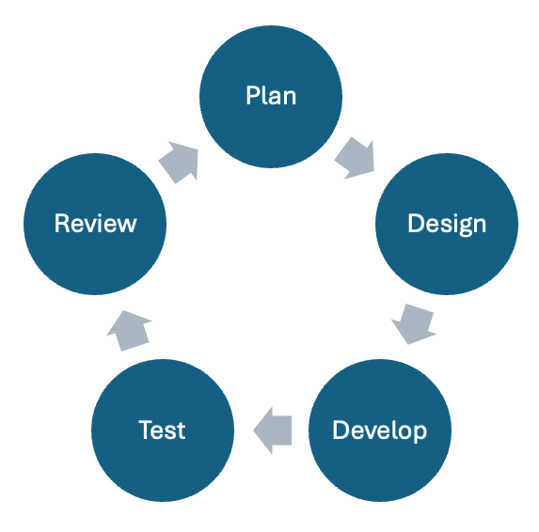
Figure 8: Agile LifeCycle
Figure 8 visually represents the agile method used in the project. This highlights how iterative design, development, testing and feedback will help refine the app based on real user interaction and data

The agile cycle breakdown goes as follows
- Plan: This section helps define goals, user needs and features that will be needed for the app. Planning also includes defining the core app structure, features such as quizzes, videos, and testing strategies for Gen Z.
- Design: In this section, wireframes will be created (UI/UX). There will be 2 prototypes made to help choose what the final product will look and feel like.
- Develop: This is where the coding and feature building will take place for the project. Apps A and B will be built using Flutter for the front end. App B will include PHP for the backend, and MySQL for database Storage.
- Test: This is the part where the experiment and testing will be conducted. Pre/post-tests will take place for participants. After the tests, there will be a feedback form for the participants to fill out. At the end of this section, both App A and B will be tested by participants, engagement will be analysed, and knowledge retention will be measured.
- Review: In this section evaluation of the results, user engagement and knowledge retention will take place. Insights from the evaluation will be used to speak about plans and improvements that can be made for the app in the future.
3.3.5 Rationale
Using a mixed-methods approach, the study ensures a thorough examination of both apps. Quantitative methods measure objective knowledge retention and engagement metrics, and qualitative methods gather user feedback to influence app design changes. The focus on Gen Z students takes use of their distinct learning preferences, ensuring that the apps match their demands and promote effective learning.

3.4 Conclusion
This chapter outlined the research methodology used to evaluate the effectiveness of two versions of the science education app. By employing a mixed-methods approach, the study combines both quantitative and qualitative data to measure user engagement, knowledge retention, and the overall learning experience. The study’s case study strategy and cross-sectional time horizon provide a structured yet flexible framework for assessing the impact of gamified and non-gamified learning experiences. The implementation strategy ensures alignment with cognitive learning principles, while ethical considerations guarantee participant safety and data privacy. This methodology provides a comprehensive foundation for analysing the comparative effectiveness of both app versions, guiding future improvements in digital education.

Chapter 4: Edu-Fusion Optimised Gamified Micro-Learning Framework

4.1 Introduction
This chapter describes the proposed model for the science education app, which includes the overall framework and its key components. The framework provides a structured approach to evaluating the difference between gamified and non-gamified learning methods. This chapter outlines how short-form video content, interactive quizzes, gamification features, and user engagement tracking are integrated to support learning objectives. Each component of the system has been carefully designed to align with the needs and preferences of Gen Z learners. By establishing this framework, the chapter sets a clear foundation for assessing the app’s impact on knowledge retention and user experience.

4.2 Edu-Fusion Optimised Gamified Micro-Learning Framework
The framework for the single gamified micro-learning app is designed to compare the effectiveness of passive learning (App A) versus interactive learning (App B). App A focuses solely on scrolling through short-form science content, while App B incorporates gamified features, including quizzes and rewards. The model emphasises knowledge retention testing through pre- and post-tests for each app. A framework diagram visually outlines the workflow, showing the progression from content exposure to knowledge retention assessment.

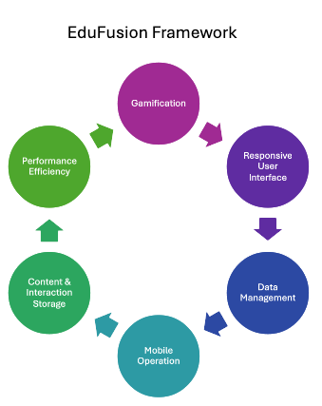
Figure 9: Edu-Fusion Framework
Figure 9 illustrates the framework being followed to create the application.

4.3 Overview of Key Components

4.3.1 Gamification
Quizzes enhance active recall and reinforce knowledge retention by encouraging users to apply what they’ve learned. Their main purpose is to test users’ understanding after engaging with short-form videos, ensuring they grasp key scientific concepts. In App B, each video module will include a linked quiz to evaluate comprehension, using Flutter’s interactive widgets including buttons and animations for an engaging experience. Questions will be stored and retrieved from MySQL for real-time updates. Overall, quizzes motivate users to review content and reinforce learning in a structured, interactive manner.

Awards, such as trophies and badges, use gamification to create a sense of achievement, boosting motivation and app engagement. Their main purpose is to reward users for their learning progress, encouraging continued participation. In App B, awards will be given for completing quizzes, reaching milestones, and maintaining consistent app usage. Visual animations will highlight achievements ultimately helping users rewarded and motivated, increasing retention and making the learning process more enjoyable and satisfying.

4.3.2 Responsive User Interface
Flutter is chosen for its cross-platform compatibility, reducing development effort while delivering high performance. The main purpose is to provide a smooth and responsive UI for both iOS and Android devices. Implementation will involve using Flutter’s Material UI for a clean, modern appearance and optimising layouts for various screen sizes to ensure responsiveness. Ultimately, this technology choice ensures users experience seamless navigation with a polished, consistent, and professional interface.

User-centred design is essential because Gen Z learners prefer intuitive, interactive, and minimalistic interfaces. The main purpose is to enhance the user experience and reduce cognitive overload. This will be implemented through features including animations, smooth transitions, and gesture-based navigation such as swipes and taps to improve usability. Ultimately, user-centred design ensures accessibility, ease of use, and high engagement, making the app more appealing and effective for its target audience.

4.3.3 Data Management
A database is crucial, with MySQL chosen for its secure storage, authentication, and real-time data access. The main purpose is to store user accounts, quiz scores, and learning progress. Implementation will involve users signing up or logging in via MySQL with learning progress and quiz data stored in MySQL for instant, real-time access. This setup allows users to track their progress, resume sessions seamlessly, and sync data across multiple devices for a consistent learning experience.

4.3.4 Mobile Operation
API integration within the mobile operations component is used to support multiple essential functions. Three main APIs have been implemented to enhance app performance and user experience. The apiBase API acts as the base path for all backend API requests, enabling secure interactions with the server, such as login, registration, and quiz data retrieval. The pfpBase API is dedicated to loading user profile pictures directly from the server, allowing dynamic updates and user personalisation. the videoBase API handles the content delivery of short-form educational videos. The API ensures that content is streamed efficiently to users without requiring manual app updates. All these APIs combined ensure that users experience seamless content access, dynamic profile management, and reliable server communication, supporting the app’s scalability, personalisation, and consistent learning engagement.

4.3.5 Content & Interaction Storage
The quiz interface in App B is designed to reinforce learning through gamified quizzes that promote active recall and engagement. Its main purpose is to test knowledge retention after each set of videos and encourage users to apply what they’ve learned. Implementation involves displaying a quiz automatically after every three videos using a popup overlay built in Flutter, with quiz questions dynamically retrieved from a MySQL database via a PHP backend.

Content scrolling is implemented using vertical swipe gestures, allowing users to seamlessly transition between short-form science videos. Instead of traditional list-based scrolling, the app uses a custom gesture-based system to load and play one video at a time, offering a TikTok-style browsing experience. This setup aligns with Gen Z’s preference for rapid, continuous content and ensures users remain focused on each video individually without distraction.

4.3.6 Performance Efficiency
The app uses on-demand video loading which reduces memory usage while increasing app responsiveness to improve performance. Only one video is loaded into memory at a time, and when the user swipes vertically, the current video is deleted, and the next one is loaded. This minimises resource consumption and ensures a consistent playback experience across devices. This custom loading method ensures that the app remains lightweight and responsive while efficiently managing content.

Flutter’s pre-built widgets are used to reduce development time and streamline the development process. The main purpose is to ensure efficiency and maintain UI consistency throughout the app. Implementation will involve using Flutter’s built-in components including buttons, text fields, and containers, which will be customised to fit a clean, modern design aesthetic. The utility of these widgets lies in enabling faster UI development, delivering smooth animations, and providing a cohesive, professional user experience with minimal effort.

4.4 Conclusion
The proposed EduFusion framework describes a systematic approach to assessing a gamified app and a test app with non-gamified learning methods. This chapter covered the key components, such as gamification, responsive UI, data management, mobile operations, content storage, and performance efficiency. Each feature is intended to increase user engagement, knowledge retention, and seamless app interaction. By combining these elements, the framework aims to provide an effective and engaging educational experience for Gen Z students. The following phase will concentrate on implementation, testing, and analysis to determine the framework's impact on learning outcomes.

Chapter 5: Design, Implementation & Testing

5.1 Introduction
This chapter presents the technical implementation and development process of the EduFusion mobile application. It outlines the tools, technologies, and design choices used to build the app, focusing on how features such as short-form video playback, quizzes, and gamified rewards were integrated to enhance learning. The chapter also discusses the frontend, backend and database integration. Each stage of development follows agile methodology, allowing iterative testing and improvement throughout the build. Diagrams are included to illustrate system architecture, data flow, and user interaction within the app.

5.2 Design Requirements

5.2.1 Functional Requirements
App A must allow users to access and scroll through a curated selection of short-form science videos. The app should support smooth video playback with minimal buffering and allow swipe gestures to navigate between content and a tap gesture to pause and resume content.

App B must include all of App A’s video functionality but also introduce interactive quizzes after every few videos. It should automatically trigger quizzes, track correct responses and count the number of quiz prompts that have appeared. Upon reaching milestones (e.g. 10 correct answers), the app must award a digital trophy and update the user’s profile with their progress. Additionally, the app must support user authentication, progress tracking, and database storage of quiz results for future review.

5.2.2 Non-Functional Requirements
Performance, scalability, and accessibility are critical. The app must work seamlessly across platforms, loading videos quickly. It should comply with GDPR for data privacy and be compatible with a wide range of devices to serve a diverse user base.

5.2.3 User Requirements
The app is aimed at students aged 18 to 22 and includes features tailored to students’ needs for simplicity (App A) and active learning (App B). Both apps aim to support their study habits and improve knowledge retention. Tools are designed to reflect Gen Z's technological preferences and learning goals.

5.2.4 App Architecture and Interaction Diagram
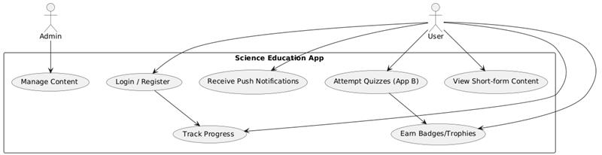
Figure 10: Use Case Diagram
Figure 10 shows a use case diagram which illustrates the interaction between two primary actors (Admin and User) using the App. The admin can manage content while users can register or log in, watch videos and attempt quizzes (App B). Users can also track progress and earn trophies.

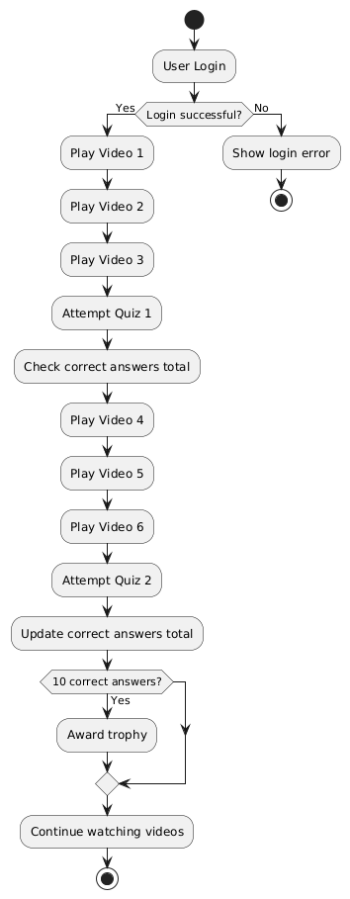
Figure 11: Activity Diagram
Figure 11 shows an activity diagram which outlines the user flow within the app. It begins with the user login and after logging in the user is directed to the video playing. After 3 videos a quiz will be prompted for the user to answer. The question is then checked to see if it is right or wrong and the user moves on. The loop is continuous. When the user reaches 10 questions answered correctly, they are then given a trophy, and they can earn more every 10 more questions answered correctly.

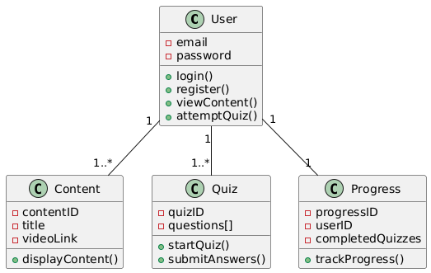
Figure 12: Class Diagram
Figure 12 shows a class diagram which illustrates the structure of the app and how the components interact. The User class can view multiple pieces of Content, take multiple Quizzes, and have a linked Progress record. Each class contains relevant attributes and methods. Content holds video data, Quiz handles questions and submissions, and Progress tracks quiz completions.

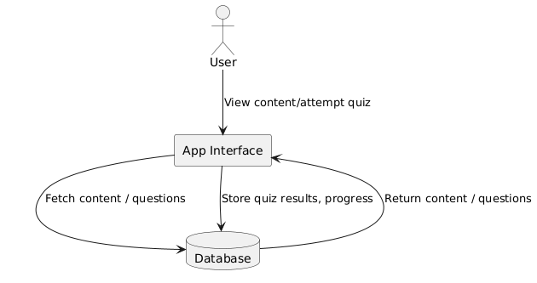
Figure 13: Data Flow Diagram
Figure 13 shows a data flow diagram which illustrates the core interaction within the app. The user engages with the app interface to view content and attempt quizzes. The app fetches the necessary educational content and quiz questions from the database, and after the user completes a quiz, it stores the results and progress back into the database. This loop ensures content delivery and user performance tracking are efficiently managed between the app and its database.

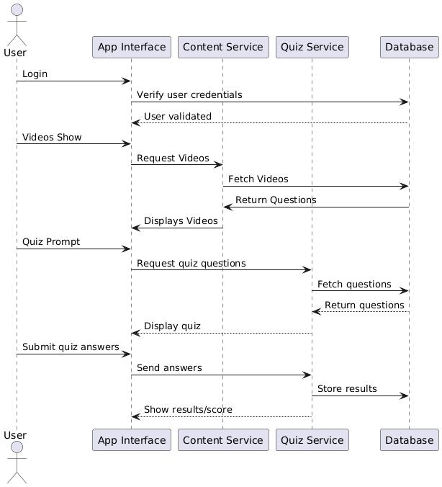
Figure 14: Sequence Diagram
Figure 14 shows a sequence diagram which illustrates the interaction between a user and different components of the app. The user begins by logging in, and their credentials are verified by the App Interface and validated via the Database. Upon successful login, videos are requested and fetched through the Content Service, then displayed to the user. When the quiz is prompted, the app requests quiz questions via the Quiz Service, retrieves them from the Database, and displays them. Finally, the user submits answers, which are sent and stored, and the results are displayed

5.3 System Architecture

5.3.1 Overview of Architecture
The application uses a hybrid architecture that combines frontend, backend, and database systems. All videos and login information will be stored in a database.

5.3.2 System Components
The below shows the system components that will be used for this project:

- Frontend: flutter for iOS and Android development
- Backend: PHP, Apache, AWS LightSail
- Database: MySQL

5.3.3 Technologies
The below shows the technologies that will be used for this project:

- MySQL: Analytics and user authentication
- APIs: To enable frontend and backend communication

5.4 UI/UX Design

5.4.1 Wireframes and Prototypes

Login  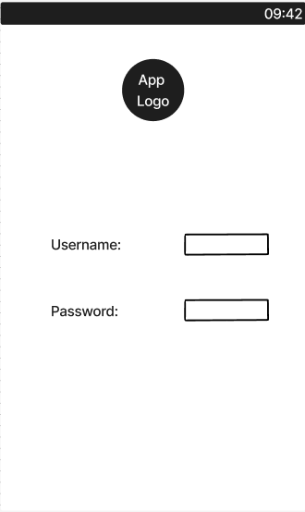 | Video  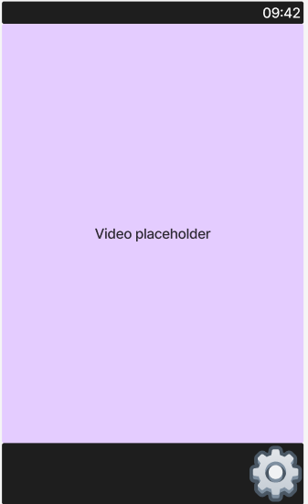
Quiz  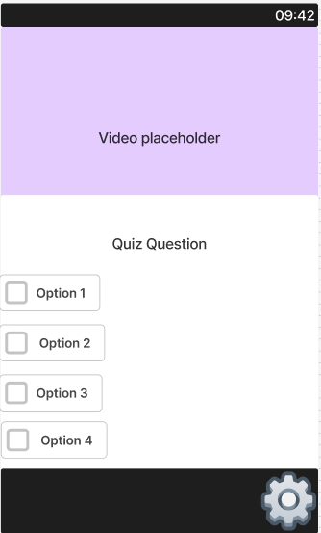 | Settings  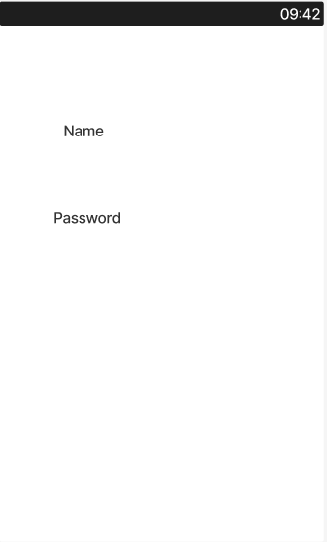
Table 1: Prototype A

Login | Video
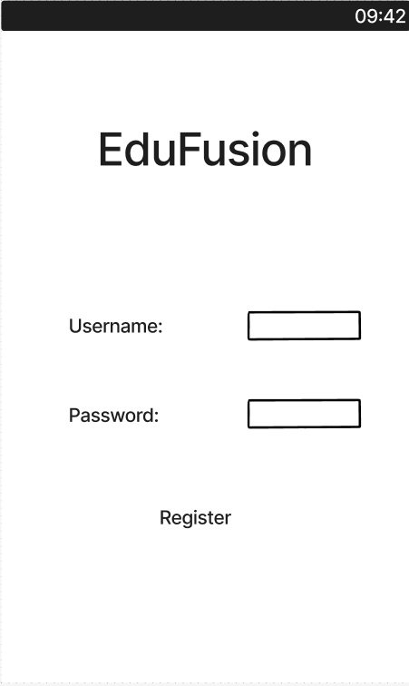 | 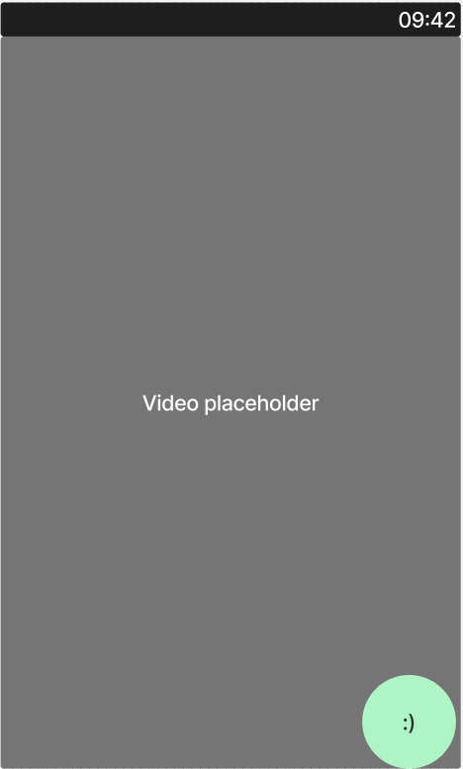
Quiz  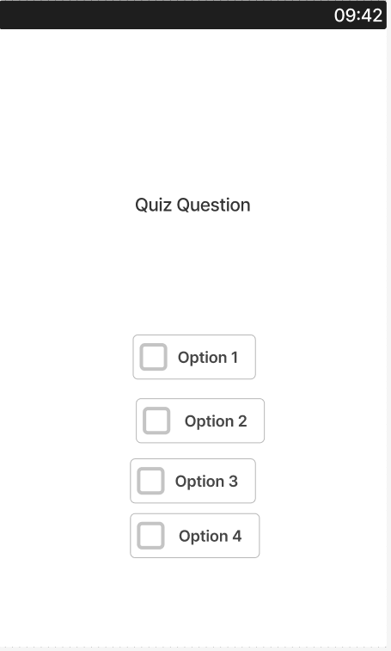 | Settings  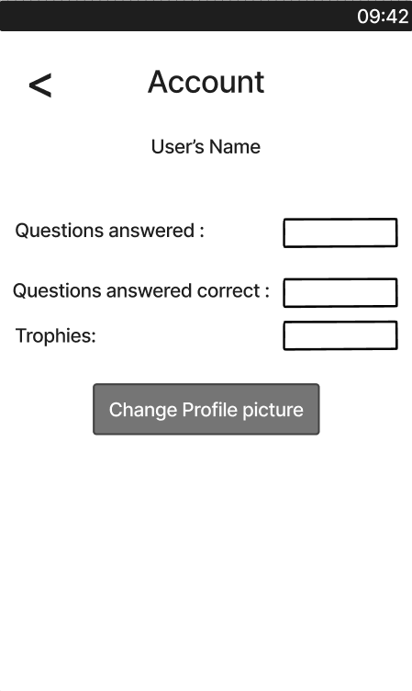
Account
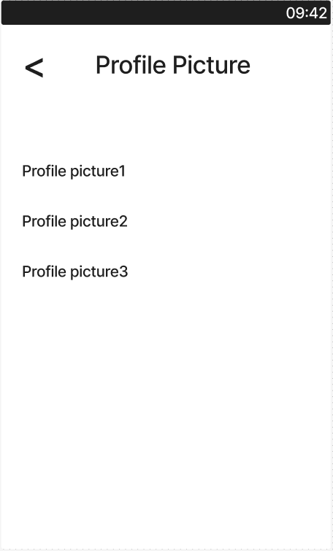
Table 2: Prototype B

5.4.2 User Journey Mapping
Stage | User Action | User Goal | Touchpoints | Emotions
App Launch | Opens The App | Access Educational Content Quickly | App Icon | Curious, Eager
Content Scrolling | Scrolls Through Short Form Science Education Videos | Quickly consume and learn bite-sized science topics | Main Video Feed | Interested, Focused
Repeat/Scroll | Scrolls More Videos | Continue Exploring and Learning | Main Video Feed | Motivated, Enjoying
Exit App | Closes The App | End Session Feeling Satisfied with Learning | Home Button, Swiping off the app | Satisfied, Ready to Return
Table 3: App A User Journey

Stage | User Action | User Goal | Touchpoints | Emotions
App Launch | Opens The App | Access Educational Content Quickly | App Icon | Curious, Eager
Onboarding | Register or Login | Be able to save awards and progress and access Videos | Login page, Sign-up page | Curious
Content Scrolling | Scrolls Through Short Form Science Education Videos | Quickly consume and learn bite-sized science topics | Main Video Feed | Interested, Focused
Quiz interaction | Attempt Quiz Prompts | Test knowledge and reinforce learning | Quiz Prompt | Focused, Challenged
Rewards | Earn Trophies | Feel rewarded and recognised for your effort | Profile page | Excited, motivated
Progress Tracking | Checks Learning Progress | See improvement and stay encouraged | Profile page | Proud, encouraged
Exit App | Close The App | End Session Feeling Satisfied with Learning | Home Button, Swiping off the app | Satisfied, Ready to Return
Table 4: App B User Journey

5.5 Application Development Process

5.5.1 Frontend Development
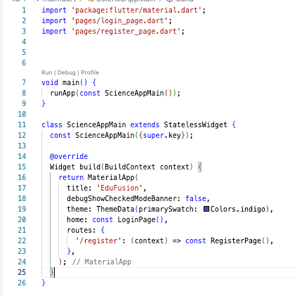
Figure 15: main.dart
Figure 15 shows the code for the main setup for the app. The initial screen is the login page, and it defines a route to the registration page under /register, allowing for navigation between the login and registration screens.


Figure 16: login_page.dart
Figure 16 shows the login function. This collects the user’s email and password, then sends them to the server via a POST request to login.php. If the server responds with success, the app navigates to the video feed page and passes along the user’s information. If the login fails or an error occurs, it displays an appropriate error message to the user. Throughout the process, it also manages a loading state which shows a buffering icon to provide feedback during the login operation for the user.

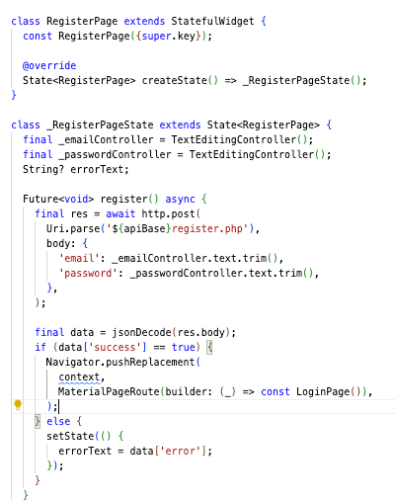
Figure 17: register_page.dart
Figure 17 shows the register function. It collects the user’s email and password and then sends them to the server using a POST request to register.php. If the server responds with success, then the user is redirected to the login page. If registration fails, then an error message from the server is displayed to inform the user what input is incorrect.


Figure 18: video_feed_page.dart
Figure 18 shows that the functions pull the 15 videos from the database, shuffle them and on display them on screen one by one. The user will then have to swipe up or down on the screen to load the next video. Every 3 videos a quiz pop will appear which the user will have to answer to continue. When the user reaches the end of the list of videos, it reshuffles the videos and starts again. Tapping on the button also pauses and resumes playback.


Figure 19: quiz_popup.dart
Figure 19 shows that this function builds the quiz popup dialogue. It first checks if the quiz data has loaded or displays a buffering icon if the quiz hasn’t loaded. Once the quiz is ready, it displays the question and multiple-choice options as radio buttons. The user selects and submits the answer. The dialogue shows whether the selected answer is correct or incorrect with coloured feedback.


Figure 20: config.dart
Figure 20 shows that config.dart file defines the base URLs used throughout the app.

• apiBase is the base path for all backend API requests.
• pfpBase is used to load user profile pictures from the server.
• videoBase is the path for accessing educational videos.

All URLs point to the server at nerdypinapple.ddns.net over HTTPS, ensuring secure communication between the app and backend services.

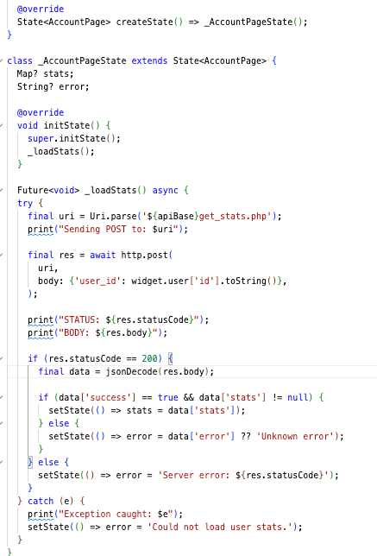
Figure 21: account_page.dart
Figure 21 shows that this function loads the user's account stats such as quiz questions answered and how many they got correct. It sends a POST request to the get_stats.php API with the user’s ID. If the server returns a successful response (statusCode == 200) and the response indicates success, it updates the UI with the user’s stats. If something goes wrong, it sets an error message to display.


Figure 22: settings_page.dart
Figure 22 shows that this function handles updating the user’s profile picture on the settings page. When called, it sends a POST request to the update_profile.php API with the user’s ID and the selected profile picture filename. The profile should update based on the user’s choice but if it fails then an error message will show.

5.5.2 Backend Development

Figure 23: login.php
Figure 23 shows that the login.php script handles user login requests from the app. It accepts email and password via POST, checks if both are provided and then queries the database for a matching user. If the user exists and the password is correct, it returns a successful response with user data including profile picture, quiz stats, and email. If the email or password is invalid, an error message will appear.

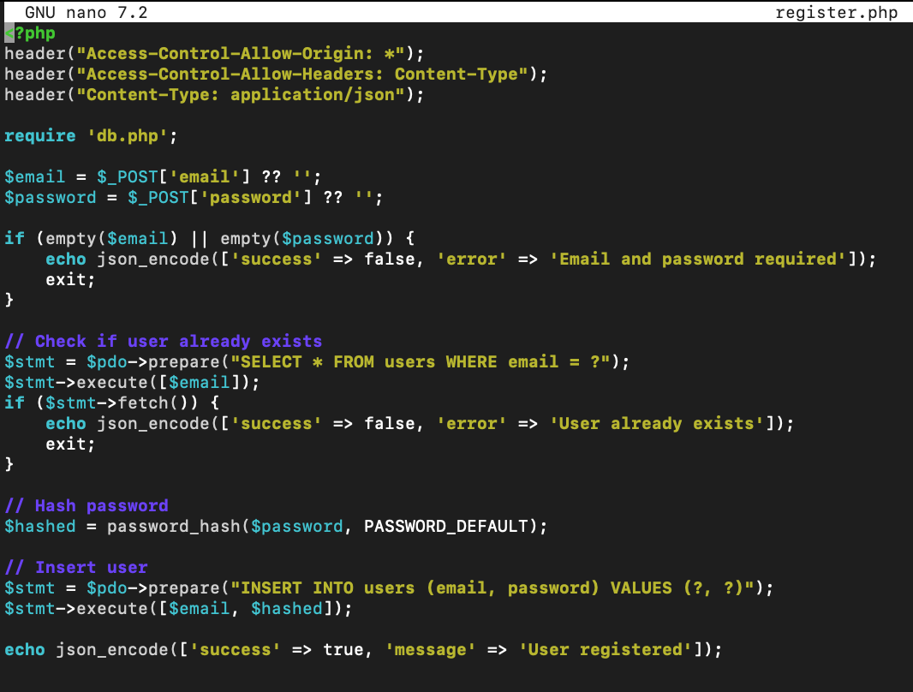
Figure 24: register.php
Figure 24 shows that the register.php script handles user registration. It receives an email and password via POST, checks that both are provided and then verifies if the email already exists in the database. If the user doesn’t exist, it hashes the password using password_hash() and inserts the new user into the user’s table. It also shows a success message or an error message if the user already exists or information is missing.

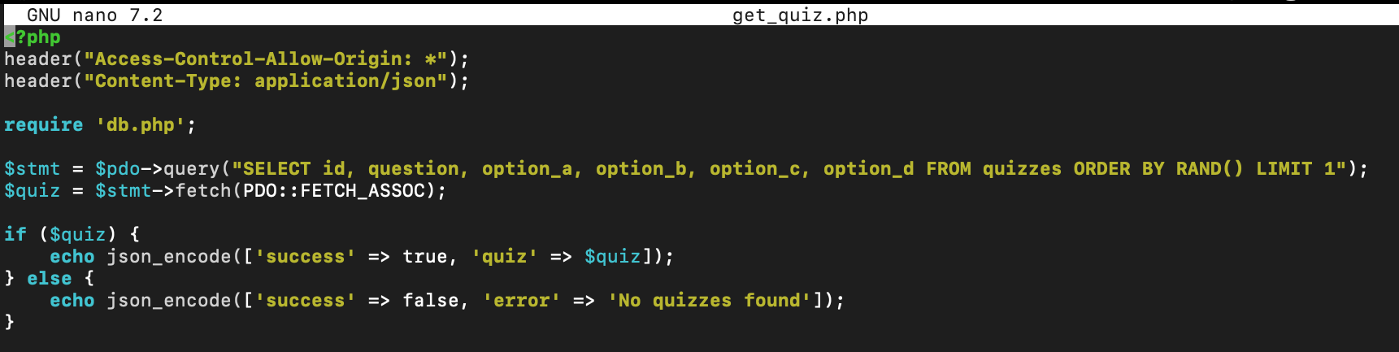
Figure 25: get_quiz.php
Figure 25 shows the get_quiz.php script returns a random quiz from the quizzes table. It connects to the database and runs a SELECT query to retrieve one random quiz with its question and four options (option_a to option_d). If the quiz is found, then it responds with a success status and the quiz data or if there isn’t a quiz it responds with an error message. This is used by the app to display quiz prompts between videos.

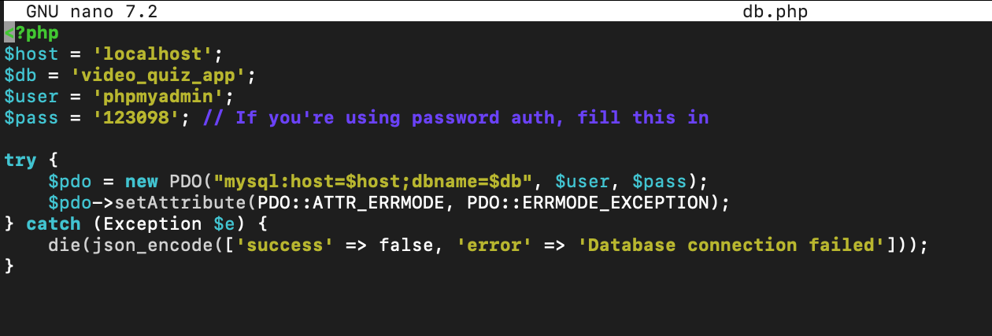
Figure 26: db.php
Figure 26 shows that this db.php script sets up the database connection using PHP’s PDO (PHP Data Objects). It defines connection variables such as host, database name, username, and password. The try block attempts to connect to the MySQL database and sets error handling to throw exceptions. This file is included in all other scripts to provide access to the database.

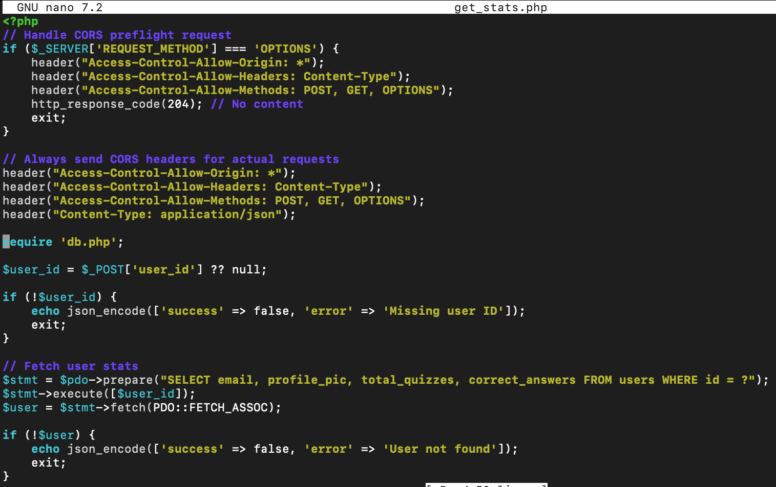
Figure 27: get_stats.php
Figure 27 shows that the get_stats.php script retrieves a user’s quiz statistics. It expects a user_id via POST and returns an error if it’s missing. If the user exists in the database, it fetches their email, profile picture, total quizzes answered, and number of correct answers. The data is returned as a JSON object. If the user doesn’t exist, it returns an error message.


Figure 28: submit_answer.php
Figure 28 shows that the submit_answer.php script processes a user’s quiz answer submission. It receives the user_id, quiz_id, and selected_option via POST. It validates the input, retrieves the correct answer for the quiz, and checks if the user’s answer is correct. It then inserts the result into an answers table and updates the user's table to increment total_quizzes and correct_answers. The script returns a JSON response indicating whether the submitted answer is correct.

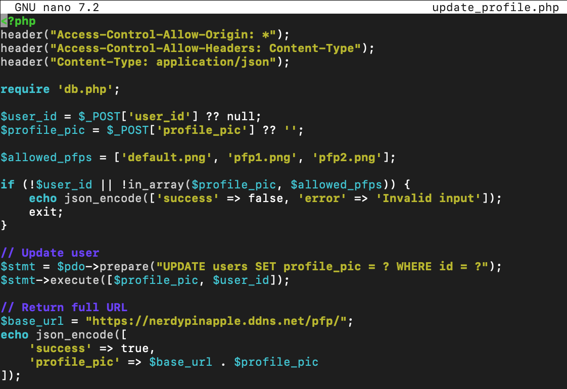
Figure 29: update_profile.php
Figure 29 shows that this update_profile.php script handles updating a user’s profile picture. It receives the user_id and selected profile_pic filename via POST. It validates that the provided profile picture is one of the allowed options (default.png, pfp1.png, or pfp2.png). If valid, it updates the user’s profile picture in the database. The script then returns a success message along with the full URL of the new profile picture.

All PHP scripts (other than DB.PHP) include CORS (Cross-Origin Resource Sharing) headers which allow the web app to make requests to your PHP backend, even if they’re on different domains or ports. They also include JSON headers (Content-Type: application/json) that tell the browser and client that the server is sending or expecting data in JSON format.

5.5.3 Database Integration

Figure 30: PHPMyAdmin
Figure 30 shows the phpMyAdmin dashboard, a web interface for managing MySQL databases. This was used to create the database and hold the data used by the app.


Figure 31: Quiz Tables
Figure 31 shows the overview of the database. All of the tables shown above were used to save data for the app.

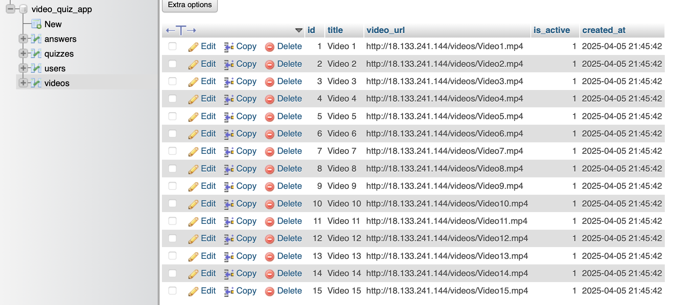
Figure 32: Videos
Figure 32 shows the table which holds all the 15 short-form educational videos that the app showcases.

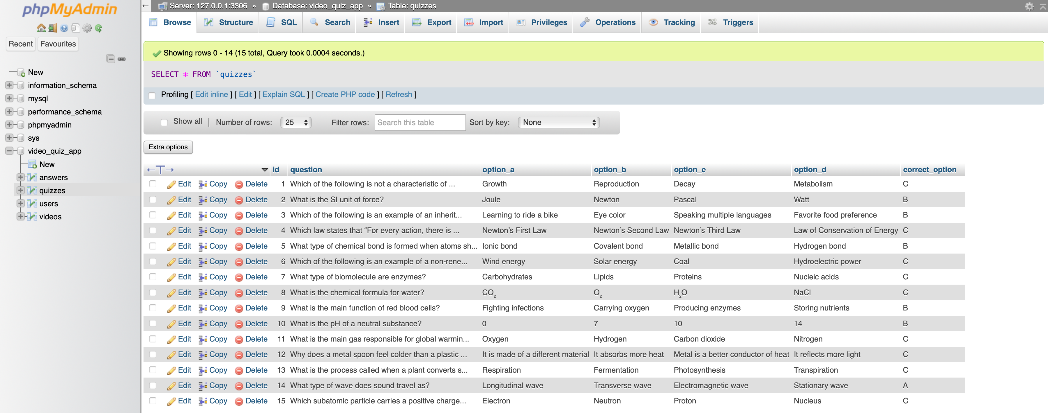
Figure 33: Questions
Figure 33 shows the table with all the quiz questions the app will ask and their corresponding options and answers.

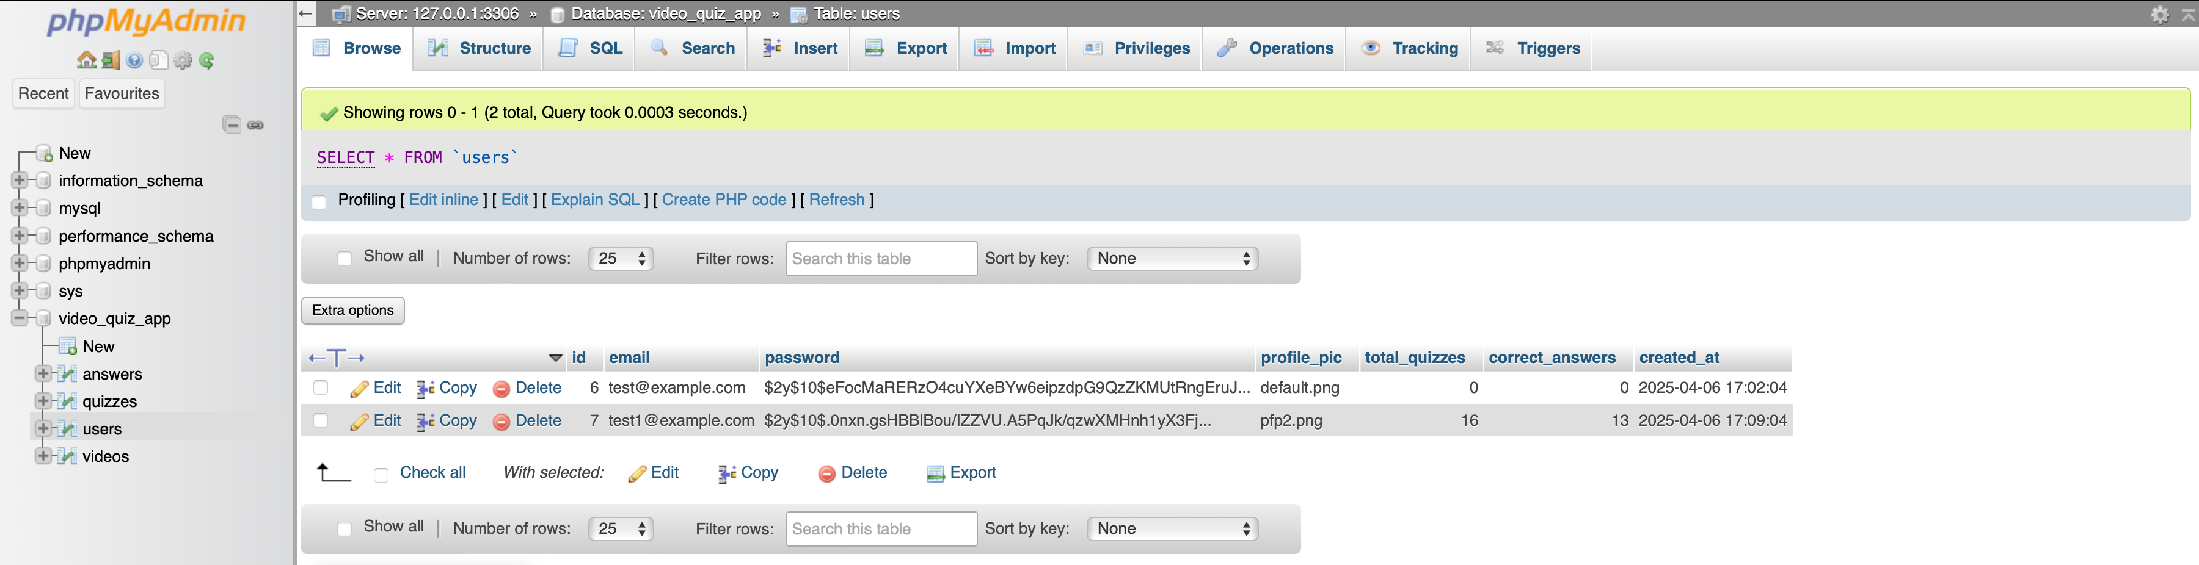
Figure 34: Users
Figure 34 shows the table which holds the users that were made for testing.

5.6 Features and Functionalities

5.6.1 Short-Form Content Delivery
Videos working
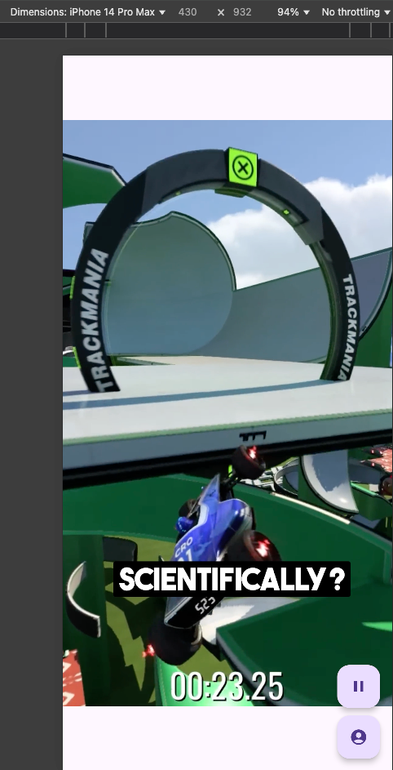
Table 5:Short Form Content

5.6.2 Gamification Features
Quiz working  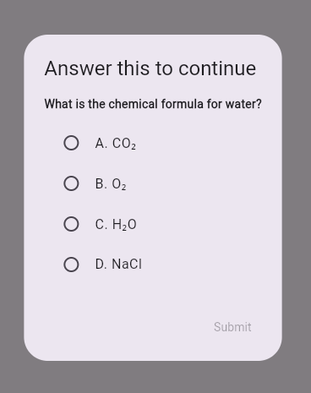 | Quiz answers wrong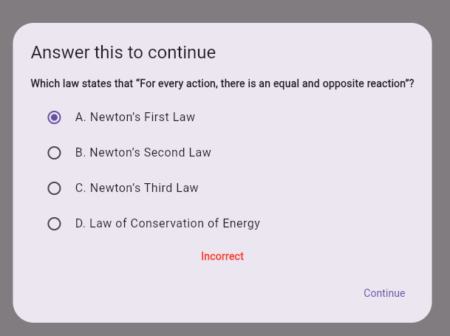
Quiz answer right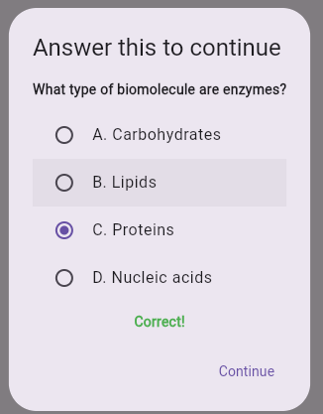 | Trophies count  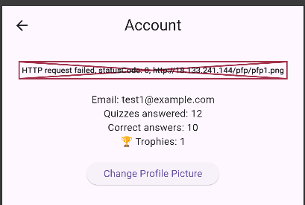
Table 6: Quiz Questions Working

5.7 Challenges in Design and Development

5.7.1 Technical Challenges
- Infinite Video Loop Crashing App: The app crashed when implementing infinite scrolling. This impacted the testing of App A.
- Profile Pictures Not Displaying: Profile images failed to load properly, affecting user personalisation and UI consistency.
- PHPMyAdmin Access Issue: Could not access PHPMyAdmin because the login wasn’t configured for the root user but instead had another username that ran as the root user. This issue was then resolved later on during development.
- Pause Gesture Not Working: Tap to pause gesture functionality on videos was unresponsive, reducing interactivity and smooth playback control.

5.7.2 Design Challenges
- Pause Button Placement: Difficulty using a pause button that fits the UI without interfering with other elements or disrupting the design flow.

5.8 Testing Framework

5.8.1 Testing Objectives
- Compare the effectiveness of App A (non-interactive) and App B (interactive with quizzes) in improving knowledge retention.
- Evaluate which app better meets the needs and preferences of Gen Z learners.

5.8.2 Tools and Techniques Used
For testing both apps, manual testing methods were primarily used:

• The app’s functionality, video playback, and quiz flow were manually tested using Flutter’s development tools.

• MySQL was used to track user engagement and quiz performance data.

• Pre-tests, post-tests, and a feedback form were distributed via Microsoft Forms to collect both qualitative and quantitative data.

• A/B Testing was used to compare the performance of App A and App B, focusing on user retention and improvements in test scores.

5.9 Test Cases and Scenarios

5.9.1 Functional Testing
Functional Testing ensures all features work as intended in both apps.
Key functional test cases include:
- Video playback without interruption (App A & B)
- Quiz Prompts, Question randomisation and scoring (App B)
- API Functionality (App B)

5.9.2 Usability Testing
Usability testing focuses on evaluating the user interface and user experience.
Key scenarios tested:
- Ease of navigation through video scrolling (App A)
- Accessibility of quiz buttons and result displays (App B)
- User satisfaction with responsiveness and visual design on different devices
- User perception of motivation and engagement (feedback form)

5.9.3 Performance Testing
Performance testing focuses on speed, responsiveness, and stability.
Key metrics tested:
- App load times for both iOS and Android devices
- Lazy loading efficiency of videos in App B
- API response times for content fetching
- Stability during long usage periods and switching between videos and quizzes

Chapter 6: Evaluation

6.1 Validation Methods

6.1.1 Knowledge Retention Validation
To validate knowledge retention, participants will complete a pre-test before using the app and a post-test after interacting with the content. By comparing the scores, the difference in knowledge gained will be measured. The same tests will be used across both App A and App B to ensure consistency. A greater increase in post-test scores will indicate better retention.

6.1.2 User Engagement Validation
User engagement will be validated through analytics tracking and user feedback. Key metrics such as time spent on the app and the number of quizzes completed will be monitored. Additionally, a feedback survey will collect qualitative data on user motivation, satisfaction, and also allow users to comment on improvements they would like to see.

6.2 Evaluation Methodology

6.2.1 Evaluation Approach
A mixed-methods evaluation approach was used to assess the learning outcomes and user engagement between App A (non-gamified) and App B (gamified). Quantitative methods such as pre- and post-test score comparisons and engagement tracking provided measurable data to evaluate performance. Qualitative methods including user feedback forms and survey responses offered insights into user satisfaction, motivation, and overall experience. A comparative A/B testing model was also used to isolate the impact of gamified features on learning outcomes in a controlled environment.

6.2.2 Participants
The study included 8 participants aged 18 to 22 from Generation Z, an age group that is excellent at using mobile devices and engaging with short-form information. These people were recruited using convenience sampling through social media platforms, ensuring digitally literate people were selected. The participants, as active learners, are well-positioned to provide feedback on the app's effectiveness in improving information retention while fitting with their academic objectives.

6.2.3 Evaluation Procedure
1. Pre-Test: Participants complete a baseline test on the science topics.
2. App Usage - App A: Participants use the app without quizzes for a set duration, engaging with short-form science content.
3. Post-Test for App A: Participants take a test to measure knowledge retention.
4. App Usage - App B: Participants use the app with quizzes and gamification features.
5. Post-Test for App B: Participants take a second test to evaluate knowledge retention after using the gamified app.
6. Feedback Survey: Participants rate the EduFusion App in terms of usability, engagement, and educational value.

6.2.4 Evaluation Metrics
The following metrics were used to assess the effectiveness of each app:
- Knowledge Retention: Measured by comparing scores from the pre and post-tests for each app.
- User Engagement: Number of quizzes completed, time spent on the app, and quiz scores.
- Score Improvement: Percentage increase in test scores used to measure retention gains.

6.2.5 Data Collection Methods
Three main data collection methods were used:
- Test Scores: Recorded and compared across pre- and post-test sessions.
- User Engagement: Collected through backend tracking (using PHP/Apache/MySQL) to monitor quiz questions answered and trophy tracking. Time spent was tracked with a stopwatch during the app usage for each participant.
- User Surveys: Microsoft Forms was used to gather user opinions and app feedback.

6.2.6 Data Analysis Methods
Data analysis involved:
- Descriptive Statistics: Used to calculate average scores and usage time.
- Comparative Analysis: Percentage improvement in scores was calculated to compare performance across App A and App B.
- Qualitative Analysis: Survey responses were reviewed to identify positive feedback and issues related to user experience and satisfaction.

6.2.7 Ethical Considerations
Ethical standards were followed throughout the evaluation process:
- Informed Consent: All participants were provided with an information sheet and a consent form to sign.
- Anonymity & Data Privacy: Participant data was anonymised using ID numbers and stored securely in compliance with GDPR.
- Right to Withdraw: Participants could withdraw at any point without penalty.
- Age-Appropriate & Inclusive Content: All app content was reviewed to ensure it was educationally appropriate and culturally sensitive.

6.3 User Testing

6.3.1 Participant Demographics
The study included 8 participants aged 18 to 22 from Generation Z, an age group that is excellent at using mobile devices and engaging with short-form information. These people were recruited using convenience sampling through social media platforms, ensuring digitally literate people were selected. The participants, as active learners, are well-positioned to provide feedback on the app's effectiveness in improving information retention while fitting with their academic objectives.

6.3.2 Pre-Test and Post-Test Results

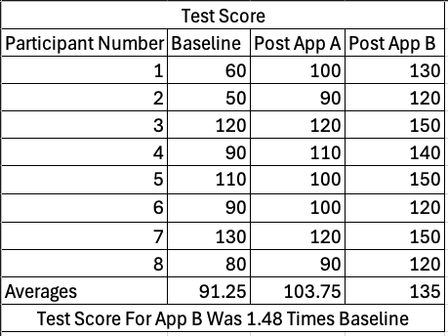
Figure 35: Test Scores
Figure 35 shows each participants test score both pre and post-tests. The figure also includes the increase of test score seen between the baseline exam and the exam after App B

6.3.3 Feedback Analysis

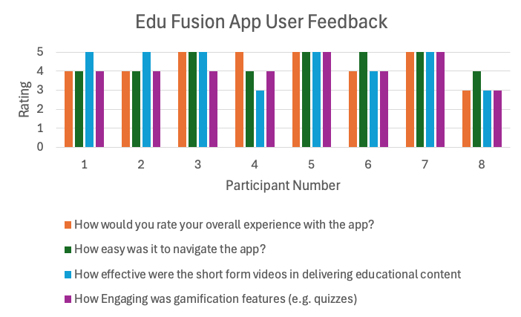
Figure 36:EduFusion App User Feedback
Figure 36 shows that Qualitative feedback was collected through a feedback survey to understand users’ views of the app. Participants highlighted EduFusion’s gamification features as more engaging, motivating them to complete quizzes and retain knowledge. Users appreciated the short-form video format for the apps. Users felt EduFusion made the experience more interactive and rewarding. Common feedback included a desire for smoother video transitions, having the ability to pause video using a gesture rather than a button, and password verification. Overall, participants preferred the interactive nature of EduFusion which aligned with their digital learning habits.

6.4 Test Results

6.4.1 Results Analysis

Figure 37: Participant Test Scores Throughout Testing
Figure 37 shows that knowledge retention was confirmed by comparing pre-test and post-test scores across both apps. The results showed a major improvement in participants’ scores after using App B, which featured quizzes, indicating stronger retention compared to App A. The average post-test score with App B was 1.48 times higher than the baseline, indicating a greater improvement compared to App A and supporting the hypothesis that gamified learning improves knowledge recall.
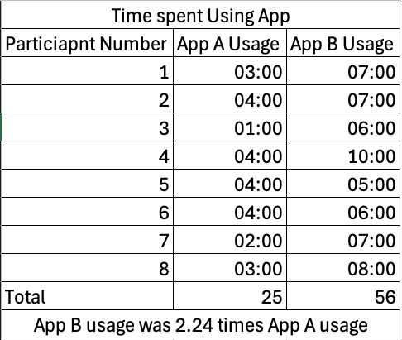
Figure 38: Time Spent on App

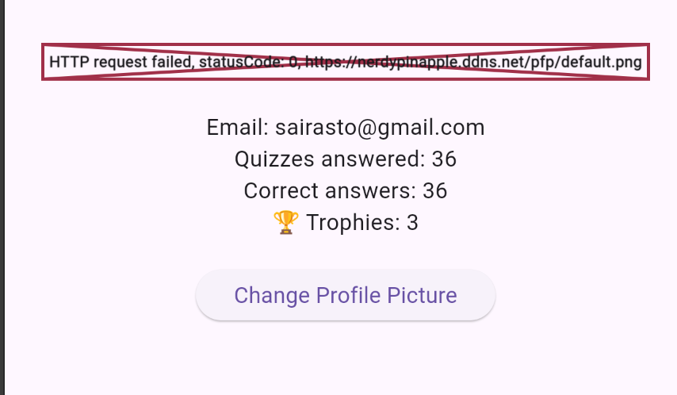
Figure 39: User Engagement

Figure 40:Time Spent Across Apps

Figures 38, 39 and 40 show how user engagement was measured by tracking metrics such as the number of quizzes attempted, and correct quiz answers. App B demonstrated higher engagement levels, with participants spending more time completing quizzes and interacting with the content. App B usage was 2.24 times as much as App A usage. This was supported by user feedback indicating a stronger sense of accomplishment and motivation when using the gamified app.

6.4.2 Success Metrics
The project’s success was measured using three key metrics: knowledge retention, user engagement, and usability. Knowledge retention was proven through improved test scores. The engagement was reflected in the number of Quiz Questions answered and Trophies collected. Usability was supported by positive survey feedback regarding app navigation, design, and satisfaction. The overall success of the app aligns with the project’s hypothesis.

6.5 Summary of Findings

6.5.1 Key Insights from Research
Research on digital learning and gamification shows that Gen Z learners prefer interactive, short-form content. From researching Duolingo's research methods and the Ebbinghaus Forgetting Curve they show that frequent interaction, active recall, and spaced repetition significantly improve knowledge retention. Gamified aspects such as quizzes, trophies, and progress tracking have been shown to increase motivation and strengthen memory.

6.5.2 Results from Testing
The testing results revealed that App B demonstrated significantly higher improvements in their post-test scores compared to App A. These results suggest that integrating gamified elements such as quizzes and rewards helped improve knowledge retention. The quizzes allowed participants to use active recall, prompting users to retrieve and apply information shortly after viewing video content. This agrees with cognitive science theories such as the Ebbinghaus Forgetting Curve which indicates that spaced repetition and retrieval practice can significantly slow memory decay.

Engagement data showed that participants spent more time interacting with App B. Participants had quizzes to complete which is what contributed to more time spent on the app. In contrast, participants which used app A, only engaging with passive content via scrolling videos still did show a small improvement. This suggests that passive learning methods may not be as effective in promoting long-term retention.

User feedback also supported this conclusion because many participants expressed that App B felt more motivating, interactive, and rewarding, which encouraged longer and more frequent usage. The gamified features appear to have created a more immersive learning experience, leading to both better performance and increased satisfaction.
These results confirm the hypothesis that interactive, gamified micro-learning models are more effective for Gen Z learners, who prefer quick, engaging, and feedback-driven digital content.

6.6 Contributions

6.6.1 Academic Contributions
The study enhances the academic understanding of gamified micro-learning by demonstrating how interactive features such as quizzes and rewards can improve retention and motivation. It adds to the existing literature by applying a mixed-methods research strategy to compare passive versus active learning environments and highlights how design decisions influence cognitive learning outcomes. Additionally, it serves as a case study for the effectiveness of mobile-first, Gen Z-targeted educational solutions.

6.6.2 Practical Contributions
On a practical level, this project provides a blueprint for developing effective hybrid mobile learning applications. The findings offer actionable insights for educators, app developers, and instructional designers looking to increase engagement through gamification. The app serves as a prototype for real-world educational tools, showing how quizzes and user interface design can be combined to create a more immersive and personalised learning experience.

6.7 Limitations

6.7.1 Technical Limitations
Some technical issues came up during development, such as problems with infinite scrolling and occasional app crashes for App A development. PHPMyAdmin also encountered access issues due to an incorrect login configuration. Additionally, some UI features such as profile pictures and pause gestures were not fully functional for App B development.

6.7.2 Resource Constraints
The project faced constraints in time and with the lack of access to advanced development resources. Limited testing devices and participant availability restricted large-scale user testing. Due to time constraints, advanced features such as adaptive learning paths and speech input were not implemented.

Chapter 7: Conclusion

7.1 Conclusion
The project successfully designed, developed and evaluated a gamified science education app which aimed to improve knowledge retention among the Gen Z Audience. The app demonstrated an ability to enhance engagement and learning outcomes by mixing short-form video content, interactive quizzes and rewards. The evaluation results clearly showed that the interactive, quiz-based version outperformed passive video consumption alone. Through the use of agile methodology, continuous testing and refinement allowed the final app to meet user needs effectively. Despite technical challenges, such as UI optimisations and backend integration, the project validated the potential of hybrid mobile apps in modern education. EduFusion serves as a practical blueprint for leveraging gamification to meet the evolving needs of digital-native learners, offering actionable insights for educators and developers alike.

7.2 Future Work
Several improvements to the overall user experience could be implemented in future app versions. To begin, implementing a password verification step during user registration would improve account security and reduce login errors. Secondly, improving video loading times and ensuring smoother transitions between videos would result in a more consistent content consumption experience. Integrating a gesture-based pause feature such as tapping the screen to pause or resume would provide more control and convenience, particularly for mobile-first users. These improvements are intended to increase usability and engagement, making the app more responsive to user expectations.

Further research could investigate the long-term retention benefits of gamified microlearning over extended periods, beyond the current short-term testing framework. Exploring the effects of adaptive quiz difficulty, personalised learning paths, or integrating artificial intelligence (AI) to tailor content based on performance could provide deeper insights into learner needs. Additionally, future studies could compare gamification outcomes across different subject areas and age groups to understand its broader educational impact.

Chapter 8: References
Agnieszka Palalas & Wark, N. (2017). Design Principles for an Adult Literacy Mobile Learning Solution. Proceedings of the 16th World Conference on Mobile and Contextual Learning. 27. p. Pages 1 - 8. Available from: [Accessed: 17 November 2024].
Ajayi, O., Omotayo, A., Orogun, A., Omomule, T. & Orimoloye, S. (2018). ISSN : 2394-4714 Foundation of Computer Science FCS. Communications on Applied Electronics (CAE). [Online]. 7 (16). Available from: https://www.caeaccess.org/archives/volume7/number16/ajayi-2018-cae-652701.pdf. [Accessed: 9 December 2024].
Ally, M. (2013). Mobile learning: from research to practice to Impact Education. Learning and Teaching in Higher Education: Gulf Perspectives. 10 (2). pp. 3–12. Available from: [Accessed: 17 November 2024].
Alruthaya, A., Nguyen, T.-T. & Lokuge, S. (2021). [PDF] The Application of Digital Technology and the Learning Characteristics of Generation Z in Higher Education | Semantic Scholar. [Online]. 2021. Semanticscholar.org. Available from: https://www.semanticscholar.org/reader/db7aec4f46fc2d9b9fa2a831b790c1feda8e194e. [Accessed: 15 November 2024].
Amagai, S., Pila, S., Kaat, A.J., Nowinski, C.J. & Gershon, R.C. (2021). Challenges in Participant Engagement and Retention using Mobile Health Apps: A Literature Review (Preprint). Journal of Medical Internet Research. 24 (4).
Andrade, P., Law, E.L.-C., Farah, J.C. & Gillet, D. (2020). Evaluating the Effects of Introducing Three Gamification Elements in STEM Educational Software for Secondary Schools. 32nd Australian Conference on Human-Computer Interaction.
Anirudh Ekambaranathan, Zhao, J. & Chalhoub, G. (2023). Navigating the Data Avalanche. Proceedings of the ACM on interactive, mobile, wearable and ubiquitous technologies. 7 (2). pp. 1–24.
Asif, M. & Kazi, S. (2024). Examining the Influence of Short Videos on Attention Span and its Relationship with Academic Performance. [Online]. 5 May 2024. ResearchGate. Available from: https://www.researchgate.net/publication/380348721_Examining_the_Influence_of_Short_Videos_on_Attention_Span_and_its_Relationship_with_Academic_Performance. [Accessed: 29 October 2024].
AYDIN, İ. (2024). Ethical Issues in Educational Technology. Kastamonu eğitim dergisi. 32 (1). pp. 861–881.
Baker, R.M. (2010). Examples of Scaffolding and Chunking in Online and Blended Learning Environments. [Online]. 14 May 2010. papers.ssrn.com. Available from: https://papers.ssrn.com/sol3/papers.cfm?abstract_id=1608133. [Accessed: 30 November 2024].
Banerjee, S., Deb, K., Das, A. & Bag, R. (2021). A Survey on the Use of Adaptive Learning Techniques Towards Learning Personalization. Handbook of Research on Modern Educational Technologies, Applications, and Management. [Online]. pp. 790–808. Available from: https://www.igi-global.com/gateway/chapter/258812. [Accessed: 21 December 2024].
Barata, G., Gama, S., Jorge, J. & Gonçalves, D. (2013). Improving participation and learning with gamification. Proceedings of the First International Conference on Gameful Design, Research, and Applications - Gamification ’13.
Bersin, J. (2017). The Disruption of Digital Learning: Ten Things We Have Learned. [Online]. 27 March 2017. JOSH BERSIN. Available from: https://joshbersin.com/2017/03/the-disruption-of-digital-learning-ten-things-we-have-learned/. [Accessed: 29 October 2024].
Blashki, K. (2021). DESIGNING EDUCATION APPLICATIONS FOR GENERATION Z. [Online]. 2021. www.iadisportal.org. Available from: https://www.iadisportal.org/digital-library/designing-education-applications-for-generation-z. [Accessed: 23 December 2024].
Bucăţa, G. (2023). Challenges at the Educational Level in the Teaching and Training of Generation ‘Z’. Revista Academiei Forţelor Terestre. 28 (4). pp. 265–276.
Carolina, A., Brenda Salenave Santana & Juho Hamari (2023). Ethical Challenges in Gamified Education Research and Development: An Umbrella Review and Potential Directions. Springer eBooks. pp. 37–48. Available from: [Accessed: 23 December 2024].
Cassano, F., Piccinno, A., Roselli, T. & Rossano, V. (2018). Gamification and Learning Analytics to Improve Engagement in University Courses. Methodologies and Intelligent Systems for Technology Enhanced Learning, 8th International Conference. pp. 156–163.
Chang, C.-Y., Lai, C.-L. & Hwang, G.-J. (2018). Trends and research issues of mobile learning studies in nursing education: A review of academic publications from 1971 to 2016. Computers & Education. 116. pp. 28–48.
Dasoo, N. (2025). View of The Innovative use of social media for teaching and learning: A case study at the University of Johannesburg. [Online]. 2025. Myres.net. Available from: https://myres.net/conferences/index.php/myres/article/view/3/3. [Accessed: 21 November 2024].
Dastane, O., Fandos-Roig, J.C. & Sánchez-García, J. (2023). It’s free! Still, would I learn? Unearthing perceived value of education apps for better entrepreneurial decisions. Management Decision.
Dias, L. & Victor, A. (2017). Teaching and Learning with Mobile Devices in the 21st Century Digital World: Benefits and Challenges. European Journal of Multidisciplinary Studies. [Online]. 5 (1). p. 339. Available from: http://journals.euser.org/files/articles/ejms_may_aug_17/Lina2.pdf. [Accessed: 17 November 2024].
Ekambaranathan, A., Zhao, J. & Van Kleek, M. (2021). ‘Money makes the world go around’: Identifying Barriers to Better Privacy in Children’s Apps From Developers’ Perspectives. Proceedings of the 2021 CHI Conference on Human Factors in Computing Systems. Available from: [Accessed: 23 December 2024].
Ferial Khaddage & Jesús Hernández Cosío (2014). Trends and Barriers on the Fusion of Mobile Apps in Higher Education Where to Next and How? Society for Information Technology & Teacher Education International Conference. [Online]. 2014. Available from: https://www.researchgate.net/publication/264309820_Trends_and_Barriers_on_the_Fusion_of_Mobile_Apps_in_Higher_Education_Where_to_Next_and_How. [Accessed: 17 November 2024].
Freeman, C., Kittredge, A., Wilson, H. & Pajak, B. (2023). The Duolingo Method for App-based Teaching and Learning. [Online]. Available from: https://duolingo-papers.s3.amazonaws.com/reports/Duolingo_whitepaper_duolingo_method_2023.pdf. [Accessed: 14 February 2025].
Gikas, J. & Grant, M.M. (2013). Mobile computing devices in higher education: Student perspectives on learning with cellphones, smartphones & social media. The Internet and Higher Education. 19. pp. 18–26.
Giurgiu, L. (2017). Microlearning an Evolving Elearning Trend. Scientific Bulletin. 22 (1). pp. 18–23.
Graf, A. (2023). Exploring the Role of Personalization in Adaptive Learning Environments. International Journal Software Engineering and Computer Science (IJSECS). [Online]. 3 (2). pp. 50–56. Available from: https://journal.lembagakita.org/index.php/ijsecs/article/view/1200. [Accessed: 21 December 2024].
GUTTA, S. & CELIK, T. (2024). Personalized Adaptive Learning Technologies Based on Machine Learning Techniques to Identify Learning Styles: A Systematic Literature Review. [Online]. 2024. Ieee.org. Available from: https://ieeexplore.ieee.org/stamp/stamp.jsp?tp=&arnumber=10124747. [Accessed: 21 December 2024].
Hampton, D., Welsh, D. & Wiggins, A.T. (2019). Learning preferences and engagement level of generation Z nursing students. Nurse Educator. 45 (3). p. 1.
Hanus, M.D. & Fox, J. (2015). Assessing the effects of gamification in the classroom: A longitudinal study on intrinsic motivation, social comparison, satisfaction, effort, and academic performance. Computers & Education. [Online]. 80. pp. 152–161. Available from: https://www.sciencedirect.com/science/article/pii/S0360131514002000. [Accessed: 15 December 2024].
Holotescu, V. & Andone, D. (2018). Developing hybrid mobile applications for learning. Developing hybrid mobile applications for learning. Available from: [Accessed: 9 December 2024].
Huss, J. (2023). Gen Z Students Are Filling Our Online Classrooms: Do Our Teaching Methods Need a Reboot? InSight: A Journal of Scholarly Teaching. [Online]. 18. pp. 101–112. Available from: https://insightjournal.park.edu/wp-content/uploads/2023/07/6-Huss.pdf. [Accessed: 29 October 2024].
Ilin, V. (2021). The role of user preferences in engagement with online learning. E-Learning and Digital Media. 19 (2). p. 204275302110355.
Jabar, M., Chiong-Javier, E. & Penchan Pradubmook Sherer (2024). Qualitative ethical technology assessment of artificial intelligence (AI) and the internet of things (IoT) among filipino Gen Z members: implications for ethics education in higher learning institutions. Asia Pacific Journal of Education. pp. 1–15.
Janko Žufić & S. Bodiš (2023). The Impact of Short and Very Short Videos on the Effectiveness of Teaching and the Principles of Their Development. The Impact of Short and Very Short Videos on the Effectiveness of Teaching and the Principles of Their Development. Available from: [Accessed: 21 November 2024].
Karadimce, A. & Bogatinoska, D.C. (2014). Using hybrid mobile applications for adaptive multimedia content delivery. 2014 37th International Convention on Information and Communication Technology, Electronics and Microelectronics (MIPRO). [Online]. pp. 686–691. Available from: https://ieeexplore.ieee.org/document/6859654. [Accessed: 9 December 2024].
Krasznay, C., Rácz-Nagy, J. & Dóra, L. (2020). Privacy challenges in children’s online presence - from the developers’ perspective. Central and Eastern European eDem and eGov Days. 338. pp. 149–158. Available from: [Accessed: 23 December 2024].
Landers, R.N. & Landers, A.K. (2014). An Empirical Test of the Theory of Gamified Learning. Simulation & Gaming. 45 (6). pp. 769–785.
Lim, S.-H. (2015). Experimental Comparison of Hybrid and Native Applications for Mobile Systems. International Journal of Multimedia and Ubiquitous Engineering. 10 (3). pp. 1–12.
Litayem, N., Dhupia, B. & Rubab, S. (2015). Review of Cross-Platforms for Mobile Learning Application Development. International Journal of Advanced Computer Science and Applications. 6 (1).
Liu, C. & Correia, A.-P. (2021). A Case Study of Learners’ Engagement in Mobile Learning Applications. Online Learning. 25 (4). Available from: [Accessed: 21 December 2024].
Mariappan, L. (2024). From Swipe to Learn: Unleashing the Potential of Tik Tok as a Nano Learning Tool. Journal of Electrical Systems. 20 (7s). pp. 1692–1695. Available from: [Accessed: 21 November 2024].
Marinelli, J.P., Hwa, T.P., Lohse, C.M. & Carlson, M.L. (2022). Harnessing the power of spaced repetition learning and active recall for trainee education in otolaryngology. American Journal of Otolaryngology. 43 (5). p. 103495.
Mehdipour, Y. & Zerehkafi, H. (2013). Mobile Learning for Education: Benefits and Challenges. [Online]. Available from: http://www.ijceronline.com/papers/Vol3_issue6/part%203/P03630930100.pdf. [Accessed: 17 November 2024].
Méndez-Carbajo, D. & Wolla, S.A. (2019). Segmenting Educational Content: Long-Form vs. Short-Form Online Learning Modules. American Journal of Distance Education. 33 (2). pp. 108–119.
Middleton, S. (2022). For You? Using TikTok® to Teach Key Content. Management Teaching Review. 7 (3). p. 237929812210968.
Mohammed, Y.B. & Fezile Ozdamli (2021). Motivational Effects of Gamification Apps in Education: A Systematic Literature Review. BRAIN. Broad Research in Artificial Intelligence and Neuroscience. [Online]. 12 (2). pp. 122–138. Available from: https://brain.edusoft.ro/index.php/brain/article/view/1144. [Accessed: 15 December 2024].
Moore, K., Jones, C. & Frazier, R.S. (2017). Engineering Education For Generation Z. American Journal of Engineering Education (AJEE). [Online]. 8 (2). pp. 111–126. Available from: https://files.eric.ed.gov/fulltext/EJ1162924.pdf. [Accessed: 15 November 2024].
Oates, G., Ekaterina Pechenkina, Laurence, D. & Hunter, D. (2016). Push notifications, digital badges and leaderboards: Evaluating the impact of Quitch mobile application on... [Online]. 14 September 2016. ResearchGate. Available from: https://www.researchgate.net/publication/307987458_Push_notifications_digital_badges_and_leaderboards_Evaluating_the_impact_of_Quitch_mobile_application_on_learning. [Accessed: 29 October 2024].
Pham, X.L. & Chen, G.D. (2018). PACARD: A New Interface to Increase Mobile Learning App Engagement, Distributed Through App Stores. Journal of Educational Computing Research. p. 073563311875629.
Pimmer, C., Mateescu, M. & Gröhbiel, U. (2016). Mobile and ubiquitous learning in higher education settings. A systematic review of empirical studies. Computers in Human Behavior. [Online]. 63. pp. 490–501. Available from: https://www.sciencedirect.com/science/article/pii/S0747563216303843. [Accessed: 9 December 2024].
Pornpon Thamrongrat & Effie Lai-Chong Law (2020). Analysis of The Motivational Effect of Gamified Augmented Reality Apps for Learning Geometry. Available from: [Accessed: 15 December 2024].
Putz, L.-M., Hofbauer, F. & Treiblmaier, H. (2020). Can gamification help to improve education? Findings from a longitudinal study. Computers in Human Behavior. 110. p. 106392.
Que, P., Guo, X. & Zhu, M. (2016). A Comprehensive Comparison between Hybrid and Native App Paradigms. 2016 8th International Conference on Computational Intelligence and Communication Networks (CICN). Available from: [Accessed: 9 December 2024].
Rose, J.A., O’Meara, J.M., Gerhardt, T.C. & Williams, M. (2016). Gamification: using elements of video games to improve engagement in an undergraduate physics class. Physics Education. 51 (5). p. 055007.
Safir, K. (2025). View of Short Form Content for Big Minds: Teaching Post- Millennials Phonetics Using YouTube Music Clips. [Online]. 2025. Ej-edu.org. Available from: https://www.ej-edu.org/index.php/ejedu/article/view/431/239. [Accessed: 21 November 2024].
Saleem, A. (2011). MOBILE LEARNING TECHNOLOGY: A NEW STEP IN E-LEARNING. Journal of Theoretical and Applied Information Technology. [Online]. 31 (2). Available from: http://www.jatit.org/volumes/Vol34No2/4Vol34No2.pdf. [Accessed: 17 November 2024].
Sanalan, V.A. & Taşlıbeyaz, E. (2020). Discovering Turkish Generation-Z in the Context of Educational Technology. Journal of Educational Issues. 6 (2). p. 249. Available from: [Accessed: 15 November 2024].
Sattler, B., Spyridakis, I., Dalal, N. & Ramey, J. (2010). The learning experience: A literature review of the role of mobile technology | IEEE Conference Publication | IEEE Xplore. [Online]. 29 July 2010. ieeexplore.ieee.org. Available from: https://ieeexplore.ieee.org/document/5529811. [Accessed: 17 November 2024].
Sensuse, D.I., Hasani, L.M. & Bagustari, B. (2020). Personalization Strategies Based on Felder-Silverman Learning Styles and Its Impact on Learning: A Literature Review. 2020 3rd International Conference on Computer and Informatics Engineering (IC2IE). Available from: [Accessed: 21 December 2024].
Shail, M.S. (2019). Using Micro-learning on Mobile Applications to Increase Knowledge Retention and Work Performance: A Review of Literature. Cureus. 11 (8).
Shonola, S. & Joy, M. (2014). BARRIERS TO M-LEARNING IN HIGHER EDUCATION INSTITUTIONS IN NIGERIA. [Online]. Available from: https://wrap.warwick.ac.uk/id/eprint/72082/1/shonola_joy_iceri_2014_2_final.pdf. [Accessed: 17 November 2024].
Singh, R.P. (2014). 17 Awesome Resources on Micro-Learning. [Online]. 11 May 2014. eLearning Industry. Available from: https://elearningindustry.com/awesome-resources-on-micro-learning. [Accessed: 6 November 2024].
Sophonhiranrak, S. (2021). Features, barriers, and influencing factors of mobile learning in higher education: A systematic review. Heliyon. 7 (4). p. e06696.
Steedman, M., Abouammoh, M. & Sharma, S. (2012). Multimedia learning tools for teaching undergraduate ophthalmology: results of a randomized clinical study. Canadian Journal of Ophthalmology. 47 (1). pp. 66–71. Available from: [Accessed: 30 November 2024].
Suppawittaya, P. & Yasri, P. (2021). The Comparison of Chunking Methods to Enhance the Cognitive Capacity of Short-term Memory to Retain Textual Information among High School Students. International Journal on Research in STEM Education. 3 (1). pp. 27–35.
Thu, L.M. (2020). BUILDING AND USING SHORT-FORM VIDEO (SHORT-FORM VIDEO) IN TEACHING THE TOPIC ‘METABOLISM AND ENERGY METABOLISM’ - BIOLOGY 11. [Online]. 2020. Vap.ac.vn. Available from: http://vap.ac.vn/proceedingvap/proceeding/article/view/1449. [Accessed: 21 November 2024].
to, C. (2025a). Duolingo teaching methodology. [Online]. 2025. Duolingo Wiki. Available from: https://duolingo.fandom.com/wiki/Blog:Duolingo_teaching_methodology. [Accessed: 14 February 2025].
to, C. (2025b). Experimental feature. [Online]. 2025. Duolingo Wiki. Available from: https://duolingo.fandom.com/wiki/Experimental_feature. [Accessed: 14 February 2025].
Tomas, J., Katerina, K. & Tatiana, H. (2023). Microlearning in the Education of Future Teachers: Monitoring and Evaluating Students’ Activity in a Microlearning Course. [Online]. 2023. staffs uni libary. Available from: https://research-ebsco-com.ezproxy.staffs.ac.uk/c/36rvvl/search/details/bynjec5tmf?db=pdh%2Cpzh%2Cpsyh%2Caft%2Cbth%2Crzh%2Cnlebk%2Cehh%2Ceric%2Clxh%2Ccmedm%2Cbwh%2Cs3h&isDashboardExpanded=true&limiters=FT%3AY%2Cnlebk.DL%3AY&q=Microlearning%20in%20the%20Education%20of%20Future%20Teachers%3A%20Monitoring%20and%20Evaluating%20Students%E2%80%99%20Activity%20in%20a%20Microlearning%20Course.%20. [Accessed: 2 November 2024].
Varkey Nadakkavukaran Santhosh, Coutinho, D., Ankola, A.V., Yuvarani Kandasamy Parimala, Siva Shankkari & Kavitha Ragu (2024). Effectiveness of spaced repetition learning using a mobile flashcard application among dental students: A randomized controlled trial. Journal of dental education.
Velički, D. & Velički, V. (2016). CHARACTERISTICS AND PARTICULARITIES OF EDUCATING THE NET-GENERATION. [Online]. Available from: https://www.westeastinstitute.com/wp-content/uploads/2016/09/Velicki-and-Velicki.pdf. [Accessed: 15 November 2024].
Vijaya Geeta Dharmavaram (2023). DATA PRIVACY IN EDUCATION SECTOR – ISSUES AND MEASURES. Edpacs. 68 (2). pp. 1–12.
Vilcek, T. & Jakopec, T. (2017). Comparative analysis of tools for development of native and hybrid mobile applications. 2017 40th International Convention on Information and Communication Technology, Electronics and Microelectronics (MIPRO).
Walkington, C.A. (2013). APA PsycNet. [Online]. 2013. psycnet.apa.org. Available from: https://psycnet.apa.org/doiLanding?doi=10.1037%2Fa0031882. [Accessed: 21 December 2024].
Wijaya, I., Yulianto, W., Ginting, D. & English On, T. (2023). Teaching English on TikTok: Content Analysis Based on Cognitive Theory of Multimedia Learning. Education of English as Foreign Language Journal (EDUCAFL). [Online]. 2023 (2). p. 2023. Available from: https://educafl.ub.ac.id/index.php/educafl/article/view/331/208. [Accessed: 21 November 2024].
Zeglen, E. & Rosendale, J.A. (2018). Increasing Online Information Retention: Analyzing the Effects. Journal of Open Flexible and Distance Learning. 22 (1). pp. 22–33. Available from: [Accessed: 30 November 2024].

Chapter 9: Appendices

9.1 Project Plan

9.2 User Consent Form
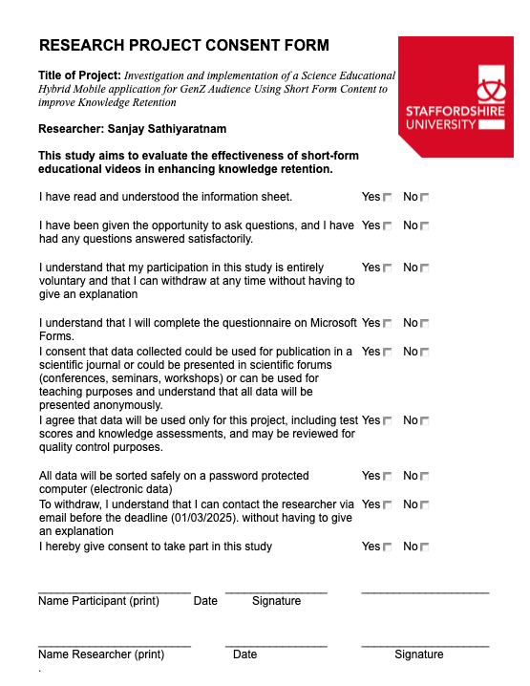

9.3 Information Sheet
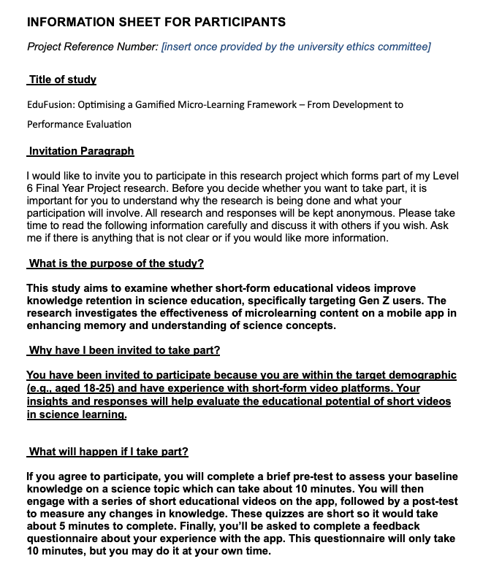

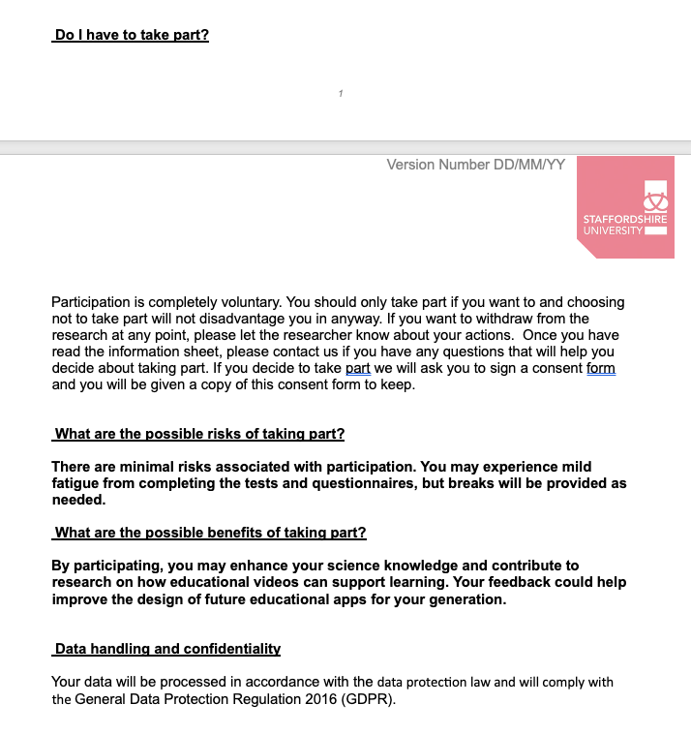

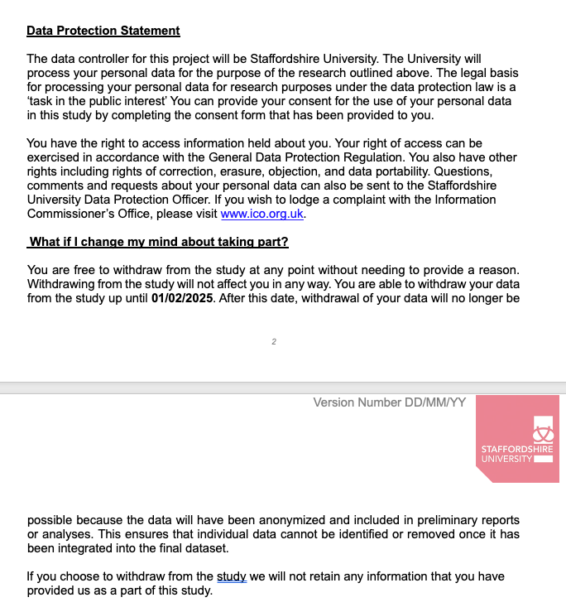

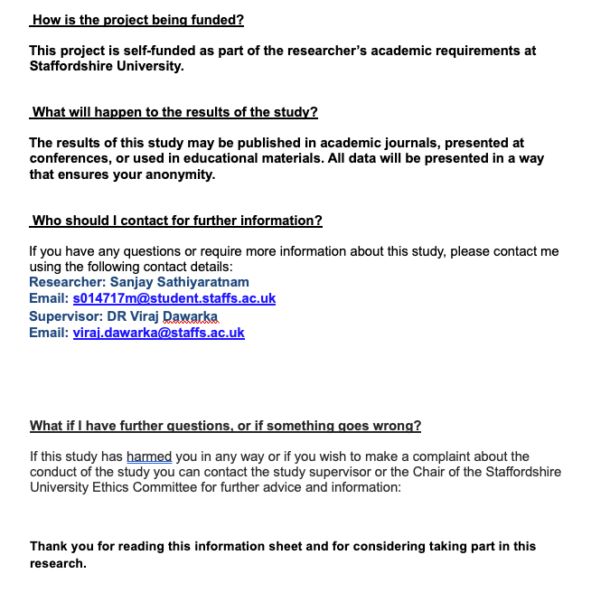

9.4 Risk Assessment
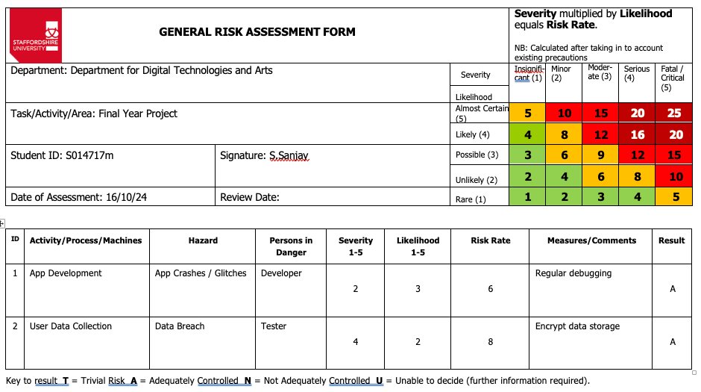

9.5 Ethics Form
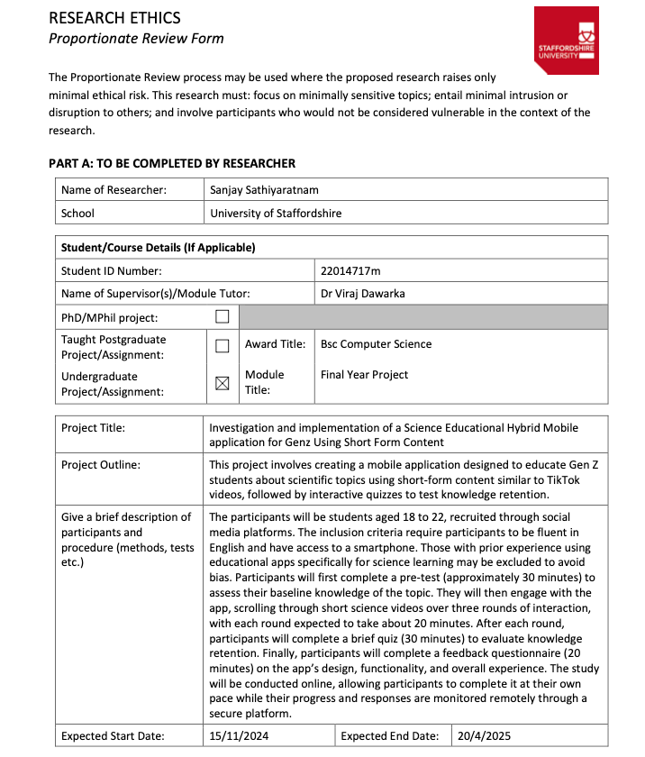

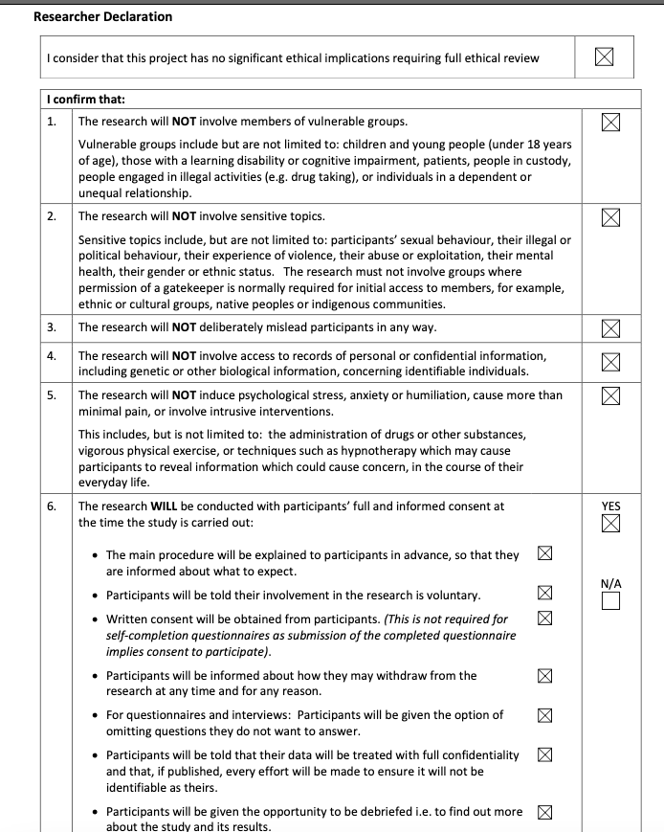

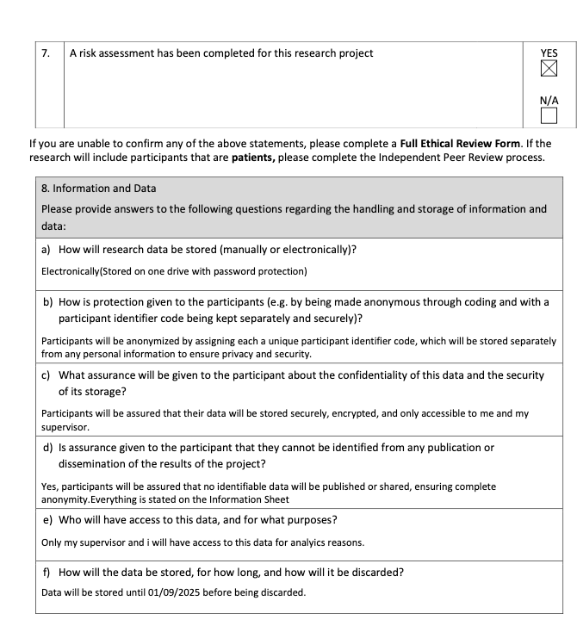

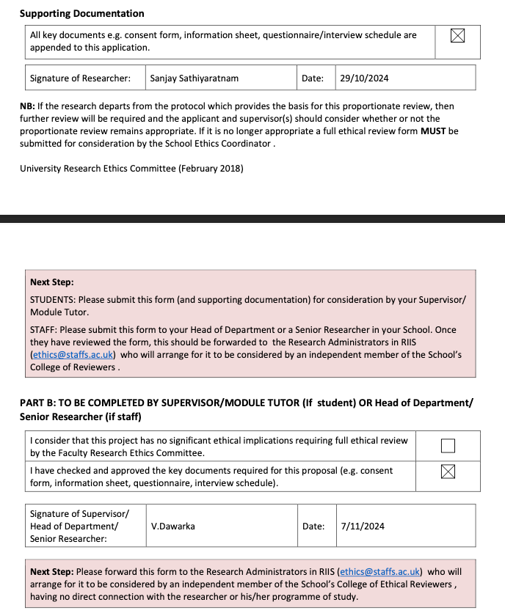

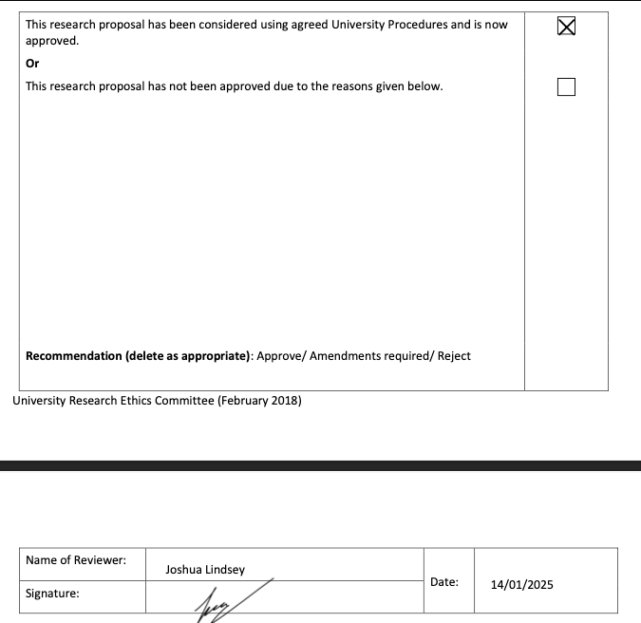

9.6 User Feedback Form
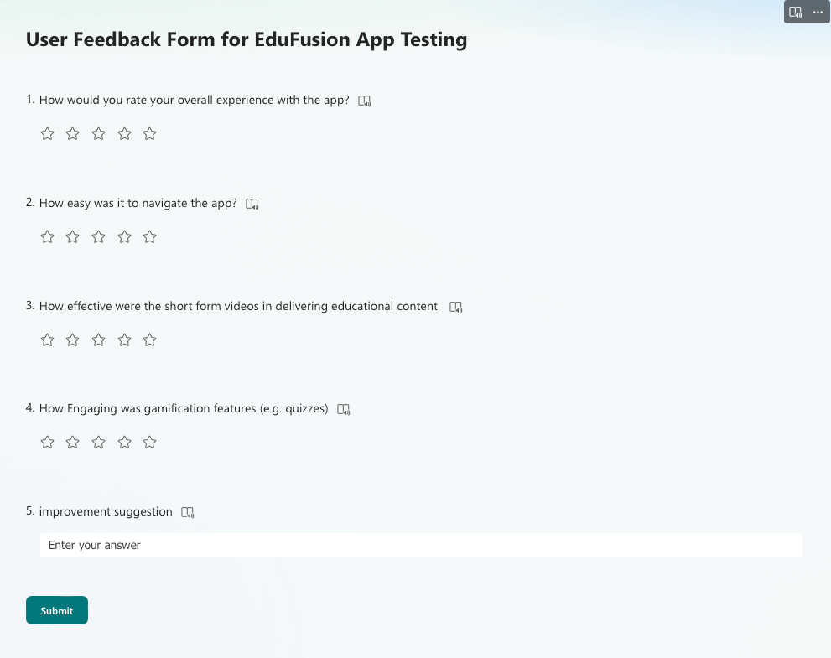

9.7 Baseline Test, Post App A and B Test
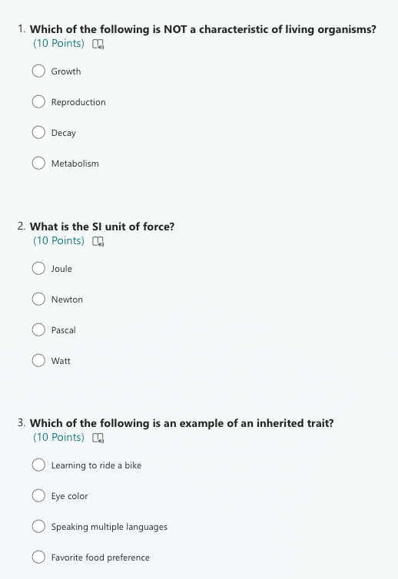

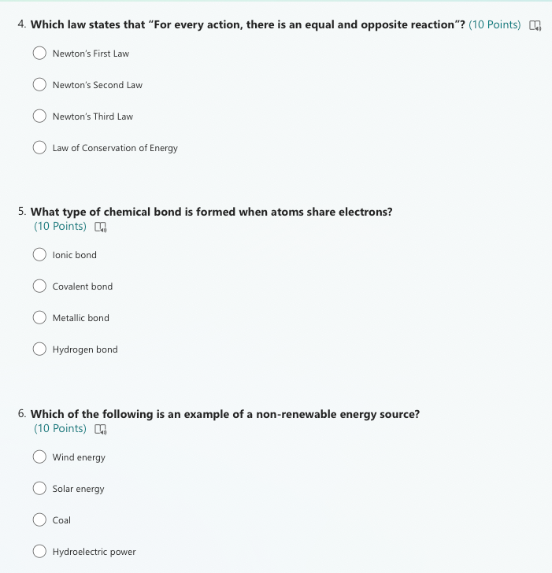

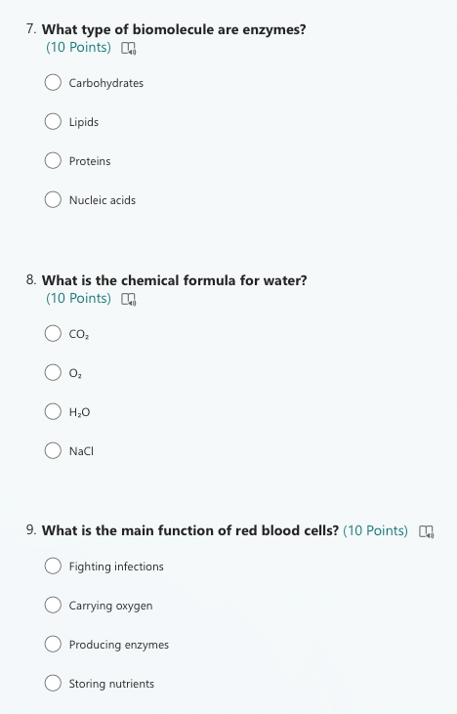

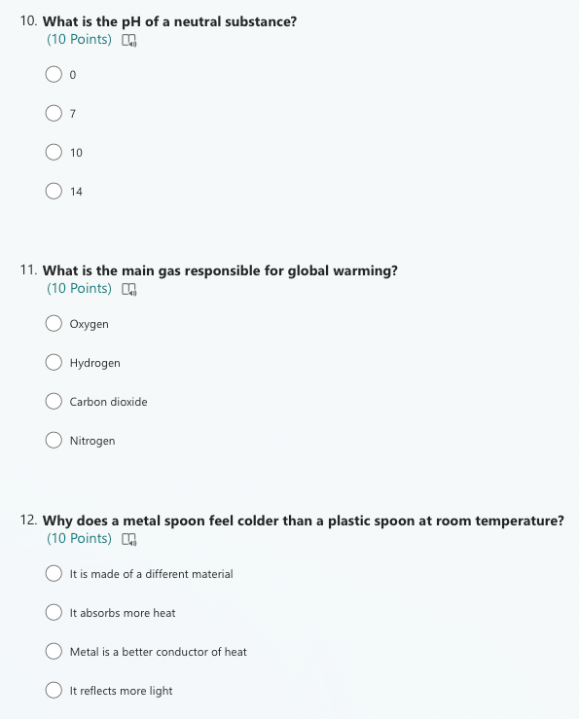

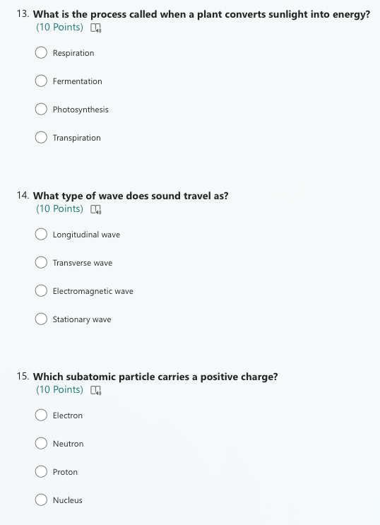

9.8 Full Length Code





