Final Year Project
ESPO60014
Dissertation
“Pixels to Perfect:
The Emergence of a Multi-Million Dollar Virtual Economy in Counter-Strikes”
Author: Haowei Wang
Student Number: 2101323
Supervisor: Cameron Vanloo

Contents
Abstract 3
Introduction 4
Literature Review 6
Luxury 9
Initial Stabilisation Period 10
Price Decline Period 12
Price Recovery Period 14
Butterfly Knife Result 14
High End 15
Before Counter-Strike 2 16
Counter-Strikes 2 Launch 19
Post Counter-Strikes 2 Launch 20
Printstream Result 21
Affordable 22
Before Counter-Strike 2 Launch 23
Counter-Strikes 2 Launch 25
Post Counter-Strikes 2 Launch 27
AK-47 Neon-Revolution Result 28
Budget 29
Conclusion 31
Reference List 33
Appendix 37

Abstract
This study examines the emergence and dynamics of a player-driven virtual economy for in-game “skins” in Counter-Strike, treating these digital items as tradable assets whose prices fluctuate similarly to stocks. Drawing on microeconomic theory—supply and demand, price elasticity, sunk-cost bias—and empirical data from four representative skins across Luxury, High-End, Affordable, and Budget tiers, it analyses their price movements over the six-to-seven-month transition from Counter-Strike: Global Offensive to Counter-Strike 2. Three distinct phases emerge: an initial stabilisation with modest gains (e.g. Butterfly Knife ROI +16.5 % vs. 1.5 % bank rate), a sharp price decline upon CS2’s release (e.g. −32 % crash), and a partial recovery as bugs were fixed and player engagement rebounded (e.g. +13.9 %). Luxury and High-End skins yielded the most significant absolute returns and losses, while lower-priced items showed lower volatility but delivered significant pre-launch ROI (e.g. +51.7 % for AK-47 Neon-Revolution). Behavioural factors—hype, sunk-cost fallacy, service-medal incentives—drove demand spikes disconnected from gameplay value, triggering supply shocks analogous to panic selling in financial markets. Findings highlight both the revenue potential and regulatory challenges of unregulated digital-goods markets. The Counter-Strike skin economy thus provides a natural laboratory to test market-microstructure theories in virtual settings. It offers lessons for platform governance, dynamic pricing, and player protection in free-to-play ecosystems. ​

Introduction
Counter-Strikes have been considered one of the most successful competitive first-person shooting games. It has also been famous for having a unique system of skins and content in the game. Existing free-to-play esports games derive most of their primary revenue from selling in-game skins (Davidovici-Nora, 2013). For example, Valorant's primary revenue comes from selling passes and skins. However, in the case of these typical competitive games, when a player purchases a skin, the skin belongs to that player permanently, and the player cannot resell or transfer it to another player. This will be a sunk cost for many gamers. Some players still experimenting with the game or have not decided to play it for a long time will not consider buying skins or value-added services (Abidin et al., 2024). This will be part of the loss for game publishers. Counter-Strikes, on the other hand. Almost all the skins will be available at random by opening loot boxes. And every skin in Counter-Strike is unique. It also provides the feature of trading and selling skins between players. The publisher, Valve, has not determined any price for any skins. It uniquely formed a free market of in-game items. A free market is an economic system in which the forces of supply and demand determine the prices of goods and services without significant government intervention, such as price controls, subsidies or regulation. In a free market, private individuals and firms decide production, distribution and consumption based on their interests and market competition (Tomasi, 2013). Therefore, the player will determine the skin prices for Counter-Strike. Due to the tradable feature of Counter-Strike, it became a unique electronic currency. The player can trade or sell at a later date. As mentioned above, the skins are not sold directly by Valve, but rather by the player who opens the Loot boxes and sells them on the Skin Marketplace at their price. There are several well-known marketplaces for trading skins, such as NetEase's Buff Marketplace and Steam's Marketplace. Therefore, the price of the skins will change according to the market. This price fluctuation is very similar to the fluctuation of stocks. This research will evaluate the factors that affect the price of skins, including the style, availability. Compare the six-month data period of Counter-Strike's transition from Global Offensive to Counter-Strike 2. Compared and evaluated the Counter-Strikes market to the deposit interest rate. The differences and similarities between the two economies.

Literature Review
The Counter-Strike skins market is a striking embodiment of free-market principles, where supply and demand dictate prices, and participants engage in trading, investing, and speculating. It sets the economy apart in its resemblance to a traditional financial market. Players and investors can buy, sell, and trade skins through platforms like the Steam Community Market or third-party websites, and prices will generally be stable and predictable.
Because skins produced through loot boxes are random, their rarity and aesthetic appeal drive demand, creating an environment where some skins are valued at tens of thousands of dollars. This market thrives without centralised control, making it a living experiment in free-market dynamics.
However, this unregulated economy is not without controversy. Concerns about gambling, fraud, and market manipulation overshadow its legitimacy. Skins are often used as currency on online gambling platforms, which poses ethical and legal challenges. In addition, the speculative nature of skin trading raises questions about market sustainability and risks for participants, especially young players who lack financial knowledge. In addition, some special events may cause sudden turbulence in the market and affect the market's stability, such as the launch of a new version, changes to the details of the game screen, or even the deletion of a skin from the game.
The free market for Counter-Strikes skins has been a double-edged sword for Valve, bringing significant benefits and major challenges. On the positive side, the marketplace has generated considerable revenue through transaction fees and in-game purchases. Valve made over one billion in revenue by players unboxing loot boxes and trading skins through the Steam Community Market (Taylor-Hill, 2024). It also increased player engagement and enhanced the visibility and appeal of the game, especially for players who do not engage in competitive gaming, such as players who are only interested in skin collections or traders (Alić and Ivan Duman čić, 2024). It has also fostered a secondary ecosystem of trading platforms and analytical tools. However, Valve faces challenges such as legal and regulatory scrutiny due to the skin's association with gambling, market manipulation and fraud (Zendle and Cairns, 2018).
The theory of supply and demand is the foundational pillar of microeconomics. This theory is defined as how market prices and quantities of goods are determined through the interaction of consumer behaviour and producer incentives. Demand is influenced by factors such as income levels, substitutes and complements, preferences and expectations, which affect the price consumers are willing to pay for a good. In the Counter-Strike skin market, demand is influenced by whether the skins look good, Valve's updates to game balance, the public's choices, and the choices of professional players.
On the other hand, supply responds to production costs, technological advances, input prices and competitive dynamics. In Counter-Strike, the impact of supply is primarily seen in whether skins are being opened from Loot Boxes and whether sufficient quantities are being sold on the market. The amount sold, in turn, depends on the impact of game updates on balance, differences in in-game effects, and whether or not the general public seeks out and spurns a particular skin.
Equilibrium prices appear where supply and demand intersect, balancing market efficiency. Elasticity further refines this framework: price elasticity of demand measures consumer sensitivity to price changes (e.g. inelastic demand for necessities such as energy versus elastic demand for luxury goods). In contrast, price elasticity of supply assesses the ability of producers to adjust output. Modern extensions integrate behavioural economics, recognising patterns of non-essential demand driven by psychological, brand and social trends - evident in the luxury market and e-commerce - and Marcuse's critique of "false demand" (Fitzgerald2, 1985). Retail strategies are increasingly capitalising on these insights, with live commerce, for example, using real-time interactions to stimulate impulse purchases. Whilst the robustness of the theory is demonstrated by its adaptability to different environments ranging from traditional price determination to digital markets, gaps remain in addressing systemic uncertainty and ethical dilemmas. Supply and demand theory remains a versatile analytical tool, which in this thesis study interprets Counter-Strike's market laws.
Individuals commit the sunk cost fallacy when they continue a behaviour or endeavour due to previously invested resources—time, money, or effort—that cannot be recovered. This bias, first formalised by Arkes and Blumer (1985), is related to loss aversion and status quo bias, leading decision-makers to irrationally factor irrecoverable past costs into current choices (Zendle et al., 2019).
Digital goods create novel platforms for the sunk cost effect. Once players spend money or time acquiring virtual currencies or items, they feel compelled to continue paying to “make the purchase worthwhile”. Studies of microtransaction engagement show that higher expenditure correlates with increased risk of gaming and gambling disorder, suggesting sunk costs can contribute to addictive behaviours in gaming environments (Tomić, 2017). Research into free-to-play models finds that players invest time to unlock battle passes, only to feel regret if they fail to complete them, triggering sunk cost and FOMO dynamics that boost spending. Like gambling mechanisms, loot boxes similarly leverage intermittent rewards to capitalise on prior investments (Joseph, 2021).
Owning skins creates an “investment” in a player’s digital identity; abandoning a game means “wasting” that investment, so players persist even when enjoyment wanes. In high-stakes environments like CS: GO skins gambling, sunk costs amplify risk-taking. Because the price of their skins is generally higher than other games, players will react more strongly when losses occur. (Hardenstein, 2017).

Luxury
Starting with luxury items in Counter-Strike. Luxury goods are products or services that are not necessities of life, but are highly attractive in a particular culture or society, usually reflecting rarity, exclusivity, superior quality and high prices, and are status symbols that reflect the consumer's aspirations and social status (Dhaliwal, Singh and Paul, 2020). In economics, luxury goods are defined as those for which demand grows more than proportionately with income, indicating a high income elasticity of demand and distinguishing them from necessities for which demand grows less or disproportionately with income. This high income elasticity makes luxury goods susceptible to economic fluctuations, with consumption rising sharply in boom times and falling more sharply in downturns (Ghosh and Varshney, n.d.). Some luxury products exhibit Veblen characteristics, where higher prices can paradoxically enhance desirability and perceived value, reinforcing their exclusive appeal (Trigg, 2001).
Among the in-game items in Counter-Strike, the luxury category includes those skins that are pretty expensive. Most players and even seasoned veterans who have been playing for a long time will not choose to buy them. This is because the price is much higher than other in-game skins and far exceeds the value of an in-game skin. For example, the most expensive single skin in Valorant is around £54 (Valorant Wiki, 2025). In Counter-Strikes, individual skins in the Luxury category usually cost £1,000 or more. In this study, the price variation of the Butterfly Knife will be examined over the bounded study interval.

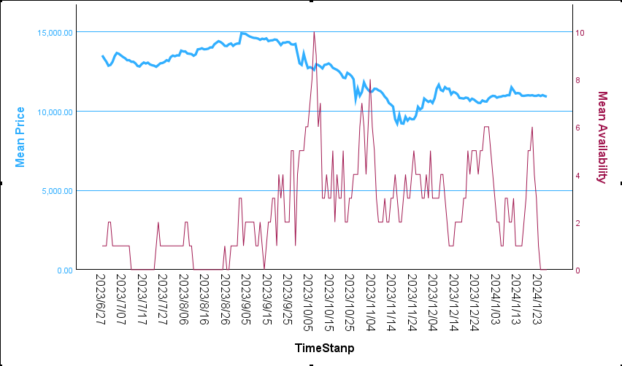
(Image 1: Butterfly Knife Price to Availability Chart)
This chart shows how the Butterfly Knife's price has changed over the seven months from 27 June 2023 to 27 January 2024 and how the number of units on sale in the Buff market has changed. Its price starts at 13,500 RMB. The price remains stable during the initial three months and rises slowly overall. The amount available for sale on the market remains relatively stable, with gaps in the market being filled daily (initial stabilisation period). From the 29th of September onwards, the price started to drop significantly, and the number of units available on the market began to increase and reaching a peak. This downward price trend continued for almost two months until 25 November (Price Decline Period). In the following month or so, the price of the Butterfly Knife slowly recovered and levelled off after January 2025 (Price Recovery Period).

Initial Stabilisation Period
During the initial three months, the price of the Butterfly Knife rose slowly in small increments, with a low of 12,779.50 RMB on 23 July and a high of 14,888.00 RMB on 2 September. The difference between the high and the low was 2,108.05 RMB if a player buys the skin at the highest point and sells it at the highest point. According to the Return on Investment formula (See Appendix), ROI = [(14888.00 - 12779.50) / 12779.50] x 100 = 16.5%. The player's optimal ROI was 16.5% over the three months. Whereas China's annual deposit rate for 2023 is 1.5% (World Bank Open Data, 2025), this gives a rate of about 0.125% per month. Using this data, we can calculate that if the player does not buy the Butterfly Knife, but deposits the cash in the bank at the lowest point, they will have suffered a profit of 12779.50 x 0.125% x 3 = 47.92 RMB. The calculation based on the ROI formula is 47.92 / 12779.50 = 0.375%. Compared to the 16.5% profit on the Butterfly Knife, this is a huge difference, and players will reap huge benefits if they can purchase skins during this period. It's even higher than the interest rate of depositing cash in a bank for a whole year.
During this period, Counter-Strikes did not have any significant events, so there were no factors that could cause the market to change drastically, and its price and the number of units available on the market remained stable. The relatively high starting price was due to Valve's announcement of a major update to the Counter-Strikes series in March of the same year, calling Counter-Strikes: Global Offensive, which had been in the works for over a decade, Counter-Strikes 2. The update would update the underlying gameplay engine, which would be released in the same year. The update will update the underlying game engine, and judging by the gameplay footage released by Valve, the new game will have huge graphical advancements that will impress the in-game skinning effects, which result in the game's skins potentially looking even better. In the meantime, since the game has not been officially launched and only some of the users who have been sampled can test it (mainly professional players), most players are still unable to experience what the new version of the game will change, so the price of the skins is being slowly raised by the heat of the players' imagination. At the beginning of September, Valve massively opened the beta test to players (Counter-Strikes, 2023; Stubbs, 2023). Because of Valve's poor official anti-cheat, most people don't play official ranked, however, the requirement of the test led to a massive influx of players back into the game, so the demand for skins spiked in early September, creating a taste of demand outstripping supply in supply and demand, leading to the price of skins going up a lot in a short period. After players started receiving invitations, they entered the game and found that the gameplay was not as stunning as they had imagined, and there were quite a lot of bugs in the game, which led to the price falling after a short period of soaring. The fall was not violent, because it was still only a test phase, Valve officials also in the test period many updates to the game to present a better effect and fix the bugs, in each update the impact of the skin has changed, so players and the market still think that in the official launch of the game, the effect of the game will be significantly improved.

Price Decline Period
The Butterfly Knife's price began to collapse quickly during the falling period. The highest price was on the day the period began, 29 September, at 13,598.50rmb, and the lowest was near the end of the period, around 16 November, at 9,200rmb. The difference between the highest and lowest was 4,398.50 RMB. Since the trading platform does not provide short-selling operations, players buying Butterfly Knives during this period will show a loss. If the player bought at the highest price and sold at the lowest price. According to the ROI formula, ROI = [(9200.00 - 13598.50) / 13598.50] x 100 = -32.3%. The player's maximum loss rate during this period is 32.3%. The loss rate is staggering and nearly double even the maximum profit rate of 16.5% for the first three months of the steady up period.
The biggest news during this period was the official release of the new game Counter-Strike 2, which Valve made free and open to all on the 27th of September (Counter-Strike, 2025). This was supposed to be good news and an opportunity to stimulate the market, as when there is a new product, a lot of buzz and participation will boost the market and make it more valuable (Ottum and Moore, 1997). However, many players entered the game and found it virtually indistinguishable from the previous beta. Because almost all Counter-Strike loyalists were allowed to test it during the extensive beta in September. As a result, all the heat has been raised to a pretty high level during that time. Gamers expected that when the official game was released, the bugs in the beta would be gone, and it would at least continue to be of the same standard as its predecessor, Counter-Strike: Global Offensive, and better (Gold and Wolfe, 2011). However, this has not been the case, and instead, the game is still riddled with bugs, and the graphics have not been improved as much as in the beta (theScore esports, 2024a). This triggered disappointment among gamers, leading to a market crash and a price drop. To add insult to injury, Valve's new Counter-Strike release differed from the past. In the past, Valve would have had both old and new Counter-Strikes on the market simultaneously, with players being able to choose which version of Counter-Strikes they wanted to play. For example, during the Counter-Strikes: Source period, when the game was first released, Valve operated both Counter-Strikes, so third-party world tournaments could choose which version of Counter-Strike they wanted to play (Slade, 1987). This was also since the early Counter-Strike: Source was poorly received, with many bugs everywhere. As a result, even the older versions of Counter-Strike were played by more people than the newer versions in the early days. After a long polishing, the new version was improved and players started to accept it. However, the pressure of running two games simultaneously is greater than just focusing on the new version. And because more people choose to play the old version, the new version doesn't have enough players to test it and give Valve feedback on where to make improvements (theScore esports, 2024b). For these reasons, Valve announced at the time of Counter-Strike 2's release that the game would be an ‘update’ rather than a new game. That Valve would shut down Counter-Strike: Global Offensive's servers immediately and ‘forcing’ players to play the game, which was riddled with bugs (theScore esports, 2024b). This has led to discontent amongst players, with many opting out of the game, and has led to players who previously owned skins selling them for cash. This led to an increase in the marketable quantity (Supply) of Butterfly Knives, and when the supply increased, the price began to drop rapidly to stay relative to the demand. Merchants who only buy skins or players who aren't loyal see the price of skins start to drop dramatically, which increases the risk of owning a Butterfly Knife, which also creates panic amongst players, which leads to more players starting to sell their Butterfly Knives. This created a nasty cycle, leading to the Butterfly Knife skin dropping by almost 35% in two months, as presented in the data.

Price Recovery Period
Since December, the game has been out for almost three months, and Valve has been updating the game to fix bugs left over from the official release, nearly every two or three days. It's still imperfect, but at least Valve has been paying attention to the community. Pros and loyal players continued to play the game, which allowed player attrition to decrease and eventually stabilise slowly. And in early December, Valve announced that access to 2023 service medals would end at the end of the year and open up a new 2024 service medal. This caused players who hadn't yet earned their 2023 service medals to start returning to the game, as they do every year, with a group of players returning to the game at the end of the year to try and get that year's service medals at the last chance. This has caused the skin market to slowly pick up, as the demand for skins is gradually rising due to the return of players, yet the supply is slowly decreasing, and thus the price of skins is increasing progressively.
The lowest price point occurred on 27 November 2023 at 10094.00 RMB. The highest point was on 9 December at 11500.00 RMB. The difference between the highest and lowest was 1406 RMB. according to the ROI formula ROI = [(11500 - 10094) / 10094] x 100 = 13.9%. If the player's maximum return during this period is 13.9%. This is also much higher than the annual Chinese deposit rate of 1.5%. However, if it is during the last month, the price movement is relatively smooth, the difference between the highest and lowest is within 500 RMB, and there is only a sudden rise in the middle of the month, while the overall trend is almost the same.

Butterfly Knife Result
Looking at the complete 7-month timeline, if a player buys and sells the skin, they still lose almost 2500 RMB, about -18.5% by the formula. Therefore, the overall investment in the skin during these 6 months is a loss. The loss rate will increase further if the skin is sold in the mid-term.

High End
High-end skins are categorised at the relatively high end of the game in relative price, but not so much that they are the choice of only a few players, as skins in the luxury category are. These skins have a relatively wide range of prices depending on the wear rate, but usually these skins are priced between £90 and £300. In this range, regular players or those who don't play Counter-Strike regularly may not choose to. However, some loyal players will go for these skins. At this price it will only cost slightly more cash for many people to purchase and is only marginally more expensive compared to other games, and because of the nature of Counter-Strikes skins being available for sale, this results in the potential to end up spending the same or even less than the most expensive skins in other games. The skin chosen for this study in this category is the M4A1-S Printstream. The effects and appearance of this skin have always been a favourite amongst players within the game, and as such, it is a very popular skin and is sold in large quantities on the market.
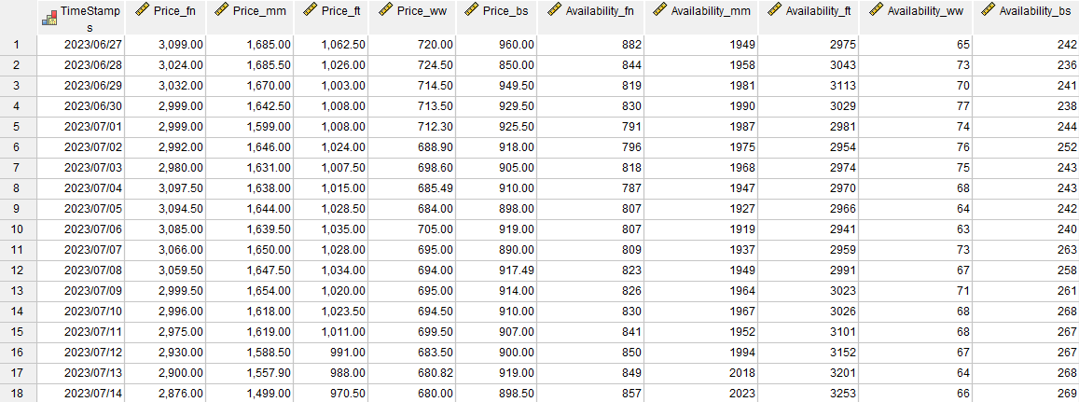
(Image 2: M4A1-S Printstream Data Sheet)
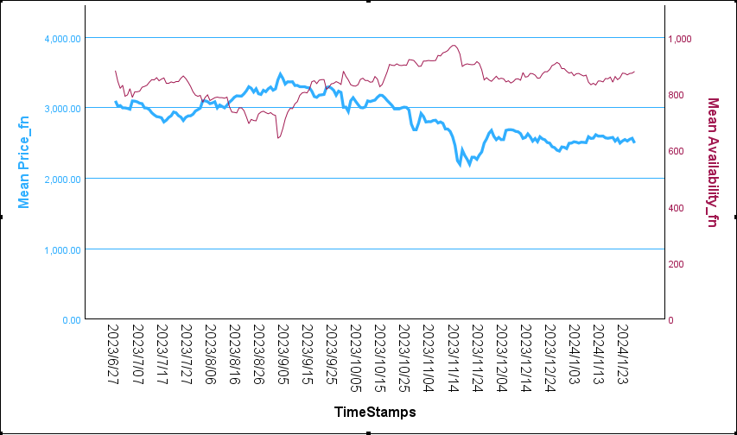
(Image 3: M4A1-Printstream Factory New Price to Availability Chart)
As with the Butterfly Knife before it, the data graph shows a curve of price movement relatively consistent with the Butterfly Knife, so it can also be broken down into three time periods, three months before the 27th of September before the new game launches, 27th of September to the end of November before the new game launches and 12th with the beginning to the end of the post-launch period. (See all charts for M4A1-S Printstream in Appendix)

Before Counter-Strike 2
During the pre-launch testing phase of Counter-Strike 2, players who were able to test it noticed that Printstream's skins in the new version were very different from those in the old version (see pictures). In the old version, Printstream had a colourful and glowing look, with a unique material that made it look great and was highly sought after by many players. However, in the new version of the test, the impact of the quality of the image has caused the colourful glow to almost disappear, replaced by a simple bright white with a slight glow. This makes players feel that the quality of the skin has regressed. As a result, more players were sold in the first two months of the data, fearing that the official version would remain the same as the beta. The increase in the number of skins on sale led to a drop in price. However, before the launch, the cost of the skins briefly rebounded as a large number of users qualified for the beta and the number of players increased, leading to an increase in demand for the skins. And there are rumours in the community that in the official version, Printstream will return to the old version of the takeaway, which in the month before the release of the price had some increase (Reddit.com, 2023).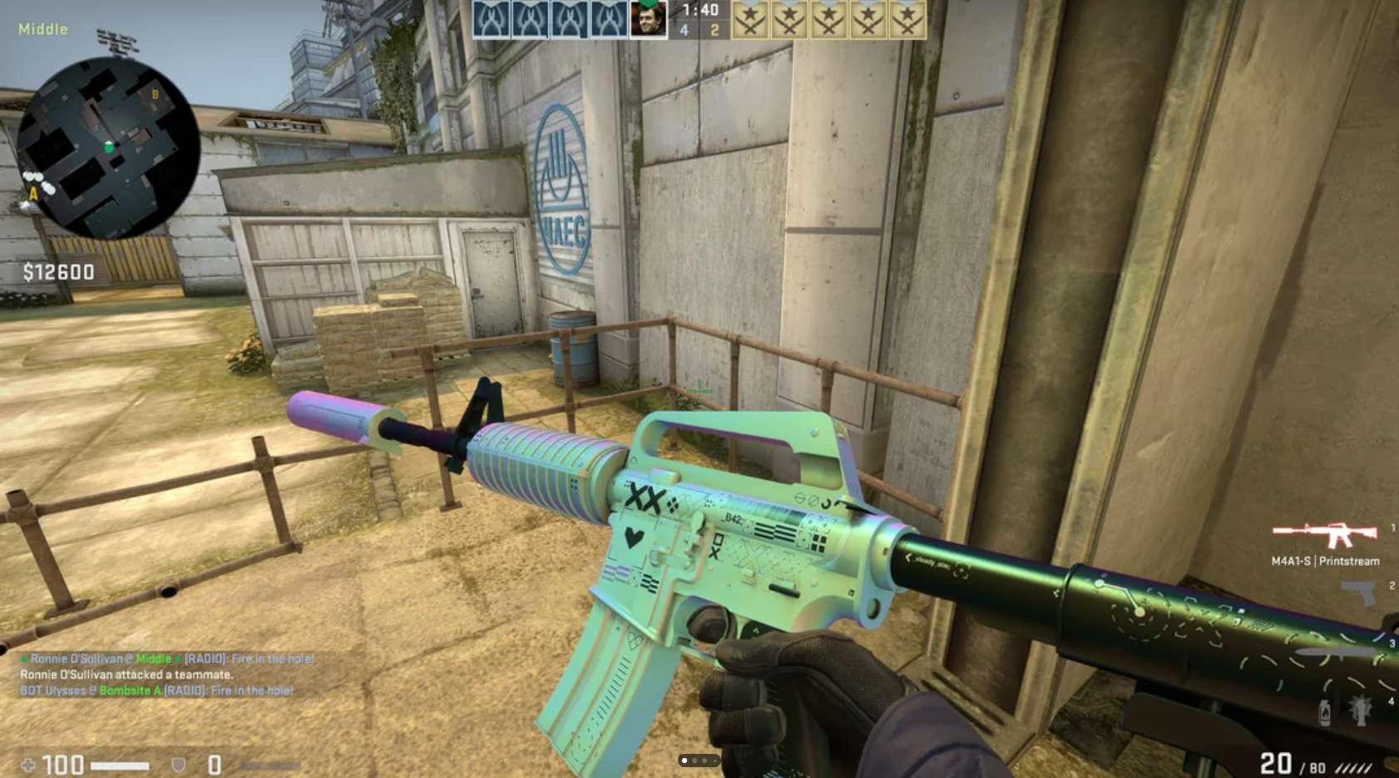
(Image 4: Counter-Strikes: Global Offensive M4A1-S Printstream)
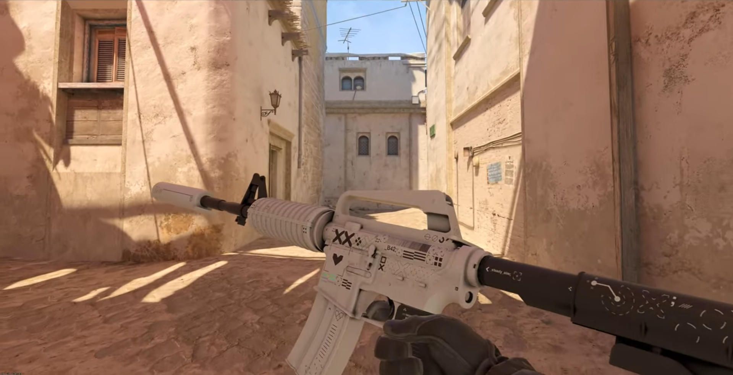
(Image 5: Counter-Strikes 2 M4A1-S Printstream)
Because Printstream's skins are divided into five different types of wear, each of which has a different price, at the start of the data, Factory New was priced at 3,099RMB, Minimal Wear at 1,685RMB, Field-Tested at 1,062.50RMB, Well-Worn at 720RMB, Battle-Scarred is 960RMB. from the data it can be seen that its price removes the Battle-Scarred category and its price decreases according to the increase of wear and tear, which is the player's opinion on whether it seems to be high priced within the game or not. Also, excluding Well-Worn and Battle-Scarred, the pricing aligns with the supply and demand model, where Factory New is less available and thus more expensive. The exception to this is Well-Worn, which has the least available on the market; however, because of how Printstream skins look in-game, Well-Worn seems very rough, leading to players not liking the look, resulting in the lowest priced skins. Conversely, Battle-Scarred has a segment of players who enjoy the ultra-high wear skins, thus pricing them a bit higher than Well-Worn, but this group is still niche, so the price still doesn't compare to the better wear.
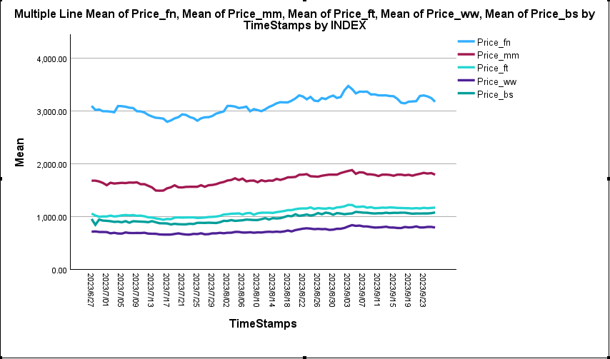
(Image 6: M4A1-S Printstream Price Change from 27/6/2023-26/9/2023)
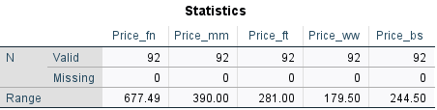
(Image 7: M4A1-S Printstream Price Highest and Lowest Difference from 27/6/2023-26/9/2023)
The data shows that the lower the starting price of the skin, the smaller the price difference during the price change. If the player buys at the lowest point and sells at the highest point, through the ROI formula, the return rate of FN is 24%, MM is 26.1%, FT is 29.7%, MM is 27.0%, and BS is 28.8%. Regarding ROI, WW is the best, although because of its small base, if the player buys several WW with the same amount of money used to buy FN, the overall return in cash will be higher than FN. Compared to the deposit rate in China of 1.5%, investing in Printstream during these three months will be extremely rewarding.

Counter-Strikes 2 Launch
When Counter-Strikes 2 was released, players found that the effects of Printstream within the game had not improved and remained the same as it was in the beta, which caused players to lose patience with Valve and start selling off their hands on Printstream, which led to an increase in the number of on-sales on the market, and thus the price began to collapse.
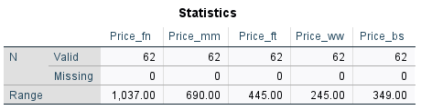
(Image 8: M4A1-S Printstream Price Highest and Lowest Difference from 27/9/2023-26/11/2023)
The data shows that if a player buys at the highest point and sells at the lowest point, the ROI formula gives a return of -32% for FN, -37.7% for MM, -37.4% for FT, -30.9% for MM and -32.2% for BS. Where FT is the option with the least loss, however, due to the higher price for lower-worn skins leading to a larger base, if a player buys a single Printstream skin with better wear, the more cash will be lost compared to worse-worn skins. During this period, Printstream prices have been trending downwards and have all been above a 30% loss.
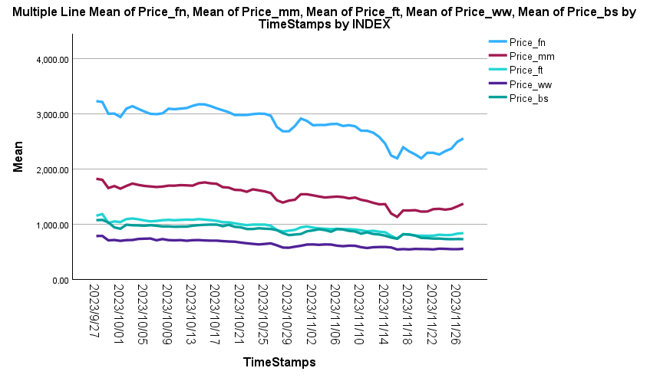
(Image 9: M4A1-S Printstream Price Change from 27/9/2023-26/11/2023)

Post Counter-Strikes 2 Launch
Two months after the release of Counter-Strike 2, players slowly began to return due to Valve's extensive fixes to the game and as the end of the year approached, allowing the year's service medals to come to an end, causing Printstream's price to pick up slowly. Also, while the time gets close to Christmas and New Year, players are starting to have some spare cash and considering buying some festive gifts. This is one of the reasons why prices are bouncing back. After a brief rise, however, its price eventually levelled off with almost no change.

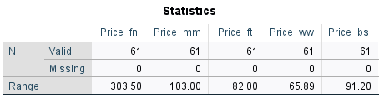
(Image 10: M4A1-S Printstream Price Highest and Lowest Difference from 27/11/2023-27/1/2024)
The data shows that if a player buys at the lows and sells at the highs, the ROI formula calculates a return of 12.7 % for FN, 7.7 % for MM, 9.8 per cent for FT, 12 % for WW and 12.5 % for BS. Of these, MM is the least profitable option. However, due to the higher price and larger base of the less worn skins, players who purchased FN returned the most cash due to the higher skins cost, even though the overall return was only about 12%.

Printstream Result
Looking at the complete 7-month timeline, if a player buys and sells a skin, FN will lose 599 RMB with an ROI of -19.3 %. MM will lose 325 RMB with an ROI of -19.3 %. FT will lose 193 RMB with an ROI of -18.2 %. WW will lose 148 RMB with an ROI of -20.6 %. BS will lose 180 RMB with an ROI of -18.8%. Therefore, the overall investment in the skin during these 7 months is a loss. And the losses are not small, nearly 20%, and will increase further if the skin is sold in the mid-term. This has this much to do with Valve's use and design of the new game engine, and the fact that players have little way of knowing about updates until they are available, which leads to players not being able to make predictions about new releases of Counter-Strike to make risk assessments.

Affordable
Affordable skins are the most significant component of the Counter-Strike skin market. They are the skins that most players primarily buy and trade, which makes the category's daily trade volume and availability on the market huge. Affordable skins usually range between five and thirty pounds (varying wear and tear for different skins). This price is similar to other competing games, such as Valorant. This makes it more affordable and accessible to most players. And players don't need to worry too much about the sunk costs they incur (Arkes and Blumer, 1985). Many new players have reported purchasing skins early in the game and realising that the skins even earned them money when they quit the game after a period of play (Reddit.com, 2023b).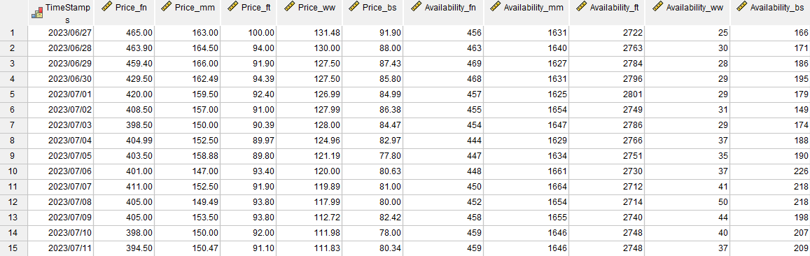
(Image 11: AK-47 Neon-Revolution Data Sheet)
This study has chosen to look at the so-called AK-47 Neon-Revolution in this category. This skin has received many positive reviews in the game and has a look in line with popular aesthetics, a skin many new players may have purchased on their way to buying skins.
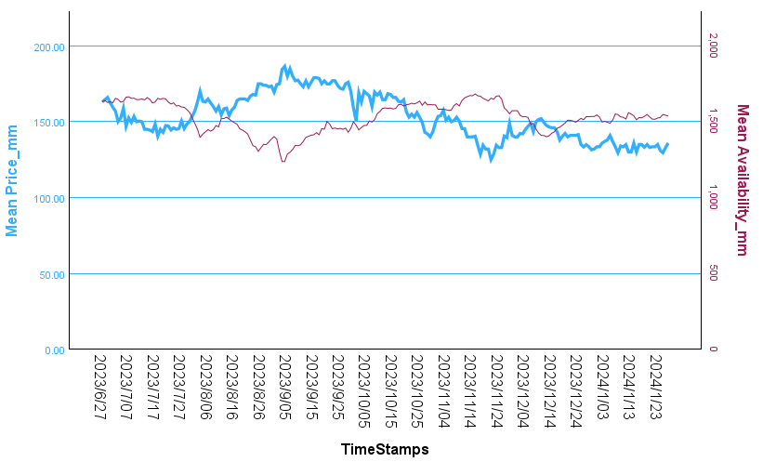
(Image 12: AK-47 Neon-Revolution Minimal Wear Price to Availability Chart)
(See All Chart Related to AK-47 Neon-Revolution in Appendix)
The study continues to be divided into three periods to analyse price trends, rates of return, and the reasons for price changes.

Before Counter-Strike 2 Launch
In the first month, the skin had a slight dip in price, as it was in the early days of Counter-Strikes 2 testing, and those who were able to get into the game realised that with the changes to the new engine its actual look and feel wasn't too different from the old version, with similar effects. This led to an increase in the amount available on the market. As time progressed, more players could access the new version of the game, more players began to purchase the skin, and the availability in the market was slowly decreasing, leading to a slow increase in price. It wasn't until early September that Valve massively opened the beta to almost all players. This led to a further influx of buyers within the market, causing the market to reduce the amount available for sale further and thus the price to peak. As the release date of the new version of the game approached, players' expectations for the official version also caused players to buy skins in the hope that they would increase.
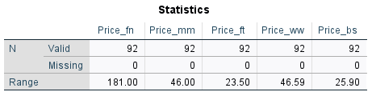
(Image 13: AK-47 Neon-Revolution Price Highest and Lowest Difference from 27/6/2023-26/9/2023)
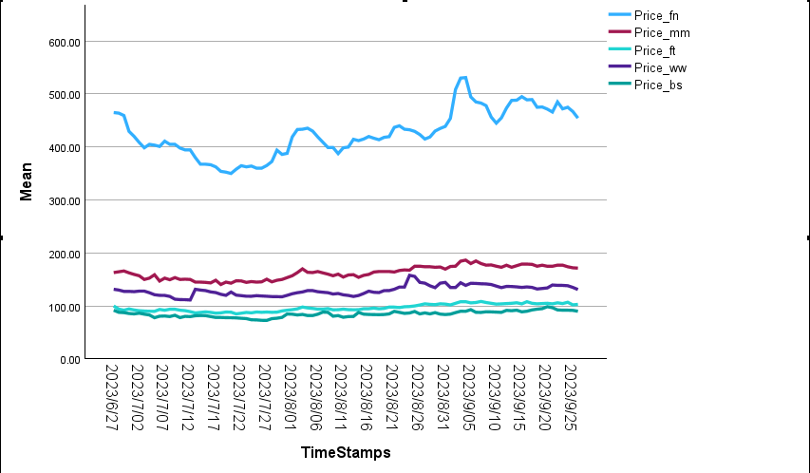
(Image 14: AK-47 Neon-Revolution Price Change from 27/6/2023-26/9/2023)
The data shows that if a player buys at the lowest point and sells at the highest, the ROI formula calculates a return of 51.7% for FN, 32.7% for MM, 27.6% for FT, 41.9% for WW, and 35.6% for BS. Of these, FT was the most profitable option; however, the overall prices for this skin are all low (the average price for FN is only 425.5 RMB). Nearly 52% ROI if you calculate that players don't get a considerable amount of money back for purchasing a skin. However, if you look at it from an investment perspective, suppose the investing merchant is willing to spend a lot of money to buy multiple copies of this skin. The return will be very considerable. From the data, the less usable skins in the category, the higher the return (excluding WW and BS, which don't look as good as the previous three due to high wear and tear). This differs from the last High End category, where the more available skins have a higher return. This is because the skins in the Affordable category are all relatively inexpensive; for example, the most expensive FN skin only costs around 400 RMB. More players prefer to buy newer-looking skins. This leads to a high volume of transactions for skins in the FN category, thus greater price fluctuations.

Counter-Strikes 2 Launch
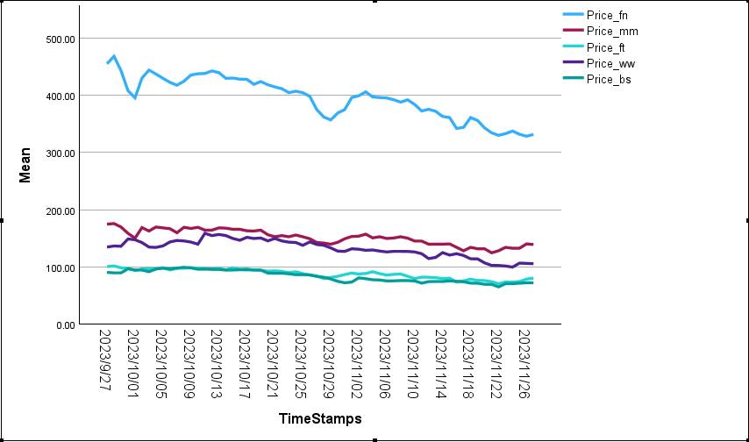
(Image 15: AK-47 Neon-Revolution Price Change from 27/9/2023-26/11/2023)
After the game's official launch on 27 September, players found that the official version of the match's skin picture effect is not too different from the previous old version and beta version, but also in line with the players' expectations of the skin. Therefore, its price did not fall off a cliff like Printstream. However, the overall trend of its price is still falling slowly, which is the same as the reason mentioned above that Counter-Strike 2's poor gameplay and many bugs led to the loss of players. Most of the players who purchased the skin were new to the game due to the latest release, while some of the older players who already had the skin in stock but hadn't sold it also contributed to the relatively slow drop in price.
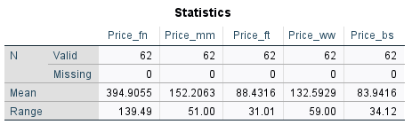
(Image 16: AK-47 Neon-Revolution Price Highest and Lowest Difference from 27/9/2023-26/11/2023)
The data shows that during the launch of the new version, if a player buys at the highest point and sells at the lowest point, the ROI formula calculates a return of -29.8 per cent for FN, -29.0 per cent for MM, -30.4 per cent for FT, -37.1 per cent for WW and -34.3 per cent for BS. Of these, FN and MM are the less loss-making options. The reason for this, as mentioned above, is that due to their higher sales volume, players are more likely to buy relatively newer-looking skins, resulting in less price fluctuation. Neon-Revolution still has a loss of almost 33%, however. At worst, this is not a good time to invest. However, because of its low price, players who routinely buy just one for everyday use do not lose too much, while investors lose much money.

Post Counter-Strikes 2 Launch
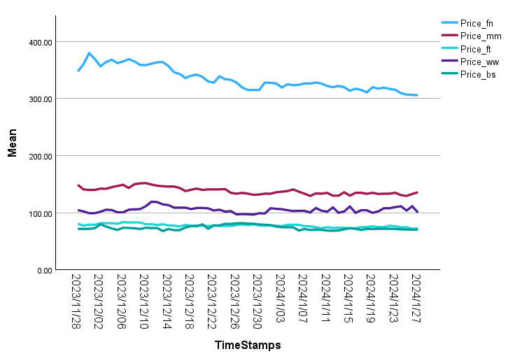
(Image 17: AK-47 Neon-Revolution Price Change from 27/11/2023-27/1/2024)
Two months after its launch, its price remains stable and slowly declines. The price has not increased as much as it did for Printstream due to some bug fixes, and towards the end of the year, due to holiday gifts. The main reason for this is that the skins are priced low enough that players can afford to buy them anytimes, unlike the Luctury and High End categories, where players have to wait until the end of the year for special holidays like Christmas and New Year's to reward themselves with the possible purchase of the skins.

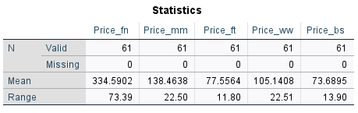
(Image 18: AK-47 Neon-Revolution Price Highest and Lowest Difference from 27/11/2023-27/1/2024)
Looking at the data, if a player buys at the highest point and sells at the lowest point, according to the ROI formula, the return on FN is -19.3%, MM is -14.8%, FT is -14.1%, WW is -18.9%, and BS is -17.0%. Among them, MM and WW had fewer minor losses. Their losses are significantly lower compared to the two months when the new version was first released, and may not be felt much by players in terms of specific cash due to the low price of Neon-Revolution.

AK-47 Neon-Revolution Result
Looking at the entire 7-month timeline, if a player buys and sells a skin, FN loses RMB 159, an ROI of -34.2%. MM loses RMB 27.02, an ROI of -16.6%. FT loses RMB 27.2, an ROI of -27.1%. WW loses RMB 30.98, an ROI of -20.6%. BS loses RMB 180, an ROI of -18.8%. WW will lose RMB 30.98 with an ROI of -23.6%, and BS will lose RMB 21.64 with an ROI of -23.6%. Therefore, the overall investment in the skins over the seven months is a loss of nearly 20 per cent. But unlike Printstream, the loss will be stoppable if the skins are sold in the medium term. This has to do with the fact that players' expectations of Neon-Revolution were already low, and it also has a lot to do with its relatively low price.

Budget
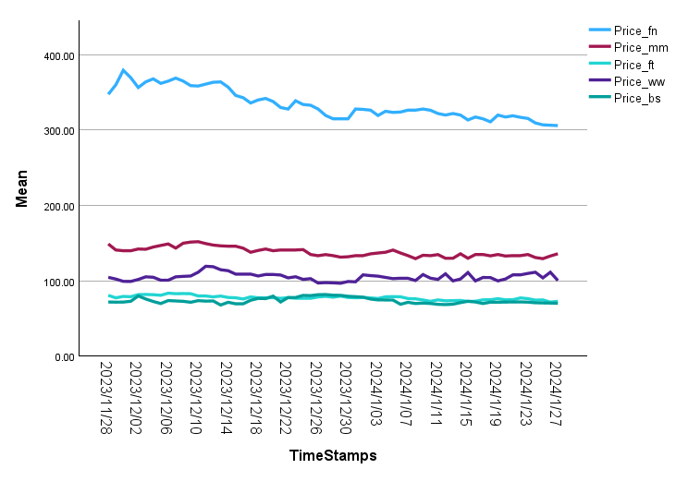
(Image 19: Tec-9 Ice Cap Price Change For 7 Months)
Cheap in-game skins are very common in Counter-Strike. Still, this category is usually not very nice or even distinctive, which leads to a rarity of players purchasing skins in this category. Only certain new players are just getting into the game and don't want to spend too much money, but don't want to play with the default skins. Skins in this category are usually under a pound, which is very cheap. The price is also very low compared to any other competing game. As a result, skins in the affordable category usually stabilise in price and don't change much. And the range of movement in the short term is likely to be less than 10p. It is impossible to visualise the reasons for the movements from the data. Short-term daily movements may be because the lower-priced option for the skin has been purchased by someone else, leaving a higher-priced option that no one will choose. So, a study of this category is only meaningful if carried out over a long period. In this study, Tec9 Ice Cap was selected as the target.
Analysing the data, Ice Cap's selling price showed an overall decreasing trend in these 7 months, which aligns with the common trend in the analysis of different skins in the previous three sections. If a player initially buys during these seven months and sells at the end, the return on investment formula calculates a return of -33.2% for FN, -40% for MM, 8.5% for FT, 20.3% for WW, and 40% for BS. This presents a very different pattern from all three previous skins. The Ice Cap for FN and MM shows a losing trend and a very high loss rate. However, from FT onwards, Ice Cap moves from a loss rate to a profit rate, and the higher the wear, the higher the rate of return for the skin. This is because players who choose skins in that flat category usually focus on whether the skin is cheap, and no longer whether it looks good or not. So, presenting players with more affordable options leads to a decrease in market availability, leading to an increase in price.

Conclusion
This study has investigated the evolution of Counter-Strike’s in-game skin market—an emergent, player-driven economy that mirrors financial markets—across four tiers of items (Luxury, High-End, Affordable, Budget) over the six-to-seven-month transition from Counter-Strike: Global Offensive to Counter-Strike 2. Several key insights emerge by applying microeconomic theory (supply & demand, elasticity, sunk‐cost fallacy) alongside empirical ROI calculations.
Across all tiers, skin prices exhibited apparent “initial stabilisation,” “price decline,” and “price recovery” phases tied tightly to major game‐version events (beta tests, full launch, service-medal cycles). For example, the Butterfly Knife (Luxury) saw a 16.5 % ROI during the pre-launch stabilisation, far outpacing China’s 1.5 % bank deposit rate, before a −32.3 % crash upon CS2’s release and a 13.9 % recovery as bugs were fixed and player engagement rebounded. This pattern closely parallels equity volatility around corporate product launches.
Higher-priced skins (Luxury, High-End) delivered the most significant absolute gains in bullish periods but also the steepest losses when player sentiment soured—e.g. Printstream (High-End) lost roughly 20 % over seven months despite short-term rebounds. Affordable and Budget skins exhibited lower volatility: Neon-Revolution (Affordable) produced up to 51.7 % ROI pre-launch but only −34.2 % overall, and budget Tec9 Ice Cap even showed positive returns for high-wear variants due to scarcity among cost-sensitive buyers. ​
Players’ expectations—amplified by the sunk-cost fallacy and hype around new releases—created demand spikes disconnected from intrinsic “gameplay” value. Upon discovering CS2’s bugs, the immediate sell-off illustrates how disappointment can trigger cascading supply shocks and margin calls analogous to panic selling in the financial market.
Valve's skin marketplace generates substantial fee revenue and regulatory scrutiny due to gambling‐like mechanics. Understanding the parallels with traditional markets can inform dynamic pricing or stabilisation mechanisms to mitigate flash crashes. For researchers, this digital-goods arena offers a natural laboratory to test market‐microstructure theories, behavioural biases, and the impact of platform interventions. Future work should extend beyond seven months to assess long-term equilibrium, incorporate player‐level trading data to model heterogeneity in risk preferences, and examine regulatory scenarios.
This study still has limitations. First, the sample size is not enough to cover the entire Counter-Strike skin market. Compared with the 1,224 skins in the entire game, 4 representative skins can show simple trends, but each skin is an independent individual, similar to the stocks of different companies. They all have different factors that affect price changes. This study is a historical study. The skin system has been added to Counter-Strike since 2013, and the study only covers 6 months in 2023. And since 2023, the skin market has also undergone many changes. Due to sample size and timeliness, certain events that lead to changes in skin prices (such as Valve's updates to game balance) were not included to capture sudden market change patterns.
To conclude, Counter-Strike’s skin economy underscores the universality of supply-and-demand laws in virtual settings and highlights novel behavioural phenomena born of digital ownership and tradability. As free-to-play titles increasingly monetise through secondary markets, insights from this case can guide both platform governance and economic theory in the digital age.

Reference List
Abidin, M.I., Adha, A.F., Yuniyanti, S.S. and Chairunnisa, C. (2024). Buying and selling activity of online game accounts containing virtual goods that are sold on an online marketplace. Brazilian Journal of Development, [online] 10(5), p.e69561. doi:https://doi.org/10.34117/bjdv10n5-028.
Alić, M. and Ivan Duman čić (2024). Gaming Economics: Unlocking the Relevance of Microtransactions on Player Engagement in CS:GO. doi:https://doi.org/10.1109/mipro60963.2024.10569548.
Arkes, H.R. and Blumer, C. (1985). The psychology of sunk cost. Organizational Behavior and Human Decision Processes, [online] 35(1), pp.124–140. doi:https://doi.org/10.1016/0749-5978(85)90049-4.
Counter-Strikes (2023). Your Time is Now. [online] Counter-strike.net. Available at: https://www.counter-strike.net/newsentry/3644028846252008595 [Accessed 22 Apr. 2025].
Counter-Strikes (2025). Welcome Home. [online] Counter-strike.net. Available at: https://www.counter-strike.net/newsentry/3747614808335282785 [Accessed 22 Apr. 2025].
Davidovici-Nora, M. (2013). Innovation in business models in the video game industry: Free-To-Play or the gaming experience as a service. The Computer Games Journal, 2(3), pp.22–51. doi:https://doi.org/10.1007/bf03392349.
Dhaliwal, A., Singh, D.P. and Paul, J. (2020). The consumer behavior of Luxury Goods: a review and research agenda. Journal of Strategic Marketing, 1(1), pp.1–27. doi:https://doi.org/10.1080/0965254x.2020.1758198.
Fitzgerald2, R. (1985). Human Needs and Politics: The Ideas of Christian Bay and Herbert Marcusel. Political Psychology, 6(1).
GALE, D. (1955). THE LAW OF SUPPLY AND DEMAND. Mathematica Scandinavica, [online] 3(1), pp.155–169. Available at: https://www.jstor.org/stable/24490348.
Ghosh, A. and Varshney, S. (n.d.). Luxury Goods Consumption: A Gonceptual Framework Based on Literature Review.
Gold, S.C. and Wolfe, J. (2011). The Validity and Effectiveness of a Business Game Beta Test. Simulation & Gaming, 43(4), pp.481–505. doi:https://doi.org/10.1177/1046878111431868.
Hardenstein, T.S. (2017). Skins in the Game: Counter-Strike, Esports, and the Shady World of Online Gambling. UNLV Gaming Law Journal, [online] 7, p.117. Available at: https://heinonline.org/HOL/LandingPage?handle=hein.journals/unlvgalj7&div=14&id=&page=.
Joseph, D. (2021). Battle pass capitalism. Journal of Consumer Culture, 21(1), pp.68–83. doi:https://doi.org/10.1177/1469540521993930.
Ottum, B.D. and Moore, W.L. (1997). The Role of Market Information in New Product Success/Failure. Journal of Product Innovation Management, 14(4), pp.258–273. doi:https://doi.org/10.1111/1540-5885.1440258.
Reddit.com. (2023a). Reddit - The heart of the internet. [online] Available at: https://www.reddit.com/r/ohnePixel/comments/18lfoks/will_they_ever_restore_the_printstream_to_its/ [Accessed 22 Apr. 2025].
Reddit.com. (2023b). Reddit - The heart of the internet. [online] Available at: https://www.reddit.com/r/csgomarketforum/comments/17mlch1/q_cs_skins_as_a_source_of_income/ [Accessed 22 Apr. 2025].
Slade, M.E. (1987). Interfirm Rivalry in a Repeated Game: An Empirical Test of Tacit Collusion. The Journal of Industrial Economics, 35(4), p.499. doi:https://doi.org/10.2307/2098585.
Stubbs, M. (2023). ‘Counter-Strike 2’ Limited Test Now Available To Almost Everyone. [online] Forbes. Available at: https://www.forbes.com/sites/mikestubbs/2023/09/01/counter-strike-2-limited-test-now-available-to-almost-everyone/ [Accessed 20 Apr. 2025].
Taylor-Hill, G. (2024). Valve Made $1 Billion From CS Cases Last Year, Data Claims. [online] Insider Gaming. Available at: https://insider-gaming.com/valve-cs-cases-earnings/.
theScore esports (2024a). Are You F@*king Serious? [online] YouTube. Available at: https://www.youtube.com/watch?v=aXu3HiR5foM [Accessed 22 Apr. 2025].
theScore esports (2024b). CS2 vs CS:GO Just Got Worse. [online] YouTube. Available at: https://www.youtube.com/watch?v=I7WURanBSJo [Accessed 22 Apr. 2025].
Tomasi, J. (2013). Free Market Fairness. doi:https://doi.org/10.1515/9781400842391.
Tomić, N. (2017). EffECTS Of MICRO TRANSACTIONS ON VIDEO gAMES INDUSTRY. 14, pp.239–258.
Trigg, A.B. (2001). Veblen, Bourdieu, and Conspicuous Consumption. Journal of Economic Issues, 35(1), pp.99–115. doi:https://doi.org/10.1080/00213624.2001.11506342.
Valorant Wiki. (2025). VALORANT Points. [online] Available at: https://valorant.fandom.com/wiki/VALORANT_Points#United_Kingdom [Accessed 11 Apr. 2025].
Valorant Wiki. (n.d.). Weapon Skins. [online] Available at: https://valorant.fandom.com/wiki/Weapon_Skins.
World Bank Open Data. (2025). World Bank Open Data. [online] Available at: https://data.worldbank.org/indicator/FR.INR.DPST?end=2023&locations=CN&start=2001 [Accessed 12 Apr. 2025].
Zendle, D. and Cairns, P. (2018). Video Game Loot Boxes Are Linked to Problem gambling: Results of a large-scale Survey. PLOS ONE, [online] 13(11). doi:https://doi.org/10.1371/journal.pone.0206767.
Zendle, D., Cairns, P., Barnett, H. and McCall, C. (2019). Paying for loot boxes is linked to problem gambling, regardless of specific features like cash-out and pay-to-win. Computers in Human Behavior, [online] 102(102). doi:https://doi.org/10.1016/j.chb.2019.07.003.

Appendix
Appendix 1: Research Proposal
Appendix 2: Research Ethics
Appendix 3: Reflective Diary
Appendix 4: Supervisor Meeting Agendas
Appendix 5: Research Poster
Appendix 6: Return on Investment Formula.
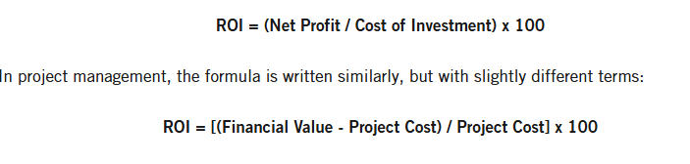

Appendix 7: Python Script for Data Collection
Appendix 8: Raw Data Set
Appendix 9: M4A1-Printstream Data Chart
(Image 20: Printstream Factory New Price to Availability)
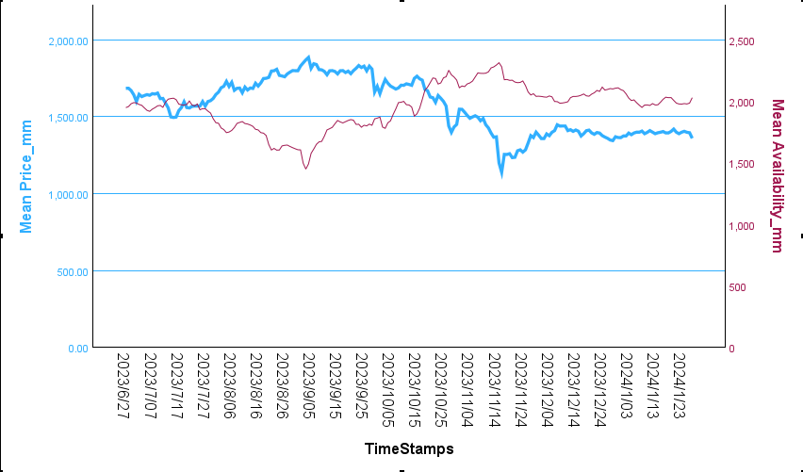
(Image 21: Printstream Minimal Wear Price to Availability)
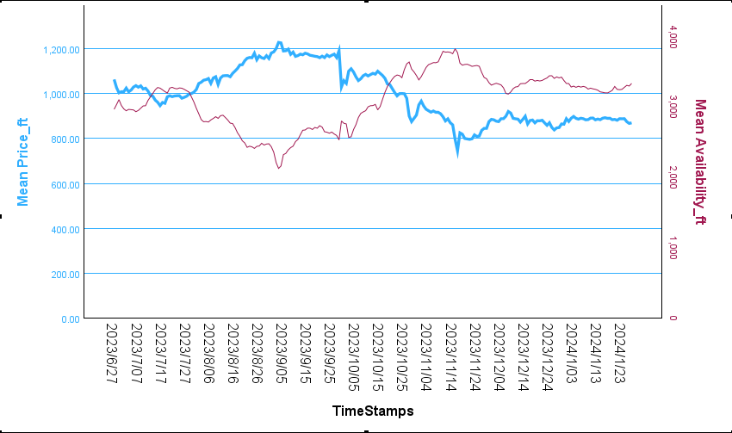
(Image 22: Printstream Field Tested Price to Availability)
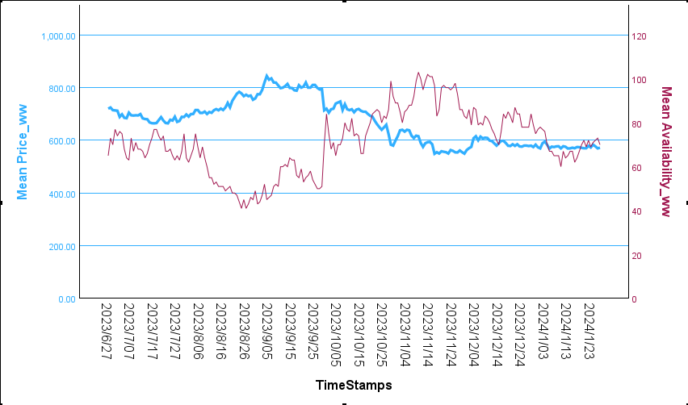
(Image 23: Printstream Well Worn Price to Availability)
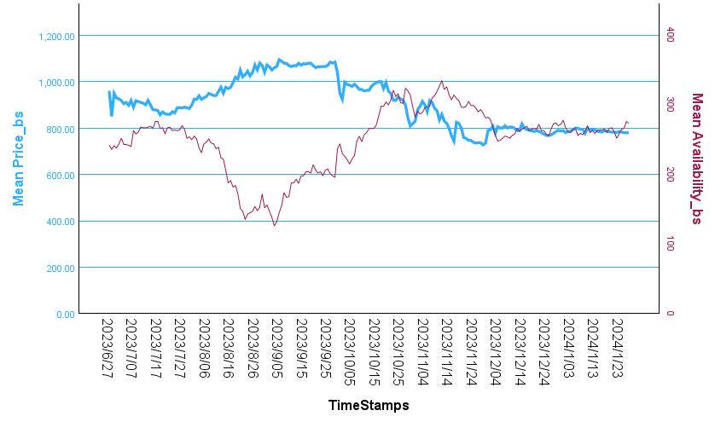
(Image 24: Printstream Battle Scarred Price to Availability)
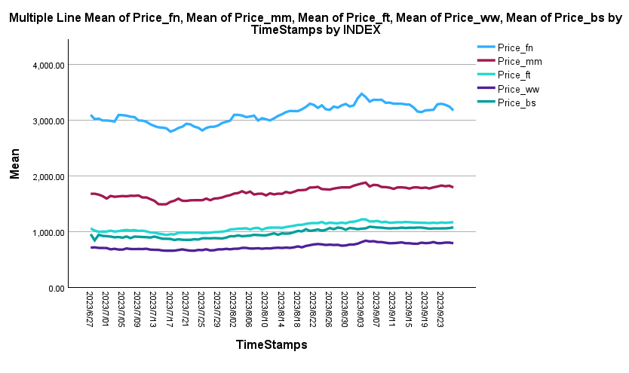
(Image 25: Printstream Price change before Counter-Strike 2 Launch)
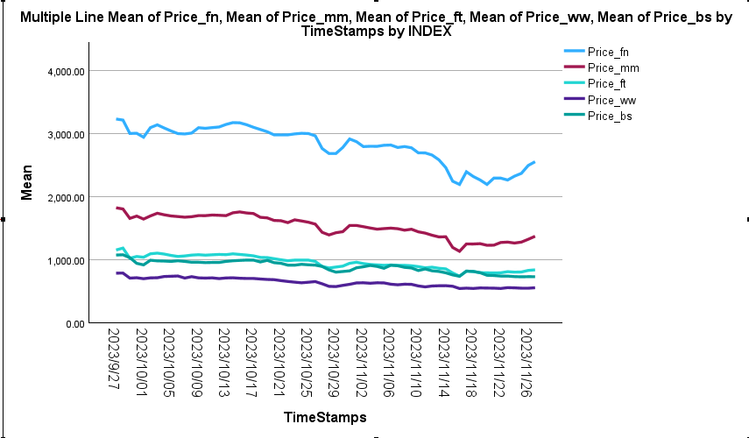
(Image 26: Printstream Price change during Counter-Strike 2 Launch)
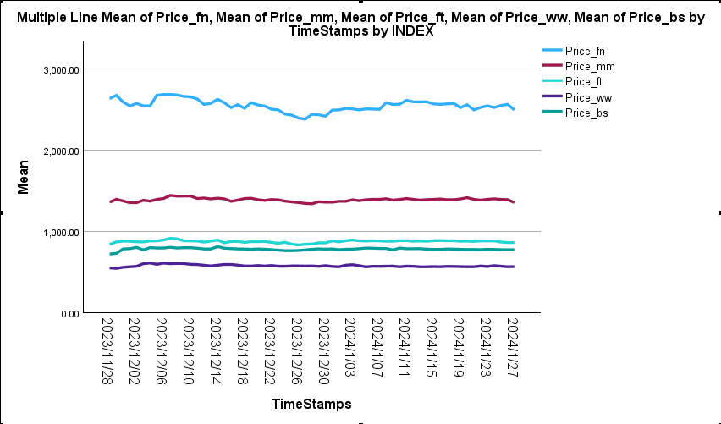
(Image 27: Printstream Price change after Counter-Strike 2 Launch)

Appendix 10: AK-47 Neon-Revolution Data Chart
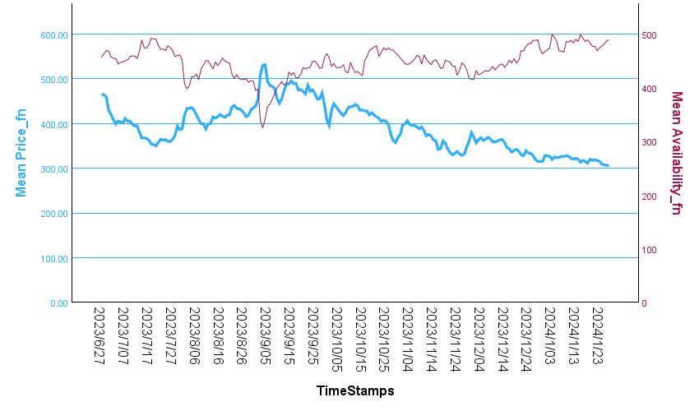
(Image 28: Neon-Revolution Factory New Price to Availability)
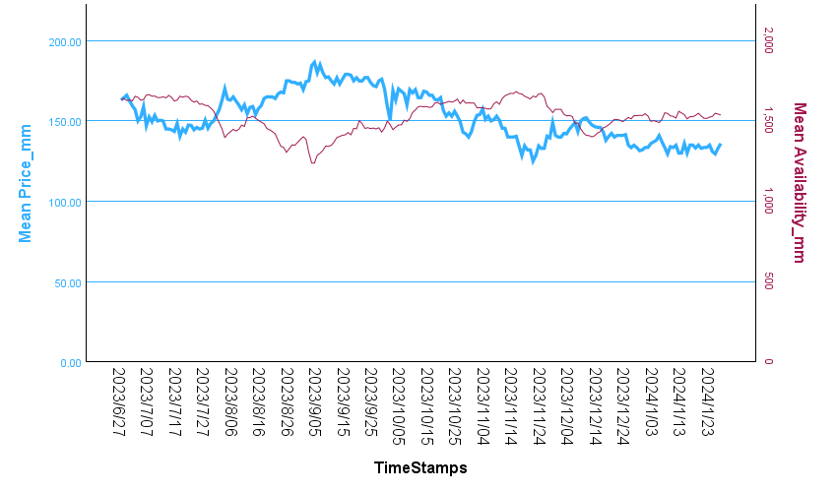
(Image 29: Neon-Revolution Minimal Wear Price to Availability)
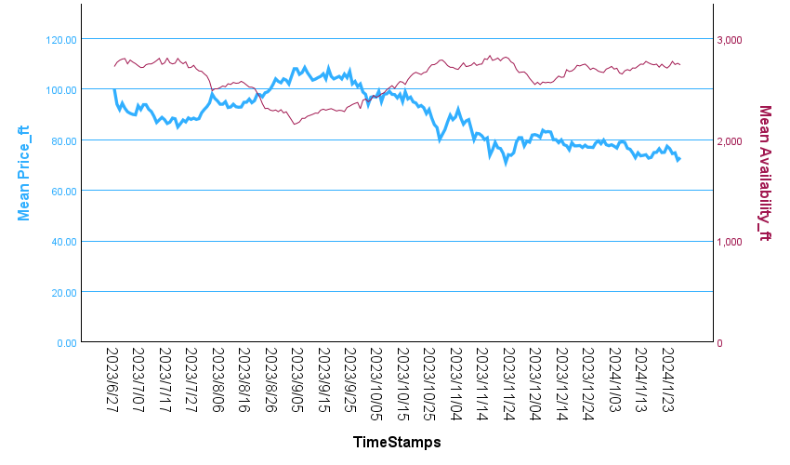
(Image 30: Neon-Revolution Field Tested Price to Availability)
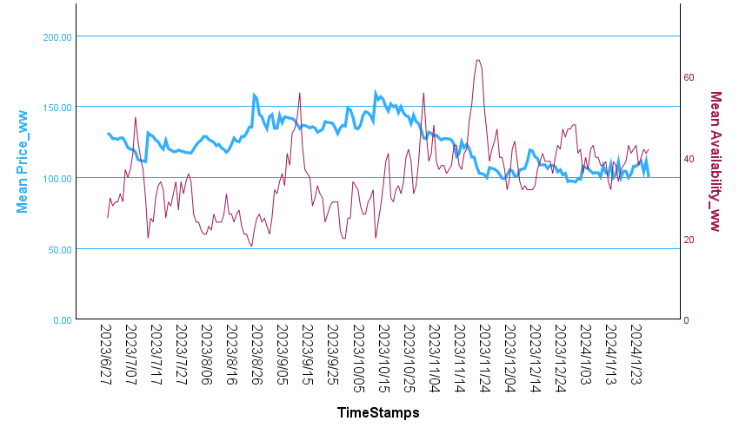
(Image 31: Neon-Revolution Well Worn Price to Availability)
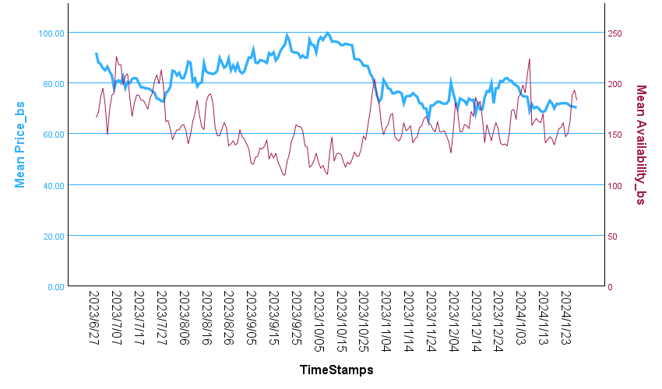
(Image 32: Neon-Revolution Battle Scarred Price to Availability)

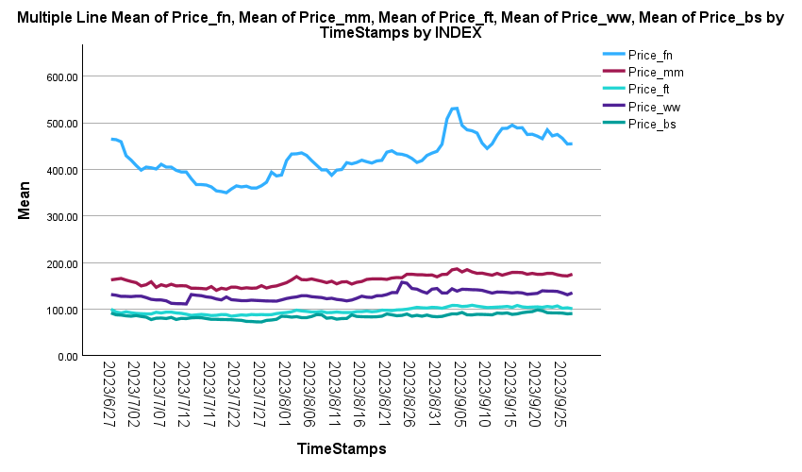
(Image 33: Neon-Revolution Price change before Counter-Strike 2 Launch)
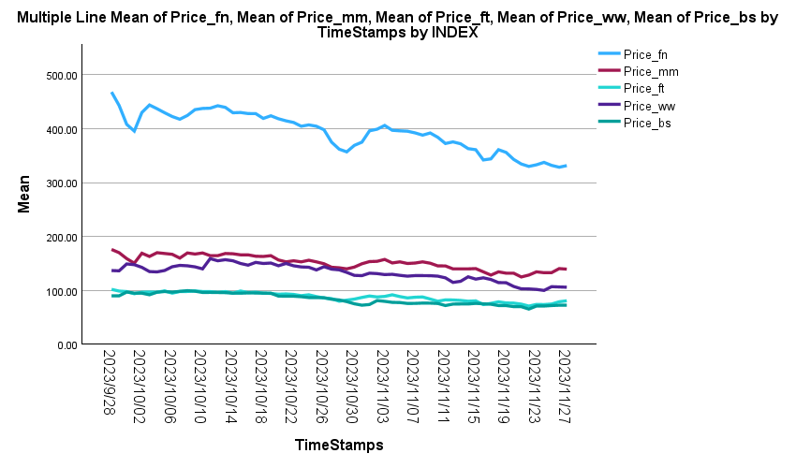
(Image 34: Neon-Revolution Price change during Counter-Strike 2 Launch)
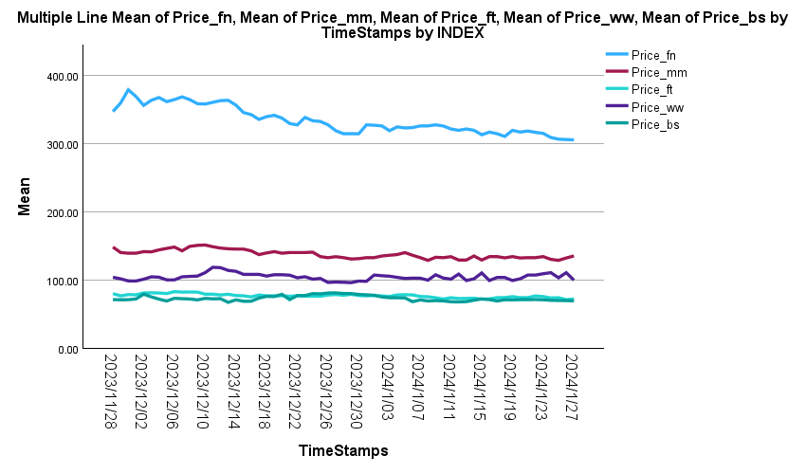
(Image 35: Neon-Revolution Price change after Counter-Strike 2 Launch)

Appendix 11: Tec9 Ice-Cap Data Chart
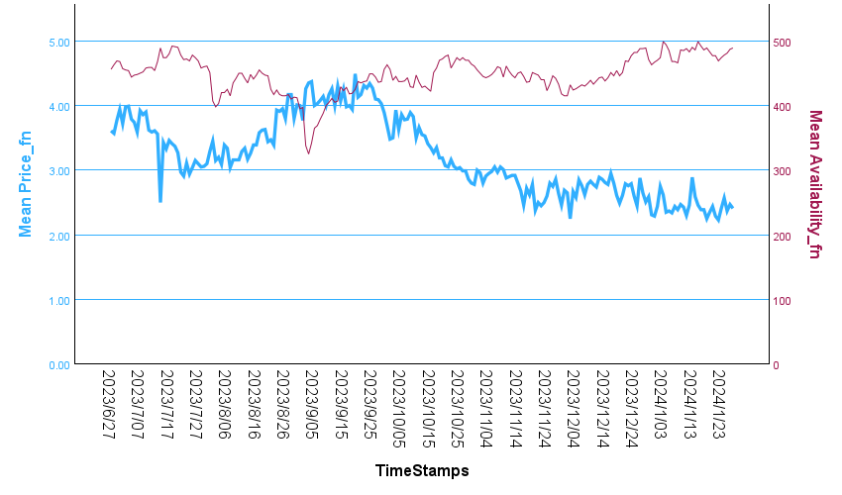
(Image 36: Ice-Cap Factory New Price to Availability)
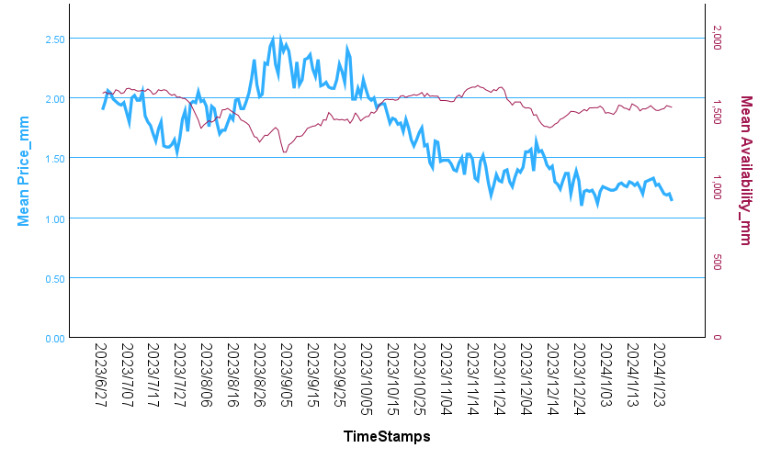
(Image 37: Ice-Cap Minimal Wear Price to Availability)
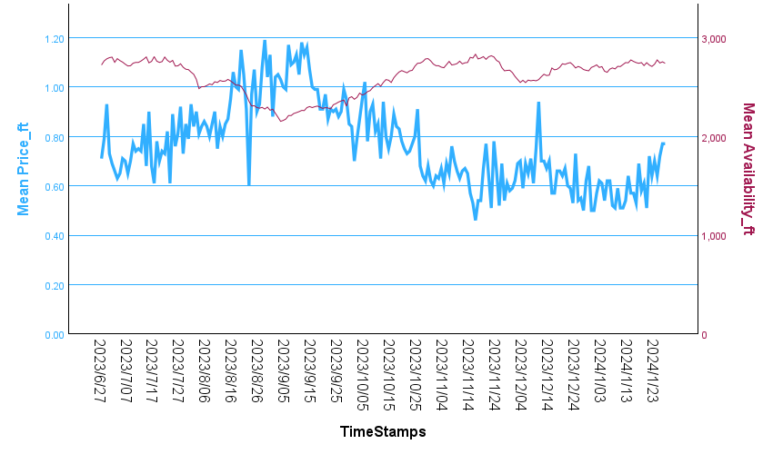
(Image 38: Ice-Cap Field Tested Price to Availability)
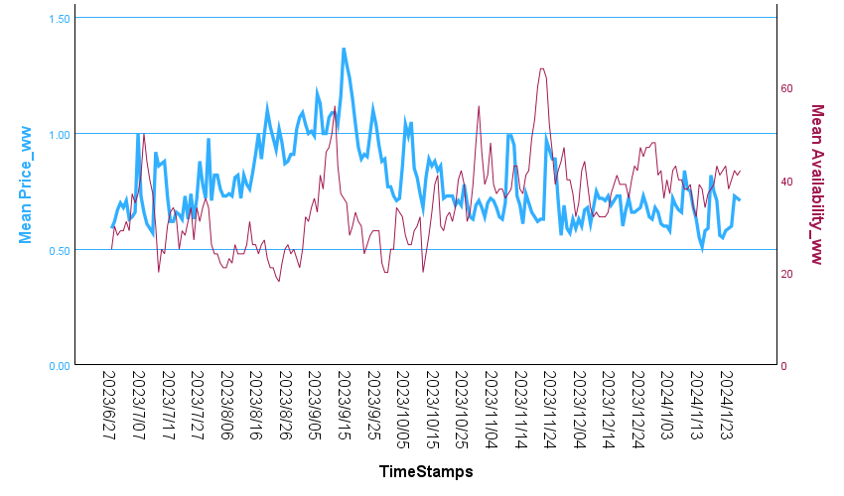
(Image 39: Ice-Cap Well Worn Price to Availability)
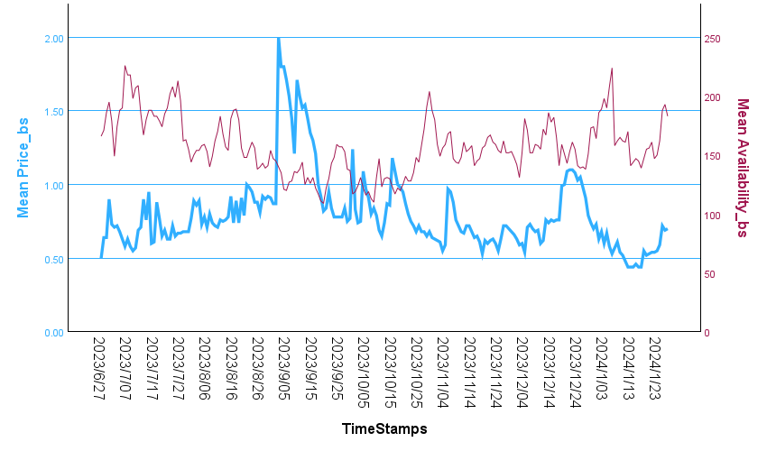
(Image 40: Ice-Cap Battle Scarred Price to Availability)

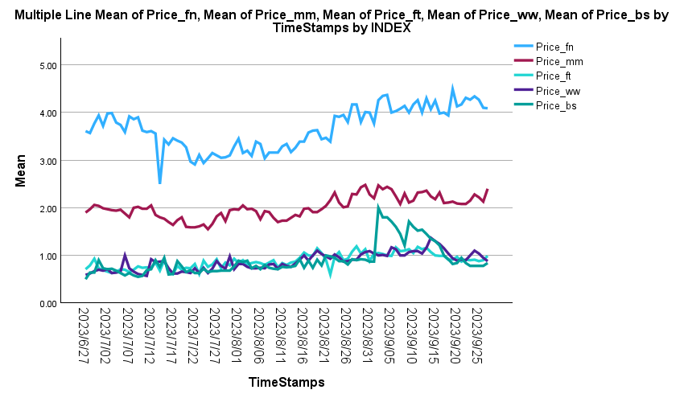
(Image 41: Ice-Cap Price change before Counter-Strike 2 Launch)
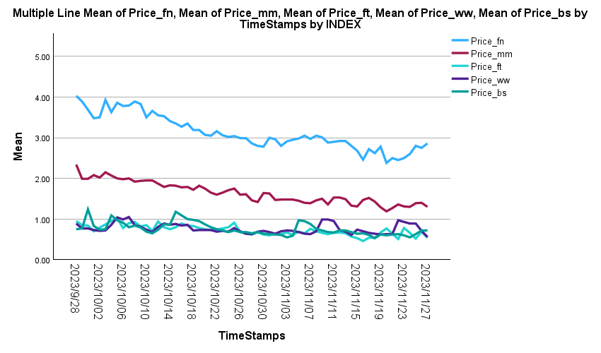
(Image 42: Ice-Cap Price change during Counter-Strike 2 Launch)
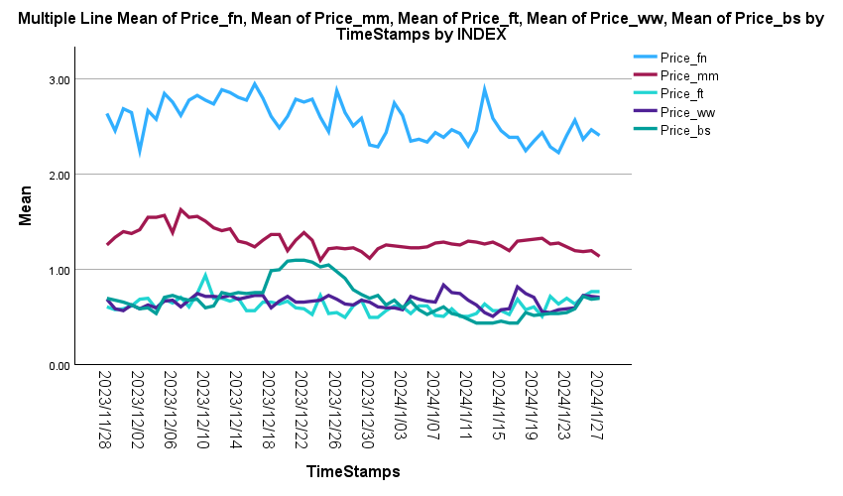
(Image 43: Ice-Cap Price change after Counter-Strike 2 Launch)

