Emotion in Motion: The Intersection of Bilingualism, Emotion Type, and Emotional Perception.
Abstract
Emotional perception is paramount amidst the social domain, determining psychological and functional outcomes. Bilingualism is predominant in the globalised world, and has shown to strengthen cognitive functioning, but research investigating its role in emotional perception is inadequate due to scarce research. This study aimed to explore whether bilingualism can serve as an advantage in emotional perception, and if this advantage is influenced by emotion type. Fifty-two participants with an age range of 18-47 years (M = 24.08, SD = 6.252) watched a series of 16 emotionally inducing dancing videos while a physiological GSR measurement was taken; they were also asked to identify the emotion after each video clip, and measured on their performance with a score out of 4 for each emotion. Two two-way mixed ANOVAs were conducted, one for physiological measure and one for performance measure in a 2 (languages known: bilingual, monolingual) by 4 (emotion type: joy, anger, sad, fear) two-way mixed ANOVA design. In line with previous research, the study hypothesised bilinguals would produce lower GSR in the physiological measure and higher scores in the performance measure as compared to monolinguals. It was also expected that bilinguals would produce lower GSR in the joy condition, and higher accuracy when identifying joy as an emotion type. The findings showed a significant main effect of emotion on accuracy of emotional perception, supporting the hypothesis that joy would be more correctly identified in both groups across all emotion types. Conclusively, the study supports the positivity bias theory, whilst neglecting any support for the bilingual advantage.
Introduction

Established as one of the predominant components of emotional intelligence (EI, Salovey & Mayer, 1990), emotional perception (EP) is defined as the recognition and identification of emotion through facial, vocal and physical expressions (Salovey & Mayer, 1997). Such a concept bears its place in Salovey and Mayer’s (1990, 1997) theory of EI, which asserts that the basic components, such as EP, are critical to achieve the higher constructs of EI. Comprehensively, EI, specifically EP, is necessary to understand and navigate the surrounding social environment (Lopes et al., 2004). This includes, but not conclusive to, social interactions (Goodwin et al., 2019), effective communication (Akgul et al., 2019), and the practical contribution to the global world (Nicoladis et al., 2016). As such, the ability to accurately perceive emotion has been directly linked to healthier relationships in both peer and professional environments (Barrick et al., 2024). By accommodating healthy social development, individuals’ wellbeing becomes increasingly positive (Mertika et al., 2020), and thus, it is plausible to suggest that EP plays a significantly direct role in determining such a relationship (Denham et al., 2003). Correspondingly, existing evidence finds that low EP may foster the development of psychopathological disorders (Weissman et al., 2020), due to an impaired pathway between social functioning and emotionally perceptive skills (Collin et al., 2013). It is, therefore, important to consider the fundamental basis EP has in day-to-day life, serving as a protective factor amidst disrupted psychological wellbeing.
Given its substantial impact on wellbeing, studies have concentrated on characteristics and traits which may impact EP. However, research remains contradictory, posing a debate between the influence of a range of attributes, such as empathic skills, influence of age, and socioeconomic status, and which dominate EP abilities. For example, Durbin et al., (2021) found older adults to have greater EP skills when compared to their younger counterparts, due the length and frequency of emotional experiences. Likewise, individuals who have greater empathy correlate with higher EP, attributable to better understanding of emotional circumstances (Hajibabaee et al., 2018). In terms of socioeconomic status, a lessened focus on others’ emotions, behaviours, and intentions occurs in people with a high socioeconomic background, which results in lower EI, with lower EP when compared to their low socioeconomic counterparts (Schmalor & Heine, 2022). The question of whether other attributes such as bilingualism can indeed promote better EP proceeds from the previous research and motivates the current study.
Bilingualism can be defined as the proficient and fluent use of two languages, in an oral or verbal form, on a day-to-day basis (Spizter, 2016), whilst monolingualism refers to the sole use of one language and can also be known as unilingualism (Ellis, 2008). For the purpose of operationalisation, the study adopts the prior definitions and concentrates on bilingualism primarily. A disregard to multilingualism has been decided due to the differing nature and influence on psychological development between multilinguals and bilinguals (Midrigan-Ciochina et al., 2024).
As for what bilingualism cognitive, social, and emotional advantages may provide and their corresponding explanations, the research remains oppositional. On one hand, linguistic research argues for the concept of a bilingual advantage (BA, Alqarni & Dewaele, 2020), which has been shown to emerge across the lifespan. The Control Process Model of code-switching (Green & Wei, 2014; Green, 2018) is paramount when explaining the BA; the theory suggests that the consistent need to switch between the two languages allows bilinguals to refine their linguistic conflict skills, as well as their cognitive flexibility, and executive functioning. Similarly, the dual-processing model (Green & Abutabeli, 2013) focuses on the skills required to constantly monitor, manage, and navigate two languages simultaneously, and what advantages this poses. Both bilingual children and adults, for instance, are better equipped in their working memory (Yang, 2017), due to the dual processing system, which reinforces inhibitory control when encoding and recalling information (Chen et al., 2015). Indeed, this has translated into older adulthood; researchers have found a significant relationship between bilingualism and a delay in the onset of Alzheimer’s disease when compared to monolinguals (Bialystok, 2011; Ballarini et al., 2023), affirming bilingualism to be a protective factor against later neural deficits. These findings corroborate the cognitive reserve hypothesis, which outlines that there is a “dissociation” (Bialystok, 2022) between cognitive functioning and the structure of the brain, which, in turn, lowers the impact of degenerated brain structure on cognition (Bialystok, 2021). Thus, whilst age-related deficits may be present, bilingualism acts a cognitive reserve to buffer against such factors, including protecting memory components (Bialystok, 2011).
The BA is evident in both academical and professional circumstances. As such, bilingual children outperform their monolingual peers in mathematics due an enhanced ability to recall mathematical strategies and equations (Chaudhury, 2018, Gonzalez-Martin et al., 2024), as a direct result of their reinforced working memory (Yang, 2017). Moreso, bilinguals are more inclined to have a wide range of career opportunities, including job flexibility in terms of location and position, due to the presence of a second language (Butvilofsky & Gumina, 2020). Greater professional prospects are aligned with better psychological wellbeing, and thus, it is feasible to argue bilingualism plays an important role in such a relationship (Zhao, 2016).
However, on the counter side of the debate, other linguistic research opposes the BA, suggesting that bilingualism deteriorates such advantages as opposed to reinforcing them. A systematic meta-analysis did not produce a significant difference between the executive functioning in bilingual and monolingual children, and further suggested that better cognitive functioning could not be directly attributional to the BA alone (Lowe et al., 2021). Similarly, Gunnerud et al’s., (2020) systematic review showed little to no significant difference in bilingual performance in problem-solving and inhibitory control when compared to a monolingual population. Critique over the control-process model of code-switching argues that a certain threshold of code-switching in bilinguals is required before any cognitive advantages can occur, and the presence of a secondary language is not sufficient to provide a BA (Kheder & Kaan, 2021). Whilst much research has found an advantageous angle to bilingualism, the conflict remains ongoing, posing a need for further clarification of where the BA lies, and if it is present in all bilinguals.
In regard to emotional functioning, early stages of research deemed it to be negatively impacted by bilingualism (Al-Amri, 2013; Bialystok, 2010). Research about bilinguals in the early 20th century, particularly children, argued for a lack of EI in bilinguals due to a hinder in personality development, causing hindered emotional development (Appel & Muysken, 1987, as cited in Al-Amri, 2013). However, as theories and research have emerged, studies have found it to have a dramatically opposite effect. The presence of a second language widens one’s emotional concept knowledge, contributing to better emotional intelligence (Barrett, 2017; Dewi et al., 2021). Through the dual-processing system (Green & Abutabeli, 2013), bilinguals are exposed to and have access to two sets of emotional concepts, which allows them to draw on increased emotional knowledge in emotional circumstances (Dewi et al., 2021). Regardless of the difference across languages, bilinguals collectively acquire emotional concepts that are not available to those monolingual (Pavlenko, 2008), which increases their emotional intelligence overall. In turn, they improve their psychological wellbeing and functioning, contributing to better functional outcomes such as improved social relationships and decreased likelihood of psychopathology (Antonanzas, 2017; Lopez-Zafra et al., 2019). To contribute further to functional outcomes, bilinguals possess a greater psychological distance due to a secondary language, which allows them to perceive situations and make decisions without unwanted emotional interference (Santiago-Rivera & Altarriba, 2002), indicating greater EI ability (Lim & Birney, 2021). Alqarni and Dewaele (2020) additionally found bilinguals do, indeed, significantly outperform monolinguals in emotionally perceptive tasks, demonstrating the BA within EP. Moreso, Tao & Cai’s, (2023) study suggested that bilinguals are equipped with a stronger and faster ability to recognise emotional stimuli, and, thus, perceive it with greater and quicker accuracy. Although, such a significant difference is not evident across all populations, including in Bukhalenkova et al’s., (2022) study which found no difference in the accuracy of EP amongst bilingual and monolingual children. The research argues that such a lack in significance in EP ability is due to a difficulty in the dual and simultaneous management of languages and emotional knowledge in bilingual children (Bukhalenkova et al., 2022).
Theory of Mind (ToM, Premack & Woodruff, 1978) has shown to be prominent in EP, operating to understand EP as well as why these emotions may occur based upon the circumstances (Navarro & Conway, 2021). Indeed, bilinguals function and perform better compared to their monolingual counterparts when tested on their ToM; Navarro and Conway (2021) argue bilingualism amplifies the ability to infer the mental states of others and make an accurate EP. Other research attributes this advantage to the enhancement of metalinguistic awareness; Schroeder (2018) suggests that understanding that a concept can be described in two formats (one as primary language, one as the secondary) contributes to an enhanced understanding of EP. ToM additionally provides a capacity to perceive emotions in subtle and intricate circumstances or scenarios (Mitchell & Philips, 2015), and, thus, bilinguals’ improved ToM on this basis may contribute to better social interactions (Caputi et al., 2012). To draw upon previous theories, Buac and Kaushanskaya (2020) suggest bilinguals possess a greater ToM due to the extended capacity of inhibitory control that they possess which allows them to perceive, infer, and recognise emotional states of others with greater accuracy.
Overall, bilingualism can be notable in the function of EP by enhancing inhibitory control in emotional contexts, providing a broader array of emotional knowledge, and expanding on a capacity to infer the mental starts of others. The prior considerations translate to better functional and mental outcomes, contributing to better psychological wellbeing.
In view of the BA within EP, researchers have taken to examine whether this advantage varies by type of emotion. This study has incorporated the emotions from the Basic Theory of Emotions (Ekman, 1992) to be perceived: joy, sadness, anger, and fear. This selection of emotions is due to their universal understanding across populations, and their biological and psychological basis in evolution, adaption, and survival (Izard, 2007; Wilson-Mendhall et al., 2013). Thus making them suitable and apprehensible to utilise.
Former research has demonstrated a general positivity bias when recognising emotions; Nelson and Russell (2013) found individuals accurately identified joy more when viewing facial stimuli compared to other emotions including sadness, anger, and fear. Whilst the underlying mechanisms which drive the positivity bias remains unidentified (Nummenmaa & Calvo, 2015), hypotheses have been suggested to account for such a concept. Calvo et al., (2014), for instance, argue happiness is the sole emotion which is clearly and universally identifiable through facial expressions. When investigating EP in bodily movement, research provides evidence for the universality of the positivity bias regardless of stimuli. Melzer et al., (2019), for instance, found that, on average, individuals perceived joy with increased accuracy as compared to anger, sadness, and fear when viewing bodily expressions of such emotions. Research appoints this bias in bodily movement to the expansive and exaggerated nature of joyful movement (Atkinson et al., 2004), additionally found in research employing dance movements to measure EP. Christensen et al., (2016) established support for this, finding participants to recognise joy much faster and with greater accuracy viewing dancers convey different emotions. Overall, the findings highlight the saliency of joy across different modalities, and present robust evidence for the positivity bias; the study takes to evidence such a bias.
To the best of current knowledge, however, definitive evidence that a BA exists when perceiving joy across all emotion types, and across the monolingual population, is sparse, and research lacks an explanation or direction as to how bilingualism may influence the recognition of any differing emotions. Nonetheless, based on previous theoretical frameworks, the widened emotional knowledge in bilingualism provides a feasibility to argue bilingual individuals may indeed recognise more emotions, specifically joy, as compared to monolinguals.
To induce EP, prior research has substantially utilised visual stimuli, particularly facial expressions and facial stimuli, concentrating on certain facial areas (Christensen et al., 2023; Martinez et al., 2016; Nummenmaa & Calvo, 2015). Whilst facial visual stimuli is most common amongst emotional research (Scherer & Scherer, 2011) and has consistently shown to be accurate when measuring EP (Barrett et al., 2019), there appears to be a gap, however. Researchers critique the use of facial stimuli, stating it is oversimplified and does not represent the complex and intricate components of emotion (Martinez et al., 2016), thus weakening its capacity to adequately measure EP (Barrett et al., 2019). To reduce such disparities, emerging research proposes the use of bodily movement to measure EP through the subtle and moderate expressions of emotion (Martinez et al., 2016; Visch et al., 2014). Studies using bodily movements have demonstrated an increase of EP accuracy, when compared to the same individuals’ EP accuracy in facial expression stimuli (Visch et al., 2014). To build upon this further, Christensen et al., (2016, 2023) constructed bodily stimuli in the form of dancing, in which emotion is conveyed through the subtle, kinetic motions of the dancer. The researchers argue such stimuli provides a greater insight into realistic emotional experiences, and how EP functions. Due to its ambiguous nature, dance movements can be interpreted several ways (Burger & Toivianien, 2020), which is fundamental to EP and evident in many social circumstances, (Neta et al., 2021), thus providing an ecological perspective (Kirsch et al., 2013). Thereby, the study has taken to bridging the gap amongst visual stimuli, employing Christensen et al’s., (2023) dance stimuli to investigate how adequately such stimuli can induce accurate EP, not only exploring this concept within the wider population, but with a centralisation on bilingual individuals.
EP can induce physiological changes in the body (Wenzler et al., 2017), but sparse research focuses on how such changes can be seen through galvanic skin response (GSR), also known as electrodermal activity (EDA). GSR has two components (Can et al., 2019), but only skin conductance response (SCR) has been employed in the current study. The prior terms are used interchangeably in this study. Such measures concentrate on the automatic production of sweat levels in the autonomic nervous system, in response to how it fluctuates in different circumstances and states of arousal (Braithwaite et al., 2013; Can et al., 2019). SCR primarily measures a short-term change in sweat levels when individuals are exposed to stimuli, also known as the phasic element (Braithwaite et al., 2013). GSR levels tend to rise when individuals are exposed to stress-inducing events or scenarios (Markiewicz et al., 2022), but research does not indicate whether such physiological changes can be observed in the case of EP, let alone amongst bilinguals. Thus, a combination of the autonomic nature of GSR and the ambiguity of the stimuli used may provide an accurate and adequate measure of EP in the wider population, as well as in bilinguals.
Implementing the use of GSR as a physiological measure alongside a performance indicator was driven partially by the absence of such measures in prior studies (Villaneuva et al., 2016), and partially by Jankowiak and Korpal’s (2018) study, as well as the autonomic component of such a measure (Can et al., 2019). Much of language research has utilised the use of performance measure alone, especially in the form of multiple choice and scoring scales, of which has not provided adequate insight into EP alone (Engelmann & Pogosyan, 2013). Whilst previous studies (Caldwell & Aycicegi-Dinn, 2009; Harris 2004; Jankowiak & Korpal, 2017) do not primarily concentrate on the measure of EP when using GSR, research does provide an insight into how this measure functions within the bilingual population. Based upon this, it is argued that bilinguals produce less GSR compared to their monolingual counterparts, due to the possession of extensive and expansion emotional concepts which allows them to perceive emotions faster and with greater accuracy, leading to lower stress levels (Barrett, 2017; Dewi et al., 2021).
Jankowiak and Korpal’s (2018) findings have also motivated the use of visual stimuli in the current study, due to the accuracy of GSR when using visual stimuli as opposed to auditory. The concurrent use of physiological and performance indicators offers a more nuanced measure, considering the autonomic responses and behavioural measures, and whether the two influence one another. Thus, specific to bilingualism, the study provides a holistic approach towards the measure of EP.
The ongoing debate in how to better EP, the literature gap in the relationship of bilingualism and EP, and whether emotion type can meditate such a relationship has impelled this study. The multitude of advantages bilingualism can provide by bettering EP must be measurably considered, and thus, the research aims to assess whether the ability to speak two languages can improve EP. In terms of physiological responses, the research hypothesises that bilingual individuals will have a lower GSR level when viewing a series of emotionally perceptive video clips as compared to the levels of their monolingual counterparts. The research additionally hypothesises that there will be a decrease in GSR when viewing joy in both groups, and bilinguals will have an additional decrease in galvanic skin response in the joy condition compared to other emotions as well as monolinguals in all conditions.
In the performance measure, it is hypothesised that bilingual individuals will correctly identify more emotions displayed in the video clips as compared to monolingual participants. It is also hypothesised that that joy will be more correctly identified as compared to the other emotions, and that, finally, bilinguals will correctly identify joy more as compared to monolinguals.
Method
Ethical approval for this study was given by the University of Staffordshire Psychology Department Ethics Committee. The BPS ethics code of conduct was followed; all participants remained anonymous by providing a unique identifier code and all data remained confidential. Participants provided informed consent by signing a consent form and had the right to withdraw at any point in the study, and a right to withdraw their data within a week of participating using their unique identifier code. Participants were not deceived and provided with all information and instruction to take part, with no exposure to any psychological or physical harm. Participants were debriefed at the end of the study, which informed them of support they could access if they felt any distress following the study.
Design
This study used a mixed design method due to all participants taking part in all emotion type conditions, regardless of being bilingual or monolingual; the first independent variable was the amount of language spoken with two levels: monolingual and bilingual. The second independent variable was the four levels of emotion type: fear, joy, anger and sad. The independent variables were consistent across both measures. In the physiological measure analysis, the dependent variable was the GSR readings taken while watching the video clips. In the performance measure analysis, the dependent variable was the number of correctly identified emotions from the video clips.
Participants
The total sample size was 52, and the age of participants ranged from 18-47 (M = 24.08, SD = 6.252); 26 bilingual and 26 monolingual individuals participated; 33 women, 13 men and 6 nonbinary individuals took part. Participants were recruited through convenience sampling through the SONA system, offering 2 SONA credit incentives to any undergraduate psychology student who took part. No incentives were offered to non-undergraduate participants. A snowball sampling technique was additionally used through word-of-mouth amongst participants. Participants were also recruited through opportunity sampling in the form of social media posts on LinkedIn, Instagram and Facebook (Appendix F).
An exclusion criterion stated individuals with severe skin conditions could not participate, as the BIOPAC system could not pick up electrodermal activity.
Materials
Participants used a computer based in the Psychology Lab at the University of Staffordshire to complete the experiment. An information sheet (Appendix A), and a consent form (Appendix B) were presented to participants through Qualtrics prior to study. A debrief form (Appendix C) was presented through Qualtrics at the end of the experiment.
Twenty silent dancing video clips (taken from Christensen et al., 2023, appendix D) were used, 4 of which were neutral in emotion for the baseline EDA reading and were not tested. 16 clips were used in the test phase of the study, where each emotion (fear, anger, joy and sad) had 4 corresponding videos. Only 20 video clips out of 150 available were used due to feasibility and time constraints; a comprehensive list of the selected video clips is available in Appendix D. The video clips were black and white in nature, showing a white silhouette dancer against a black background. To illustrate the sense of the video clips for the reader, when asked to convey joy, for example, the dancer uses movements such as lightly jumping, raising arms in the air, and moving their hands and feet in sync (Appendix D).
The clip presentation time ranged from 4 to 15 seconds (see Appendix D). Participants could achieve a maximum of 16 when asked to identify the emotion, and a maximum of 4 for each emotion. The videos’ order of presentation was counterbalanced. To present the videos, Superlab Software 6 was used.
A BIOPAC Systems was used to measure electrodermal activity. An EDA electrode, isotonic EDA gel and electrode leads were used to measure electrodermal activity. The EDA electrodes were secured with masking tape.
Procedure
The study was conducted in one of the Psychology Labs in the Psychology Human Sciences Suite at the University of Staffordshire in the Science Centre. Using a computer in the lab, participants read an information sheet and asked to consent by filling in a consent form via Qualtrics. Once given consent, participants were asked their age, gender and whether they were monolingual or bilingual. Participants were asked which was their non-dominant hand, and 2 EDA electrodes were then each attached to the participants’ index and middle fingers with EDA isotonic gel and secured with masking tape. 2 SS57 leads were attached to each EDA electrode, which was hooked up to the BIOPAC Systems through Channel 2 to measure GSR levels; participants GSR’ was measured and recorded across all neutral and emotion videos. Participants were asked to relax their non-dominant hand and to complete the experiment with their dominant hand. Participants were instructed to use a grey box keyboard, with 4 labelled emotions: fear, anger, joy, and sad. Participants were first asked to watch a series of 4 neutral silent dancing videos for a baseline EDA reading, and then asked to watch a following series of 16 test randomised silent dancing clips, each conveying a different emotion. After each test video, participants were asked to select which emotion they believed was being conveyed by pressing 1 of the 4 options on the grey box keyboard. Participants had 60 seconds between each video to provide an answer. Once all 16 videos had played, participants’ EDA electrodes and leads were removed and were given a debrief form to read.
Results
Prior to analysis, the raw GSR data for every emotion in every trial across bilingual and monolingual groups had been calculated into mean scores. A mean score for baseline EDA was calculated. Raw scores were used in the performance measure analysis, with no missing data in either the performance or physiological measure data set.
IBM SPSS Statistics Version 29.0.1.0 (171) was used to analyse the data (Appendix E). Two two-way mixed ANOVAs were conducted, one for physiological measure of GSR and one for performance in correctly identifying the emotion. A one-way within subjects ANOVA was conducted in the physiological measure data to screen for any significant difference in baseline EDA. Data screening was done to ensure there were no outliers present through Z-scores, and no data were excluded from either analysis.
Performance measure
Table 1
Descriptive statistics for perfomance score in bilinguals and monolinguals
Emotion type | Bilingual |  | Monolingual
 | M | SD | M | SD
Anger | 2.23 | 1.18 | 2 | 1.23
Joy | 3.31 | 0.74 | 3.31 | 0.79
Sad | 2.69 | 1.01 | 2.08 | 1.2
Fear | 2 | 1.02 | 1.88 | 1.11

Table 1 shows that bilingual participants correctly identified more out of 4 in the joy condition when compared to the other conditions. The condition also produced a smaller standard deviation, indicating smaller variation in scores. As shown, fear was the least correctly identified, but the anger condition had the highest standard deviation, suggesting a larger variation in scores as compared to the other conditions. Table 1 also shows that monolingual participants also correctly identified more in the joy condition when compared to the other conditions. The condition had the smallest standard deviation amongst the others, indicating a smaller variation in scores. As shown, fear, on average, was the least correctly identified, but the anger condition had the highest standard deviation, suggesting a higher variation in scores as compared to the rest of the conditions. Compared to monolinguals, bilinguals, on average correctly identified more emotions in the anger, fear and sad condition. In the joy condition, both groups performed the same.
In regard to parametric assumptions, in this data set there was no homogeneity of variance, checked for through kurtosis and skewness scores, meaning the data did not meet parametric assumptions. However, it was normally distributed, checked through variance scores, and had a non-significant sphericity result when checked on Mauchley’s test of Sphericity. Due to a lack of a non-parametric alternative test, a 2 (languages spoken) by 4 (emotion type) two-way mixed ANOVA was conducted, with emotion type as a within-subjects variable and languages spoken as a between-subjects variable, on the number of correctly identified emotions.
A significant main effect of emotion was found, $F_{(3,150)}$ = 21.878, p < .001, $η^{2}$ = 0.203. The effect size reported is large according to Cohen (1988). To follow up this significant difference, planned contrasts were conducted.
Three planned contrasts were conducted to compare performance between the joy and fear conditions, between the joy and the anger conditions, and between the joy and anger conditions. The contrasts were planned due to the directional hypothesis proposed and previous research, suggesting joy would be more correctly identified against all other emotions. Alpha level was adjusted using the Bonferroni correction to 0.167. The contrasts were conducted using within-subjects t-tests.
The number of emotions correctly identified was significantly higher in joy condition compared to the fear condition, $t_{\left(51\right)}$ = 7.58, p <.001, one-tailed test, d =1.488. The number of emotions correctly identified was significantly higher in the joy condition compared to the anger condition, $t_{(51)}$ = 5.749, p < .001, one-tailed test, d = 1.19. The number of emotions correctly identified was additionally significantly higher in the joy condition compared to sad condition, $t_{\left(51\right)}$ = 4.859, p < .001, one-tailed test, d = 0.955. According to Cohen (1988), the reported effect sizes in the planned contrasts are all large.
However, there was no significant interaction between emotion type and language, $F_{\left(3,150\right)}$ = 1.056, p < 0.37, $η^{2}$ = 0.009, or a significant effect of language on emotion type, $F_{(1,150)}$ = 1.709, p < 0.197, $η^{2}$ = 0.011. Both reported effect sizes are small, according to Cohen (1988).
After conducting a retrospective power analysis, the initial power of the study was between 0.16 and 0.19, indicating the study to be underpowered. 400 participants would be required in both the bilingual and monolingual groups to produce a power of 0.8 with a 0.01 effect size, and 300 participants across all emotion type conditions to produce a power of 0.8 with a 0.01 effect size (Clark-Carter, 2024).
Physiological measure
Table 2
Baseline EDA | Mean | Standard Deviation
Bilingual | 9.5 | 2.7
Monolingual | 10.35 | 4.6
Descriptive statistics for baseline EDA in bilinguals and monolinguals

Table 2 shows that, on average, bilinguals had lower EDA when compared to monolingual participants. Data derived from the bilingual group also had a smaller standard deviation, indicating a smaller variation in EDA compared to data from monolinguals.
As the data were not normally distributed, as shown in the kurtosis and skewness values (Appendix E), a Friedman’s ANOVA was conducted to determine whether there was a significant difference in baseline EDA between bilinguals and monolinguals. The analysis showed no significant difference in the baseline EDA between monolinguals and bilinguals, $χ^{2}$ (1) = 0.154, p = 0.845, N = 26.
Table 3
Descriptive statistics for EDA in bilinguals and monolinguals
Emotion type | Bilingual |  | Monolingual
 | M | SD | M | SD
Anger | 9.69 | 2.75 | 10.48 | 4.4
Joy | 9.63 | 2.7 | 10.37 | 4.2
Sad | 9.54 | 2.68 | 10.35 | 4.35
Fear | 9.67 | 2.74 | 10.49 | 4.38

Table 3 shows that, on average, the sad condition produced the smallest EDA in bilinguals when compared to the other conditions. This condition also produced the smallest standard deviation indicating a smaller variation in scores compared to the other conditions. The anger condition produced the highest EDA activity, and the highest standard deviation, indicating a larger variation in scores when compared to the other conditions. Table 3 also shows that, on average, monolingual participants produced lower EDA in the sad condition. The joy condition produced the smallest standard deviation, indicating a smaller variation in scores as compared to the other conditions. Monolinguals produced the highest EDA in the fear condition, which also produced the largest standard deviation, indicating a larger variation in scores compared to the other conditions. Compared to monolingual participants, on average, bilinguals produced lower EDA across all conditions.
In this data set, when screening for parametric assumptions, homogeneity of variance was met, checked for through kurtosis and skewness scores, but was not normally distributed and had a significant result on the Mauchley’s test of Sphericity. Due to a lack of a non-parametric alternative, a 2 (languages spoken) by 4 (emotion type) two-way mixed ANOVA was conducted, with emotion type as a within-subjects variable and languages spoken as a between-subjects variable, on electrodermal activity.
The analysis did not produce any significant results. There was no significant effect of emotion, $F_{(2.174, 108.686)}$ = 2.638, p < 0.071, $η^{2}$ = 0.0002, and no significant interaction between emotion type and language, $F_{\left(2.174, 108.686\right)}$ = 0.223, p < 0.818, $η^{2}$ = 0.00002. There was no significant interaction between language and emotion type, $F_{(1,50)}$ = 0.62, p < 0.435, $η^{2}$ = 0.012. All reported effect sizes, according to Cohen (1988), are small.
After conducting a retrospective power analysis, the initial power of the study was between 0.16 and 0.19, indicating the study to be underpowered. 400 participants would be required in both bilingual and monolingual groups to achieve a power of 0.8 with a 0.01 effect size, and 300 participants across all emotion type conditions to produce a power of 0.8 with an effect size of 0.01 (Clark-Carter, 2024).
Discussion
The aim of this study was to examine the difference in EP between bilingual and monolingual individuals, and whether the type of emotion could meditate such a relationship. The results show a non-significant interaction between language and emotion in both the physiological and performance measure. There was no significant influence of language on the type of emotion identified in either measure. However, both monolingual and bilingual individuals significantly identified joy more; the findings support one of the performance measure hypotheses, stating that both groups would identify joy correctly more compared to other emotions, regardless of language ability. Completing a post-hoc analysis showed joy was correctly identified amidst all emotion types in both groups.
As appears by the current findings, joy perception seems to be universally present, as accuracy persists consistent across both groups and all conditions. There is correspondence to Calvo et al’s., (2014) findings, reinforcing the idea that joy is universally perceived, and can be understood through subtle, kinetic motions of dance and bodily movements. As such, it contributes to the general positivity bias, which states that individuals are inherently inclined to perceive joy amongst other basic emotions (Kauschke et al., 2019). In terms of bodily movement, the current findings also evidence Atkinson et al’s., (2004) study; the exaggerated and lively manner in which the dancer portrays joy in the present video clips has translated into accurate joy perception. The current findings are also in alignment with Christensen et al’s., (2016) study, which correspondingly demonstrates greater accuracy in joy perception in comparison to other emotions, when using dance movement stimuli. Thus, the consistent accuracy in recognising joy in bilinguals and monolinguals across all conditions provides evidence that the emotional salience of joy may outweigh and overcome the influence of linguistic domains. The findings account for a partial support in Williams et al’s., (2005) study, which showed a superiority in accurately recognising both joy and anger in facial visual stimuli when compared to recognising both sadness and fear. Moreso, it provides an opposition to de Gelder and van den Stock’s (2011) study, which found a pattern of difficulty when individuals were asked to recognise joy from bodily movement, as compared to anger or sadness.
Additionally, the findings could be in line with the emotional contagion theory (Hatfield et al., 1993) as the model asserts that in EP, individuals may subconsciously imitate the perceived emotion, activating mirror neurons, resulting in the feel of that emotion. Above this, research finds individuals to perceive emotion more accurately in a positive state, such as joy, (Johnson, 2020), and, thus, it stipulates the question of whether such mechanisms interlinked during of the test phase and influenced the results of the current study. It is recommended that additional physiological measures are taken in future studies, such as heart rate (HR, Appelhans & Luecken, 2006) or electropherogram activity (EEG, Zhu et al., 2020) to understand if such internal processes do concur.
One possible explanation for the lack of a significant difference between language groups may be due to a reduced use of the BA in bilingual adults, when compared to children or older adults (Bialystok et al., 2005), because of an increase in other cognitive processes during this life stage (Boutris et al., 2020; Grant et al., 2014). It is of relevance to the current findings due to range of age in the sample size, which is considered young and middle-aged adults (Tamm et al., 2024). Whilst research is deficient in measuring the BA in EP, other studies have shown that there is, indeed, a reduction in adopting the BA in cognitive functioning due to the prioritisation of other psychological resources. Bialystok et al., (2005) found both groups of bilingual children and older adults outperformed their monolingual counterparts when tested on inhibitory control but found no significant difference between a group of young and middle-aged bilingual and monolingual adults. To expand this, research suggests the stage of young adulthood has already provided individuals with adequate cognitive functioning and resources, thus, the BA is used less frequently and with less occurrence (Boutris et al., 2020; Grant et al., 2014). It is, therefore, plausible to argue that there is a lack of prioritisation for the use of BA in EP in young adults, which could be in line with the current findings.
Beside support for research indicating a positivity bias, the current results contradict those previously mentioned. The non-significant findings further question whether the BA does exist in EP, providing an array of theories to explain the lack and / or absence of the BA, and casting light to contradictory evidence against such an advantage. As outlined previously, research lacks substantiating evidence that bilinguals may face a difficulty in the dual processing of their primary and secondary language when perceiving emotion, however, the present findings may contribute to this theory. It may be argued that due to the additionally processing of language in emotional contexts (Dewi et al., 2021), bilingual participants in this study may have experienced a disconnect to their wider emotional knowledge, influencing their EP, and producing a non-significant result. It may also suggest that the BA was present but could not be utilised, explaining the non-significant results. Similarly, former research suggests bilinguals face cognitive overload due to the presence of a secondary language which can interfere with executive function, such as decision making and inhibitory control (Green & Abutalebi, 2013). Such functions are subsequent in EP and can impact it widely if deteriorated (Schmeichel & Tang, 2015). It may position the current findings toward an issue of cognitive overload, and a disassociation between two languages, thereby not producing a significant difference between bilingual and monolingual performance. Other research disregards the BA entirely, showcasing monolinguals to either outperform bilingual individuals in EP and EI tests, or find no differences in abilities (Bukhalenkova et al., 2022). Chung-Fat-Yim et al., (2023) found monolinguals did recognise emotional faces with greater accuracy and speed when compared to bilinguals, but not with multilinguals. It questions whether an advantage in EP appears in the acquisition and fluency of not two, but three or more languages, and if cognitive overload occurs solely in bilingual individuals. However, due to a lack of screening for bilingualism proficiency, and a feasibility for sample size, multilinguals were not explicitly excluded, thus weakening the prior argument. The study guides a focus towards incorporating multilinguals in such research to determine the function and process of the BA in EP.
Evidence is contradictory and complex when it comes to understanding the subsegments of BA; some suggest BA in EP emerges only when stimuli is presented in bilinguals’ primary language (Harris et al., 2006; Pavlenko, 2002), whilst others state is it due to modality (Jankowiak & Korpal, 2018). Such research may explain the present finding in that bilingual participants may have utilised their secondary language to navigate EP, whereas monolinguals did not face this decision. However, a clarification in whether bilinguals had English as their secondary language was not made, and, thus, weakens the prior argument.
When viewing raw data in the performance measure analysis, on average, bilinguals did produce slightly higher scores across all conditions when compared to monolinguals. Bilinguals additionally, on average, had a lower GSR in the physiological measure analysis when compared to monolinguals for all emotion types. Whilst the hypotheses cannot be accepted based on average scoring, such findings question the methodology and sampling size of the study, suggesting adjustments, such as a larger sampling size or incorporating additional stimuli, may provide significant results. A larger sample size would implicate a broad array of both bilingual and monolingual perspectives and may supply a significant value based upon the average scores derived from the current findings. Implementing additional stimuli increases the number of measurements taken, which, in turn, increases the number of differences and / or relationships the study may provide (Christensen et al., 2016; Jankowiak & Korpal, 2017) of which can be analysed.
Gender data had been collected with an initial intention to explore this variable and its subsequent relationship with current factors. Due to recruitment and sample size, however, the use of such data did not prove plausible. Nonetheless, the influence of gender is considered within this data set. Women participants dominated the sample size, with an unequal number of men, and non-binary individuals (33 women, 13 men, 6 non-binary individuals), which may have influenced the corresponding results. Prior research suggests a gender bias towards women in EP; women have shown to recognise basic emotions with greater accuracy and speed, as opposed to men (Olderbak et al., 2018; Sullivan et al., 2017). It poses the question of whether the significant perception of joy was due to a universal understanding across genders, or whether it was specific to women. Thus, whilst the findings evidence the positivity bias, it must be considered whether this bias is primary to the EP abilities of women only. To disregard this, future investigations should aim for equal sample sizes across all genders and all language groups before drawing conclusions.
In regard to limitations, the study has been evaluated to draw out any potential confounding variables and / or bias present. To begin, participants were not asked to clarify their cultural background, in which different display rules shape how emotion is perceived between cultures (Engelmann & Pogosyan, 2013; Ji et al., 2022). Several studies show that individuals from different cultural backgrounds will concentrate on different parts of the body when perceiving emotions (Bjornsdottir et al., 2017; Liu et al., 2015), and thus, it is probable that the present findings may be due to a lack of cultural difference. Operationalising bilingualism is an intricate process and has a variety of types and definitions; it may be divided into child- and adult-bilingualism, which has additional subsections (De Jong, 1986, as cited in Marlina, 2017). Child-bilingualism is sectioned into beginning bilingualism from birth to age 4, and middle-bilingualism from age 5 to 11 (De Jong, 1986, as cited in Marlina, 2016), whereas Romaine (1995, as cited in Marlina, 2017) argues child- and adult-bilingualism is sectioned into three forms: additive-bilingualism, dominant-bilingualism and semilingualism (Romaine, 1995 as cited in Marlina, 2017). Additive-bilingualism refers to an equal use of both languages, creating greater cognitive functioning, whereas dominant-bilingualism states one language overrides the other, and is more in use; semilingualism is when bilinguals have a lower usage of both languages (Romaine, 1995, as cited in Marlina, 2017). However, the study did not exclude bilinguals based upon the prior types, but used a general definition (Spitzer, 2016) to aid the recruitment process. Such a decision may have governed the findings, in that research suggests bilingualism developed in childhood provides a greater BA, due to the length and frequency of bilingualism use, as opposed to bilingualism developed in adulthood (Marlina, 2017). Thus, further studies should discriminate between such types and definitions to produce a robust sample.
As for additional confounding variables, participants were not asked to clarify if they had any background in dance. As such, dance experience has the potential to skew the results, by inducing a bias in EP due to a greater knowledge in the interpretation and recognition of emotion within dance movements (Kordahi & Hassmen, 2024). With this being one possibility, the case of uneven distribution of individuals with dance experience across the language groups may have obscured any significant differences; this may be due to an increase of EP abilities of one group or another.
As the recruitment process made it a challenge to collect a large sample size, the exclusion criteria was kept short. Although it was assumed that the participants were in good health, they were not explicitly asked if they had any issues perceiving emotions or any disorders which may have influenced their ability to perceive emotions. Thus, no participants were excluded on this basis. However, anxiety, mood disorders, and autism spectrum condition (ASC) are prone to influencing the perception of emotion (Feldborg et al., 2021; Kaletsch et al., 2014; Molnar-Szakacs et al., 2009) and can either improve EP or debilitate it (Leppanen, 2006; Leung et al., 2022). For instance, individuals with mood disorders are more inclined to accurately recognise negative emotions, such as sadness or anger, due to an attentional negativity bias (Leppanen, 2006), whereas those with ASC may experience a difficulty in accurately recognising emotion types (Leung et al., 2022). The absence of such clarification in this study may provide a reason for the non-significant hypotheses and skew in the data.
In conclusion, the present study explored the influence of bilingualism and monolingualism on EP, and whether this relationship could be meditated by differing emotion types. To provide a complex measure of EP, dance movement stimuli was employed for four different types of emotions, alongside a physiological measure of GSR for greater insight into the autonomic workings of EP. Collectively, a bilingual advantage was not established within this study, however, it evidenced a general positivity bias in bodily movement. To account for and further validate such findings, the research proposes several future steps, including the inclusion of stimuli complexity, a control for confounding variables, and obtaining greater sample sizes. Due to feasibility, the study faced many challenges in recruitment, and, thus, the findings should be interpreted with caution. Nonetheless, the present study contribute to a growing literature of bilingualism, emotional perception, and the role of emotion.
Word count: 7556
References
Akgul, E., Yazıcı, D., & Akman, B. (2017). Views of parents preferring to raise a bilingual child. Early Child Development & Care, 189(10), 1588–1601. https://doi.org/10.1080/03004430.2017.1400541
Alqarni, N., & Dewaele, J. M. (2020). A bilingual emotional advantage? An investigation into the effects of psychological factors in emotion perception in Arabic and in English of Arabic-English bilinguals and Arabic/English monolinguals. International Journal of Bilingualism, 24(2), 141–158. https://doi.org/10.1177/1367006918813597
Antonanzas, J. L. (2017). The relationship between psychopathology and emotional intelligence in adolescents and adults. Procedia-Social and Behavioural Sciences, 237, 1093–1096.
Appelhans, B. M., & Luecken, L. J. (2006). Heart rate variability as an index of regulated emotional responding. Review of General Psychology, 10(3), 229–240. https://doi.org/10.1037/1089-2680.10.3.229
Atkinson, A. P., Dittrich, W. H., Gemmell, A. J., & Young, A. W. (2004). Emotion perception from dynamic and static body expressions in point-light and full-light displays. Perception, 33(6), 717—746.
Ballarini, T., Kuhn, E., Röske, S., Altenstein, S., Bartels, C., Buchholz, F., Buerger, K., Dechent, P., Dobisch, L., Ewers, M. & Fliessbach, K., (2023). Linking early-life bilingualism and cognitive advantage in older adulthood. Neurobiology of Aging, 124, 18—28. https://doi.org/10.1016/j.neurobiolaging.2022.12.005
Barrett, F. L., Adolphs, R., Marsella, S., Martinez, A. M., & Pollak, S. D. (2019). Emotional expressions reconsidered: Challenges to inferring emotion from human facial movements. Psychol-Sci Public Interest, 20(1), 1–68. https://doi.org/10.1177/1529100619832930
Barrett, L. F. (2017). How emotions are made: The secret life of the brain. New York: Houghton Mifflin Harcourt.
Barrick, E. M., Thornton, M. A., bu, Z., & Tamir, D. I. (2024). Individual differences in emotion prediction and implications for social success. Emotion. https://doi.org/10.1037/emo0001386
Bialystok, E. (2010). Bilingualism. Wiley Interdisciplinary Reviews., 1(4), 559–572. https://doi.org/10.1002/wcs.43
Bialystok, E. (2011). Reshaping the mind: the benefits of bilingualism. Canadian Journal of Experimental Psychology, 65(4), 229—247.
Bialystok, E. (2021). Bilingualism: Pathway to cognitive reserve. Trends in Cognitive Sciences, 25(5), 355—364. https://doi.org/10.1016/j.tics.2021.02.003
Bialystok, E., Martin, M. M., & Viswanathan, M. (2005). Bilingualism across the lifespan: The rise and fall of inhibitory control. International Journal of Bilingualism, 9(1), 103–119. https://doi.org/10.1177/13670069050090010701
Bjornsdottir, R. T., Tskhay, K. O., Ishii, K., & Rule, N. O. (2017). Cultural differences in perceiving and processing emotions: A holistic approach to person perception. Culture & Brain, 5(2), 105–124.
Boutris, P., Rees, J., Bevan, B., & Izura, C. (2020). Bilingualism and cognitive reserve: It’s a matter of top-down or bottom-up process. Yearbook of the Poznan Linguistic Meeting, 6(1), 113—158. https://doi.org/10.14746/yplm.2020.6.5
Braithwaite, J. J., Watson, D. G., Jones, R., & Rowe, M. (2013). A guide for analysing electrodermal activity (EDA) & skin conductance responses (SCRs) for psychological experiments. Psychophysiology, 49(1), 1017—1034.
Buac, M., & Kaushanskaya, M. (2020). Predictors of Theory of Mind performance in bilingual and monolingual children. International Journal of Bilingualism, 24(2), 339—359.
Bukhalenkova, D., Veraksa, A., Gavrilova, M., & Kartushina, N. (2022). Role of Bilingualism in Child Development: Insights from Executive Functions and Emotion Understanding. In Child Development in Russia: Perspectives from an international longitudinal study (pp. 85-112). Cham: Springer International Publishing.
Butvilofsky, S. A., & Gumina, D. (2020). The possibilities of bilingualism: Perceptions of bilingual learners in Arizona. Bilingual Research Journal, 1–16. https://doi.org/10.1080/15235882.2020.1781295
Caldwell-Harris, C. L., & Aycicegi-Dinn, A. (2009). Emotion and lying in a non-native language. International Journal of Psychophysiology, 71(3), 193–204.
Calvo, M. G., Fernández-Martín, A., & Nummenmaa, L. (2014). Facial expression recognition in peripheral versus central vision: Role of the eyes and the mouth. Psychological Research, 78, 180–195. http://dx.doi.org/10.1007/s00426-013-0492-x
Can, Y. S., Arnrich, B., & Ersoy, C. (2019). Stress detection in daily life scenarios using smart phones and wearable sensors: A survey. Journal of Biomedical Informatics, 92, e103139. https://doi.org/10.1016/j.jbi.2019.103139
Caputi, M., Lecce, S., Pagnin, A., & Banerjee, R. (2012). Longitudinal effects of theory of mind on later peer relations: The role of prosocial behaviour. Developmental Psychology, 48(1), 257–270. https://doi.org/10.1037/a0025402
Chaudhary, A. A. (2018). Enhancing Academic Achievement and Language Proficiency Through Bilingual Education: A Comprehensive Study of Elementary School Students. Educational Administration: Theory & Practice, 24(4), 803-812.
Chen, P., Lin, J., Chen, B., Lu, C., & Guo, T. (2015). Processing emotional words in two languages with one brain: ERP and fMRI evidence from Chinese–English bilinguals. Cortex, 71, 34—48. https://doi.org/10.1016/j.cortex.2015.06.002
Christensen, J. F., Bruhn, L., Schmidt, E. M., Bahmanian, N., Yazdi, S. H., Farahi, F., & Menninghaus, W. (2023). A 5-emotions stimuli set for emotion perception research with full-body dance movements. Scientific Reports, 13(1), 1—16. https://doi.org/10.1038/s41598-023-33656-4
Christensen, J. F., Gomila, A., Gaigg, S. B., Sivarajah, N., & Calvo-Merino, B. (2016). Dance expertise modulates behavioural and psychophysiological responses to affective body movement. Journal of Experimental Psychology: Human Perception & Performance, 42(8), 1139—1152.
Chung-Fat-Yim, A., Lo, R. F., & Mar, R. A. (2023). Multilingualism and mentalizing abilities in adults. Bilingualism: Language and Cognition, 26(2), 456–467. https://doi:10.1017/S1366728922000669
Clark-Carter, D. (2024). Appendix XX: Power Tables. In Quantitative psychological research: The complete student's companion. (pp. 686—742). Routledge.
Cohen, J. (1988). Statistical Power Analysis for the Behavioral Sciences, 2nd Edition. Hillsdale: Lawrence Erlbaum.
Collin, L., Bindra, J., Raju, M., Gillberg, C., & Minnis, H. (2013). Facial emotion recognition in child psychiatry: a systematic review. Research in Developmental Disabilities, 34(5), 1505—1520. https://doi.org/10.1016/j.ridd.2013.01.008
De Gelder, B., & Van den Stock, J. (2011). The bodily expressive action stimulus test (BEAST). construction and validation of a stimulus basis for measuring perception of whole-body expression of emotions. Frontiers in Psychology, 2, 181—203.
Denham, S. A., Blair, K. A., DeMulder, E., Levitas, J., Sawyer, K. Auerbach-Major, S., & Queenan, P. (2003). Preschool emotional competence: Pathway to social competence. Child Development, 74, 238 –256.
Dewi, G. P. R., Nitiasih, P. K., Artini, L. P., Suwastini, N. K. A., & Haryanti, N. D. (2021). Investigating the advantages of bilingualism: Multidimensional research findings. Eternal English, Teaching, Learning, & Research Journal, 7(2), 423—441.
Durbin, K. A., Rastegar, S., & Knight, B. G. (2020). Effects of age and mood on emotional face processing differ depending on the intensity of the facial expression. Aging, Neuropsychology, & Cognition, 27(6), 902-917. https://doi.org/10.1080/13825585.2019.1700900
Ekman, P. (1992). An argument for basic emotions. Cognition and Emotion, 6, 169–200. http://dx.doi.org/10.1080/02699939208411068
Ellis, E. M. (2008). Defining and investigating monolingualism. Sociolinguistic Studies, 2(3), 311—330.
Engelmann, J. B., & Pogosyan, M. (2013). Emotion perception across cultures: The role of cognitive mechanisms. Frontiers in Psychology, 4, 118—132.
Feldborg, M., Lee, N. A., Hung, K., Peng, K., & Sui, J. (2021). Perceiving the self and emotions with an anxious mind: Evidence from an implicit perceptual task. International Journal of Environmental Research & Public Health, 18(22), 1—14. https://doi.org/10.3390/ijerph182212096
González-Martín, A. M., Berd-Gómez, R., Saura-Montesinos, V., Biel-Maeso, M., & Abrahamse, E. (2024). On the Relationship Between Bilingualism and Mathematical Performance: A Systematic Review. Education Sciences, 14(11), 1172—1193. https://doi.org/10.3390/educsci14111172
Goodwin, M. H., Cekaite, A., Goodwin, C., & Tulbert, E. (2012). Emotion as stance. Emotion in Interaction, 16, 41—58.
Grant, A., Dennis, N. A., & Li, P. (2014). Cognitive control, cognitive reserve, and memory in the aging bilingual brain. Frontiers in Psychology, 5, 1401—1431. https://doi.org/10.3389/fpsyg.2014.01401
Green, D. W. (2018). Language control and code-switching. Languages, 3(2), 8—21.
Green, D. W., & Abutalebi, J. (2013). Language control in bilinguals: The adaptive control hypothesis. Journal of Cognitive Psychology, 25(5), 515–530.
Green, D. W., & Wei, L. (2014). A control process model of code-switching. Language, Cognition and Neuroscience, 29(4), 499–511.
Gunnerud, H. L., Ten Braak, D., Reikeras, E. K. L., Donolato, E., & Melby-Lervåg, M. (2020). Is bilingualism related to a cognitive advantage in children? A systematic review and meta-analysis. Psychological bulletin, 146(12), 1059.
Hajibabaee, F., Farahani, M. A., Ameri, Z., Salehi, T., & Hosseini, F. (2018). The relationship between empathy and emotional intelligence among Iranian nursing students. International Journal of Medical Education, 9, 239—254. https://doi.org/10.5116/ijme.5b83.e2a5
Harris, C. L. (2004). Bilingual speakers in the lab: Psychophysiological measures of emotional reactivity. Journal of Multilingual & Multicultural Development, 25(2–3), 223–247.
Hatfield, E., Cacioppo, J. T., & Rapson, R. L. (1993). Emotional contagion. Current Directions in Psychological Science, 2(3), 96—100.
Izard, C. E. (2007). Basic emotions, natural kinds, emotion schemas, and a new paradigm. Perspectives on Psychological Science, 2(3), 260—280.
Jankowiak, K., & Korpal, P. (2018). On modality effects in bilingual emotional language processing: Evidence from galvanic skin response. Journal of Psycholinguistic Research, 47, 663—677.
Ji, E., Son, L. K., & Kim, M. (2022). Emotion perception rules abide by cultural display rules. Experimental Psychology, 69(2), 83–103. https://doi.org/10.1027/1618-3169/a000550
Johnson, M. K. (2020). Joy: A review of the literature and suggestions for future directions. The Journal of Positive Psychology, 15(1), 5—24. https://doi.org/10.1080/17439760.2019.1685581
Kaletsch, M., Pilgramm, S., Bischoff, M., Kindermann, S., Sauerbier, I., Stark, R., Lis, S., Gallhofer, B., Sammer, G., Zentgraf, K., Munzert, J., & Lorey, B. (2014). Major depressive disorder alters perception of emotional body movements. Frontiers in Psychiatry, 5, 4—23. https://doi.org/10.3389/fpsyt.2014.00004
Kauschke, C., Bahn, D., Vesker, M., & Schwarzer, G. (2019). The role of emotional valence for the processing of facial and verbal stimuli—positivity or negativity bias? Frontiers in Psychology, 10, 1654—1676.
Kheder, S., & Kaan, E. (2021). Cognitive control in bilinguals: Proficiency and code-switching both matter. Cognition, 209, e104575.
Kirsch, L. P., Drommelschmidt, K. A., & Cross, E. S. (2013). The impact of sensorimotor experience on affective evaluation of dance. Frontiers in Human Neuroscience, 7, 521—545.
Leppanen, J. M. (2006). Emotional information processing in mood disorders: A review of behavioral and neuroimaging findings. Current Opinion in Psychiatry, 19(1), 34–39. https://doi.org/10.1097/01.yco.0000191500.46411.00
Leung, F. Y. N., Sin, J., Dawson, C., Ong, J. H., Zhao, C., Veić, A., & Liu, F. (2022). Emotion recognition across visual and auditory modalities in autism spectrum disorder: A systematic review and meta-analysis. Developmental Review, 63, 1—21. https://doi.org/10.1016/j.dr.2021.101000
Lim, M. D., & Birney, D. P. (2021). Experiential and strategic emotional intelligence are implicated when inhibiting affective and non-affective distractors: Findings from three emotional flanker N-back tasks. Journal of Intelligence, 9(1), 12—34. https://doi.org/10.3390/jintelligence9010012
Liu, P., Rigoulot, S., & Pell, M. D. (2015). Culture modulates the brain response to human expressions of emotion: Electrophysiological evidence. Neuropsychologia, 67, 1–13. https://doi.org/10.1016/j.neuropsychologia.2014.11.034
Lopes, P. N., Brackett, M. A., Nezlek, J. B., Schütz, A., Sellin, I., & Salovey, P. (2004). Emotional Intelligence and Social Interaction. Personality and Social Psychology Bulletin, 30(8), 1018-1034. https://doi.org/10.1177/0146167204264762
Lopez-Zafra, E., Ramos-Alvarez, M. M., El Ghoudani, K., Luque-Reca, O., Augusto-Landa, J. M., Zarhbouch, B., Alaoui, S., Cortes-Denia, D., & Pulido-Martos, M. (2019). Social support and emotional intelligence as protective resources for well-being in Moroccan adolescents. Frontiers in Psychology, 10, 1529—1551.
Lowe, C. J., Cho, I., Goldsmith, S. F., & Morton, J. B. (2021). The bilingual advantage in children's executive functioning is not related to language status: A meta-analytic review. Psychological Science, 32(7), 1115–1146. https://doi.org/10.1177/0956797621993108
Markiewicz, R., Markiewicz-Gospodarek, A., & Dobrowolska, B. (2022). Galvanic skin response features in psychiatry and mental disorders: A narrative review. International Journal of Environmental Research & Public Health, 19(20), 13428. https://doi.org/10.3390/ijerph192013428
Marlina, L. (2017). Bilingualism and bilingual experiences: A case of two Southeast Asian female students at Deakin University. Lingua Didaktika: Jurnal Bahasa Dan Pembelajaran Bahasa, 10(2), 182—193.
Martinez, L., Falvello, V. B., Aviezer, H., & Todorov, A. (2016). Contributions of facial expressions and body language to the rapid perception of dynamic emotions. Cognition & Emotion, 30(5), 939–952.
Mayer, J. D., & Salovey, P. (1997). What is emotional intelligence?. Emotional development and emotional intelligence: Implications for educators. New York: Basic Book (pp. 3—31)
Melzer, A., Shafir, T., & Tsachor, R. P. (2019). How do we recognize emotion from movement? Specific motor components contribute to the recognition of each emotion. Frontiers in Psychology, 10, e392097.
Mertika, A., Mitskidou, P., & Stalikas, A. (2020). “Positive relationships” and their impact on wellbeing: A review of current literature. Psychology: The Journal of the Hellenic Psychological Society, 25(1), 115–127.
Mitchell, R. L. C., & Phillips, L. H. (2015). The overlapping relationship between emotion perception and theory of mind. Neuropsychologia, 70, 1–10. https://doi.org/10.1016/j.neuropsychologia.2015.02.018
Midrigan-Ciochina, L., Vodacek, K. P., Balabhadra, S., & Corina, D. P. (2024). A comparison of structural brain differences in monolingual and highly proficient multilingual speakers. Bilingualism: Language and Cognition, 27(1), 117–127. https://doi.org/10.1017/S1366728923000445
Molnar-Szakacs, I., Wang, M. J., Laugeson, E. A., Overy, K., Wu, W. L., & Piggot, J. (2009). Autism, emotion recognition and the mirror neuron system: the case of music. McGill Journal of Medicine, 12(2), 87—102.
Al-Amri, N. M. (2013). Effects of bilingualism on personality, cognitive and educational developments: A historical perspective. American Academic & Scholarly Research Journal, 5(1), 1—21.
Navarro, E., & Conway, A. R. (2021). Adult bilinguals outperform monolinguals in theory of mind. Quarterly Journal of Experimental Psychology, 74(11), 1841–1851. https://doi.org/10.1177/17470218211009159
Neta, M., Berkebile, M. M., & Freeman, J. B. (2021). The dynamic process of ambiguous emotion perception. Cognition & Emotion, 35(4), 722–729. https://doi.org/10.1080/02699931.2020.1862063
Nicoladis, E., Charbonnier, M., & Popescu, A. (2016). Second language/bilingualism at an early age with emphasis on its impact on early socio-cognitive and socio-emotional development. Encyclopedia on Early Childhood Development, 1—12.
Nummenmaa, L., & Calvo, M. G. (2015). Dissociation between recognition and detection advantage for facial expressions: A meta-analysis. Emotion, 15(2), 243–256. https://doi.org/10.1037/emo0000042
Olderbak, S. G., Mokros, A., Nitschke, J., Habermeyer, E., & Wilhelm, O. (2018). Psychopathic men: Deficits in general mental ability, not emotion perception. Journal of Abnormal Psychology, 127(3), 294—320.
Pavlenko, A. (2008). Emotion and emotion-laden words in the bilingual lexicon. Bilingualism: Language and Cognition, 11(2), 147—164.
Poulin-Dubois, D., Blaye, A., Coutya, J., & Bialystok, E. (2011). The effects of bilingualism on toddlers’ executive functioning. Journal of experimental child psychology, 108(3), 567—579. https://doi.org/10.1016/j.jecp.2010.10.009
Premack, D., & Woodruff, G. (1978). Does the chimpanzee have a theory of mind? Behavioural & Brain Sciences, 1(4), 515—526.
Salovey, P., & Mayer, J. D. (1990). Emotional intelligence. Imagination, Cognition and Personality, 9(3), 185—211.
Santiago-Rivera, A. L., & Altarriba, J. (2002). The role of language in therapy with the Spanish-English bilingual client. Professional Psychology: Research and Practice, 33(1), 30—38.
Schmalor, A., & Heine, S. J. (2022). Subjective economic inequality decreases emotional intelligence, especially for people of high social class. Social Psychological & Personality Science, 13(2), 608–617. https://doi.org/10.1177/19485506211024024
Schmeichel, B. J., & Tang, D. (2015). Individual differences in executive functioning and their relationship to emotional processes and responses. Current Directions in Psychological Science, 24(2), 93–98. https://doi.org/10.1177/0963721414555178
Schmid, P. C., & Schmid Mast, M. (2010). Mood effects on emotion recognition. Motivation and Emotion, 34(3), 288–292. https://doi.org/10.1007/s11031-010-9170-0
Schroeder, S. R. (2018). Do bilinguals have an advantage in theory of mind? A meta-analysis. Frontiers in Communication, 3, 36—49.
Shamay-Tsoory, S. G., Harari, H., Aharon-Peretz, J., & Levkovitz, Y. (2010). The role of the orbitofrontal cortex in affective theory of mind deficits in criminal offenders with psychopathic tendencies. Cortex, 46(5), 668–677. https://doi.org/10.1016/j.cortex.2009.04.008
Spitzer, M. (2016). Bilingual benefits in education and health. Trends in Neuroscience and Education, 5(2), 67-76. https://doi.org/10.1016/j.tine.2016.07.004
Sullivan, S., Campbell, A., Hutton, S. B., & Ruffman, T. (2017). What’s good for the goose is not good for the gander: Age and gender differences in scanning emotion faces. Journals of Gerontology Series b: Psychological Sciences and Social Sciences, 72(3), 441—447.
Tamm, A., Pirko Tõugu, & Tulviste, T. (2024). Self-concept at different stages of life: How do early and late adolescents and young, middle-aged, and older adults describe themselves? International Journal of Behavioural Development, 48(5), 434–441. https://doi.org/10.1177/01650254241254103
Tao, L., & Cai, Q. (2018). Effects of early home language environment II: Speech comprehension and cognitive functions. Bilingualism: Language and cognition, 21(3), 537-549.
Villanueva, I., Valladares, M., & Goodridge, W. (2016). Use of galvanic skin responses, salivary biomarkers, and self-reports to assess undergraduate student performance during a laboratory exam activity. Journal of Visualized Experiments, (108), e53255.
Visch, V. T., Goudbeek, M. B., & Mortillaro, M. (2014). Robust anger: Recognition of deteriorated dynamic bodily emotion expressions. Cognition & Emotion, 28(5), 936–946. https://doi.org/10.1080/02699931.2013.865595
Weissman, D. G., Nook, E. C., Dews, A. A., Miller, A. B., Lambert, H. K., Sasse, S. F., Somerville, L. H., & McLaughlin, K. A. (2020). Low emotional awareness as a transdiagnostic mechanism underlying psychopathology in adolescence. Clinical Psychological Science, 8(6), 971-988. https://doi.org/10.1177/2167702620923649
Wenzler, S., Hagen, M., Tarvainen, M. P., Hilke, M., Ghirmai, N., Huthmacher, A., Trettin, M., van Dick, R., Reif, A., & Oertel-Knöchel, V. (2017). Intensified emotion perception in depression: Differences in physiological arousal and subjective perceptions. Psychiatry Research, 253, 303–310. https://doi.org/10.1016/j.psychres.2017.03.040
Williams, M., Moss, S., Bradshaw, J., & Mattingley, J. (2005). Look at me, i'm smiling: Visual search for threatening and nonthreatening facial expressions. Visual Cognition, 12(1), 29–50.
Wilson-Mendenhall, C. D., Barrett, L. F., & Barsalou, L. W. (2013). Neural evidence that human emotions share core affective properties. Psychological Science, 24(6), 947-956.
Yang, E. (2017). Bilinguals’ working memory (WM) advantage and their dual language practices. Brain Sciences, 7(7), 86—104. https://doi.org/10.3390/brainsci7070086
Zhao, C. (2016): The bilingual advantage: language, literacy and the US labour market, International Journal of Bilingual Education and Bilingualism, 1—3. https://doi.org10.1080/13670050.2016.1161927
Zhu, L., Su, C., Zhang, J., Cui, G., Cichocki, A., Zhou, C., & Li, J. (2020). EEG-based approach for recognizing human social emotion perception. Advanced Engineering Informatics, 46, e101191. https://doi.org/10.1016/j.aei.2020.101191

Appendices
Appendix A – Information Sheet
INFORMATION SHEET

To what extent does emotional perception differ between bilingual and monolingual individuals, and can this be meditated by gender?

Barbara Balogh  B011187l@student.staffs.ac.uk | Romina Vivaldi  Romina.vivaldi1@staffs.ac.uk

INVITATION PARAGRAPH
I would like to invite you to participate in this research project, which forms part of my undergraduate psychology degree at University of Staffordshire. The research will be conducted by Barbara Balogh. Before you decide whether you want to take part, it is important for you to understand why the research is being done and what your participation will involve. Please take time to read the following information carefully.
What is the purpose of the study?
I am conducting a study looking at whether there is a difference in levels of emotional perception between bilingual and monolingual individuals when tested by emotionally evoking stimuli, and whether this difference is meditated by gender.
Who has given approval for this study?
Approval for this study has been granted by the University of Staffordshire Psychology Department Psychology Ethics Committee.
TAKING PART
Why have I been invited to take part?
I am recruiting participants over 18 years of age to take part in this study. Participants should also meet the following criteria:
Bilingual – ability to speak and comprehend two or more languages
Monolingual – ability to speak and comprehend English
NO diagnose of severe skin conditions
What will happen if I take part?
I am asking you to take part in a study lasting approximately 30 minutes. This will involve you watching a series of video clips on a PC whilst a galvanic skin (sweat) response is taken. After each video clip, you will be asked to select which emotion you believe was being conveyed on the video through a multiple-choice selection.
The study/experiment will take place at University of Staffordshire, in the Science Centre, in one of the Psychology Labs.
Do I have to take part?
Participation is completely voluntary. You should only take part if you want to and choosing not to take part will not disadvantage you in anyway. Once you have read this information sheet, please feel free to ask any questions that will help you decide about taking part. If you decide to take part, we will ask you to sign a consent form.
Incentives
If you are an undergraduate psychology student at University of Staffordshire, you will receive 2 SONA credits for taking part in the study.
What are the possible risks of taking part?
There are no risks to taking part in the study.
What if I am upset by anything during the course of the study?
If this happens you might like to take a break or, if you prefer, you can withdraw from the study at any point. If you decide to withdraw, you will be shown a copy of the debriefing sheet, which contains information about sources of support you can access if there is anything you wish to talk about in confidence.
What are the possible benefits of taking part?
Aside from any incentives discussed above, there are no direct benefits to you as a participant. However, the research may help us to better understand on how the advantages of bilingualism are demonstrated in emotional perception.

What if I change my mind about taking part?
You are free to withdraw at any point of the study, without having to give a reason. Withdrawing from the study will not affect you in any way.

You can also withdraw your data from the study after you have finished participating, up until 1 week, after which withdrawal of your data will no longer be possible as the data will already have been processed. To withdraw from the study, please email the researcher with your unique code you provided in the study.

If you choose to withdraw from the study, we will not retain any information you have provided us.

What if I don’t want to answer any particular questions?
You are free to skip any questions you would prefer not to answer, without penalty.
DATA HANDLING AND CONFIDENTIALITY
Will the information I give you be kept confidential?
The information obtained will be treated with the strictest confidence throughout the study and the data will be stored safely in a secure location to which only the researcher and their supervisor has access. Your data will be processed in accordance with data protection law and will comply with the General Data Protection Regulation 2018 (GDPR).
Data Protection Statement
The data controller for this project will be University of Staffordshire. The University will process your personal data for the purpose of the research outlined above. The legal basis for processing your personal data for research purposes under data protection law is a ‘task in the public interest’. You can provide your consent for the use of your personal data in this study by completing the consent form that will be provided to you.
Who will have access to my data?
Only the researcher and the researcher’s supervisor will have access to the raw data. You have the right to access information held about you. Your right of access can be exercised in accordance with the General Data Protection Regulation. You also have other rights including rights of correction, erasure, objection, and data portability. Questions, comments, and requests about your personal data can also be sent to the University of Staffordshire Data Protection Officer. If you wish to lodge a complaint with the Information Commissioner’s Office, please visit www.ico.org.uk
Who will see the finished report?
All data in the finished report will be presented in the form of group statistics. The final report will be seen by the researcher’s supervisor and a second marker from the Psychology department, and possibly by an external examiner. In addition, the completed report may also be made available to future University of Staffordshire students for teaching/reference purposes.
What will happen to my responses to the study?
All data will be kept in secure storage (to which only the researcher has access) for ten years, according to departmental policy, and it will be destroyed after that.
What will happen to the results of the study?
The results of the study will be disseminated in the final written report and in a student conference presentation. There is a possibility that results might be disseminated more widely, for example at a research conference or in an article published in a research journal. If the research is written up for academic journal publication your anonymised data may be stored permanently in an online research data repository.
FURTHER QUESTIONS
Is there anyone I can talk to about the study before I take part?
You can contact me directly on the details provided at the top of this form. If you wish to talk to someone else about my study before taking part, please feel free to contact my project supervisor (contact details also available at the top of this form).
What if I have further questions, or if something goes wrong?
If this study has harmed you in any way, or if you wish to make a complaint about the conduct of the study, you can contact the study supervisor or the Chair of the University of Staffordshire Ethics Committee for further advice and information:
Ethics Committee
Research, Innovation and Impact Services
University of Staffordshire
Cadman Building
College Road
Stoke-on-Trent
ST4 2DE
ethics@staffs.ac.uk
I know a friend who may be interested; can they participate in your study?
Yes, as long as your friend meets the criteria mentioned above. Your friend should can use the link provided to take part: (link will be provided once Qualtrics file is live).
If you have any further questions, please do not hesitate to just ask. Thank you for your time.

Thank you for reading this information sheet and for considering taking part in this research.

Appendix B – consent form

I am over 18 years of age, and I voluntarily agree to participate in a research project conducted as part of a psychology undergraduate degree by Barbara Balogh, an Undergraduate Psychology student at University of Staffordshire.
- Yes
- No

I understand that I am being asked to participate in a study lasting approx. 30 minutes and I will be asked to watch a series of video clips and answer some multiple choice questions while my sweat response is being measured.
- Yes
- No

I understand that, if I wish, I may withdraw from participating at any time and my data will be destroyed. I have been informed that withdrawal after 1 week will not be possible.
- Yes
- No

I understand that I will be fully protected in accordance with the Data Protection Act of 2018, and in compliance with the British Psychological Society ethical guidelines, and that any personal details will be kept confidential.
- Yes
- No

I understand that in the case that a report is published based on this study, the fully anonymised data may be made available for the use of other researchers for an indefinite period of time. Otherwise, they will be kept until ten years after the article has been published, and then destroyed.
- Yes
- No

I understand that any personal details will be anonymised in any report based on this study and if the research is written up for academic journal publication my anonymised data may be stored permanently in an online research data repository.
- Yes
- No

Q17 Enter your age.
________________________________________________________________

Q18 Please select your gender
- Woman
- Man
- Non-binary
- Prefer not to say

Q16 Please select whether you are monolingual or bilingual.
- Monolingual
- Bilingual

Q9 Because we are not collecting your name or other identifying information, we need a way to identify your data if you wish to withdraw it after participation. Please enter a five-digit code, made of any numbers and/or letters of your choosing, and make a note of it as you will be asked to enter this code before the beginning of the experiment. Additionally, if you wish to withdraw your data in future, you must provide this code.
________________________________________________________________

Appendix C – Debrief form

To what extent does emotional perception differ between bilingual and monolingual individuals, and can this be meditated by gender?
Barbara Balogh
B011187L@student.staffs.ac.uk

Thank you for taking part in this study. The purpose of this study was to see if there is a difference in emotional perception between bilinguals and monolinguals, and whether this difference was affected by the gender of participants.
The research question for this study was to what extent do bilingual individuals have higher levels of emotional perception, when compared to those monolingual, and can this be meditated by gender?

For more detailed explanations, or if you wish to know the results of the study, please contact the researcher using the contact details above.

Your details will be kept confidential at all times, and complete anonymity will be maintained. Raw data will be kept on University Sharepoint system, which will only be accessible to me and academic staff. Raw data will be destroyed after ten years. In the case that a report is published based on this study, the fully anonymised data may be made available for the use of other researchers for an indefinite period of time . Otherwise, they will be kept by University of Staffordshire until ten years after the article has been published, and then destroyed.
If you wish to withdraw your data you need to contact the researcher using the code you provided earlier, within 1 week of participating. No other information is required, and you will not be asked to provide a reason.
If you have been affected by any of the issues raised in this study, and would like to talk to someone in confidence about it, you may wish to contact the following organisation(s): GP, university STUDENT COUNSELLING, Mind Charity (https://www.mind.org.uk, 0300 123 3393)
Thank you again for your participation.

Appendix D – video clips
An example image of the stimuli:



The video clips for all stimuli can be accessed here: https://osf.io/uecg9/?view_only=e5a5661b89104701aca750101325d30f

The following clips were selected and used in this study:
Anger  - S04a  - S08a  - S15a  - S23a  Fear  - S05f  - S07f  - S10f  - S16f | Joy  - S03h  - S12h  - S18h  - S20h  Sad  - S05s  - S08s  - S18s  - S21s
Neutral
- S04n
- S10n
- S21n
- S24n

Appendix E – SPSS Output

Baseline EDA analysis
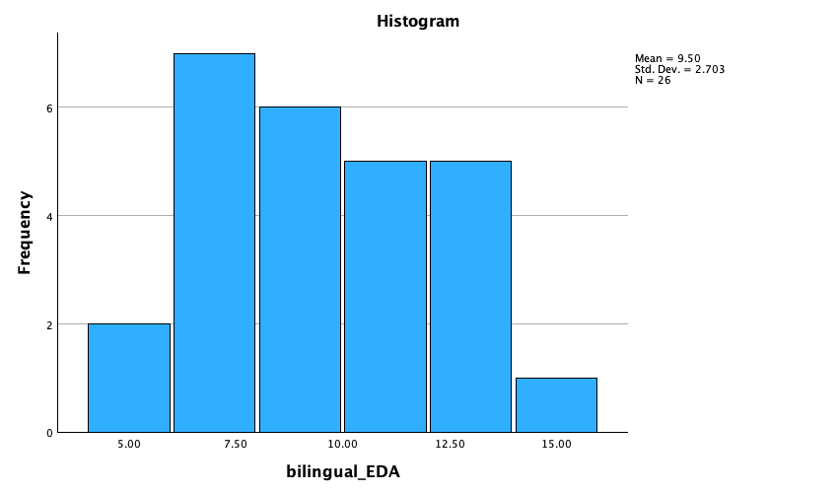
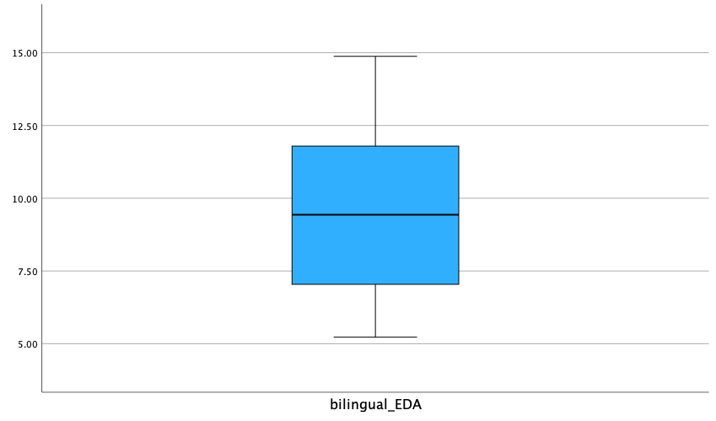
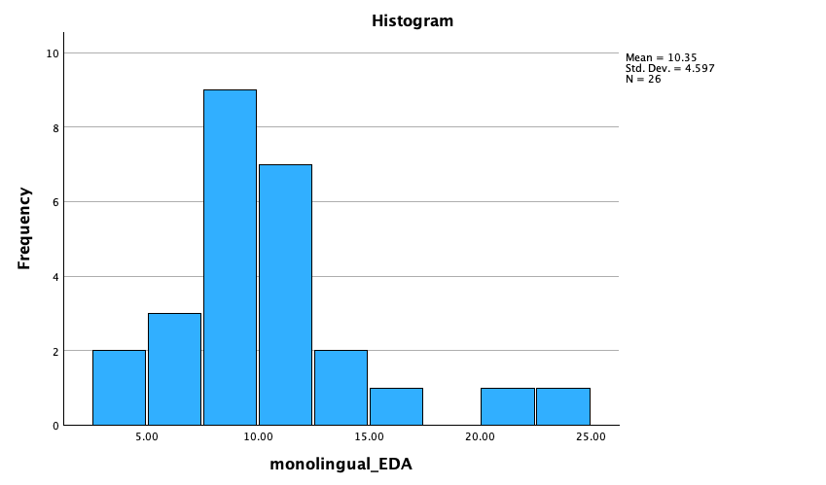

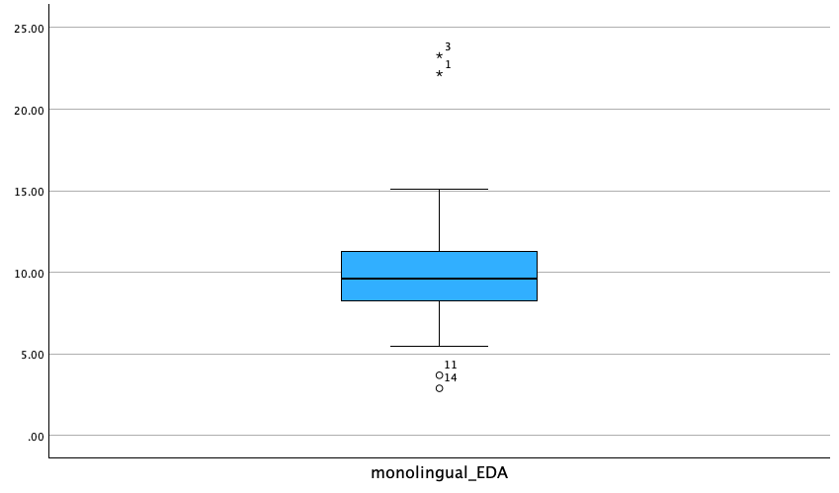

Performance ANOVA analysis

Physiological ANOVA analysis

HISTOGRAMS
PHYSIOLOGICAL MEASURE
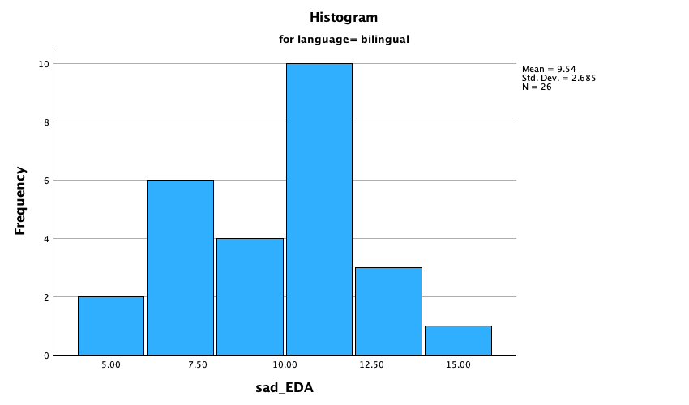

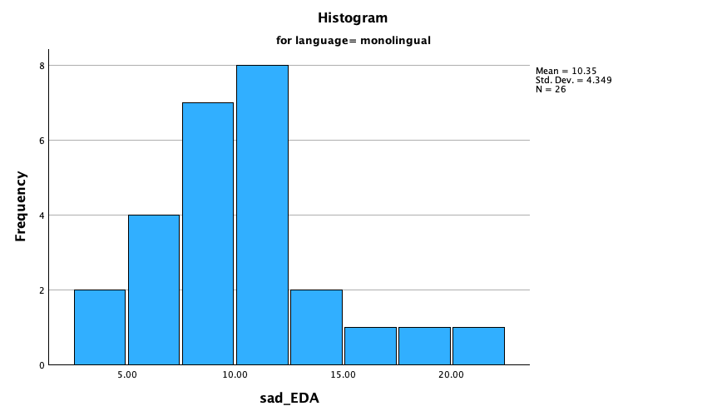

anger_EDA

Histograms

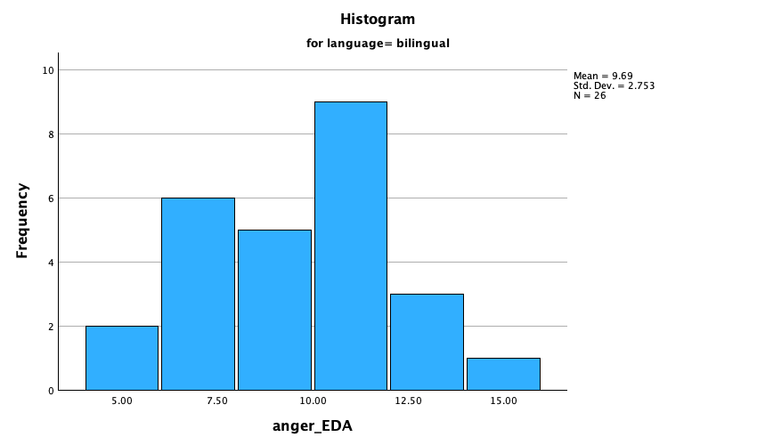

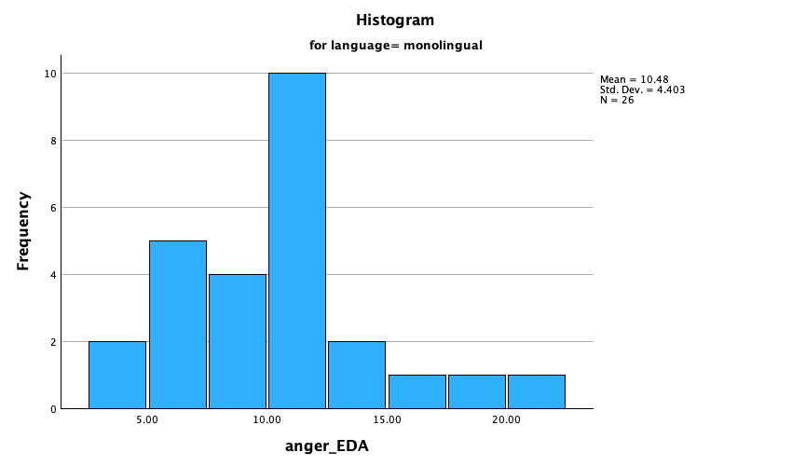

joy_EDA

Histograms

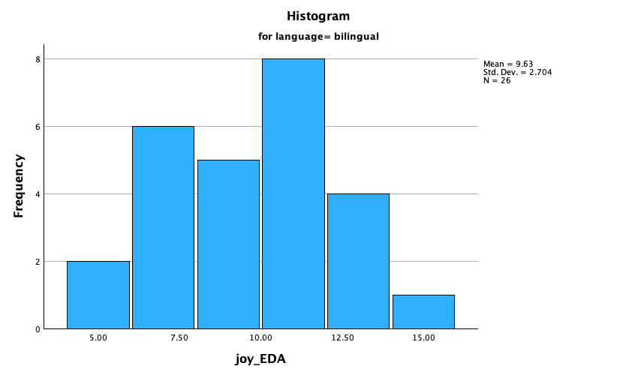

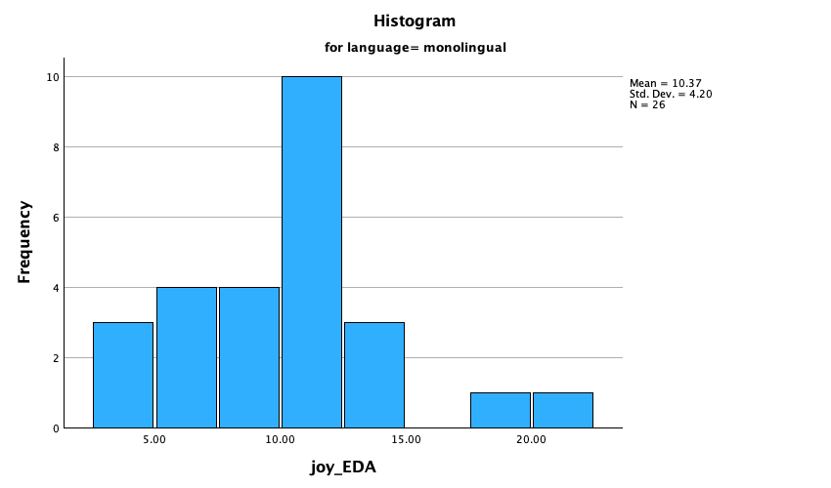

fear_EDA

Histograms

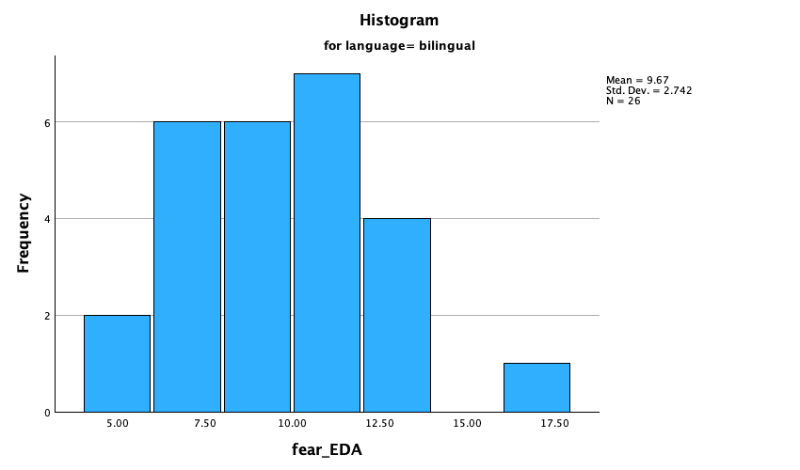

Performance
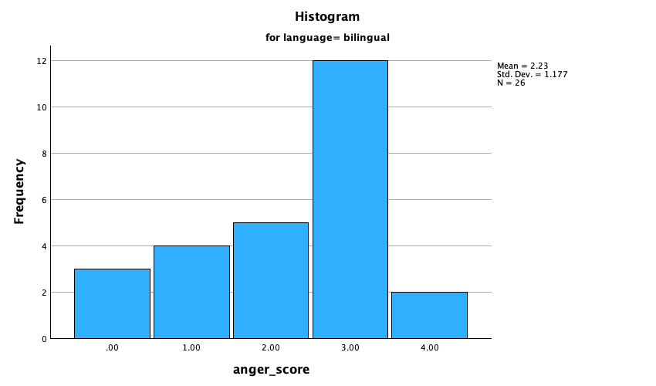

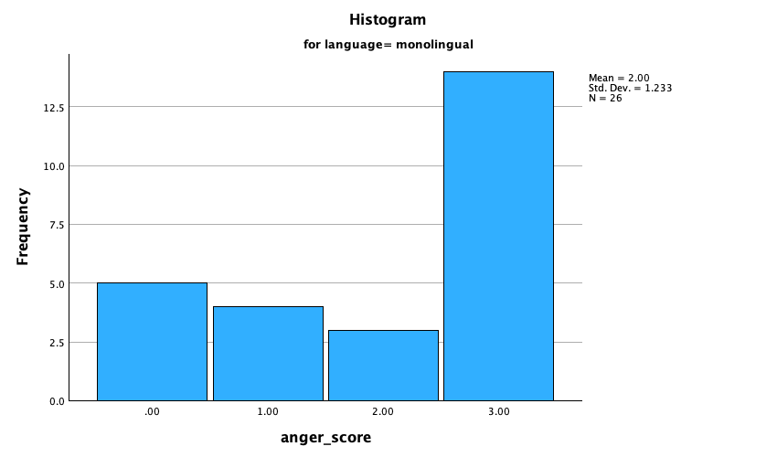

fear_score

Histograms

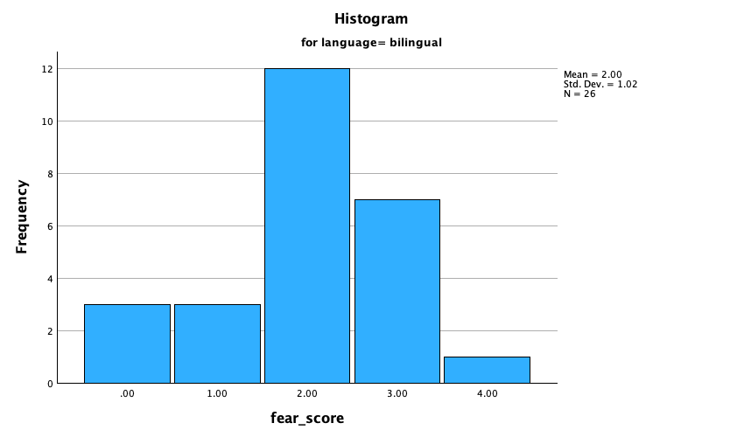

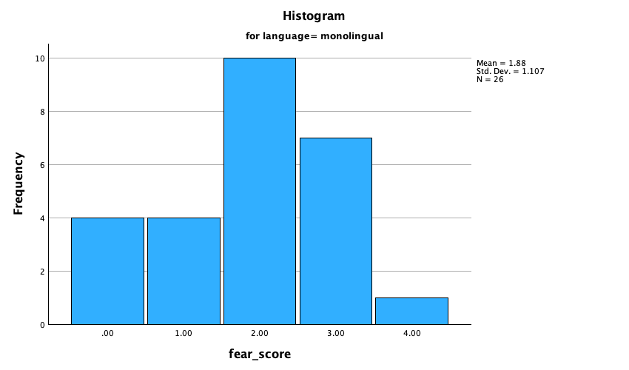

joy_score

Histograms
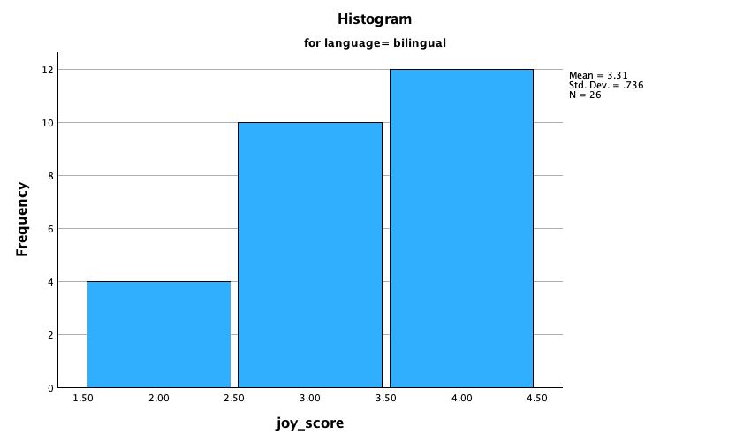

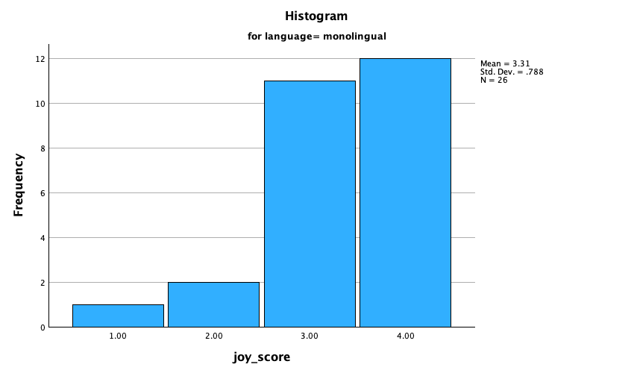

sad_score

Histograms

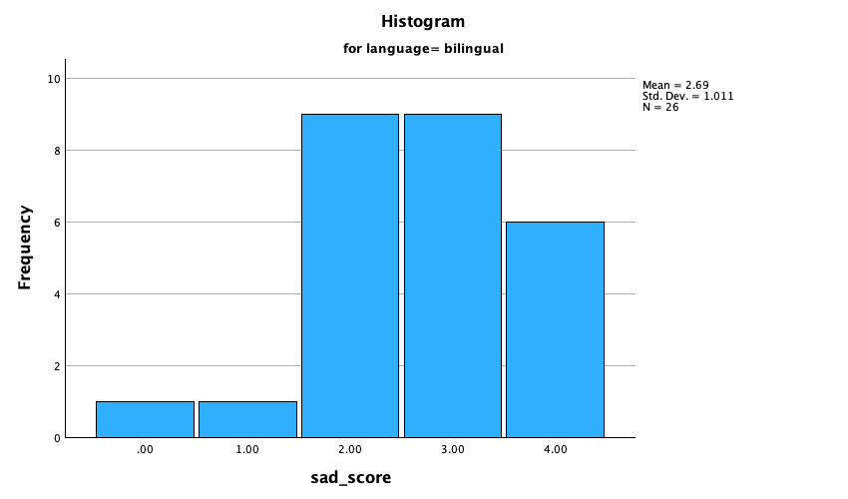

AGE AND GENDER ANALYSIS

Planned contrasts output

Appendix F – social media post / poster

Social media advertisement / recruitment post

How do bilingual and monolingual individuals perceive emotions?

I am currently carrying out a study that examines the emotional perception of both monolingual and bilingual individuals. The study takes place in person, on the University of Staffordshire campus in Stoke-on-Trent, at the Science Centre and requires around 45 minutes of your time. The study is anonymous, and you are free to withdraw at any given time.

Who can participate?
- If you are bilingual, or can speak and comprehend more than 1 language proficiently
- If you are monolingual in English
What is involved?
- You will be asked to watch a series of video clips and complete a short survey.
- Your sweat response will be taken during this time.
Why should I participate?
- If you are a psychology student at University of Staffordshire, you will be credited 4 SONA credits for your participation.
- You will contribute to existing new research and add to the growing field of the impact of language on emotional intelligence.

If you’d like to participate, please email the researcher below: b011187l@student.staffs.ac.uk
POSTER

HOW DO BILINGUAL AND MONOLINGUAL INDIVIDUALS PERCEIVE EMOTIONS?

WHO CAN PARTICIPATE?
- If you are bilingual, or can speak and comprehend more than 1 language proficiently
- If you are monolingual in English

WHAT IS INVOLVED?
- You will be asked to watch a series of video clips and complete a short survey.
- Your sweat response will be taken during this time.

WHY SHOULD I PARTICIPATE?
- If you are a psychology student at University of Staffordshire, you will be credited 2 SONA credits for your participation.
- You will contribute to existing new research and add to the growing field of the impact of language on emotional intelligence.

