Tom Harriman

Supervisor: Peter Cooper

Second supervisor: Kieran Osborne

How can in-game narratives be made more impactful through environments?

GDEV60001 Games development project

Contents

Abstract 2

Introduction 3

Aims and Objectives 3

Literature Review 3

Research Methodologies 10

Results and Findings 11

Appendix 11

Discussion and Analysis 16

Conclusion 16

Recommendations 16

References 16

# Abstract

This project undertook various industry-effective methods of environmental design such as shape and space, sound and player feel to answer the question as to if a game’s environment alone is enough to convey an effective narrative and if it can potentially enhance an already established story. The reasons for this project’s creation and completion is to understand how games that have no discernible dialogue or limited written text can convey an effective and memorable story through the various techniques they use as well as how those who play similar games can become immersed in their worlds and find themselves asking questions like “What happened here?”.

Through user-testing an Unreal Engine demo that was created for the purpose of using the researched techniques to prove their effectiveness, it was shown that an environment alone alongside utilising sound, player interaction and lighting was able to immerse players enough for them to form a narrative and their own interpretations of a story and lore that matched the intended design. These results are significant because they answer the main question of this project, proving that if an environment takes the liberty of including effective and creative techniques within its design, players can become immersed within it.

# Introduction

The project intends to understand how environments in games can enhance a narrative being told as well as how they can provoke certain questions and emotions within its player-base. There is much hidden potential for narratives to shine and have multiple potential meanings depending on the viewer by using the correct techniques like utilising player movement, physical properties and gameplay ecology alongside understanding the complexities and limitations of the available engines.

# Aims and Objectives

The aim of this project is to research and understand the most effective methods of setting out and conveying a story to players and what makes said stories memorable through gameplay, emotional impact and environmental design. The research will later be used in a short Unreal demo. The demo will be centred around the player traversing through an environment that uses the relevant techniques gathered by the research conducted prior to its creation. Doing this will determine whether the project can solve the problem it is setting out to do.

Completion of this task firstly requires careful time management and how those in the industry do so effectively, including how much time they should spend on each part of the project, and which areas are more important than others. Additional research into popular and effective methods of environmental design and level design will also be crucial in creating a memorable and interesting environment for the player to explore and will also be a way to support the narrative.

# Literature Review

Designers use a vast array of techniques to tell stories through environments, one of these techniques is using shape, space and colour to project the emotions the protagonist may be feeling onto the player. Critical Path’s “Ask a Developer: Emilia Schatz Talks Level Design” had NaughtyDog level designer Emilia Schatz talks about her methods of conveying emotional storytelling through the unique uses of shape and space within the levels she designs. Schatz went on to explain how the environments she created allowed the player to experience the emotional highs and lows of the story. An example of this is how some environments are cramped with low ceilings during intense and stressful situations. Following this is another example of how once the story reaches its climax, the game may present a large, open space with the player being able to see all the different areas they have visited thus far, creating a triumphant feeling.

The concept of using shape and space can also convey how dangerous or inviting an overall environment can be, as well as conveying to the player where they can and cannot traverse. The concept of using different simple shapes to invoke different feelings in a person can be studied in a book called “Picture This: How Pictures Work”, written and illustrated by American illustrator Molly Bang in 1991. In this piece, Bang explains how humans “see shapes in context” and their reactions to them “depend in large part on that context”. This hypothesis was tested by illustrating a simple retelling of “Little Red Riding Hood” using only simple shapes like triangles and squares, filling them in basic colours to match. Bang took the protagonist of this story; Little Red Riding Hood, and depicted her as a little red triangle, a triangle was used because of the similarities of a literal hood going over a head creating a distinct and smoother triangular shape. Bang then then asked the question “Do I feel anything for this shape?”, going into detail about how it “isn’t huggable” due to the shape’s points, yet stable thanks to its flat, wide and horizontal base. If the shape were sharper, it might give off a sense of danger due to the reality of sharp objects leading to cuts. Bang then depicted Little Red Riding Hood’s mother depicted as a larger triangle with the shape’s corners rounded off, removing the points to give a sense of comfort and warmth, much like the actual character in the story. Alongside the shape itself, Bang also comments on how the size of these shapes and create emotional impact, she does this by placing the triangle representing the protagonist into the titular forest, the home of the Big Bad Wolf. Bang depicts the trees as big, black rectangles that stretch all the way to the top of the illustration, even going as far as reducing Little Red’s size to make the trees look even taller and foreboding, creating an overwhelming feeling, as if the woods are more suited to larger and nastier inhabitants like the Wolf.

Using size, orientation and curvature in shapes can allow for interesting and easy-to-understand level design games. This concept was proven by Breath of The Wild’s “triangle rule”, revealed by senior lead artist Makoto Yonezu. The “triangle rule” explains how using triangles within the open, ruined world of Hyrule gave players the option to either move around them or go straight over them. These triangles could come in the form of mountains, hills and tall structures. Alongside this, the “triangle rule” also depicted the idea of obscuring the player’s view meaning they would not be able to see anything past the triangle unless they traverse it, often leading to collectables and beautiful sights as a reward, enticing the player to explore more.

Manipulating shape and space within an environment can enhance a plot by actively pushing the player down much like the character they control, placing the player in their position and allowing them to feel the same pressure before releasing it soon after. Doing so can also communicate to the player where potentially dangerous areas are, rewarding curiosity and exploration without accidentally punishing the player and preventing future cases.

Colour can be used in environments to invoke certain messages and emotions within an environment, this is done through the study of colour psychology. Aryaf Alnasuan, a graduate of Fontbonne University’s Art School describes how colour is “a lot more than just the player of paint or as a decoration tool” but is “one of the base elements of design while also the most expressive in terms of the meaning it conveys, and the psychological effects perceived by the audience”. Alnasuan mentions colour theory, which is the idea that different colours can hold different meanings depending on the culture and context of where said colour is used. An example they give is how in Asia, the colour orange is a “spiritually enlightened, positive and life affirming colour” while in other countries like the United States, the same colour can be associated with traffic delays and road hazards, being a more industrial colour compared to its Asian counterpart. Alongside this, Alnasuan states that people who may live in specific climates in the world may have a more positive reaction to certain hues and experience differing emotions depending on what they perceive. Using Psychologist E.R Jaensch’s survey on the subject, it was discovered that people who live in warmer and more tropical regions prefer bright and warm colours, while those living in colder climates preferred less saturated and cooler colours, even stating that “Eskimos have seventeen words to describe white as it applies to different snow conditions”.

Colour theory can also apply to level design. Video Game Psychologist Jamie Madigan provides the idea that the human brain lacks the horsepower to comprehend specific colours and shapes if it is focussed on performing a simple task such as mathematics. This phenomenon has been coined “The Attentional Set” by psychologists. A famous example of this experience is the “Selective Attention Test”, a video created in 1999 and uploaded to YouTube in 2010 by psychologists Christopher Chabris and Daniel Simons. This simple video was uploaded to YouTube and contained a clip of people passing around a basketball, the viewer being given a task of counting how many times players wearing specifically white pass the ball between each other. The viewer would be so concentrated on counting the passes that they would not see an unrelated person dressed in a gorilla costume walk through the set. At the end of the video, the user is asked if they saw the gorilla, to which they would on the second watch. This video went viral, currently sitting at thirty-one million views and spawned a book called “The Invisible Gorilla” by the same two creators, going into more detail on “the numerous ways our intuitions can deceive us”.

Game environments will contain a lot of visual clutter with a wide array of colours, objects and sounds that it may end up resulting in the player ultimately not knowing how to progress through it, getting stuck. Colour theory can remedy this by using a technique seen in the first-person parkour game Mirror’s Edge, released on consoles in November 2008. Mirror’s Edge is known for its high-speed gameplay with strict player pathing via the use of specific colours telling the player where to go. An example of this is how objects coloured in red can be interacted with, these being doors, ledges, pipes and tarps. The colour red is never used anywhere else and not only stands out amidst the greyscale buildings but quickly conditions the player into knowing that the specific colour means progression in some way or form. As easy as this technique is, it is easy for environments to lose player immersion value by using colours that stand out too much compared to their environment, as multiple games such as The Last of Us rely on bright yellow paint to mark where players need to traverse to advance the story, getting to the point where avid fans of the series would take to social media and criticize the design and how it doesn’t look like it fits into the world.

When creating an environment with colours, it is important to use the knowledge of colour theory to create the emotional impact the player needs to experience while traversing, considering the intrinsic meanings of each colour used and not only ensure it fits the themes and tone of the environment itself, but also creates the correct emotions required for the story being told.

Deciding which game engine to utilise specifically for environmental design within games can be done purely based on what features can assist in it. Whether it be graphics, optimisation or programming interactive events within said environment to allow for additional immersion for players.

The official Unity Manual has a section on world building within the engine, which explains Unity’s built-in terrain generation and rendering features. Unity also has a High-Definition Render Pipeline (HDRP) demo that displays a pre-built environment, that allows developers and designers to understand how these systems work. Unity has its own selection of terrain tools that have multiple methods to edit the overall size and shape of the environment, these tools include being able to raise or lower terrain, paint holes within it, apply imported or self-created textures, smooth-out terrain surfaces as well as being able to create custom Terrain tools. Alongside these terrain tools are the many Unity Packages that can be installed alongside the primary software. Unity Packages act as additional tools that can assist in a variety of ways such as animation, splines and multiplayer systems. One of these additional terrain tools is a tool that allows for foliage placement such as trees, bushes and rocks by way of paintbrush. Each piece of foliage is saved as a prefab, which in the official Unity documentation is described as a “reusable asset for GameObjects”, using prefabs for props and pieces of scenery is more optimal as it allows for the copy and pasting of the singular GameObject and keeps them all synchronised and in the same state.

Unreal Engine 5 has a unique sample pack called Valley of the Ancients, which is a pre-built environment that displays two unique systems native to Unreal Engine 5, these being the Nanite system and the Lumen system. Both systems work in tandem to make environments more detailed and graphically impressive. The Nanite system is a type of internal mesh format and rendering technology that allows the rendering of pixel-scale detail and high object counts, it also renders the details that can be perceived by the player at a given time without changing the silhouette and shape of the object it is applied to. This system allows for greater optimisation because of this. The Lumen system is Unreal Engine 5’s dynamic illumination system designed with next-gen consoles primarily in mind, the Lumen system also works alongside the software’s default lightning system. Lumen helps in rendering diffuse inter-reflection with potential for unlimited bounces as well as specular reflection in larger environments. It can also work in scales millimetres to kilometres. Using this system means that lighting within the environment will be rendered dynamically in real-time.

An impressive environment can allow a player to feel immersed in a game. However, the importance of audio in said environment through music and ambience can immerse the player further. These audio queues can help set specific tones for story-beats, link areas together using motifs and repeating sound queues, or making gameplay more satisfying by linking sounds to actions. Audio is a crucial step in immersing a player and creating a more memorable experience. Felix Andersen’s “Audio Influence on Game Atmosphere during Various Game Events” included study on such a topic which was performed to test this hypothesis. The study involved using a pre-built FPS Microgame from Unity’s library and creating two levels that can be played, A “Alien City” and B “Moving Castle”. The main difference between these two levels is that one would be entirely muted, and the other would include the soundtrack “BFG Division”, a metal genre track created by composer Mick Gordon, alongside various sounds and ambience that were inherited from the pre-built game. A set of players was then tasked with playing these two demos and answering questions such as if the game was more exciting with the addition of sound as well as how important audio is in games. The study concluded with an overall majority of players believing that audio in the form of sound effects and music are critical elements in what makes a game enjoyable and atmospheric, as the data gathered showed increased player engagement and faster level completion. the software. This system is called MetaSounds and according to official Unreal Engine documentation; acts as a “high-performance audio system that provides audio designers complete control over a Digital Signal Processing (DPSP) graph for generating sound sources.”

Unreal’s Node-based interface, or Blueprint; allows for designers with little to no programming experience to create procedural sounds using a unique series of nodes that implement sound waves and allow them to be edited. Users can also implement their own audio sources through third-party software and edit them through the same system.

Game Maker’s Toolkit’s “Adaptive Soundtracks in Games” has a good example of games linking areas together through audio by using the example of New Super Mario Bros’ U’s overworld screen. The map screen is what connects each level together through a hub-like minimap that acts as a level select screen. The map itself has a simple melody that stays consistent throughout the game, however when moving to different worlds within the game, the instruments used in the composition change to fit the area’s tone and design. “Frosted Glacier”; the ice area uses instruments to create an icy-like feel to the soundtrack while keeping the familiarity of the map motif, while “Sparkling Waters”; a beach-like area ditches the coldness by using handpans to guide the map motif.

Another example in the same talk is how The Legend of Zelda: Skyward Sword’s dungeons have adaptive music. The game’s dungeons are long, winding labyrinths filled with many rooms to explore and puzzles to complete, each given their own soundtrack to layer over the environment to truly bring it to life. The tone of the soundtrack will also change depending on the type of room the player enters at a given time, shifting in intensity if said rooms has enemies or a puzzle. The intensity of an adaptive soundtrack can be changed by using multiple sound techniques in tandem. One of these techniques is using sound envelopes. TechMeAudio.com’s “Sound Envelopes” tutorial describes sound envelopes as “helping establish the sound’s unique individual quality” and how it has “a significant influence on how we interpret sound”. The envelope of a sound can be measured in four ways, these being Attack, Decay, Sustain and Release.

The Attack is “the portion of the envelope that represents the time taken for the amplitude to reach its maximum level”, meaning it is the initial build-up of a sound. Decay is “the progressive reduction in amplitude of a sound over time”, this starts the moment the Attack phase has reached its peak, making the signal drop until it reaches the Sustain phase. Sustain is “the period of time during which the sound is held before it begins to fade out”, most instruments don’t contain a sustain phase, meaning it is mostly done in sound editing software like Audacity or through the MetaSound system. Release “is the final fade or reduction in amplitude over time”, a sound with an obvious long release. A more intense situation in a game may use each phase of an envelope in its adaptive music by creating a loud and sudden introduction before decaying the sound down once the tension levels. It may then sustain a constant level of volume for a duration before releasing the tension and lowing the volume. Manipulation of tension and intensity using audio envelopes within an environment can make scenes within it more memorable as games such as Breath of The Wild’s opening sequence uses this technique as the player walks out of the Shrine of Resurrection at the start of the game. In making a scene more memorable, the environment alongside the story told in said environment will remain within the player’s mind while continuing to explore, said exploration leading to memorable story reveals.

Audio isn’t only used in soundtracks to go along with an environment. Sound effects are a staple when it comes to bringing an environment to life, and alongside it the narrative in which is being told. Sound effects are important because they can affect a player’s immersion, people can see an object and have a basic understanding of what sound it makes, examples being the splashing of water, the grinding of metal on metal and the light tapping of footsteps on a wooden floor. If any of these sounds are not what the player is expecting, immersion will break as the ear is quicker than the eye. The art of foley enables realistic sounds like those to a game. Foley is the act of reproducing everyday sound effects via the use of props that are added in post-production to films, games and other media. Interviewing company “WIRED” had the opportunity to talk to Sony’s foley artist for God of War, Joanna Fang. Fang explains how she uses objects in tandem to create everyday sounds a lot more effectively. A scene may contain someone in heavy boots walking in snow, Fang demonstrated a foley technique of using similar footwear and stepping on charcoal to emulate the heavy crunching of snow. However, more unorthodox and violent sounds can be emulated through hitting fruit with a hammer or a crowbar. Foley is an effective method to enhance immersion within particularly intense scenes within games as it alongside post-audio editing can bring a scene to life.

Using all the techniques mentioned previously can allow for the creation of immersive and unique environments within games that can also help in delivering a narrative that will make a lasting impression on the player. However, if the player is unable to advance through said environment due to reasons like gameplay being dissatisfactory or lack of player feel, they will never be able to see the passion and thought behind each creative decision made behind the area they may find themselves in. Player feel is described as “all about timing, about making players really feel the impact, about the number of frames each move takes, or about how polished the interactions are”, making it all about the intangible tactile feeling that makes a game ‘feel good’ to play. Game feel is commonly achieved through how a player can move around in a game, a good example of movement specifically a 3D space is in Super Mario 64, which was praised for having tight and responsive controls as well as having a wide array of movement options such as long jumping, wall-kicking and triple jumping. Not only are all these movement techniques within the game bound to a singular button alongside either a secondary button or tilting the control stick in a certain direction, but all of them allow for greater traversal of a level. The term ‘game feel’ was popularised by games designer and author Steve Swink, who released a book in 2008 named “Game Feel: A Game Designer’s Guide to Virtual Sensation”, this book details the meaning of game feel and its importance when creating a game that feels satisfying and responsive to play, a way to keep the player invested in what it has to offer. Swink went on to create seven principles of game feel, these being predictable results, instantaneous response, “easy but deep”, novelty, appealing responses, organic motion and harmony. Swink even compared these principles to similar principles used in animation.

Predictable results is summarised as “when a player takes an action, they should get the response they expect”, this means there should be no interference between the intent of the player and the outcome of an action regardless of the game’s difficulty or the difficulty of the player’s inputs, following this idea would encourage the player to get better as they play while knowing their inputs won’t give a random result. When creating a set of controls for a character in-game, it is important to consider what actions they players will perform at precise points, also thinking about non-precise inputs that can lead to player frustration when an action is not performed. The player may need to jump across a platform to not fall into a pit, but since they are unable to make precise inputs alongside most humans, they may press the jump button a few milliseconds late and fall. Predictability also means inference; an experienced player may be able understand the structure of the game they are playing within the first few minutes. Falling into a pit may result in losing a life, therefore the player will avoid pits for the rest of their gameplay. “A predictable result should reveal as much about the possibilities you haven’t tried as about the ones you have”. There are three factors that go into the feeling of randomness a player may feel from their inputs, these being control ambiguity, state overwhelm and staging.

Control ambiguity comes from the idea of designers unintentionally placing similar actions the player can take on similar inputs. In Super Mario 64, pressing the A- and Z- buttons a the same time will either perform a long jump or a ground pound, these two actions are determined by which buttons are pressed in a certain amount of milliseconds, if these buttons are pressed simultaneously over and over, the player may start to think the movements performed by these inputs are random and may never understand how to perform them properly.

Swink describes state overwhelm as the state in which a player may find themselves in within the game they are playing at a given time. A game like Super Mario Brothers may have two states, these being “grounded” and “midair”. The simplicity ends when comparing it to most classic and modern fighting games, which has multiple states that inexperienced players may find overwhelming due to each button having multiple random outcomes depending on either directional inputs or “chorded” inputs, pressing two buttons at the same time. Most first-time players will end up pressing random buttons and learn what each one does through its response.

Staging is the “result of an input that is difficult for the player to perceive”, like the staging principle of animation in which actions must be “staged” In order to for the audience or player to understand the outcome of their input. If the animation or action was too fast, this can confuse the player and can result in them losing interest if unsuccessful multiple times.

“Games that feel good typically respond immediately to input”. Swink uses Halo’s Warthog controls as a good example of instantaneous response and how they are loose and flowing yet still feel tight and responsive. When the player begins turning the warthog, it immediately begins seeking the direction that the player is attempting to steer it in, the speed of the turn being influenced by how far the new direction is from its current facing position, this results in larger, more obvious responses happening moments after the change in input. This rule is heavily related to the “Slow-in, Slow-out” principle of animation. This principle goes into the idea of using frames of animation to denote speed. Less frames would make the action faster while more would make the action slower, using this technique can make an animation feel more lifelike which can immerse a player into an environment by making their actions feel lifelike too. In a game however, slower responses can give a sense of sluggishness and unresponsiveness, this is solved by making the input the player performs give an immediate result while still being perceivable.

The “Easy but deep” principle denotes how “good games take minutes to learn, but a lifetime to master”, the most effective method most games achieve this principle is through natural control mappings, Swink uses an example of the controls for the ship in Geometry Wars and how the thumbstick is used to drive it, noting how the ship itself closely matches the physical movement of the thumbstick. The W, A, S, and D keys are also natural control mappings as they are established cultural standards for control in games. In-game tutorials and “helping tools” such as auto-aim and difficulty adjustment are also a good way to make a game easy to learn, by allowing the player to adjust how the game acts, they can better understand and raise their skill level, and in doing so garner enjoyment.

Novelty alludes to the concept of making the results of player input predictable after a certain amount of time yet allow for subtle differences in response to keep the controls feeling fresh and interesting. While games like Jak and Daxter attempt to solve this issue is through Jak’s linear animations, the player will eventually see every animation and feel the content getting more boring overtime. Swink uses Castlevania: Dawn of Sorrow as an example of a better and more gameplay-focussed approach to this problem by commenting on how the additional mechanics in the form of weapons and character upgrades can increase virtual sensation which adds a “different feel to the underlying movements or augments it with new states, such as the ability to jump twice without landing”

An “appealing response” is described by Swink by mentioning how "Real-time control should still be engaging an aesthetically appealing when completely removed from context”. Also ensuring the result of the player’s input is compelling regardless of said input. Small additions to animation can add to appeal by making movement seem organic and complex, New Super Mario Brothers does this by having Mario throw up dust particles whenever he runs or makes a quick turn. Ski Stunt Simulator does this from a gameplay perspective by using a “ragdoll” physics rig, meaning each limb has an individual mass with constraints to simulate joints whenever the skier bails and falls. Using a ragdoll rig ensures that the same animation won’t be playing over and over and produces a satisfying and organic response that often brings entertaining and visceral responses from the player due to the comically extreme nature of the ragdoll being tossed around and slamming into objects in the environment.

Games that have a good feel to them often produce flowing, organic motion. Whether this motion comes from the avatar itself, overlayed effects as well as simple curving or arcing motions are more appealing. This draws parallels to the principle of animation involving arcs, as arcs are natural and flowing motions that both humans and animals follow. Setting the position of an avatar every frame with the horizontal movement seen in games like Donkey Kong and Contra produce rigid and stilted linear motion, while games such as Asteroids use the avatar’s thrusters to simulate velocity in the game space, creating more flowing and organic motions.

“Each element of a game’s feel should support a single, cohesive perception of a unique physical reality”. Harmony is described by using the player’s perception of objects both in the real world and in games, taking note on how players will notice if objects do not perform exactly like their real-world counterparts such as a ball not bouncing right, or objects not tipping over correctly. This makes designing game environments very difficult, as inconsistencies can become obvious. The best games have shown to be able to maintain harmony across each of its elements of game feel. If an object in a game looks like a car for example, it must control like one, have grip on the road it may be driving on, the crackling of its engine and the screeching of its tires must sound convincing. This rule applies to photorealism the most, meaning the more detail that goes into an environment, the more akin to the real world the player expects it to act at a given point.

Each principle of game feel is important to designing and creating a compelling and immersive environment that has player actions that not only feel good for the player to perform, but remain clear, concise and accurate to their inputs and real-world experiences.

# Research Methodologies

To truly understand and prove if the research performed is true and to answer the question if a story of some kind can be told or conveyed through an environment, a playable experience was made in the Unreal Engine. This project features first-person player movement via a unique “grid-based” system akin to games like “Legend of Grimrock”, interactable objects, custom made textures, lighting and ambient sound that has been mixed and made loopable through both Unreal Engine’s sound settings and Audacity, a free-use audio editing software. The focus would be on if the player would be able to attain a sense of immersion through the combination of an environment and sound as well as if they could piece together limited context clues to form an idea of what the environment is and what story it could be attempting to convey. The movement system was taken from an Unreal Engine blank project by user ‘Everynone’ from the Unreal Engine community page. All other additions are original work. All sounds used are provided by user-created posts on FreeSound.org, a free-use audio download website for use in games and other media. The scene includes a glowing green “test tube”-like object as the main setpiece, a button with a flashing red light on the opposite end of the room. Interacting with the button will cause a row of extra lights to flicker on, revealing rows of similar looking “test tube” objects that do not glow. The area is akin to a test-chamber of a scientific containment room. The playtesters will not know this and will be asked to attempt to piece together what the environment means and potentially a narrative behind it with the help of lights, audio and interaction immersing them.

The testers consented through a form and were invited to experience the demo, given as much time as required until they feel as if they have seen everything the project has to offer. Upon completion, the testers were given a questionnaire using Microsoft Forms and were requested to answer questions based on a ‘1 through 10 system’, mainly enquiring if the testers experienced immersion and to what degree as well as attempting to understand if they could piece together a narrative or story through it. All these tests were performed using similar hardware and software to that of a controlled, industry standard environment.

The consent forms as well as the Microsoft Form questionnaires will be kept in a secure OneDrive that is separate from both outside and the project developer’s reach and will be discarded once the window for testing has been completed. The testers names will also be anonymous.

# Results and Findings

### Appendix

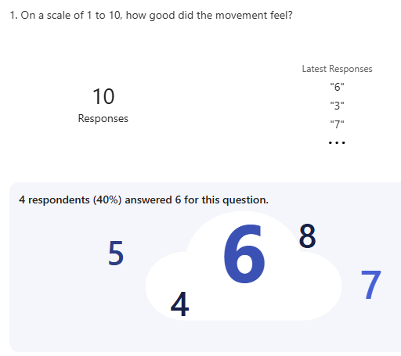

40% of the playtesters believed the movement felt above average with an overall score of 6/10

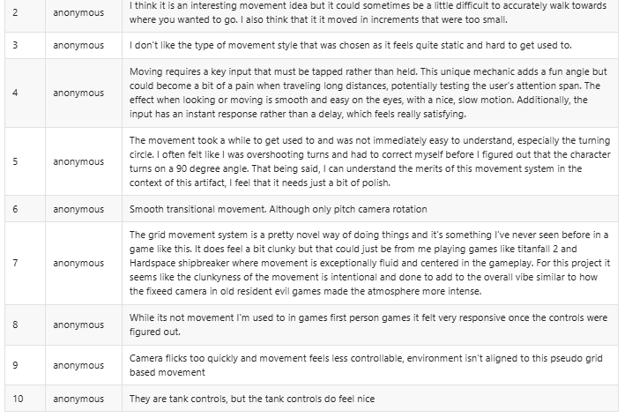

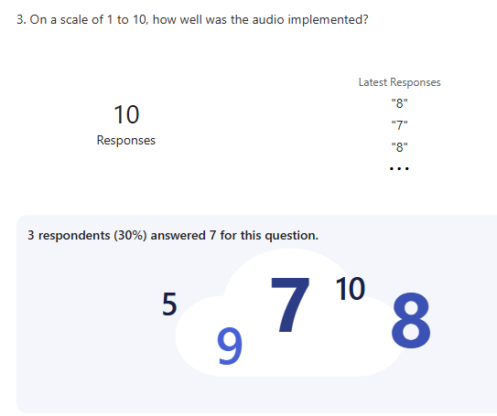

30% of the playtesters believed that audio was implemented almost perfectly with an average score of 7/10

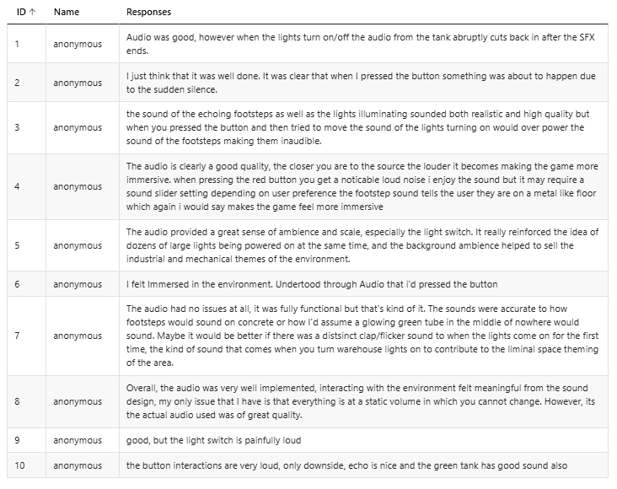

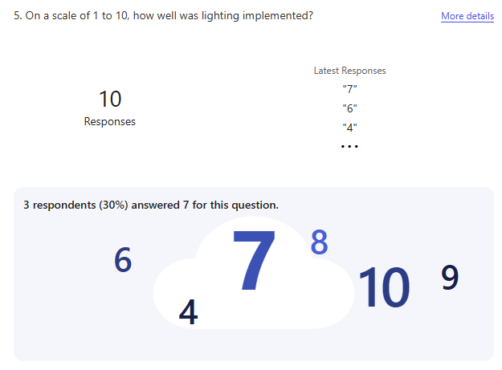

30% of playtesters believed that lighting was used effectively with an average score of 7/10

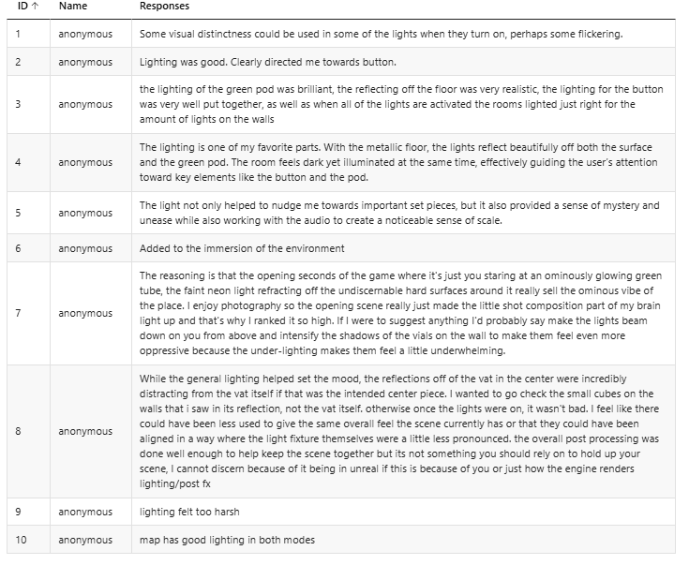

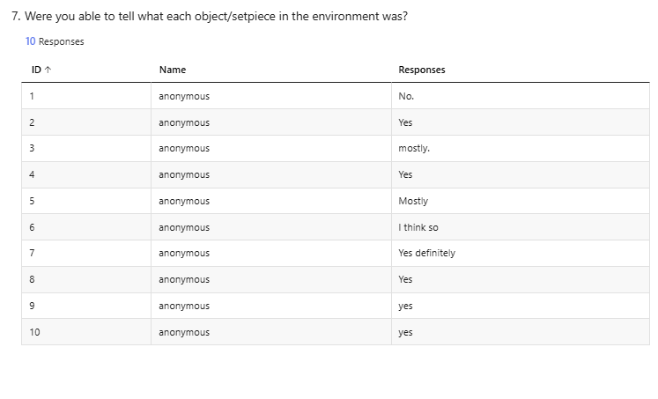50% of playtesters could understand what each setpiece within the artifact’s environment was at a first glance

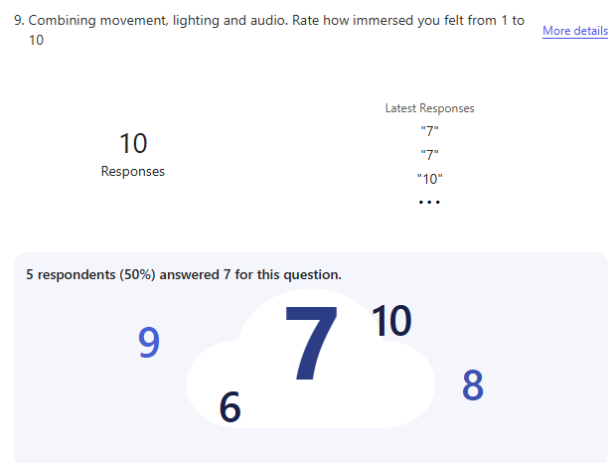

50% of playtesters stated that they felt a 7/10 score in immersion while playing, combining movement mechanics, lighting and audio within the scene they played.

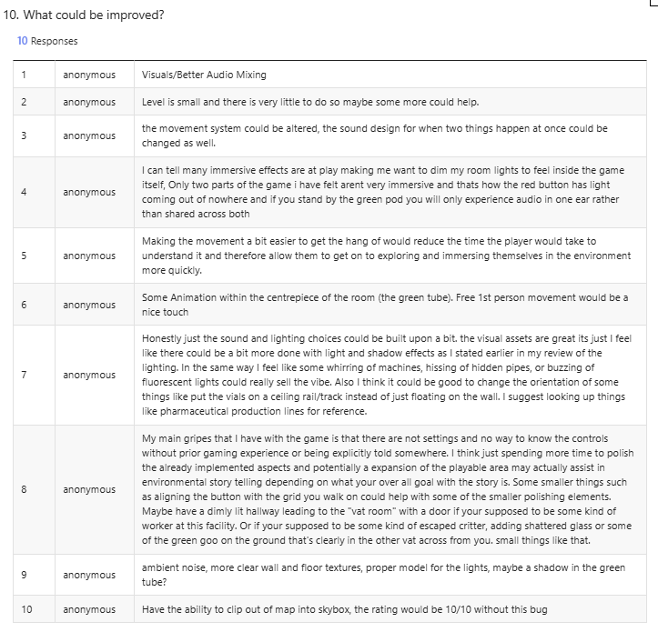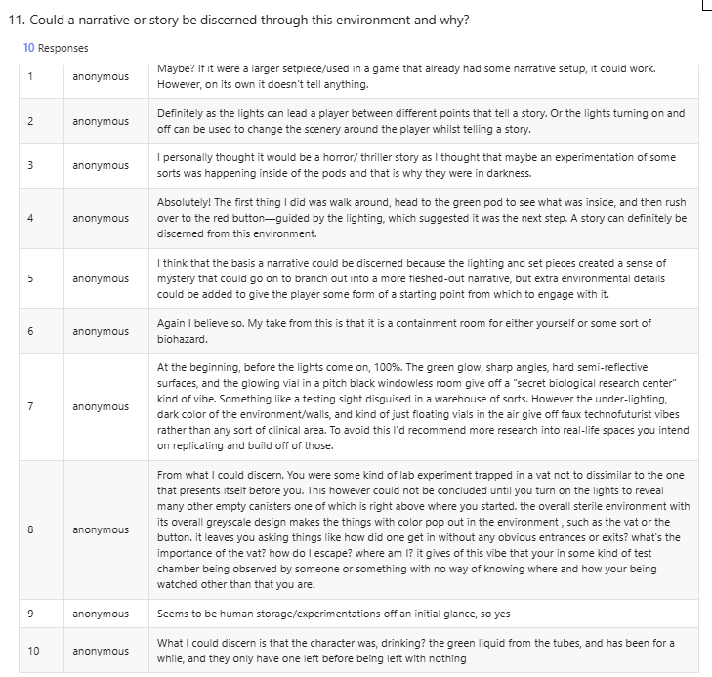

# Discussion and Analysis

Upon sampling feedback on the artifact, the investigation has shown that the created environment using the techniques have been well-received and effective in achieving the goal it has set out to do.

A majority of the playtesters felt that the tank-like control system is a new and different way of moving around an environment akin to the artifact, users noting that it felt decent to control yet moving forward and backward felt too short, as if the player’s strides weren’t realistic enough. Another improvement that could be made is making turning less snappy and more natural. Playtester 7 noted that the clunkiness of the movement adds to the atmosphere, using the example of the early Resident Evil games’ tank-controls and how combined with the fixed camera

Audio was well-received, and the feedback provided was positive as a majority. Each object within the environment from the player’s footsteps to the sounds of the lights were accurate enough to generate immersion and gave meaning to the interactions within the environment. The only improvements that could be made according to the research provided is that the ambient sounds within the environment cut out abruptly when interaction starts, only to begin again once the interaction ends. Alongside this, the audio for the lights specifically was the loudest and drowned all other sound out upon being activated. Better sound mixing within the game engine can resolve this. The usage of sound mixing in Audacity to create the ambient sounds for the main “test tube” object by combining bubbling noises with an industrial fan supports the research based upon it as combining sounds can create entirely new sounds that can be accurate to what the object would emit, even if said object does not exist in the real world.

Research gathered on lighting implementation showed that playtesters enjoyed the use of lighting to direct the player toward an interactable object, noting how well the lights reflect off the walls and floor and how it also helps to illuminate key objects of focus within the environment which increased immersion. Some users also noted that the lighting also felt harsh in some areas. An improvement specifically on the lights on the wall. One playtester noted how the direction of the lights would be more effective if inverted, shining downward instead of upward. Doing so would create more oppressive shadows and create an entirely new and potentially more effective feel that could push a greater feeling of story and immersion. Using the Lumen system’s advanced reflections as research proved effective as users enjoyed the reflections off the more metallic surfaces of the environment.

Using Bang’s research into using simple shapes to create objects within an environment was an effective design philosophy when creating each object with the environment, each setpiece was low-poly and used simple shapes like cubes and cylinders. Despite the simple nature of these objects, a majority of playtesters could clearly tell what each object was and what kind of significance they held within the environment. The tank in the centre in the room could have been given some kind of animation within the green liquid inside, such as bubbles moving to give more of a clear indication as to what the object is.

Combining aspects of movement, lighting, audio and intractability. The playtesters have discovered that the narrative and story of the artifact’s environment is that of a containment room for a biohazard, a warehouse for a testing site or a storage and experimentation facility. These assumptions almost match the description of the story that the environment was aiming to tell from the beginning. There were however a few playtesters that were unable to discern a story due to the early build of the environment being small, noting however that if the environment was bigger and more developed with more rooms and interactable objects, it could very well have the potential to.

# Conclusion

In conclusion, this project has proven that a well-crafted environment that undertakes the proper and industry-proven research has been effective in enhancing storytelling. The majority of playtesters that consented and experienced the artifact yielded the results that the goal of the project was aiming to achieve as the story and narrative that they discerned through playing the demo matched the intended design of the environment itself as well as the tone and feel of the kind of narrative it was aiming to express. This conclusion was reached despite the lack of high-poly models which originally was a high-priority concern as the knowledge to create highly detailed setpieces was a new area of research and development compared to other objectives.

# Recommendations

If further investigation into this project is undertaken, improvements on the environment itself would be useful. This is because most of the feedback from the playtesters indicated that the environment itself was a little too small and could use some expansion or player mechanics. Early concepts of this project involved puzzles which the player could complete to unlock future rooms, integrating this into the demo will not only make the experience longer, but also provide further and more effective narrative storytelling through tangible in-game progression. Due to the environment’s props being low poly, a majority of Unreal Engine’s true capabilities when it comes to crafting environments was left untouched. Further research into lighting, modelling and texturing would also be a good recommendation for the future development of this project as it will not only allow the props to undergo a significant change in design and detail, but also increase immersion through better looking reflections and textures that would help set the tone more effectively. Alongside this change, further research into graphics and optimisation would prove useful to compensate for potentially weaker and more dated hardware compared to the hardware used during the testing phase.

Obtaining a greater number of testers may also assist in creating a more detailed and expanded list of opinions and truly understand how and why players who enjoy a wider range of genres obtain immersion through games and come to understand their stories.

# References

1: “Ask a Developer: Emilia Schatz Talks Level Design”, Critical Path, Emilia Schatz (2018)

<https://www.youtube.com/watch?v=CRDaXvkge8Y>

2: Bang, M. (2000) *Picture this : how pictures work.* New York: SeaStar Books.

<https://sienaproseminar.weebly.com/uploads/1/3/1/0/13109053/mollybang_reduced.pdf>

3: “The Design Secrets of Breath of The Wild”, Makoto Yonezu (translated by Matt Walker, 2017)

<https://80.lv/articles/the-design-secrets-of-breath-of-the-wild/>

4: Alnasuan, A. Colour Psychology, American Research Journal of Humanities and Social Sciences, Volume 2, 2016; pp:1-6

<https://www.arjonline.org/papers/arjhss/v2-i1/9.pdf>

5: “Inattentional Blindness and Video Games”, Jamie Madigan (2013)

<https://www.psychologytoday.com/gb/blog/mind-games/201307/inattentional-blindness-and-video-games>

6: “Selective attention test”, Daniel Simons (2010)

<https://www.youtube.com/watch?v=vJG698U2Mvo>

7: “World Building”, Unity Documentation (2005-2025)

<https://docs.unity3d.com/Manual/CreatingEnvironments.html>

8: “Lumen Global Illumination and Reflections”, Unreal Engine (2004-2025)

<https://dev.epicgames.com/documentation/en-us/unreal-engine/lumen-global-illumination-and-reflections-in-unreal-engine>

9: “Nanite Virtualized Geometry” Unreal Engine (2004-2025)

<https://dev.epicgames.com/documentation/en-us/unreal-engine/nanite-virtualized-geometry-in-unreal-engine>

10: Andersen, F. *et al.* (2021) ‘Audio Influence on Game Atmosphere during Various Game Events’, *Procedia Computer Science*, 179, pp. 222–231. Available at: <https://doi.org/10.1016/j.procs.2021.01.001>.

11: “MetaSounds Quick Start”, Unreal Engine (2004-2025)

<https://dev.epicgames.com/documentation/en-us/unreal-engine/metasounds-quick-start>

12: “Sound Envelopes” TeachMeAudio (2020)

<https://www.teachmeaudio.com/recording/sound-reproduction/sound-envelopes>

13: “Adaptive Soundtracks in Games”, Game Maker’s Toolkit (2014)

<https://www.youtube.com/watch?v=b0gvM4q2hdI>

14: “How This Woman Creates God of War’s Sound Effects | Obsessed | WIRED”, WIRED, Joanna Fang (2023)

<https://www.youtube.com/watch?v=WFVLWo5B81w>

15: Swink, S. (2009) *Game Feel: A Game Designer’s Guide to Virtual Sensation*. 1st edn. Milton: CRC Press. Available at: <https://doi.org/10.1201/9781482267334>.