BENG Mechanical Engineering: Individual Engineering Project ENG61010
Electronic Waste Solutions for a Sustainable Computer Mouse
Joshua HADDOCK
Student Number: 21010567
Joshua Haddock
01/05/2024

Abstract

A major problem faced today environmentally and socially is electronic waste. This growing issue destroy habits and produces dangerous toxins that can cause harmful health effects to nearby people.
Furthermore, the development of modern plastics like ABS and a throwaway culture continues to require large amounts of carbon and oil, contributing to climate change.
The aim of this project is to take a common electronic product found in almost every home (the computer mouse) and investigate possible sustainable solutions for reducing its harmful impacts to provide an example of what could be achieved with other products.
After an extensive literature review, a prototype is developed using the Double Diamond Design system and life cycle analysis to focus and test a few solutions such as using biodegradable bioplastics and reducing material waste.
Computer Aided Design and Stress analysis are used to optimize the design to the point it could be 3D printed.
As a result, the new design reduced the carbon output of its shell by 93% in comparison to mainstream counterparts. It also reduced the price by 20% giving an incentive for businesses.
The project overall found that it is very possible to decrease the harmful effects of electronic waste through sustainable design, but it requires further education, policy and a changing customer demand for businesses to avidly use the principles.

Contents
Abstract 1
Table of Figures 5
1. Introduction 7
2. Aims 7
3. Objectives 8
3.1 SMART 8
3.2 Methods for Achieving Objectives 8
3.3 Further Specific Tasks/ Objectives 10
4. Research Hypothesis 11
5. Impact of Research 12
5.1 Social 12
5.2 Economic 13
5.3 Environmental 13
6. Gantt Chart 14
7. Literature Review 14
7.1 History of e waste 14
7.2 Polylactic Acid 15
7.3 Manufacturing 17
7.4 Product Design principles 17
7.5 Intellectual property 19
7.6 How Mice Work 20
7.7 Requirements Research 21
7.8 Current Popular Mice 24
8. Method 25
8.1 Design Research 25
8.2 Ideation 27
8.3 Consumer Feedback 29
8.4 Physical Breakdown 30
31
8.5 First Designs 31
8.6 CAD Testing 31
8.7 Electronics Build 33
8.8 More CAD Testing 38
8.9 Main CAD Build 40
8.10 3D Print 48
8.11 Coding 51
9. Results and Analysis 52
9.1 Mesh Independence Study 52
9.2 Stress Tests 55
9.2.1 ABS Plastic 55
9.2.2 PLA 57
9.2.3 Nylon 62
9.3 Parameter Discussion 63
9.4 Results Analysis 65
9.5 Experimental Errors 67
9.6 Critical Review of Methods 68
9.6.1 Project Management 68
9.6.2 Design Phase 69
9.6.3 CAD Phase 69
9.6.4 Stress Simulations 70
9.7 Validation of model 71
10 Conclusions 73
10.1 Achievement of aims 73
11 Relevance and Impact 74
12 Validity 75
12.1 Limitations 75
12.2 Potential transferability 76
13 Future Work Recommendations 77
14 References 78
15 Appendix 82
88

Table of Figures
Figure 1- Double Diamond Design Process 9
Figure 2 - Initial Gantt Chart 14
Figure 3 - Differences Between Design and Molding 17
Figure 4 - Patented Design of Interchangeable components found at https://worldwide.espacenet.com/patent/search/family/034138720/publication/CA2534662A1?q=pn%3DCA2534662A1: 20
Figure 5 - Scroll Wheel Mechanism 21
Figure 6 - Best mouse hand posture 22
Figure 7 - Ideal Mouse Inclination 23
Figure 8 - Logitech MC Master 3S Found at: https://www.amazon.co.uk/gp/product/B07W4DGFSM?tag=rtings-u-mc-21&ie=UTF8 24
Figure 9 - Logitech M185 Found at: https://www.amazon.co.uk/Logitech-Wireless-Windows-Ambidextrous-Design/dp/B00552K0GM/ref=zg_bs_g_430567031_d_sccl_1/260-0888630-5680230?psc=1 24
Figure 10 - Feature Cost Scoring 29
Figure 11- Feature Value User Feedback 29
Figure 12 - First Mouse Breakdown 30
Figure 13 - Initial Sketches 31
Figure 14 - First CAD Experiments 32
Figure 15 - Snap Joint CAD Test 32
Figure 16 - Chosen Spare Mouse 33
Figure 17 - Recovered Electronics 34
Figure 18 - Making Electronics Board 35
Figure 19 - Making Scroll Wheel 37
Figure 20 - First Prototype 39
Figure 21 - Shell Body 41
Figure 22 - Generative Design 41
Figure 23 - Shape Generation 42
Figure 24 - High Factor of Safety Structure 43
Figure 25 - Shape Generation on Top 43
Figure 26 - Button Slits 43
Figure 27 - High Stress Areas 44
Figure 28 - Adding Electronics 45
Figure 29 - Solving Problems 45
Figure 30 - Plastic Part 45
Figure 31 - Base Supports 46
Figure 32 - Base Attachment Pins 46
Figure 33 - 3D print design 47
Figure 34 - Technicians Structures 48
Figure 35 - Recommended Structure 48
Figure 36 - 3D Print 49
Figure 37 - Elements vs Max Stress up to 400,000 elements 52
Figure 38 - Mesh Independence Results 52
Figure 39 - Elements vs Max Stress Up to 5 mil elements 53
Figure 40 - 7000 elements 54
Figure 41 - 100000 elements 54
Figure 42 - 500000 elements 54
Figure 43 - ABS Material Properties 55
Figure 44 - 50N Safety Factor 56
Figure 45 - Main Structure 50N Von Mises Stress 56
Figure 46 - Top half safety factor 56
Figure 47 - Button Safety Factor 57
Figure 48 - PLA Material Properties 58
Figure 49 - Main Structure 50N 59
Figure 50 - Safety Factor 59
Figure 51 - 50N no removed material 59
Figure 52 - Safety Factor 60
Figure 53 - 50N on main shell 60
Figure 54 - Safety Factor 61
Figure 55 - 2N Main Shell 61
Figure 56 - Safety Factor 61
Figure 57 - 7N on buttons 62
Figure 58 - Safety Factor 62
Figure 59 - Nylon Material Properties 63
Figure 60 - Main Structure 50N 63
Figure 61 - Safety Factor 64
Figure 62 - PLA Properties 65
Figure 63 - Mesh Settings 66
Figure 64 - Results Table 1 66
Figure 65 - Results Table 2 66
Figure 66 - ABS vs PLA tensile / yield 67
Figure 67 - Similar CAD model and stress test found at: Mouse organic shape | 3D CAD Model Library | GrabCAD 72
Figure 68 - Factor of Safety 73

Introduction

The World Counts (2023) has stated each year, 50 million tons of E-Waste are generated. This is made up of everyday electronic products such as microwaves, computers or phones and about 85% is sent to landfills or burned with devastating consequences.
Electronics contain metals such as lead, mercury and cadmium that can cause toxins when dumped. The symptoms of contact with these toxins can be brain damage, allergic reactions or cancer (R. Widmer, 2005). Even worse is the waste is usually sent to landfills in Asia or Africa where it is often burned by children who are at a higher risk of their health being damaged. All this considering many of the materials in E-waste like copper and gold can be lucratively recycled and resold.
The cause is a drive for profit over sustainability, with a lack of incentives for businesses except brand reputation. This can lead to them looking for marketing opportunities instead of lasting change (L. MacCarthy, 2017).
The aim of this project is to take a step in the right direction with just one electronic product: the computer mouse.
Designing and prototyping a sustainable mouse that considers mass manufacturing and turning a profit can provide an example of how all electronic products could move towards ensuring a positive, sustainable future.
The bioplastics industry has grown rapidly in the last few years with materials such as PLA that are made from sugarcane and can biodegrade at the end of life. These could be used for the casing, recycling can be used for the electronics, generative design can minimize materials needed, and it can be designed around easy repair and maximizing the lifespan.

Aims
The aim of this project is to design, prototype, refine and establish a feasible production/manufacturing plan for a computer mouse for market that prioritizes sustainability, minimizing the problems created by e-waste whilst creating high value for consumers.
Further personal aims are to develop a higher capability in Computer Aided Design, understanding of product design principles, the processes for prototyping and project management strategies.

Objectives

3.1 SMART
SMART goals will be used to define some of the main objectives. SMART stands for Specific, Measurable, Attainable, Realistic and Timely and its purpose is to create goals that are realistic and not general, usually giving a much clearer sense of direction for moving a project forward and achieving success (CFI Team, 2024).
An important one is carbon output of the mouse during its life cycle. This can be measured through the amount of plastic usage and how much CO2 is outputted by the material during its production. Since Polylactic Acid (PLA) will likely be the material of choice for this project, by the end it may be realistic and attainable to aim for a 50% reduction in carbon output compared to a standard mouse since PLA is so biofriendly.
Another specific measurement would be the cost of production. It is realistic to aim for no more than a price increase of 20% which is realistic considering materials like PLA are usually more expensive than the oil-based plastics currently used.
An important measurement would be the perceived value to consumers which would be gained through feedback with a working prototype. A realistic goal for the prototype would be matching the budget competitors as these ones rarely have extra features, are light and are made for general use. These usually sell for around £15.

3.2 Methods for Achieving Objectives
This project will be based around common product design procedures and a double diamond framework.
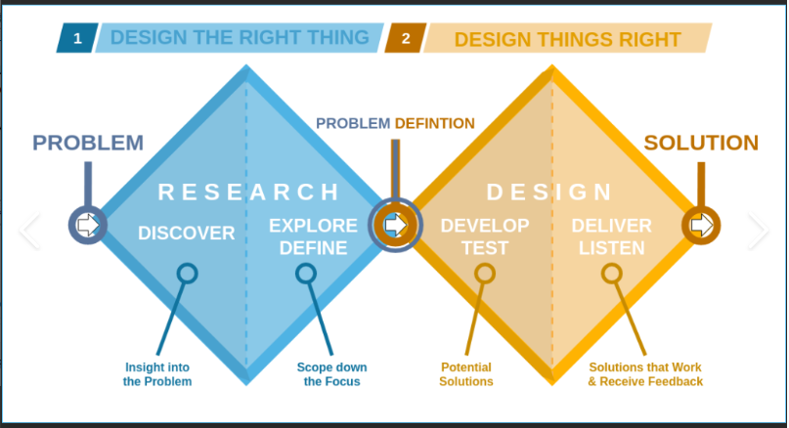
Figure 1- Double Diamond Design Process
Casey (2021)
The double diamond represents a process of exploration, problem refinement, testing and solution refinement.
First, there should be a research stage. Research is focused on the people, machines and environment. The customers, users, producers, sellers and recyclers; the people related throughout the entire product lifecycle and how their needs may impact the product design. Machines refers to the market expectations for this product based on similar examples such as functions and form. And finally, the social environment, which will highlight modern tastes, values and concerns. With all these considerations, the specific problems the product will tackle are defined.
The next is conceptual design where the research is used to focus on possible solutions. Usually this means exploring options that create the most value by addressing needs whilst minimizing the resource input, usually trying to maximize a profit or optimizing sustainability metrics.
Quality Function Deployment (QFD) could be used to transform customer requirements into the design, production and manufacturing process characteristic. A Pugh matrix can be used to score several solutions to find the best one.
Next is the detailed design phase. This is a visualization of the previous ideas, a design evaluation and optimization. The abstract ideas are put into physical objects and prototyped before a final vision is decided and created. In this project, Autodesk Inventor 2024 will be used as it has great engineering modelling capabilities and stress testing. Fusion 360 may be used for the generative design aspects to minimize material usage as this program excels in this field. 3D printing will be used for the casing prototypes. Ansy Granta can help with material selection. Electronics for the prototype will be sourced from other mouse models. Visual Studio Code with different plugins may be used for developing software.

3.3 Further Specific Tasks/ Objectives

A review into the state of the art, baseline functionality and requirements of the mouse. This includes:
- Basic input features
- Shape requirements for comfort
- Strength and endurance capabilities
- Safety requirements, especially concerning electrical components
- Other needs such as smooth bottom surface

Review of literature on e-waste to identify key issues in life cycle of products, specifically a computer mouse.
Research on statistics for current popular mouse models. These could include:
- Raw material cost
- Manufacturing cost
- C02 emitted from manufacturing per unit
- Distribution emissions
- Average time before a replacement is needed
- Toxins released after disposal
- Time before decomposition
Review literature on best solutions to the problems caused by e-waste, assessing the pros and cons of implementing them in this project.
Identify material needs for casing and research sustainable solutions such as bioplastics or recycled material.
Analysis of possible manufacturing methods considering sustainability and the limitations they may bring to design.
Using CAD and generative design, an aesthetic, modern looking mouse case built around comfort, functionality and minimizing weight/ material usage will be created. FEA and stress testing should be used to make sure the safety standards are met.
A working prototype will be fabricated to make sure basic functionality is solid.
The structure will be tested by using varying loads and pressuring the model over time to simulate the extensive usage it would go through as a real product.
Consumer feedback will be gained formally allowing participants to try the prototype and answer questions. A plan of adjustments will then be made for the next iteration.
A manufacturing analysis can be used to find a cost breakdown and a sustainability assessment which can then be compared to other current models, hopefully showing improvement in several metrics aligned with the aims of the project.

Research Hypothesis

Hypothesis: Popular computer mice on the market contribute to damaging the environment through electronic waste.
Justification: Most popular mice are built for a short life span, being discarded and replaced when they start to malfunction. They contain many components and materials such as plastics and metals that both sourcing and disposing of causes pollution and habitat destruction.
Hypothesis: There are implementable solutions for reducing E-waste in common electronic products.
Justification: Advancements in materials, technology and sustainable design principles has offered opportunities to reduce electronic waste such as biodegradable plastics, life cycle considerations and promoting longevity and repair.
Hypothesis: a circular economy approach can lead to cost savings for manufacturers and reduce environmental impact of products.
Justification: A circular economy increases efficiency, product durability and creates a closed loop system, reducing the number of new materials needed and production costs. It manages the risks caused by resource scarcity and disposal.
Hypothesis: Sustainable products attract a premium pay from consumers and improves brand reputation.
Justification: There is an increasing shift in attitude from consumers towards aligning their purchases with their values which can include a concern for the environment. Committing to sustainability has also been shown to improve reputation and brand image, allowing for differentiation from the market and possible customer loyalty. All of these suggest an economic benefit to investing in sustainable products.

Impact of Research

If the project produces a radically more sustainable mouse than competitors with enough consumer value to make it profitable and feasible to produce, these are some possible impacts.

5.1 Social
For those living in an environment where E-waste is incinerated and disposed releasing harmful toxins, any effort to reduce this waste can improve the health and well-being of these people. The lead and mercury can reduce intellectual ability, lung function and increase risk of chronic diseases like cancer later in life. The World Health Organization warns it is mostly children who are at risk due to having less developed organs and being less able to eradicate toxic substances (C. Johnson, 2021).
The access to sustainable technology can raise awareness of its availability and possibilities. More awareness can influence what consumers demand of producers as well as policy makers who can make decisions based on a knowledge of the harms of E-waste and potential solutions.
Sustainable practices in manufacturing and recycling/ biodegrading process will improve working conditions for laborers and those (usually kids) who previously manually searched through landfills to find reusable materials.
Increasingly affordable technology will also improve access to lower income families allowing them the benefits of tech such as communication, education, the opportunity to improve skills like typing that are needed in many jobs as well as the many other everyday solutions it provides.

5.2 Economic
Since there is a long-term drive towards sustainability and an increase in policy demanding manufactures adhere to certain standards, investing early could save producers money in the long term. This matches an increase preference from consumers who are environmentally conscious and meeting these demands is an opportunity for economic growth and market share.
The research and development required to create other products with a focus on sustainability will create new job opportunities or spaces for entrepreneurship.
Products with an extended lifespan will be beneficial to consumers in terms or reducing long terms costs with maintenance or replacement, as well as reducing the costs in waste management.

5.3 Environmental
Using materials that can be recycled or biodegrade will reduce the amount of waste in landfills which release biogas, contamination and destruct the local ecosystem. This protects biodiversity and benefits wildlife and human populations.
Reducing material usage and using sustainable manufacturing practices will reduce material usage, energy usage and the carbon footprint, conserving natural resources and reducing the output of harmful greenhouse gases that contribute to climate change. The beneficiaries of this are the communities that will be impacted by climate change such as coastal town, as well as future generations.

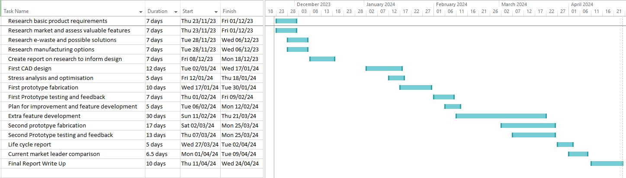
Gantt Chart
Figure 2 - Initial Gantt Chart

Literature Review

7.1 History of e waste
Packard describes a throwaway revolution describing ‘the postwar rise in automation and disposability in the US, when objects with short life spans or limited use increasingly appeared on the market’ (J. Gabrys, 2013). Cost of production became very low which meant an increase in goods. People found it cheaper to buy new instead of repair old products.
Electronics developed almost alongside plastics. Plastic was the ultimate, cheap disposable material, non-conductive and could easily package electronics.
As electronic waste increased, places began to appear to deal with them. Landfills, storage, re-use, incinerators and occasional recyclers.
More recently, it became cheaper for developed countries to send electronic waste across the ocean to developing countries, such as from the US to China. Furthermore, when China’s economy was mainly focused on manufacturing, they were able to use the electronics for raw materials. However, residents in these countries are the ones who face the health hazards when electronics are openly burned.
Jennifer Gabrys (2013) argues against the proposal of a ‘zero waste’ society. She says ‘things wear out, fail and break; systems of value shift and render some things worthless’ and that these factors are intrinsic to products and material processes. She suggests ‘the development of apparent waste-eliminating strategies such as recycling not only obscures the inevitability of waste but also defers the ethical aspects of how we attend to waste’.
It must be considered that Jennifer is from the United States and was published by the University of Michigan, suggesting possible government funding. It must therefore be considered that she doesn’t directly suffer the harmful consequences of electronics waste and is incentivized to advocate an acceptance of the current system.
J. Boldero (1995) says recycling is a behavior which requires considerable effort on the part of the individual as household waste must be sorted, prepared and stored.
This suggests that the manufactures and designers must do everything possible to make the decision to recycle easy and to take into account people’s decision not to do so.
This is backed by Molotoch (2003) who suggests ‘design determines 80-90 percent on an artifact’s life-cycle economic and ecological cost’.
A study by T. Ramaya et al. (2012) found that ‘knowledge and awareness of environmental benefits was positively related to attitude’ towards recycling behavior. This suggests that study and work that bring light to e-waste issues may increase action taken from others to contribute to a solution.
Considering these arguments, this work attempts to put the responsibility of sustainability at the design stage and identify possible step forwards for future electronic product development that decreases harm to people and the environment, hopefully providing a positive example of the work that could be done on any product.

7.2 Polylactic Acid
Polylactic acid (PLA) is a thermoplastic produced from plant starch, making it renewable and biodegradable.
It is produced through the bacterial fermentation of sugars and carbohydrates coming from plants like corn, sugar can, sugar beet and cassava.
The compound annual growth rate of the bioplastic industry is predicted to grow 11.7% per year in the UK, meaning the cost and availability of PLA will come down over time as competition and investment increases.
A. Barrett (2020) says the advantages of producing PLA are that the raw materials are renewable, the crops absorb CO2 and takes much less energy to produce than sourcing oil for regular plastics. The plants can also be grown in environments such as the US or UK reducing the costs of importation.
A lower melting point makes it easier to work with, requiring less energy plus it creates no toxic fumes. It can be commonly found as it currently has a 45% market share.
There are many benefits at the end of life, such as PLA can be composted. It can be incinerated and will produce fewer toxic fumes than oil plastics. It degrades into a non-toxic acid mainly useful in Bio medics.

There are a few disadvantages. The main one standing in the way of mainstream use is its cost. Furthermore, there are inherent problems with crop production such as toxic fertilizers and destruction of habitats.
The current composting infrastructure works too fast for PLA and current recycling incinerators mean that it can’t be recycled with other plastics because of its melting point. This is not a problem with the material inherently and therefore these problems may decrease as PLA becomes more widely used.
On hot days, PLA may show signs of becoming soft due to its low melting point and it is not a tough plastic making it unsuitable for some uses where impacts are regular.
At 160 – 220 degrees it melts and can be extruded from a 3D printer. It will then fuse and harden to create a product. It happens to face less shrinkage issues than other materials and can be printed at high speeds.
However, there are issues such as PLA can degrade when used, recycled or melted. However, Nascimento et al. (2010) found that multiple recycling stages are needed for there to be any major material or structural change in the PLA.
There is the possibility of reinforcing PLA with other agents such as wood fiber (improving mechanical properties) and Carbon fiber (increasing tensile and bending strength) which should be considered since PLA has is known to sometimes be brittle.
PLA can be bought and used with 3D printers making it ideal for prototyping. K.Q. Nguyen et al. (2023) says that a ‘considerable amount of waste exists due to failed print and disposable prototypes’ and sustainable materials is essential for limiting the impact.

7.3 Manufacturing
The most common place technique for manufacturing the outer shells of Computer Mice is injection molding. This is where molten plastics are injected into a mold cavity, cooled, and then ejected.
It is good for precision and small tolerances, allowing complex shapes to be made. The mold can be used multiple times so there is an ability to produce many of the same products. It makes the cost per part very low after the initial investment of the mold. It can take as low as 10 seconds per part making it ideal for mass production.
Another benefit of injection molding is that bioplastics can be seamlessly integrated making it ideal for producing this product. PLA, PBAT and PCL are types of bio-based polymers that are suitable. This means there is no learning curve for current manufacturers and less upfront cost to change the process entirely (Green Dot Bioplastics, 2017).

There are some limitations with injection molding in terms of shape. For instance, thin parts may snap upon removal, the heating and cooling process can cause shrinkage and warping and there should be no undercuts (Carnegie Mellon University, 2003).
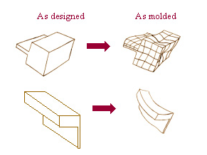
Figure 3 - Differences Between Design and Molding

7.4 Product Design principles
Altshuller (1996) said a problem should be termed as concise as possible. The objective, function, factors, effects, requirements and specifications (OFFERS) of the problem should be primarily considered. With products, two strategies emerge: either conceptual analysis to ideate a completely new product apart from current trends, or part analysis to work on the improvement of an existing product.
A simple formula be used during design to constantly measure the products sustainability. Eco-efficiency ratio = product value / environmental influence.

K. Hurst (1999) says engineering design is drastically different to scientific work as theories can’t be tested in labs. It involves people, companies, shareholders and there is never a single, absolute answer that is a law of the universe. This is because design decisions are made with compromises around specifications. Its main purpose is to find solutions to problems, to find a product to suit a market need.
Success usually means a product that adheres to national and international markets meaning the process is usually standardized and formal. A step-by-step process can be used to keep a project organized, maintain a logical record of events and give guidance on what to do. It can be a defense against lawsuits such as issues over patents.
A useful breakdown is clarifying the task and specification, identify the main problems and begin brainstorming solutions. The concepts should be tightened and evaluated to identify which are most valuable. Then, initial form designs should be created and the best selected. The project should always be checked against technical and economical specifications throughout, and there should always be improvement and revision at every stage. The designs should be completed, checked for errors and formally put into production documents.
M. Chamorro-Koc et al. (2009) talks about how maintaining recognizable features from similar products means consumers have at least a superficial knowledge about what the product is, and it’s intended use and therefore marketing and design needs to mainly be focused around conveying unknown/new functionality. For an international market, it must be considered that there are different cultural expectations for what is user friendly and common in products. Not working with these may cause confusion.
It must also be noted that consumers and designers have different conceptual ideas of products and what is important in them. Furthermore, people who have never used a product will hold inaccurate descriptions of their intended use.

Some other basic principles are always considering the user first, making the product as useful and attractive to them as possible. It should be as simple as possible, so the consumer uses minimal effort in understanding and utilizing the product. The priority should always be adding value instead of an endless stream of features that don’t add to the product. Customer feedback is important to help with decision making, reduce guesswork in consumer desires (P. Kanski, 2022).

7.5 Intellectual property
Since this is a design project, it was important to check research some the intellectual property regulations.
For a patent to be granted, the design must not be ’obvious changes’ from a previous product. A patent is usually focused on inventions/ new mechanisms. This may not apply in this project unless work is done on designing an original haptic feedback system and original software to control it (Gov.uk, 2012).

You can also register a design, IE the shape or how parts fit together which may be relevant for this project. This costs £50 in the UK. An example would be if interchangeable parts were created.
Gaining registered intellectual property protects it from being copied and resold by others. However, it will eventually expire. A patent does after 5 years, unless you renew it every year to a maximum of 20 years.
However, they can take 3 years to process due to the searching through prior art process and waiting for offices to work through backlogs. Furthermore, defending infringement usually requires the use of your own funds, usually gained from the sale of the invention.
There are registered trademarks that have interchangeable parts but they focus more on entire sections and changeable components instead of for aesthetic purposes.
The final design of my project will have to be crosschecked with patents to prevent infringement. However, since no products may be sold and it is primarily for research purposes, no action may be needed.
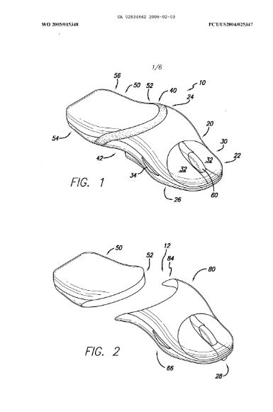
Figure 4 - Patented Design of Interchangeable components found at https://worldwide.espacenet.com/patent/search/family/034138720/publication/CA2534662A1?q=pn%3DCA2534662A1:

7.6 How Mice Work
A mouse allows easy user input into a computer system using a peripheral device. It’s usually used for navigating around a screen and selection.
A small camera on the bottom of the mouse constantly registers the landscape below it to an extremely small scale. Any time the mouse moves, the camera compares what it can now see to the previous image and calculates the distance moved and direction. This information is used to determine how the cursor on screen should move.
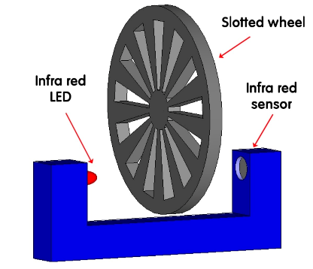
A scroll wheel usually works with an optical encoder where a infrared light is sent through the scroll wheel which has regularly spaced bars. A sensor on the other side can then tell how much the wheel has been turned by the number of times it has sensed the infrared light shining through and then being blocked.
Figure 5 - Scroll Wheel Mechanism
The buttons use a simple on/off binary signal when pressed.
Whenever the state of any of the inputs change, the data is sent in a packet to a PC mouse driver where it is decoded (T. Engdahl, n.d).
The relationship between mouse movement and cursor movement is not linear in most drivers. Usually, the faster the movement speed of the mouse, the further the cursor will go making it suitable for more applications.

7.7 Requirements Research
Most mainstream mice use 4 different methods of input: left click, right click, scroll wheel and mouse movement.
They can come in many sizes but this project will try to adhere to the mouse size that fits the largest amount of people possible. The dimensions are usually around 12 cm by 7 cm based on that when the mouse is 60% of hand size, it is most comfortable. The average male hand size is 19.3cm and female 17.27cm.
There is consistently a larger percentage of males using computers to access the internet than females (a biggest difference of 73.8% to 64.1% in 55-64 year olds in 2022) however the gap is increasingly smaller in newer generations (60.5% to 60%) suggesting that while previous mouse designs have been geared slightly for the average male hand, there’s no definitive answer if it should be geared for either gender to capture the biggest population for comfort (A. Petrosyan, 2024).
Specifically for a PC gaming mouse, 59% are male and 41% are female in 2023 though this gap is also declining (A. Kunst, 2024).
85 – 90 % population is right-handed and many left handers use right handed mice so designing specifically for the right hand could increase comfort without turning away many customers.
There is an expectation of at least 2 years of usage before issues but sometimes they will last 5-7 years if they only experience gentle use. Therefore, to meet the customer demand, the material, mechanisms and structure must be durable.
The British Standards Institute (2014) released specifications about physical input devices that must be adhered to if the product is to be sold to consumers.
The parts (shell) need to be anchored to surface in some way. This is usually done with friction using pads on the bottom. When the mouse is wired and there is no friction, there is danger of the wire causing the mouse to move leading to erroneous inputs. The cable also must have a level of flexibility since the mouse is constantly moving.
There should be no noise except clicking to provide tactile feedback.
The designers must be aware there are factors that can affect usage: vibrations, the amount of free space available, stability of the surface, surface characteristics such as dents and dust/ dirt which can affect the camera.
No size requirements are given as the compatibility between mouse and user population is unknown. However, there should be considerations about how the neutral finger sits, wrist posture, how to minimize muscle forces and static workload.
Operation learning concerns how difficult it may be for a first-time user to learn how to use the product. It can be divided into 4 categories: immediately obvious, trial and error, simple instructions and specific training. Documentation is needed if the mouse contains features that require simple instructions such as extra buttons customization or LED use.
The mouse must be categorized depending on how consistent it is on different surfaces: independent of characteristics of surface, will work on any smooth surface, mouse pad required or a mouse pad with specific characteristics.
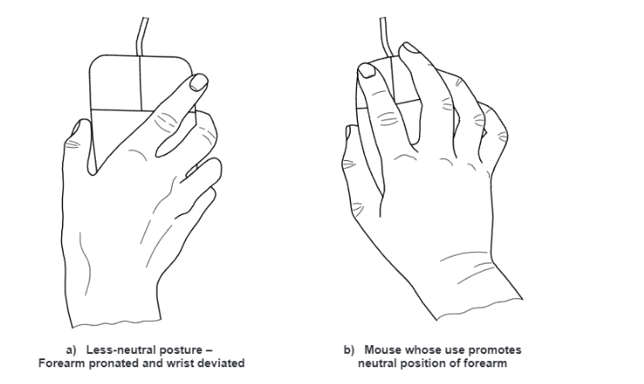
Pointing task accuracy should be limited by limbs capability and not the device itself. IE, practice from a human could make perfect accuracy. If this is not true, it must be indicated.

The mouse should give direct tactile feedback on relative positioning (position on screen). This should be consistent with how the mouse is moving.
Figure 6 - Best mouse hand posture
There must be no delay between the mouse and pointer movement. 20ms delay doesn’t affect performance. 40ms reduces user performance 10% and 100ms reduces it 50%.
The button displacement when pressed should be between 0.5mm and 6mm. Kinesthetic feedback like this assures uses mouse is working.
Pressing buttons should not move the pointer. Buttons should minimize any finger extension or finger strain. Pressing them should not decrease control and there should not be any unintended pressing. A force of 0.5-1.5N should be needed before actuation.
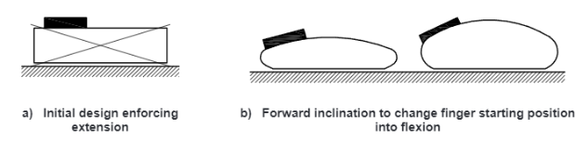
The buttons should have a lock feature allowing dragging across the screen.
Figure 7 - Ideal Mouse Inclination
The motion sensor should be under the fingers instead of palm of hand and should be accessible for cleaning.
The materials should not cause problems from skin contact or emissions. The minimum radius for edges is 2mm and corners 3mm so a bevel should be used. This is to prevent cuts from sharp edges.
If there is no dedicated software, documentation is needed to tell the user how to get desired effectiveness, setup and testing.

7.8 Current Popular Mice
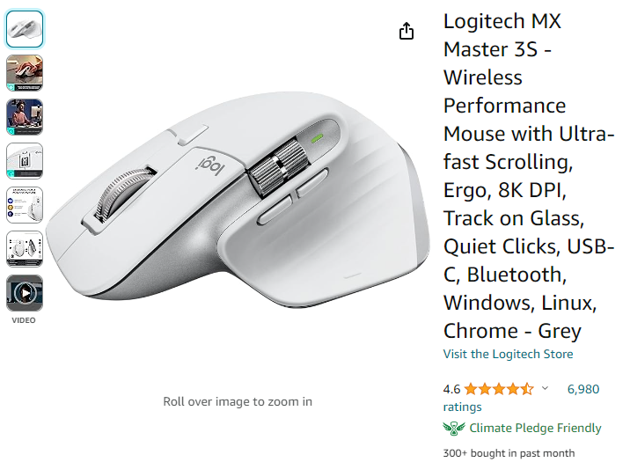
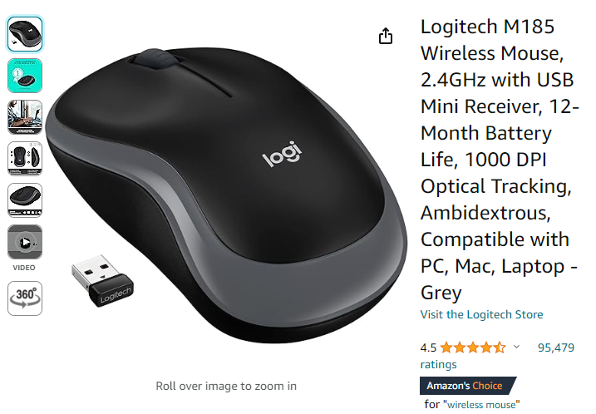
Figure 8 - Logitech MC Master 3S Found at: https://www.amazon.co.uk/gp/product/B07W4DGFSM?tag=rtings-u-mc-21&ie=UTF8
Figure 9 - Logitech M185 Found at: https://www.amazon.co.uk/Logitech-Wireless-Windows-Ambidextrous-Design/dp/B00552K0GM/ref=zg_bs_g_430567031_d_sccl_1/260-0888630-5680230?psc=1
The Logitech M185 is the best-selling budget mouse on Amazon, selling for around £10 (fluctuating with deals). This makes it popular for workplaces and schools or those with lower budgets who just need a mouse that works. It makes it a good example of the minimum features consumers value.
It is wireless, has a long battery life and is ambidextrous. Its compatible with any OS such as Mac or Windows. It has a frequency of 2.4GHz (affecting the speed of connection with the computer) and 1000DPI (Dots per Inch) which measures the sensitivity of the sensor.
In comparison, the Logitech MX Master 3S by the same company is the best-selling high-end mouse, costing around £87. Mainly, this product will be for regular users and professionals. It earns this price with its extra features.
It has 8000DPI, quiet clicks, a quick scrolling wheel (magnetic), an ergonomic design, customizable software/ buttons, wireless, quick charging and works on any surface.
G. Holmes (n.d) describes how the raw materials for these products are a plastic ABS shell, electrical switches and cables (plastic and metals), a printed circuit board (PCB) made of various metals and silicon.
The normal manufacturing process is a PCB is prepared as a flat, resin coated sheet. Machinery or humans place electrical components on the board and then they are soldered on. It is then washed to remove contaminants and given a final inspection.
The sensor mechanism is assembled separately. Plastic parts are injection molded and then fastened to the PCB.
When there is a cable, it manufactured with a wiring (usually copper) and then given rubber cover.
The outer shell is molded, trimmed and given a surface finish treatment. The PCB and encoder are inserted in bottom, the buttons snapped into the top half, the cable attached and then the top and bottom are put together.
There is a final performance and quality check before it is packaged.
A programming team develops and tests the matching between the hardware and software.
Mice found on websites such as Alibaba sell for extremely cheap (sometimes less than £1) and give a hint at the production cost since they usually sell off these websites for an extremely low profit margin. However, labor and electricity are cheaper in countries like China where Alibaba suppliers are focused.

Method

8.1 Design Research
Casing material selection:
- PLA or other sustainable alternative.
- The material reducing sweat or dirt build up.
- Using structural analysis and AI generation and 3D printing could remove the required amount of material.

Current cons of mice product:
- Needed a wide flat space,
- Excessive uncomfortable use can cause strain injury,
- If the battery runs out of a wireless mouse it can’t be used.
- A wired one can’t be used at range
- Can’t enter text,
- Limited portability
- Costly for high end features
- Buttons and wheels can wear down
- Double clicking when not intended
- There is no one size fits all for maximum comfort
- Accumulation of dust and dirt
- Cleaning may be difficult
- May not always be compatible with every computer
- Dropping can be damaging
- Noise
- Not all users know what size and weight is best for them
- Latency
- Scroll tension not to liking
- Lack of customization
- Glossy surfaces create fingerprints
- Many designed not for left hand users
- Infrared disturbed by sunlight
- Awkward button placement
- Weight distribution

Manufacturing and distribution cons:
- Production creates electronic waste
- Disposal causes environmental damage
- Global events can disrupt supply
- Manufacturing location can cause vulnerabilities
- Quality control difficulty
- Defective units reaching customers
- Labor condition concerns
- Compliance with regulation
- Differences in regulation in different markets
- Packaging contributes to waste
- Shipping is a complex infrastructure
- Poor counterfeits can harm reputation of legitimate products
- Innovation can make models obsolete
- Economic factors influence product cost and pricing
- Intellectual property theft

E-waste solutions:
K. Liu et al. (2023) discusses possible E-waste solutions, advocating that recycling e-waste should be supported by regional co-operation, legislation and eco-design.
- Designing for recycling
- Making deconstruction easy for recycling plants and separation between reusable and non-reusable materials
- Making it modular and parts easily replaceable means whole device will last longer.
- Eco-friendly materials or recyclable.
- Energy saving.
- Using standardized components for users can replace them easier.
- Sustainable manufacturing.
- Designs that when done, can be re-manufactured into something else or even already have other uses.

8.2 Ideation

First I began brainstorming feature ideas that might contribute to the project aims.
feature ideas:

- companion app for customization and tracking usage, environmental impact of mouse over time, maintenance required
- sensors (heart/ stress)
- gamification of healthy computer habits
- haptic feedback
- customizable aesthetics
- machine learning for prediction (shortcuts or setting preferences)
- LED lighting
Idea Notes
Tracking usage: There are already companies that provide a mouse tracking service. Therefore, you could integrate their API into any custom software. It would also users to regulate themselves so thy maintain healthy habits.
Track environmental impact: This requires knowing the power usage of the mouse which is known and then multiplying by the time used and calculating impact from impact of average energy generation. So all that is needed is the amount of time being used and displaying it in an app. Users can then make informed decisions about the mouse they use and how much.
Maintenance required: this could be done by checking the difference between desired performance and actual performance, suggesting reasons why and how to fix them most appropriately. How can you check if the physical component like a button is not working through software? It would allow users to find issues easily and fix them before they turn into larger problems such as the mouse being completely unresponsive.
Heart rate monitor: A small component would be attached and placed on the mouse where there is always contact either where the palm is resting or on the forefinger button. It would need to be attached to an Arduino or the PCP and the data accessed and displayed through software. It means users can be informed about where they may be experiencing the most stress and calm, informing their choices and promoting healthier habits.
Gamification: tracking of metrics such as stress, usage as discussed before and custom software that sets goals, keeps scores and tracks progress promoting health and productivity.
Haptic feedback: Haptics simulate senses of touch and motion, usually replicating the feelings of interacting with real objects to increase the immersion of entertainment or convey information.
Creating vibration with an actuator using sound as the input signal is the usual method. However, this vibration could affect the sensors making it harder for the user to be accurate in clicking.
Customizable aesthetic: This would mean designing the mouse with parts of the shell able to be easily clipped on and off. Then, you could have different aesthetic options for this part that could be switched out. It makes the product resonate more with the user, making it feel special to them and even align more closely with what they are looking for.
LED lighting: LEDs with a switch attached. Gaps in the design for them to shine through (logo on top of around edges). Can’t be too distracting. Must consider it makes them more unsuitable for office use.

IDEA: remove need for sensors that don’t work on certain surfaces by using a base station (possibly the PC) and coordination with the mouse to find the mouse’s exact position.
IDEA: turn phone into a mouse, you just need exact position and to send it to computer
IDEA: Mouse you can deform and it stays in position, you can change it to shape your hand better.

8.3 Consumer Feedback
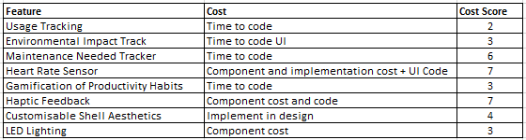
Figure 10 - Feature Cost Scoring

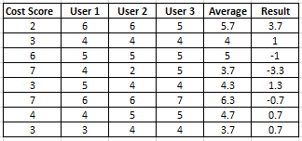
Figure 11- Feature Value User Feedback
A Pugh matrix was used to identify the most valuable features to consumers.
3 users of mice were asked to rate the features above from 1 to 7 in terms of much it would appeal to them. All regularly used mice for worked and played computer video games which means there may have been a bias towards usage tracking and features that improved the video game experience such as haptic feedback. Averaging their results, haptic feedback was the most desired and the least was LED lighting and a heart rate sensor.
I personally rated each from 1 to 7 based on the potential cost in terms of time and whether they needed physical components. This number was subtracted from the average of the user results to give a balanced view of whether the features were worth doing.
The top 3 results were usage tracking, gamification of productivity and environmental impact tracking, It must be considered that this is largely because the cost of coding these features is substantially lower than the features that required electronics.

8.4 Physical Breakdown

I initially had very little understanding of how a physical mouse is constructed or even how electronics are shelled in most products. So, as well as the research and a literature reviews in the previous section, I sourced mouses that were being thrown away both from staff offices at the university and an electronic repair store.
Then, I tore them apart to identify the components I’d need to build. 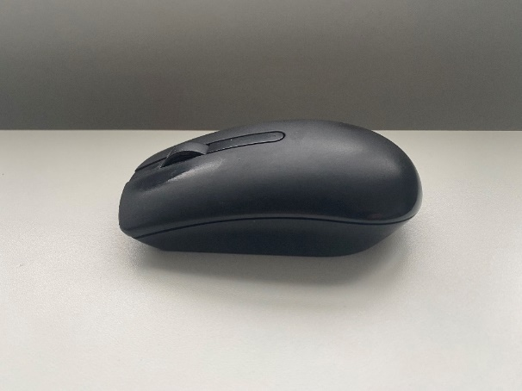
Figure 12 - First Mouse Breakdown
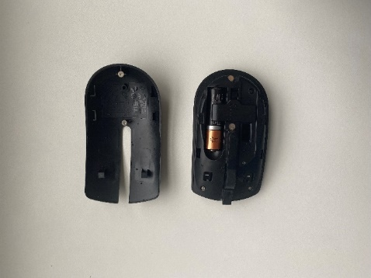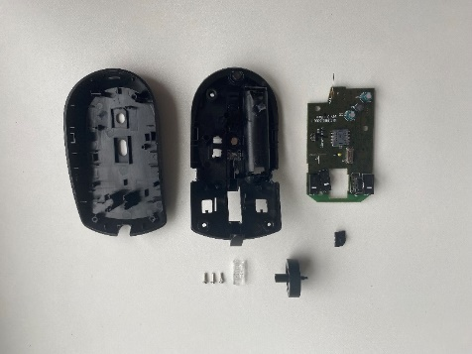
Doing so showed that most computer mice consist of a PCP board with electronic components, a separate scroll wheel and an outer shell composed of a top and base. The shell parts were connected with screws and then could be clipped apart once they were removed. and the base had many small holders that allowed the electronics board to fit and remain stable.
On the electronics board, I could see the 3 click inputs, where the scroll wheel attached and could turn providing an input and he infrared camera on the bottom.
With the sourced mice, I had plenty of still working electronics I could use for prototypes.

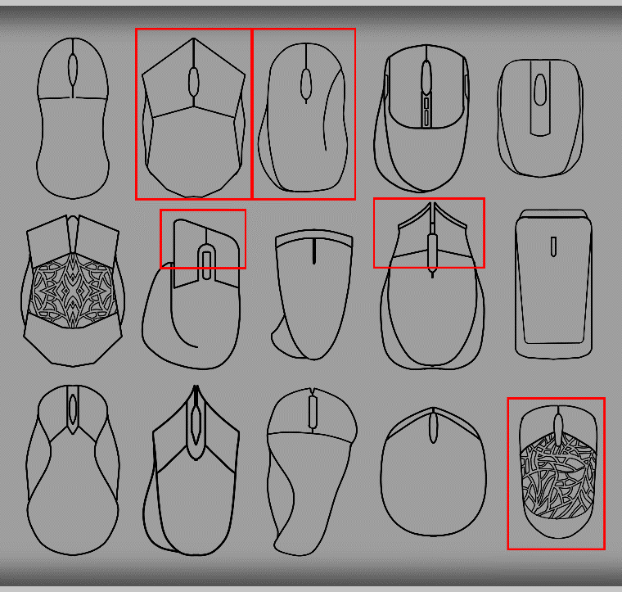
Figure 13 - Initial Sketches

8.5 First Designs

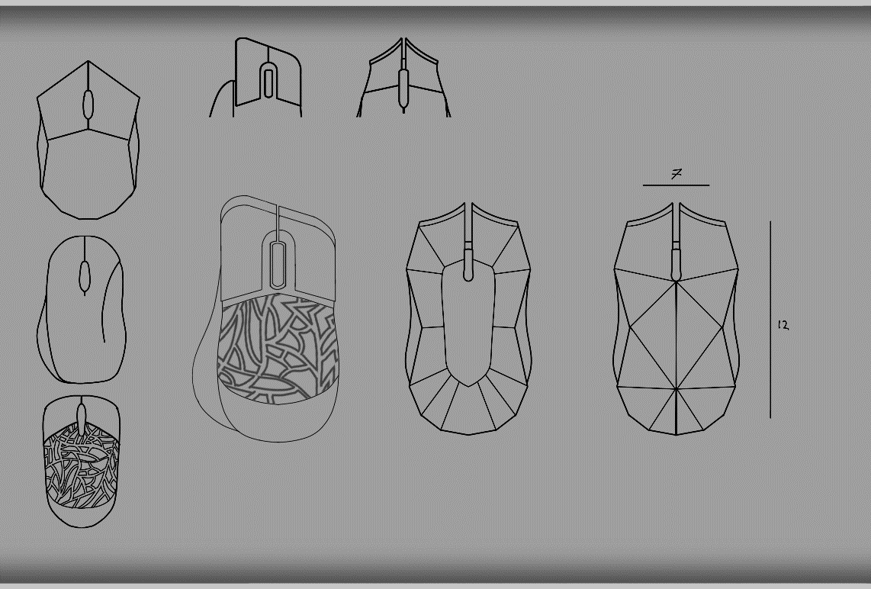
I worked with an artist to brainstorm different aesthetics with the mouse after the research knowing certain parameters I had to comply to such as tilt, width and length. We actively allowed ourselves to draw any possible shapes we could think of to explore possibilities that may not be on the market. After the favorites were selected (in red) they were put in another document and expanded upon. These became the ideals. However one of the designs used a great deal of jagged edges which would’ve cut into the hands.

8.6 CAD Testing
My theory was the more iterations I went through, the better the final product would be. I initially suffered from a great deal of perfectionism and pressure to make a great final piece, making it hard to get started. I overcame this by working simply on tests first. I decided on Autodesk Inventor as the programme for the shell creation. Inventor has many options for part creation as well as assembly options and stress analysis. Parts could be exported in many file formats, including ones acceptable by 3D printers making it ideal for this project.
I began creating CAD experiments with no intention of them being the final version.
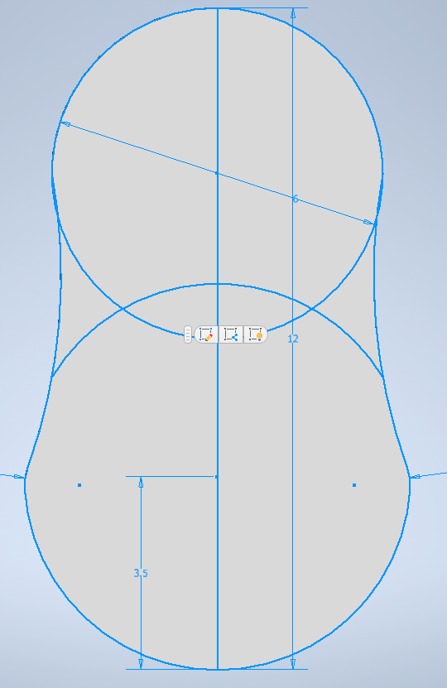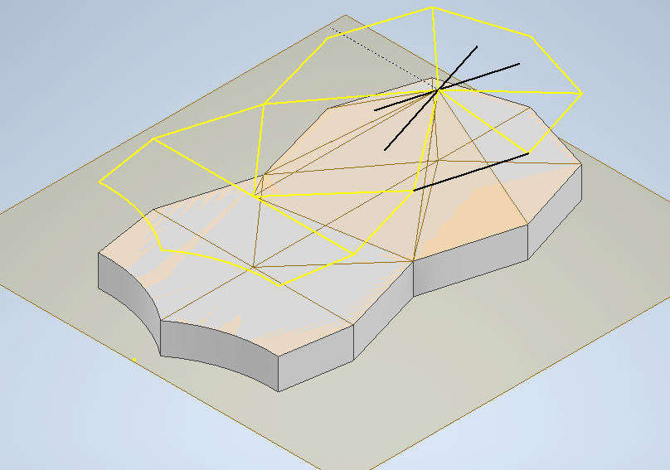
Figure 14 - First CAD Experiments

I didn’t have much experience with combining real parts and so researched and designed methods of attachment such as a snap clip where the elasticity of plastic is utilized.
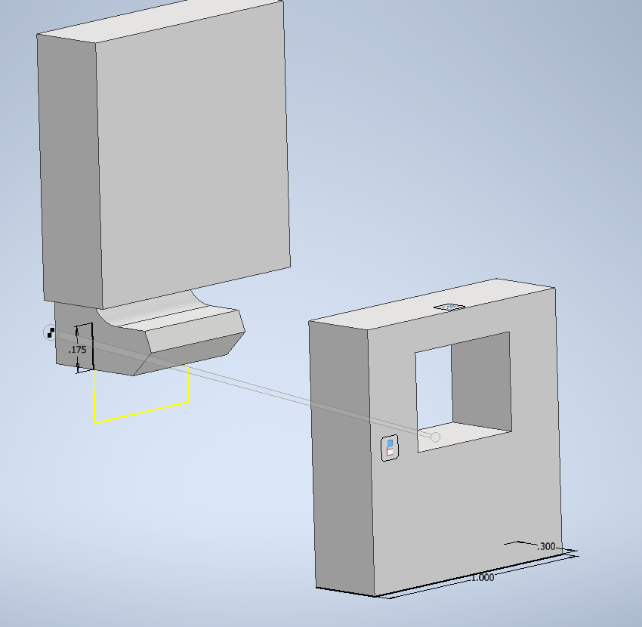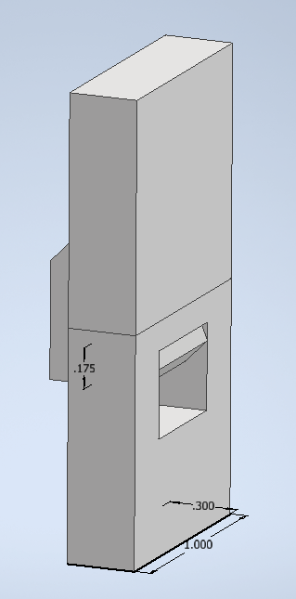
Figure 15 - Snap Joint CAD Test

8.7 Electronics Build

It was becoming increasingly clear that the shell would have to be built around a predetermined set of electronic components so that when it is 3D printed, it would be able to house the components correctly.
In case of breakage during testing, to stay at a low budget and to keep the ideals of a sustainable product, I based it around the components of one of the discarded mice I had sourced.
Whilst it meant I didn’t need to buy new parts, this came at the sacrifice of having a wired mouse instead of a wireless one which would’ve been more ideal based on researched consumer demand and first hand surveys conducted.
The model was a Microsoft Optical Mouse 200. Using a well-known brand like Microsoft meant if these parts broke at any time, new ones could be easily sourced for the project.
Furthermore, it being a small design, the electronics inside would be small which would allow for flexibility in my own design and a lower weight. Large components would’ve created a requirement for the size of the mouse.
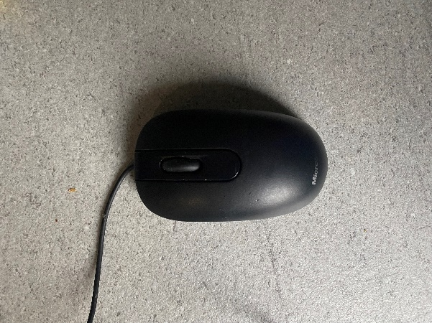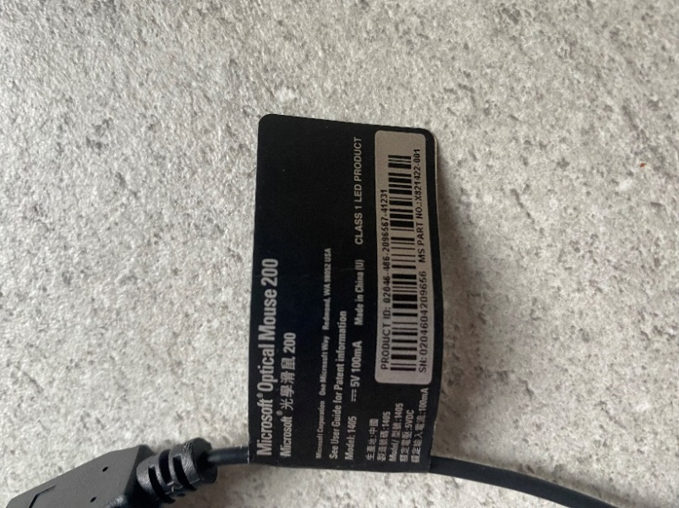
Figure 16 - Chosen Spare Mouse

I tore it apart to retrieve the electronics I would work with (a PCP board, attached wired USB, scroll wheel and plastic part needed on the bottom of the camera).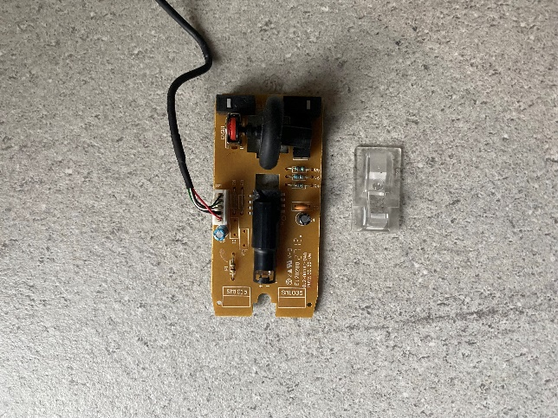 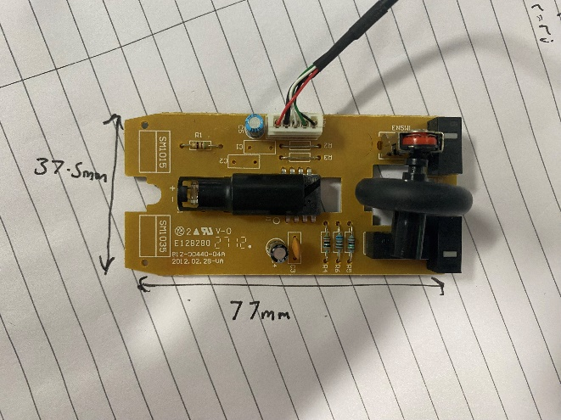
Figure 17 - Recovered Electronics

Taking measurements with a ruler, I began to reconstruct the shape as accurately as possible in Inventor. The margin for error had to be very small since my own shell had to have parts that kept the board stable and buttons that would accurately click the inputs on the board when pressed.

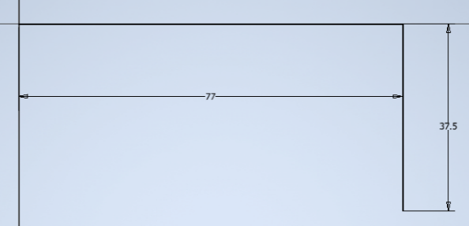
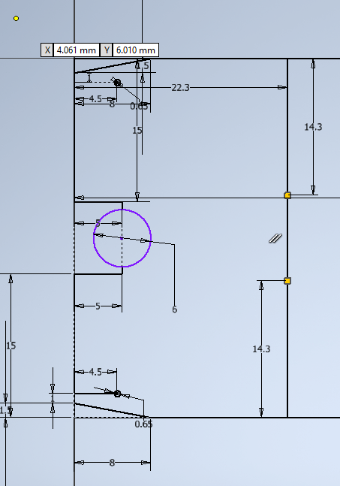
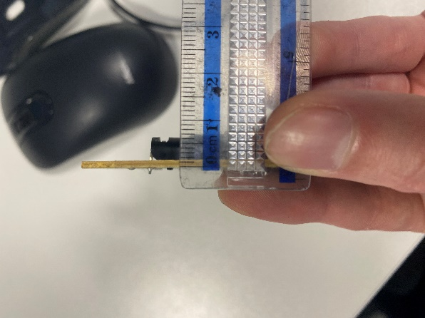
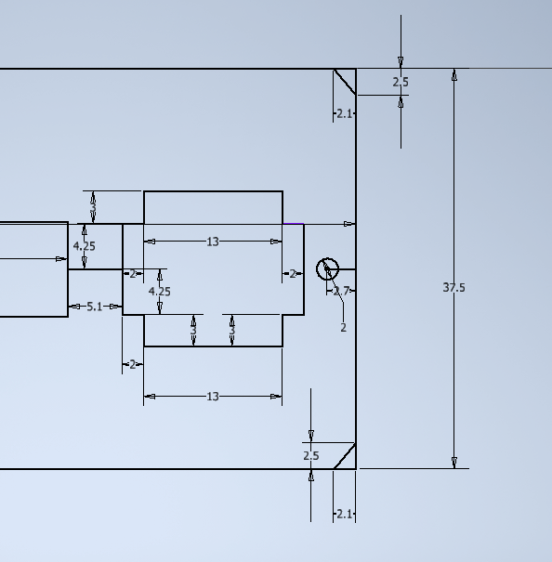
I found the thickness to be 2mm and could make an extrude.
Figure 18 - Making Electronics Board
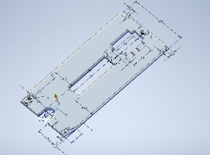
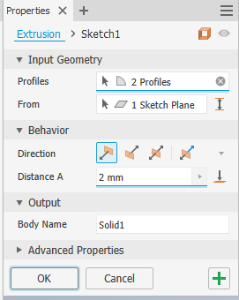
I then added the electronic components attached to the board.
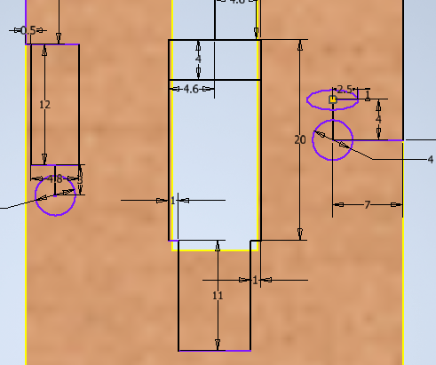
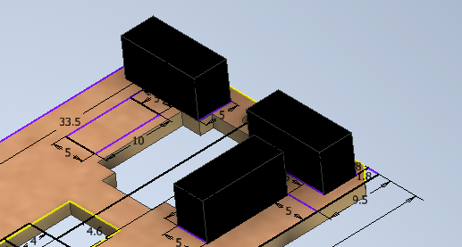

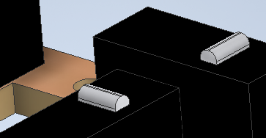
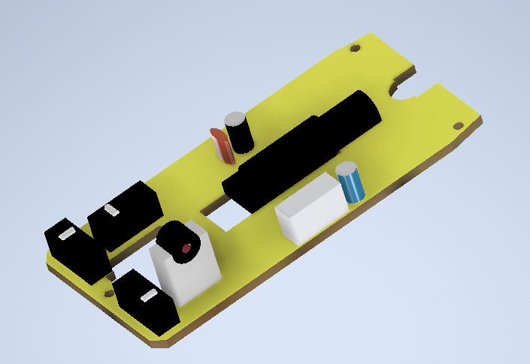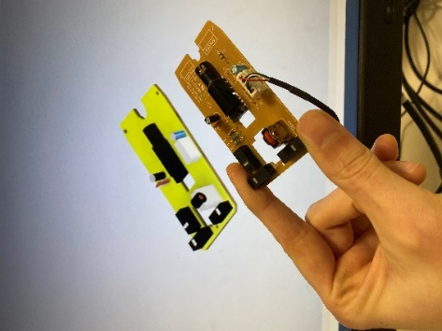
Next was to make the scroll wheel.

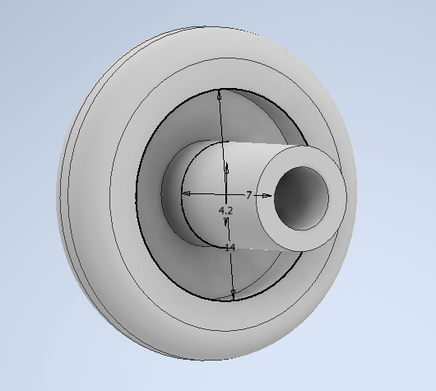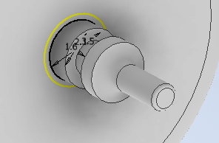
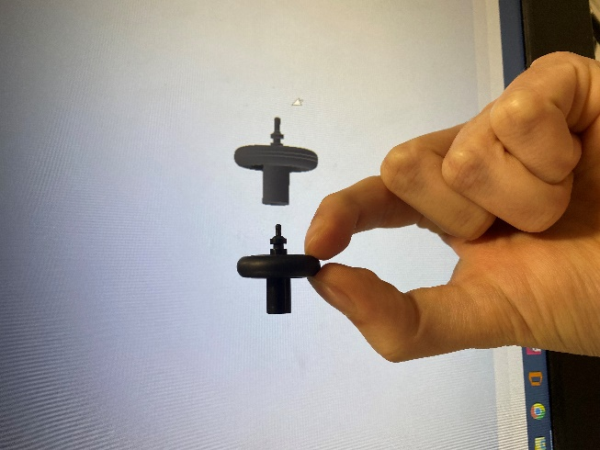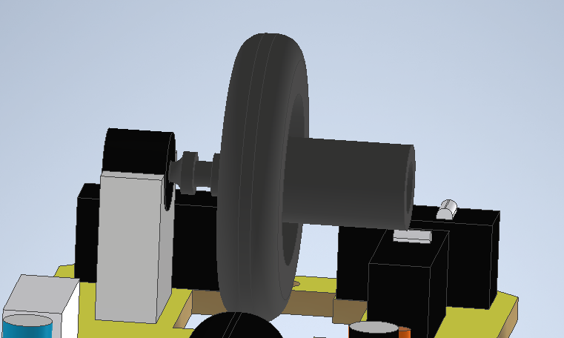
Figure 19 - Making Scroll Wheel

8.8 More CAD Testing
Next, I began to form a first version of the shell, consistently trying to create a form that would comfortably fit an average hand based on the research.
.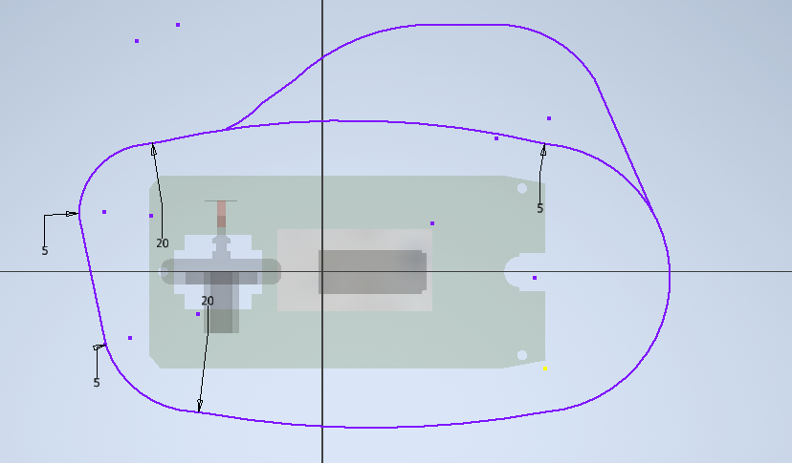
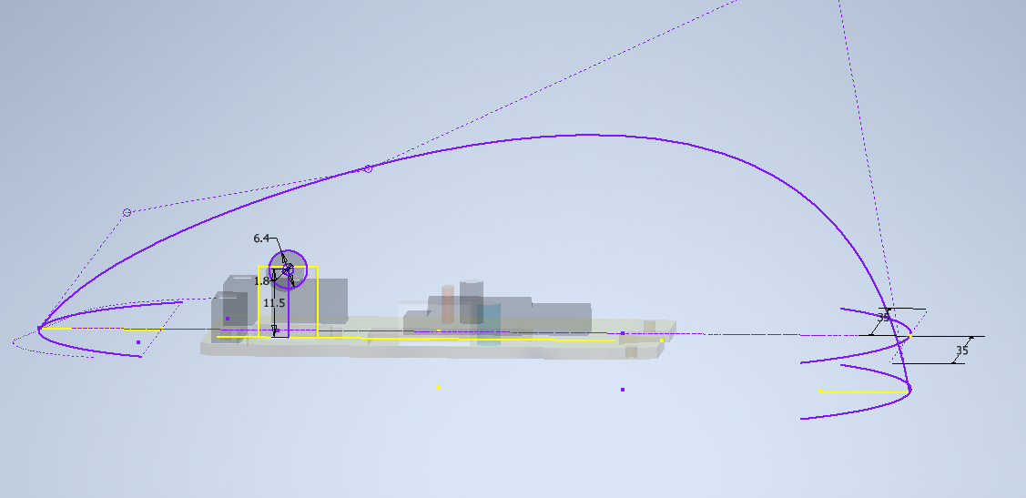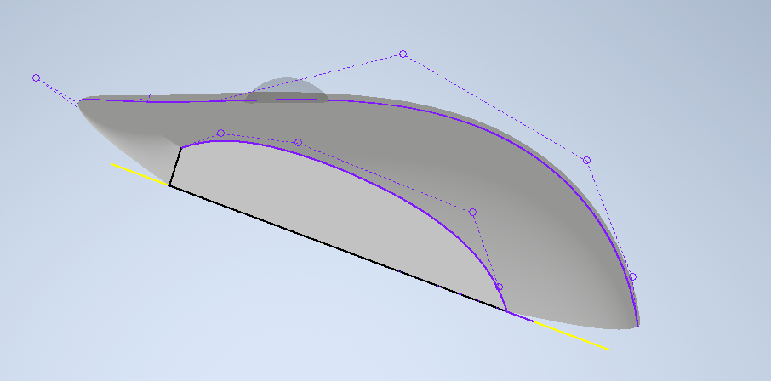
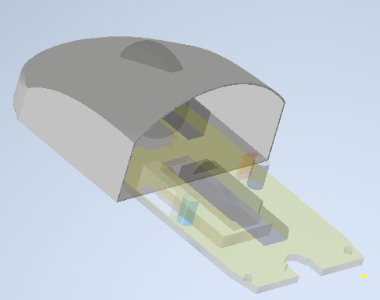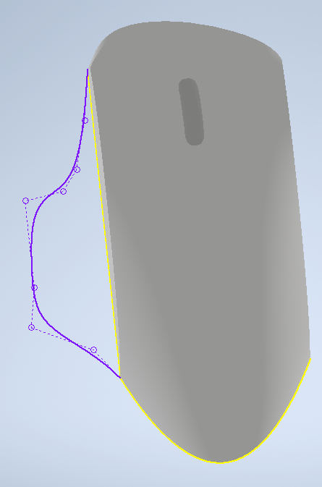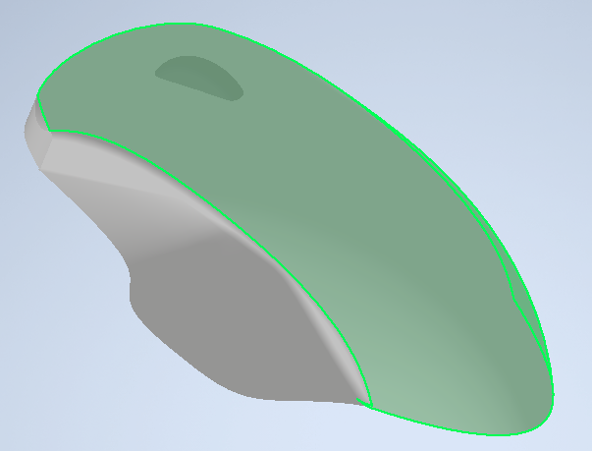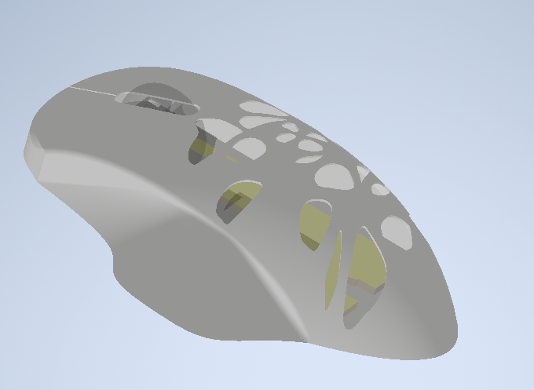
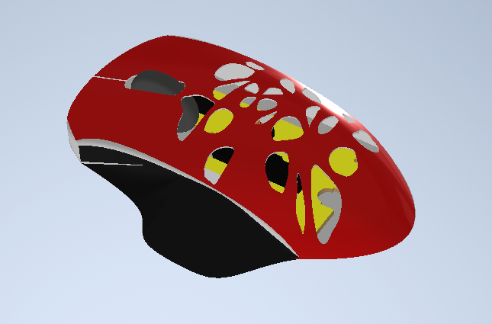
Figure 20 - First Prototype
This was an experimentation, mainly focused on the aesthetic ideas I had envisioned for the project. The area on the left for thumb placement was planned to have been detachable, maybe allowing for different aesthetics and an entrance for the electronics so that the rest of the shell could be a singular piece. The holes on top were an idea to reduce material usage the maximum amount whilst making the product as light as possible.
I decided to restart, wanting a sleeker, symettrical design but kept material usage low.

8.9 Main CAD Build
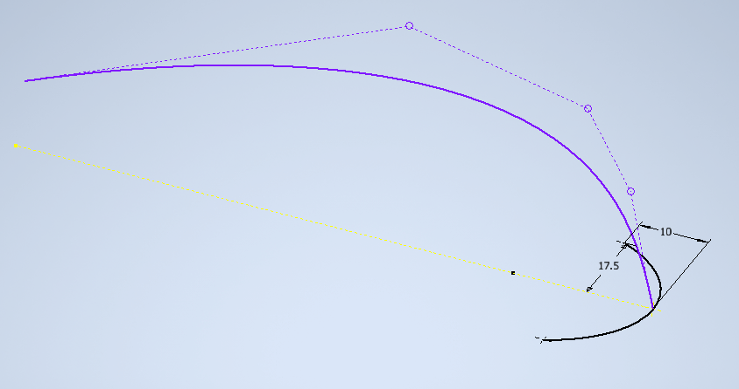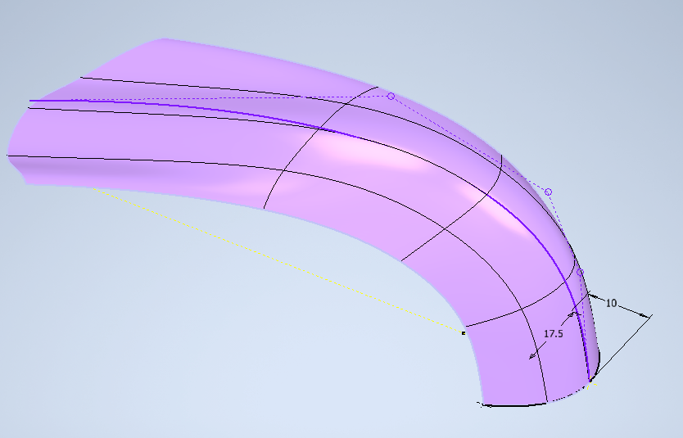
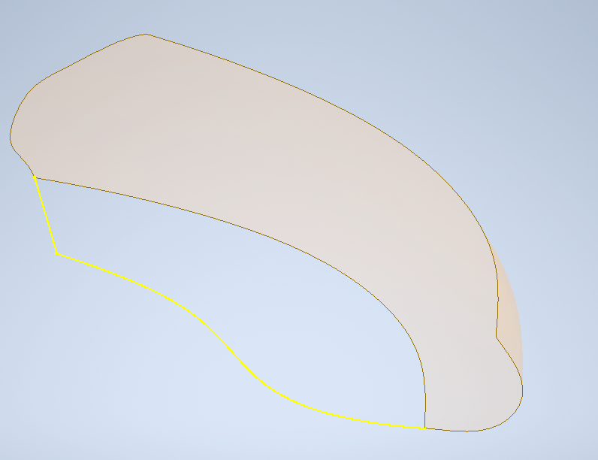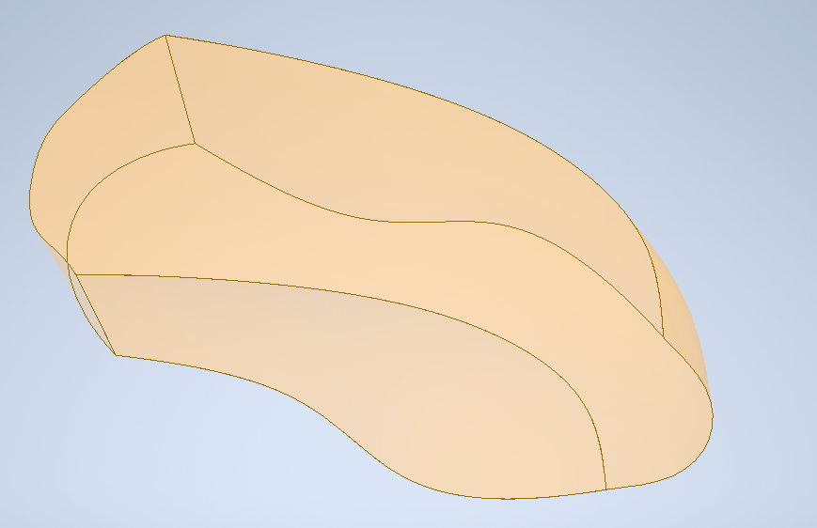
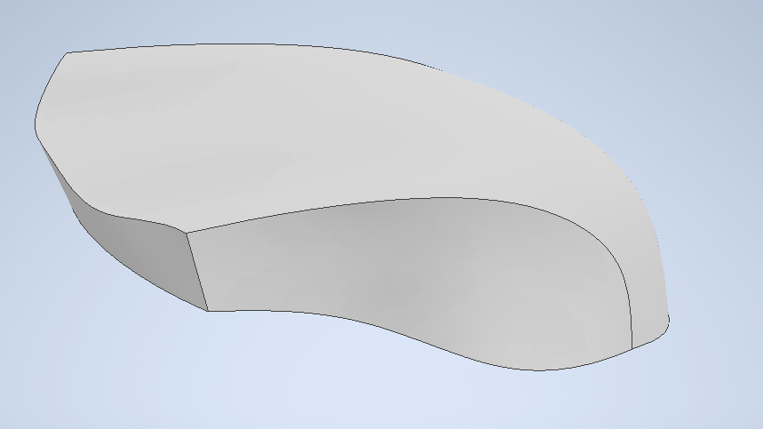
Figure 21 - Shell Body
Through tutorials online, I learned to use the Freeform, Mirror and Stitch tools in Inventor to create a much smoother form to build around. 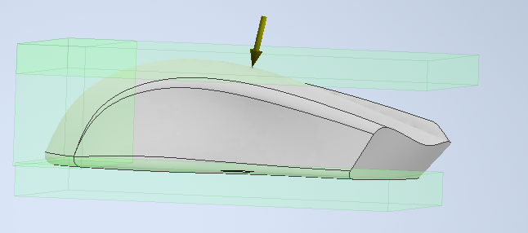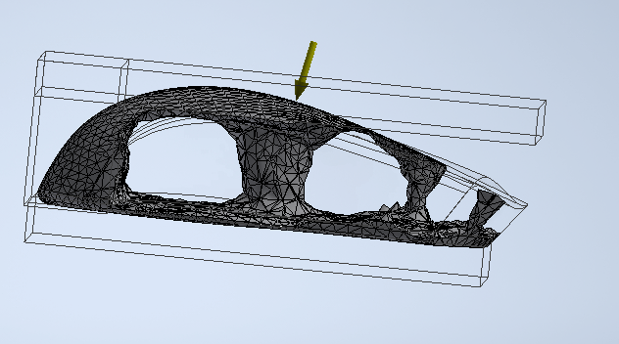
Figure 22 - Generative Design
I used the shape generator to experiment with removing as much material as possible to inform a possible design.
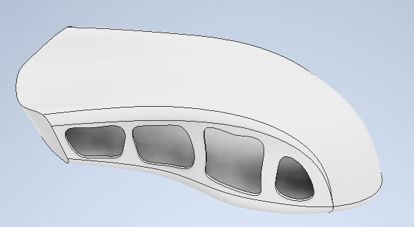 I began once again trying to remove as much material as possible starting on the sides and hollowing out the inside.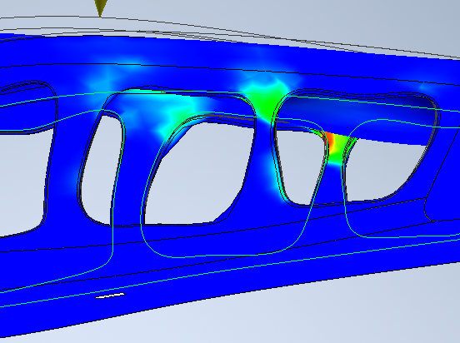
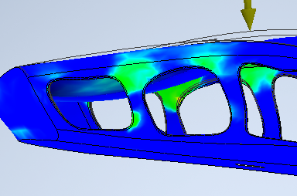
Figure 23 - Shape Generation
Using a Stress Analysis function in Inventor, I could identify where there were high amounts of stress and alter the shapes.
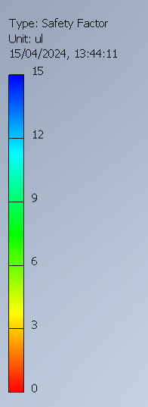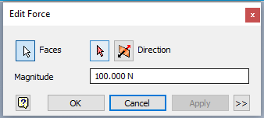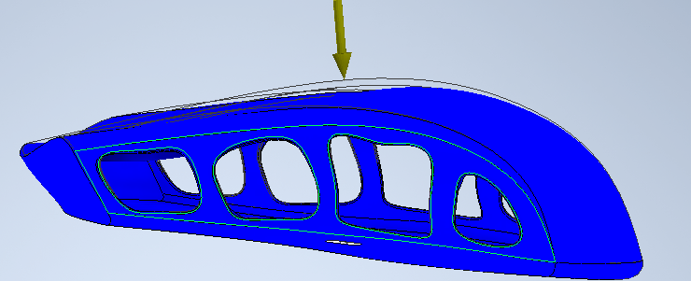
Figure 24 - High Factor of Safety Structure
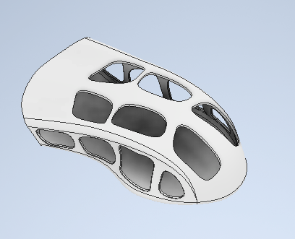
I kept going until under 100 Newtons, the factor of safety (the multiplication of the force input that the structure could sustain before failure) remained solidly at 15 all over. This, considering the industry standard can be as low as 1.25. I then did the same on top. 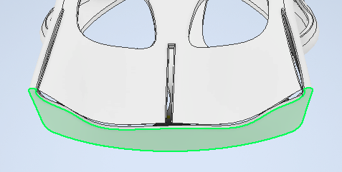
Figure 25 - Shape Generation on Top
Figure 26 - Button Slits
I added the slits that would allow for the buttons to move up and down, however these created a lot of problems with the structure.
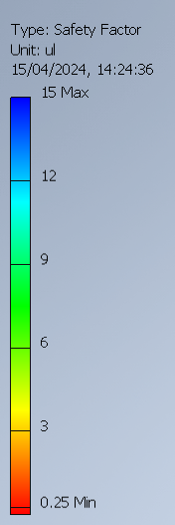
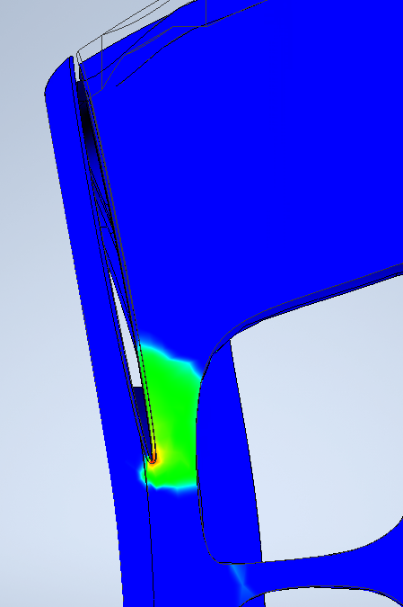
Figure 27 - High Stress Areas
There were extremely high concentrations of stress at the ends of these slits, with a factor of safety of 0.25 at 100N. This suggests failure at 25N and would not be accepted in industry.
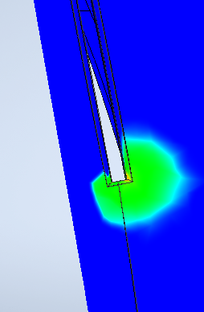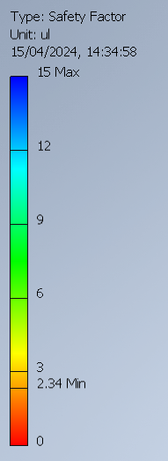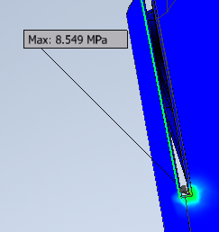To mitigate this, I shortened the slits and added fillets which would distribute stress more evenly. This raised the minimum factor of safety to 2.34 in this area which was acceptable. It must also be noted that most of the stress on the structure would be less distributed over the entire top face and instead in singular areas. The areas of significant stress from these tests would experience force only when the mouse is clicked which would be much lower than 100N.
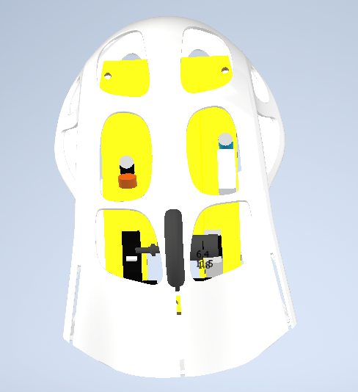
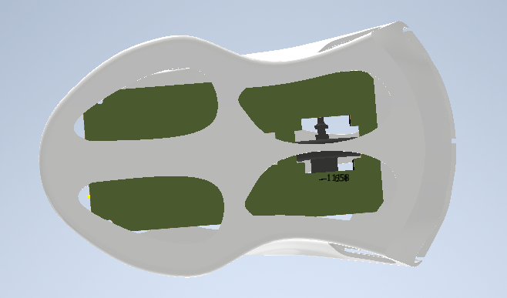
Figure 28 - Adding Electronics
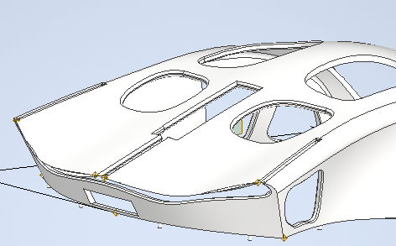
I then added holes on the button and inserted the previously built electronic circuit at scale to find issues. It was obvious the holes on top couldn’t accommodate the scroll wheel, there need to be a hole on the front for the USB wire to come out, the holes on the bottom didn’t allow for the pins to hold the board in place and there needed to be space on either side to rest the thumbs and pinky fingers.
Figure 29 - Solving Problems
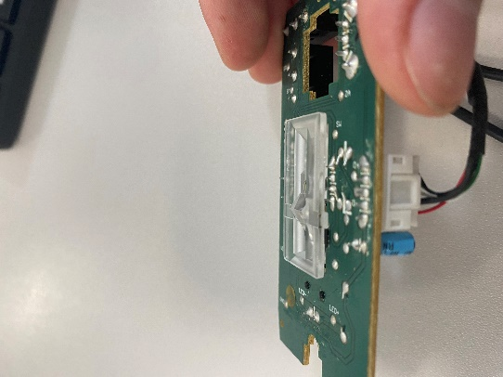
These problems were fixed, and I split the base and top into two parts so the electronics could be inserted and then closed in. 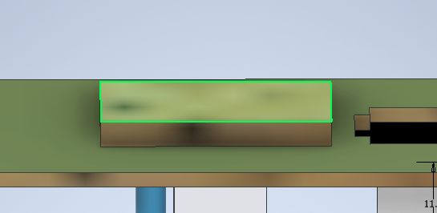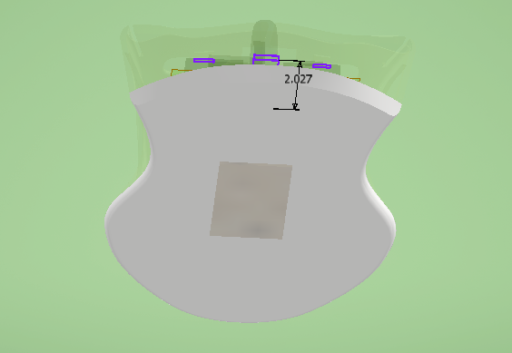I initially thought I would simply rest the board on the base but after adding this small plastic part that works with the IR camera, I saw it was too long and stuck through the base. I therefore created enough supports to raise the base as well as pins to keep it stable.
Figure 30 - Plastic Part
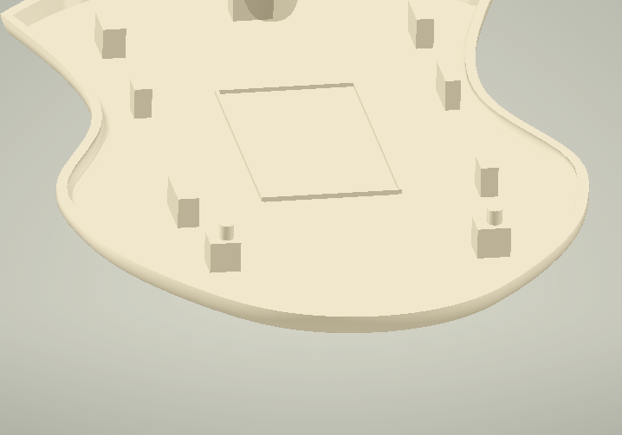
Figure 31 - Base Supports
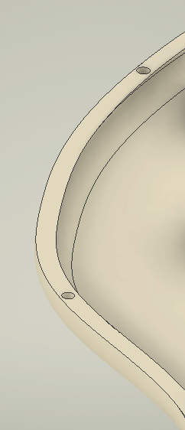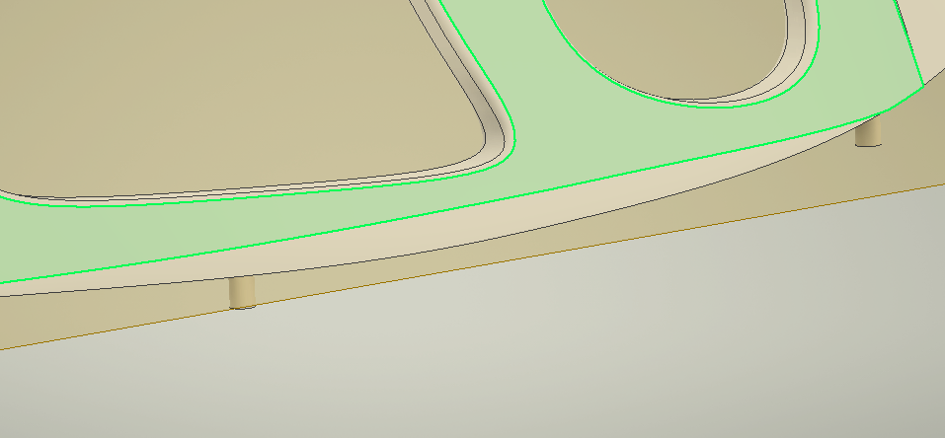
Figure 32 - Base Attachment Pins
I added small pins and holes as a temporary method of connecting the 2 pieces when this version was 3D printed. However, the holes being so small and 3D printers not being perfectly accurate, there was a risk of them not fitting together.
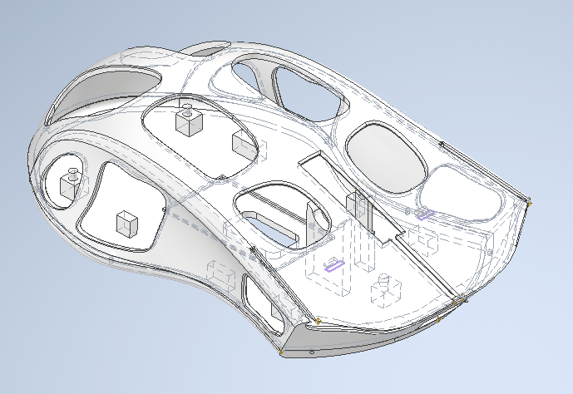
Figure 33 - 3D print design
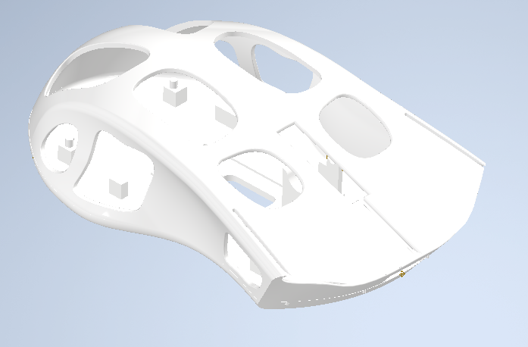
Here was the version submitted for 3D print.

8.10 3D Print
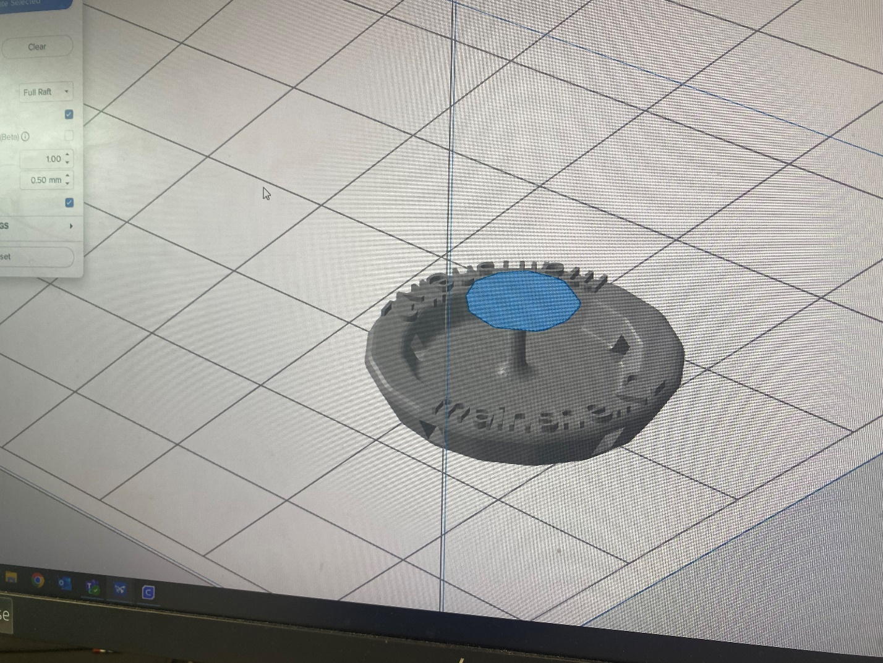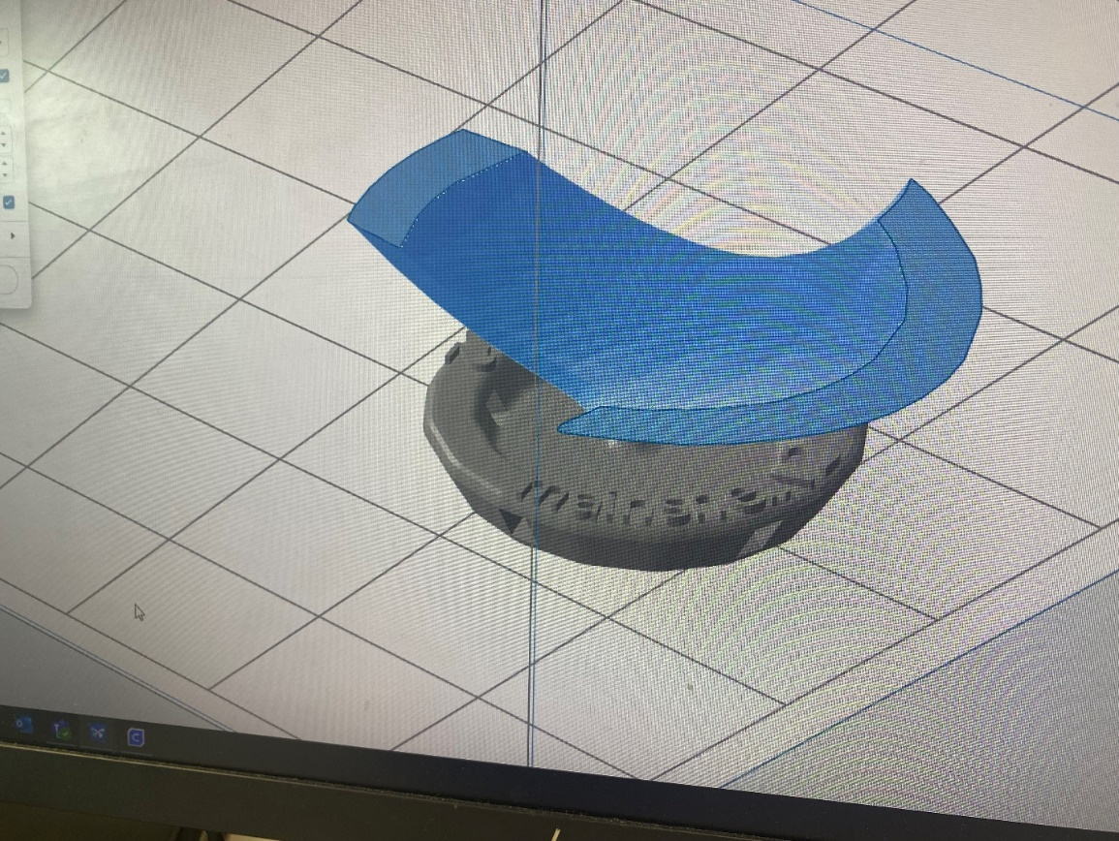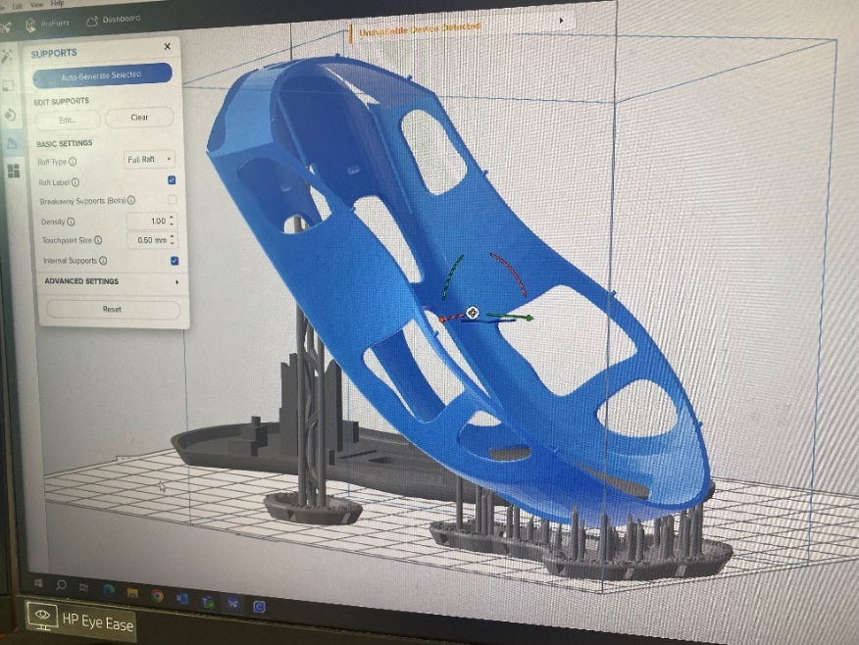
Figure 34 - Technicians Structures
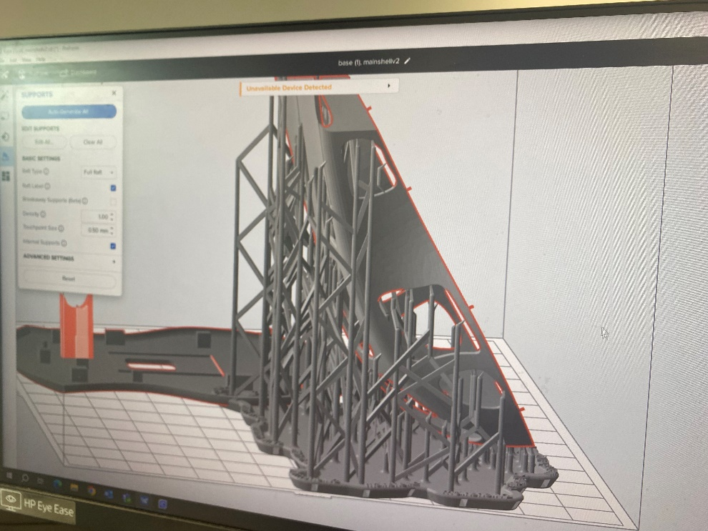
Figure 35 - Recommended Structure
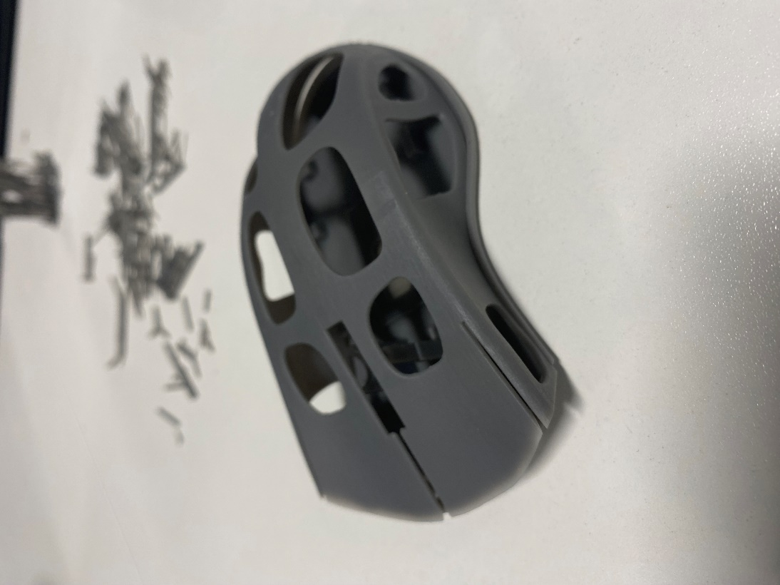
Working with the University technicians, structures were added to the file to support the 3D print. The top part of the shell would be printed at a 45 degree angle to reduce overhangs. However, it was possible to minimize the structures needed to reduce print time and material usage. For instance, figure 35 shows the recommended structures by the software, and figure 34 is close to what was chosen, bringing the print time to 5 hours. 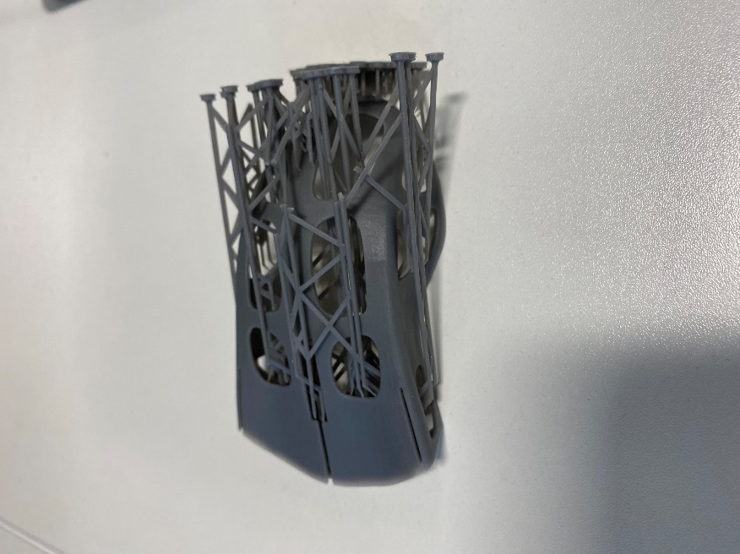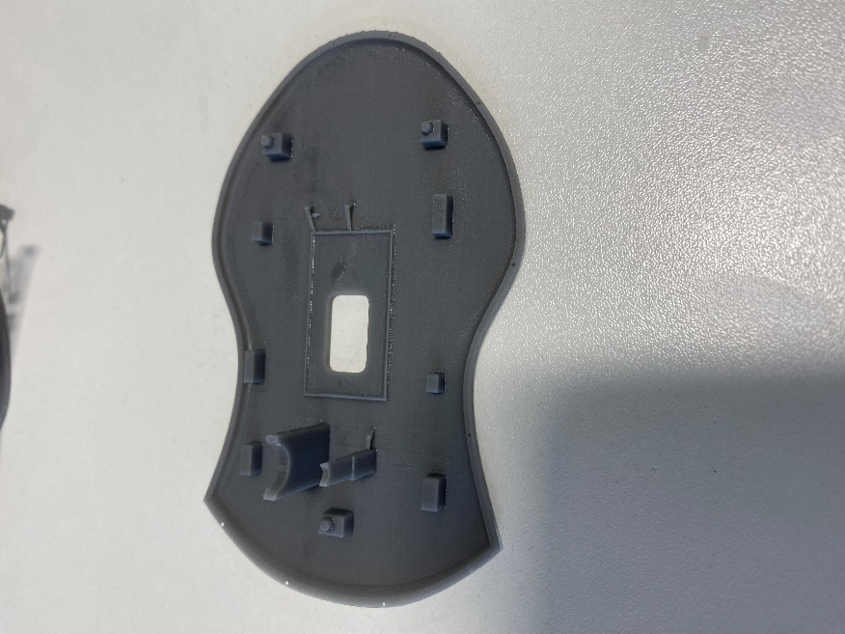
Figure 36 - 3D Print
Unfortunately, the model was printed on the final day of the project due to the print queue being overwhelmed due to deadlines for over a week.
This left no time to use it to validate the stress tests or receive customer feedback.
However, in Figure 36 it can be seen that it is definetely structurally sound and the buttons work as intended.
It could be analysed for any features that would be changed in the next iteration.
For instance, unfortunately the pieces were not printed both exactly to the same dimensions as intended. The top was slightly stretch meaning the attachment pins were unable to fit in one another. The holes for the pins in the base were incredibly small that if they did match, it was hard to see the pins going it.
The pins that were supposed to hold the electronics in place were too big for the holes by a significant margin. The gap for the scroll wheel was not large enough for it to fit through and it would become wedged. The supports that were meant to hold the scroll wheel were also lopsided. The hole at the front, it was realised, simply was going to be unable to allow the USB cable through and so another solution would be needed for it.
In the right place, the buttons were able to press down on the electronic inputs creating a click.
The main problems at this point are therefore small dimension changes to make sure the elctronics can sit inside properly.

Coding
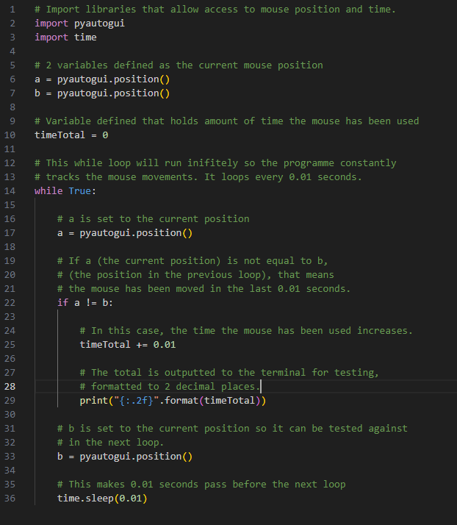
This code is designed to output to the terminal the total amount of time the mouse has been used since the program began running. This metric can be used to calculate the carbon footprint of the mouse through total energy usage as well as track usage for gamification, all features that rated most highly in the customer feedback.

Results and Analysis

9.1 Mesh Independence Study

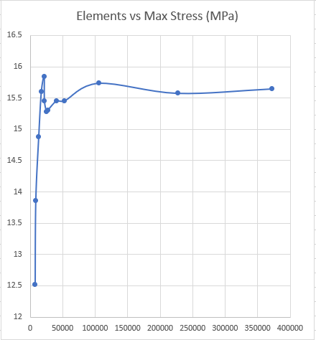
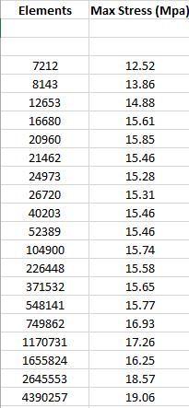
Figure 37 - Elements vs Max Stress up to 400,000 elements
Figure 38 - Mesh Independence Results
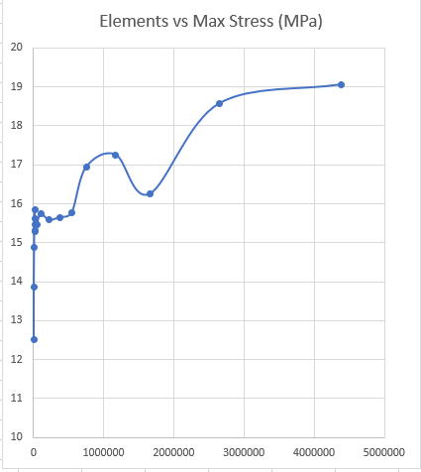
Figure 39 - Elements vs Max Stress Up to 5 mil elements
A mesh independence study is usually used in Finite Element Analysis (predicting an objects behavior with calculations) to identify the optimal density of the mesh. A higher mesh density can increase both the accuracy of results (due to calculations being done at an increasing number of points on the form) and the computational cost (since more calculations are done) so a balance must be found.
Figure 37 shows how between 7000 and 20,000 elements, the resulting maximum stress calculated by the model sharpy increases as the results converge towards a mesh independent result. Afterwards until 400,000 elements, the model plateaus which would have initially suggested a convergence.
However, figure 39 shows how after this point, the stress computed continues to increase as the elements goes into the millions. Unfortunately, computation for elements in the millions was taking 30 minutes per simulation whereas for a few thousand elements, it would take less than a minute. This computation time can be not practical when sometimes you are doing stress analysis constantly to make many small adjustments to the shape and face deadlines.
Since the criteria is met when increasing the elements doesn’t significantly change the results, then around 2.5 million seems to optimum, as more than this does not produce greatly different results plus it drastically increases computation. However, using a mesh size of 1 million for times when you need quick results would still give a good level of accuracy for low computation time.
In future, an investigation into the different shapes used in meshes could provide a higher level of efficiency and accuracy.
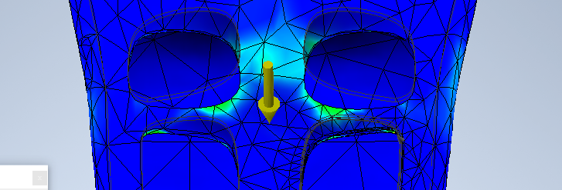
Figure 40 - 7000 elements
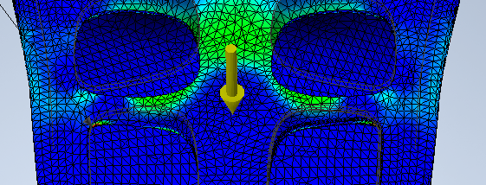
Figure 41 - 100000 elements
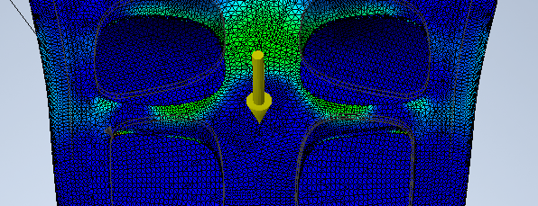
Figure 42 - 500000 elements

9.2 Stress Tests

9.2.1 ABS Plastic
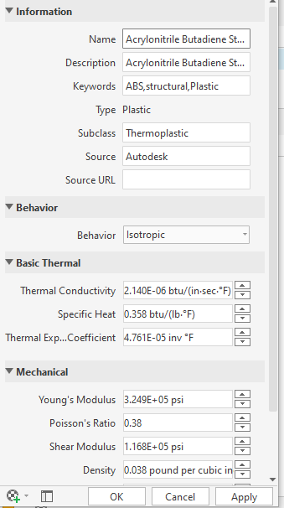
Figure 43 - ABS Material Properties
Weight of my top half: 8.173g
Weight of my base: 7.871g
Total: 16.584g
Material Cost: US$1.77/KG EUR as APR 24
1.77 * 0.016584 = $0.029 per unit
Mike (2021)
Carbon Footprint: 3.5kh carbon emissions per 1kg plastic
Teora (2023)
0.016584 * 3.5 = 0.058kg carbon emitted per unit

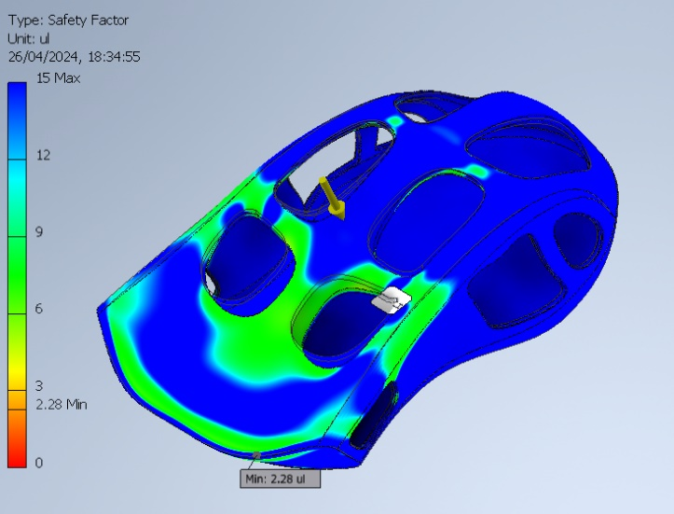
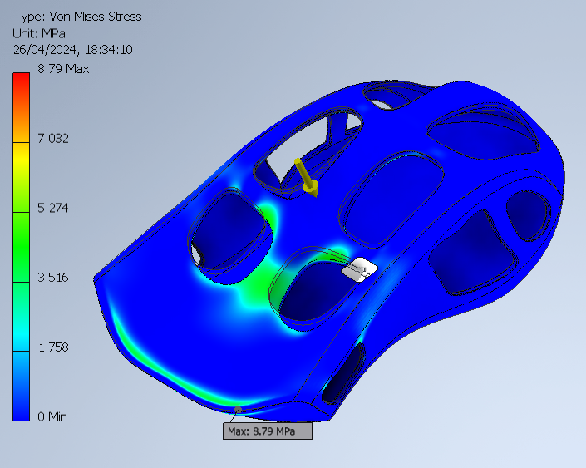
Figure 44 - 50N Safety Factor
Figure 45 - Main Structure 50N Von Mises Stress
These tests put 50N on the main structure using ABS to see how structurally sound it is.
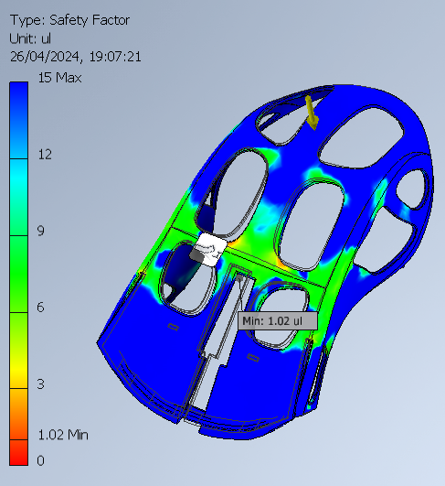
Figure 46 - Top half safety factor
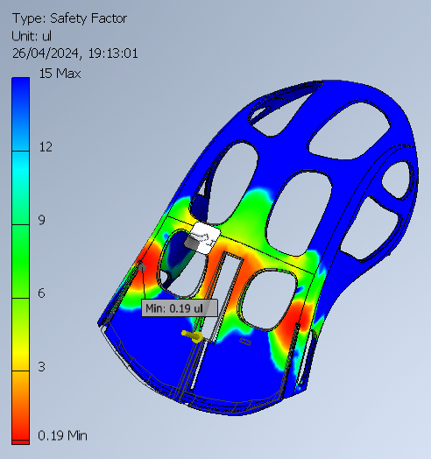
Figure 47 - Button Safety Factor

9.2.2 PLA
Thermal conductivity is 0.13W/(m*k) which is 2.505E-04 btu/(in*sec*F).
Specific heat 0.439 btu/lb*F)
Young’s Modulus of 143,000 psi.
BKingan (2016)
P. Keane (2020)
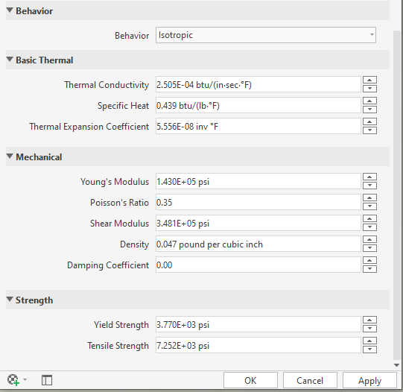
Figure 48 - PLA Material Properties
PLA weight:
Base: 9.661g
Top Shell: 10.031g
Total: 19.692g
Material Cost: US$2.88/KG EUR as APR 24
2.88 * 0.019692 = $0.056 per unit
Carbon Footprint: 0.5kg carbon emitted per 1kg of PLA
0.019692 * 0.5 = 0.009846kg carbon emitted per unit

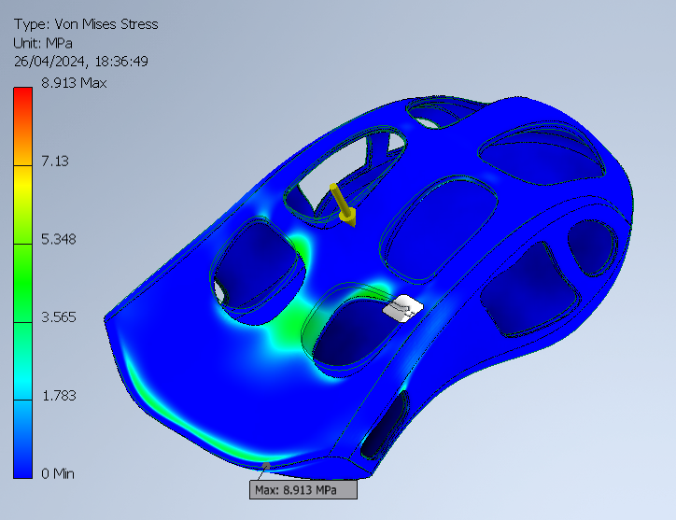
Figure 49 - Main Structure 50N
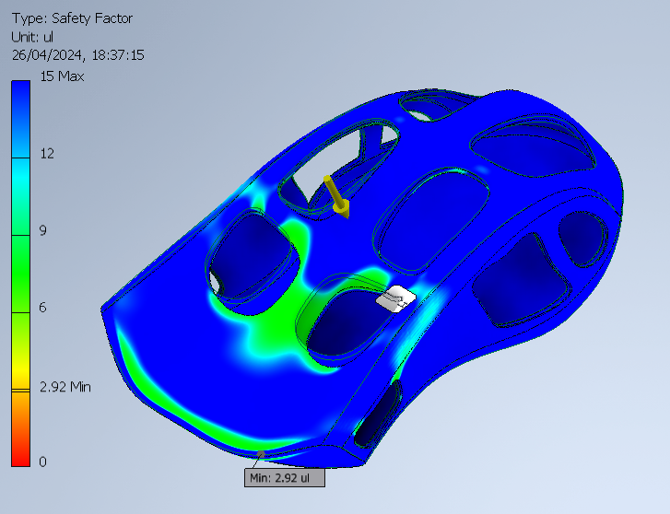
Figure 50 - Safety Factor
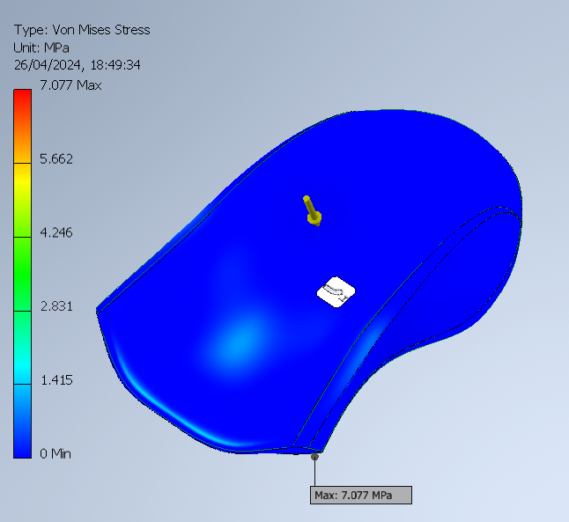
Figure 51 - 50N no removed material
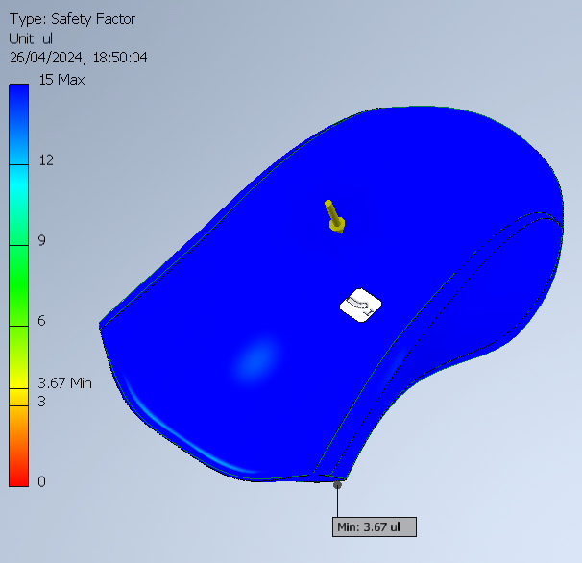
Figure 52 - Safety Factor
Weight as full shell: 23.718g
Weight with material removed: 18.943g
Holes have no significant impact on safety factor but removed 4.775g of material.

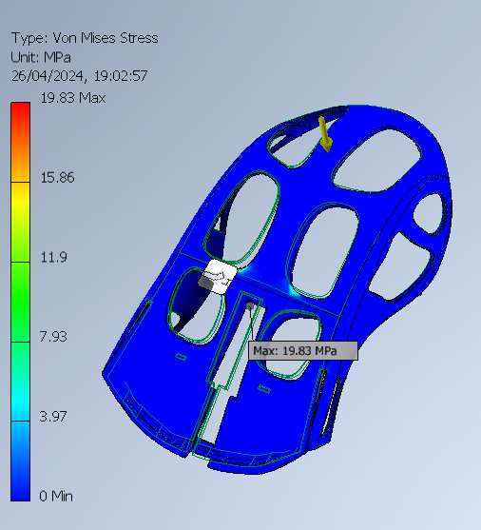
Figure 53 - 50N on main shell
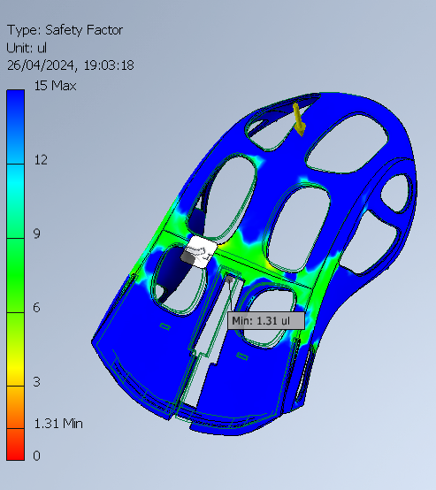
Figure 54 - Safety Factor
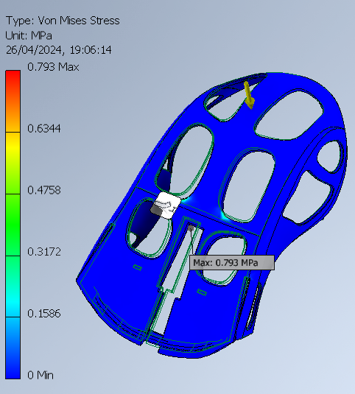
Figure 55 - 2N Main Shell

Figure 56 - Safety Factor

It has to be considered that once the electronics are in, the buttons will be supported from below as pressing them will make contact with the inputs on the board. Therefore, the deformation from these simulations only represent pressure on the shell itself.
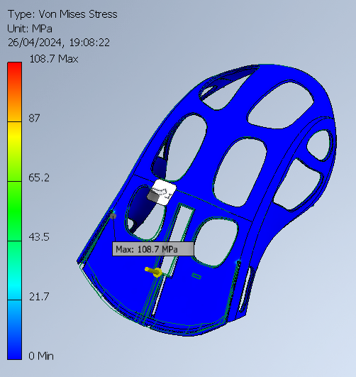
Figure 57 - 7N on buttons
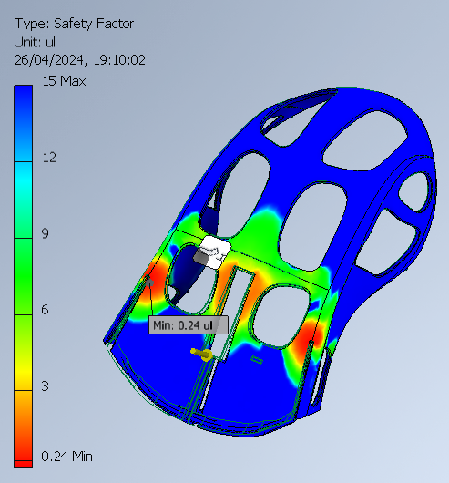
Figure 58 - Safety Factor

9.2.3 Nylon
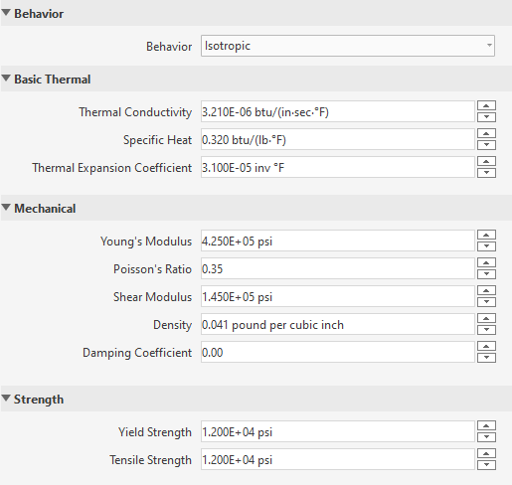
Figure 59 - Nylon Material Properties
Top Weight: 8.713g
Base Weight: 8.391g
Total = 17.122g

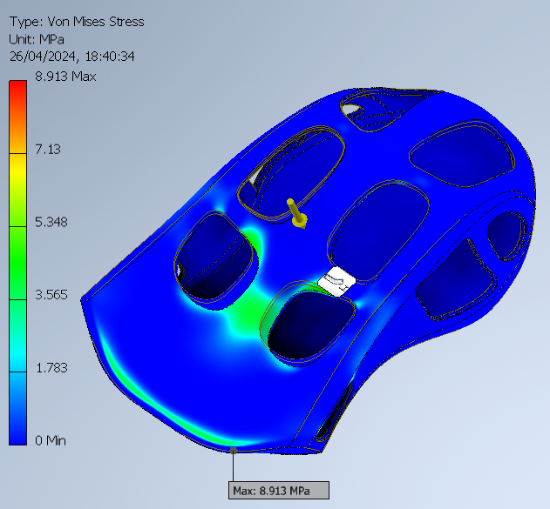
Figure 60 - Main Structure 50N
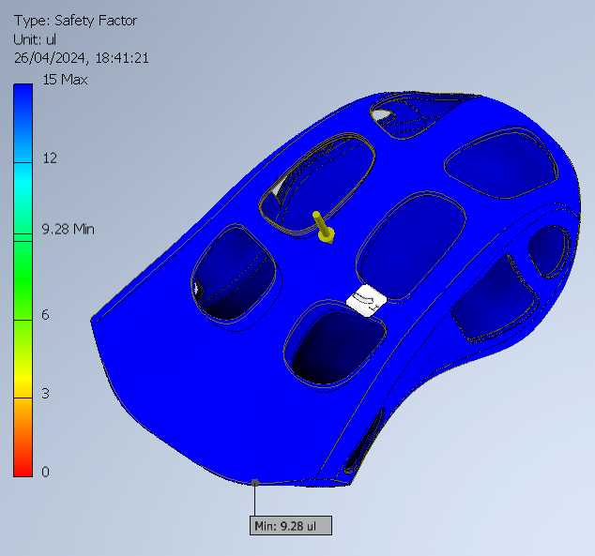
Figure 61 - Safety Factor

9.3 Parameter Discussion
The size of the shell was determined firstly by the research that suggested a mouse that sits comfortably with the majority of possible users would be 12 by 7cm as well as the exact replica of the electronics that the shell was built around.
Measurements of the original shell were taken to estimate the force that an average mouse would need to sustain during regular use so stress tests could be conducted as close to reality as possible.
The shell the electronics came with weighed 40g by itself with electronics removed. Using an average male hand then resting on the structure, the weight measured 220g. Using the equation of Force = Mass * Acceleration (the gravitational acceleration of 9.81 m/s^2), we find this resting force to be 2.1582N. This value is the absolute minimum the structure should hold.
$$Hand Resting Force = 0.18kg * 9.81m/s^2 = 2.1582N$$
Next, the same was done with the buttons being pressed down. The weight came as 710g, giving a total force of 6.9651N. This parameter was used in the stress simulations to test the structure when the button surfaces were pressed.
$$Button Pressing Force = 0.71kg * 9.81m/s^2 = 6.9651N$$
Finally, as much pressure as possible was applied to the mouse to try find the breaking point. However, the scales being used measure a maximum value of 5000g and so this value was used instead as a benchmark for the industry standard, coming out at 49N.
$$Maximum Force Required = 5kg * 9.81m/s^2 = 49N$$

Autodesk Inventor came with a Library of materials to be used in simulations such as ABS and Nylon which included their properties such as Young’s Modulus, Tensile Strength and Density. However, there wasn’t one for PLA and so these properties had to be found online and used to create a new material in Inventor. Using accurate properties makes the simulations more realistic meaning you can make changes at the design phase based on predictions of how the material is going to react.
The thermal conductivity of PLA is 0.13W/(m*k) which converted to 2.505E-04 btu/(in*sec*F) (the format which Inventor accepted) and its specific heat is 0.439 btu/lb*F.
It has a young’s modulus of 143,000 psi, notably less than the 325,000 psi of ABS which makes it less flexible (BKingan, 2016).

Figure 62 - PLA Properties
The average element size in Inventor was set to 0.006 as this gave around 2.6 million elements in the mesh, around the amount the mesh independence study suggested for a balance between accuracy and computation time
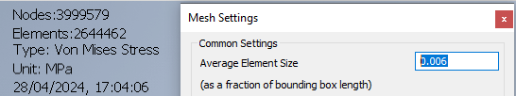
Figure 63 - Mesh Settings

9.4 Results Analysis
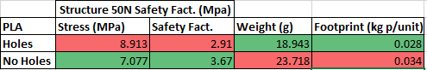
Figure 64 - Results Table 1
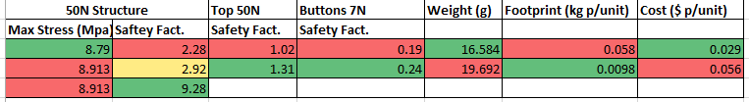
Figure 65 - Results Table 2
Firstly, an analysis was done on the benefits of the removal of material (assuming PLA is being used). With holes, the maximum stress was 8.914MPa and without, 7.077MPa. The areas of maximum stress, however, were at the very front ridge where the top and front is connected. This ridge is not in the final version as the buttons need space to be able to be pressed down and so these areas of high pressure would be decreased.
There is a 26% increase in the maximum stress and a 26% decrease in safety factor by including these holes. However, there is also a 20% decrease in weight and carbon footprint. Therefore, if the increase in stress does mean the structure will fail, it is worth decreasing the material since sustainability is a priority. Plus, a light weight has high consumer value and 18.943g is 47% less than the original shell the electronics came with which weighed 40g.
Next was an investigation into the effects of using different materials that would be accessible with a 3D printer. This included Acrylonitrile Butadiene Styrene (ABS), PLA and Nylon.
The safety factor when ABS was used was 2.28 and 2.92 for PLA. This slight increase for PLA may reflect it having a higher Yield and Tensile strength (the maximum stress the material can take before permanently deforming as shown in figure 66).
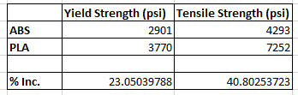
Figure 66 - ABS vs PLA tensile / yield
While this is an advantage for PLA, it also has a higher Young’s modulus which defines how flexible the material is. This is bad considering the buttons need to have a level of flexibility to be pressed without snapping.
Nylon has a much higher safety factor of 9.28 even though the maximum pressure is the same as PLA at 8.913MPa. This is because Nylons Yield Strength is 12,000 psi, more than 4 times higher than PLA. However, the rigidity in Nylon is much higher making it unsuitable for the purposes of the mouse.
The fully created shell was then analyzed. This version included many fault points which attracted large amounts of stress. With PLA, the safety factor was 1.31 when 50N of force was added to the section where the palm would be resting meaning there would be no failure if excessive force was used on this part of the mouse. The ABS safety factor was 1.02 which runs a very high risk of failure since a value of 1 represents when the structure would not be able to bear the input load.
Unfortunately, when a force of 7N was put on the buttons, the safety value dipped to 0.24 for PLA. This was because the points that separate the buttons from the main structure had a large, centralized amount of stress as shown in figure 58 for example. In a practical scenario, the electronics below would hopefully support the buttons enough to prevent failure, but this remains to be tested. In a future iteration, it would be better to distribute stress more evenly, so most of the stress is not at a single point and doesn’t go below a 1 safety factor. Even though 0.24 is a failure, it is better than the ABS results of 0.19.
Considering that the original shell was 40g, there is a small difference in weight between the ABS (16.584g) and PLA (19.662g) versions with ABS coming out slightly lighter.
Based on current statists for the price of ABS and PLA per kilogram in Europe, we can calculate the cost of material per shell unit if the product was manufactured at a large scale and therefore could be made in bulk.

$$ABS Material Cost: US\$1.77/KG EUR as APR 24$$
$$1.77 * 0.04 = \$0.071 per original 40g ABS unit$$
$$1.77 * 0.016584 = \$0.029 per new 16.6g ABS unit$$
$$PLA Material Cost: US\$2.88/KG EUR as APR 24$$
$$2.88 * 0.019692 = \$0.056 per new 19.7g PLA unit$$

These results show that if simply ABS was used, then the new shell design created reduces costs by 58.54% per unit, which already is an incentive for producers even without considering the environmental impact of using less plastic.
Calculating the carbon footprint based on the release of CO2 per kilogram of material produced, we find that the original 40g shell releases 0.14kg per unit. In comparison, the new PLA shell releases only 0.0098kg per unit, a 93% decrease. Furthermore, the PLA shell costs $0.056 per unit compared to $0.071 for the original, making it 21% cheaper. These results show a high level of success in designing a sustainable mouse that can remain profitable.
Using PLA compared to ABS on the new shell reduces carbon emissions by 6 times but is 51.79% more expensive which is a valid explanation as to why ABS is popular in products with high volumes of manufacturing.
These results conclude for the outer shell of a mouse, a plastic such as ABS or PLA is most suitable over something rigid such as Nylon. They also conclude that there are major benefits to the design created over the original shell that the electronics came with, such as a decreased cost and a major decrease in carbon footprint. Whilst costs could be decreased further by sticking with ABS, the positive sustainable impact of PLA is substantial enough to choose to manufacture with it.

9.5 Experimental Errors

There are some areas in which the Inventor Simulations may have given results that have a degree of error compared to real life.
For instance, whilst the materials properties from Inventor and online research will be somewhat accurate, real materials always have a level of fluctuation compared to the ideal.
They may have undergone impact or have impurities that cause weakness. The manufacturing process will usually have an impact on the material and how it reacts under stress. For instance, PLA is usually layered when it is 3D printed meaning it is less strong along the horizontal axis compared to the vertical.
The stress tests done used singular forces distributed on entire surfaces. In reality, a mouse would experience forces in several locations at the same time with some specific areas experiencing more than others. Therefore, the tests may not accurately portray the how a mouse will be used and experience stress.
As identified in the mesh independence analysis, the mesh quality has a high impact on the results given. The study found that the amount of stress the simulations recognized continued to rise after 2.5 million elements (the amount used for the tests) and therefore the mesh will cause a discrepancy with reality.
There are several environmental factors that are going to affect how the material reacts. For instance: temperature. PLA has a relatively low melting point and has actually been known to soften on extremely hot days. The material could absorb water if there is a high level of humidity which can cause warping or degradation. These factors can not be accounted for in computer simulations.
The tests done used a singular, static force. However, the mouse will be subject to fatigue over time which can cause differences in the stress concentrations. The loading and unloading of a force can have its own problems such as microstructural damage and crack propagation.

9.6 Critical Review of Methods

9.6.1 Project Management
A Gantt chart was used to plan out the project from start to end. However, as time went on it became more and more obsolete, even with changes. This is due to certain aspects of the work taking more time than expected or even separate projects not being accounted for in the plan. While the arbitrary deadlines initially helped to stay on track, they fell by the wayside when the errors in judgement were realized.
It was beneficial in terms of breaking down every aspect that needed completing and even just an estimate of the time helped give a realistic outlook on the work required.

9.6.2 Design Phase
Whilst the initial brainstorming was positive as it generated several different ideas to pull from, it set too much expectation of the possibilities of the project. I struggled to focus on a few good ideas, instead thinking I needed to include every single one. Furthermore, I began coming up with these ideas with very little knowledge of how a mouse works and how I’d implement them, making it very difficult to measure their feasibility.
I made decisions about the direction of the product before I’d got the feedback from the consumers of what they value, and it turns out my estimation of what was important was very different to the average.
I initially was very focused on the aesthetics which didn’t leave much time for practicality and the more important and impactful goals of sustainability.
Taking more time to ground the vision through more initial research, focus and talking with possible consumers would have possibly helped with identifying the right path towards the goals earlier.

9.6.3 CAD Phase
This was the highest standard of CAD model I had created yet, needing to be structurally sound enough to be 3D printed, house electronics and be a step forward in terms of sustainability and weight compared to computer mice on the market. The amount of experimentation and learning I did before moving onto the final piece turned out to be very helpful in making mistakes and identifying what the limitations of the software were as well as showing errors in my estimations in the work needed to complete different tasks.
For instance, removing as much material as possible I thought would be a major task in optimization, but I was able to identify areas to improve relatively quickly, especially with fast stress tests. However, building the shell to be able to hold the electronic board stably took much longer, needing a precise recreation of the board and many small intricate parts to keep the board in place and accommodate its shape.
If it had been possible to find already created models of electronic parts online, that would have saved lots of time. Furthermore, if I had wanted to add further electronic parts, this would have had to be decided on and physically tested at a much earlier stage since knowing the electronic parts you’re using informs the rest of the design so substantially.
I CAN PROBABLY SAY MORE SOME THINGS ONCE I KNOW HOW THE 3D PRINT TURNS OUT

9.6.4 Stress Simulations
In terms of the stress testing, the variety of parameters to test the main structure and areas that would especially be under pressure was good and being able to use forces taken from what the mouse would actually experience was beneficial.
However, only 3 materials were tested and while they were the ones usable for a 3D printer, it may have been better to test and analyze the majority of materials that could’ve been used with injection molding processes that would be used when manufacturing the mouse at a larger scale. Furthermore, there are more than one variety of bioplastics and others could’ve provided lighter weights, lower costs or lesser carbon footprints making them worth investigating.
Many of the areas of high stress which was found in testing was not a result of the entire structure but instead localized areas of bad design where distribution could’ve been improved. It made it hard to draw conclusions about the design as a whole when singular, small problems were massively affecting results.
Since the base and top were separate parts, it was also very difficult to run simulations on the shell when put together which would’ve have given more accurate to life results.

9.7 Validation of model
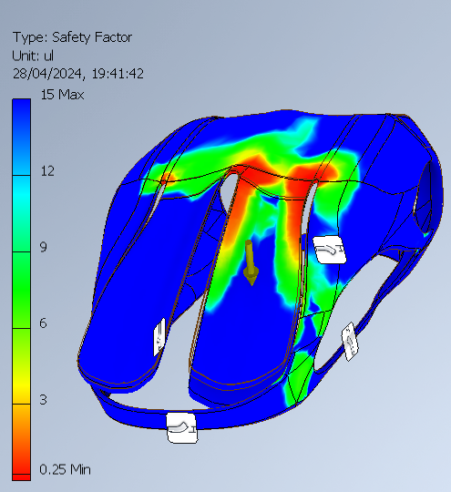
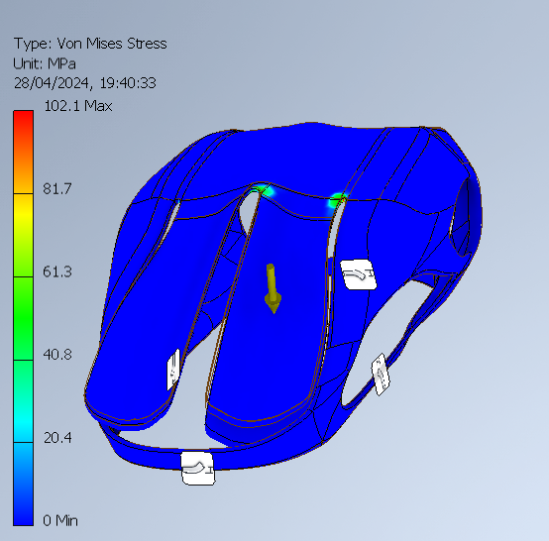
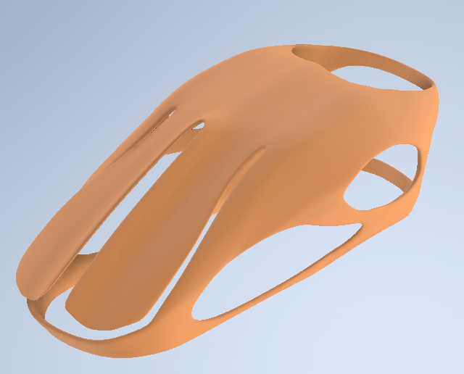
Figure 67 - Similar CAD model and stress test found at: Mouse organic shape | 3D CAD Model Library | GrabCAD

To validate my own model, I started by downloading a similar model off a popular CAD model provider. Giving it PLA as a material, and putting a button under 7N force, there were high areas of stress at the corners which attach the button to rest of the structure, like mine. It reached a factor of safety of 0.25, whilst mine was 0.24, showing that mouse designs usually experience high stress in these areas and mine is not an anomaly.

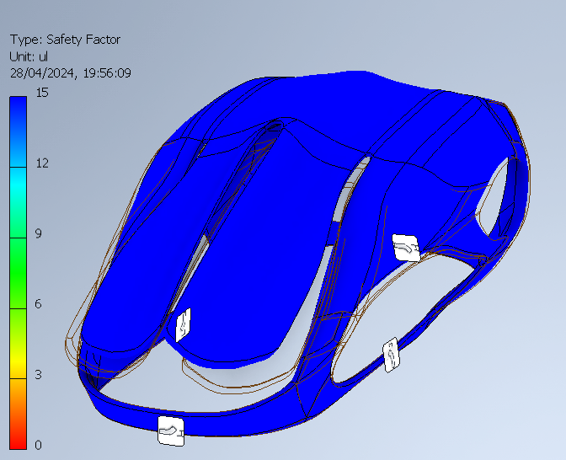
Figure 68 - Factor of Safety

Under 50N, the rest of the structure experiences minimal stress with a factor of safety of 15, showing this CAD model is viable, though unable to hold electronics.
G.N Ganeshan et al. (2020) was found to do a similar project, designing and analyzing the sustainability of a computer mouse using PLA. He also 3D printed his own design and investigated the carbon footprint.
His model considered the energy consumption of manufacturing and the possibilities of acid rain formation. He found the carbon footprint of PLA to be 0.016kg CO2e and 0.048kg C02e for ABS, similar metrics to our results where using ABS to print the model produced 0.058 kg of C02 per unit compared to 0.0098 for PLA

Conclusions

10.1 Achievement of aims
The key issues set out at the beginning of this report was the extent of electronic waste that has been created and dumped in various parts of the world, causing harmful effects to people and the environment.
The aims were to lead by example and design a mouse that attempts to solve many of the problems that made electronic products unsustainable.
Some specific goals were set out at the beginning such as trying to reduce the carbon output of a mouse by 50%.
This was achieved to some extent. For instance, the transportation of goods takes up 8% of global greenhouse emissions and that can’t be altered by a product but would need systematic change (S. Greene, 2023). Therefore, there will be a transportation carbon output for the mouse.
Furthermore, even though the project itself used recycled electronics from other discarded mice, this couldn’t be done at a production level. While the product has been designed to be taken apart easily so these electronics can be accessed and recycled at an appropriate center, there is no guarantee of the product not being simply dumped and releasing the toxins in the electronics.
However, an important metric to look at is the carbon output of the shell itself, usually produced from ABS which requires a lot of carbon to produce, especially since its oil based. The new PLA shell reduces the carbon output of creation by 93%, exceeding the 50% target.
Furthermore, PLA can biodegrade meaning when disposed of, there is reduced effect on the environment from less plastic waste.
A program has been designed to track the usage of the product which would also make the customer more aware of the carbon output of the mouse, possibly influencing future purchasing decisions.
Overall, making changes only to the product itself and not its further life cycle, the carbon output has been drastically reduced hopefully providing a powerful example of what’s possible.
Another specific goal was trying to minimize the price increase of production compared to a common ABS mouse to around 20%.
Work was done on trying to minimize the material usage per shell unit leading to a cost decrease of 20% using PLA and this shell design if the mouse was produced at a large scale to source material in bulk.
Furthermore, PLA can be implemented into current injection molding set ups meaning extremely low costs in initial startup.
While the electronics used in this project were sourced for free, at an industrial scale they would need to be bought in making it difficult to estimate a final production cost.
Some of the features found by customers to be valuable such as gamification and usage tracking required only code meaning and extremely low cost to implement.
Overall, the price target was met to a decent level which hopefully shows manufacturers there doesn’t need to be a substantial decrease in profits to make these sustainable changes.
The research and design prove the hypothesis that there are implementable solutions to help with E-waste and that current popular designs cause unnecessary harm. Not every solution was fabricated here and there are plenty that could be tested with more resources such as trying end of life recycling strategies or creating standardized components that can be switched out if they break. However, the ones that were tested such as bioplastics, minimizing material usage and environment impact tracking have been shown to have a conclusively positive impact on electronic waste if implemented at a larger scale.

11 Relevance and Impact

The results show a very plausible possibility of reducing carbon output with low costs for the manufacturers. This underscores the potential of widespread adoption of bioplastic materials and other sustainable design choices.
This research shows that having approach to design that considers the entire life cycle, such as what will happen when the product is disposed of, will inform choices that minimize footprint like opting for materials with biodegradability.
In the period between 2017 and 2022, products that claimed their products had ESG initiatives (Environmental, Social, Governance) grew 28% compared to 20% those that didn’t make ESG claims (McKinsey & Company, 2023).
Using these sustainable alternatives will give products and companies an increased competitive advantage as demand continues to grow. As materials like bioplastics are investigated, produced and optimized more, they may become more widespread and cheaper to source increasing profits.
This project gives an example of using an interdisciplinary approach to create products, drawing from engineering, material science, product design and business to come up with new solutions.
The results highlight a potential for policy makers to create an impact. With funding they can support innovation and provide financial incentives for companies to work towards sustainability. Since corporations are largely driven by profit, governments are needed sometimes to step in and create regulation for there to be lasting changes. This work shows that when high standards for sustainability are established, they can be met.
The research and resulting product can be used for educational purposes. Driving awareness in the benefits of sustainability and the harmful effects of E-waste will inform customer decisions creating a higher demand for these types of products, which will in turn incentivize companies to priorities these objectives more. Educating manufacturers on the possible solutions and benefits will also increase the adoption rate of bioplastics.

12 Validity

12.1 Limitations
Apart from the experimental errors discussed in the analysis section that affect the simulation itself, there are limitations to the project and its finding at a larger scale.
There were many possible features that were not tested due to the cost and possibility (for instance some needed a greater exploration of the electronic components, and it wasn’t possible to access the output signals from the PCP board that was used). Some of these features rated highly on customer value and so would have been worth investigating to find more possible profits.
To be able to actually test consumer demand for this type of sustainable product, it would have needed to be produced at a larger scale and put up for sale. Manufacturing more than a prototype would have required large startup costs that wasn’t in the scope of the project.
Also, at these larger scales, there can be high variability and difficulty in quality control, problems which were not accounted.
There were limitations in being able to calculate the entire carbon output of a mouse. For instance, it was not possible to gain manufacturing process details from producers or exact transport details. Furthermore, it’s very hard to estimate the carbon output of the specific electronic components that were used. All this made it hard to estimate the life cycle sustainability to be able to compare the new solutions.
There was a limitation on the spare electronics available, for instance it would have been more ideal to work on a wireless mouse as this has become the increasing customer expectation.
There were no similar projects found on a computer mouse specifically making it very difficult to validate the model or compare to previous research to find errors.
Usually, a design may go through several iterations and testing before a final product, but the scope of this project left room only for one main design with some experiments around it.
The design may experience problems related to having open electronics or hygiene, but these are very long-term issues and can’t be tested systematically.
Overall, there are several variables left unanswered in if this product would survive at market and in calculating the exact total effect it may create on the environment.

12.2 Potential transferability
While some variables are unknown, there are definite in the benefits of bioplastic, reducing material weight and designing for long term durability and repair. These factors and solutions could be easily investigated by any product design company in their own products.
The project also reinforces how using the double diamond design approach and SMART objectives can lead to achieving specific goals. The process of generating many ideas and then refining can be replicated in any project that is solving a problem.
The use of stress testing and Finite Element Analysis to generate shapes with reduced material and identify areas that may fail from the forces can be used in any product to reduce the number of physical iterations needed before achieving working product by solving potential issues at the CAD phase.
Specifically for anyone making a mouse, the identifying of the largest areas of stress may be helpful and give a model for them to validate their work and improve upon.

13 Future Work Recommendations

There are many areas that could benefit from further work and surpass some of the limitations found in this project.

The exact strategies that may be used for scaling up production could be explored, maintaining the drive for sustainability during this process as well as the design phase.
This would require careful planning and optimization. For instance, a review of possible manufacturing processes and the opportunities for high efficiency. Lean manufacturing principles could be used to minimize waste and resources used.
Since manufacturing is usually a collaboration with suppliers, working with them to develop standards and assessments so there are sustainable practices at all points in the life cycle, including ones not controlled by the manufacturers.
Production would require a large amount of energy and so investigating renewable sources or on site energy generation that uses discarded material.

With a more finished prototype or more iterations, further customer feedback could be gained and factors such as how willing consumers will accept this type of product, the usability and value could be looked at in detail.
This could be done with group user testing sessions with a diverse set of perspectives. Surveys and interviews could get qualitative feedback and identify their preferences and negative experiences which would inform the next iteration.

While the shell was the main focus of this project, looking into further mouse components that are sustainable or working on electronics that use the most eco friendly materials is an area for further review. This could be paired with investigating the other features with high value such as haptic feedback by prototyping and testing.
A more complete lifecycle assessment could be done to raise areas of issues at every single point in the chain and then attempt to find solutions for them.
This could be done by thorough data collection and assessing the environmental impact in several categories such as global warming potential or resource depletion.
For this specific mouse shell, the minimum amount of material usage has not yet been achieved and with further shape generation and stress analysis, the weight could come down which would reduce carbon output even more.
There is still more to look at with PLA. For instance, experiments have been conducted with reinforcing PLA with other materials such as fibers giving different properties that are suited for different purposes. PLA is not the only biodegradable plastic and so other options could be tested.
Standardized testing methods like tensile testing, flexural testing, impact testing and thermal analysis could identify which composites would be suitable for different applications.

The design process and principles could be transferred to other products. For instance, continuing with the office supplies them, a whole workspace could be designed around sustainable products.
Realistically, this would include workshops and brainstorming sessions for teams to explore these sustainable principles and design methods. Research could be conducted into current companies to gain insight onto their operations, identifying where these principles are most needed.

14 References
The World Counts (2023). The World Counts. [online] www.theworldcounts.com. Available at: https://www.theworldcounts.com/challenges/planet-earth/waste/electronic-waste-facts.
Widmer, R. et al. (2005) ‘Global perspectives on e-waste’, Environmental Impact Assessment Review, 25(5), pp. 436–458. Available at: https://doi.org/10.1016/j.eiar.2005.04.001.
L. MacCarthy (2017) Why 98% of Companies Do Not Achieve Their Sustainability Goals, Sustainable Brands. Available at: https://sustainablebrands.com/read/organizational-change/why-98-of-companies-do-not-achieve-their-sustainability-goals#:~:text=Lack%20of%20resources%20and%20competing
Corporate Finance Institute. (n.d.). SMART Goals. [online] Available at: https://corporatefinanceinstitute.com/resources/management/smart-goal/?utm_source=google&utm_medium=cpc&utm_term=&utm_content=&utm_campaign=&utm_adgroup=&utm_funnel=&gad_source=1&gclid=EAIaIQobChMIxuK-g5LthQMVZ4pQBh1ByAOyEAAYASAAEgL6lvD_BwE [Accessed 1 May 2024].
Casey (2021). Double Diamond Design Thinking Framework Training. [online] Innovation Training | Design Thinking Workshops. Available at: https://www.innovationtraining.org/design-thinking-double-diamond-framework-training/.
Johnson, C. (2021). Soaring e-waste affects the health of millions of children, WHO warns. [online] World Health Organization. Available at: https://www.who.int/news/item/15-06-2021-soaring-e-waste-affects-the-health-of-millions-of-children-who-warns.
Gabrys, J. (2013), Digital Rubbish: a natural history of electronics , Book, University of Michigan Press, Available at: Digital Rubbish: A Natural History of Electronics - 1006114.pdf (oapen.org)
Boldero, J. (1995). The Prediction of Household Recycling of Newspapers: The Role of Attitudes, Intentions, and Situational Factors1. Journal of Applied Social Psychology, [online] 25(5), pp.440–462. doi:https://doi.org/10.1111/j.1559-1816.1995.tb01598.x.
Molotch, H. (2003). Where stuff comes from: How toasters, toilets, cars, computers, and many other things come to be as they are. [online] NYU Scholars. Routledge. Available at: https://nyuscholars.nyu.edu/en/publications/where-stuff-comes-from-how-toasters-toilets-cars-computers-and-ma [Accessed 1 May 2024].
Ramayah , T.,Lee, J. W. C, Lim, S., (2012) Sustaining the environment through recycling: An empirical study, Journal of Environmental Management, Volume 102, Available at: (https://www.sciencedirect.com/science/article/pii/S0301479712001004)
Barrett, A. (2020). Advantages and Disadvantages of PLA. [online] Bioplastics News. Available at: https://bioplasticsnews.com/2020/06/09/polylactic-acid-pla-dis-advantages/.
‌Nguyen, K.Q., Vuillaume, P.Y., Hu, L., López-Beceiro, J., Cousin, P., Elkoun, S. and Robert, M. (2023). Recycled, Bio-Based, and Blended Composite Materials for 3D Printing Filament: Pros and Cons—A Review. Materials Sciences and Applications, [online] 14(3), pp.148–185. doi:https://doi.org/10.4236/msa.2023.143010.
‌ Nascimento, L., Gamez-Perez, J., Santana, O.O., Velasco, J.I., Maspoch, M.LI. and Franco-Urquiza, E. (2010) Effect of the Recycling and Annealing on the Mechanical and Fracture Properties of Poly(Lactic Acid). Journal of Polymers and the Environment, 18, 654-660.
https://doi.org/10.1007/s10924-010-0229-5
Anon (2017). Injection molders who have made bioplastics work. [online] Green Dot Bioplastics. Available at: https://www.greendotbioplastics.com/injection-molders-made-bioplastics-work/#:~:text=Modern%20bioplastics%20can%20be%20seamlessly [Accessed 1 May 2024].
Carnagie Mellon University (2003). Size and Shape Limitations? [online] Available at: https://www.cs.cmu.edu/~rapidproto/students.03/mrau/project2/report/4.html#:~:text=Limitations%20of%20making%20a%20part [Accessed 1 May 2024].
‌ Altshuller, G., 1996. And Suddenly The Inventor Appeared TRIZ, the Theory of Inventive Problem Solving. 2nd Edn., Technical Innovation Centre, Inc., Worcester, ISBN: 10: 0964074028, pp: 196.
Hurst, K. (1999). Engineering Design Principles. [online] Google Books. Butterworth-Heinemann. Available at: https://books.google.co.uk/books?hl=en&lr=&id=Uasl_obEdRUC&oi=fnd&pg=PP1&dq=product+design+principles&ots=O8MyK00q_F&sig=zIBH868MtRTRscP-aSlbAUmJoqg&redir_esc=y#v=onepage&q=product%20design%20principles&f=false [Accessed 1 May 2024].
‌Chamorro-Koc, M., Popovic, V., Emmison, M., (2009), Human experience and product usability: Principles to assist the design of user–product interactions, Applied Ergonomics, Volume 40, Issue 4, Pages 648-656, Available at: https://www.sciencedirect.com/science/article/pii/S0003687008001026
Kanski, P. (2022). Product Design Principles & Tips - How to Design a Good One? [online] Available at: https://www.boldare.com/blog/principles-of-product-design/#five-universal-product-design-principles
‌Gov.uk (2012). Intellectual property and your work. [online] GOV.UK. Available at: https://www.gov.uk/intellectual-property-an-overview/protect-your-intellectual-property.
‌Engdahl, T (n.d) courses.cs.washington.edu. PC mouse info. [online] Available at: https://courses.cs.washington.edu/courses/cse477/00sp/projectwebs/groupb/PS2-mouse/mouse.html.
‌Kunst. A (2024). PC gamers by gender in the United States 2023. [online] Available at: https://www.statista.com/forecasts/1221450/us-pc-gamers-by-gender#:~:text=U.S.%20PC%20gamers%20by%20gender%202023&text=As%20of%20September%202023%2C%20some [Accessed 1 May 2024].
Petrosyan, A. (2024). Global users going online via computer by age and gender 2022. [online] Available at: https://www.statista.com/statistics/1380363/users-going-online-via-computers-by-age-and-gender/.
‌BS EN ISO 9241-410:2008+A1:2012: Ergonomics of human-system interaction: Design criteria for physical input devices (2014). British Standards Institute. Available at: https://www.iso.org/obp/ui/#iso:std:iso:9241:-410:ed-1:v1:en
Holmes. G (n.d.) www.madehow.com., How computer mouse is made - manufacture, history, used, processing, parts, components, structure, steps, product. [online] Available at: https://www.madehow.com/Volume-5/Computer-Mouse.html.
Liu, K., Tan, Q., Yu, J., Wang, M., (2023), A global perspective on e-waste recycling, Circular Economy, Volume 2, Issue 1, Available at: (https://www.sciencedirect.com/science/article/pii/S2773167723000055)
Mike (2021). Acrylonitrile butadiene styrene (ABS) USA price index. [online] businessanalytiq. Available at: https://businessanalytiq.com/procurementanalytics/index/acrylonitrile-butadiene-styrene-abs-usa-price-index-2/.
‌Teorra (2023). What Is the Carbon Footprint of Packaging? [online] www.teorra.info. Available at: https://www.teorra.info/blog/what-is-the-carbon-footprint-of-packaging#:~:text=Cardboard%20%26%20Paper%3A%200.94kg%20carbon.
‌Keane, P. (2020). Thermally Conductive Polymer Materials for 3D Printing. [online] 3D Printing. Available at: https://3dprinting.com/3d-printing-use-cases/thermally-conductive-polymer-materials/#:~:text=PLA%20has%20a%20thermal%20conductivity [Accessed 1 May 2024].
‌ BKingan (2016). Tensile Testing Results of Toner Plastics 3D Filament. [online] Toner Plastics. Available at: https://tonerplastics.com/tesile-testing-results-of-toner-plastics-3d-filament/#:~:text=PLA%20had%20the%20highest%20Young [Accessed 1 May 2024].
‌Greene, S. (2023). Freight Transportation. [online] MIT Climate Portal. Available at: https://climate.mit.edu/explainers/freight-transportation.
‌McKinsey & Company (2023). Consumers Care about Sustainability—and Back It up with Their Wallets. [online] Mckinsey & Company. Available at: https://www.mckinsey.com/industries/consumer-packaged-goods/our-insights/consumers-care-about-sustainability-and-back-it-up-with-their-wallets.
‌ Ganeshan, G.N., Kamalakannan, R. and Vijay, S. (2019). Design, manufacture and sustainable analysis of biodegradable computer mouse using solid works and 3D printer. Materials Today: Proceedings. doi:https://doi.org/10.1016/j.matpr.2019.05.360. Available at: https://www.sciencedirect.com/science/article/pii/S2214785319312180

15 Appendix
Journal Gantt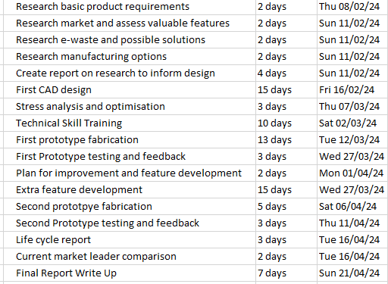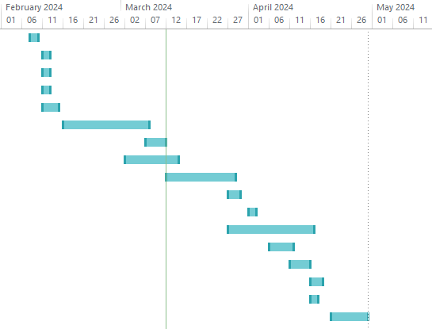
Final Gantt Chart
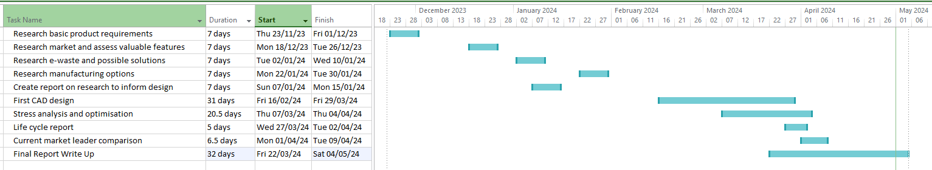
A lot of the research was finished on time and a lot quicker than expected but I think that created too much confidence and the CAD design was left too long to the point where fabrication wasn’t able to happen until the final 2 weeks. Also, I only left 10 days originally for the final write up but this was instead spread of the 2 months leading up to the deadline and took much longer than expected. In hindsight, I would’ve worked continuously on the prototype throughout the early part of the year and plan to start the report earlier.

RESEARCH ETHICS
Proportionate Review Form
The Proportionate Review process may be used where the proposed research raises only minimal ethical risk. This research must: focus on minimally sensitive topics; entail minimal intrusion or disruption to others; and involve participants who would not be considered vulnerable in the context of the research.

PART A: TO BE COMPLETED BY RESEARCHER
Name of Researcher: | Joshua Haddock
School | Staffordshire University

Student/Course Details (If Applicable)
Student ID Number: |  |  | 21010567
Name of Supervisor(s)/Module Tutor: |  |  | Bhavesh Patel
PhD/MPhil project:
Taught Postgraduate Project/Assignment: |  | Award Title: | BEng Mechanical Engineering
Undergraduate  Project/Assignment: |  | Module  Title: | Final Year Project

Project Title: | Computer Mouse Product Design
Project Outline: | Designing, prototyping and creating a mass production manufacturing analysis of a computer mouse that is designed for current emerging market needs such as sustainability, an integration with AI, new research in computer usage health issues and other quality of life features.
Give a brief description of participants and procedure (methods, tests etc.) | After brainstorming, CAD will be used to design components, a prototype will be fabricated with 3D printing and spare parts, coding software will be used for integrated features, questionnaires will be used for customer feedback, the process will be repeated, research will be used to find suitable mass manufacturing techniques.
Expected Start Date: | 20/10/23 | Expected End Date: | 01/05/24

Relevant professional body ethical guidelines should be consulted when completing this form.
Please seek guidance from the School Ethics Coordinator if you are uncertain about any ethical issues arising from this application.
There is an obligation on the researcher and supervisor (where applicable) to bring to the attention of the School Ethics Coordinator any issues with ethical implications not identified by this form.

Researcher Declaration

I consider that this project has no significant ethical implications requiring full ethical review

I confirm that:
1. | The research will NOT involve members of vulnerable groups.
 | Vulnerable groups include but are not limited to: children and young people (under 18 years of age), those with a learning disability or cognitive impairment, patients, people in custody, people engaged in illegal activities (e.g. drug taking), or individuals in a dependent or unequal relationship.
2. | The research will NOT involve sensitive topics.  Sensitive topics include, but are not limited to: participants’ sexual behaviour, their illegal or political behaviour, their experience of violence, their abuse or exploitation, their mental health, their gender or ethnic status. The research must not involve groups where permission of a gatekeeper is normally required for initial access to members, for example, ethnic or cultural groups, native peoples or indigenous communities.
3. | The research will NOT deliberately mislead participants in any way.
4. | The research will NOT involve access to records of personal or confidential information, including genetic or other biological information, concerning identifiable individuals.
5. | The research will NOT induce psychological stress, anxiety or humiliation, cause more than minimal pain, or involve intrusive interventions.  This includes, but is not limited to: the administration of drugs or other substances, vigorous physical exercise, or techniques such as hypnotherapy which may cause participants to reveal information which could cause concern, in the course of their everyday life.
6. | The research WILL be conducted with participants’ full and informed consent at the time the study is carried out:  - The main procedure will be explained to participants in advance, so that they are informed about what to expect.  - Participants will be told their involvement in the research is voluntary.  - Written consent will be obtained from participants. (This is not required for self-completion questionnaires as submission of the completed questionnaire implies consent to participate).  - Participants will be informed about how they may withdraw from the research at any time and for any reason.  - For questionnaires and interviews: Participants will be given the option of omitting questions they do not want to answer.  - Participants will be told that their data will be treated with full confidentiality and that, if published, every effort will be made to ensure it will not be identifiable as theirs.  - Participants will be given the opportunity to be debriefed i.e. to find out more about the study and its results. | YES  N/A
7. | A risk assessment has been completed for this research project | YES  N/A
If you are unable to confirm any of the above statements, please complete a Full Ethical Review Form. If the research will include participants that are patients, please complete the Independent Peer Review process.
8. Information and Data
Please provide answers to the following questions regarding the handling and storage of information and data:
a) How will research data be stored (manually or electronically)?
Both
b) How is protection given to the participants (e.g. by being made anonymous through coding and with a participant identifier code being kept separately and securely)?
Questionnaires will be completed anonymously
c) What assurance will be given to the participant about the confidentiality of this data and the security of its storage?
Their data has restricted access and secure storage practices are used.
d) Is assurance given to the participant that they cannot be identified from any publication or dissemination of the results of the project?
Yes
e) Who will have access to this data, and for what purposes?
Myself and possibly my project supervisor.
f) How will the data be stored, for how long, and how will it be discarded?
On restricted cloud storage and physical paper versions, the duration of the project, deleted permanently or shredded.

Supporting Documentation
All key documents e.g. consent form, information sheet, questionnaire/interview schedule are appended to this application.

Signature of Researcher: |  | Date: | 14/11/23

NB: If the research departs from the protocol which provides the basis for this proportionate review, then further review will be required and the applicant and supervisor(s) should consider whether or not the proportionate review remains appropriate. If it is no longer appropriate a full ethical review form MUST be submitted for consideration by the School Ethics Coordinator .

Next Step:
STUDENTS: Please submit this form (and supporting documentation) for consideration by your Supervisor/ Module Tutor.
STAFF: Please submit this form to your Head of Department or a Senior Researcher in your School. Once they have reviewed the form, this should be forwarded to the Research Administrators in RIIS
(ethics@staffs.ac.uk) who will arrange for it to be considered by an independent member of the School’s College of Reviewers .

PART B: TO BE COMPLETED BY SUPERVISOR/MODULE TUTOR (If student) OR Head of Department/ Senior Researcher (if staff)
I consider that this project has no significant ethical implications requiring full ethical review by the Faculty Research Ethics Committee.
I have checked and approved the key documents required for this proposal (e.g. consent form, information sheet, questionnaire, interview schedule).

Signature of Supervisor/ Head of Department/ Senior Researcher: |  | Date: | 15/11/23

Next Step: Please forward this form to the Research Administrators in RIIS (ethics@staffs.ac.uk) who will arrange for it to be considered by an independent member of the School’s College of Ethical Reviewers , having no direct connection with the researcher or his/her programme of study.

