Experimental Level Design Documentation – Beacon GP (Turbo Sliders Unlimited)

By Brandon Langford
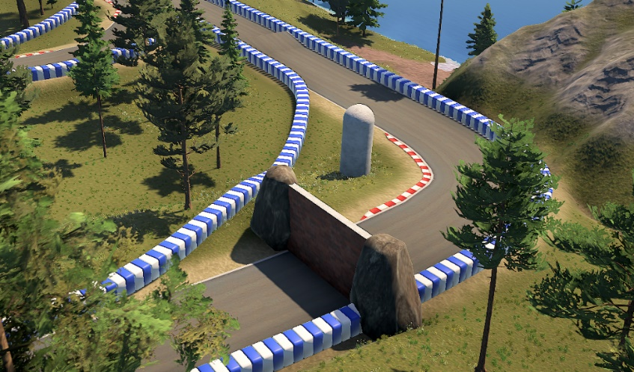
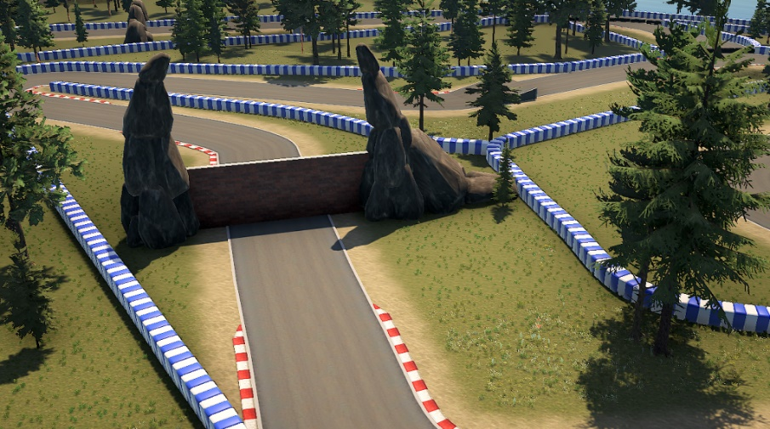
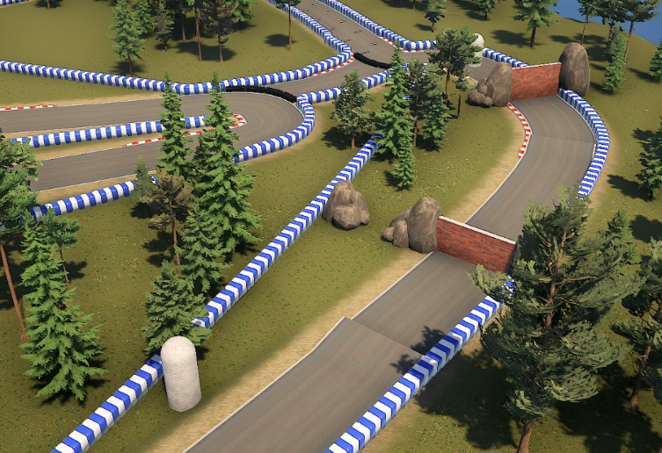
Contents

High Level Overview 3
Design Motivations: 3
Key Elements: 3
Level Goals: 4
Design Considerations: 5
Expected Player Experience: 6
Bubble Map: 7
Beats and Pacing: 8
Mechanics: 8
Research 9
Video Game Research: 9
Real Life Research: 12
Map Overview 14
Player Paths: 14
Challenge Placements: 15
Conflict Points: 16
Points of Interest: 17
Rewards: 18
Aesthetics 19
Visual Development: 19
Visual and Audio Affordance: 20
Balance 21
Considerations: 21
Expected Issues: 21
Testing 22
Testing Plan: 22
Evidence of Testing: 24
Level Development Log 29
Level Images: 29

High Level Overview

Design Motivations:
My motivations come from wanting to design intricate and interesting racetracks for racing games in the future. I have looked at all kinds of racing games and understand the difference between them all such as Mario Kart, Trackmania and for this project, Turbo Sliders Unlimited. I have spent most of my life sketching out designs for racetracks so this is something I couldn’t wait to create.

Key Elements:
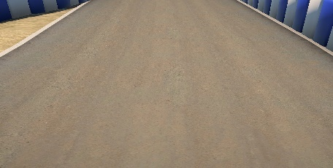
- Road: - The main element that the player drives on, staying on the road allows for a quicker time around the track as going off road slows the player down.

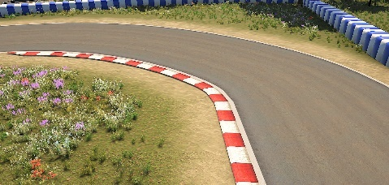
- Curbs: - Red and White inner curves on most turns in the track, placed to warn the player of an upcoming turn.

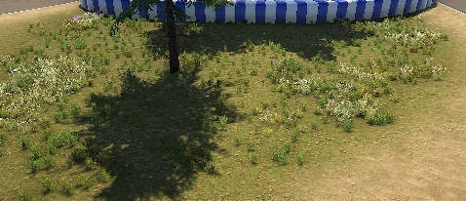
- Off-Road: - Anywhere off the main road that slows the player down, players may be shoved off onto it or use it to go around obstacles.

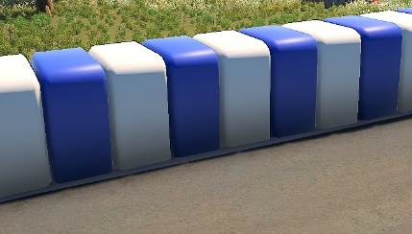
- Wall: - Blocks the player from leaving the bounds of the track, though they may launch over the wall, this can be solved by pressing the Respawn Key which can be mapped to whatever key the player desires.

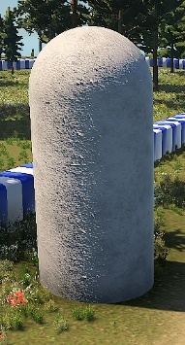

- Moving Column: - Slides left and right at an average speed to block the players path throughout the level, can be avoided by timing the drive past it.

- Moving Wall: - A slow brick wall that moves up and down, always surrounded by a bunch of rocks either side of it. There will always be a small gap in one of the rocks on one of the sides for players to risk driving through.
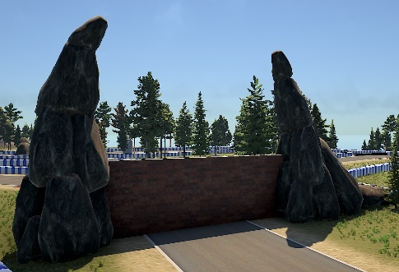

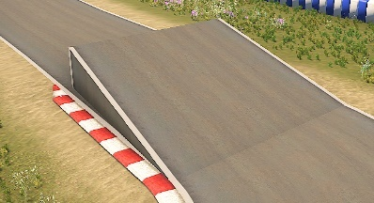
- Ramp: - An elevated section of road that allows players to jump into the air, this allows for more dynamic gameplay where players will need to make a split decision while racing.

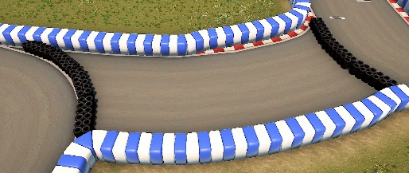
- Tire Barriers: - Block players from driving on the unused sections of the track that make the overall loop smaller, they add a layer of narrative to the level by acting as though they will be moved for other lengths of race, adding to the realism aspect also.

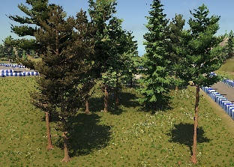
- Trees: - Surrounding the scenery of the track, they immerse the player, making them believe they are in a forest that houses a racetrack. They are physical and act as an obstacle for the player.

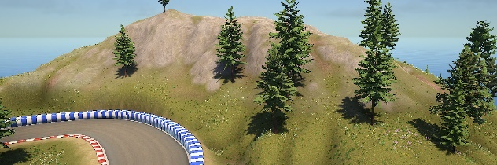
- Hills & Mountains: - Another element that adds to the surrounding scenery giving the player more to look at as they move around the racetrack, they provide elevation in a different way for the player.

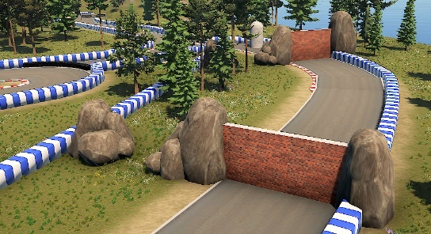
- Rocks: - Rocks are almost always found with the Moving Walls usually as a barrier that the player cannot cross, but there will always be a gap in the rocks to act as an alternate pro route for more experienced players.

Level Goals:
Level goals can be split up into three main types: Main/Primary Goal, Secondary Goal or Tertiary Goal.
The Primary Goal is to complete the racetrack by any means necessary, not the fastest or in the best position, but just completing the racetrack is the main goal.
The Secondary Goal is to complete the racetrack in the best position but not necessarily in the fastest time, this will be through getting first place and gaining the most points for your victory. Points are a nice incentive for players to want to do better, as the higher your points, the more likely you are to win overall.
And finally, the Tertiary Goal is to complete the racetrack in the fastest time, usually through taking shortcuts and taking the best lines around each turn and avoiding the obstacles and/or the other players who will slow you down.

Design Considerations:
I must consider the fact that there are 4 base car types in Turbo Sliders Unlimited:
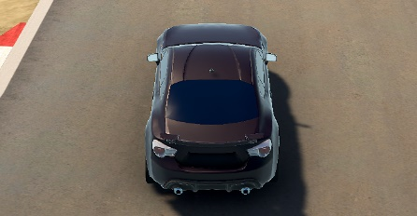
- Sporty: - The starting all-around car that has a good mix of all the stats. Modelled after a typical car that is considered sportier than the average family car.

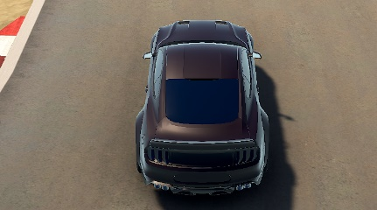
- Speedy: - This car is built for speed and is one of the fastest cars in the base game. Modelled after many kinds of Supercars as they are all usually quite fast.

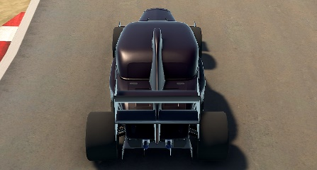
- Grippy: - Sticking to the track is the name of this cars game and it does just that incredibly well. Modelled after a Heavy Formula Car as they are built for gripping to racetrack surfaces to maximise speed.

- Drifty: - Handling is this car’s strong suit, it’s able get around corners with ease and never misses a turn outside of maybe oversteering. Modelled after a typical drift car with cambered wheels.
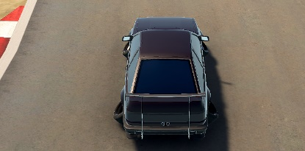

I also must consider the experience and skill gap between players as people will be entering the track at different skill levels:
- Beginner: - These kinds of players can be relatively new to the genre or the game itself and thusly must be taught the Fundamentals correctly, that’s why this track doesn’t start too hard as to not turn away potentially entry level players. They are probably best to start with Sporty as it is the most all-around of the 4 base cars. The first few turns and obstacles teach new players what they will expect when playing Turbo Sliders Unlimited.

- Intermediate: - These kinds of players will be a little more experienced with the game and potentially the level itself if they have played it enough times, they know the Fundamentals and have begun to try some of the more Skilled Techniques. This track offers challenges throughout that the average player will come across, they may also choose to use Speedy or Grippy as they are for players who aren’t necessarily new but are seeking a bit more challenge, that’s why this track starts off hard and gradually ramps up the difficulty.
- Professional: - These kinds of players are well versed in the genre they are playing and have mastered the Fundamentals and Skilled Techniques, so they seek some challenge and try to push themselves. Throughout the track, there are a few Shortcuts that are left for any player that notices them, some of them require a bit of skill to pull off but are super rewarding when they do. The middle of the track contains the most difficult section being a sharp U-turn, so a professional player may be challenged depending on how well they know the track’s layout from playing it repeatedly.
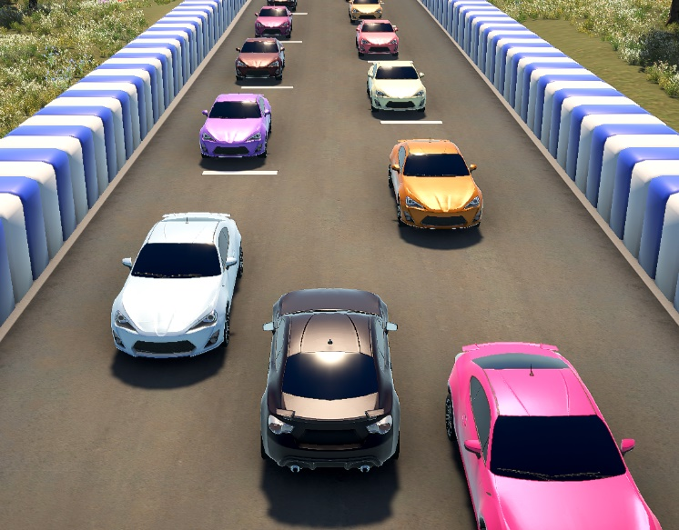
Finally, I must also consider the Multiplayer aspect of the game as any Online Lobby of Turbo Sliders Unlimited can hold up to 20 Players.

Expected Player Experience:
Players can Expect to Experience:
- A Chaotic and Hectic environment where up to 20 Players of varying skills and abilities are Racing against each other.
- A set of Obstacles that are out to stop the player by getting in their way all the while other players are trying to do the same thing.
- Turns of varying Difficulty to help Teach and Challenge the player on how to get around the track.
- They can also expect to experience Shortcuts if they go for them or if other players try to attempt them.
- If set to Missile Mode, then the Environment gets more insane as people are firing off Rockets left and right.

Bubble Map:
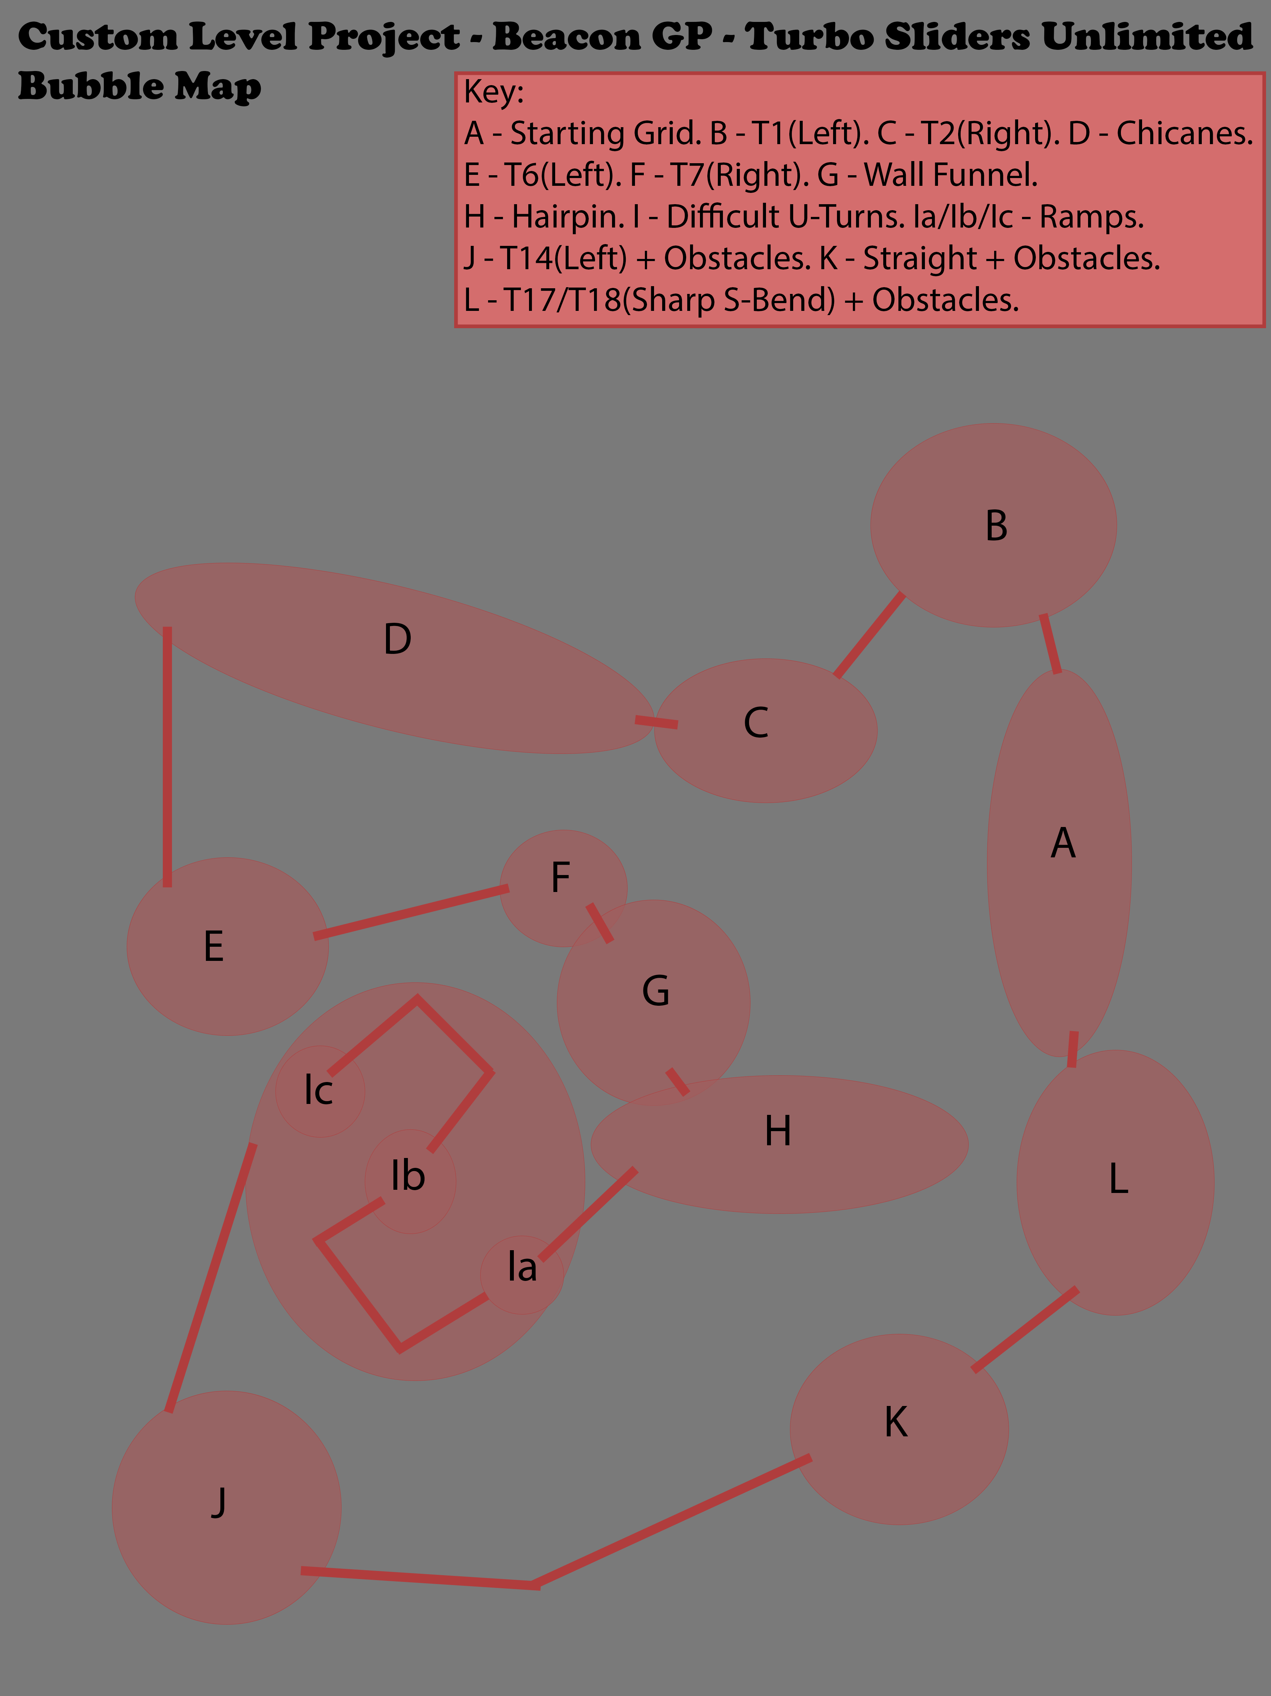
An Image showing the Bubble Map of my Track, Beacon GP.

Beats and Pacing:
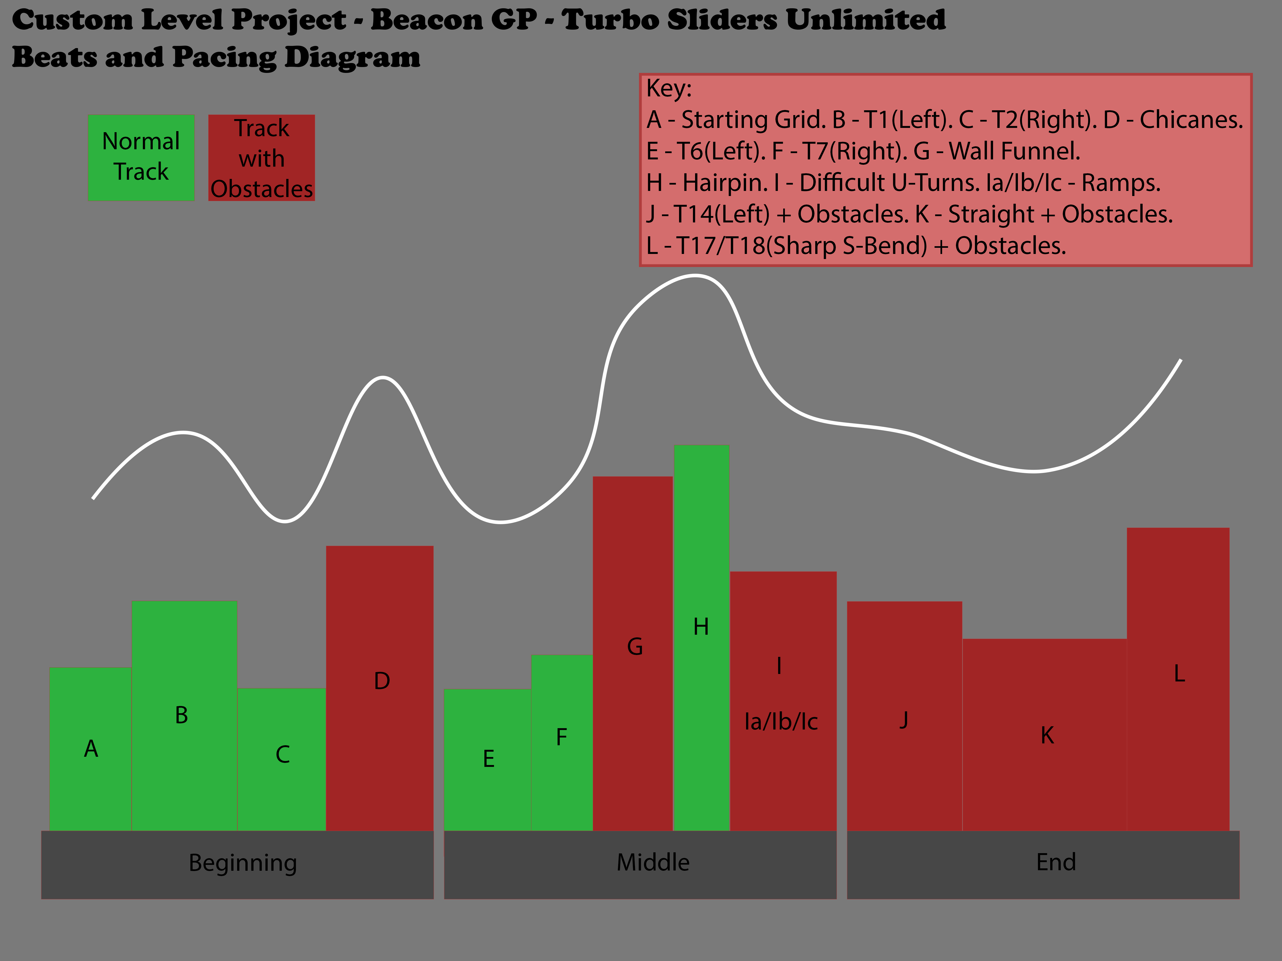
An Image showing the Beats and Pacing Diagram of my Track, Beacon GP.

Mechanics:
Here I will list the Mechanics within Turbo Sliders Unlimited:
- Acceleration: - Allows the player to move forward via the car speeding up. Has an opposite known as Reversing, as it is just accelerating in the backward direction. – Press W

- Steering: - Allows the player to turn the car towards the direction they want to travel in. Also has an opposite, this time know as Reverse Steering. – Press A or D

- Braking: - Allows the player to Decelerate to either come to a complete stop or to perform something known as Drifting. – Press S

- Respawning: - Allows the player to Spawn at the last Checkpoint they crossed, useful for if they flip over or launch over the Wall and out of the Track Boundaries. – Press Backspace (Though R may be a good Alternative)

- Collection: - Allows the player to pick up Collectibles around the map, they may be inclined to follow the collectibles like Breadcrumbs as they will be laid out to give some Visual Affordance to the player.

- Obstacles: - Stops or Hinders players from moving through the track with ease. Ramps may send players off course; Moving Walls will squeeze players into a Funnel and Moving Columns will knock players about every which way.

- Collision: - Is the main Mechanic behind stopping a player from passing through objects in the world, this includes Walls, Trees, Barriers, Columns, Rocks and Other Players.

- Triggers: - Allows the player to activate specific Animations or Checkpoints within the world to create Alternate Laps or Self-Inflicted Traps and Obstacles.

- Checkpoints: - Allows the players Lap to be counted and to ensure that they cannot Cheat and Skip Large Portions of the track Unintentionally. Shortcuts are present in the track but not large skips that Break the Game.

- Timer: -Tracks the players Time getting around the Track, this can be used as a Time Trial to Improve a player’s time around a specific Course.

Research

Video Game Research:
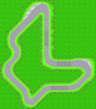
Mario Kart: Super Circuit: - Is the main inspiration in terms of how it constructs its tracks, specifically:
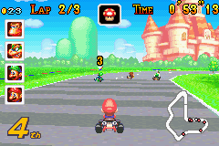
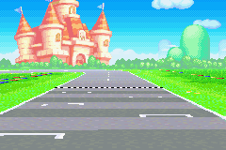
- Peach Circuit:

This is the first track of the Mushroom Cup and the first track overall of Mario Kart: Super Circuit and it is built to be the easy track of the game. A lot of what I took as inspiration from this track is the style of the curbs on the turns as well as the sharp hairpin near the beginning of the start.
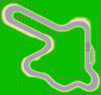
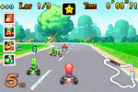
- Mario Circuit:
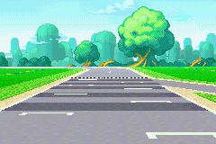

This is first track of the Flower Cup which is the second cup of Mario Kart: Super Circuit and ramps up the difficulty a little bit by adding a sharper hairpin closer to the middle of the track. Another added inspiration from this track specifically is the sand sections either side of the road, which also just so happened to be a feature of Turbo Sliders Unlimited.
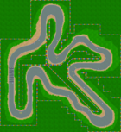
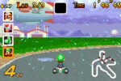
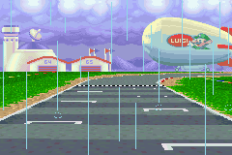
- Luigi Circuit:

This is the last circuit track in Mario Kart: Super Circuit and it sits as the first track of the Lightning Cup which is the third cup overall. Luigi Circuit is easily the hardest of the circuit tracks from Mario Kart: Super Circuit as utilises many U-turns and the sand at the edges of the road, as well making sure that huge broken track skips are blocked off by the coloured barriers.
Of course, the main issue with Mario Kart: Super Circuit is that the tracks are completely flat due to the limitations of the Game Boy Advance. This is an issue that gets fixed in later games as Nintendo, from Mario Kart DS onwards, started introducing Retro Tracks, which are remakes of older tracks to bring them into the modern era.

Mario Kart DS: - Is the first game in the series to introduce the newly added Retro tracks and so any tracks they add will be visually improved and built upon since they’re now actually in 3D, the two tracks, previously mentioned that made the jump to Mario Kart DS are:
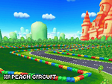
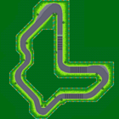
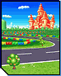
- GBA Peach Circuit:

When this track got its remake in Mario Kart DS, it didn’t play too differently from its original version, but the difference here is that the track is now playable for the first time in full a 3D world.

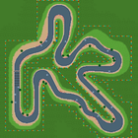
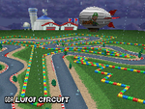
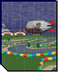
- GBA Luigi Circuit:

This track also got the remake treatment but managed to utilise its environment a ton, including the iconic rain from the Game Boy Advance version of the track. That is what this level will utilise by using its environment to its advantage.
At this stage, both tracks have a remake but the remaining one, GBA Mario Circuit, has not been remade at this point in time. Either way, this stage of these tracks lives is only a transitional stage as they get much more modern remakes later.

Mario Kart 8 Deluxe: - We only got one Mario Kart: Super Circuit track in Mario Kart 8 Deluxe but the track we got was the remaining circuit track from Super Circuit. This was of course:
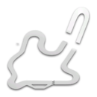
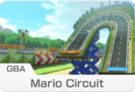
- GBA Mario Circuit:
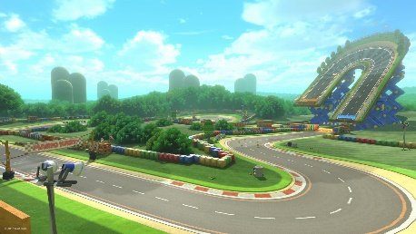

This track has had a major visual overhaul compared its circuit brethren, it even had a completely new track change added to assist with one of Mario Kart 8 Deluxe’s new to the series mechanics, Anti-Gravity. They changed the U-turn to be raised at around a 60-degree angle to reinvent this classic track slightly.
Mario Kart 8 Deluxe helped in breathing new life into an old beloved track by reinventing the formula of how it worked, and the result was an addition of verticality mixed with the true definition of a modernised Mario Kart track.

Mario Kart Tour: - Is the final step in seeing a fully modernised version of older tracks made by Nintendo, this mobile game was completely unexpected, but it has been innovative for the series even bringing back tracks that had previously had their chance to be remade, two such tracks are:


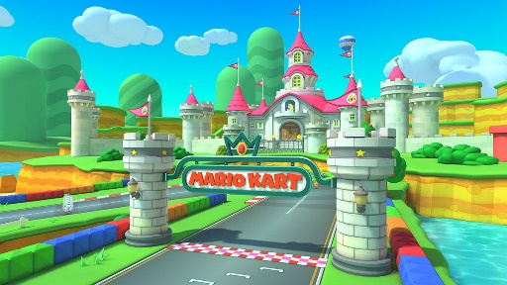
- GBA Peach Circuit:
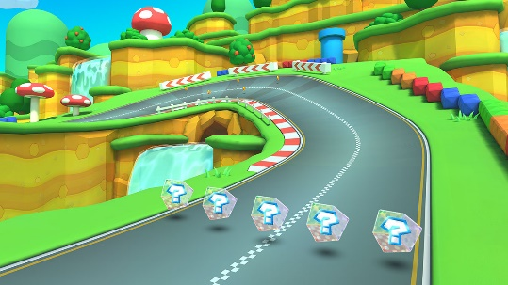


Improvements to this track are aplenty as now it features both elevation and a lake that it didn’t have previously. These have given the track a new look that even compliments its simplistic design, making it easy to understand for the player. Beacon GP will take inspiration of Elevation from this track and use it to its advantage.
- GBA Luigi Circuit:
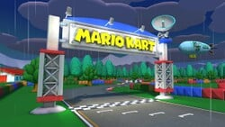
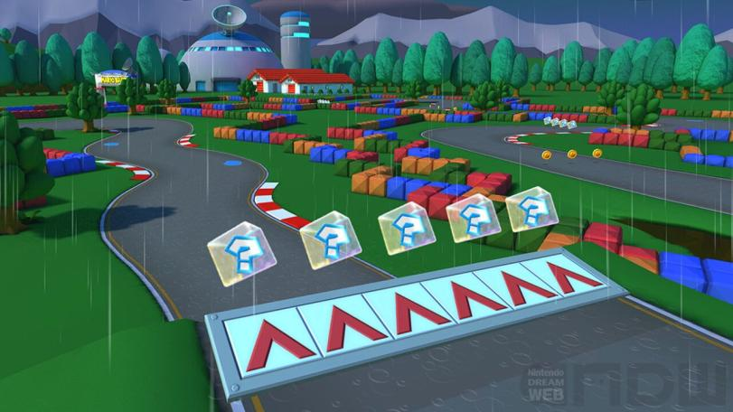

Just like its remake in Mario Kart DS, this version faithfully recreates the same atmosphere with the rain and the night sky, but where this remake differs from older versions is through its use of elevation like all the modernised circuit tracks from Mario Kart: Super Circuit and the introduction of ramps off these elevated sections. This is something that Beacon GP will be including to change up the gameplay.
This is the last time any of these tracks have been seen but they could be very remade again to keep up with the modern era in the future, but as they stand now, these are the updated versions, and it really shows as they play just as good but look much better.

Real Life Research:
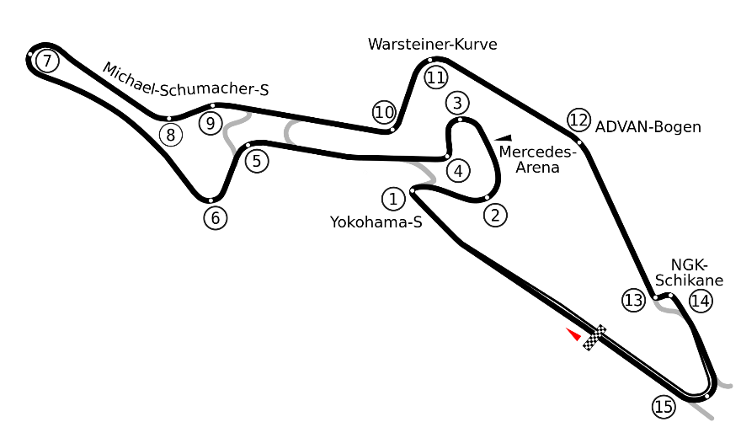
Nürburgring – GP-Strecke: - Is the longest racetrack in the world, but the section of the track that inspires the design of Beacon GP is the shortened version of the track called GP-Strecke:
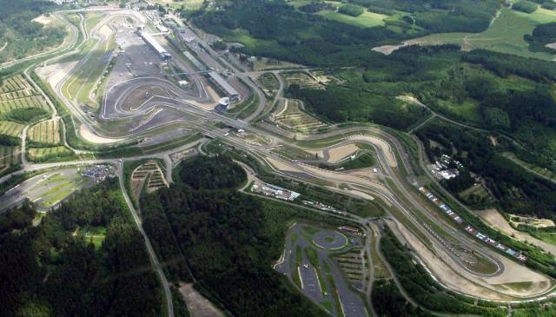

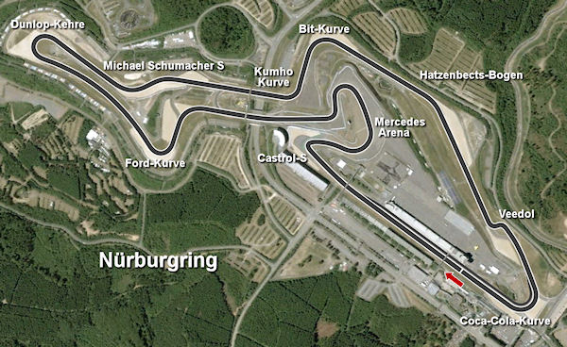

- One thing that stands out incredibly is the simplicity of the track while it also remains quite complex and not only that, but it features unused sections of track to act as different configurations of the course. This has inspired the unused sections of track in Beacon GP as they add to the courses overall appeal of replayability, if configured in a different way than the overall race would be its own new experience.
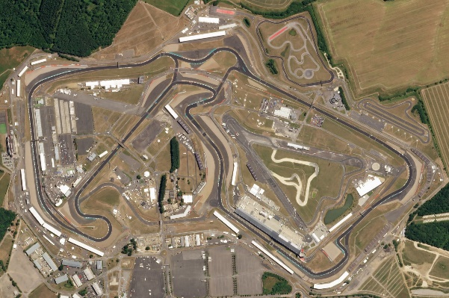
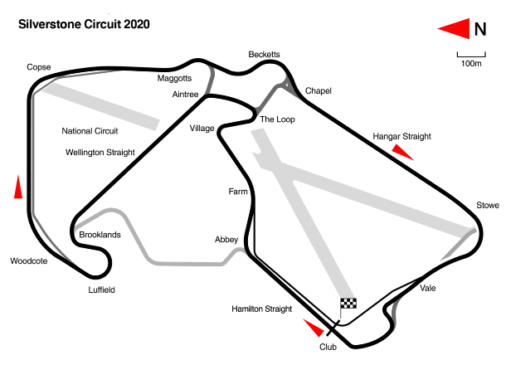
Silverstone Circuit: - Is the largest racetrack in the UK and is another realistic inspiration of Beacon GP mainly for the overall look and appearance of the track:
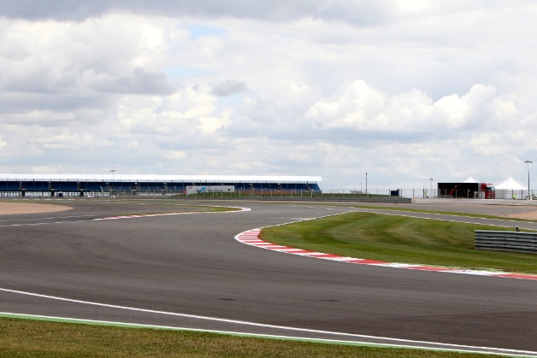

- The Aesthetic of Silverstone was the main draw for inspiration when looking at real life F1 Racetracks, mainly the surrounding area and the way the turns and straights are constructed. Beacon GP will incorporate similar looking turns from Silverstone to match its road layout aesthetic.
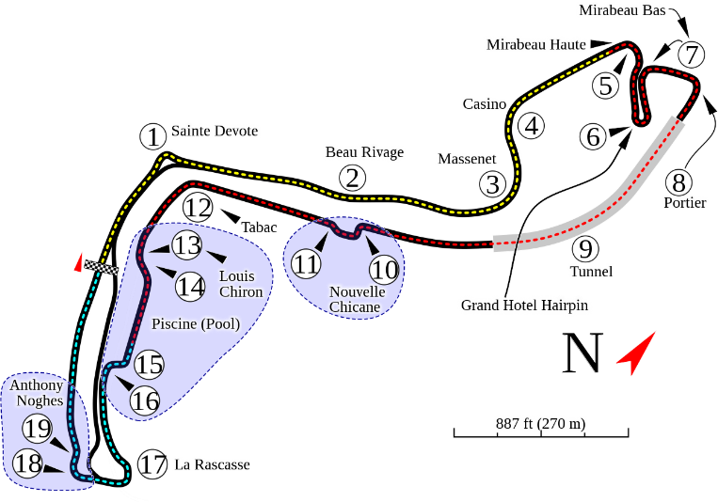
Circuit de Monaco: - Is one of the most Iconic racetracks in F1 mainly because of its location and difficulty, its full of many complex and tricky turns as well as a couple straights that are all for speed:
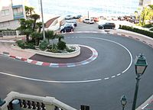
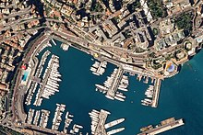

- Even though this track is quite small overall, it does not stop it from being complex and difficult to navigate, this is a famous course for being one of the hardest F1 tracks in the series, and Beacon GP will try to reflect that as much as it can with its use of tricky sections in the middle and where it needs them.

Map Overview

Player Paths:
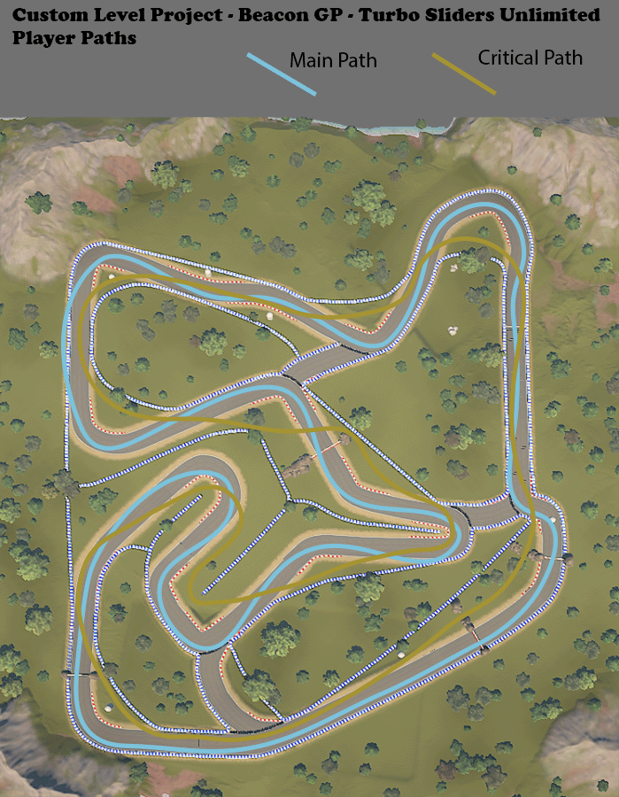
An Image showing the Main Path and Critical Path of my Track, Beacon GP.

Challenge Placements:
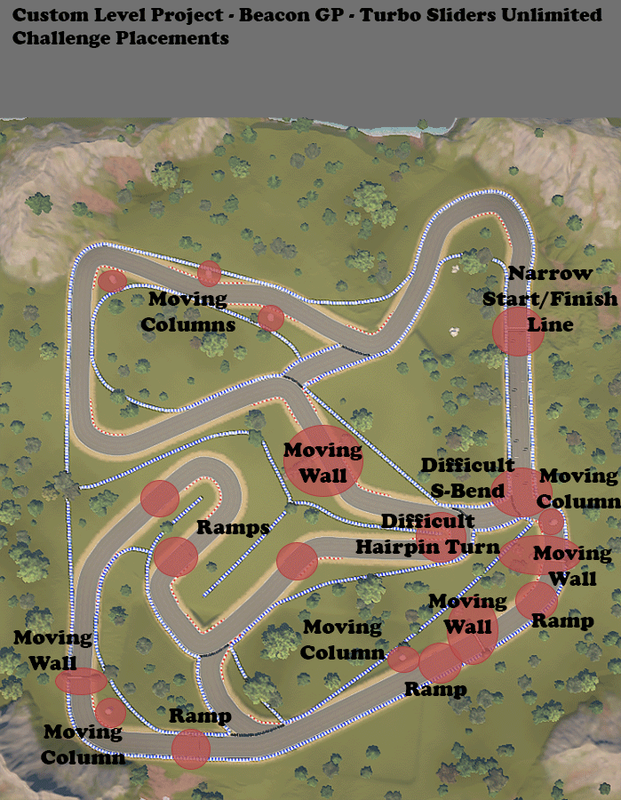
An Image showing the Challenge Placements, (for example the Obstacles) around my Track, Beacon GP.

Conflict Points:
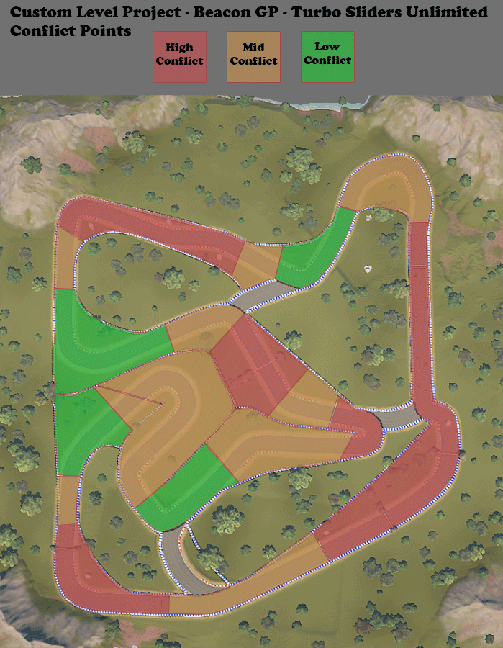
An Image showing the areas of the track, Beacon GP, that will have the most conflict between players or between players and the environment.

Points of Interest:
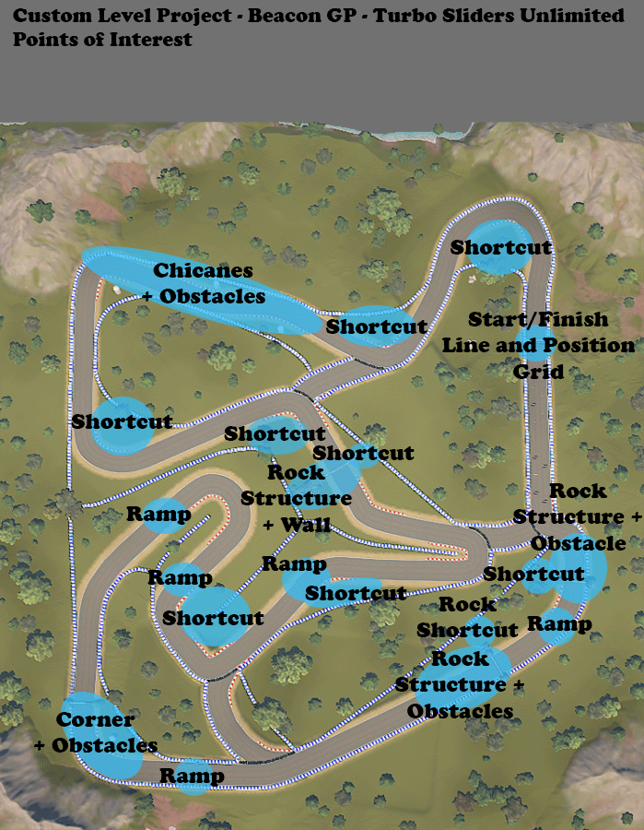
An Image showing all the Points of Interest such as Shortcuts and Obstacles on my track, Beacon GP.

Rewards:
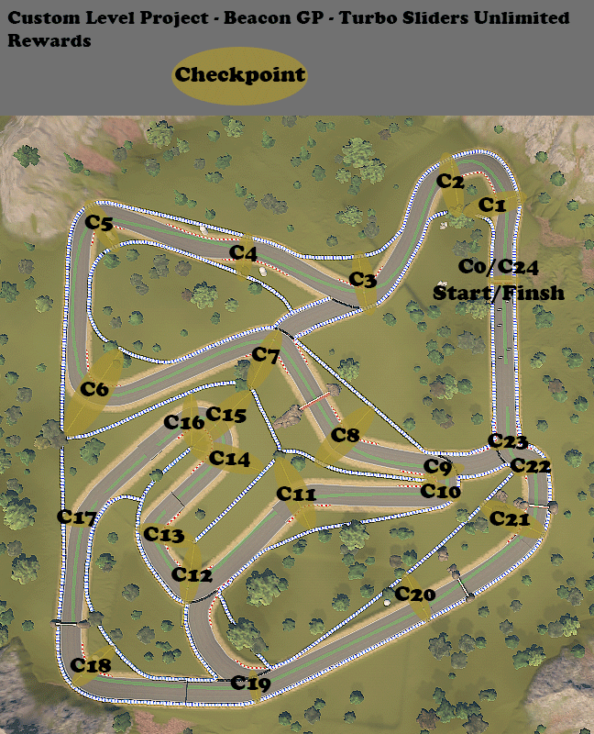
An Image showing the Checkpoints in my track, Beacon GP, that act to update the players position, then when a lap is completed, the player is rewarded via moving onto the next lap.

Aesthetics

Visual Development:
This level was originally going to be a simple Circuit with no sense of life or character from what it was based on, being F1 Grand Prix tracks, as I feel it leaned a bit too heavily into the other Inspiration being Mario Kart: Super Circuit tracks.
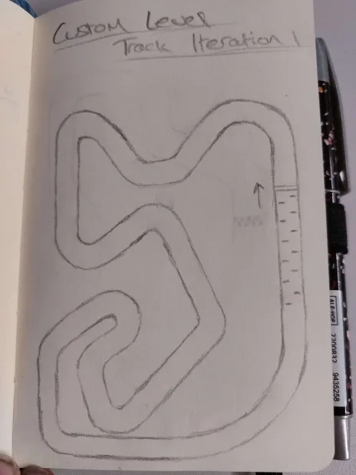
An Image showing a Sketch of the First Iteration of my Custom Level.

Then, after Developing the design a little more, the track then started to take Shape and resemble a nice mix of its inspirations of F1 Grand Prix tracks and Mario Kart: Super Circuits tracks.
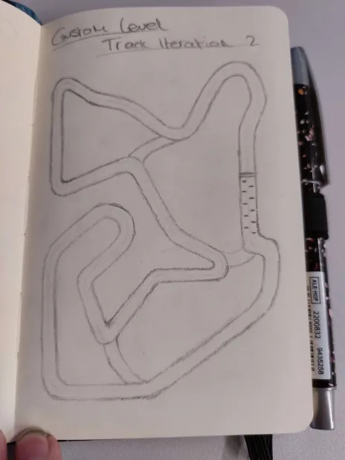
An Image showing a Sketch of the Second Iteration of my Custom Level.

Visual and Audio Affordance:
Visual Affordance has been created for the player in the form of Curbs, Rocks, Walls and Arrows:
- Curbs: - Act as a Simple way to tell the players that there is a Turn coming up and they have been Warned about it. It gives players enough time to React to the upcoming bend as to better Navigate it.
- Rocks: - Can be used as a Visual Aesthetic as well as a Functional use of Affordance. In this level they are many uses for the Rocks, they can be used as an Obstruction like walls, they are used to add something visually Interesting to the level and they also act as an affordance tool that tells the Player that there is a Moving Wall nearby.
- Walls: - Are a very easy way of affording to the player that they cannot pass through an area or that they aren’t meant to go that way, Walls on the track include, the Blue and White Walls, Tire Barriers and the Moving Walls. In a hectic environment such as Turbo Sliders Unlimited, Walls will act as an extra obstacle as there are up to 20 Players at a time in a race.
- Arrows: - The easiest way to warn the player and afford them the knowledge of an upcoming turn is as simple as an Arrow Marking on the ground. This functions similarly to a Curb as it Acknowledges the player of its existence before they get to it.
Audio Affordance has also been used to tell the player about certain things occurring in the world:
- Engine Sounds: - Tell the player that the car is in fact switched on and Accelerating along the track. It also has a Job to Immerse the player in their surrounding Environment amongst all the chaos of a Lobby full of other Players.
- Tire Screeching: - Allows the player to know when the Brakes are applied to the cars Wheels for either slowing down at an Obstacle or performing a Drift around a turn. This is all for immersion and Affording to the player that they are playing a Racing game, with the goal being to Involve the player as much as possible in the world of Turbo Sliders Unlimited.

Balance

Considerations:
There are a few kinds of balancing that will need to be carried out, here are the considerations for this custom level:
- Player Skill: - Players with different skill levels will need to be considered for the racetrack.
- Vehicle Performance: - Different vehicles will perform better in certain conditions, so this will need to be considered.
- Obstacle Interference: - Obstacles will be getting in the way of players and so this will need to be properly balanced as to not be too unfair.

Expected Issues:
As with anything that is released to the public, there will be issues that we may encounter due to the balancing that has been implemented, such as:
- Player Inexperience: - If there are players having trouble playing then it may cause disruptions.
- Player’s Trolling: - Trolling is a very bad issue that can only be mitigated through banning players and so it not something that can be controlled in the level design of this racetrack.
- Overpowered & Underpowered Vehicles: - If a vehicle is overpowered then it will be unfair for other racers and similarly, underpowered vehicles will stand no chance.
- Vehicle Diversity Broadness: - Due to the Vehicle Editor, then people can make whatever vehicles they want, and it will be tricky to account for these specific cars.
- Obstacle Intensity: - Will need to strike a balance between being in the way and avoidable, too fast or too slow and they may be unfair or pointless.
- Obstacle Placement: - Obstacles may be placed in a way that can unfairly disadvantage them in some way shape or form.

Testing

Testing Plan:
For Playtesting, I decided to let other students have a go at the track, all three laps. This is the Questionnaire that I set up for them to complete after their session on my track:
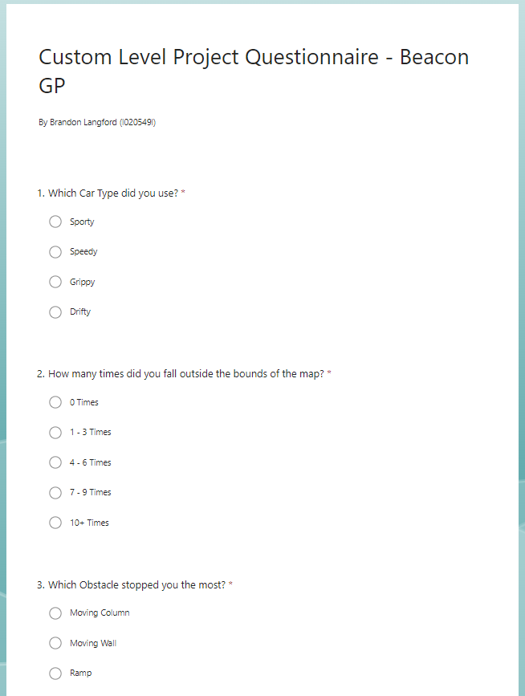
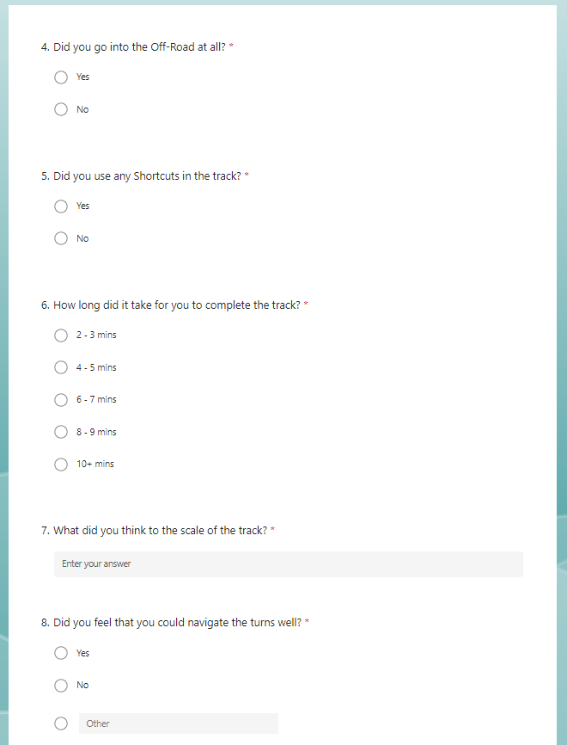
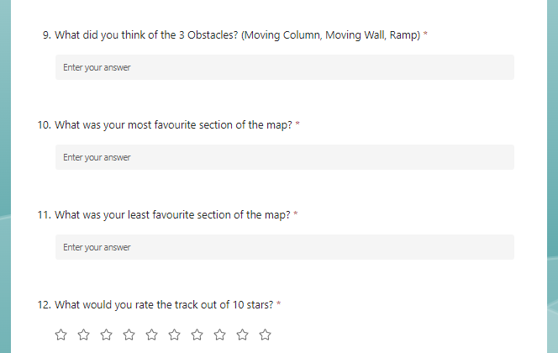

Evidence of Testing:
Here is the Evidence of my Playtesting, for the most part the Feedback was Positive so there wasn’t much Action that needed taking.
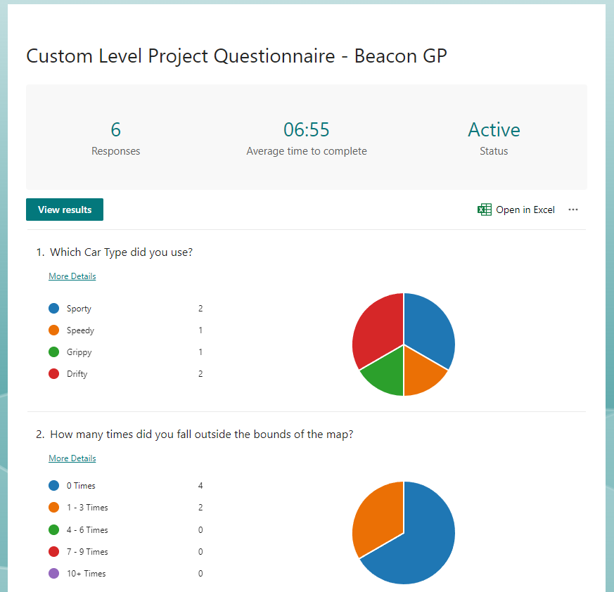
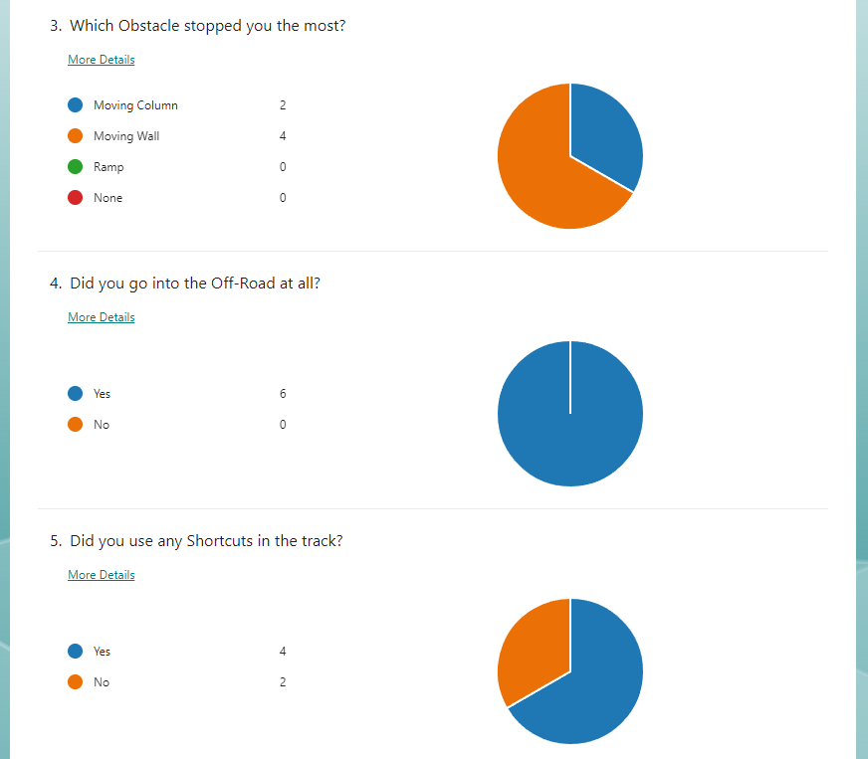
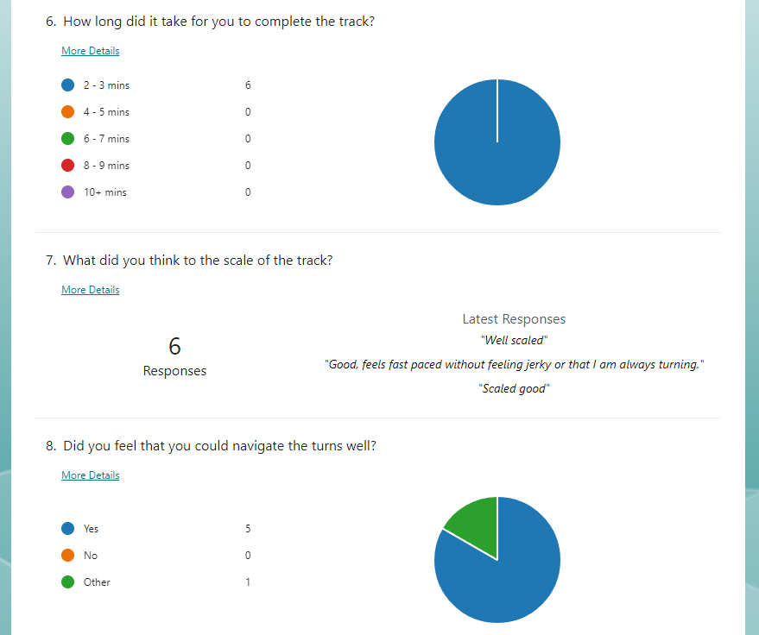
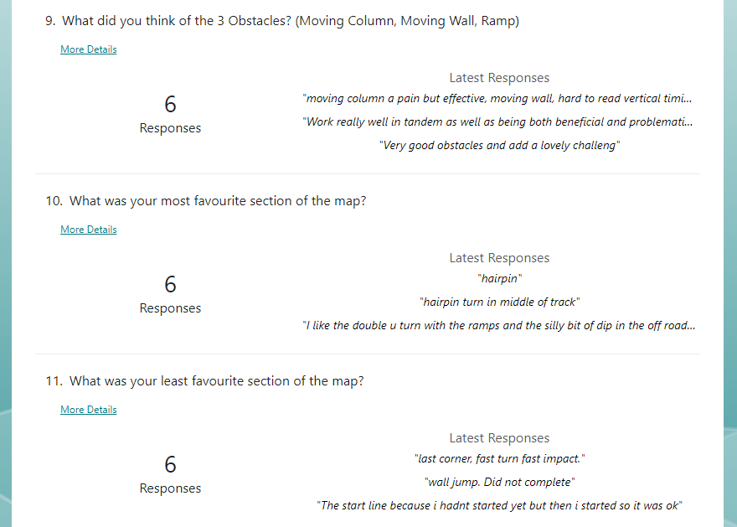
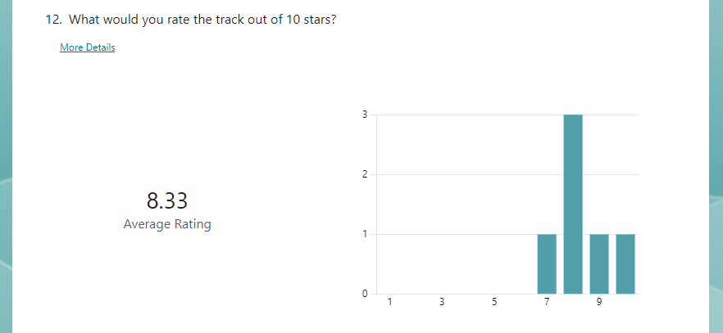
Images showing the responses I got from the playtesting of my level.

Level Development Log

Level Images:
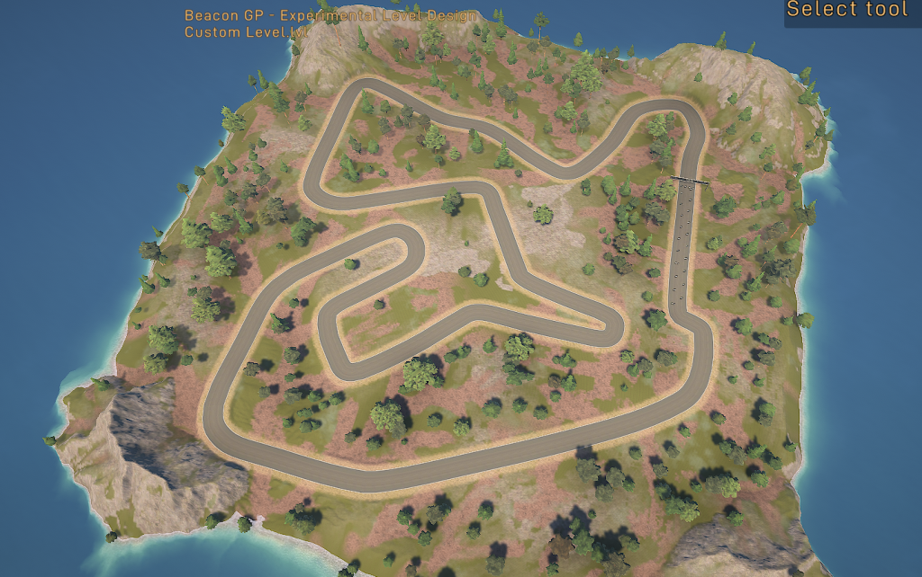
An Image showing my progress of my Custom Level inside of Turbo Sliders Unlimited.
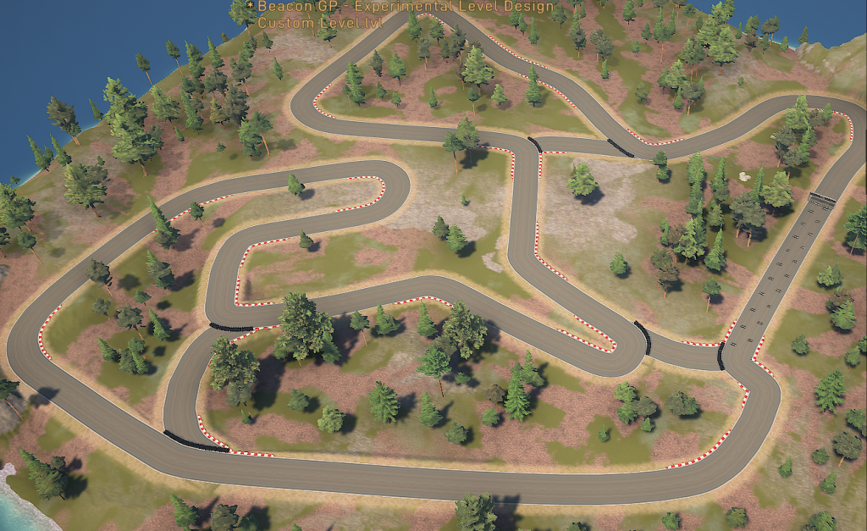
An Image showing the progress made to my Custom Level, Beacon GP.
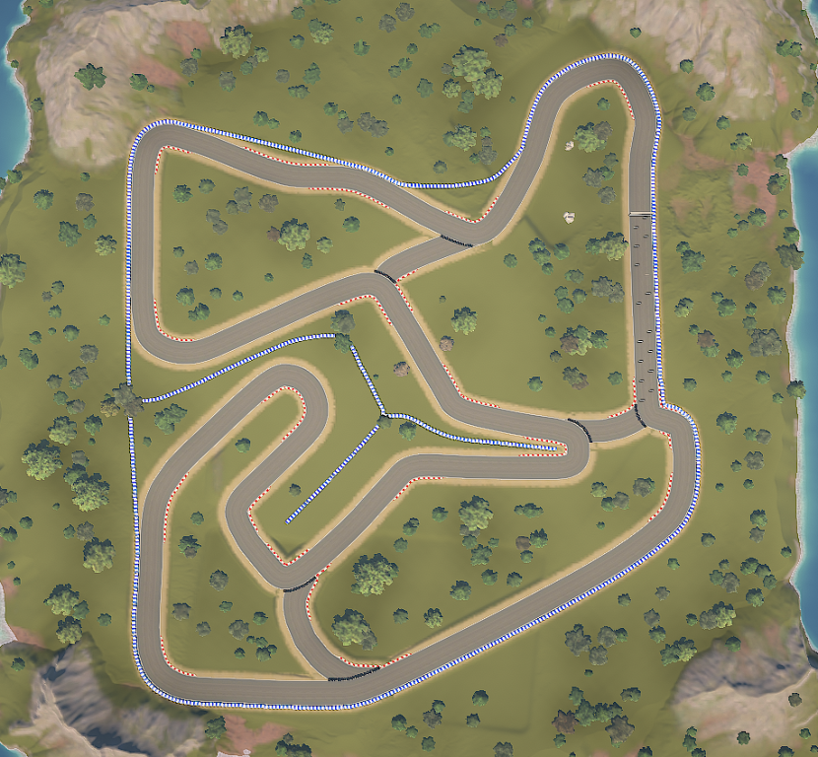
An Image showing the progress made to my Custom Level, Beacon GP.
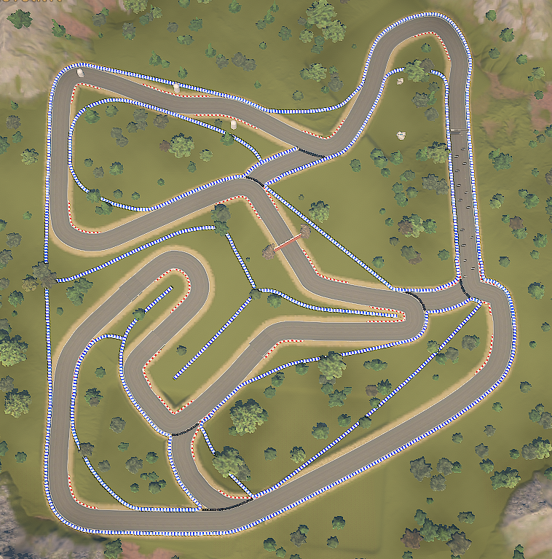
An Image showing the progress made to my Custom Level, Beacon GP.
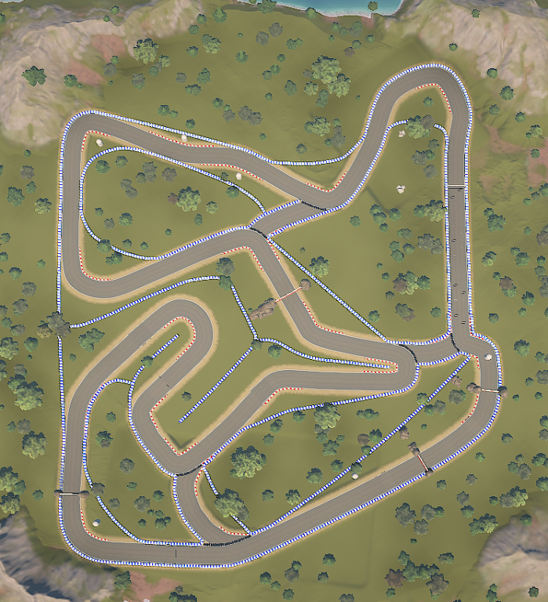
An Image showing the completed Top-Down View of my Custom Level, Beacon GP.

